1. create database custom;

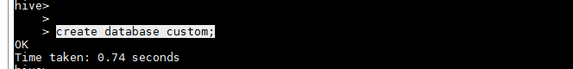

1. use custom;

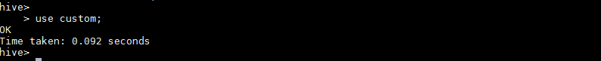

1. create table temperature_temp

(date string,

zipcode int,

temperature float)

row format delimited fields terminated by ',';

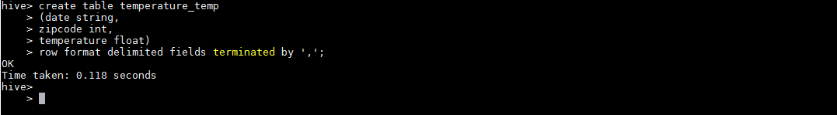

1. load data local inpath '/home/acadgild/shared/dataset.txt' into table temperature_temp;

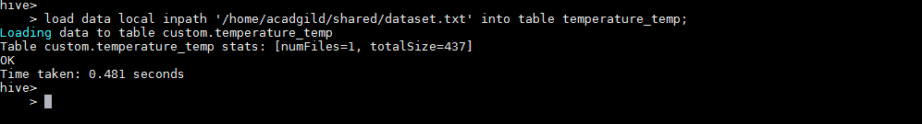

1. create table temperature_data

(date string,

zipcode int,

temperature float)

row format delimited fields terminated by ',';

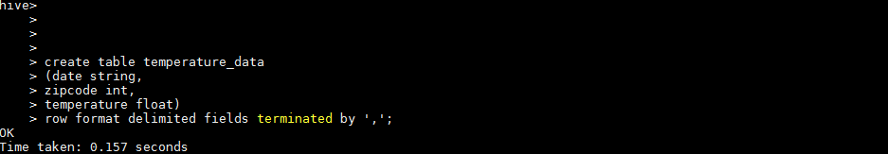

1. insert into table temperature_data select from_unixtime(unix_timestamp(date, 'dd-MM-yyyy'),'MM-dd-yyyy'),zipcode,temperature from temperature_temp;

