1. select * from temperature_data

where zipcode > 300000

and

zipcode < 399999;

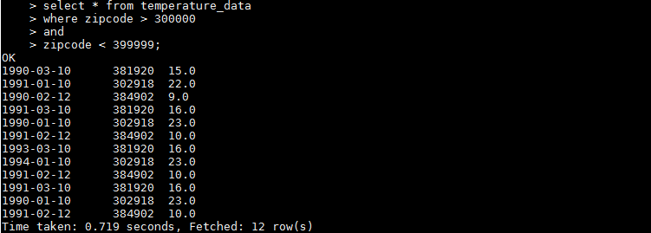

1. select from_unixtime(unix_timestamp(date,'MM-dd-yyyy'),'yyyy') year ,

max(temperature) maxtemp from temperature_data

group by from_unixtime(unix_timestamp(date,'MM-dd-yyyy'),'yyyy');



1. select from_unixtime(unix_timestamp(date,'MM-dd-yyyy'),'yyyy') year ,

max(temperature) maxtemp,

count(from_unixtime(unix_timestamp(date,'MM-dd-yyyy'),'yyyy')) cnt

from temperature_data

group by from_unixtime(unix_timestamp(date,'MM-dd-yyyy'),'yyyy')

having count(from_unixtime(unix_timestamp(date,'MM-dd-yyyy'),'yyyy')) >= 2;

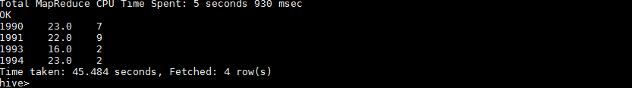

1. create view temperature_data_vw

as

select from_unixtime(unix_timestamp(date,'MM-dd-yyyy'),'yyyy') year ,

max(temperature) maxtemp,

count(from_unixtime(unix_timestamp(date,'MM-dd-yyyy'),'yyyy')) cnt

from temperature_data

group by from_unixtime(unix_timestamp(date,'MM-dd-yyyy'),'yyyy')

having count(from_unixtime(unix_timestamp(date,'MM-dd-yyyy'),'yyyy')) >= 2;

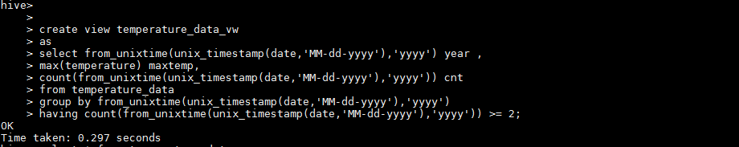

1. INSERT OVERWRITE LOCAL DIRECTORY '/home/acadgild/output'

ROW FORMAT DELIMITED

FIELDS TERMINATED BY '|'

SELECT * FROM temperature_data_vw;

