**Apache Hive** is an ETL and Data warehousing tool built on top of **Hadoop**. It makes job easy for performing operations like

* Analysis of huge datasets
* Ad-hoc queries
* Data encapsulation

**Hadoop Hive Architecture and its Components**

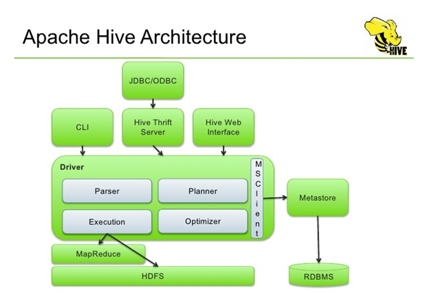

Above diagram shows the major components of Apache Hive-

* **Hive Clients –** Apache Hive supports all application written in languages like C++, Java, Python etc. using JDBC, Thrift and ODBC drivers. Thus, one can easily write Hive client application written in a language of their choice.
* **Hive Services –** Hive provides various services like web Interface, CLI etc. to perform queries.
* **Processing framework and Resource Management –** Hive internally uses Hadoop MapReduce framework to execute the queries.
* **Distributed Storage –** As seen above that Hive is built on the top of Hadoop, so it uses the underlying HDFS for the distributed storage.

Now let us discuss the Hive client and Hive services in detail-

The Hive supports different types of client applications for performing queries. These clients are categorized into 3 types:

* **Thrift Clients –** As Apache Hive server is based on Thrift, so it can serve the request from all those languages that support Thrift.
* **JDBC Clients –** Apache Hive allows Java applications to connect to it using JDBC driver. It is defined in the class *apache.hadoop.hive.jdbc.HiveDriver.*
* **ODBC Clients –** ODBC Driver allows applications that support ODBC protocol to connect to Hive. For example JDBC driver, ODBC uses Thrift to communicate with the Hive server.

### Hive Services:

Apache Hive provides various services as shown in above diagram. Now, let us look at each in detail:

**a) CLI (Command Line Interface) –** This is the default shell that Hive provides, in which you can execute your Hive queries and command directly.

**b) Web Interface –** Hive also provides web based GUI for executing Hive queries and commands.

**c) Hive Server –** It is built on Apache Thrift and thus is also called as Thrift server. It allows different clients to submit requests to Hive and retrieve the final result.

**d) Hive Driver –** Driver is responsible for receiving the queries submitted Thrift, JDBC, ODBC, CLI, Web UL interface by a Hive client.

* **Complier –**After that hive driver passes the query to the compiler. Where parsing, type checking, and semantic analysis takes place with the help of schema present in the metastore.
* **Optimizer –** It generates the optimized logical plan in the form of a DAG (Directed Acyclic Graph) of MapReduce and HDFS tasks.
* **Executor –** Once compilation and optimization complete, execution engine executes these tasks in the order of their dependencies using Hadoop.

**e) Metastore –** Metastore is the central repository of Apache Hive metadata in the Hive Architecture. It stores metadata for Hive tables (like their schema and location) and partitions in a relational database. It provides client access to this information by using metastore service API. Hive metastore consists of two fundamental units:

* A service that provides metastore access to other Apache Hive services.
* Disk storage for the Hive metadata which is separate from HDFS storage.