1. Creating the employee table as per the data set provided :

create table employee

(empname varchar(100),

empskills varchar(200),

experience int,

location varchar(50))

row format delimited

fields terminated by ',';



1. Loading the data into employee table from dataset:

load data local inpath '/home/acadgild/shared/emp_details.txt' into table employee;

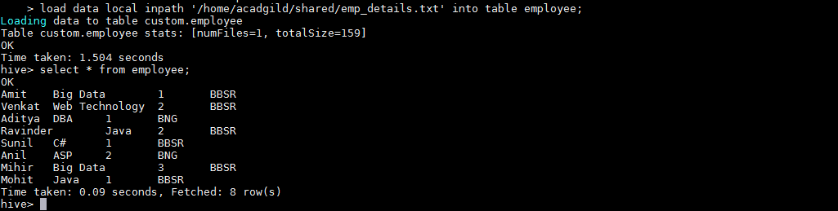

1. Calculate the number of employees corresponding to each skill from the table 'employee' which is loaded in the Demo.

select empskills,count(empname) total_employees

from employee

group by empskills;

