1. select country,count(total_medals) total_medals

from

olympic

where sport='Swimming'

group by country;

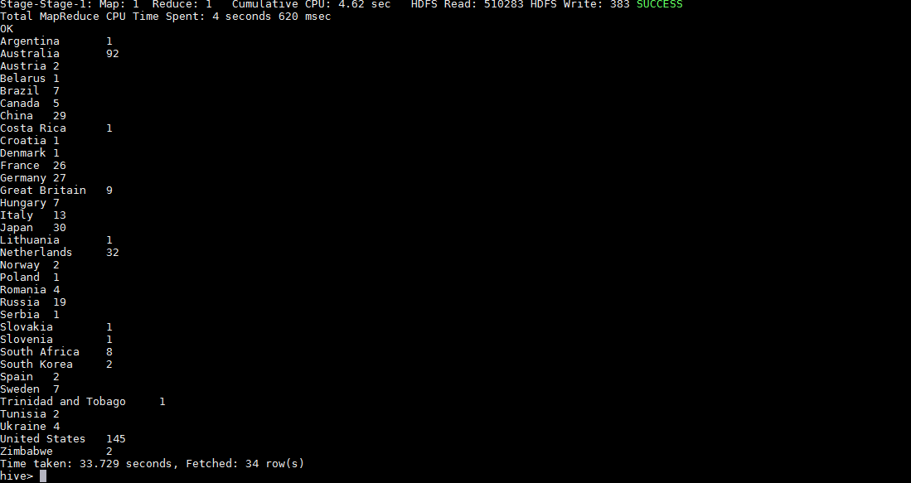

1. select country,year,count(total_medals) total_medals

from

olympic

where country='India'

group by country,year;

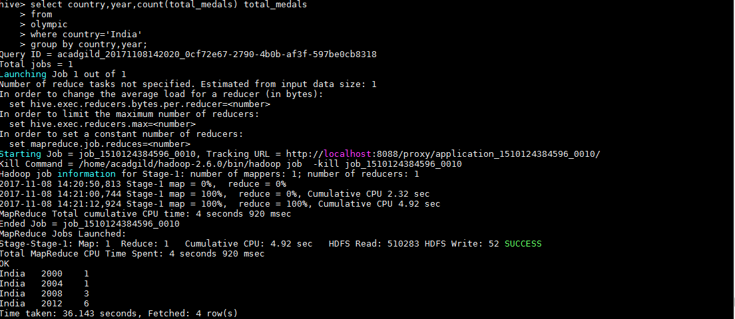

3. select country,count(total_medals) total_medals

from

olympic

group by country;

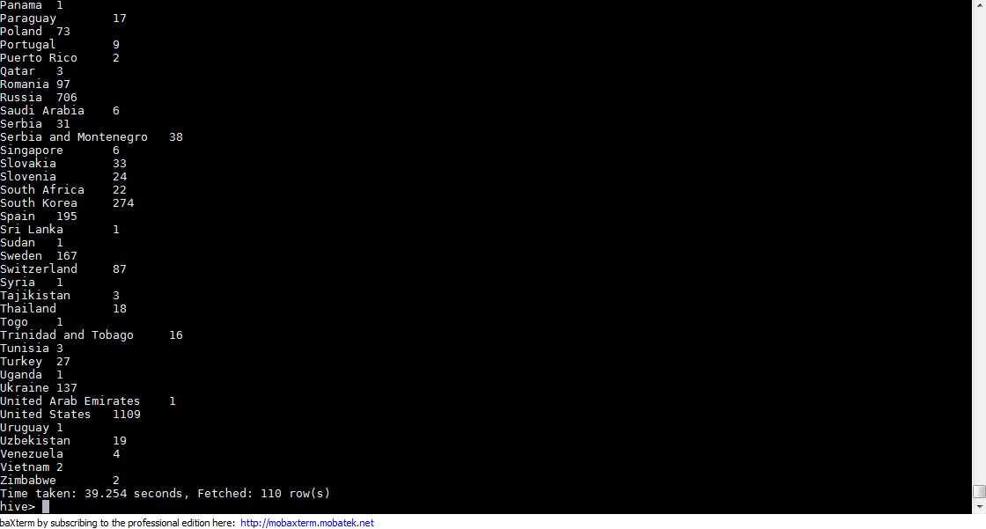

4.

select country,count(Gold_Medals) Gold_Medals

from

olympic

group by country;

