Below properties needs to be set appropriately in **hive shell**, order-wise to work with transactions in Hive:

**set hive.support.concurrency = true;**

**set hive.enforce.bucketing = true;**

**set hive.exec.dynamic.partition.mode = nonstrict;**

**set hive.txn.manager = org.apache.hadoop.hive.ql.lockmgr.DbTxnManager;**

**set hive.compactor.initiator.on = true;**

**set hive.compactor.worker.threads = 4;**

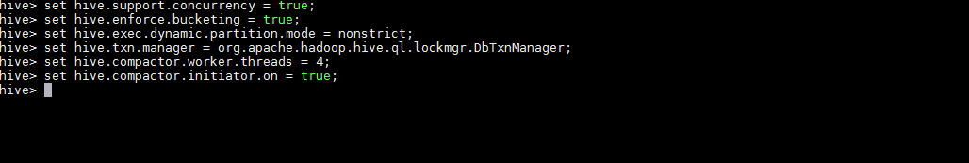

Creating a Table That Supports Hive Transactions

**CREATE TABLE college(clg_id int,clg_name string,clg_loc string) clustered by (clg_id) into 5 buckets stored as orc TBLPROPERTIES('transactional'='true');**



## Inserting Data into a Hive Table

|  |  |
| --- | --- |
|  | **INSERT INTO table college values(1,'nec','nlr'),(2,'vit','vlr'),(3,'srm','chen'),(4,'lpu','del'),(5,'stanford','uk'),(6,'JNTUA','atp'),(7,'cambridge','us');** |

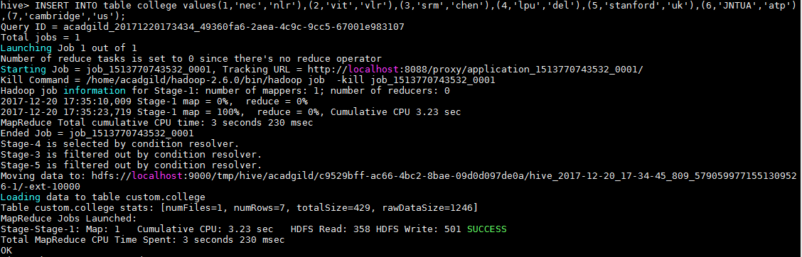

**Viewing the contents of table**

***select * from college;***

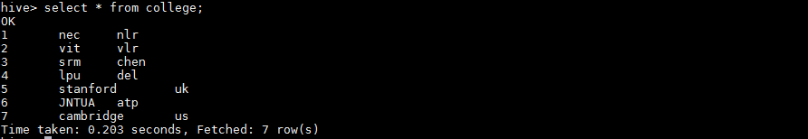

**Reinserting the data again to the table**

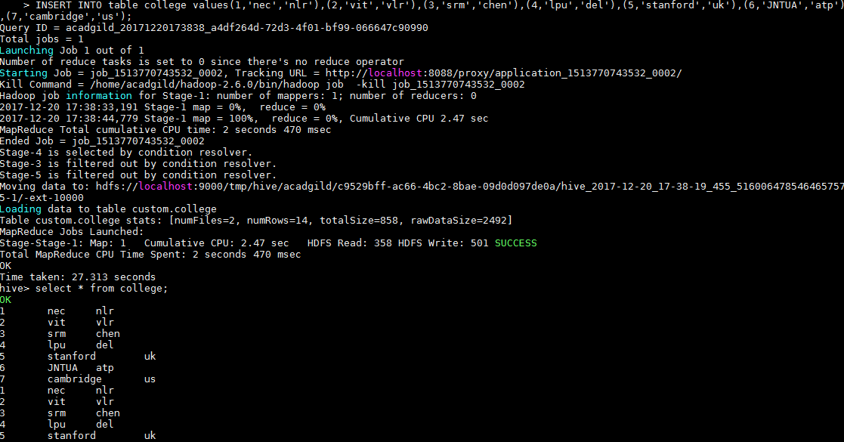

## Updating the Data in Hive Table

**UPDATE college set clg_id = 8 where clg_id = 7;**

## 

**UPDATE college set clg_name = 'IIT' where clg_id = 6;**

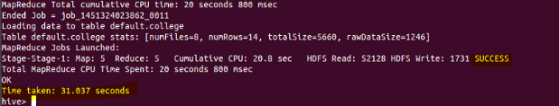

The updated data can be checked using the command ***select * from college.***

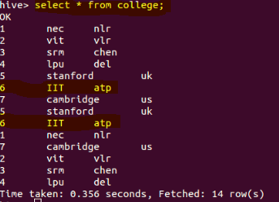

## Deleting a Row from Hive Table

**delete from college where clg_id=5;**

## 

We have now successfully deleted a row from the Hive table. This can be checked using the command **select * from college.**

## 