Problem 1:

Create an HBase table named 'clicks' with a column family 'hits' such that it should be able to

store last 5 values of qualifiers inside 'hits' column family.

1. Create table **clicks** with column family **hits**

**create 'clicks','hits'**

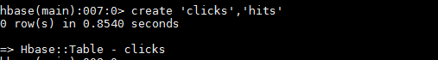

1. Alter table clicks. Change the VERSIONS property of column family so that it stores last 5 values

**alter 'clicks',{NAME=>'hits',VERSIONS=>5}**

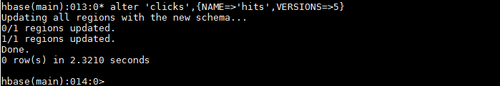

Problem 2:

Add few records in the table and update some of them. Use IP Address as row-key. Scan the

table to view if all the previous versions are getting displayed.

1. Adding records to table and updating some of them

**put 'clicks','120.18.19.210','hits:ipaddress','www.cricinfo.com'**

**put 'clicks','120.18.19.210','hits:ipaddress','www.espnstar.com'**

**put 'clicks','120.18.19.210','hits:ipaddress','www.google.com'**

**put 'clicks','120.18.19.210','hits:ipaddress','www.apache.com'**

**put 'clicks','120.18.19.210','hits:ipaddress','www.timesofindia.com'**

**put 'clicks','100.20.20.190','hits:ipaddress','www.cricinfo.com'**

**put 'clicks','100.20.20.190','hits:ipaddress','www.hadoop.com'**

**put 'clicks','100.20.20.190','hits:ipaddress','www.twitter.com'**

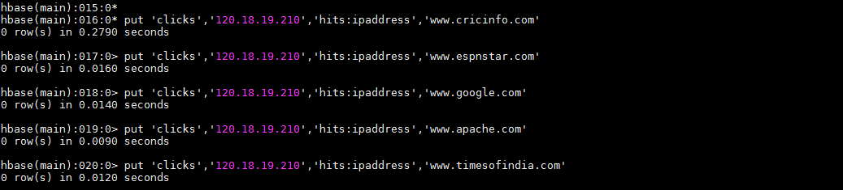

1. Scanning the table for displaying all the previous versions**:**

**get 'clicks','120.18.19.210',{COLUMN=>'hits:ipaddress',VERSIONS=>5}**

