**Create (Insert) Operations:**

INSERT INTO Bikes (BikeID, BikeName, RentalPricePerHour, AvailabilityStatus)

VALUES (6, 'Cruiser Bike', 9.50, TRUE);

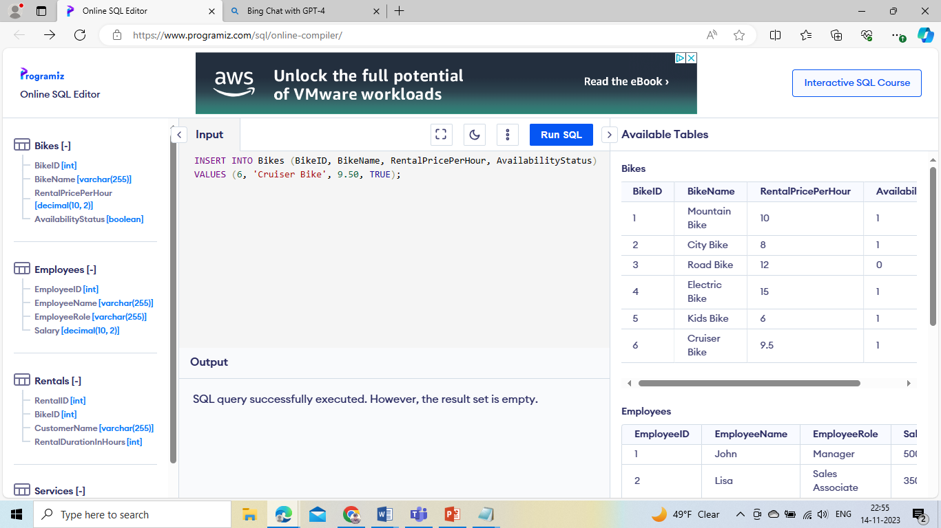

INSERT INTO Rentals (RentalID, BikeID, CustomerName, RentalDurationInHours)

VALUES (6, 2, 'Frank', 6);

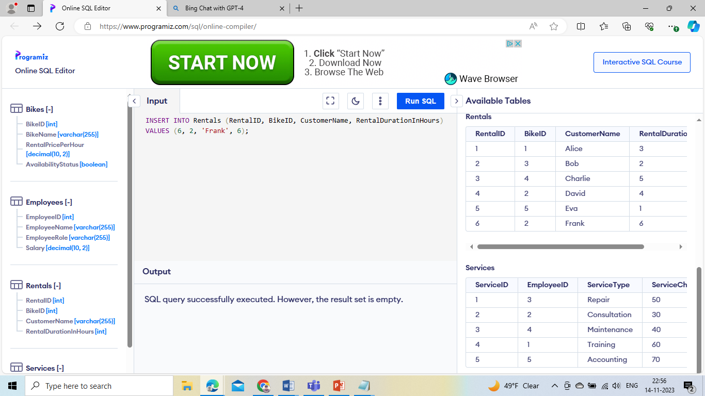

INSERT INTO Employees (EmployeeID, EmployeeName, EmployeeRole, Salary)

VALUES (6, 'Grace', 'Sales Associate', 38000.00);

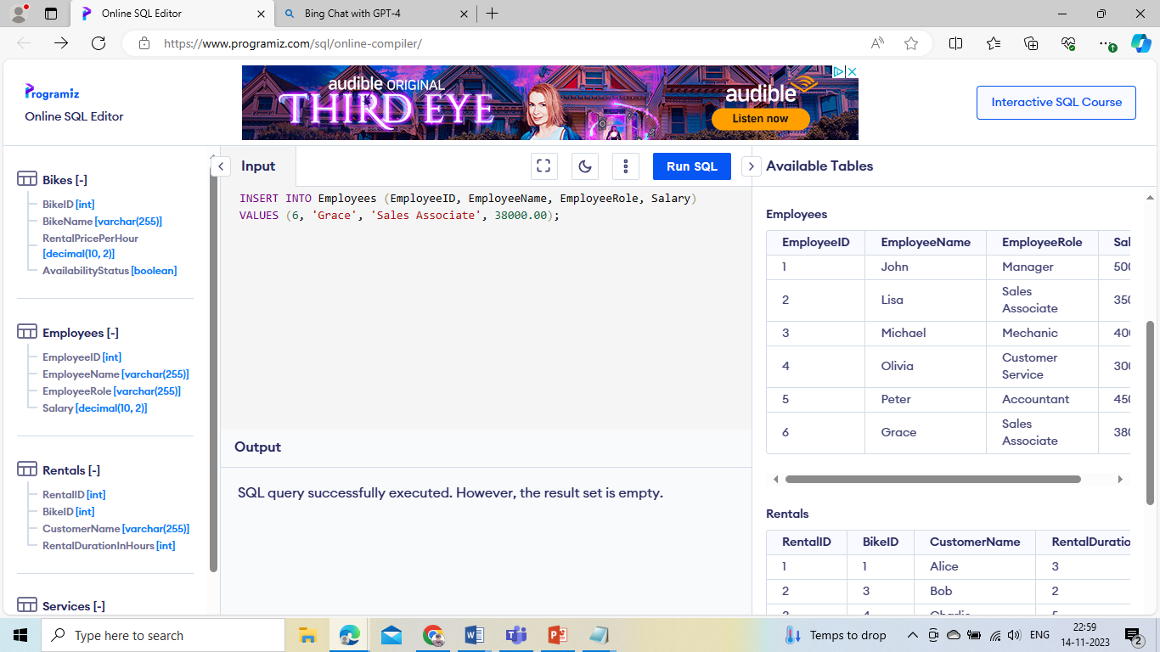

INSERT INTO Services (ServiceID, EmployeeID, ServiceType, ServiceCharge)

VALUES (6, 3, 'Tune-up', 70.00);

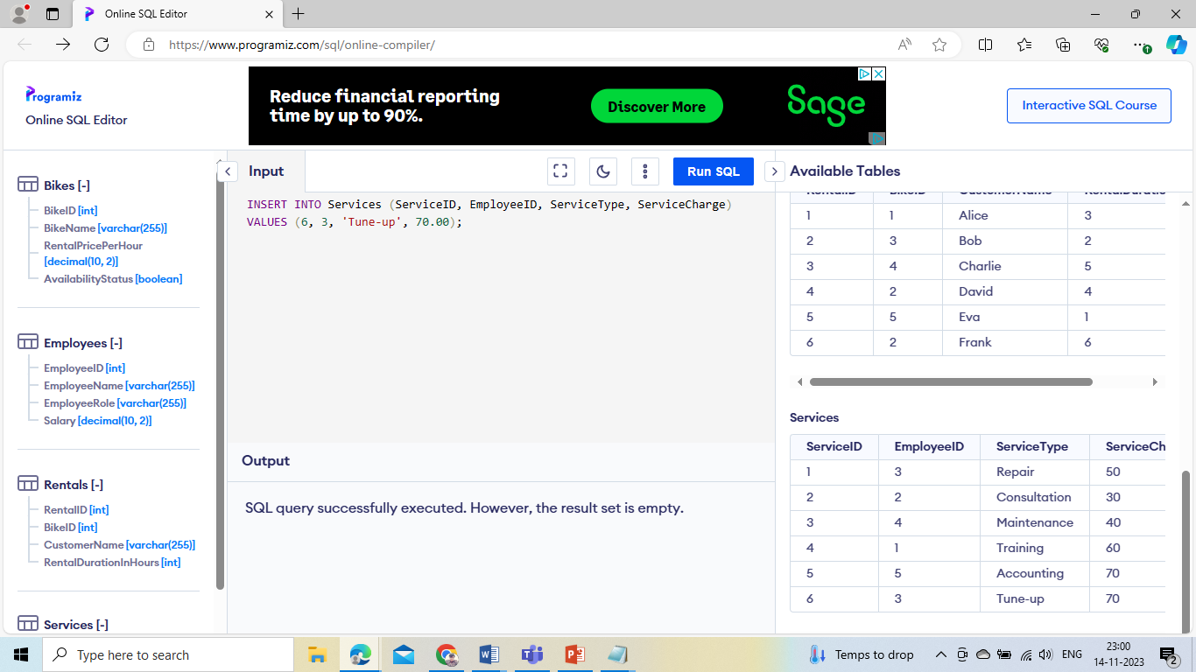

**Read Operations:**

SELECT BikeName, RentalPricePerHour FROM Bikes;

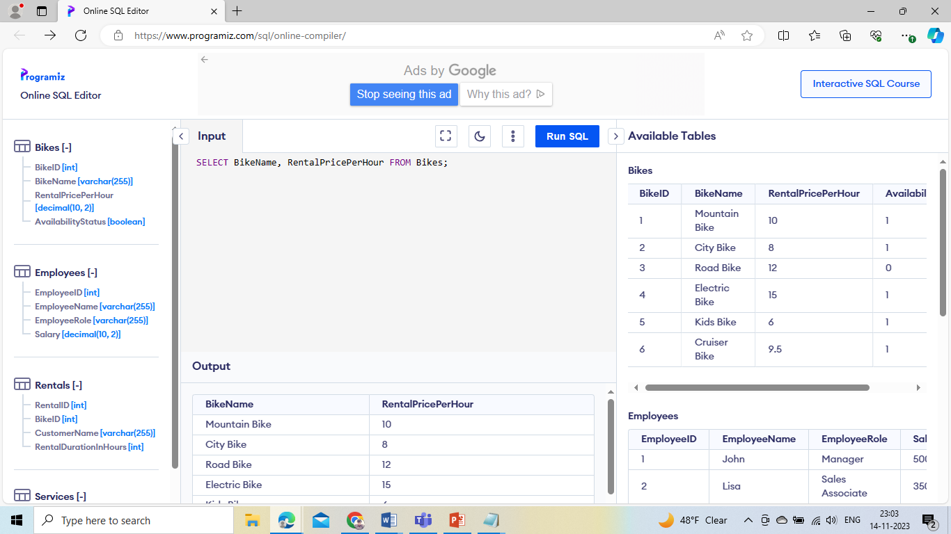

SELECT RentalID, CustomerName

FROM Rentals

WHERE BikeID = 2;

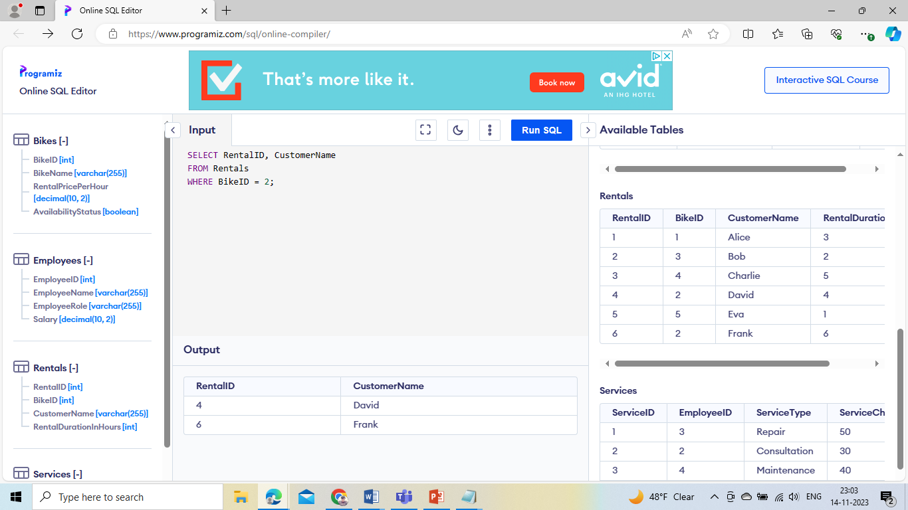

SELECT EmployeeName, EmployeeRole FROM Employees;

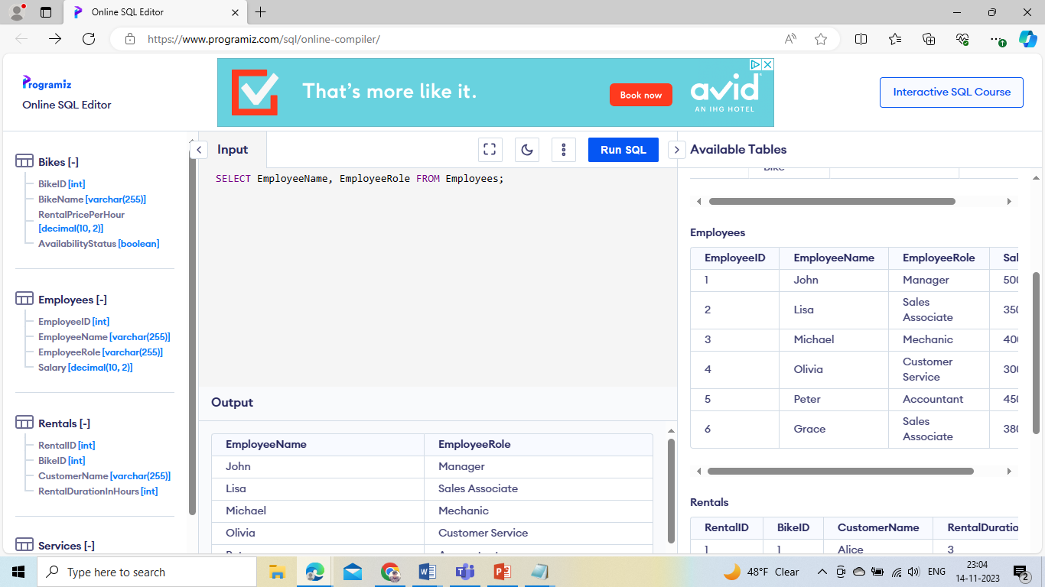

SELECT ServiceType, ServiceCharge FROM Services;

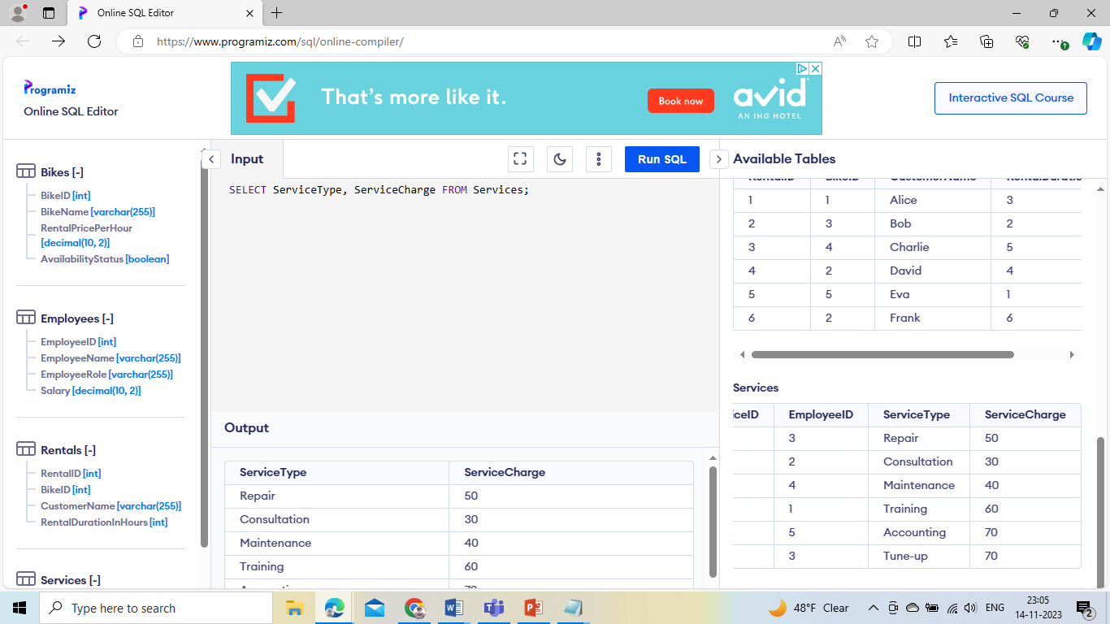

**Update Operations:**

UPDATE Rentals

SET RentalDurationInHours = 7

WHERE RentalID = 3;

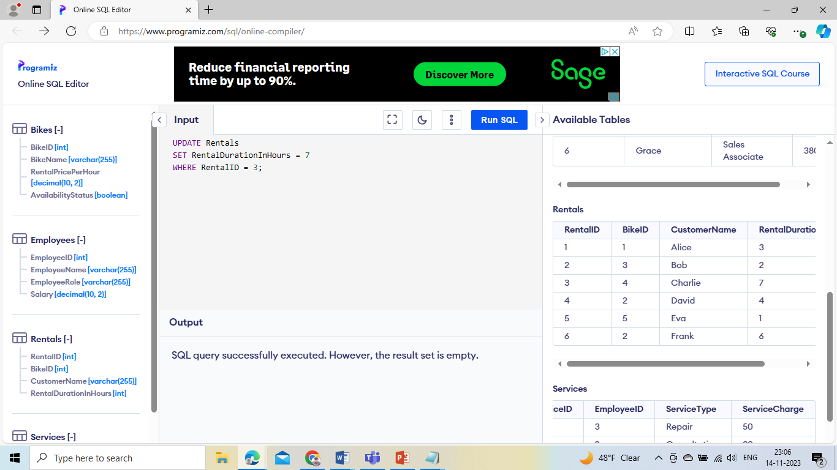

UPDATE Employees

SET Salary = 42000.00

WHERE EmployeeID = 4;

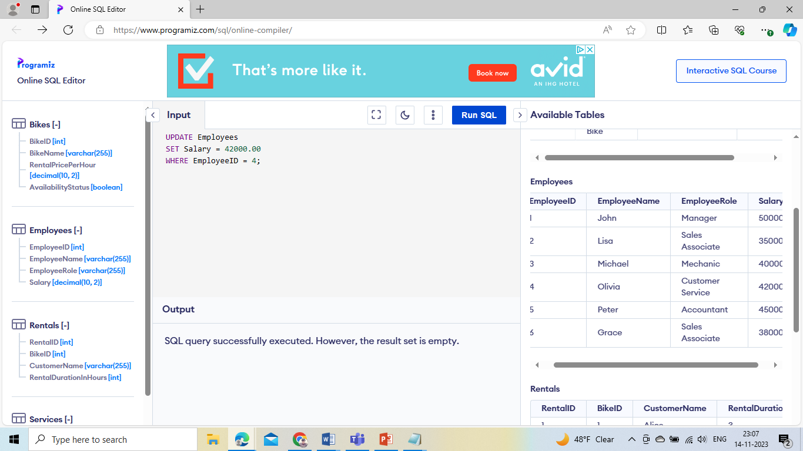

**DELETE Operation:**

DELETE FROM Rentals

WHERE BikeID = 1;

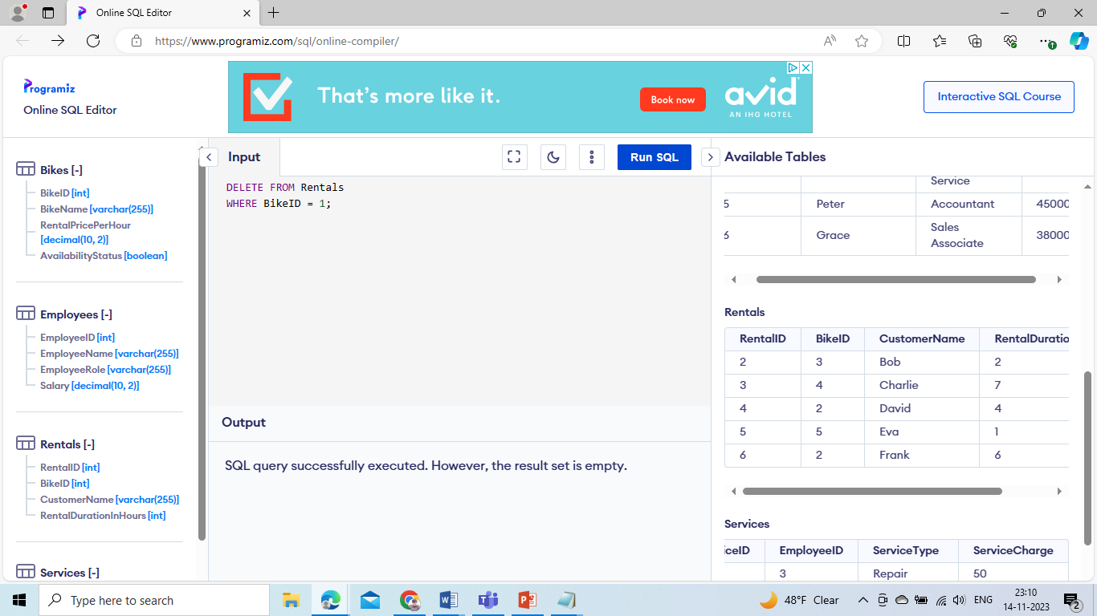

DELETE FROM Rentals

WHERE RentalID = 5;

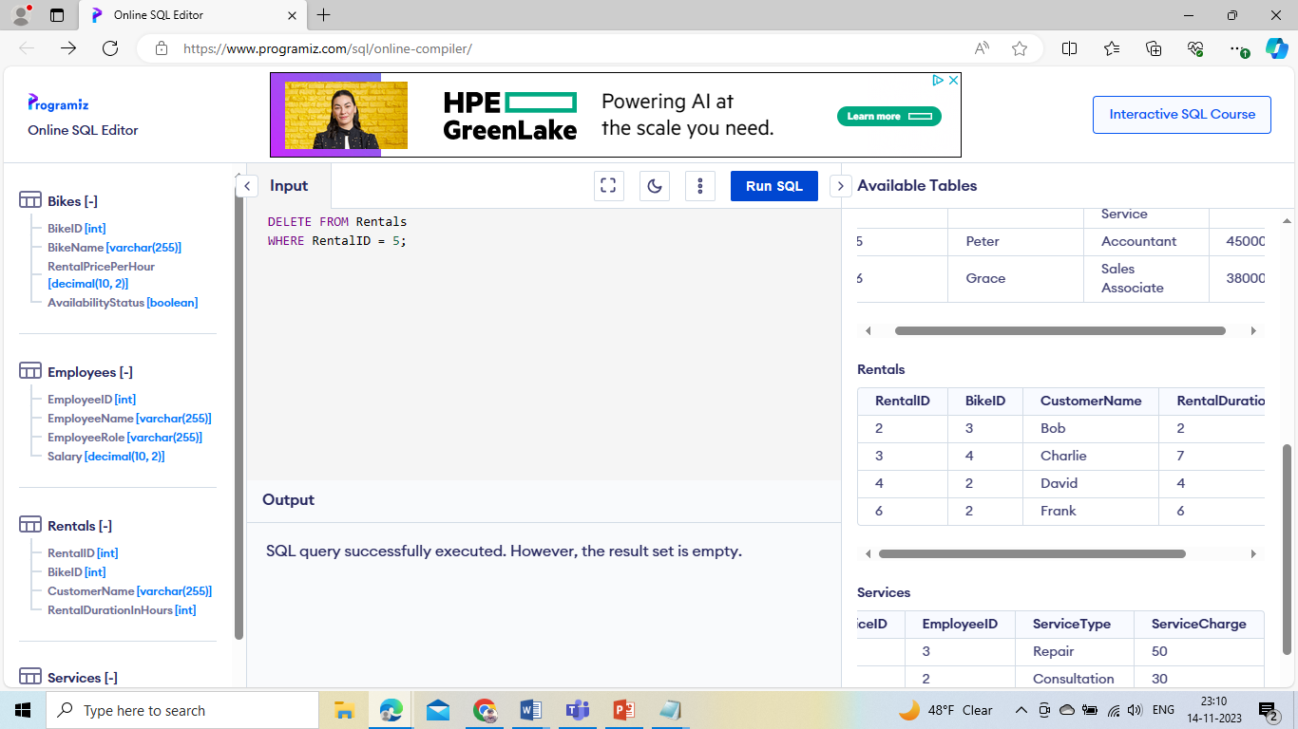

DELETE FROM Services

WHERE EmployeeID = 5;

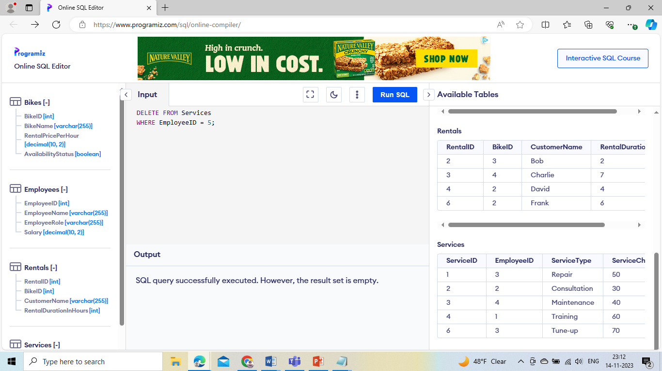

DELETE FROM Services

WHERE ServiceID = 4;

