FACE RECOGNITION BASED ATTENDANCE SYSTEM
Using RetinaFace, ArcFace and OpenCV

INDEX
- Introduction
- Problem Statement
- Objectives of the Project
- Scope of the Project
- Literature Review
- System Overview
- System Architecture
- Module Description
- Face Detection Module (RetinaFace)
- Face Recognition Module (ArcFace)
- Enrollment Module
- Attendance Module
- Database Design
- Admin Panel Description
- Technologies Used
- Advantages of the System
- Limitations of the System
- Future Enhancements
- Conclusion
- References

1. Introduction
Attendance management is an essential activity in educational institutions. Traditional attendance methods such as manual roll calls and paper-based registers are time-consuming, error-prone, and susceptible to proxy attendance. With the rapid growth of artificial intelligence and computer vision, automated attendance systems have become more reliable and efficient.
The Face Recognition Based Attendance System is designed to automate the attendance process using facial recognition technology. This system captures live video through a camera, detects faces, recognizes individuals, and marks attendance automatically. The project uses advanced deep learning models such as RetinaFace for face detection and ArcFace for face recognition, along with OpenCV for image processing.

2. Problem Statement
Traditional attendance systems suffer from several drawbacks:
- Manual attendance consumes valuable classroom time
- High chances of proxy attendance
- Errors due to human involvement
- Difficulty in maintaining long-term records
The need is for a system that can automatically identify students and mark attendance accurately without manual intervention. The Face Recognition Based Attendance System aims to solve these issues using AI-based face recognition.

3. Objectives of the Project
The main objectives of this project are:
- To develop an automated attendance system using face recognition
- To prevent proxy attendance
- To reduce time consumption in attendance marking
- To maintain digital attendance records
- To ensure accuracy and reliability

4. Scope of the Project
This project can be implemented in:
- Schools and colleges
- Training institutions
- Offices and organizations
The system is scalable and can be enhanced further with cloud deployment, mobile integration, and multi-camera support.

5. Literature Review
Several biometric systems such as fingerprint recognition, RFID-based attendance, and iris recognition have been used in attendance systems. However, these methods require physical interaction or additional hardware. Face recognition stands out as a non-intrusive and efficient approach.
Recent advancements in deep learning models like RetinaFace and ArcFace have significantly improved face detection and recognition accuracy, making real-time attendance systems feasible and reliable.

6. System Overview
The Face Recognition Based Attendance System captures live video, detects faces in real time, recognizes registered students, and marks their attendance in the database. The system operates through a centralized server architecture using Python and Flask.

7. System Architecture
The system architecture consists of the following components:
- Camera module
- Face detection module
- Face recognition module
- Database
- Admin panel

Workflow:
- Camera captures live video
- RetinaFace detects faces
- ArcFace generates facial embeddings
- Embeddings are matched with stored data
- Attendance is marked

8. Module Description
The system is divided into multiple modules:
- Enrollment Module
- Attendance Module
- Face Detection Module
- Face Recognition Module
- Database Module
- Admin Panel Module
Each module performs a specific function to ensure smooth system operation.

9. Face Detection Module (RetinaFace)
RetinaFace is a deep learning-based face detection model capable of detecting faces under different lighting conditions and angles. It provides high accuracy and real-time performance.

Features:
- Detects multiple faces
- Handles occlusions
- Provides bounding boxes and landmarks

10. Face Recognition Module (ArcFace)
ArcFace is used to generate unique facial embeddings for each individual. These embeddings are 512-dimensional vectors representing facial features.
The system uses cosine similarity to compare embeddings and identify the closest match. A threshold value is applied to avoid false recognition.

11. Enrollment Module
The enrollment module is used to register new students into the system. During enrollment:

- The camera captures the student’s face
- Face is detected using RetinaFace
- Facial embedding is generated using ArcFace
- Student details and embeddings are stored in the database

12. Attendance Module
The attendance module operates in real time by continuously detecting and recognizing faces using the system camera. When a student’s face is successfully recognized, the system automatically marks the attendance for that day. To ensure accuracy, the system checks whether attendance has already been recorded and allows only one entry per student per day, thereby preventing duplicate records. Attendance is stored along with the date and time for future reference.

Rules:
- Attendance is marked only once per day per student
- Duplicate entries are prevented

13. Database Design
13. Database Design – Short Detailed Description
SQLite is used as the database management system for the Face Recognition Based Attendance System because it is lightweight, easy to configure, and does not require a separate server. It is well suited for academic projects and small to medium-scale applications, providing fast and reliable data storage.
The database consists of multiple tables to manage different types of information:
- Student Table: Stores basic student details such as student ID, name, roll number, and course information. Each student is assigned a unique identifier.
- FaceEmbedding Table: Stores facial embedding vectors generated using the ArcFace model. These embeddings are linked to the corresponding student ID and are used for face recognition.
- Attendance Table: Records daily attendance information, including student ID, course ID, date, and timestamp. It ensures that attendance is marked only once per day for each student.
- Course Table: Contains details of courses such as course ID and course name, helping to organize students and attendance records.
- Admin Table: Stores login credentials of authorized administrators who can access and manage the system through the admin panel.

14. Admin Panel Description
The admin panel is developed using Flask. It provides:
- Secure login
- Student enrollment
- Attendance session control
- Attendance report generation
Only authorized users can access the admin panel.

15. Technologies Used
- Python
- OpenCV
- RetinaFace
- ArcFace (InsightFace)
- NumPy
- Scikit-learn
- Flask
- SQLite

16. Advantages of the System
- Eliminates proxy attendance
- Fully automated
- High accuracy
- Real-time processing
- Secure and reliable

17. Limitations of the System
- Requires good camera quality
- Sensitive to extreme lighting
- Needs sufficient training data
- Requires adequate processing power

18. Future Enhancements
- Liveness detection
- Cloud-based deployment
- Mobile application support
- Attendance analytics
- Multi-camera support

19. Conclusion
The Face Recognition Based Attendance System provides an efficient and reliable solution for attendance management. By integrating RetinaFace and ArcFace with OpenCV and Flask, the system ensures accuracy, automation, and security. This project demonstrates the practical application of artificial intelligence in educational environments.

20. References
- InsightFace Documentation
- OpenCV Official Documentation
- Research papers on Face Recognition
- Flask Documentation
- Deep Learning-based Face Detection Models

app.py

from flask import Flask, render_template, redirect, request
from flask_login import LoginManager, login_user, login_required, logout_user
from werkzeug.security import generate_password_hash, check_password_hash

from config import Config
from models import db, Admin, Course, Student
from enrollment import enroll_bp
from attendance import attendance_bp
from view_attendance import view_bp

app = Flask(__name__)
app.config.from_object(Config)

db.init_app(app)

login_manager = LoginManager()
login_manager.init_app(app)
login_manager.login_view = "login"

@login_manager.user_loader
def load_user(user_id):
return Admin.query.get(int(user_id))

with app.app_context():
db.create_all()

if not Admin.query.first():
db.session.add(
Admin(
username="admin",
password=generate_password_hash("admin123")
)
)

courses = [
"Data Science and Analytics",
"Artificial Intelligence",
"Full Stack Developer"
]

for c in courses:
if not Course.query.filter_by(name=c).first():
db.session.add(Course(name=c))

db.session.commit()

# ---------- ROUTES ----------

@app.route("/", methods=["GET", "POST"])
def login():
if request.method == "POST":
user = Admin.query.filter_by(username=request.form["username"]).first()
if user and check_password_hash(user.password, request.form["password"]):
login_user(user)
return redirect("/dashboard")
return render_template("login.html")

@app.route("/dashboard")
@login_required
def dashboard():
return render_template(
"dashboard.html",
students_count=Student.query.count(),
courses_count=Course.query.count()
)

@app.route("/logout")
@login_required
def logout():
logout_user()
return redirect("/")

# ---------- BLUEPRINTS ----------
app.register_blueprint(enroll_bp)
app.register_blueprint(attendance_bp)
app.register_blueprint(view_bp)

# ---------- RUN ----------
if __name__ == "__main__":
app.run(debug=True)

config.py

import os
BASE_DIR = os.path.abspath(os.path.dirname(__file__))
class Config:
SECRET_KEY = "super-secret-key"
SQLALCHEMY_DATABASE_URI = "sqlite:///" + os.path.join(BASE_DIR, "attendance.db")
SQLALCHEMY_TRACK_MODIFICATIONS = False

Admin Page

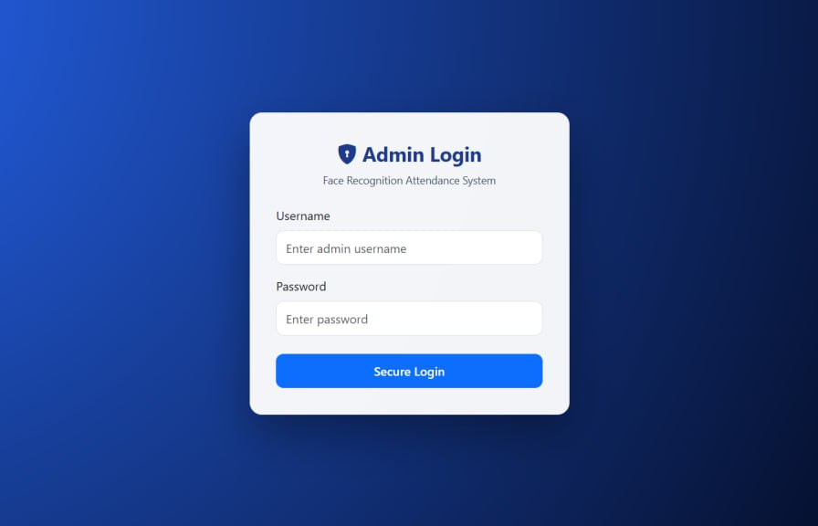

The Admin Login page provides secure access to the Face Recognition Based Attendance System. It allows only authorized administrators to log in using a valid username and password. This page ensures that sensitive operations such as student enrollment, attendance management, and report generation are protected from unauthorized access. The clean and user-friendly interface makes the login process simple while maintaining system security.

Dashboard

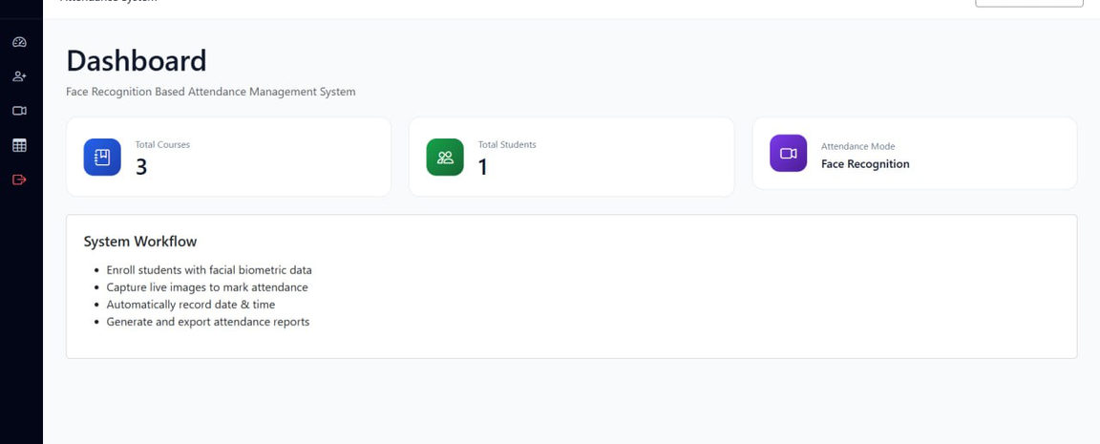

The Dashboard page provides an overview of the Face Recognition Based Attendance System. It displays key information such as the total number of courses, total registered students, and the selected attendance mode. The dashboard also outlines the system workflow, including student enrollment, live face capture, automatic attendance marking, and report generation. This page helps the administrator monitor and manage the attendance system efficiently from a single interface.

Student Enroll Page

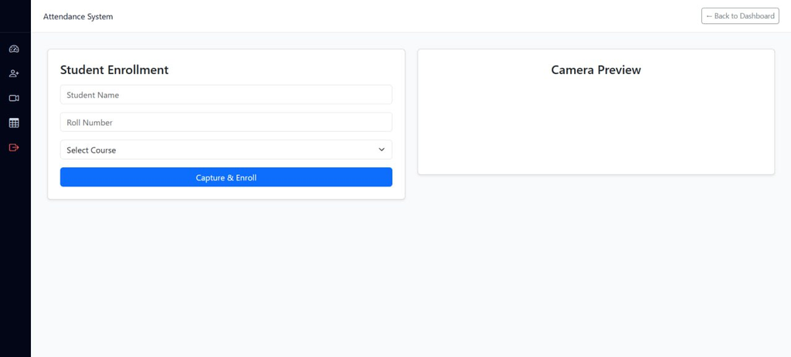

The Student Enrollment page is used to register new students into the Face Recognition Based Attendance System. The administrator enters the student’s name, roll number, and selects the course. Using the camera preview, the system captures the student’s facial image and generates a facial embedding. This data is then securely stored in the database for future face recognition and attendance marking.

Course Selection

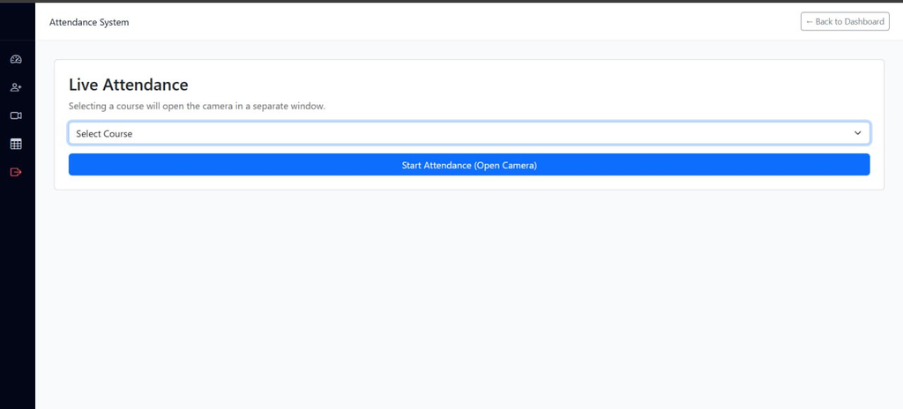

The Course Selection page is used to mark student attendance in real time using face recognition. The administrator selects the required course and starts the attendance session, which activates the system camera. The system continuously detects and recognizes student faces and automatically records their attendance in the database. Attendance is marked only once per day for each student to prevent duplication.

Attendence Records

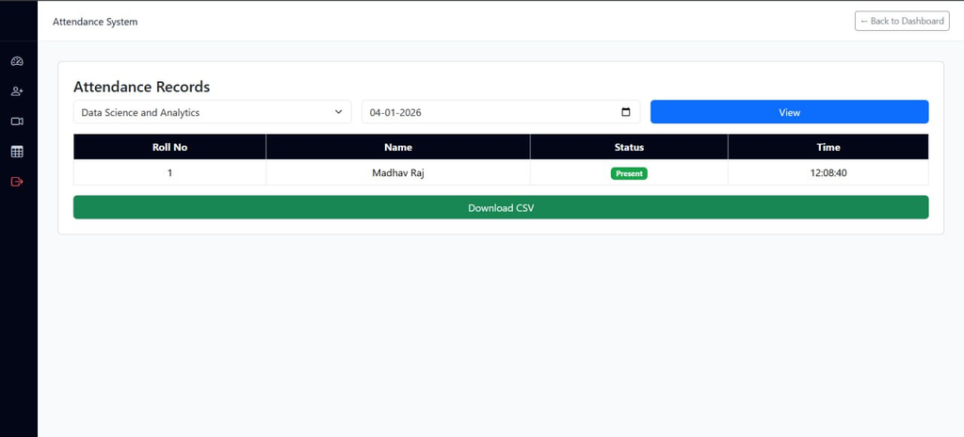

The Attendance Records page allows the administrator to view student attendance details for a selected course and date. It displays information such as roll number, student name, attendance status, and time of attendance. The system also provides an option to download the attendance data in CSV format, enabling easy storage, analysis, and report generation for future reference.

