**Open Source Graphics & Animation Tools**

**MID-SEM EVALUATION**

**MARCH 2020**

**Submitted to**

**Dr. Durgansh Sharma**

**Professor, Cybernetics SCS, UPES**

**Submitted By**

Name: Madhav Manocha

Roll No: 74

SAP ID: 500070080

B. Tech CSE (OSSOS) Department of Cybernetics

COMPUTER SCIENCE & ENGINEERING



**School of Computer Science**

**University of Petroleum and Energy Studies,**

**Dehradun – 248007: Uttarakhand**

Table of Contents

Phase- 2: 3

Project on Blender 3

Topic: Holi colurs 3

Procedure: 3

# Phase- 2:

# Project on Blender

# Topic: Holi Colors

## Procedure:

### MAKING MODEL

Step1: First open a new project now select the cube and distort it applying a curve modifier.

Step2: Add quick smoke effect, select adaptive domain option and use mesh as particle emitter.

Step3: tweak the density, temperature, color and source velocity settings of the particles to acquire the required effect

Step4: Duplicate the smoke emitter to make two copies of it, and also scale the effect domain.

Step5: Now using key frames set the animation path of the three smoke emitters.

Step6: Set some light sources around the model till adequate amount of light is available.

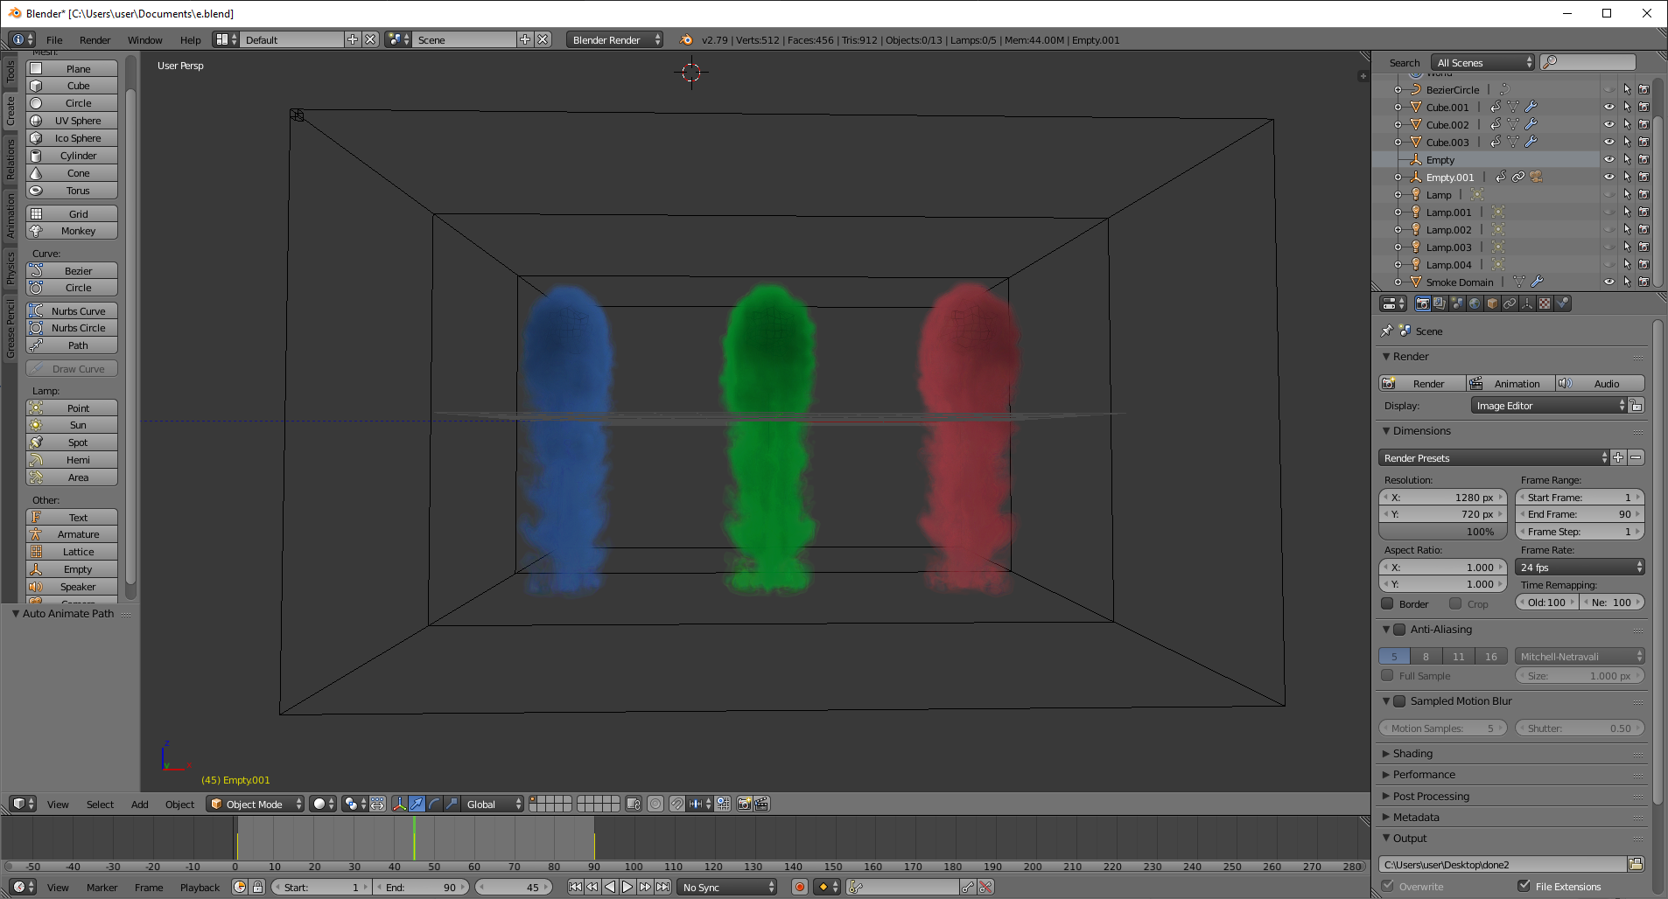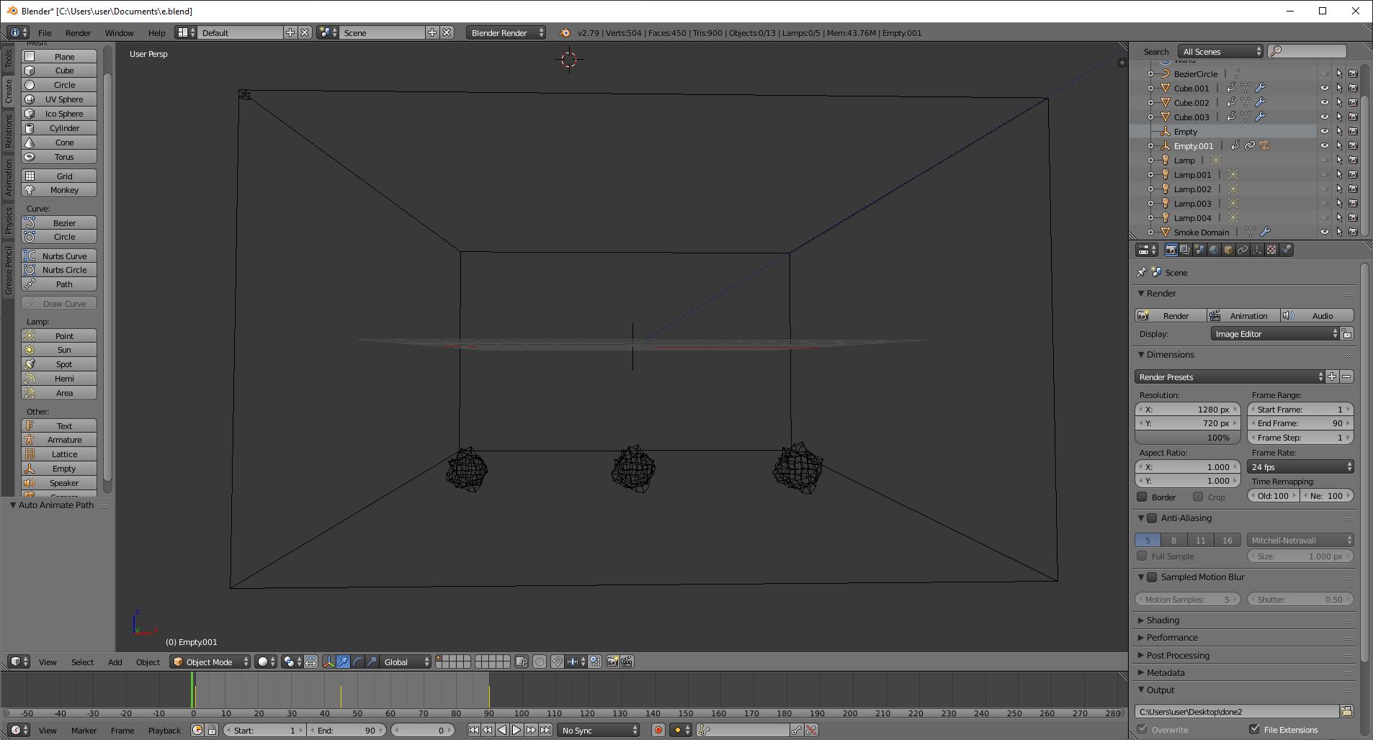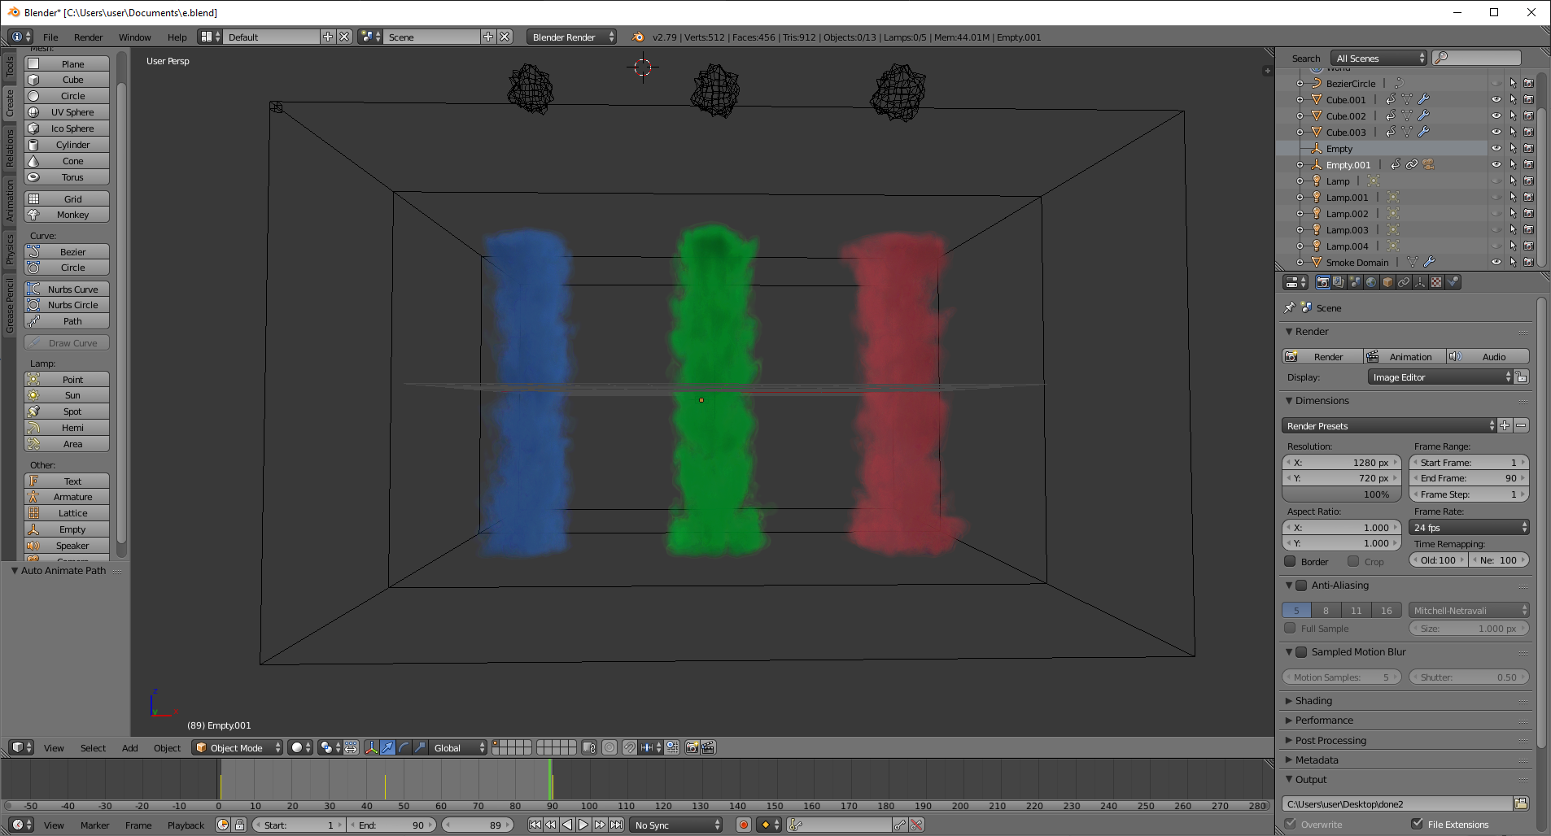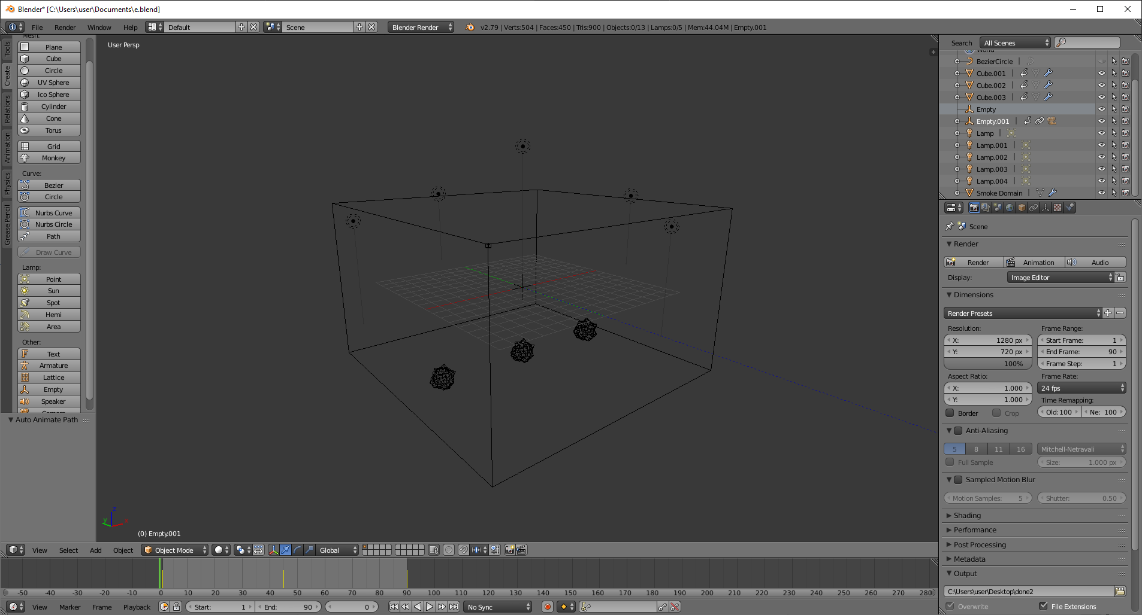

### Camera Rig setup

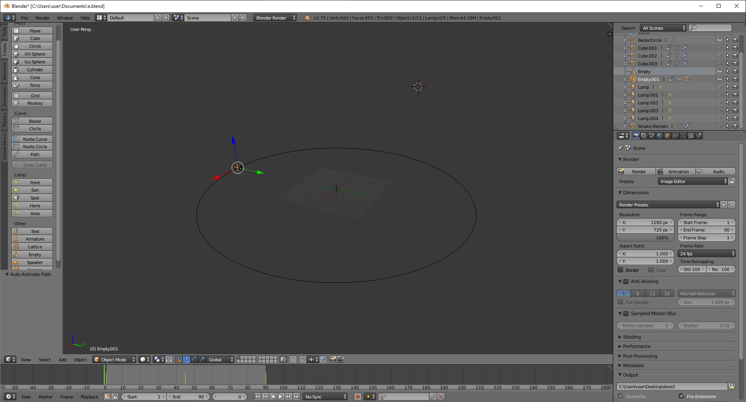

Step1: To make the camera move around the model firstly create a beaze circle.

Step 2: Scale the circle such that its radius should be equal to the distance that you want between your model and camera.

Step 3: Now create an empty mesh, place it at the centre and also place the camera at the centre.

Step 4: Select empty and camera at the same time and press ctrl+P and select parent to object, to attach the camera to the empty object.

Step 5: To make this empty go around the circle select the empty with camera parented to it and add object constraint of follow path to it, and select beaze circle.

Step 6: select follow curve and fixed position options in constraint, move the offset between 0 and 1 to check the camera motion.

Step 7: Now to make the camera point at the center, create another empty and place it at the center.

Step 8: Now add track to constraint on the camera and select empty as the target to be followed that is at the center.

Step 9: To make the camera point at the empty at the center select to -Z and “up” as Y.

Step 10: Now apply three keyframes to the offset of the empty that is parented to the camera to make it go till halfway around the model.

### Rendering

Step 1: Name the file and give the location it has to be saved at.

Step2 : Define the resolution of the rendered animation.

Step 3: Tweak the options for anti-aliasing, shading and motion blur to get the best quality.

Step 4: Select the extension and codec of the final video file and press ctrl+f12 to render animation.

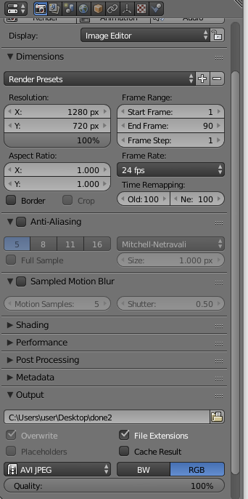

**Final View:**

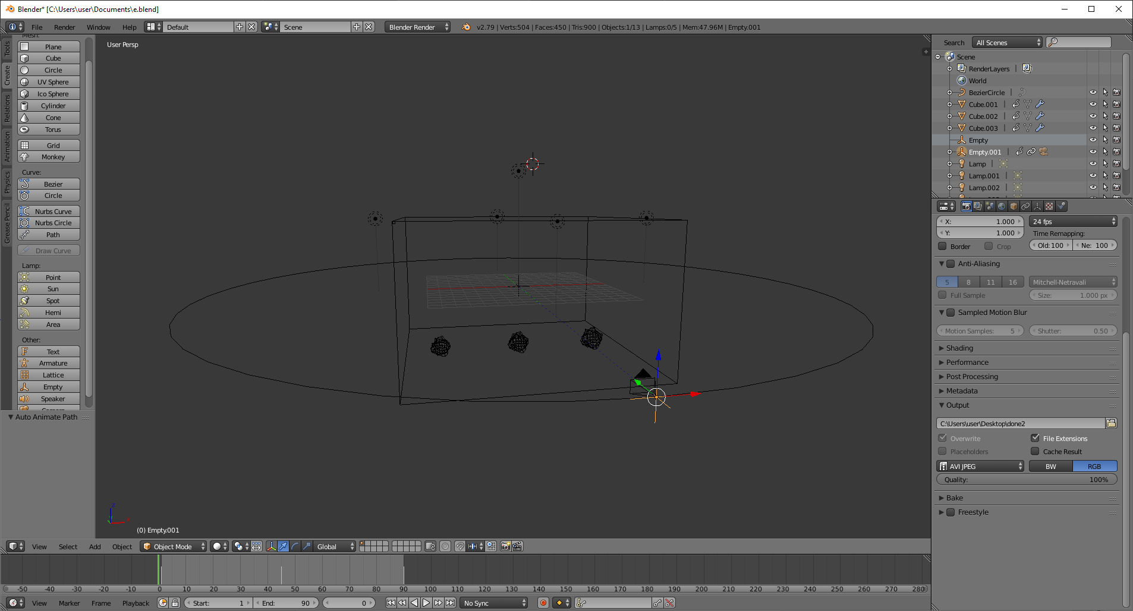

**Output:**

Output video in avi file