PAPER EVALUATION USING ARTIFICIAL INTELLIGENCE (HYBRID AI FRAMEWORK FOR RESEARCH PAPER EVALUATION AND REVIEWER RECOMMENDATION)
Results
Department of Computer Science and Engineering, TKR College of Engineering & Technology
Batch C8 (CSE-C) · Academic year [ACADEMIC YEAR]
Table 1: Project team
S.No. | Student name | Roll number
1 | Mula Sreebindu | 23K91A05G3
2 | Puramshetty Vishnu Vardhan | 23K91A05K2
3 | K Sampoorna | 24K95A0512
4 | Korsa Shivashankar | 24K95A0515

Project guide: M Anupama
Chapter and section numbers quoted in the text (for example Chapter 8 or Section 6.2) refer to the full project report, 17.Final Document. Figures and tables in this document are numbered from 1.

1. RESULTS AND OUTPUT SCREENS
This chapter reports what was measured and what the running application shows. Section 8.1 describes the set-up, Section 8.2 presents every output screen, Sections 8.3 to 8.7 give the quantitative results for the decision model, reviewer matching, conflict handling, real papers and speed, Section 8.8 compares the work with the base paper, and Sections 8.9 to 8.12 give sample output, success and failure analysis, limitations and the outcome against each objective. Where a result is weak it is reported as weak.

1.1 Experimental set-up
All measurements in this chapter were made on one machine: 12th Gen Intel(R) Core(TM) i5-12500, 15.7 GB of memory, no GPU used, Windows-10-10.0.26200-SP0, Python 3.11.9. The main package versions were scikit-learn 1.9.1, PyMuPDF 2.0, FastAPI 0.120.4, PyTorch 2.14.1, Transformers 5.20.2 and sentence-transformers 6.2.0. The local language model is Qwen2.5-1.5B-Instruct [29] in 32-bit floating point on the CPU; the sentence encoder is all-MiniLM-L6-v2 [19], [20]. Every figure and table below is produced by scripts/measure_metrics.py, scripts/measure_latency.py and scripts/docs_build/make_figures.py from the stored JSON in docs/metrics/; no number was typed by hand.
Table 2: Data used in the evaluation
Item | Content | Source and status
Decision-model corpus | 1,400 labelled rows (362 accept, 619 borderline, 419 reject) | Synthetic, generated by scripts/prepare_dataset.py with seed 42; the public PeerRead probe returned no usable data
Train / test split | 1,120 / 280 papers | 80/20 stratified, seed 42; four more splits for the seed study
Reviewer directory | 6 profiles (Reviewer Alpha to Zeta; Epsilon inactive) | Demo profiles seeded by app/services/seed.py; no real people
Matching probe set | 40 abstracts, six topic areas plus four cross-area cases | Written by the project team (scripts/eval_data.py); labels are the team's own judgement
Conflict probes | 15 injected sentences (12 literal, 3 paraphrased) | Appended to a probe abstract; 240 clean paper-reviewer pairs checked for false flags
Real PDFs | Four research papers (3, 30, 17 and 30 pages) | A generated demo fixture, the base paper, the survey [6] and the ReViewGraph paper [7]

Test conditions: the decision-model figures were recomputed from the shipped artifacts in models/ on the stored split and agree with models/metrics.json exactly (same accuracy and confusion matrix). Latency figures were measured with nothing else of the project running; the local-model analyses shared the machine with the ordinary background programs of a desktop PC, so they are indicative of this class of hardware rather than exact. Statistical significance tests were not run: the decision-model test set has 280 papers and the matching probe set 40, and the five-split study gives an idea of the spread.

1.2 Output screens
The 17 captures below are real screens of the running application (Chrome, 1440 by 900 pixels, dark theme unless stated). They were produced by scripts/capture_screens.py with the API and the web app running, the local language model and the MiniLM encoder loaded, and three real papers in the database: the base paper, the survey and the ReViewGraph paper. The analysis shown on the Analyze and Saved-analysis screens is that of the ReViewGraph paper (17 pages, 11,562 words). It was run once with the language model; because that run takes several minutes, the capture script replays its stored result into the page instead of running it twice. The screens are discussed in the order a user meets them.

1.2.1 Landing page and dashboard
  Figure 1: Landing page, dark theme: the pitch, a WebGL hexagon hero and the two entry buttons. |   Figure 2: Landing page scrolled to the how-it-works section.

The landing page states the product in one sentence ("turns a research-paper PDF into a structured preliminary assessment and a transparent, auditable ranking of reviewers") and carries three claims that the code backs: it runs on the user's machine, needs no paid API or credentials, and leaves the final judgement to a human. The scrolled view explains the steps of the pipeline. The page is decorative for the purposes of this report; its numbers are read live from the API.
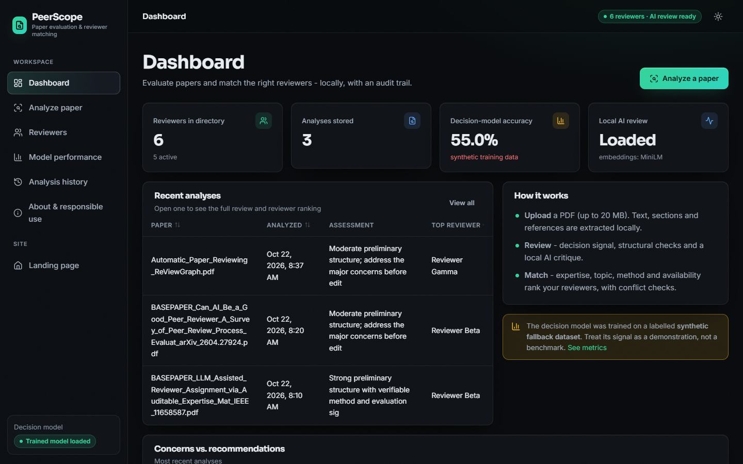
Figure 3: Dashboard with six reviewers, three stored analyses, the decision-model accuracy and the local-model status.
The dashboard has four tiles: six reviewers in the directory (five active), three analyses stored, the decision-model accuracy of 55.0% marked in red as "synthetic training data", and the local AI review status ("Loaded", embeddings MiniLM). Below them are the recent analyses and an amber notice that the decision model was trained on a labelled synthetic dataset and is a demonstration, not a benchmark. This is the honest framing the project adopted: the accuracy figure is shown, but never without its caveat.

1.2.2 Analysing a paper
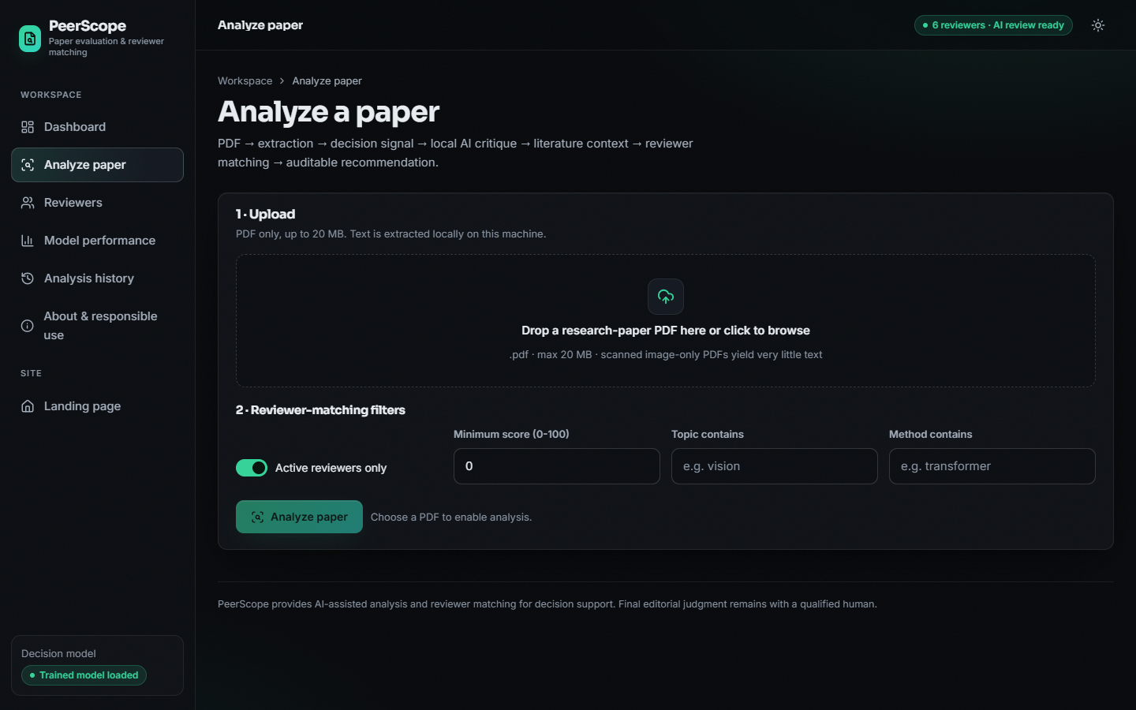  Figure 4: Analyze screen before a file is chosen. |   Figure 5: Landing page in the light theme.

Before upload the Analyze screen shows a drop zone (PDF only, 20 MB limit, scanned image-only PDFs yield little text) and the reviewer-matching filters: active reviewers only, a minimum score, and topic and method filters. The light-theme landing page is shown beside it to document that both themes are implemented and switchable from the header.

Figure 6: Analyze screen after the ReViewGraph paper was processed: four result tiles, paper overview and preliminary assessment.
The result begins with four tiles: structural score 65.2, two concerns raised (one major), five recommendations and the top reviewer, Reviewer Gamma with a score of 28.4. The overview tab lists the extracted facts: 17 pages, 11,562 words, 9 references detected and seven of the nine expected sections (the summary and discussion sections were not found). The preliminary-assessment card puts three independent items side by side: the historical decision signal (borderline, 58% confidence, with accept 21.6%, borderline 58.3%, reject 20.1%), the structural score with its four components (77.8 structure, 21.7 evidence, 70.0 method clarity, 100.0 presentation), and the status of the local AI review ("Generated by Qwen/Qwen2.5-1.5B-Instruct"). The first words of the overview are taken from the first page and show a limitation of the summary extraction: the opening paragraph runs into the copyright line of the conference template.

Figure 7: Review tab: strengths, major and minor concerns, recommendations, dimension notes, coverage bars and the language-model synthesis.
The Review tab shows the deterministic review (four strengths, one major concern about a short methodology section, one minor concern about the undetected discussion section, five standard recommendations), the dimension notes and the coverage bars, and below them the AI synthesis written by the local model with its provenance line ("Local model, Qwen/Qwen2.5-1.5B-Instruct, can contain errors"). The synthesis is readable and structured, but it contains visible errors that Section 8.10 discusses: it invents a title suffix, misdescribes the datasets, and ends mid-sentence because generation is capped at 700 tokens. The Novelty bar of 55% is a fixed value and not a measurement (Section 8.11).

Figure 8: Literature tab: six works retrieved from OpenAlex, ranked by embedding similarity to the query.
The Literature tab lists six works retrieved from OpenAlex for the title as query. Three of them are the submitted paper itself, in its arXiv, publisher and conference versions, with a relevance of 0.875; the other three are general knowledge-graph papers with relevance between 0.37 and 0.50. The tab therefore demonstrates both the intended behaviour (related work with sources and years, clearly labelled as "supporting context, not proof of novelty") and a weakness: the retrieval does not remove the submission itself, and the relevance score reflects title similarity, not novelty.
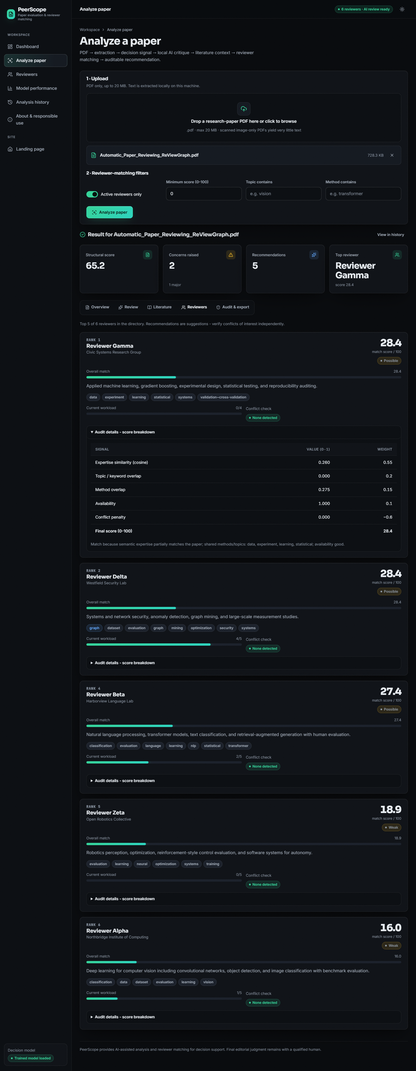
Figure 9: Reviewers tab: five ranked reviewers with workload, conflict status and the opened score breakdown of the first.
The Reviewers tab is the core of the recommendation. Each card shows the rank, the match score out of 100 and its strength band, the reviewer's expertise, the matching terms, the current workload, the conflict check and an expandable audit table. For Reviewer Gamma the table reads: expertise similarity 0.260 (weight 0.55), keyword overlap 0.000 (0.20), method overlap 0.275 (0.15), availability 1.000 (0.10), conflict penalty 0.000 (0.60), final score 28.4. The reader can reproduce the number by hand, which is the meaning of "auditable" here. Two details deserve notice: Reviewers Gamma and Delta tie at 28.4, and the ranks run 1, 2, 4, 5, 6 because the inactive Reviewer Epsilon held rank 3 before the active-only filter removed it.

Figure 10: Audit and export tab: the score formula, the analysis identifier, module statuses and the JSON and PDF export buttons.
The Audit tab prints the formula used, the analysis identifier (3), the creation time, the reviewer pool size (6), the review source ("deterministic+llm"), the literature status ("ok") and the decision-model status ("ok"), and offers the JSON and PDF exports. It ends with the responsible-use statement that AI output can contain errors and that retrieved literature is context, not proof of novelty.

1.2.3 Reviewer directory
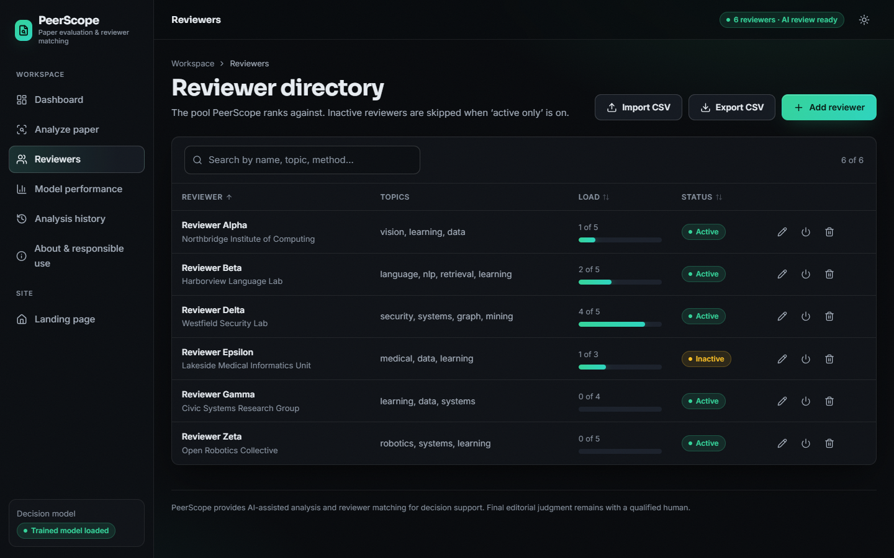
Figure 11: Reviewer directory with search, workload bars, status badges and edit, activate and delete actions.
The directory lists the six demo reviewers with affiliation, topics, load (for example Reviewer Delta at 4 of 5) and status; Reviewer Epsilon is inactive and is skipped when "active only" is on. The header offers CSV import and export and the Add reviewer button. Every entry is a demo identity; the application ships no real person.
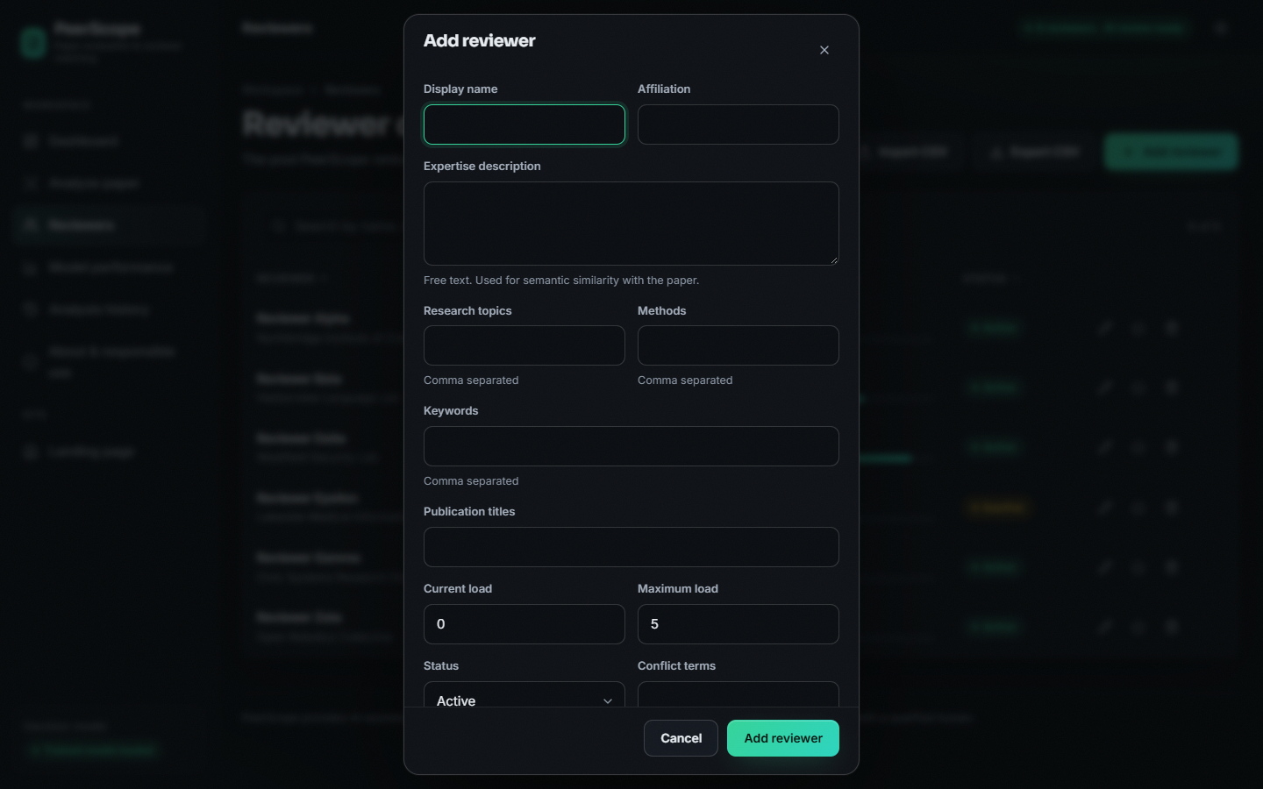  Figure 12: Add-reviewer dialog with all eleven editable fields. | 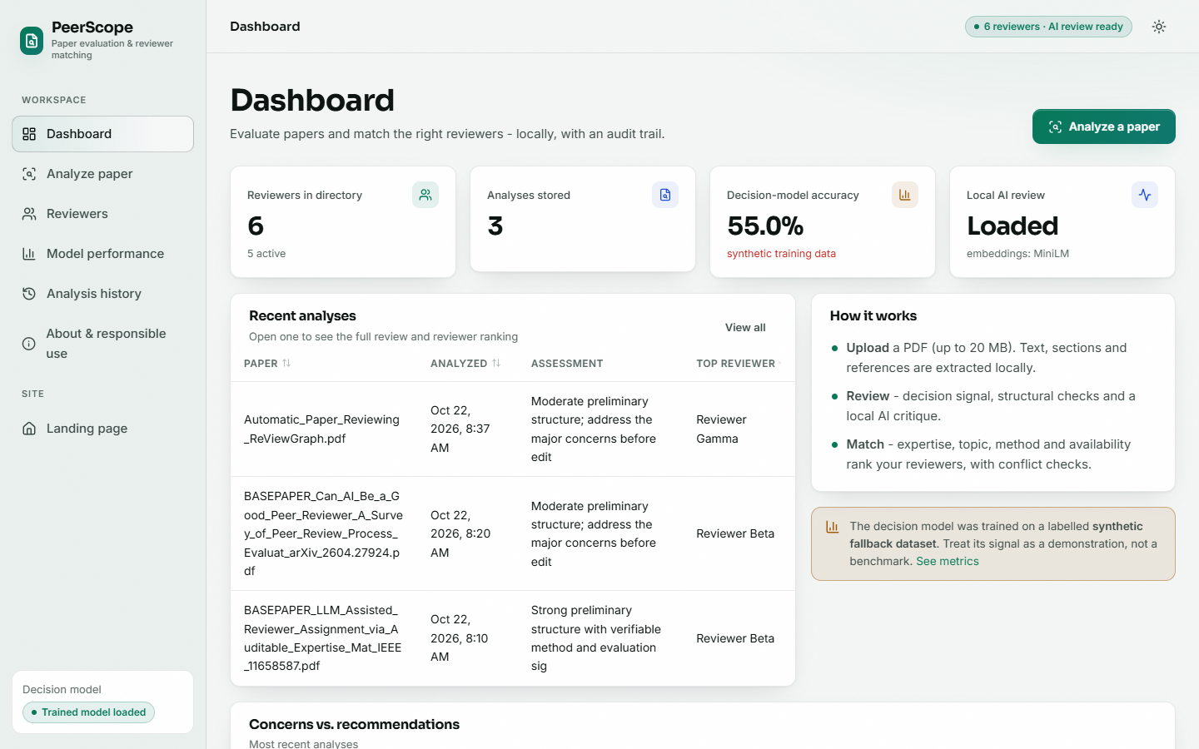  Figure 13: Dashboard in the light theme.

The dialog collects display name, affiliation, a free-text expertise description (used for the semantic similarity), topics, methods and keywords as comma-separated lists, publication titles, current and maximum load, status and conflict terms. Empty names are rejected by the server with HTTP 422 (checked by the smoke test). The light-theme dashboard shows the same data as the dark one.

1.2.4 Model performance, history and about
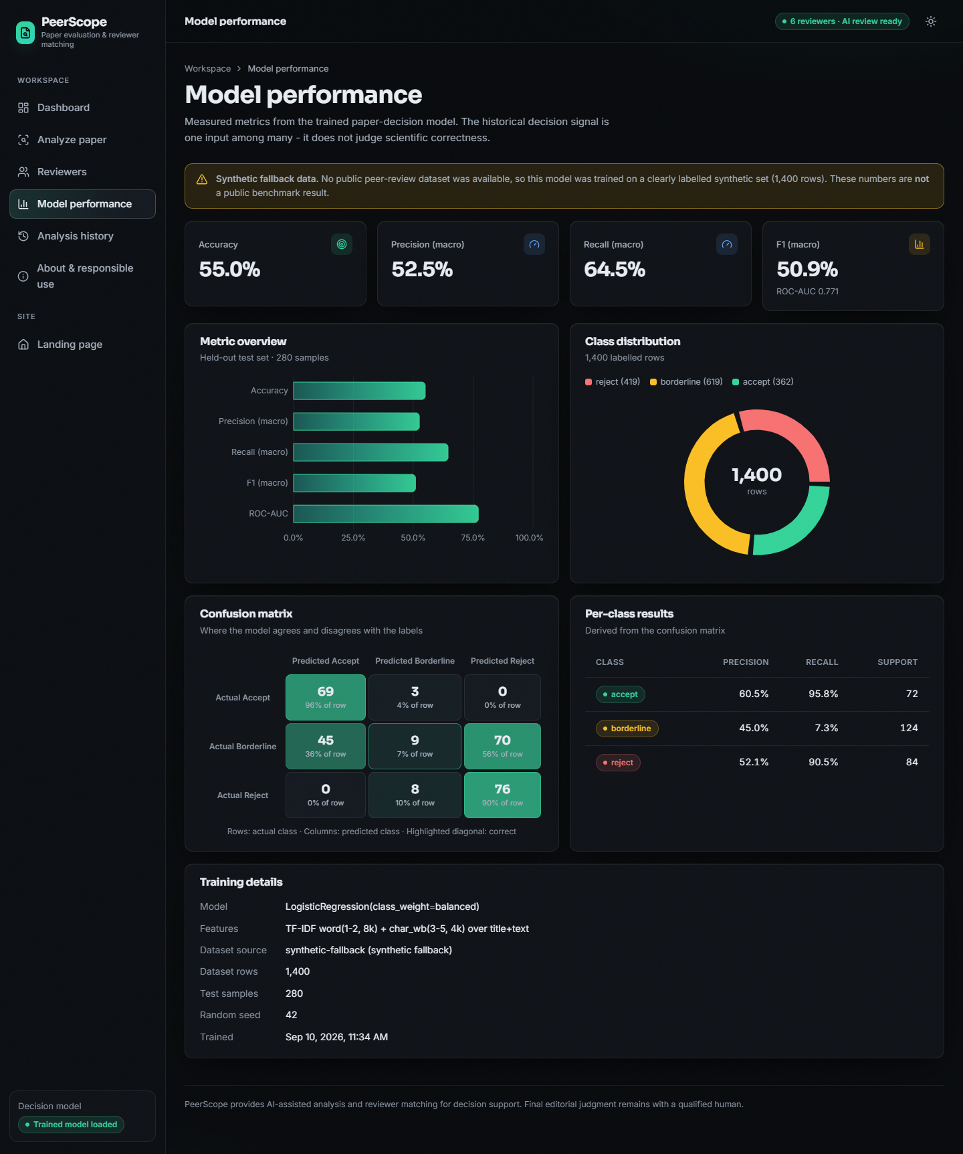
Figure 14: Model performance screen: metric tiles, class distribution, confusion matrix, per-class results and training details.
The model page shows the measured metrics (55.0% accuracy, 52.5% macro precision, 64.5% macro recall, 50.9% macro F1, ROC-AUC 0.771), the class distribution of the 1,400 rows, the confusion matrix with row percentages and the per-class table. A prominent amber banner states that the numbers come from synthetic fallback data and are not a public benchmark. The values on this page are read from models/metrics.json and match Section 8.3.
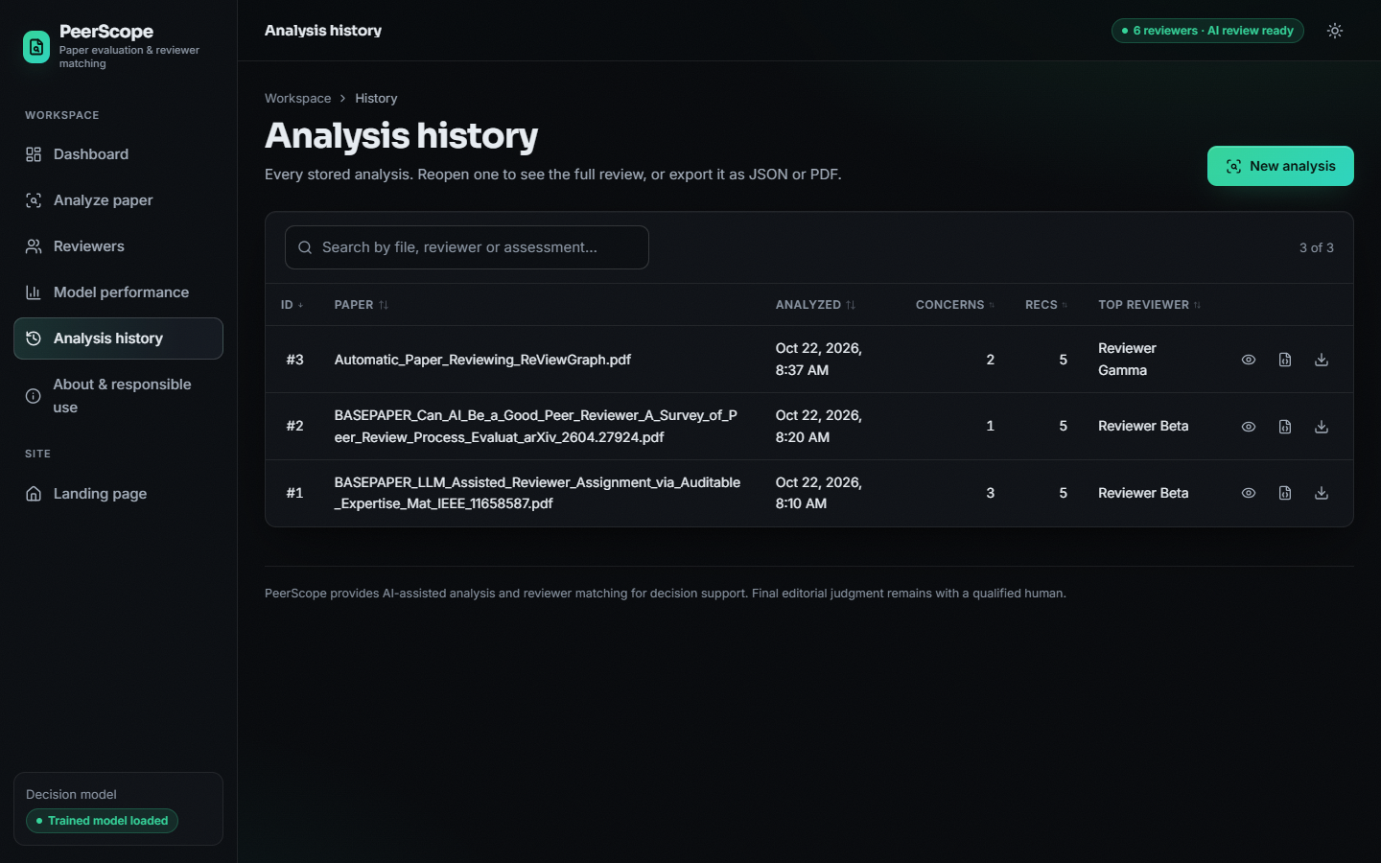
Figure 15: Analysis history with search, sortable columns and open, export JSON and export PDF actions.

History lists the three stored analyses (#1 the base paper, #2 the survey, #3 the ReViewGraph paper) with concerns, recommendations and top reviewer. One display defect is visible here: the time column shows 8:10, 8:20 and 8:37 AM, which are UTC times printed without a zone, while the Audit tab (screen 10) shows the same analysis as created at 2:07 PM local time.

Figure 16: A saved analysis reopened from history: the same result as the live run.
Opening a row of the history restores the full result from the stored JSON, including the AI synthesis, without recomputation. This is the screen on which a user inspects an earlier analysis.

Figure 17: About and responsible use: pipeline steps, the weights, responsible-use rules, privacy statement and live system status.
The About page documents the six pipeline steps, the five weights, five responsible-use rules (AI output can contain errors; recommendations are suggestions; literature is context, not proof of novelty; verify conflicts; never use as the sole basis for decisions), the privacy statement (only title and topic keywords go to OpenAlex; PDFs are not copied) and a live system-status table showing the backend, decision model, local AI review, embedding model, literature source and reviewer count.

1.3 Decision-model performance
The decision model is a TF-IDF (word 1-2 grams and character 3-5 grams) and logistic-regression classifier with three classes. It was trained on the 1,400-row synthetic corpus and evaluated on 280 held-out papers. The first thing to say about the results is what the data is: the dataset was generated by a script that draws a hidden quality value, attaches three strength or weakness phrases to the text accordingly, and assigns the label from the same value. The result can therefore show that the pipeline trains, stores and serves a classifier; it cannot show that the classifier predicts real editorial decisions.
Table 3: Metrics of the shipped model on the 280 held-out papers
Metric | Value
accuracy | 0.5500
macro precision | 0.5253
macro recall | 0.6452
macro F1 | 0.5093
ROC-AUC (one-vs-rest, macro) | 0.7715

Table 4: Confusion matrix (rows true class, columns predicted class)
True \ predicted | accept | borderline | reject | Support
accept | 69 | 3 | 0 | 72
borderline | 45 | 9 | 70 | 124
reject | 0 | 8 | 76 | 84

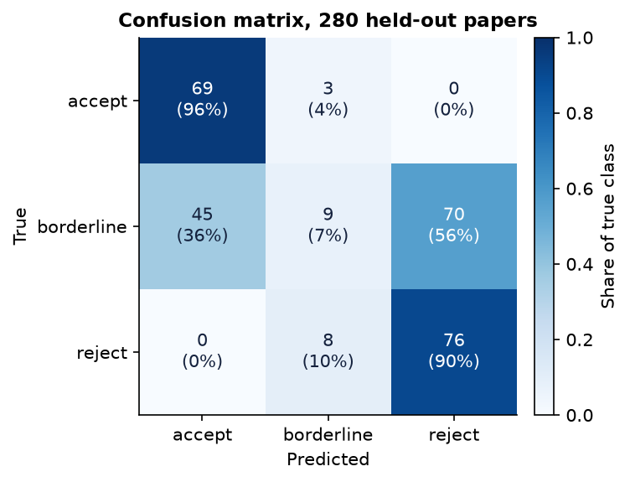
Figure 18: Confusion matrix of the shipped model on 280 held-out papers (counts and row percentages).
Table 5: Per-class precision, recall and F1
Class | Precision | Recall | F1 | Support
accept | 0.605 | 0.958 | 0.742 | 72
borderline | 0.450 | 0.073 | 0.125 | 124
reject | 0.520 | 0.905 | 0.661 | 84

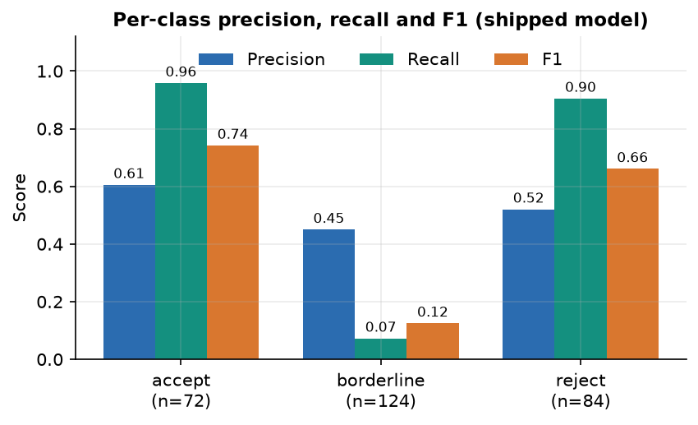
Figure 19: Precision, recall and F1 per class: accept and reject are found, borderline is not.

1.3.1 Reading the result
The model finds almost every accept paper (recall 0.958) and almost every reject paper (recall 0.905), but only 9 of the 124 borderline papers (recall 0.073). Of the 124 borderline papers, 45 were called accept and 70 reject. If only the decisive classes are considered, 145 of 156 accept and reject papers are classified correctly (93.0%). The weakness is therefore concentrated in one class, and the data explains why.
In the synthetic corpus a paper whose text carries strength phrases is accept in 362 cases and borderline in 293; a paper with weakness phrases is reject in 419 cases and borderline in 326. The text of a borderline paper is identical in kind to that of an accept or a reject paper, so no text-based rule can separate them. The best accuracy any rule can reach from the phrases is 0.558, and the measured 0.550 is close to that ceiling. The balanced class weights buy macro recall (0.645) at the price of some accuracy, as the unweighted variant below shows.
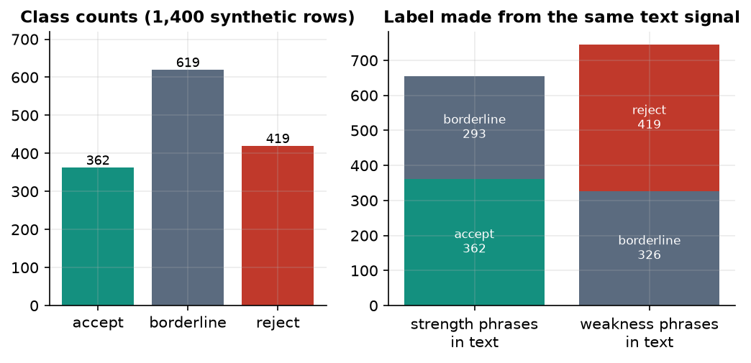
Figure 20: Class counts of the synthetic dataset and how each label relates to the strength or weakness phrases in the text.
Table 6: Comparison with simple baselines on the same split
Model | Accuracy | Macro F1 | ROC-AUC
Majority class (always borderline) | 0.443 | 0.205 | -
Naive Bayes, word TF-IDF | 0.457 | 0.342 | 0.751
Logistic regression, unweighted, word + char | 0.529 | 0.542 | 0.769
Logistic regression, balanced, word only | 0.557 | 0.520 | 0.772
PeerScope: logistic regression, balanced, word + char | 0.550 | 0.509 | 0.771

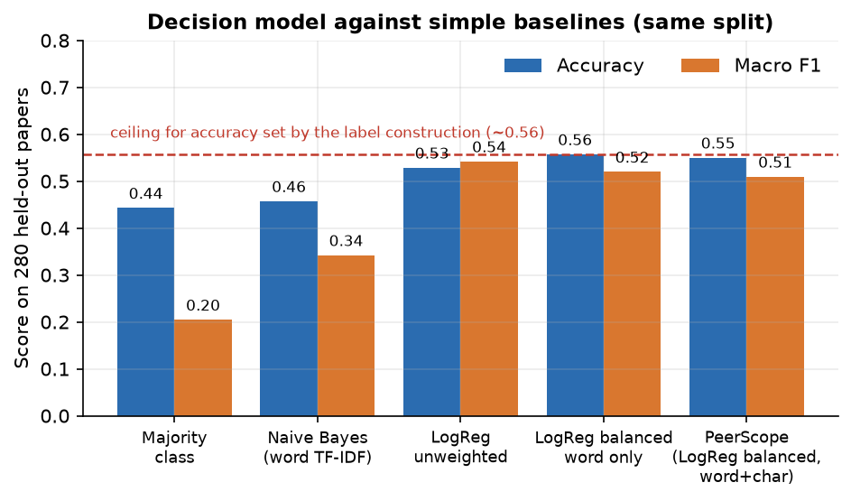
Figure 21: The shipped model against four baselines; the dashed line is the ceiling set by the construction of the labels.
Against baselines the shipped configuration is clearly better than the majority class (accuracy 0.443) and Naive Bayes (0.457), and is statistically indistinguishable from the unweighted and word-only variants: their accuracies (0.529 and 0.557) differ by less than one standard deviation of the five-split study. The character n-grams add nothing measurable on this data, and the model kept them only because the design decision was taken before the result was known.
Table 7: Five different train/test splits (same model configuration)
Split seed | Accuracy | Macro F1 | ROC-AUC
0 | 0.550 | 0.530 | 0.756
1 | 0.532 | 0.508 | 0.727
2 | 0.586 | 0.559 | 0.741
3 | 0.511 | 0.481 | 0.721
4 | 0.546 | 0.507 | 0.744
mean +/- sd | 0.545 +/- 0.028 | 0.517 +/- 0.029 | 0.738 +/- 0.014

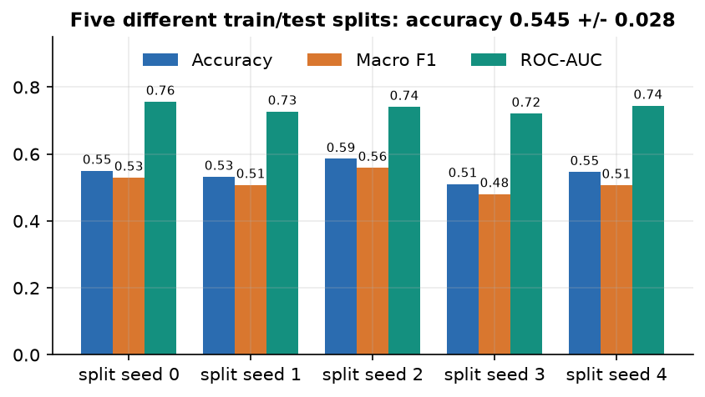
Figure 22: Accuracy, macro F1 and ROC-AUC on five different splits.
The headline split (seed 42, accuracy 0.550) is typical: over five splits accuracy ranges from 0.511 to 0.586, a spread of about 7.5% points. Differences below roughly three points between configurations should not be read as improvements.
Table 8: Confidence threshold: papers kept and accuracy on them
Minimum confidence | Papers kept | n | Accuracy on kept papers
0.0 | 100.0% | 280 | 55.0%
0.4 | 100.0% | 280 | 55.0%
0.5 | 97.5% | 273 | 54.9%
0.6 | 64.6% | 181 | 58.0%
0.7 | 29.3% | 82 | 69.5%
0.8 | 3.9% | 11 | 72.7%
0.9 | 0.0% | 0 | -

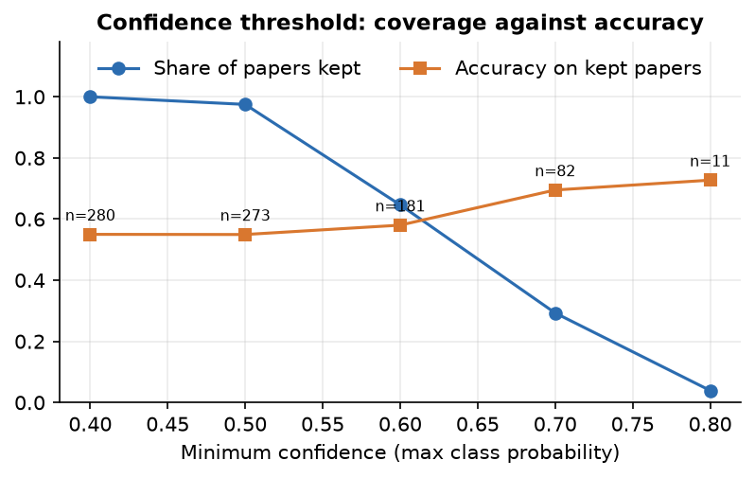
Figure 23: Share of papers kept and accuracy on the kept papers as the minimum confidence rises.
The probabilities are not very confident: at a threshold of 0.7 only 29.3% of the papers remain and accuracy on them rises to 69.5%; at 0.8 only 11 papers remain. The application does not use a threshold; it shows the three class probabilities and states that the signal is one input among several.

1.4 Reviewer-matching results
Reviewer matching was evaluated on the 40-abstract probe set described in Section 8.1: six topic areas with six abstracts each, plus four cross-area abstracts for which either of two reviewers is acceptable. For each abstract the full ranking of the six demo reviewers was produced by the production code, with no conflict text added, and the position of the best acceptable reviewer was recorded. Top-1 is the share of abstracts for which an acceptable reviewer is ranked first, top-3 the share for which one is in the first three, and MRR the mean reciprocal rank of the best acceptable reviewer. The labels were written by the project team and the abstracts avoid copying the reviewers' keyword lists, but the evaluation is still small and not independent; it measures whether the machinery behaves sensibly, not how it would perform on real submissions.
Table 9: Matching quality on 40 probe abstracts
Configuration | MiniLM top-1 | top-3 | MRR | TF-IDF top-1 | top-3 | MRR
Hybrid, shipped weights | 0.950 | 0.975 | 0.965 | 0.750 | 0.925 | 0.844
Semantic similarity only | 0.975 | 1.000 | 0.983 | 0.725 | 0.925 | 0.838
Keyword and method overlap only | 0.625 | 0.825 | 0.741 | 0.625 | 0.825 | 0.741
Hybrid without availability | 0.950 | 1.000 | 0.971 | 0.775 | 0.975 | 0.872
Random ranking (expectation) | 0.183 | 0.530 | - | 0.183 | 0.530 | -

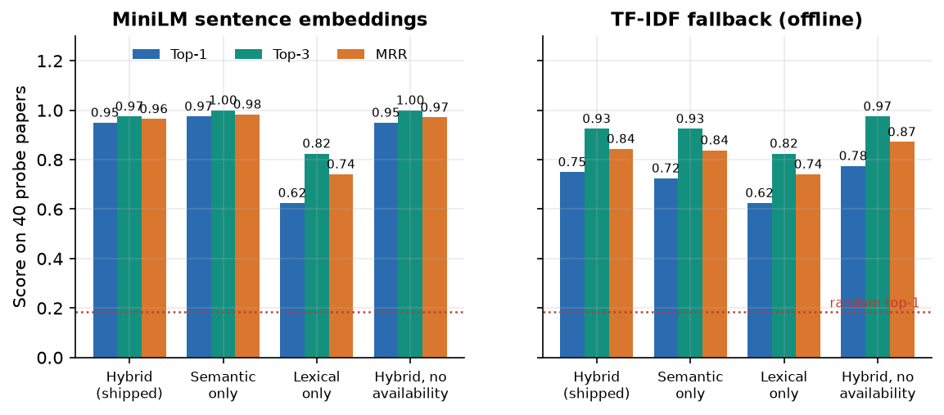
Figure 24: Top-1, top-3 and MRR of four score configurations with MiniLM embeddings (left) and the offline TF-IDF fallback (right); the dotted line is the random top-1 expectation.
With sentence embeddings the shipped hybrid score ranks an acceptable reviewer first for 95.0% of the abstracts (MRR 0.965), against a random expectation of 18.3%. Semantic similarity alone is marginally better (97.5% top-1): the keyword, method and availability terms do not improve the ranking on this probe set; their purpose is auditability and the handling of load, not accuracy. The keyword and method overlap on its own reaches 62.5%: on these abstracts, which are short and use varied vocabulary, a dense encoder is clearly stronger than lexical overlap; in the base paper the relative merit of lexical and dense measures depends on the text view that is matched [1]. Removing availability changes the result by at most one abstract (95.0% top-1 with MiniLM).
The offline fallback is clearly worse: 75.0% top-1 and 92.5% top-3 for the shipped weights. The fallback vectoriser is fitted once on the texts of the first request and then frozen, so its vocabulary reflects whichever paper was analysed first; the probe set reproduces that behaviour by ranking the 40 abstracts in sequence.
Table 10: Top-1 hits per area (shipped hybrid score)
Area of the abstract (acceptable reviewer) | MiniLM | TF-IDF fallback
Alpha | 6 / 6 | 3 / 6
Beta | 6 / 6 | 5 / 6
Gamma | 6 / 6 | 5 / 6
Delta | 5 / 6 | 3 / 6
Epsilon | 6 / 6 | 6 / 6
Zeta | 6 / 6 | 5 / 6
cross-area (2 acceptable) | 3 / 4 | 3 / 4

With MiniLM five areas are matched perfectly and the cross-area cases three out of four. The two misses are shown below. In both, the generalist Reviewer Gamma (applied machine learning and statistics) outscored the security specialist: abstracts on malware classifiers and on learning-based intrusion detection use machine-learning vocabulary heavily and security vocabulary lightly. With the TF-IDF fallback there are 10 top-1 misses, concentrated in the vision and security areas (three of six each).
Table 11: Probe abstracts for which the shipped hybrid score (MiniLM) did not rank an acceptable reviewer first
Probe abstract | Acceptable | Ranked first | Score: acceptable vs first
Adversarial evasion of malware classifiers | Delta | Gamma | 15.5 vs 26.0
Learning-based intrusion detection from textual logs | Beta or Delta | Gamma | 26.5 vs 35.5

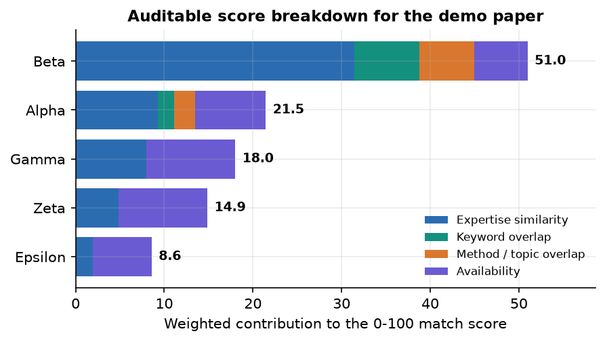
Figure 25: Weighted contributions to the match score of the five active reviewers for the demo paper (3 pages, retrieval-grounded text classification).
Mean gap between the first- and second-ranked reviewer is 12.6 points with MiniLM (about 7.7 with the fallback), so rankings are usually decisive on the probe set, but not on real papers outside the demo pool: the ReViewGraph paper obtained a top score of only 28.4 and a tie between two reviewers (Section 8.10).

1.4.1 Cost of ranking
Table 12: Median time to rank one paper against a growing reviewer pool
Reviewers in the directory | MiniLM embeddings | TF-IDF fallback
6 | 86 ms | 1 ms
50 | 578 ms | 7 ms
200 | 1.7 s | 25 ms
500 | 5.2 s | 68 ms

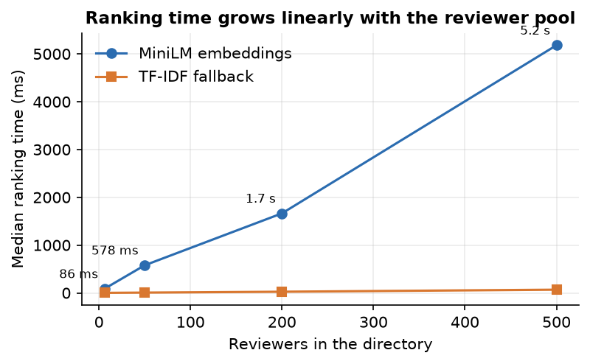
Figure 26: Median ranking time against the number of reviewers (the pool is replicated from the six demo profiles).
Ranking time grows linearly with the pool because every reviewer profile is embedded again for each request: 86 ms for the six demo reviewers, 578 ms for 50, 1.7 s for 200 and 5.2 s for 500. That is acceptable next to the minutes spent on the language model, but a cache of profile vectors would be the first change for a larger directory (Chapter 10).

1.5 Conflict-of-interest results
Conflict handling was tested by injection. One sentence containing a known link was appended to a probe abstract, the six reviewers were ranked again and the flag, score and rank of the linked reviewer were compared with the clean ranking. Fifteen injections were made: six conflict terms, four affiliations, two full names and three links the matcher cannot see because they are paraphrased. In addition, all 40 clean probe abstracts were ranked against all six reviewers and the flags counted (240 pairs).
Table 13: Conflict detection by kind of link
Kind of injected link | What was written | Detected
conflict term | A reviewer's conflict term appears in the text | 6 / 6
affiliation | The reviewer's affiliation string appears in the text | 4 / 4
full name | The reviewer's full name appears in the text | 2 / 2
paraphrased affiliation | The affiliation is reworded ("Computing Institute at Northbridge") | 0 / 2
first name only | Only the reviewer's first name is mentioned | 0 / 1

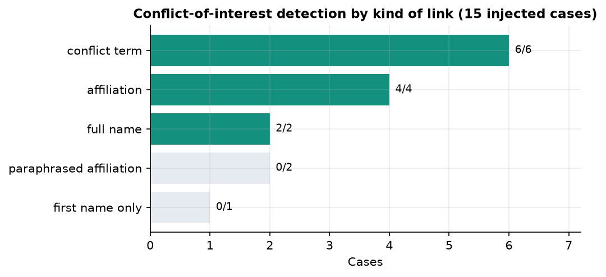
Figure 27: Conflict detection by kind of link: literal strings are found, paraphrases are missed.
All twelve literal links were flagged and none of the three paraphrased ones was. The false-flag count on clean papers is 0 of 240 pairs. When a link is flagged, the penalty of 0.60 is subtracted before scaling, so the score of a flagged reviewer falls to zero in every injected case and the reviewer drops to the last rank; the card then shows "Penalized" with the reason and the instruction to verify before assigning.
Table 14: Effect of a flagged conflict on a reviewer's rank and score (examples)
Reviewer | Kind | Rank before | Rank after | Score
Alpha | conflict term | 1 | 6 | 34.3 to 0.0
Beta | conflict term | 4 | 6 | 8.7 to 0.0
Gamma | conflict term | 3 | 6 | 16.2 to 0.0

These results describe a literal matcher doing what it was designed to do. They do not describe conflict-of-interest detection in the sense of the base paper's setting, where co-authorship, shared funding and institutional ties are the relevant relations and are not visible as strings in the submission. The three misses (paraphrased affiliation, paraphrased affiliation, first name only) show the gap; a co-author graph and normalised affiliations are listed as future work.

1.6 The pipeline on real papers
Four PDFs were run through the same code as an uploaded file: the three-page demo fixture generated by scripts/make_demo_pdf.py and three real research papers kept with the batch, the base paper [1], the survey [6] and the ReViewGraph paper [7]. No ground truth exists for these files, so the table reports what the pipeline extracted and what it concluded, not whether it was right.
Table 15: Extraction and signals on four PDFs
File | Pages | Words | Sections found | Refs found | Structural | Decision signal | Title extracted
Demo fixture (3 pages) | 3 | 431 | 9 | 1 | 68.10 | borderline (0.66) | Efficient Retrieval-Grounded Text Classifica
Survey, arXiv 2604.27924 | 30 | 19,877 | 8 | 13 | 68.50 | borderline (0.55) | Can AI Be a Good Peer Reviewer? A Survey of
ReViewGraph, arXiv 2511.08317 | 17 | 11,562 | 7 | 9 | 65.20 | borderline (0.58) | Automatic Paper Reviewing with Heterogeneous
IEEE Access base paper | 30 | 21,708 | 6 | 55 | 75.90 | borderline (0.55) | Digital Object Identifier 10.1109/ACCESS.202

Table 16: Components of the structural score
Paper | Structure completeness | Evidence coverage | Method clarity | Presentation | Overall
Demo fixture | 100.00 | 17.30 | 70.00 | 75.00 | 68.10
Survey | 88.90 | 19.50 | 70.00 | 100.00 | 68.50
ReViewGraph | 77.80 | 21.70 | 70.00 | 100.00 | 65.20
IEEE base paper | 66.70 | 50.30 | 100.00 | 100.00 | 75.90

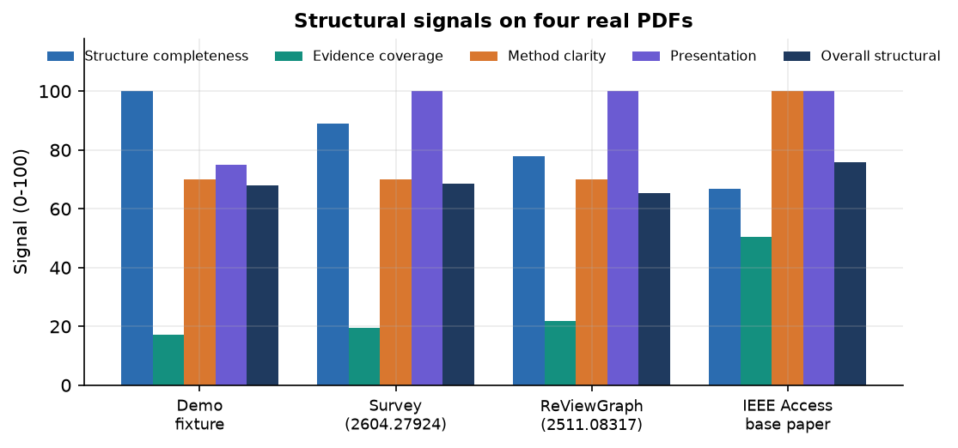
Figure 28: Structural signals on four real PDFs.
Four observations follow. First, extraction works on text-based academic PDFs of 17 to 30 pages in under half a second after the library is loaded. Second, the structural score varies little (65.2 to 75.9) because three of its four components saturate for any normal paper; the evidence component, which depends on references per page, is the one that moves (17.3 to 50.3). Third, the extraction is not robust to layout conventions: the base paper from IEEE Access uses roman-numeral headings, so its introduction is not detected (six of nine sections found), and its title heuristic returns the "Digital Object Identifier" line. Fourth, the decision model returned "borderline" for all four papers with confidences between 0.55 and 0.66. A classifier trained on templated synthetic sentences has no basis for judging real manuscripts, and the output is what that implies; the interface presents it as a weak signal for this reason.

1.7 Performance and latency
Latency was measured in two ways: stage by stage in one process (the model files already cached on disk), and over HTTP on 127.0.0.1 against a running server. The local address matters: on this machine localhost adds about two seconds per call through an IPv6 fallback, which would hide the real figures.
Table 17: Time per pipeline stage (one analysis, local language model on)
Stage | Demo paper, 3 pages | Survey, 30 pages
PDF extraction | 2.4 s | 383 ms
Feature extraction | 1 ms | 68 ms
Decision signal | 31 ms | 86 ms
Local AI review (3 steps) | 509.4 s | 521.7 s
Literature (OpenAlex) | 2.3 s | 1.5 s
Reviewer matching | 136 ms | 664 ms
Total | 514.3 s | 524.5 s

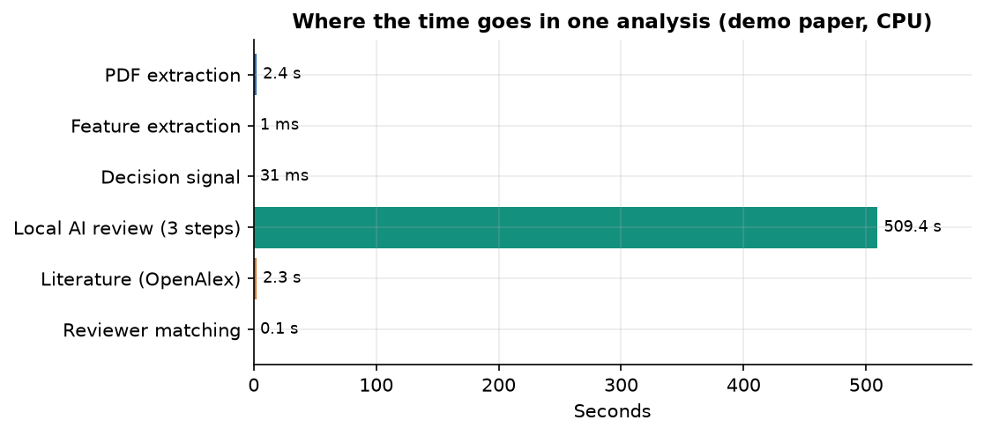
Figure 29: Where the time goes in one analysis of the demo paper on the CPU.
The local language model takes 99.1% of the time of an analysis: 509.4 s for three generation calls producing 1,410 tokens, about 2.8 tokens per second. Everything else together takes 4.9 s. The first PDF extraction of a process is slower (2.4 s) because the PDF library is imported lazily; later extractions of a 30-page paper take 383 ms. Loading the encoder took 20.4 s and the language model 9.0 s once, from the local cache, in the measuring process. Through the server, with a cold process, the complete analysis took 534 s for the base paper and 621 s for the survey, and 946 s when driven through the browser while Chrome was rendering.
Table 18: HTTP latency on 127.0.0.1 (local model switched off for the analyze rows)
Request | Calls | Median | 95th percentile / extra
GET /api/health | 40 | 2 ms | 4 ms
GET /api/reviewers | 40 | 2 ms | 3 ms
GET /api/model/metrics | 40 | 2 ms | 2 ms
GET /api/analyses | 40 | 2 ms | 3 ms
POST /api/analyze, 3-page PDF, AI review off | 8 | 1.3 s | max 1.6 s
POST /api/analyze, 30-page PDF, AI review off | 4 | 1.2 s | max 1.3 s
GET export, PDF report | 1 | 12 ms | 4,506 bytes
GET export, JSON | 1 | 3 ms | 21,123 bytes

With the language model switched off the whole analysis of a 3-page or 30-page paper takes about 1.2 to 1.3 seconds over HTTP, of which the OpenAlex lookup is the largest part; simple reads take a few milliseconds. The application is therefore interactive in its deterministic mode and a background job in its full mode. No job queue exists in the code, and two simultaneous full analyses would compete for the same cores.

1.8 Comparison with the base paper
The base paper [1] studies one half of the editorial workload, reviewer assignment, on a large historical dataset, and its contribution is a way to make the affinity score auditable by restricting large language models to keyword induction. PeerScope adopts the auditability principle for its own, much simpler, score and adds the other half, the assessment of the submission. The two works are not comparable on results: they differ in task scope, data, metric and scale, and the table states this plainly.
Table 19: What the two works cover
Dimension | Base paper [1] | PeerScope
Task | Reviewer assignment only | Preliminary paper assessment and reviewer ranking
Data | 663 papers from 85 computer-science conferences, 1,989 historical assignments, 524 reviewer profiles with up to 20 cited publications each (Semantic Scholar) | 40 team-written probe abstracts, 6 demo reviewer profiles; 1,400 synthetic rows for the decision model
Relevance labels | Historical assignments | The team's own judgement (probe set)
Role of the language model | Keyword induction by an ensemble of producers and a judge, with an audit trail | Local Qwen2.5-1.5B writes a review text; it does not rank reviewers
Affinity measures | TF-IDF, Jaccard, SBERT (all-MiniLM-L6-v2), cross-encoder re-ranking, keyword-aware SBERT, knowledge-graph methods | MiniLM cosine, keyword and method overlap, availability, conflict penalty (fixed weights)
Reported metrics | MRR@3, P@3, MAP@3; best MRR@3 0.7778 (titles) and 0.7843 (abstracts); SBERT cosine on abstracts MRR@3 0.7023 | Top-1 0.950, top-3 0.975, MRR 0.965 among 6 reviewers
Conflict of interest and capacity | Not benchmarked (metadata unavailable); left to a downstream solver | Inside the score: literal conflict penalty and workload term; measured by injection
Paper assessment | None | Structural signals, decision signal, local AI review, literature context
Delivery | Offline experiments | Local web application with directory, history and export
Statistics | Paired t-tests, confidence intervals, Gini coefficient of workload | None beyond a five-split spread for the decision model

Our top-1 of 0.950 must not be set beside the base paper's MRR@3 of about 0.78: ours ranks six candidate reviewers for 40 short abstracts the team wrote, with a random top-1 of 0.183; theirs ranks hundreds of reviewers for real submissions against historical assignments, with about three relevant reviewers per paper. The comparison that can be made honestly is qualitative. The base paper found that the ranking of lexical and dense measures depends on the text view (on abstracts SBERT cosine reached MRR@3 0.7023 against 0.6235 for TF-IDF cosine; on titles TF-IDF reached 0.7078 against 0.6571 for SBERT) and that most differences among text encoders were not statistically significant. Our probe set, a far smaller sample of short abstracts, favours the dense encoder; it cannot confirm or contradict the paper. PeerScope neither reproduces nor challenges the base paper's numbers.

1.9 Sample input and output
The input of the sample is the PDF of the ReViewGraph paper [7] (728 KB, 17 pages, 11,562 words, nine references detected by the parser), uploaded through the Analyze screen with the default filters (active reviewers only, minimum score 0). The server returns one JSON document of about 32 KB, stored in the analyses table and available through GET /api/analyses/3 and the export buttons. The listing shows its main fields with the values of that run; long text fields are shortened.
{
"product": "PeerScope",
"filename": "Automatic_Paper_Reviewing_ReViewGraph.pdf",
"paper": {"title": "Automatic Paper Reviewing with Heterogeneous Graph Reasoning over",
"page_count": 17, "word_count": 11562, "reference_count": 9,
"sections": ["introduction", "related_work", "methodology", "experiments", "results", "conclusion", "references"]},
"ml_decision_signal": {"status": "ok", "label": "borderline", "confidence": 0.5829,
"probabilities": {"accept": 0.2163, "borderline": 0.5829, "reject": 0.2009}},
"structural_assessment": {"overall_structural": 65.2, "structure_completeness": 77.8, "evidence_coverage": 21.7,
"method_clarity_signal": 70.0, "presentation_signal": 100.0},
"review": {"llm_status": "ok", "llm_model": "Qwen/Qwen2.5-1.5B-Instruct", "source": "deterministic+llm",
"major_concerns": ["Methodology clarity: methodology section is short; add architecture/training details, ..."],
"coverage": {"Method": 90, "Evidence": 90, "Clarity": 85, "Reproducibility": 80, "Novelty": 55, "Limitations": 70},
"ai_synthesis": "PAPER TITLE: Automatic Paper Reviewing with ... BACKGROUND: ... (about 4,000 characters)"},
"literature": {"literature_retrieval_status": "ok", "works": [{"year": 2025, "relevance": 0.8745}, "... 5 more"]},
"reviewers": [{"rank": 1, "display_name": "Reviewer Gamma", "score": 28.4, "match_strength": "Possible",
"breakdown": {"expertise_similarity": 0.2595, "keyword_score": 0.0, "method_score": 0.275,
"availability_score": 1.0, "conflict_penalty": 0.0}}, "... 4 more"],
"reviewer_pool_size": 6, "concern_count": 2, "recommendation_count": 5, "top_reviewer": "Reviewer Gamma"
}

A second sample shows how errors appear in the output rather than as crashes. For the survey paper the literature block was {"literature_retrieval_status": "unavailable", "works": [], "error": "OpenAlex retrieval failed (HTTPError): 400 Client Error: Bad Request ..."}, the rest of the analysis was complete, and the screen showed the notice instead of a table. Likewise, with the language model switched off the review block carries llm_status: "unavailable" and the reason, and only the deterministic review is shown.

1.10 Success and failure analysis

1.10.1 What worked
Table 20: Cases in which the system did what it was designed to do
No. | Case | Evidence
S1 | Accept and reject papers are separated by the decision model | 145 of 156 decisive-class test papers correct (93.0%)
S2 | The hybrid score puts an acceptable reviewer first with sentence embeddings | 95.0% top-1 on 40 probes against 18.3% random
S3 | Literal conflict links are found and penalised; clean papers are not flagged | 12 of 12 literal links flagged; 0 false flags in 240 clean pairs
S4 | Every recommendation can be recomputed by hand from its audit table | Gamma 28.4 = 0.55x0.260 + 0.20x0.000 + 0.15x0.275 + 0.10x1.000 (x100)
S5 | The system degrades visibly instead of failing | AI review off, literature unavailable and an inactive reviewer were all handled with notices (smoke test 24 of 24, pytest 7 of 7)
S6 | The deterministic path is fast | Whole analysis about 1.3 s over HTTP with the language model off
S7 | A full analysis is stored, reopened and exported | Analysis #3 reopened from history; JSON 21 KB and PDF report 4.5 KB exports

1.10.2 What went wrong
Table 21: Failure cases observed while measuring
No. | Case | What happened | Cause (as far as known)
F1 | Language-model text contains errors | The synthesis of the ReViewGraph paper shows "PAPER TITLE: ... over ANLMSIMPLE", a stray "REFERENCE PAGE: [Page 2]", a wrong description of the datasets, a contradictory statement on code availability and a sentence cut off at the 700-token limit | A 1.5-billion-parameter model reading 6,000 characters of text; no fact checking; the interface labels the text "can contain errors"
F2 | Literature unavailable for the survey | literature_retrieval_status = unavailable for the survey paper | The extracted title contains a question mark; OpenAlex answers HTTP 400 and the query is not sanitised
F3 | The submission retrieves itself | Three of six literature results are the ReViewGraph paper (relevance 0.875) | No filter removes the paper's own title; relevance is title similarity
F4 | Title and introduction missed for the IEEE paper | Title returned as "Digital Object Identifier 10.1109/ACCESS.2026.3724622"; six of nine sections found | Heuristics expect a plain title line and "Introduction" headings, not roman numerals
F5 | All four real papers get the same decision signal | borderline for all four, confidence 0.55 to 0.66 | Classifier trained on templated synthetic sentences; the borderline class is also the largest in training
F6 | Probe misses | 2 of 40 probes with MiniLM; 10 of 40 with the fallback | A generalist reviewer's profile overlaps with specialised abstracts; fallback vocabulary is frozen after the first request
F7 | Low and tied scores on a real paper | Top score 28.4 (band "Possible"); Gamma and Delta tied; the NLP reviewer ranked fourth (27.4) | The six demo reviewers are far from the paper's topic; Beta had similarity 0.30 but zero keyword overlap and a load of 2 of 5
F8 | Paraphrased conflicts are invisible | 0 of 3 paraphrased or first-name links flagged | Literal string matching on the first 3,000 characters
F9 | Rank numbers skip | Ranks 1, 2, 4, 5, 6 shown | Rank is assigned before the active-only filter removes Reviewer Epsilon
F10 | Times shown in two zones | History shows 8:37 AM, the audit tab 2:07 PM for the same analysis | Stored as naive UTC; one view converts to local time, the other does not
F11 | A damaged PDF is accepted | A corrupt file that begins with the PDF header returns HTTP 200 with almost no text and a short-text warning | Validation checks the header and size only

None of the failures corrupts data or crashes the application, and each is visible to the user as a notice, a low score or an odd value. The three that matter most for a real deployment are F5 (the decision signal), F7 (low and tied scores outside the demo pool) and F1 (unchecked language-model text), and each of them is a reason why the interface presents all output as decision support for a human.

1.11 Limitations of the results
• Synthetic training data. The decision-model figures describe a generated corpus. They are not evidence of the ability to predict real editorial decisions, and the model's output on real papers (all borderline) shows it.
• Small, team-written probe set. Forty abstracts, six reviewers and labels written by the same team that built the matcher. The top-1 of 0.95 is an upper-bound style figure for a friendly sample, not an estimate for a real conference.
• Demo reviewer pool. Six invented profiles; no publication histories, no h-index and no real workloads. Behaviour with hundreds of real reviewers was measured for time only, not for quality.
• No independent expert judgement and no user study. Nobody outside the team rated the rankings, the structural scores or the language-model reviews.
• Novelty is not assessed. The Novelty bar is a fixed 55; the literature tab is context, and it can return the paper itself.
• One machine, one run per timing. Latencies come from a single CPU-only PC; the full-analysis times are single runs and vary by tens of seconds with other load.
• Heuristic structural score. Its weights were chosen by the team, not fitted; three of its four components barely move for ordinary papers.
• Not measured at all: accuracy on real peer-review decisions, scanned PDFs, non-English papers, GPU speed, concurrent users, and the quality of the language-model review as judged by people.

1.12 Objectives against outcomes
The table sets the six objectives of the project against what was measured. The last three rows record items that appear in the abstract but were not among the numbered objectives and were not delivered in full.
Table 22: Objectives against outcomes
No. | Objective | Status | Evidence
1 | Build a corpus of submitted papers and reviewer publication profiles | Partly met | Analyses are stored (3 in this run) and a reviewer directory with CSV import exists; it holds 6 demo profiles. No real publication corpus; the decision corpus is synthetic (1,400 rows).
2 | Extract topics, methods and keywords from paper text with NLP | Met (heuristic) | Frequency keywords, a 21-term method lexicon and 18 topic hints; verified on four real PDFs. No learned topic model.
3 | Represent reviewer expertise as comparable vectors | Met | Profile text and publication titles embedded with all-MiniLM-L6-v2; offline TF-IDF fallback. Not built from real publication histories.
4 | Compute semantic similarity to rank reviewers | Met | Cosine similarity inside an auditable score; top-1 0.950 (MiniLM) and 0.750 (fallback) on the probe set.
5 | Provide a preliminary quality assessment (structure, novelty signals, completeness) | Met except novelty | Structure, evidence, method clarity and presentation signals, a decision signal and an AI review. Novelty is a fixed value and is not measured.
6 | Evaluate assignment quality against expert judgement and measure conflict-of-interest handling | Partly met | Team-labelled probe set instead of independent experts; conflict handling measured by injection (12 of 12 literal, 0 of 3 paraphrased, 0 false flags).
A1 | Abstract: deep-learning classification of research areas | Not implemented | Areas come from keyword hints; the classifier is a linear model.
A2 | Abstract: originality scoring and h-index ranking | Not implemented | No corpus-distance originality score; no h-index field.
A3 | Abstract: readability and scope alignment with a target venue | Partly | Average sentence length only; no venue model.

In summary, the engineering objectives (a working local application with transparent, tested, degradable components) are met, and the evaluation objectives are met only at the scale of a demonstration. The honest reading of the results is that PeerScope shows how auditable matching and preliminary assessment can be combined in one tool, that its matching works well on a small friendly sample, and that its decision signal and its language-model review need real data and human validation before they could support any editorial decision.

