MULTI-DISEASE PREDICTION USING MACHINE LEARNING
(An Intelligent Health Assistant for Diabetes, Heart, Liver and Kidney Risk)
Results
Department of Computer Science and Engineering, TKR College of Engineering and Technology (Autonomous)
Batch A3 (CSE-A) · Academic year [ACADEMIC YEAR]
Table 1: Project team
S.No. | Student name | Roll number
1 | AJMEERA HARINI | 23K91A0507
2 | BANDI LIKITHA | 23K91A0526
3 | CHINTHAKINDI SWATHI | 23K91A0555
4 | BADROJU SRI HANSIKA | 23K91A0524

Project guide: B. SRUTHI, Faculty Project Guide, Department of CSE
Chapter and section numbers quoted in the text (for example Section 6.6 or Chapter 8) refer to the full project report, 17.Final Document. Figures and tables in this document are numbered from 1.

CHAPTER 8: RESULTS AND OUTPUT SCREENS

8.1 Experimental Setup
All results come from the project's own scripts: train_models.py (the metrics the application shows, stored in models/training_report.json), scripts/run_experiments.py (ROC-AUC, confusion matrices, cross-validation, repeated splits, thresholds, importance, sensitivity), scripts/real_data_check.py (a supplementary check on real public data), scripts/api_tests.py (API checks and latency) and scripts/make_figures.py (charts). Re-running them reproduces the numbers below on the same software versions; run_experiments.py reproduces all 16 model-and-disease cells of the shipped report to four decimals.
Table 2: Experimental setup
Item | Value
Data | Four synthetic CSV files in data/, 2,000 rows each (8,000 in total), generated by generate_data.py (seed 42): a hand-written linear risk score, thresholded at 0.5, with 8% of the labels flipped at random
Split | Stratified 80/20, random_state 42: 1,600 training rows and 400 test rows for every disease
Models | Logistic Regression (max_iter 1000), Decision Tree (max_depth 6), Random Forest (200 trees, max_depth 8), SVM (RBF, C 1, probability on); inputs standardised with a scaler fitted on the training rows
Selection rule | Highest F1 on the test split (as in train_models.py)
Extra protocols | Stratified 5-fold cross-validation (scaler refitted per fold) and ten random 80/20 splits (seeds 0-9) for all four algorithms
Real-data check | Pima Indians Diabetes, UCI Cleveland heart, UCI ILPD liver and UCI chronic kidney disease, same algorithms and settings with median imputation (Section 8.8)
Machine | Intel Core i5-12500 (12 threads), 16 GB RAM, Windows 11, Python 3.11.9, scikit-learn 1.8.0, CPU only

Reading the numbers. The training data are synthetic. Their labels follow a known linear rule and 8% of them are flipped, so no classifier can exceed about 92% accuracy on this data (the noise ceiling) and a linear model is the correct model family. The accuracies below therefore show that the pipeline recovers a known rule; they are not clinical performance. Section 8.8 shows what the same method scores on real public data.

8.2 Hold-out Results for the Four Diseases
The tables give the four algorithms for each disease on the 400-row test split. The row marked (selected) is the model the application serves; accuracy, precision, recall and F1 are the values stored in the training report and shown on the Models page, and ROC-AUC was computed afterwards from the predicted probabilities of the same fitted models.
Table 3: Diabetes: test-split metrics (400 rows, 162 high-risk)
Model | Accuracy | Precision | Recall | F1-score | ROC-AUC
Logistic Regression | 0.8900 | 0.8882 | 0.8333 | 0.8599 | 0.9034
Decision Tree | 0.8000 | 0.7808 | 0.7037 | 0.7403 | 0.8037
Random Forest | 0.8625 | 0.8794 | 0.7654 | 0.8185 | 0.9070
SVM (selected) | 0.8950 | 0.9110 | 0.8210 | 0.8636 | 0.9077

Table 4: Heart disease: test-split metrics (400 rows, 292 high-risk)
Model | Accuracy | Precision | Recall | F1-score | ROC-AUC
Logistic Regression (selected) | 0.8850 | 0.8917 | 0.9589 | 0.9241 | 0.8455
Decision Tree | 0.7675 | 0.8241 | 0.8664 | 0.8447 | 0.7339
Random Forest | 0.8275 | 0.8195 | 0.9795 | 0.8924 | 0.8306
SVM | 0.8775 | 0.8857 | 0.9555 | 0.9193 | 0.8563

Table 5: Liver disease: test-split metrics (400 rows, 112 high-risk)
Model | Accuracy | Precision | Recall | F1-score | ROC-AUC
Logistic Regression (selected) | 0.9175 | 0.9158 | 0.7768 | 0.8406 | 0.8881
Decision Tree | 0.8600 | 0.7642 | 0.7232 | 0.7431 | 0.8072
Random Forest | 0.8825 | 0.8652 | 0.6875 | 0.7662 | 0.8880
SVM | 0.8900 | 0.9048 | 0.6786 | 0.7755 | 0.8890

Table 6: Kidney disease: test-split metrics (400 rows, 239 high-risk)
Model | Accuracy | Precision | Recall | F1-score | ROC-AUC
Logistic Regression (selected) | 0.8825 | 0.8934 | 0.9121 | 0.9027 | 0.9076
Decision Tree | 0.7450 | 0.7665 | 0.8243 | 0.7944 | 0.7540
Random Forest | 0.8150 | 0.8113 | 0.8996 | 0.8532 | 0.8805
SVM | 0.8525 | 0.8516 | 0.9121 | 0.8808 | 0.8963

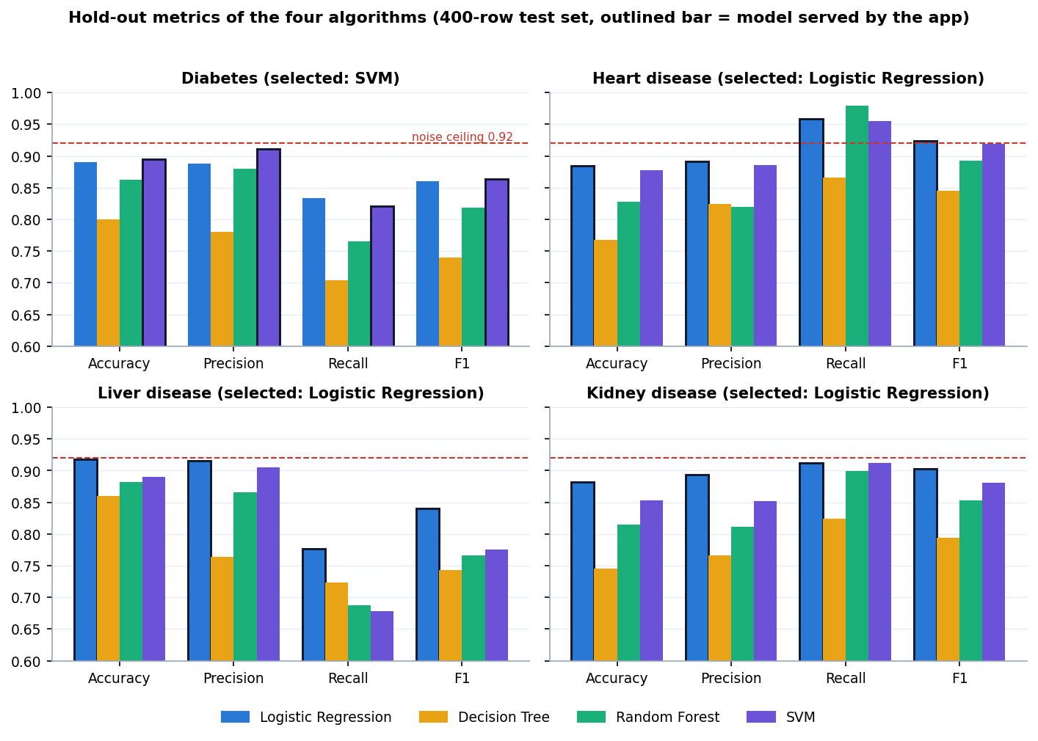
Figure 1: Hold-out metrics of the four algorithms for each disease (outlined bars: the model served by the application; dashed line: 92% noise ceiling)
Three points stand out. First, the selected models score 89.5% (diabetes), 88.5% (heart), 91.8% (liver) and 88.3% (kidney), all close to the 92% ceiling set by the label noise. Second, Logistic Regression is the selected model for three of the four diseases and is within 0.5 points of the SVM for the fourth, which is what a linear label rule predicts. Third, the Decision Tree is clearly the weakest everywhere (accuracy 0.7450 to 0.8600) and Random Forest is behind the linear model on every disease, because both fit the flipped labels (Section 8.5).
Recall matters most when a screening tool must not miss patients. Heart disease has the highest recall of the selected models (0.9589) because its data are 73.1% high-risk; liver disease has the lowest (0.7768) with 28.1% high-risk rows, so the liver model misses about one high-risk patient in four. Precision and recall are not averaged across diseases because the class balance differs (high-risk share of the 2,000 rows: diabetes {pb['diabetes']}, heart {pb['heart']}, liver {pb['liver']}, kidney {pb['kidney']}).

8.3 Confusion Matrices and ROC Curves
Table 7: Confusion matrices of the served models on the 400-row test split
Disease | Model | TN | FP | FN | TP | High-risk missed | Low-risk flagged
Diabetes | SVM | 225 | 13 | 29 | 133 | 17.9% | 5.5%
Heart disease | Logistic Regression | 74 | 34 | 12 | 280 | 4.1% | 31.5%
Liver disease | Logistic Regression | 280 | 8 | 25 | 87 | 22.3% | 2.8%
Kidney disease | Logistic Regression | 135 | 26 | 21 | 218 | 8.8% | 16.1%

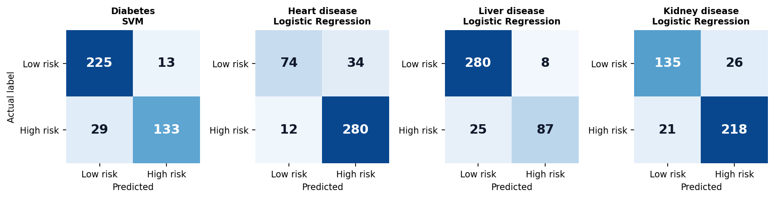
Figure 2: Confusion matrices of the served model for each disease (rows: actual label; columns: prediction)
The error types differ by disease. The diabetes model has few false alarms (13 of 238 low-risk rows) but misses 29 of 162 high-risk rows; the heart model does the opposite, flagging 34 of 108 low-risk rows and missing only 12 of 292; the liver model misses 25 of 112 high-risk rows; and the kidney model makes both kinds of error (26 false alarms, 21 misses). The heart behaviour follows from the class balance: with 73% positives, calling most records high-risk is rarely wrong.
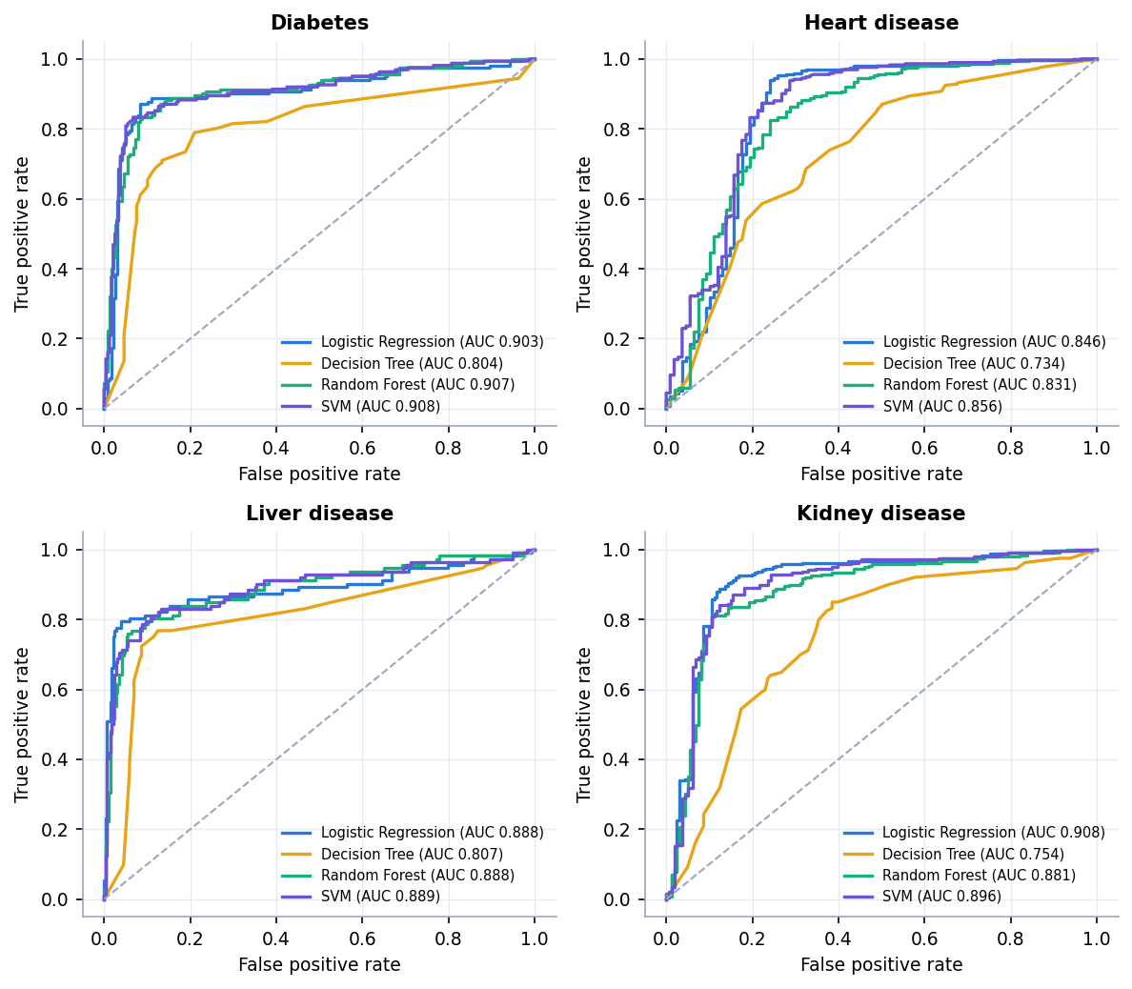
Figure 3: ROC curves of the four algorithms for each disease on the test split
ROC-AUC separates the algorithms less than accuracy does: for diabetes Logistic Regression, Random Forest and SVM have AUC 0.9034, 0.9070 and 0.9077, and for liver 0.8881, 0.8880 and 0.8890, so their ranking ability is practically the same even though Random Forest has lower accuracy and recall at the 0.5 cut-off. The Decision Tree has the lowest AUC for every disease (0.7339 to 0.8072).

8.4 Stability of the Model Choice
A 400-row test set with a single split gives noisy numbers, and the training script chooses the best model on that same test set. To see whether the choice survives, all four algorithms were re-evaluated by stratified 5-fold cross-validation and on ten further random 80/20 splits.
Table 8: 5-fold cross-validation and ten random splits (mean ± standard deviation)
Disease | Model | CV accuracy | CV F1 | CV ROC-AUC | Split accuracy | Best-F1 splits of 10
Diabetes | LR | 0.8955 ± 0.0062 | 0.8688 ± 0.0073 | 0.9083 ± 0.0116 | 0.8925 ± 0.0134 | 10
 | DT | 0.7990 ± 0.0116 | 0.7405 ± 0.0167 | 0.8116 ± 0.0169 | 0.8022 ± 0.0159 | 0
 | RF | 0.8545 ± 0.0073 | 0.8109 ± 0.0096 | 0.8996 ± 0.0117 | 0.8583 ± 0.0111 | 0
 | SVM | 0.8765 ± 0.0174 | 0.8429 ± 0.0225 | 0.9086 ± 0.0107 | 0.8675 ± 0.0147 | 0
Heart disease | LR | 0.9040 ± 0.0060 | 0.9361 ± 0.0044 | 0.8903 ± 0.0193 | 0.9037 ± 0.0142 | 10
 | DT | 0.7855 ± 0.0090 | 0.8589 ± 0.0066 | 0.7574 ± 0.0091 | 0.7665 ± 0.0129 | 0
 | RF | 0.8295 ± 0.0043 | 0.8931 ± 0.0022 | 0.8725 ± 0.0198 | 0.8310 ± 0.0090 | 0
 | SVM | 0.8860 ± 0.0155 | 0.9251 ± 0.0105 | 0.8817 ± 0.0164 | 0.8795 ± 0.0141 | 0
Liver disease | LR | 0.9035 ± 0.0110 | 0.8126 ± 0.0193 | 0.8835 ± 0.0044 | 0.9058 ± 0.0098 | 10
 | DT | 0.8650 ± 0.0143 | 0.7301 ± 0.0287 | 0.8168 ± 0.0253 | 0.8510 ± 0.0152 | 0
 | RF | 0.8785 ± 0.0060 | 0.7554 ± 0.0072 | 0.8833 ± 0.0102 | 0.8840 ± 0.0132 | 0
 | SVM | 0.8855 ± 0.0097 | 0.7677 ± 0.0176 | 0.8773 ± 0.0079 | 0.8872 ± 0.0119 | 0
Kidney disease | LR | 0.8780 ± 0.0153 | 0.8986 ± 0.0143 | 0.8991 ± 0.0104 | 0.8768 ± 0.0138 | 10
 | DT | 0.7160 ± 0.0140 | 0.7623 ± 0.0104 | 0.7488 ± 0.0170 | 0.7355 ± 0.0092 | 0
 | RF | 0.8245 ± 0.0099 | 0.8607 ± 0.0085 | 0.8776 ± 0.0097 | 0.8225 ± 0.0077 | 0
 | SVM | 0.8520 ± 0.0132 | 0.8790 ± 0.0107 | 0.8920 ± 0.0130 | 0.8540 ± 0.0065 | 0

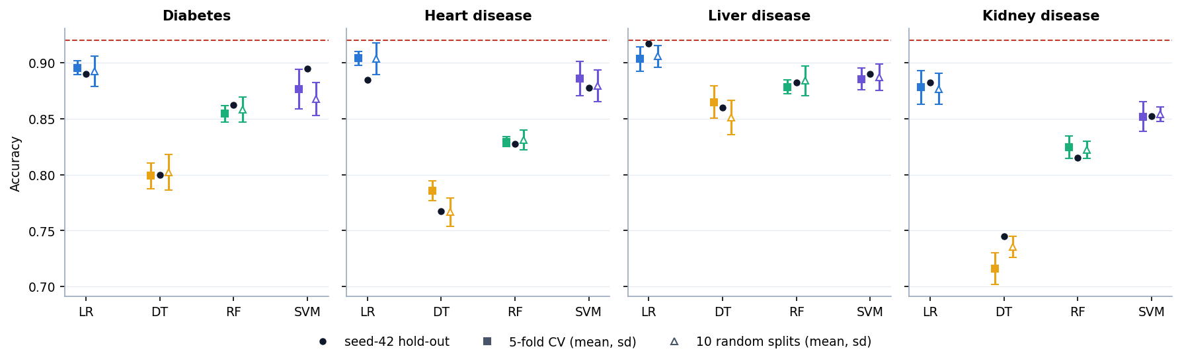
Figure 4: Accuracy on the seed-42 hold-out split, in 5-fold cross-validation and on ten random splits (error bars: one standard deviation; dashed line: 92% noise ceiling)
Logistic Regression has the best F1 on 10 of 10 splits for all four diseases, and the best or tied-best cross-validated accuracy. The diabetes row is the notable case: on the seed-42 split the SVM has the higher F1 (0.8636 against 0.8599), and train_models.py therefore saved the SVM; on cross-validation and on every one of the ten other splits Logistic Regression is better (CV accuracy 0.8955 against 0.8765; split accuracy 0.8925 against 0.8675). The difference on the chosen split is far inside the split-to-split standard deviation of about 0.013 to 0.015, so the selection picked a model that the other evidence does not support. Selecting on the same data that is then used to report the score also makes the reported figures slightly optimistic, a known source of bias in model selection [24]. A nested or separate validation split, as the base paper uses, would avoid it.

8.5 Over-fitting and Hyper-parameter Sensitivity
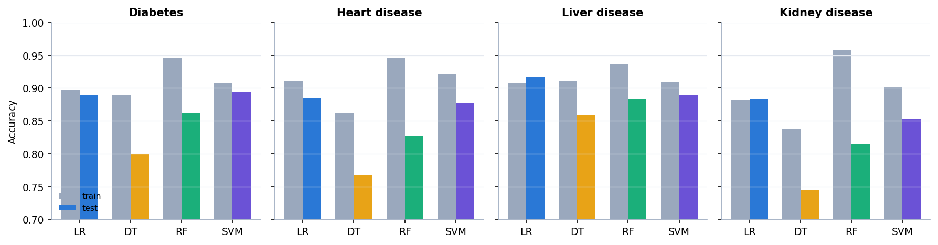
Figure 5: Training and test accuracy of the four algorithms for each disease
Random Forest fits the training rows to 93.6-95.9% but reaches only 81.5-88.3% on the test rows; its 200 trees of depth 8 fit the flipped labels. Logistic Regression's training and test accuracy are within about three points (heart 91.1% against 88.5%, the largest gap), which is what a model with few parameters on 1,600 rows should show.
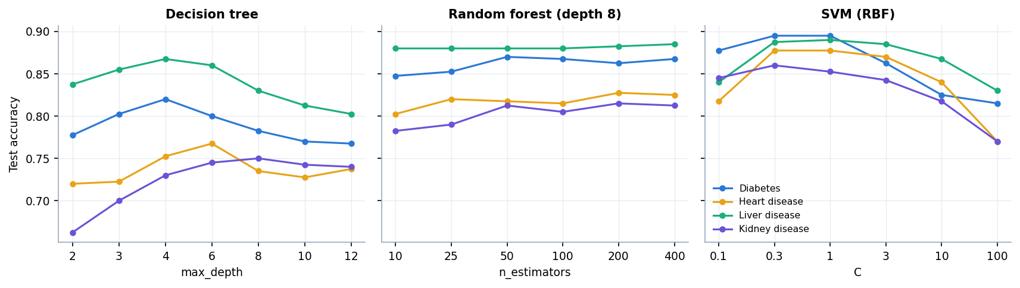
Figure 6: Test accuracy against decision-tree depth, forest size and SVM C, for the four diseases
The settings in train_models.py were never tuned and no grid search was run, so a sensitivity sweep shows how much was left on the table. Decision trees peak at depth 4 to 8 and decline beyond (diabetes 0.8200 at depth 4, 0.7675 at depth 12), random forests are flat beyond 50 trees, and the RBF SVM is best at C between 0.3 and 1 and falls to 0.7700-0.8300 at C = 100. The shipped settings (depth 6, 200 trees, C = 1) sit near the best values, so tuning would change the scores by a point or two, not more.

8.6 Decision-threshold Analysis
The application uses each model's own decision rule, which corresponds to a probability threshold of 0.5. The sweep below uses the predicted probability of the high-risk class of the served model on the test split (for the SVM this is the probability from Platt scaling, so its 0.50 row differs slightly from the predict result in Section 8.2).
Table 9: Effect of the decision threshold (served model, test split)
Disease | At 0.50: precision / recall / F1 | Best F1 threshold: F1 | Highest threshold with recall ≥ 0.90
Diabetes | 0.893 / 0.827 / 0.859 | 0.50: 0.859 | 0.20: P 0.656
Heart disease | 0.892 / 0.959 / 0.924 | 0.55: 0.926 | 0.60: P 0.911
Liver disease | 0.916 / 0.777 / 0.841 | 0.50: 0.841 | not reached (0.20-0.80)
Kidney disease | 0.893 / 0.912 / 0.903 | 0.50: 0.903 | 0.50: P 0.893

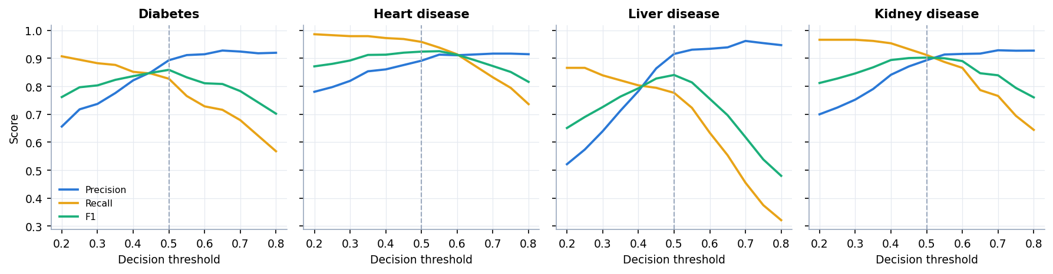
Figure 7: Precision, recall and F1 against the decision threshold for the four served models (dashed line: 0.5)
F1 is nearly flat around 0.5 for every disease; the best threshold is 0.55 for heart and 0.50 for the other three, so the default is reasonable. For a screening use, where missing a patient costs more than a false alarm, the threshold could be lowered: for diabetes recall reaches 0.907 at a threshold of 0.20, at the price of precision 0.656. For liver disease recall never reaches 0.90 in the range 0.20-0.80. The application does not let the user change the threshold; this is listed as future work.

8.7 Which Inputs Matter
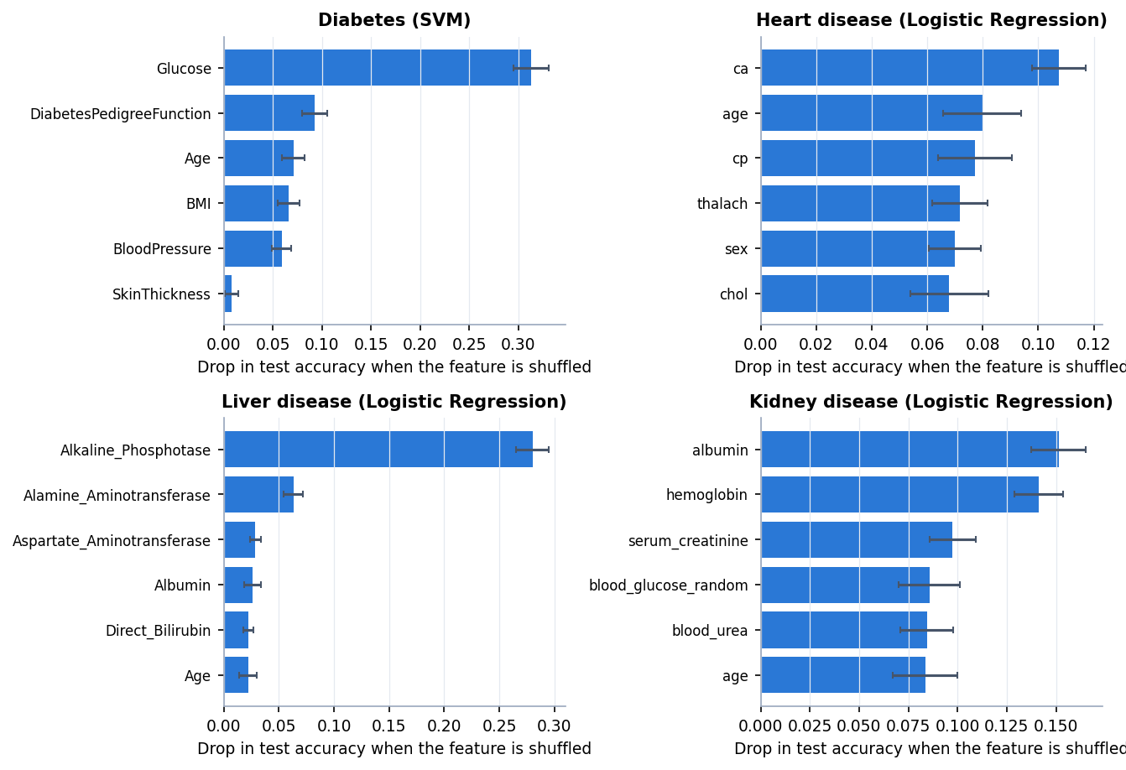
Figure 8: Permutation importance of the six strongest inputs for each served model (drop in test accuracy when the input is shuffled)
The three strongest inputs by permutation importance are, for each disease, diabetes: Glucose (0.313), DiabetesPedigreeFunction (0.092), Age (0.071); heart disease: ca (0.108), age (0.080), cp (0.077); liver disease: Alkaline_Phosphotase (0.280), Alamine_Aminotransferase (0.063), Aspartate_Aminotransferase (0.029); kidney disease: albumin (0.151), hemoglobin (0.141), serum_creatinine (0.097). They are the inputs that carry the largest weight in the risk rule inside generate_data.py, which is expected because the labels were built from that rule; the analysis confirms that the models recover it. It was run offline for this report. The application itself does not show which inputs drove a prediction, so the sixth objective is only partly met (Section 8.13).

8.8 Supplementary Check on Real Public Data
Because the main results rest on synthetic data, the same four algorithms with the same settings were also trained and cross-validated on public data sets with the matching columns: the Pima Indians Diabetes data [12], the Cleveland heart-disease data [14], the Indian Liver Patient data (ILPD) [16] and the chronic kidney disease data [15]. Missing values (Pima zeros treated as missing, and the blank cells counted in the table below) were filled with the median inside each fold; the check is a supplementary script and is not part of the application.
Table 10: Real data sets used in the supplementary check
Disease | Source | Rows | Positive / negative | Missing cells | Majority-class rate
Diabetes | Pima Indians Diabetes (NIDDK), 768 rows | 768 | 268 / 500 | 652 | 65.1%
Heart disease | UCI Heart Disease, Cleveland, 303 rows | 303 | 139 / 164 | 6 | 54.1%
Liver disease | UCI ILPD (Indian Liver Patient), 583 rows | 583 | 416 / 167 | 4 | 71.4%
Kidney disease | UCI Chronic Kidney Disease, 400 rows (12 of 24 attributes) | 400 | 250 / 150 | 541 | 62.5%

Table 11: (a) Algorithms trained and cross-validated on the real data (5-fold, repeated 3 times)
Disease | Model | Accuracy | F1 | ROC-AUC
Diabetes | LR | 0.765 ± 0.031 | 0.621 | 0.836
 | DT | 0.734 ± 0.040 | 0.609 | 0.762
 | RF | 0.759 ± 0.031 | 0.628 | 0.834
 | SVM | 0.758 ± 0.024 | 0.612 | 0.827
Heart disease | LR | 0.843 ± 0.042 | 0.822 | 0.909
 | DT | 0.761 ± 0.050 | 0.731 | 0.763
 | RF | 0.836 ± 0.052 | 0.814 | 0.911
 | SVM | 0.839 ± 0.033 | 0.818 | 0.900
Liver disease | LR | 0.718 ± 0.027 | 0.822 | 0.751
 | DT | 0.671 ± 0.033 | 0.777 | 0.681
 | RF | 0.706 ± 0.036 | 0.810 | 0.753
 | SVM | 0.712 ± 0.006 | 0.831 | 0.657
Kidney disease | LR | 0.976 ± 0.015 | 0.981 | 0.999
 | DT | 0.974 ± 0.014 | 0.979 | 0.972
 | RF | 0.988 ± 0.011 | 0.991 | 1.000
 | SVM | 0.982 ± 0.013 | 0.985 | 0.999

Table 12: (b) The shipped (synthetic-trained) models applied to every real record
Disease | Shipped model | Accuracy | Recall | ROC-AUC | Predicted positive | Majority baseline
Diabetes | SVC | 0.750 | 0.649 | 0.796 | 35.4% | 65.1%
Heart disease | LogisticRegression | 0.696 | 0.957 | 0.884 | 72.3% | 54.1%
Liver disease | LogisticRegression | 0.540 | 0.380 | 0.745 | 28.8% | 71.4%
Kidney disease | LogisticRegression | 0.823 | 0.716 | 0.992 | 44.8% | 62.5%

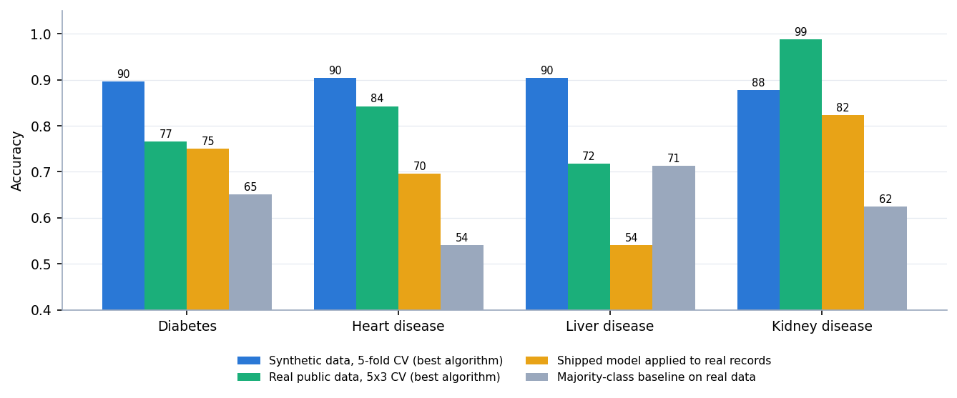
Figure 9: Accuracy on synthetic data (CV), on real data (CV) and of the shipped models on real records, with the majority-class baseline
Findings. (1) On real data the best algorithm reaches 76.5% for diabetes, 84.3% for heart disease, 71.8% for liver disease and 98.8% for kidney disease, against 87.8-90.4% in cross-validation on the synthetic data; the kidney set is almost separable, the others are much noisier than the synthetic data. (2) The shipped models transfer only partly: their ROC-AUC on real records is 0.796, 0.884, 0.745 and 0.992, so the ranking of risk carries over, but the 0.5 decision rule does not fit real populations. For liver disease the shipped model's accuracy of 54.0% is below the 71.4% majority-class baseline (it flags only 28.8% of patients, while 71.4% of the records are positive). (3) The heart codes (chest-pain type, slope, thalassemia) had to be recoded to the project's coding, and the thalassemia mapping is arbitrary. The more honest estimate of how this method behaves on patients is therefore the real-data table, and the application must not be used for clinical decisions.

8.9 Testing and Performance
Table 13: API checks (41 of 41 passed in scripts/api_tests.py)
Group | Passed | What is checked
Functional | 24 / 24 | Every endpoint, both classes, all four diseases; metadata matches the form fields
Consistency | 2 / 2 | API prediction equals a direct model.predict on 40 sampled rows; the same input twice gives the same output
Validation | 14 / 14 | Missing, empty, text, NaN, infinite and null values give 422; unknown disease 404; malformed JSON 422; wrong method 405
Sanity | 1 / 1 | An extreme low-risk and an extreme high-risk diabetes record are classified correctly
Smoke test | 27 / 27 | scripts/smoke_test.py: health, lists, report, datasets, samples and predictions for each disease, invalid input and unknown disease

Two observations are recorded but are not failures: the API accepts physiologically impossible values (a glucose of 100,000 mg/dL returns High Risk with 60.94%, an age of -5 returns High Risk with 74.61%), because the only range check is a warning in the web form. There is no pytest suite, no frontend test, no security test (the application has no sign-in) and no load test beyond the one below.
Table 14: Measured API latency on 127.0.0.1 (200 calls after 10 warm-up calls)
Request | Median (ms) | 95th percentile (ms) | Max (ms)
GET /api/health | 12.9 | 25.0 | 27.0
GET /api/diseases | 14.6 | 25.1 | 63.0
GET /api/diseases/diabetes | 16.4 | 26.9 | 29.8
POST /api/predict/diabetes | 13.5 | 24.9 | 27.4
POST /api/predict/heart | 14.4 | 25.0 | 26.2
POST /api/predict/diabetes (4 concurrent clients) | 5.1 | 25.1 | 29.5

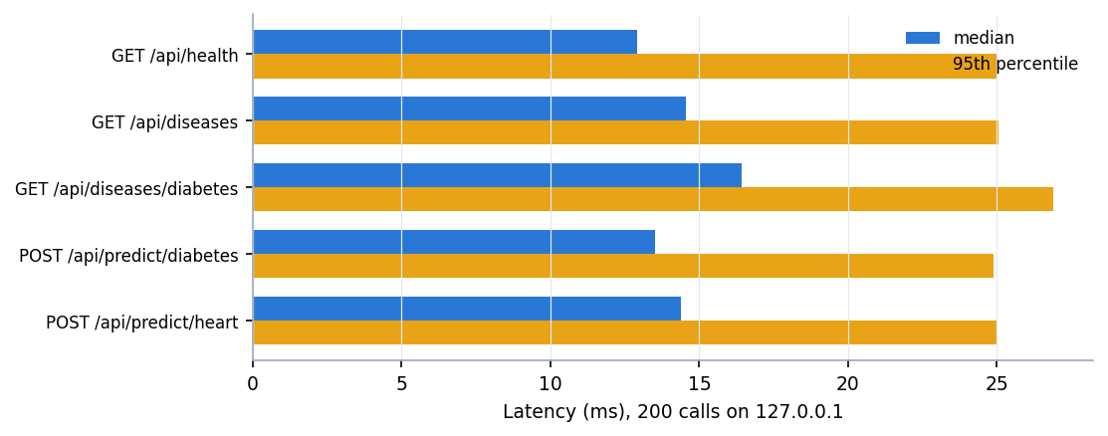
Figure 10: Median and 95th-percentile latency of the API routes
A prediction takes about 14 ms at the median and about 25 ms at the 95th percentile; with four concurrent clients the service handled 416 requests per second. Windows timer resolution (about 15.6 ms) quantises single-call timings and the machine was under memory pressure from other programs while these were taken, so the values are upper bounds and a prediction takes well under 25 ms in practice. In process, fitting the four diabetes models takes 12 ms (Logistic Regression), 9 ms (Decision Tree), 304 ms (Random Forest) and 188 ms (SVM), and predicting one row takes 0.0001 to 0.0335 ms.

8.10 Comparison with the Base Paper
The base paper [1] diagnoses thyroid disease on a real data set, so its results are not comparable with this project's; the comparison is for context and is not a like-for-like comparison. The two differ in disease, data, class structure and evaluation protocol.
Table 15: Base paper compared with this project
Aspect | Base paper (Alam et al., 2026) | This project
Disease(s) | Thyroid status (Normal, Hypothyroid, Hyperthyroid), three classes | Diabetes, heart, liver and kidney disease, each a binary high-risk / low-risk task
Data | UCI thyroid data, 7,200 samples, 21 features, strongly imbalanced, real | Four synthetic CSVs of 2,000 rows each (8,000 rows); real data only in a supplementary check
Classifiers | SVC, Random Forest, Extra Trees, AdaBoost, CatBoost | Logistic Regression, Decision Tree, Random Forest, SVM
Evaluation | Nested cross-validation (5 outer folds, 3-fold inner grid search); full set and top-10 features | One 80/20 hold-out split with fixed settings, plus cross-validation and ten splits as extra checks
Imbalance | SMOTE tried and rejected (minority recall improved by under 2%) | Not applied; not needed on the synthetic class balance
Reported performance | Random Forest accuracy and F1 0.996-0.997, ROC-AUC 0.999-1.000; SVC accuracy 0.965-0.967, ROC-AUC 0.990-0.992 | Served models: accuracy 88.3%-91.8%, ROC-AUC 0.8455-0.9077 on synthetic data; 71.8-98.8% accuracy on real data
Explainability | SHAP and counterfactual explanations | None in the application (offline permutation importance only)
Scope | One disease, a modelling study | Four diseases behind one web interface, with a prediction API

The project reuses the base paper's idea of comparing several classical classifiers by held-out evaluation and extends the scope from one disease to four behind a single interface. It does not reproduce the thyroid experiment, and its lower figures on real data (71.8-98.8% accuracy) should not be read against the paper's 0.99+, which is for a different, much more separable task and uses nested cross-validation and tuning that this project does not.

8.11 Success and Failure Cases
• Success. The application predicts for all four diseases in a few milliseconds, the API handled every malformed request with a clear 422 or 404, and for a low-risk and a high-risk sample record of each disease the models agree with the label in most cases (screens in Section 8.12).
• Success. For every disease the served model is within about four points of the 92% accuracy that the label noise allows, so the pipeline recovers the rule the data were built from.
• Failure: missed patients. The diabetes model misses 29 of 162 high-risk test rows and the liver model 25 of 112; for a screening tool these false negatives are the costly error.
• Failure: false alarms. The heart model flags 34 of 108 low-risk rows. Screen 20 shows one: a record labelled low-risk is classified Positive (High Risk) with a displayed confidence of 99.53%.
• Failure: confidence is not correctness. The percentage shown is the model's probability for the class it predicted (50-100%), not the chance that the prediction is right; the false positive above has the highest confidence of any screen.
• Failure: transfer to real records. The shipped liver model scores 54.0% on real ILPD records, below the 71.4% majority baseline; the diabetes (75.0% against 65.1%), heart (69.6% against 54.1%) and kidney (82.3% against 62.5%) models stay above the baseline but far below their synthetic-data scores.
• Failure: no range validation. Impossible values such as glucose 100,000 are accepted by the API and classified.
• Failure: model choice. The diabetes model is an SVM although Logistic Regression is better on cross-validation and on ten of ten splits.

8.12 Output Screens
The screens were captured from the running application at 1440 x 900 (Chrome driven by Playwright, scripts capture_screens.py and capture_extra.py). The prediction screens use real rows drawn from the training CSV by the "Positive sample" and "Negative sample" buttons; the Datasets screen carries the application's own warning that the data are synthetic. Screens that do not show a prediction (landing, about, not-found) are in Appendix C.
  Figure 11: Overview page: four conditions, 43 clinical inputs, 16 models trained, best accuracy 91.8% (liver, Logistic Regression) and the test accuracy of the selected model for each condition | 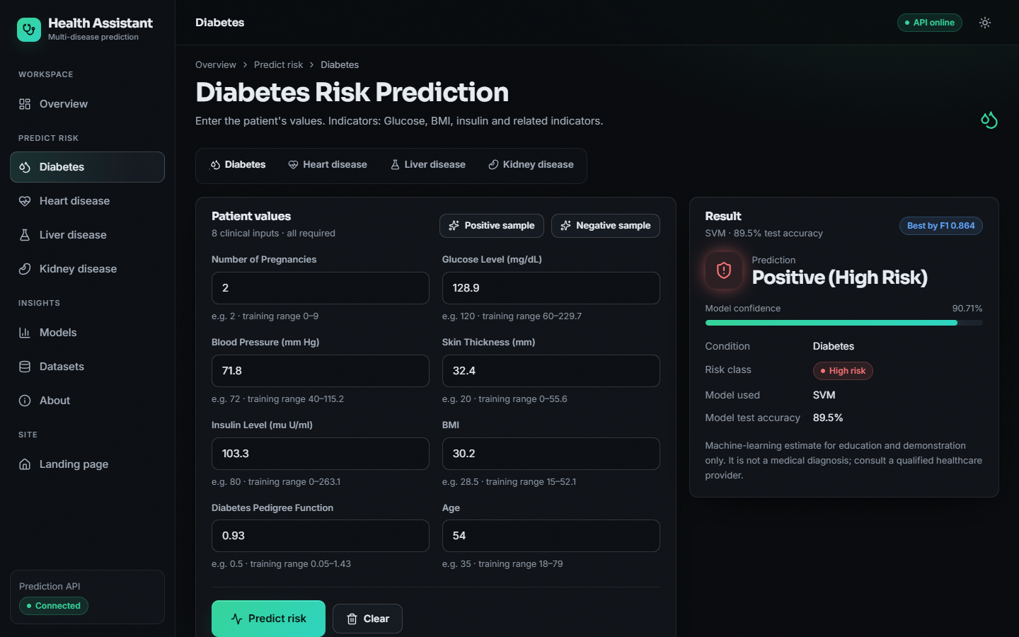  Figure 12: Diabetes prediction for a positive sample: Positive (High Risk), confidence 90.71%, SVM, test accuracy 89.5%

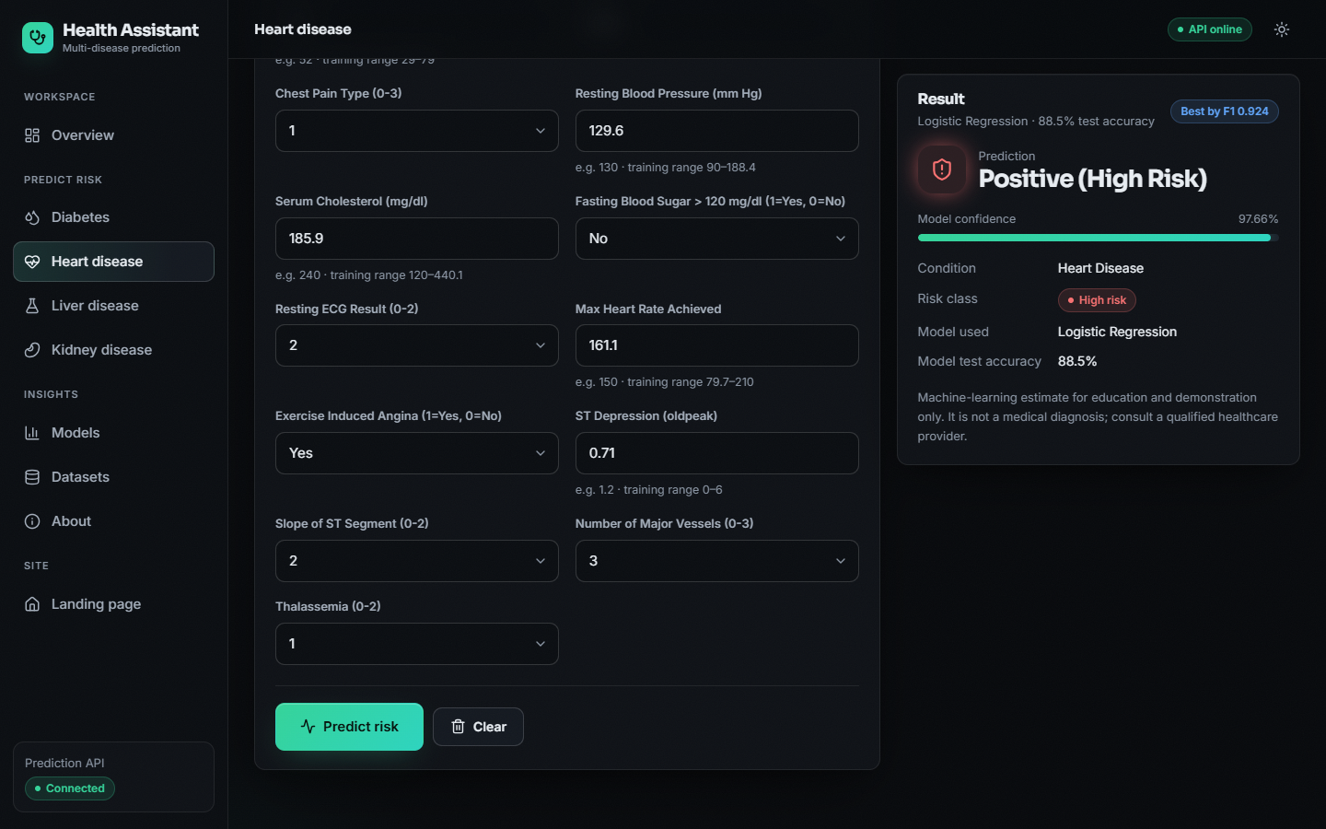  Figure 13: Heart disease prediction for a positive sample (Logistic Regression) | 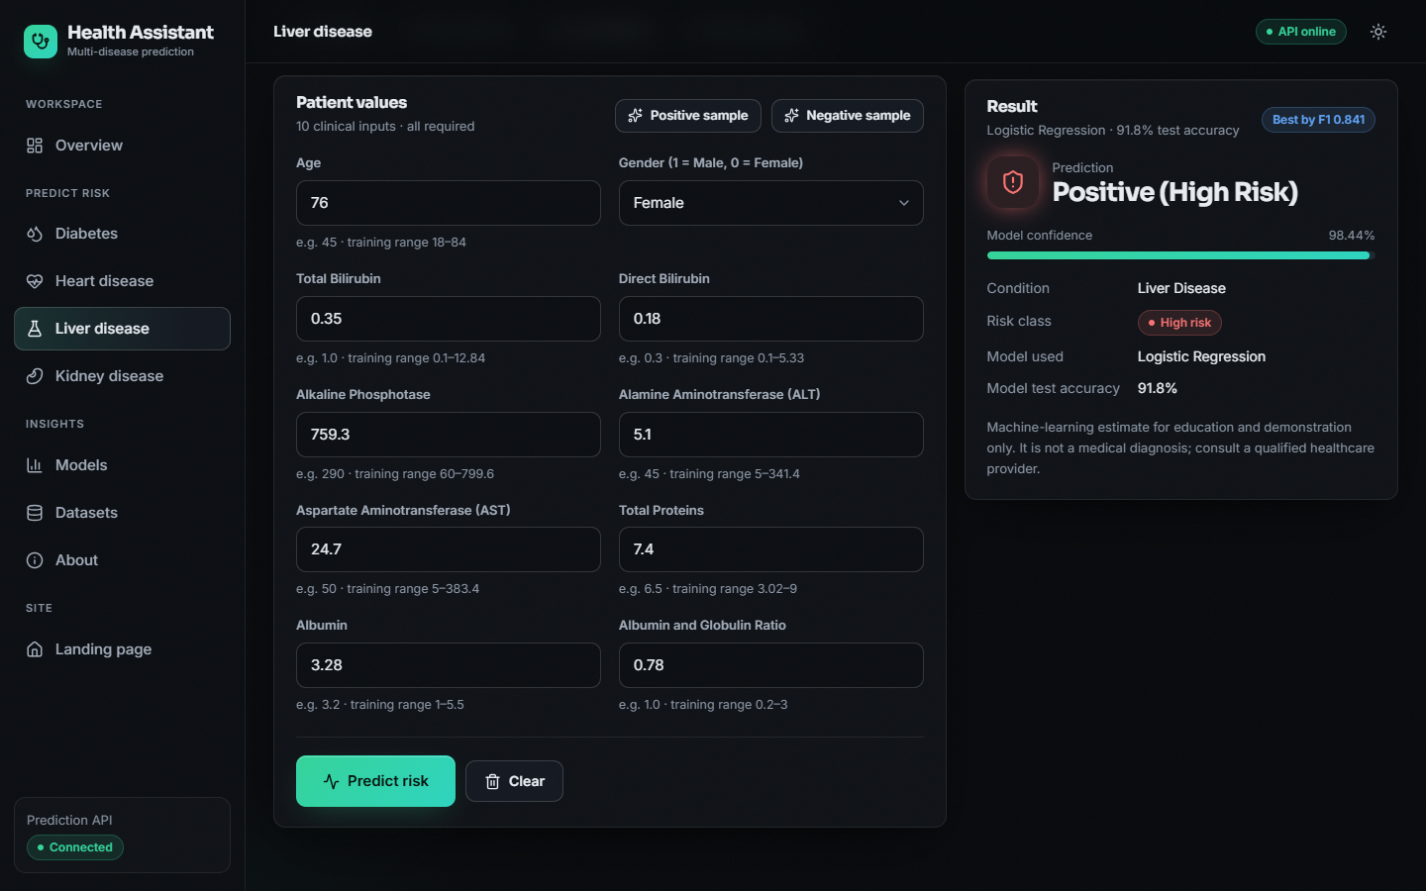  Figure 14: Liver disease prediction for a positive sample (Logistic Regression)

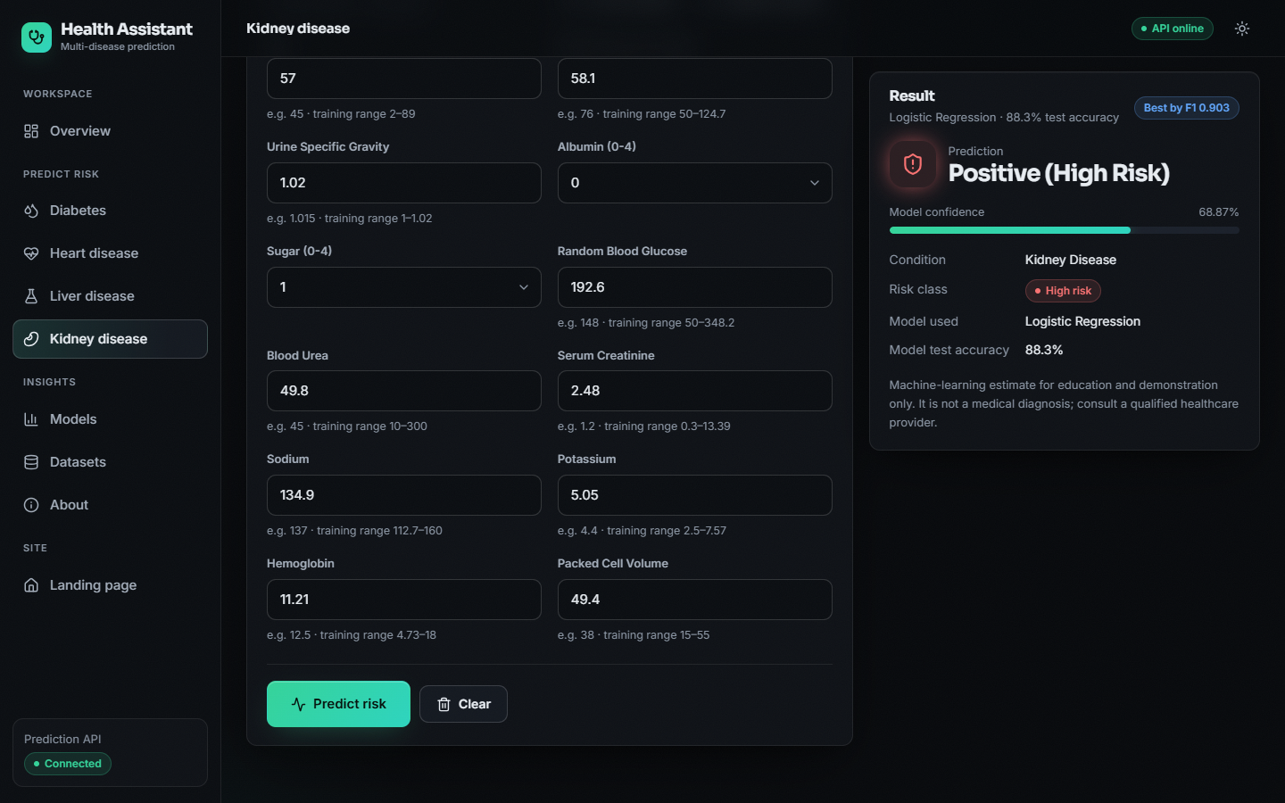  Figure 15: Kidney disease prediction for a positive sample (Logistic Regression) | 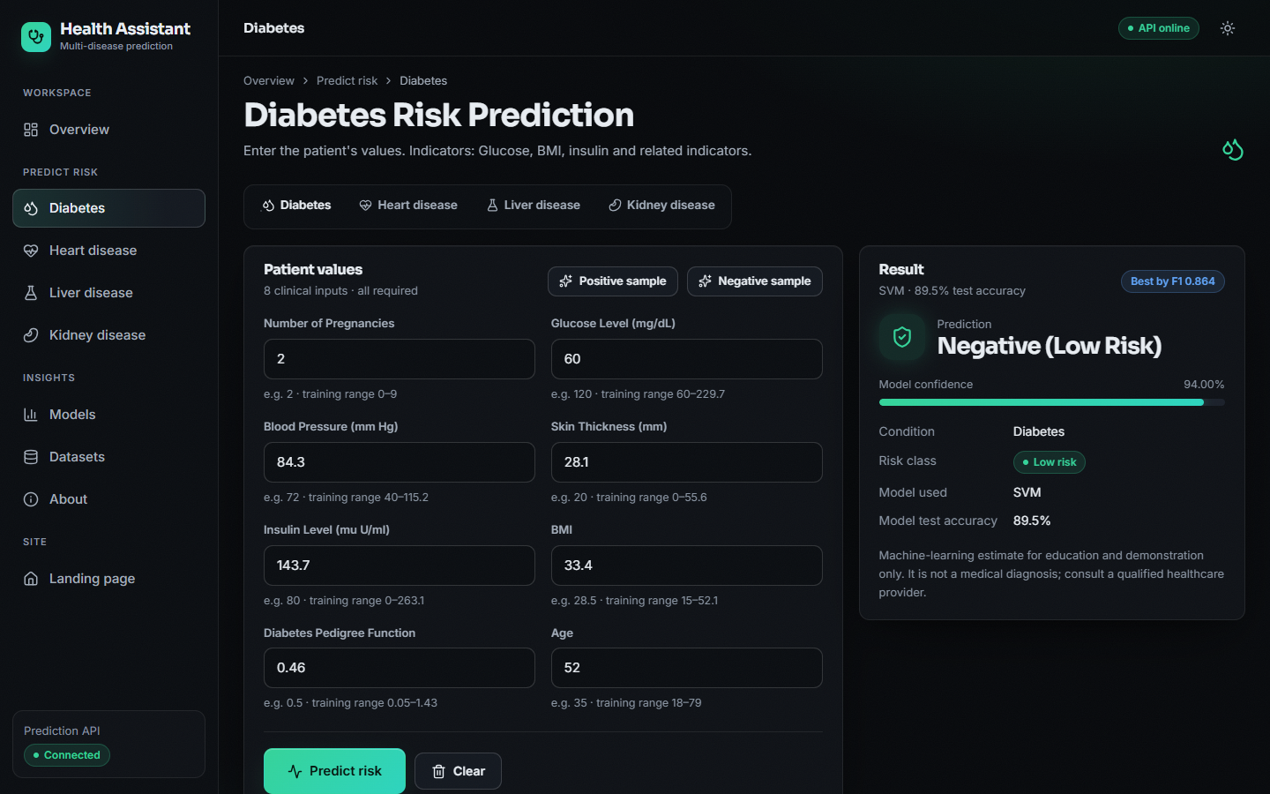  Figure 16: Diabetes prediction for a negative sample classified Negative (Low Risk)

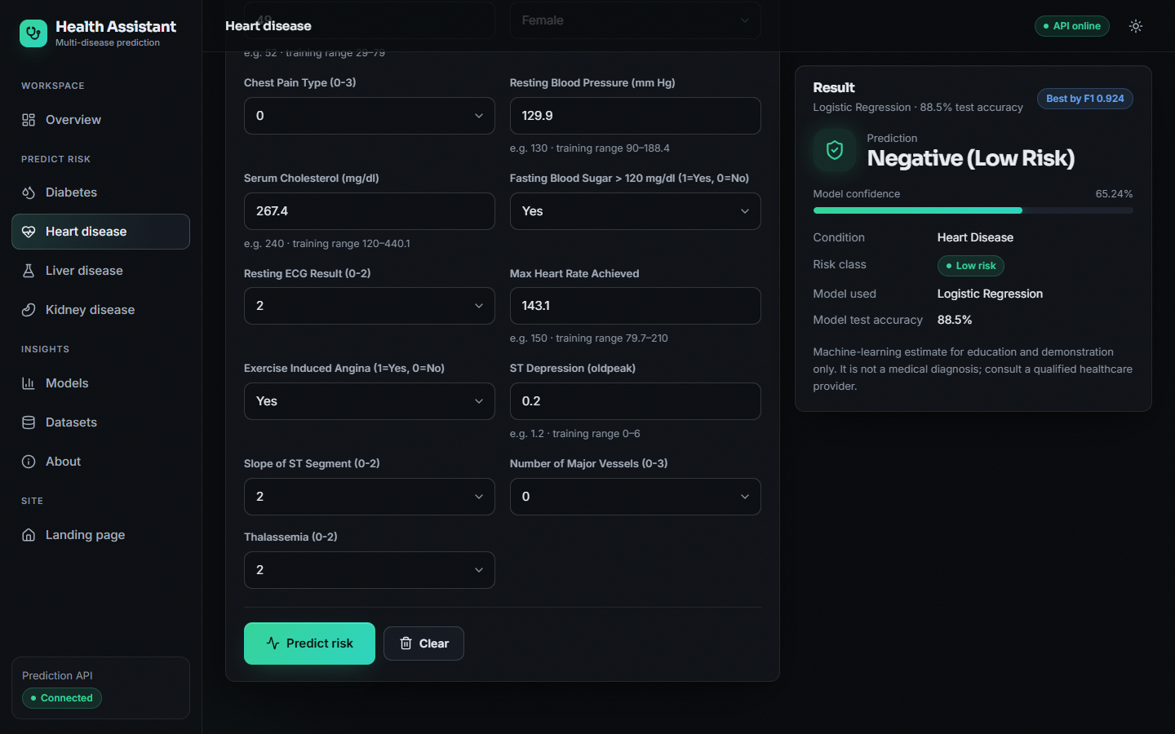  Figure 17: Heart disease prediction for a negative sample classified Low Risk | 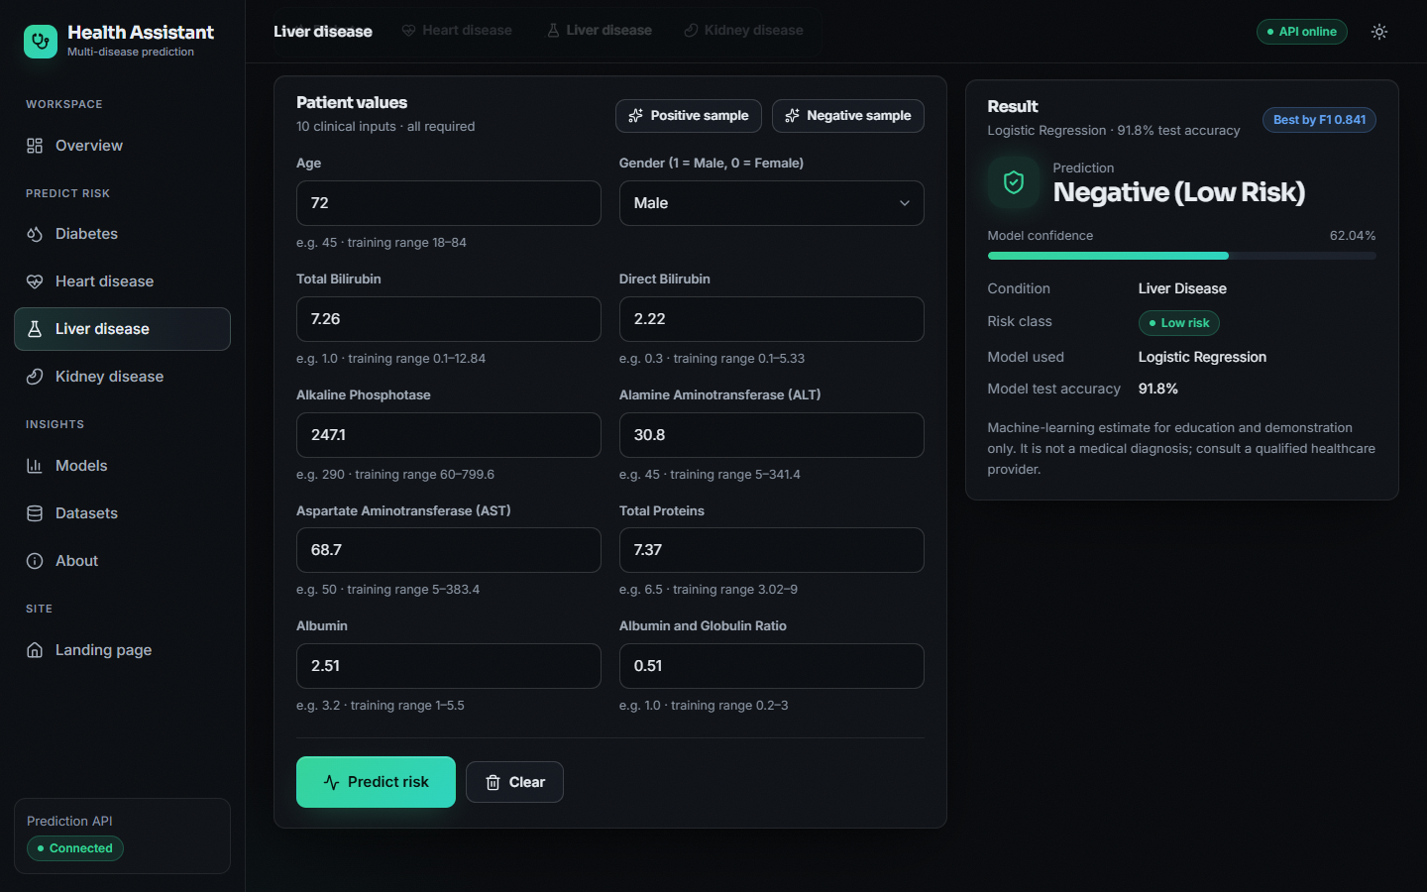  Figure 18: Liver disease prediction for a negative sample classified Negative (Low Risk)

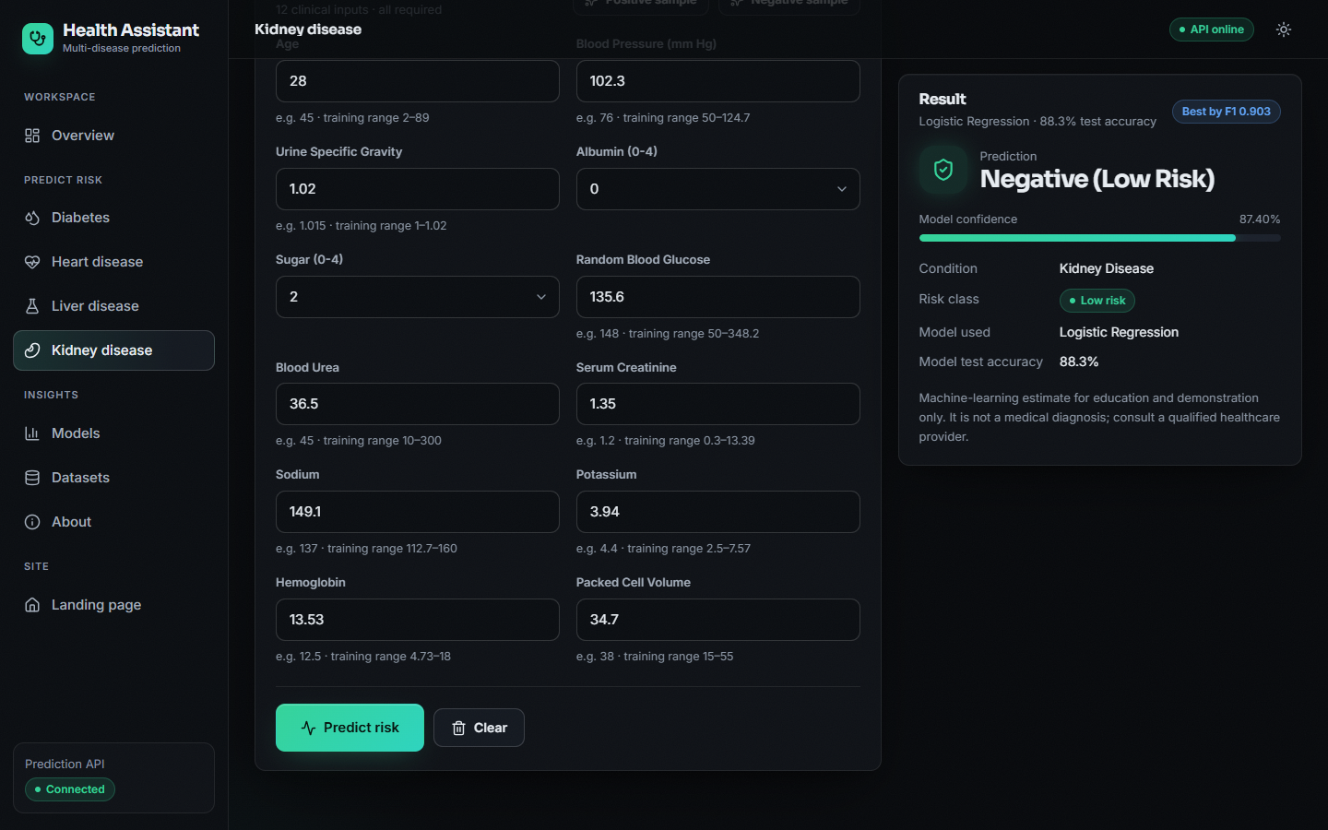  Figure 19: Kidney disease prediction for a negative sample classified Low Risk | 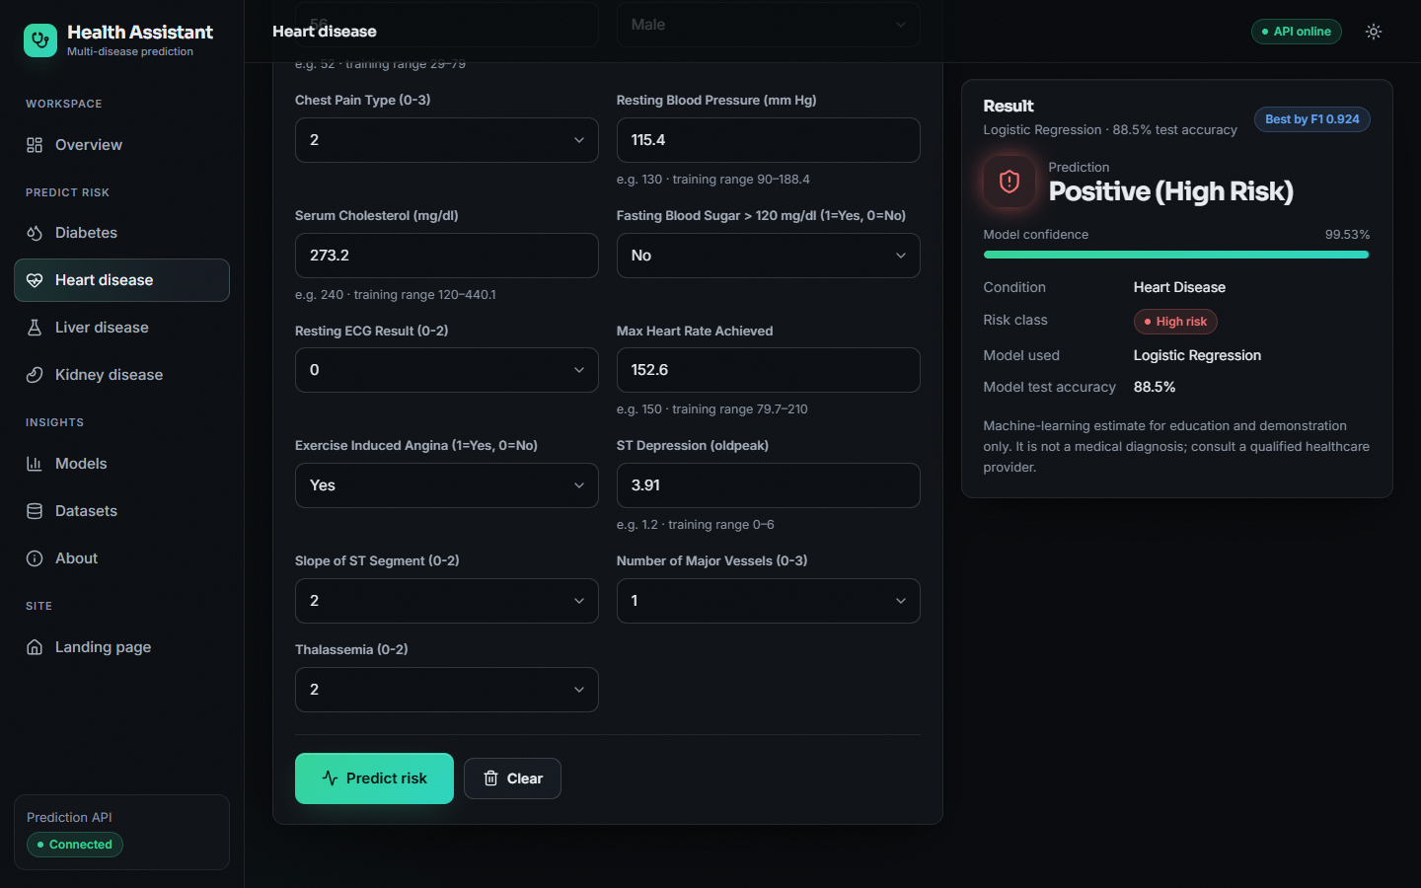  Figure 20: Failure case: a heart record labelled low-risk in the data that the model classifies Positive (High Risk) with 99.53% confidence

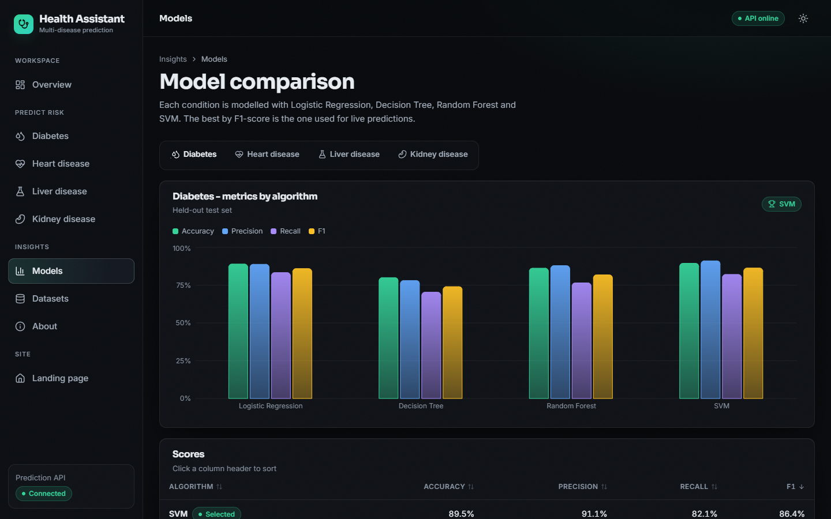  Figure 21: Models page: metric bars and sortable score table for the four algorithms (diabetes tab) | 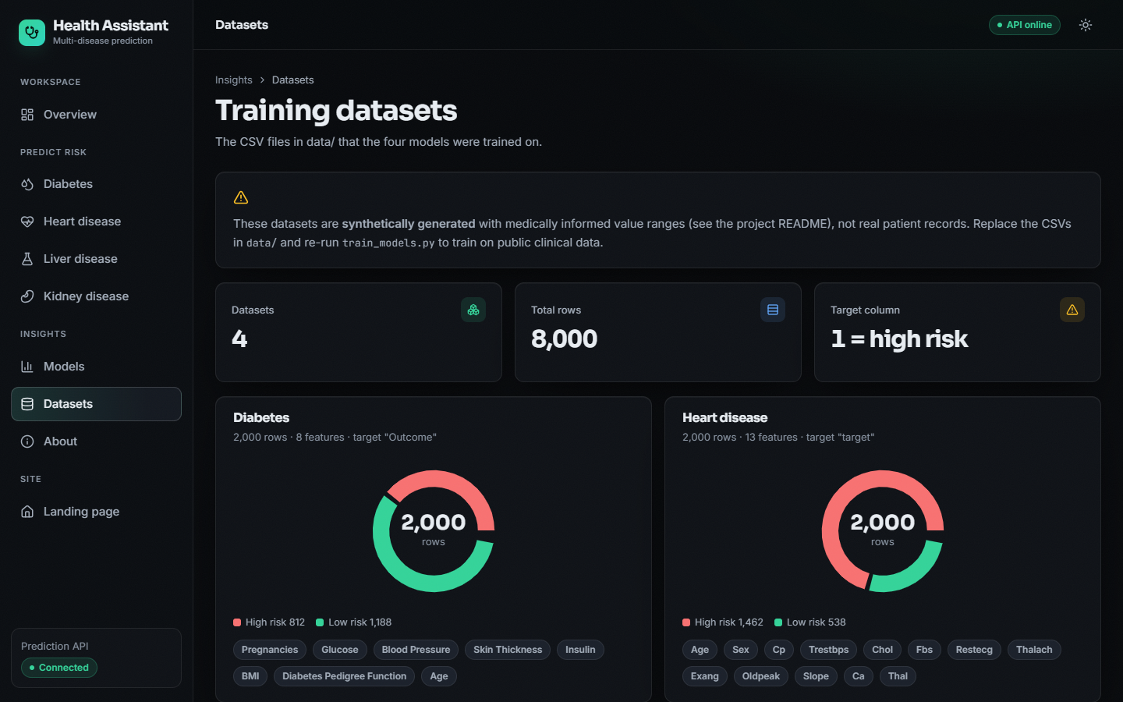  Figure 22: Datasets page: row counts and class balance of the four CSV files, with the warning that they are synthetic

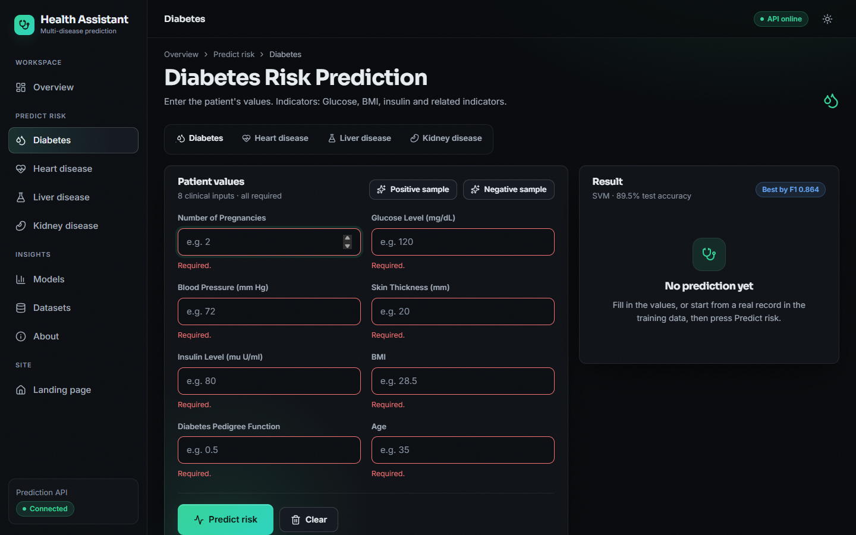  Figure 23: Validation: pressing Predict on an empty diabetes form marks all eight fields as required and does not call the API | 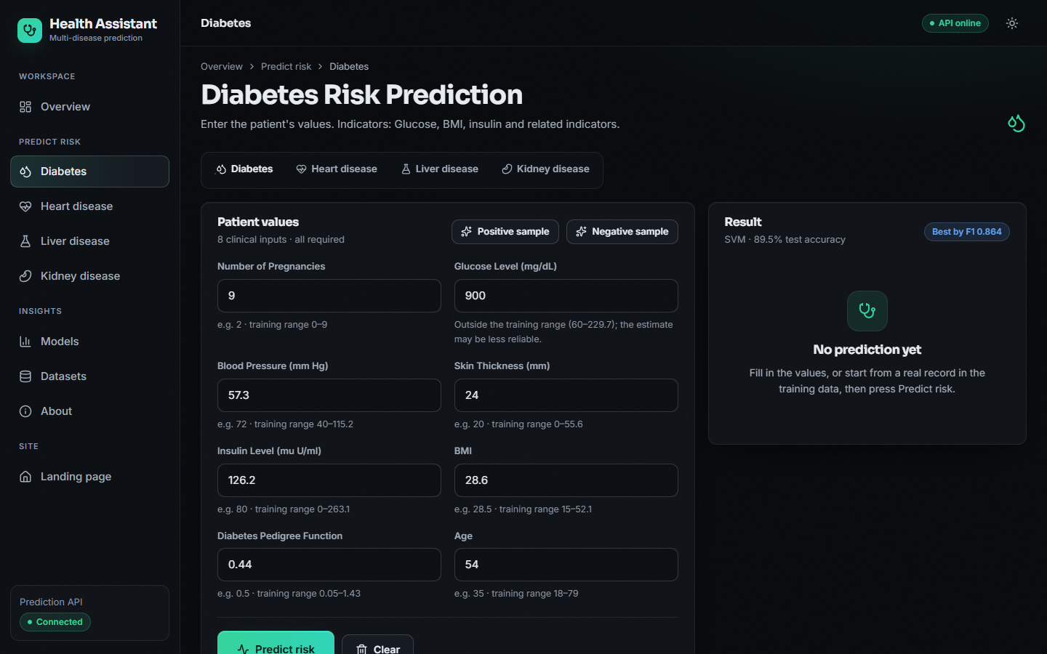  Figure 24: Out-of-range warning: a glucose of 900 mg/dL is outside the training range (60-229.7) and the form warns that the estimate may be less reliable

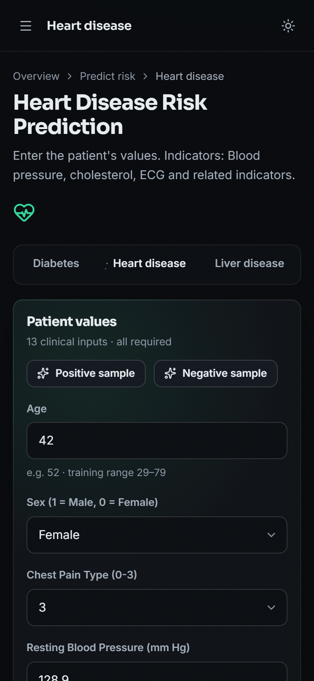
Figure 25: Phone layout (390 x 844 px): the heart form with a sample loaded and the sidebar collapsed into a menu

8.13 Objectives versus Outcomes
Table 16: Objectives of the project against what was measured
# | Objective | Status | Evidence
1 | Collect and clean benchmark datasets covering diabetes, heart disease, liver and kidney disorders. | PARTLY | Four datasets of 2,000 rows each exist, but they are synthetic (generated by generate_data.py), not benchmark data. Real benchmark data was used only in a separate supplementary check.
2 | Handle missing values, outliers and feature scaling through a common preprocessing pipeline. | PARTLY | All inputs pass through one StandardScaler step. The synthetic data contains no missing values or outliers, so no imputation or outlier handling was written.
3 | Train and compare Logistic Regression, Decision Tree, Random Forest and Support Vector Machine for each disease. | ACHIEVED | 16 models (4 algorithms x 4 diseases) were trained on the same split with fixed settings and compared.
4 | Select the best model per disease using accuracy, precision, recall and ROC-AUC. | PARTLY | Selection is by F1 on the test set. Accuracy, precision and recall are reported by the training script; ROC-AUC was not part of it and was measured afterwards in run_experiments.py.
5 | Serve the selected models behind a single interface that accepts one patient record. | ACHIEVED | A FastAPI + React application serves the four selected models through 7 API routes; 41 of 41 API checks passed. Each disease has its own form.
6 | Present a per-disease risk indication together with the parameters that drove it. | PARTLY | The risk class and the model's confidence are shown. The parameters that drove each prediction are not shown in the application; permutation importance exists only as an offline analysis.

Two further promises in the abstract are not met: the system does not produce "healthcare recommendations" and it does not perform feature selection. The result card shows only the class, the confidence and a not-a-diagnosis notice.

8.14 Discussion and Threats to Validity
• What the results support. The pipeline works end to end for four diseases; four classical algorithms can be compared fairly on one split; a linear model recovers a linear rule best; and an interface and API around the models respond in milliseconds.
• What they do not support. Any claim about accuracy on patients; a claim that Random Forest or SVM is better than Logistic Regression here; calibrated probabilities; or clinical usefulness.
• Data validity. The data are synthetic and the label is built from the same features the model sees, so the relationships are cleaner and more linear than in real data; the real-data check shows the gap.
• Statistical validity. Each test set has 400 rows (112 to 292 high-risk), so single-split differences of one to two points are noise; cross-validation and ten splits were added for that reason.
• Selection bias. The served model is chosen on the same test set that reports its score.
• Explanation validity. Importance was computed offline on the same data and mirrors the generator; it says nothing about clinical causes.
• Comparability. The base paper [1] and this project use different diseases, data and protocols; the metrics are not comparable.

