ATHENA - AUTONOMOUS TRIAGE AND HEALTHCARE ELECTRONIC NEURAL ASSISTANT
Results
Department of Computer Science and Engineering, TKR College of Engineering & Technology
Batch A7 (CSE-A) · Academic year [ACADEMIC YEAR]
Table 1: Project team
S.No. | Student name | Roll number
1 | Badaveni Srinath | 23K91A0523
2 | Basani Avinash | 23K91A0532
3 | Degala Praneeth | 23K91A0561
4 | Bontha Saisree | 23K91A0545

Project guide: K. Shalini
Chapter and section numbers quoted in the text (for example Chapter 8 or Section 6.2) refer to the full project report, 17.Final Document. Figures and tables in this document are numbered from 1.

1. RESULTS AND OUTPUT SCREENS
This chapter reports what was measured and what the running application shows. Section 8.1 describes the set-up and the data, Section 8.2 presents the output screens, Sections 8.3 to 8.9 give the triage-model results (headline metrics, eight model types, the effect of fusing the report with the vitals, calibration and confidence, the safety view, robustness to missed findings and what the model relies on), Section 8.10 the report-reading results, Section 8.11 the comparison with the base paper, Sections 8.12 and 8.13 sample output and the analysis of successes and failures, and Sections 8.14 and 8.15 the limits of the evaluation and the objectives against the outcomes. Every model figure is on seeded synthetic data. Where a result is weak it is reported as weak.

1.1 Experimental set-up
All measurements in this chapter were made on one machine: Intel Core i5-12500 (12 threads), 15.7 GB RAM, Windows 11 Pro, no GPU, Python 3.11.9, Node 24.19.0. The machine was shared with other programs while the experiments ran, so absolute timings are indicative; accuracy figures do not depend on load. Every figure and table below was produced from stored JSON by ml/train.py, ml/eval.py, scripts/run_experiments.py, scripts/extract_stress.py and scripts/measure_api.py; no result was typed in by hand.
A caution that applies to every number in this chapter: the triage model is trained and tested on seeded synthetic data. No real patient record was used. The 'recorded priority' that the model is scored against is a label produced by a hand-written severity rule plus noise, standing in for a clinician's recorded decision. A high score therefore means the model has recovered that rule; it is not evidence about agreement with clinicians or about patient outcomes.
Table 2: Data used in the evaluation
Item | Content | Source and status
Synthetic triage dataset | 6,000 rows, 36 inputs plus a priority from 1 to 5; priority shares P1 5.5%, P2 19.9%, P3 26.1%, P4 26.7%, P5 21.8% | Generated by ml/make_data.py (seed 7307) from seven clinical archetypes and a severity score with Gaussian noise (sd 0.4); not patient data
Split used by the shipped model | 3,840 fit / 960 calibration / 1,200 test (stratified) | Test rows never used for fitting or calibration
Generated sample reports | 12 files: 8 two-page PDFs and 4 PNG scans, each with an expected flag list | scripts/make_sample_reports.py; written with the reader's lexicon in view
Reader stress fragments | 40 hand-written fragments, 70 expected flags | scripts/extract_stress.py; written by the developers
Demo queue | 12 sample cases drawn from the hold-out rows, each labelled as sample data | Seeded into an empty database at start-up

Test conditions: the shipped model is XGBoost (220 trees, depth 4, learning rate 0.1) with isotonic calibration; the comparison models of Section 8.4 were trained on the same 3,840 fit rows without calibration and scored on the same 1,200 test rows. No significance test was run; spread is given by five further random splits and by 5-fold cross-validation.

1.2 Output screens
The captures below are real screens of the running application (Chrome, 1440 by 900 pixels), made by scripts/capture_screens.py with the backend and the React console running and data in every view. Screens 01 to 03, 05, 09 and 11 (landing page in both themes, sign-in, the empty intake form, the change dialog and the queue after a change) are shown in Appendix C of the full project report. The seeded queue holds 12 sample cases labelled as such; the live patient in the screens was entered through the interface.
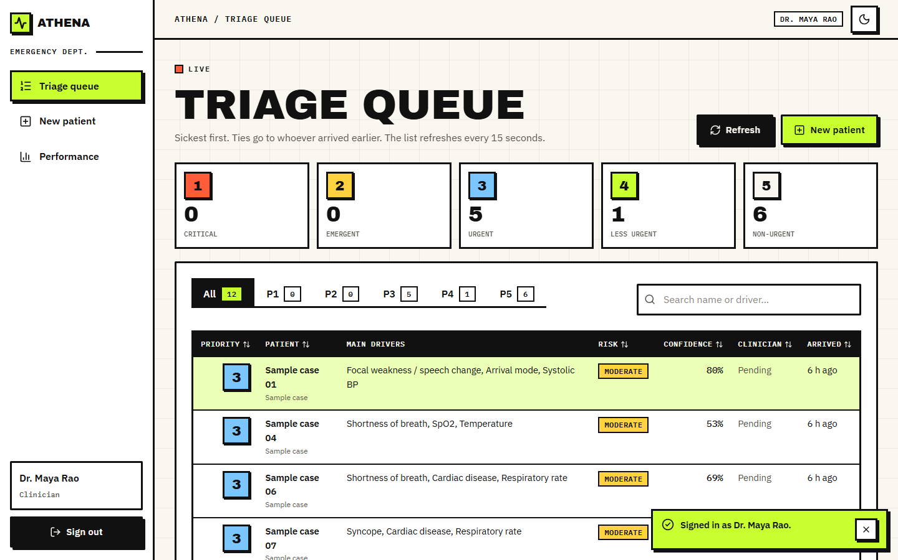
Figure 1: Output screen: the triage queue. Twelve sample cases, counts per priority along the top (0 / 0 / 5 / 1 / 6), filter tabs, a search box, and rows with the main drivers, risk level, confidence and arrival time.
The queue is the page a nurse returns to. Rows are ordered sickest first and, within one priority, by arrival time; the list refreshes every 15 seconds. The Main drivers column shows the three largest explanation items so that the reason is visible without opening the case. The Clinician column reads Pending until someone has accepted or changed the priority.
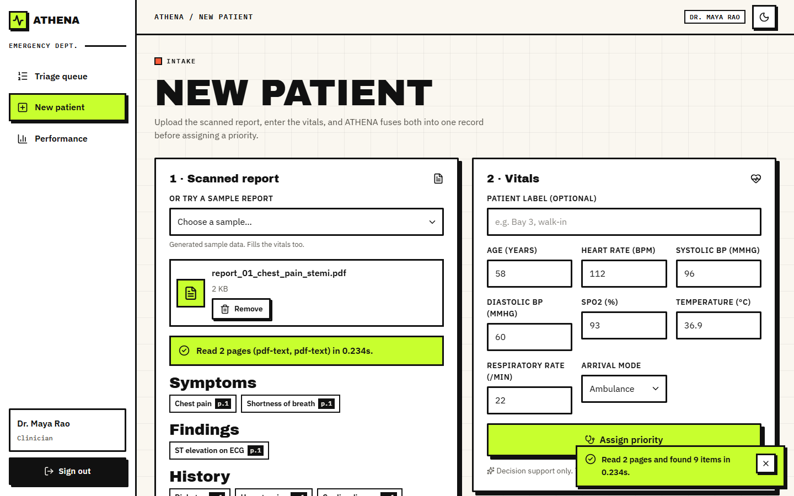
Figure 2: Output screen: new patient. Sample report 01 was chosen and read in 0.234 s; its symptoms, findings and history are listed with the page each came from, and the vitals fields were filled from the sample.
The intake screen shows the two inputs side by side: the scanned report on the left, the eight vitals on the right. A report can be uploaded or chosen from the generated samples, which also fills the vitals. Each extracted item carries a page badge (p.1, p.2), so the clinician can check it against the source page. The extracted items are read-only.
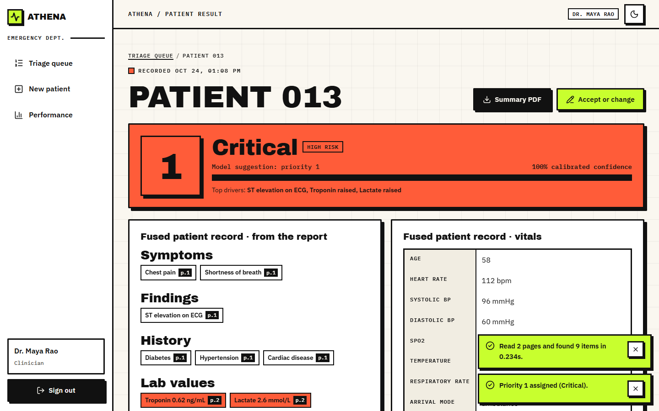
Figure 3: Output screen: result for the live patient. Priority 1 Critical, High risk, calibrated confidence 100 %, top drivers named, with the fused record (report items and vitals) below.
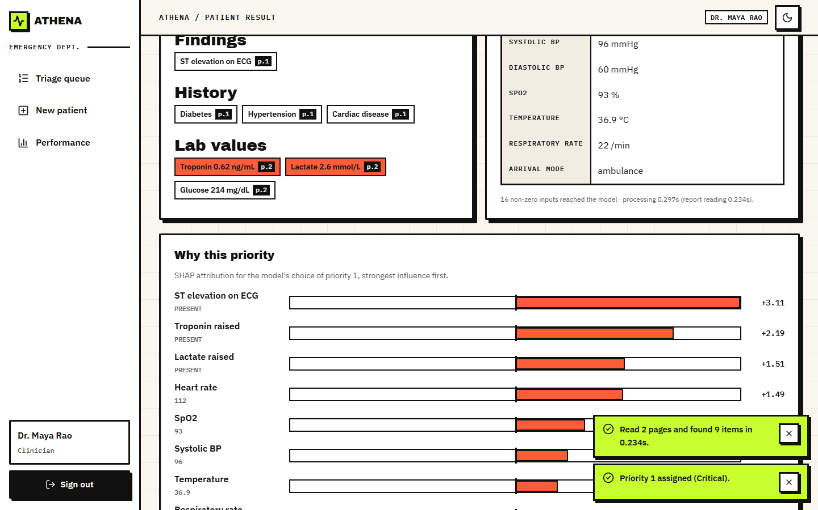
Figure 4: Output screen: why this priority. The report's findings with their pages, the vitals, and SHAP bars toward the chosen priority: ST elevation +3.11, troponin +2.19, lactate +1.51, heart rate +1.49.
The result screen shows the model's suggestion as a decision and its reasons. Laboratory values outside range are drawn in red with their units and pages. The SHAP list is ordered by absolute influence and names each factor with its value (for example heart rate 112). The same strongest factors appear in the queue row, so the explanation travels with the case.
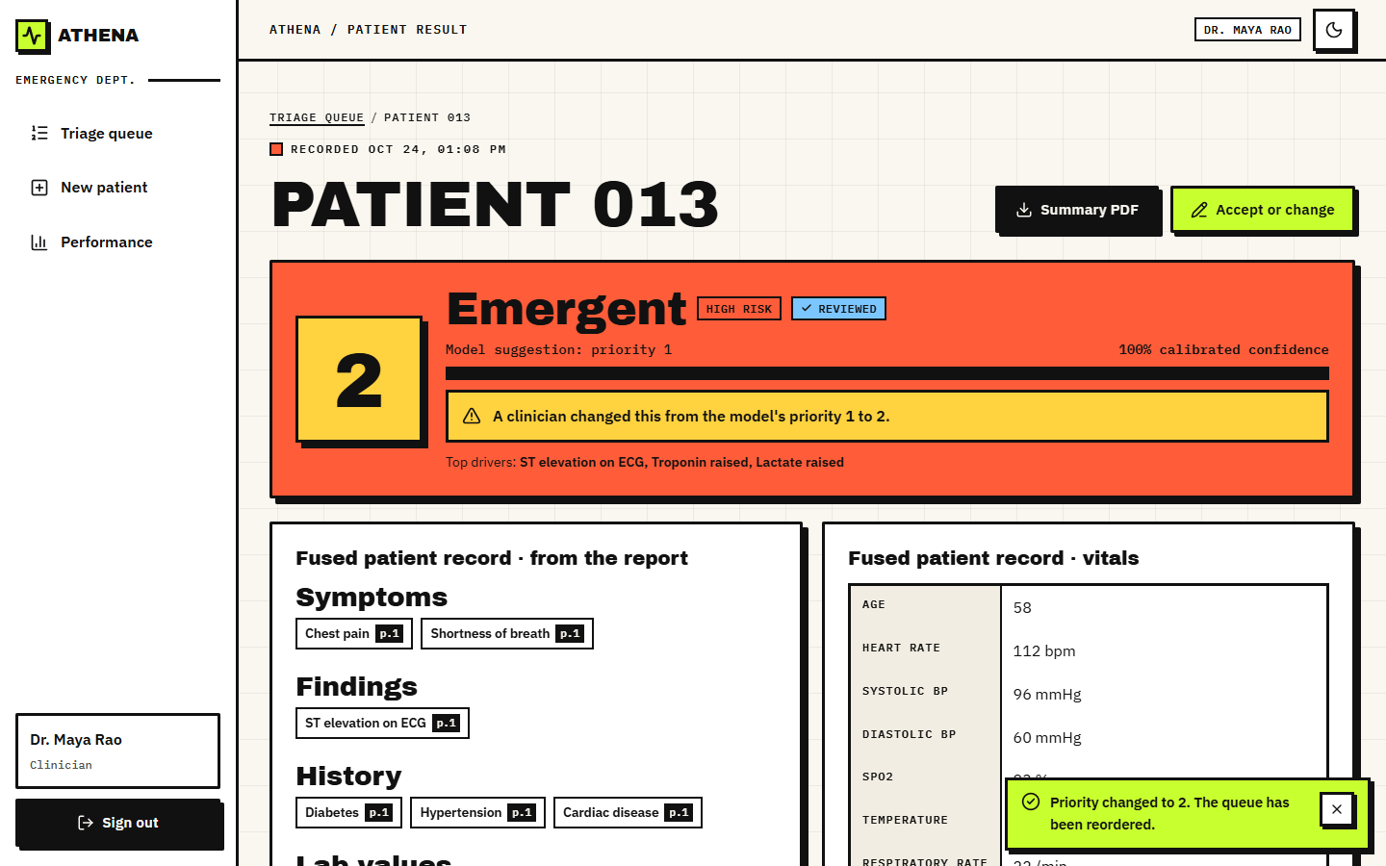
Figure 5: Output screen: after a clinician changed the priority from 1 to 2 with a reason. The banner states the change, the case is marked REVIEWED, and the model's original suggestion stays visible.
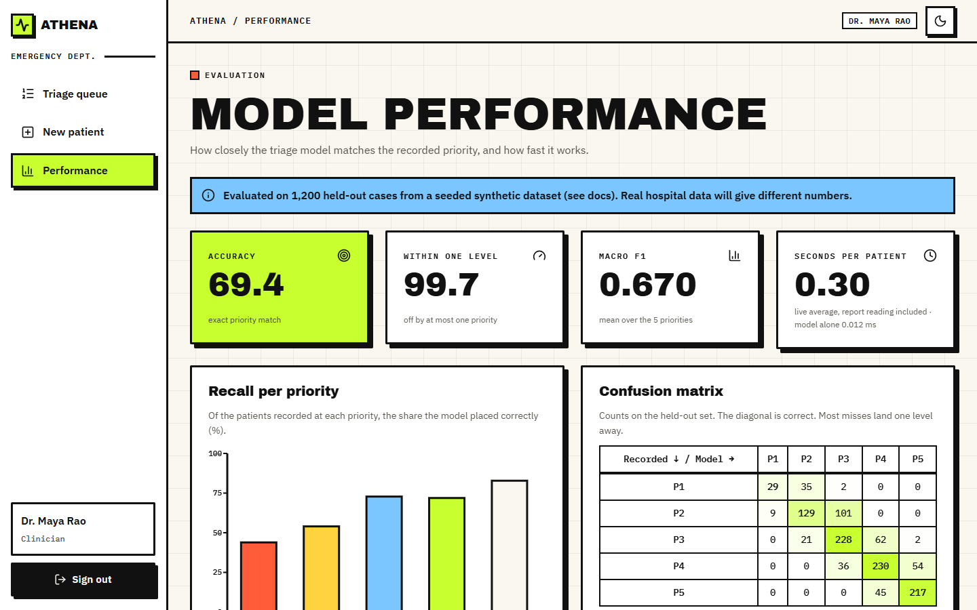
Figure 6: Output screen: model performance. Accuracy 69.4 %, within one level 99.7 %, macro F1 0.670, 0.30 s average per patient in that session, recall per priority and the confusion matrix. The blue banner states that the data are synthetic.
The performance page reads the stored evaluation and adds live counts. The banner at the top says the evaluation used a seeded synthetic data set and that real hospital data will give different numbers; it was kept deliberately where the numbers are. Of the 69.4 % exact accuracy and the per-priority recall bars, the weak bar is the first: recall for priority 1 is 43.9 %.

1.3 Triage model performance (synthetic hold-out)
On the 1,200 held-out synthetic cases the shipped model assigns the recorded priority exactly in 69.42% of cases and within one level in 99.67%. The macro F1 is 0.670, the quadratic weighted kappa 0.880 and the top-2 accuracy (recorded priority among the two most probable) 95.3%. Mean confidence is 0.732, close to the accuracy, as a calibrated model should give. Without calibration the same trees reach 68.25% accuracy and a macro F1 of 0.653, so calibration cost nothing in accuracy. Training took 0.44 s on the CPU.
Table 3: Shipped model: per-priority results on the 1,200 synthetic test cases.
Priority | Support | Recall | Precision | F1
P1 Critical | 66 | 43.9% | 76.3% | 0.558
P2 Emergent | 239 | 54.0% | 69.7% | 0.608
P3 Urgent | 313 | 72.8% | 62.1% | 0.671
P4 Less urgent | 320 | 71.9% | 68.2% | 0.700
P5 Non-urgent | 262 | 82.8% | 79.5% | 0.811

Table 4: Confusion matrix (rows: recorded priority, columns: model priority).
Recorded \ model | P1 | P2 | P3 | P4 | P5 | Total
P1 Critical | 29 | 35 | 2 | 0 | 0 | 66
P2 Emergent | 9 | 129 | 101 | 0 | 0 | 239
P3 Urgent | 0 | 21 | 228 | 62 | 2 | 313
P4 Less urgent | 0 | 0 | 36 | 230 | 54 | 320
P5 Non-urgent | 0 | 0 | 0 | 45 | 217 | 262

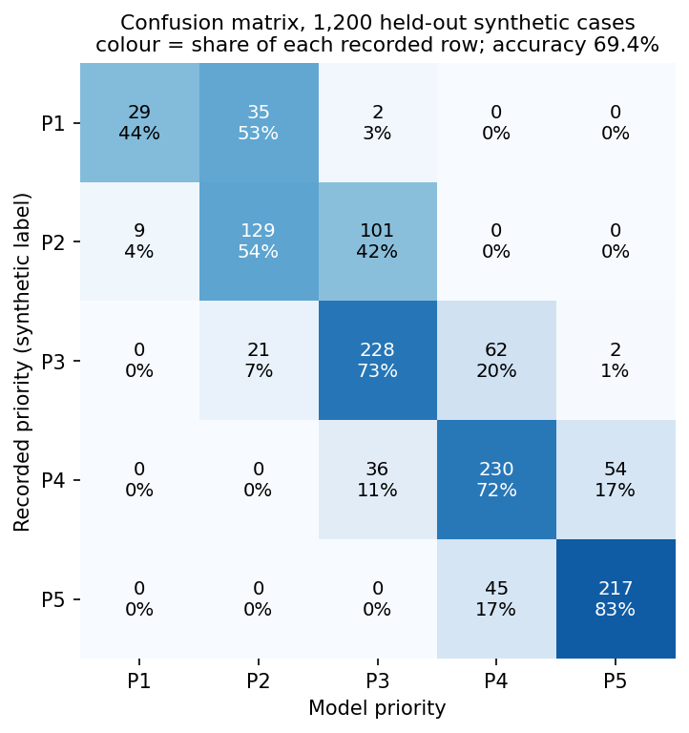
Figure 7: Confusion matrix of the shipped model on the synthetic hold-out set; the diagonal is correct, nearly every error is one level away.
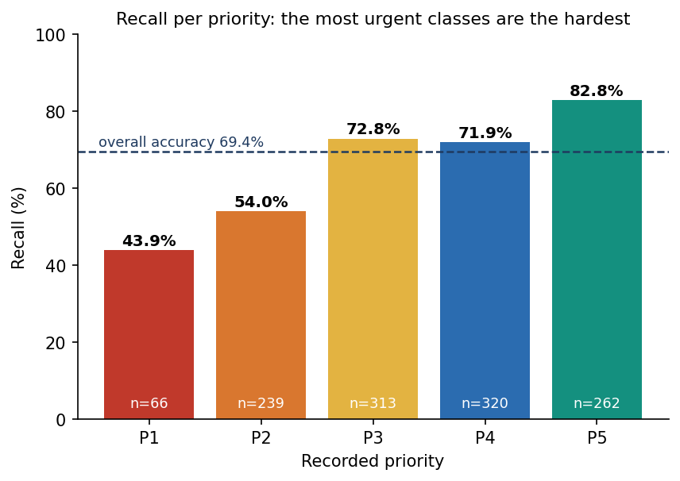
Figure 8: Recall for each priority on the synthetic hold-out set: highest for the non-urgent end, lowest for priority 1.
Two features of the matrix matter. First, the errors are almost all adjacent: only 4 of 1,200 cases are two levels off, and none further. Second, the two most urgent classes are the weakest. Priority 1 is rare (5.5% of the data, 66 test cases) and only 43.9% of those were found; 35 of the 66 were placed at priority 2. Priority 2 recall is 54.0%: 101 of 239 were placed at priority 3. The model leans toward the less urgent neighbour for the sickest patients, which is the safer-looking error to avoid and the more dangerous one to make (Section 8.7).
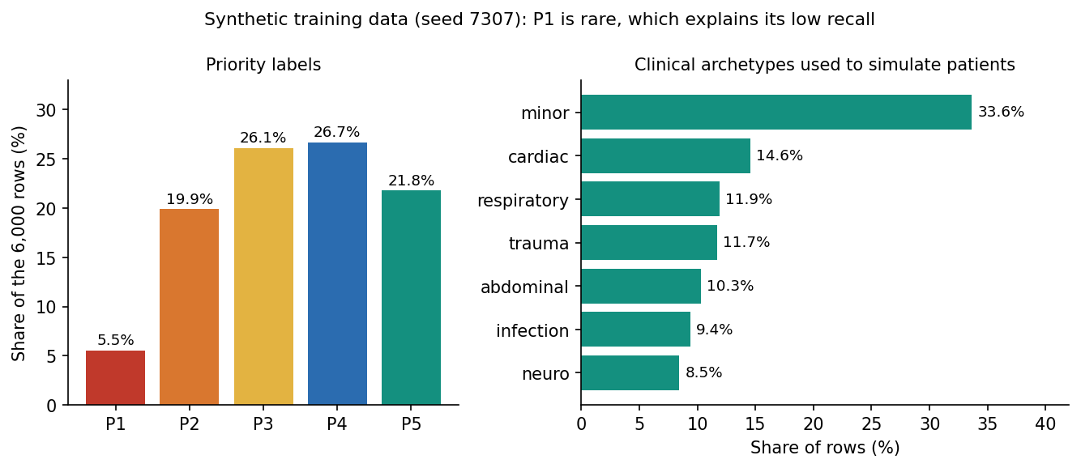
Figure 9: Priority shares of the synthetic dataset: priority 1 is about one case in eighteen.

1.4 Comparison of eight model types
The base paper's central exercise is to compare many classifiers on one task [1]. The same was done here on a smaller scale: eight model types on the same fit rows and the same test rows, all uncalibrated, with settings chosen once and not tuned (no search of the kind the base paper ran with Optuna).
Table 5: Eight model types on the synthetic hold-out set (same split, uncalibrated).
Model | Accuracy | Within 1 | Macro F1 | QWK | Top-2 | Fit s
Logistic regression | 72.4% | 99.7% | 0.727 | 0.897 | 96.4% | 0.07
Decision tree | 54.7% | 94.7% | 0.530 | 0.761 | 80.5% | 0.02
Random forest | 67.2% | 99.7% | 0.623 | 0.871 | 95.1% | 0.52
Extra trees | 69.1% | 99.2% | 0.653 | 0.872 | 94.3% | 0.50
k-nearest neighbours | 62.6% | 97.8% | 0.564 | 0.830 | 89.2% | 0.00
MLP | 70.9% | 99.3% | 0.701 | 0.888 | 97.2% | 6.07
HistGradientBoosting | 70.3% | 99.6% | 0.669 | 0.884 | 95.6% | 0.94
XGBoost (shipped config) | 68.2% | 99.7% | 0.653 | 0.877 | 95.5% | 0.48

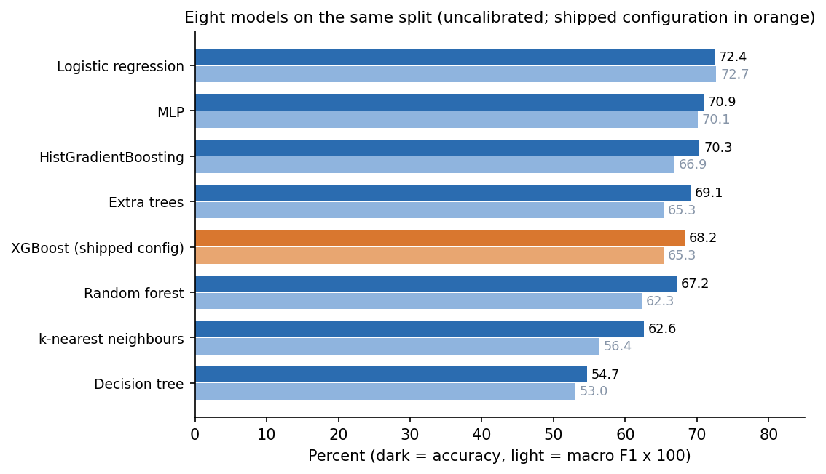
Figure 10: Accuracy and macro F1 of eight model types on the synthetic hold-out set.
The ranking is not the one the design implies. Logistic regression is the best single model (72.42% accuracy, macro F1 0.727) and the shipped gradient-boosted configuration reaches 68.25% uncalibrated (macro F1 0.653). The reason is in how the data were made: the label comes from an additive severity score, which a linear model can represent almost exactly, whereas trees must approximate it with steps. On real triage records, where interactions and thresholds matter, the order could be different, but this experiment cannot say so. The comparison agrees with the literature that tree ensembles are strong on tabular data [21], but it does not show an advantage for them here. The choice of XGBoost for the product rested on three other reasons: an exact and fast per-patient explanation with TreeExplainer [17], graceful handling of mixed binary and numeric inputs, and an established calibration recipe [18], [19]. A decision tree (54.7 %) and k-nearest neighbours (62.6 %) were clearly worse; the random forest and extra trees sit near the shipped model.
Stability was checked two ways. Five-fold cross-validation over all 6,000 rows gave 71.58% (sd 2.15%) for logistic regression, 71.12% (sd 0.91%) for the random forest and 72.37% (sd 1.52%) for XGBoost. Retraining the shipped recipe on five other splits gave a mean accuracy of 71.57% (sd 0.93%) and a mean macro F1 of 0.682. The shipped split (seed 7307, 69.42%) is therefore a below-average draw by about two points; the honest summary is 'about 70 % to 72 % exact accuracy'. Differences of one to two points between model types are inside this spread.
Table 6: Accuracy of the shipped recipe on five other splits.
Split seed | Accuracy | Within 1 | Macro F1 | QWK
1 | 72.50% | 98.83% | 0.696 | 0.882
2 | 71.58% | 99.25% | 0.670 | 0.887
3 | 72.50% | 99.75% | 0.706 | 0.895
4 | 70.00% | 99.50% | 0.657 | 0.883
5 | 71.25% | 99.25% | 0.679 | 0.883

A ceiling. Because the labels are the severity score plus noise, there is a best possible exact accuracy. A reader that knew the noiseless severity score would reproduce 86.25% of the recorded priorities (and 100% within one level). No model can exceed about 86%. The shipped model's 69.4% is about 17 points below that ceiling; the gap is learning error, mostly on the rare urgent classes.

1.5 What fusing the report with the vitals adds
The gap named in the literature survey is that surveyed models use one modality of structured data. To measure what the second modality adds, the same XGBoost configuration was trained on subsets of the 36 inputs and scored on the same synthetic test cases.
Table 7: Modality ablation (XGBoost, uncalibrated, synthetic hold-out).
Inputs used | Inputs | Accuracy | Within 1 | Macro F1 | QWK | Top-2
Vitals only (8) | 8 | 40.6% | 82.2% | 0.367 | 0.489 | 70.3%
Vitals + lab flags (14) | 14 | 46.9% | 87.9% | 0.429 | 0.608 | 77.8%
Vitals + text flags (30) | 30 | 61.5% | 96.9% | 0.577 | 0.824 | 89.7%
Report only (28) | 28 | 63.2% | 97.2% | 0.615 | 0.835 | 92.2%
Fused (36) | 36 | 68.2% | 99.7% | 0.653 | 0.877 | 95.5%

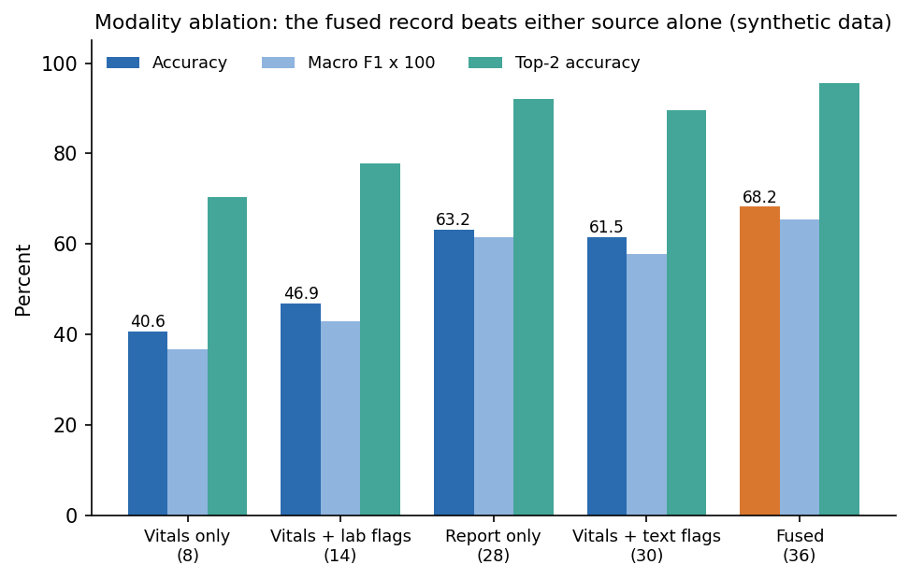
Figure 11: Accuracy and macro F1 for vitals only, report only and the fused record (synthetic hold-out).
The fused record is 27.7 points more accurate than the vitals alone (40.6%) and 5.1 points more accurate than the report alone (63.2%). Within-one accuracy tells the same story: 82.2% for vitals, 99.7% fused. The text flags carry most of the report's value (vitals plus text flags 61.5%); the six laboratory flags add less on their own (vitals plus labs 46.9%). This supports the design, but with the same caveat as every result here: the synthetic generator draws the labels from both the vitals and the report flags, so the data were built to reward fusion. How much a real report adds is an open question that only real records can answer.

1.6 Calibration and the confidence threshold
A triage tool shows a confidence next to the priority, so that number should mean something. Isotonic calibration on a separate split lowered the expected calibration error (10 bins, top label) only modestly, from 0.0466 to 0.0412, and the summed multiclass Brier score from 0.4187 to 0.4104. Mean confidence rose from 0.646 to 0.732, against an accuracy of 69.4%. The uncalibrated model was already under-confident; calibration corrected that. The reliability bins show where it is still wrong:
Table 8: Reliability bins of the calibrated model (synthetic hold-out).
Confidence bin | Cases | Mean confidence | Observed accuracy
0.3 to 0.4 | 9 | 0.383 | 0.222
0.4 to 0.5 | 57 | 0.471 | 0.404
0.5 to 0.6 | 189 | 0.542 | 0.524
0.6 to 0.7 | 240 | 0.650 | 0.658
0.7 to 0.8 | 325 | 0.745 | 0.714
0.8 to 0.9 | 138 | 0.847 | 0.659
0.9 to 1.0 | 242 | 0.953 | 0.942

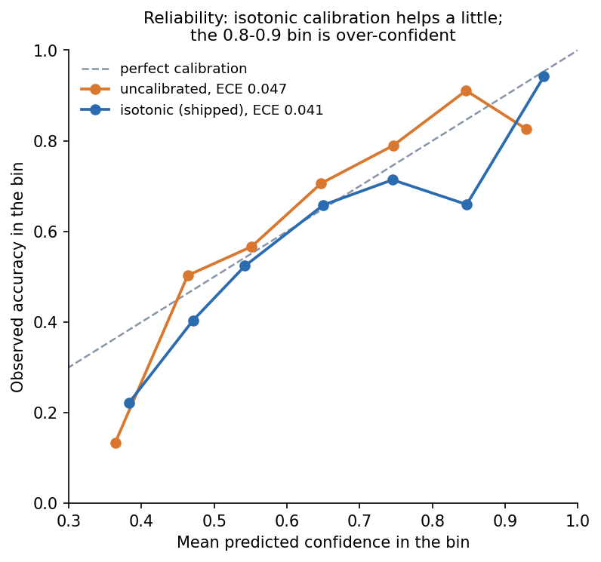
Figure 12: Reliability diagram of the calibrated and uncalibrated model on the synthetic hold-out set.
The bins from 0.5 to 0.8 are close to the diagonal. The 0.8 to 0.9 bin is over-confident: 138 cases with a mean confidence of 0.847 were right only 65.9% of the time. Confidence is therefore a useful ranking signal, not a probability to quote to a patient. This is the modest end of what calibration literature reports for non-neural models [20].

1.6.1 Accuracy against coverage
The base paper accepts a diagnosis as highly probable when its probability exceeds 0.85 and reports that such predictions are more accurate than the average [1]. The same analysis was made here: how accurate is the model on the cases where it is more confident, and how many cases are left?
Table 9: Accuracy of the calibrated model when only cases above a confidence threshold are kept (synthetic hold-out).
Threshold | Coverage | Cases | Accuracy | Within 1
0.00 | 100.0% | 1200 | 69.4% | 99.7%
0.50 | 94.7% | 1136 | 71.2% | 99.8%
0.60 | 78.8% | 945 | 75.0% | 99.8%
0.70 | 58.8% | 705 | 78.2% | 99.7%
0.80 | 31.8% | 382 | 84.0% | 100.0%
0.85 | 25.5% | 306 | 87.6% | 100.0%
0.90 | 20.2% | 242 | 94.2% | 100.0%
0.95 | 9.7% | 116 | 94.8% | 100.0%

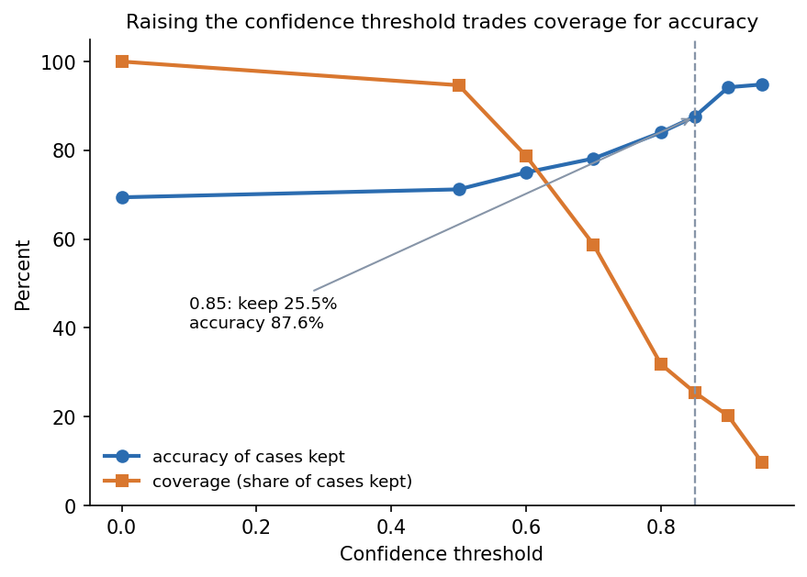
Figure 13: Exact accuracy and coverage as the confidence threshold is raised (synthetic hold-out).
Accuracy rises from 69.4% for all cases to 87.6% at a threshold of 0.85, but that threshold keeps only 25.5% of the cases; at 0.9 the figures are 94.2% and 20.2%. ATHENA does not apply any threshold: every case gets a priority. The table shows what a 'confident cases first, others to a senior nurse' rule could look like. It was computed on the test set, so it describes the trade-off and is not a tuned operating point.

1.7 The safety view: under-triage and missed high-risk cases
Accuracy treats every error alike, but in triage an error that sends a sicker patient down the queue is worse than one that moves a well patient up. The errors were therefore split by direction.
Table 10: Direction and size of the model's errors (synthetic hold-out, 1,200 cases).
Measure | Value
Under-triage: model less urgent than recorded | 21.33%
Over-triage: model more urgent than recorded | 9.25%
Under-triage by two or more levels | 0.33% (4 cases)
Over-triage by two or more levels | 0.00%
Recorded priority 1 placed at priority 3 or less urgent | 2 of 66
High risk (P1 or P2) found at arg-max: recall / precision (305 cases) | 66.2% / 90.6%
High risk found when P(1) + P(2) is at least 0.4 (not implemented): recall / precision | 84.3% / 81.6%

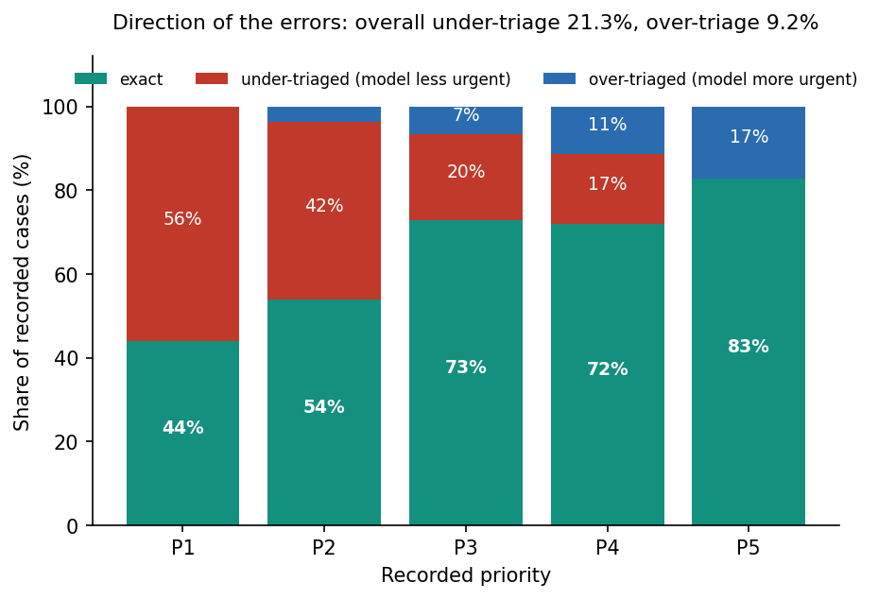
Figure 14: Under-triage and over-triage rates of the shipped model on the synthetic hold-out set.
The model under-triages 21.3% of cases and over-triages 9.2%: it errs toward the less urgent side more than twice as often as toward the more urgent. Almost all of this is one level. For the question that matters most, 'is this patient high risk?', recall at arg-max is only 66.2% with precision 90.6%, so about one high-risk case in three is labelled Moderate or Low. Raising an alarm whenever the combined probability of priorities 1 and 2 reaches 0.4 would lift recall to 84.3% at a precision of 81.6%. That rule is not in the product; it is the most direct improvement the results suggest (Chapter 10). Until then, a clinician must review every priority, which is what the override loop is for. These figures are on synthetic data and are consistent with the known tendency of triage scales themselves to miss critical illness [9].

1.8 Robustness to missed report findings
The base paper stresses that clinical records are incomplete and treats an unreported symptom as absent rather than imputing it [1]. ATHENA follows the same rule: a report flag that the reader does not find is 0. To see what that costs, each positive report flag in the test set was removed with a given probability before scoring, imitating a reader that misses findings. The vitals were left intact.
Table 11: Accuracy when report findings are dropped at random (shipped model, synthetic hold-out).
Probability a finding is dropped | Accuracy | Within 1 | Macro F1 | Top-2
0.0 | 69.4% | 99.7% | 0.670 | 95.3%
0.1 | 66.2% | 98.1% | 0.633 | 93.1%
0.2 | 62.1% | 96.3% | 0.594 | 90.1%
0.3 | 59.5% | 95.0% | 0.565 | 88.4%
0.5 | 50.9% | 89.5% | 0.465 | 81.8%
1.0 (no report) | 33.9% | 70.4% | 0.246 | 64.0%

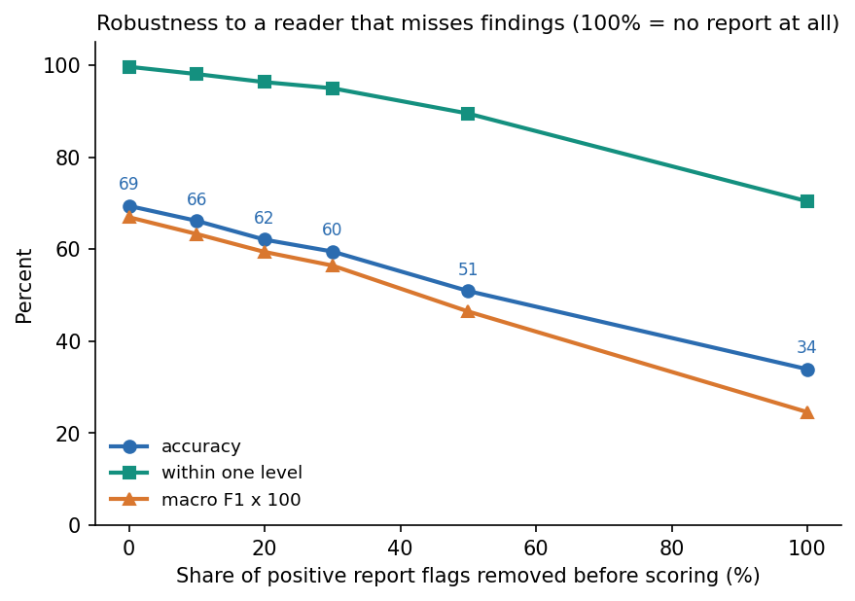
Figure 15: Accuracy and within-one accuracy as report findings are dropped at random.
The model degrades gradually: 66.2% accuracy when one finding in ten is missed, 62.1% at one in five, and 33.9% with no report at all (within-one 70.4%). A missed finding is costly. The report reader's recall on the stress fragments is 84.3%, which puts real use nearer the 0.1 to 0.2 rows than the 0.0 row; on wording outside the lexicon it is far lower. The result also shows why the reader is the part of the system to improve first (Chapter 10).

1.9 What the model relies on
Averaging the absolute SHAP attribution over all test cases and classes gives a global picture of the inputs the model uses [16], [17].
Table 12: Ten largest mean absolute SHAP values (synthetic hold-out).
Rank | Input | Mean |SHAP|
1 | SpO2 | 0.422
2 | Arrival mode | 0.325
3 | Shortness of breath | 0.271
4 | Systolic BP | 0.237
5 | Respiratory rate | 0.235
6 | ST elevation on ECG | 0.228
7 | Focal weakness / speech change | 0.220
8 | Troponin raised | 0.213
9 | Chest pain | 0.200
10 | Lactate raised | 0.177

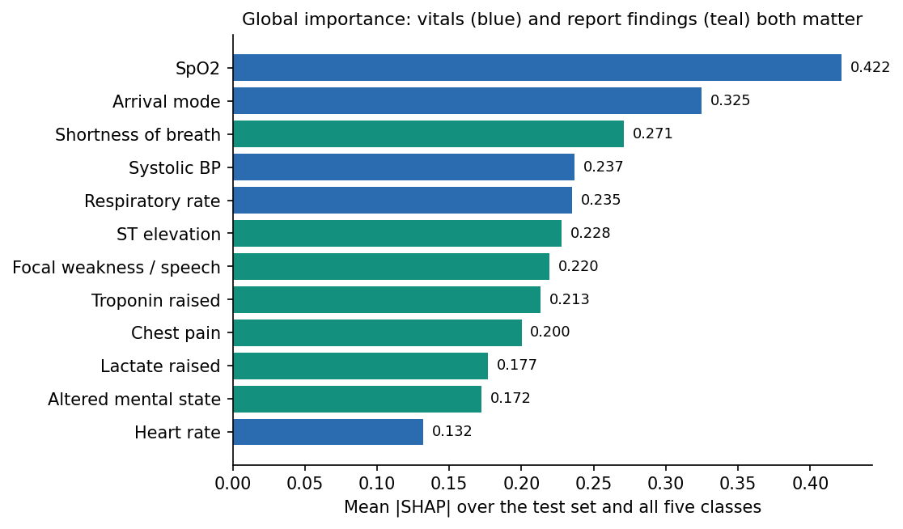
Figure 16: Mean absolute SHAP value of the fifteen most influential inputs on the synthetic hold-out set.
Oxygen saturation, arrival mode, shortness of breath, blood pressure and respiratory rate lead, followed by ST elevation, focal weakness, raised troponin and chest pain. That is what the synthetic severity rule rewards, so the ranking is a check that the explainer reports what the model learned and that the model learned the rule; it is not clinical validation. Whether the explanation is useful to a clinician is untested.

1.10 Report reading
On the 12 generated sample reports (8 PDFs and 4 PNG scans read through OCR) the reader found every expected flag and no extra one: precision 100%, recall 100%, 12 of 12 read exactly. That figure shows that the pipeline works end to end; it does not show that real scans are solved, because these reports were written and drawn with the lexicon in view. On the 40 hand-written stress fragments the figures are lower and more informative: precision 95.2%, recall 84.3%, 27 of 40 read exactly. Wording the lexicon contains (plain statements, abbreviations, laboratory values, history) was read almost perfectly; negation edge cases, OCR-damaged words and paraphrases were not (Section 7.6).
Reading time per patient (ml/eval.py, 12 samples): mean 1.26 s, median 0.017 s, maximum 4.32 s from upload to priority. A text PDF is read in a few milliseconds; a scan takes 2 to 5 s on the CPU. Over HTTP the median for a text PDF through to a priority is 30 ms and for a scan 2.1 s.

1.11 Comparison with the base paper
The two studies are not comparable on accuracy, and no claim is made that ATHENA outperforms the base paper. They differ in task (diagnosis among 87 ICD-10 classes against a five-level priority), in data (real clinical cases against a synthetic generator), in input (typed indicators against a scanned report fused with vitals), and in metric difficulty. A five-class problem with an ordinal structure and a rule-generated label is a different, easier kind of problem than 87-class diagnosis from incomplete real records, so a higher or lower accuracy in either direction would prove nothing. The table sets the two side by side by feature.
Table 13: The base paper [1] and ATHENA, feature by feature.
Aspect | Base paper | ATHENA (synthetic data)
Task | Diagnosis as an ICD-10 class (87 classes, 32 in paediatrics, 55 in internal medicine) | Triage priority, 5 ordered classes, plus risk level
Data | 1,655 real clinical cases (616 internal medicine, 1,039 paediatrics); external check on 120 cases | 6,000 synthetic rows; no real data, no external check
Input | 479 typed symptom, sign and laboratory indicators; missing = absent | Scanned report (OCR + lexicon) fused with 8 vitals into 36 inputs; missing = absent
Models compared | 19 algorithms, Optuna tuning (100 trials each) | 8 model types, settings not tuned
Best exact accuracy | Gradient Boosting 84.74% (internal medicine); Multi-Layer Perceptron 87.20% (paediatrics) | Logistic regression 72.42%; shipped XGBoost 69.42% (synthetic)
Ranked output | TOP-3: mean 77.43% / 81.99%; best 91.72% / 94.71% | Top-2 95.3% (2 of 5 classes; not the same difficulty as 3 of 87)
High-confidence threshold | 0.85, 'highly probable'; sensitivity analysis 0.70 to 0.95 | Threshold table (Section 8.6): at 0.85 coverage 25.5%, accuracy 87.6%
Explanation | SHAP and LIME, global, by ICD-10 block | SHAP only, per patient, shown beside each decision; no LIME
Incomplete data | No imputation; analysis of six kinds of incompleteness | No imputation; dropped-finding experiment (Section 8.8): 62.1% at 20 % dropped
Statistics | Bootstrap 95 % intervals, McNemar tests | Five splits and 5-fold cross-validation; no significance test
Scanned documents | Not handled | Reader recall 100 % on generated samples, 84.3% on stress fragments
Time per case | Not reported in the sections read | Median 30 ms (PDF) and 2.1 s (scan) over HTTP

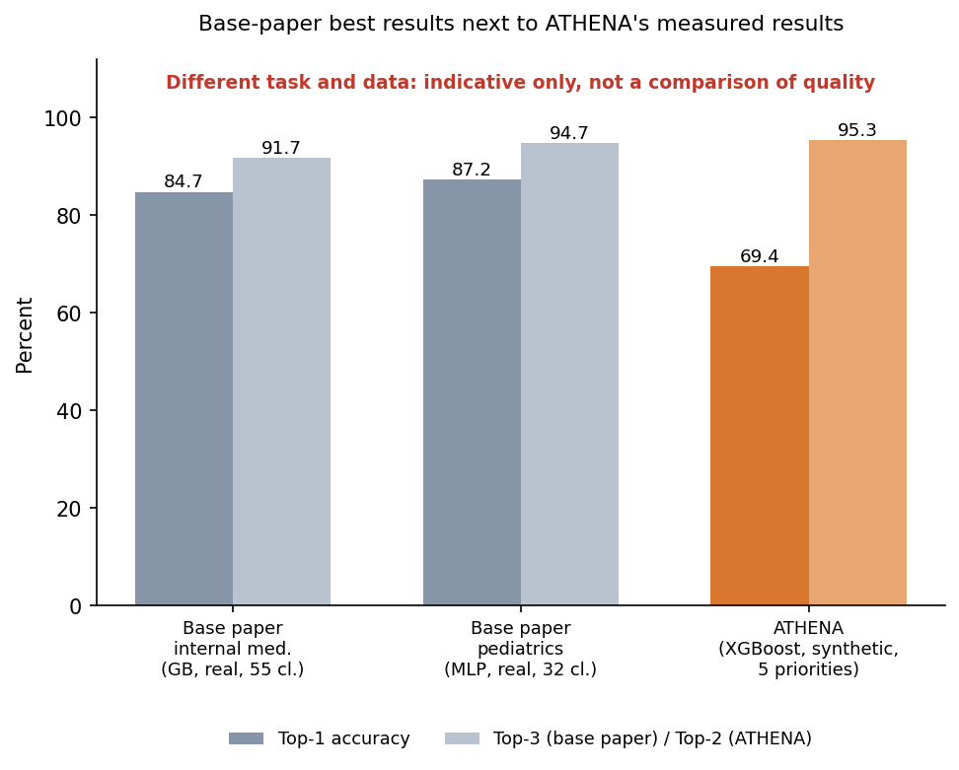
Figure 17: Headline figures of the base paper and the values measured here, with the task and data of each stated; the two sets of numbers are not comparable.
Where ATHENA does follow the base paper it adopts four ideas: comparing several algorithms on one task, reading the probabilities as a ranking (top-k) rather than only the arg-max, studying a high-confidence threshold, and treating an unreported finding as absent. Where it goes beyond the paper is the intake of scanned reports, fusion with vitals, a five-level target, calibrated confidence, a per-patient explanation shown with the decision, the clinician override record, and the measured processing time. Where it falls short is evidence: the base paper used real cases, tuned 19 algorithms, reported intervals and tests, and validated on an external facility. ATHENA did none of these.

1.12 Sample inputs and outputs
Three illustrative cases were run through the real reader and the shipped model with the project environment (backend.app.services.extract and triage.predict) on the generated sample reports, using the vitals that accompany each sample. They are chosen to show a clear critical case, a case the model is less sure of, and a trivial one; they are not a test set. All three are synthetic documents.
Table 14: Three illustrative cases (computed with the shipped model; synthetic sample data).
Case | Vitals entered | Flags read from the report | Model output | Largest explanation items
A: sample report 01 (chest pain, ambulance) | Age 58, HR 112, BP 96/60, SpO2 93, 36.9 C, RR 22 | chest pain, shortness of breath, ST elevation, diabetes, hypertension, cardiac disease, troponin raised, lactate raised | P1 Critical, High, confidence 1.00 | ST elevation +3.11; troponin +2.19; lactate +1.51; heart rate 112 +1.49; SpO2 93 +0.97
B: sample report 03 (fever, cough, low oxygen) | Age 66, HR 118, BP 104/64, SpO2 89, 39.1 C, RR 28 | shortness of breath, fever, lung infiltrate, COPD, diabetes, WBC raised, lactate raised | P1 Critical, High, confidence 0.74 (P2 0.26) | SpO2 89 +2.92; lactate +1.76; resp. rate 28 +1.28; heart rate 118 +0.86; lung infiltrate +0.68
C: sample report 07 (minor cold, walk-in) | Age 22, HR 74, BP 118/74, SpO2 99, 36.8 C, RR 15 | none found | P5 Non-urgent, Low, confidence 0.98 (P4 0.02) | arrival mode walk-in +0.65; no trauma +0.25; SpO2 99 +0.20; systolic BP 118 +0.19; no chest pain +0.19

Case A is the screen shown in Section 8.2: the reader found eight flags, including the ST elevation and two raised laboratory values from page 2, and the model is certain. Case B reaches priority 1 mainly through low oxygen saturation, raised lactate and a fast breathing rate, but the second-most probable class takes 26 % of the probability, which is the kind of case a clinician would look at twice. In case C every finding flag is zero and the model returns the lowest priority with high confidence; here the arrival mode (walk-in) is the largest single factor, an effect of how the synthetic data were generated more than a clinical truth. A fourth case, the generated scan of an ankle sprain (sample 12), was read through OCR in 7.6 s on the first call in a fresh process, found one flag (trauma) and gave priority 4 with confidence 0.66.
The 12 sample cases seeded into the queue come from the synthetic hold-out rows with their recorded priority. The shipped model matches that recorded priority for 8 of the 12 (67 %); the four misses (sample cases 01, 02, 09 and 12) are all one level away and all recorded as priority 4, which is the kind of error the noise in the labels produces.

1.13 Success and failure analysis

1.13.1 Where the system works
• The pipeline works end to end. A PDF or scan goes in; findings with pages, a priority, a calibrated confidence and an explanation come out in about 30 ms for a text PDF and about 2 s for a scan (Section 7.7).
• Errors are close. 99.67% of priorities are within one level of the recorded one on the synthetic hold-out, and the quadratic weighted kappa is 0.880.
• Fusion helps on this data: 28 points over vitals alone.
• The explanation names the right things. The largest attributions for the critical sample are ST elevation, troponin and lactate; globally the model relies on oxygen saturation, arrival mode, breathlessness and blood pressure, as the generating rule does.
• The reader is strong on what it knows: negated statements, abbreviations, laboratory ranges and pages are handled, and 12 of 12 generated reports (including four OCR scans) were read exactly.

1.13.2 Where it fails
• The most urgent classes are the weakest. 35 of 66 priority-1 cases went to priority 2 (recall 43.9%), and 101 of 239 priority-2 cases went to priority 3 (recall 54.0%). The cut points between these classes lie where the added noise matters most and the classes are rare.
• High-risk recall is 66.2% at arg-max; one high-risk case in three would be labelled Moderate or Low.
• Over-confidence in one band. Cases scored 0.8 to 0.9 were right about two times in three.
• A linear model does as well or better (72.4% against 68.2%), so the added machinery is not justified by the synthetic data alone.
• The reader misses what the lexicon does not contain, and a few spurious or lost flags follow from the negation rules (Section 7.6). A missed finding lowers accuracy by about three points for every ten per cent of findings dropped.
• The explanation wording is inverted in the API for low-priority predictions (Section 7.6), and the interface cannot correct a misread finding.
• Nothing here is a real-world test. The model was never shown a real patient.
The pattern of failure is consistent with the data rather than with a bug in the model. The recorded priority is the severity score plus noise of standard deviation 0.4, cut at four thresholds; cases close to a threshold carry a label that even a perfect reader of the score gets wrong about one time in seven. The classes at the sick end are rare, so there are few examples to learn their boundary from.

1.14 Limitations of the evaluation
• Synthetic data throughout. Every accuracy, recall and calibration figure describes recovery of a known rule. The study cannot say how ATHENA would perform on real patients, and it should not be quoted as an accuracy for triage.
• Circular design. The same author-written assumptions generate the data, the sample reports and the lexicon; the 100 % reading score and the benefit of fusion are partly built in.
• One dataset, one generator, one split for the headline numbers. Five other splits and cross-validation show a spread of about one point, and the shipped split is two points below their mean.
• Developer-written stress fragments and a small number of generated scans; no independent clinical text and no real scans.
• Threshold, safety and robustness analyses were run on the test set and describe trade-offs; none was tuned.
• No external validation, no prospective study, no clinician review of the explanations, and no comparison with a nurse's own triage or with a standard scale such as ESI [14].
• No significance tests, and the model settings were not searched, unlike the base paper's 100-trial tuning.

1.15 Objectives versus outcomes
Table 15: The six objectives of the project against what was achieved.
Objective | Status | Evidence
1. Build an OCR stage that converts scanned reports to machine-readable text | Met | PDF text layer plus local RapidOCR (PaddleOCR-family models on ONNX Runtime) for scans; 12 of 12 generated reports read; scans take 2 to 5 s
2. Apply a medical language model to extract symptoms, findings and history | Partly met | A rule-based lexicon of 22 terms with negation and 6 lab rules was used instead of BioBERT [22]; precision 95.2%, recall 84.3% on stress fragments, 100 % on generated samples
3. Combine text-derived features with vitals in a single representation | Met | 36-input fused record (8 vitals + 28 report flags), shown side by side in the interface
4. Train a model that assigns a risk level and a triage priority | Met on synthetic labels | Calibrated XGBoost, priority 1 to 5 and High/Moderate/Low; 69.4% exact, 99.7% within one level on synthetic hold-out
5. Add an explainability layer showing which findings drove the priority | Met | Per-patient SHAP beside every decision, strongest first; no LIME; usefulness to clinicians untested
6. Evaluate accuracy against clinician-assigned priority and measure processing time per patient | Partly met | Accuracy measured only against the synthetic recorded priority, not clinicians; time per patient measured (median 30 ms for a PDF, 2.1 s for a scan)
Batch brief: BioBERT, RAG, multi-agent orchestration, six disease-risk models, MongoDB, Node.js and Flask | Not built | Replaced by a lexicon, no RAG, a single pipeline, no disease models, SQLite, and FastAPI with React; listed as future work

Taken together, the project delivered a working, tested, honestly evaluated decision-support prototype whose weakest links are the ones the batch brief most wanted: a medical language model for reading reports, and accuracy against real clinician judgement. Both remain open.

