DATA PROTECTION USING HYBRID ENCRYPTION AND STEGANOGRAPHY
Results
Department of Computer Science and Engineering, TKR College of Engineering & Technology
Batch A15 (CSE-A) · Academic year [ACADEMIC YEAR]
Table 1: Project team
S.No. | Student name | Roll number
1 | Allam Rakesh | 23K91A0509
2 | Bolleddu Shanker | 23K91A0543
3 | Agaram Sri Sarvagna | 23K91A0506
4 | B Akshay | 24K915A0504

Project guide: Rajalakshmi
Chapter and section numbers quoted in the text (for example Chapter 8 or Section 6.2) refer to the full project report, 17.Final Document. Figures and tables in this document are numbered from 1.

1. RESULTS AND OUTPUT SCREENS
This chapter reports what was measured. It begins with the set-up, shows every screen of the working product, then gives the core evaluation of imperceptibility, capacity and speed, the fill-ratio study, the key-size and latency measurements, robustness, steganalysis and tamper evidence, the comparison with the base paper, sample inputs and outputs, a success and failure analysis and the objectives against outcomes. Where a result is weaker than the product's screens suggest, the text says so.

1.1 Experimental set-up
All measurements in this chapter were made on one machine: an Intel Core i5-12500 (6 cores, 12 threads) with 15.7 GB of memory, Windows 11 Pro, Python 3.11.9 and Node.js 24.19. No GPU was used. The backend ran FastAPI 0.115.6 with cryptography 44.0.0, Pillow 11.0.0, NumPy 2.1.3 and scikit-image 0.24.0; screens were captured with headless Google Chrome driven by a Playwright script. Other programs shared the machine, so absolute timings vary by about 10-30 % between runs (the median RSA-3072 unwrap and decrypt was 86 ms in ml/eval.py and 94 ms in scripts/run_experiments.py). The embedding and the image-quality numbers do not depend on load. Every table and figure comes from stored JSON written by ml/eval.py, scripts/run_experiments.py and scripts/measure_api.py; nothing was typed in by hand.
CipherVeil learns nothing from data, so there is no training set, validation split or test split. The system is deterministic apart from the random AES key and nonce. Evaluation uses six committed cover images and four committed synthetic payloads, all regenerated by the seeded script scripts/make_samples.py.
Table 2: Data used in the evaluation
Item | Size | Source and licence
astronaut_512x512.png | 512 x 512 | scikit-image astronaut(), NASA photograph, public domain
cat_451x300.png | 451 x 300 | scikit-image chelsea(), CC0
coffee_600x400.png | 600 x 400 | scikit-image coffee(), CC0
coffee_small_200x200.png | 200 x 200 | crop and resize of coffee(), CC0
generated_landscape_1280x720.png | 1280 x 720 | procedural, seed 11, generated for this project
rocket_640x427.png | 640 x 427 | scikit-image rocket(), public domain
accounts.csv, confidential_memo.pdf, meeting_notes.txt, settings.json | 2,774 B, 21,517 B, 169 B, 99 B | synthetic, generated for this project

Evaluation grid: the six covers crossed with payloads of 1, 4, 16, 64 and 128 KiB (30 combinations), each measured three times with an RSA-3072 key; 22 combinations fit and 8 are blocked by the capacity check. Additional experiments (fill-ratio, key-size, steganalysis, tamper and extra-attack studies) are described where they are reported.

1.2 Output screens
The screens below were captured in one working session on a fresh database, driving the real interface: two RSA-3072 keypairs were generated, a partner's public key was imported, five files were sent, one was received, and the robustness test and benchmark were run. Nothing on screen is a mock-up; the numbers in the captions are the numbers the screens show.

1.3 Keys
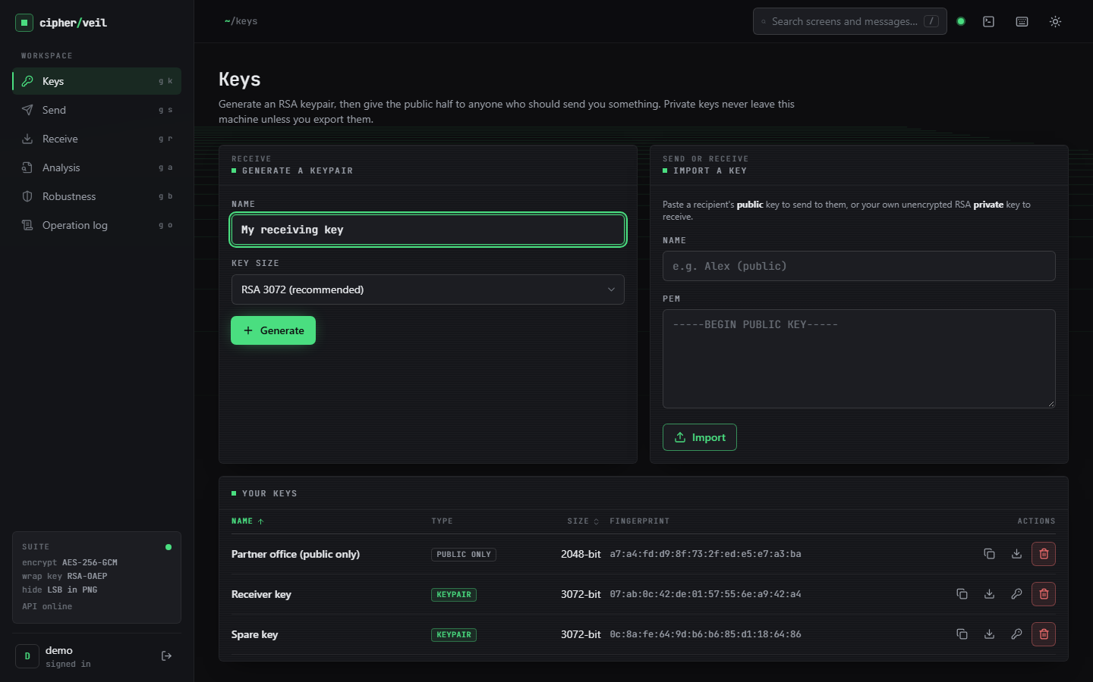
Figure 1: Output screen: Keys. Two generated RSA-3072 keypairs (Receiver key, Spare key) and one imported public-only RSA-2048 partner key, each with its fingerprint and download actions.
The Keys screen holds the cryptographic identities. A keypair can send and receive; a public-only entry can only be sent to. The fingerprint is the first 12 bytes of the SHA-256 of the public key, so two people can compare keys by eye. Private keys never appear in the list; they are exported only on request, and each export is written to the log.

1.4 Send
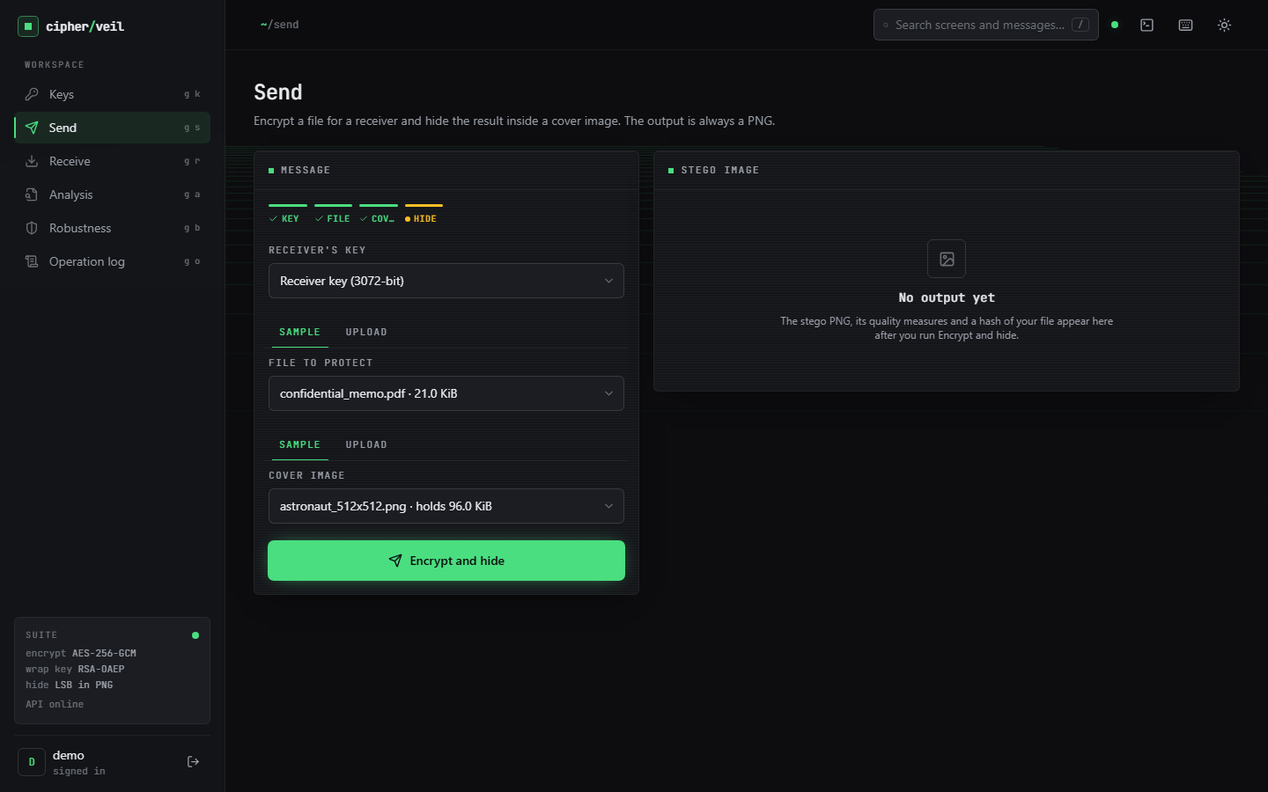
Figure 2: Output screen: Send, before the run. Receiver key, confidential_memo.pdf (21.0 KiB) and the astronaut cover (holds 96.0 KiB) are selected; the capacity estimate is shown before anything is sent.
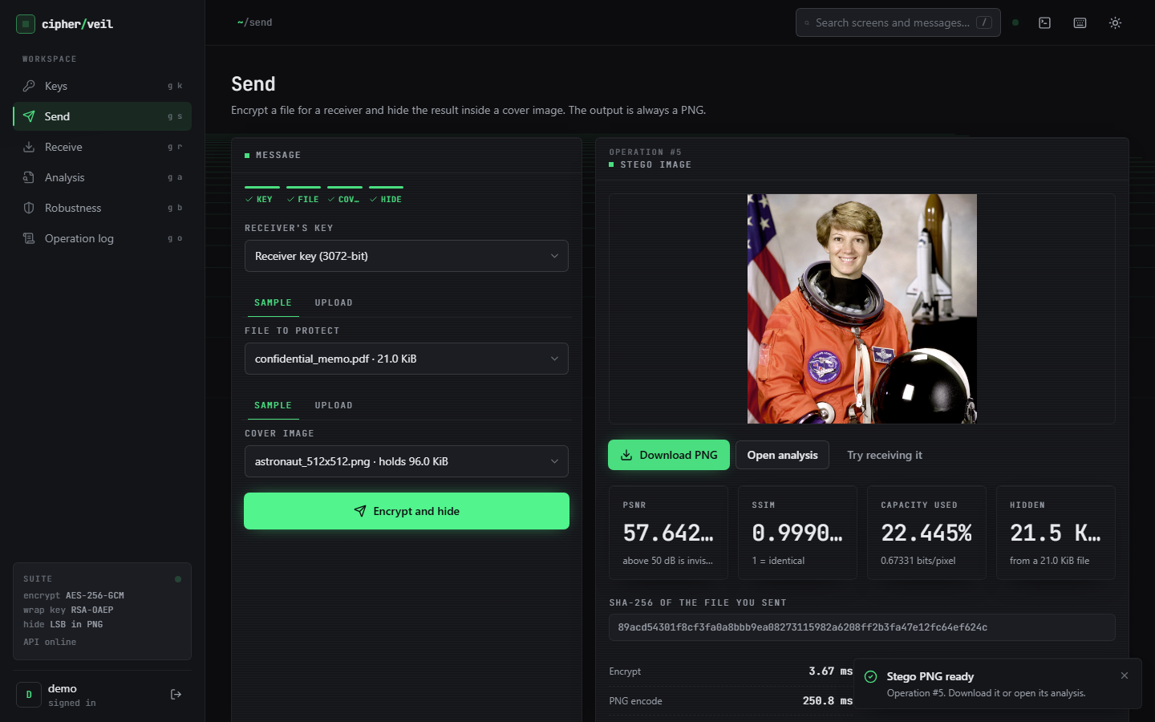
Figure 3: Output screen: Send result. The stego PNG with PSNR 57.642 dB, SSIM 0.9991, 22.445 % of the cover used (0.67331 bits per pixel), the SHA-256 of the file and the per-stage timings.
The 21,517-byte memo grows to a 22,063-byte bundle (546 bytes of overhead with RSA-3072, of which 384 are the wrapped key) and occupies 22.445 % of the astronaut image. The picture shown is the stego image and is indistinguishable by eye from the cover. Largest change to any colour value is 1 out of 255; the SHA-256 shown is the fingerprint the receiver must reproduce.

1.5 Analysis
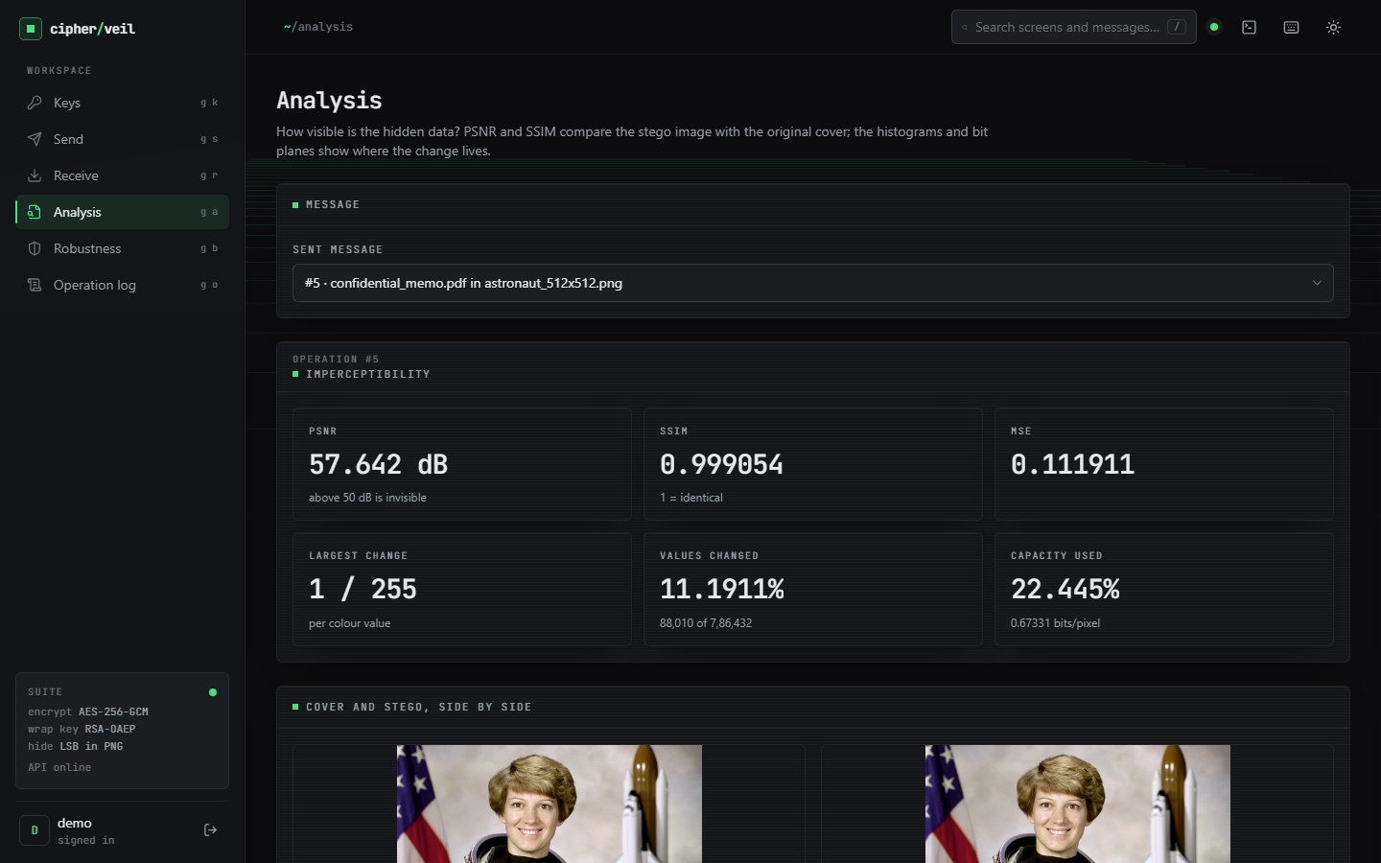
Figure 4: Output screen: Analysis. PSNR 57.642 dB, SSIM 0.999054, MSE 0.111911, largest change 1 / 255, 11.1911 % of values changed (88,010 of 786,432), cover and stego side by side.
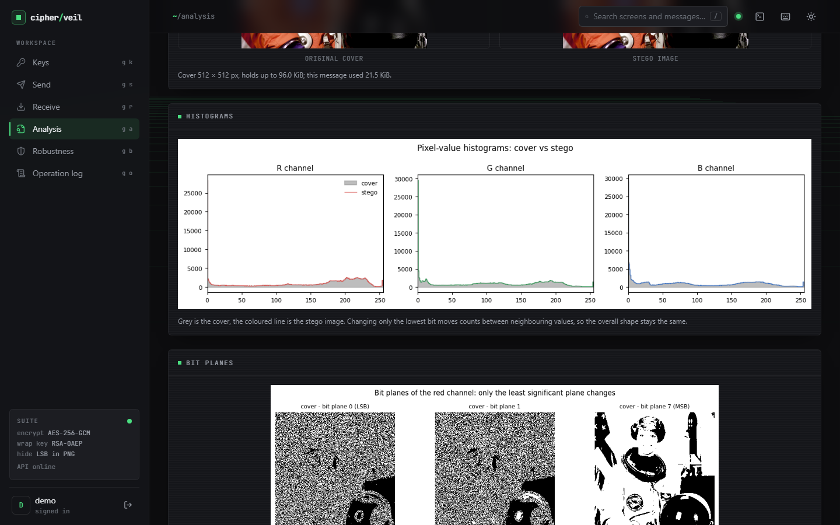  Figure 5: Output screen: Analysis, histograms of cover and stego per colour channel. | 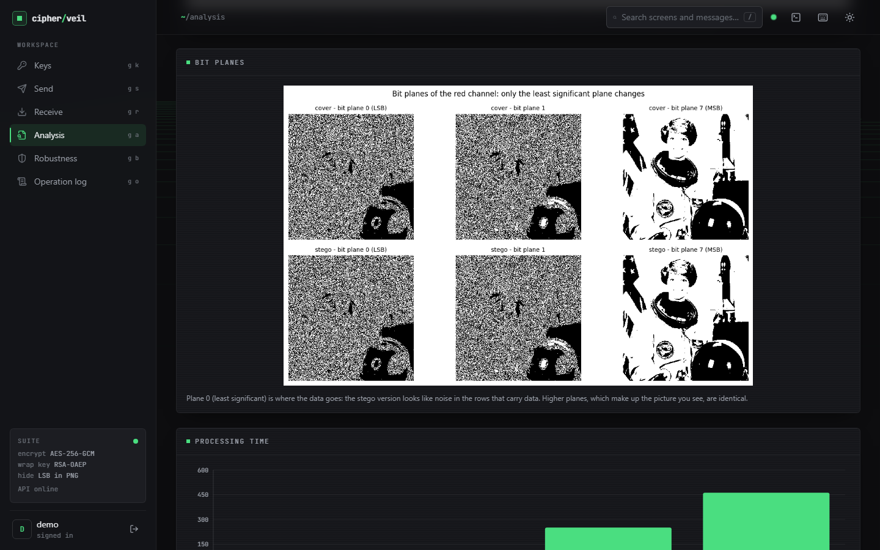  Figure 6: Output screen: Analysis, bit planes 0, 1 and 7 of the red channel, cover and stego.

The histograms overlay almost exactly: replacing the least significant bit moves a count only between two neighbouring values. The bit-plane view shows where the change lives: plane 7 (the picture) is identical, while plane 0 carries noise-like data in the rows used by the bundle. Only the first 22 % of the rows are touched, which is also why the analysis in Section 8.8 can find them.

1.6 Receive
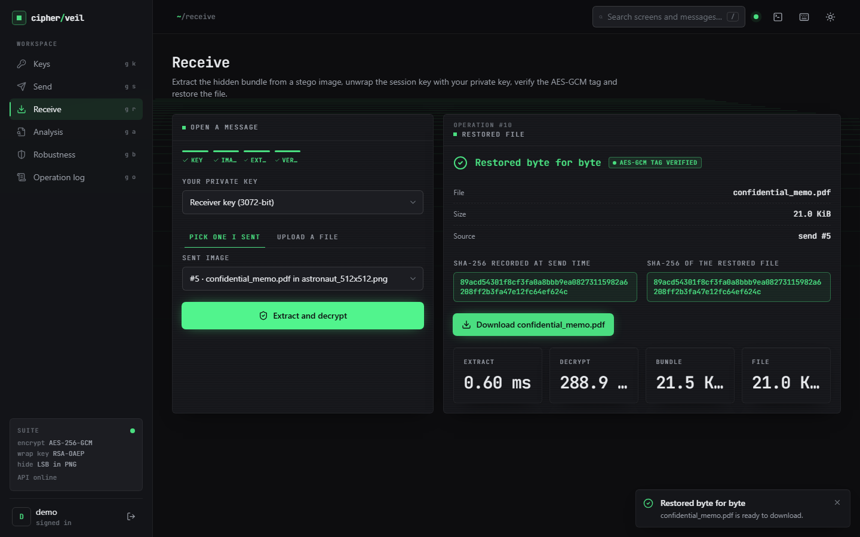
Figure 7: Output screen: Receive. The file is restored byte for byte, the AES-GCM tag is verified, and the SHA-256 recorded at send time equals the SHA-256 of the restored file.
Receiving the same image with the Receiver key extracts the bundle in 0.60 ms and decrypts it in 288.9 ms on that run (the machine was busy with the browser and the screen capture; the evaluation median is 86 ms). The two hashes are identical, so the file is the one that was sent. The download button returns confidential_memo.pdf unchanged.

1.7 Robustness and benchmark
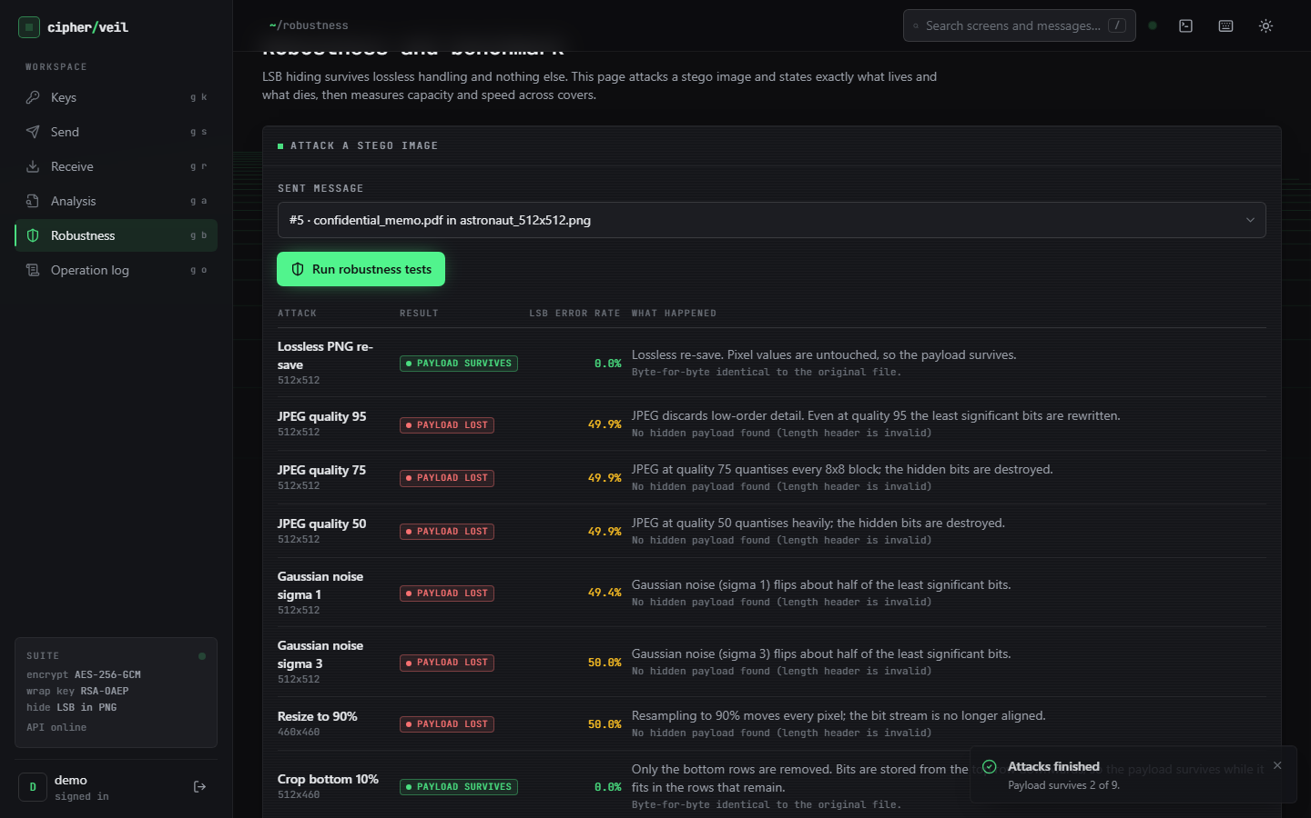  Figure 8: Output screen: Robustness, the nine attacks with their verdict and LSB error rate. | 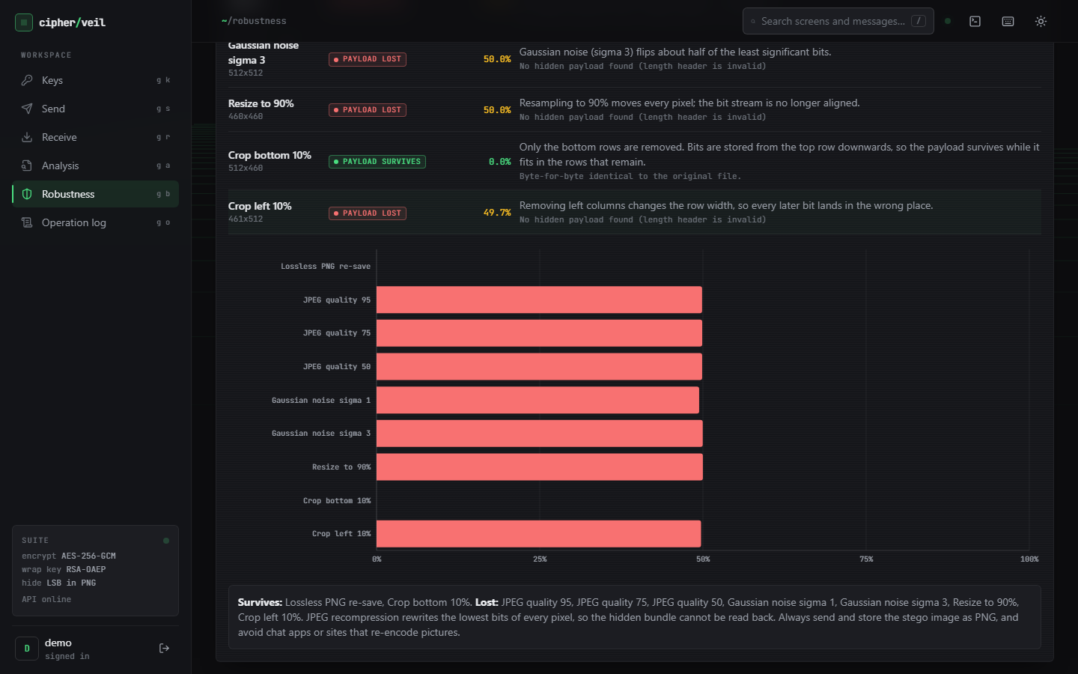  Figure 9: Output screen: Robustness, LSB error-rate chart and the plain-language verdict.

Of the nine attacks only two let the payload through: the lossless PNG re-save (error rate 0.0 %) and the bottom crop of 10 % (0.0 %, because the bundle lies in the top rows). JPEG at quality 95, 75 and 50, Gaussian noise of sigma 1 and 3, resizing to 90 % and the left crop all leave about half of the least significant bits wrong (49.4-50.0 % in the screen) and the payload is lost. The page states the consequence in words: send and store the stego image as a PNG and avoid applications that re-encode pictures.
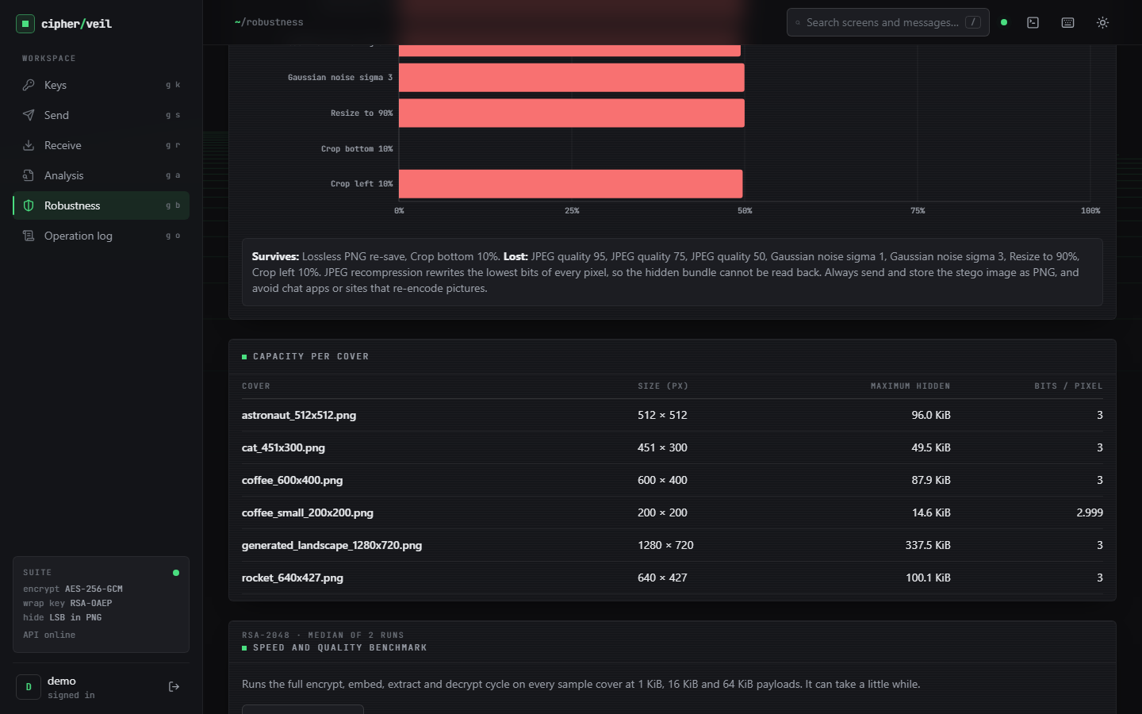  Figure 10: Output screen: capacity per cover, 14.6 KiB (200 x 200) to 337.5 KiB (1280 x 720), 3.0 bits per pixel. | 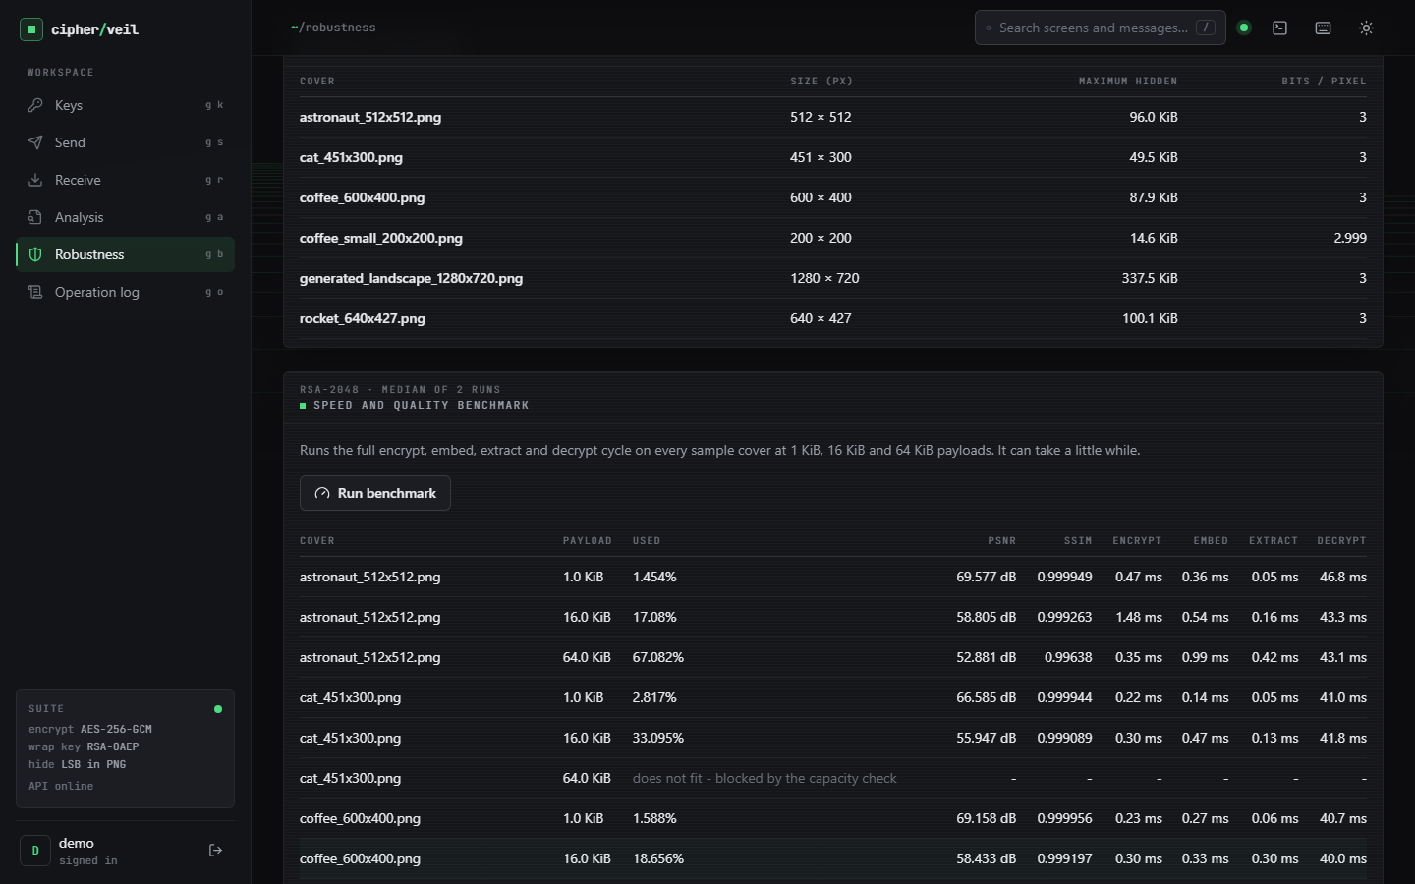  Figure 11: Output screen: speed and quality benchmark rows (RSA-2048), including a row blocked by the capacity check.

The capacity table is a direct consequence of the formula (width x height x 3 - 32) / 8. The benchmark runs the full encrypt, embed, extract and decrypt cycle on every cover at 1, 16 and 64 KiB; a combination that does not fit is shown as blocked instead of failing, for example 64 KiB into the 451 x 300 cat image.

1.8 Operation log
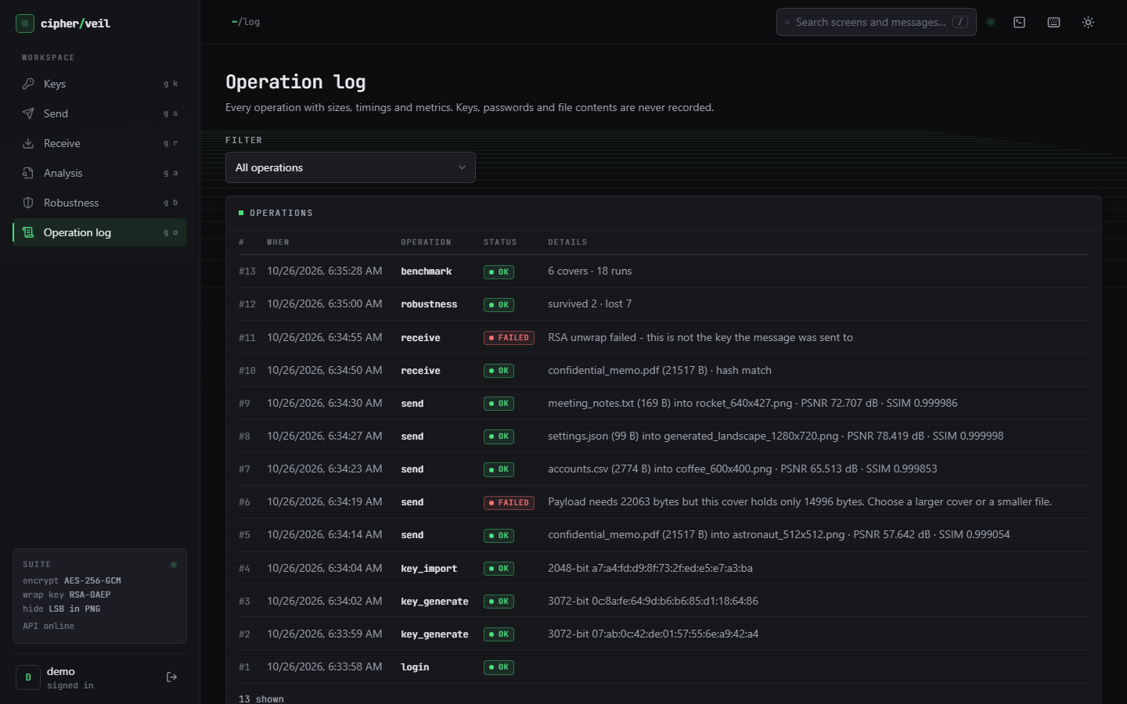  Figure 12: Output screen: operation log of the session (login, key generate and import, sends, receives, robustness, benchmark; failed operations in red). | 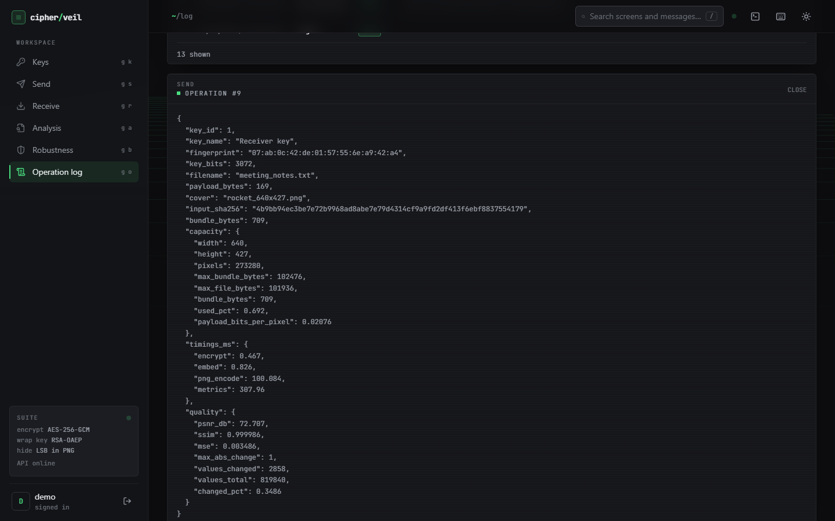  Figure 13: Output screen: log detail of one send, with sizes, timings, quality and key fingerprint but no key material.

The log lists thirteen operations for the session, including the failed send (capacity) and the failed receive (wrong key), each with a plain-language reason. Expanding an entry shows the stored JSON: file name, sizes, hash, capacity, timings and quality. The test suite checks that no private key, PEM text or file content ever reaches this log.

1.9 Core evaluation: imperceptibility, capacity and speed
The core evaluation (ml/eval.py) hides random-length files in the six covers with an RSA-3072 key. Of the 30 combinations, 22 fit and 8 are refused by the capacity check, which is the intended behaviour. All 22 round trips restored the file byte for byte. PSNR was never below 52.479 dB (mean 61.731 dB) and SSIM never below 0.995806 (mean 0.999039). The median times were 0.15 ms to encrypt and wrap, 0.25 ms to embed, 0.05 ms to extract and 86.37 ms to unwrap and decrypt.
Table 3: Capacity of each cover (1 bit per colour value, 32-bit length header)
Cover | Size (px) | Pixels | Max bundle (B) | Max bundle (KiB) | Bits per pixel
astronaut_512x512 | 512 x 512 | 262,144 | 98,300 | 96.0 | 3.0
cat_451x300 | 451 x 300 | 135,300 | 50,733 | 49.5 | 3.0
coffee_600x400 | 600 x 400 | 240,000 | 89,996 | 87.9 | 3.0
coffee_small_200x200 | 200 x 200 | 40,000 | 14,996 | 14.6 | 2.999
generated_landscape_1280x720 | 1280 x 720 | 921,600 | 345,596 | 337.5 | 3.0
rocket_640x427 | 640 x 427 | 273,280 | 102,476 | 100.1 | 3.0

Table 4: Quality and speed of the 22 runs that fit (RSA-3072, median of 3 repeats)
Cover | Payload (B) | Used % | PSNR (dB) | SSIM | Enc (ms) | Embed (ms) | Extr (ms) | Dec (ms)
astronaut_512x512 | 1,024 | 1.584 | 69.171 | 0.999941 | 0.131 | 0.115 | 0.034 | 87.481
astronaut_512x512 | 4,096 | 4.709 | 64.423 | 0.999767 | 0.19 | 0.222 | 0.047 | 86.009
astronaut_512x512 | 16,384 | 17.211 | 58.754 | 0.999256 | 0.154 | 0.183 | 0.091 | 88.198
astronaut_512x512 | 65,536 | 67.213 | 52.865 | 0.996392 | 0.211 | 0.684 | 0.178 | 85.482
cat_451x300 | 1,024 | 3.069 | 66.217 | 0.999934 | 0.12 | 0.102 | 0.028 | 86.946
cat_451x300 | 4,096 | 9.124 | 61.531 | 0.999764 | 0.158 | 0.112 | 0.03 | 84.322
cat_451x300 | 16,384 | 33.347 | 55.898 | 0.999078 | 0.146 | 0.17 | 0.059 | 86.181
coffee_600x400 | 1,024 | 1.73 | 68.74 | 0.999948 | 0.138 | 0.175 | 0.028 | 93.163
coffee_600x400 | 4,096 | 5.144 | 63.993 | 0.999786 | 0.139 | 0.266 | 0.037 | 85.139
coffee_600x400 | 16,384 | 18.799 | 58.409 | 0.999195 | 0.153 | 0.374 | 0.066 | 87.478
coffee_600x400 | 65,536 | 73.414 | 52.479 | 0.997186 | 0.21 | 0.828 | 0.234 | 84.241
coffee_small_200x200 | 1,024 | 10.383 | 61.014 | 0.99977 | 0.129 | 0.095 | 0.022 | 87.388
coffee_small_200x200 | 4,096 | 30.868 | 56.264 | 0.999166 | 0.14 | 0.121 | 0.051 | 89.865
generated_landscape_1280x720 | 1,024 | 0.451 | 74.615 | 0.99999 | 0.135 | 0.55 | 0.03 | 92.94
generated_landscape_1280x720 | 4,096 | 1.339 | 69.876 | 0.999931 | 0.174 | 0.595 | 0.059 | 85.656
generated_landscape_1280x720 | 16,384 | 4.895 | 64.234 | 0.999664 | 0.145 | 0.565 | 0.066 | 87.522
generated_landscape_1280x720 | 65,536 | 19.118 | 58.321 | 0.998598 | 0.212 | 0.796 | 0.208 | 85.791
generated_landscape_1280x720 | 131,072 | 38.081 | 55.333 | 0.99718 | 0.367 | 1.674 | 0.507 | 95.645
rocket_640x427 | 1,024 | 1.519 | 69.365 | 0.999941 | 0.176 | 0.138 | 0.033 | 84.905
rocket_640x427 | 4,096 | 4.517 | 64.581 | 0.999723 | 0.205 | 0.242 | 0.042 | 85.478
rocket_640x427 | 16,384 | 16.509 | 58.955 | 0.998853 | 0.144 | 0.315 | 0.084 | 86.566
rocket_640x427 | 65,536 | 64.474 | 53.049 | 0.995806 | 0.213 | 0.543 | 0.17 | 84.287

The eight refused combinations are 128 KiB into every cover except the landscape, 64 KiB into the 451 x 300 and 200 x 200 covers, and 16 KiB into the 200 x 200 cover. PSNR falls as the share of the cover used grows, from 74.615 dB at 0.45 % (1 KiB into the landscape) to 52.479 dB at 73.4 % (64 KiB into the 600 x 400 coffee image); SSIM stays above 0.9958. RSA unwrap dominates the time of the cryptographic step and is almost independent of payload size, while embedding grows with the payload to 1.674 ms for 128 KiB.
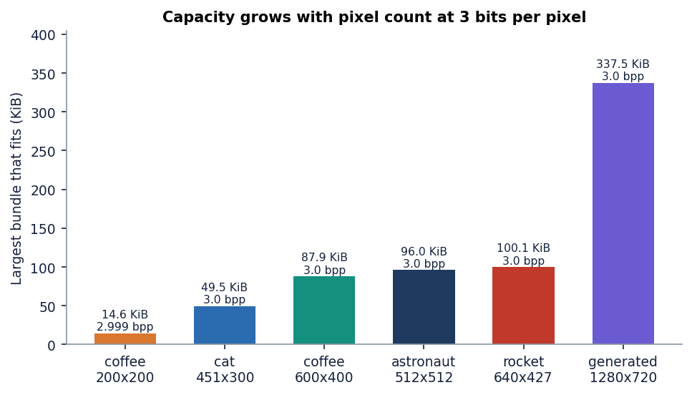
Figure 14: Maximum hidden bundle per cover: capacity is proportional to the pixel count at 3.0 bits per pixel.

1.10 Fill-ratio study and the closed-form PSNR model
The core evaluation uses a few payload sizes. To cover the whole range the fill-ratio study fills each of the six covers to 1, 5, 10, 25, 50, 75 and 100 % of capacity with random payloads of five different seeds (RSA-2048). Because the embedded bits are ciphertext, each bit equals the cover's own least significant bit half of the time, so half of the used values change by exactly one. This gives a closed-form model:
MSE = 0.5 x n_bits / N, PSNR = 10 log10(255^2 / MSE) (N = width x height x 3 colour values, n_bits = 8 x (bundle bytes + 4)) (1)
Measured PSNR matches the model within 0.053 dB over all 42 cover and fill combinations, and the standard deviation across payload seeds never exceeded 0.0987 dB. The model also gives the floor: with every value used, PSNR is 10 log10(255^2 / 0.5) = 51.14 dB, and the measurement at 100 % fill is 51.14-51.17 dB. PSNR is therefore above 50 dB at every fill level on every cover. SSIM depends on the picture as well as the amount of data and is lowest (0.992893) for the smooth procedural landscape at 100 % fill.
Table 5: Imperceptibility against fill ratio (mean over the six covers and five payload seeds)
Fill | Capacity used % | PSNR mean (dB) | PSNR min (dB) | PSNR model (dB) | SSIM mean | SSIM min
1 % | 1.8 | 68.93 | 65.44 | 68.94 | 0.99995 | 0.99993
5 % | 5.8 | 63.58 | 62.36 | 63.57 | 0.99975 | 0.99965
10 % | 10.7 | 60.85 | 60.19 | 60.85 | 0.99952 | 0.99928
25 % | 25.5 | 57.07 | 56.87 | 57.07 | 0.99880 | 0.99815
50 % | 50.3 | 54.13 | 54.08 | 54.13 | 0.99765 | 0.99630
75 % | 75.0 | 52.39 | 52.39 | 52.39 | 0.99639 | 0.99462
100 % | 99.9 | 51.15 | 51.14 | 51.15 | 0.99507 | 0.99289

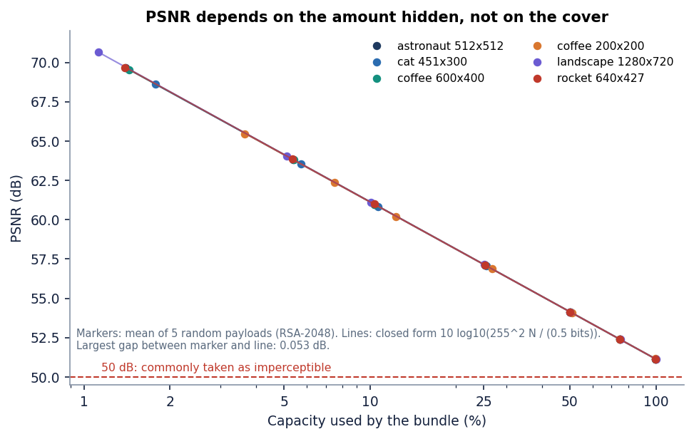
Figure 15: Measured PSNR against fill ratio for the six covers, with the closed-form model; the 50 dB line marks the usual limit of visibility.
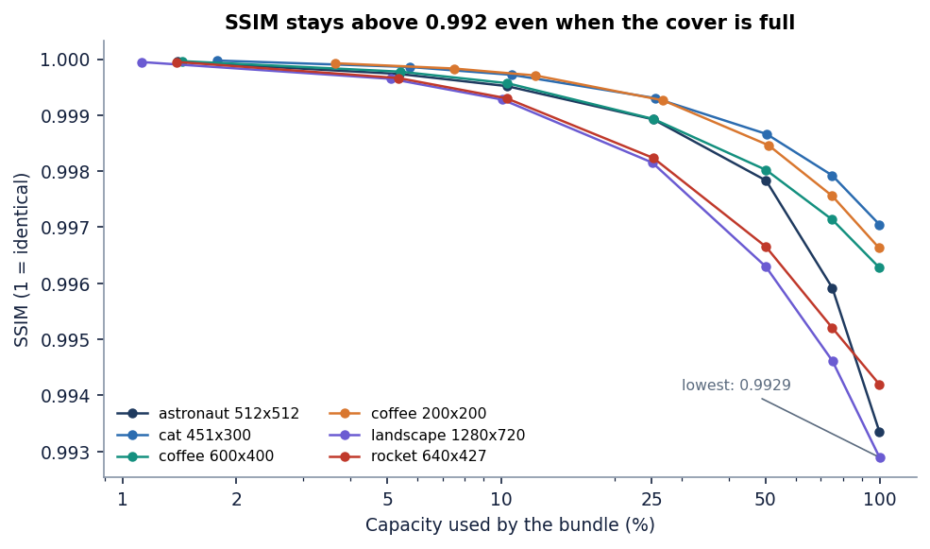
Figure 16: Measured SSIM against fill ratio for the six covers.
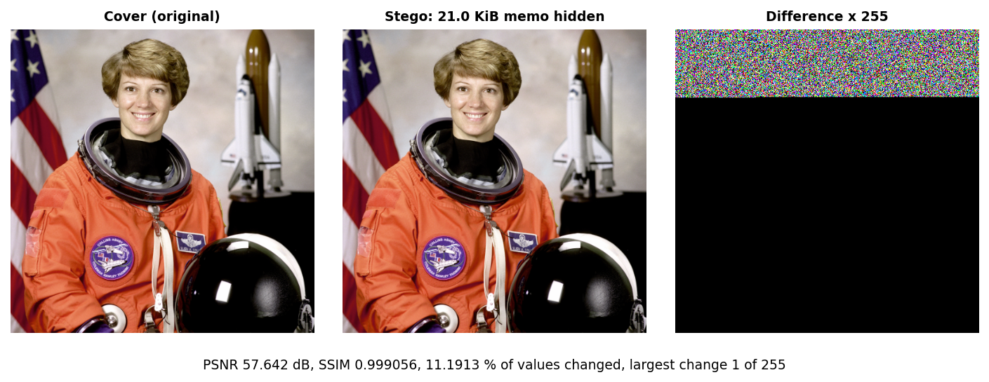
Figure 17: Absolute difference between cover and stego, amplified, for the 22 % fill of the Send screen: the changes are scattered values of 1 in the rows used.

1.11 Key size, stage timings and API latency
Key size changes three things: the time to generate a key, the time to unwrap, and the bundle overhead. Wrapping is cheap (0.16-0.24 ms) because it uses the public exponent 65537; unwrapping uses the private key and grows roughly with the cube of the key size. Key generation varies strongly from run to run because it searches for primes, so the range is shown beside the median.
Table 6: RSA key size study (4 KiB payload; 30 wraps and unwraps, 5 key generations)
RSA bits | Key generation (ms), median (min-max) | Encrypt + wrap (ms) | Unwrap + decrypt (ms) | Wrapped key (B) | Bundle overhead (B)
2048 | 32.497 (24.9-101.6) | 0.164 | 31.054 | 256 | 401
3072 | 191.488 (70.8-271.3) | 0.173 | 93.693 | 384 | 529
4096 | 353.921 (97.0-541.0) | 0.236 | 221.139 | 512 | 657

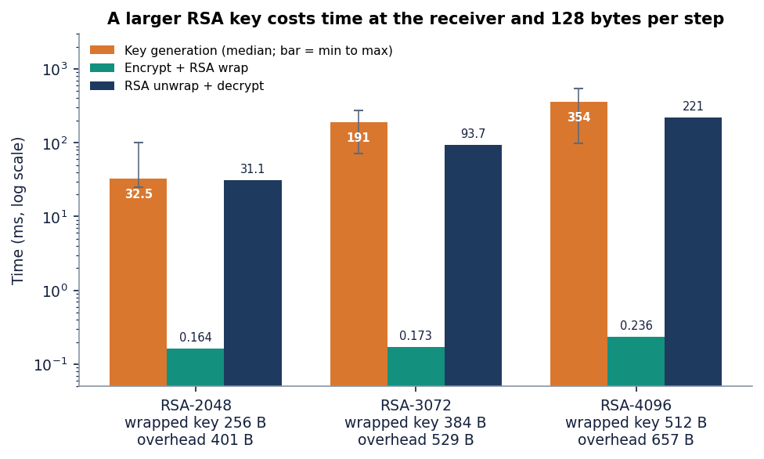
Figure 18: RSA key size against key-generation time, wrap time and unwrap time (median).
For a 4 KiB message the 3072-bit key costs 94 ms to open and adds 128 bytes more than the 2048-bit key; the 4096-bit key costs 221 ms and 256 bytes more. The overhead is a fixed 401, 529 or 657 bytes (wrapped key, magic, lengths, nonce, header, tag), which matters only for very small covers: it is 3 % of the 14.6 KiB capacity of the 200 x 200 image.
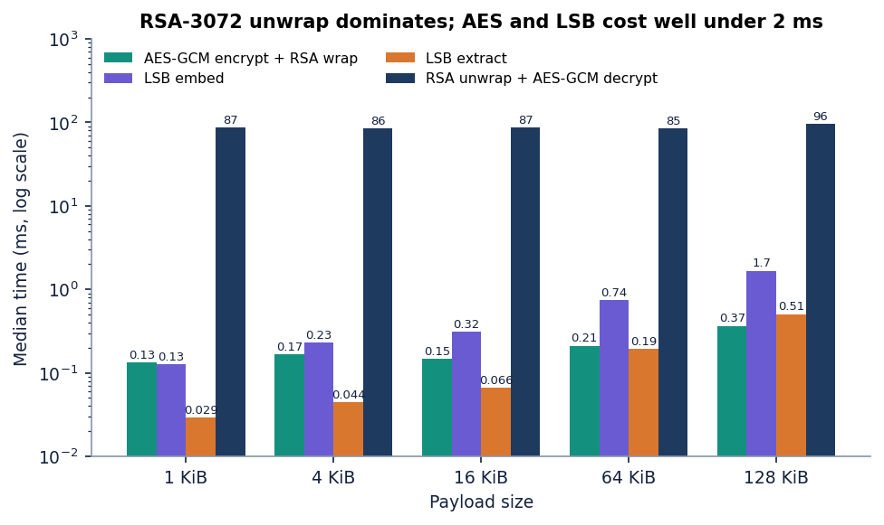
Figure 19: Median time of the four cryptographic and embedding stages for payloads of 1 to 128 KiB (RSA-3072): the unwrap dominates and everything else is below 2 ms.
End to end, through HTTP, the picture changes because the web layer adds the work the library benchmark leaves out: PNG encoding and the image-quality measures. A send of the 21 KiB memo into a 512 x 512 cover takes 437.7 ms at the median, and 1,873.4 ms into a 1280 x 720 cover; the cryptography is about 0.15 ms of that, and the log of the send shows png_encode at 100-190 ms and metrics (PSNR and SSIM) at about 300 ms. Receiving takes 198.2 ms, mostly the RSA unwrap. Login costs 286.7 ms because bcrypt is deliberately slow.
Table 7: API latency on the measurement machine (127.0.0.1, demo user)
Call | Runs | Median (ms) | p95 or max (ms)
login | 10 | 286.7 | 315.5
keys/generate 3072 | 5 | 223.4 | 350.6
send (21 KiB memo, 512x512 cover, RSA-3072) | 10 | 437.7 | 534.5
send (21 KiB memo, 1280x720 cover) | 10 | 1873.4 | 2154.4
receive (RSA-3072) | 10 | 198.2 | 234.8
analysis metrics | 10 | 5.2 | 6.0
histogram + bit planes, first render | 3 | 942.4 | 1031.6
robustness (9 attacks) | 5 | 542.6 | 587.7
benchmark/run (6 covers x 3 sizes, RSA-2048) | 2 | 14962.4 | 15140.5
log (100 rows) | 10 | 12.9 | 30.4

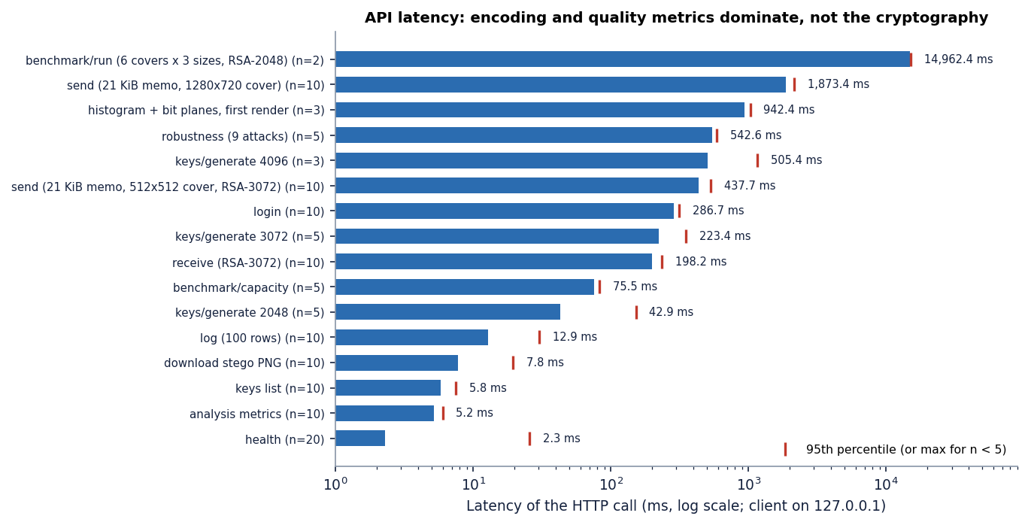
Figure 20: API latency per call (median, with 95th percentile or maximum).

1.12 What encryption adds to the embedded bits
A natural question is whether encryption costs image quality. The experiment hides each sample file twice in the generated_landscape_1280x720 cover, once as plain bytes and once as the encrypted bundle. In both cases about half of the embedded bits change a value (49.1-51.6 %), so PSNR depends on the number of bits and not on their kind: encryption costs nothing in imperceptibility. What changes is the statistics of the stream. Plain files are unbalanced (fraction of 1-bits 0.42-0.46) and have low entropy (4.2-4.4 bits per byte for the text files), so they can be read directly once the carrier bits are found; the encrypted bundle has a fraction of 1-bits of 0.49-0.51 and 7.58-7.99 bits per byte, bounded only by the small sample size.
Table 8: Plain versus encrypted payloads in the same cover
Payload | Kind | Bytes | Fraction of 1-bits | Entropy (bits/byte) | Embedded bits that flip a value (%) | PSNR (dB)
accounts.csv | plain | 2774 | 0.4649 | 4.346 | 49.67 | 72.119
accounts.csv | encrypted | 3182 | 0.4971 | 7.94 | 50.37 | 71.462
confidential_memo.pdf | plain | 21517 | 0.4367 | 6.933 | 49.96 | 63.201
confidential_memo.pdf | encrypted | 21935 | 0.5004 | 7.992 | 50.09 | 63.107
meeting_notes.txt | plain | 169 | 0.4512 | 4.379 | 49.06 | 84.229
meeting_notes.txt | encrypted | 581 | 0.489 | 7.609 | 50.09 | 78.848
settings.json | plain | 99 | 0.4167 | 4.246 | 51.58 | 86.264
settings.json | encrypted | 506 | 0.5091 | 7.577 | 51.3 | 79.34

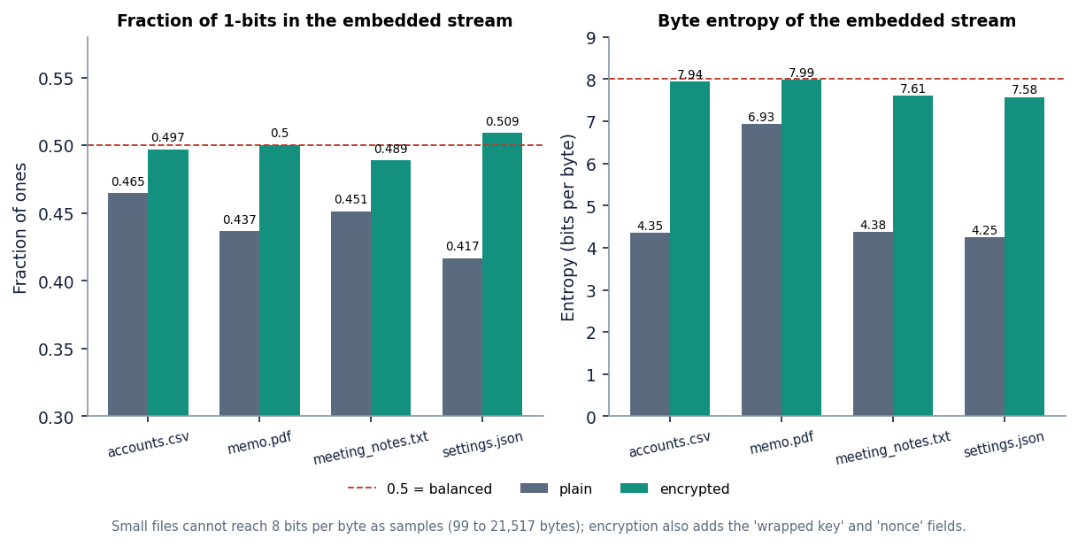
Figure 21: Fraction of 1-bits and byte entropy of plain files and of the encrypted bundles.

1.13 Robustness: what survives
Robustness was tested on all six covers with the 2,774-byte accounts.csv and an RSA-3072 key. Each attack modifies the stego image, then the real extraction and decryption are attempted and the recovered file is hashed. The nine attacks of the application are in the first block of the table; a further nine (re-encodings, a colour reduction and geometric changes) were added in scripts/run_experiments.py on the same six images with RSA-2048.
Table 9: Payload recovery after each attack (6 covers)
Attack | Recovered | Mean LSB error rate
Lossless PNG re-save | 6 / 6 | 0.0
JPEG quality 95 | 0 / 6 | 0.4973
JPEG quality 75 | 0 / 6 | 0.4999
JPEG quality 50 | 0 / 6 | 0.5032
Gaussian noise sigma 1 | 0 / 6 | 0.4935
Gaussian noise sigma 3 | 0 / 6 | 0.4988
Resize to 90% | 0 / 6 | 0.501
Crop bottom 10% | 6 / 6 | 0.0
Crop left 10% | 0 / 6 | 0.4995
PNG re-save, compression 9 | 6 / 6 | -
PNG with alpha channel added | 6 / 6 | -
WebP lossless | 6 / 6 | -
WebP lossy q90 | 0 / 6 | -
JPEG quality 100 | 0 / 6 | -
Grayscale conversion | 0 / 6 | -
Rotate 90 degrees | 0 / 6 | -
Flip horizontally | 0 / 6 | -
256-colour palette | 0 / 6 | -

The pattern is exact. Anything that preserves pixel values keeps the payload: PNG re-save, PNG at compression 9, PNG with an alpha channel added, lossless WebP, and a crop that removes only rows below the payload. Anything that changes pixel values or their order loses it: JPEG even at quality 100, lossy WebP, Gaussian noise of sigma 1, resizing, grayscale conversion, a 256-colour palette, rotation, flipping and cropping columns. The error rate of the lossy attacks is 49-50 %, which is what a coin toss gives, so there is nothing left for an error-correcting code to repair; the batch objective of measuring robustness is met, and the answer is that the scheme is robust to lossless handling only. The 5 attacks of 18 that were survived are lossless or leave the payload rows untouched.
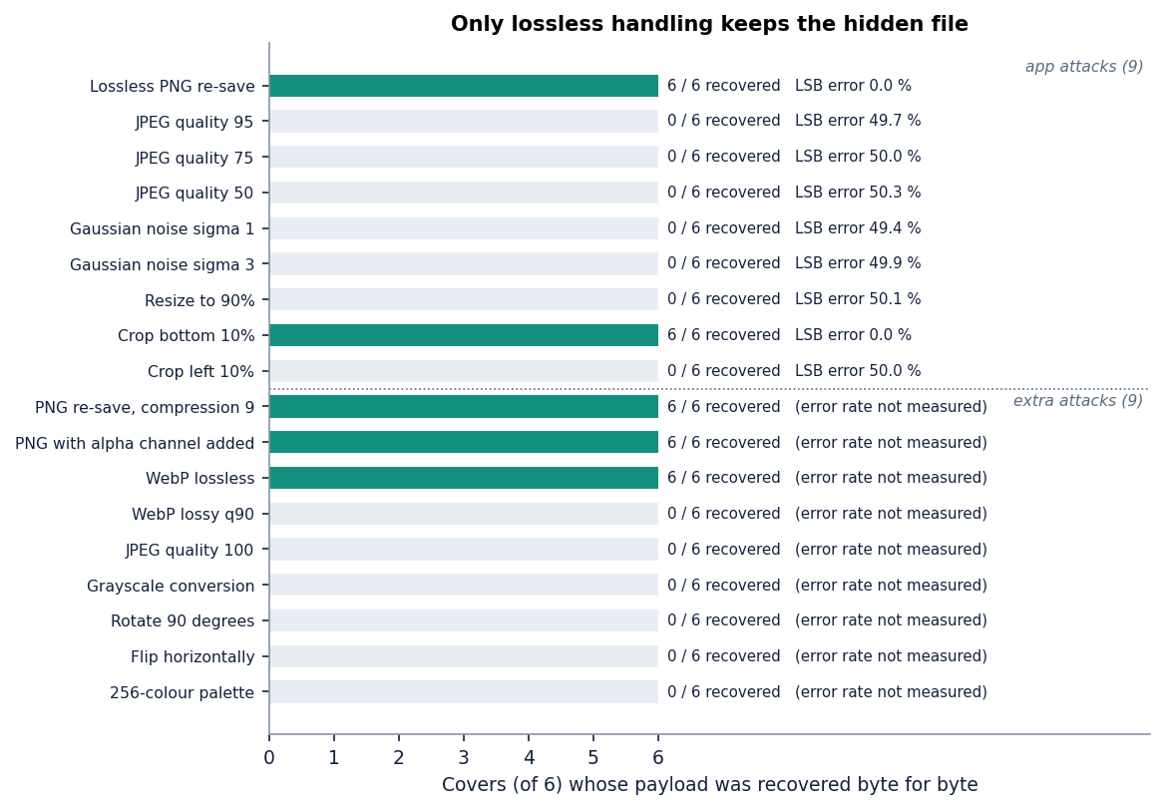
Figure 22: Payload recovery and LSB error rate for the 18 attacks over the six covers.

1.14 Steganalysis and tamper evidence
Imperceptible does not mean undetectable, so the stego images were attacked with two classical detectors. The chi-square test of Westfeld and Pfitzmann [15] checks whether the counts of the value pairs (2k, 2k+1) have been equalised; a p-value near 1 means the least significant bit plane has been overwritten with random-looking bits. It was applied to the embedded prefix, which is an oracle because it assumes the length of the payload is known. The stego prefix gave p between 0.97 and 1.00 in all 30 cases (six covers, five fill levels); the clean cover gave p below 0.5 in 27 of them. In three cases (the cat image at 10 and 25 % and the small coffee image at 10 %) the clean image's prefix was already near-equalised, so the test could not separate cover from stego there.
The weighted-stego estimator [18], [19] is blind: it estimates the fraction of overwritten samples from the whole image. Its estimate tracks the true fill (about 0.10, 0.50 and 1.00 for the three levels shown, within 0.30 at the low end), with a natural-image bias of 0.08-0.18 on four of the six covers and about 0 on the other two. A steganalyst with such a tool can therefore tell that these images carry data when the fill is medium or high. Because the embedding starts at the first pixel and does not depend on a key, the location of the payload is also known to anyone who knows the algorithm; the secrecy rests on the encryption, not on the hiding.
Table 10: Steganalysis of the stego images (selected fill levels; full 30 cases in the experiment file)
Cover | Fill | Chi-square p, cover | Chi-square p, stego | Weighted-stego, cover | Weighted-stego, stego
astronaut_512x512 | 10 % | 0.0 | 1.0 | 0.0828 | 0.182
astronaut_512x512 | 50 % | 0.0 | 1.0 | 0.0828 | 0.5696
astronaut_512x512 | 100 % | 0.0 | 0.9999 | 0.0828 | 0.9944
cat_451x300 | 10 % | 0.9988 | 1.0 | 0.0037 | 0.102
cat_451x300 | 50 % | 0.3416 | 0.9991 | 0.0037 | 0.5218
cat_451x300 | 100 % | 0.0135 | 1.0 | 0.0037 | 1.0044
coffee_600x400 | 10 % | 0.0 | 1.0 | 0.0868 | 0.1915
coffee_600x400 | 50 % | 0.0 | 0.9999 | 0.0868 | 0.5434
coffee_600x400 | 100 % | 0.0 | 1.0 | 0.0868 | 1.0104
coffee_small_200x200 | 10 % | 0.5819 | 1.0 | 0.1804 | 0.3008
coffee_small_200x200 | 50 % | 0.0 | 1.0 | 0.1804 | 0.6205
coffee_small_200x200 | 100 % | 0.0 | 0.9993 | 0.1804 | 0.9865
generated_landscape_1280x720 | 10 % | 0.0 | 0.9982 | -0.005 | 0.0956
generated_landscape_1280x720 | 50 % | 0.0 | 1.0 | -0.005 | 0.4933
generated_landscape_1280x720 | 100 % | 0.0 | 1.0 | -0.005 | 0.9972
rocket_640x427 | 10 % | 0.0 | 0.9935 | 0.1082 | 0.2026
rocket_640x427 | 50 % | 0.0 | 0.9999 | 0.1082 | 0.5659
rocket_640x427 | 100 % | 0.0 | 1.0 | 0.1082 | 1.0311

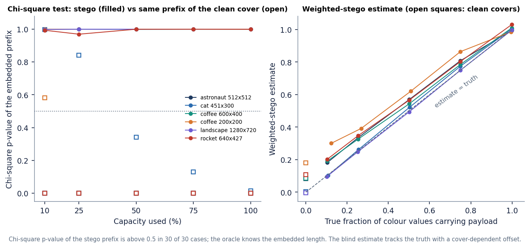
Figure 23: Chi-square p-value and weighted-stego estimate against the true fill, for cover and stego images.
Tamper evidence is the opposite case: the receiver must notice any change. One stego LSB was flipped at a random position inside each field of the bundle, 40 times per field, 240 flips in all (astronaut cover, RSA-2048, 4 KiB payload). All 240 were rejected and 0 produced a wrong file. Flips in the magic, the key-length field and the wrapped key are caught by the format checks and the RSA unwrap; flips in the nonce, the ciphertext and the tag fail the AES-GCM tag check; flips in the 32-bit length header either give an invalid length (13 cases) or shift the bundle and fail the tag (27 cases).
Table 11: Outcome of single-bit tampering by field
Field | Flips | Outcome
length header | 40 | rejected: bad length header x13; rejected: AES-GCM tag check failed x27
magic | 40 | rejected: No CipherVeil bundle found in this image x40
wrapped-key length | 40 | rejected: This bundle was wrapped for a different key size x40
wrapped key | 40 | rejected: RSA unwrap failed x40
nonce | 40 | rejected: AES-GCM tag check failed x40
ciphertext and tag | 40 | rejected: AES-GCM tag check failed x40

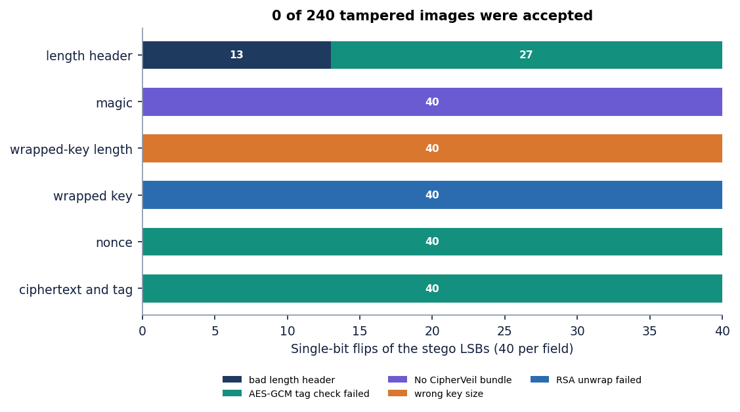
Figure 24: Outcome of 240 single-bit flips by bundle field: every flip is rejected.
A further check shows that encrypting the same file 50 times under one key gives 50 different nonces and 50 different wrapped keys, and two bundles differ in 49.9 % of their bits on average, so an observer cannot tell that two images carry the same file.

1.15 Comparison with the base paper and the supporting papers
The base paper [1] and CipherVeil solve different problems, and the comparison below is therefore qualitative. ProSt hides single secret bits at a secret position among random decoy bits so that an untrusted cloud can compute on them with Fredkin gates; it proves that the adversary's advantage is of order 1/n in the number n of positions and recommends n of at least 2^20 (about 10^6). It reports no PSNR, SSIM or capacity, because its goal is private computation, not transmitting a file. Its reported runtime of 8.38 s is for a 17-gate circuit on a 128 x 128 x 3 image on an Intel Core i5-1135G7 and cannot be compared with the milliseconds of CipherVeil, which does no gate evaluation.
Table 12: Qualitative comparison (different goals, covers and payloads)
Aspect | ProSt (base paper) [1] | SCReedSolo [3] | Memristive ciphers [2] | CipherVeil (this project)
Goal | Compute on hidden bits in an untrusted cloud | Robust hiding of text, audio or image | Lightweight ciphers in memory hardware | Send a file with two layers of protection
Embedding | Secret bit among random decoy LSBs | Shuffled, encrypted and RS-coded LSB, 3 bpp | LSB hiding of cipher output (demonstration) | Sequential 1-bit LSB in RGB, 3.0 bpp
Encryption | None on the payload; location secrecy | Fernet (symmetric) | Trivium, Grain-128a on IMPLY logic | AES-256-GCM + RSA-OAEP-SHA256
Reported quality | Not reported | PSNR 51.774, 57.653, 52.888 dB; SSIM 0.996, 0.936, 0.996 | PSNR table for 256 x 256 gray images | PSNR 52.479-74.615 dB up to 73 % fill; 51.14 dB at 100 %; SSIM 0.9929-0.99999
Robustness | Not applicable | Reed-Solomon against bit corruption | Not studied | Lossless only; no error correction
Security argument | Provable, advantage of order 1/n | Empirical steganalysis tools | Hardware energy and steps | Standard primitives; detectable by chi-square and weighted-stego
Speed | 8.38 s (17 gates, 128 x 128 x 3) | Not given in comparable form | Energy reductions up to 42 % and 44 % | 0.15 ms encrypt, 0.25 ms embed, 86 ms unwrap (median)

SCReedSolo [3] reports PSNR 51.774 dB and SSIM 0.996 for 5.46 million characters of text in a 14589 x 8423 x 3 image, 57.653 dB and 0.936 for audio in a 21188 x 30328 x 3 image, and 52.888 dB and 0.996 for a 100 x 100 x 3 image in the 512 x 512 Lenna image. These use very different covers and payloads, so the numbers are of the same order as CipherVeil's 52.5-74.6 dB up to 73 % fill, not better or worse. SCReedSolo adds shuffling and error correction, which CipherVeil does not have; CipherVeil adds public-key key transport and authenticated encryption, which SCReedSolo does not have. The memristive paper concerns hardware (energy and step reductions of up to 42 % and 44 %) and offers no software result to compare.
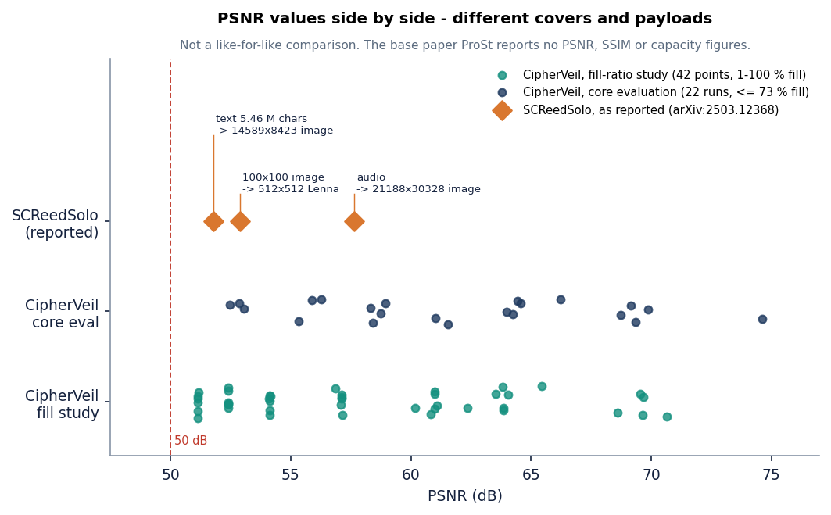
Figure 25: PSNR range reported for SCReedSolo and measured for CipherVeil. Covers and payloads differ, so the bars indicate order of magnitude only.
What CipherVeil adopts from the base paper is the LSB carrier and the idea of exchanging a secret between sender and receiver by standard cryptography. What it does not implement is homomorphic computation on hidden bits, decoy-bit location hiding and a provable-security argument; Chapter 10 lists how a key-dependent pixel selection could move towards the base paper's location secrecy.

1.16 Sample inputs and outputs
Table 13: The five messages of the demonstration session
Op | Input file (bytes) | Cover | PSNR (dB) | Result
5 | confidential_memo.pdf (21,517) | astronaut_512x512 | 57.642 | bundle 22,063 B, 22.445 % of the cover; received byte for byte (op 10)
6 | confidential_memo.pdf (21,517) | coffee_small_200x200 | - | blocked: needs 22,063 B, cover holds 14,996 B
7 | accounts.csv (2,774) | coffee_600x400 | 65.513 | bundle 3,310 B, 3.678 % of the cover; stego PNG produced
8 | settings.json (99) | generated_landscape_1280x720 | 78.419 | bundle 634 B, 0.183 % of the cover; stego PNG produced
9 | meeting_notes.txt (169) | rocket_640x427 | 72.707 | bundle 709 B, 0.692 % of the cover; SSIM 0.999986

The input is any file up to 25 MB and the output is a PNG. The same hash is shown at both ends: for the memo the SHA-256 begins 89acd543 before sending and after receiving. A second output of the receive step, the failed one, is shown below. The smaller the payload relative to the cover, the higher the PSNR, as the closed-form model predicts: 99 bytes in the landscape gives 78.419 dB, 21,517 bytes in the astronaut image gives 57.642 dB.

1.17 Success and failure analysis
Where the system succeeds. Every file that fits is restored byte for byte (22 of 22 in the core evaluation, plus the 240 tamper trials and 50 repeated encryptions that all decrypted correctly). The stego image is visually identical to the cover (largest change 1 of 255, PSNR above 51.14 dB at every fill level). Any modification of the bundle is detected before anything is released. A wrong key, an image without a payload and a file that is not an image are each refused with a specific message.
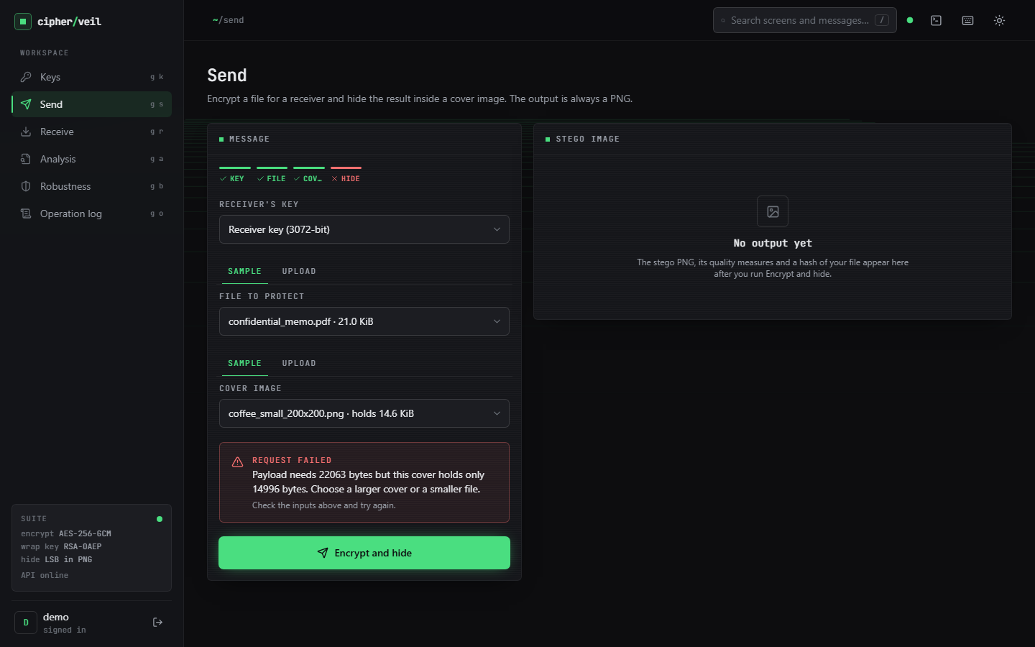  Figure 26: Failure case: a 22,063-byte bundle does not fit the 14,996-byte 200 x 200 cover; the send is refused with the exact numbers. | 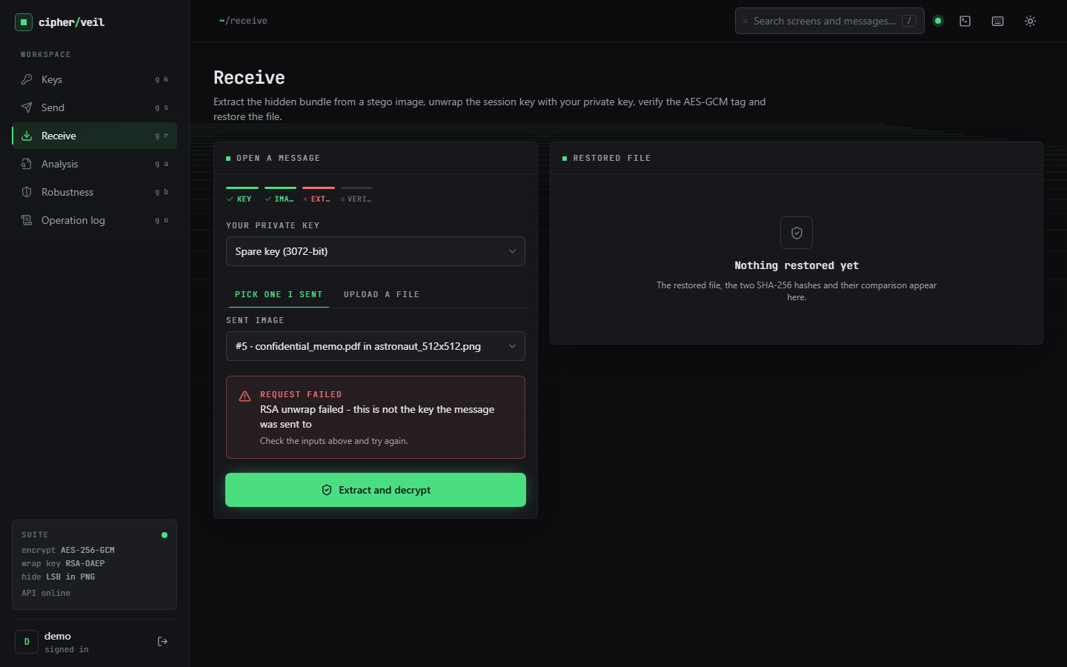  Figure 27: Failure case: receiving with the Spare keypair; the RSA unwrap fails and no data is released.

Where it fails, by design. The two screens above show refusals that protect the user. The failures that cost data are different: JPEG, noise, resizing, rotation, grayscale and palette conversion destroy the payload (Section 8.7), and the receiver is told only that no payload was found, because after such an attack the length header is garbage. The image cannot be repaired, only resent. A chat application or a social site that recompresses the picture will make a sent message unreadable.
Where it is weaker than it looks. The imperceptibility numbers are excellent, but the chi-square test flags the images and the weighted-stego estimate recovers the fill (Section 8.8). A user who reads PSNR above 50 dB as safe from detection draws the wrong conclusion. Low fill is the best defence: a 169-byte note in a 640 x 427 image changes 0.35 % of the values.

1.18 Limitations of these results
• Six covers, all committed test images or a procedural landscape; no camera photographs, no images that were already JPEG-compressed before conversion, and no large corpus.
• Four small synthetic payloads and random payloads; no real confidential documents were used.
• One machine and one operating condition; timings vary by 10-30 % with load. Only the embedding, PSNR and SSIM numbers are load-independent.
• Steganalysis used only two classical detectors, and the chi-square test was applied with the payload length known. Sample-pair, RS and deep-learning detectors were not run, so the detectability reported is a lower bound.
• Robustness was measured with a single payload (accounts.csv) and a single noise seed; the bottom-crop result holds only while the bundle lies in the retained rows.
• The comparison with the base paper is qualitative; its provable-security claim was not reproduced and was not in scope.
• The web interface was driven by a script to capture screens, not tested with an assertion-based browser suite, and no usability study with real users was done.

1.19 Objectives against outcomes
Table 14: The six objectives of the project and what was measured
# | Objective (from the objectives document) | Outcome
1 | AES for the payload and RSA for the AES key | Met: AES-256-GCM with RSA-OAEP-SHA256; 22 of 22 round trips and 240 of 240 tampered images rejected
2 | Key generation and exchange between sender and receiver | Met for RSA 2048, 3072 and 4096 keypairs with PEM import and export and fingerprints; no key-agreement protocol, certificate or identity check
3 | Embed the encrypted payload by LSB | Met: 1 bit per colour value, 3.0 bits per pixel, capacity check before embedding
4 | Extraction and decryption path | Met: byte-exact restoration with tag and SHA-256 verification
5 | PSNR and SSIM against the cover | Met: PSNR 52.479-74.615 dB up to 73 % fill and 51.14 dB at full fill; SSIM 0.9929-0.99999
6 | Capacity, time and robustness | Measured: 14.6-337.5 KiB capacity, sub-millisecond embedding, 86 ms unwrap; robust to lossless handling only; detectable by statistics

All six objectives are met in the sense that each was implemented and measured, but objective 6 was answered with a limit rather than a strength: the combined scheme is fast and has high capacity, and it is fragile and statistically visible. The project is supported by 39 passing unit and API tests (13 cryptography, 9 embedding, 7 metrics and pipeline, 10 API) and 21 smoke checks against the running backend.

