Department of Computer Science and Engineering (Data Science)
CSDS-A | Batch A7 (CSE - Data Science, Section A)
SHEGUARD: AI Powered Women's Safety Platform
S.No. | Student name | Roll / hall ticket no.
1 | CH.AARTHI | 23K91A6741
2 | D.PRANATHI | 23K91A6748
3 | BALA VIGNESH | 23K91A6717
4 | A.VISHAL | 23K91A6704
Under the guidance of: [GUIDE NAME], [DESIGNATION]
RESULTS
This document reports the real results of the project: the evaluation of the area-risk model, the route scoring, the SafePhrase matcher, the API and the live channel, every output screen with a caption, the success and failure cases, and the objectives measured against the outcomes. The risk model is unsupervised and has no ground truth, so its scores measure cluster quality, not safety; the alert channels and the Gemini assistant could not be demonstrated and are reported as gaps.

1 Model Performance
SHEGUARD contains one trained model, the area-risk model: K-Means with three clusters on a single number per district, the average number of recorded crimes against women per reporting year. Everything else that is scored (the route score, the SafePhrase matcher) is rule-based. There is no ground truth for "how risky a district is" and therefore no accuracy, precision or recall for this model and no train/test split: the model is fitted on all 467 districts, and the only measures available are internal cluster-quality indices, which describe how well one number separates into groups, not whether the groups predict harm. All figures come from experiments/metrics.json, experiments/eval/metrics.json and the re-run in experiments/study/metrics.json, produced on an Intel Core i5-12500 with 15.7 GB RAM and no GPU; fitting takes well under a second.
Table 1: Headline results of the area-risk model and the route scorer
Measure | Result | Data
Districts clustered | 467 of 827 (56.5% geocoded) | district file 2001-2012
Silhouette (shipped, k = 3) | 0.5798 | 467 districts
Davies-Bouldin (lower is better) | 0.531 | 467 districts
Calinski-Harabasz | 1155.4 | 467 districts
Tiers low / medium / high | 278 / 148 / 41 | mean 97.76 / 327.92 / 720.93 crimes per year
Re-run agrees with the shipped table | 100% | district_risk.csv
Stability over 30 random starts (adjusted Rand index) | min 0.659, mean 0.790 | k = 3, n_init = 1
Route scoring sanity check | all-high route 5.0, all-low route 1.0 (pass) | ml/eval.py
Routes scored (16 real city pairs) | 16 routed, 10 with an alternative | OSRM demo server
Time to score one route | 304 ms | pure Python, 467 districts
Automated tests | 51 passed, 6 documented defects fail as expected | pytest

1.1 Choice of the number of clusters
Table 2: Cluster-quality indices for k = 2 to 8 on the standardised crime rate
k | Silhouette | Davies-Bouldin | Inertia
2 | 0.6616 | 0.5507 | 159.78
3 | 0.5798 | 0.5310 | 78.09
4 | 0.5955 | 0.4932 | 41.78
5 | 0.5598 | 0.5181 | 29.63
6 | 0.5615 | 0.5400 | 20.49
7 | 0.5557 | 0.5382 | 14.86
8 | 0.5525 | 0.5018 | 11.34

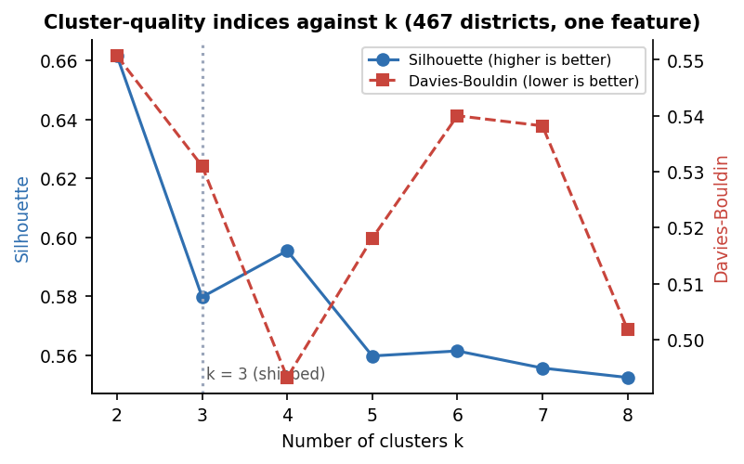
Fig. 1: Silhouette and Davies-Bouldin index against the number of clusters
The shipped k = 3 is a design choice, not the optimum of either index: k = 2 has the highest silhouette (0.662) and k = 4 has both a higher silhouette (0.596) and a lower Davies-Bouldin value (0.493) than k = 3 (0.580, 0.531). Three tiers were chosen because the interface shows low, medium and high. The differences between k = 3 to 8 in silhouette are small (0.553 to 0.596), so the data do not strongly prefer one number.

1.2 What the tiers are
Table 3: Value ranges of the three tiers
Tier | Crimes per year (min to max) | Districts | Share
Low | 0.0 to 212.0 | 278 | 60%
Medium | 215.5 to 522.0 | 148 | 32%
High | 537.7 to 1191.6 | 41 | 9%

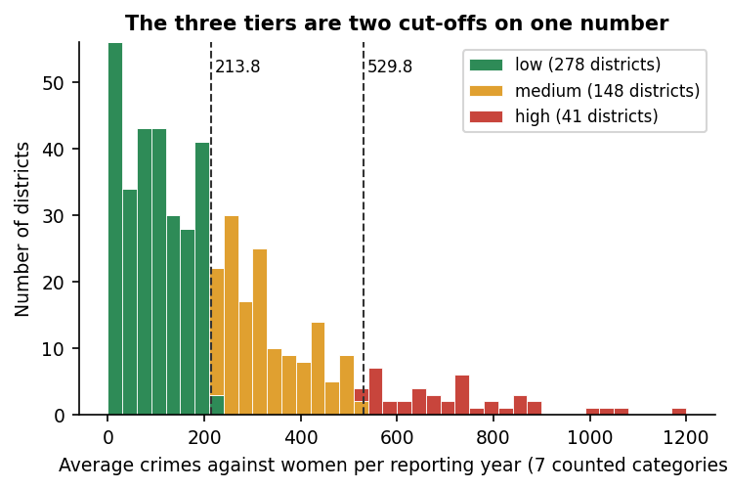
Fig. 2: Distribution of the crime rate with the two cut-offs that K-Means found
Because the only feature is one number, K-Means is equivalent to two thresholds: 213.75 and 529.83 crimes per year, which reproduce the K-Means tiers for 100% of districts. The model is therefore a data-driven pair of cut-offs, not a multi-feature classifier. The silhouette of 0.58 means that these three groups are cleanly separated along this one axis; it does not mean that the groups describe safety.
Other ways of cutting the same number disagree with K-Means for many districts (Figure on tiering agreement): Ward hierarchical clustering agrees for 83.3%, a Gaussian mixture for 72.6%, fixed cut-offs of 100 and 300 for 54.6% and equal-count terciles for 49.2%. Across 30 random starts the adjusted Rand index against the shipped clustering ranges from 0.66 upward (mean 0.79), so districts near the cut-offs change tier with the initialisation. The size of the 41-district "high" group is a property of the method chosen.
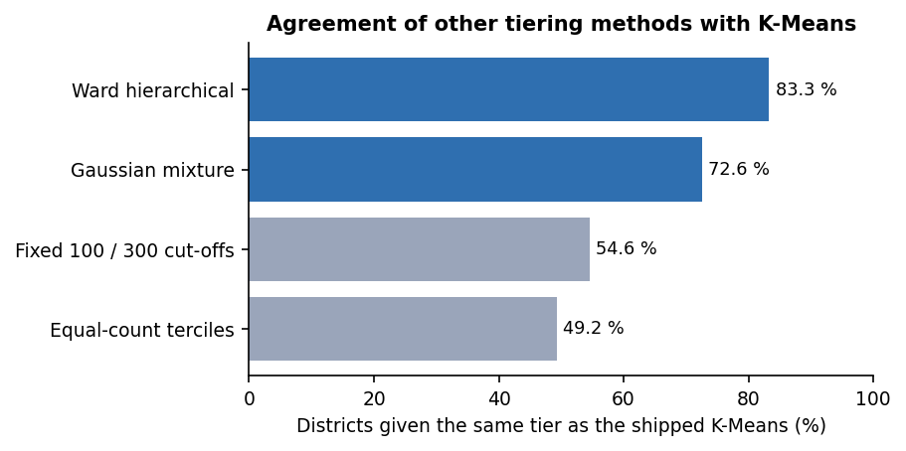
Fig. 3: Agreement of other tiering methods with the shipped K-Means

1.3 What the score counts
The crime rate adds seven recorded categories. Cruelty by husband or relatives is 40.0% of everything counted, assault on modesty 25.8%, rape 13.0%, kidnapping and abduction 11.7%, insult to modesty 5.2% and dowry deaths 4.2%. A district's tier is therefore driven mainly by recorded domestic-violence counts, which say little about the safety of a street at night. The measure is also a raw count, not a rate per head of population: the highest values are West Godavari (1,191.6), Vijayawada (1,059.0), Guntur (1,032.5), Jaipur (1,001.4) and Krishna (895.2), and large or well-reporting districts rank high. Vijayawada, Jaipur and Mumbai are averages over only 5 reported years.
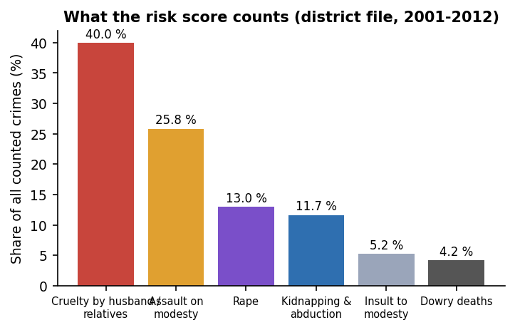
Fig. 4: Share of each crime category in the counted total

1.4 Coverage of the district table
Only 467 of 827 district entries (56.5%) could be geocoded; the others were dropped rather than guessed. The table has no district at all for Uttar Pradesh (77 entries), West Bengal (30), Delhi (24), Uttarakhand (13), Tripura (10) and six small union territories. The consequence appears when the nearest district to a city centre is measured (40 cities): the median is 8.1 km, but 7 cities are more than 100 km from any district, among them Hyderabad (149 km), Secunderabad (147 km), Warangal (195 km), Kolkata (191 km), Lucknow (231 km) and Kanpur (164 km). The scorer takes the nearest district however far away it is.
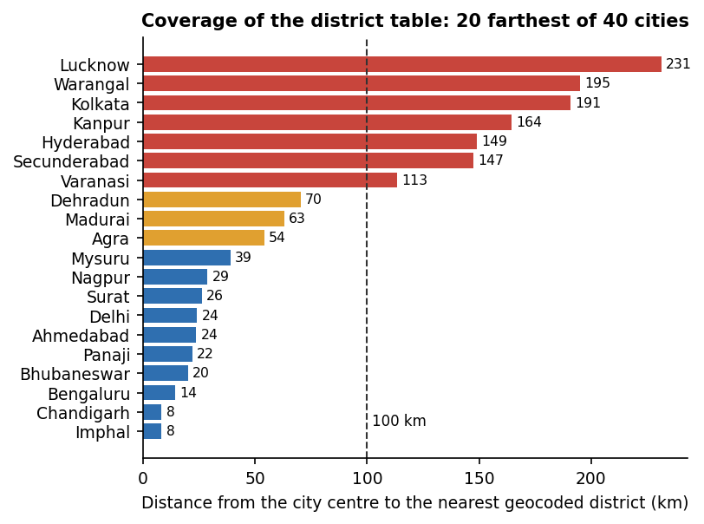
Fig. 5: Distance from city centres to the nearest district in the risk table (20 farthest of 40 cities)
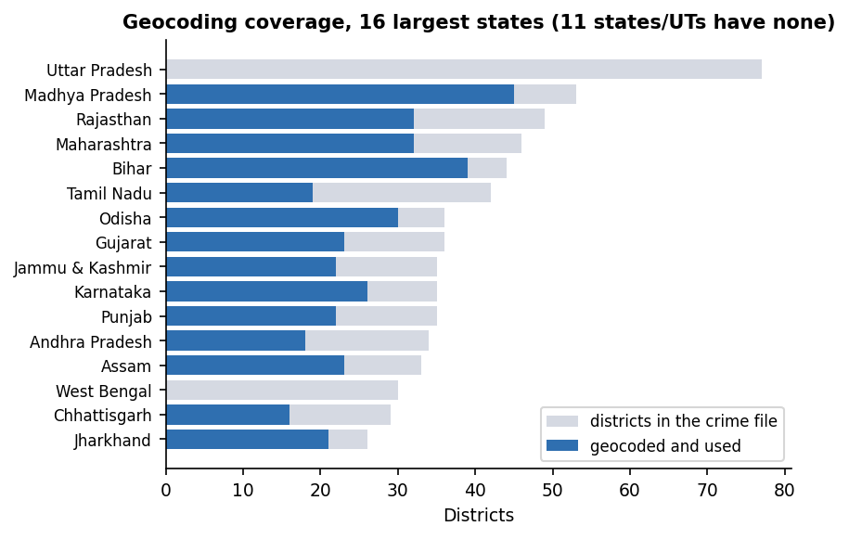  Fig. 6: Geocoded districts per state | 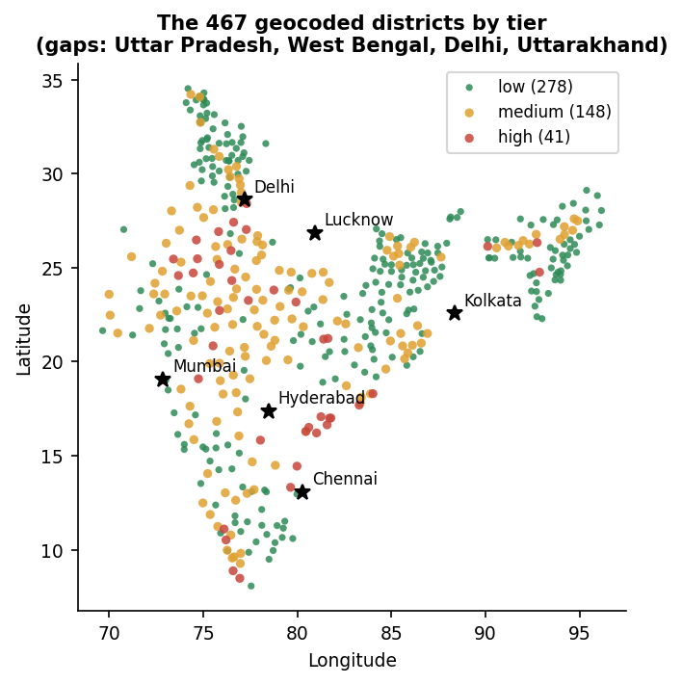  Fig. 7: The 467 districts by tier

1.5 Route scoring on real routes
Sixteen real city pairs were routed through OSRM and scored. 10 pairs returned two alternatives and 6 returned one, so for 37.5% of trips there was nothing to choose between. The recommended (lowest-score) route was also the OSRM-fastest in 11 of 16 pairs, and where an alternative existed the safest pick cost 3.7 minutes more on average. Along the 16 routes the mean distance to the nearest district was 61.9 km (maximum 231.3 km).
Table 4: Scores of eight of the 16 routed pairs (lower is safer; the first number is OSRM's first route)
Pair | Routes | Km | Score by day | Score at night | Nearest district, mean km
Hyderabad - Warangal | 2 | 149 / 157 | 2.87 / 2.52 | 4.60 / 4.03 | 185
Delhi - Jaipur | 2 | 285 / 312 | 3.20 / 4.22 | 5.13 / 6.75 | 23
Delhi - Agra | 2 | 203 / 210 | 4.54 / 4.43 | 7.27 / 7.09 | 45
Mumbai - Pune | 1 | 145 | 1.85 | 2.95 | 22
Kolkata - Patna | 2 | 605 / 636 | 1.15 / 1.36 | 1.84 / 2.18 | 61
Lucknow - Kanpur | 2 | 94 / 96 | 1.02 / 1.02 | 1.64 / 1.64 | 199
Bhopal - Indore | 2 | 188 / 256 | 3.99 / 3.11 | 6.38 / 4.97 | 21
Chandigarh - Delhi | 2 | 269 / 288 | 2.63 / 1.95 | 4.21 / 3.12 | 18

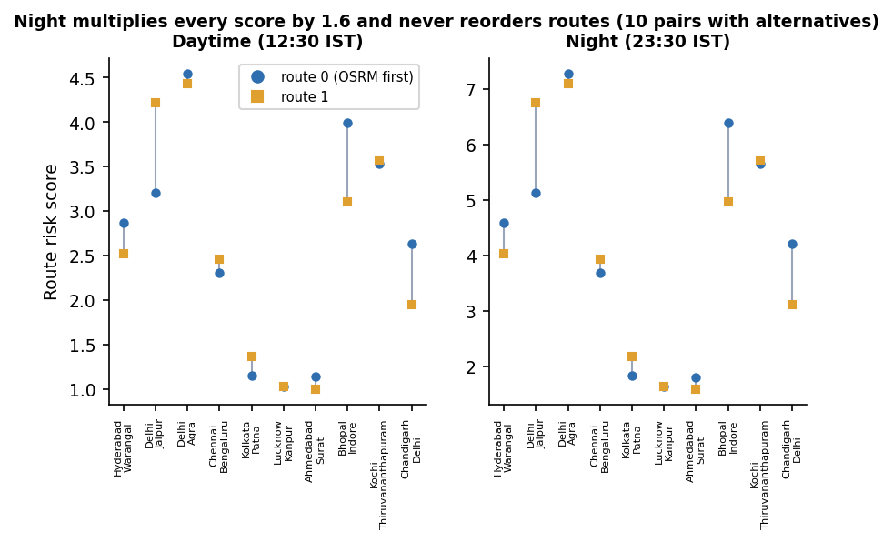
Fig. 8: Route scores by day and at night for the pairs that returned two alternatives
The night factor changes the numbers but never the choice. The same route scores 2.5 by day and 4.0 at night (ratio 1.6); because the multiplier of 1.6 is applied to every sampled point of every route, the ranking was identical by day and at night for all 16 of 16 pairs. It affects only the displayed value and the route label. Changing the tier weights to 1/2/3 or 1/3/9 changed the recommended route in 0 of 10 pairs, and changing the sampling step (1, 4, 16, 32 instead of 8) changed it in 1 of 10.
Scoring one route takes about 304 ms because every sampled point is compared with all 467 districts in Python; a live POST /api/routes/plan including the OSRM call took 1.6 s on average (see the table of response times).

2 Software Verification Results
The project has a pytest suite in tests/ that uses a throw-away SQLite database and replaces OSRM, Gemini, Telegram and Gmail by stubs, so it runs offline in about 14 s. 51 of 57 tests pass; the other 6 are expected failures that assert the behaviour a hardened system should have and fail on the shipped code. They are kept visible instead of being deleted.
Table 5: Automated test results by area
Area | Tests | What is checked
Authentication | 10 | register, duplicate e-mail, validation (short password, bad e-mail, missing field), login and wrong password, bcrypt hash stored, token required, forged and expired token rejected
Guardians | 4 | create, list, update, delete; another user's guardian cannot be read, edited or deleted
Risk data | 2 | 467 districts served with three tiers and scores in 0-100; tier counts 278 / 148 / 41
Route planning | 4 | alternatives sorted by risk, first one recommended; login required; OSRM failure gives 502; no route gives 404
SOS lifecycle | 5 | session and tracking link, alert fan-out to every configured channel, ordered location trail, cancel and no updates afterwards, owner-only access, login and coordinates required
Guardian view and WebSocket | 2 | public page with owner name and last position; unknown token 404; WebSocket pushes a location and the cancel message
Evidence | 6 | SHA-256 equals the hash of the stored file; one flipped bit changes it; audio accepted, other kinds and empty files rejected; count on the session; other users get 404
AI endpoint | 4 | answer returned, login and question required, provider error gives 502, missing key gives a clear error
Places search | 2 | login required, one-character query rejected
Scorer and model artefacts | 12 | haversine distance, nearest district, tier weights 1.0 / 2.5 / 5.0, night factor 1.6 on every route, no reordering at night, empty route, no-district fallback, night window in UTC, shipped model loads, district table consistent, tiers are threshold bands
Known defects (expected fail) | 6 | see the next table

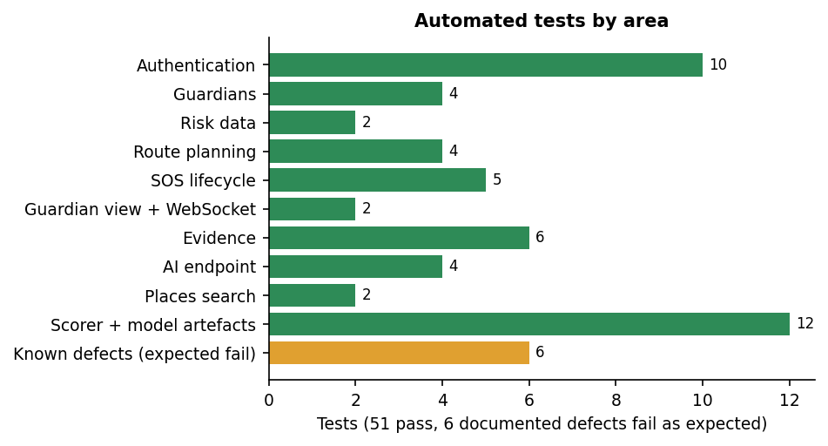
Fig. 9: Automated tests by area
Table 6: The six documented defects
Defect (test that documents it) | Observed behaviour
Gemini timeout | An httpx.ReadTimeout is not caught, so the API answers HTTP 500 instead of 502 (seen live: the first two assistant calls returned 500 after 20 s)
Latitude 999 | POST /api/sos/start with latitude and longitude 999 is accepted (HTTP 200)
Unknown trigger | trigger is a free string: any value is stored
WebSocket token | /ws/track/{token} accepts a token that matches no session
Upload size | No limit: a 20 MB "audio" upload was accepted in 0.24 s
Evidence served as HTML | A file named page.html uploaded as a photo is served back from /evidence-files/ as text/html on the API origin

2.1 Response time
Table 7: API response times (server and client on 127.0.0.1, one client, sequential calls)
Endpoint | n | Mean (ms) | Median (ms) | 95th percentile (ms)
Health check | 30 | 2.3 | 2.1 | 4.1
Risk areas (467 rows) | 30 | 36.2 | 31.1 | 81.3
Log in (bcrypt) | 15 | 285.2 | 279.0 | 314.6
Profile | 30 | 5.1 | 4.9 | 6.7
Add guardian | 30 | 11.0 | 10.9 | 13.3
Start SOS (30 guardians, no channel configured) | 15 | 50.7 | 34.2 | 137.4
Push a location | 30 | 15.3 | 14.7 | 20.4
Guardian tracking page | 30 | 9.4 | 8.3 | 15.3
Upload evidence 100 KB | 10 | 15.0 | 13.3 | 24.0
Upload evidence 1 MB | 10 | 19.1 | 18.4 | 23.8
Upload evidence 5 MB | 10 | 68.2 | 61.0 | 117.9
Plan a route (live OSRM) | 5 | 1628.6 | 1591.1 | 2001.5

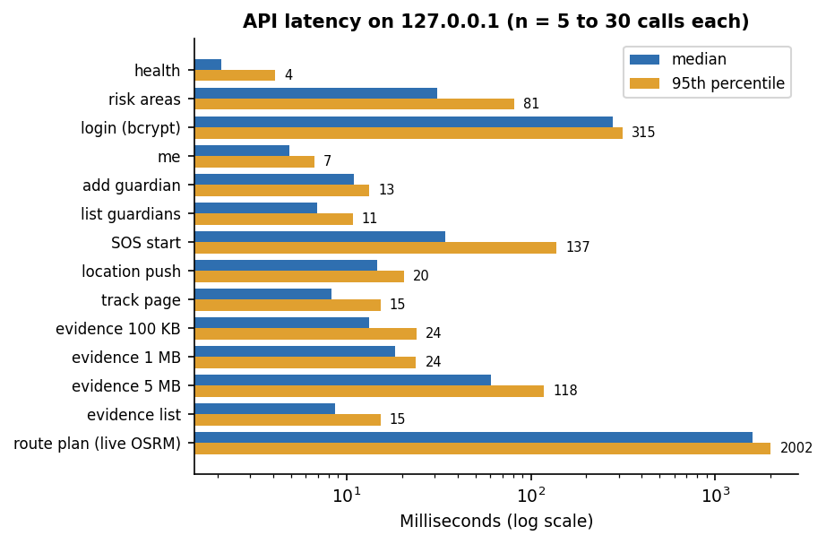
Fig. 10: Median and 95th-percentile response time per endpoint
Every call except log-in and route planning answers within a few tens of milliseconds. The bcrypt log-in takes about 279 ms, which is intended, and a route plan about 1.6 s because it waits for the public OSRM server. The time from a location being posted to a guardian's page receiving it over the WebSocket was 15.4 ms on average for one viewer (95th percentile 17.2 ms) and 14.6 ms until all five of five viewers had it (95th percentile 18.8 ms), 30 trials each. The time to deliver an alert by Telegram or e-mail was not measured, because no credentials are configured; with real channels the start-SOS request would wait for each guardian's send in turn, and send_email is a blocking call inside an asynchronous route. No load test with many concurrent users was run.

2.2 Access control and input handling
Table 8: Access-control and input probes against the live API
Probe | Result
No token on guardians, SOS start, AI and route planning | HTTP 401 on all four
Forged or tampered JWT | HTTP 401
User B reads, pushes to, cancels, lists evidence of or uploads to user A's session | HTTP 404 on all five
User B edits or deletes user A's guardian; B's own list | HTTP 404 on both; B sees 0 guardians
Public tracking page with a wrong / the right token | HTTP 404 / 200
Stored evidence file requested with no token | HTTP 200 (file name needs the 16-hex hash prefix; a guessed name gives HTTP 404)
25 consecutive wrong passwords | all HTTP 401, no lockout or rate limit
Password of six characters, "aaaaaa" | accepted: the only rule is a minimum length of six
Location push after cancel | HTTP 400 (correct)
Tracking page after cancel | HTTP 200 with the whole trail (91 points); there is no expiry
Evidence kind video; empty file | HTTP 400 on both

Evidence integrity. The hash is computed on the server when the file arrives. Recomputing it from the stored file gives the same 64-character value, and flipping one bit of the stored file changes it; hashing 1 MB takes about 1.1 ms. There is no verification endpoint, and the hash is stored in the same database as the file path, so tampering is detected only if someone recomputes and compares.

2.3 SafePhrase matcher
Table 9: The product's SafePhrase matcher on written transcripts
Sensitivity (share of words needed) | Recall on 24 phrase transcripts | False triggers on 80 ordinary-speech checks
Low (100%) | 13/24 = 54.2% | 0/80 = 0.0%
Medium (85%) | 13/24 = 54.2% | 0/80 = 0.0%
High (75%) | 18/24 = 75.0% | 0/80 = 0.0%
Ultra (60%) | 24/24 = 100.0% | 8/80 = 10.0%

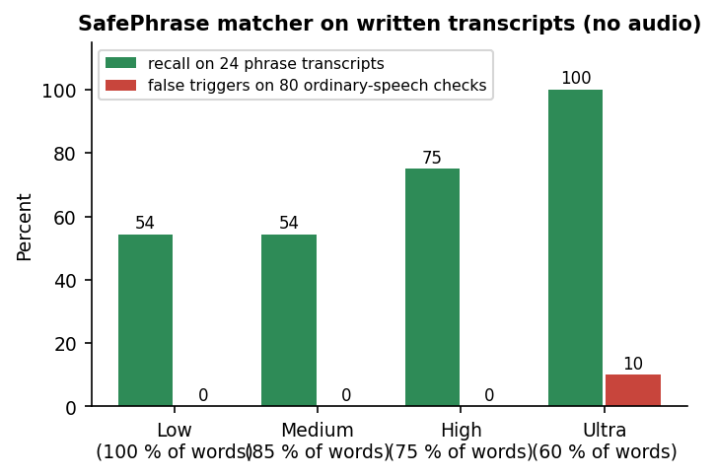
Fig. 11: Recall and false triggers by sensitivity level
The matcher in frontend/src/lib/safephrase.ts was run unchanged on hand-written transcripts of two phrases ("help me sheguard" and "please call my brother now"): exact, embedded in a sentence, one word dropped, one word misheard and reordered, plus 40 ordinary sentences. No audio and no speech recogniser were involved, so the accuracy of Chrome's recogniser on the phrase was not measured. Exact and embedded phrases trigger at every level (10 of 10). At the default Medium level the recall is 54.2%, because for a three-word phrase one missing word (2 of 3 = 0.67) is below 0.85, so Medium behaves like Low. Ultra finds all 24 but also fires on sentences such as "can you help me with my homework" and "tell me about sheguard" (8 of 80). A match costs 1.5 microseconds.

2.4 AI safety assistant
Ten fixed prompts (five general, three emergencies, two off-topic) were sent once each through POST /api/ai/ask. 0 of 10 were answered. All 10 returned HTTP 502 because Google replied with error 429 (quota exceeded). Earlier in the same run the first two calls returned HTTP 500 after a 20 s read timeout and one returned a 503 "high demand" error from Google. The questions the evaluation was designed to answer, whether the first line of an emergency answer points to SOS or emergency services as the system prompt demands and whether answers stay under 150 words, could therefore not be measured. The endpoint, its error mapping and its login check are covered by the stubbed tests only.
The end-to-end flow was also executed in the browser as shown in the output screens: registration, guardians, route planning, SOS with a moving position, evidence, the guardian's live page and hold-to-cancel; and the earlier scripts/smoke_test.py passes all 12 live steps (the Gemini step only warns).

3 Functional Testing
Two functional runs were made against the live application on 26 October 2026. The first is the project's own scripts/smoke_test.py, which drives the real API through twelve steps with real external calls (OSRM for the route, Gemini for the assistant). The second is a scripted browser walk-through (Playwright driving the installed Chrome at 1440 x 900) that registers an account through the interface, adds guardians, plans routes, starts a real emergency with live position updates, uploads evidence, opens the guardian's page in a second, logged-out browser context and cancels; the screenshots in Chapter 8 are its captures. The browser's geolocation is set by the test script to fixed city centres and its microphone is Chrome's built-in test tone, so position and audio are injected, not taken from a phone.
Table 10: Smoke test of the live API
No. | Smoke-test step | Observed
1 | Health check | Pass
2 | Register a new user | Pass: token returned
3 | Log in | Pass
4 | Add a guardian | Pass
5 | Read risk areas | Pass: 467 districts
6 | Plan a route (Hyderabad to Secunderabad, real OSRM) | Pass: one route returned, risk score 1.0
7 | Start SOS | Pass: session and share token; delivery report telegram false, email false (no credentials configured)
8 | Push a location update | Pass
9 | Upload photo evidence | Pass: 64-character SHA-256
10 | Read the public tracking page | Pass: two location points
11 | Cancel the SOS and re-read the tracking page | Pass: status cancelled
12 | Ask the AI assistant | Warning, not a pass: HTTP 500 (read timeout); later probes returned 502 with Google quota error 429

Table 11: Functional test cases (browser walk-through)
No. | Requirement | Test performed in the browser | Observed
F1 | Register and sign in | Fill the registration form, accept the terms, create the account | Pass: lands on the dashboard
F2 | Trusted guardians | Add three guardians (name, phone, e-mail, Telegram ID) on the profile page | Pass: Trusted guardians (3) listed; the dashboard shows 3 added
F3 | Area risk at the user's position | Open the dashboard with the position set to Delhi | Pass: tile reads Medium - GURGAON (Delhi has no district of its own in the table)
F4 | Place search | Type Jaipur on Safe routes | Pass: suggestions from Nominatim
F5 | Safe route with alternatives | Select Jaipur from Delhi | Pass: two routes, 274.1 km / 204 min and 299.5 km / 205 min, both labelled HIGH risk, risk circles drawn
F6 | Single-route case | Plan Hyderabad to Vijayawada | Pass: one route, 269.1 km / 213 min, HIGH risk (20 / 0 / 80 % low / medium / high samples)
F7 | AI assistant | Send a safety question | Fail by environment: reply "The AI assistant is unavailable right now" (Gemini quota error); the route advice panel shows the same message
F8 | SafePhrase settings | Open SafePhrase, add a second cover phrase | Pass: phrase listed with a SHA-256 fingerprint, sensitivity buttons shown, two active phrases
F9 | Start an emergency | Press the SOS button | Pass: Guardian tracking active, tracking link, live map; 0 of 3 guardians reached because no Telegram or Gmail credentials are configured
F10 | Evidence | Upload a photo, record a 3-second audio clip | Pass: two rows with SHA-256 prefixes and times
F11 | Live tracking | Open the link in a clean browser context while the position moves | Pass: the guardian page shows the owner's name, status active and a growing path
F12 | Hold to cancel | Hold the cancel button for three seconds | Pass: the capture shows the progress ring part-way ("Keep holding..."), then the dashboard with the event in recent activity; the guardian page reads "has ended the emergency"

Every step passed except the assistant, which could not be demonstrated because the shared API key had exhausted its quota, and the delivery of alerts, which was not testable without credentials. The walk-through therefore proves that the session, the tracking link, the live path, the evidence list and the cancellation work from the interface, and does not prove that a guardian is actually notified.
A separate probe of the assistant with 10 fixed prompts (five general, three emergency, two off-topic; scripts/assistant_eval.py) answered 0 of 10; all 10 failed with HTTP 502 (Google quota error 429). Whether the emergency prompts get an SOS-first reply, as the system prompt requires, was therefore not measured.

4 Performance Testing
Response times were measured against the live server over 127.0.0.1 with one sequential client (scripts/measure_api.py) on an Intel Core i5-12500 (6 cores, 12 threads) with 15.7 GB of memory and no discrete GPU, running Windows 11, with other work present on the machine, so the figures are indicative rather than a benchmark. (The address 127.0.0.1 is used because localhost adds about two seconds of IPv6 fallback per call on this machine.)
Table 12: API response times (live server)
Request | Runs | Median (ms) | 95th percentile (ms) | Max (ms)
Health check | 30 | 2.1 | 4.1 | 5.5
District list (467 rows) | 30 | 31.1 | 81.3 | 87.8
Log in (bcrypt verification) | 15 | 279.0 | 314.6 | 330.0
Current user | 30 | 4.9 | 6.7 | 9.4
Add a guardian | 30 | 10.9 | 13.3 | 16.0
List guardians | 30 | 6.9 | 10.8 | 11.0
Start SOS (30 guardians, no alert channel configured) | 15 | 34.2 | 137.4 | 181.6
Push a location | 30 | 14.7 | 20.4 | 22.2
Guardian tracking page | 30 | 8.3 | 15.3 | 15.5
Upload evidence, 100 KB | 10 | 13.3 | 24.0 | 24.0
Upload evidence, 1 MB | 10 | 18.4 | 23.8 | 23.8
Upload evidence, 5 MB | 10 | 61.0 | 117.9 | 117.9
List evidence | 30 | 8.7 | 15.3 | 18.0
Plan a route (live OSRM call) | 5 | 1591.1 | 2001.5 | 2001.5

Fig. 12: API latency, median and 95th percentile (logarithmic axis)
A location update reaches a guardian's WebSocket quickly: measured from the moment the owner's POST is sent to the moment the viewer receives the frame, the mean is 15.4 ms with one viewer (median 13.2 ms, 95th percentile 17.2 ms, maximum 77.1 ms) and 14.6 ms until all of five viewers have it (95th percentile 18.8 ms), over 30 trials each. Every ordinary request completes in under 70 ms at the median except log-in, which takes about 279 ms because bcrypt is deliberately slow, and route planning, which takes a median of 1.6 s because it waits for the public OSRM server and then scores each alternative in pure Python (about 304 ms per route). Computing the SHA-256 of 1 MB takes about 1.1 ms, so hashing is not the cost of an evidence upload.
The SOS-start figure excludes any real alert: no Telegram or Gmail credentials were configured, so the time to deliver a message to a guardian was not measured. With real channels the request waits for each Telegram call and each SMTP exchange in turn (10 s timeout each), and the blocking SMTP call would also stall the event loop; this is read from the code. Not measured: many simultaneous users, more than five viewers per session, memory use under load, a large database, the front end's load time on a phone, battery drain of continuous speech recognition or position watching, and other hardware.

5 Output Screens
Every screen below is a real capture of SHEGUARD running on 26 October 2026 with real data in it: an account registered through the form, three guardians added through the profile screen, real OSRM routes and Nominatim place search, a real SOS session with a moving position, evidence saved with its hash, and the guardian's page opened in a second, logged-out browser. The browser position was set by the test script to the centres of Delhi and Hyderabad (a phone's GPS was not used), the microphone was Chrome's built-in test device and the evidence photograph is one of the application's own screenshots. The captures are 1440 by 900 pixels.
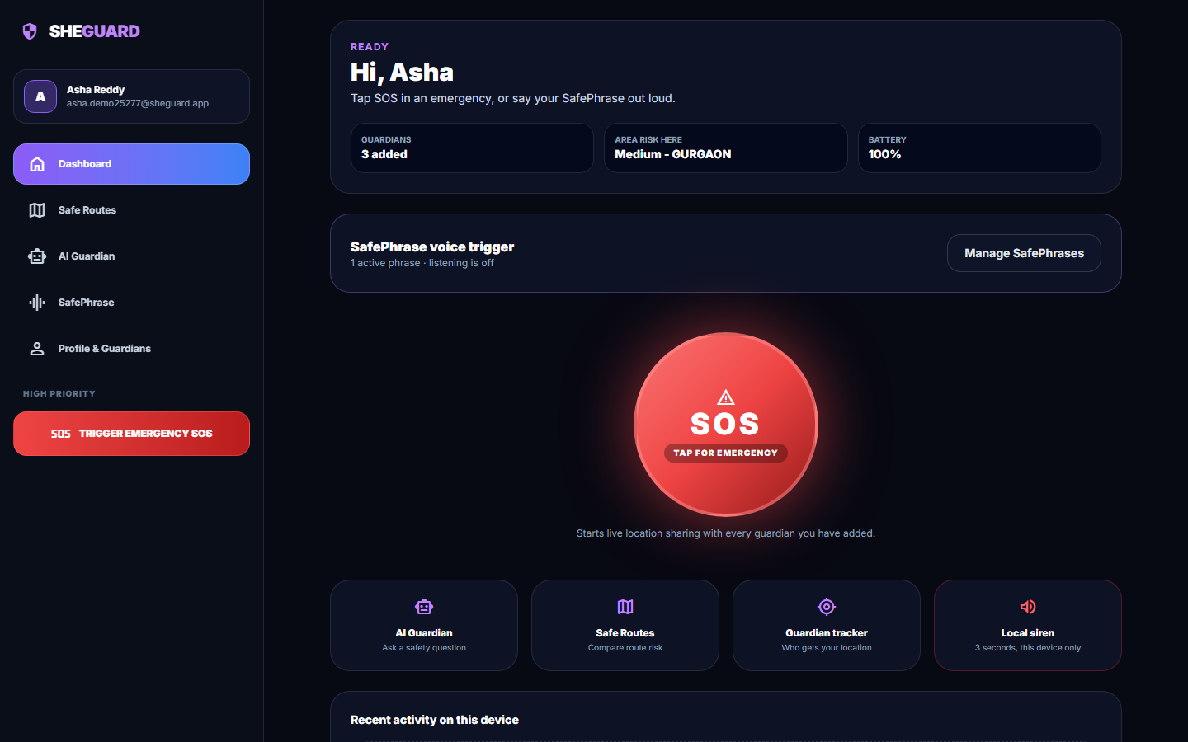
Fig. 13: Dashboard

Dashboard. The signed-in home screen: the large SOS button, three status tiles (3 guardians added, area risk here "Medium - GURGAON" because the browser position was set to central Delhi and the nearest district in the table is Gurgaon, battery 100%), the SafePhrase tile (one active phrase, listening off) and shortcuts to the AI Guardian, Safe Routes, the guardian tracker and a local siren.
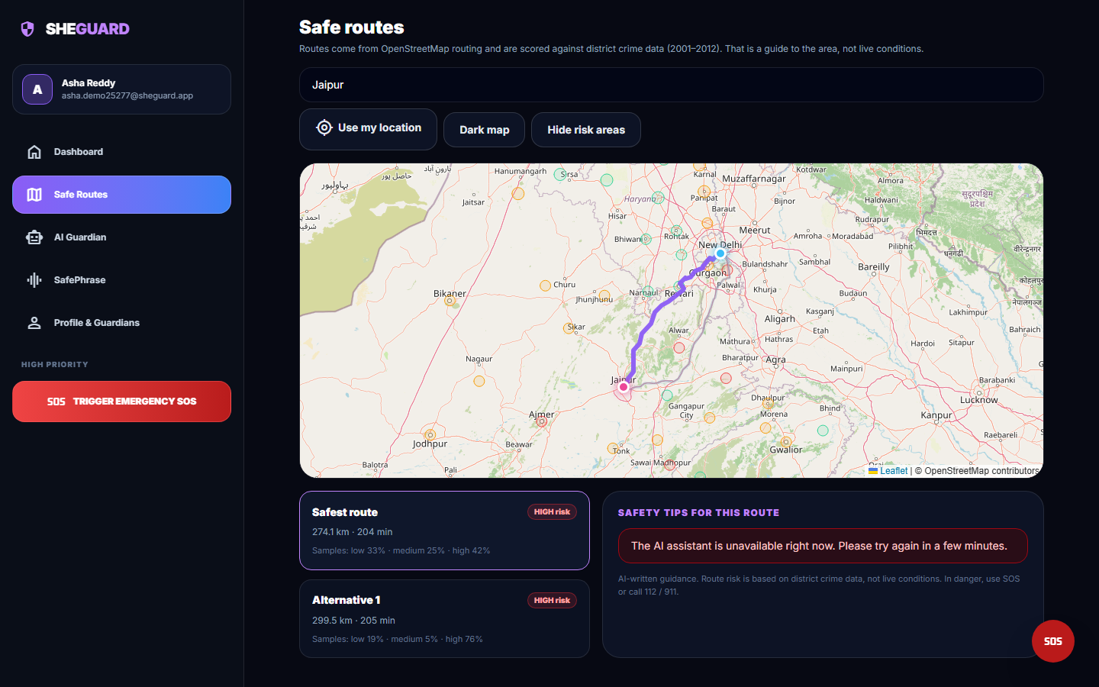
Fig. 14: Delhi to Jaipur: two scored alternatives
Two real OSRM driving routes from Delhi to Jaipur on the Leaflet map with the district risk circles: the "Safest route" of 274.1 km and 204 min (samples 33% low, 25% medium, 42% high) and "Alternative 1" of 299.5 km and 205 min (19% low, 5% medium, 76% high). Both carry the badge HIGH risk, because at least 20% of the sampled points lie in high-tier districts. The safety-tips panel shows the unavailable message of the AI assistant.
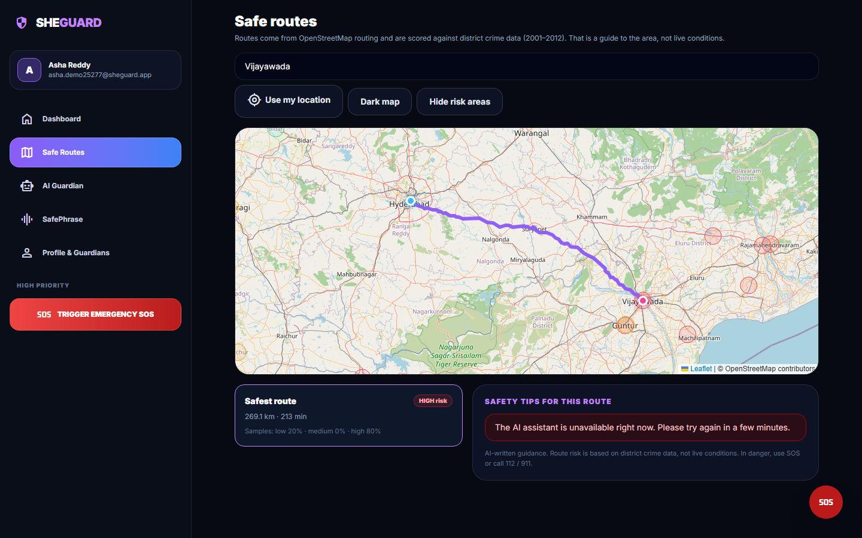  Fig. 15: Hyderabad to Vijayawada | 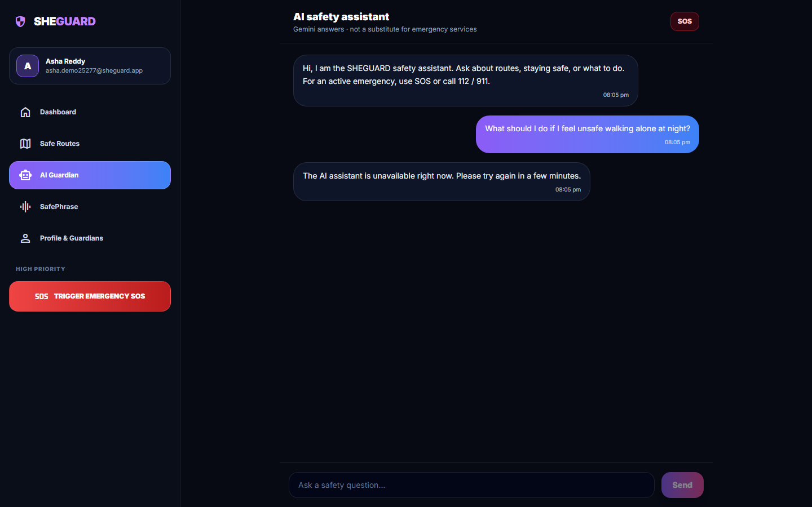  Fig. 16: AI Guardian chat

Hyderabad to Vijayawada. A single route of 269.1 km and 213 min with 20% low, 0% medium and 80% high samples, labelled HIGH risk. Only one alternative was returned by OSRM, so there is nothing to choose between. The risk circles near Vijayawada, Guntur, Machilipatnam and Eluru are the high-tier Andhra Pradesh districts; none is drawn around Hyderabad itself because the nearest geocoded district is 149 km away.
AI Guardian chat. The assistant screen after the question "What should I do if I feel unsafe walking alone at night?" was sent. The reply bubble is the failure message "The AI assistant is unavailable right now" (the backend returned HTTP 502 for Google's quota error 429). The screen is a real capture of the failure path; no answer from Gemini could be captured in this run.
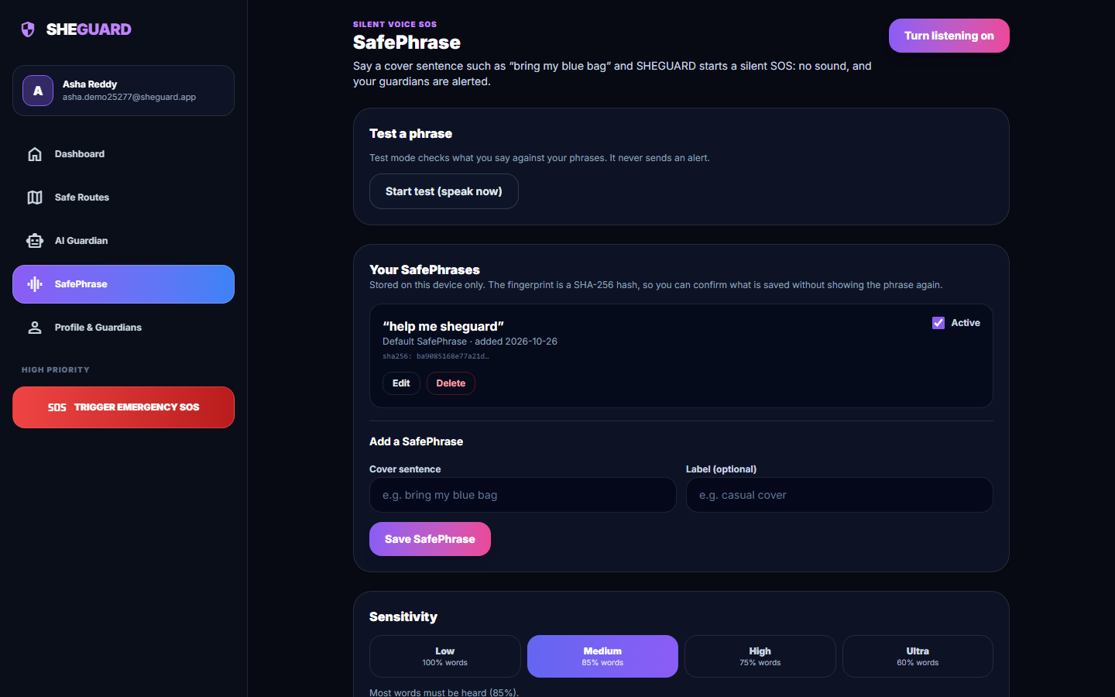
Fig. 17: SafePhrase settings

SafePhrase settings. The SafePhrase screen: the Turn listening on button, a Test a phrase panel that never sends an alert, the default phrase "help me sheguard" with its SHA-256 fingerprint prefix, the form for a new cover sentence and the four sensitivity levels (Low 100% of words, Medium 85%, High 75%, Ultra 60%). Phrases are stored in the browser only.
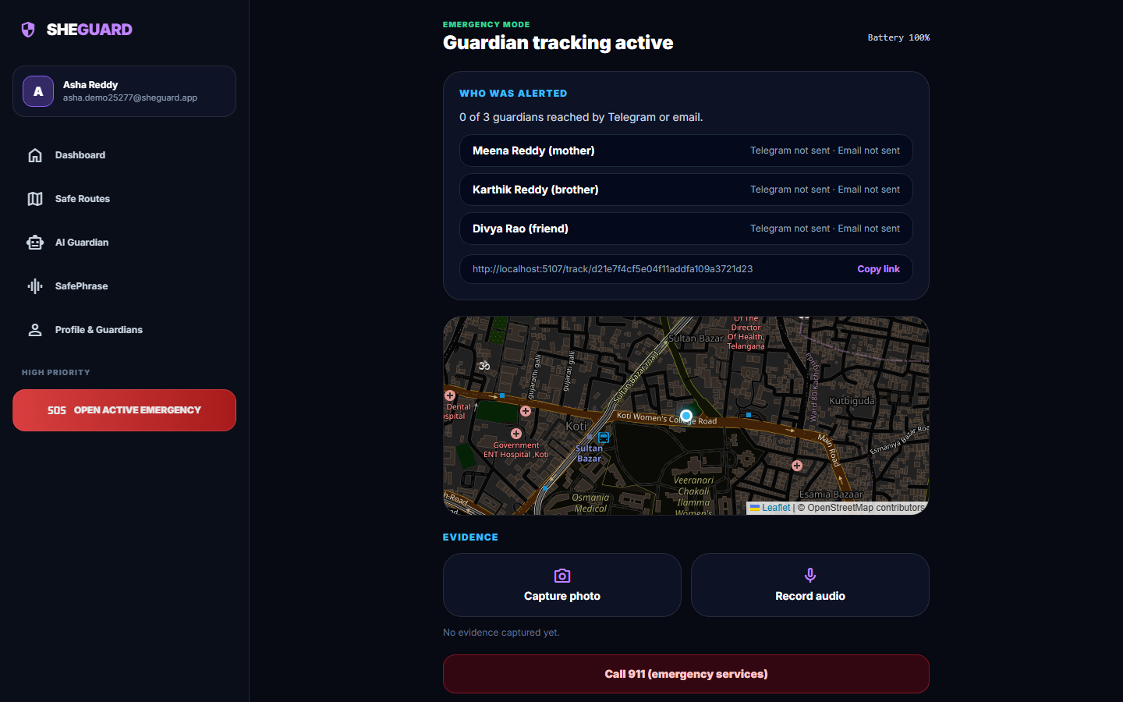
Fig. 18: Emergency screen after SOS
One tap on SOS at the Hyderabad position opened the emergency screen: "Guardian tracking active", the delivery report 0 of 3 guardians reached by Telegram or email (no Telegram bot token or Gmail credentials are configured, so each channel reports not sent), the live tracking link http://localhost:5107/track/... with a Copy link button, the live map, the Capture photo and Record audio buttons and the call button.
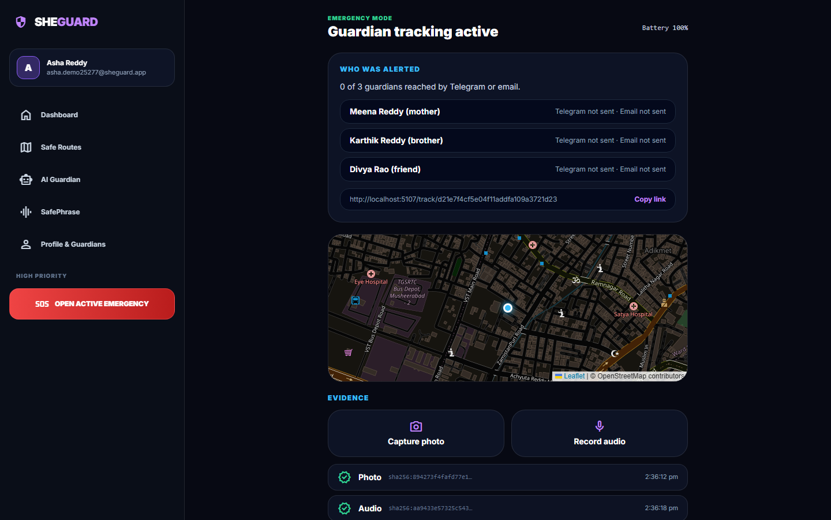
Fig. 19: Evidence captured

Evidence captured. A photograph and a 3-second audio clip were saved: each row shows a green tick, the kind, the beginning of the SHA-256 hash and the time stamp. The photograph is one of the application's own screenshots and the audio is Chrome's built-in test tone (fake microphone), so the evidence content is a stand-in; the hashing, storage and listing are real.
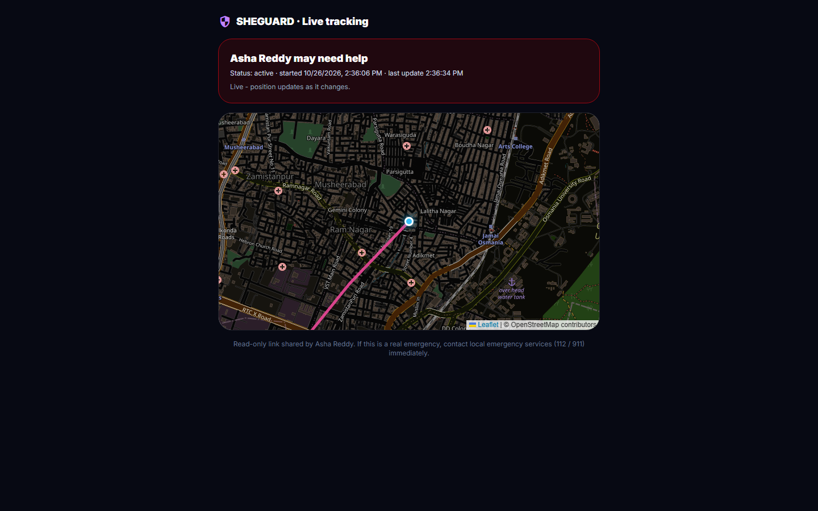
Fig. 20: Guardian's live tracking page
The read-only page a guardian opens from the link, in a second browser with no login: "Asha Reddy may need help", status active with start and last-update times, "Live - position updates as it changes", the map with the moving position and the pink trail, and the note to contact emergency services (112 / 911).
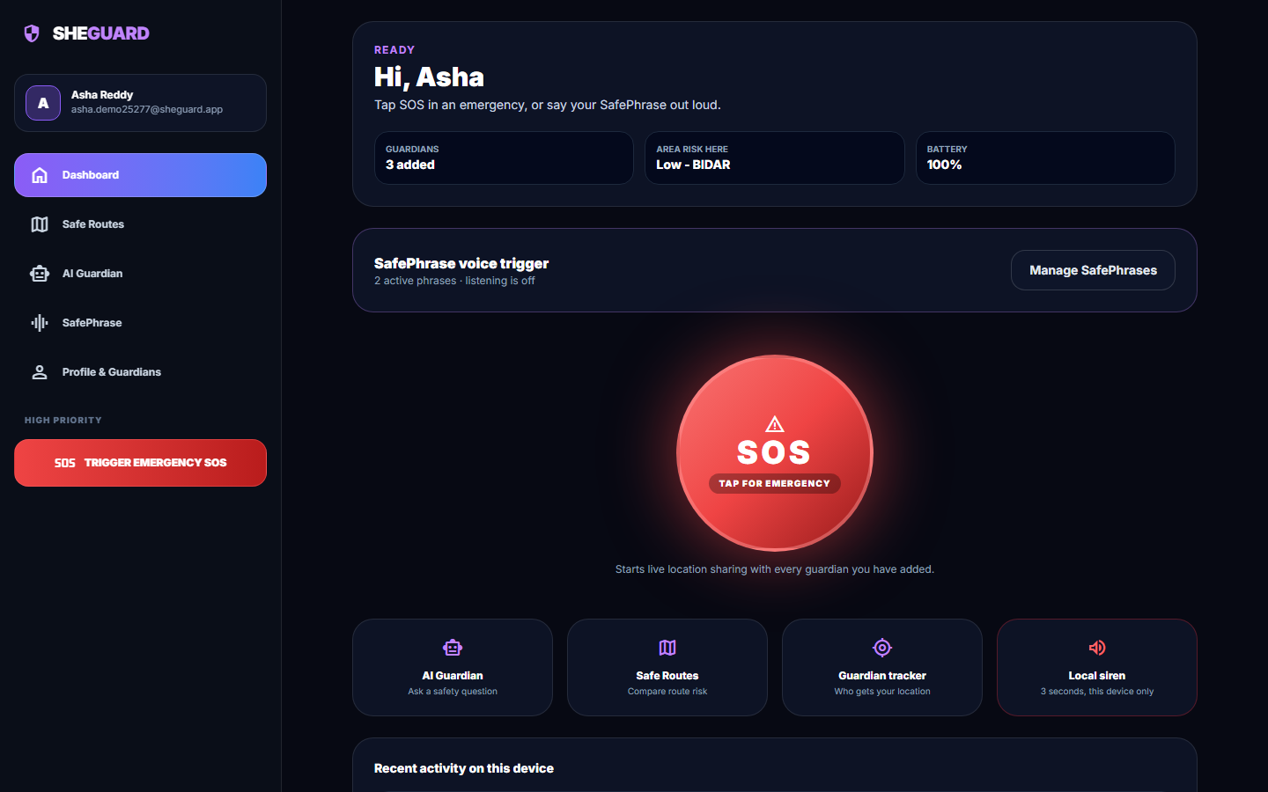  Fig. 21: Dashboard after cancelling | 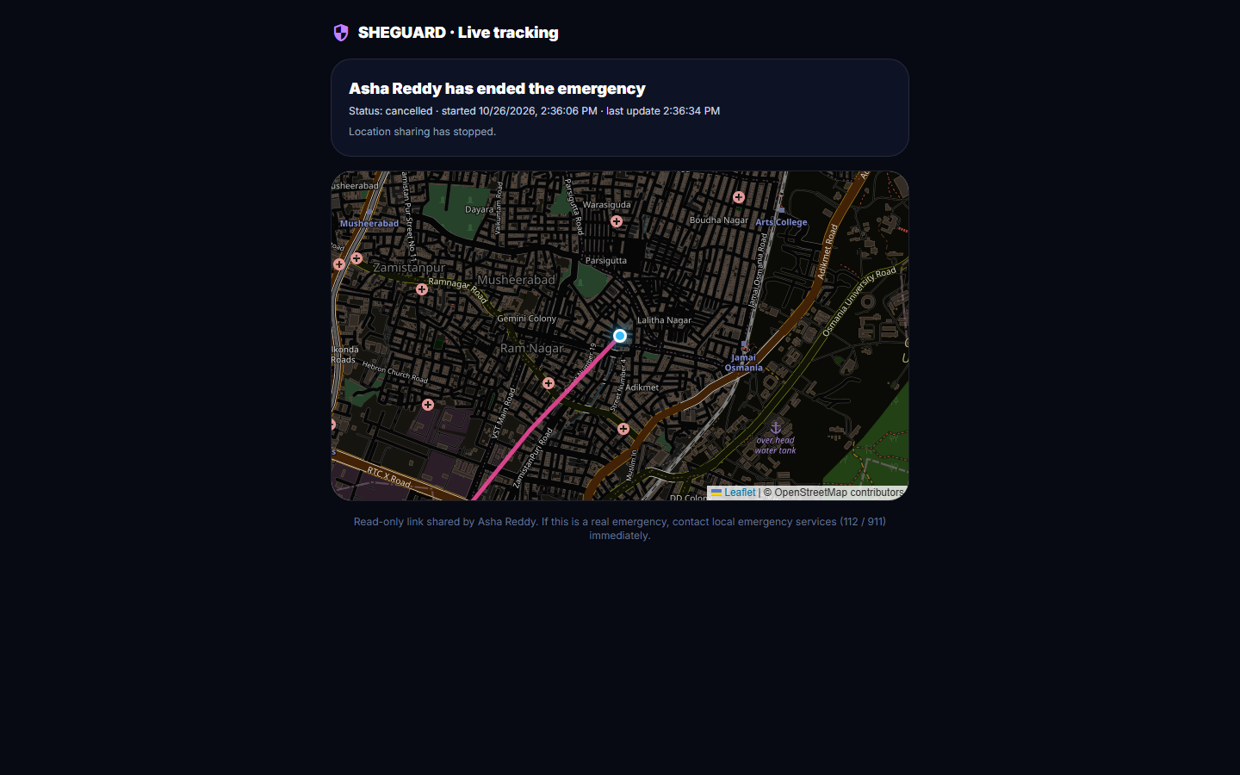  Fig. 22: Guardian's page after cancel

Dashboard after cancelling. After the three-second hold the app returned to the dashboard: two active phrases, the SOS button ready again and, under Recent activity on this device, the entries "Emergency cancelled - Confirmed safe by hold-to-cancel", "Audio evidence saved" and "Photo evidence saved" (hashed and time-stamped).
Guardian's page after cancel. The same tracking page after the user confirmed safety: "Asha Reddy has ended the emergency", status cancelled, "Location sharing has stopped", with the full trail kept on the map. The cancel message reached the open page through the WebSocket.

5.1 Additional screens
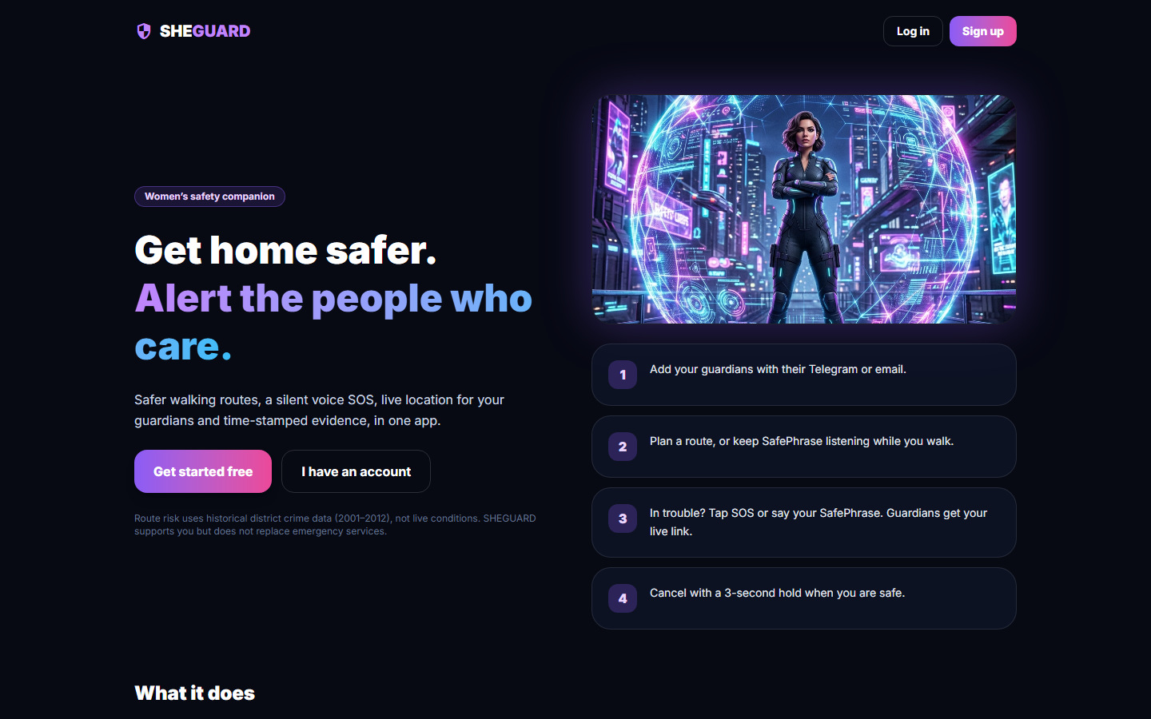  Fig. 23: Landing page | 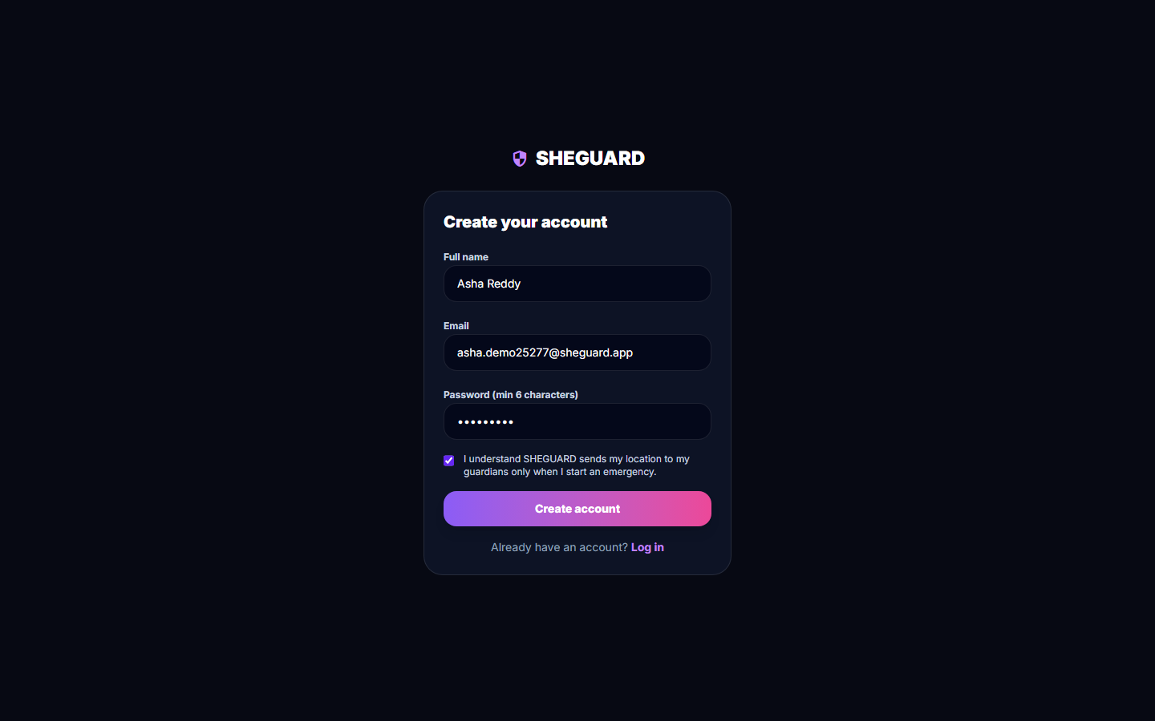  Fig. 24: Registration form

Landing page. The public home page: "Get home safer. Alert the people who care.", the four-step explanation (add guardians, plan a route or keep SafePhrase listening, tap SOS or say the phrase, cancel with a 3-second hold) and the buttons Get started free, I have an account, Log in and Sign up. The small print states that route risk uses historical district crime data (2001-2012), not live conditions, and that SHEGUARD does not replace emergency services. The hero picture is an illustration shipped with the app.
Registration form. The Create your account form filled in for the test user: full name, e-mail, a password of at least six characters and the terms checkbox. The account was created through this form; the API answered HTTP 200 and returned a token and the profile.
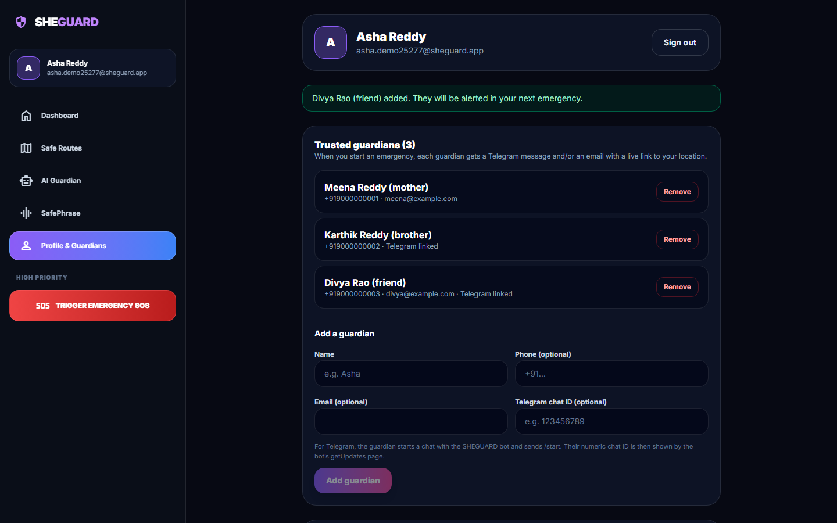  Fig. 25: Profile with three trusted guardians | 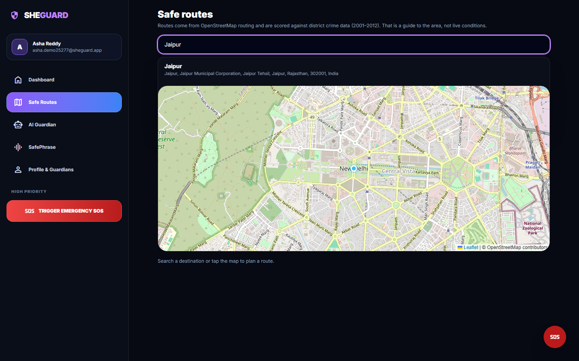  Fig. 26: Destination search

Profile with three trusted guardians. The Profile and Guardians screen after three guardians were added through the form: Meena Reddy (mother, phone and e-mail), Karthik Reddy (brother, phone and Telegram chat ID) and Divya Rao (friend, phone, e-mail and Telegram chat ID). The banner confirms that the last guardian "will be alerted in your next emergency".
Destination search. The Safe Routes screen with "Jaipur" typed into the search box. The suggestions come from the OpenStreetMap Nominatim service through the backend (GET /api/places/search); the start point is the browser position (Delhi).
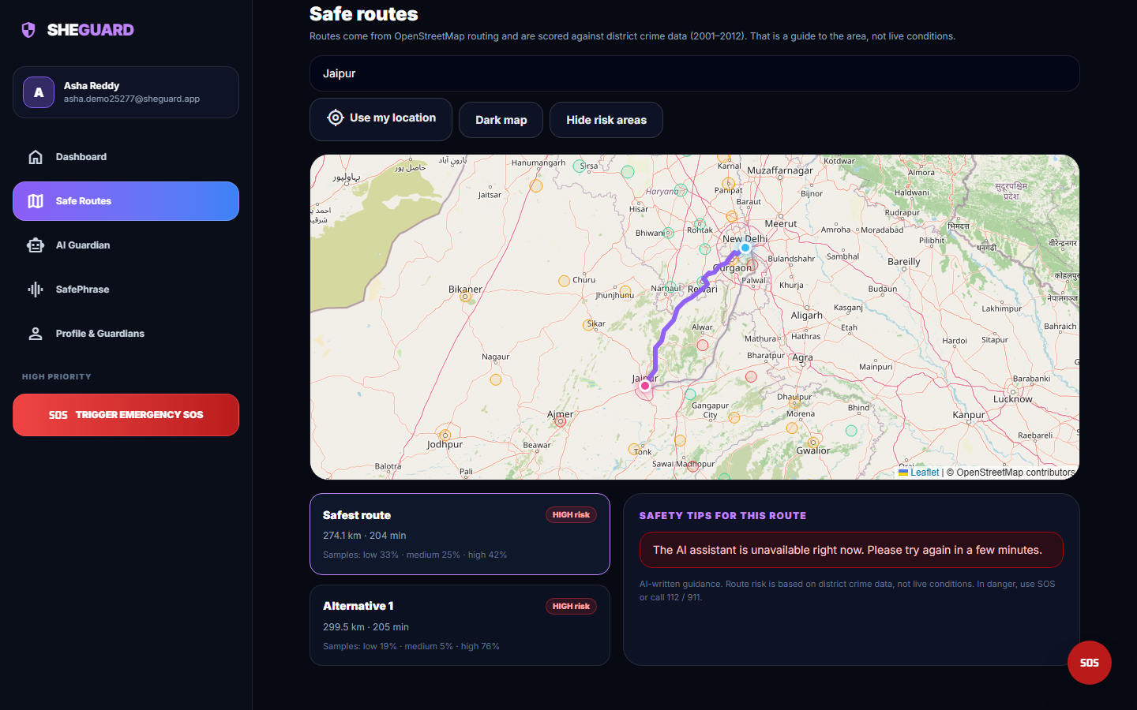  Fig. 27: Route cards and the assistant panel | 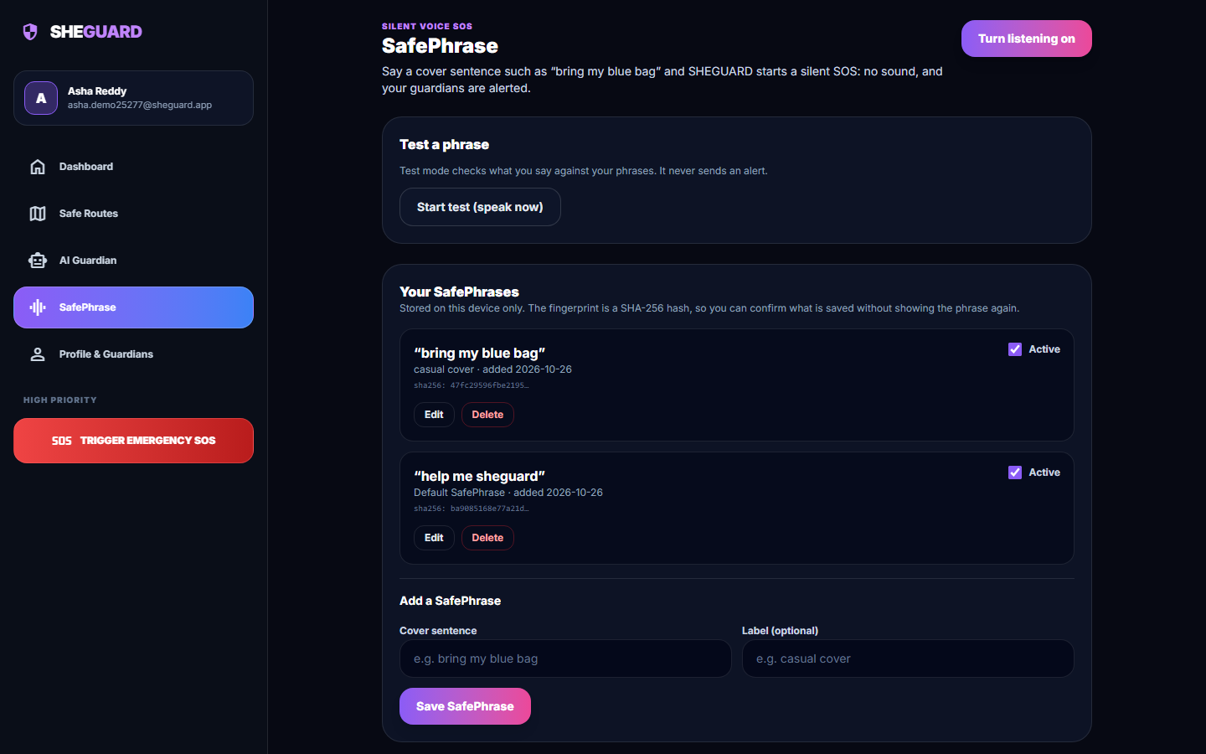  Fig. 28: Second SafePhrase added

Route cards and the assistant panel. The same plan scrolled to the route cards and the "Safety tips for this route" panel. The panel would show Gemini-written advice; during this run the Gemini key's quota was exhausted (HTTP 429), so the interface shows "The AI assistant is unavailable right now. Please try again in a few minutes." instead of an invented answer.
Second SafePhrase added. After saving the cover sentence "bring my blue bag" (label "casual cover"): the list now holds two active phrases, the new one above the default "help me sheguard", and only the beginning of a SHA-256 fingerprint of each sentence is displayed. The sentences are stored in this browser, not on the server.
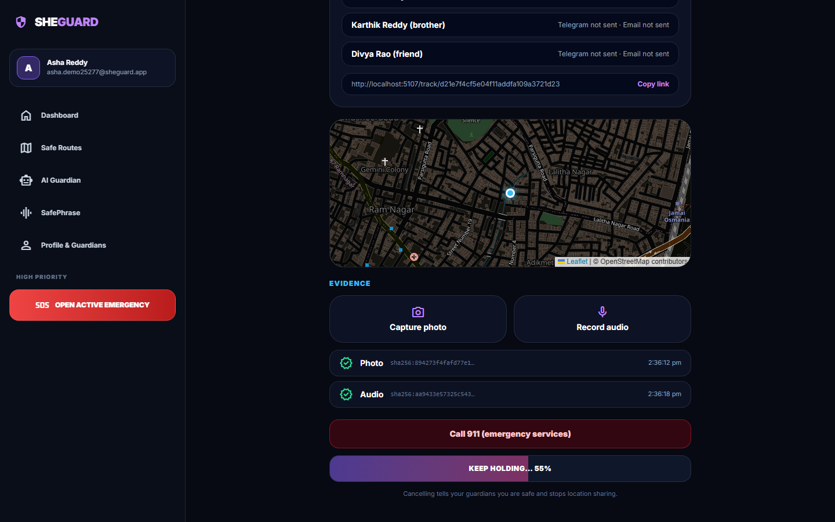  Fig. 29: Hold-to-cancel | 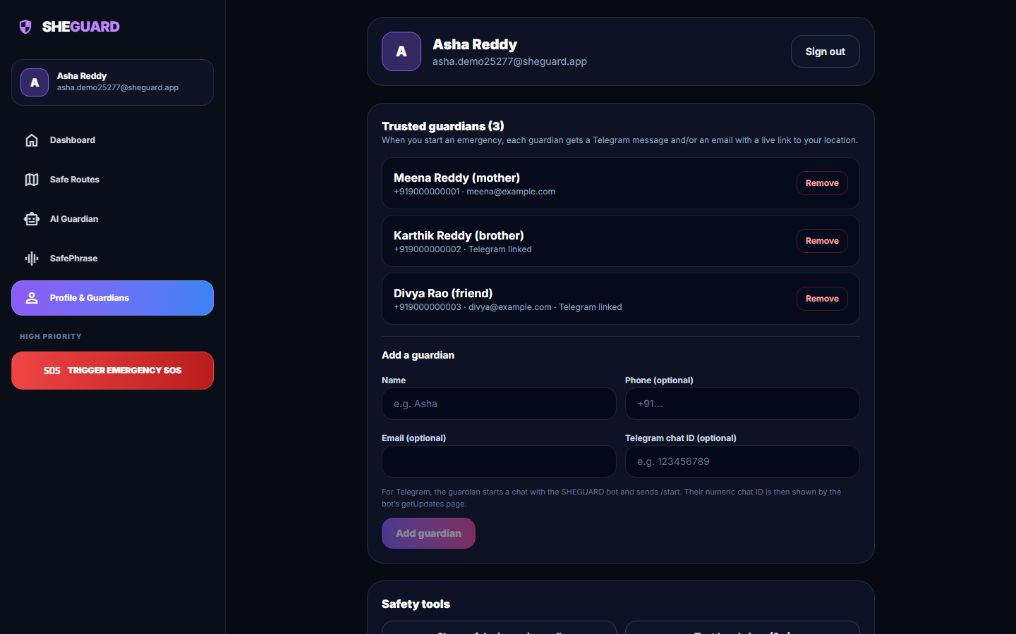  Fig. 30: Profile with recent activity

Hold-to-cancel. The cancel button while it is being held: "KEEP HOLDING... 55%". The user must keep pressing for three seconds, so a stray tap cannot end the alert. The evidence rows and the call button are visible above it.
Profile with recent activity. The profile screen again at the end of the run: the account header with the Sign out button, the three trusted guardians with their Remove buttons, the Add guardian form (disabled until a name is typed) and, further down, the Safety tools section.

6 Sample Inputs and Outputs
The following are real exchanges with the running application on 26 October 2026 (coordinates and identifiers as stored; long coordinate lists are omitted).
Table 13: Sample inputs and outputs
Input | Output
Hyderabad (17.385, 78.4867) to Vijayawada (16.5062, 80.648), POST /api/routes/plan | One route, 273.5 km, 217 min, risk score 4.246 by day; 91 low, 0 medium and 392 high samples; recommended
One tap on SOS at (17.385, 78.4867), trigger manual | Session 44 with a 32-character share token and tracking URL; delivery report for three guardians: Telegram false, e-mail false
Four location updates while moving north-east, then (17.412, 78.512) | Seven stored points in the trail; last position and last-update time kept on the session
Photo and a 3-second audio clip uploaded | Two evidence rows with 64-character SHA-256 values and the capture location and time
Guardian opens the tracking link | Public read-only payload with name, status, last position and the full path
Hold the cancel button for three seconds | Status cancelled, end time set, WebSocket message cancelled pushed to the guardian page
Question to the assistant | HTTP 502 with Google quota error 429; the interface shows the unavailable message

Listing: A real route-plan response (coordinates shortened)
POST /api/routes/plan {"origin_lat": 17.385, "origin_lng": 78.4867, "dest_lat": 16.5062, "dest_lng": 80.648}
{"routes": [{"index": 0, "distance_m": 273495.9, "duration_s": 13023.3, "risk_score": 4.246,
"risk_tiers": {"low": 91, "medium": 0, "high": 392}, "is_night": false,
"recommended": true, "coordinates": [[17.385, 78.4867], ... 3857 points]}],
"safest_index": 0}

Listing: The start-SOS response of the captured session (read back from the database and the screenshot)
POST /api/sos/start {"lat": 17.385, "lng": 78.4867, "trigger": "manual"}
{"session_id": 44, "share_token": "d21e7f4cf5e04f11addfa109a3721d23",
"tracking_url": "http://localhost:5107/track/d21e7f4cf5e04f11addfa109a3721d23",
"started_at": "2026-10-26T14:36:06.208981",
"delivery": [{"guardian": "Meena Reddy (mother)", "telegram": false, "email": false},
{"guardian": "Karthik Reddy (brother)", "telegram": false, "email": false},
{"guardian": "Divya Rao (friend)", "telegram": false, "email": false}]}

Listing: The guardian's tracking payload after the session was cancelled (timestamps rounded to seconds)
GET /api/track/d21e7f4cf5e04f11addfa109a3721d23 (no login)
{"status": "cancelled", "trigger": "manual", "started_at": "2026-10-26T14:36:06", "ended_at": "2026-10-26T14:36:55",
"last_lat": 17.412, "last_lng": 78.512, "last_update_at": "2026-10-26T14:36:44", "user_name": "Asha Reddy",
"path": [{"lat": 17.385, "lng": 78.4867}, {"lat": 17.385, "lng": 78.4867}, {"lat": 17.3895, "lng": 78.4905},
{"lat": 17.395, "lng": 78.496}, {"lat": 17.401, "lng": 78.502}, {"lat": 17.4075, "lng": 78.5075}, {"lat": 17.412, "lng": 78.512}]}

Listing: The two evidence records of the session (capture times omitted)
GET /api/sos/44/evidence
[{"id": 77, "kind": "photo", "sha256": "894273f4fafd77e1b2a310395099313a0b15b6f2a520edec769b0ac36d191dd7", "lat": 17.385, "lng": 78.4867},
{"id": 78, "kind": "audio", "sha256": "aa9433e57325c5438bcb36665386ee822892d42d8fd91054d6ecbdc13f0d9bc1", "lat": 17.385, "lng": 78.4867}]

7 Comparison with the Base Paper
The base paper [1] (SafeRoutes, IEEE Access 2024) clusters regions for women's safety from public Indian data: 2001 and 2011 district population, the 2013 IPC crimes against women, literacy, per-capita expenditure, police strength and forest cover. After imputation, scaling and a Pearson and Spearman correlation analysis it applies K-Means and Gaussian mixture models, finds that three to four clusters suit its data, scores clusters against "dummy" data from globally safe cities and designs a cab-service integration with a 1.96x safety buffer and deviation alerts. Its results are largely "anticipated": correlation matrices and cluster-selection tables, no accuracy figures and no evaluation of the cab integration. SHEGUARD adopts the district-clustering idea and the safe-route guidance and adds a full emergency workflow. The two works use different data, different numbers of features and different sizes, so their numbers cannot be compared and no claim of being better is made.
Table 14: SHEGUARD and the base paper
Measure | Base paper [1] (as printed in its tables) | SHEGUARD
Features clustered | Many (crime, population, literacy, expenditure, police, forest cover) | One (average crimes per year)
Data year | IPC 2013 and census data | District crimes 2001-2012
Number of districts | Not stated | 467 (of 827 entries)
Algorithms compared | K-Means, Gaussian mixture, hierarchical (Ward) | K-Means in the product; Gaussian mixture and Ward only in this project's study
Preferred number of clusters | 3-4 | 3 (design choice; k = 4 scores better)
Silhouette at k = 3 | 0.416 (Table 3) | 0.580
Davies-Bouldin at k = 3 | 0.970 (Table 5) | 0.531
Calinski-Harabasz at k = 3 | 221.0 (Table 4) | 1155.4
Travel integration | Cab vendors, deviation alerts (designed, not evaluated) | OSRM alternatives scored by risk (implemented, 16 pairs scored)
Emergency features | None | SOS, SafePhrase, live guardian link, hash-stamped evidence, assistant (implemented; delivery channels and assistant not verified live)

The paper's silhouette column is headed "Explained Variance" and its Figure 11 shows silhouette values near 0.25-0.31, which differ from Table 3; the table values are quoted as printed. SHEGUARD's indices are higher because a single count is inherently easier to separate into groups than a multi-feature space, which is not evidence of a better safety model. What SHEGUARD lacks compared with the paper: population and per-capita normalisation, police-presence and socio-economic features, a cluster-selection analysis inside the product and cab-vendor deviation alerts.
The other papers read for this project give context rather than comparable numbers. The IoT review [2] (2016-2022 studies) found that pulse-rate and pressure sensors dominate wearable devices and that systems with automatic activation and little human interaction are still needed, which motivates SafePhrase and one-tap SOS. The ESP32-camera application [6] reports SOS delivery in 4-6 seconds and 93% accuracy on crime-zone classification of pre-defined test locations, on its own hardware and data; SHEGUARD's alert delivery was not measured. The batch survey entries [3], [4] and [5] could not be retrieved, so no result from them is used.

8 Success and Failure Analysis

8.1 Where it works
- The emergency workflow runs end to end in a browser: register, add guardians, start an SOS, stream a moving position, save hashed evidence, let a guardian follow without an account and cancel with a deliberate three-second hold; the guardian's page receives location and cancel messages in about 15 ms on this machine.
- User data are separated: every probe of another user's session, evidence or guardians returned 404, unauthenticated calls returned 401, and 51 automated tests pass.
- The risk model is reproducible (shipped numbers re-created exactly) and the route scorer ranks an all-high-risk route above an all-low-risk route (5.0 against 1.0).
- Evidence hashing detects a single flipped bit, and uploads of 100 KB to 5 MB take 13 to 61 ms (median).
- The interface is honest about its limits: the landing page and route screens say that risk comes from 2001-2012 district data, and failures (no alert channel, assistant unavailable) are shown as such.

8.2 Where it fails or is weak
Table 15: Failure and weakness analysis
Observation | Cause | Effect / handling
Hyderabad is 149 km, Warangal 195 km, Kolkata 191 km and Lucknow 231 km from the nearest district in the table | Only 56.5% of districts were geocoded; Uttar Pradesh, West Bengal and Delhi have none; the scorer has no distance limit | Routes through these cities are scored with a district hundreds of kilometres away; extend geocoding and cap the distance
The night multiplier never changes which route is recommended (16 of 16 pairs) | The same factor 1.6 multiplies every sampled point of every route | Night only changes the displayed number; use time-dependent tier weights or night-specific data
37.5% of the trips tested returned a single route | OSRM demo server returns alternatives only when they exist | Nothing to compare; add waypoints or another routing engine
Guardians reached: 0 of 3 in every captured emergency | TELEGRAM_BOT_TOKEN, GMAIL_ADDRESS and GMAIL_APP_PASSWORD are empty | Only the in-app link works; alert delivery is unverified, and send_email blocks the event loop
The AI assistant answered 0 of 10 prompts | Gemini quota exhausted (429), 503 under load, and a 20 s read timeout that returns 500 | Interface shows a friendly message; map timeouts to 502 and add retries or a fallback
SafePhrase Medium recall 54.2%; Ultra false triggers 10.0% | Word-window rule: one wrong word fails a three-word phrase at Medium; 60% of words is too loose | Use phrases of five or more words, test with real speech, add a confirmation step
Stored evidence is retrievable by URL with no login; an .html upload is served as text/html; no size limit | Static mount of the evidence folder and the client's extension is kept | Serve files through an authorised route, force a safe content type, cap upload size
Impossible coordinates, free-text trigger and unknown WebSocket tokens are accepted; no login lockout | No range validation, no rate limiting | Add schema validation and throttling
A district's tier follows raw counts dominated by domestic-violence reports (40% of the counted total) | Single feature, no population normalisation | Use rates per population and street-level categories

9 Limits of the Results
- No ground truth. The cluster indices (silhouette 0.58, Davies-Bouldin 0.53) measure separation of one number, not agreement with real danger; no train/test split exists and no field validation was done.
- Old, coarse data. The district file covers 2001-2012, counts are not per head of population, 56.5% of districts are geocoded and several large states are missing.
- Written transcripts, not speech. The SafePhrase figures test the matching rule on hand-made text; the recogniser was not measured.
- Injected position and stand-in media. The screenshots use a position set by the test script, a test-tone microphone and the application's own screenshot as the photograph; no phone, GPS or camera was used.
- Unverified channels. Alert delivery by Telegram and e-mail and the Gemini assistant could not be demonstrated returning results in this run.
- Small single-machine measurements. Timings come from one desktop with sequential calls (5 to 30 per endpoint), one client and no concurrent load; no user study was carried out.
- No numeric comparison with the base paper is possible, as explained in the section Comparison with the Base Paper.

10 Objectives Against Outcomes
Table 16: Objectives against outcomes
Objective | Outcome | Evidence
1. Provide Safe Route guidance using available safety information | Partly achieved | Working OSRM + district-risk scoring with a heat layer and route cards, but the data are 2001-2012 counts with 56.5% geocoding and gaps around Hyderabad, Kolkata and Lucknow; night factor never reorders routes; 37.5% of trips have one route
2. Quick emergency activation through SafePhrase and Smart SOS | Partly achieved | One-tap SOS and hold-to-cancel work; SafePhrase matcher tested on written text only (Medium recall 54.2%, Ultra false triggers 10%); no shake, power-button or automatic trigger
3. Share live location with trusted guardians during an emergency | Achieved (link); delivery unverified | WebSocket push about 15 ms, no guardian login, public tracking page; Telegram and e-mail delivery reported 0 of 3 because no credentials are configured
4. Preserve evidence (timestamps, location, audio, images) securely | Partly achieved | Photo and audio saved with time, location and SHA-256 (tamper changes the hash); files retrievable by URL without login, no size limit, no verification endpoint
5. AI-powered safety assistance using the Gemini API | Implemented, not demonstrated | Endpoint, system prompt and interface exist; 0 of 10 probe prompts answered (quota 429, timeout returns 500)
6. Protect user data with role-based access and Row Level Security | Partly achieved | bcrypt + JWT, every query scoped to the owner (all cross-user probes 404); no database RLS (SQLite) and no roles beyond user and token-based guardian

