SMART ALCOHOL INTOXICATION DETECTION AND PREVENTION SYSTEM USING AI
Results
Department of Computer Science and Engineering, TKR College of Engineering and Technology (Autonomous)
Batch A6 (CSE-A) · Academic year [ACADEMIC YEAR]
Table 1: Project team
S.No. | Student name | Roll number
1 | B PRANITHA | 23K91A0522
2 | BANTU KAVYA | 23K91A0531
3 | DASARI VIVEKA SARVESHWARI | 23K91A0560
4 | BEKKAM VAMSHI | 23K91A0534

Project guide: N. PADMAVATHI
Chapter and section numbers quoted in the text (for example Section 6.6 or Chapter 8) refer to the full project report, 17.Final Document. Figures and tables in this document are numbered from 1.

CHAPTER 8: RESULTS AND OUTPUT SCREENS

8.1 Output screens
The screens below are captures of the running web application at 1440 x 900 pixels (phone-width captures are in Appendix C), made by scripts/capture_screens.py with the demo account. Screen numbers in the text (for example "screen 06") are the file numbers in docs/screenshots/. Simulation screens show scripted measurements and are labelled SIMULATION on the page; the live-camera screens use Chromium's fake webcam, which plays a looping video of one public-domain portrait, because no rider was available to the capture script. The history screen therefore holds both simulated and camera events, and the research screen holds a synthetic file, as its banner says.
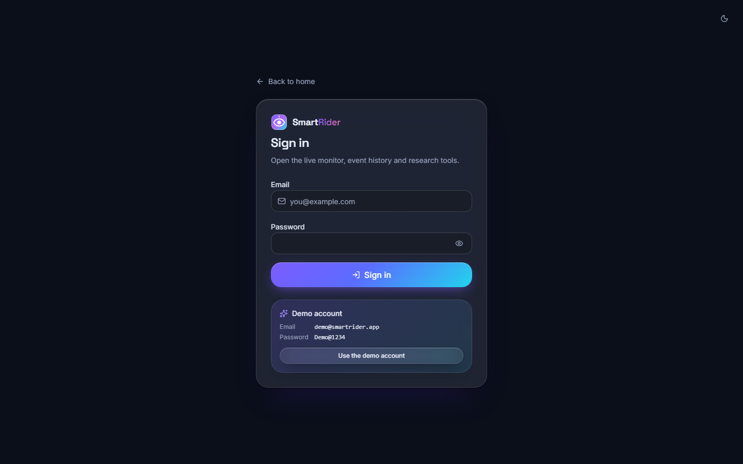
Figure 1: Screen 03: sign-in page with the demo account shown
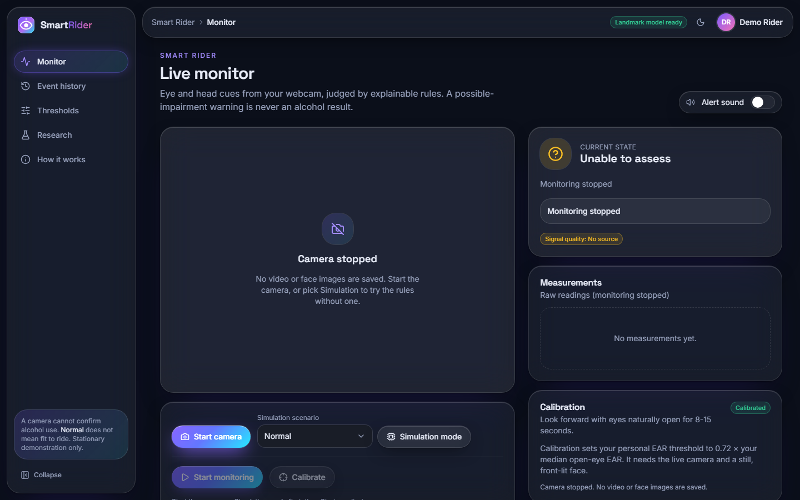
Figure 2: Screen 07: monitor before any source is chosen; the disclaimer is always visible in the sidebar
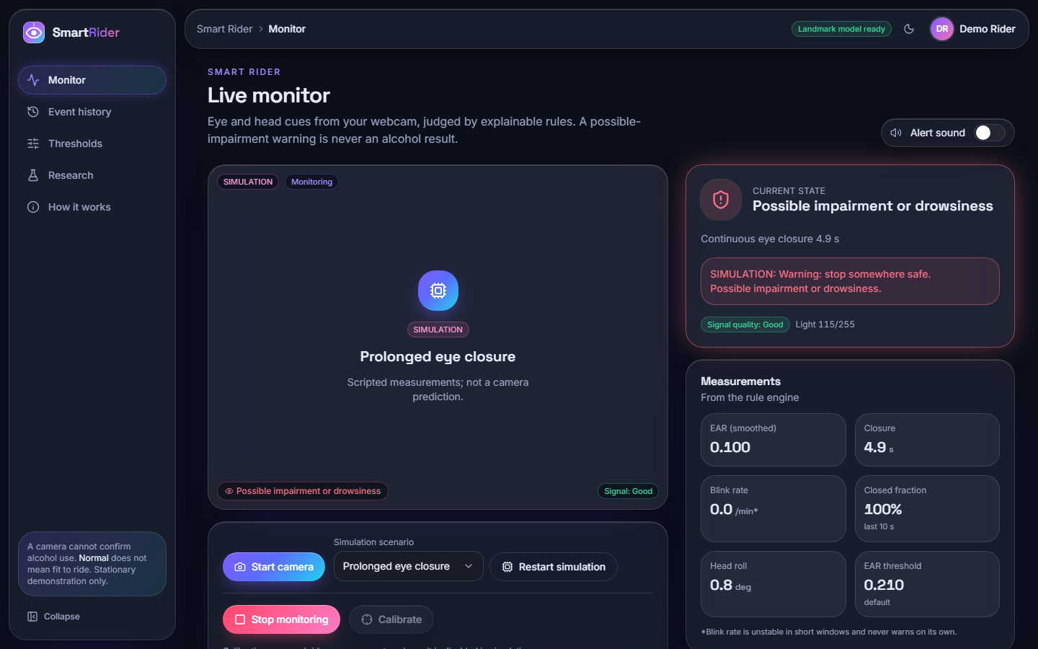
Figure 3: Screen 04: scripted "Prolonged eye closure" scenario; the warning Possible impairment or drowsiness is shown with its reason (continuous closure 4.9 s), and the SIMULATION label marks the data as scripted
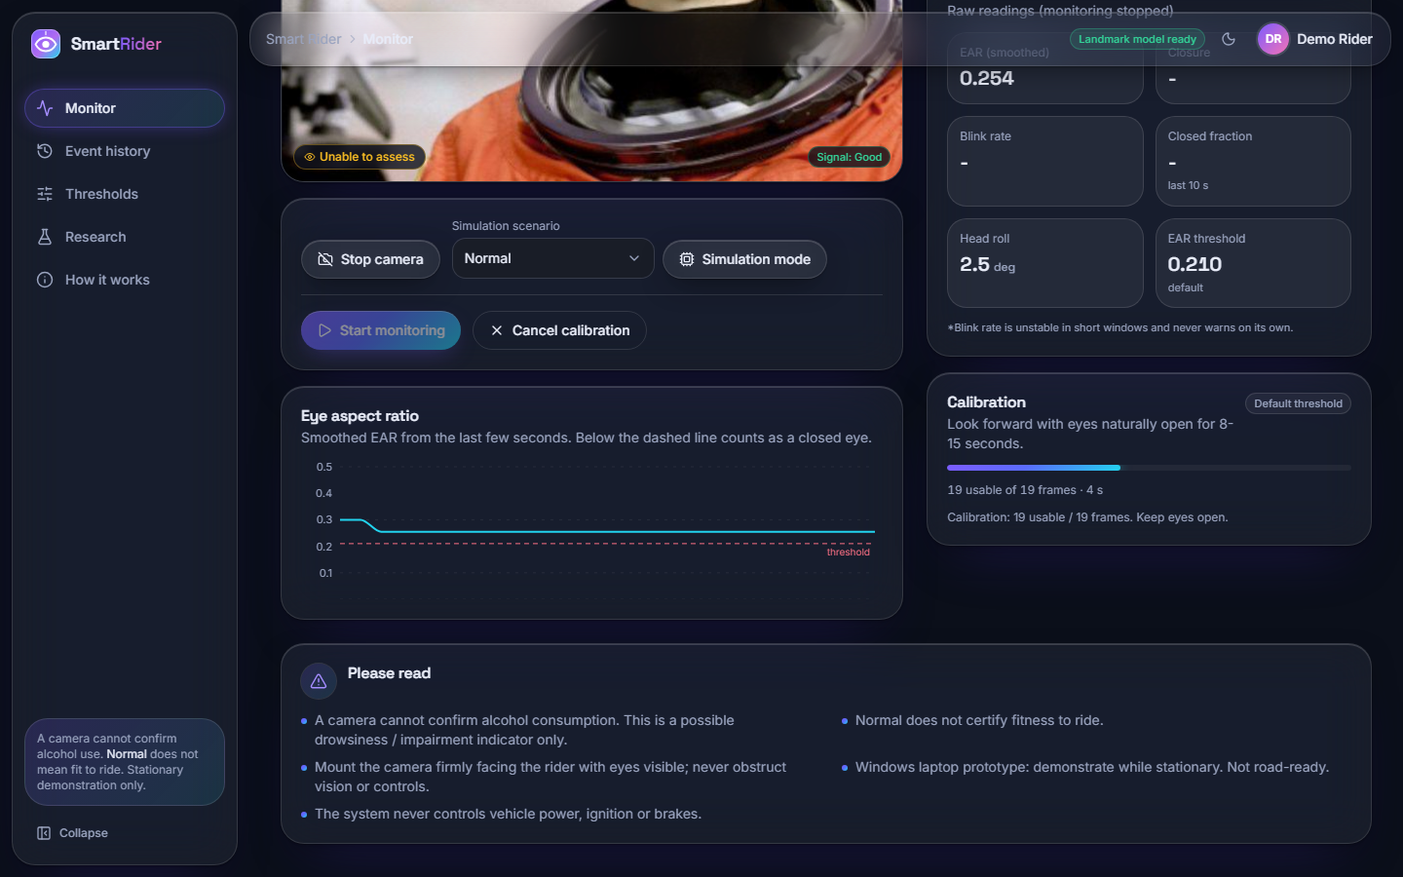
Figure 4: Screen 05: personal calibration in progress on the camera path (19 usable of 19 frames, 4 s of the 8-15 s window); monitoring is stopped meanwhile and the state is Unable to assess
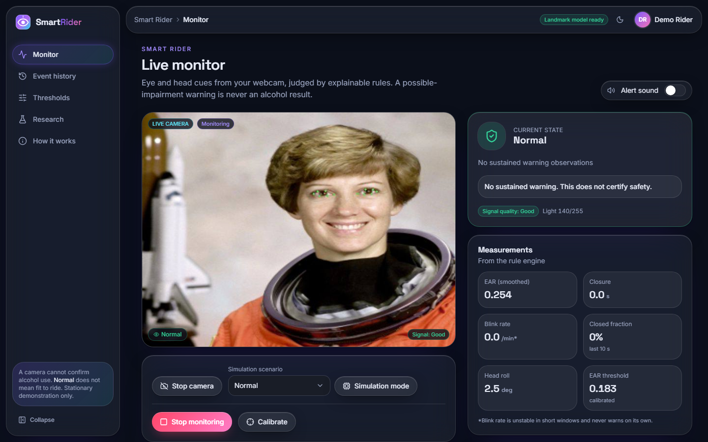
Figure 5: Screen 06: live camera path after calibration; green dots mark the six points of each eye, the verdict is Normal, EAR 0.254, calibrated threshold 0.183, head roll 2.5 degrees
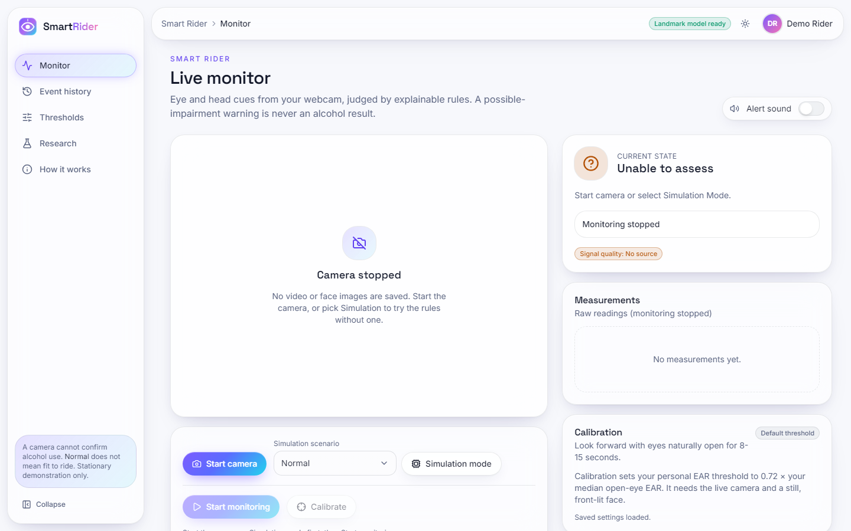
Figure 6: Screen 15: the monitor in the light theme
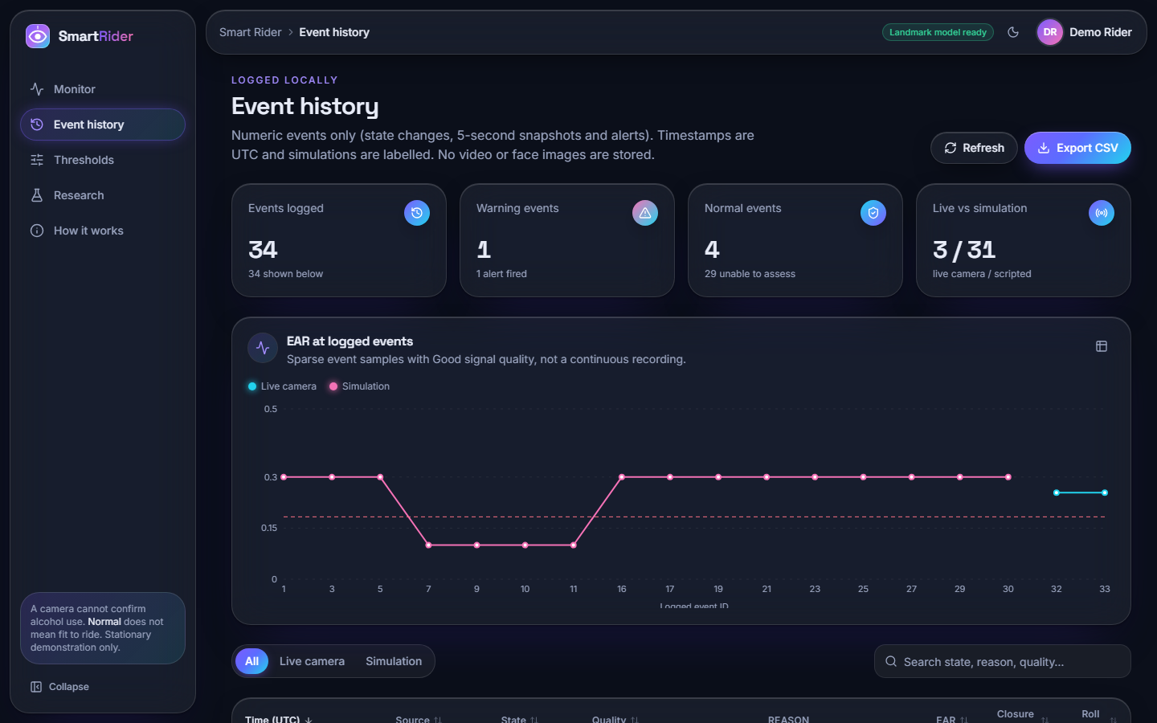
Figure 7: Screen 08: event history with the EAR chart (live camera against simulation), counts, filters, search and CSV export; 34 events at the time of capture
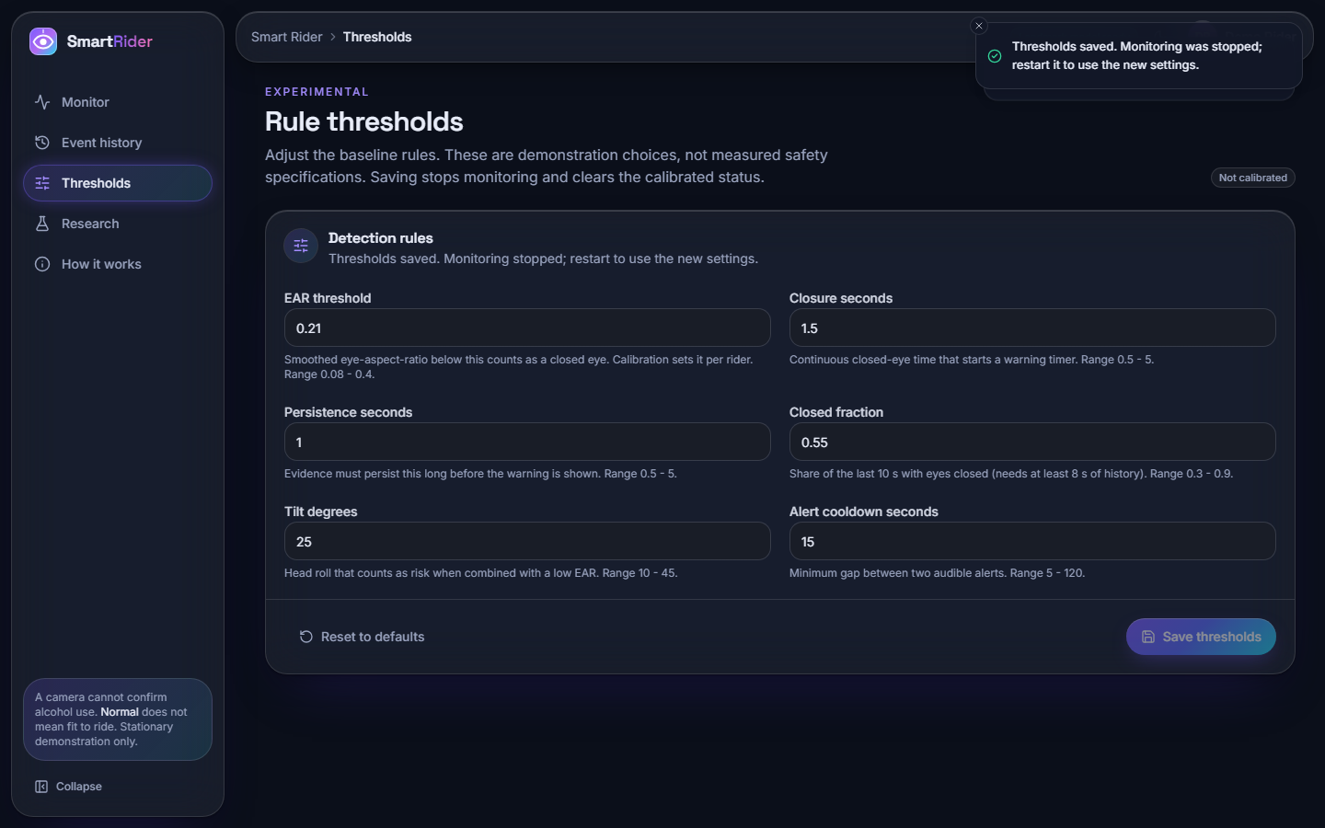
Figure 8: Screen 10: the six rule thresholds with their bounds; the badge shows that the threshold came from calibration
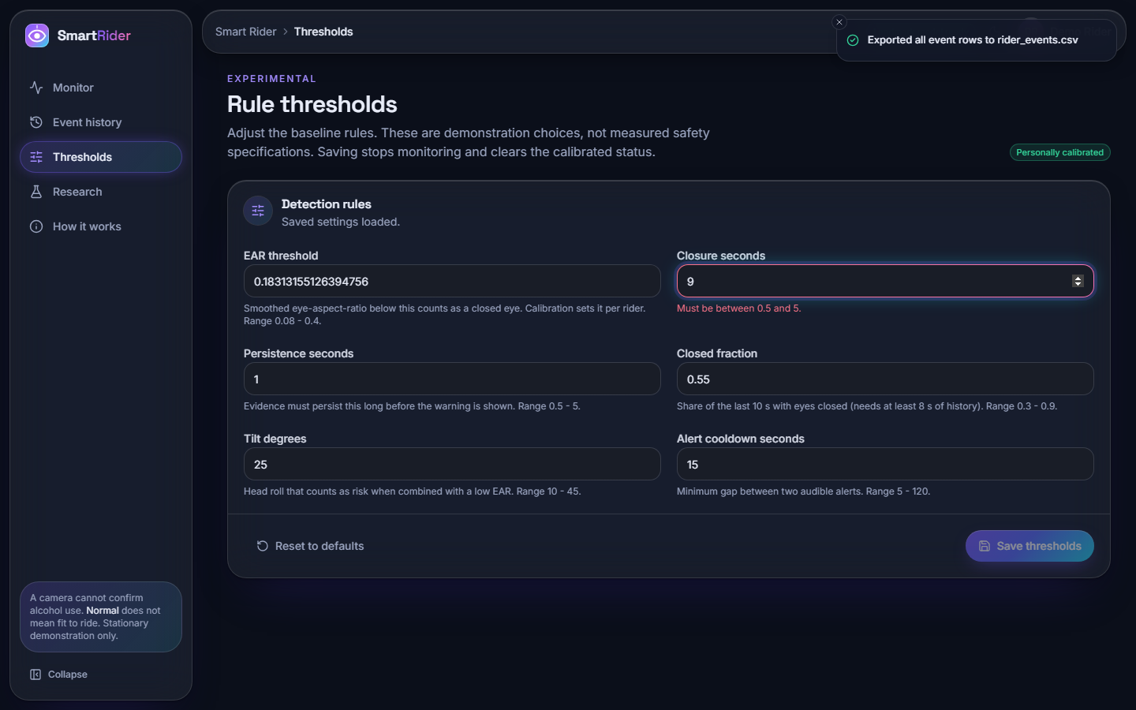
Figure 9: Screen 09: an out-of-range closure value (9 s) is refused with the message "Must be between 0.5 and 5"; the toast reports an earlier CSV export
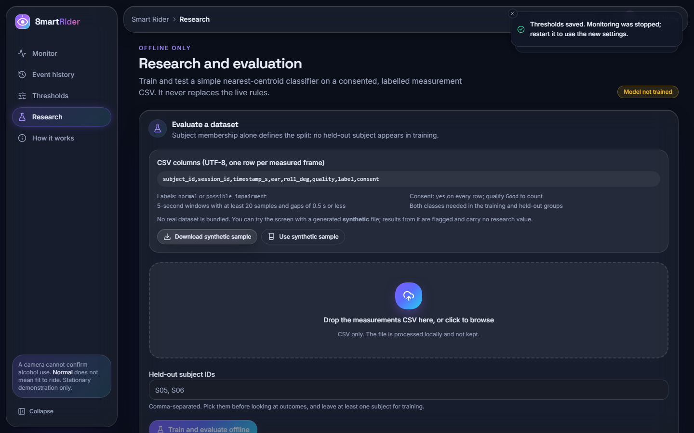
Figure 10: Screen 11: the research screen before any data is supplied; the status is Model not trained
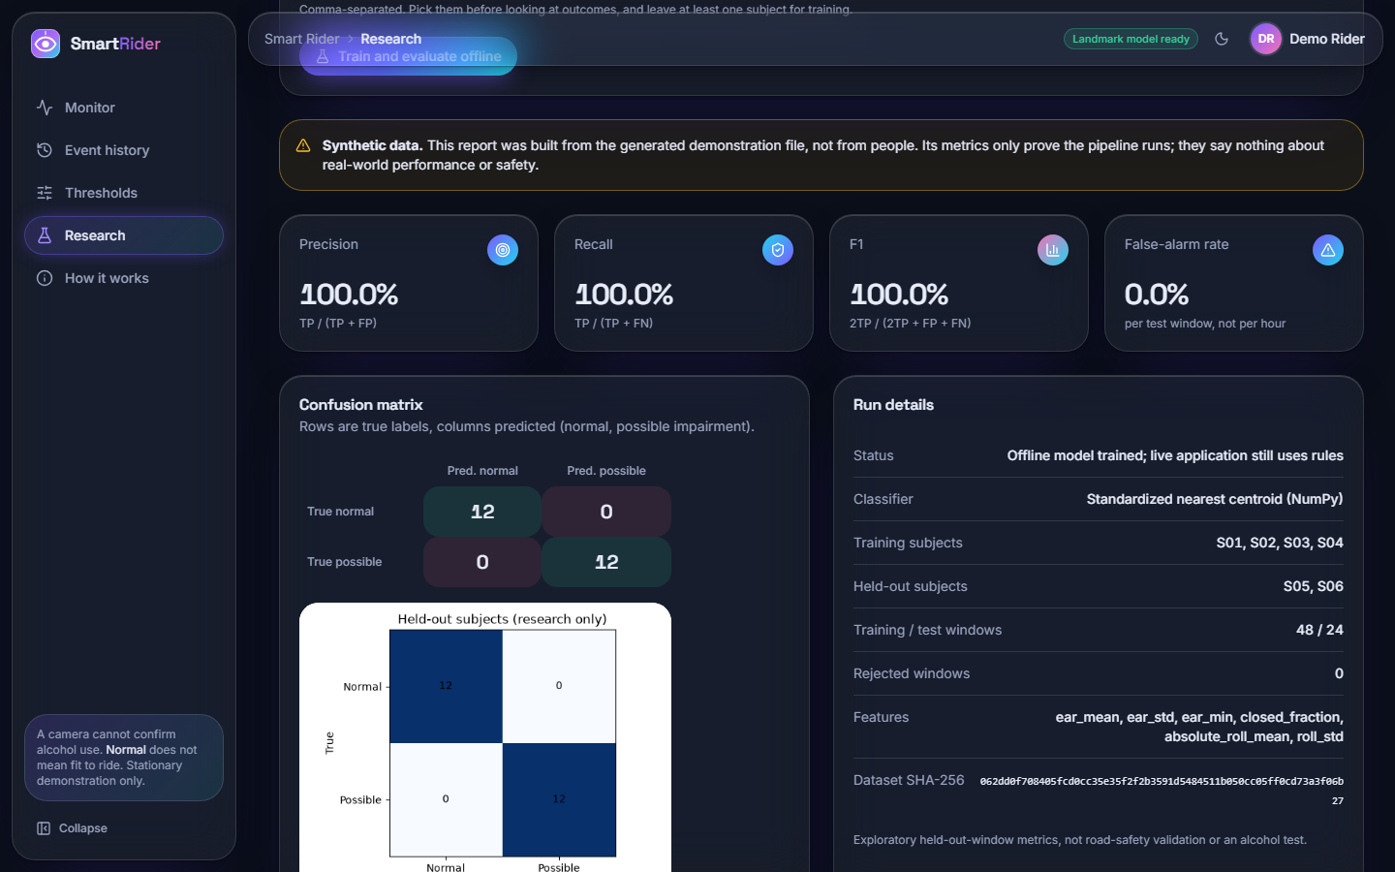
Figure 11: Screen 12: offline evaluation of the synthetic demonstration file. The 100 % precision and recall come from a generated file in which the two classes are separable by construction; they show that the pipeline runs and are not a performance result
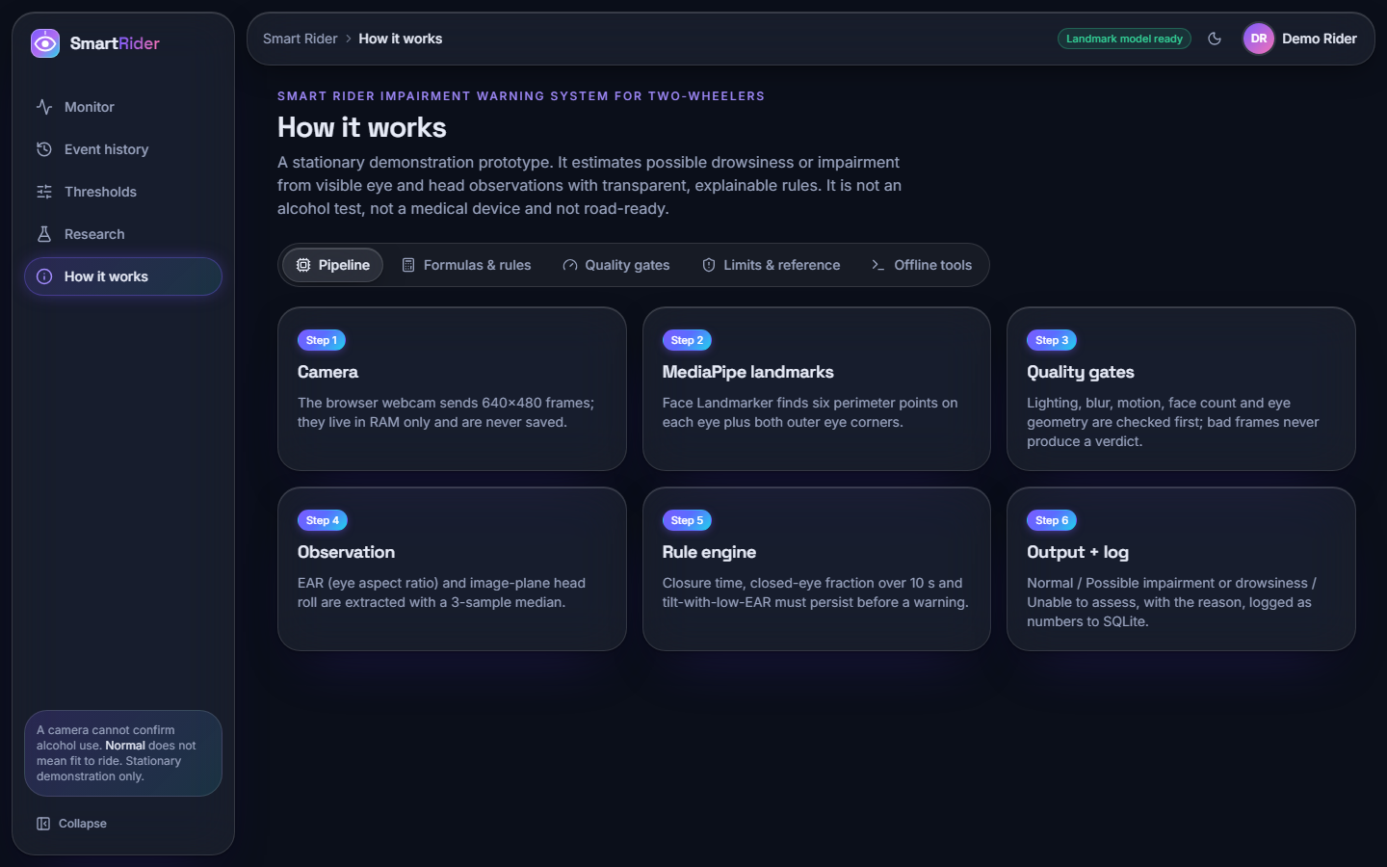
Figure 12: Screen 13: pipeline overview and limitations on the "How it works" page
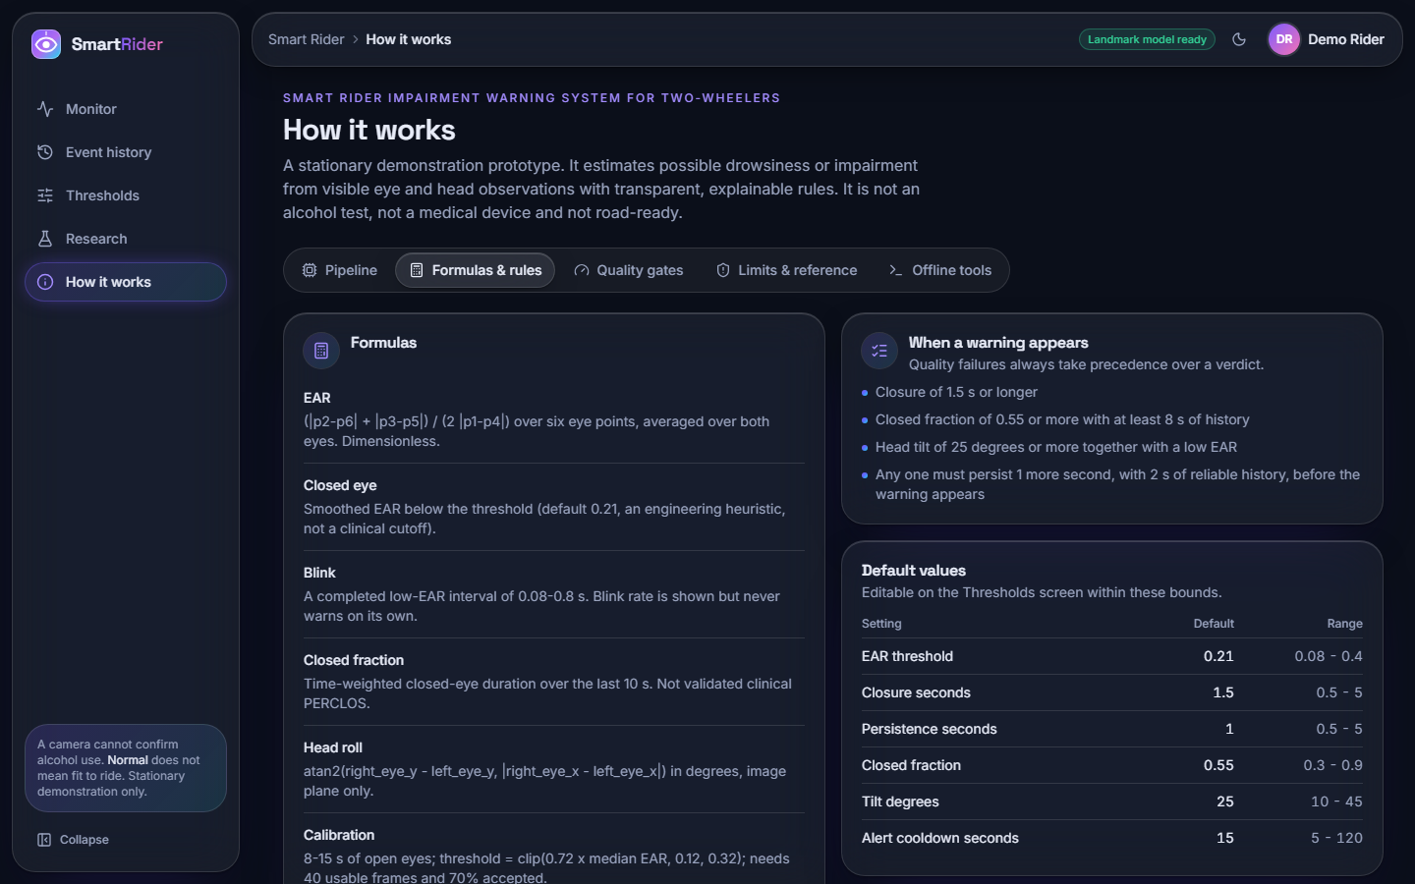
Figure 13: Screen 14: formulas, warning rules and default values on the "How it works" page

8.2 Behaviour of the rule engine on scripted streams
The decision logic was characterised with scripts/measure_rules.py, which generates seeded measurement streams (open-eye EAR about 0.30, closed about 0.12) and feeds them to the real RiskEngine. These streams are scripted, not recordings of people, so they show how the rules behave, not how riders behave. All results below use the default settings unless a sweep is stated.

Closure length against warning
Each closure was inserted into a quiet stream 6 s after the start and repeated 30 times at 10, 15 and 30 frames per second. At 15 frames per second the outcome is the same for every run (table below): closures of up to 2.4 s never produce a warning, and closures of 2.6 s or longer always do. The warning appears 2.60 s after the eyes close (2.53 s at 30 frames per second): the 1.5 s closure rule plus 1.0 s of persistence plus the lag of the three-sample median. A rider whose eyes close for two seconds and then reopen is never warned; this is a design consequence of persistence, and it is the main sensitivity limit of the default rules.
Table 2: Closure duration against warning (15 frames/s, 30 runs each)
Closure | Runs that warned | Mean latency from closure onset
0.5 s | 0 / 30 | -
1.0 s | 0 / 30 | -
1.5 s | 0 / 30 | -
2.0 s | 0 / 30 | -
2.4 s | 0 / 30 | -
2.6 s | 30 / 30 | 2.60 s
3.0 s | 30 / 30 | 2.60 s
4.0 s | 30 / 30 | 2.60 s
6.0 s | 30 / 30 | 2.60 s

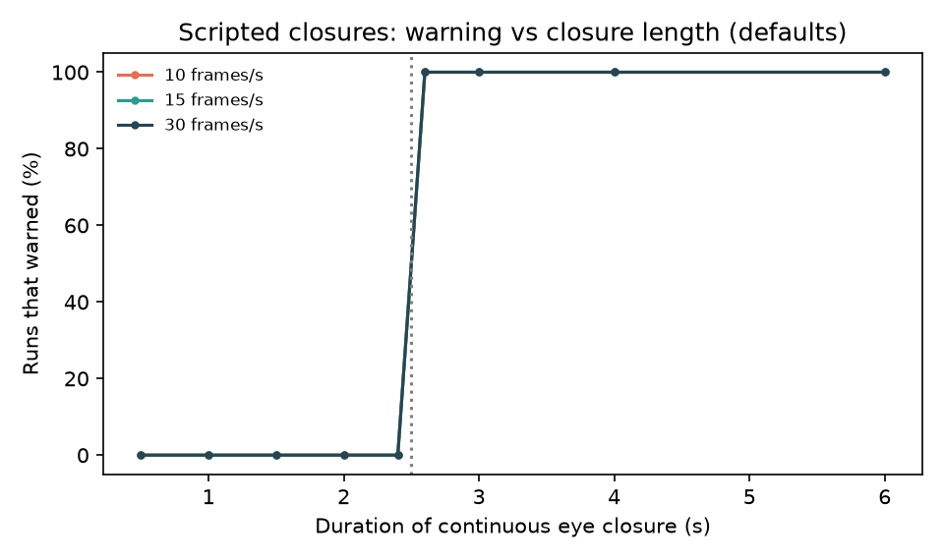
Figure 14: Share of runs that warned against closure duration at 10, 15 and 30 frames per second

False warnings on blink streams
Normal-looking streams (180 s each, 15 frames per second, 300 sessions per case) were generated with blinks of 0.1 to 0.4 s and counted for warnings. Blinks never warned, even at 35 per minute or with noisy EAR. Warnings appeared only when 20 % of the blinks were made unnaturally slow (0.8 to 1.3 s).
Table 3: Warnings on generated blink streams (defaults)
Stream | Sessions with a warning | Alerts per hour
normal blinks 17/min (0.1-0.4 s) | 0 / 300 | 0.00
frequent blinks 35/min (0.1-0.4 s) | 0 / 300 | 0.00
noisy EAR (sd 0.04), blinks 17/min | 0 / 300 | 0.00
5% slow blinks (0.8-1.3 s), 17/min | 0 / 300 | 0.00
20% slow blinks (0.8-1.3 s), 17/min | 3 / 300 | 0.20

Parameter trade-off
Closure time and persistence were varied together. The sweep shows that sensitivity and false alerts pull in opposite directions, and that the sum of closure and persistence is what matters: any setting whose sum exceeds the 3 s test closure misses it entirely. The defaults (1.5 s and 1.0 s) detect the 3 s closure and, on streams with 10 % slow blinks, produce no alerts, while a faster setting (1.0 s and 0.5 s) detects it too but raises 3.0 alerts per hour.
Table 4: Closure and persistence against detection and false alerts
Closure (s) | Persistence (s) | 3 s closure detected | Alerts per hour (10 % slow blinks)
1.0 | 0.5 | 100% | 3.00
1.0 | 1.0 | 100% | 0.33
1.0 | 2.0 | 0% | 0.00
1.5 | 0.5 | 100% | 0.33
1.5 | 1.0 | 100% | 0.00
1.5 | 2.0 | 0% | 0.00
2.0 | 0.5 | 100% | 0.00
2.0 | 1.0 | 0% | 0.00
2.0 | 2.0 | 0% | 0.00
3.0 | 0.5 | 0% | 0.00
3.0 | 1.0 | 0% | 0.00
3.0 | 2.0 | 0% | 0.00

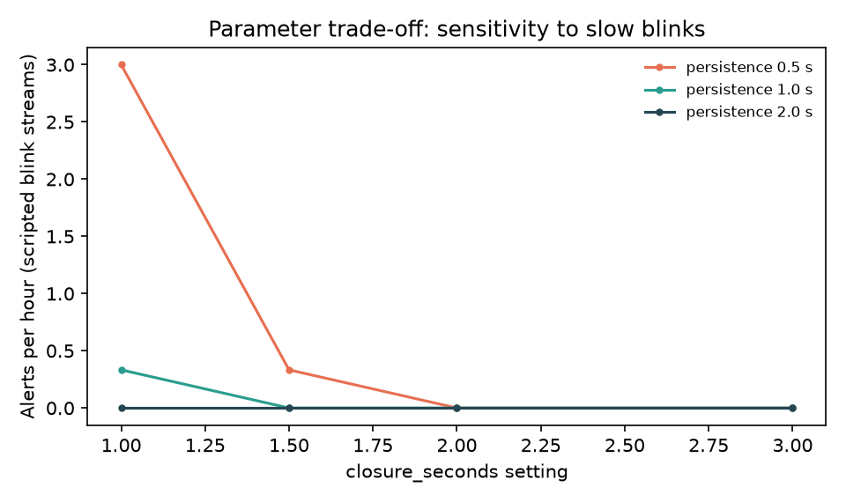
Figure 15: Alerts per hour against the closure setting for three persistence values

Other rules
• Closed-fraction rule. Closures of 0.9 s every 1.5 s (60 % closed, no single long closure) produce a warning 10.1 s after onset with the reason "Closed-eye fraction 63% over 10.0 s"; it needs at least 8 s of history, so it reacts slowly.
• Head-tilt rule. A 30 degree roll with an EAR of 0.19 warns after 1.07 s; the same roll with open eyes never warns (confirmed).
• Warm-up and recovery. The first Normal appears 2.0 s after the start, and 2.13 s after a signal loss.

8.3 Experimental setup for the eye-state measurement
The only component that can be measured on public data is the one that turns a face image into an EAR and decides whether the eye is closed. It was evaluated on the Closed Eyes in the Wild (CEW) dataset [12]: 1,192 faces with both eyes closed (collected from the Internet) and 1,231 faces with open eyes (from LFW [13]), supplied as 100 x 100 pixel warped crops. Each crop was enlarged to 480 x 480 pixels and centred on a 640 x 480 canvas, the size of the application's camera frames, and passed through the shipped Vision.process (MediaPipe Face Landmarker, quality gates, six-point EAR). The dataset is not part of the repository.
Table 5: Protocol of the eye-state measurement
Item | Value
Data | CEW, 2,423 still images: 1,192 closed, 1,231 open
Pipeline A (as shipped) | Vision.process with all quality gates; only assessed (Good) images are classified
Pipeline B (geometry only) | Same landmarks and eye_aspect_ratio, first detected face, no gates: separates "is EAR informative" from "did the gates let the image through"
Decision rule | Closed if EAR is below the threshold (default 0.21); positive class = closed
Training | None: there is no learned model; the threshold is a fixed engineering default
Hardware | 12th Gen Intel Core i5-12500 (6 cores, 12 threads), 15.7 GB, CPU only, Python 3.14.7, MediaPipe 1.0.1

8.4 Eye-state results on public data
Pipeline A (as shipped). Only 1,068 of 2,423 images (44.1%) pass the quality gates (closed 44.4%, open 43.8%). The main reason is the sharpness gate: a 100-pixel crop enlarged 4.8 times is soft, and 1,061 images were refused as "Blurred or hidden eyes"; a further 240 were refused because a second face was detected. If every refused image is counted as an error, end-to-end accuracy is only 41.8%. This says more about the low-resolution test images than about webcam frames, but it also shows how strict the gates are. Among the assessed images the default threshold gives:
Table 6: Pipeline A: assessed images, threshold 0.21
Measure | Value
True closed / false open (FN) | 529 / 0
True open / false closed (FP) | 484 / 55
Accuracy | 94.85%
Precision (closed) | 90.58%
Recall (closed) | 100.00%
Specificity (open) | 89.80%
F1 | 95.06%
ROC AUC of EAR | 0.993
Mean EAR, closed / open | 0.059 / 0.290

Pipeline B (geometry only). Without the gates a face is found in 2,407 of 2,423 images (closed 1,176, open 1,231). At the default threshold the result is accuracy 92.2%, recall of closed eyes 99.2%, specificity 85.5%, precision 86.7% and F1 92.5%, with an AUC of 0.989. The mean EAR is 0.065 for closed and 0.286 for open eyes, so EAR separates the two states well; the errors come from where the threshold is set.
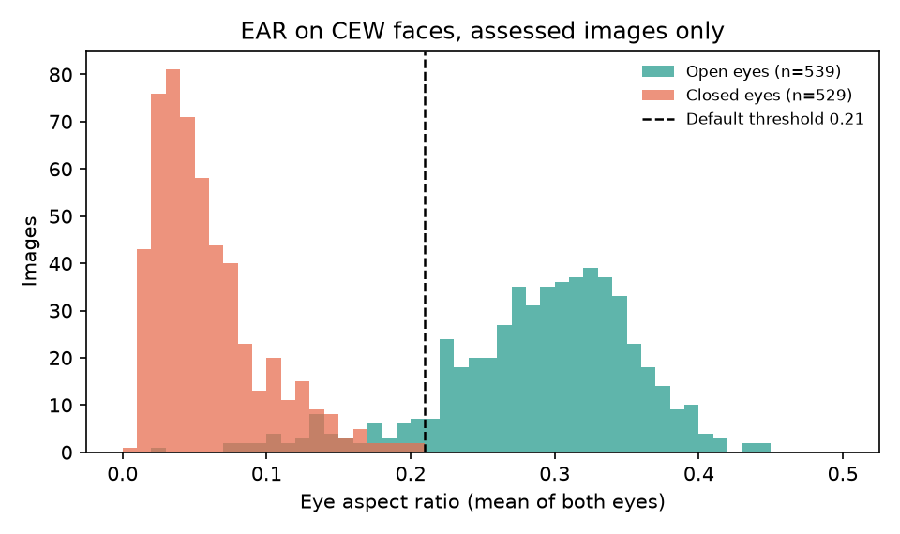
Figure 16: Distribution of EAR for closed and open eyes among the assessed CEW images, with the default threshold
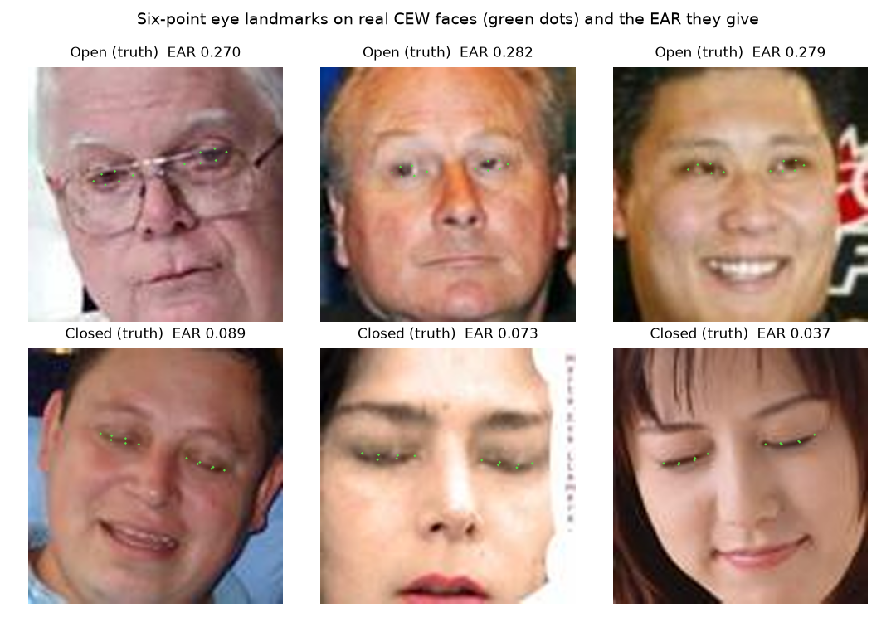
Figure 17: Six-point eye landmarks (green dots) and the resulting EAR on open (top) and closed (bottom) CEW faces that passed the quality gates
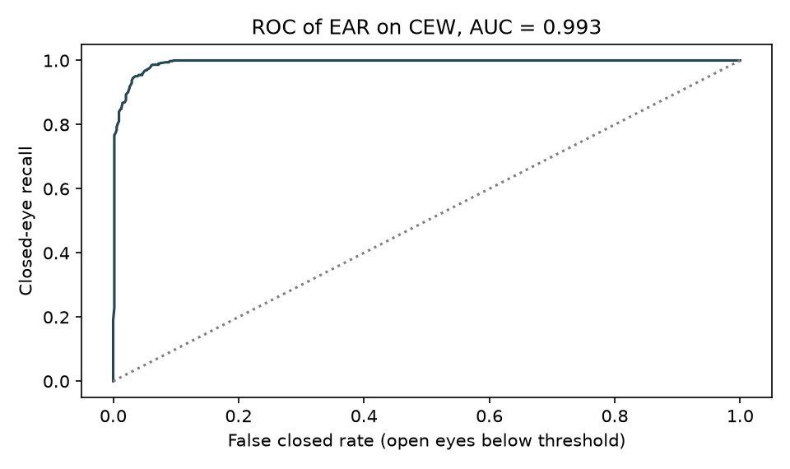
Figure 18: ROC curve of EAR as a closed-eye score on the assessed CEW images

Threshold analysis
The sweep below (pipeline B) shows the cost of the conservative default. Raising the threshold only adds closed-eye recall, but specificity falls quickly: at 0.21 about 14.5% of open eyes are called closed. The in-sample best threshold, 0.17, reaches accuracy 94.7% (recall 97.6%, specificity 92.0%); the same threshold is also best for pipeline A (96.2%). It was chosen on the test images themselves, so it is an indication and not a validated setting. In the application, calibration replaces the fixed 0.21 by 0.72 times the rider's own median open-eye EAR, which is the intended remedy: the calibrated value in screen 06 is 0.183. Whether calibration is better than a fixed 0.17 could not be measured, because the CEW images do not contain several images of the same person.
Table 7: Threshold sweep, pipeline B
Threshold | Accuracy | Closed recall | Open specificity
0.15 | 94.8% | 95.4% | 94.2%
0.17 | 94.7% | 97.6% | 92.0%
0.19 | 94.0% | 98.8% | 89.4%
0.21 | 92.2% | 99.2% | 85.5%
0.23 | 89.3% | 99.6% | 79.5%
0.25 | 86.2% | 99.7% | 73.4%
0.28 | 78.8% | 99.7% | 58.7%

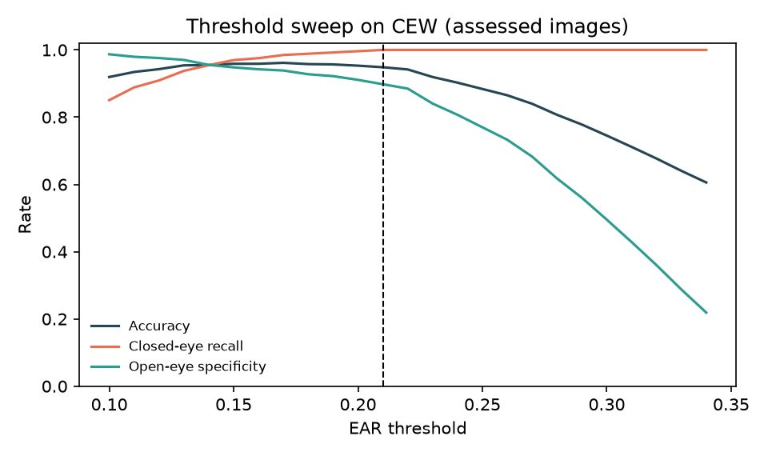
Figure 19: Accuracy, closed-eye recall and open-eye specificity against the EAR threshold (pipeline B)

8.5 Behaviour under degraded conditions
Objective 6 asks for performance under low light and partial occlusion. The measurement in Section 7.6 degraded 272 open-eye faces in software. The gates refuse when the picture is dark (brightness x0.25 and below: 0.0% assessed), blurred (0.0%), hidden behind opaque sunglasses (0.7%) or when one eye is covered (0.0%); that is the intended safe failure. They pass most images with noise (82.0%), a lower-face mask (86.8%) or tinted lenses (65.1%). Two findings are unfavourable. Halving the brightness (x0.50) already blocks assessment (0.4% assessed, almost all refused by the sharpness gate, because scaling intensity scales the Laplacian variance by the square of the factor), so the system is unavailable in dim but still visible light. And two images in the sunglasses test slipped through the gates, one of them with a false closed reading, which confirms the README's warning that the gates are heuristics and not a proof of occlusion detection.

8.6 Speed
Vision.process takes 12.1 ms on average on a 640 x 480 frame (median 13.1 ms, 95th percentile 26.9 ms) on the CPU. Through the HTTP API a camera frame takes 31.2 ms at the median and 47.8 ms at the 95th percentile (Section 7.7), about 32 frames per second for one session, so the prototype is not limited by computation on this laptop.

8.7 Comparison with the base paper
The base paper [1] and this project differ in target, method, data and hardware, so the table is context and not a ranking. The paper's figures are taken from its own text; those for this project are from Sections 8.2 to 8.6.
Table 8: Base paper and this project
Aspect | Base paper (Feng and Li) | This project
Target state | Drowsiness, fatigue and distraction | A drowsiness-type impairment indicator; not alcohol detection
Eye feature | EAR-4 (four upper-lid points) compared with six-point EAR | Conventional six-point EAR
Decision | Fuzzy belief rule-based inference fusing EAR, head pose and voice | Transparent if-then duration rules on EAR, closed fraction and roll
Voice interface | Whisper-tiny wake words and commands | None
Calibration | Personalised adaptive threshold from more than 300 frames | 8-15 s, threshold = 0.72 x median EAR
Data | NTHU-DDD: 4 subjects, 65,834 frames (29,804 open, 36,030 closed), 80/20 split; Random Forest and XGBoost | CEW: 2,423 still faces for the EAR component only; no rider data; no training
Reported eye-state metric | EAR-4 recall 0.894, F1 0.845 (Subject 2, Random Forest); six-point EAR 0.856 and 0.813 | Six-point EAR at 0.21: recall 0.992, specificity 0.855, F1 0.925 (CEW, pipeline B)
Hardware and speed | NVIDIA Jetson Orin Nano 8 GB, 25 frames per second | Laptop CPU (i5-12500), about 32 frames per second through the API
Deliverable | Embedded driver monitoring and assistance system | Stationary web and desktop demonstration prototype

Three points should be stated plainly. First, the metrics are not comparable: the base paper classifies frames of four drivers from a video dataset with trained models, whereas this project applies a fixed threshold to still faces of different people. Second, the base paper's six-point recall of 0.856 is lower than the 0.992 measured here, but the datasets, the class mix and the protocol differ, so no conclusion about which method is better can be drawn. Third, the project does not reproduce the base paper's EAR-4, voice interface or fuzzy belief engine.

8.8 Sample inputs and outputs
Scripted scenarios through the real rule engine. The table gives the decision of RiskEngine after 12 s of each scenario in core.simulate, together with the time of the first warning. These are deterministic demonstrations, not predictions.
Table 9: Decisions for the four simulation scenarios
Scenario | Verdict after 12 s | Reason | EAR | Closure | First warning
Normal | Normal | No sustained warning observations | 0.30 | 0.0 | -
Prolonged eye closure | Possible impairment or drowsiness | Continuous eye closure 8.8 s; Closed-eye fraction 88% over 10.0 s | 0.10 | 8.8 | 5.7 s
Missing face | Unable to assess | No face | 0.00 | 0.0 | -
Poor lighting | Unable to assess | Poor lighting | 0.00 | 0.0 | -

Camera frames through the API. A real face frame (21,350 bytes) was posted 150 times in a row with monitoring on. All frames were assessed as quality Good; 63 of the verdicts were Unable to assess (the two-second warm-up at about 30 frames per second) and 87 were Normal, with no warning, as expected for an open-eyed face.
Logged events. The events table of the repository holds a short live-camera diagnostic recorded on 23 September 2026. One row per distinct outcome is shown; the camera was pointed at a real scene and the labels are those the quality gates produced, including Multiple faces.
Table 10: Rows from data/events.sqlite3
id | UTC time | Source | State | Quality | Reason | EAR | Closure | Roll
1 | 2026-09-23 09:17:18 | LIVE CAMERA | Unable to assess | Multiple faces | Multiple faces | 0.000 | 0.0 | 0.0
2 | 2026-09-23 09:17:18 | LIVE CAMERA | Unable to assess | Good | Gathering 2 seconds of reliable observations | 0.265 | 0.0 | -2.1
9 | 2026-09-23 09:17:21 | LIVE CAMERA | Normal | Good | No sustained warning observations | 0.226 | 0.0 | -4.3
14 | 2026-09-23 09:17:27 | LIVE CAMERA | Unable to assess | Not assessed | Monitoring stopped | 0.000 | 0.0 | 0.0

8.9 Success and failure analysis
Where it works. Closed eyes are found reliably: recall is 99.2% at the default threshold, and the EAR distributions of closed and open eyes barely overlap (AUC 0.989). The rule engine ignores normal blinks entirely, warns on sustained closure with a stated reason, and the gates refuse to guess in darkness, blur and with covered eyes. The application runs at about 30 frames per second on a laptop CPU, and all 54 automated checks pass.
Where it fails.
• False closed readings. the default threshold of 0.21 labels 179 of 1,231 open eyes (14.5%) as closed, while a threshold of 0.17 would have mislabelled 99 (8.0%). People with narrow eyes, or looking down, have a low open-eye EAR; this is why calibration exists.
• Availability. Only 44.1% of the low-resolution test images pass the gates, and dim light (half brightness) already blocks assessment.
• Slow onset. Closures shorter than 2.6 s never warn, so a rider who nods off for two seconds is not warned.
• Spurious second face. About one in ten test images was refused because a second face was detected, even though each crop shows one face.
• Occlusion gaps. A few sunglasses images passed the gates, one of them with a false closed reading.
• Not alcohol. Closed eyes and low EAR have many causes; open eyes do not prove alertness. No result in this report relates to intoxication.

8.10 Limitations of the results
• One public still-image dataset, with closed and open classes taken from different sources; separation may be optimistic.
• No video, no blink dynamics and no head motion in the eye-state measurement; the rule engine was exercised only with scripted streams.
• The best threshold is chosen in-sample; there is no held-out validation of a tuned setting.
• Tracking state in MediaPipe's video mode makes unrelated stills depend on the previous image: coverage figures carry about two percentage points of noise.
• No intoxicated person, no rider, helmet, visor, vibration or night condition, and no demographic analysis.
• All results come from one machine and one run per measurement.

8.11 Objectives against outcomes
Table 11: Objectives of the batch and their outcome
Objective | Outcome | Evidence
1. Capture driver facial video with a webcam and detect the face and landmarks in real time | Achieved | MediaPipe landmarks with six-point eye geometry; 31 ms median per frame (Sections 7.7, 8.6)
2. Extract impairment cues: eye closure ratio, blink frequency, gaze deviation, head movement | Partly achieved | EAR, closure time, closed fraction, blink rate (display only) and image-plane head roll are measured; gaze deviation is not
3. Train a deep-learning classifier to separate a sober driver from an intoxicated one | Not achieved | No intoxication dataset was available; live decisions use explainable rules; the offline nearest-centroid pipeline has only been run on a synthetic file
4. Run inference continuously and alert when the impairment score crosses a threshold | Achieved | Rule engine with three outputs, on-screen warning and optional bell with cooldown (Section 8.2); the score is a drowsiness-type indicator, not an alcohol score
5. Integrate a prevention action (ignition warning, notification to a registered contact) | Not achieved | The application only shows a warning and plays a bell; it never controls ignition and sends no notification
6. Evaluate accuracy, false-positive rate, low light and partial occlusion | Partly achieved | Eye-state accuracy and false-closed rate on CEW and gate behaviour under degradation (Sections 8.4, 8.5); no intoxication accuracy and no rider study

