Smart Rider: A Webcam Impairment Warning from Eye Closure and Head Tilt
B Pranitha  Dept. of Computer Science and Engineering  TKR College of Engineering and Technology  Hyderabad, India  [email address] | Bantu Kavya  Dept. of Computer Science and Engineering  TKR College of Engineering and Technology  Hyderabad, India  [email address] | Dasari Viveka Sarveshwari  Dept. of Computer Science and Engineering  TKR College of Engineering and Technology  Hyderabad, India  [email address] | Bekkam Vamshi  Dept. of Computer Science and Engineering  TKR College of Engineering and Technology  Hyderabad, India  [email address] | N. Padmavathi  [DESIGNATION], Dept. of Computer Science and Engineering  TKR College of Engineering and Technology  Hyderabad, India  [email address]

Abstract---Drunk riding is a serious road-safety problem, but a camera cannot confirm that someone has drunk alcohol. This paper describes and measures Smart Rider, a webcam system that warns of possible drowsiness or impairment from visible eye and head cues. Face landmarks give an eye aspect ratio and the image-plane head roll, quality gates withhold a verdict when the signal is unreliable, and transparent duration rules with a per-rider calibration produce one of three outputs: Normal, Possible impairment or drowsiness, or Unable to assess. No deep-learning classifier was trained, no intoxication data were available and no prevention action such as an ignition lock is implemented. On 2,423 public face images the eye-state signal reaches an AUC of 0.989 and 92.2% accuracy at the default threshold, which calls 14.5% of open eyes closed; the quality gates pass only 44% of these low-resolution images and refuse to assess when brightness is halved. On scripted streams a closure must last about 2.6 s to warn. One camera frame takes 31 ms through the API on a laptop CPU. The system is a stationary demonstration prototype and not an alcohol test.
Index Terms---driver monitoring, explainable rules, eye aspect ratio, facial landmarks, impairment warning, MediaPipe, quality gating.
I. INTRODUCTION
Road crashes kill about 1.19 million people a year, and riders of powered two- and three-wheelers account for 21 % of those deaths [2]. Impairment by alcohol or fatigue is among the preventable causes, yet it is checked mainly at the roadside and only occasionally. Trained officers already judge impairment partly from the eyes, for example through gaze nystagmus [3], which suggests that eye behaviour carries a signal that a camera might also see.
Vision research on drivers has concentrated on drowsiness: the eye aspect ratio (EAR) of six eye landmarks [4], the share of time the eyes are closed [5], blink behaviour [6] and combined visual cues [7]. The base paper of this work, Feng and Li [1], fuses EAR, head pose and voice commands with a fuzzy belief rule-based engine on an embedded board. Work aimed at alcohol uses facial video [8], [9], thermal images [10], [11] or a smartwatch [12]. All of it needs labelled intoxicated data, which are hard to obtain: many source videos of the best-known face dataset are no longer online [8], and testing detection systems requires giving participants alcohol under controlled conditions [13].
The project title promises alcohol intoxication detection and prevention. What was built is narrower and is stated here plainly: a rule-based drowsiness and impairment warning. It is not an alcohol detector. It has no trained deep-learning classifier because no intoxication dataset was available, it implements no prevention action (it never touches ignition, brakes or power and notifies no contact), it does not measure gaze, and it has not been studied with riders. Of the six batch objectives, two were achieved, two partly and two not. The contributions are:
(1) an explainable, quality-gated and personally calibrated rule engine with three outputs, one of which is a refusal to guess; (2) a desktop and web implementation verified by 20 unit tests and 34 API checks; (3) measurements of its parts: eye-state separation on public data, behaviour under degraded images, rule behaviour on scripted streams and latency; and (4) an offline, subject-disjoint evaluation pipeline that has so far run only on a synthetic demonstration file.
Why a refusal matters. A warning system for a rider can fail in two familiar ways: it can miss an impaired rider, or it can accuse a sober one. A third failure is quieter, namely reporting confidently when the eyes cannot be seen at all. Smart Rider treats the third as the most avoidable. When the picture is dark, blurred, off-centre or the eyes are hidden it answers Unable to assess and discards what it has accumulated instead of guessing. The price is availability, which Section IV measures. Normal never means fit to ride.
Section II reviews related work, Section III describes the method, Section IV reports measurements and Section V concludes.
A. System Hardware
All measurements ran on one laptop: 12th Gen Intel Core i5-12500 (6 cores, 12 threads), 15.7 GB RAM, Intel UHD Graphics 770 (not used), Windows 11 Pro. No GPU was used.
B. Software Requirements
Python 3.14.7 with MediaPipe 1.0.1 [14], OpenCV 5.0, NumPy 2.5 and Matplotlib 3.11; FastAPI 0.162 [15] with SQLite for the server; React 18, Vite 8 and TypeScript for the web interface; the standard unittest library and a scripted API check for testing. Google's face-landmark model (about 3.7 MB) is downloaded once.
II. LITERATURE SURVEY
Base paper. Feng and Li [1] build an adaptive driver monitoring system for drowsiness, fatigue and distraction. MediaPipe landmarks give a six-point EAR and a four-point variant, EAR-4, that uses only the upper eyelid; head pose is estimated from six landmarks; a small speech model handles voice commands; and a fuzzy belief rule-based engine fuses the three sources and sounds a buzzer above a risk threshold. A personal EAR threshold is learned from more than 300 frames. On four subjects of the NTHU drowsy-driver data [16] (65,834 frames, 80/20 split) Random Forest and XGBoost reach an EAR-4 recall of 0.894 for one subject against 0.856 for six-point EAR, and the system runs at 25 frames per second on a Jetson Orin Nano. The authors list subject-independent validation as future work. The target is drowsiness, not alcohol.
Eye measures and drowsiness. EAR was introduced for blink detection [4]; closure over time (PERCLOS) was proposed as a real-time alertness measure [5] and blink rate was studied as a fatigue signal [6]. Ji et al. [7] combine eyelid movement, gaze, head movement and expression in a probabilistic model with infrared illumination. These works establish the cues Smart Rider uses, but in all of them the target state is fatigue.
Intoxication from the face and body. Baroutian et al. [8] fuse a graph attention network over facial landmarks with 3D ResNet features on 3,542 clips from 202 people (YouTube) and report 95.82 % accuracy. The DIF dataset [9] labels how intoxicated people look, not their measured alcohol level. Thermal images have been used with CNNs and classical classifiers [10], [11], and a smartwatch study with 54 participants on a test track reaches an AUROC of 0.88 [12]. A testing methodology for in-vehicle alcohol detection is still being piloted [13].
Datasets. Public driver datasets cover drowsiness and yawning, for example NTHU-DDD [16] and YawDD [17], but none of the intoxication studies cited here releases labelled video that could simply be reused: DIF depends on videos that have since been removed [8], the study of Baroutian et al. [8] is curated from online clips, and the thermal studies used their own volunteers [10], [11]. For the eye-state component alone, the Closed Eyes in the Wild data (CEW) [18] supply 1,192 closed-eye faces from the Internet and 1,231 open-eye faces taken from LFW [19], so the signal can be checked even though intoxication cannot.
Critical reading. The cues reported for intoxicated faces, such as prolonged eye closure, downward gaze and head tilt [8], overlap with those of drowsiness, and the same study found false negatives for intoxicated people with neutral expressions. A system that sees only eyes and head tilt can therefore report that something is wrong but not what. This is the reason the output of this work is a possible impairment or drowsiness warning and never an alcohol result.
Evaluation practice. The reported figures come from different protocols. The base paper [1] splits the frames of four subjects 80/20 at random and lists subject-independent validation as future work, which can let a person's appearance leak across the split; Baroutian et al. [8] split by subject over curated clips; the smartwatch study [12] uses leave-one-subject-out validation on a test track. This work therefore keeps its offline pipeline subject-disjoint and does not rank its own eye-state numbers against these results.
TABLE I
REPRESENTATIVE RELATED WORK
Ref. | Approach | Data | Reported result | Limitation
[1] | EAR-4, head pose, voice, fuzzy rules | NTHU-DDD, 4 subjects | EAR-4 recall 0.894; 25 FPS | Drowsiness; not alcohol
[8] | Landmark GAT + 3D ResNet | 202 people, 3,542 clips | 95.82 % accuracy | Online videos
[12] | Smartwatch accelerometer + HRV, CNN | 54 participants, test track | AUROC 0.88 / 0.86 | Preprint; wearable
[10] | Thermal camera, CNN | 50 volunteers | 85.10 % (4 levels) | Abstract only read
[11] | Thermal faces, MLP and others | Public + own images | About 90 % | Abstract only read
[7] | Eyelid, gaze, head cues; probabilistic | Drivers, infrared | Robust per abstract | Fatigue; infrared

Gap. Published intoxication detectors need labelled alcohol data and report results on data the team here did not have, while drowsiness work does not claim alcohol. What is missing in this setting is a camera system that is explicit about what it cannot know: one that gates its input, explains each verdict, calibrates to the person and has measured limits. Smart Rider addresses that narrower gap, not the detection of alcohol.
III. METHODOLOGY
Pipeline. A browser or desktop camera supplies 640 x 480 frames that live only in memory. MediaPipe Face Landmarker [14] returns 478 landmarks. Seven quality gates are applied first: mean brightness outside 40 to 225, Laplacian variance below 25, frame-to-frame change above 35, no face or more than one face, eye width below 14 px, eye-region contrast too low and a difference between the two eyes' EAR above 0.12. A frame that fails any gate gives Unable to assess and clears all evidence. Otherwise an observation (time, EAR, roll) enters the rule engine. Fig. 1 shows the architecture.
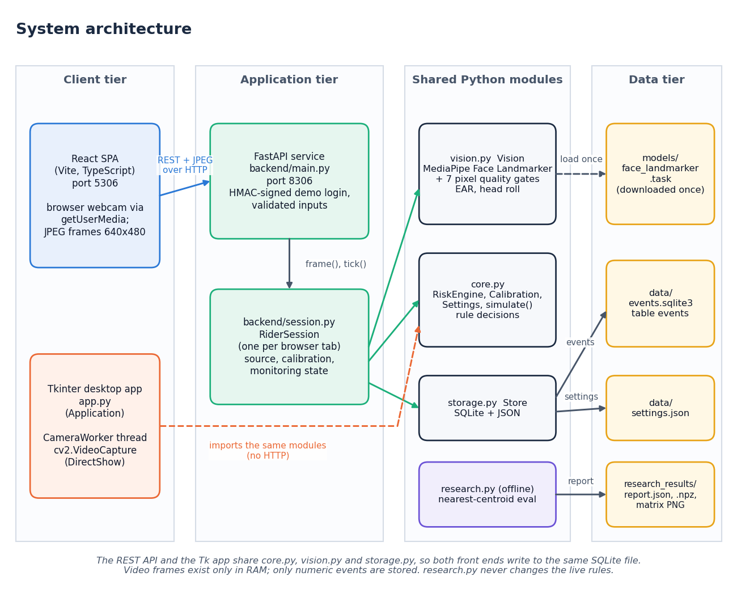
Fig. 1. Architecture: React and Tk front ends, FastAPI service, shared Python modules and numeric-only data stores.
Features. For six eye points p1 to p6 the EAR is (|p2 - p6| + |p3 - p5|) / (2 |p1 - p4|), averaged over both eyes and smoothed by a median of three frames. Head roll is atan2(y_r - y_l, |x_r - x_l|) between the outer eye corners, in degrees; it is an image-plane tilt, not a full head pose. An eye is closed when the smoothed EAR is below a threshold, 0.21 by default. Blink rate is displayed but never warns on its own.
Rules. A closure of at least 1.5 s, or a closed-eye fraction of at least 0.55 over the last 10 s (with 8 s of history), or a roll of at least 25 degrees with a closed eye starts an evidence timer; the warning appears only when the evidence persists for another second with 2 s of reliable history. Alert sounds are rate limited to one per 15 s. Every verdict carries its reason. The constants are engineering choices; they were not tuned on data, and they are adjustable within validated bounds.
Start-up and recovery. After monitoring starts, 2 s of continuous good observations are required before Normal can appear. Any failed gate, a time gap above 0.5 s or a non-finite value clears the closure timers, the 10 s window and the evidence, so a warning can never be built from stale or unreliable data; only the alert-sound cool-down is kept across such gaps, which prevents a flickering signal from sounding the alert repeatedly.
Calibration. The rider looks forward with eyes open for 8 to 15 s. If at least 40 frames and 70 % of observations are usable and the EAR spread is small, the threshold becomes 0.72 times the median EAR, limited to 0.12 to 0.32. Calibration cannot tell whether the rider was already tired.
Design principles. Four choices follow from the missing data. Decisions are rules a reviewer can read, because there is no labelled intoxication set to train on and a black box could not be justified without one. Every verdict carries a reason, so a warning can be checked against the measurements. Unreliable input produces a refusal, not a guess. And no image is kept: frames exist in memory for the length of one request, and only numeric events are written, locally.
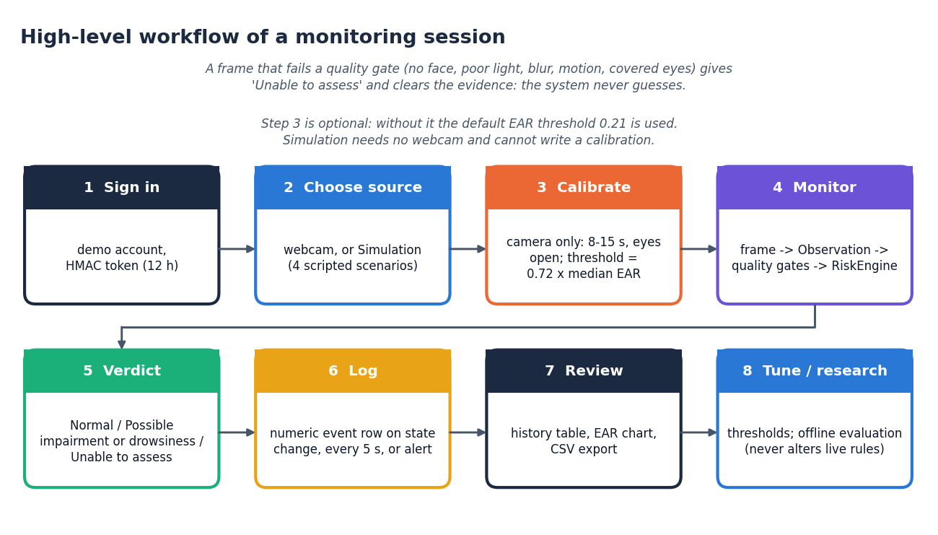
Fig. 2. Main flow of a monitoring session, from sign-in to review.
Implementation. The original Tkinter application and a FastAPI service share the same vision, rule and storage modules. The service issues an HMAC-signed 12-hour demo token, validates every input and stores only numeric events (state, quality, reason, EAR, closure, roll) in SQLite; it never writes images. A React interface shows the live verdict, history, thresholds and an offline research page. The offline pipeline cuts labelled measurement files into 5 s windows, separates subjects between training and test, and fits a standardised nearest-centroid classifier; it never changes the live rules.
Logging and export. An event row is written when the state or the signal quality changes, every 5 s while monitoring and whenever an alert fires. Each row has a UTC timestamp, a source label (live camera, or the name of the simulated scenario so that scripted rows cannot be mistaken for live ones), the verdict, its reason and the measurements. The history screen shows the latest 500 rows with a chart, and the whole table can be exported as a CSV file.
Offline pipeline. For research use, a measurement file has the columns subject, session, time, EAR, roll, quality, label and consent. Windows of 5 s need at least 20 frames, 4.5 s of coverage, gaps of at most 0.5 s, all-Good quality and one label. Six features (EAR mean, standard deviation and minimum, closed fraction, mean absolute roll, roll standard deviation) are standardised on training windows only, and each test window goes to the nearer class centroid. Subjects never appear on both sides, precision is TP/(TP+FP), recall TP/(TP+FN), F1 2TP/(2TP+FP+FN) and the false-alarm rate FP/(FP+TN), all per window and not per hour.
Evaluation protocols. (a) The eye-state signal was run through the shipped code on the Closed Eyes in the Wild data [18]: 1,192 closed-eye faces from the Internet and 1,231 open-eye faces from LFW [19], as 100 x 100 images upscaled to 480 x 480. It was scored twice: with the quality gates (the shipped pipeline) and geometry only (same landmarks and EAR, no gates). (b) 272 open-eye faces were degraded by darkening, over-exposure, blur, noise, opaque or tinted lenses, a covered eye and a masked lower face, to see how the gates respond. (c) Seeded scripted EAR streams (open 0.30, closed 0.12) probe the rule engine. (d) Latency was timed on 127.0.0.1 with a real face image. ROC analysis follows Fawcett [20].
IV. RESULTS
Eye-state signal. Table II gives the results on the CEW faces at the default threshold of 0.21 (closed eyes are the positive class). Without gates, 2,407 of 2,423 faces gave a measurement; EAR averaged 0.065 for closed and 0.286 for open eyes, an AUC of 0.989. At 0.21 the signal misses 0.8% of closed eyes but calls 14.5% of open eyes closed. The sweep in Fig. 3 shows why: a threshold of 0.17 would give 94.7% accuracy and a 8.0% false-closure rate. That value was found on the same images and is context, not a tuned setting; the default was left at 0.21, which the personal calibration is meant to correct.
TABLE II
EYE-STATE RESULTS ON CEW FACES (CLOSED = POSITIVE)
Setting | n | Acc. | Prec. | Rec. | Spec. | F1 | AUC
Geometry only, 0.21 | 2,407 | 92.2% | 86.7% | 99.2% | 85.5% | 92.5% | 0.989
Geometry only, 0.17 (in-sample) | 2,407 | 94.7% | 92.1% | 97.6% | 92.0% | 94.8% | 0.989
Shipped, gated, 0.21 | 1,068 | 94.9% | 90.6% | 100.0% | 89.8% | 95.1% | 0.993
Shipped, gated, 0.17 (in-sample) | 1,068 | 96.2% | 94.0% | 98.5% | 93.9% | 96.2% | 0.993

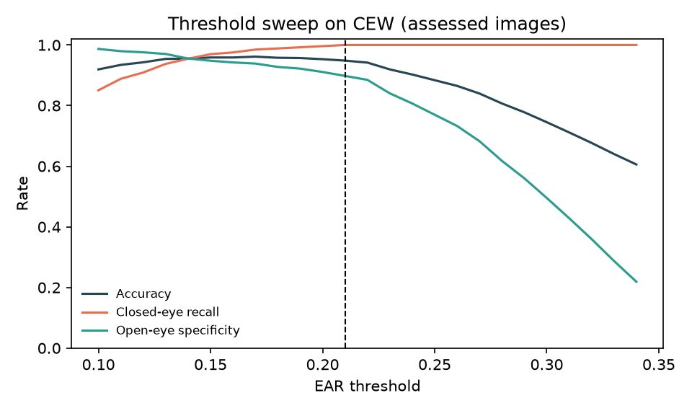
Fig. 3. Accuracy, closed-eye recall and open-eye specificity against the EAR threshold on the images that pass the gates; the dashed line is 0.21.
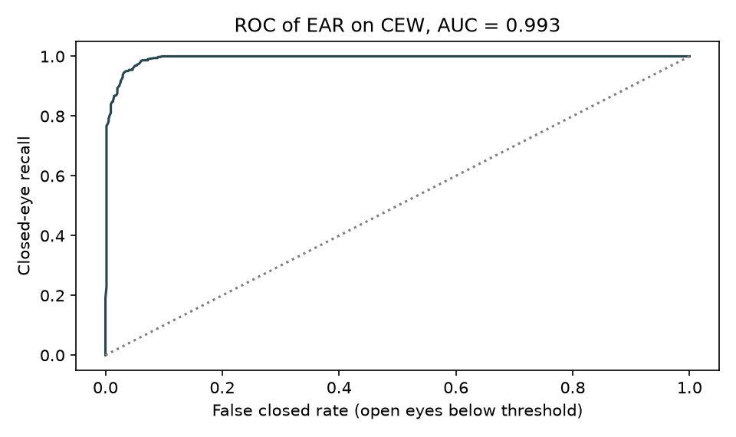
Fig. 4. ROC curve of the EAR for closed against open eyes on the assessed images.
Overlap of the classes. The ROC curve in Fig. 4 stays close to the top-left corner. On the assessed images the EAR of closed eyes lies between 0.017 and 0.133 (5th to 95th percentile) and that of open eyes between 0.148 and 0.387. The open-eye spread is wide because narrowed eyes, squints, eyeglasses and head pose all lower the ratio, and this tail is what a fixed threshold of 0.21 falsely calls closed. A per-rider threshold, which Smart Rider sets at 0.72 of the median open-eye EAR, moves with the person; the CEW images are of different people with no per-person calibration frames, so the effect of calibration could not be measured here.
Quality gates. The shipped pipeline assesses only 1,068 of 2,423 images (44.1%); the main reason is the sharpness gate, because a 100-pixel face enlarged almost five times is soft. Among assessed images accuracy is higher, 94.9%, and AUC 0.993. Counting every unassessed image as wrong gives 41.8%. Coverage is alike for both classes (44% closed, 44% open). The sharpness gate rejects 480 closed and 581 open images, and a spurious second face 139 and 101. These coverage figures are a property of the test images, not of webcam frames, and vary by about two points between runs because the landmark tracker keeps state between frames. Fig. 5 shows the live screen with landmarks on a real face, and Fig. 9 the landmarks on CEW faces.
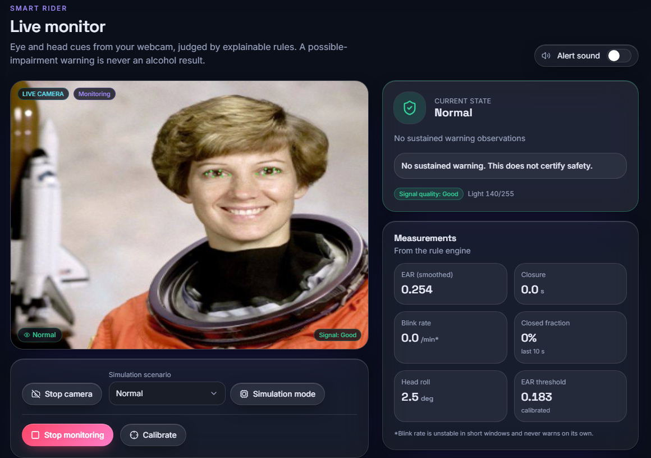
Fig. 5. Output screen, live camera path: landmarks on a real face, verdict Normal, EAR 0.254 against a calibrated threshold of 0.183.
Degraded conditions. Of 272 open-eye faces, 98.2% are assessed unmodified. Halving the brightness leaves 1 assessed and a quarter leaves 0; Gaussian blur of 2 px leaves 0; opaque sunglasses leave 2, a covered eye 0. The gates therefore fail safe (Fig. 8), with Unable to assess, but they are strict, so availability in dim light is poor. Noise (82%), tinted lenses (65%) and a masked lower face (87%) are mostly still assessed, with false-closure rates of 14.8%, 8.5% and 12.7%.
Rule behaviour. On scripted streams closures up to 2.4 s never warn and closures of 2.6 s or more always do, with a latency of 2.60 s at 15 frames per second (the 1.5 s closure rule plus 1 s of persistence, plus median lag). No warning occurred in 300 sessions of 180 s each with normal blinks, frequent blinks, noisy EAR or 5 % slow blinks; with 20 % slow blinks 3 of 300 sessions warned (0.2 alerts per hour). A 60 %-closed pattern of 0.9 s closures warned after 10.1 s, a 30-degree tilt with a low EAR after 1.1 s, and tilt alone never warned. These streams are generated, so they show how the rules behave, not how real riders blink. Fig. 6 shows the warning screen for a scripted closure and Fig. 7 how often a closure of each length warns.
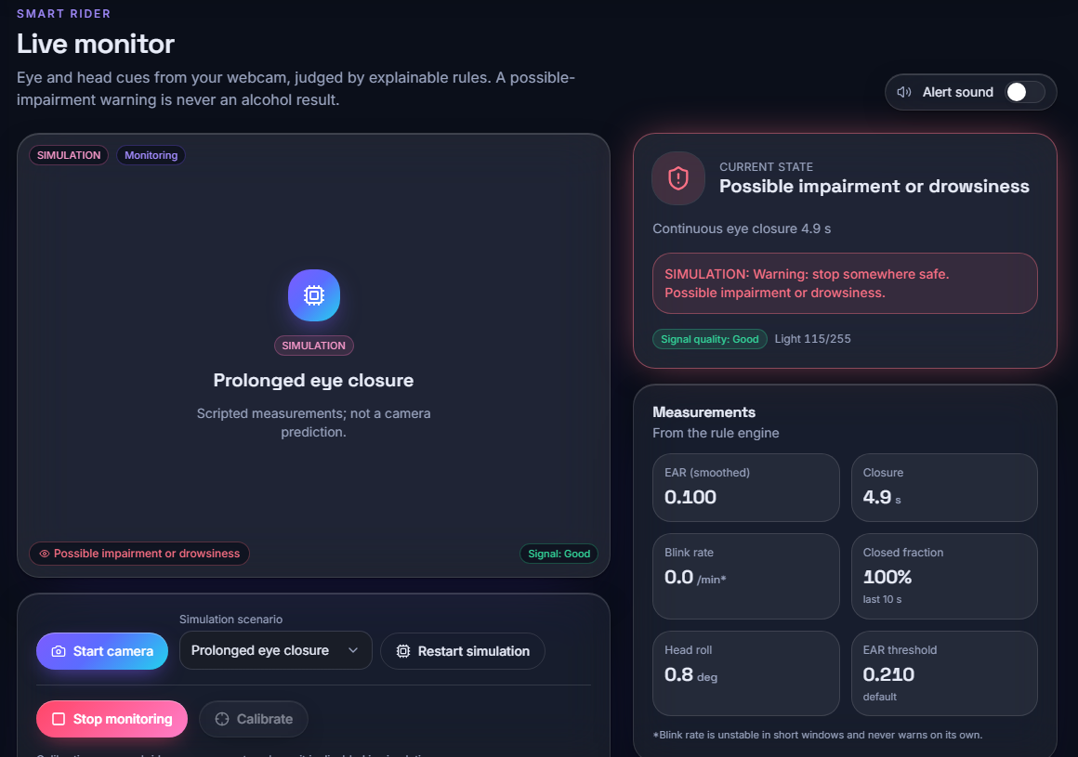
Fig. 6. Output screen, simulation: a scripted prolonged closure raises the warning with its reason; the simulation is labelled on screen.
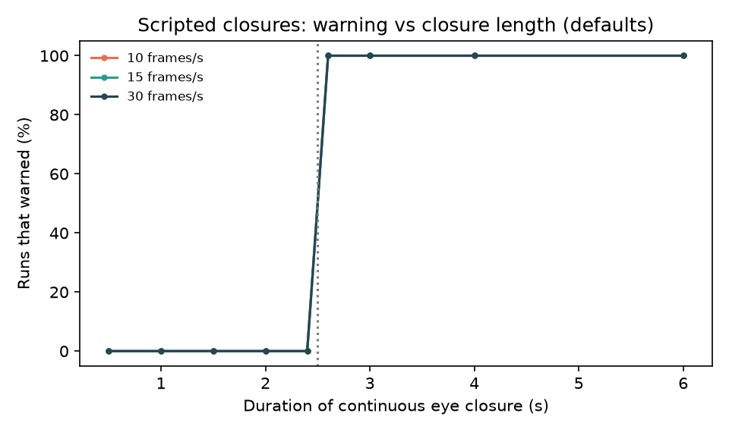
Fig. 7. Share of scripted runs that warn against the length of one closure, at three frame rates (default rules).
TABLE III
RULE PARAMETERS ON SCRIPTED STREAMS (DEFAULT IN BOLD)
Closure (s) | Persistence (s) | Detects 3 s closure | Alerts per hour*
1.0 | 0.5 | 100% | 3.00
1.0 | 1.0 | 100% | 0.33
1.5 | 0.5 | 100% | 0.33
1.5 | 1.0 | 100% | 0.00
1.5 | 2.0 | 0% | 0.00
2.0 | 0.5 | 100% | 0.00
2.0 | 1.0 | 0% | 0.00
3.0 | 0.5 | 0% | 0.00

*Streams with 10 % slow blinks (0.8 to 1.3 s). Shortening the closure or persistence time detects the same 3 s closure but alerts more often on slow blinks; any pair whose sum exceeds 3 s misses it. The default, 1.5 s and 1.0 s, detects every scripted closure and raised no alert on these streams. This is a trade-off curve of a generator, not a measured rate for riders.
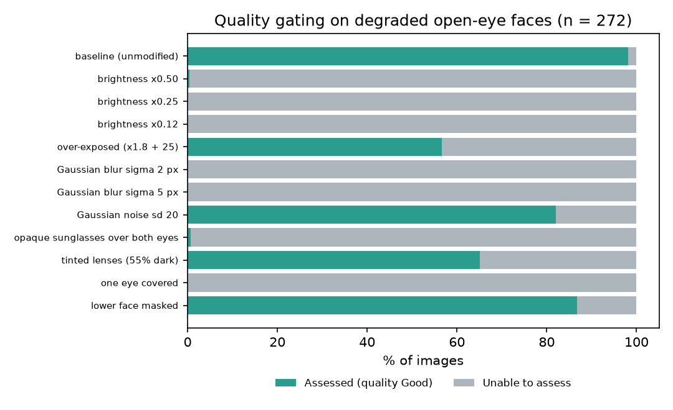
Fig. 8. Share of open-eye faces that are assessed under each degradation; the rest receive Unable to assess.
Speed and tests. A camera frame takes a median of 31.2 ms (95th percentile 47.8 ms) from HTTP request to annotated reply, and the landmark step alone averages 12.1 ms, about 30 frames per second on one laptop CPU. The rule engine costs 41 microseconds per observation. All 20 unit tests and 34 API checks pass.
Offline pipeline. The subject-disjoint pipeline was exercised on a seeded synthetic file of six subjects, 12 held-out windows per class. It separated them perfectly, which says only that the code runs: the data are generated, the screen that shows the report carries a Synthetic data banner, and the pipeline has never seen a real labelled recording. It is therefore listed as untested on real data and not as a result.
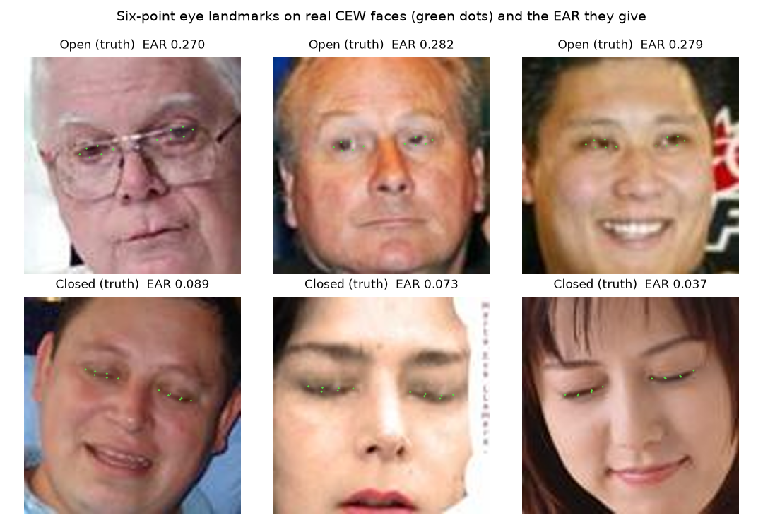
Fig. 9. Six eye landmarks (green) on CEW faces that passed the gates, with the EAR obtained.
Comparison with the base paper. The two studies differ in target (drowsiness, not alcohol), data, method and hardware, so this is context and not a ranking. The base paper reports an EAR-4 recall of 0.894 for one NTHU subject with Random Forest, on frames of four drivers, and 25 frames per second on a Jetson Orin Nano. Here the six-point EAR has a recall of 99.2% and a specificity of 85.5% at one threshold on still faces from two image sources, with no learned model and no voice or fuzzy fusion.
Objectives. Real-time capture with landmarks (objective 1) and continuous inference with an alert above a threshold (objective 4) were achieved. Impairment cues (objective 2) were measured only in part: EAR, closure time, closed fraction, blink rate and head roll, but not gaze. The deep-learning classifier (objective 3) and the prevention action (objective 5) were not built. Evaluation (objective 6) covered the eye-state signal, low light and covering of the eyes, but not intoxication, false-positive rates on riders or road conditions, and is only partly done.
Failure cases and limits. Closed eyes are not intoxication, and open eyes do not prove alertness. The default threshold over-calls closed eyes; the gates are strict; a slow eye closure needs about 2.6 s to be reported; CEW classes come from different sources, so separation may be optimistic; the screens use a public-domain portrait and scripted scenarios, not riders; and the offline classifier's only report, from a synthetic file, is not evidence of performance.
What this means for use. Three consequences follow. First, the threshold must be set per rider: the shipped default errs towards calling eyes closed, and only calibration, not yet measured on people, addresses it. Second, availability matters as much as accuracy: a system that refuses in dim light is safe but not useful at dusk, so the sharpness and brightness gates need tuning on real webcam footage. Third, any prevention action such as an ignition interlock would act on this output, so its false-alarm rate on riders would have to be measured first; none of that has been done, and the prototype is for stationary demonstration only.
Threats to validity. Each measurement comes from one machine and one configuration. CEW images are small, from two sources, and show mostly frontal faces; the degradations are synthetic and applied to still images; the scripted streams assume the EAR values and blink statistics written into the generator; and the best thresholds were chosen on the same images they describe. None of these were checked on motorcyclists, helmets, visors, night riding, vibration, different skin tones or glasses, so the results bound the signal and the software, not a rider's safety.
V. CONCLUSION
Smart Rider turns a webcam into an explainable warning of possible drowsiness or impairment and is honest about what it cannot do. Against the six batch objectives, real-time face and landmark capture and continuous inference with an alert were achieved; impairment cues were measured only in part (no gaze); and the deep-learning classifier and the prevention action were not built. The key finding is that the eye signal separates open from closed eyes well (AUC 0.99) but that its default threshold and strict gates, not the rules, limit practical use. Limitations are the absence of intoxication data, of a rider study and of validation under helmets and visors, and a stationary-only prototype. Future work: collect a consented sober and intoxicated video dataset and train and test on held-out subjects; add gaze and temporal features; tune thresholds on separate validation subjects; run an in-vehicle trial with helmets, visors and vibration; and connect a prevention action such as an ignition interlock or a trusted-contact alert.
REFERENCES
[1] C.-L. Feng and T.-H. S. Li, "Robust driver state assessment on an embedded platform using a fuzzy belief rule-based fusion of eye aspect ratio and voice commands," IEEE Access, vol. 14, pp. 36158-36175, 2026, doi: 10.1109/ACCESS.2026.3670924.
[2] World Health Organization, "Global status report on road safety 2023," Geneva, Switzerland, Dec. 2023.
[3] National Highway Traffic Safety Administration, "DWI detection and standardized field sobriety testing (SFST) participant manual," U.S. Dept. Transportation, Washington, DC, USA, 2023 ed.
[4] T. Soukupova and J. Cech, "Real-time eye blink detection using facial landmarks," in Proc. 21st Computer Vision Winter Workshop, Rimske Toplice, Slovenia, Feb. 2016.
[5] Federal Motor Carrier Safety Administration, "PERCLOS: A valid psychophysiological measure of alertness as assessed by psychomotor vigilance," Tech Brief FHWA-MCRT-98-006, Washington, DC, USA, Oct. 1998.
[6] J. A. Stern, D. Boyer, and D. Schroeder, "Blink rate: A possible measure of fatigue," Human Factors, vol. 36, no. 2, pp. 285-297, 1994, doi: 10.1177/001872089403600209.
[7] Q. Ji, Z. Zhu, and P. Lan, "Real-time nonintrusive monitoring and prediction of driver fatigue," IEEE Trans. Veh. Technol., vol. 53, no. 4, pp. 1052-1068, Jul. 2004, doi: 10.1109/TVT.2004.830974.
[8] B. Baroutian, A. Aghaei, and M. Ebrahimi Moghaddam, "Detection of intoxicated individuals from facial video sequences via a recurrent fusion model," arXiv:2512.04536, Dec. 2025.
[9] V. Mehta, D. P. Yadav, S. S. Katta, and A. Dhall, "DIF: Dataset of perceived intoxicated faces for drunk person identification," arXiv:1805.10030, 2018 (revised 2019).
[10] L. P. Acharya, "Infrared deep learning system for non-invasive drunk detection and alcohol level classification," Iowa State Univ., Ames, IA, USA, Dec. 2024. [Online]. Available: https://dr.lib.iastate.edu/handle/20.500.12876/105973
[11] C.-H. Chai, S. F. Abdul Razak, S. Yogarayan, and R. Shanmugam, "Drunk driver detection using thermal facial images," Information, vol. 16, no. 5, Art. no. 413, 2025.
[12] R. Deuber et al., "Detecting drunk driving using off-the-shelf smartwatches," arXiv:2605.23663, May 2026 (manuscript under review).
[13] F. Deiana, J. Jackson, and C. Periago, "Development and verification of a testing methodology for driver alcohol intoxication detection systems," in Human Systems Engineering and Design (IHSED2026): Future Trends and Applications, AHFE Int., 2026, doi: 10.54941/ahfe1008145.
[14] C. Lugaresi et al., "MediaPipe: A framework for building perception pipelines," arXiv:1906.08172, 2019.
[15] S. Ramirez, "FastAPI framework, high performance, easy to learn, fast to code, ready for production." [Online]. Available: https://fastapi.tiangolo.com
[16] C.-H. Weng, Y.-H. Lai, and S.-H. Lai, "Driver drowsiness detection via a hierarchical temporal deep belief network," in Computer Vision - ACCV 2016 Workshops (Lecture Notes in Computer Science). Cham, Switzerland: Springer, 2017, pp. 117-133, doi: 10.1007/978-3-319-54526-4_9.
[17] S. Abtahi, M. Omidyeganeh, S. Shirmohammadi, and B. Hariri, "YawDD: A yawning detection dataset," in Proc. 5th ACM Multimedia Syst. Conf. (MMSys), 2014, pp. 24-28, doi: 10.1145/2557642.2563678.
[18] F. Song, X. Tan, X. Liu, and S. Chen, "Eyes closeness detection from still images with multi-scale histograms of principal oriented gradients," Pattern Recognit., vol. 47, no. 9, pp. 2825-2838, Sep. 2014, doi: 10.1016/j.patcog.2014.03.024.
[19] G. B. Huang, M. Ramesh, T. Berg, and E. Learned-Miller, "Labeled faces in the wild: A database for studying face recognition in unconstrained environments," Univ. Massachusetts Amherst, Amherst, MA, USA, Tech. Rep. 07-49, Oct. 2007.
[20] T. Fawcett, "An introduction to ROC analysis," Pattern Recognit. Lett., vol. 27, no. 8, pp. 861-874, Jun. 2006, doi: 10.1016/j.patrec.2005.10.010.

