SECURE DATA TRANSMISSION IN CLOUD COMPUTING USING ENCRYPTION AND MACHINE LEARNING
Results
Department of Computer Science and Engineering, TKR College of Engineering & Technology
Batch A5 (CSE-A) · Academic year [ACADEMIC YEAR]
Table 1: Project team
S.No. | Student name | Roll number
1 | Avuti Sandhya | 23K91A0520
2 | Banothu Indu | 23K91A0530
3 | Dasari Sriteja | 23K91A0559
4 | Bejugam Vaishnavi | 23K91A0533

Project guide: CH. Prabhakar
Chapter and section numbers quoted in the text (for example Chapter 8 or Section 6.2) refer to the full project report, 17.Final Document. Figures and tables in this document are numbered from 1.

1. RESULTS AND OUTPUT SCREENS
This chapter reports what was measured and what the running application shows. Section 8.1 describes the set-up and the data, Section 8.2 presents the output screens, Sections 8.3 to 8.5 give the detection results on real and on synthetic data, Sections 8.6 and 8.7 the cryptographic and combined-overhead measurements, Section 8.8 the comparison with the base paper, Sections 8.9 and 8.10 sample output and the analysis of successes and failures, and Sections 8.11 and 8.12 the limits of the evaluation and the objectives against the outcomes. Where a result is weak it is reported as weak.

1.1 Experimental set-up
All measurements in this chapter were made on one machine: an Intel Core i5-12500 (6 cores, 12 threads) with 15.7 GB of memory, no GPU, Windows 11, Python 3.11.9, cryptography 42.0.7, XGBoost 2.0.3, scikit-learn 1.5.0, pandas 2.2.1 and PyTorch 2.14.1 (CPU build). The machine was shared with other programs while the experiments ran, so absolute timings are indicative; accuracy figures do not depend on load. Every figure and table below was produced from stored JSON by scripts/run_experiments.py, scripts/benchmark_crypto.py, scripts/measure_pipeline.py and scripts/docs_build/make_figures.py; no result was typed in by hand.
Table 2: Data used in the evaluation
Item | Content | Source and status
Shipped (synthetic) dataset | 12,000 rows, split 8,400 / 1,800 / 1,800 | Generated by cipherguard/ids/synthetic.py with the UNSW-NB15 feature schema; 2.5% label noise; not real traffic
UNSW-NB15 official training set | 175,341 flows (56,000 normal, 119,341 attack) | Real flows [7]; fetched by scripts/fetch_unsw_nb15.py; used for fitting (85%) and validation (15%)
UNSW-NB15 official testing set | 82,332 flows (55.1% attack) | Real flows from a later capture period; never used for fitting
Base-paper-style subset | 9,000 flows, 4,500 per class, split 6,300 / 1,350 / 1,350 | Sampled from the official training set, 10 repetitions with different seeds
Real sample for the console | 120 flows (60 normal, 60 attack) | Drawn from the official testing set, data/samples/real_unsw_nb15_sample_120.csv
Crypto payloads | 1 KB, 10 KB, 100 KB, 1 MB, 5 MB random bytes | Generated in scripts/benchmark_crypto.py; 15 to 300 repetitions per size

Test conditions for detection: models were trained with the shipped hyper-parameters (XGBoost 200 trees of depth 6, learning rate 0.08; CNN with two convolution layers, at most 15 epochs with early stopping; logistic-regression meta-model fitted on the validation split) and scored at the decision threshold 0.5 unless a threshold analysis is stated. No statistical significance test was run; five seeds on the official partition and ten repetitions of the base-paper protocol give the spread.

1.2 Output screens
The twelve captures below are real screens of the running console (Chrome, 1440 by 900 pixels, dark theme unless stated), made by scripts/capture_screens.py and scripts/capture_real_screens.py with the backend and the React console running and data in every view. Screens 01 to 09 show the shipped bundle on its bundled synthetic sample; screens 10 to 12 use 120 real UNSW-NB15 flows.
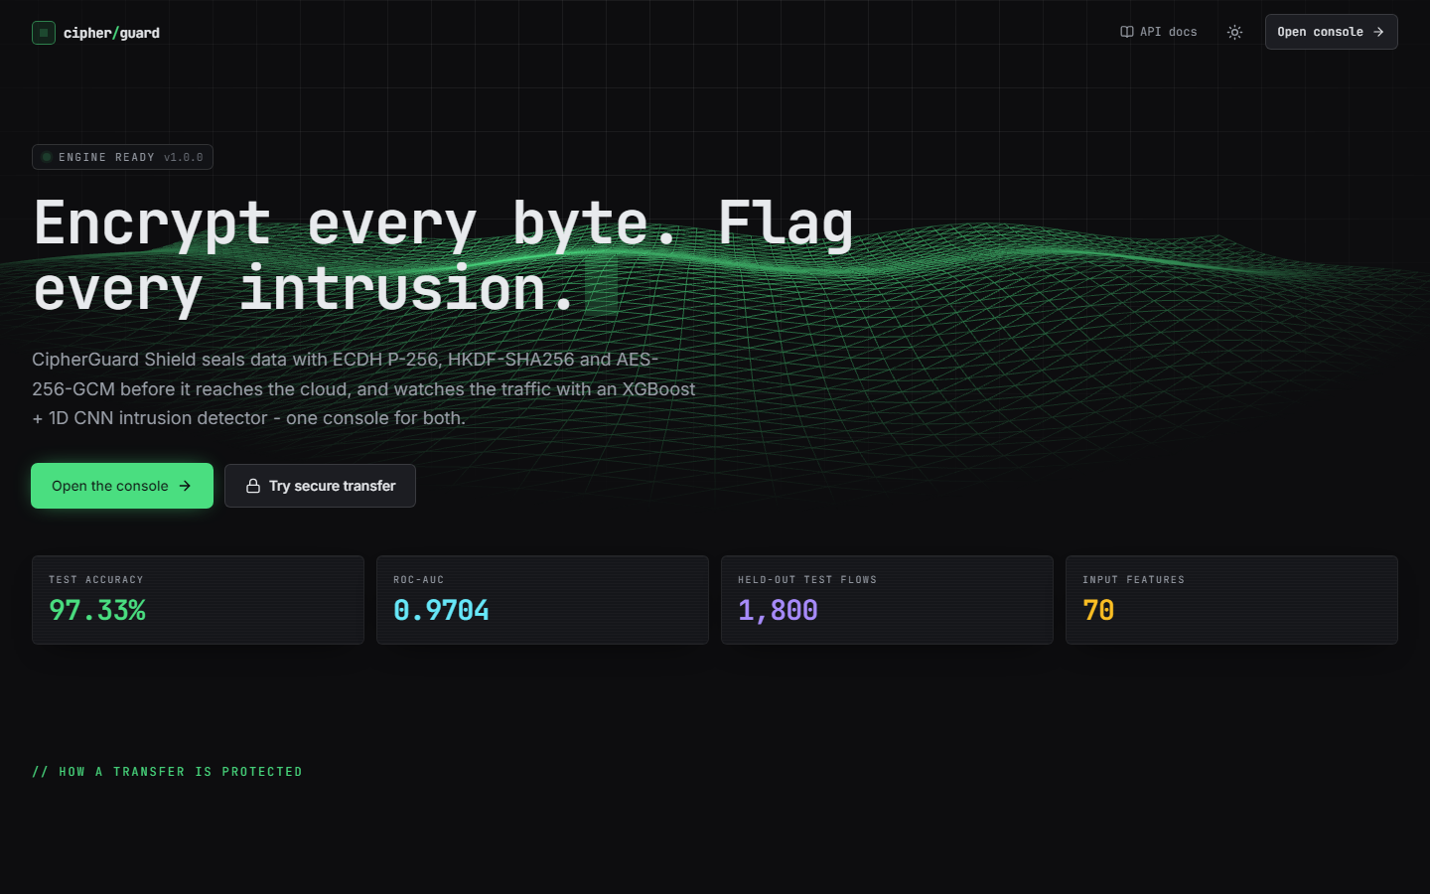
Figure 1: Output screen 1: landing page (dark theme) with live counters and a terminal that calls the real API.
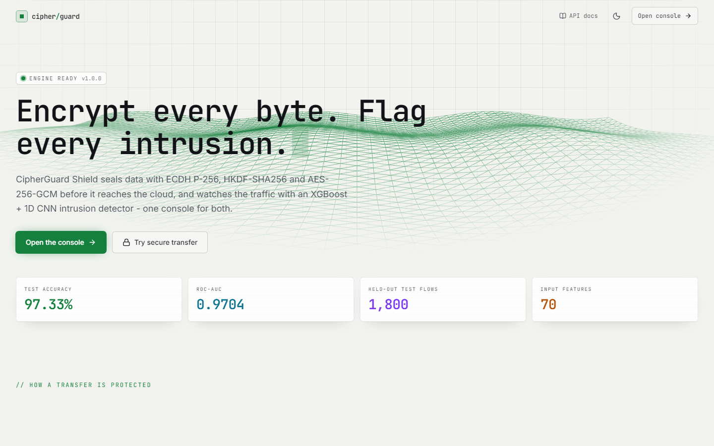
Figure 2: Output screen 2: the same landing page in the light theme; the theme is remembered in the browser.
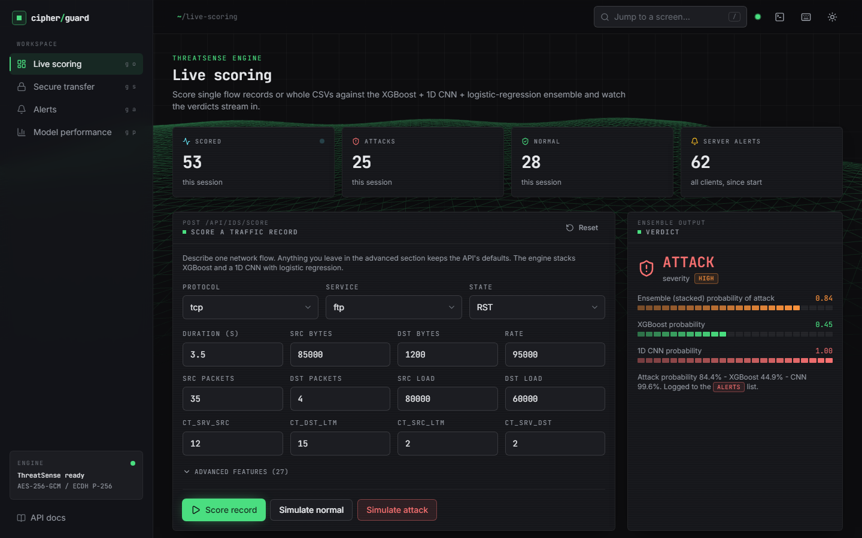
Figure 3: Output screen: live scoring. The attack preset was scored: verdict ATTACK, severity HIGH, stacked probability 0.84 (XGBoost 0.45, CNN 1.00). Counters show 53 flows scored in this session.
The live-scoring screen shows the single-record form (three selects and twelve main numeric fields; 27 more features are kept at API defaults under Advanced features), the ensemble verdict and a bar for each model. It is the clearest view of why the stacked model matters to an operator: the two base models disagree (0.45 against 1.00) and the meta-model settles on 0.84, which is still above the 0.5 threshold and in the HIGH band (0.70 to 0.85).
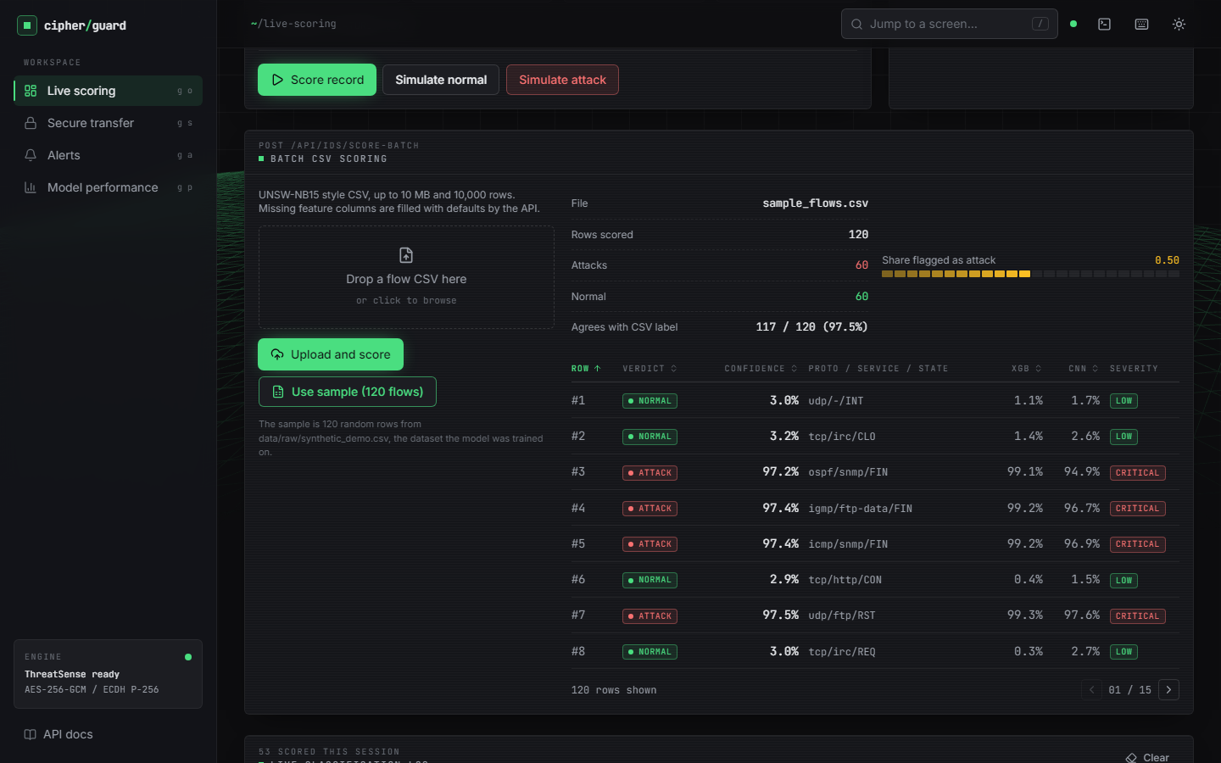
Figure 4: Output screen 4: batch CSV scoring of the bundled 120-row synthetic sample, with the share flagged as attack and per-row verdicts.
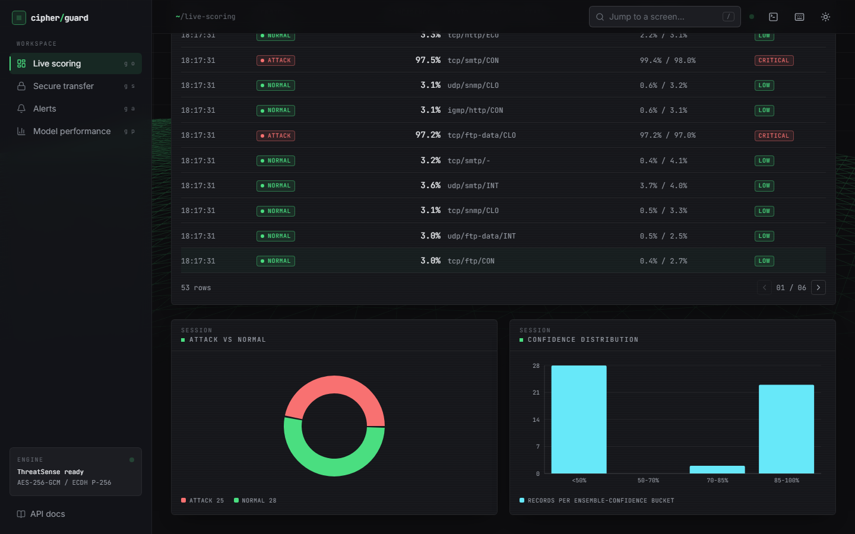
Figure 5: Output screen 5: session charts - attack versus normal and the distribution of the stacked confidence.
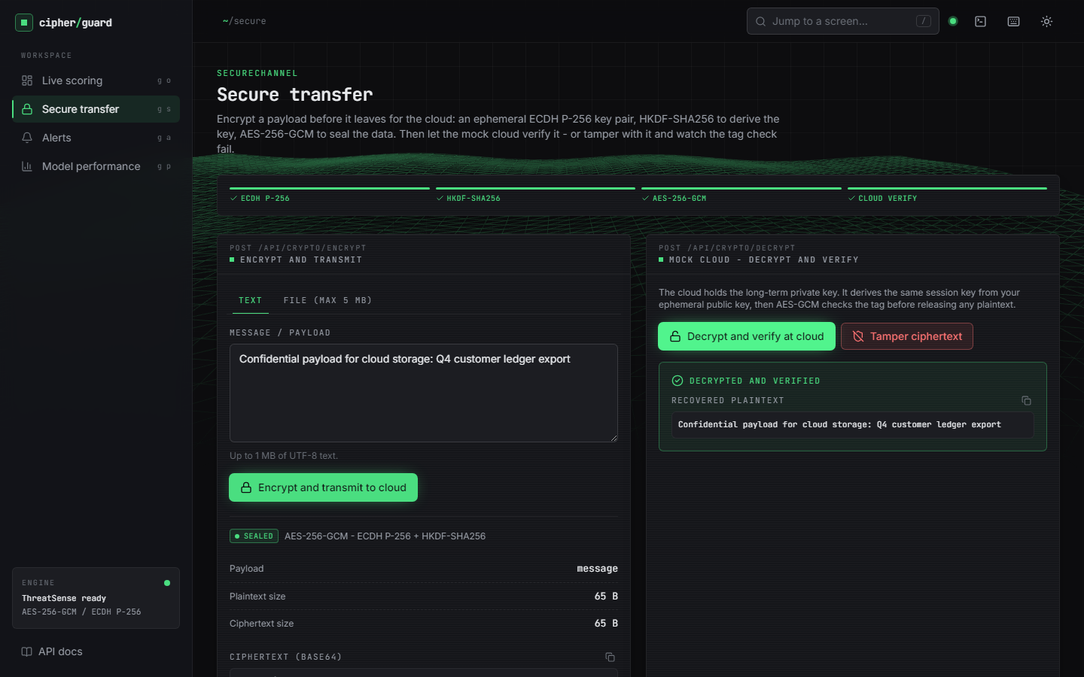
Figure 6: Output screen: secure transfer. A text payload was encrypted (ciphertext, 12-byte nonce, 16-byte tag, 65-byte ephemeral public key shown) and then decrypted and verified at the mock cloud.
The secure-transfer screen exposes the real values returned by POST /api/crypto/encrypt and /api/crypto/decrypt; nothing is simulated in the browser. The Decrypted and verified banner appears only when the API returns verified: true.
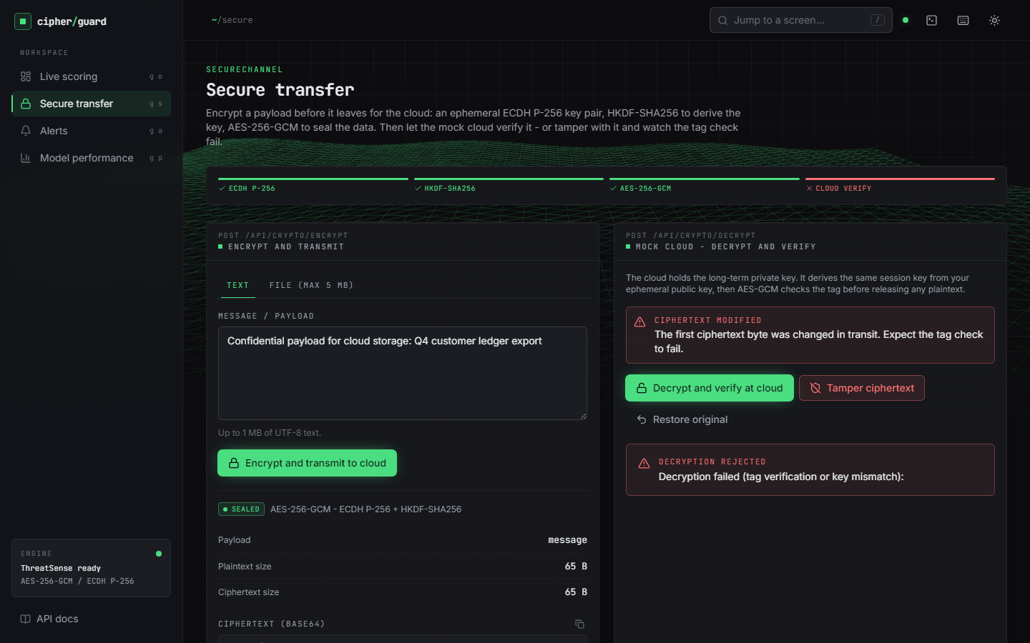
Figure 7: Output screen 7: the same envelope after Tamper ciphertext: the cloud rejects it with HTTP 400 (tag verification failed).
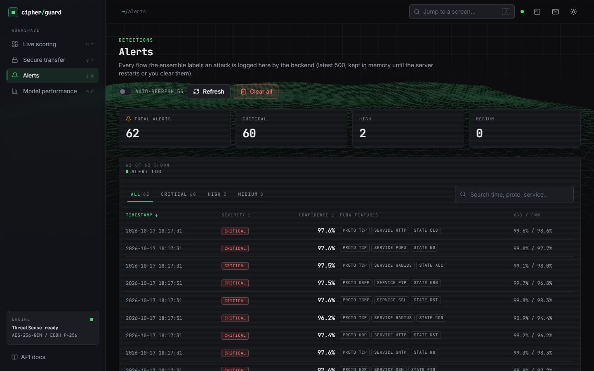
Figure 8: Output screen 8: the alerts table, filled by the batch above, with severity, confidence, key features and the two model scores.

Figure 9: Output screen: model performance of the shipped bundle - 97.33% accuracy on 1,800 synthetic test rows. The banner at the top states the data mode.
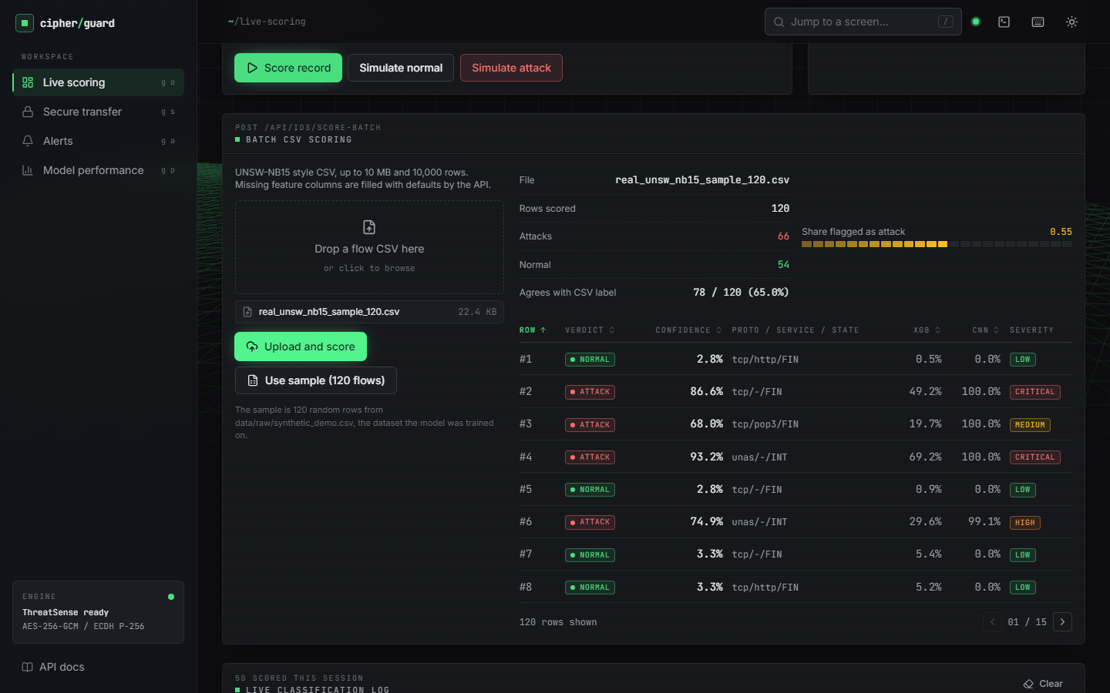
Figure 10: Output screen: 120 real UNSW-NB15 flows scored by the shipped (synthetic-trained) bundle - 66 flagged as attack and 78 of 120 verdicts (65.0%) agree with the labels in the file.

Figure 11: Output screen: model performance of the real-trained bundle served with CIPHERGUARD_MODELS_DIR - 88.79% accuracy on the 82,332-flow official test set, 192 input dimensions.
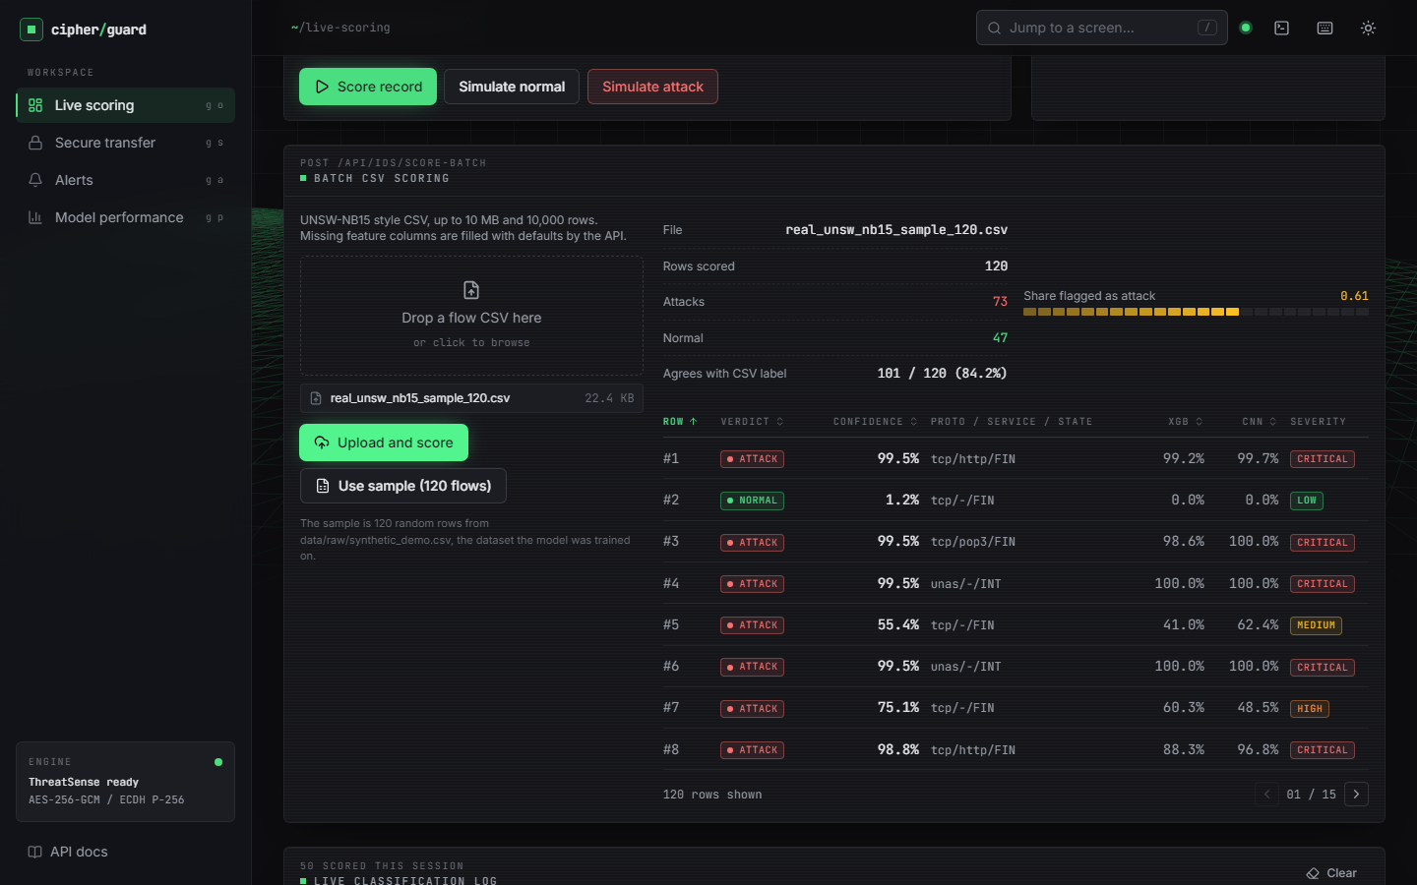
Figure 12: Output screen: the same 120 real flows scored by the real-trained bundle - 73 flagged as attack and 101 of 120 verdicts (84.2%) agree with the labels.
Screens 10 and 12 make the main finding of this chapter visible in the product itself: the same screen, the same 120 flows and the same code give 65.0% agreement with a synthetic-trained model and 84.2% with a model trained on real flows. The 120-flow sample is small, so only the direction (not the exact percentages) should be taken from it; the exact figures come from the full test set in the next sections.

1.3 Detection performance on real UNSW-NB15 traffic
This section reports the shipped model design trained on the real official training set and tested on the real official testing set (82,332 flows, 55.1% attack). The test period is later than the training period, so this is the realistic deployment question - train on the past, detect in the future - and it is harder than a random split [8].
Table 3: Detection metrics on the official testing set, mean ± standard deviation over five seeds (threshold 0.5)
Model | Accuracy | Precision | Recall | F1 | ROC-AUC | FPR
Stacked ensemble (shipped design) | 0.890 ± 0.002 | 0.844 ± 0.002 | 0.981 ± 0.001 | 0.907 ± 0.001 | 0.984 ± 0.000 | 0.222 ± 0.004
XGBoost alone | 0.910 ± 0.001 | 0.883 ± 0.001 | 0.964 ± 0.001 | 0.922 ± 0.001 | 0.985 ± 0.000 | 0.156 ± 0.001
1D CNN alone | 0.841 ± 0.004 | 0.780 ± 0.005 | 0.991 ± 0.001 | 0.873 ± 0.003 | 0.976 ± 0.002 | 0.342 ± 0.010
Mean of XGBoost and CNN | 0.888 ± 0.004 | 0.843 ± 0.007 | 0.979 ± 0.002 | 0.906 ± 0.003 | 0.983 ± 0.001 | 0.223 ± 0.011
Random forest (100 trees) | 0.859 ± 0.001 | 0.800 ± 0.001 | 0.991 ± 0.001 | 0.885 ± 0.001 | 0.982 ± 0.000 | 0.303 ± 0.003
Decision tree (depth 12) | 0.853 ± 0.009 | 0.803 ± 0.011 | 0.973 ± 0.004 | 0.880 ± 0.006 | 0.958 ± 0.006 | 0.293 ± 0.021
Logistic regression | 0.806 ± 0.000 | 0.749 ± 0.000 | 0.973 ± 0.000 | 0.846 ± 0.000 | 0.955 ± 0.000 | 0.399 ± 0.001

The headline reading is not the one the design intended. The stacked ensemble reaches 0.890 ± 0.002 accuracy and an F1 of 0.907 ± 0.001, but XGBoost alone is better on accuracy (0.910 ± 0.001), precision and false-positive rate (0.156 ± 0.001 against 0.222 ± 0.004). The 1D CNN has the highest recall (0.991 ± 0.001) but raises false alarms on 34.2% of normal flows, and the logistic-regression meta-model, fitted on a validation split from the training period, inherits much of that. Stacking beats the plain mean of the two models only marginally (0.890 ± 0.002 against 0.888 ± 0.004) and beats a decision tree, a logistic regression and a random forest, but not XGBoost. The standard deviations are small (at most 0.009), so these orderings are stable across seeds (Figure below).
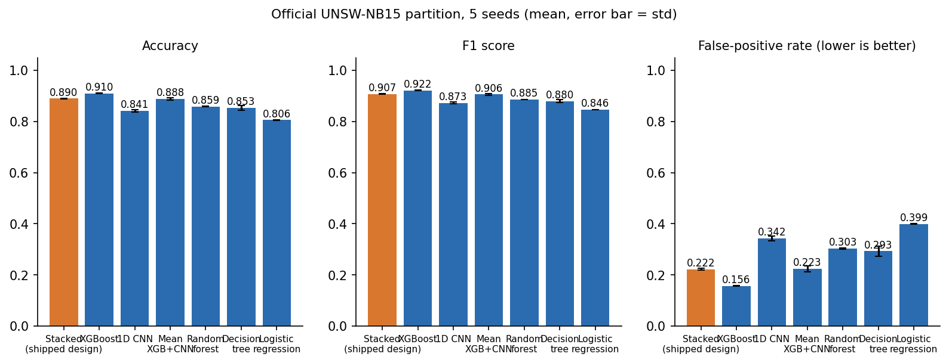
Figure 13: Accuracy, F1 and false-positive rate of the seven models on the official test set; error bars are one standard deviation over five seeds.
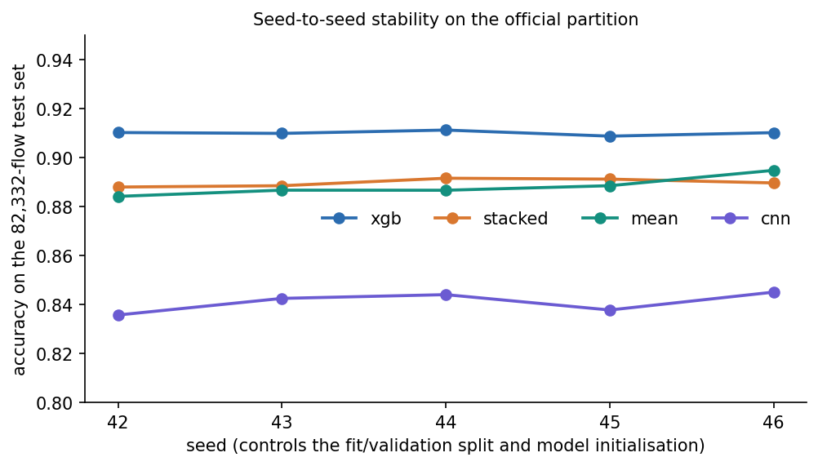
Figure 14: Test accuracy of four models for each of the five seeds; the seed changes the fit/validation split and the initialisation.

1.3.1 Confusion matrices
For seed 42 the stacked model's confusion matrix is [[28,646 true negatives, 8,354 false positives], [877 false negatives, 44,455 true positives]]: accuracy 0.8879, precision 0.8418, recall 0.9807, F1 0.9059, ROC-AUC 0.9839, false-positive rate 0.2258, false-negative rate 0.0193 and a Matthews correlation of 0.783. The error is lopsided: the system misses few attacks but raises many false alarms.
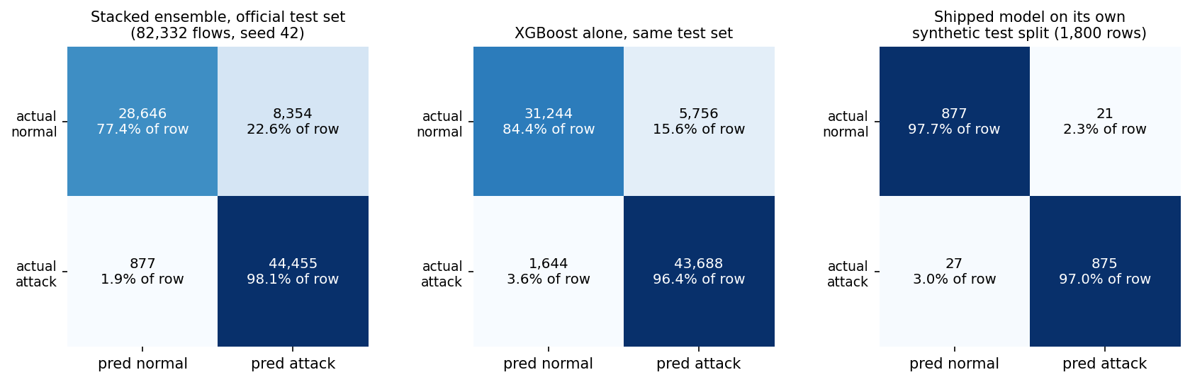
Figure 15: Confusion matrices: the stacked model and XGBoost on the official test set (seed 42), and the shipped model on its own synthetic test split.

1.3.2 ROC curves
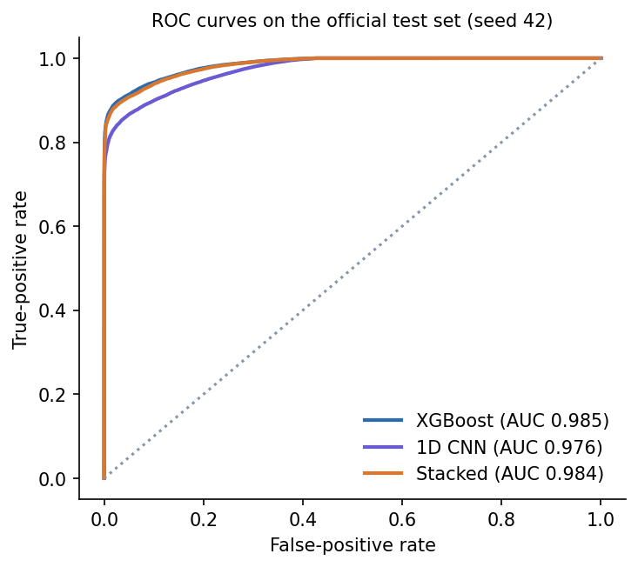
Figure 16: ROC curves of the two base models and the stacked model on the official test set (seed 42).
The three curves are close: ranking quality is high for all of them (AUC 0.976 to 0.985), and the differences in accuracy at threshold 0.5 are mostly calibration differences, not ranking differences. That is why the threshold analysis below matters.

1.3.3 Threshold analysis
Table 4: Stacked model on the official test set (seed 42) at different thresholds
Threshold | Accuracy | Precision | Recall | F1 | FPR
0.10 | 0.8157 | 0.7494 | 0.9995 | 0.8566 | 0.4095
0.30 | 0.8573 | 0.7979 | 0.9922 | 0.8845 | 0.3078
0.50 | 0.8879 | 0.8418 | 0.9807 | 0.9059 | 0.2258
0.70 | 0.9058 | 0.8761 | 0.9655 | 0.9186 | 0.1673
0.80 | 0.9135 | 0.8950 | 0.9550 | 0.9240 | 0.1372
0.90 | 0.9214 | 0.9224 | 0.9360 | 0.9292 | 0.0965
0.95 | 0.9253 | 0.9488 | 0.9135 | 0.9308 | 0.0604

Raising the threshold from the shipped 0.5 to 0.9 lifts accuracy from 0.8879 to 0.9214 and cuts the false-positive rate from 0.2258 to 0.0965, at the price of recall falling from 0.9807 to 0.9360. The best F1 on this sweep is 0.9308 at threshold 0.95. The sweep was run on the test set, so it shows the trade-off the operator can choose; it is not a tuned result, and a deployment would pick the threshold on a validation set.
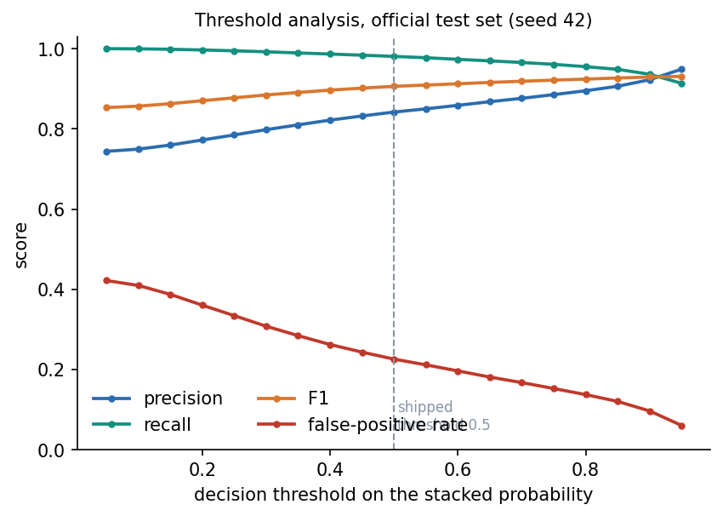
Figure 17: Precision, recall, F1 and false-positive rate of the stacked model against the decision threshold (official test set, seed 42).

1.3.4 Results by traffic category
Table 5: Stacked model by category on the official test set (seed 42, threshold 0.5)
Category | Flows | Handled correctly | Share
Normal (passed) | 37,000 | 28,646 | 77.4%
Fuzzers | 6,062 | 5,257 | 86.7%
Analysis | 677 | 665 | 98.2%
Shellcode | 378 | 375 | 99.2%
Exploits | 11,132 | 11,083 | 99.6%
Reconnaissance | 3,496 | 3,492 | 99.9%
DoS | 4,089 | 4,086 | 99.9%
Generic | 18,871 | 18,870 | 100.0%
Backdoor | 583 | 583 | 100.0%
Worms | 44 | 44 | 100.0%

Eight of the nine attack categories are detected at 98% or better; the ninth is Fuzzers (86.7% detected, 805 of 6,062 missed). The weak class is normal traffic: only 77.4% of the 37,000 normal flows pass, so 22.6% raise a false alarm. Rare classes (Worms, 44 flows; Shellcode, 378) are detected, but their small counts make the percentages uncertain.
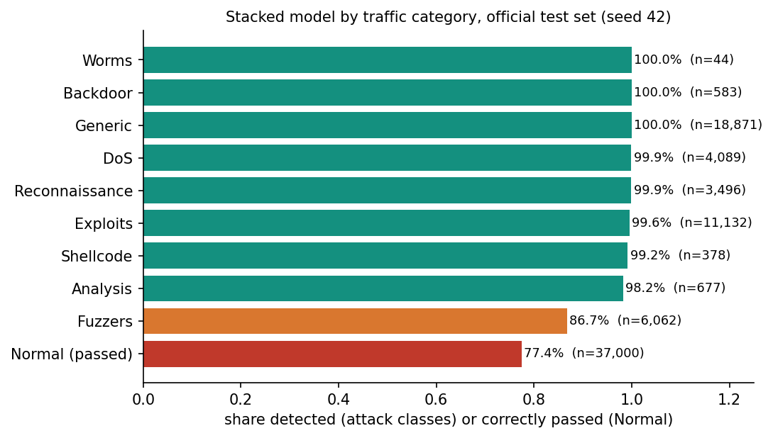
Figure 18: Share of each category handled correctly by the stacked model (attack classes: detected; Normal: correctly passed).

1.3.5 What the model relies on
The five most important XGBoost features by gain are sttl, swin, ct_srv_dst, ct_state_ttl, ct_dst_sport_ltm. sttl (the source time-to-live) has a gain of 2,725, about 16 times that of the second feature. A time-to-live that separates attack from normal flows so cleanly is a property of how the UNSW-NB15 testbed generated its traffic rather than of attacks in general, so part of the accuracy above would not carry over to another network.
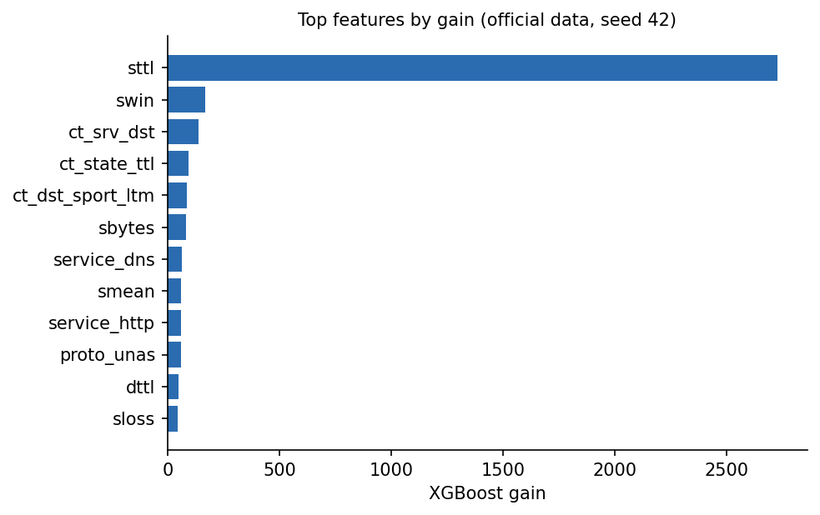
Figure 19: The twelve features with the largest XGBoost gain on the official data (seed 42).

1.4 Detection performance under the base paper's protocol
To make a comparison with the base paper [1] possible, the experiment was repeated in the paper's style: 9,000 flows, balanced at 4,500 per class, a stratified 70/15/15 split (here 6,300 / 1,350 / 1,350) and 10 repetitions with different seeds. The sample was drawn from the official training set; the paper does not say which 9,000 flows it used.
Table 6: Detection metrics under the base-paper-style protocol, mean ± standard deviation over ten repetitions
Model | Accuracy | Precision | Recall | F1 | ROC-AUC | FPR
Stacked ensemble (shipped design) | 0.938 ± 0.007 | 0.934 ± 0.012 | 0.944 ± 0.009 | 0.939 ± 0.007 | 0.988 ± 0.002 | 0.067 ± 0.013
XGBoost alone | 0.939 ± 0.007 | 0.938 ± 0.012 | 0.939 ± 0.007 | 0.939 ± 0.007 | 0.989 ± 0.002 | 0.062 ± 0.013
1D CNN alone | 0.904 ± 0.010 | 0.865 ± 0.033 | 0.960 ± 0.036 | 0.909 ± 0.008 | 0.977 ± 0.003 | 0.153 ± 0.045
Mean of XGBoost and CNN | 0.936 ± 0.008 | 0.922 ± 0.016 | 0.953 ± 0.005 | 0.937 ± 0.007 | 0.988 ± 0.002 | 0.081 ± 0.019
Random forest (100 trees) | 0.939 ± 0.008 | 0.938 ± 0.011 | 0.941 ± 0.008 | 0.939 ± 0.008 | 0.989 ± 0.002 | 0.063 ± 0.011
Decision tree (depth 12) | 0.926 ± 0.006 | 0.931 ± 0.013 | 0.921 ± 0.011 | 0.926 ± 0.006 | 0.955 ± 0.009 | 0.068 ± 0.015
Logistic regression | 0.908 ± 0.009 | 0.870 ± 0.016 | 0.961 ± 0.007 | 0.913 ± 0.008 | 0.979 ± 0.003 | 0.144 ± 0.020

On a random balanced subset the picture is different from the temporal split: the stacked model scores 0.938 ± 0.007, XGBoost 0.939 ± 0.007 and the random forest 0.939 ± 0.008, all within one standard deviation of each other, while the CNN alone is clearly lower (0.904 ± 0.010). Stacking therefore brings no measurable gain over XGBoost here either. False-positive rates (0.067 ± 0.013 for the stack) are far lower than on the official partition, because the test flows come from the same period as the training flows.
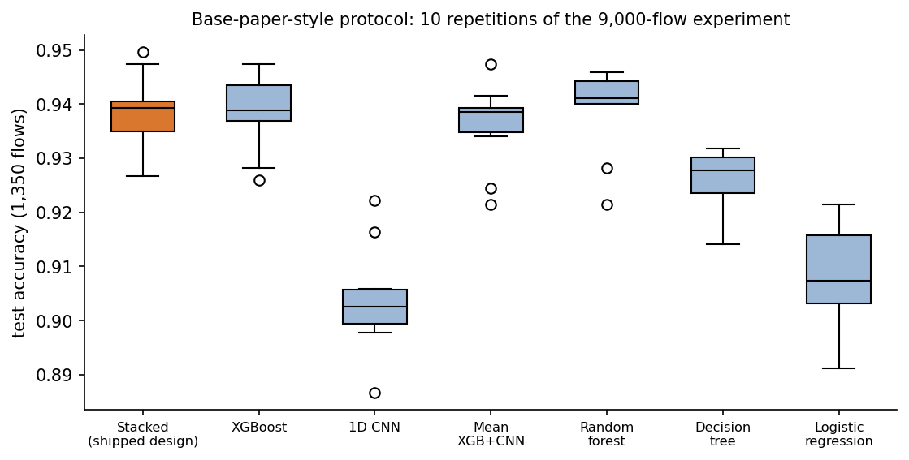
Figure 20: Test accuracy of the seven models over the ten repetitions of the base-paper-style protocol.

1.5 The shipped model on synthetic data: why 97.33% is not evidence
The bundle that the application loads by default, and whose numbers the Model performance screen shows, was trained on 12,000 synthetic rows. On its own 1,800-row test split it reaches accuracy 0.9733, precision 0.9766, recall 0.9701, F1 0.9733 and ROC-AUC 0.9704; XGBoost alone (0.9733) and the CNN alone (0.9733) score exactly the same. Three different models agreeing to four decimals is a sign that the task, as generated, is almost perfectly separable: the generator draws attack and normal flows from different distributions, and the only unavoidable error is the 2.5% label noise (300 of 12,000 rows), which caps accuracy at 0.975 if the clean classes were separable. On a fresh synthetic sample (seed 7, 6,000 rows) the same model scores 0.9750, right at that cap.
Table 7: The same models on different data
Models trained on | Tested on | Rows | Accuracy | F1 | ROC-AUC
Synthetic data (shipped) | Its own synthetic test split | 1,800 | 0.9733 | 0.9733 | 0.9704
Synthetic data (shipped) | Fresh synthetic data (seed 7) | 6,000 | 0.9750 | 0.9750 | 0.9749
Synthetic data (shipped) | Real official test set | 82,332 | 0.6603 | 0.6917 | 0.6567
Real official training set | Real official test set (5-seed mean) | 82,332 | 0.8897 | 0.9073 | 0.9843
Real official training set | Synthetic demo CSV | 12,000 | 0.3733 | 0.3557 | 0.3394

Scored on the 82,332 real test flows, the shipped model reaches an accuracy of 0.660 and a ROC-AUC of 0.657, with a Matthews correlation of 0.313: barely better than guessing; it flags 55.1% of the flows as attacks although the true share is 55.1%, and its XGBoost part alone is at 0.589. In the other direction, a model trained on real flows scores 0.373 on the synthetic CSV, below chance, because the generator's distributions differ from, and in places invert, the patterns of real traffic. The 97.33% on the Model performance screen is therefore a property of the generator, not a statement about intrusion detection, and the console says so in its data-mode banner.
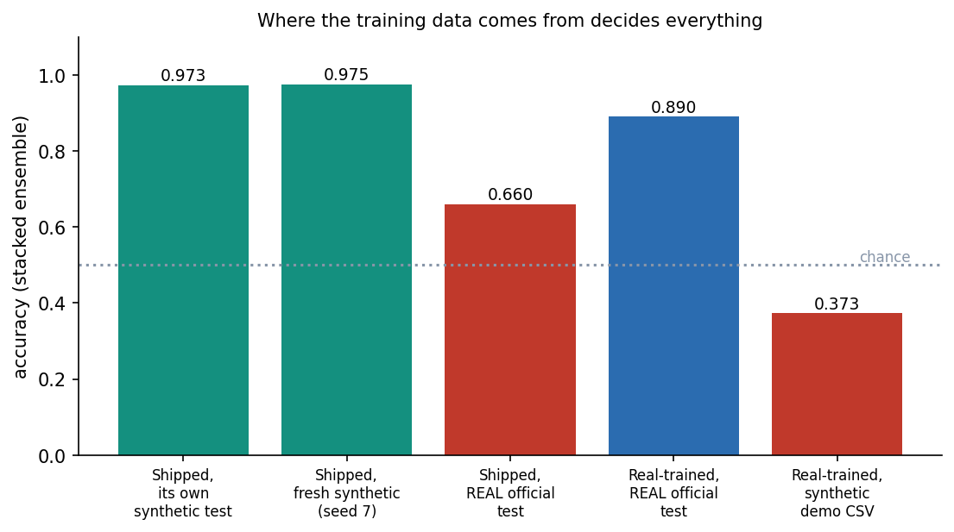
Figure 21: Accuracy of the stacked ensemble for each combination of training data and test data.

1.6 Cryptographic performance and integrity
scripts/benchmark_crypto.py times the product's SecureChannel and two baselines on the same machine: raw AES-256-GCM (no key exchange) and a classical hybrid in which a fresh AES-256-GCM key is wrapped with RSA-OAEP (SHA-256) for a 2048-bit and a 3072-bit key [16]. SecureChannel timings include an ephemeral P-256 key pair, ECDH, HKDF-SHA256 and the base64 conversion that the HTTP API needs; the RSA and AES-only timings do not include base64.
Table 8: Median time in milliseconds (encrypt / decrypt) by payload size
Payload | SecureChannel (ECDH + HKDF + AES-GCM) | AES-256-GCM only | RSA-2048-OAEP + AES-GCM | RSA-3072-OAEP + AES-GCM
1 KB | 0.122 / 0.104 | 0.008 / 0.008 | 0.029 / 0.449 | 0.044 / 1.351
10 KB | 0.145 / 0.116 | 0.009 / 0.009 | 0.032 / 0.443 | 0.046 / 1.458
100 KB | 0.510 / 0.302 | 0.026 / 0.026 | 0.050 / 0.471 | 0.065 / 1.442
1 MB | 4.263 / 2.990 | 0.787 / 0.797 | 0.811 / 1.230 | 0.970 / 2.236
5 MB | 21.387 / 14.213 | 3.895 / 3.327 | 3.774 / 3.695 | 3.806 / 4.699

For payloads up to 100 KB, SecureChannel encrypts in 0.12 to 0.51 ms and decrypts in 0.10 to 0.30 ms. At 1 KB, RSA-2048 wraps a key faster (0.029 ms against 0.122 ms) because encryption with the small public exponent is cheap, but the cloud-side unwrap is dearer (0.449 ms for RSA-2048 and 1.351 ms for RSA-3072 against 0.104 ms), which matters because the cloud serves many senders. For large payloads the bulk cipher dominates and the base64 step makes SecureChannel the slowest option (5 MB: 21.4 ms to encrypt, about 234 MB/s, against 3.9 ms for raw AES-GCM). Key set-up is small: an ephemeral P-256 key pair takes 24 microseconds and ECDH plus HKDF 53 microseconds, whereas a one-time RSA-2048 key pair took 68 ms and an RSA-3072 pair 104 ms (single samples).
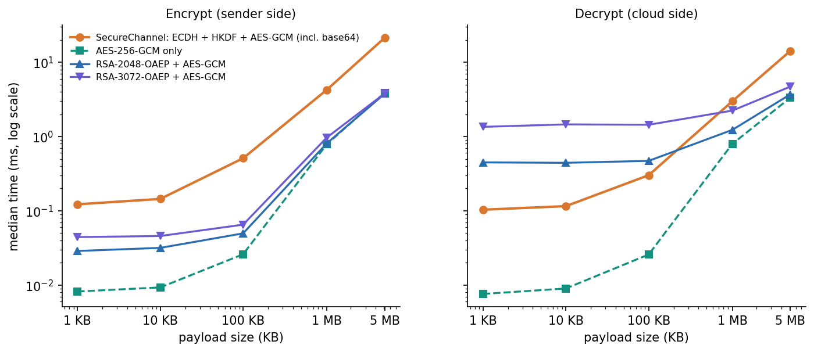
Figure 22: Median encryption and decryption time against payload size for SecureChannel, raw AES-256-GCM and two RSA-OAEP hybrids (log-log axes).
Table 9: Integrity and uniqueness tests (scripts/benchmark_crypto.py)
Case | Trials | Behaved as expected | All
Untouched message accepted | 1,000 | 1,000 | yes
Ciphertext bit flipped | 1,000 | 1,000 | yes
Tag bit flipped | 1,000 | 1,000 | yes
Nonce bit flipped | 1,000 | 1,000 | yes
Ciphertext truncated by one byte | 1,000 | 1,000 | yes
Decrypted with another party's key | 1,000 | 1,000 | yes

Every tamper case was rejected in all 1,000 trials (flipping a bit in the ciphertext, tag or nonce, truncating the ciphertext by one byte, or decrypting with another party's key), and an untouched message was accepted every time. 20,000 encryptions of one plaintext produced 20,000 distinct nonces and 20,000 distinct ciphertexts, so identical messages are unlinkable. The wire overhead is fixed at 93 bytes (12-byte nonce, 16-byte tag and 65-byte ephemeral public key), i.e. 9.1% of a 1 KB message, 0.09% of 100 KB and 0.0089% of 1 MB, before the 33% that base64 adds in the JSON API.

1.7 The combined overhead of encryption and detection
The literature survey named a gap: cryptography and intrusion detection are treated as separate concerns, and the combined overhead of running both on one transmission path is not measured. scripts/measure_pipeline.py measures it in two ways: in process against the shipped models (200 repetitions) and through the HTTP API on 127.0.0.1 (30 to 100 repetitions).
Table 10: In-process timings (milliseconds)
Operation | Median | 95th percentile
IDS scoring of one flow (in process) | 3.92 | 4.33
Encrypt 100 KB (in process) | 0.54 | 0.67
Decrypt 100 KB (in process) | 0.38 | 0.51
Protected transfer: score + encrypt + decrypt (in process) | 5.67 | 7.35
Batch scoring, 120 rows (in process) | 5.7 | 6.1
Batch scoring, 1,000 rows (in process) | 16.6 | 17.7

One protected transfer of a 100 KB payload costs 5.67 ms end to end. Scoring the flow takes 81% of the combined cost, encryption 11% and decryption 8% (shares of the three component medians). The security layer that adds most latency is therefore the detector, not the cipher; the cipher is cheap enough to be left on for every message. The one-time engine load took 112 ms.
Table 11: HTTP API latency on 127.0.0.1 (milliseconds)
Request | Median | 95th percentile
GET /api/health | 0.78 | 1.15
POST /api/ids/score | 5.47 | 6.01
POST /api/crypto/encrypt (1 KB text) | 1.20 | 1.38
POST /api/crypto/decrypt (1 KB text) | 0.91 | 1.09
POST /api/ids/score-batch (120 rows) | 19.02 | 19.68
POST /api/crypto/encrypt-file (1 MB) | 17.23 | 38.54
score + encrypt + decrypt, three HTTP calls (1 KB) | 8.11 | 8.86

Through the API, the three calls of a protected 1 KB transfer take 8.1 ms in total. The measurements were made against 127.0.0.1 because on this machine a request to localhost adds about two seconds of name-resolution fallback. Real network round trips to a cloud provider, TLS and concurrent users are not included; they are not part of what was measured.
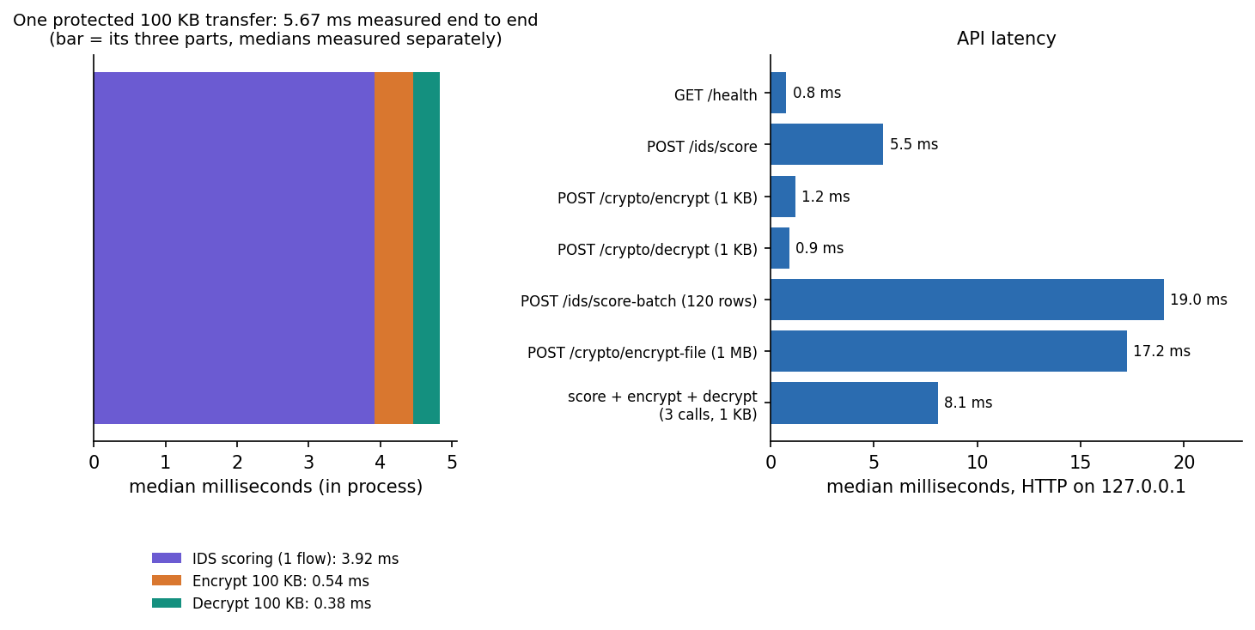
Figure 23: Left: the parts of one protected 100 KB transfer. Right: median latency of the API requests.

1.8 Comparison with the base paper
The base paper [1] fuses a quantum-inspired network and LeNet with a double-sigmoid score-level fusion (DSMMN-SLF) for detection and encrypts data with an enhanced elliptic-curve scheme (EECC). It evaluates on 9,000 balanced UNSW-NB15 samples with a 70/15/15 split and 10 runs. This project uses neither the quantum-inspired network nor EECC; it uses XGBoost, a 1D CNN and logistic-regression stacking for detection, and standard ECDH + AES-GCM for encryption.
Table 12: Reported and measured detection results
Model / setting | Accuracy | Precision | FPR | Status
Proposed model (FLPF-EVD-QNN + LeNet, DSMMN fusion) | 0.9487 (Table 2 mean); 0.9564 (ablation, TD 80%) | 0.97 at TD 90% | 0.03 | Base paper, as reported
Best re-implemented baseline in the paper (SqueezeNet) | 0.9354 | not stated | not stated | Base paper, as reported
Weakest baseline in the paper (Bi-LSTM) | 0.8993 | not stated | not stated | Base paper, as reported
This project: stacked ensemble (paper-style protocol) | 0.9383 ± 0.0071 | 0.9338 ± 0.0121 | 0.067 ± 0.013 | Measured, 10 runs
This project: XGBoost alone (paper-style protocol) | 0.9386 ± 0.0070 | 0.9380 ± 0.0119 | 0.062 ± 0.013 | Measured, 10 runs
This project: stacked ensemble (official partition) | 0.8897 ± 0.0016 | 0.8442 ± 0.0021 | 0.222 ± 0.004 | Measured, 5 seeds, temporal split
This project: shipped model as delivered | 0.9733 | 0.9766 | 0.023 | Synthetic data - not comparable

Under a comparable protocol the stacked ensemble reaches 0.9383 ± 0.0071: about one point below the paper's proposed model (0.9487), 3.6 points below its quoted precision of 0.97, and slightly above the strongest baseline the paper re-implemented (0.9354). The comparison is indicative only: the paper does not publish which 9,000 flows it sampled, the hyper-parameters of its baselines, or its test fraction; our flows come from the official training file; and the paper's own numbers vary by table (0.9564 in the ablation, 0.9487 in the statistical table). On the harder official partition the stacked ensemble falls to 0.890, a figure the paper does not report. Encryption cannot be compared at all: the paper reports 0.39 s to encrypt and 0.26 s to decrypt for its EECC without stating the data size or hardware, whereas SecureChannel takes about 0.1 ms for 1 KB on a desktop CPU; the two numbers answer different questions. The paper's attack analysis (key-breaking time, correlation) is not reproduced here; the only security evidence in this project is the tamper and uniqueness tests of Section 8.6 and the standard security properties of the primitives.
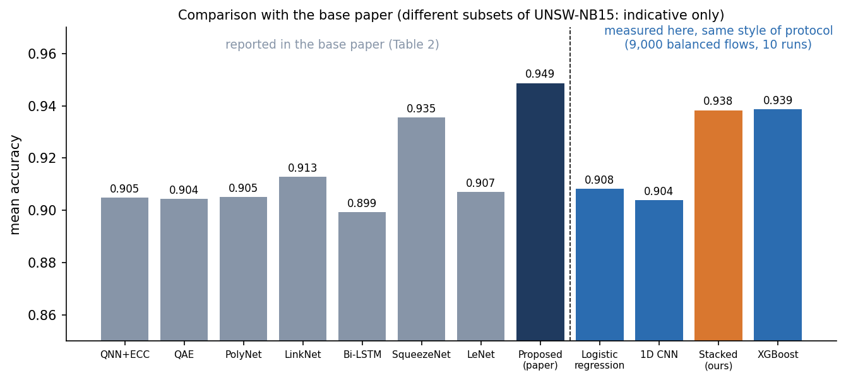
Figure 24: Mean accuracy reported in the base paper (Table 2) next to the values measured here; the datasets differ, so the bars are indicative only.

1.9 Sample inputs and outputs
The following requests and responses were produced by the running API with the shipped bundle (docs/metrics/sample_io.json); long base64 strings are shortened with an ellipsis.

1.9.1 Scoring one flow
POST /api/ids/score
{
"proto": "tcp",
"service": "ftp",
"state": "RST",
"dur": 3.5,
"sbytes": 85000,
"dbytes": 1200,
"rate": 95000,
"spkts": 35,
"dpkts": 4,
"ct_srv_src": 12,
"ct_dst_ltm": 15
}

200 OK
{
"label": "attack",
"confidence": 0.844,
"severity": "high",
"xgb_score": 0.4486,
"cnn_score": 0.9963
}

The flow (large upload on FTP, reset state) is flagged as an attack with severity high: the stacked probability is 0.84, from XGBoost 0.45 and the CNN 1.00. An alert object with the timestamp and key features is also returned and appended to the alert log.
POST /api/ids/score (the normal preset: an ordinary web flow)
200 OK
{
"label": "normal",
"confidence": 0.458,
"severity": "low",
"xgb_score": 0.0338,
"cnn_score": 0.9142
}

The ordinary web flow is passed as normal with severity low, but note how far the models disagree: XGBoost gives 0.034 while the CNN gives 0.91; the meta-model settles on 0.46, just under the 0.5 threshold. A borderline verdict like this is the kind that produces false alarms when the data change.

1.9.2 Encrypting and decrypting
POST /api/crypto/encrypt
{
"plaintext": "Quarterly payroll export - confidential"
}
200 OK
{
"ciphertext": "2mSrflJYn6ItVT1wMqGEQoqGxydD...",
"nonce": "/bE1BSizpoUG59kq",
"tag": "Dcl1xvdC57l+8SrIR1tT5g==",
"ephemeral_public": "BFxP6HV3qRUuxqORG4YMYp9hZ5sY...",
"algorithm": "AES-256-GCM",
"key_exchange": "ECDH P-256 + HKDF-SHA256"
}

POST /api/crypto/decrypt (the four fields above, in full)
200 OK
{
"plaintext": "Quarterly payroll export - confidential",
"verified": true
}

-- after flipping one bit of the ciphertext --
400 Bad Request
{
"detail": "Decryption failed (tag verification or key mismatch): "
}

The envelope holds a 39-byte ciphertext (the plaintext has 39 characters), a 12-byte nonce, a 16-byte tag and a 65-byte uncompressed ephemeral public key. Decrypting returns the plaintext with verified: true; changing a single bit of the ciphertext makes the API answer 400, and no plaintext is released. An empty plaintext is refused with 400 ("Plaintext cannot be empty").

1.10 Success and failure analysis

1.10.1 What worked
• Authenticated encryption behaved exactly as specified. All six tamper and wrong-key cases were rejected 1,000 times out of 1,000 and nonces never repeated in 20,000 encryptions; 26 of 26 automated tests and 15 of 15 smoke checks passed.
• The detector ranks real traffic well. ROC-AUC is 0.984 ± 0.000 on the temporally shifted official test set, recall is 98.1%, and every one of the nine attack categories is detected at 86% or better.
• The combined layer is cheap. A protected transfer of 100 KB costs 5.7 ms in process.
• The console tells the truth about its data. The data-mode banner and the real-flow screens (10 to 12) show the difference between synthetic and real training data to anyone using the product.

1.10.2 What did not work
• False alarms. At the shipped threshold the stacked model flags 22.6% of normal flows (8,354 of 37,000 in the seed-42 run). With about half of real traffic being attacks in this dataset that is tolerable for a benchmark; in a network where attacks are rare it would bury operators in alerts. Raising the threshold to 0.9 reduces the false-positive rate to 9.6% at the price of 6.4% missed attacks.
• Fuzzers. 13.3% of Fuzzers flows (805 of 6,062) are missed; they resemble normal traffic in the 42 features.
• Stacking did not help. The meta-model is fitted on a validation split from the training period; on the later test period it is no better than XGBoost alone, and the CNN adds false alarms. The extra model costs 246 s of CNN training on the CPU (XGBoost: 4 s) for no measured gain.
• Domain shift. The shipped model trained on synthetic data scores 0.660 on real flows. Any retraining on another network would face the same risk in milder form, because UNSW-NB15 is a laboratory capture.
• Reliance on `sttl`. One feature carries most of the importance. A deployment in which the time-to-live distribution differs would lose accuracy without any attack changing.

1.10.3 Edge cases handled
The API refuses empty text, payloads over 1 MB, files over 5 MB, CSV files over 10 MB or 10,000 rows, non-CSV uploads, malformed base64, a missing ephemeral key and any tag mismatch, each with a status code and a message; unseen protocol, service or state values are ignored by the one-hot encoder and do not crash scoring (tested). Missing numeric features take the API's defaults, which silently makes a partial record look like an average flow: this is convenient for the demo and a limitation for any real use.

1.11 Limitations of the evaluation
• The detection results use one public dataset captured in one laboratory; no result was checked on another network or on traffic captured by the project team.
• The threshold sweep and the per-category table come from one seed and from the test set; they describe the trade-off but are not tuned results.
• Five seeds and ten repetitions give a spread but not a significance test; paired tests were not run.
• The base-paper comparison cannot be exact (unpublished subset and hyper-parameters) and says nothing about EECC or the quantum-inspired network, which were not implemented.
• Timing was measured on one shared desktop-class machine, in process and on the loopback interface; no network, TLS, concurrency, memory or energy measurement was made.
• The IDS was not tested against adversarial or evasive traffic, and the console was tested in Chrome only. The Docker image and the TensorFlow code path were not exercised.

1.12 Objectives versus outcomes
Table 13: The six batch objectives and what the measurements show
# | Objective | Outcome
1 | Hybrid AES + RSA encryption | Partly met by substitution. A hybrid asymmetric-plus-symmetric scheme is implemented with ECDH P-256 + HKDF-SHA256 + AES-256-GCM; RSA-OAEP + AES-GCM was implemented only as a benchmark baseline (Section 8.6).
2 | Secure key generation, distribution and storage | Generation and distribution met (a fresh ephemeral key per message, HKDF-derived 256-bit key, public key carried in the envelope). Storage not met: the cloud key pair exists only in process memory.
3 | Encrypt before upload, decrypt after download | Met against a mock cloud: text and file encryption, decrypt-and-verify, tamper rejection. No real cloud provider or upload.
4 | Classifier on a benchmark intrusion dataset | Met in the experiments: real UNSW-NB15, stacked 0.890 ± 0.002, XGBoost 0.910 ± 0.001 on the official partition. The shipped default model is trained on synthetic data.
5 | Flag and log suspicious sessions during transfer | Partly met: flows are scored and attacks are logged with severity in a 500-entry in-memory list; detection is not tied to a specific transfer and nothing is blocked automatically.
6 | Evaluate enc/dec time, throughput overhead and detection accuracy | Met: latency by size and algorithm, throughput, a combined per-transfer overhead of 5.7 ms, and detection metrics with seeds, thresholds and categories.

Taken together the results support a measured, partly positive conclusion: the encryption layer meets its specification and is cheap; the detection layer works on real traffic with a high ranking quality but a false-alarm rate that needs a higher threshold; the added complexity of stacking is not justified by the data; and the number the product shows by default describes its synthetic generator, not the world.

