RESQAI: AI-BASED ACCIDENT DETECTION, SEVERITY ASSESSMENT AND INTELLIGENT EMERGENCY RESPONSE SYSTEM
Results
Department of Computer Science and Engineering, TKR College of Engineering & Technology
Batch A2 (CSE-A) · Academic year [ACADEMIC YEAR]
Table 1: Project team
S.No. | Student name | Roll number
1 | Adepu Meenakshi | 23K91A0503
2 | Ayila Shanmukha Sai | 23K91A0521
3 | Chekka Chandrashekhar | 23K91A0552
4 | Avula Sreeya | 23K91A0519

Project guide: Shirisha Reddy
Chapter and section numbers quoted in the text (for example Chapter 8 or Section 6.2) refer to the full project report, 17.Final Document. Figures and tables in this document are numbered from 1.

1. RESULTS AND OUTPUT SCREENS

1.1 Experimental Set-up
All model results in this chapter are measured on 2,400 held-out events: the 20 % split of 12,000 synthetic sensor events that train_models.py generates with seed 42 and splits with a stratified random split. The test part holds 1,463 normal-driving, 460 harsh-braking, 233 minor-crash, 156 moderate-crash and 88 severe-crash events, that is 477 accidents (19.9%) and 1,923 non-accidents. The shipped models in models/*.pkl are evaluated, and a fresh retraining with the same seed is compared with them. The measurements ran with Python 3.11.9, scikit-learn 1.5.0, numpy 1.26.4 and pandas 2.2.1, on one Intel Core i5-12500 with 15.7 GB of RAM and no GPU. The pickles were written by scikit-learn 1.9.0 and loaded by 1.5.0; the retrained models agree with them on 100.00% of the detector decisions and 100.00% of the severity decisions, so the version difference does not change a single answer.
The word 'real' in this chapter means that the number was measured by running the code; it does not mean that the data are real. There is no dataset of smartphone recordings of crashes in this project. The events are drawn from hand-written distributions that imitate normal driving, harsh braking and three grades of impact (Chapter 6), and the test events come from the same distributions as the training events. The scores that follow therefore measure how well the forests learn the generator, and they are an upper bound on what any real recording could achieve.

1.2 Output Screens
The screens below were captured from the running application with a Playwright script (Chrome, 1440 by 900 pixels, Flask backend on port 8302, React front end on port 5302, demo account). Every result on them was produced by the real models: the readings come from the built-in simulator, which stands in for the phone, and the position is supplied by the browser (set to a point in Banjara Hills, Hyderabad, for the capture). Nothing was edited after capture.

1.2.1 Landing and sign-in
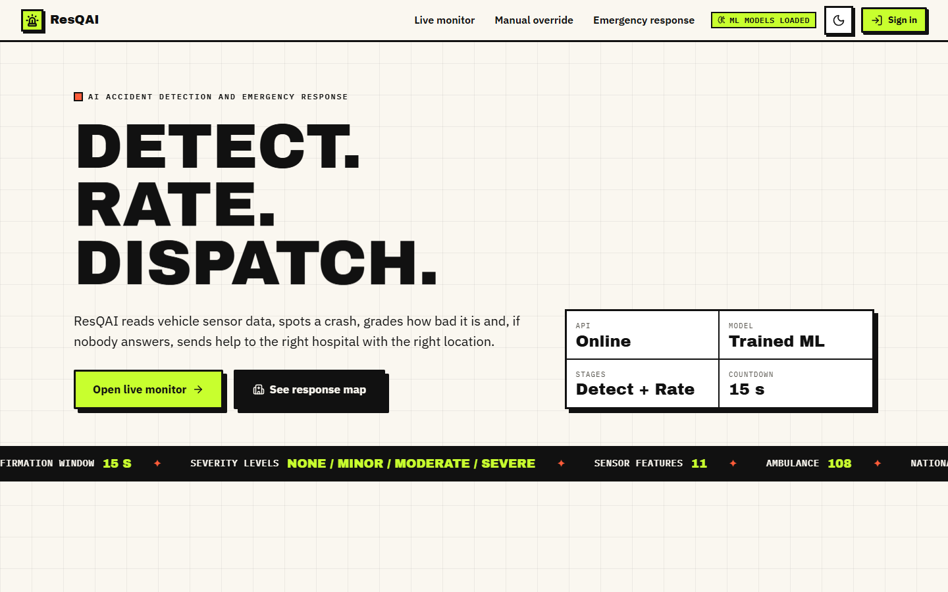
Figure 1: Landing page, light theme: the pitch 'Detect. Rate. Dispatch.', the live status tiles (API online, model trained ML, countdown 15 s) and the entry buttons.
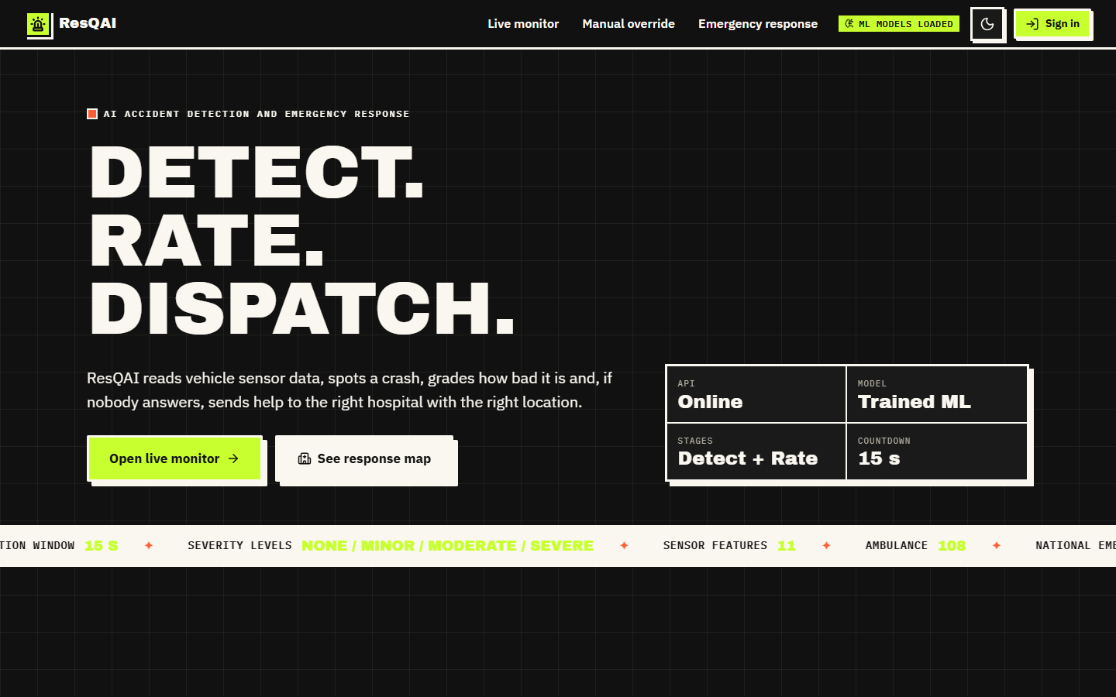
Figure 2: Landing page, dark theme (the theme switch at the top right is remembered in the browser).
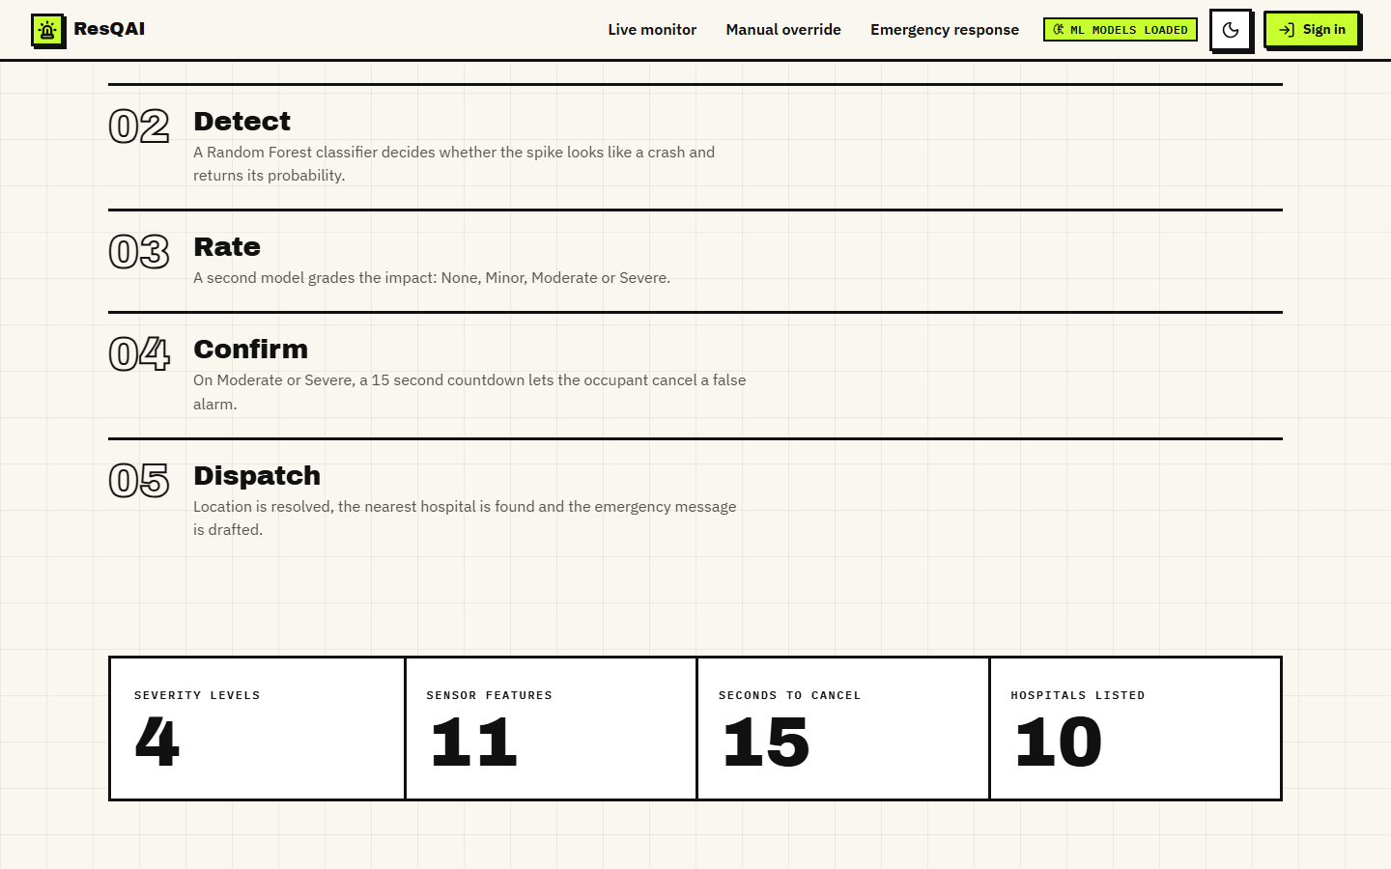
Figure 3: 'How it works' section of the landing page (Detect, Rate, Confirm, Dispatch). The tiles at the bottom (4 severity levels, 11 sensor features, 15 seconds to cancel, 10 hospitals listed) are captured after their count-up animation has finished.
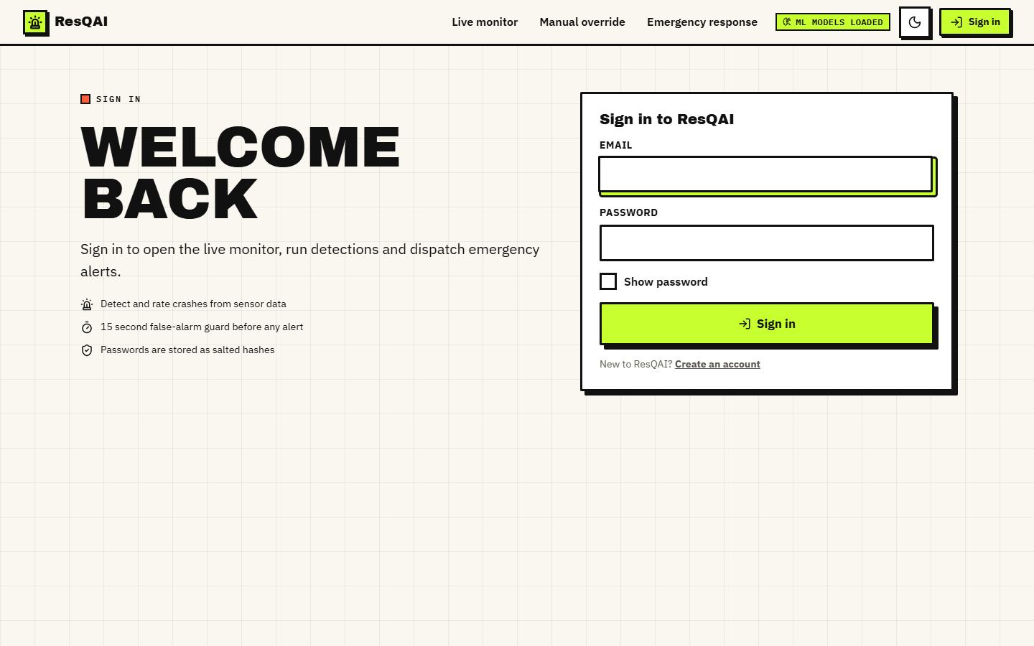
Figure 4: Sign-in form. The monitor, manual override and response screens are reachable only after signing in.
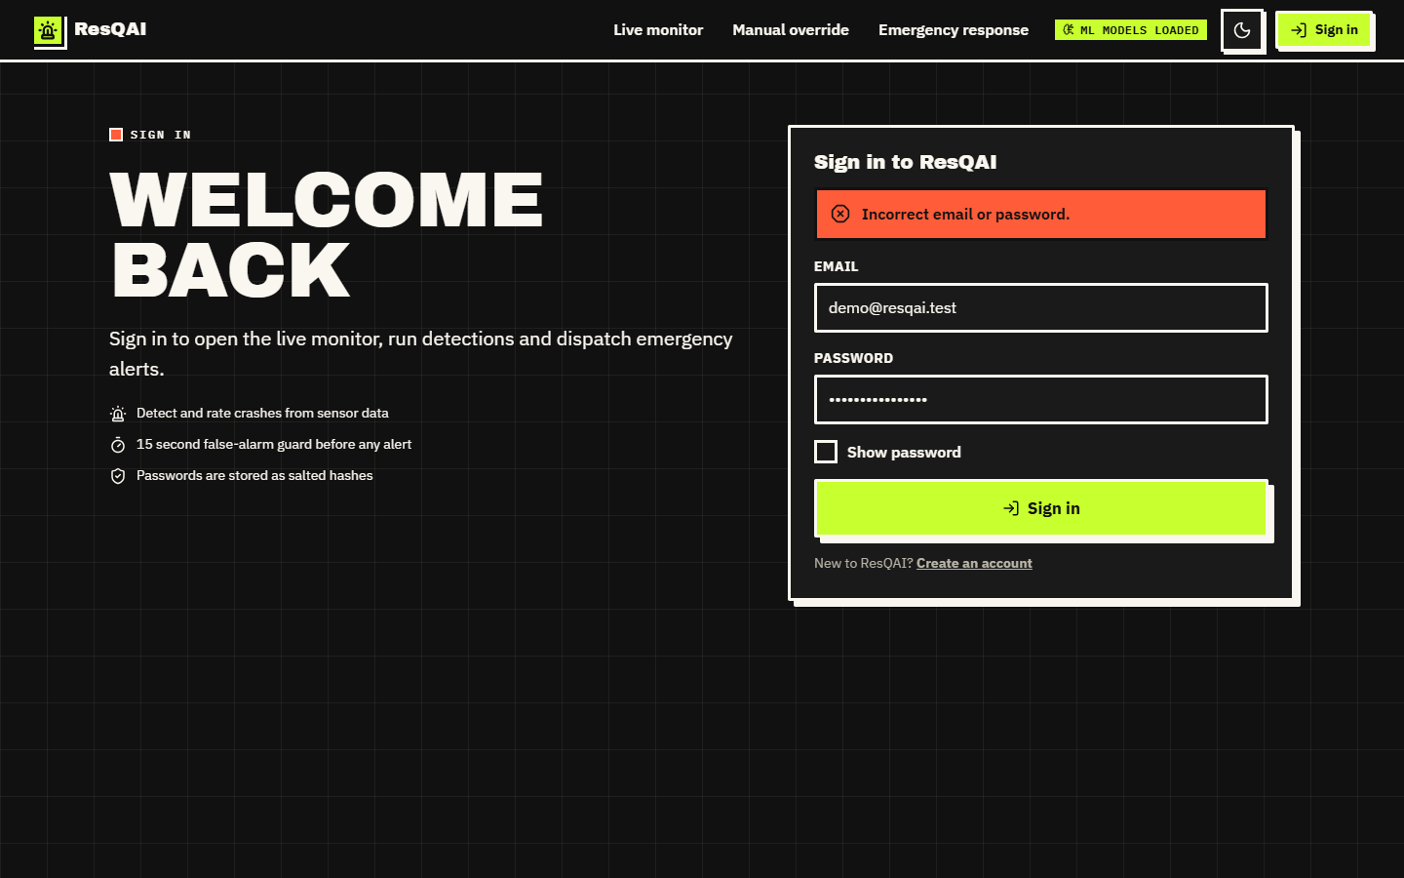
Figure 5: Sign-in with a wrong password (dark theme): the form reports 'Incorrect email or password.' without saying which of the two was wrong.
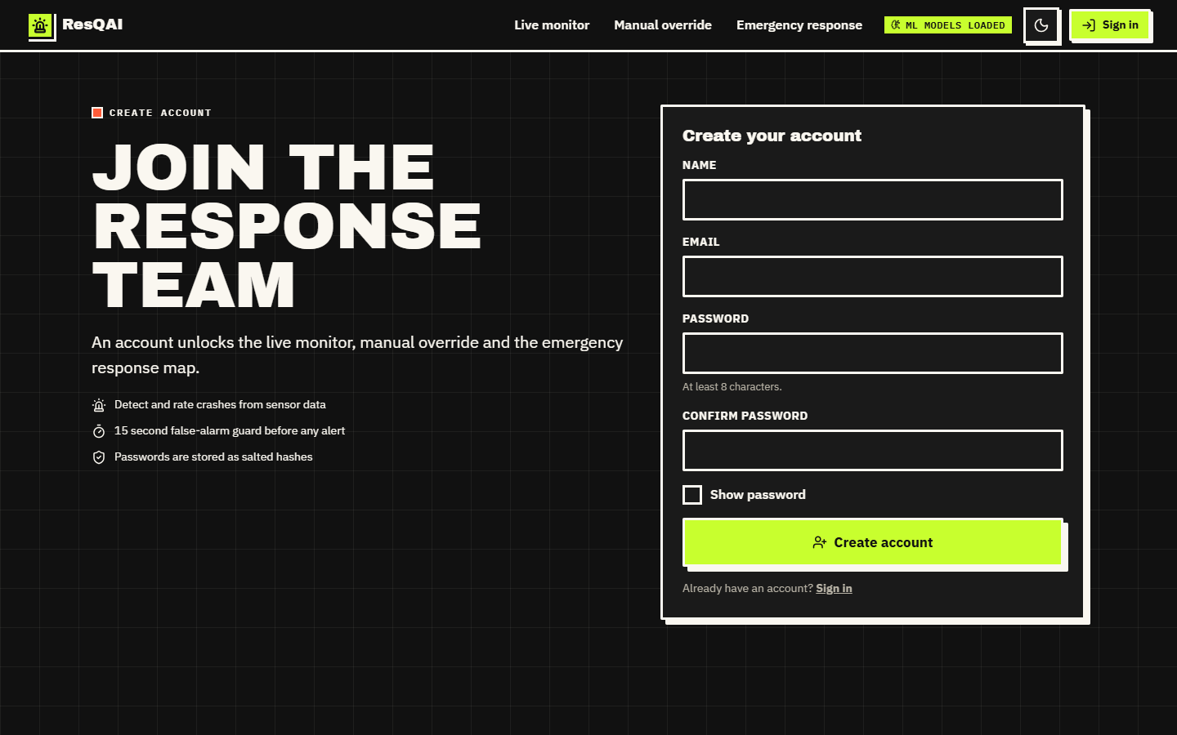
Figure 6: Create-account form (name, e-mail, password and confirmation).

1.2.2 Live monitor and confirmation
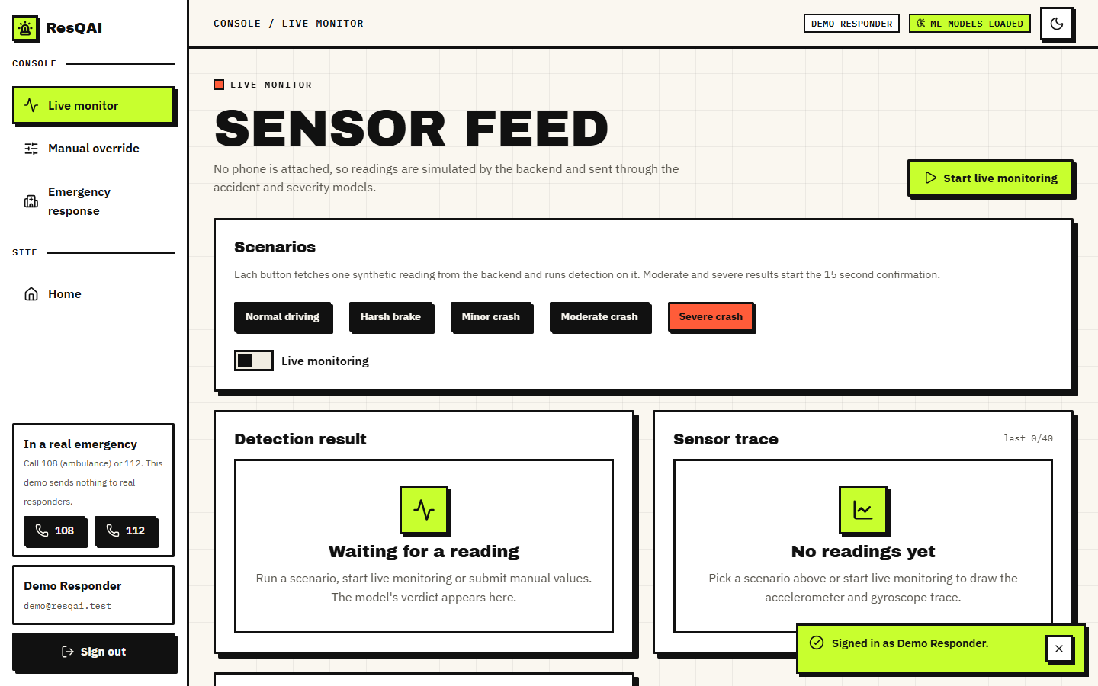
Figure 7: Live monitor before any reading: the five scenario buttons, the live-monitoring switch, and empty result and trace panels.
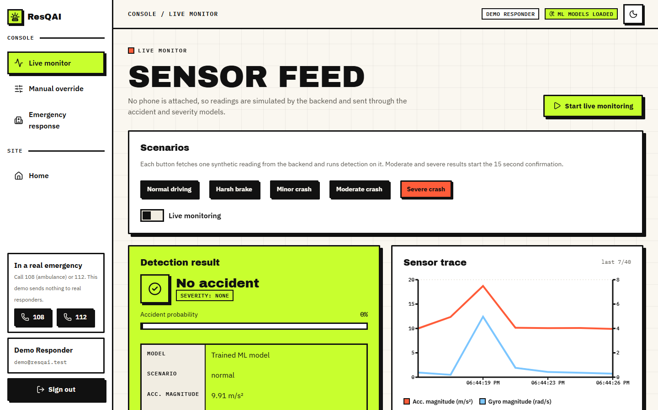
Figure 8: Live monitor after normal driving: 'No accident', severity None, accident probability 0 %, with the sensor trace of acceleration and rotation magnitude.
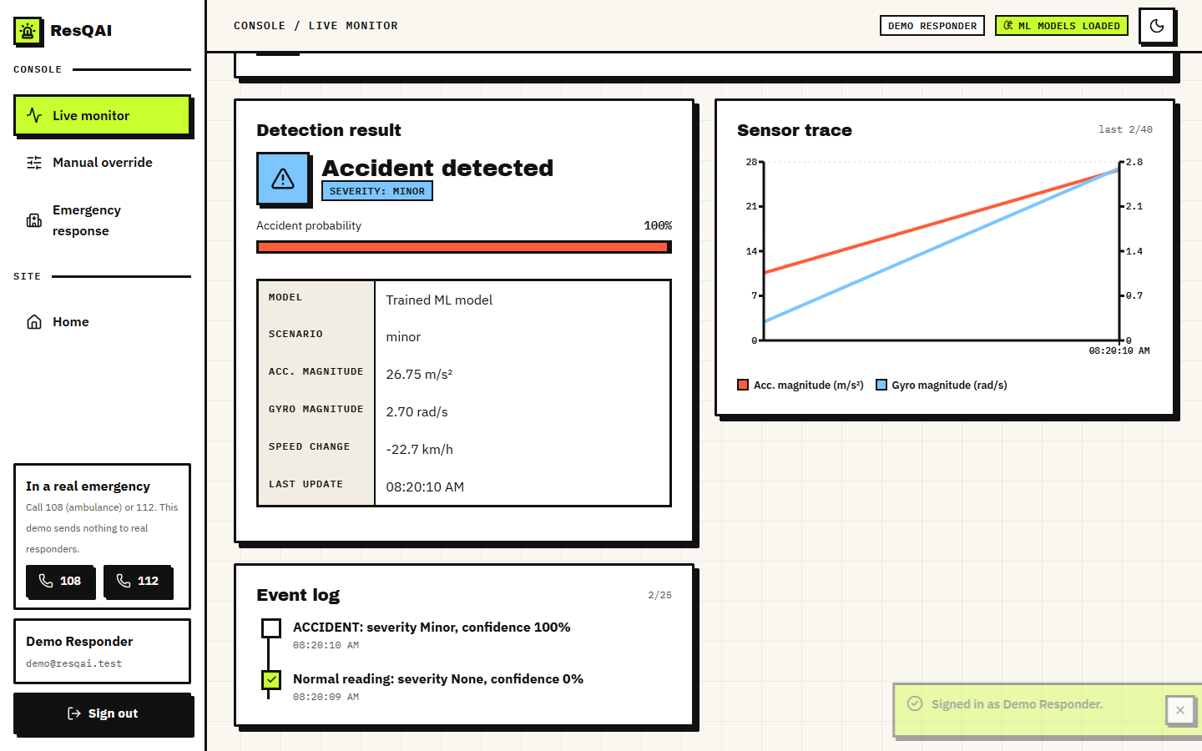
Figure 9: A Minor crash on the live monitor: 'Accident detected', severity Minor, 100 % probability; it is written to the event log and does not open the countdown.
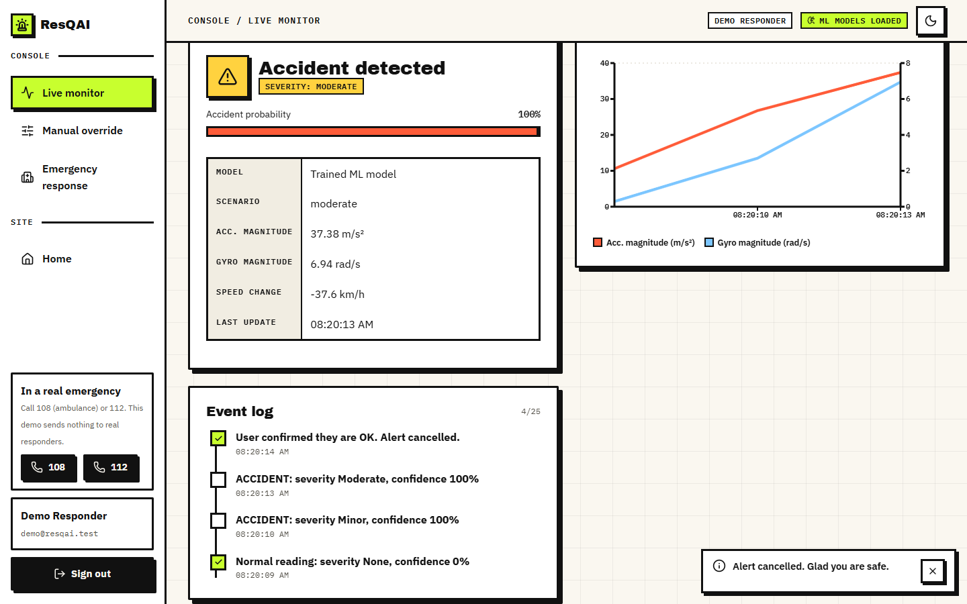
Figure 10: A Moderate crash after the occupant pressed 'I'm fine, cancel': the event log reads 'User confirmed they are OK. Alert cancelled.'
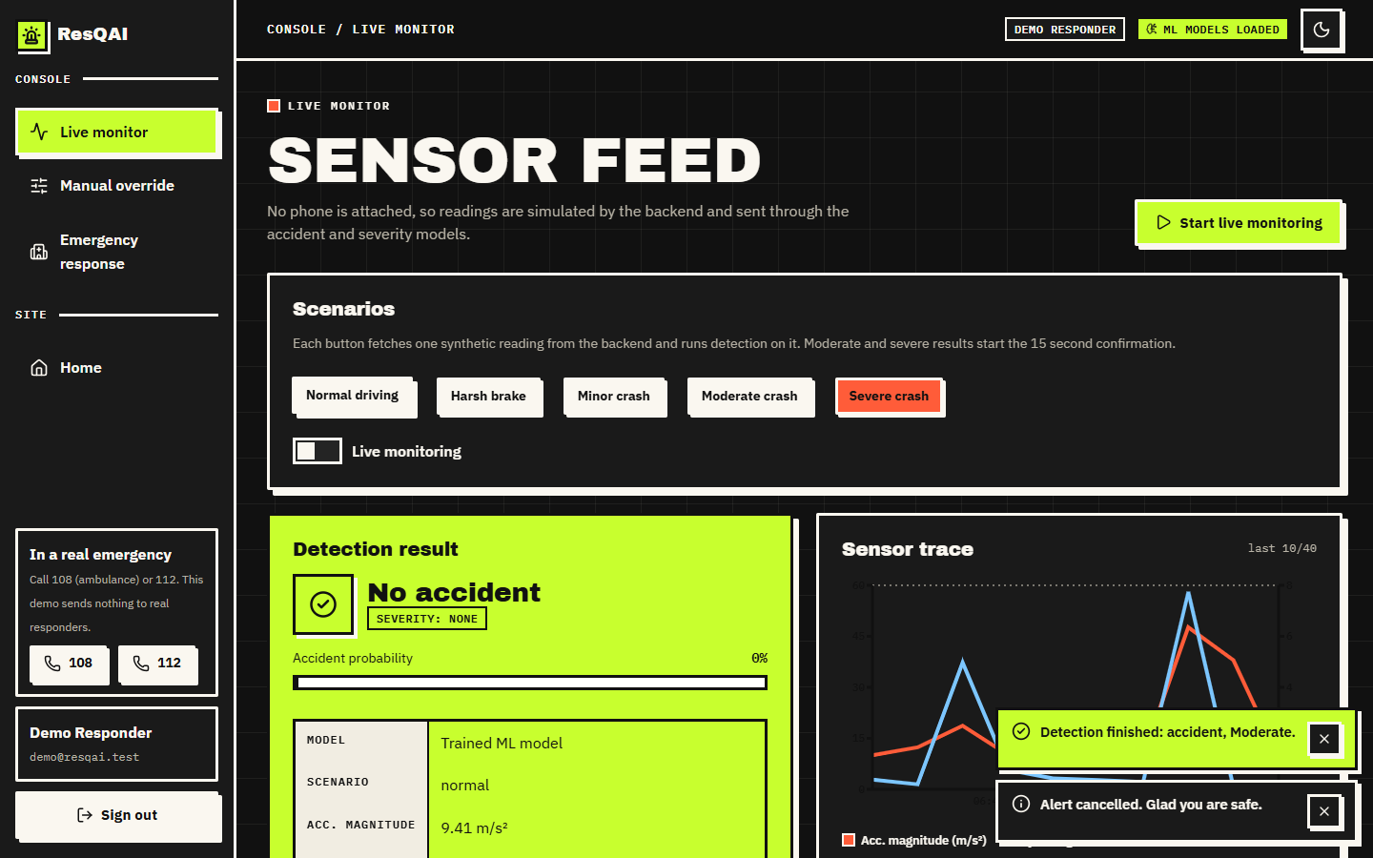
Figure 11: Live monitor in the dark theme after a normal reading.
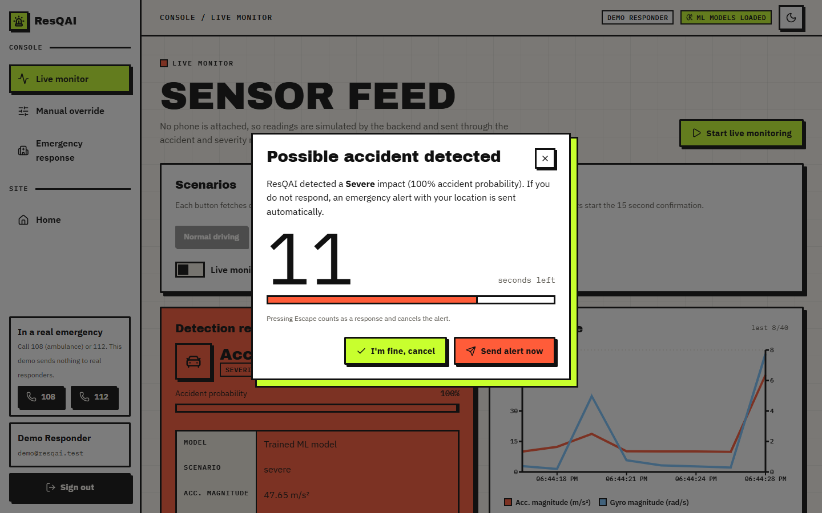
Figure 12: Confirmation dialog 'Possible accident detected' after a Severe crash: 100 % probability, 11 seconds left, the buttons 'I'm fine, cancel' and 'Send alert now', and the note that Escape cancels.

1.2.3 Dispatch, response map and manual override
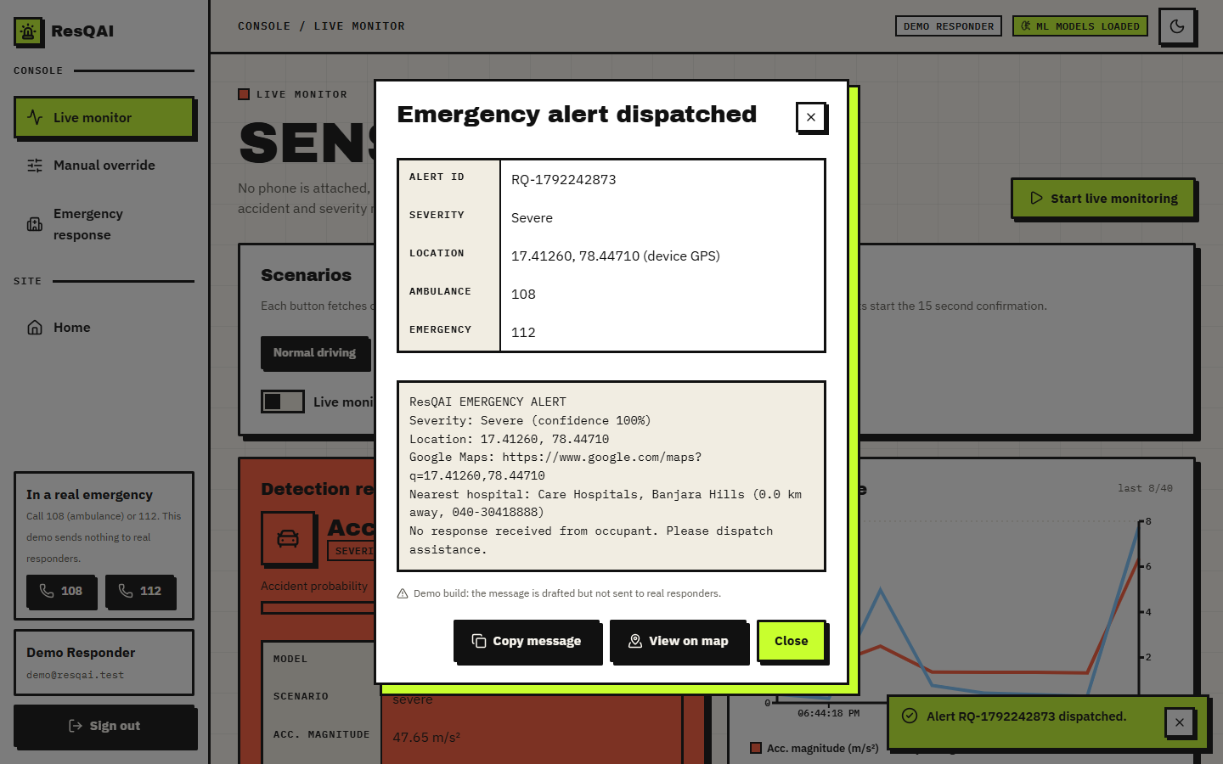
Figure 13: Dialog 'Emergency alert dispatched': alert id, severity, device location, the drafted message with its map link and nearest hospital, and the statement that the message is not sent to real responders.
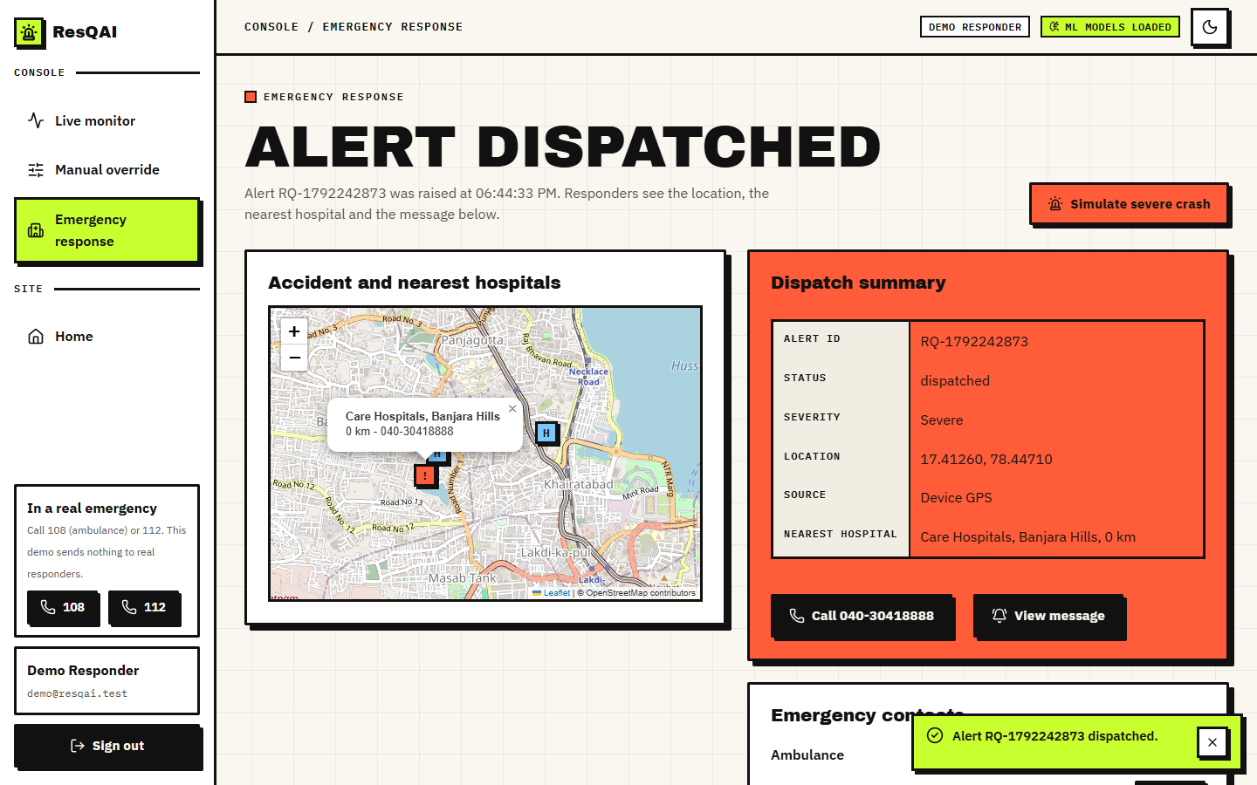
Figure 14: Emergency response screen after the dispatch: map with the accident and hospital markers, dispatch summary (id, severity, location source, nearest hospital) and the call button.
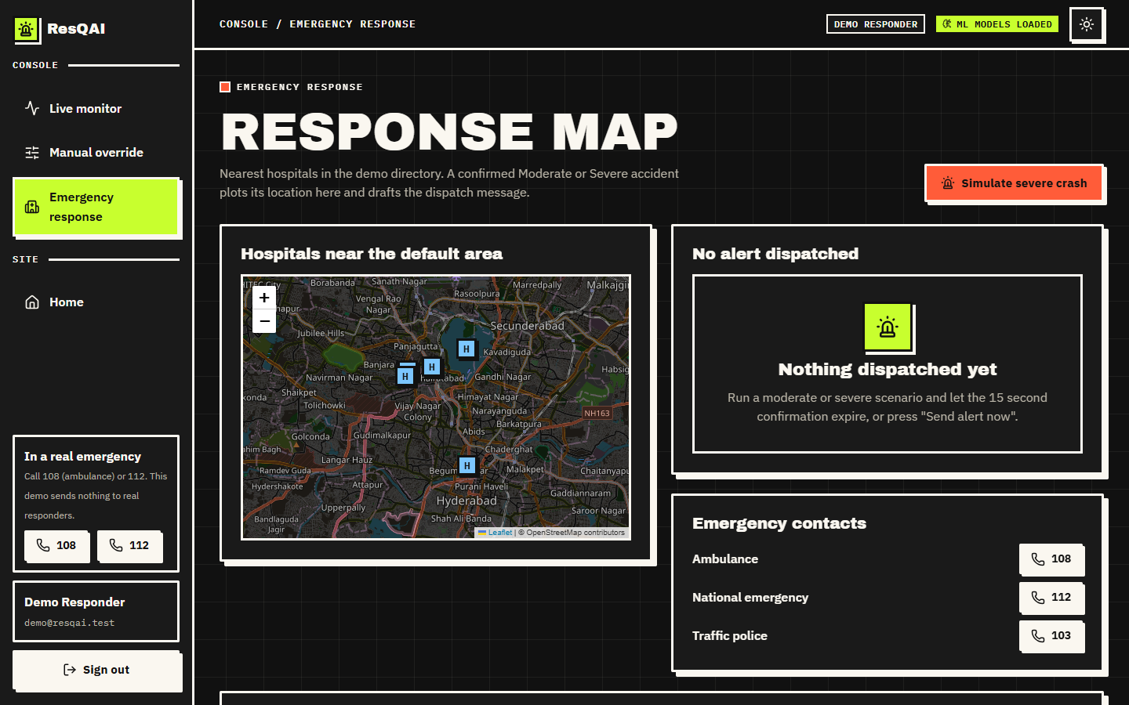
Figure 15: Response map before any alert (dark theme): the ten-hospital directory around the default location and the emergency numbers 108, 112 and 103.
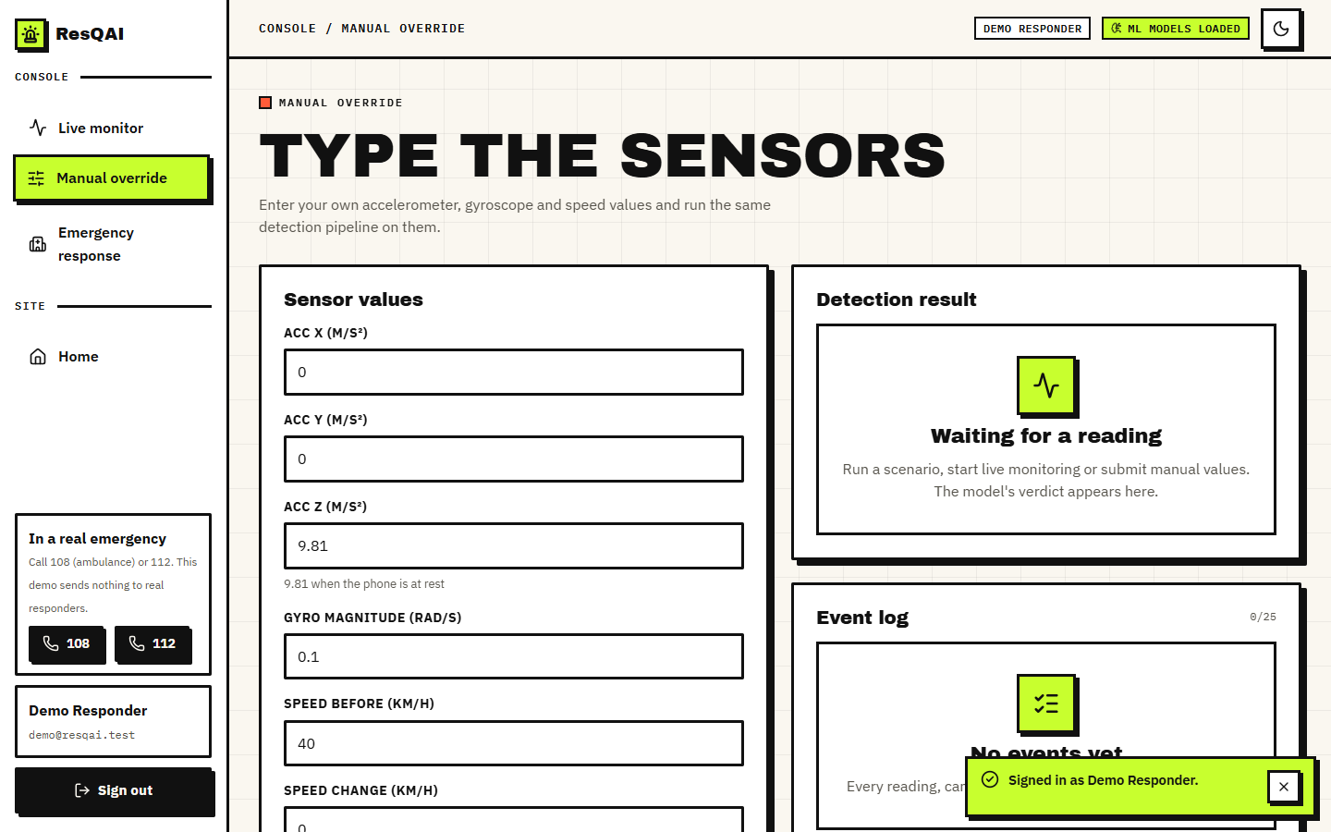
Figure 16: Top of the manual override screen: the input fields for the accelerometer, gyroscope, speed and jerk, with the magnitude derived from them.
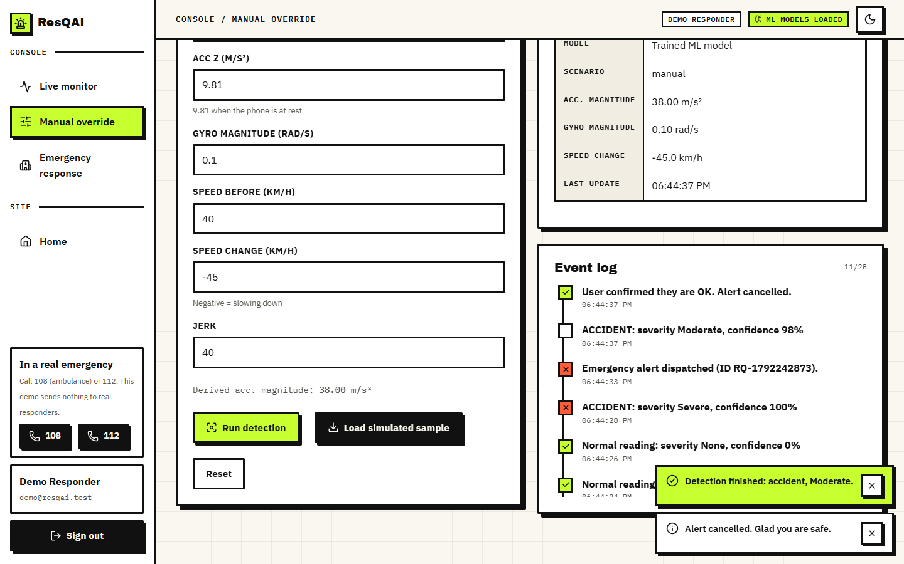
Figure 17: Manual override with acc_x 32, acc_y 18 m/s2, speed change -45 km/h and jerk 40: derived magnitude 38.00 m/s2, result Moderate; the event log below records the earlier alerts.

Figure 18: The 404 page shown for an unknown route.

1.3 Accident Detector
On the 2,400 held-out events the detector makes no error: accuracy, precision, recall, F1 and ROC-AUC are all 1.0000, the confusion matrix is [[1923, 0], [0, 477]], and both the false-alarm rate and the miss rate are 0.0%. Its accuracy on the 9,600 training events is also 1.0000, so there is no gap between training and test. A perfect score on a test set is normally a warning sign, and here it is one: it comes from the way the data are built, not from a skilful model.
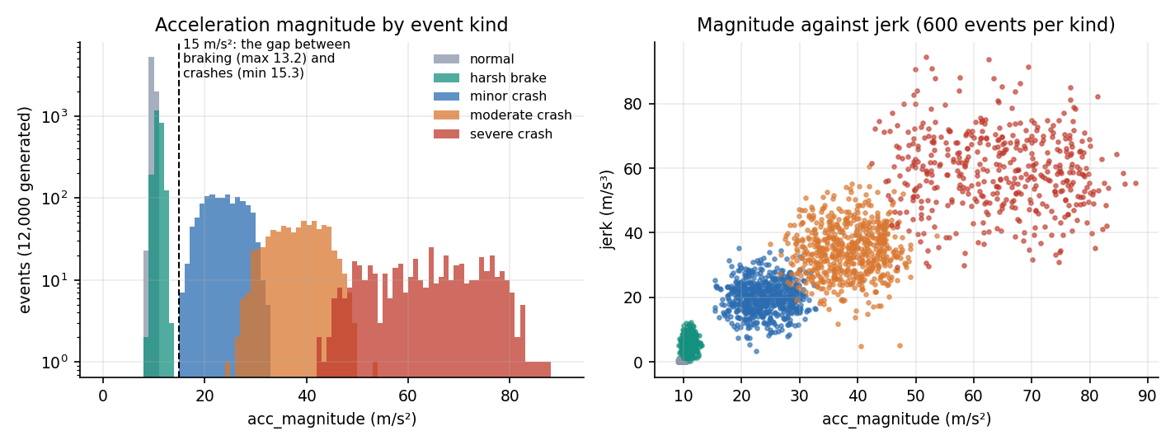
Figure 19: Why the detector cannot fail on this data: normal driving and harsh braking stay below 13.2 m/s2 of acceleration magnitude, every crash is above 15.3 m/s2.
The left panel of the figure above shows the reason. The largest acceleration magnitude of any harsh-braking event in the 12,000 generated is 13.18 m/s2, the smallest of any crash is 15.3 m/s2, and a gap lies between them. A single threshold at 15 m/s2 separates the two classes without an error, and Section 8.5 confirms that a rule with that threshold scores exactly as well as the random forest. The detector in this project is therefore easy by construction; its value in this chapter is that the full pipeline from reading to alert is exercised, not that 100 % tells us something about roads.
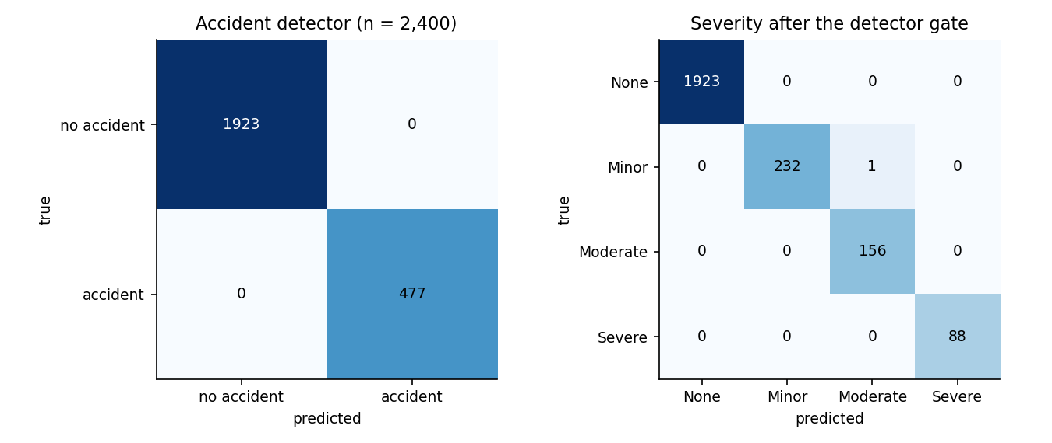
Figure 20: Confusion matrices of the shipped detector (left) and of the severity model after the detector gate (right), 2,400 test events.
Table 2: Detector behaviour by kind of event (shipped model, held-out events)
Event kind | Events | Flagged as accident | Mean accident probability
normal | 1463 | 0.0% | 0.0000
harsh brake | 460 | 0.0% | 0.0024
minor crash | 233 | 100.0% | 0.9984
moderate crash | 156 | 100.0% | 0.9998
severe crash | 88 | 100.0% | 1.0000

The row that matters for the first objective is harsh braking: none of the 460 held-out braking events is flagged, and their mean accident probability is 0.0024. The weakest accident in the test set still receives an accident probability of 0.90, and the strongest non-accident receives 0.17, so the probabilities are well separated.

1.3.1 Decision threshold
The application uses the forest's own decision (equivalent to a probability threshold of 0.5). The table and figure below vary that threshold. Between 0.20 and 0.90 there is no error at all; at 0.10 and 0.05 a few false alarms appear (2 and 5), and at 0.95 two true accidents are missed. The operating point is not sensitive to the threshold on this data, which is again a sign of well-separated classes. On real recordings the choice would trade missed crashes against false alarms and would have to be set with a cost in mind: a missed crash can cost a life, a false alarm costs the occupant a few seconds, which is what the confirmation window is for.
Table 3: Detector threshold sweep (shipped model)
Threshold | Precision | Recall | F1 | False positives | False negatives
0.05 | 0.9896 | 1.0000 | 0.9948 | 5 | 0
0.10 | 0.9958 | 1.0000 | 0.9979 | 2 | 0
0.20 | 1.0000 | 1.0000 | 1.0000 | 0 | 0
0.30 | 1.0000 | 1.0000 | 1.0000 | 0 | 0
0.40 | 1.0000 | 1.0000 | 1.0000 | 0 | 0
0.50 | 1.0000 | 1.0000 | 1.0000 | 0 | 0
0.60 | 1.0000 | 1.0000 | 1.0000 | 0 | 0
0.70 | 1.0000 | 1.0000 | 1.0000 | 0 | 0
0.80 | 1.0000 | 1.0000 | 1.0000 | 0 | 0
0.90 | 1.0000 | 1.0000 | 1.0000 | 0 | 0
0.95 | 1.0000 | 0.9958 | 0.9979 | 0 | 2

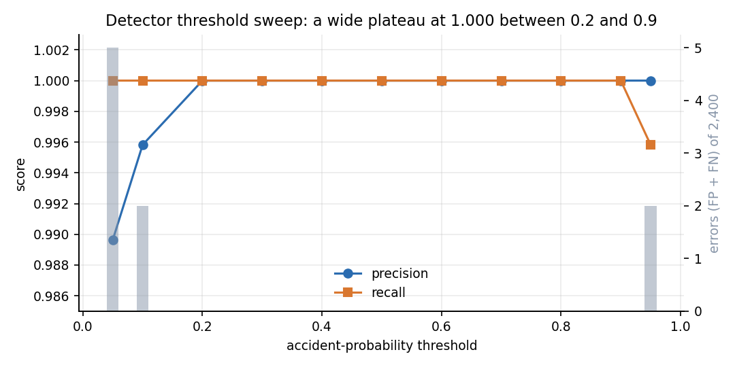
Figure 21: Precision and recall of the detector against the accident-probability threshold, with the number of errors.

1.4 Severity Predictor
After the detector gate, as the application runs it, the severity model reaches accuracy 0.99958 and macro-F1 0.99866 on the 2,400 test events. There is exactly one error (1 of 2,400): a Minor crash graded Moderate. It is a neighbouring class (Minor and Moderate are adjacent grades). Per class, precision and recall are at least 0.9936.
Table 4: Severity per-class results (shipped model, after the gate)
Class | Precision | Recall | F1 | Support
None | 1.0000 | 1.0000 | 1.0000 | 1923
Minor | 1.0000 | 0.9957 | 0.9978 | 233
Moderate | 0.9936 | 1.0000 | 0.9968 | 156
Severe | 1.0000 | 1.0000 | 1.0000 | 88

The decision that actually starts a countdown is whether the grade is Moderate or Severe. Treated as a two-class problem this decision has precision 0.9959, recall 1.0000 and a false-alarm rate of 0.046% (1 false trigger in 2,156 events that should not trigger one). No Moderate or Severe event was missed. The one false trigger is the Minor crash that was graded Moderate: in the application it would have opened the countdown, and the occupant could have cancelled it.

1.4.1 Repeatability over five seeds
A single split can flatter a model, so the whole experiment was repeated five times, each time with a new dataset, a new split and newly trained forests (seeds 11, 22, 33, 44 and 55). The detector scored accuracy 1.0000 in all five runs. The severity results varied only in the third decimal: accuracy 0.99875 on average (SD 0.00066, worst run 0.99792) and macro-F1 0.99501 (SD 0.00293, worst 0.99158). The shipped model's single-split figures therefore sit within the spread of the five repeats, slightly above their mean.
Table 5: Five-seed repeat (2,400 test events each)
Seed | Severity accuracy | Severity macro-F1 | Alert precision | Alert recall | Alert false-alarm
11 | 0.99917 | 0.99727 | 0.9958 | 0.9958 | 0.046%
22 | 0.99875 | 0.99503 | 1.0000 | 0.9917 | 0.000%
33 | 0.99958 | 0.99847 | 1.0000 | 0.9956 | 0.000%
44 | 0.99833 | 0.99269 | 1.0000 | 0.9914 | 0.000%
55 | 0.99792 | 0.99158 | 0.9959 | 0.9918 | 0.046%
mean | 0.99875 | 0.99501 | 0.9983 | 0.9933 | 0.018%
SD | 0.00066 | 0.00293 | 0.0023 | 0.0022 | 0.025%

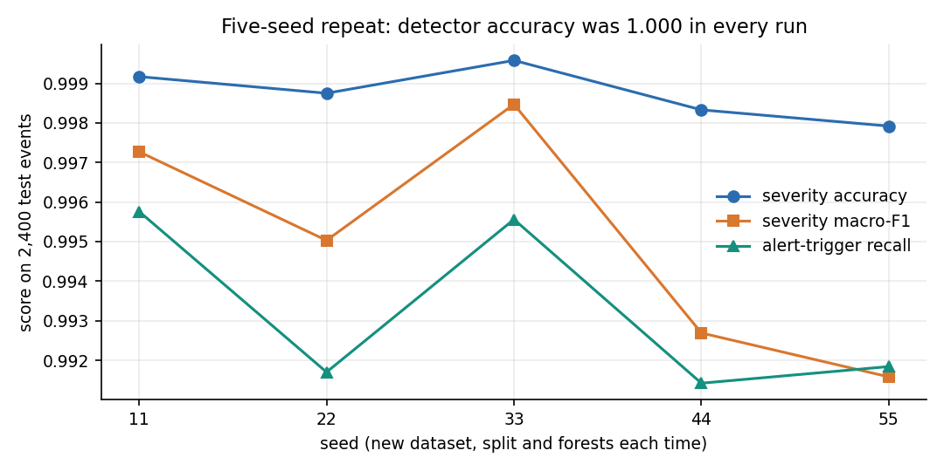
Figure 22: Severity accuracy, macro-F1 and alert-trigger recall in the five repeats.

1.4.2 Which features matter
The detector relies on few features: by Gini importance the leaders are acc_magnitude (0.324), jerk (0.311), gyro_magnitude (0.206); by permutation, shuffling acc_magnitude alone lowers the detector's F1 by 0.798 while shuffling any other single feature changes nothing, because the others carry the same information (jerk, gyroscope magnitude and speed change all rise with the impact). The severity model uses more of the inputs: acc_magnitude (0.386), jerk (0.240), speed_change (0.152), gyro_magnitude (0.096); its permutation drops are largest for acc_magnitude (0.459), speed_change (0.189) and speed_before (0.130).
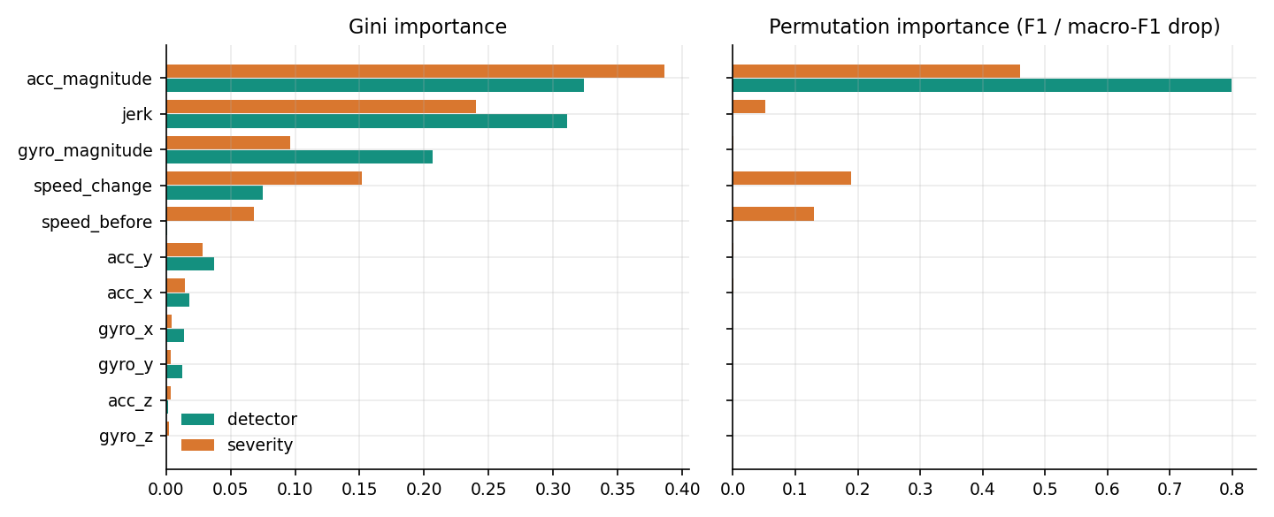
Figure 23: Gini and permutation importance of the 11 features for the detector and the severity model.
Retraining on feature subsets (table below) shows what can be removed. The gyroscope can be dropped without any change on this data, and speed and jerk each add a little to severity; acceleration alone detects every crash but grades severity less well (accuracy 0.9904, macro-F1 0.9622), and the single feature acc_magnitude gives severity accuracy 0.9858. That the gyroscope adds nothing is a property of the generator, in which rotation grows with impact exactly as acceleration does; on a real phone, rotation would help to separate a roll-over from a frontal impact.
Table 6: Feature-group ablation (models retrained on each subset)
Features used | N | Detector accuracy | Severity accuracy | Severity macro-F1
all 11 features | 11 | 1.0000 | 0.9996 | 0.9987
accelerometer only (x, y, z, magnitude) | 4 | 1.0000 | 0.9904 | 0.9622
acc_magnitude only | 1 | 1.0000 | 0.9858 | 0.9459
without gyroscope | 7 | 1.0000 | 0.9996 | 0.9987
without speed (speed_before, speed_change) | 9 | 1.0000 | 0.9983 | 0.9929
without jerk | 10 | 1.0000 | 0.9983 | 0.9938
without acc_magnitude and jerk | 9 | 0.9996 | 0.9917 | 0.9677

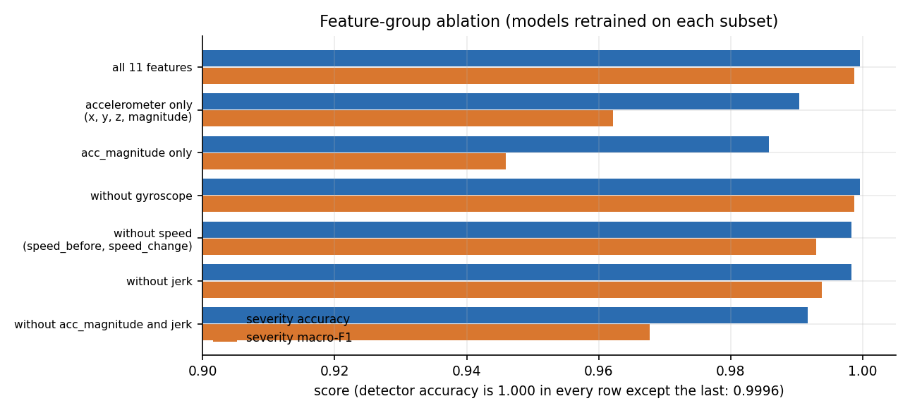
Figure 24: Severity accuracy and macro-F1 for each feature group.

1.5 Comparison with Simpler Models
To see what the random forests add, four other models were trained on the same split, with the same scaling and the same detector gate for severity. All five detect crashes perfectly. The random forest and gradient boosting are the best on severity (accuracy 0.9996 and 0.9996); the decision tree and logistic regression are close (0.9988 and 0.9983); and the three-threshold rule on acceleration magnitude, which the application itself uses as a fallback, is clearly worse (0.9750 accuracy, 0.9122 macro-F1).
Table 7: Models on the same split (2,400 test events)
Model | Detector accuracy | Detector F1 | False-alarm | Severity accuracy | Severity macro-F1
Rule-based fallback (acc_magnitude < 15 / 28 / 45) | 1.0000 | 1.0000 | 0.0% | 0.9750 | 0.9122
Logistic regression | 1.0000 | 1.0000 | 0.0% | 0.9983 | 0.9946
Decision tree (depth 10) | 1.0000 | 1.0000 | 0.0% | 0.9988 | 0.9960
HistGradientBoosting | 1.0000 | 1.0000 | 0.0% | 0.9996 | 0.9987
Random forest (ResQAI, retrained) | 1.0000 | 1.0000 | 0.0% | 0.9996 | 0.9987

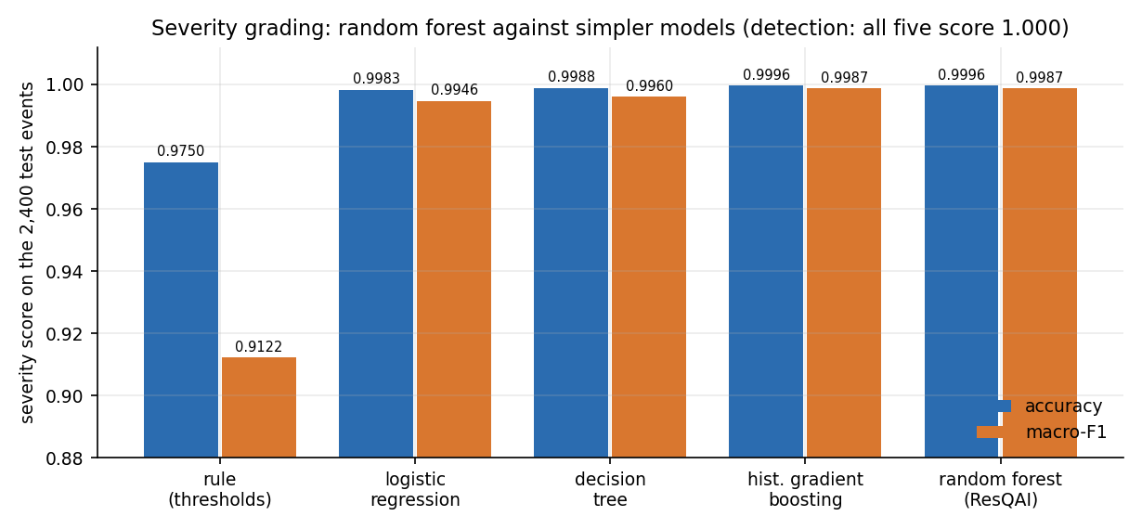
Figure 25: Severity accuracy and macro-F1 of the random forest and four simpler models.
The honest reading is twofold. For detection, the machine-learning model is not needed on this data: a single threshold does as well. For severity, the forest gains 2.5% points of accuracy and 8.6% points of macro-F1 over the rule, because the three severity bands overlap at their edges and the extra inputs (jerk, speed change, speed) resolve many of those cases. Gradient boosting would have been an equally good choice. The random forest [21] was kept because it is robust, needs no tuning, runs both models in about 14 ms and was already in the shipped application.

1.6 Robustness and Road-Surface Events
Two tests go beyond the clean test split. The first adds Gaussian noise to the nine raw sensor channels of the test events; the standard deviation of the noise is a fraction of each feature's own standard deviation across the test set, and the magnitudes are recomputed afterwards. The shipped models were never trained on noisy readings.
Table 8: Shipped models under added sensor noise
Noise (fraction of SD) | Detector accuracy | Detector F1 | False-alarm rate | Detector recall | Severity accuracy | Severity macro-F1
0.00 | 1.0000 | 1.0000 | 0.0% | 100.0% | 0.9996 | 0.9987
0.05 | 1.0000 | 1.0000 | 0.0% | 100.0% | 0.9996 | 0.9987
0.10 | 1.0000 | 1.0000 | 0.0% | 100.0% | 0.9971 | 0.9898
0.25 | 0.9904 | 0.9765 | 1.2% | 100.0% | 0.9804 | 0.9427
0.50 | 0.8058 | 0.6718 | 24.2% | 100.0% | 0.8029 | 0.7569
1.00 | 0.4167 | 0.3976 | 72.0% | 96.9% | 0.3721 | 0.4274

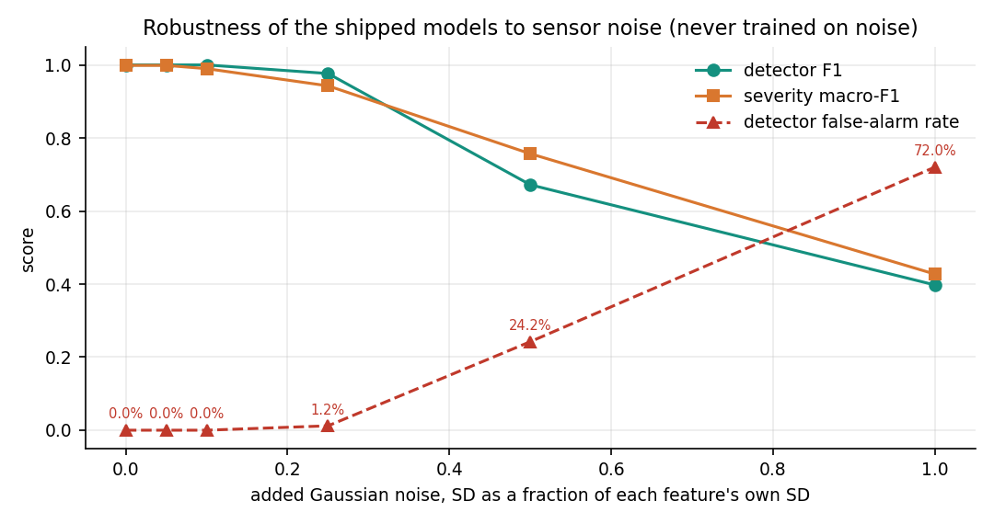
Figure 26: Detector F1, severity macro-F1 and false-alarm rate as noise grows from 0 to 100 % of each feature's SD.
The models tolerate noise up to about one tenth of the natural spread: at 0.10 the detector is still perfect and severity macro-F1 is 0.9898. At 0.25 false alarms reach 1.2% and at 0.50 they reach 24.2%, so a quarter of non-accident events would be flagged. At 1.00 the detector's accuracy (41.7%) is below 50 %. Detector recall stays above 0.969 throughout: noise makes the system cry wolf, it does not make it miss crashes. A real phone is noisy (vibration, orientation, a loose mount), so a noise-aware retraining and a filter before the model would be necessary.
The second test asks the question that the second objective raises: what does the detector do with events that are neither crashes nor the harsh braking it was trained on? Two sets of 1,000 events each were constructed for this report, a pothole-like set (a vertical spike of 6 to 18 m/s2, almost no change of speed) and a speed-breaker-like set (a vertical rise of 3 to 9 m/s2 and a small slowing). They are our own construction and not recordings, and the parameters are in scripts/measure_metrics.py.
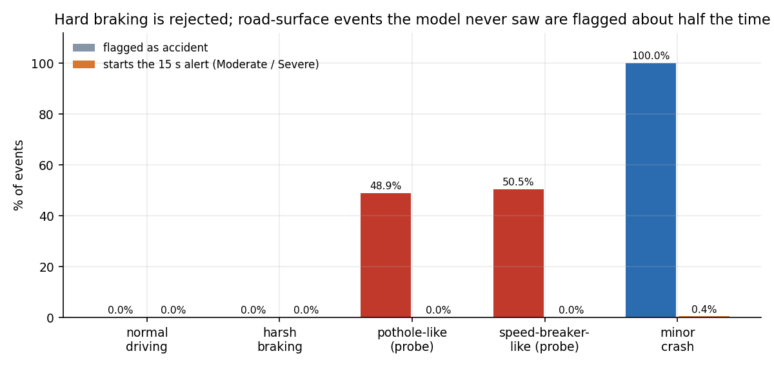
Figure 27: Share of events flagged as accident and share that start the 15-second alert, for trained and unseen kinds of event.
The detector flags 48.9% of the pothole-like events (mean accident probability 0.49) and 50.5% of the speed-breaker-like events (mean probability 0.45): it behaves like a coin toss, because it has never seen a vertical-only spike. None of them is graded Moderate or Severe (0.0% and 0.0% reach the countdown), so no alert would be raised, but the logged 'Accident detected' entries would be false. The objective of telling accidents from potholes and speed breakers is therefore met for hard braking and not demonstrated for the road-surface events. The fix is data, not tuning: such events must be recorded on real roads and added to training as their own class.

1.7 Sample Inputs and Outputs
The table below lists seven readings typed into /api/predict (the same payload the Manual override screen builds) and the answers returned by the shipped models on 2026-10-25. They are hand-picked to show each outcome, not a random sample, and the pothole-like reading is one of our constructed probes.
Table 9: Sample readings and the response of /api/predict
Reading | Input (m/s2, rad/s, km/h) | Acc. magnitude | Gyro magnitude | Accident | Severity | Probability
Calm driving | acc (0.1, -0.2, 9.8), speed 40, change +0.5, jerk 0.3 | 9.80 | 0.11 | No | None | 0.00
Hard braking | acc_x -4.5, speed 60, change -25, jerk 6 | 10.79 | 0.37 | No | None | 0.00
Minor-like impact | acc (17, 8, 9.8), gyro about 1.1 each, change -22, jerk 20 | 21.19 | 1.91 | Yes | Minor | 1.00
Moderate impact (screen 12) | acc (32, 18, 9.81), change -45, jerk 40 | 38.00 | 0.10 | Yes | Moderate | 0.975
Severe impact | acc (55, 25, 10.5), gyro about 3 each, speed 90, change -70, jerk 62 | 61.32 | 5.24 | Yes | Severe | 1.00
Boundary case | acc (22, 14, 9.8), gyro 2 each, change -30, jerk 28 | 27.86 | 3.46 | Yes | Minor | 1.00
Pothole-like (our probe) | acc_z 21.8 (a 12 m/s2 vertical spike), change +1, jerk 12 | 21.82 | 0.67 | Yes | Minor | 0.80

For a Moderate or Severe answer the browser then calls /api/emergency. For the Banjara Hills position used in the screenshots (latitude 17.4126, longitude 78.4471) the server returned alert id RQ-1792896858 and this message:
ResQAI EMERGENCY ALERT
Severity: Severe (confidence 100%)
Location: 17.41260, 78.44710
Google Maps: https://www.google.com/maps?q=17.41260,78.44710
Nearest hospital: Care Hospitals, Banjara Hills (0.0 km away, 040-30418888)
No response received from occupant. Please dispatch assistance.

The three nearest hospitals returned with it were Care Hospitals (0.00 km), Rainbow Children's Hospital (0.27 km) and Yashoda Hospitals, Somajiguda (1.34 km). The second is a paediatric hospital: the directory holds no information about specialty or capacity, so the nearest hospital is not always the most suitable one (Section 8.10).
The single severity error of the test split is a minor crash (true severity Minor) with acceleration magnitude 31.93 m/s2, gyroscope magnitude 2.79, speed change -24.33 km/h and jerk 27.04, which the model graded Moderate with accident probability 1.0. Its magnitude lies in the stretch where the minor and moderate generators overlap (24.9 to 32.8 m/s2), so the error is a boundary case and not a surprise.

1.8 Comparison with the Base Paper and Related Work
The base paper [1] predicts the severity of a crash from the police record written after it happened: 30,442 crash records from Dongguan, China, 2019 to 2023, split 19,483 / 4,871 / 6,088, with driver, vehicle, road and weather attributes, and three tasks (injury severity with five classes, fatal severity with five classes and property loss with six classes). Its multi-task FT-Transformer reports accuracy 70.31 % for injury severity (F1 64.48 %), 90.38 % for fatal severity (F1 86.71 %) and 80.79 % for property loss (F1 79.18 %), and beats eight baseline models and an earlier multi-task CNN.
The two works cannot be compared by their numbers, and the table below is a comparison of what each does, not of scores.
Table 10: ResQAI against the base paper and the two companion papers
Aspect | Base paper [1] | GreenBox [6] | CIRS [7] | ResQAI
Input | Police crash records (tabular, after the event) | Push-button impact sensors, MPU-6050, water sensors, GPS (Arduino) | Camera frames | 11 motion features of a (simulated) phone reading
Data | 30,442 real records, one Chinese city | None reported | 5,200 accident and 4,800 non-accident frames | 12,000 synthetic events; none real
Task | Severity of injury, fatality and property loss | Impact and roll-over detection, alert by SMS | Accident detection, scene description, dispatch | Crash detection, 4-level severity, confirmation, hospital and message
Reported result | Accuracy 70.31 / 90.38 / 80.79 % | Qualitative: SMS 'in a matter of seconds' | Accuracy 86.5 %, precision 0.866, recall 0.856, F1 0.861 | Detector 1.0000, severity 0.99958 on synthetic data (Section 8.3-8.4)
Alert path | None | SMS with GPS position to preset contacts; cancel by SMS | Multi-agent dispatch (reported) | Message drafted and displayed; not sent
False-alarm handling | Not applicable | Owner can cancel by SMS | 128 of 1,044 non-accident frames falsely flagged | 15-second cancel window; measured 0 % on held-out braking

ResQAI's scores are higher than the base paper's, but that is not a finding. The base paper works on real, noisy, human-recorded data with overlapping classes and an inherently uncertain target (how many people were injured); ResQAI works on synthetic classes that are separable by construction. A fair comparison would need ResQAI evaluated on real sensor recordings of crashes, which do not exist in this project. What ResQAI does take from the base paper is the framing: severity is worth predicting, not only occurrence, and per-class accuracy, precision, recall and F1 are the right way to report it. It does not use the FT-Transformer, the multi-task loss, SMOTE or SHAP.
Against GreenBox [6], ResQAI replaces fixed hardware thresholds with a learned severity grade and adds the hospital ranking, but GreenBox sends a real SMS and has been tested on a vehicle on the road, which ResQAI has not. Against CIRS [7], ResQAI uses motion sensors that every phone carries instead of fixed cameras, so it can follow a vehicle anywhere, but CIRS was evaluated on real images and reports a false-alarm count, while ResQAI's figures describe generated data. Neither companion paper reports an end-to-end alert time, so ResQAI's alert-path compute time (56 ms) has nothing to be compared with.

1.9 Success and Failure Analysis

1.9.1 What worked
• The pipeline runs end to end. A reading becomes a detection, a grade, an optional countdown, a location, three ranked hospitals and a dispatch message; 33 of 33 smoke checks and 17 of 17 unit checks pass.
• Hard braking is not mistaken for a crash. None of 460 held-out braking events is flagged, and the 15-second window gives the occupant a way to correct any other false alarm.
• Severity grading is accurate on its own distribution. Accuracy 0.99958 (five-seed mean 0.99875); every error is to a neighbouring class.
• It is quick. 56.4 ms of compute for the three calls of an alert, 14.0 ms for the two models.
• Access control behaves as coded. All 18 security checks pass, including the lock-out after five wrong passwords.

1.9.2 What failed or is unproven
• One severity error. A Minor crash at 31.9 m/s2 was graded Moderate (Section 8.7); the application would have opened a countdown for it.
• Road-surface events. About half of pothole-like (48.9%) and speed-breaker-like (50.5%) events are flagged as accidents because the models have never seen them.
• Noise. Above a quarter of the natural spread the detector's false-alarm rate climbs (1.2% at 0.25, 24.2% at 0.50).
• Input validation. Eight edge cases are mishandled: four return HTTP 500, three accept nonsense input and one reuses an alert id (Chapter 7).
• Alert delivery. No message is sent, so the time to reach a human, which is what the system is for, is unmeasured.

1.9.3 Why the near-perfect scores should not be trusted as a forecast
Three features of the experiment make the scores optimistic. The training and test events come from one generator, so there is no distribution shift; the crash classes are far from the non-crash classes, so detection is trivial; and the sensors are noiseless apart from the Gaussian spread written into the generator. The repeat over five seeds and the fact that a retrained model agrees with the shipped one show that the numbers are stable and reproducible; they do not show that they transfer. The right claim is that the software and the models are consistent with each other and with the design, and that the next step is real data.

1.10 Limitations
• No real data. All 12,000 events are generated; no smartphone recording, crash test or road trial was used.
• Single sensor location and orientation. The generator has no notion of how the phone is mounted, which axis points forward, or whether the phone is in a pocket; a real deployment needs orientation normalisation.
• Pothole, speed-breaker, drop and bump events are not modelled (Section 8.6).
• Hospital directory. Ten hospitals in Hyderabad, ranked by straight-line distance; no road network, traffic, specialty (the second-nearest hospital in the sample is a children's hospital), bed capacity or opening hours. Outside Hyderabad the 'nearest' hospital would be hundreds of kilometres away.
• No transmission. The dispatch message is displayed; there is no SMS, voice call or e-mail gateway, no contact list and no acknowledgement from a responder.
• Confirmation window. 15 seconds is taken from the project brief; an incapacitated occupant cannot cancel, which is intended, but a conscious occupant who is slow also triggers an alert.
• Server. Flask development server, in-process lock-out counter, JSON-file accounts, 12-hour tokens without revocation, no HTTPS, no rate limiting beyond the login lock-out.
• Alerts are not stored and carry no user id, so there is no audit trail and no history of alerts.
• No user study and no usability or accessibility evaluation beyond the keyboard (Escape) and screen-reader labels visible in the code.

1.11 Objectives Against Outcomes
The project brief lists six objectives (6.OBJECTIVES&PROBLEM STATEMENT.docx). The table states, for each, what was built and what was measured, in plain terms.
Table 11: Objectives and outcomes
No. | Objective | Outcome | Evidence
1 | Collect and preprocess smartphone accelerometer, gyroscope, speed and GPS data for normal driving and collision events | Partly. An 11-feature pipeline and a generator of 12,000 synthetic events; no real smartphone recordings were collected. | train_models.py; Sections 8.1, 8.3
2 | Train a classifier that separates genuine accidents from potholes, speed breakers and hard braking | Partly. Hard braking: 0 of 460 held-out events flagged. Potholes and speed breakers are not in the training data; a constructed probe flags 49% and 50% of them, never as Moderate or Severe. | Sections 8.3, 8.6
3 | Build a severity model that grades an impact as minor, moderate or severe | Achieved on synthetic data. Accuracy 0.99958, macro-F1 0.99866; five-seed mean 0.99875 / 0.99501. | Section 8.4
4 | Use GPS to locate the crash and identify a suitable nearby hospital | Achieved at demo level. Browser geolocation (fallback: default area), haversine ranking over a ten-hospital Hyderabad directory; no live hospital service, no specialty or capacity. | Sections 8.2, 8.7
5 | Dispatch an automated alert carrying location and severity to emergency contacts and medical services | Partly. The alert id, message, map link and hospital are generated and displayed, with tap-to-call for 108, 112 and 103; nothing is transmitted. | Screens 10, 11
6 | Evaluate detection accuracy, false-alarm rate and end-to-end alert latency | Done. Accuracy and false-alarm rate reported with five-seed repeat, baselines, noise and threshold analyses; alert path 56.4 ms mean on loopback plus the 15 s confirmation window; real delivery latency not measurable. | Sections 8.3-8.6; Chapter 7

Two items of the project definition beyond the six objectives were also met: a confirmation mechanism that reduces false alerts (the 15-second countdown, cancellable by button or Escape) and an emergency dashboard showing the accident and the hospitals on a map. The evaluation metrics named in the brief (accuracy, precision, recall and F1) are all reported, per class for severity.

