AI Powered Intelligent Hospital Patient Flow Management System
RESULTS

Student | Hall Ticket No.
A. RAMU | 23K91A6715
B. RUSHI | 23K91A6720
B. RAJ KUMAR | 23K91A6725
A. PRABHAS | 23K91A6703
Under the guidance of [GUIDE NAME]
Department of Computer Science and Engineering (Data Science)
[COLLEGE NAME]
[ACADEMIC YEAR]

1. Measurement Conditions
Measurements were taken on Windows 11 Pro 64-bit, Intel Core i5-12500 (6 cores, 12 logical processors), 15.7 GB RAM and Python 3.11.9. Models were evaluated on deterministic synthetic test partitions. API timings are 15 sequential loopback requests per read endpoint against Uvicorn, FastAPI and SQLite. The screenshots use a synthetic demonstration database and Google Chrome at 1440 x 900.
Table 1. Measured model results.
Model | Evidence | Metric | Value
Wait-time regressor | 12,000 synthetic rows | R-squared | 0.951041
Wait-time regressor | 1,800-row test | MAE | 5.982 min
Wait-time regressor | 1,800-row test | RMSE | 8.580 min
Triage classifier | 2,250-row test | Accuracy | 0.9680
Triage classifier | 2,250-row test | Macro F1 | 0.898475
Triage classifier | 100 critical cases | Critical recall | 0.63

2. Model Performance
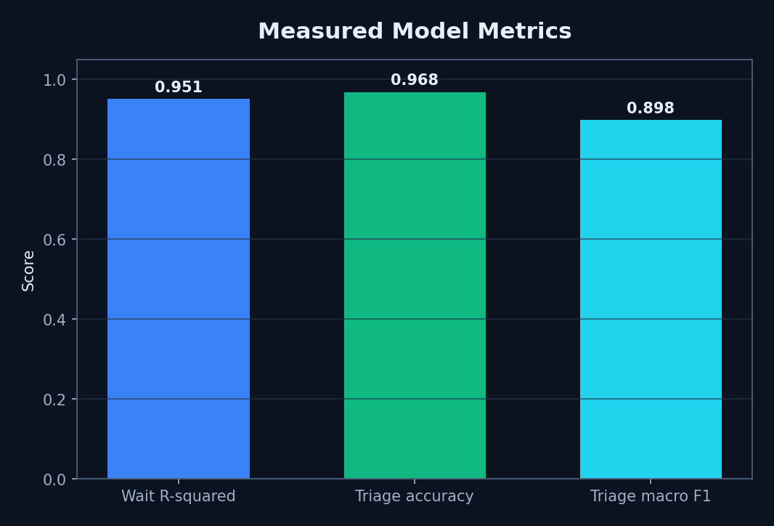
Figure 1. Measured model metrics.
The wait model reconstructs its designed synthetic relationship with R-squared 0.951041. Its MAE of 5.982 minutes and RMSE of 8.580 minutes show that larger misses remain. The triage model reached 96.80% accuracy and 0.898475 macro F1, while its 63% critical recall is the decisive safety limitation.

3. Triage Error Analysis
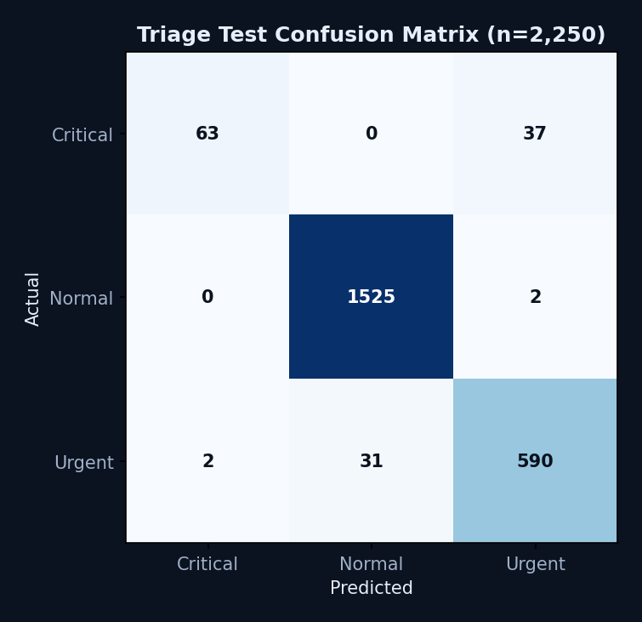
Figure 2. Triage confusion matrix.
Thirty-seven of 100 actual critical examples were classified as urgent, while two urgent cases were classified as critical and 31 urgent cases as normal. The classifier therefore requires clinician override, threshold/cost-sensitive investigation and external validation before any clinical use.

4. API and Build Results
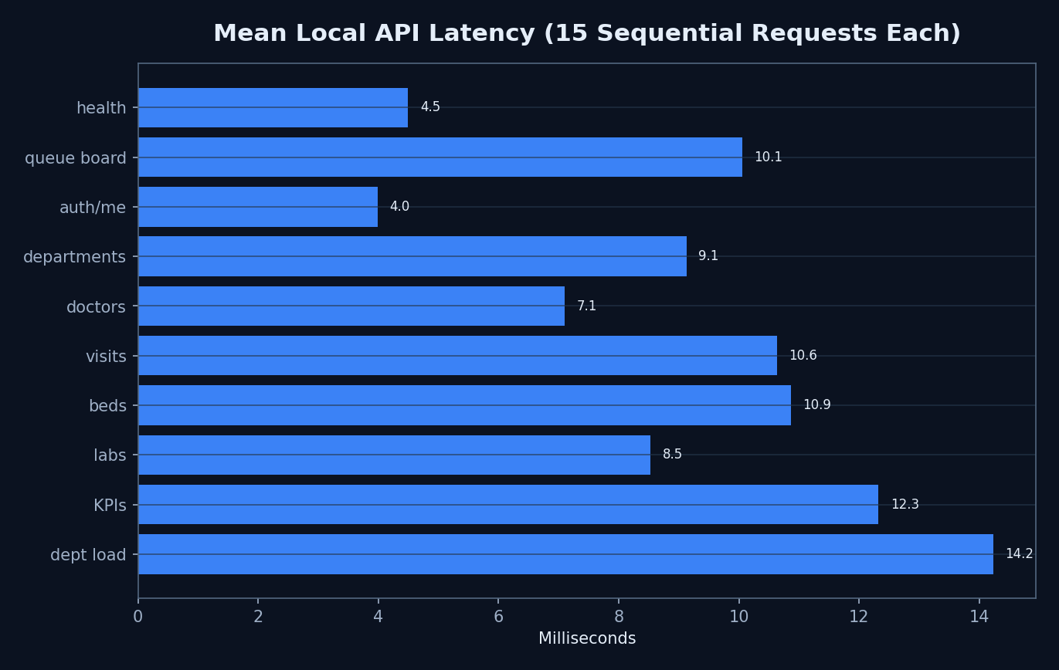
Figure 3. Mean local API latency.
All 150 measured read requests returned HTTP 200. Mean endpoint times ranged from 3.985 ms for /api/auth/me to 14.231 ms for department load. One WebSocket connection completed in 46.657 ms. These are local sequential measurements and not a capacity claim.
Frontend lint exited zero with 14 warnings. The production build exited zero after 3,573 modules and 1.73 seconds, with warnings for two JavaScript chunks larger than 500 kB.

Public waiting board
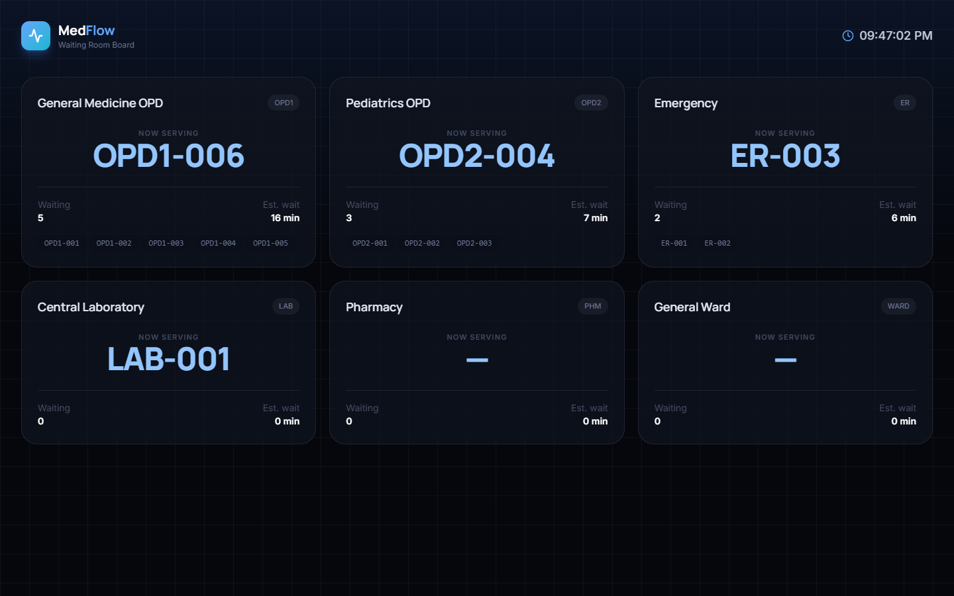
Figure 4. Public waiting board
Live department cards show now-serving tokens, waiting counts, upcoming tokens and mean predicted waits.

Administrator command centre
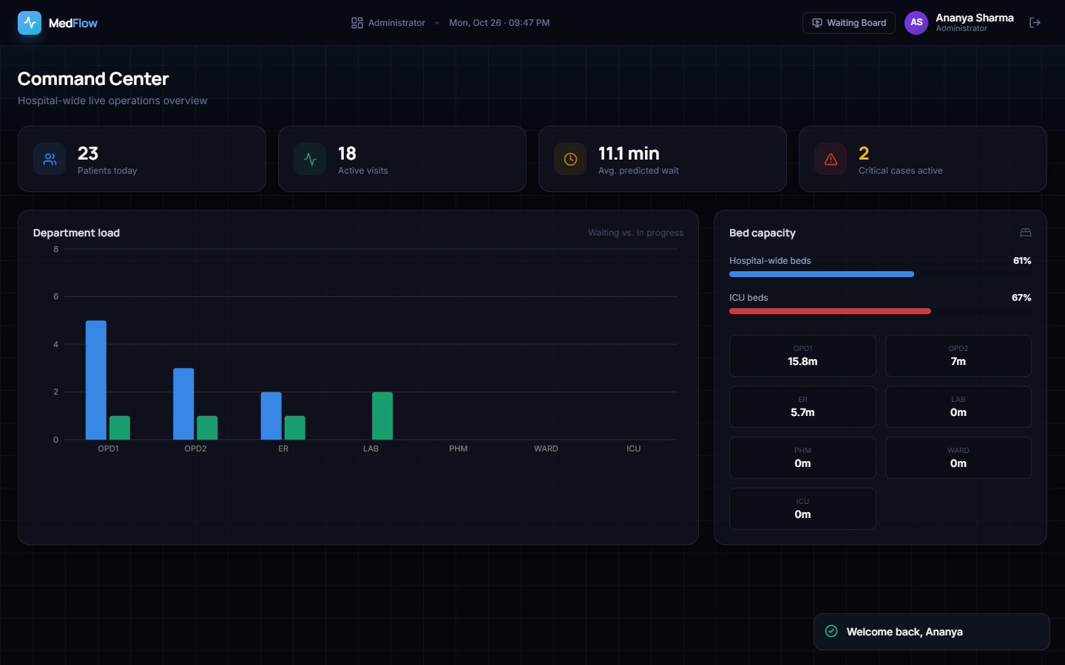
Figure 5. Administrator command centre
The demonstration snapshot shows 23 patients today, 18 active visits, 11.1-minute predicted wait, two active critical cases and capacity.

Reception dashboard
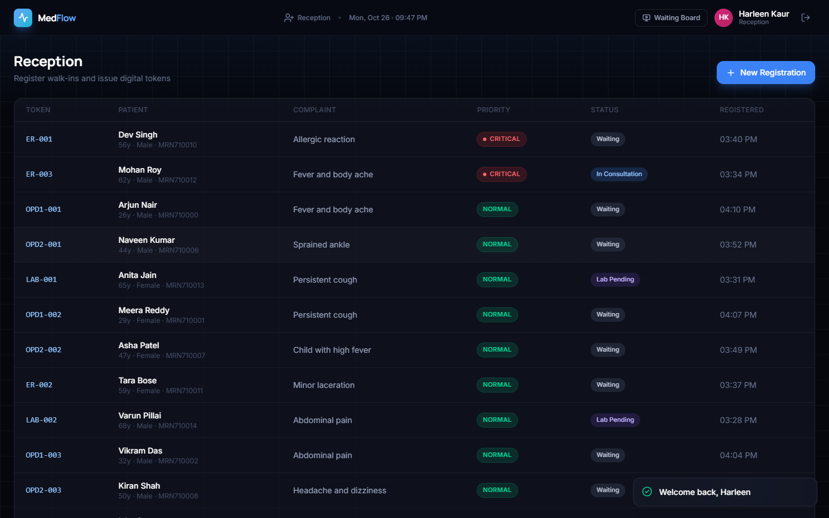
Figure 6. Reception dashboard
Token, patient, complaint, priority, state and registration time are visible in one table.

Registration and triage input
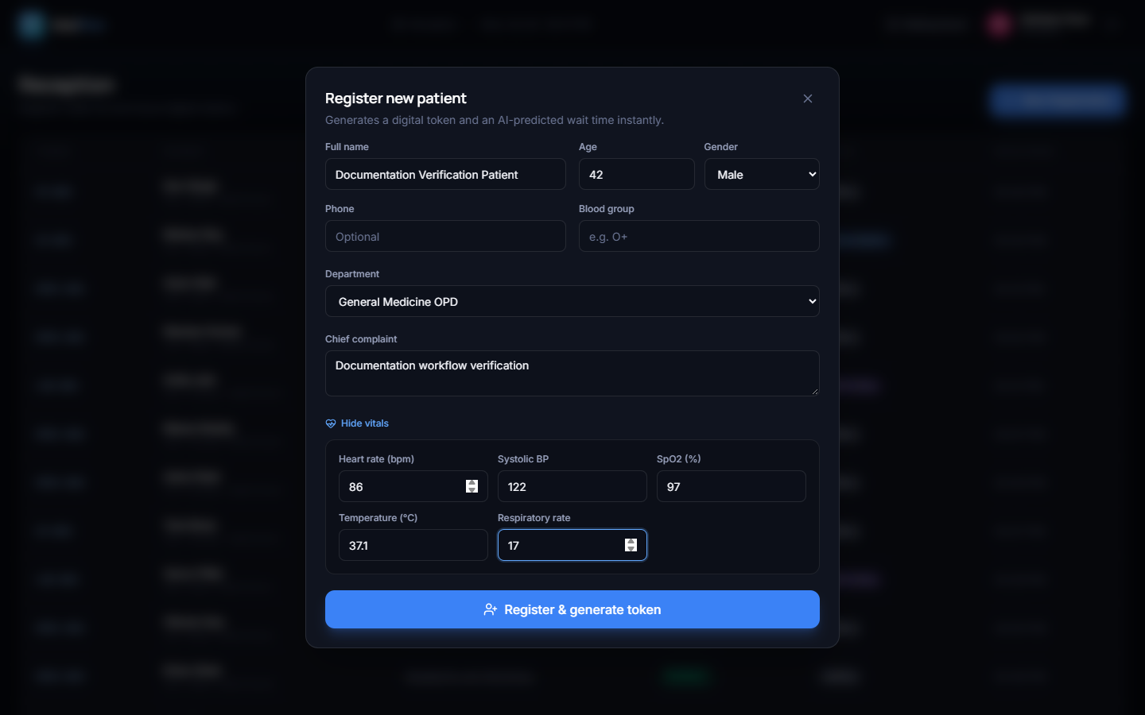
Figure 7. Registration and triage input
The real form accepts patient identity, department, complaint and optional vitals.

Doctor dashboard
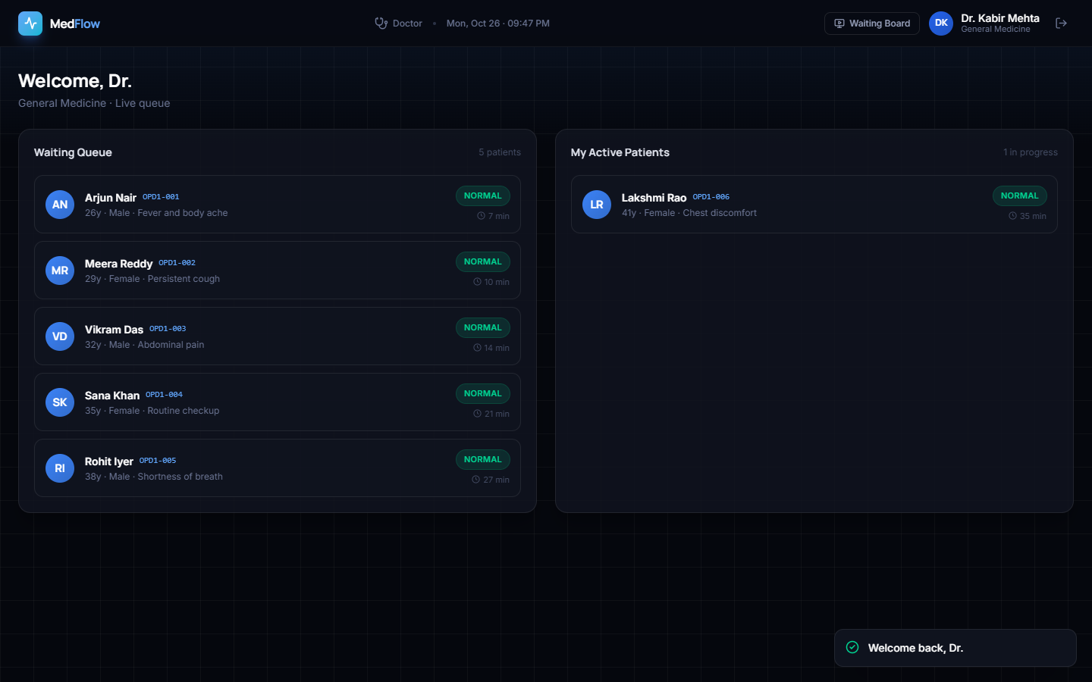
Figure 8. Doctor dashboard
Waiting and assigned patients are separated while retaining priority and predicted wait.

Visit detail
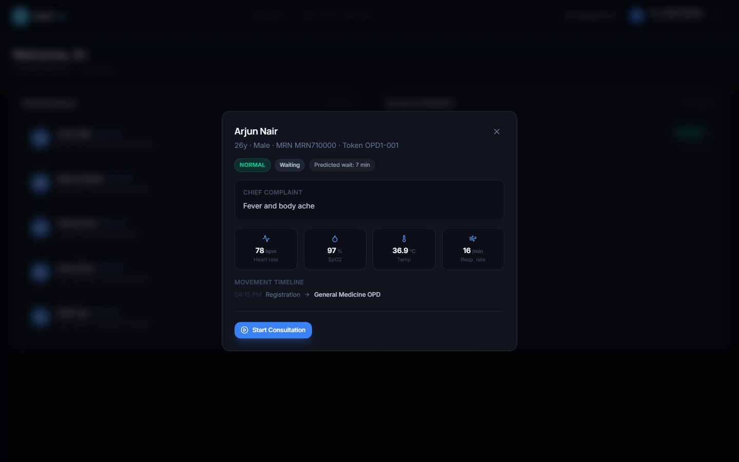
Figure 9. Visit detail
Vitals, complaint, priority, wait and movement history support the consultation decision.

Laboratory order modal
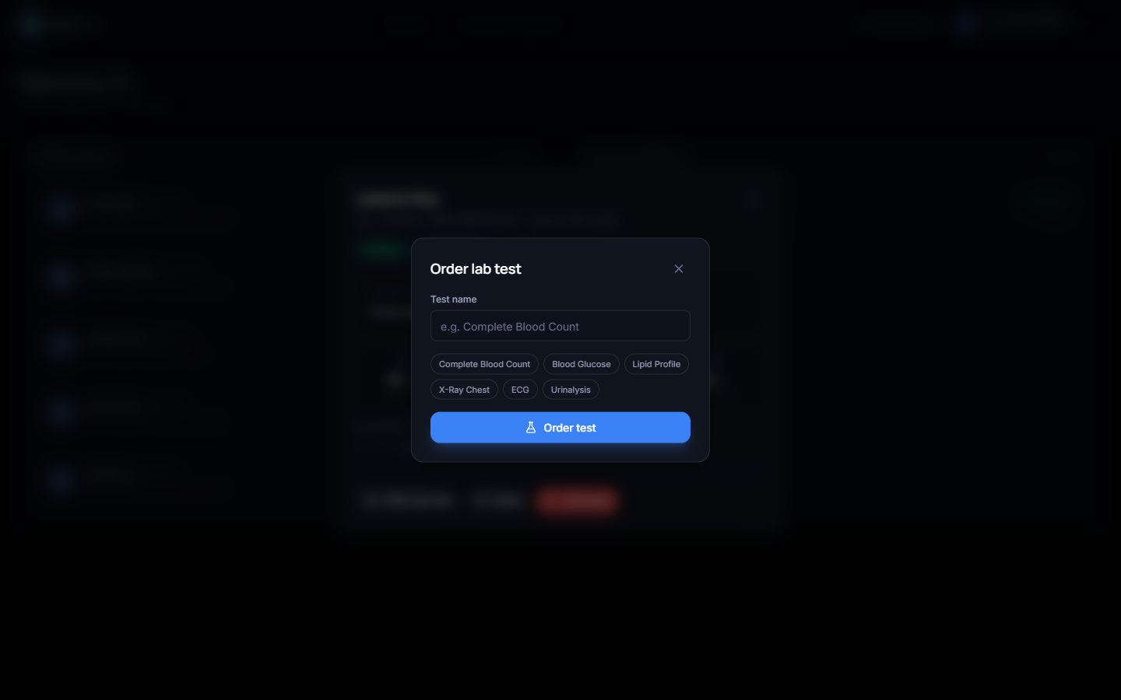
Figure 10. Laboratory order modal
Doctors may enter a named test or choose a frequent test.

Bed admission modal
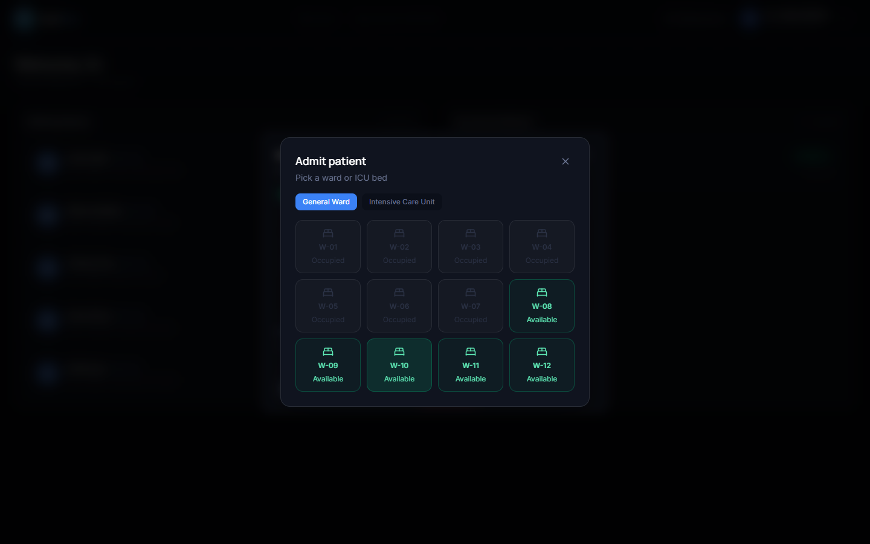
Figure 11. Bed admission modal
Occupied beds are disabled and available ward or ICU beds are selectable.

General Ward bed board
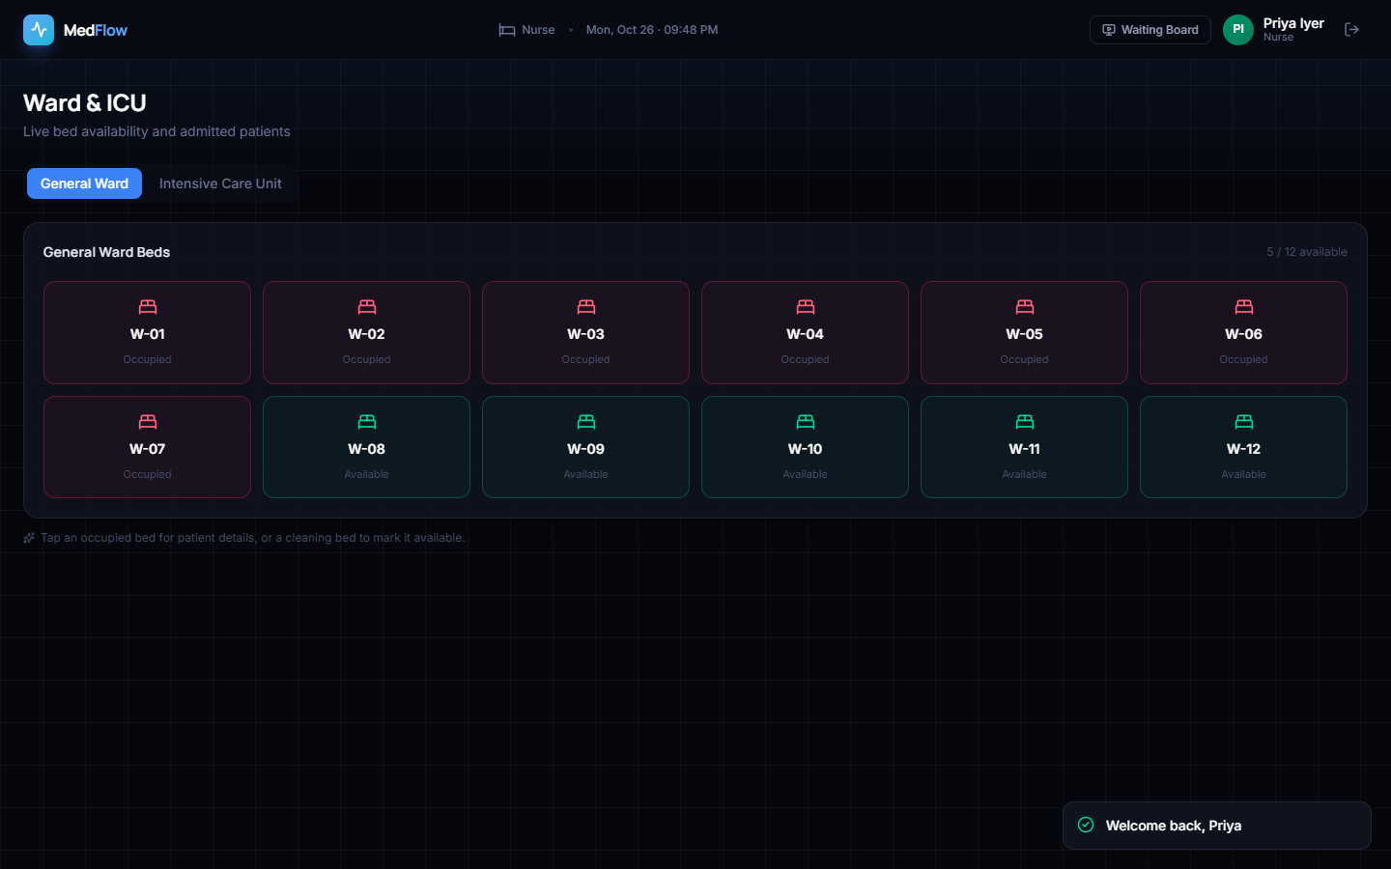
Figure 12. General Ward bed board
The synthetic snapshot contains 12 ward beds: seven occupied and five available.

ICU bed board
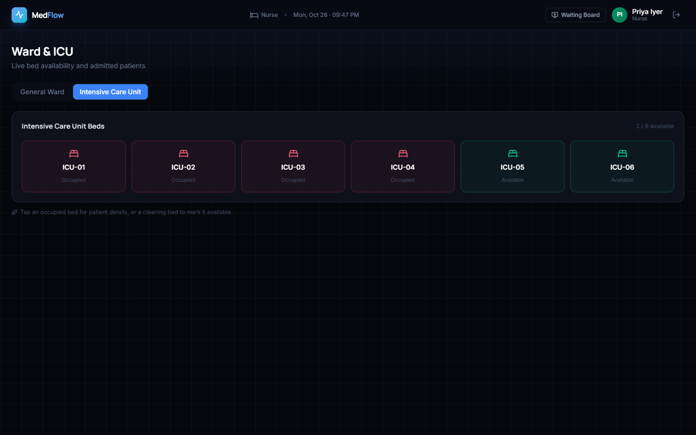
Figure 13. ICU bed board
The synthetic snapshot contains six ICU beds: four occupied and two available.

Laboratory workflow
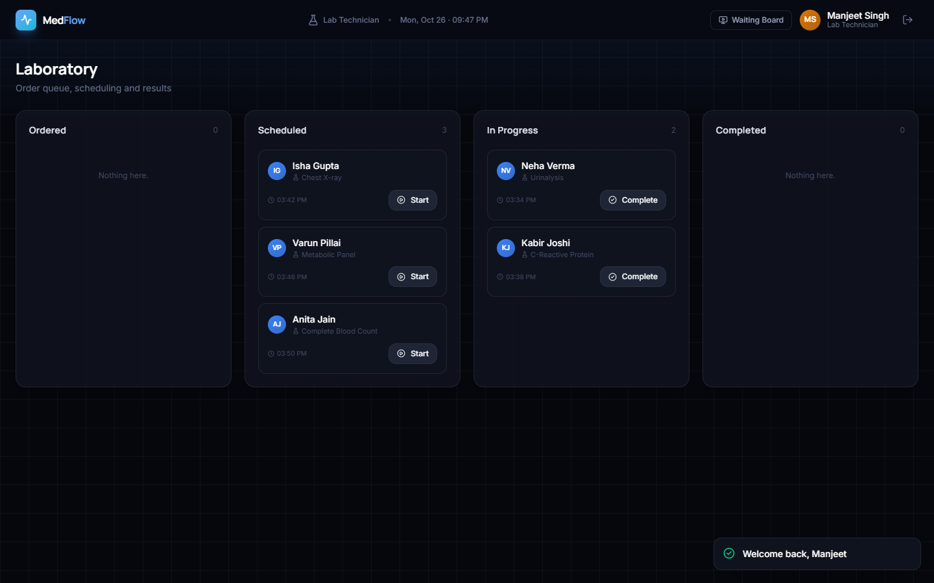
Figure 14. Laboratory workflow
Five tests appear across scheduled and in-progress columns with valid actions.

16. Objectives versus Outcomes
Table 2. Objectives and outcomes.
Objective | Outcome | Evidence
Digital tokens | Achieved | Token allocation and queue board
Movement tracking | Partially achieved | Registration and explicit department changes logged
Lab scheduling | Achieved as workflow state | Five populated tests; no optimisation study
Live bed/ICU monitoring | Achieved for state visibility | Ward and ICU boards
AI wait and priority | Prototype achieved | Measured synthetic-model results
Role dashboards | Achieved | Five staff roles plus public board

17. Success and Failure Cases
Successful cases include authenticated access, priority-first queue ordering, coherent token display, model inference, laboratory-state display, bed-capacity display and live dashboard refresh. The measured endpoints all returned HTTP 200 under the defined smoke conditions.
Observed limits include 37 critical-to-urgent triage errors in the synthetic test, the nurse page requiring an initial tab click, incomplete coupling between laboratory and visit states, seeded occupied beds without visit links, large frontend chunks and absence of automated tests. No unsupported wait-reduction claim is made.

18. Results Limitations
Both model datasets are synthetic and generated from designed distributions; they are not real patient records.
The measured model test partitions come from the same deterministic generators as training and are not independent clinical validation.
No real hospital deployment, clinician study, user-acceptance study, security audit, accessibility audit, or concurrent-load test was performed.
The 96.80% triage accuracy must be interpreted with the 63% critical-class recall; accuracy alone overstates safety-critical performance.
SQLite, a development JWT secret fallback, an unauthenticated WebSocket, and in-process broadcasting are unsuitable for production without hardening.
The landing-page claims of 42% wait reduction, 214 patients, and six departments are hard-coded marketing copy and are excluded from results.

