Department of Computer Science and Engineering (Data Science)
CSDS-A | Batch A13 (CSE - Data Science, Section A)
AI-Enabled Digital Examination Seating Management System
(SeatWise)
S.No. | Student name | Roll / hall ticket no.
1 | A.SANJAY | 23K91A6702
2 | CH.NAVEEN | 23K91A6743
3 | D.KOTESH | 24K95A6705
4 | A.AKSHITH | [Roll number to be confirmed]
Under the guidance of: [GUIDE NAME], [DESIGNATION]
RESULTS
This document reports the real results of the project: the engine benchmark, the product measurements, every output screen with a caption, the success and failure cases, and the objectives measured against the outcomes. Because nothing is trained, there are no accuracy or F1 figures; the evaluation is a benchmark of rule violations and speed.

1 Engine Performance (Benchmark Results)
Because nothing is trained, the usual measures of a learned model (accuracy, precision, recall, F1, a confusion matrix) do not exist for SeatWise, and we do not report invented substitutes. The engine is evaluated by benchmarking: it is run on seeded synthetic sittings, every plan is validated independently, and the results are compared with the three ways in which seating is usually done. The run engine-benchmark-20260921 took place on 21 September 2026 on a 12-thread Intel desktop with Windows 11, Python 3.11.9 and OR-Tools 9.15.6755. It covers 8 scenarios, 4 methods and 3 seeds (11, 12, 13), plus predictability over 6 seeds (21 to 26) and budget tuning on two scenarios.
Table 1: Measures used in the benchmark
Measure | Meaning | Target
Same-paper neighbour pairs | Neighbouring seats (8 around each seat) whose candidates write the same paper | 0
Roll-gap violations | Neighbours whose roll numbers (same prefix) are closer than the gap | 0
Accessible seats missed | Candidates needing an accessible seat who are not on one | 0
Hard rules met | Share of plans with all of the above at 0 and everyone seated | 100%
Solve time | Wall-clock seconds from request to a validated plan | seconds
Same-department pairs | Neighbours from one department (a preference, minimised) | low
Roll-to-seat correlation | Spearman correlation between roll order and seat order | about 0
Repeated neighbour pairs | Share of neighbour pairs that recur when the plan is regenerated with another seed | as low as random
Front-row bias | Largest gap between a department's share of front-row seats and its share of candidates | small

The three baselines are sequential (roll-number order, row by row, the classic spreadsheet plan), round-robin (papers interleaved in a repeating cycle, the usual improved manual plan) and random shuffle (a random permutation with no rules).

1.1 Headline results
Table 2: Headline benchmark results
Result | Value
Plans meeting every hard rule (SeatWise) | 24 of 24 (100%); baselines: 0 of 72
Same-paper neighbours, SeatWise | 0 in every run
Same-paper neighbours, sequential seating (600 candidates) | 1,253
Solve time, 600 candidates (mean) | 2.36 s
Solve time, 2,000 candidates (mean) | 4.77 s
Slowest SeatWise run in the benchmark | 6.14 s (4-neighbour mode)
Roll-to-seat correlation | 0.065 (sequential 1.000)
Neighbour pairs repeated with a new seed | 1.0% (sequential and round-robin 100%)

1.2 SeatWise in every scenario
Table 3: SeatWise results by scenario (mean of 3 seeds)
Scenario | Candidates | Solve (s) | Same-paper | Roll-gap | Accessible missed | Same-dept pairs | Halls | Seats filled
xs-150 | 150 | 1.25 | 0 | 0 | 0 | 23 | 3 | 71%
s-300 | 300 | 2.03 | 0 | 0 | 0 | 7 | 5 | 82%
m-600 | 600 | 2.36 | 0 | 0 | 0 | 109 | 9 | 96%
l-1000 | 1,000 | 2.55 | 0 | 0 | 0 | 190 | 12 | 96%
xl-2000 | 2,000 | 4.77 | 0 | 0 | 0 | 597 | 28 | 97%
m-600-adj4 | 600 | 6.02 | 0 | 0 | 0 | 12 | 9 | 96%
m-600-gap0 | 600 | 2.31 | 0 | 0 | 0 | 108 | 9 | 96%
m-600-gap10 | 600 | 2.42 | 0 | 0 | 0 | 104 | 9 | 96%

1.3 Baselines in every scenario
Table 4: Violations left by the baselines (mean of 3 seeds; every baseline run failed at least one hard rule)
Scenario | Same-paper: seq. | round-robin | random | Roll-gap: seq. | round-robin | random | Accessible missed (seq.)
xs-150 | 307 | 41 | 116 | 122 | 44 | 21 | 3
s-300 | 648 | 63 | 171 | 231 | 56 | 21 | 3
m-600 | 1,253 | 281 | 265 | 453 | 198 | 23 | 6
l-1000 | 1,954 | 607 | 376 | 755 | 408 | 21 | 11
xl-2000 | 3,299 | 511 | 490 | 1,528 | 351 | 18 | 16
m-600-adj4 | 704 | 216 | 145 | 453 | 166 | 12 | 6
m-600-gap0 | 1,253 | 281 | 265 | 0 | 0 | 0 | 6
m-600-gap10 | 1,253 | 281 | 265 | 921 | 252 | 48 | 6

The baselines fill halls in the order given, so they sometimes use one more hall than SeatWise's compact strategy. In the gap-0 scenario the baselines have no roll-gap violations because the rule is switched off, but they still leave same-paper neighbours and accessible-seat misses.
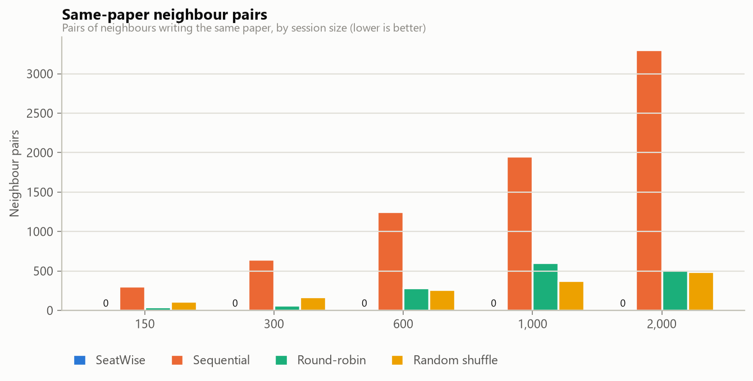
Fig. 1: Same-paper neighbour pairs by method and sitting size
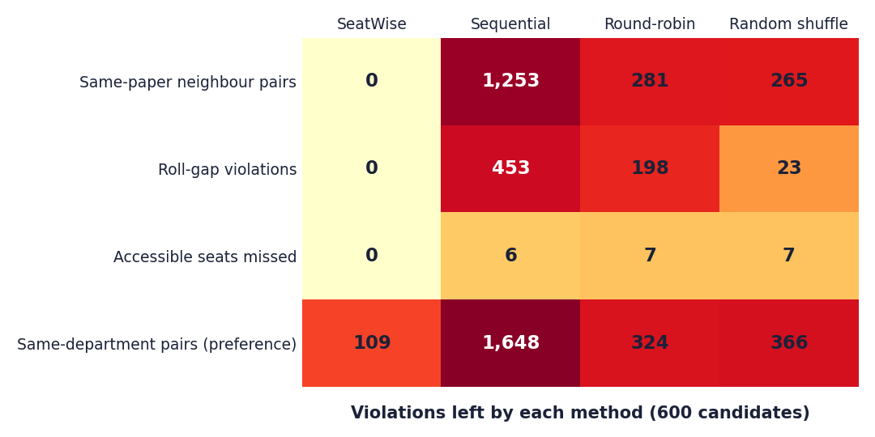
Fig. 2: Violations left by each method at 600 candidates (the equivalent of a confusion matrix for an optimisation engine)
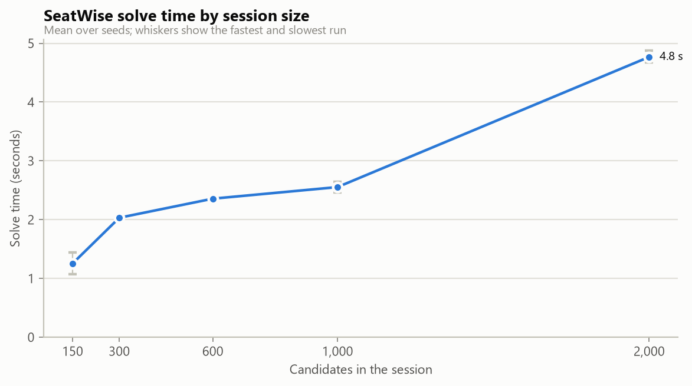
Fig. 3: Solve time by sitting size

1.4 Unpredictability and fairness
Table 5: Unpredictability of each method (600 candidates, 6 seeds)
Method | Roll-to-seat correlation | Repeated neighbour pairs | Front-row bias (percentage points)
SeatWise | 0.065 | 1.0% | 4.7
Sequential | 1.000 | 100% | 12.4
Round-robin | 0.213 | 100% | 3.4
Random shuffle | 0.034 | 1.0% | 1.6

SeatWise is as unpredictable as a pure random shuffle: neighbours almost never repeat, and roll order says nothing about the seat. Unlike the shuffle it keeps every rule. Its front-row bias is small but higher than a shuffle's, because a paper occupies one colour class per hall and only two of the four classes include the front row; which paper gets which class is itself random, so the bias shrinks as more plans are drawn.
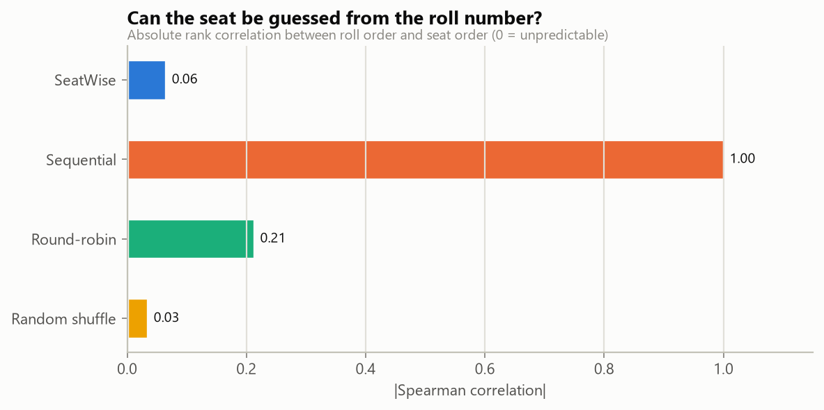
Fig. 4: Roll-to-seat correlation by method
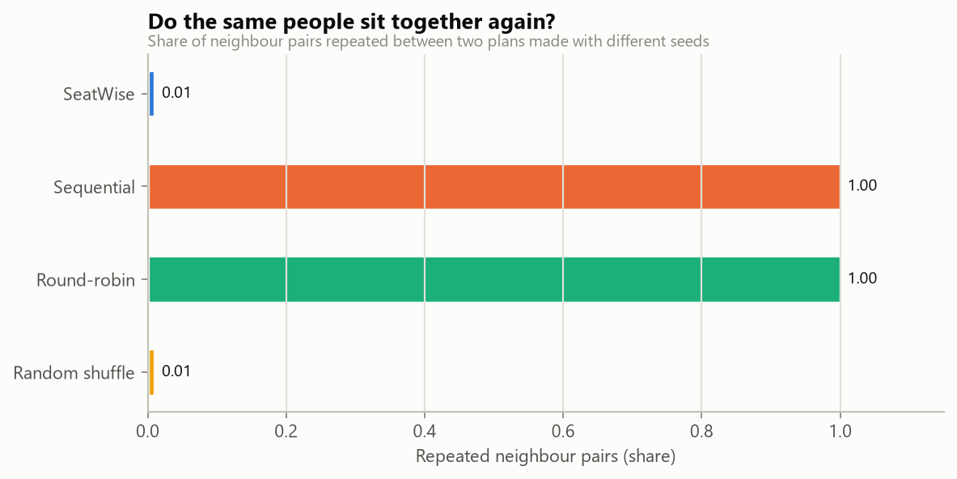
Fig. 5: Neighbour pairs repeated across seeds
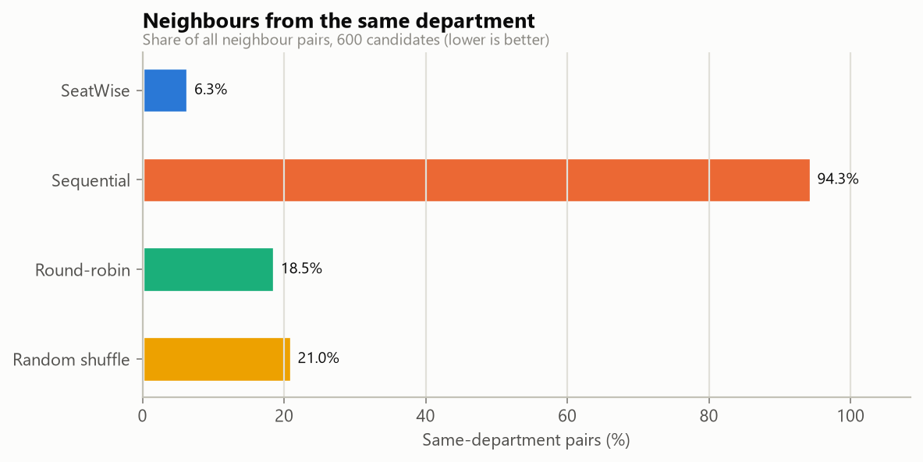
Fig. 6: Department mix by method
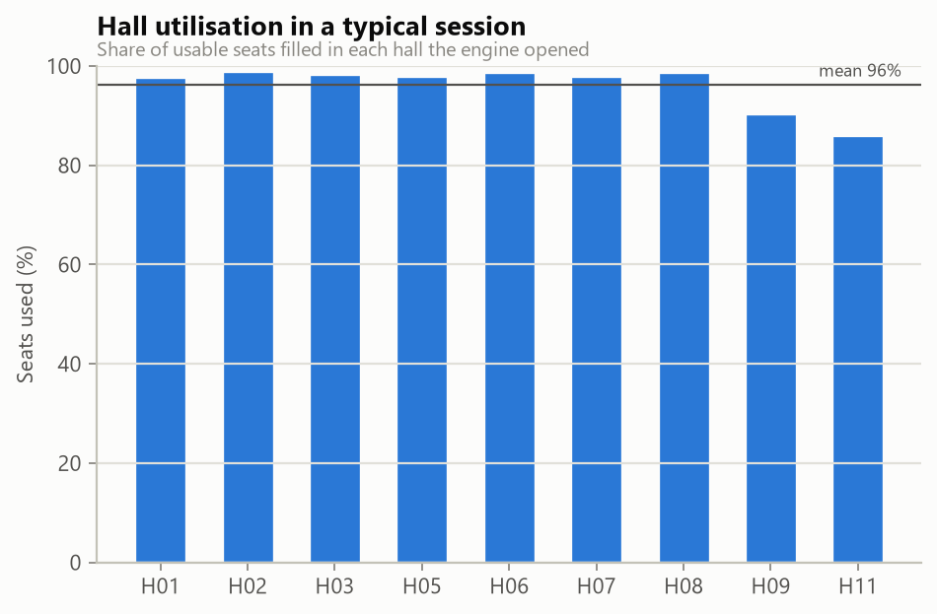
Fig. 7: Hall utilisation by method

1.5 Observations
- Correctness is structural. Stage A confines each paper to one colour class per hall, and seats of one class are never neighbours, so same-paper neighbours are impossible before Stage B starts. This is why no run has any.
- Four-neighbour adjacency is slower (6.0 s against 2.4 s for 600 candidates) because its two classes each cover half the hall, so Stage B has twice as many seat choices per candidate; it also gives far fewer same-department neighbours (12 against 109).
- Scaling is close to linear in the number of halls: halls are solved in parallel and most of the time goes to the deterministic per-hall budget.
- Reproducibility. Re-running with the stored seed reproduces the plan exactly; the Verify action and the test suite both check this.
- Department mix is a preference, not a rule: SeatWise leaves 109 same-department pairs at 600 candidates against 1,648 for sequential seating.

2 Product Measurements
The product was also measured through its own interface and API on 15 October 2026. Three sittings of the sample timetable were planned with random seeds, each solved in about two seconds, with no rule violated.
Table 6: Plans generated in the demonstration scenario
Sitting | Candidates | Halls | Same-paper pairs | Conflicts avoided vs roll order | Solve (s)
Mon 12 Oct 2026 Morning | 451 | 6 | 0 | 1,099 | 2.1
Mon 12 Oct 2026 Afternoon | 457 | 7 | 0 | 1,175 | 1.8
Tue 13 Oct 2026 Morning | 451 | 7 | 0 | 1,105 | 2.2

For plan 1 the scorecard recorded 451 candidates in 6 halls with 92% of their seats filled, 0 same-paper neighbours, 0 roll-gap violations, no accessible seat missed and 1 same-department neighbour pair; the roll-order baseline for the same sitting had 1,099 same-paper pairs, 342 roll-gap violations and 7 accessible-seat misses. Stage A took 1.15 s and Stage B 0.97 s of the 2.1 s. API response times are in Chapter 7.

3 Functional Testing: the Scripted Scenario
The scenario script performs the definition-of-done flow through the API of a running installation and stops at the first failure. It was run on 15 October 2026 against an empty database.
Table 7: Scripted scenario results
Step | Action | Result
1 | Import the sample workbook | Validation passed: 1,020 rows, 10 warnings; imported 908 candidates, 49 courses, 14 halls, 6 sittings
2 | Generate and publish plans for three sittings | Mon 12 Oct 2026 Morning: 451 candidates in 6 halls, 0 same-paper neighbours, 1,099 avoided, 2.1 s; Mon 12 Oct 2026 Afternoon: 457 candidates in 7 halls, 0 same-paper neighbours, 1,175 avoided, 1.8 s; Tue 13 Oct 2026 Morning: 451 candidates in 7 halls, 0 same-paper neighbours, 1,105 avoided, 2.2 s
3 | Try an illegal swap (A1 to A2) | Blocked: the candidate would sit next to a neighbour who writes the same course (reason shown)
3 | Download outputs | seating-charts.pdf 135 KB; invigilator-sheets.pdf 147 KB; qr-slips.pdf 1,666 KB; hall-lists.xlsx 47 KB; attendance.xlsx 28 KB
4 | Seat lookup and QR slip | BMG24064 (Zoe A.) sits in EW-205 seat A2; slip PDF of 64 KB downloaded
4 | Attendance as an invigilator | Two candidates marked present in EW-205 (2 present, 72 to mark)
 | Whole scenario | Passed in 11.4 s

4 Performance Testing
Solve time was measured by the engine benchmark (Chapter 8). API latencies were measured on 15 October 2026 against the development server on the benchmark machine with the sample data loaded: thirty calls per endpoint after one warm-up (five for the file downloads and Verify, twenty for the public lookup, which is rate-limited to thirty requests a minute).
Table 8: API response times
Endpoint | Median (ms) | 95th percentile (ms)
GET /health | 1.9 | 2.6
GET /data/summary | 4.0 | 4.6
GET /plans/1 | 4.1 | 4.7
GET seat map (hall) | 7.2 | 10.8
GET swap-check (one seat) | 8.0 | 11.4
GET /candidates?q=ACF | 9.3 | 12.9
GET /sessions | 10.7 | 12.1
GET public lookup | 2.8 | 3.2
GET seating-charts.pdf | 96.0 | 96.0
GET hall-lists.xlsx | 314 | 354
GET qr-slips.pdf | 3,208 | 3,236
POST verify plan | 2,178 | 2,191

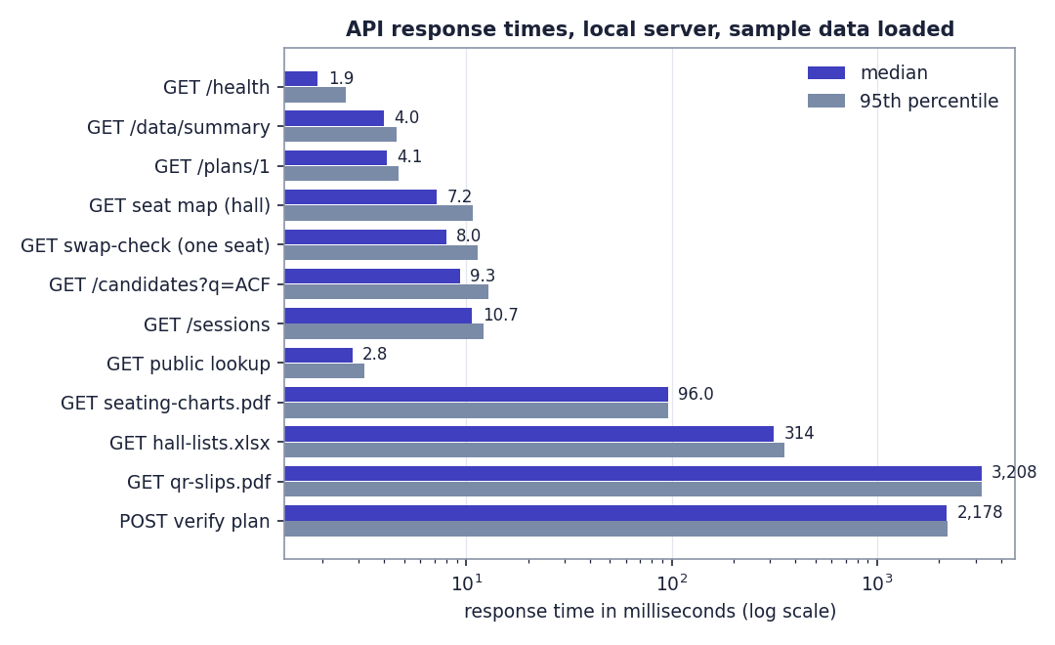
Fig. 8: API response times on a logarithmic scale
Interactive endpoints answer in 2 to 11 ms. File generation is slower, as expected: the QR-slip PDF (76 pages for the first plan) takes 3.2 s, and Verify, which re-runs the engine, takes 2.2 s. Not measured: memory use, behaviour under many simultaneous users, and other hardware.

5 Output Screens
All screens below are real captures of the running application at 1440 x 900 with the sample dataset imported, three plans published and attendance marked for one hall. Nothing is mocked up. The same screens are described in the user guide.
The public front page: a hero with an example seat grid, the Get started and Find my seat actions, and the headline results of the engine benchmark read from the stored run: 1,253 same-paper neighbours avoided in a 600-candidate sitting compared with roll order, 2.36 s to seat 600 candidates (2,000 take 4.8 s), a roll-to-seat correlation of 0.065, and 24 benchmark runs, every one meeting every hard rule.
Email and password sign-in, with Demo workspace buttons for the exam controller and the invigilator, and links to request an account and to find a seat without signing in.
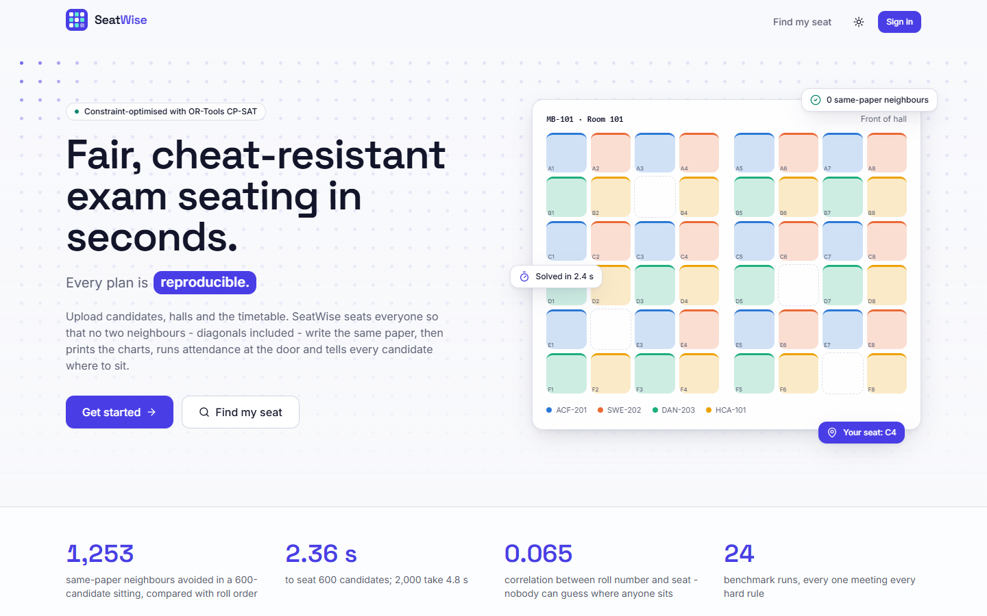  Fig. 9: Public home page | 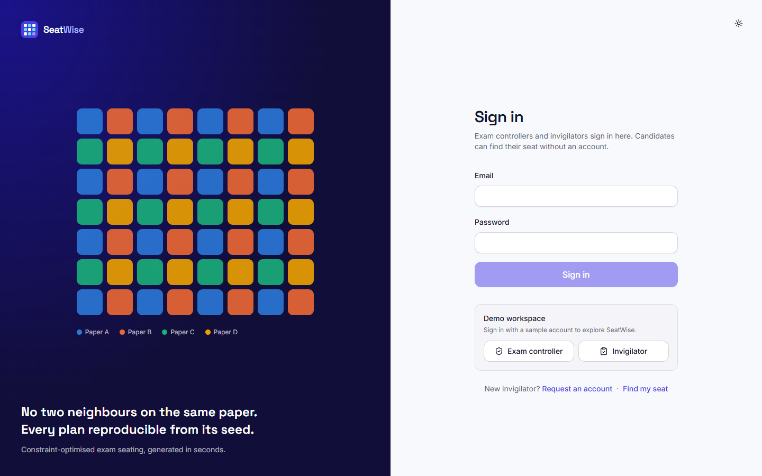  Fig. 10: Sign-in page

Invigilators request an account with name, work e-mail and a password of at least eight characters; the account waits for administrator approval.
The hero tile shows 3,379 same-paper neighbours avoided across three published sittings compared with roll-order seating (remaining: 0). The tiles show 1,359 candidates seated, 3 of 6 sittings published, an average solve time of 2.0 s (slowest 2.2 s), attendance at 95% (57 present, 3 absent, 1,299 still to mark), 100% of plans meeting every rule, and 14 halls, 7 of them used. The charts show attendance by sitting and solve time per plan.
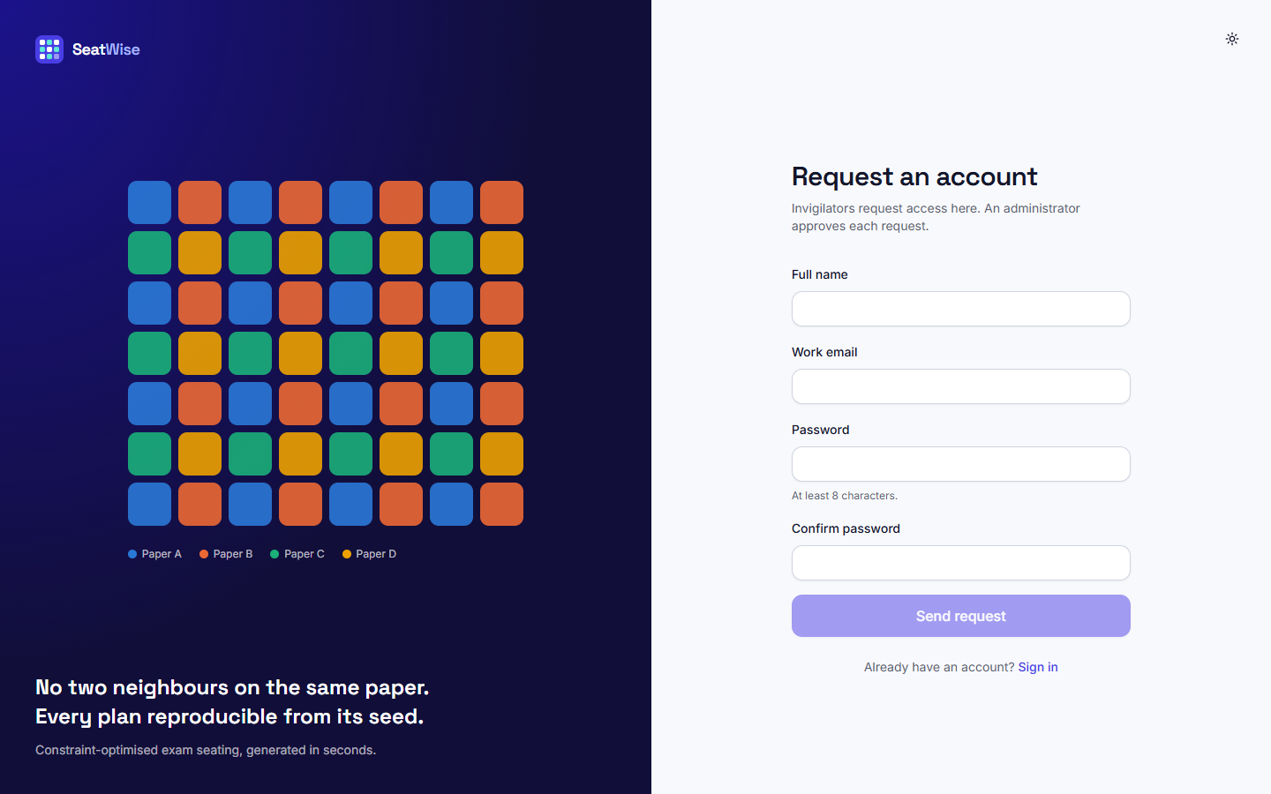  Fig. 11: Request an account | 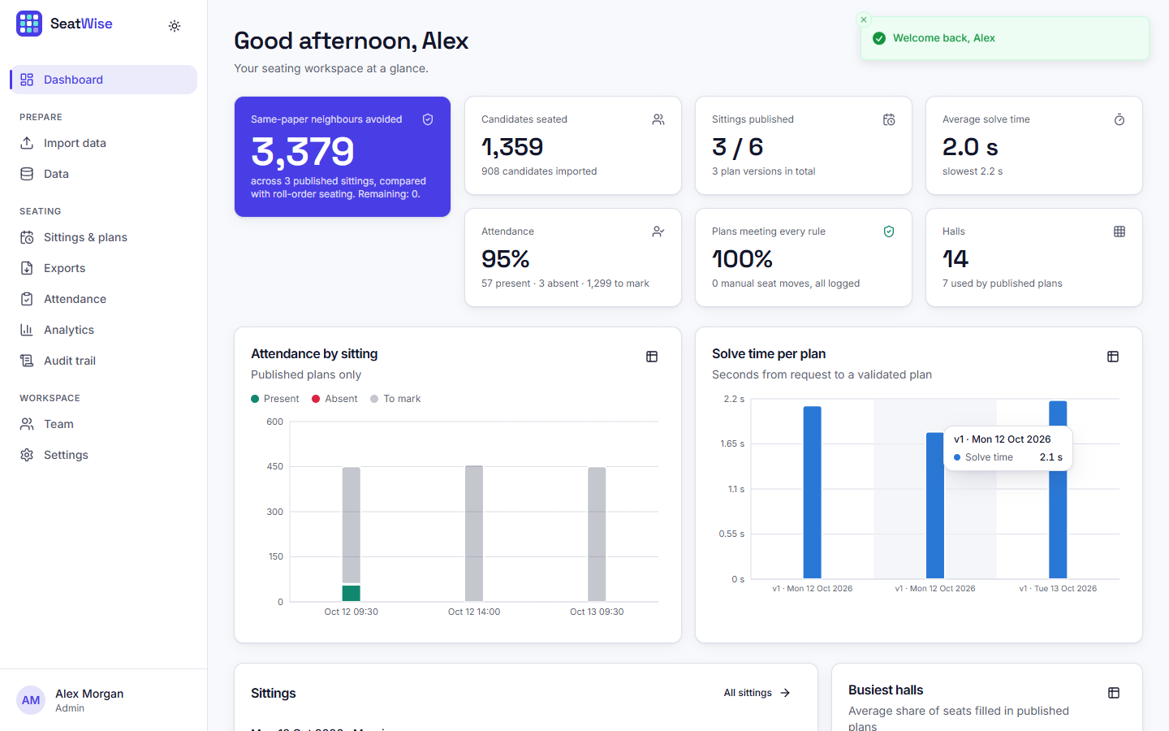  Fig. 12: Administrator dashboard after three plans and one register

The three steps of an import: what is being imported (everything, courses, halls, candidates or timetable), how it is applied (add and update, or replace), and the upload area, with the list of recent imports below.
Validation passed: 1,020 of 1,020 rows are valid with 10 warnings. The sheet summaries show 49 courses, 14 halls (10 warnings), 908 candidates and 49 timetable rows. The problems table lists each warning with its sheet, row and column; here every warning says that no accessible seats were given and the front-row seats A1 and A2 were used. Nothing is saved until Import is pressed.
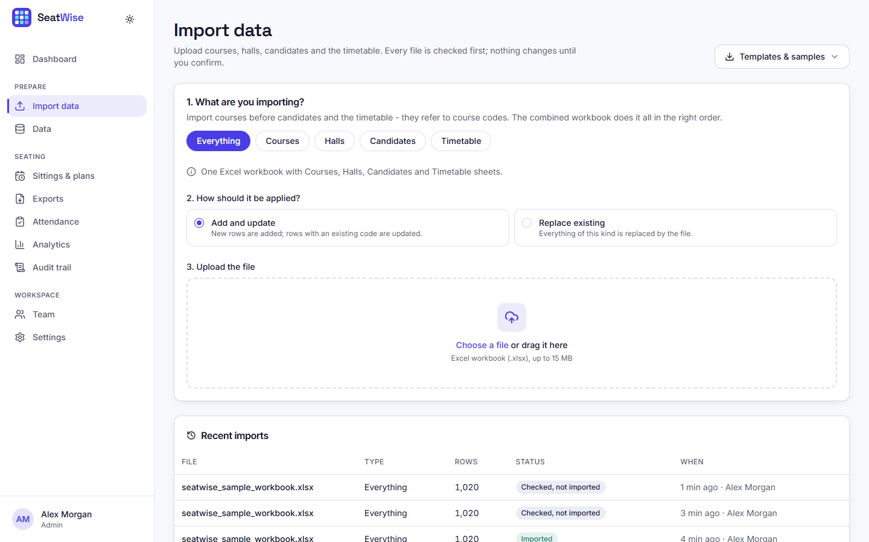  Fig. 13: Import page before upload | 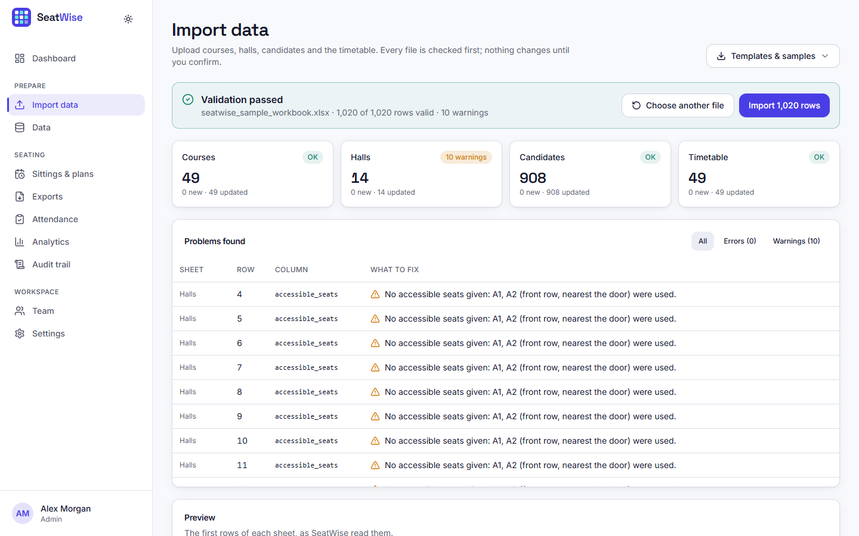  Fig. 14: Validation report for the sample workbook

The candidate tab lists the 908 imported candidates with roll number, name, department and courses, a search box and a department filter; further tabs show courses, halls and the timetable.
The six sittings of the sample timetable with their candidates, papers and plan status: three are published, three show Plan seating.
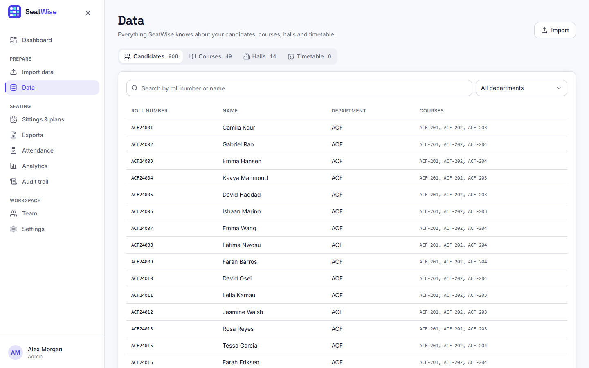  Fig. 15: Data page: candidates | 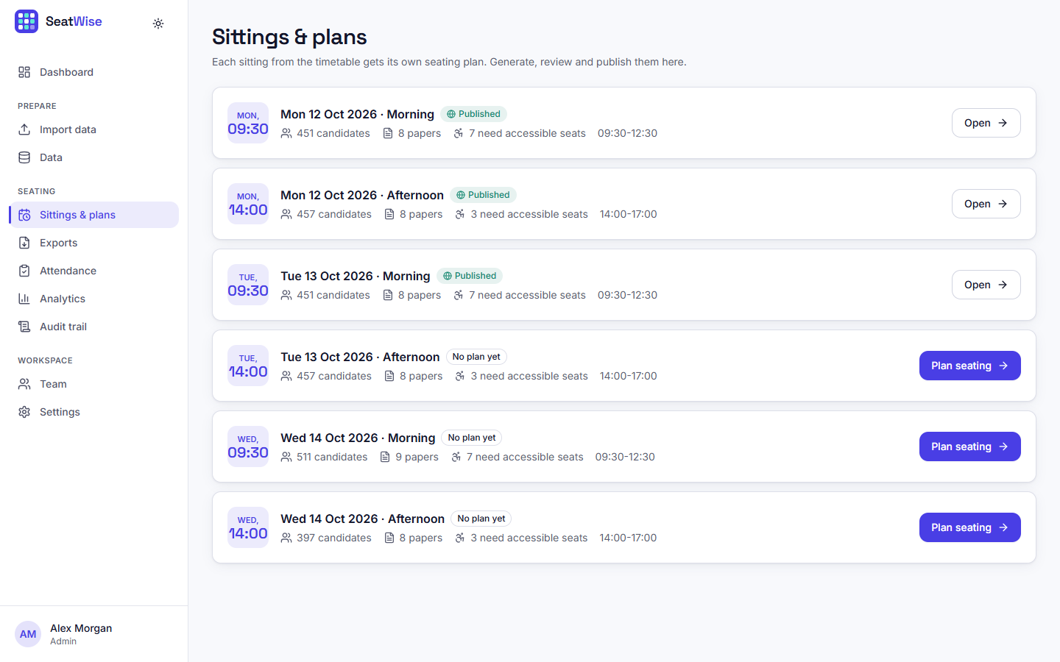  Fig. 16: Sittings and plans

Version 1 of Mon 12 Oct 2026 (morning), published, with its seed. The scorecard shows 0 same-paper neighbours, 0 roll-gap violations, 1,099 conflicts avoided compared with roll order, accessible seating honoured for everyone who needs it, a solve time of 2.1 s, and 6 halls used with 92% of their seats filled. The halls table lists seats used, papers and the assigned invigilator of each hall.
Running the engine again with the stored seed on unchanged data gives an identical result: the stored engine result and the recomputed one have the same hash, so the plan was not hand-picked.
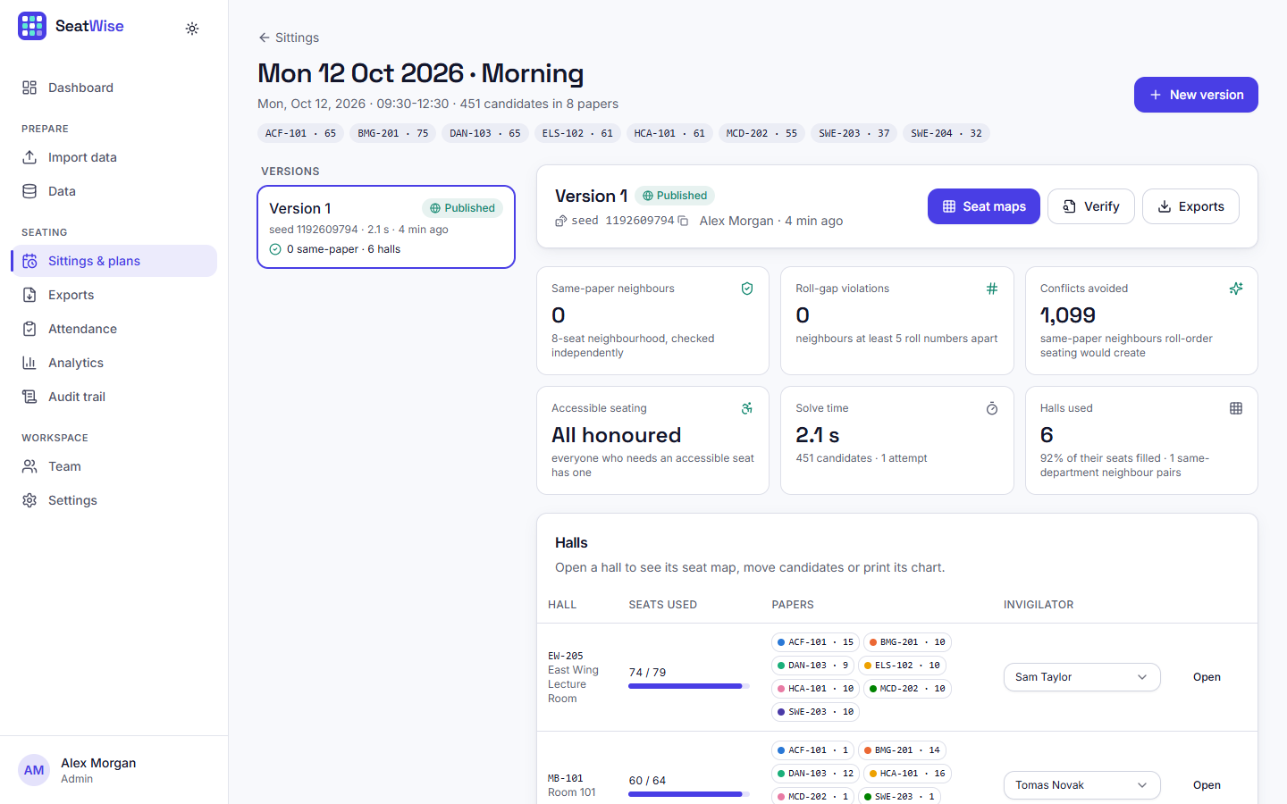  Fig. 17: Plan page with scorecard | 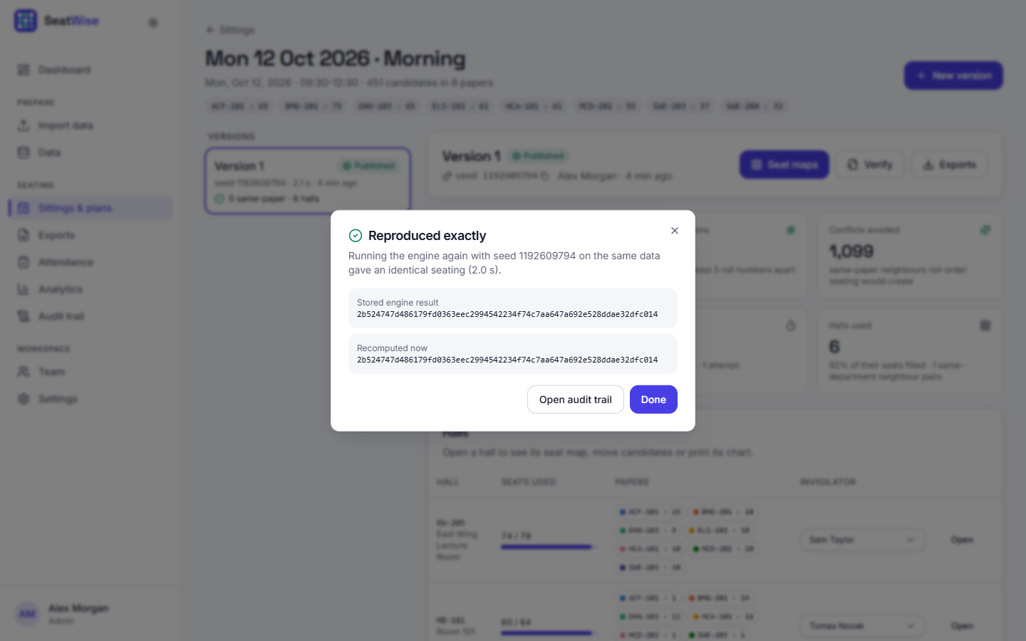  Fig. 18: Verify: reproduced exactly

Hall MB-G01 (Main Hall A) with 105 of 118 seats used and 8 papers. Seats are tinted by paper, aisles are gaps, hatched seats are blocked and the wheelchair mark shows accessible seats. The side panel shows that every rule is met in this hall.
After picking up the candidate on seat A1, every other seat is outlined green (the move keeps every rule) or red (it does not). The side panel names the candidate being moved and shows the verdict for the seat under the pointer.
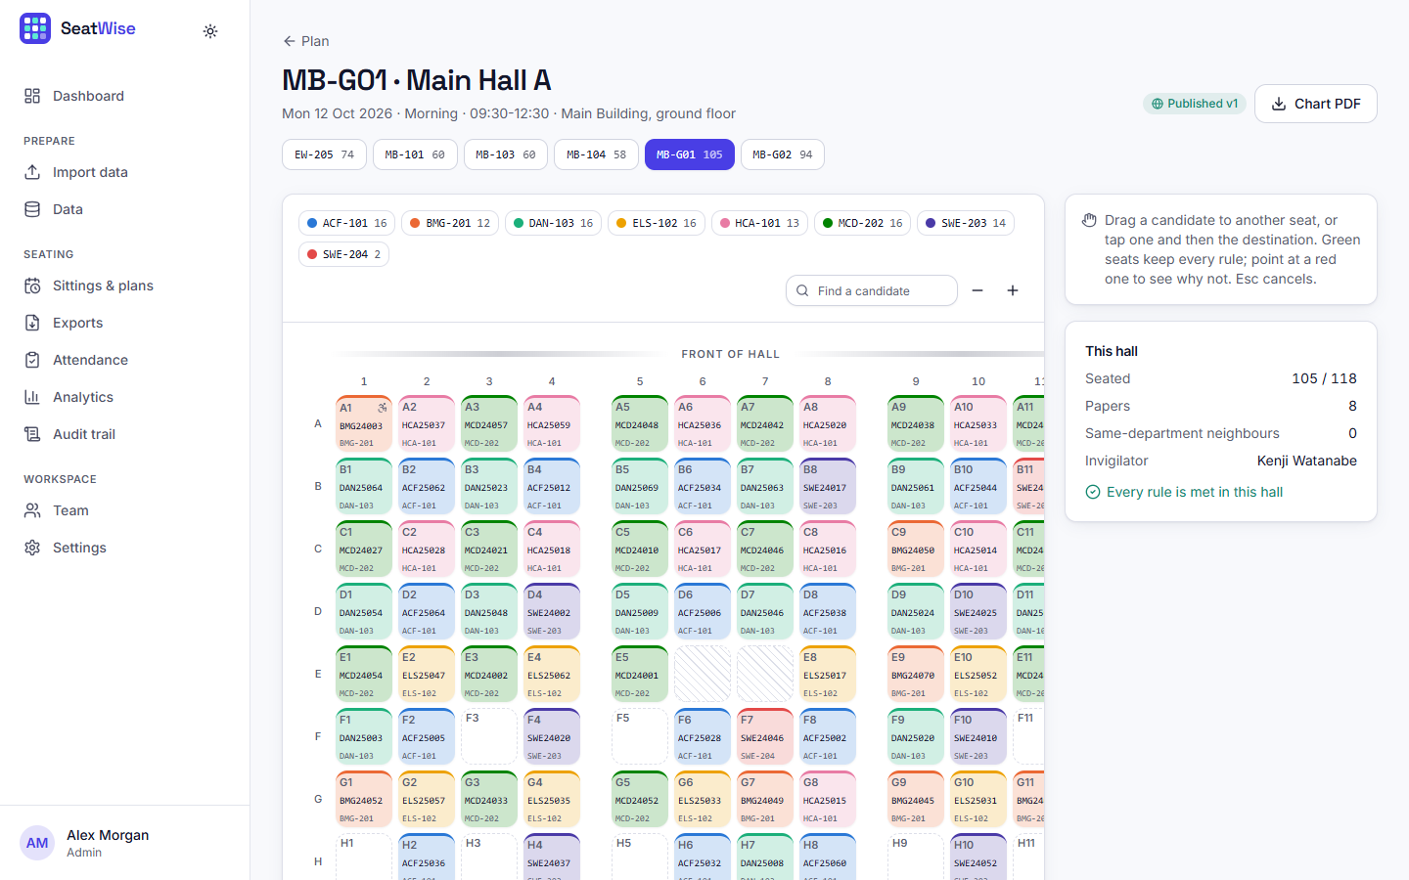  Fig. 19: Seat map of a hall | 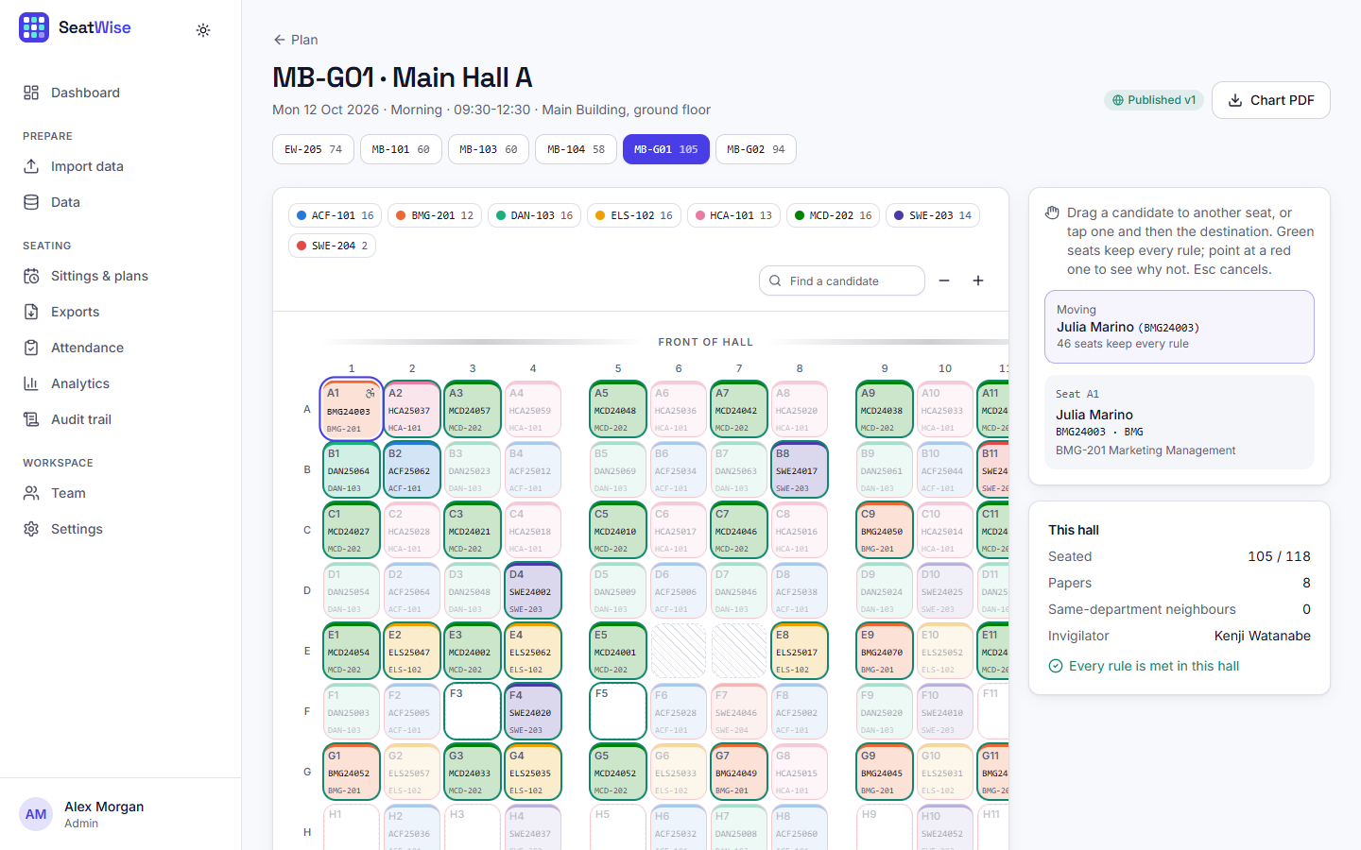  Fig. 20: Seat map with a candidate picked up

Dropping the candidate on a red seat is refused. The message reads: HCA25059 would sit next to HCA25037 (A2) - both write HCA-101. The refusal is the live rule check working on the same code as the engine.
A plan and a hall (or all halls) are chosen, and five files can be downloaded: seating charts (PDF), hall-wise lists (Excel), invigilator sheets (PDF), seat slips with QR codes (PDF) and the attendance report (Excel).
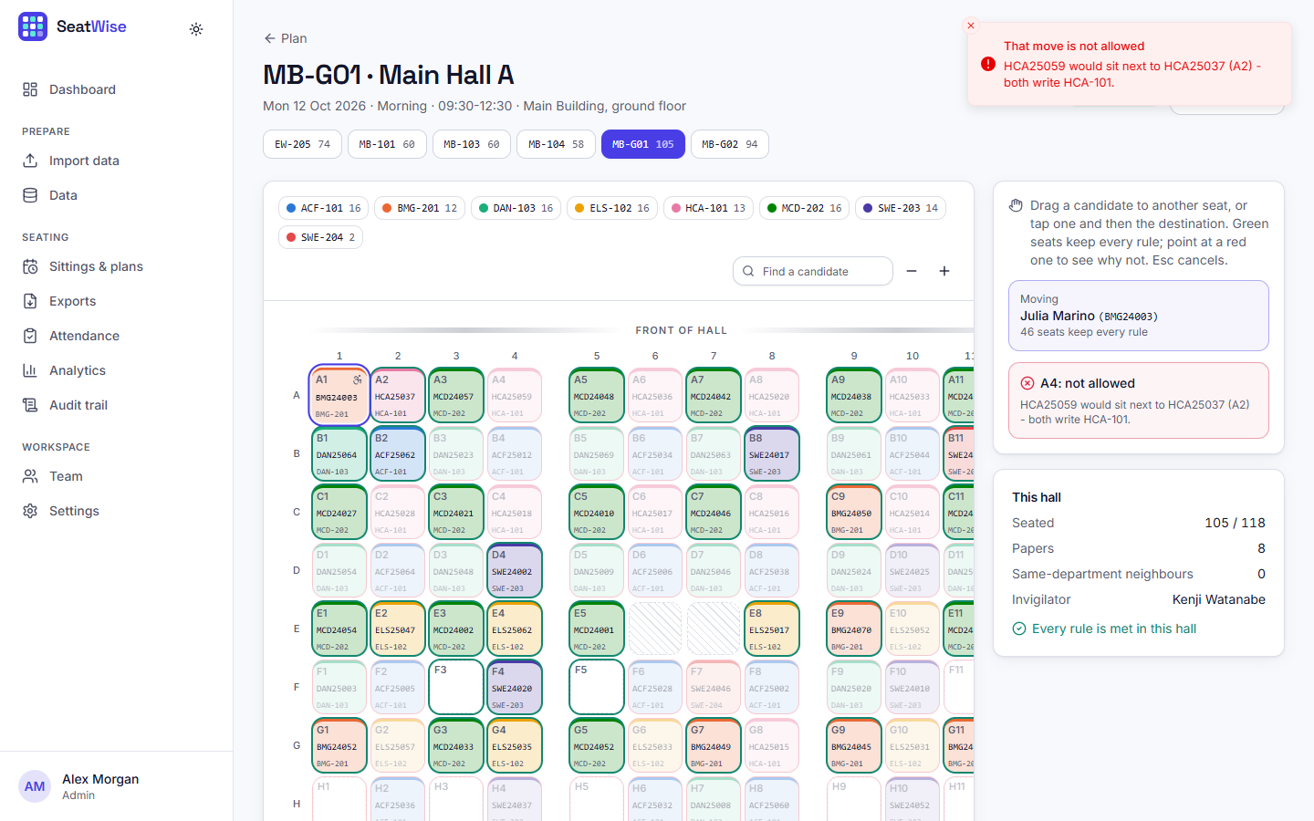  Fig. 21: An illegal move is refused with the reason | 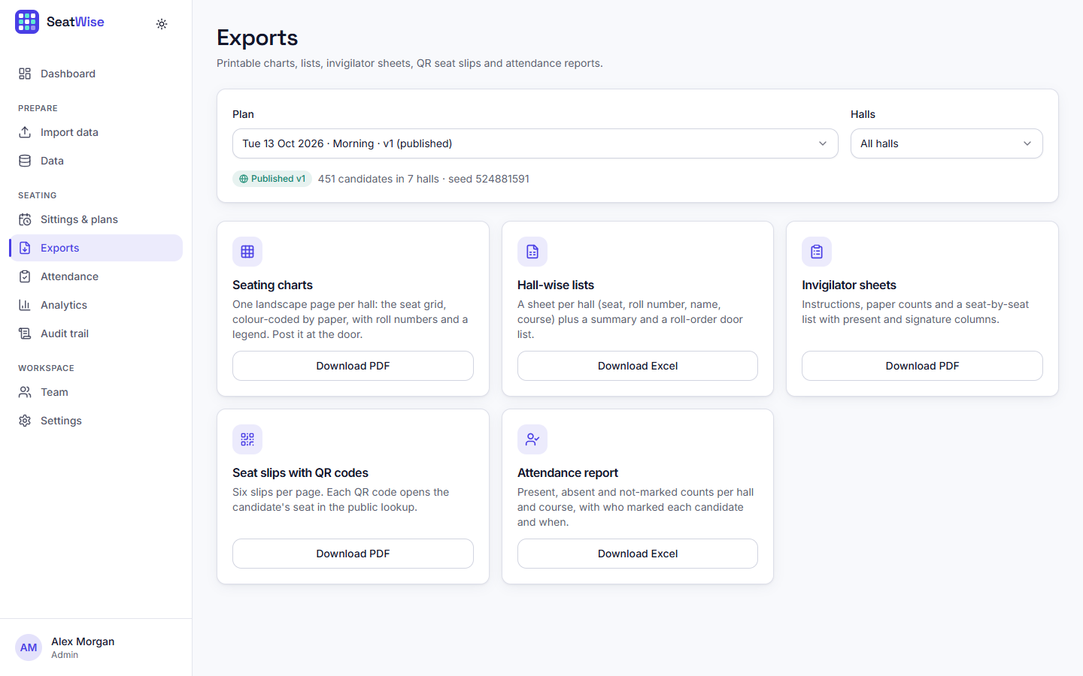  Fig. 22: Exports page

For the selected plan the page shows same-paper neighbours (0, with 1,105 avoided), solve time, seats filled, and neighbour pairs, a bar chart that compares SeatWise with roll-order seating for each rule, and seats filled per hall.
The benchmark as seen by the administrator: 100% of plans satisfy every hard rule across 8 scenarios and 3 seeds, 2.4 s for 600 candidates, 1,253 conflicts avoided compared with roll order, and a roll-to-seat correlation of 0.06, with charts of solve time by session size and same-paper pairs by method.
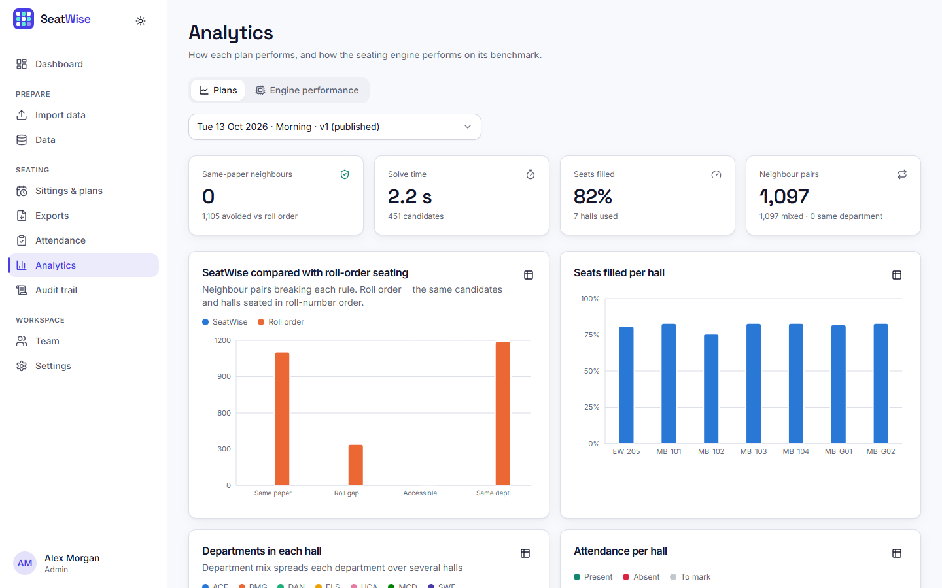  Fig. 23: Analytics: plan figures | 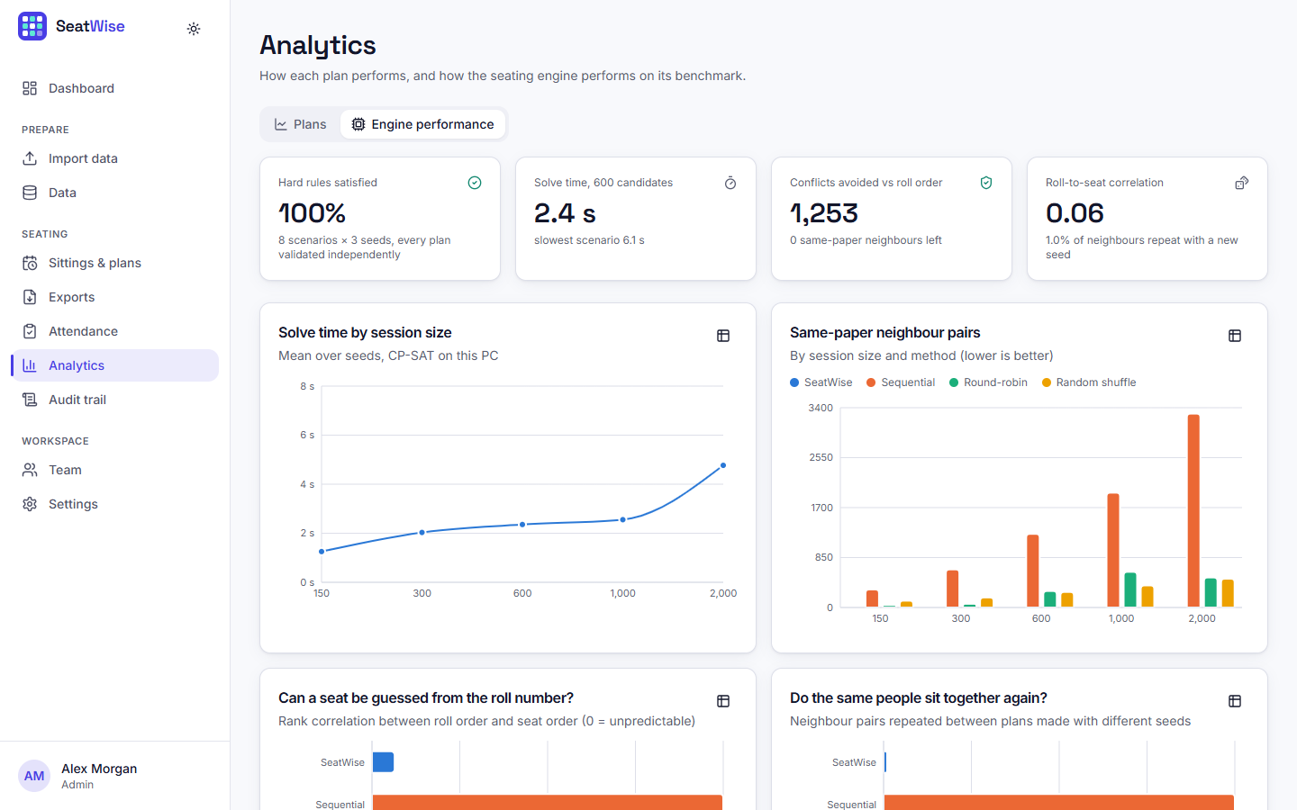  Fig. 24: Analytics: engine performance

A filterable, append-only log: plan versions with their seeds and results, publications, downloads and verifications, each with the person, the time and a link to the plan.
Accounts of the administrator and the invigilators with role, status and last sign-in; new people can be added and requests approved.
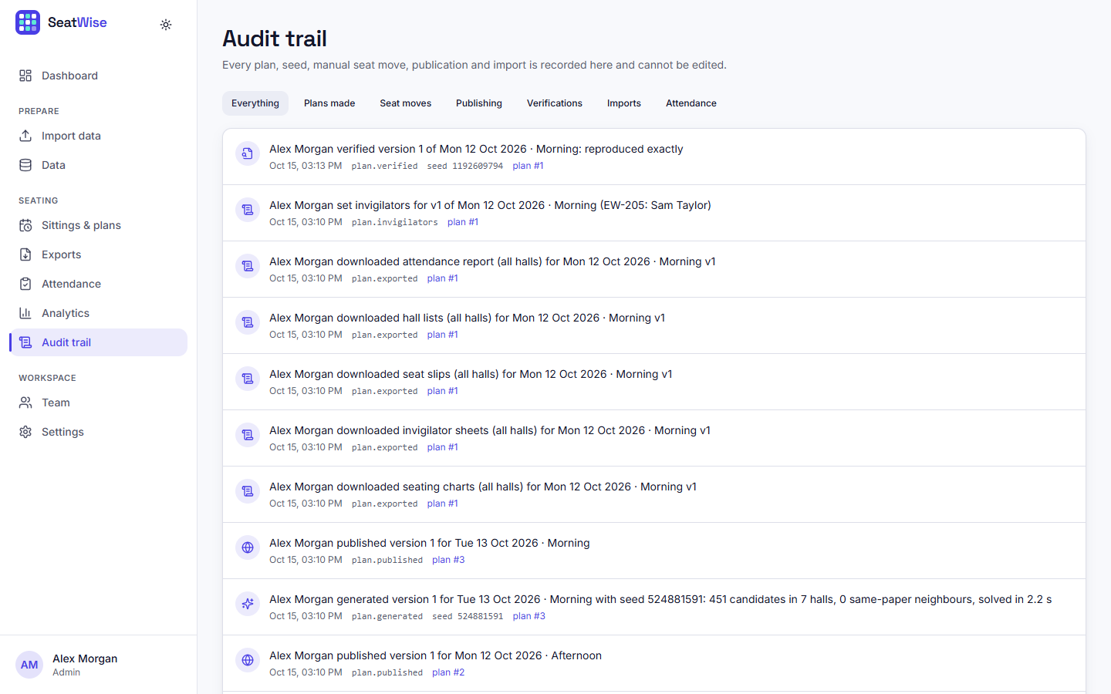  Fig. 25: Audit trail | 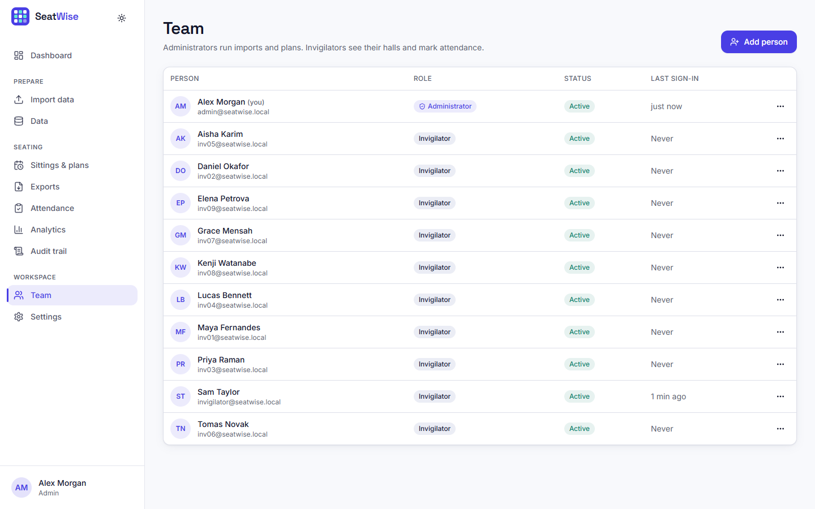  Fig. 26: Team page

The default rules used to pre-fill new plans: 8 or 4 neighbours, the roll-number gap (5), department mix, compact or balanced hall usage, and the number of accessible seats per hall when a hall lists none (2).
The public page where a candidate enters a candidate ID.
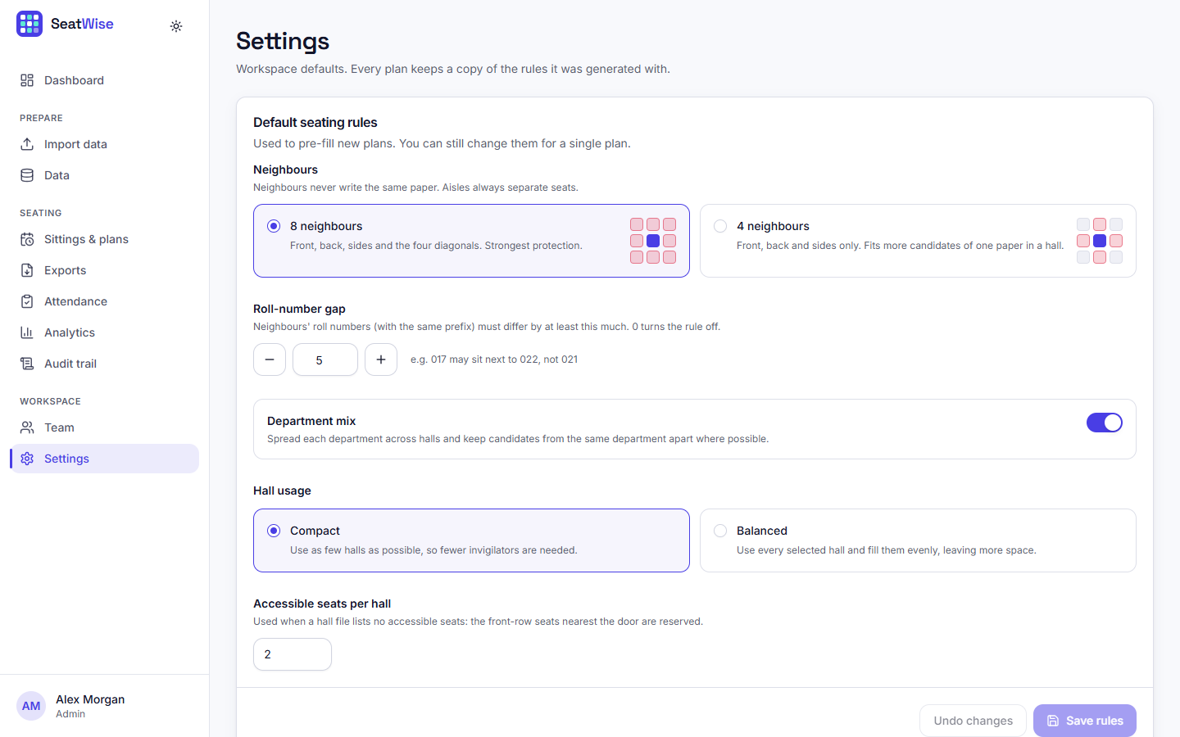  Fig. 27: Settings: default seating rules | 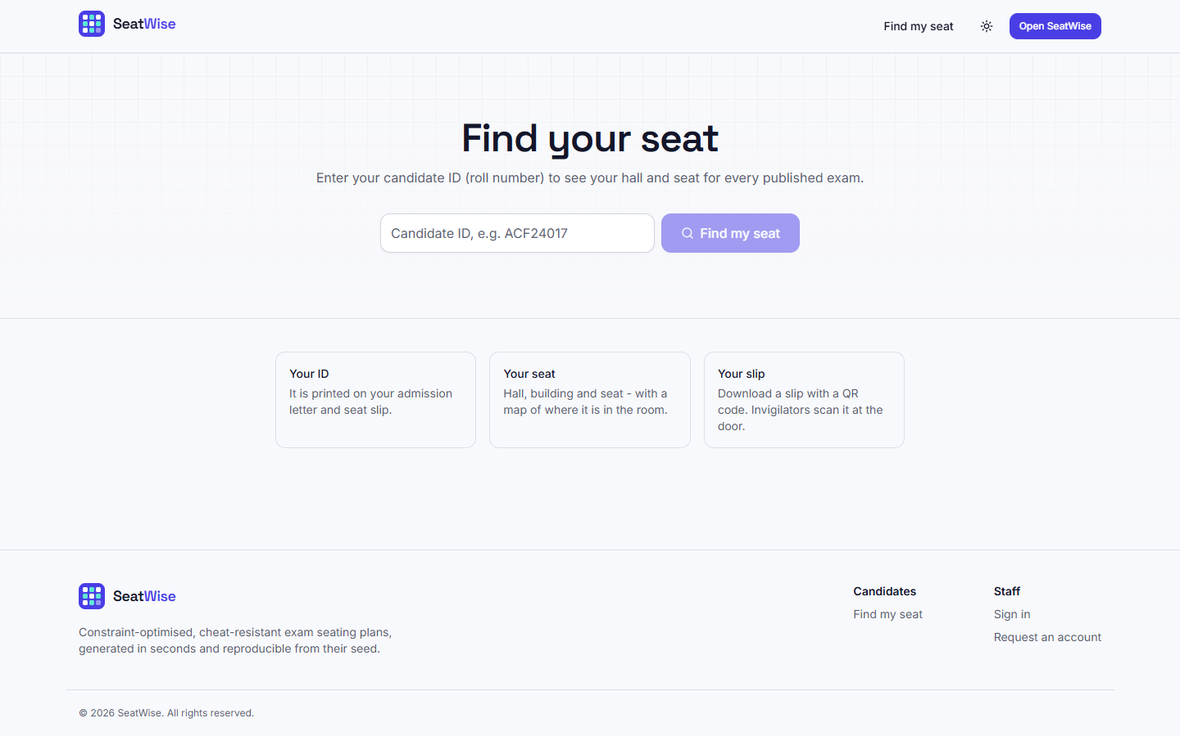  Fig. 28: Find my seat

For candidate BMG24003 the page greets "Julia M." (a shortened name), shows the sitting, the course, the hall, the seat A1 and a mini map of the hall with the seat marked, and offers the seat slip (PDF) and the QR code. No e-mail or date of birth is shown.
The same plan page in the dark theme; light, dark and system themes are available everywhere.
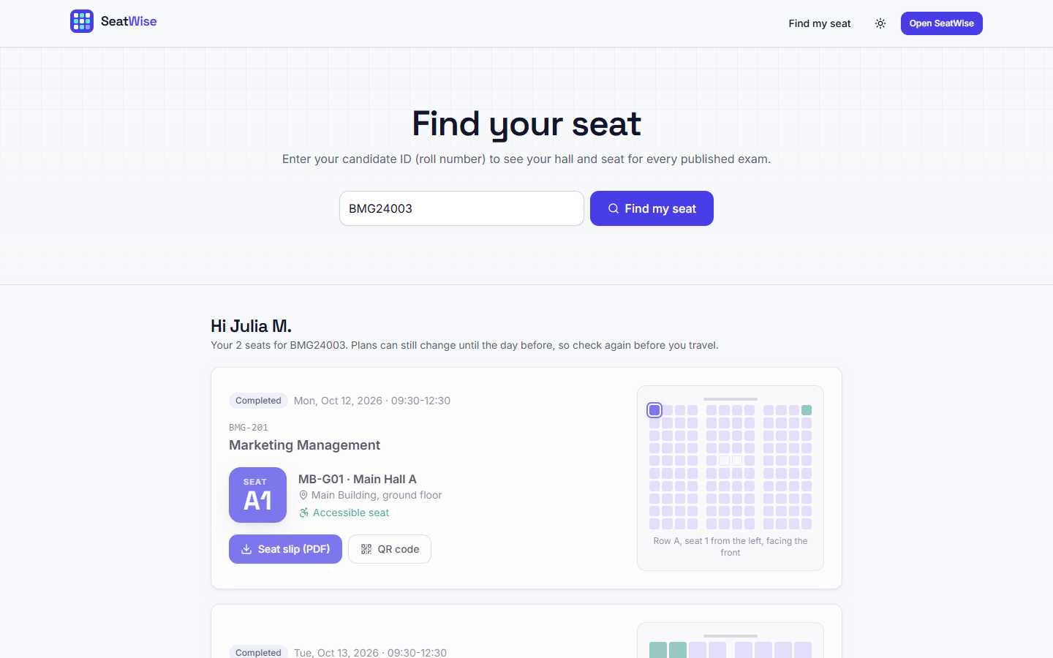  Fig. 29: Seat lookup result | 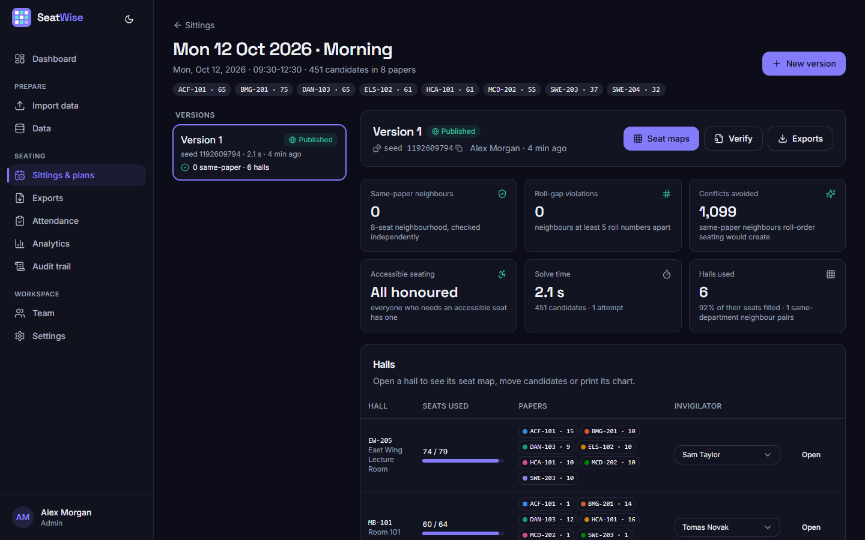  Fig. 30: Plan page in the dark theme

The invigilator sees the halls to supervise, grouped by sitting, with progress bars: EW-205 is in progress (57 present, 3 absent, 14 to mark) and the others have not started.
Counters for present (57), absent (3) and to mark (14); a scan or type box; filters and search; a Present and an Absent button for every seat; and a bottom bar with Mark remaining absent and Submit (enabled only when everyone is marked).
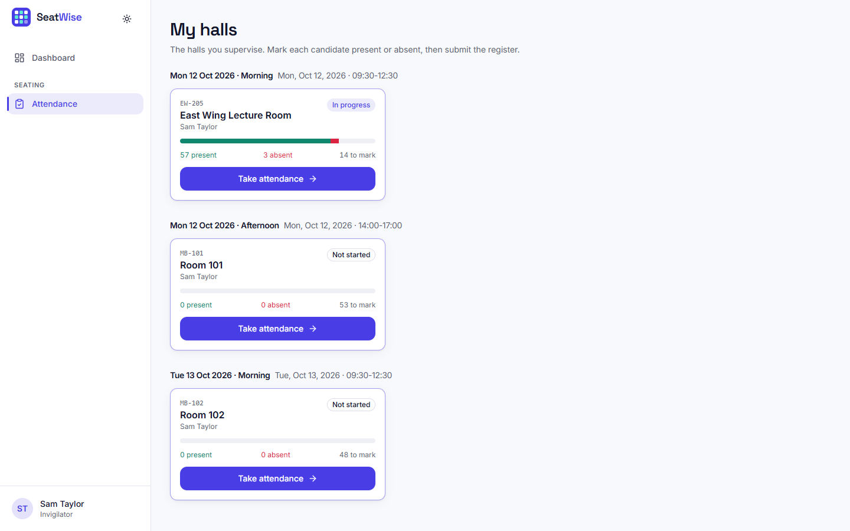  Fig. 31: My halls (invigilator) | 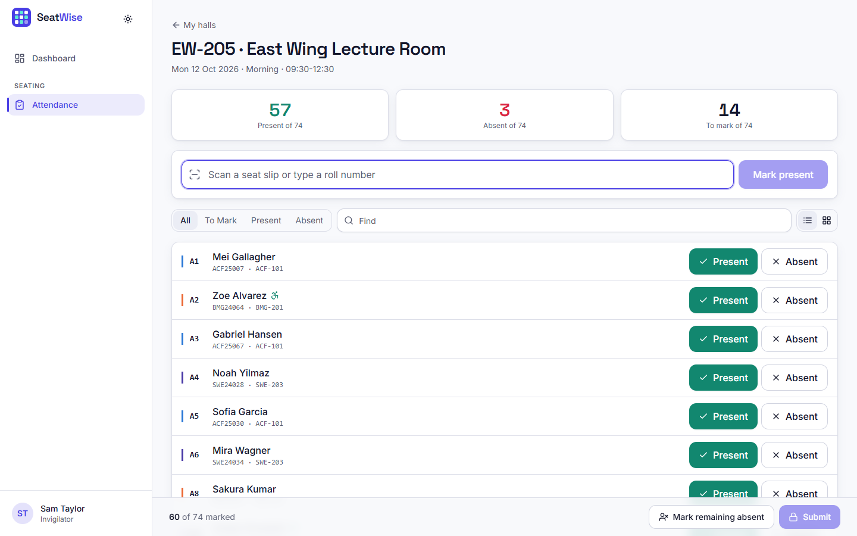  Fig. 32: Tablet attendance: list view

The same register as a seat map: present candidates are green, absent red; tapping a seat cycles present, absent and cleared.
One landscape page per hall: the grid colour-coded by paper with roll numbers and course codes, the paper legend with counts, the invigilator, and a footer with the plan version, the seed and the seating fingerprint.
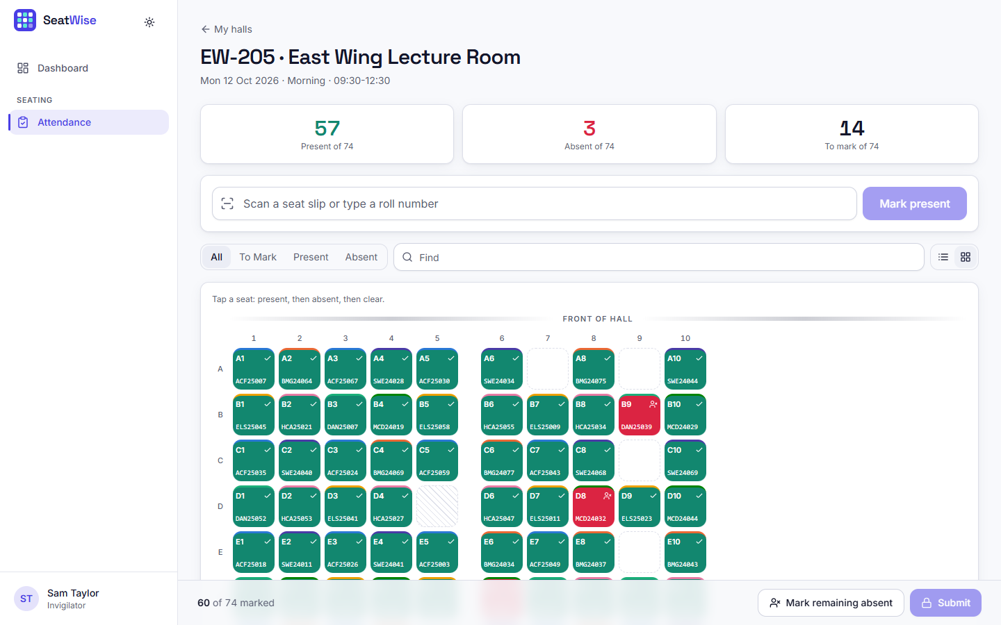  Fig. 33: Tablet attendance: seat-map view | 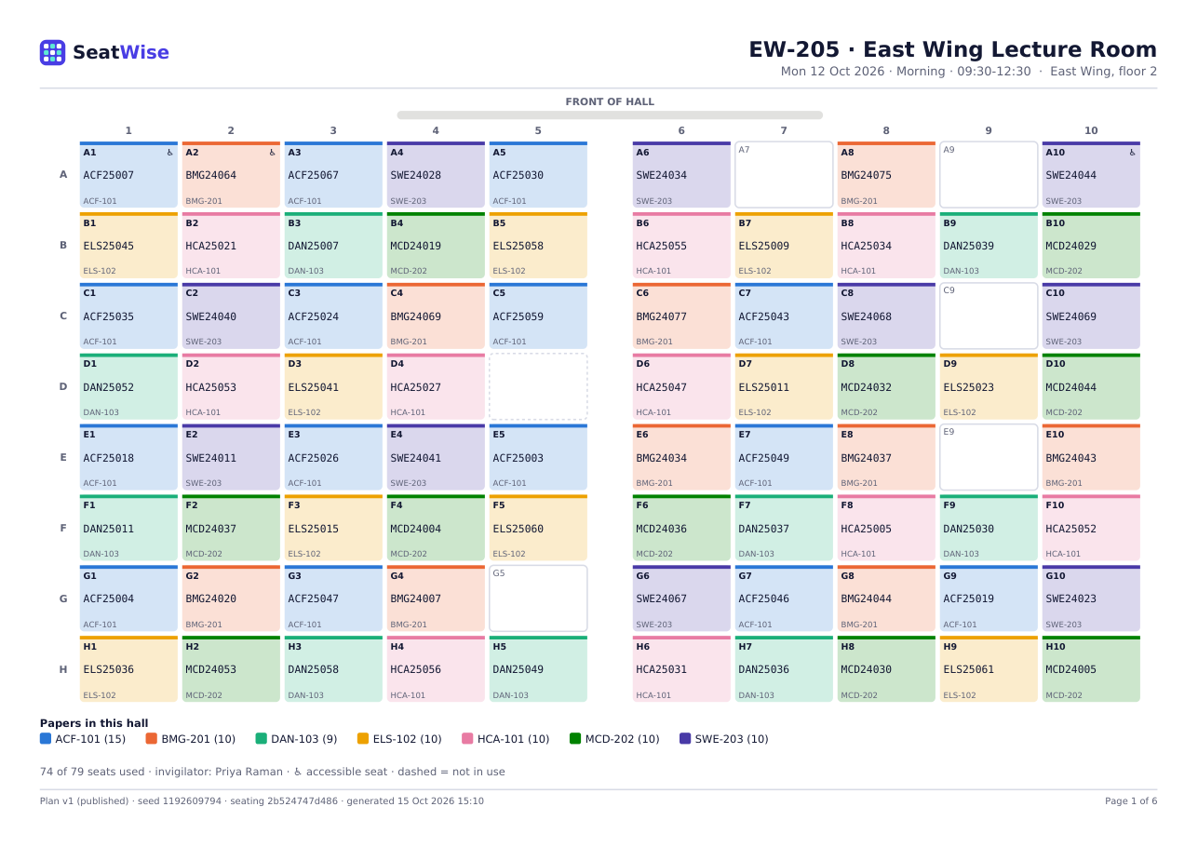  Fig. 34: Generated seating chart (PDF, hall EW-205)

Per hall: the papers and their candidate counts, instructions for the invigilator, and a seat-by-seat list with Present and Signature columns.
Six slips per page with name, roll number, course, time, hall, building, seat and a QR code that opens the candidate's lookup page.
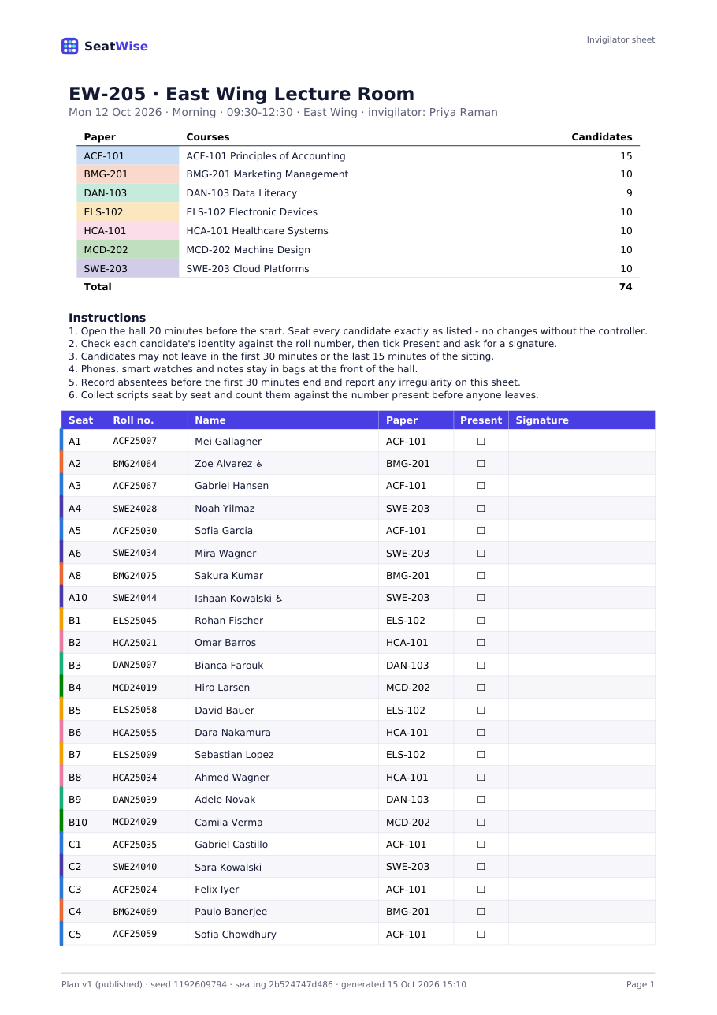  Fig. 35: Generated invigilator sheet (PDF) | 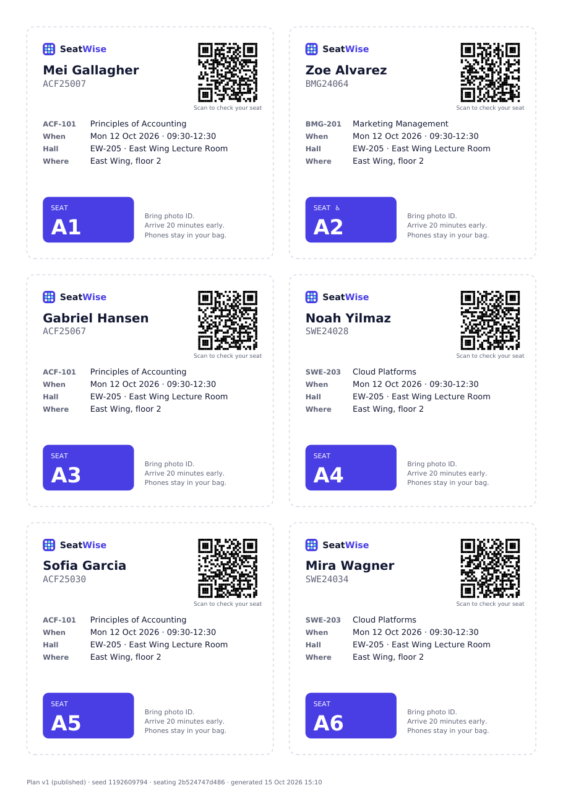  Fig. 36: Generated seat slips with QR codes (PDF)

6 Sample Inputs and Outputs

6.1 Sample inputs
These are the first rows of the committed sample files.
Table 9: courses.csv
course_code | course_name | department_code | department_name
ACF-101 | Principles of Accounting | ACF | Accounting & Finance
ACF-102 | Business Mathematics | ACF | Accounting & Finance

Table 10: candidates.csv (e-mail and date of birth columns omitted)
roll_no | full_name | department_code | course_codes | needs_accessible_seat
ACF24001 | Camila Kaur | ACF | ACF-201;ACF-202;ACF-203 | no
ACF24002 | Gabriel Rao | ACF | ACF-201;ACF-202;ACF-204 | no

Table 11: halls.csv
hall_code | hall_name | building | floor | rows | columns | blocked_seats | accessible_seats | aisles
MB-G01 | Main Hall A | Main Building | Ground | 10 | 12 | E6;E7 | A1;A12 | 4;8
MB-101 | Room 101 | Main Building | 1 | 8 | 8 |  |  | 4

Table 12: timetable.csv
session_date | start_time | end_time | course_code | paper_group
2026-10-12 | 09:30 | 12:30 | ACF-101
2026-10-12 | 09:30 | 12:30 | BMG-201

6.2 Sample outputs
Plan scorecard (plan 1, seed 1192609794, engine 1.0.0, per-hall budget 0.15):
Table 13: Scorecard of a generated plan
Measure | SeatWise plan | Roll-order baseline for the same sitting
Candidates seated | 451 in 6 halls (92% of their seats) | 451
Same-paper neighbour pairs | 0 | 1,099
Roll-gap violations | 0 | 342
Accessible seats missed | 0 | 7
Same-department neighbour pairs | 1 | 1,194
Solve time | 2,118 ms (Stage A 1,151 ms, Stage B 965 ms, 1 attempt, 0 retries) | -

Refused seat move. This move is not allowed: HCA25059 would sit next to HCA25037 (A2) - both write HCA-101. (HTTP 409.)
Public lookup response (excerpt for BMG24003): the name is shortened to "Julia M.", and each published seat is returned with the sitting, the course (BMG-201, Marketing Management), the hall (MB-G01, Main Hall A, 10 rows by 12 columns, blocked seats E6 and E7, accessible seats A1 and A12, aisles after columns 4 and 8) and the seat (A1, row 0, column 0, accessible).

7 Comparison with the Base Paper
The comparison is qualitative, and the datasets differ. The base paper [1] reports no accuracy, no timing and no dataset: its only quantitative statement is a requirement that a batch of 100 students be allocated in under 3 seconds. SeatWise has not been run on the base paper's data, and the base paper's system was not available to us to run on ours, so a numerical head-to-head is not possible. What we can do is compare the two on what they do, and compare SeatWise with the closest proxy for the base paper's method that we could measure, our round-robin baseline, which interleaves papers in a repeating cycle much as the zipper interleaves two subject lists. The round-robin baseline is not a re-implementation of the base paper.
Table 14: SeatWise compared with the base paper
Aspect | Base paper [1] | SeatWise
Reported performance | Target: 100 students in under 3 s; no measurement reported | 2.4 s at 600 candidates; 4.8 s at 2,000 (measured)
Rules guaranteed | Subject alternation in a line; optional branch rule; blocked seats | No same-paper neighbours in 8 or 4 directions; roll gap; accessible seats; capacity
Violations at 600 candidates (our benchmark) | Not measured. Closest proxy, round-robin: 281 same-paper pairs, 198 roll-gap violations | 0 and 0 in every run
Predictability | Fixed pattern (the proxy repeats 100% of neighbour pairs) | 1.0% repeated pairs; correlation 0.065
Reproducibility and audit | Not described | Seed, fingerprints, Verify, audit trail
Live editing | Future work (drag and drop) | Implemented, with live rule checks
Attendance | Future work | Implemented (tablet register, scan, lock)
Tests | Not described | 58 automated tests; benchmark

In short: where the base paper stops at generating and displaying a seating pattern, SeatWise guarantees the rules, measures its own behaviour and covers the examination-day workflow. Whether those advantages matter to a real examination cell is something only a pilot can show.

8 Analysis of Successful and Failure Cases

8.1 Successful cases
- Every one of 24 benchmark plans, in scenarios from 150 to 2,000 candidates, with 8 or 4 neighbours and roll gaps of 0, 5 and 10, met every hard rule.
- Three real sittings of the sample timetable were planned in 1.8 to 2.2 s each with no violation, and each plan reproduced exactly when verified.
- An illegal manual move was refused with a precise reason, and a legal move was applied, audited and re-fingerprinted.
- The end-to-end scenario (import, plan, export, lookup, attendance) passed in 11.4 s.

8.2 Failure and boundary cases
Table 15: Failure and boundary cases
Case | What happened | Assessment
Two small halls for a 457-candidate sitting | 422: 457 candidates but only 72 usable seats in the selected halls. Select halls with at least 385 more seats. The reply also named every paper larger than the halls' per-paper ceiling (for example 73 candidates but at most 18) | Correct refusal with an actionable reason; no plan was stored
Five large halls with too few seats | 422: 457 candidates but only 424 usable seats. Select halls with at least 33 more seats. | Correct; the pre-check catches it before any solving
Import file with errors | Status failed with four row-level errors (duplicate roll number, unknown department, unknown course, invalid yes or no) | Correct; nothing was imported
Front-row bias | SeatWise places departments on the front row less evenly than a random shuffle (4.7 against 1.6 percentage points) | A real weakness of the colour-class construction; documented
Four-neighbour mode | Solve time 6.0 s against 2.4 s for 600 candidates; the slowest benchmark run was 6.14 s | Acceptable for interactive use, but the slowest mode
Tight budget | A per-hall budget of 0.1 was slower overall (3.72 s) than 0.15 (2.63 s) because some halls were re-solved | Handled by the retry strategy; the tuned budget avoids it

9 Discussion of Limitations
- Synthetic data. Every number in this chapter comes from seeded synthetic sittings; real institutions' data may differ in paper sizes, hall shapes and roll-number formats.
- One machine, one run. The benchmark ran once on one desktop with three seeds per scenario. We did not study variation between machines, and we did not measure memory or concurrent use.
- No user study. The usability of the seat map, the attendance screen and the lookup page was not tested with real users.
- No accuracy-style metrics. Because nothing is trained, accuracy, F1 and confusion matrices do not exist; the benchmark measures rule violations and speed instead.
- Base-paper comparison is qualitative. The base paper reports no measurements; the round-robin baseline is a proxy, not a re-implementation.
- Front-row bias and 4-neighbour speed are known weaknesses, described above.

10 Objectives versus Outcomes
Table 16: Objectives against outcomes
Objective | Outcome | Evidence | Status
1 Automate seat allocation from uploaded data | Four file kinds imported and validated; plans generated in seconds | 1,020 rows imported; 2.4 s at 600 candidates | Met
2 Satisfy capacity, subject and roll-number constraints with optimisation | CP-SAT engine; every hard rule met | 24 of 24 benchmark plans; 3 of 3 demo plans | Met on synthetic data
3 Enforce anti-cheating spacing and randomise | 0 same-paper neighbours; seeded random choice | Correlation 0.065; 1.0% repeated pairs | Met, with a front-row bias of 4.7 points
4 Exportable charts and hall-wise reports | Five exports | Charts, sheets, slips (PDF); hall lists, attendance (Excel); tests | Met
5 Real-time seat lookup and attendance | Public lookup with QR slip; tablet register with lock | Scenario and tests; screens captured | Met in testing; no real-user trial
6 Reduce time and errors of manual preparation | Plan in seconds; rules guaranteed | 2.4 s; roll-order seating leaves 1,253 violations | Met for generation time and rule errors; time saved in a real cell not measured
Added: reproducible and auditable plans | Seeds, three hashes, Verify, audit trail | Verify reproduced exactly; tests | Met
Added: evaluate against manual methods | Benchmark with three baselines | 8 scenarios x 3 seeds | Met, with the limits above

