Department of Computer Science and Engineering (Data Science)
CSDS-A | Batch A9 (CSE - Data Science, Section A)
Privacy-Preserving Machine Unlearning in Federated LLMs: A Certified Right-to-Be-Forgotten Framework
(ForgetSafe)
S.No. | Student name | Roll / hall ticket no.
1 | G.SHASHANK | 23K91A6761
2 | B.SATHISH | 23K91A6719
3 | G.RAKESH | 23K91A6759
4 | B.AKHIL | 23K91A6721
Under the guidance of: [GUIDE NAME], [DESIGNATION]
RESULTS
This document reports the real results of the project: the measurements of the unlearning engine, every output screen with a caption, the success and failure cases, and the objectives measured against the outcomes. The model is a character-bigram proxy trained on a 25-sentence synthetic corpus, so the results describe the behaviour of the unlearning workflow, not the quality of a language model.

1 Model and Verification Results
The results in this section were produced by scripts/run_experiments.py, scripts/run_synthetic_corpus.py and scripts/run_neural_experiment.py on the development machine and are stored in experiments/*/metrics.json. Throughout, perplexity and next-character accuracy are measured on the five public evaluation sentences, membership AUC is the loss-based attack of Chapter 6 (a client's five records against five fixed non-member sentences, so its resolution is 0.04), and utility retention is the utility score after removal divided by the score before, capped at 100 %. The last two subsections extend the study with synthetic data: a larger corpus on the real engine, and a small neural model.

1.1 Baseline run with the default configuration
With seed 2026, clip norm 25, noise multiplier 3 and δ = 1e-5 the trained model has ε = 1.6149, perplexity 130.22 and next-character accuracy 5.09 % (utility 0.0926; training took 5.4 ms). A model that spread probability evenly over the 32 symbols it can emit would have perplexity 32, so the trained model is worse than uniform. The table gives the result of removing each client in turn from a freshly trained model.
Table 1: Removing each client from the default model (seed 2026)
Client removed | Status | Reference L2 | Membership AUC | Perplexity | Accuracy | Retention %
Client 01 (Finance) | Certified | 2.79e-14 | 0.20 → 0.16 | 130.2 → 146.5 | 5.09 % → 4.36 % | 93.65
Client 02 (Healthcare) | Certified | 2.61e-14 | 0.48 → 0.44 | 130.2 → 147.1 | 5.09 % → 5.09 % | 98.71
Client 03 (Education) | Certified | 2.62e-14 | 0.08 → 0.12 | 130.2 → 146.3 | 5.09 % → 5.09 % | 98.76
Client 04 (Retail) | Certified | 2.54e-14 | 0.32 → 0.28 | 130.2 → 146.7 | 5.09 % → 5.09 % | 98.73
Client 05 (Travel) | Certified | 2.54e-14 | 0.04 → 0.04 | 130.2 → 145.6 | 5.09 % → 4.36 % | 93.71

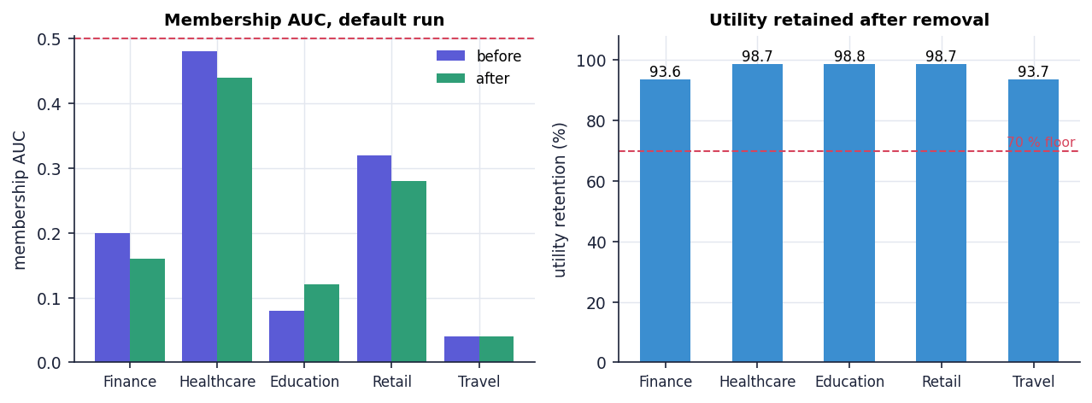
Fig. 1: Membership AUC before and after removal, and utility retained, for each client (default run)
All five requests are CERTIFIED and the reference distance is of the order of 1e-14 (largest 2.79e-14). Utility retention is between 93.65 % and 98.76 % (mean 96.71 %). The two lowest values, Finance and Travel, are the two cases in which next-character accuracy fell from 5.09 % to 4.36 %, that is by two correct predictions out of 275 characters; the retention figure is therefore dominated by a tiny accuracy count. The membership AUC values (0.04 to 0.48 before removal) scatter on both sides of 0.5: with ten sentences and a noisy model they carry no signal about membership.

1.2 Fifty seeds: how stable is the default result?
To separate the behaviour of the method from the luck of one noise draw, the procedure was repeated for 50 noise seeds and for all five clients, giving 250 unlearning requests.
Table 2: Fifty-seed study with the default configuration
Quantity | Mean | Std. dev. | Min | Max
Perplexity before removal (50 models) | 142.2 | 27.5 | 81.6 | 215.7
Accuracy before removal (50 models) | 3.71 % | 1.76 % | 1.09 % | 8.73 %
Perplexity after removal (250 requests) | 164.5 | 33.0 | 92.2 | 256.0
Membership AUC before removal | 0.524 | 0.219 | 0.04 | 1.00
Membership AUC after removal | 0.495 | 0.222 | 0.04 | 1.00
Change in AUC (after - before) | -0.029 | 0.040 | -0.24 | +0.04
Utility retention (%) | 97.14 | 3.47 | 79.90 | 100.00

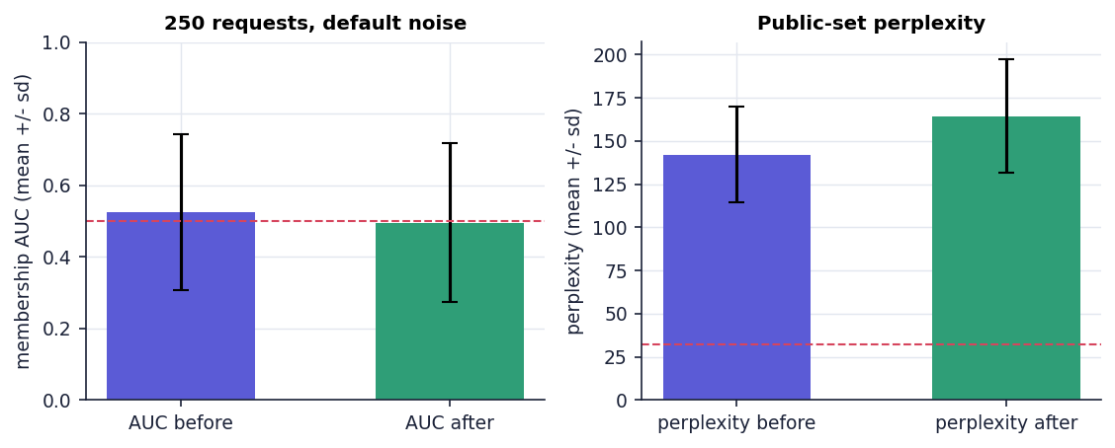
Fig. 2: Membership AUC and public-set perplexity before and after removal over 250 requests (mean +/- standard deviation)
250 of 250 requests are CERTIFIED, none falls below the 70 % retention floor (the minimum is 79.9 %) and the largest reference distance is 3.25e-14. These numbers are stable, but what they stabilise is the bookkeeping. The informative result is the membership AUC: 0.524 before removal, which is chance, and 0.495 after, a mean change of only -0.029. At the default noise the attacker learns nothing about a client either before or after the removal, so the experiment has no leakage to show disappearing. The perplexity of about 142 (range 82 to 216) confirms that the aggregate is noise-dominated: the expected noise vector has an L2 norm of 2475, while a clipped client update has norm 25 (about 1 % of the noise).

1.3 Noise sweep: the privacy-utility trade-off
The noise multiplier σ was varied from 0.001 to 10 (20 seeds, five clients each, 100 requests per value). The reported ε follows the engine's formula ε = sqrt(2 ln(1.25/δ)) / σ with δ = 1e-5, so ε = 4.8448 / σ.
Table 3: Noise sweep (mean over 100 requests per row)
σ | ε | Perplexity | Accuracy | AUC before | AUC after | Retention %
0.001 | 4844.805 | 12.5 | 24.6 % | 0.992 | 0.542 | 99.6
0.01 | 484.481 | 12.7 | 24.5 % | 0.983 | 0.543 | 99.6
0.05 | 96.896 | 14.2 | 24.2 % | 0.922 | 0.550 | 98.7
0.1 | 48.448 | 16.3 | 23.5 % | 0.856 | 0.550 | 96.5
0.3 | 16.149 | 27.4 | 15.5 % | 0.708 | 0.544 | 88.1
0.5 | 9.690 | 39.1 | 9.9 % | 0.653 | 0.534 | 89.6
1 | 4.845 | 65.6 | 5.4 % | 0.597 | 0.520 | 91.6
2 | 2.422 | 110.1 | 3.8 % | 0.563 | 0.527 | 97.6
3 | 1.615 | 145.2 | 3.6 % | 0.552 | 0.522 | 97.5
4.85 | 0.999 | 197.9 | 3.4 % | 0.539 | 0.525 | 97.7
6 | 0.807 | 225.5 | 3.3 % | 0.538 | 0.524 | 96.3
10 | 0.484 | 304.5 | 3.0 % | 0.530 | 0.524 | 98.5

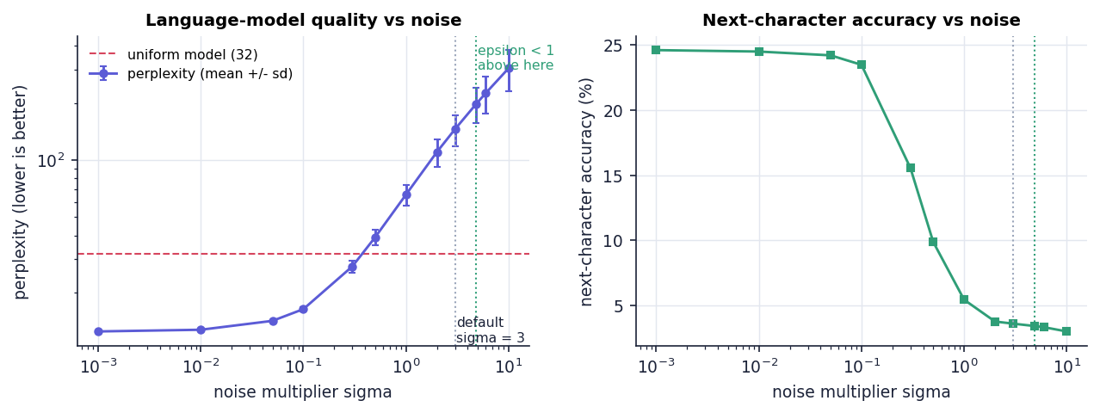
Fig. 3: Perplexity and next-character accuracy against the noise multiplier (dotted lines: default σ = 3 and the ε < 1 boundary at σ = 4.85)
Three regimes are visible. For σ <= 0.1 (ε >= 48) the model is a useful bigram model: perplexity 12.5 to 16.3, accuracy about 24 %, and the membership attack works (AUC 0.86 to 0.99 before removal). For 0.3 <= σ <= 1 quality degrades quickly (perplexity 27 to 66, accuracy 15 % to 5 %). From σ = 2 upward the model is no better than noise; at the default σ = 3 perplexity is 145 against 32 for a uniform model, and at σ = 10 it is 305.
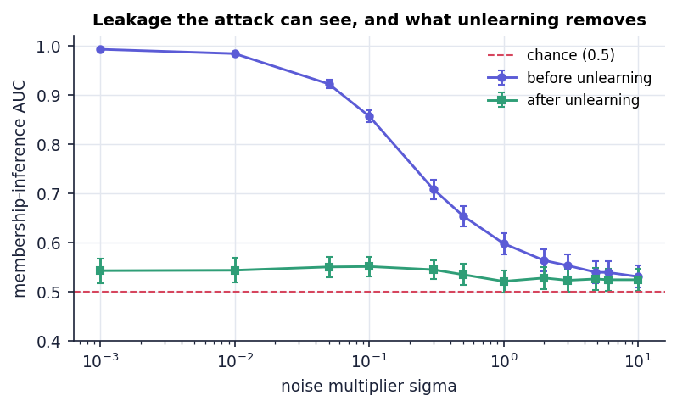
Fig. 4: Membership AUC before and after removal against the noise multiplier (error bars: standard error)
The attack gives the second half of the story. Where there is something to find (small σ) the removal clearly works: the mean AUC drops from 0.992 to 0.542 at σ = 0.001 and from 0.856 to 0.550 at σ = 0.1. Where the noise is large the attack is already at 0.52 to 0.55 before removal, so unlearning has nothing to remove. A privacy-preserving noise level and a measurable forgetting effect are therefore mutually exclusive in this configuration: the noise that makes the leakage invisible also makes the removal invisible.
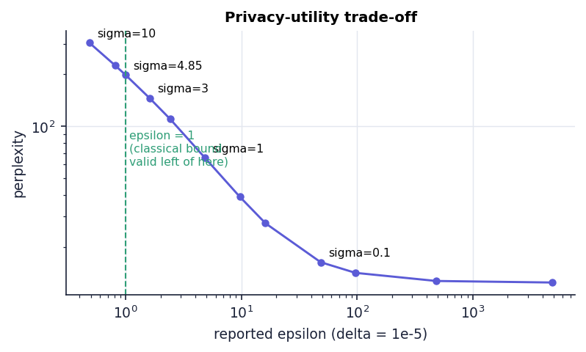
Fig. 5: Reported ε against perplexity: the classical bound is valid only to the left of ε = 1
The classical one-shot Gaussian bound is valid for ε < 1, which needs σ > 4.84. At σ = 4.85 the model has perplexity 198 and accuracy 3.4 %. At the default σ = 3, the reported ε = 1.6149 lies outside the range for which that bound is proved. There is no point on the curve that is both inside the proven range and useful.

1.4 What unlearning removes when there is no noise
Table 4: Removal with σ = 1e-6 (essentially no noise)
Client | Member NLL (before → after) | Membership AUC (before → after) | Retention %
Finance | 2.379 → 2.590 | 1.00 → 0.76 | 98.92
Health | 2.383 → 2.562 | 1.00 → 0.88 | 100.00
Education | 2.448 → 2.676 | 1.00 → 0.20 | 100.00
Retail | 2.435 → 2.621 | 0.96 → 0.52 | 99.59
Travel | 2.462 → 2.649 | 1.00 → 0.36 | 99.80

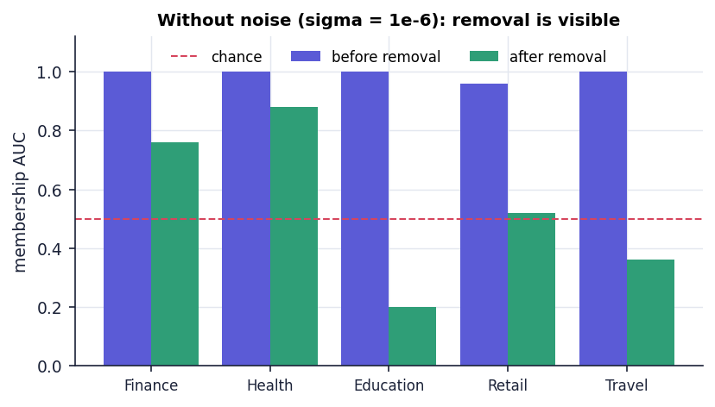
Fig. 6: Membership AUC before and after removal with almost no noise
To check that removal itself works, the noise was effectively switched off. The attack then separates a client's records from non-members almost perfectly (mean AUC 0.992), and after subtraction it falls to 0.544, close to chance; the mean per-character loss on the removed client's own sentences rises from 2.421 to 2.619. Individual AUCs after removal range from 0.20 to 0.88 because the attack uses only ten sentences. This is the evidence that subtracting the stored update really removes the client's statistical footprint from the model, and it is the experiment that the default configuration cannot provide.

1.5 An independent check: comparison with retraining on fresh noise
The shipped certificate compares the unlearned model with a "reference" built from the retained clients' stored updates and the same stored noise; the two sides share every input, so their distance is zero up to rounding by construction. A real retraining would draw new noise. The experiment gold_retrain therefore compares each unlearned model with models retrained on the retained clients with independent noise (200 pairs for each σ), and compares two independent retrainings with each other as the yardstick for how far two honest runs differ.
Table 5: Unlearned model against retraining with independent noise (200 pairs per σ)
σ | L2: unlearned vs fresh retrain | L2: fresh retrain vs fresh retrain | AUC (unlearned / retrain) | Perplexity | Accuracy
3 | 875.3 ± 16.0 | 881.4 ± 18.2 | 0.481 / 0.552 | 167.1 / 152.8 | 3.35 % / 3.95 %
0.5 | 145.9 ± 2.7 | 146.9 ± 3.0 | 0.505 / 0.547 | 46.0 / 44.6 | 8.06 % / 8.64 %

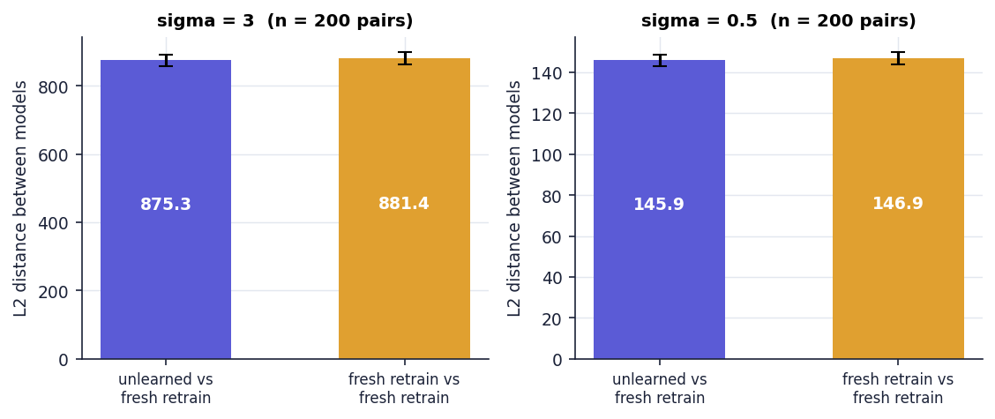
Fig. 7: Distance between the unlearned model and a fresh retrain, compared with the distance between two fresh retrains
At σ = 3 the unlearned model is 875.3 away from a fresh retrain and two fresh retrains are 881.4 apart; at σ = 0.5 the figures are 145.9 and 146.9. The unlearned model is therefore exactly as far from a retrained model as retrained models are from each other: the distance is the injected noise, and the unlearned model behaves like one more retrained model. Perplexity and accuracy agree to within the noise (167 against 153 at σ = 3, 46.0 against 44.6 at σ = 0.5), and the membership AUC of the unlearned model is, if anything, closer to chance than that of the retrained model (0.481 against 0.552 at σ = 3). This is the evidence that the unlearned model is distributed like a retrained one, which the 1e-14 reference distance does not demonstrate on its own.

1.6 Sequential removal
Table 6: Removing four of the five clients in turn (seed 2026)
Step | Removed | Active clients | Perplexity | Accuracy | Retention % | Status
0 | - | 5 | 130.2 | 5.09 % | - | -
1 | Finance | 4 | 146.5 | 4.36 % | 93.65 | Certified
2 | Health | 3 | 171.3 | 4.36 % | 98.30 | Certified
3 | Education | 2 | 213.6 | 4.36 % | 97.70 | Certified
4 | Retail | 1 | 302.8 | 4.36 % | 96.59 | Certified

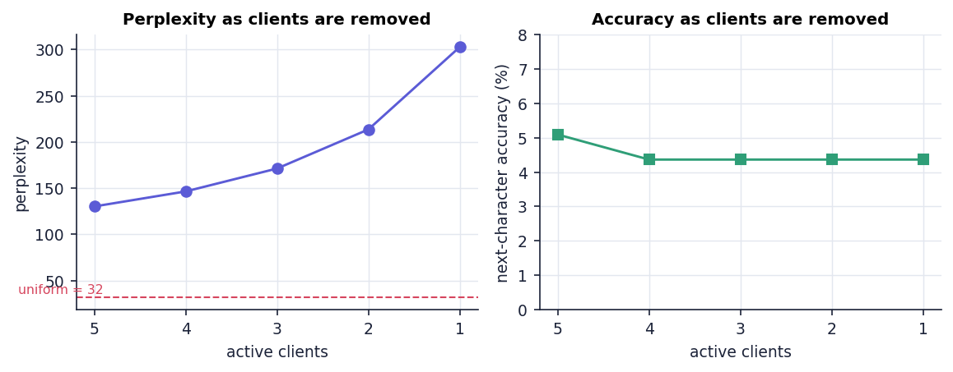
Fig. 8: Perplexity and accuracy as clients are removed one after another
All four removals are CERTIFIED and the ledger verifies afterwards ("Verified 5 audit record(s)"). Perplexity rises from 130 to 303 as the five clients are reduced to one: the noise vector is unchanged while the aggregate is divided by a smaller client count, so the relative weight of the noise grows. Removing the fifth client is refused with "At least one client must remain in the model". Retention values remain above 93 % at every step because each is measured against the previous model, which is already poor.

1.7 Synthetic-corpus study: more data, larger federations
The 25-sentence corpus is too small for the bigram model to learn and gives the membership attack only five members. scripts/run_synthetic_corpus.py therefore generates a seeded synthetic corpus (a template grammar with per-domain vocabularies, 20 domains) with 200 training sentences and 200 held-out sentences per client plus a 300-sentence public set, and runs the real engine classes on it. Two attacks are used: sentence-level (a client's training sentences against its own held-out sentences, which measures memorisation) and domain-level (its training sentences against other clients' held-out sentences, which measures leakage of what the client's data is about); their resolution is 5e-5.
Clip norm. The raw update norm of a 200-sentence client has median 1,239 (range 1,178 to 1,408), so the product's C = 25 scales every update by 0.020, about 50 times down. Without noise this costs utility (perplexity 11.1 at C = 25 against 8.8 at the median norm, because the fixed smoothing constant then dominates the shrunken counts); with noise the small C seems to help (perplexity 33.5 against 92.8 at σ = 1) only because it flattens the predictions: accuracy is identical (19.3 %). The study therefore uses C = median norm, the setting that preserves the signal.
Table 7: Synthetic-corpus study, 10 clients, 200 sentences each (50 requests per row)
σ | ε | Perplexity | Domain-level AUC | Sentence-level AUC | Certified
1e-9 | no noise | 8.8 | 0.474 → 0.220 | 0.506 → 0.506 | 100 %
0.1 | 48.4 | 12.7 | 0.472 → 0.324 | 0.506 → 0.502 | 100 %
1 | 4.84 | 92.8 | 0.490 → 0.463 | 0.498 → 0.496 | 100 %
3 | 1.61 | 310.9 | 0.499 → 0.488 | 0.496 → 0.497 | 100 %

A bigram model does not memorise sentences: the sentence-level AUC stays at 0.50 before and after removal at every σ, even with no noise. What it does carry is the domain: the domain-level attack is at chance with the client in the model (0.474) and falls to 0.220 without noise (0.472 to 0.324 at σ = 0.1) once the client is removed, because its now-unseen text is less likely under the model than the other clients' text: the fall is the size of the footprint that subtraction removes. At σ ≥ 1 the noise hides the effect (0.490 → 0.463). The fresh-noise comparison above repeats at this scale: the unlearned model is 645 from a fresh retrain and two retrains are 650 apart at σ = 0.1 (6452 against 6498 at σ = 1), with equal perplexity (106.2 and 103.7).
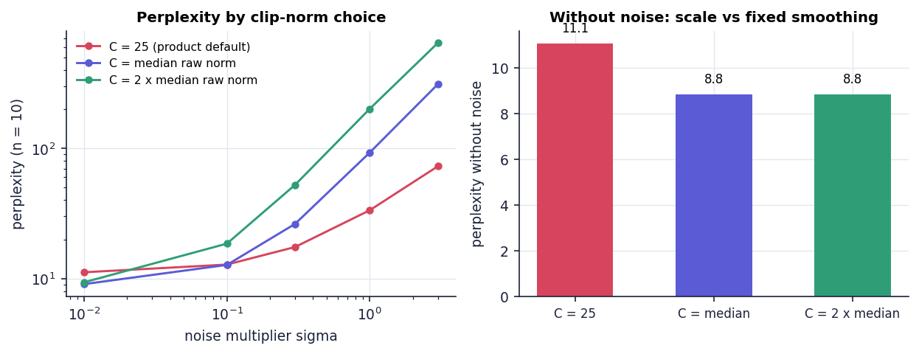
Fig. 9: Perplexity for three choices of the clip norm, with noise (left) and without (right)
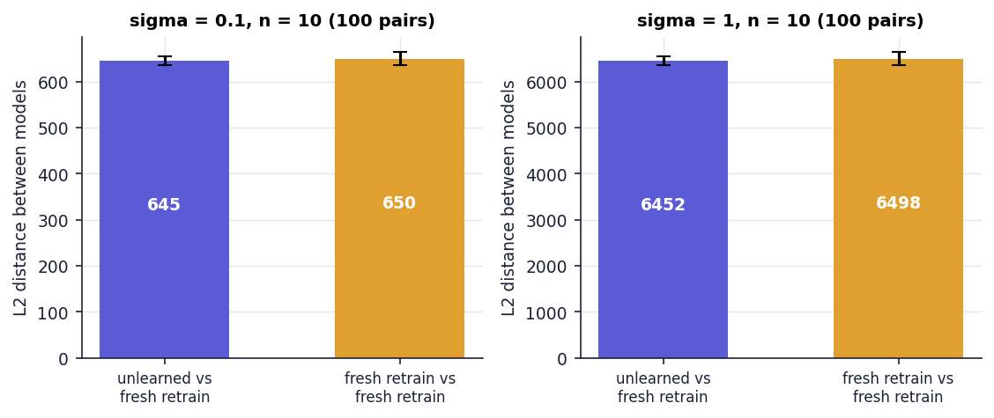
Fig. 10: Distance between the unlearned model and a fresh retrain, against two fresh retrains (synthetic corpus, 10 clients)
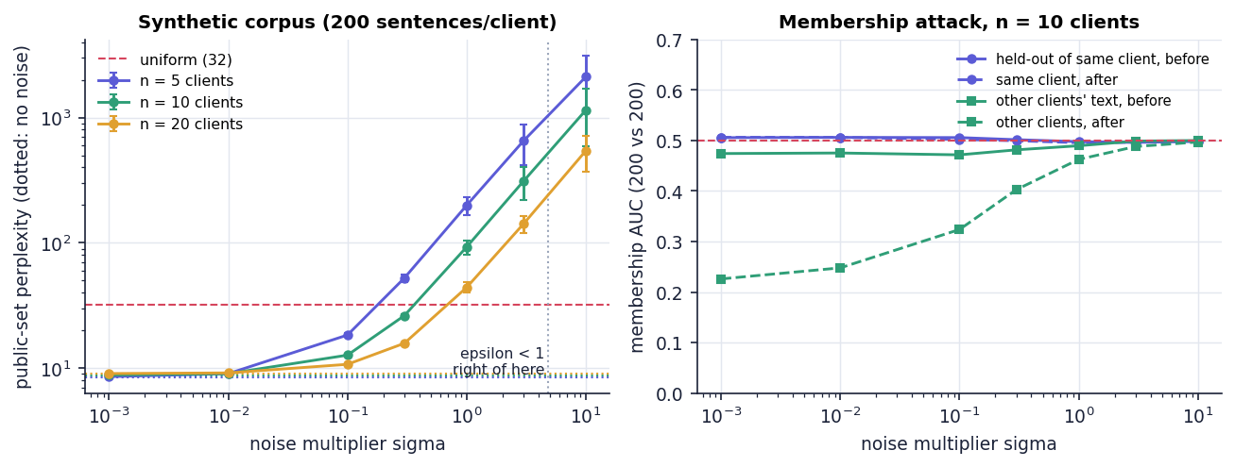
Fig. 11: Synthetic corpus: perplexity against σ for 5, 10 and 20 clients (left) and the two membership attacks for 10 clients (right)
Large federations make ε < 1 useful. The noise is added once to the sum and the sum is divided by the number of clients n, so the relative noise shrinks as n grows. The table gives the perplexity of the released model relative to the noise-free model (100 synthetic sentences per client, C = median norm, five seeds); a value of 1.2 or less is marked with an asterisk.
Table 8: Perplexity relative to the noise-free model against federation size (* = within 1.2x)
Clients n | σ = 1 (ε 4.84) | σ = 3 (ε 1.61) | σ = 4.85 (ε 1.00) | σ = 10 (ε 0.48)
5 | 20.75 | 59.78 | 102.23 | 185.93
20 | 4.15 | 13.42 | 23.82 | 45.40
100 | 1.40 | 2.65 | 4.05 | 8.58
500 | 1.06* | 1.22 | 1.39 | 1.96
1,000 | 1.03* | 1.09* | 1.17* | 1.40
4,000 | 1.01* | 1.02* | 1.03* | 1.07*

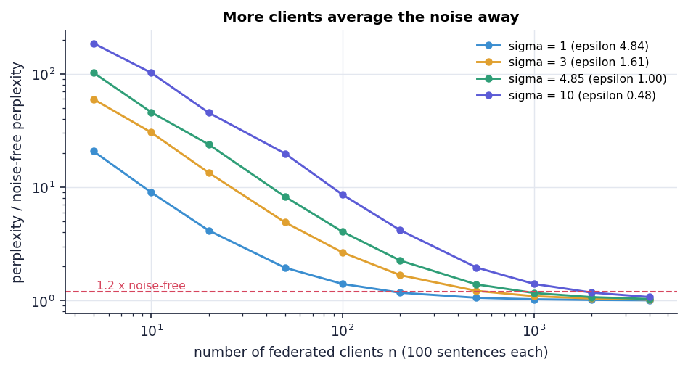
Fig. 12: Perplexity relative to the noise-free model against the number of federated clients, for four noise levels
With ε below 1 (σ = 4.85) the model is within 1.2 times the noise-free perplexity from about 1,000 clients, and within 1.2 times at the default σ = 3 from 1,000; at σ = 1 200 clients suffice. At n = 1,000, σ = 4.85 (ε = 0.999) five successive removals were all CERTIFIED with retention of at least 99.998 %. The conclusion for the privacy-utility trade-off is therefore not that the Gaussian mechanism is unusable but that the five-client demonstration is far too small a federation for it: the proxy is private and useful only in the regime a real federated service lives in. Timing at 20 clients of 200 sentences: training 585 ms, unlearn() 1425 ms, retraining on the 19 retained clients 550 ms; the fixed cost of the metrics and the two attacks again exceeds the proxy's retraining time.

1.8 Neural adapter study: the same method on a small neural model
To check that the method is not an artefact of a count-based model, scripts/run_neural_experiment.py applies ForgetSafe's release and removal unchanged to the parameters of a small neural language model. A character-level GRU with 137,151 parameters is pre-trained on a synthetic public pool and frozen; 8 synthetic client domains (own vocabulary and sentence templates, 150 training and 150 held-out sentences each) each train a LoRA-style low-rank adapter (14,272 parameters, rank 64); the flattened adapters are clipped to the median norm, summed, noised with σ·C and divided by n, and a client is removed by subtracting its stored adapter. Five seeds, 234 s on the CPU. Adapting helps a client's own domain a great deal (held-out perplexity 102 for the base model, 2.41 with its adapter) and a single adapter already leaks (sample-level AUC 0.74, client-level AUC 1.00).
Table 9: Neural adapter study: removal of one of eight clients (40 requests per row)
σ | ε | Retained-client perplexity | Client-level AUC before → after (fresh retrain) | L2 unlearned / retrain vs retrain / retrain | Retention %
0 | no noise | 9.2 → 8.99 | 0.779 → 0.534 (0.532) | 0.8667 / 0.868 | 99.9
0.01 | 484 | 9.25 → 9.06 | 0.779 → 0.534 (0.534) | 3.313 / 3.311 | 99.8
0.05 | 96.9 | 12.6 → 13.7 | 0.761 → 0.531 (0.577) | 15.94 / 16.01 | 92.1
0.1 | 48.4 | 47.3 → 81.6 | 0.735 → 0.561 (0.501) | 31.76 / 31.8 | 59.2
0.3 | 16.1 | ≥ 1e8 (destroyed) → ≥ 1e8 (destroyed) | 0.456 → 0.410 (0.564) | 96.01 / 95.84 | -
1 | 4.84 | ≥ 1e8 (destroyed) → ≥ 1e8 (destroyed) | 0.478 → 0.473 (0.405) | 319.2 / 319.6 | -
3 | 1.61 | ≥ 1e8 (destroyed) → ≥ 1e8 (destroyed) | 0.466 → 0.465 (0.436) | 960.6 / 959.7 | -

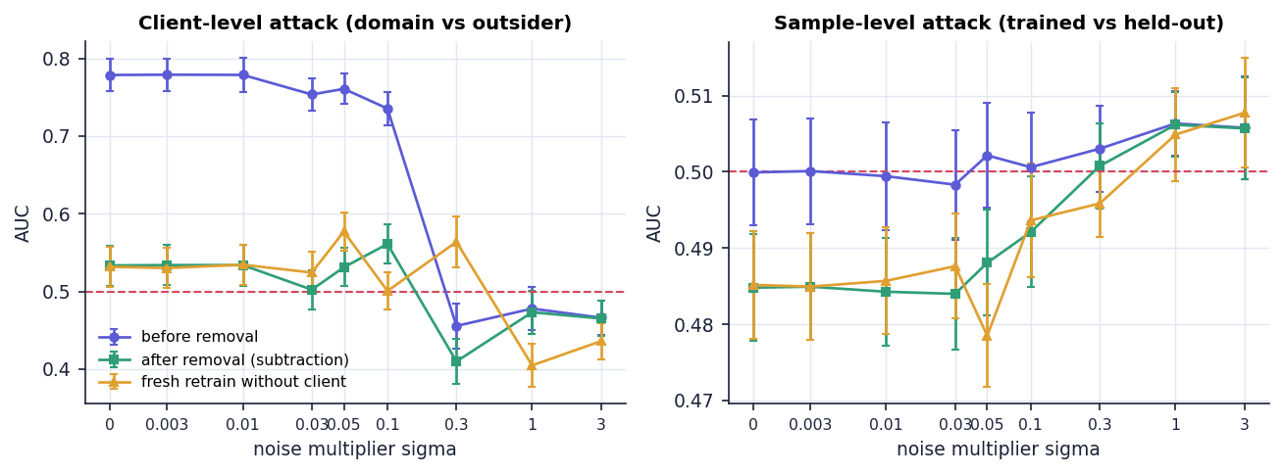
Fig. 13: Client-level (left) and sample-level (right) membership AUC before removal, after removal and after a fresh retrain
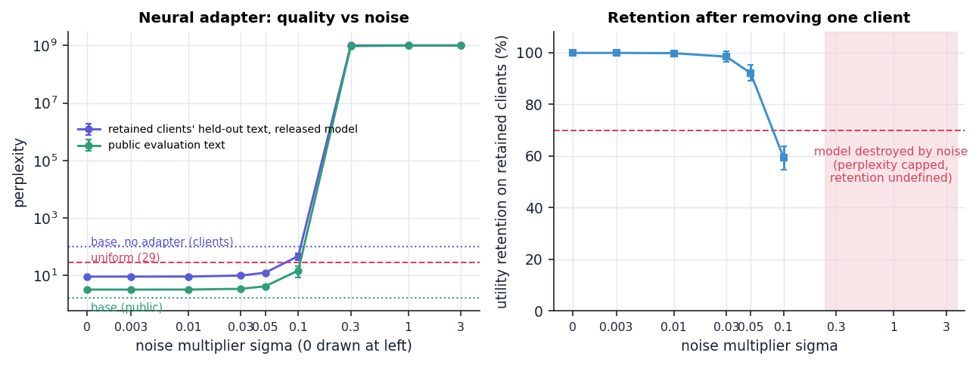
Fig. 14: Neural adapter study: perplexity against σ (left) and utility retention after removal (right)
The three findings of the bigram product recur on a neural model. Removal is real: without noise the client-level attack falls from 0.78 to 0.53, exactly where a fresh retrain without the client sits (0.53); the sample-level AUC of the released average stays at 0.50 because averaging eight adapters hides what a single adapter memorises. The unlearned model is distributed like a retrained one: its distance to a fresh retrain equals the distance between two fresh retrains at every σ (for example 31.8 and 31.8 at σ = 0.1), and the same-noise identity check agrees to float32 rounding (7e-08 to 3e-06). Privacy and utility compete: retention of the retained clients' perplexity is 99.8 % at σ = 0.01, 92.1 % at σ = 0.05 and 59.2 % at σ = 0.1, below the 70 % floor, and the model is destroyed from σ = 0.3, while ε < 1 would need σ > 4.85; with eight clients the neural study sits in the same small-federation regime as the bigram product with ten. Removing three clients one after another at σ = 0 raises the public perplexity from 3.26 to 4.50. The cost is the clearest gain: subtraction takes 24 microseconds, the full request with metrics and attack 91 ms, and retraining the seven retained adapters 5.9 s, which is 65 times slower than the whole request.
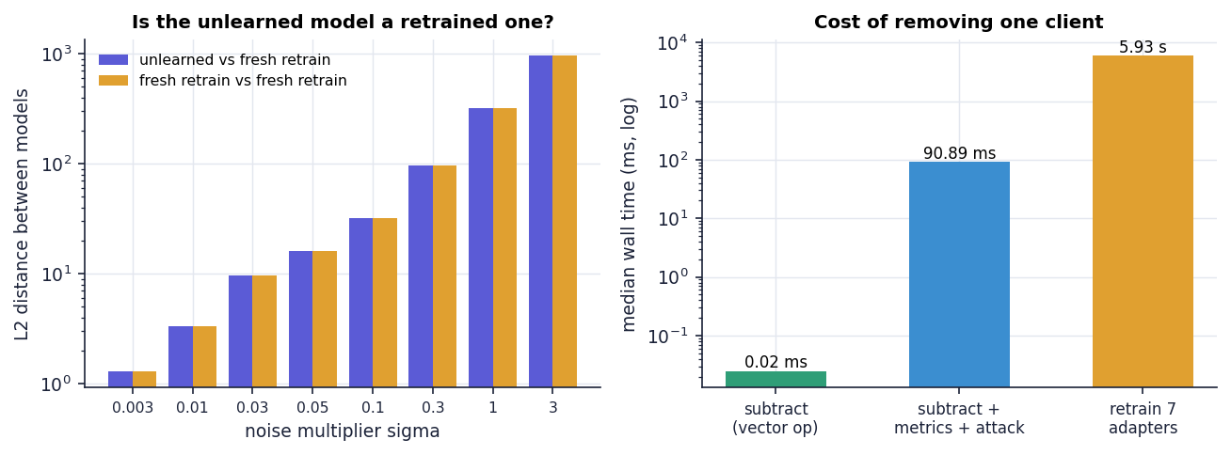
Fig. 15: Distance to a fresh retrain against distance between fresh retrains (left) and the cost of removing one client (right)

2 Certificate, Ledger and API Results
The product's visible output is the certificate and the ledger record behind it. The first removal of the default session (Client 01, Finance) produced the following values; the field names are those of the JSON that GET /api/certificate/latest returns.
Table 10: Fields of the unlearning certificate
Field | Value (default session, seed 2026)
certificate_id / status | CERT-6DCAB9E98480 / CERTIFIED
client | Client 01 (Finance)
method | Tracked clipped-update subtraction with retained-client renormalization
epsilon, delta | 1.6149, 1e-05
clip_norm, noise_multiplier | 25, 3
residual_influence_l2 = reference_retrain_l2 | 2.790e-14
membership_auc_before → after | 0.20 → 0.16
perplexity_before → after | 130.221 → 146.472
accuracy_before → after | 5.09 % → 4.36 %
utility_retention_percent | 93.65
clients_before → after | 5 → 4
model_hash_before | fe4d958335a7a158acdf8d5d441073a3…
model_hash_after | d0f7b70df52c5d17097b83b9144b0062…
audit_record_hash | c5a6d39418d916e3b60023556ba8ea72…

Two fields deserve a remark. residual_influence_l2 and reference_retrain_l2 are always equal: the engine assigns one to the other (the comment in engine.py explains that the stored update is subtracted algebraically, so its coefficient in the retained aggregate is zero within floating-point error). And epsilon is the training-time value; the certificate does not recompute any privacy figure after the removal.
Every training and every unlearning event becomes one line of data/audit_log.jsonl. A record keeps its event fields and adds sequence, previous_hash and record_hash, where the hash is the SHA-256 of the predecessor's hash, a vertical bar and the canonical (sorted, compact) JSON of the record. The first record's predecessor is 64 zeros. The certificate's audit_record_hash equals the hash of its own ledger record, which is how a certificate is tied to the ledger: in the capture session certificate CERT-C5427F948A72 carries 208f652b947ede28…, the hash shown in row 3 of the ledger screen.
The API returned the expected status codes for all 14 smoke checks and for 18 of the 20 edge-case probes (Chapter 7). It kept a correct ledger under 32 simultaneous removals and 16 simultaneous trainings, and 20 scripted synthetic-user journeys passed every step. Typical latencies on the local loop-back were 36 ms for training and 58 ms for a complete unlearning request, and a certificate is available for download as JSON with the audit verdict attached.

3 Functional Testing
Functional testing compares each feature with its description. The user-interface rows come from the scripted browser sessions (screens are shown in Chapter 8); the engine rows come from the unit, smoke and experiment runs.
Table 11: Functional test results
Feature | How it was exercised | Observed outcome
Federated training | UI button and POST /api/train | 5 clients aggregated; epsilon 1.6149; perplexity 130.22; accuracy 5.09 %
Clipping | per-client norms on the training screen | all five raw norms (25.22 - 28.23) exceed C = 25 and are clipped to 25.000
Certified unlearning | UI: Client 01 then Client 02; API for all five clients | 5/5 certified on the default seed; 250/250 over 50 seeds
Guards | API probes | untrained, repeat and last-client requests: HTTP 400 with a JSON message
Sequential removal | 5 -> 4 -> 3 -> 2 clients | 4/4 CERTIFIED; perplexity 130.2 -> 302.8; ledger verifies 5 records
Model explorer | seed "privacy" before and after a removal | text produced both times; the two 44-character samples are identical (see the results chapter)
Certificate download | GET /api/certificate/latest | JSON with audit_valid true; 404 when no certificate exists
Audit verification | UI button and API | "Verified 4 audit record(s)" in the capture session
New session | UI confirm dialog and API | engine reset, audit history preserved
Dark mode and mobile layout | UI at 1440 x 900 and 390 px | both render in all 20 acceptance journeys; bottom navigation replaces the sidebar on the narrow screen
Legacy interface | GET / on the API port | original four-tab page loads and shows the same session state

No functional defect was found in the engine paths the product offers. The defects found by the security and load studies concern the HTTP layer and the ledger file, and are listed in the next sections.

4 Performance Testing
Single-client performance was measured on 127.0.0.1. (Against localhost on this machine, Python clients pay about two seconds per call for an IPv6 fall-back, which would inflate every figure fourfold.) Each endpoint was called 30 to 100 times; the table gives the median and 95th percentile.
Table 12: API response times on 127.0.0.1
Endpoint | Calls | Median (ms) | p95 (ms) | Max (ms)
GET /api/health | 100 | 3.0 | 25.4 | 28.7
GET /api/state (untrained) | 100 | 5.4 | 24.3 | 41.3
POST /api/train | 50 | 36.5 | 60.0 | 69.0
GET /api/state (trained) | 100 | 20.8 | 44.3 | 56.5
POST /api/generate | 50 | 7.3 | 23.6 | 26.8
POST /api/audit/verify | 50 | 5.8 | 25.2 | 37.4
POST /api/unlearn | 30 | 57.9 | 82.4 | 109.3
GET /api/state (grown ledger) | 30 | 22.3 | 33.4 | 37.9

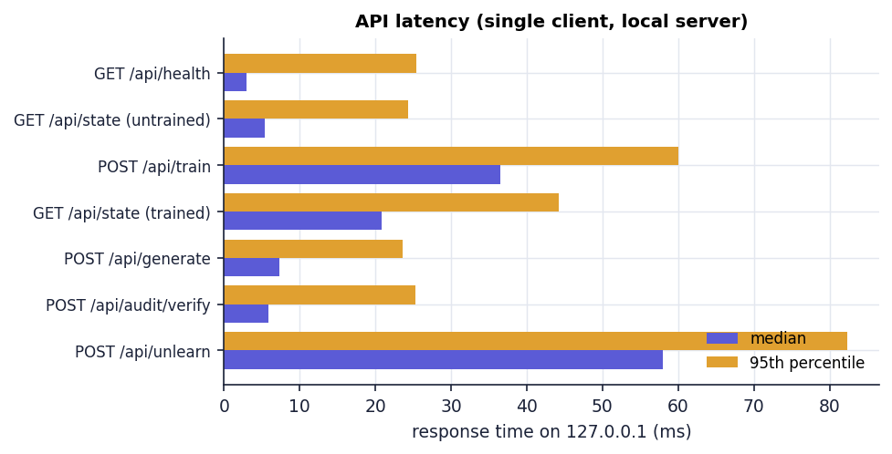
Fig. 16: Median and 95th-percentile response time per endpoint
Training answers in 36 ms and a full unlearning request, including two membership-attack evaluations, the metric recomputation and the ledger write, in 58 ms (p95 82 ms).

4.1 Load and concurrency
Threaded HTTP clients on 127.0.0.1 (up to 500 requests or 20 s per level) exercised four request mixes at 1, 2, 4, 8, 16, 32 and 64 concurrent clients against one server. The table gives requests per second, 95th-percentile latency in milliseconds and the number of 5xx or connection errors.
Table 13: Throughput, latency and errors under concurrency (127.0.0.1)
Request mix (req/s / p95 ms / errors) | 1 client | 4 clients | 16 clients | 64 clients
GET /api/health | 233 / 21 / 0 | 1070 / 15 / 0 | 488 / 15 / 0 | 315 / 1017 / 0
GET /api/state | 68 / 29 / 0 | 77 / 66 / 0 | 86 / 202 / 0 | 85 / 1627 / 19
POST /api/generate | 180 / 19 / 0 | 371 / 25 / 0 | 189 / 78 / 1 | 241 / 1035 / 5
mixed read/write | 48 / 54 / 0 | 49 / 155 / 0 | 34 / 671 / 0 | 26 / 2911 / 0

Read-only endpoints scale until the thread-per-connection server saturates: /api/health peaks near 1,070 req/s at four clients, while /api/state stays near 80 req/s because every call re-reads and re-verifies the ledger, and its p95 latency grows from 29 ms with one client to 1.6 s with 64, where 19 of its requests failed with connection errors. The mixed read/write scenario falls from 48 to 26 req/s as the single engine lock serialises the writes. Correctness under concurrency held in all three race tests: 32 simultaneous removals of the same client produced exactly one HTTP 200 and 31 HTTP 400 responses (1 unlearning event in the ledger); 16 simultaneous training requests produced 16 ledger records, one per success, with contiguous sequence numbers and a valid chain; and 8 writers appending 120 records while a ninth thread verified the chain saw 0 invalid reads. A soak of 2000 mixed requests produced 0 errors, the ledger grew to 400 records, memory rose from 26 to 31 MB, and the median state read slowed from 26 ms to 68 ms, the visible cost of reading the whole ledger on every call.
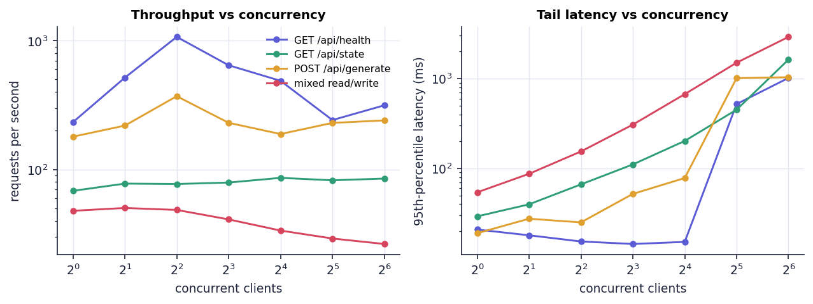
Fig. 17: Throughput and latency against the number of concurrent clients (127.0.0.1)

4.2 Unlearning against retraining
Table 14: Cost of `unlearn()` against re-running the proxy training (median of 5 runs, synthetic clients)
Clients | Records | Train (ms) | unlearn() (ms) | Retrain on retained (ms) | Retrain / unlearn
5 | 25 | 14.0 | 45.3 | 13.4 | 0.30x
25 | 500 | 32.3 | 72.0 | 30.5 | 0.42x
100 | 5,000 | 159.6 | 115.8 | 159.5 | 1.38x
250 | 25,000 | 691.2 | 195.8 | 709.6 | 3.62x
500 | 50,000 | 1425.6 | 204.0 | 1384.8 | 6.79x

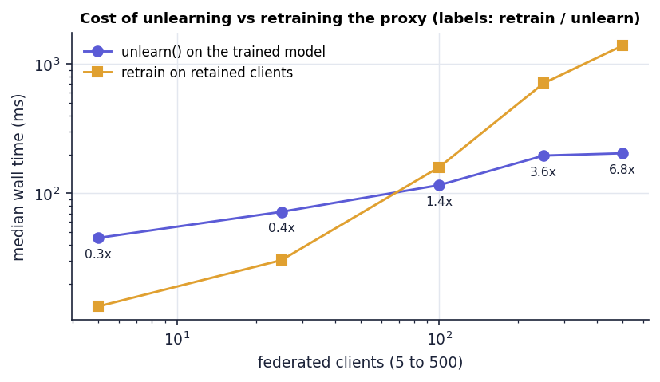
Fig. 18: Median wall time of unlearning and of retraining the proxy against the number of clients
On the five-client demonstration unlearn() (45.3 ms) is about three times slower than re-running the proxy training on the four retained clients (13.4 ms), because it carries a fixed cost that retraining does not: two membership evaluations, two metric evaluations and a ledger write. The curves cross near 100 clients (1.38x in favour of unlearning); at 500 clients and 50,000 synthetic records unlearning is 6.8x faster, because it touches one stored vector while retraining grows with the records. For the neural adapters of Chapter 8 the same comparison is far larger: subtraction takes 24 microseconds and retraining the seven retained adapters 5.9 s.

4.3 Growth of the audit ledger
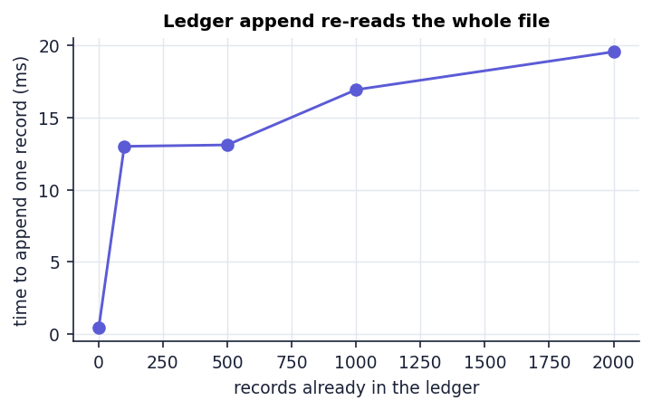
Fig. 19: Time to append one record against the number of records already in the ledger
AuditLedger.append reads the entire file to find the previous hash, so each append costs more as the ledger grows: 0.44 ms at the first record, 13.0 ms at 100, 16.9 ms at 1,000 and 19.6 ms at 2,000 records; verifying 2,000 records took 43.6 ms. A service logging every deletion request would need an index or a tail read (Chapter 10).

5 Output Screens
The screens below were captured from the running application (Python API on port 8109, React interface on port 5109) at 1440 x 900 pixels by a scripted Chrome session. The interface was driven by clicks, so every value shown was produced by the application: one session with the default configuration (seed 2026, clip norm 25, noise multiplier 3, δ = 1e-5), training through the interface, then removal of Client 01 (Finance) and of Client 02 (Healthcare). Each caption describes only what is visible in the picture.

Fig. 20: Landing page with the live lab status
The landing page carries the ForgetSafe name and the tag line "Certified right to be forgotten", a navigation bar (How it works, Screens, Live), a dark-mode toggle and an Open the lab button. The headline reads "Forget a client, prove it, keep the model useful." On the right, a Live lab status card is filled from GET /api/state: the badge says Connected, the session is "Not trained yet", there are "5 registered" active clients in the domains Finance, Healthcare, Education, Retail and Travel, and the audit ledger shows "1 record(s), chain valid" (the ledger already held one training event from an earlier session of the capture run). Two floating chips name the guarantees the product claims, "ε · δ DP guarantee" and "SHA-256 hash-chained ledger"; three tags below the buttons read Differential privacy, Membership-inference check and Audit trail.

Fig. 21: Landing page, how-it-works section
Scrolled down, the landing page lists five numbered stages: 01 Federated training (isolated clients, each update L2-clipped before the coordinator sees it), 02 Noisy aggregation (a Gaussian noise gives a one-shot (ε, δ) bound), 03 Parameter-level unlearning (a client's tracked update is subtracted, retained clients renormalised, no full retraining), 04 Independent verification (comparison with a clean retained-only recomputation, then a membership-inference attack) and 05 Tamper-evident audit (every event hash-chained with SHA-256). A heading "Four screens, one workflow" starts the next section.
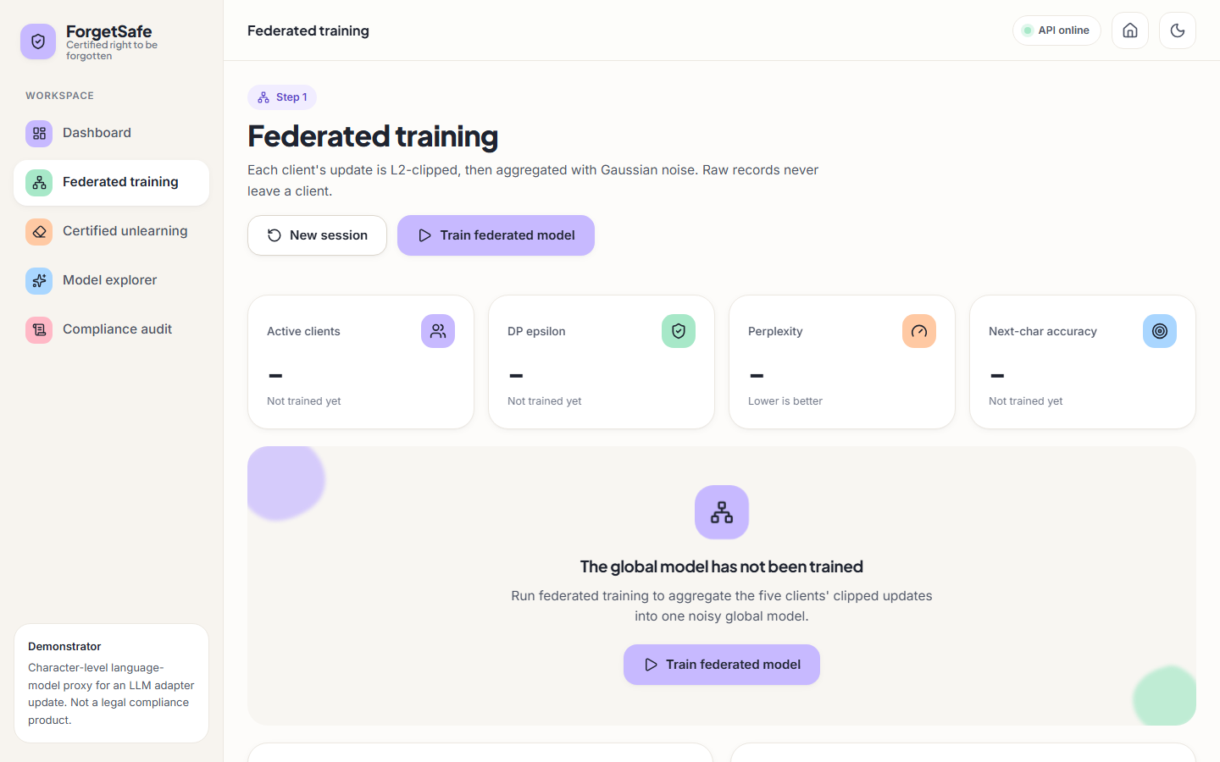
Fig. 22: Federated training screen before the first training run
In the untrained state all four tiles show a dash with the foot-note "Not trained yet", and an empty-state card reads "The global model has not been trained. Run federated training to aggregate the five clients' clipped updates into one noisy global model" with a Train federated model button. The header buttons New session and Train federated model are available and the status chip reads API online.
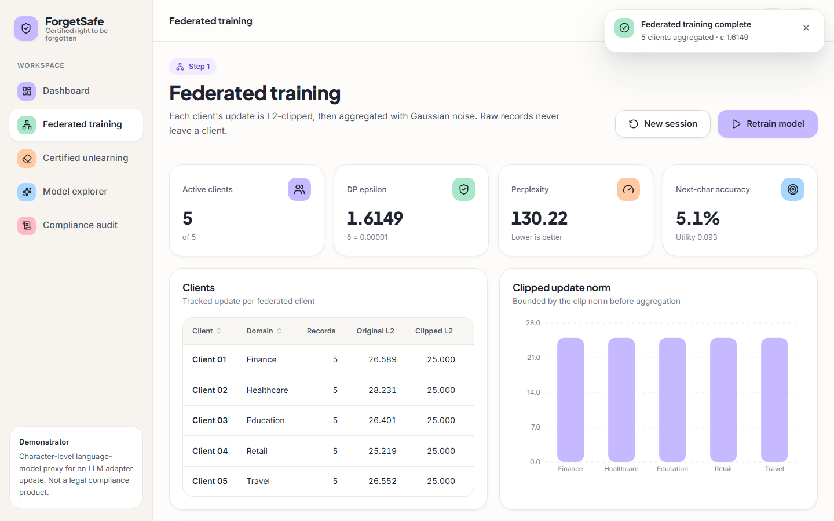
Fig. 23: Federated training screen after training
After pressing Train federated model a toast reads "Federated training complete, 5 clients aggregated, ε 1.6149". The four tiles show 5 of 5 active clients, DP epsilon 1.6149 with δ = 0.00001, perplexity 130.22 and next-character accuracy 5.1 % (utility 0.093). The Clients table lists Client 01 to Client 05 with their domains, 5 records each, original L2 norms of 26.589, 28.231, 26.401, 25.219 and 26.552, and a clipped L2 of 25.000 for every client. The Clipped update norm chart beside it shows five bars of equal height under an axis that runs to 28, which is the visual form of the clipping: every update leaves the client at the same length.
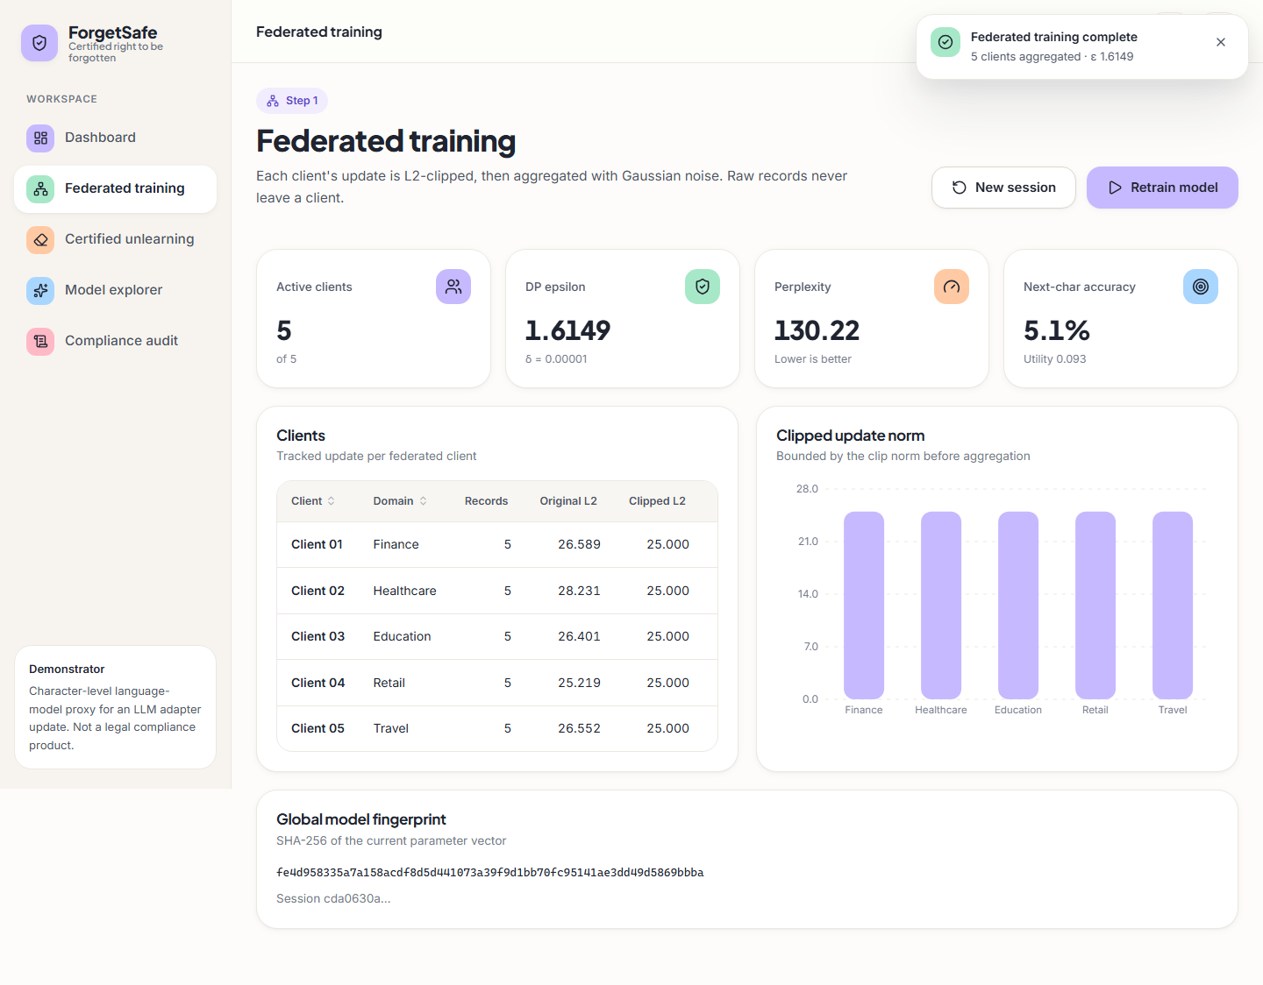
Fig. 24: Federated training screen, full page
The full-page capture adds the Global model fingerprint card below the clients table: the SHA-256 of the current parameter vector, fe4d958335a7a158acdf8d5d441073a39f9d1bb70fc95141ae3dd49d5869bbba, and the start of the session identifier.

Fig. 25: Dashboard after training
The dashboard headline reads "Right-to-be-forgotten, certified". The Workflow card is a three-step stepper: Train is ticked and marked Done, Unlearn ("Remove a client") is highlighted as the current step and Verify shows "Audit chain valid". The summary tiles repeat the training figures (5 of 5 clients, ε 1.6149, perplexity 130.22, accuracy 5.1 %, both labelled with the public evaluation set). Below, Client updates draws the clipped norm of each client as a horizontal bar and Latest certificate still shows "No certificate yet" with a Request unlearning button, because no removal has been made.
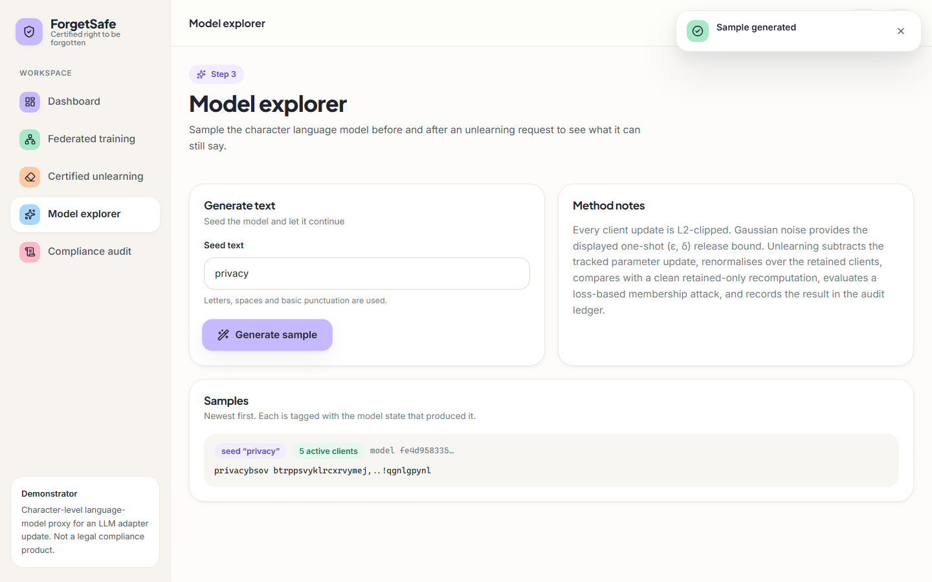
Fig. 26: Model explorer before any removal
The explorer offers a Seed text field (here "privacy"), a Generate sample button and a Method notes card that summarises clipping, Gaussian noise, subtraction and the membership attack. The Samples list, newest first, tags the generated text with the seed, the model state ("5 active clients") and the first characters of the model hash (fe4d958335…). The text is "privacybsov btrppsvyklrcxrvymej,..!qgnlgpynl": a string of characters with no words, which is what a bigram model dominated by noise produces.

Fig. 27: Certified unlearning screen before a request
The Right-to-be-forgotten request card shows a drop-down labelled Client to remove set to "Client 01 — Finance", the note "5 active clients" and the Execute & certify button. The area underneath is an empty state: "No certificate yet. A verification certificate with the residual-influence check, membership-inference AUC and retained utility appears here after an unlearning request."

Fig. 28: Confirmation dialog before a removal
Pressing Execute & certify opens a modal dialog titled "Remove this client?" with the text "Client 01 (Finance) will be erased from the global model. This cannot be undone in this session." and two buttons, Cancel and Remove & certify. The page behind it is blurred. The dialog guards against an accidental click on an action that changes the model.
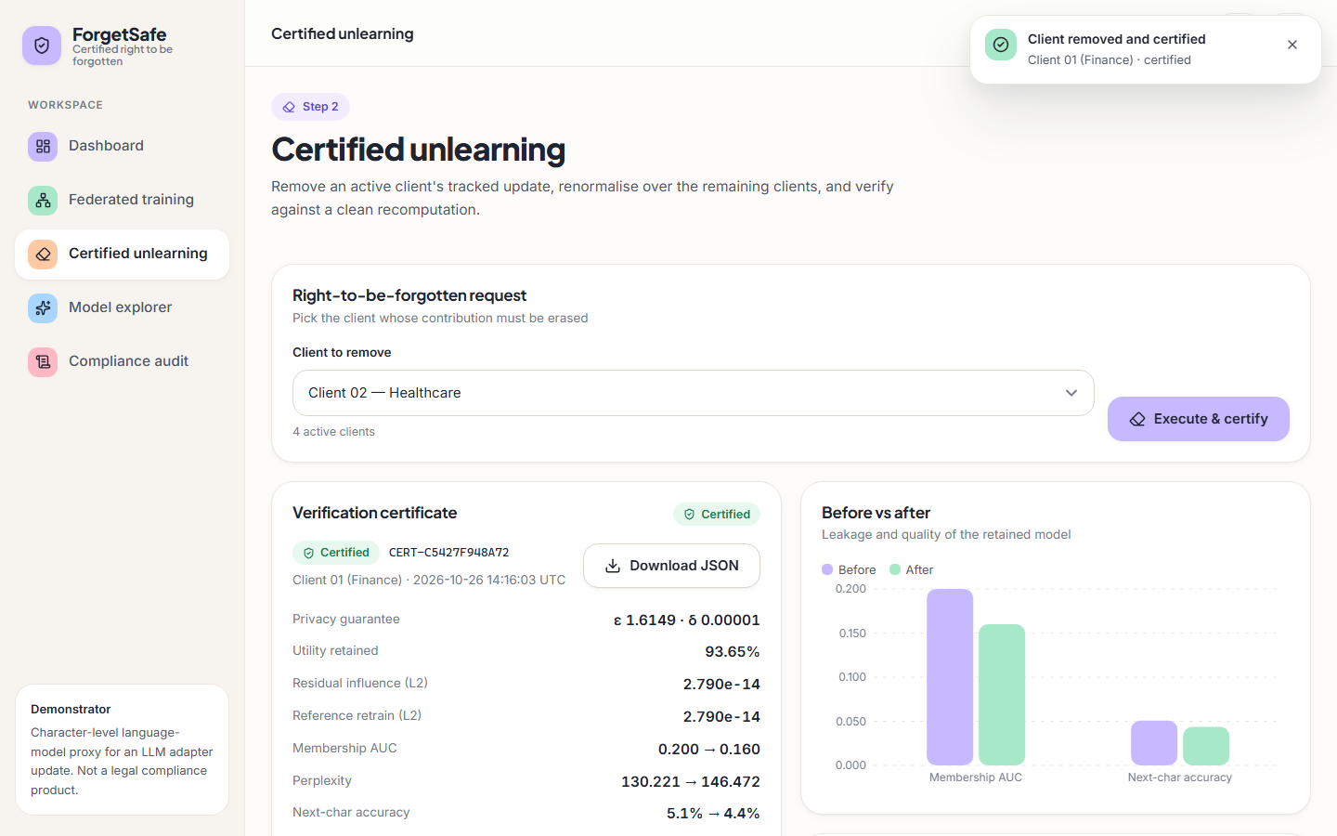
Fig. 29: Verification certificate after removing Client 01
A toast confirms "Client removed and certified, Client 01 (Finance) · certified". The drop-down now offers the four remaining clients (Client 02 — Healthcare is selected, "4 active clients"). The Verification certificate card shows the badge Certified, the identifier CERT-C5427F948A72, the client and the UTC time (2026-10-26 14:16:03) and a Download JSON button, followed by the measured fields: privacy guarantee ε 1.6149 · δ 0.00001, utility retained 93.65 %, residual influence (L2) 2.790e-14, reference retrain (L2) 2.790e-14, membership AUC 0.200 → 0.160, perplexity 130.221 → 146.472 and next-character accuracy 5.1 % → 4.4 %. The Before vs after chart on the right draws the membership AUC and the accuracy as paired bars.

Fig. 30: Verification certificate, full page
The full certificate adds the lower rows: Clients 5 → 4, clip norm · noise 25 · 3, the method "Tracked clipped-update subtraction with retained-client renormalization", the model hash before (fe4d958335a7a158…) and after (d0f7b70df52c5d17…) and the audit record hash 208f652b947ede288f0291ceb321ab92bd9cf7911af5ad74bb3dc6f96e864ca8, which is the value that links the certificate to ledger record 3. A second chart, Perplexity, shows the before bar (130.221) lower than the after bar (146.472).
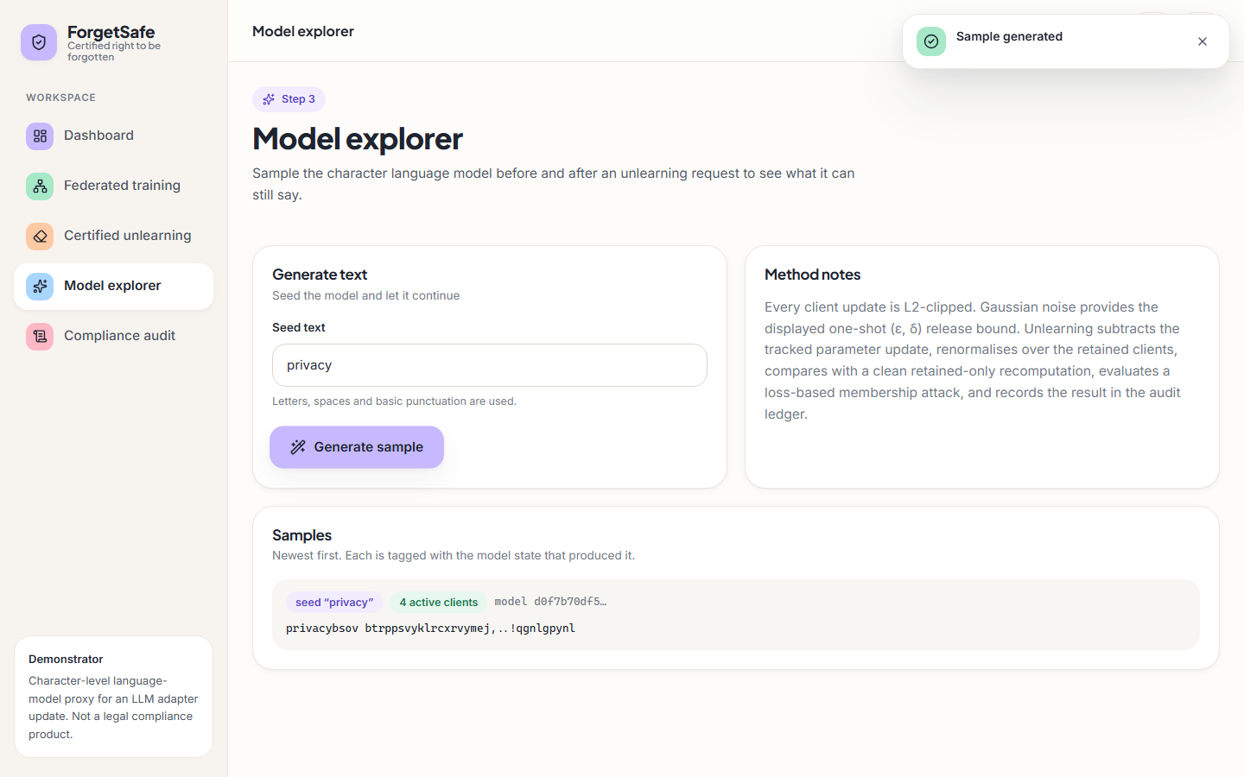
Fig. 31: Model explorer after removing Client 01
The same seed "privacy" now produces a sample tagged "4 active clients" and model hash d0f7b70df5…, and the text is again "privacybsov btrppsvyklrcxrvymej,..!qgnlgpynl", character for character the same as before the removal. The generator uses a fixed random seed and the noisy probabilities changed too little to alter any draw, so the explorer cannot show, by eye, that a client was removed (Section on sample inputs and outputs).
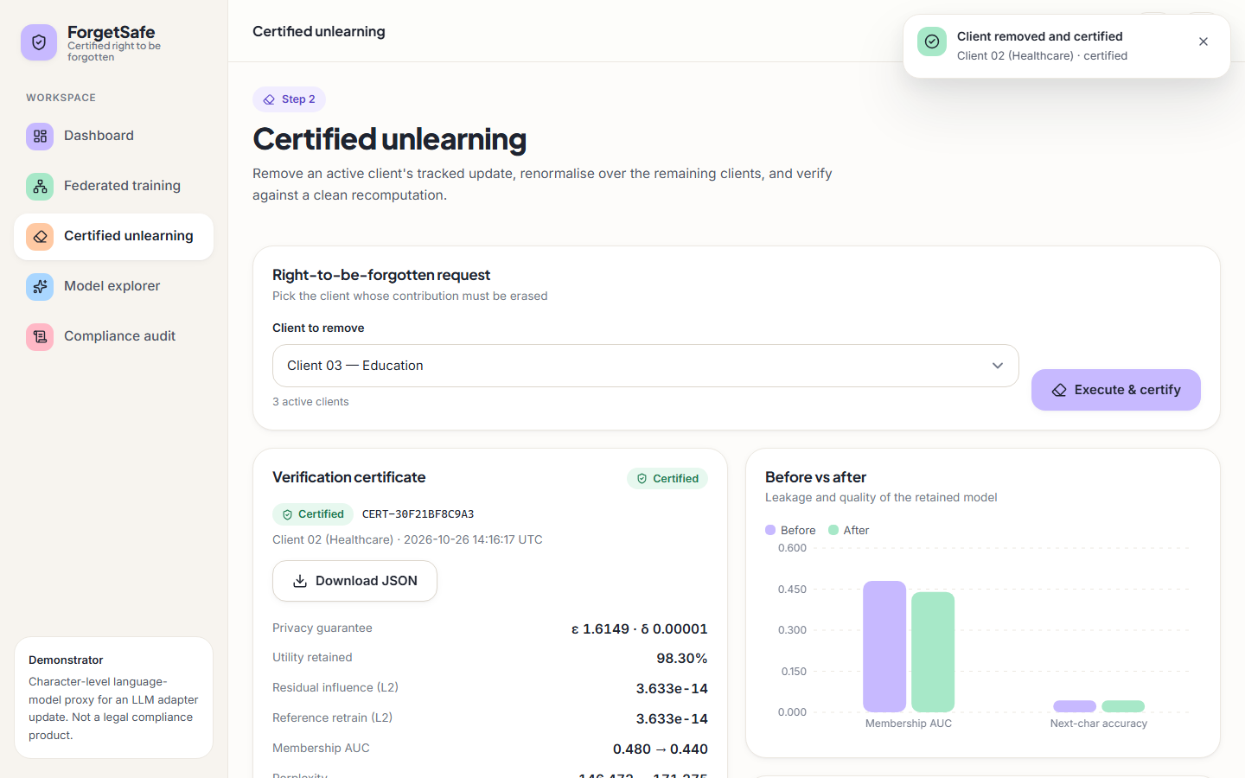
Fig. 32: Certificate for the second removal (Client 02)
After the second request the certificate is CERT-30F21BF8C9A3 for Client 02 (Healthcare), issued 2026-10-26 14:16:17 UTC: ε 1.6149 · δ 0.00001, utility retained 98.30 %, residual influence and reference retrain both 3.633e-14, membership AUC 0.480 → 0.440, and perplexity 146.472 → 171.275 (the bottom row is partly cut off in the capture). The drop-down now offers Client 03 — Education with "3 active clients".

Fig. 33: Dashboard after two removals
All three workflow steps are ticked; Unlearn reads "2 client(s) removed" and Verify "Audit chain valid". The tiles show 3 of 5 active clients, ε 1.6149 (unchanged), perplexity 171.28 and accuracy 4.4 %. The Client updates bars for Finance and Healthcare are drawn in a different colour from the others, and Latest certificate now shows CERT-30F21BF8C9A3 for Client 02 (Healthcare) with ε 1.6149 · δ 0.00001 and utility retained 98.30 %.
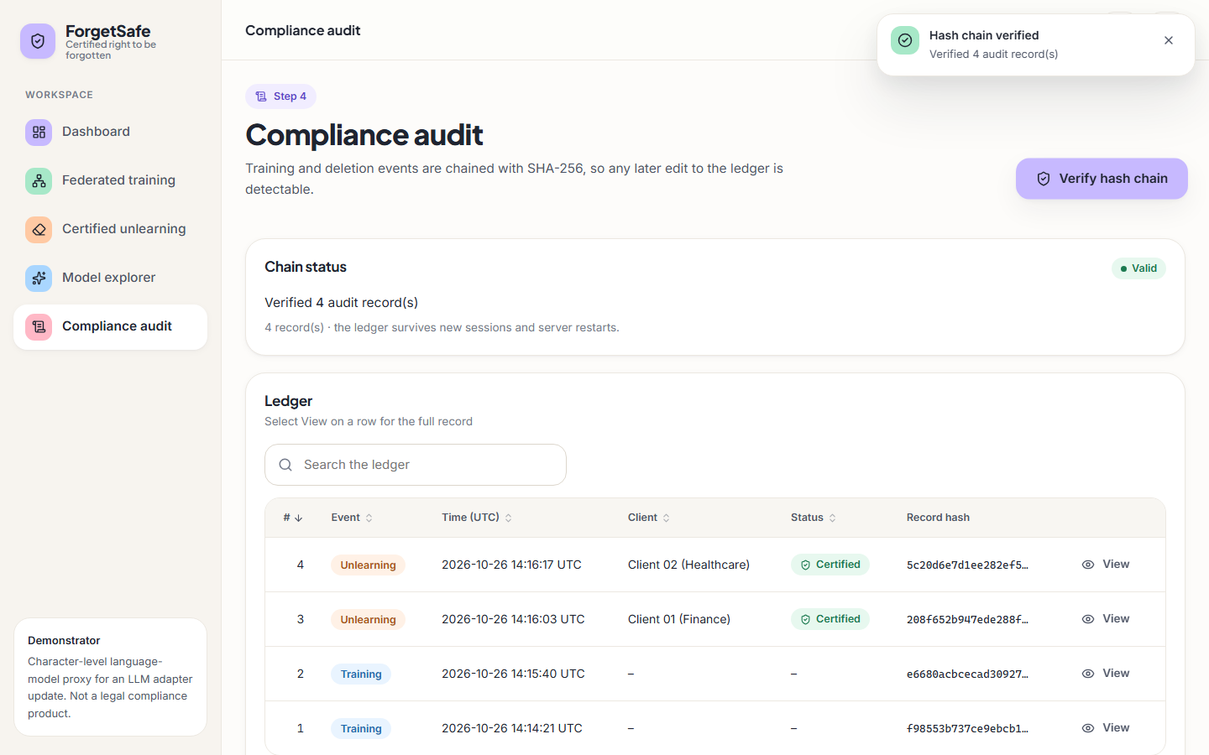
Fig. 34: Compliance audit screen with a verified hash chain
After pressing Verify hash chain a toast reads "Hash chain verified, Verified 4 audit record(s)" and the Chain status card shows the badge Valid and the note that the ledger "survives new sessions and server restarts". The Ledger table lists the four records, newest first, with sequence number, event type (Unlearning or Training), UTC time, client, status and the first characters of the record hash: #4 Unlearning, Client 02 (Healthcare), Certified, 5c20d6e7d1ee282ef5…; #3 Unlearning, Client 01 (Finance), Certified, 208f652b947ede288f…; #2 and #1 Training. A search box and a View action on each row open the full record.
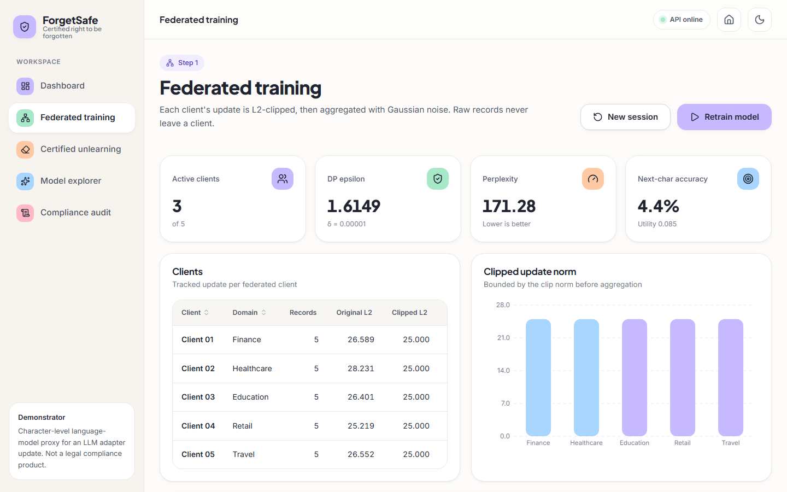
Fig. 35: Training screen after two removals
The training screen keeps the per-client table (original and clipped norms are unchanged, because the stored updates are not modified by unlearning) while the tiles show 3 of 5 active clients, perplexity 171.28, accuracy 4.4 % and utility 0.085. The button now reads Retrain model and the bars of the two removed clients are drawn in a different (light blue) colour.

Fig. 36: Dashboard in dark mode
The same dashboard in the dark theme: the page, cards and tiles switch to dark surfaces with light text, the toggle in the top bar now shows a sun icon, and the accent colours remain legible. The numbers are the same as in the light theme (3 of 5 clients, 171.28, 4.4 %, certificate CERT-30F21BF8C9A3).

Fig. 37: Certified unlearning screen on a 390-pixel-wide viewport
On a phone-width viewport the sidebar is replaced by a top bar (menu button, logo, status dot, theme toggle) and a bottom navigation with Home, Train, Forget, Explore and Audit, with Forget highlighted. The request card stacks vertically (Client 03 — Education, "3 active clients", Execute & certify) and the certificate card for CERT-30F21BF8C9A3 begins below it.
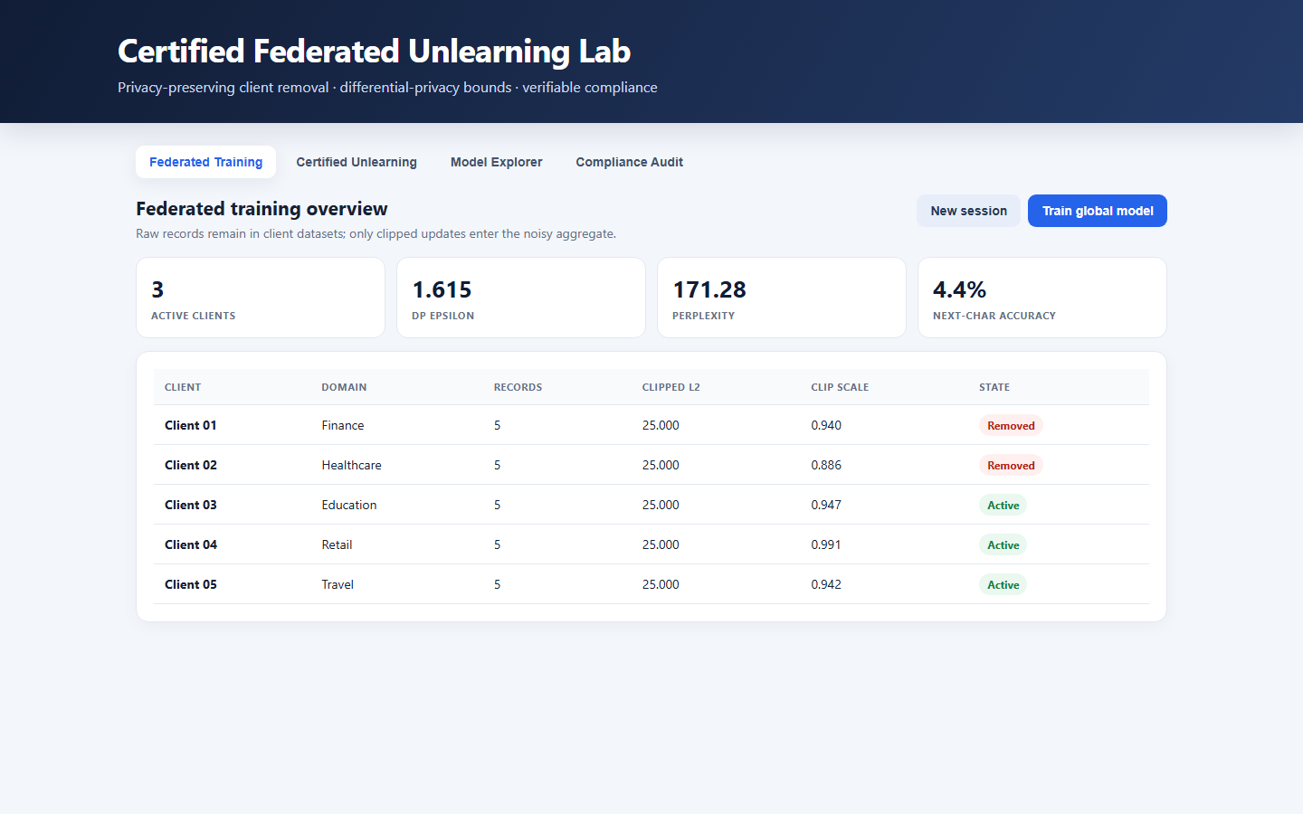
Fig. 38: Original single-page interface served by the API
The original interface, served at / by the Python server, shows the title "Certified Federated Unlearning Lab", four tabs (Federated Training, Certified Unlearning, Model Explorer, Compliance Audit) and the same session state as the React interface: 3 active clients, ε 1.615, perplexity 171.28, accuracy 4.4 %. The client table lists clipped L2 25.000 and clip scales 0.940, 0.886, 0.947, 0.991 and 0.942, with Client 01 and Client 02 marked Removed and the other three Active.

6 Sample Inputs and Outputs
The following requests and responses were captured from a live server started for this purpose (scripts/capture_samples.py, port 8197, a temporary working directory), using the default configuration; they are stored in docs/sample_io/samples.json. Certificate identifiers and timestamps differ from run to run, the numerical fields do not.
Listing: Training request and response
POST /api/train -> HTTP 200
{
"active_clients": 5,
"epsilon": 1.6149350875351296,
"delta": 1e-05,
"perplexity": 130.22138531571318,
"next_character_accuracy": 0.05090909090909091,
"utility_score": 0.0926462600496639,
"model_hash": "fe4d958335a7a158acdf8d5d441073a39f9d1bb70fc95141ae3dd49d5869bbba"
}

Listing: Text generated before the removal
POST /api/generate {"seed": "privacy"} -> HTTP 200
{
"text": "privacybsov btrppsvyklrcxrvymej,..!qgnlgpynl"
}

Listing: Unlearning request and the certificate it returns
POST /api/unlearn {"client_id": "client_finance"} -> HTTP 200
{
"certificate_id": "CERT-E4834FD06896",
"session_id": "d79d22d9-f68e-4c4b-9611-e8ed4e49e751",
"client_id": "client_finance",
"client_name": "Client 01 (Finance)",
"issued_at_utc": "2026-10-26T14:29:18+00:00",
"status": "CERTIFIED",
"method": "Tracked clipped-update subtraction with retained-client renormalization",
"epsilon": 1.6149350875351296,
"delta": 1e-05,
"clip_norm": 25.0,
"noise_multiplier": 3.0,
"residual_influence_l2": 2.7903189690385764e-14,
"reference_retrain_l2": 2.7903189690385764e-14,
"membership_auc_before": 0.2,
"membership_auc_after": 0.16,
"perplexity_before": 130.22138531571318,
"perplexity_after": 146.47196760072828,
"accuracy_before": 0.05090909090909091,
"accuracy_after": 0.04363636363636364,
"utility_retention_percent": 93.64532042042157,
"clients_before": 5,
"clients_after": 4,
"model_hash_before": "fe4d958335a7a158acdf8d5d441073a39f9d1bb70fc95141ae3dd49d5869bbba",
"model_hash_after": "d0f7b70df52c5d17097b83b9144b00621123921d6c60d960604fc2de312ac898",
"audit_record_hash": "c21d202b7a2ee6c91eba527d5d72127df7bf9b92660e16561b08403337d1dc7d"
}

Listing: Text generated after the removal
POST /api/generate {"seed": "privacy"} -> HTTP 200
{
"text": "privacybsov btrppsvyklrcxrvymej,..!qgnlgpynl"
}

Listing: Audit verification and a repeated request
POST /api/audit/verify -> HTTP 200
{
"valid": true,
"detail": "Verified 2 audit record(s)"
}

POST /api/unlearn {"client_id": "client_finance"} -> HTTP 400
{
"error": "client_finance has already been unlearned"
}

Reading the samples: the training response carries the privacy and quality figures and the SHA-256 fingerprint of the parameter vector; the unlearning response carries every field of the certificate, including the model hash before and after (they differ, so the parameters changed) and the audit record hash. The two generated texts are identical: the generator draws from a fixed random seed and the noisy probabilities changed too little to alter a draw. The text therefore cannot be used to see the removal, and the evidence for it has to come from the attack and the retraining comparison above. The repeated request is refused with a clear JSON error and leaves the model and the ledger unchanged.
Table 15: The two ledger records written by this sequence of requests
Seq. | Event | previous_hash (first 16) | record_hash (first 16)
1 | FEDERATED_TRAINING | 0000000000000000… | be69f32ebfec00d6…
2 | CLIENT_UNLEARNING | be69f32ebfec00d6… | c21d202b7a2ee6c9…

7 Comparison with the Base Paper and Related Work
The comparison has to begin with a plain statement of what can and cannot be compared. The base paper recorded in the batch files, Khan et al. [1], is a review of deep-learning approaches to continuous sign language recognition. Its subject is unrelated to federated unlearning, it reports no unlearning, privacy or language-model measurement, and this project adopts only its review method: a taxonomy of approaches, a comparison of strengths and limitations and the identification of open gaps. No numerical comparison with [1] is possible, and none is made.
The technically closest works are [2] (the paper named in the project's base-paper record as the 2026 base paper), [3] and [4]. They were read from the PDFs kept in the project's archive; the table lists what they evaluate. ForgetSafe's numbers are not comparable with theirs: those works train real neural networks on public benchmarks, while ForgetSafe measures a 1,089-parameter bigram model on 25 hand-written sentences, synthetic corpora with up to 4,000 clients, and a 137,151-parameter GRU with LoRA-style adapters on synthetic text.
Table 16: What the closest works evaluate, and why the numbers are not comparable
Work | Setting and data | Method | What it reports | Relation to ForgetSafe
[1] Khan et al. (IEEE Access, 2025) | Review of continuous sign language recognition | Taxonomy of spatial, temporal and alignment approaches | Survey of studies, datasets, challenges and gaps | Review method only; subject unrelated; no results to compare
[2] Wei et al. (KDD 2026) | Federated unlearning on CIFAR-10, CIFAR-100 and EMNIST with ResNet-18, ResNet-34 and VGG-9; six baselines | FedMemPrune: pruning of parameters that carry memorised information, guided by a grouped memorisation metric | Abstract: closely matches retraining-based baselines while eliminating memorisation more effectively than existing methods | Same goal (client-level removal in FL); ForgetSafe subtracts a stored update instead of pruning, and has no image or example-level evaluation
[3] Zhang et al., Oblivionis (arXiv, 2025) | Federated LLM fine-tuning and unlearning with Llama-2-7B and Llama-3.x models on the TOFU and MUSE benchmarks | Framework combining 6 federated-learning and 5 unlearning algorithms | Forget quality and model utility across algorithm pairs; motivated by GDPR erasure | Same problem at LLM scale; ForgetSafe is a bigram stand-in without any LLM
[4] Jiang et al., FedORA (arXiv, 2025) | Vertical federated learning on Income (48,842 samples), MedMNIST, CIFAR-10, CIFAR-100 and Tiny-ImageNet | Primal-dual optimisation with a theoretical bound to training from scratch | Unlearning effectiveness comparable to retraining at lower computation and communication | Provides a formal bound where ForgetSafe provides an identity check; different FL setting (vertical)

Three qualitative observations follow. First, [2] and [4] state their guarantee or their evidence against retraining, and ForgetSafe adopts the same yardstick on all three of its models (fresh-noise retraining: 875 against 881, 645 against 650 and 31.8 against 31.8 in L2 distance, each equal to the distance between two retrains); what those works have and ForgetSafe lacks is a benchmark with real pretrained models. Second, [3] shows that the federated-LLM setting needs forget-quality and utility metrics on real text; the perplexities here, bigram and GRU, are the crudest members of that family, but the GRU study shows the method working on adapter parameters of the kind [3] uses. Third, what ForgetSafe adds is an end-to-end, inspectable workflow in which the guarantee, the attack, the utility check and the audit record are produced together for every request, with the weaknesses of each step measured and reported, and two quantitative results the other works do not give: the federation size at which ε < 1 and a useful model coexist (about 1,000 clients) and the cost of removal against retraining (24 microseconds against 5.9 s for adapters).

8 Success and Failure Analysis

8.1 What worked
Table 17: Cases in which the system succeeds
Success | Evidence
The unlearning workflow is complete and repeatable | train → request → subtract → verify → certificate → ledger; 250/250 certified over 50 seeds; 5 unit tests, 14 smoke checks and 20/20 scripted acceptance journeys pass
Removal is real when there is something to remove | bigram, no noise: AUC 0.992 → 0.544; synthetic corpus, domain level 0.474 → 0.220; neural adapters, client level 0.78 → 0.53 (a fresh retrain gives 0.53)
The unlearned model behaves like a retrained one | L2 to a fresh retrain 875 against 881 between two fresh retrains (bigram, σ = 3); 645 against 650 (synthetic corpus, σ = 0.1); 31.8 against 31.8 (neural, σ = 0.1)
ε < 1 and a useful model coexist in a large federation | σ = 4.85 (ε = 0.999) and perplexity within 1.17 times noise-free at 1,000 synthetic clients; five removals CERTIFIED, retention ≥ 99.998 %
Removal is cheap where retraining is not | neural adapters: 24 µs to subtract against 5.9 s to retrain seven adapters; bigram proxy: 6.8 times faster than retraining at 500 clients
Concurrency is correct | 32 simultaneous removals of one client: one 200, 31 × 400; 16 simultaneous trainings: 16 valid ledger records; 2,000-request soak without errors
The guards and the interface hold up | untrained, unknown, repeat and last-client requests refused with JSON errors; 20 journeys × 7 steps, 49 certificates, 0 console errors; light, dark and 390-px layouts

8.2 Weak points and defects, as measured
Table 18: Weak points and defects found
Weak point or defect | Evidence | Consequence
The default model is noise-dominated | perplexity 142 ± 28 against 32 for a uniform model; accuracy 3.7 %; noise norm about 100 times a client's signal | retained "utility" of 97 % is measured against an almost useless model
Nothing is visible to remove at the default setting | membership AUC 0.524 before and 0.495 after (chance); sentence-level AUC 0.50 even without noise | at five clients and σ = 3 the attack neither supports nor refutes forgetting
The certificate cannot fail | reference distance 1e-14 on 250/250 requests; the reference shares the stored noise and updates | CERTIFIED states that the arithmetic was done correctly; the fresh-noise comparison supplies the independent evidence
ε is outside its proven range, noise is reused, no accountant | ε = 1.6149 > 1 at σ = 3; with the noise reused, n·θ − (n−1)·θ′ recovers the removed update to 1.3e-13 | the certificate's ε is a one-release figure; the released models must not both be published
Small federations are not both private and useful | five clients: ε < 1 gives perplexity 198 and accuracy 3.4 %; eight neural clients: destroyed from σ = 0.3, 59 % retention at σ = 0.1 | the demonstration size is the cause; 1,000 clients are needed (previous section)
The explorer cannot show the effect | the 44-character samples before and after a removal are identical | the screen is illustrative only
The ledger is not tamper-proof and can break the UI | tail truncation, re-hash forgery, a forged appended record and an emptied file all verify; one garbage line makes /api/state return 500 | signatures, an external anchor and tolerant reading are needed (Chapter 10)
Defects in the HTTP layer | 8 defects in 58 probes, six of them in the HTTP layer: negative and short Content-Length block a thread, a cross-site POST removes a client, Host is not checked, a 64-connection burst has 30 refused, no authentication; the other two are the ledger-file defects above | acceptable for a local demonstrator, not for a service (Chapter 7 lists the fixes)
Unlearning is not faster on the small demo | 45.3 ms against 13.4 ms for retraining the proxy; break-even near 100 clients | the efficiency claim holds at scale (500 clients, neural adapters)

9 Boundaries of the Results
Four boundaries define what the results of this chapter cover; each is stated with the evidence that sets it.
- Scale. The product is a 1,089-parameter bigram model; the neural adapter study uses a 137,151-parameter GRU with 8 synthetic clients and one aggregation round, and the synthetic-corpus study up to 4,000 synthetic clients. No pretrained billion-parameter language model is used, and no claim is made about one.
- Data. The product's 25 sentences and every other corpus are synthetic (seeded generators); membership AUC has a resolution of 0.04 at five sentences and 5e-5 at 200, with a standard deviation of 0.22 over the 250 default requests.
- Acceptance. Interface acceptance is established by 20 scripted synthetic-user journeys, not by human participants.
- Machine and baselines. All timings are medians from one CPU workstation (i5-12500, 15.7 GB, no GPU); the only comparison algorithm is retraining. Gradient ascent, SISA sharding, pruning [2] and primal-dual methods [4] are compared with in the literature table, not implemented.

10 Objectives Against Outcomes
The six objectives come from the project's objectives and problem statement. The verdicts use the evidence of this chapter and of Chapter 7.
Table 19: Objectives measured against outcomes
No. | Objective | Outcome | Verdict
1 | Set up federated fine-tuning of an LLM across multiple clients | Federated aggregation of clipped, noised updates across 5 simulated clients on the bigram proxy, and across 8 synthetic clients fine-tuning LoRA-style adapters of a 137,151-parameter GRU; pretrained billion-parameter LLMs are outside the project's scope and hardware | Met at small scale
2 | Remove a client's influence by parameter-level unlearning without full retraining | Exact subtraction of the tracked update in both models; 250/250 bigram requests; neural removal 24 µs against 5.9 s retraining; behaves like a fresh retrain | Met
3 | Certify forgetting with differential-privacy based guarantees | ε and δ reported with the classical formula; outside its range at σ = 3 (ε = 1.6149); ε < 1 and a useful model coexist from about 1,000 clients (ε = 0.999); noise reused, no accountant | Met as reported, with measured conditions
4 | Verify with membership-inference tests and comparison with retraining | Attack and reference check on every request; fresh-noise retraining comparison agrees on three models (L2 875 vs 881; 645 vs 650; 31.8 vs 31.8); the attack is informative where leakage exists (noise-free, small σ, domain level) | Met
5 | Preserve model utility on the remaining data | Retention 97.1 % ± 3.5 over 250 bigram requests; neural 99.9 % at σ ≤ 0.01 and 98.5 % at σ = 0.03; 59 % at σ = 0.1 would be REVIEW_REQUIRED | Met, with the measured noise limits
6 | Provide auditable compliance records for each request | Every training and removal is a hash-chained record linked to its certificate; edits, deletions and swaps detected; truncation, re-hash forgery and an emptied file are not (findings with fixes in Chapter 10) | Met with measured defects

