Department of Computer Science and Engineering (Data Science)
CSDS-A | Batch A4 (CSE - Data Science, Section A)
Advanced Optimization in E-Commerce Logistics: Combining Matheuristics With Random Forests for Hub Location Efficiency
(HubOptima)
S.No. | Student name | Roll / hall ticket no.
1 | CH.ARCHANA | 23K91A6745
2 | A.MEENAKSHI | 23K91A6705
3 | B.ARUN | 23K91A6734
4 | A.SAMPATH | 23K91A6712
Under the guidance of: [GUIDE NAME], [DESIGNATION]
RESULTS
This document reports the real results of the project: the forecast accuracy, the plans, the comparison with traditional methods, the rolling re-optimisation, the scalability benchmark, every output screen with a caption, the success and failure cases and the objectives measured against the outcomes. The dataset is synthetic; the base paper's real-data results are not reproduced.

1 Demand Forecast Results
The Random Forest was fitted on 2,430 region-months (2023-04 to 2025-06) and evaluated on the 540 region-months of July to December 2025, which it never saw. Two naive forecasters are scored on the same rows: the last month's value and the three-month moving average.
Table 1: Forecast accuracy on the held-out months
Forecaster | MAE (orders) | RMSE (orders) | MAPE (%) | R-squared
Random Forest (proposed) | 1,984.0 | 6,618.9 | 7.67 | 0.9766
Last month's value | 4,151.1 | 12,604.1 | 19.71 | 0.9152
3-month moving average | 3,785.5 | 11,882.0 | 17.56 | 0.9246

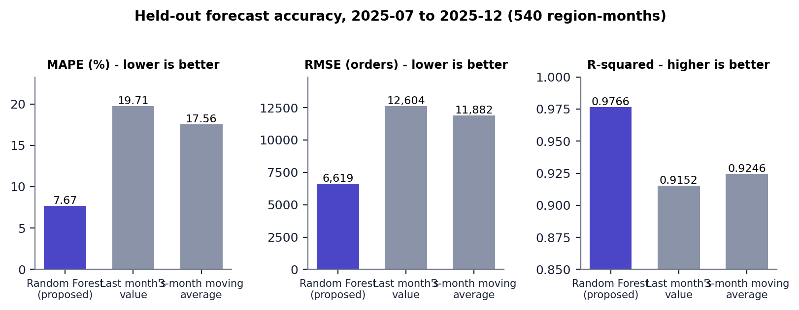
Fig. 1: Held-out accuracy of the three forecasters
The Random Forest roughly halves the error of both naive forecasters: MAE 1,984 against 4,151 and 3,786, MAPE 7.67% against 19.71% and 17.56%. These are results on a synthetic series whose generating process the model can learn; they should not be read as accuracy that would be achieved on real orders.

1.1 What the model relies on
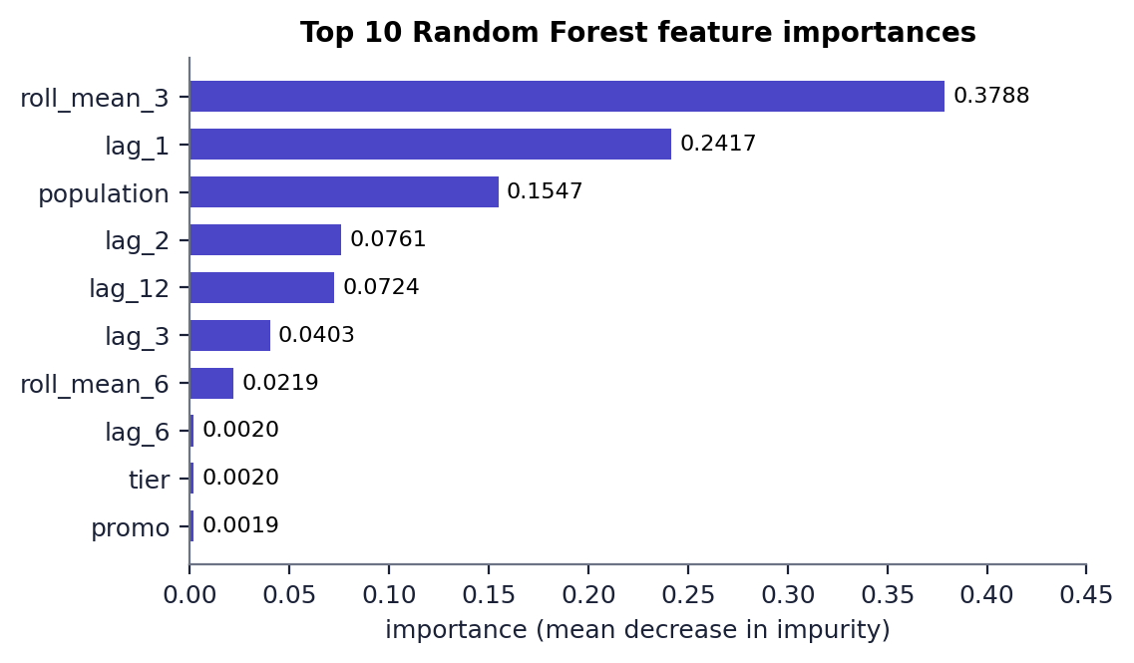
Fig. 2: Top 10 Random Forest feature importances
Three features carry almost all of the importance: the three-month rolling mean (0.379), the previous month's orders (0.242) and the region's population (0.155). The calendar features that encode the festival peak have very small importance (festival 0.0017, month 0.0011, promo 0.0019). This is consistent with the dataset: the level of a region is the main driver, and the trees appear to take most of the festival effect from recent lags rather than from the calendar.

1.2 Error by region and by month
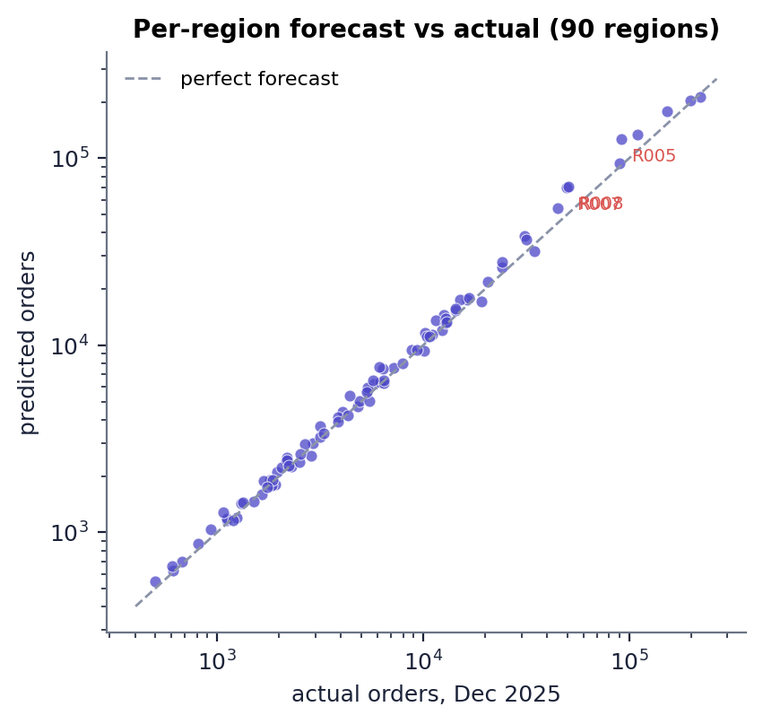  Fig. 3: Per-region forecast and actual orders, Dec 2025 | 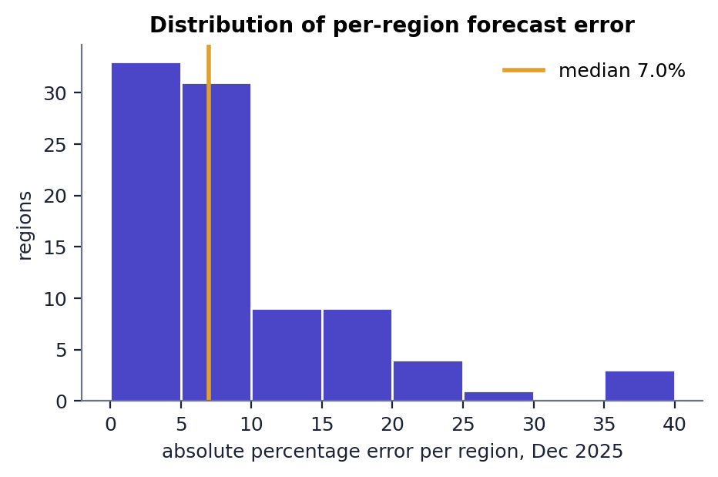  Fig. 4: Distribution of per-region error, Dec 2025

In December 2025 the median absolute error across the 90 regions is 7.0% and the mean 8.9%; 8 regions exceed 20%. The worst are Pune (39.9%), Ahmedabad (39.3%), Chennai (39.0%), all over-forecasts of large tier-1 cities.
Table 2: Network-level forecast error by test month
Month | Forecast total | Realised total | Network error (%)
2025-07 | 1,409,247 | 1,453,765 | 3.06
2025-08 | 1,569,092 | 1,625,632 | 3.48
2025-09 | 1,430,570 | 1,521,247 | 5.96
2025-10 | 2,071,229 | 2,383,534 | 13.10
2025-11 | 2,145,198 | 2,177,565 | 1.49
2025-12 | 1,756,241 | 1,593,341 | 10.22

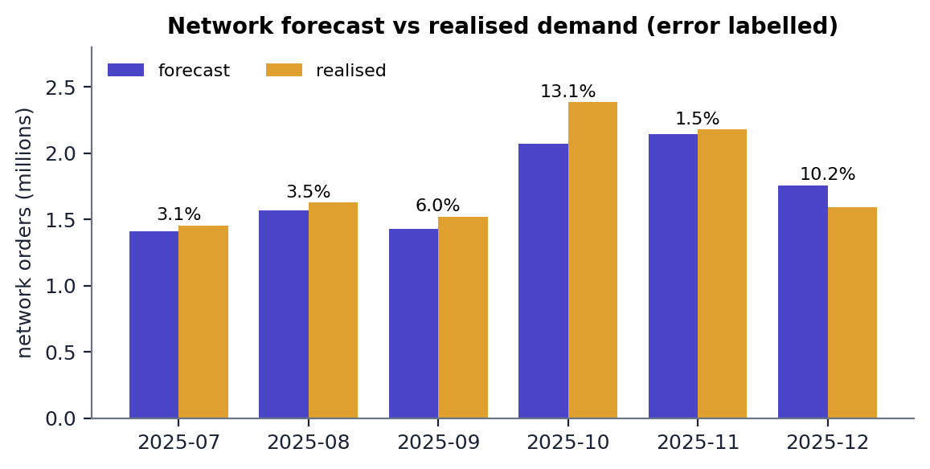
Fig. 5: Network forecast against realised demand, July to December 2025
Network errors are small in ordinary months (1.5-6.0%) and large at the festival peak (13.1% in October, an under-forecast) and in December (10.2%, an over-forecast after the peak). The October 2025 volume (2.38 million orders) is higher than any month the model was trained on (the previous maximum was 1.96 million in October 2024); a forest cannot predict beyond the range of the targets it has seen, so this is a likely cause of the under-forecast, although the project did not test it further.

2 The Proposed Plan for October 2025
The matheuristic, planned on the forecast of 2,067,718 orders and scored on the 2,383,534 orders that occurred, opens six hubs: three tier-1 cities (Mumbai, Delhi, Kolkata) and three satellite districts (Hyderabad-W2, Bengaluru-SE, Ahmedabad-SE).
Table 3: Hubs of the proposed plan, Oct 2025 (scored on realised demand)
Hub | Regions served | Realised demand | Utilisation | Longest delivery (h) | Mean distance (km)
Mumbai | 9 | 473,277 | 110% (over) | 10.0 | 133
Delhi | 12 | 524,850 | 122% (over) | 17.8 | 284
Kolkata | 16 | 346,521 | 80% | 27.2 | 424
Hyderabad-W2 | 18 | 253,915 | 59% | 25.4 | 453
Bengaluru-SE | 16 | 478,108 | 111% (over) | 16.2 | 264
Ahmedabad-SE | 19 | 306,863 | 71% | 37.7 | 582

Table 4: KPIs of the proposed plan
Measure | Value
Operating cost | INR 62,157,534 per month (INR 26.08 per order)
Fixed / transport / delivery-time penalty | INR 15,750,000 / 15,818,196 / 30,589,338
Average / maximum delivery time | 8.56 h / 37.71 h
Average distance | 165.9 km
Simulated fulfilment / SLA reliability (48 h) | 92.3% / 92.3%
Overloaded hubs | 3 of 6
Solver time (saved comparison) | 4.89 s (matheuristic), 7.99 s (exact MIP)

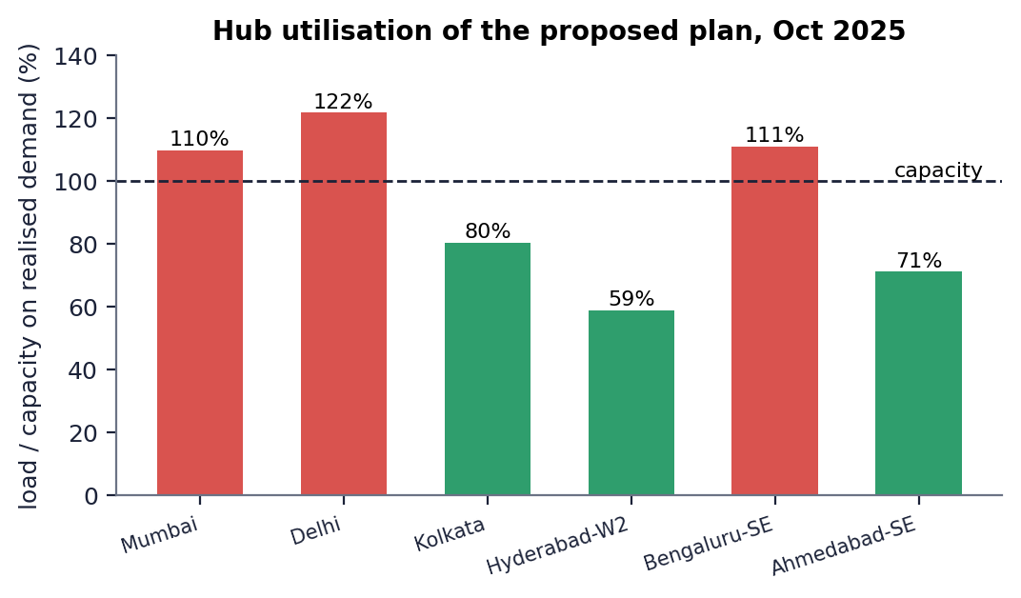
Fig. 6: Hub utilisation of the proposed plan on realised demand
Delhi (122%), Bengaluru-SE (111%) and Mumbai (110%) are above capacity. Capacity was sized from the forecast, which was 13.2% below the realised demand, so the three hubs that serve the biggest markets run over, and 7.7% of the realised orders are counted as unfulfilled. No hub is far under-used except Hyderabad-W2 (59%). The longest delivery (37.7 h to Dehradun-N through Ahmedabad-SE, 1,427 km) is within the 48 h SLA; with only six hubs, the north of the country is served from distant hubs.

3 Comparison with Traditional Methods
All methods plan the same month (October 2025) from the same forecast with p = 6 hubs and are scored on the realised demand. The exact MIP had a 30 s time limit.
Table 5: Methods compared on October 2025 (p = 6)
Method | Cost (INR M) | vs proposed | Avg delivery (h) | Fulfilment | Overloaded | Solve (s)
RF forecast + matheuristic (proposed) | 62.16 | reference | 8.56 | 92.3% | 3 | 4.89
RF forecast + exact MIP (CBC) | 62.16 | +0.00% | 8.56 | 92.3% | 3 | 7.99
RF forecast + greedy heuristic | 69.31 | +11.51% | 9.47 | 89.3% | 3 | 0.01
RF forecast + k-means clustering | 64.41 | +3.62% | 9.19 | 91.8% | 3 | 0.11
Largest-markets rule (no optimisation) | 72.15 | +16.08% | 8.96 | 91.1% | 3 | 0.00
Historical-average demand + matheuristic (no forecast) | 67.17 | +8.07% | 9.91 | 66.0% | 5 | 3.60

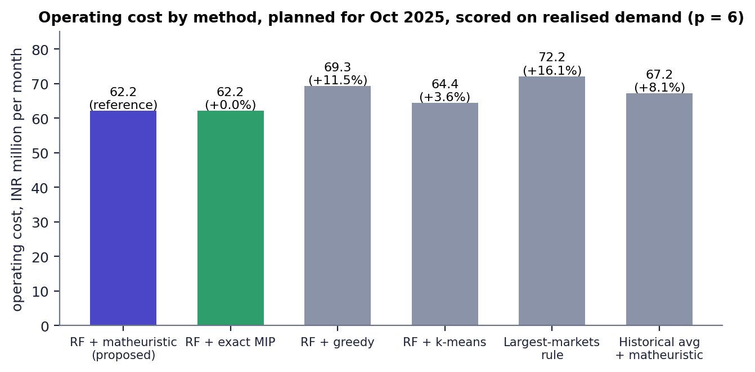
Fig. 7: Operating cost by method
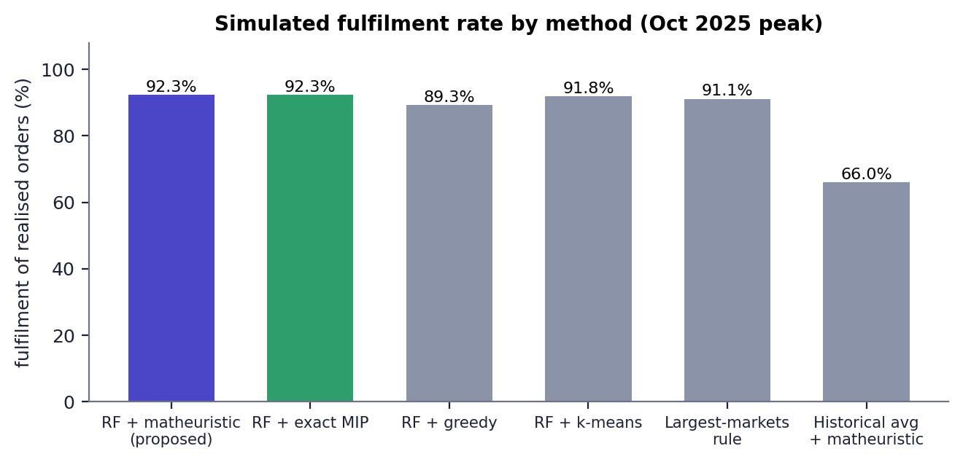
Fig. 8: Simulated fulfilment by method
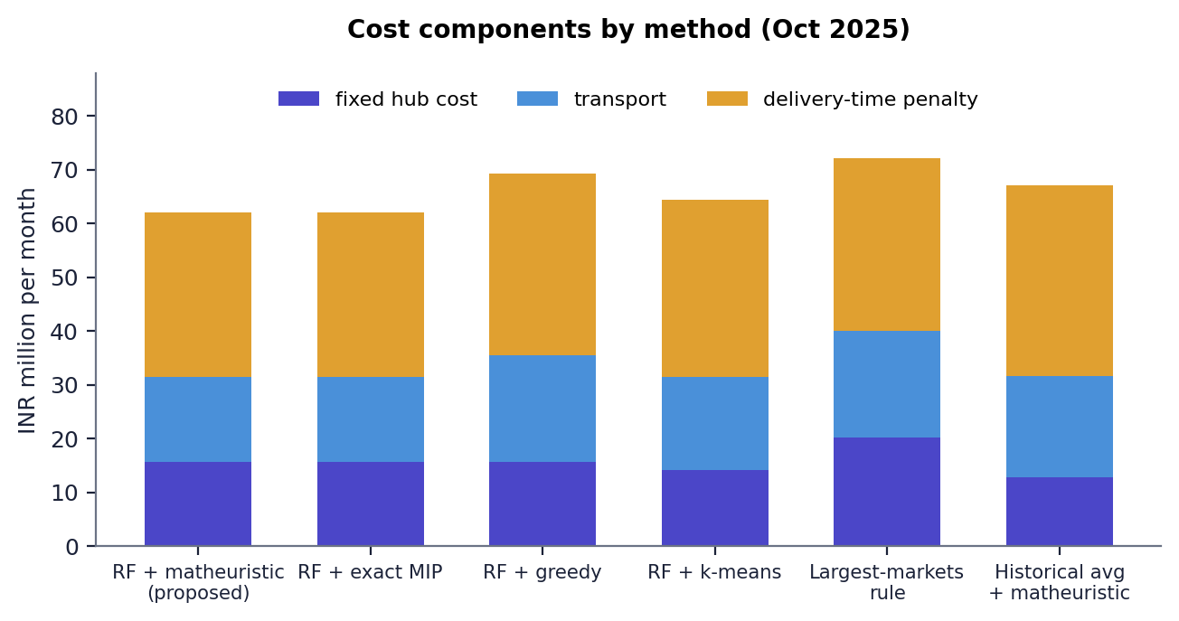
Fig. 9: Cost components by method

3.1 Reading the comparison
- The matheuristic equals the exact MIP. Both open the same six hubs and cost INR 62.16 M; CBC proved the exact plan optimal in 7.99 s against 4.89 s. On a 90-region network the matheuristic confirms the optimum but does not yet save much time (Section 'Scalability').
- Heuristics cost more. Greedy is 11.5% more expensive (it opens Nagpur-N instead of Ahmedabad-SE and has the lowest fulfilment of the forecast-based methods, 89.3%); k-means is 3.6% more expensive; the largest-markets rule is 16.1% more expensive and has the longest delivery of any plan (50.0 h maximum, beyond the 48 h SLA).
- Forecasting matters. Planning on the historical average costs 8.1% more in the model and serves only 66.0% of realised orders, with five of six hubs overloaded, because its capacities are sized for much lower demand.
- Fulfilment is similar for the forecast-based methods (89-92%): all of them inherit the 13.2% under-forecast, so every method has overloaded hubs (3 each). The proposed plan has the highest fulfilment and the lowest cost of the six, but its fulfilment advantage over k-means is 0.5 points only.
- These are single-instance results; no repeated runs, confidence intervals or other months were evaluated in this comparison.

4 Rolling Re-Optimisation
For each month from July to December 2025 the forecaster is applied using only earlier data, the matheuristic re-plans, and the plan is scored on the realised demand. A static plan, computed once from the average demand before July, is scored on the same months. The forecaster is not retrained during the simulation; its lag features are updated each month.
Table 6: Adaptive and static plans, July to December 2025
Month | Adaptive fulfilment | Static fulfilment | Adaptive cost (INR M) | Static cost (INR M) | Hub change
2025-07 | 100.0% | 95.3% | 45.83 | 46.48 | none
2025-08 | 99.4% | 88.5% | 48.65 | 50.16 | none
2025-09 | 99.0% | 93.3% | 46.49 | 47.75 | none
2025-10 | 92.4% | 64.9% | 62.16 | 67.44 | open Kolkata; close Kolkata-W
2025-11 | 98.7% | 70.8% | 58.79 | 63.10 | none
2025-12 | 100.0% | 89.5% | 46.49 | 49.34 | none
Average | 98.3% | 83.7% | 51.40 | 54.05 | 1 opening

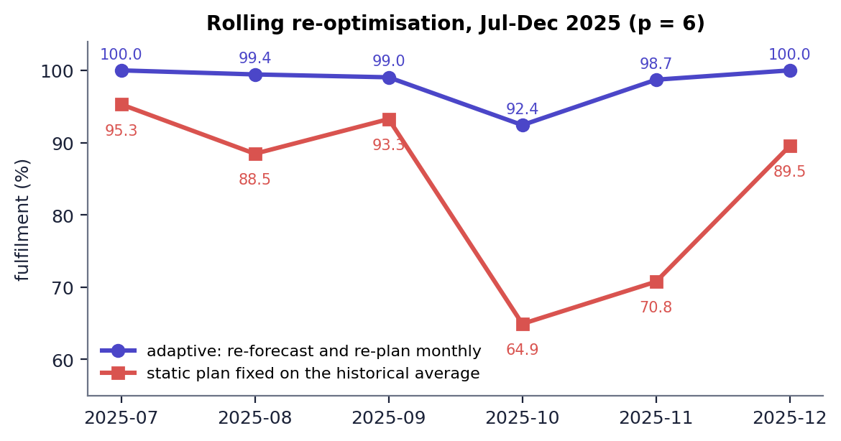
Fig. 10: Fulfilment of the adaptive and the static plan by month
Adaptive re-planning achieves 98.3% average fulfilment against 83.7% for the static plan (+14.6 points), an average delivery time of 8.93 h against 9.98 h, and an average cost of INR 51.4 M against INR 54.0 M (-4.9%). The gap is widest in the October peak (92.4% against 64.9%), where the static plan is sized for ordinary demand. The only hub change is Kolkata-W being replaced by Kolkata in October. The static plan was fitted on the earlier average, so it is a deliberately simple control; a static plan with generous capacity or a plan re-trained monthly was not tested.

5 Scalability
The scalability benchmark splits every region into 1, 2 or 3 nearby demand points to build networks of 90, 180 and 270 nodes and times the exact MIP (with a time limit) against the matheuristic.
Table 7: Exact MIP against matheuristic by network size
Nodes | Binary variables | Matheuristic (s) | Exact MIP (s) | Exact status | Matheuristic gap
90 | 8,190 | 3.13 | 12.74 | Optimal | +0.00%
180 | 32,580 | 8.31 | 42.94 | Optimal | -0.05%
270 | 73,170 | 30.53 | 67.14 | Not Solved | +3.67%

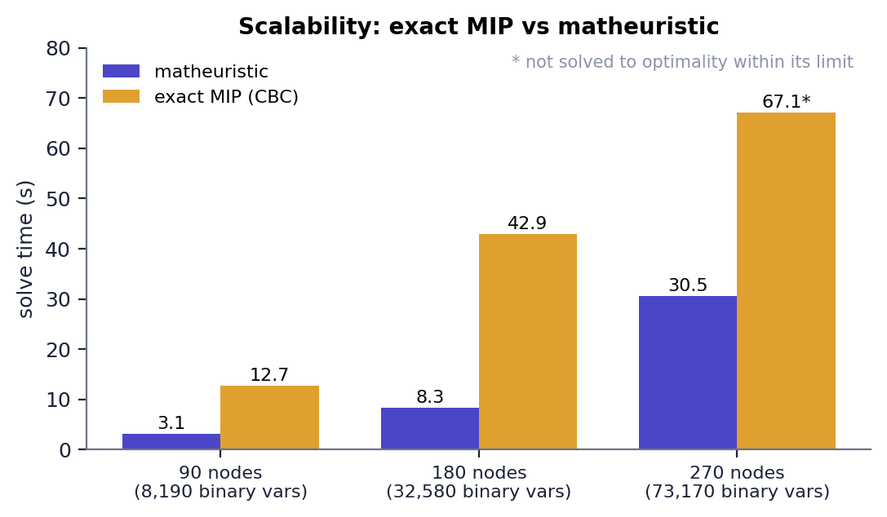
Fig. 11: Solve time of the exact MIP and the matheuristic
- At 90 and 180 nodes both methods find the same plan (gap 0.00% and -0.05%, i.e. the matheuristic was marginally better at 180 nodes because CBC stops within its default tolerance); the matheuristic is 4.1 and 5.2 times faster.
- At 270 nodes (73,170 binary variables) CBC did not finish within its limit (status 'Not Solved') and reported an incumbent of INR 53.43 M; the matheuristic returned INR 55.39 M in 30.5 s, 3.67% above the incumbent.
- The base paper reports networks of 50 to 500 nodes; this project measured three sizes up to 270 and makes no claim beyond them.

6 Performance Testing
Timings were taken over HTTP on localhost with the servers running (Intel Core i5-12500 (6 cores, 12 threads), 15.7 GB RAM, Windows 11 Pro, Python 3.11.9, Node.js v24.19.0); n is the number of calls, the median and range are in the table. The planning calls include forecasting, instance construction, the solve and the evaluation, so they are slower than the solver-only times stored in the result files (for example 4.89 s for the matheuristic in the saved comparison).
Table 8: Latency of read endpoints
Endpoint | Median (ms) | Range (ms) | n
GET /api/health | 10 | 2-27 | 20
GET /api/summary | 30 | 4-37 | 20
GET /api/regions | 16 | 2-32 | 20
GET /api/forecast (next month, 90 regions) | 264 | 200-343 | 10
GET /api/forecast/metrics | 4 | 2-24 | 10
GET /api/compare | 11 | 8-35 | 10
GET /api/rolling | 3 | 2-14 | 10
GET /api/scalability | 2 | 1-30 | 10

Table 9: Latency of the planning endpoint
Planning call | Median | Range | n
POST /api/optimize, matheuristic, Oct 2025, p = 6 | 12.2 s | 9.2-13.4 s | 5
POST /api/optimize, exact MIP, Oct 2025, p = 6 | 15.3 s | 13.4-15.7 s | 3
POST /api/optimize, matheuristic, next month, p = 6 | 10.7 s | 9.6-13.2 s | 5
POST /api/optimize, matheuristic, Dec 2025, p = 4 | 3.4 s | 3.2-4.1 s | 5

- Read endpoints answer in 2-30 ms; the forecast endpoint takes 0.26 s because it builds features for 90 regions.
- Planning takes about 3 s for four hubs and 11-12 s for six hubs. At 90 nodes the exact MIP (15.3 s) is slower than the matheuristic (12.2 s) end to end but not dramatically; in the UI runs the solver-only times were 9.23 s and 9.29 s.
- Run-to-run variation of several seconds comes from CBC and from sharing the processor with the browser; the saved comparison measured 4.89 s (matheuristic) and 7.99 s (exact) for the same instance.

7 Output Screens
Every screen below is a capture of the running application (1440 x 900, Chrome) with the real data of this project; the planning screens were produced by operating the form. The comparison, scalability and rolling screens display the saved results in results/.

Fig. 12: Landing page
The product landing page: the headline, a preview of the planned network (INR 62.2 M per month) and the key claims (90 regions, Random Forest MAPE 7.67%, +14.6 points of fulfilment against a static plan).

Fig. 13: Landing page: the pipeline
The landing section that explains the pipeline in five steps: historical orders, Random Forest forecast, hub-location model, matheuristic solve and monthly re-optimisation.
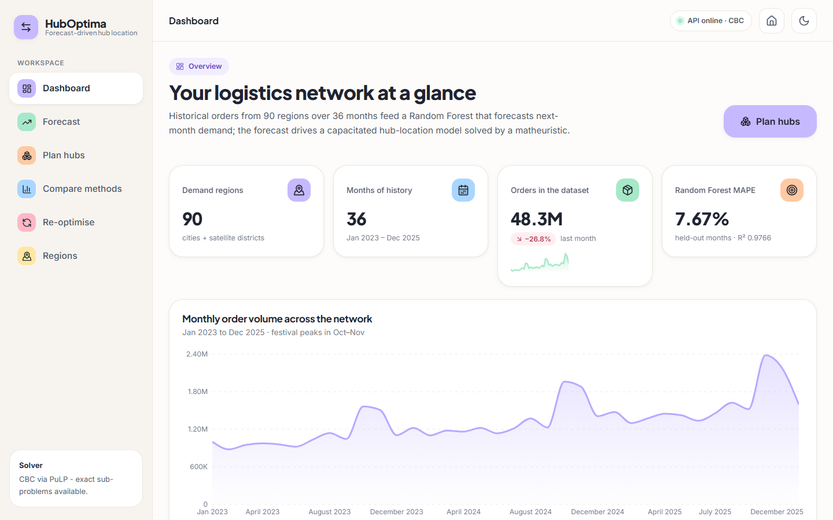
Fig. 14: Dashboard
Network overview: 90 regions, 36 months, 48.3 M orders in the dataset, Random Forest MAPE 7.67% (R-squared 0.9766) and the monthly order volume with the October-November festival peaks.
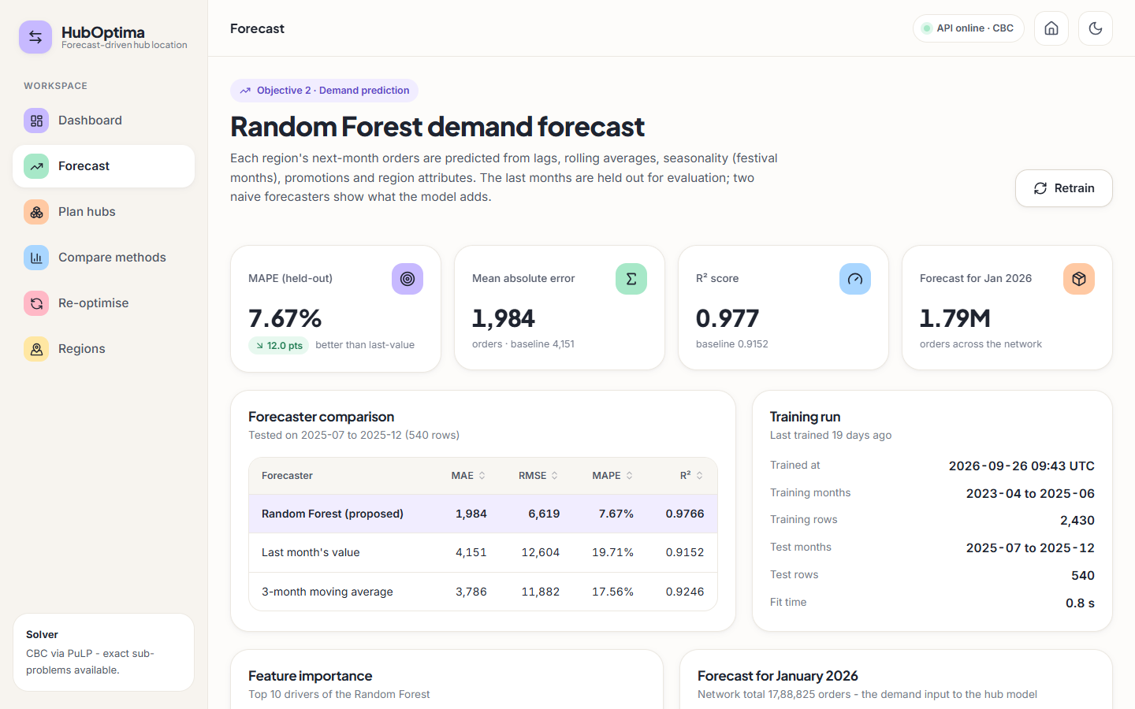
Fig. 15: Forecast page
Random Forest against the two naive forecasters on the 540 held-out region-months, with the training-run details.
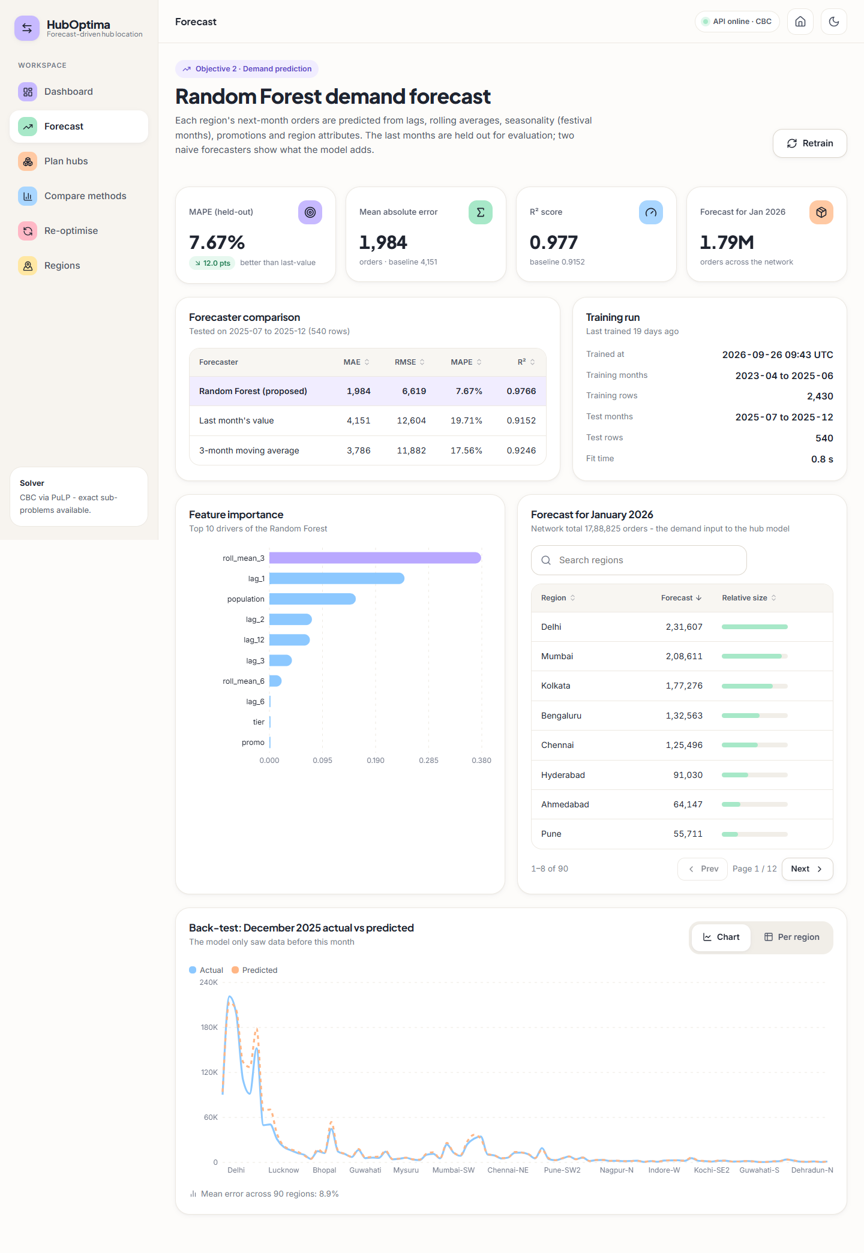
Fig. 16: Forecast page (full)
The whole forecast page: accuracy tiles, forecaster comparison, feature importance, the January 2026 forecast per region (1,788,825 orders in total) and the December 2025 back-test (mean error 8.9% across 90 regions).
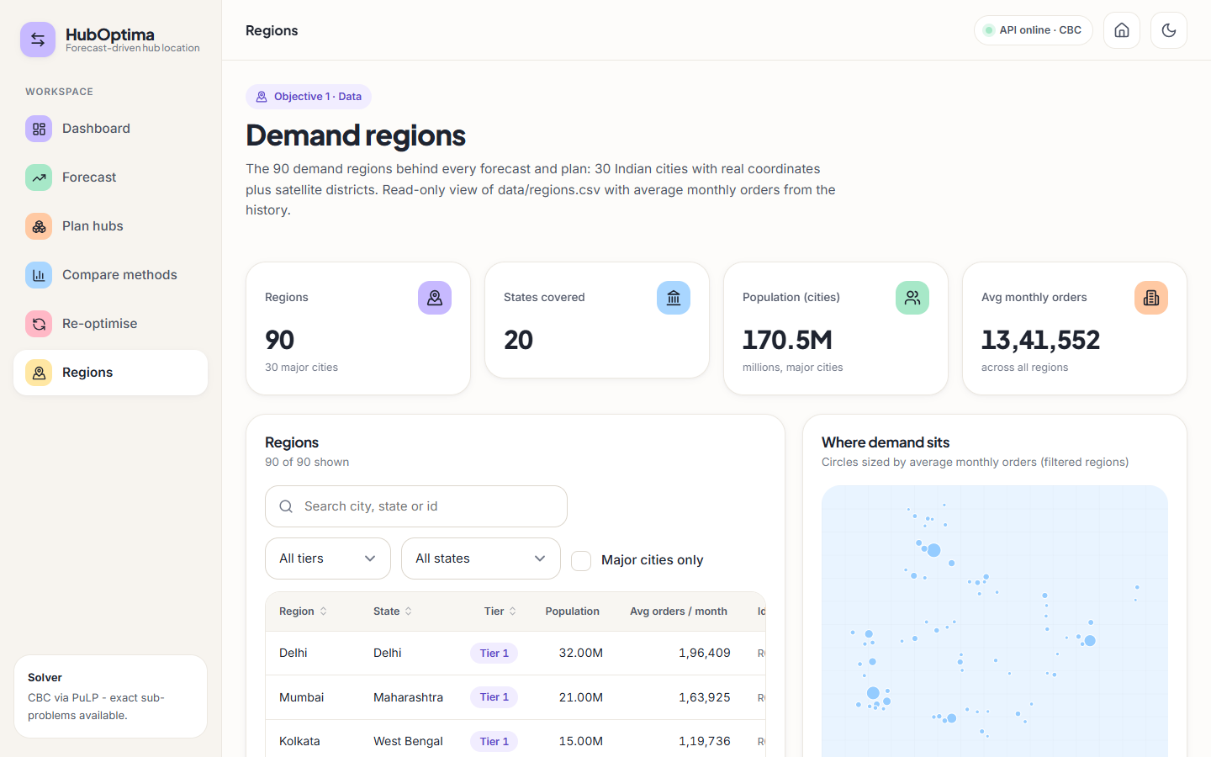
Fig. 17: Regions page
The 90 demand regions (30 cities and 60 satellite districts, 20 states) with search and filters, population, average monthly orders and a map of where demand sits.
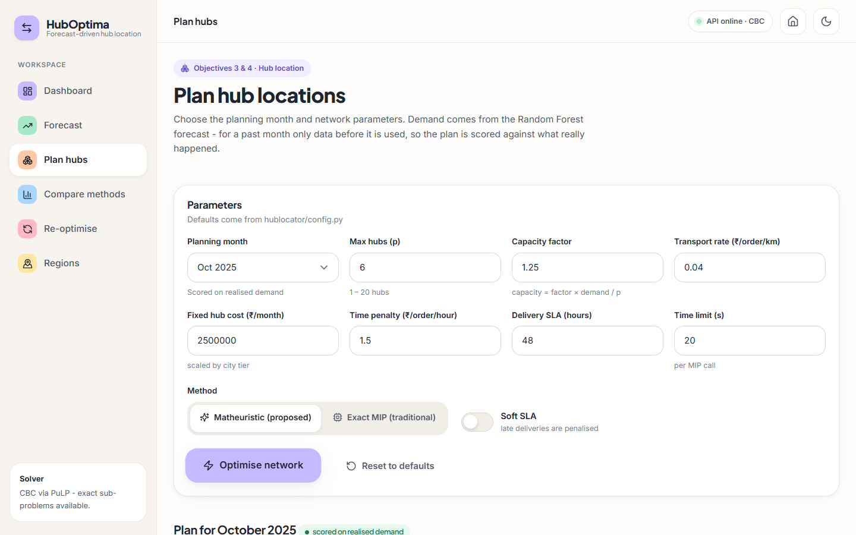
Fig. 18: Plan hubs: parameters
The planning form: month, maximum hubs p = 6, capacity factor 1.25, transport rate, fixed hub cost, time penalty, SLA, time limit, method and hard/soft SLA.
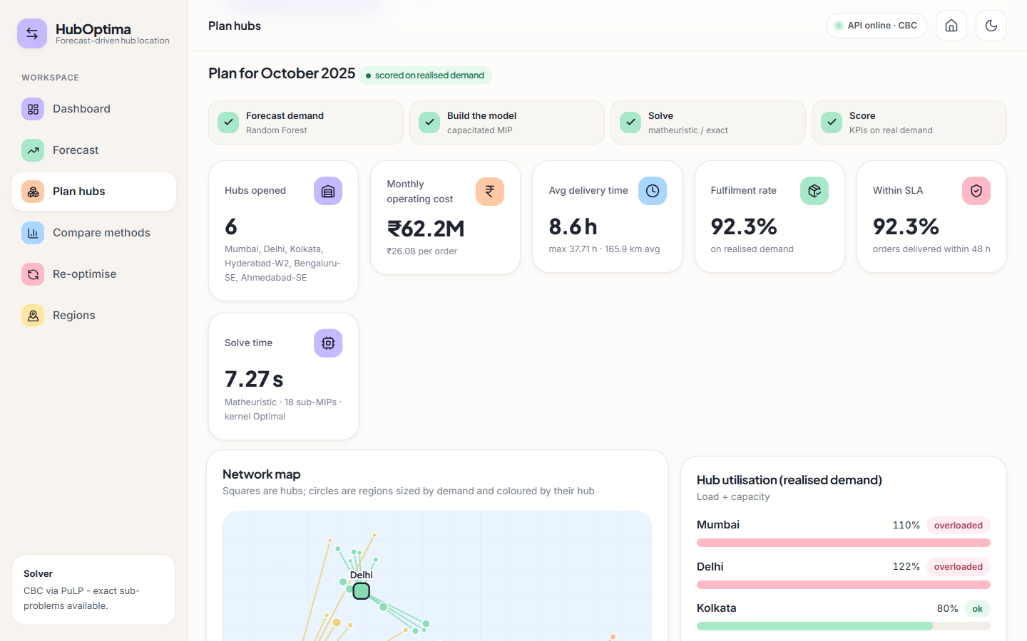
Fig. 19: Plan hubs: result KPIs
Oct 2025 plan from the matheuristic: 6 hubs, INR 62.2 M per month, 8.6 h average delivery, 92.3% fulfilment and 92.3% within the 48 h SLA on realised demand, solved in 9.23 s.
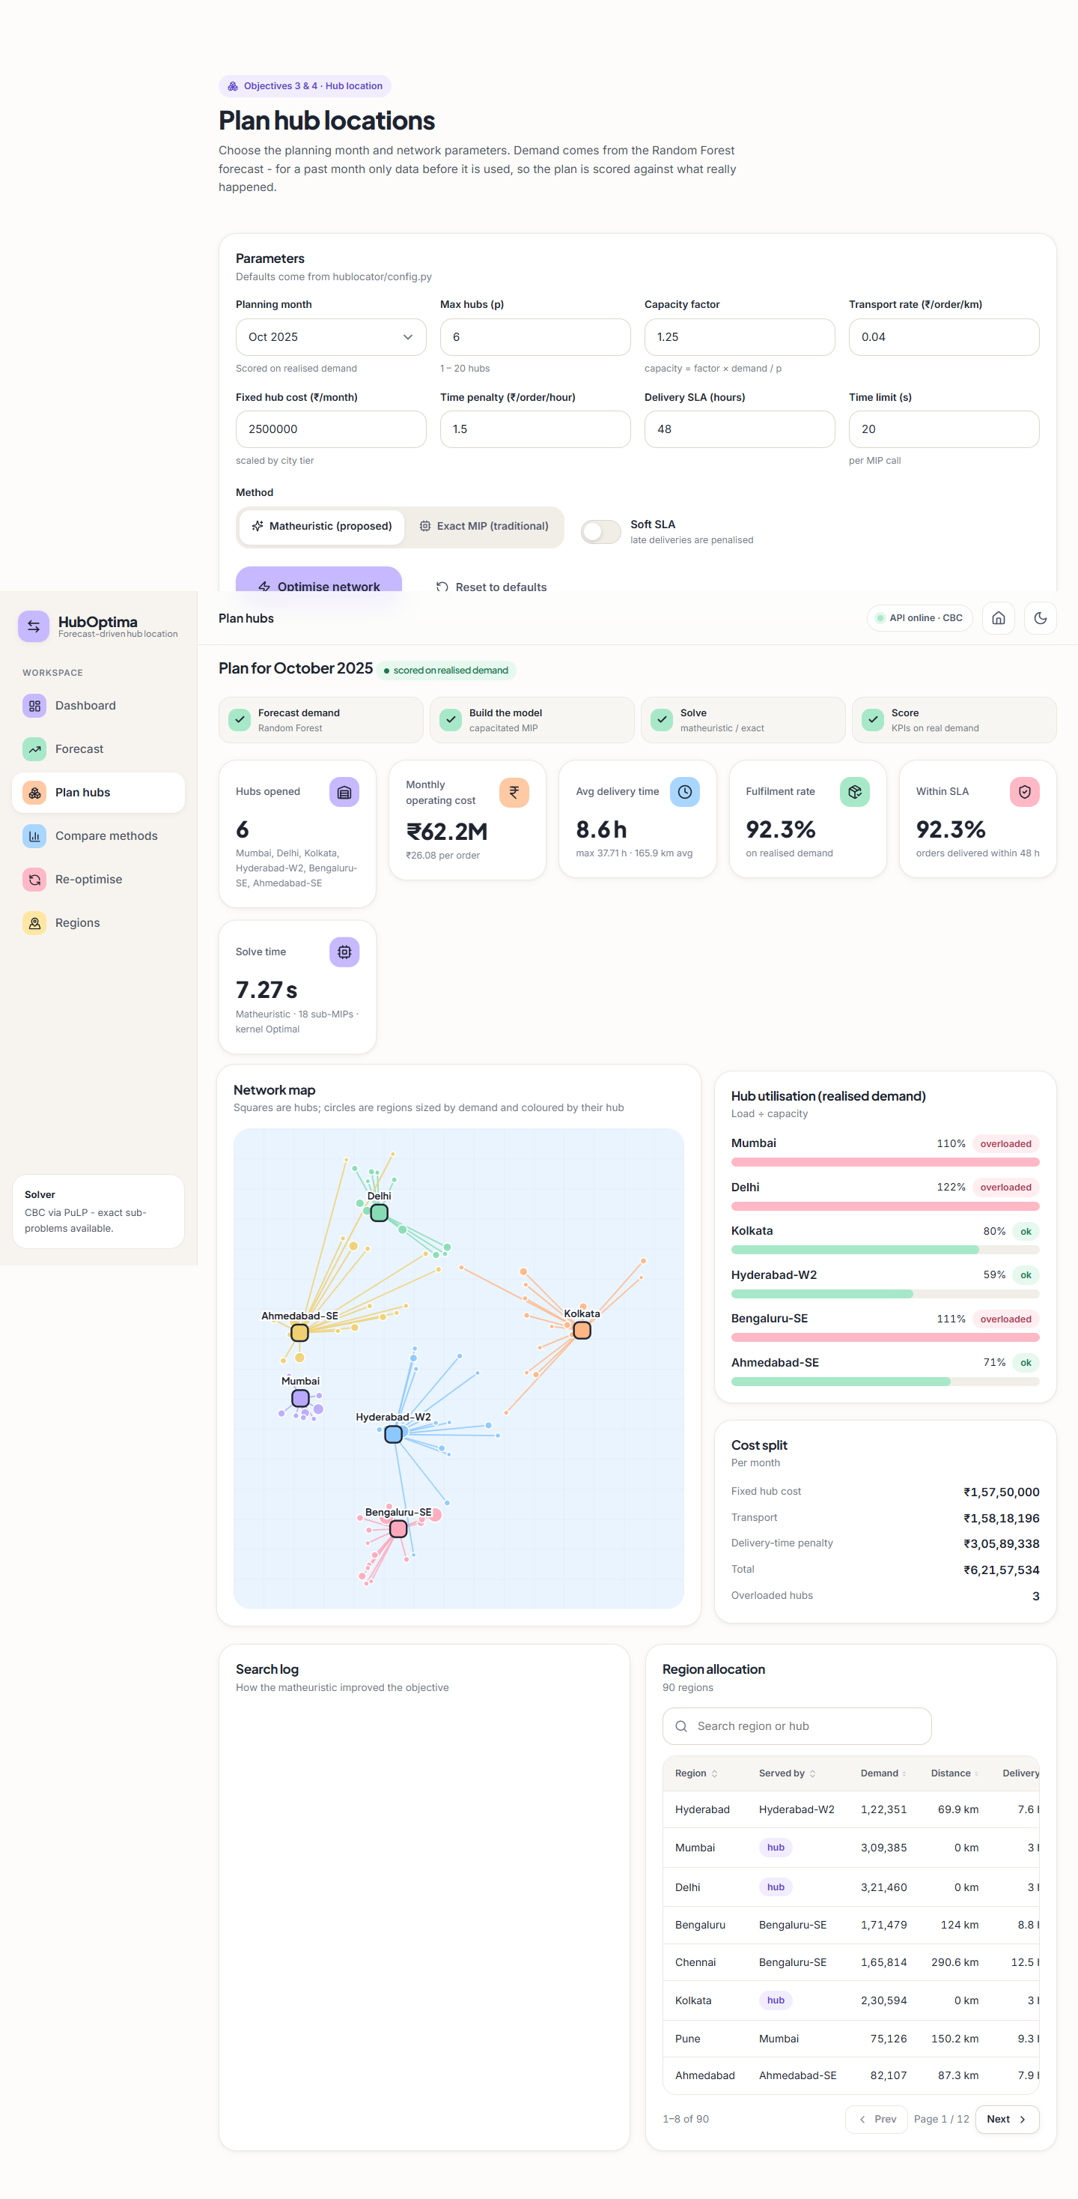
Fig. 20: Plan hubs: complete result
The full result page: KPI tiles, network map, hub utilisation, cost split, search log and the region allocation table.
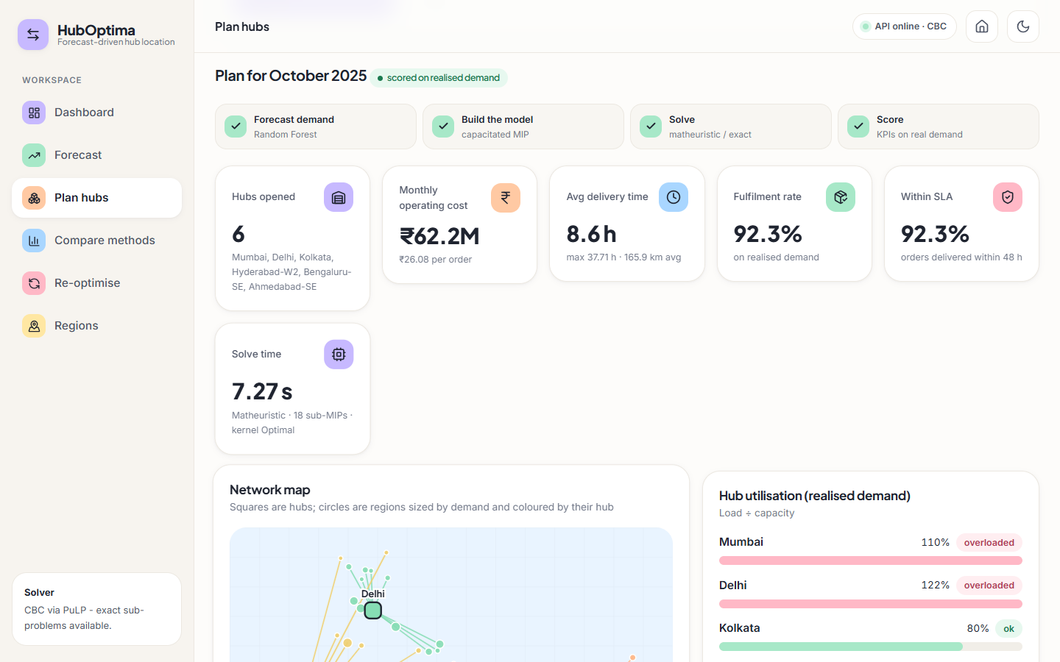
Fig. 21: Plan hubs: network map and cost split
Squares are hubs, circles are regions sized by demand and coloured by their hub; the cost split is INR 15.75 M fixed, 15.82 M transport and 30.59 M time penalty.
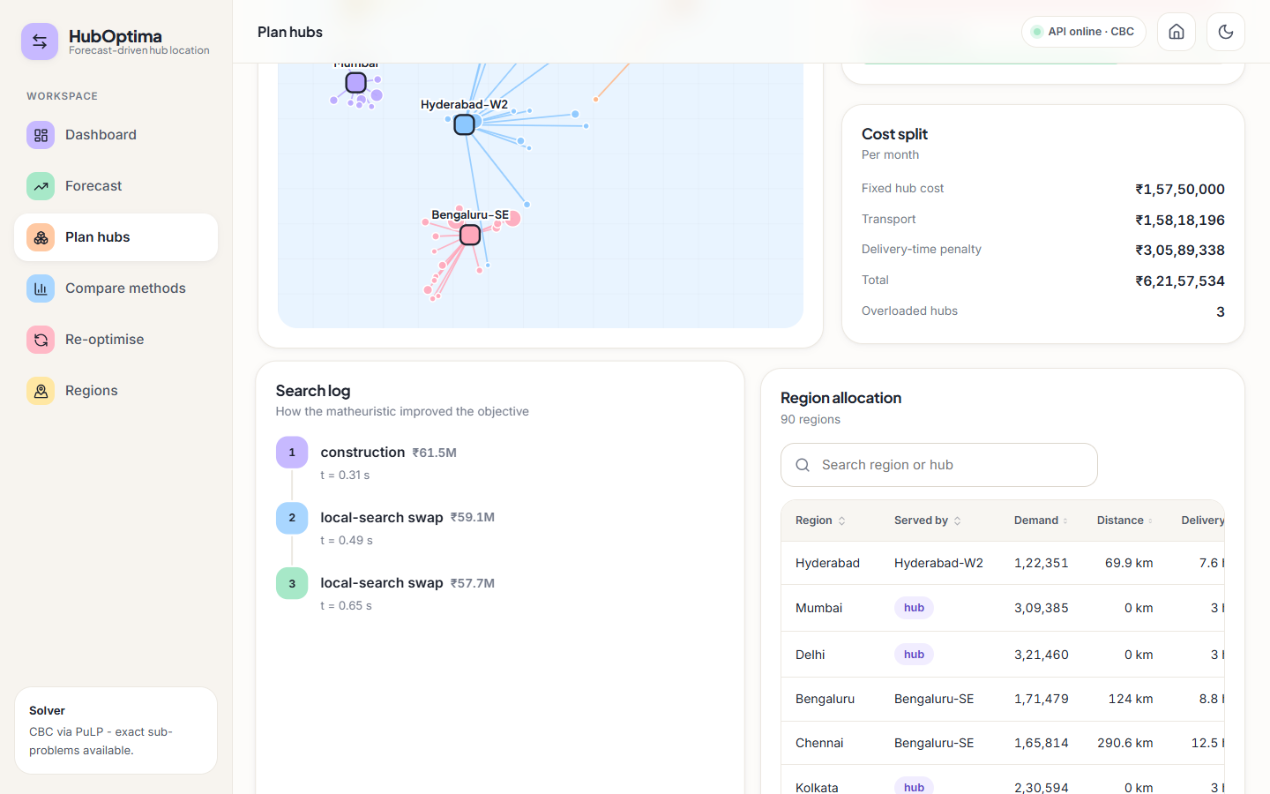
Fig. 22: Plan hubs: search log and allocation
How the matheuristic improved the objective: construction INR 61.5 M, then two local-search swaps to INR 57.7 M planned cost; below it the allocation of each region to its hub.
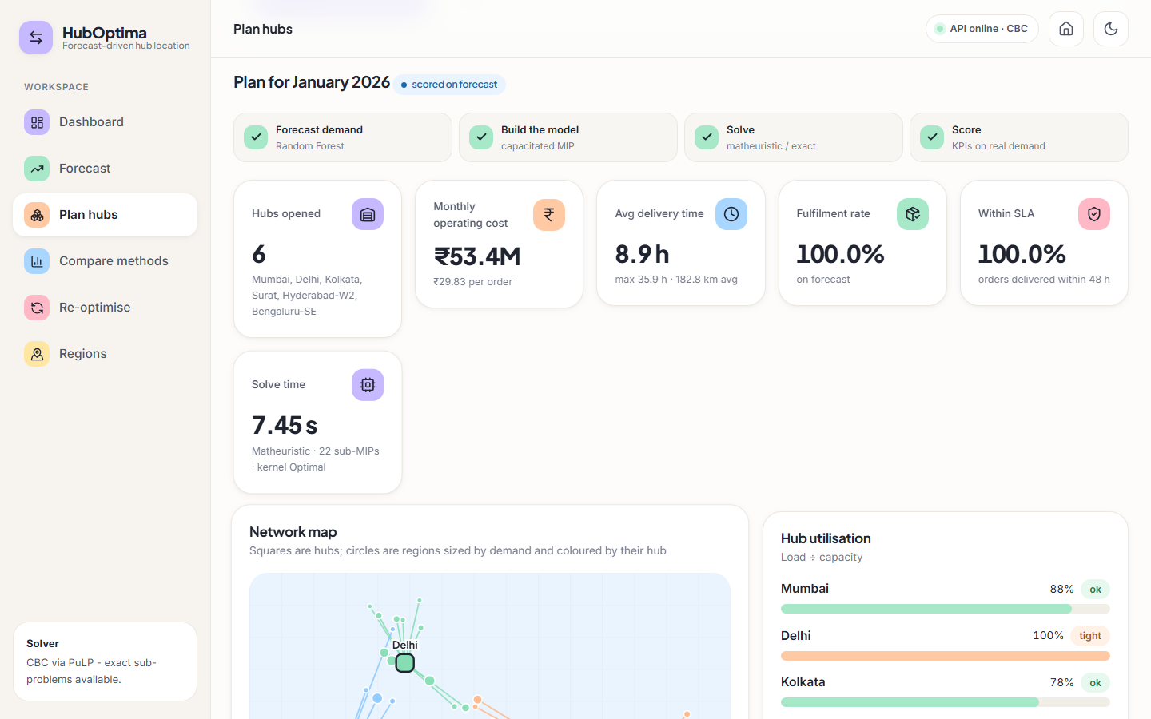
Fig. 23: Plan hubs: next month on the forecast
The January 2026 plan, scored on the forecast because that month has not happened yet.
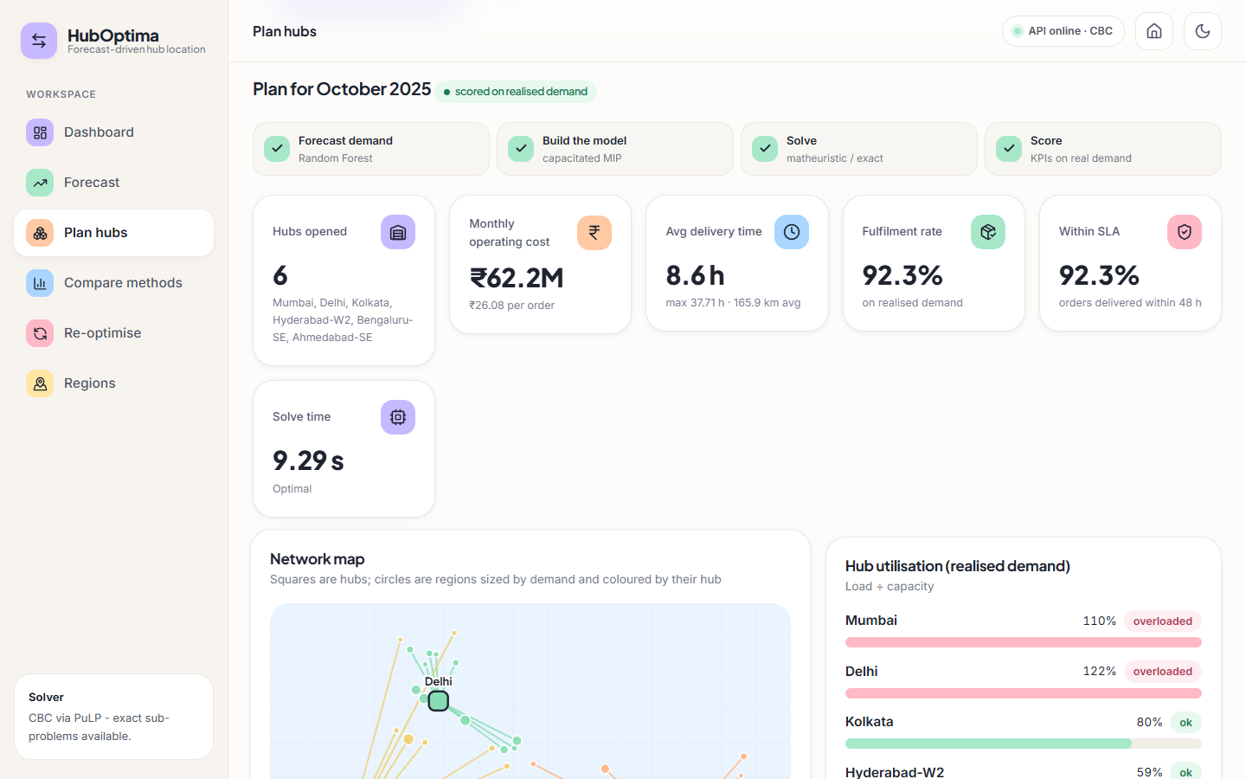
Fig. 24: Plan hubs: exact MIP
The same October 2025 plan solved by the traditional exact MIP: identical hubs and cost, status Optimal.
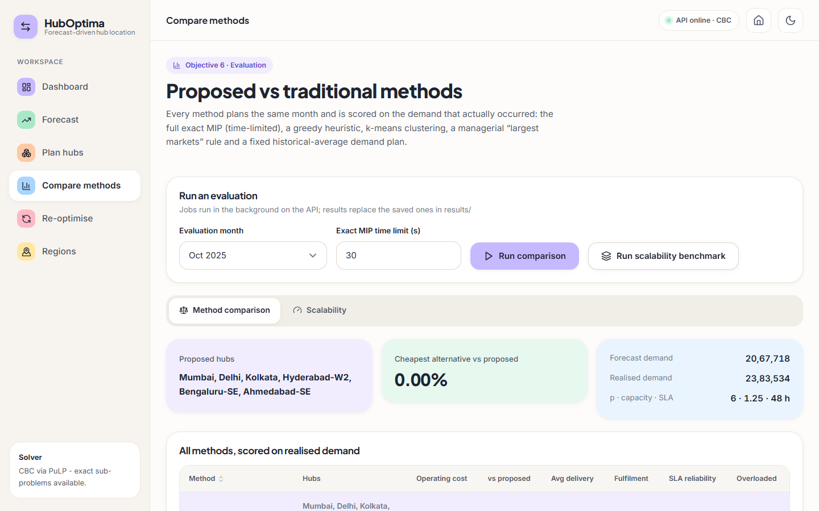
Fig. 25: Compare methods
Proposed method against the traditional methods: the proposed hubs and the headline comparison.
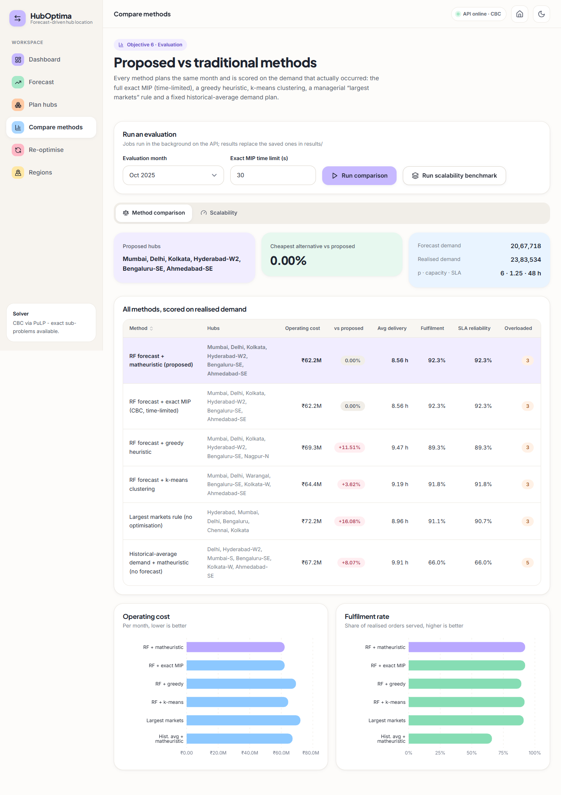
Fig. 26: Compare methods (full)
All six methods scored on the realised October 2025 demand, with operating-cost and fulfilment charts.
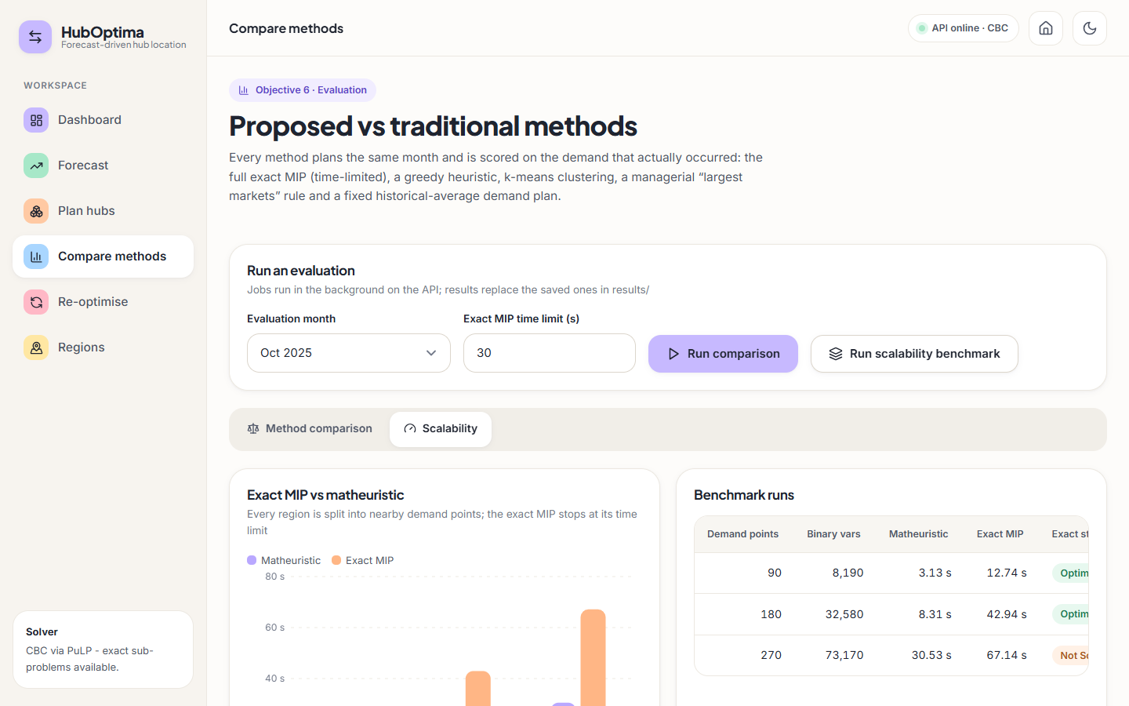
Fig. 27: Scalability benchmark
Exact MIP against the matheuristic at 90, 180 and 270 demand points.
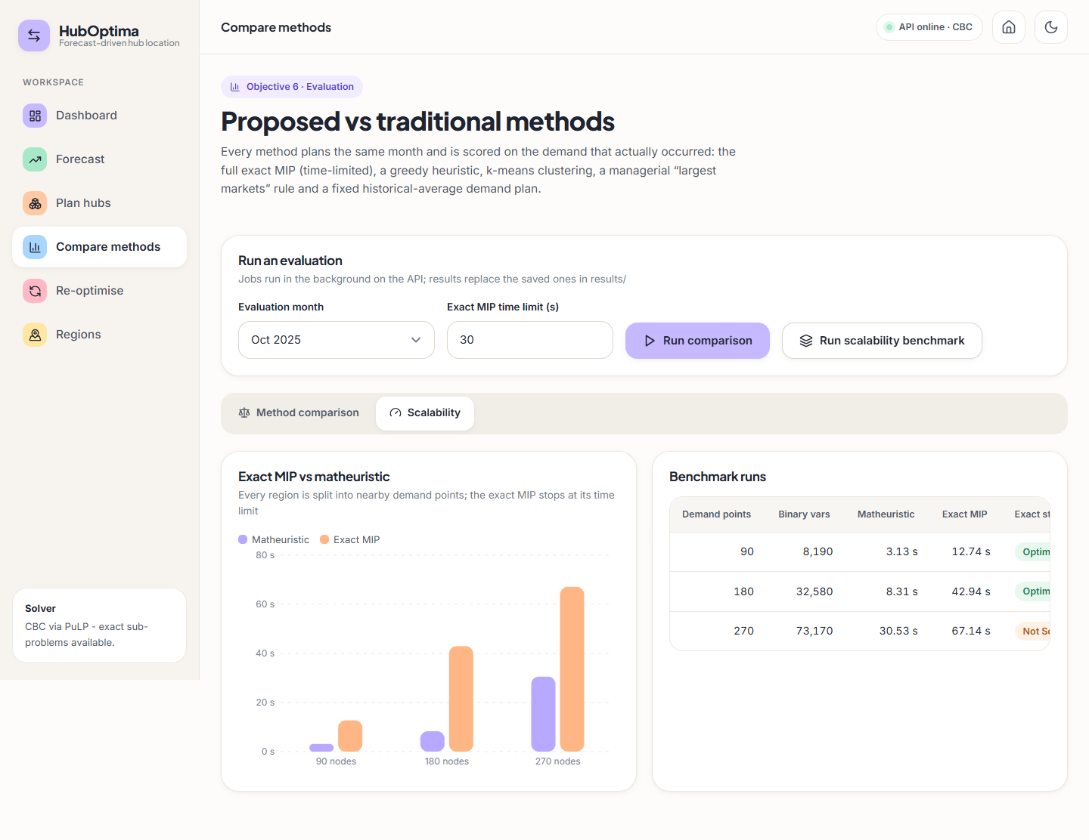
Fig. 28: Scalability benchmark (full)
The scalability charts and the table of benchmark runs.
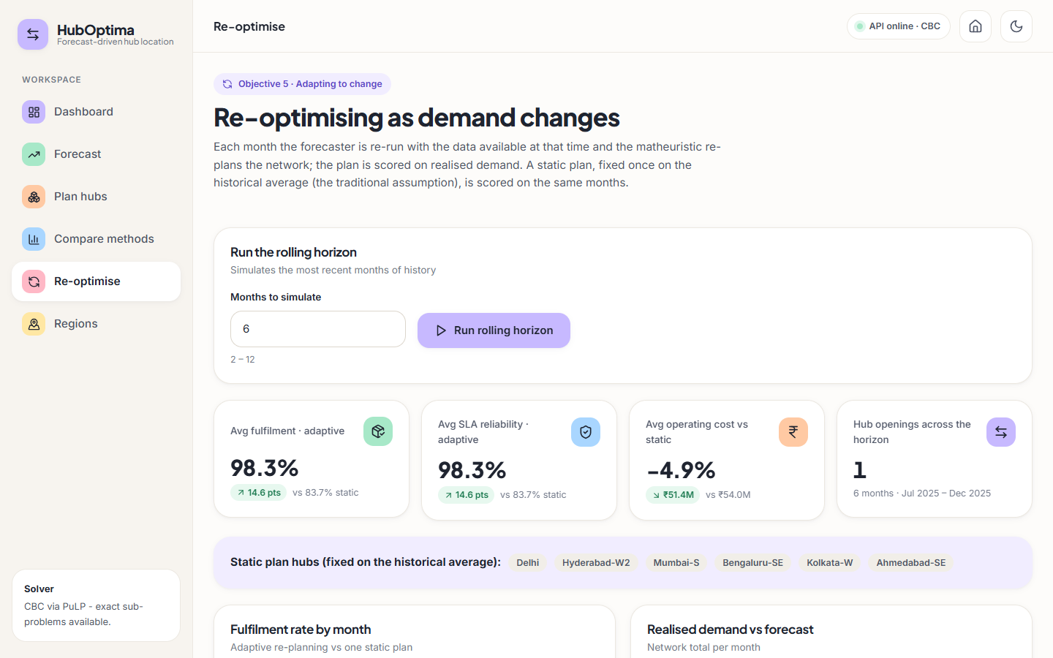
Fig. 29: Re-optimise page
Rolling-horizon summary: adaptive re-planning gives 98.3% fulfilment against 83.7% for a static plan.
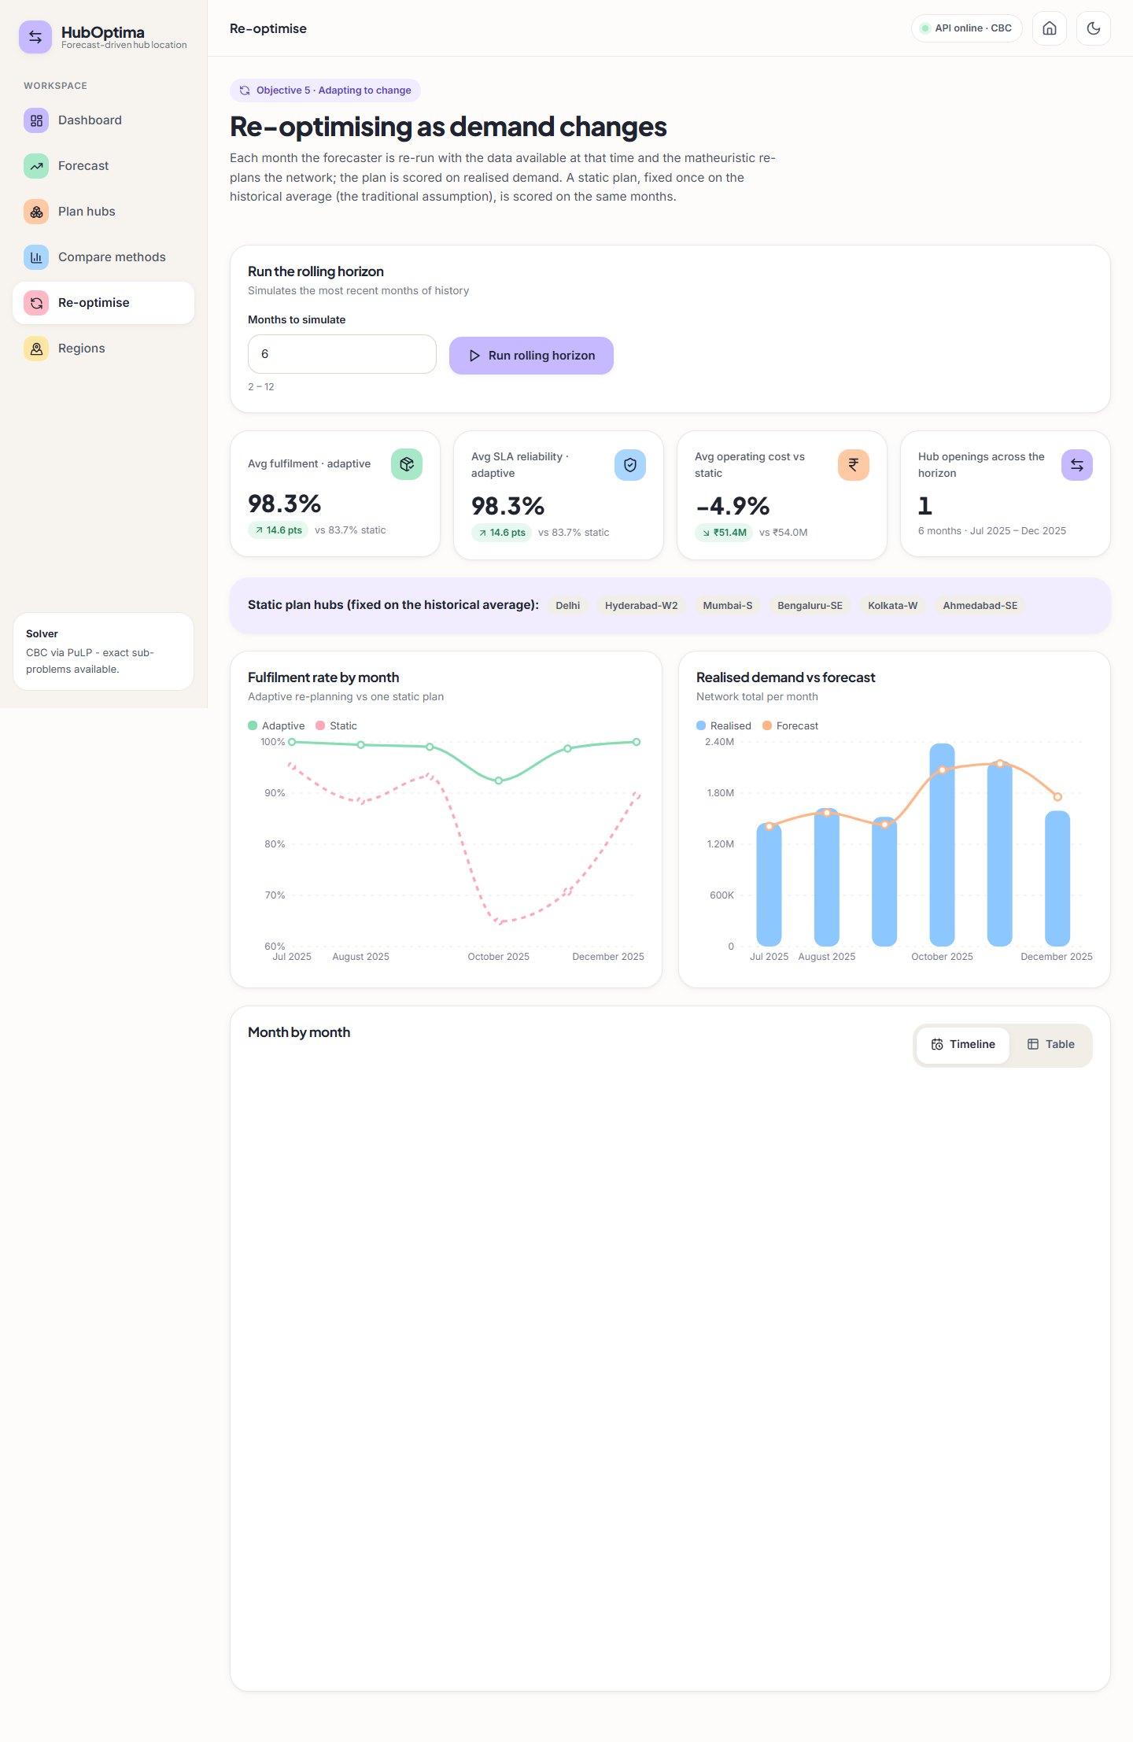
Fig. 30: Re-optimise page (full)
Month-by-month fulfilment, forecast against realised demand, hub changes and the monthly table.

Fig. 31: Dashboard in dark mode
The same dashboard in the dark theme, which follows the operating-system setting until the user chooses.

Fig. 32: Not-found page
A friendly page for routes that do not exist.

8 Sample Inputs and Outputs
Planning request and result. Four hubs for December 2025 (the month is in the test range, so it is scored on realised demand):
Listing: sample input
{
"period": "2025-12",
"n_hubs": 4,
"method": "matheuristic"
}

Listing: sample output (trimmed)
{
"period": "2025-12",
"realized": true,
"sol": {
"status": "Matheuristic",
"hubs": [
1,
2,
5,
39
],
"objective": 54722309.15060887,
"seconds": 2.34,
"iterations": 1,
"subproblems_solved": 14,
"kernel_status": "Optimal"
},
"kpi": {
"n_hubs": 4,
"hub_cities": [
"Mumbai",
"Delhi",
"Kolkata",
"Bengaluru-N"
],
"total_cost": 50039855.0,
"fixed_cost": 12000000.0,
"transport_cost": 14358230.0,
"time_cost": 23681626.0,
"cost_per_order": 31.406,
"avg_delivery_hours": 9.91,
"max_delivery_hours": 27.07,
"avg_distance_km": 225.3,
"fulfilment_rate": 1.0,
"reliability_sla": 1.0,
"overloaded_hubs": 0,
"utilisation": {
"1": 0.892,
"2": 0.751,
"5": 0.431,
"39": 0.828
}
},
"kpi.assignment[0]": {
"region": "Hyderabad",
"region_id": "R001",
"hub": "Bengaluru-N",
"demand": 90287,
"distance_km": 546.7,
"hours": 18.1
},
"demand_used": "[90 values]"
}

Forecast. The next-month forecast (period 2026-01) totals 1,788,825 orders. The first two regions:
Listing: GET /api/forecast: first two regions
[
{
"region_id": "R001",
"period": "2026-01",
"forecast": 91030,
"city": "Hyderabad"
},
{
"region_id": "R002",
"period": "2026-01",
"forecast": 208611,
"city": "Mumbai"
}
]

Rejected input. POST /api/optimize {"n_hubs": 0} returns HTTP 422 and {"period": "1999-01"} returns HTTP 400 with 'Unknown planning month 1999-01.'.

9 Comparison with the Base Paper
The datasets and metric definitions differ, so the numbers below are not a head-to-head. The base paper [1] uses a proprietary dataset from a global transport company with thousands of customer locations; this project uses a synthetic dataset of 90 regions. The base paper's 'delivery-time compliance', 'fulfilment' and 'robustness' are defined on its own data; the 'fulfilment' and 'SLA reliability' of this project are simulated capacity-based measures. The table puts the two side by side and states what is and is not comparable.
Table 10: Base paper and this project, side by side
Indicator | Base paper [1] | This project | Comparable?
Delivery-time compliance | 92.3% average | SLA reliability (48 h) 92.3% in the Oct 2025 peak; 98.3% average with re-planning | No: different data and definition
Fulfilment rate | 97.6% average | 92.3% (Oct 2025 peak); 98.3% average over Jul-Dec 2025 with re-planning | No: simulated vs observed
Network robustness | 0.87 | Not implemented, not measured | -
Cost improvement | 15-20% against benchmarks | 3.6-16.1% lower than the heuristics and the managerial rule (greedy 11.5%, k-means 3.6%, largest 16.1%); 0% against the exact MIP | Qualitatively similar direction; different baselines
Improvement from adapting to demand | +7.8% delivery compliance, +9.4% fulfilment (abstract) | +14.6 points fulfilment against a static plan | Different comparison
Scalability | 50-500 nodes; near-optimal to 500 | 90-270 nodes; exact failed at 270; matheuristic +3.67% there | Smaller range tested
Forecast accuracy | 'X %' improvement (not stated) | MAPE 7.67%, R-squared 0.9766 vs naive 17.6-19.7% MAPE | Not reported by [1]

The qualitative agreement is that (i) forecasting demand before optimising helps, (ii) heuristic or managerial hub rules cost more than an optimised plan and (iii) adapting the network to changing demand improves service. This project does not reproduce the base paper's numbers and does not claim to.

10 Success and Failure Analysis
Table 11: Success cases
Success cases | Evidence
Forecast beats naive benchmarks by a wide margin | MAPE 7.67% vs 19.71% and 17.56%
Matheuristic reaches the optimum on 90 and 180 nodes | Gap 0.00% and -0.05%; same hubs as CBC at 90 nodes
Optimised plan is cheapest of six methods | Others cost 3.6% to 16.1% more
Re-planning protects service in the peak | 92.4% vs 64.9% fulfilment in October; 98.3% vs 83.7% average
Everything runs from one interface | 4 tests and 18 API checks pass; 22 screens captured

Table 12: Failure and weak cases
Failure or weak case | What happened | Cause (as far as known)
Peak under-forecast | Oct 2025 forecast 13.2% low; 3 of 6 hubs above capacity; fulfilment 92.3% | Volume above the training range; the optimiser trusts the forecast and has no safety margin
December over-forecast | 10.2% high | Probably the lag features still contain the October-November peak
Large errors for some regions | Pune, Ahmedabad and Chennai over-forecast by 39-40% in Dec 2025 | Not investigated; the post-peak drop is probably larger than the lags imply
No gain at 90 nodes | Same plan and similar time as the exact MIP | The instance is small enough for CBC
270 nodes | Matheuristic 3.67% above the exact incumbent | Probably the kernel of 24 candidates and the 70% time rule limit the search (not isolated by an experiment)
Distant service | Dehradun-N served 1,427 km away (37.7 h) | Only six hubs; cost model favours consolidation
Static control is simple | A stronger static plan was not tried | Comparison may overstate the benefit of re-planning

11 Limitations of the Results
- All results come from one synthetic dataset and one random seed; absolute rupee values, delivery hours and fulfilment are model outputs.
- Fulfilment and SLA reliability are simulated capacity measures, not observed deliveries.
- The comparison covers a single month (October 2025); the rolling horizon covers six months; the benchmark three sizes.
- The base paper's real-data results are not reproduced and its robustness measure is not implemented.
- No confidence intervals, repeated runs or statistical tests; solve times vary by several seconds from run to run.

12 Objectives Against Outcomes
Table 13: Objectives and outcomes
Objective | Outcome | Status
1 Collect and preprocess historical e-commerce logistics data | Synthetic 90-region, 36-month dataset generated and cleaned (duplicates, gaps); real data is not available | Met with synthetic data
2 Predict regional demand with a Random Forest | MAPE 7.67%, R-squared 0.9766 on held-out months; naive MAPE 17.6-19.7% | Met
3 Formulate hub location with cost, time and capacity constraints | Capacitated single-allocation MIP with fixed, transport and time cost, capacity, p, optional hard SLA | Met (single capacity level, no robustness)
4 Solve efficiently with a matheuristic | Optimal at 90 and 180 nodes, 4-5 times faster; 3.67% above the incumbent at 270 nodes | Met, with a stated gap at the largest size
5 Re-optimise as demand changes | Rolling horizon: 98.3% vs 83.7% fulfilment, one hub change | Met (model not retrained monthly)
6 Compare with traditional methods | Five baselines on the same instance; proposed is cheapest | Met on one month; base-paper numbers not reproduced

