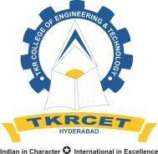
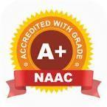
TKR COLLEGE OF ENGINEERING AND TECHNOLOGY
Autonomous,
(Accredited by NBA & NAAC with ‘A+’ Grade)
___________________________________________________________________
CSE (Data Science)
Title of the project: AI – DRIVEN LEARNING AND EARNING ECOSYSTEM FOR KNOWLEDGE ENGINEERS

Abstract;
Engineering students often face difficulties in managing their academic resources, placement preparation, mentorship, and career planning because these services are usually available across different platforms. This makes it difficult for students to find reliable study materials, receive proper guidance, and track their learning and career progress in one place. The proposed system addresses this problem by providing an integrated platform specifically designed for engineering students, bringing learning, mentorship, career guidance, placement preparation, and knowledge sharing together within a single ecosystem.
The platform provides a Learn and Earn Marketplace where students can access and share academic resources such as notes, study materials, project reports, coding templates, and technical courses. Students can also buy and sell useful educational content, allowing them to earn from their knowledge and skills while contributing to peer-to-peer learning. A Peer Mentorship System enables students to connect with experienced seniors and peers for academic support, coding assistance, project guidance, internship advice, placement preparation, and other technical guidance. This encourages collaboration and knowledge exchange within the student community.
Artificial Intelligence is used to make the platform more personalized and useful for each student. The system can analyze students' interests, skills, learning progress, and career goals to recommend suitable career paths and personalized learning roadmaps. It also provides AI-powered interview practice with feedback on areas such as technical knowledge, communication, and overall interview performance. Through features such as student profiles, progress tracking, community interaction, and skill development, the platform supports students throughout their academic and career journey. Overall, the proposed system aims to provide a simple, collaborative, and intelligent ecosystem that improves learning, strengthens placement readiness, encourages knowledge sharing, creates earning opportunities, and helps students make informed career decisions.

