Department of Computer Science and Engineering (Data Science)
CSDS-A | Batch A1 (CSE - Data Science, Section A)
AI Health Insurance Assistance Using LLM + RAG
(PolicyLens)
S.No. | Student name | Roll / hall ticket no.
1 | G.PRANATHI | 23K91A6764
2 | CH.AISHWARYA | 23K91A6747
3 | BHAVANSH MANE | 23K91A6728
4 | B.DEEKSHITH | 24K95A6701
Under the guidance of: [GUIDE NAME], [DESIGNATION]
RESULTS
This document reports the real results of the project: the evaluation of the retrieval, answer, claim and extraction pipeline, every output screen with a caption, the success and failure cases, and the objectives measured against the outcomes. Because nothing is trained, there are no training curves or F1 figures of a trained network; the evaluation measures the pipeline itself.

1 Model Performance
PolicyLens trains no model, so there are no accuracy curves, confusion matrices of a classifier or F1 scores of a trained network. The evaluation measures the pipeline that PolicyLens actually runs, on the hand-built set described in Chapter 6, with the product's own code. All figures below come from run eval-20260922-0027 (22 September 2026). During this run the free-tier quota of the two larger Gemini models was used up, so every answer, claim check and Policy Card came from gemini-3.5-flash-lite, the smallest model in the chain.
Table 1: Headline results (run eval-20260922-0027)
Measure | Result
Retrieval: relevant clause in the top 5 (hybrid + re-rank) | 100% (51 / 51)
Retrieval: relevant clause ranked first | 80.4% (hit@1 0.804, MRR@10 0.897)
Answer accuracy (every key fact present) | 100% (51 / 51)
Citation accuracy | 100% (51 / 51)
Faithfulness score, mean / median | 87.0 / 91.7 (56 answers scored)
Out-of-scope questions declined | 100% (6 / 6), 0 false abstentions on 51 answerable questions
Hindi / Telugu answers in the requested script with all key facts | 5 / 5
Claim Copilot verdict accuracy | 100% (14 / 14)
Policy Card extraction accuracy | 98.1% (51 / 52); 96.9% of values have a verified source quote
Answer time, median / 95th percentile | 4.3 s / 18.2 s

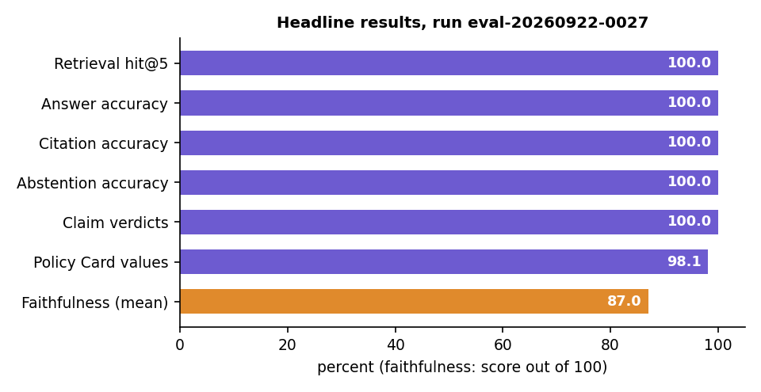
Fig. 1: Headline results of the evaluation run

1.1 Retrieval
Table 2: Retrieval on 51 answerable questions
Method | hit@1 | hit@3 | hit@5 | MRR@10 | recall@5 | median ms
BM25 (keywords) | 0.647 | 0.922 | 1.000 | 0.779 | 1.000 | 1.1
Dense (MiniLM + Chroma) | 0.490 | 0.765 | 0.804 | 0.632 | 0.794 | 10.7
Hybrid (RRF) | 0.686 | 0.882 | 0.961 | 0.795 | 0.951 | 11.0
Hybrid + re-rank (used) | 0.804 | 0.980 | 1.000 | 0.897 | 0.990 | 878.9

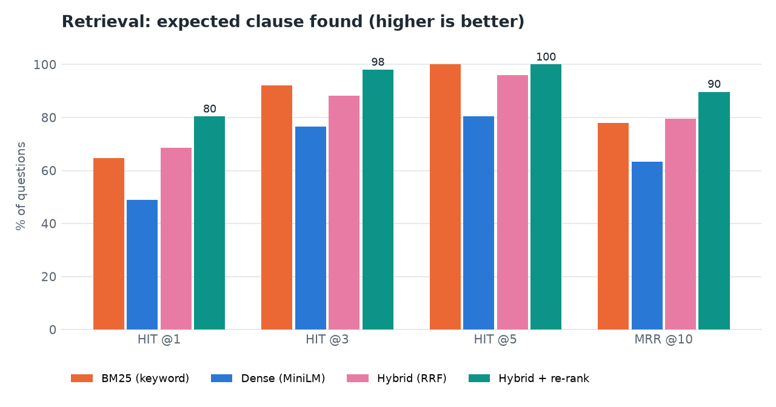
Fig. 2: Retrieval ablation (hit@1, hit@3, hit@5, MRR@10) for the four methods
- Keywords matter in policies. BM25 alone already finds the clause in the top 5 every time, because questions and clauses share exact terms ("cataract", "ambulance", "free look").
- Embeddings alone are weakest. Policy clauses are formulaic and look alike to a general-purpose embedding model; dense search misses one question in five at rank 5 (hit@5 0.804). It still helps fusion with paraphrased questions.
- The re-ranker makes the difference at the top. Reading question and clause together lifts hit@1 from 0.686 (fusion) to 0.804 and MRR@10 from 0.795 to 0.897, at a cost of about 0.9 s on the CPU, the largest part of retrieval time.

1.2 Answers, citations and faithfulness
Table 3: Answer accuracy by question category
Category | Questions | Correct
Waiting periods | 14 | 14
Benefits | 15 | 15
Claim process | 8 | 8
Exclusions | 5 | 5
Policy terms | 4 | 4
Room rent | 3 | 3
Sub-limits | 2 | 2
Total | 51 | 51

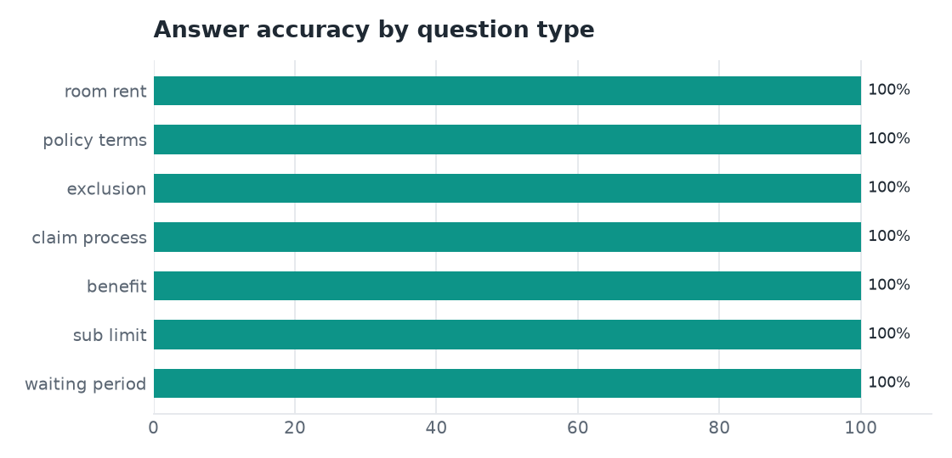
Fig. 3: Answer accuracy by question category
Of the 56 answers that were scored for faithfulness (the 51 answerable questions and the 5 multilingual ones), 45 are well supported (80-100), 8 partly supported (50-79) and 3 weakly supported (below 50). All three weakly supported answers were still correct and correctly cited; they show where the small NLI model struggles: an exclusion-list item that does not itself say "excluded" (the heading above it does), a rule stated as the inverse of an exclusion, and a defined term replaced by its abbreviation.
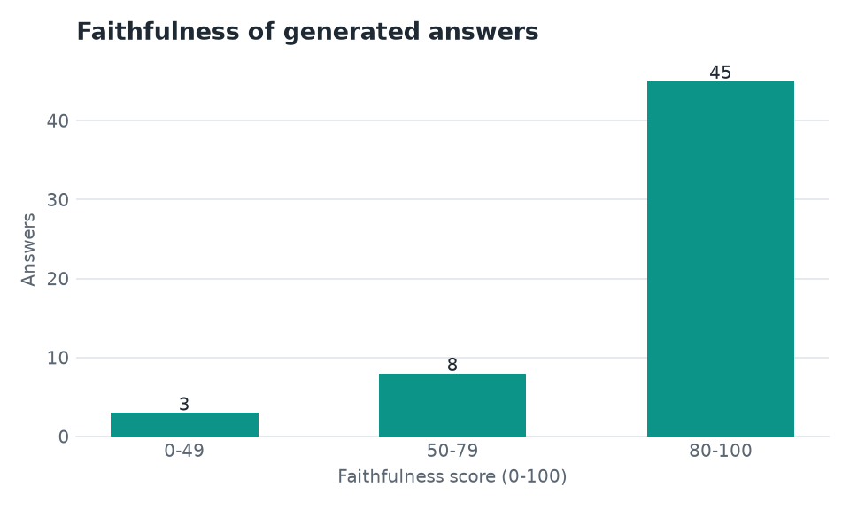
Fig. 4: Distribution of faithfulness scores (56 answers)
Adding the clause heading to the evidence lifted the first kind of case (0.003 to 0.92) but also let the model confirm a wrong statement about an exception ("ectopic pregnancy treatment is excluded" scored 0.87 against a clause that excepts it). That change was therefore not adopted: a faithfulness score should err towards caution. It is shown next to every answer as a prompt to open the cited clause, not as a verdict.

1.3 Knowing when to say "not covered in this policy"
Table 4: Scores used by the abstention rule
 | Best re-rank score | Best BM25 score
Out-of-scope questions (6) | at most 0.0029 | at most 7.3
Answerable questions (51) | as low as 0.0020 | as low as 7.1
Answerable with re-rank < 0.004 (3) | 0.0020-0.0021 | 15.5 or more

Neither score separates the two groups alone, but the pair does: answering "not covered" without a model call only when the re-rank score is below 0.004 and the BM25 score is below 9.0 declined 6 of 6 out-of-scope questions and none of the 51 answerable ones.

1.4 Response time
Table 5: Answer time by stage (live Gemini calls)
Stage | Median | 95th percentile
Retrieval (BM25 + dense + fusion + re-rank) | 0.86 s | 1.8 s
Gemini answer | 2.5 s | 17.2 s
Faithfulness (NLI) | 0.83 s | 1.7 s
Total | 4.3 s | 18.2 s

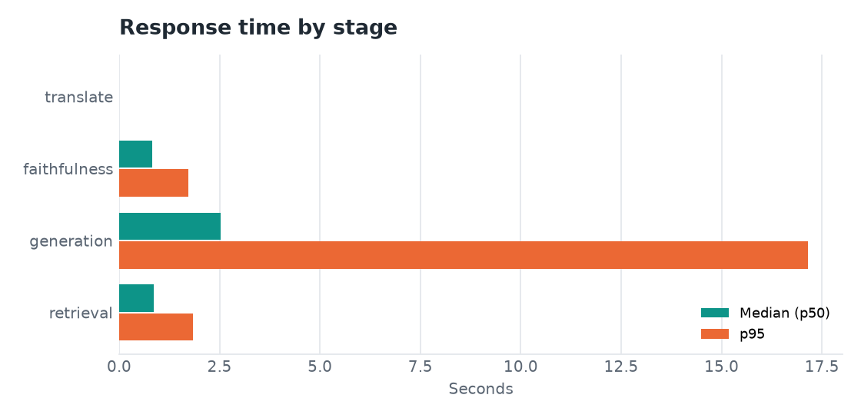
Fig. 5: Median and 95th-percentile time by stage
The long tail comes from the fallback chain: when the primary models answer "quota exceeded" or "overloaded", the request moves to the next model and that wait is included. Claim Copilot checks take longer (one larger Gemini call plus retrieval for several queries): a mean of 13.8 s on four timed live calls.

1.5 Claim Copilot
Table 6: Claim verdicts: expected (rows) against predicted (columns), 14 scenarios
expected \ predicted | covered | partly covered | not covered | needs info
covered | 5 | 0 | 0 | 0
partly covered | 0 | 1 | 0 | 0
not covered | 0 | 0 | 7 | 0
needs info | 0 | 0 | 0 | 1

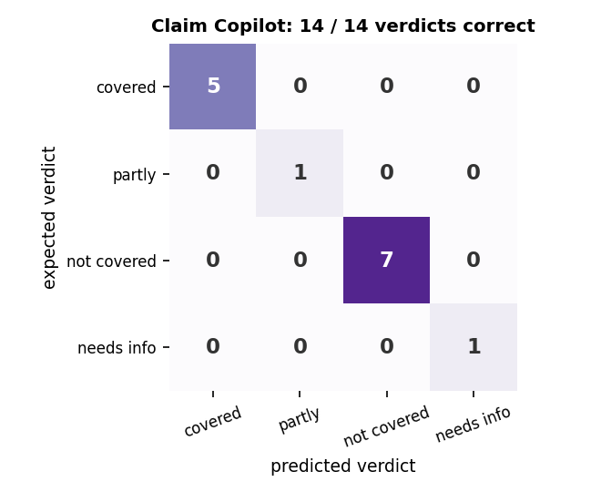
Fig. 6: Claim Copilot confusion matrix
Precision, recall and F1 are 1.0 for every verdict. The reasons behind the verdicts have a mean faithfulness of 82.7, and each check lists 7.3 documents and 4.3 claim steps on average. Waiting periods, age-based and network co-payments, sub-limits and the cost estimate are calculated by rules from the Policy Card, not generated, and a failed waiting period always yields "not covered".

1.6 Policy Card extraction
Table 7: Policy Card values by policy (52 hand-checked values)
Policy | Values checked | Correct
Family Health Optima | 14 | 14
my: Optima Secure | 14 | 13
ReAssure 2.0 | 11 | 11
Care Supreme | 13 | 13

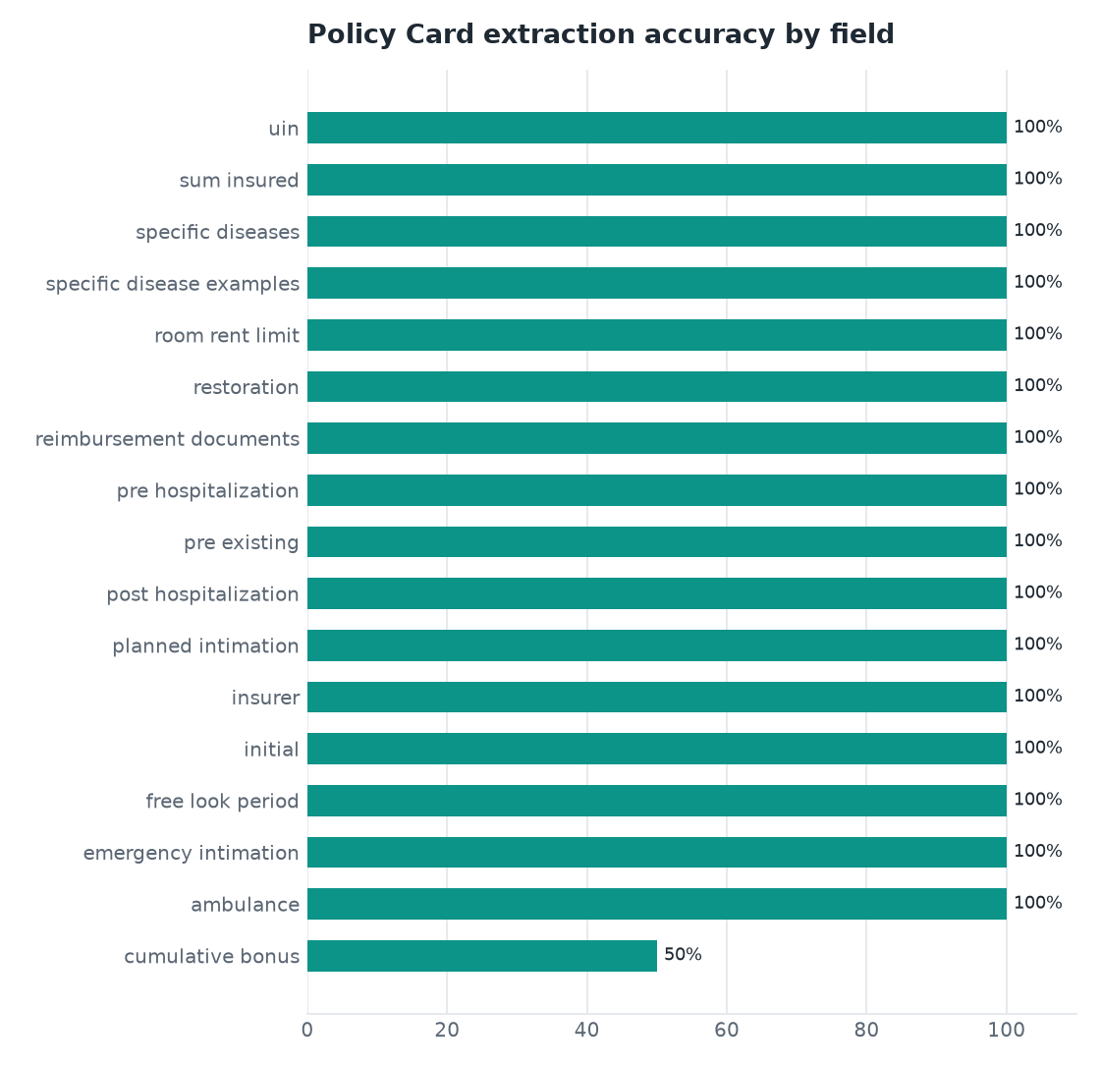
Fig. 7: Extraction accuracy by field
The single difference is the cumulative bonus of the HDFC ERGO wording, and it is an ambiguity in the document rather than a misreading: the wording covers seven plan variants (10% a year for Optima Suraksha and Optima Lite, 25% for Optima Select, none for Optima Secure, which instead grows cover by 50% a year through its Plus Benefit). The reference value takes the general clause (10%); the card reports the Optima Secure figure (50%, up to 100%). Letting the user pick the plan variant on the card is the planned fix.

2 Improvement Across the Three Runs
Three evaluation runs are kept in experiments/. Each fixed what the previous one revealed.
Table 8: Evaluation runs
Run | Change | hit@5 | Answer acc. | Citation acc. | False abstentions | Claim verdicts
eval-20260921-2353 | Baseline | 98.0% | 88.2% | 92.2% | 5 | 14/14
eval-20260922-0008 | Abstain only if both scores are low; rule and governed tables sent together | 98.0% | 98.0% | 96.1% | 1 | 14/14
eval-20260922-0027 | Exclusion-code list items become separate clauses; prompt says an exclusion is an answer; non-network co-pay not applied to cashless | 100% | 100% | 100% | 0 | 14/14

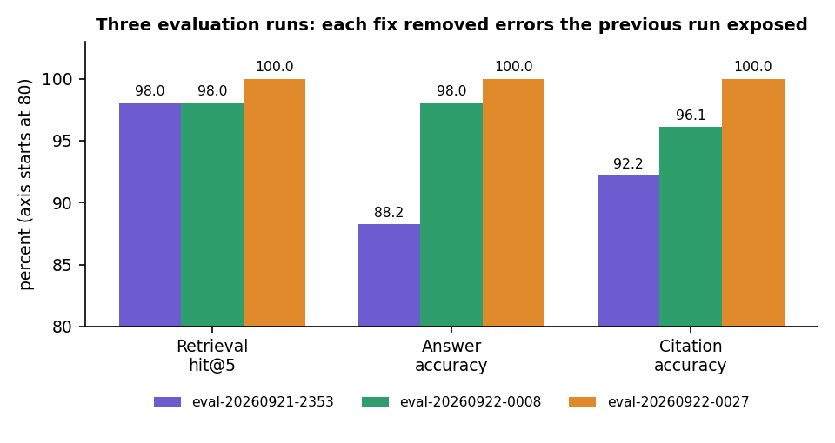
Fig. 8: Retrieval, answer and citation accuracy across the three runs
The first run's errors were of two kinds: the system answered "not covered" for answerable questions (5 false abstentions) and cited a neighbouring fragment instead of the governing rule. Requiring both a low re-rank score and a low keyword score before abstaining, and sending a rule together with the tables it governs, removed most of them. The remaining errors came from list items that carry an IRDAI exclusion code, which the segmenter had merged into one clause; making each its own clause removed them. Because these fixes were made by studying failures on the evaluation set itself, the final figures are optimistic.

3 Functional Testing
The functional tests follow the demo scenario of the project, run against the live application with live Gemini calls on 15 October 2026 using the demo account and the four sample policies. The observed results are those recorded during the run and shown in the screenshots of Chapter 8.
Table 9: Functional test cases
No. | Test | Expected | Observed
F1 | Sign in with the demo account | Dashboard opens | Pass
F2 | Open My policies | Four ready sample policies | Pass: four policies, all ready
F3 | Open the Policy Card of the Star Health policy | Values with clause and page chips; verified share shown | Pass: 91% of values verified in the text
F4 | Ask "Is cataract surgery covered and after how long?" | Covered after the 24-month specified-disease wait; citations; faithfulness | Pass: answered, citations Clause 2 p. 10 and Clause Excl02 p. 28, faithfulness 88, 6.2 s
F5 | Ask "Does this policy insure my house against fire?" | Declines without a model call | Pass: "Not covered in this policy document", 1.7 s
F6 | Ask a room-rent question in Hindi (HDFC ERGO) | Hindi answer with citations; Show in English | Pass: answered in Hindi with 4 citations, faithfulness 91.5
F7 | Claim Copilot: knee replacement, cover from 2023-10-01, age 64, Rs. 3,50,000 | Partly covered: waiting periods complete, 20% co-payment | Pass: partly covered; 36 months of cover; estimate shown
F8 | Claim Copilot: same treatment, cover from 2026-04-01, age 45 | Not covered: waiting period incomplete | Pass: not covered
F9 | Compare Star Health with HDFC ERGO Optima Secure | Side-by-side table, trade-offs, choose-A/B-if | Pass: 21-row table
F10 | Open a cited clause | Original page with the clause highlighted | Pass
F11 | Switch the card to Telugu | Translated card | Pass with a defect: one line contains Bengali/Gurmukhi script
F12 | Dark theme and 390 px phone layout | Readable, no horizontal scroll | Pass (captured)

4 Performance Testing
Performance was measured on the development machine (12-thread Intel Core i5-12500, 15.7 GB RAM, no GPU) with live Gemini calls. The figures come from the evaluation run eval-20260922-0027 and from the live run of 15 October 2026.
Table 10: Performance measurements
Measurement | Result
Retrieval, 51 queries, median (p95) | BM25 1.1 ms (32.2); dense 10.7 ms (15.7); hybrid 11.0 ms (16.6); hybrid + re-rank 878.9 ms (995.5)
Answer, all 62 questions, median / p95 / max | 4.34 s / 18.18 s / 24.77 s
Answer stages, median (p95) | retrieval 0.86 s (1.83); Gemini 2.53 s (17.16); faithfulness 0.83 s (1.72)
Claim check, 4 timed live calls | mean 13.8 s, median 12.3 s, p95 22.8 s
Parsing a policy wording | 3.2 s (24 pages) to 4.2 s (53 pages)
Live run, 15 October 2026 | cataract answer 6.2 s; co-payment answer 5.6 s; abstained question 1.7 s; Hindi answer 10.0 s; claim check 14.2 s
Web build | Vite production build 7.6 s; type check passes

The long tail of the answer time comes from the fallback chain: when the primary models report quota or overload, the request moves to the next model and that wait is included in the figure. Not measured: concurrent users, memory use under load, other hardware.

5 Output Screens
Every screen below is a real capture of PolicyLens running with real data on 15 October 2026: the four sample policy wordings, answers produced by live Gemini calls, and claim checks and a comparison created through the application. The captures are 1440 by 900 pixels unless stated.
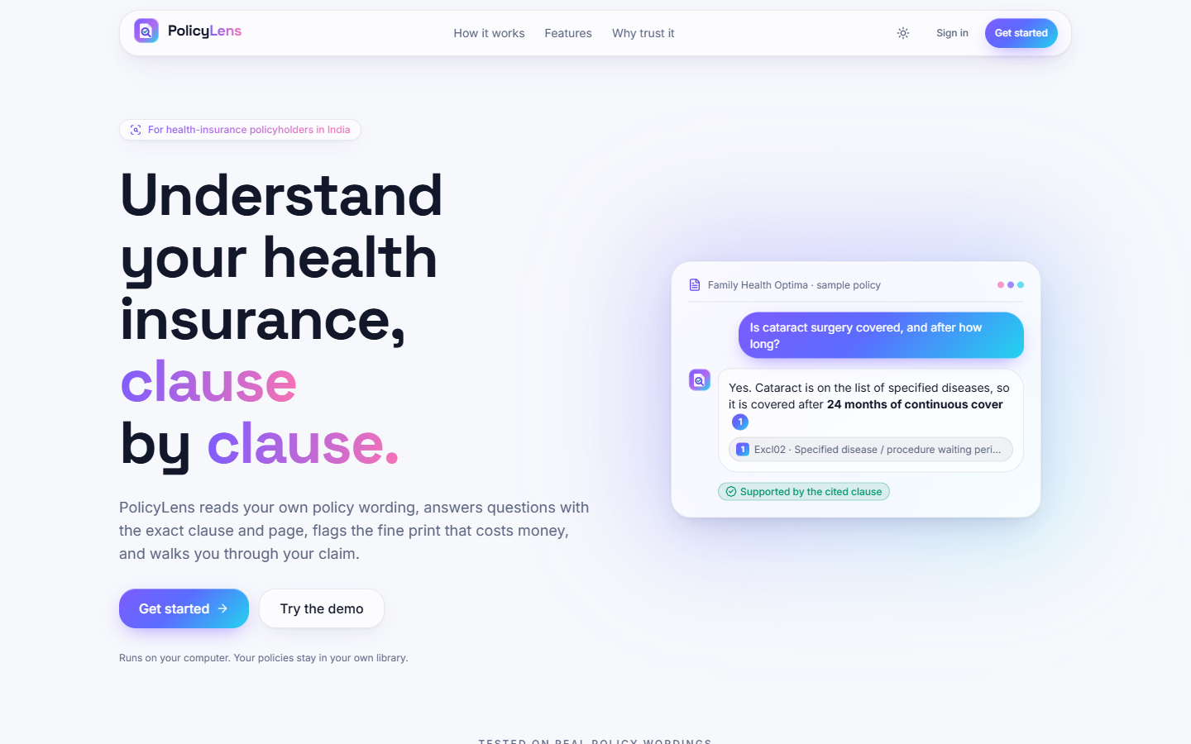
Fig. 9: Landing page
The public home page: the headline "Understand your health insurance, clause by clause", a sample question about cataract surgery answered with a cited clause and the badge "Supported by the cited clause", and the buttons Get started and Try the demo.
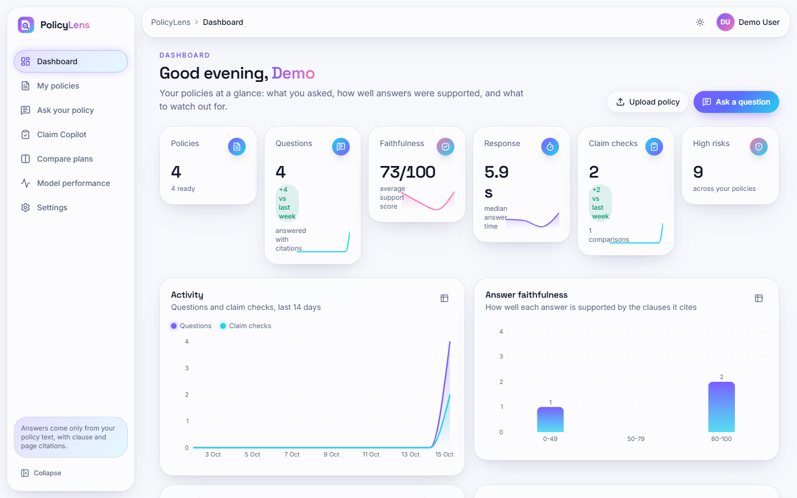
Fig. 10: Dashboard
Counters for policies (4 ready), questions asked (4), average faithfulness (73/100 over the three answers of this live session that were scored), median response time (5.9 s), claim checks (2) and high risks (9), the 14-day activity chart, and the faithfulness distribution of the answers asked so far.
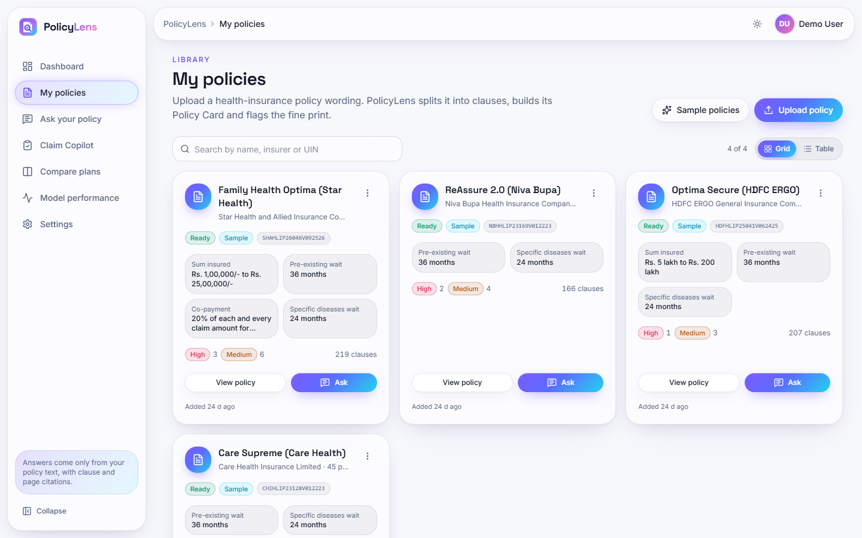
Fig. 11: My policies
The library with the four sample policies, each tile showing its status, UIN, key values from the Policy Card (sum insured, pre-existing and specific-disease waiting periods, co-payment), the number of high and medium risks and the number of clauses.
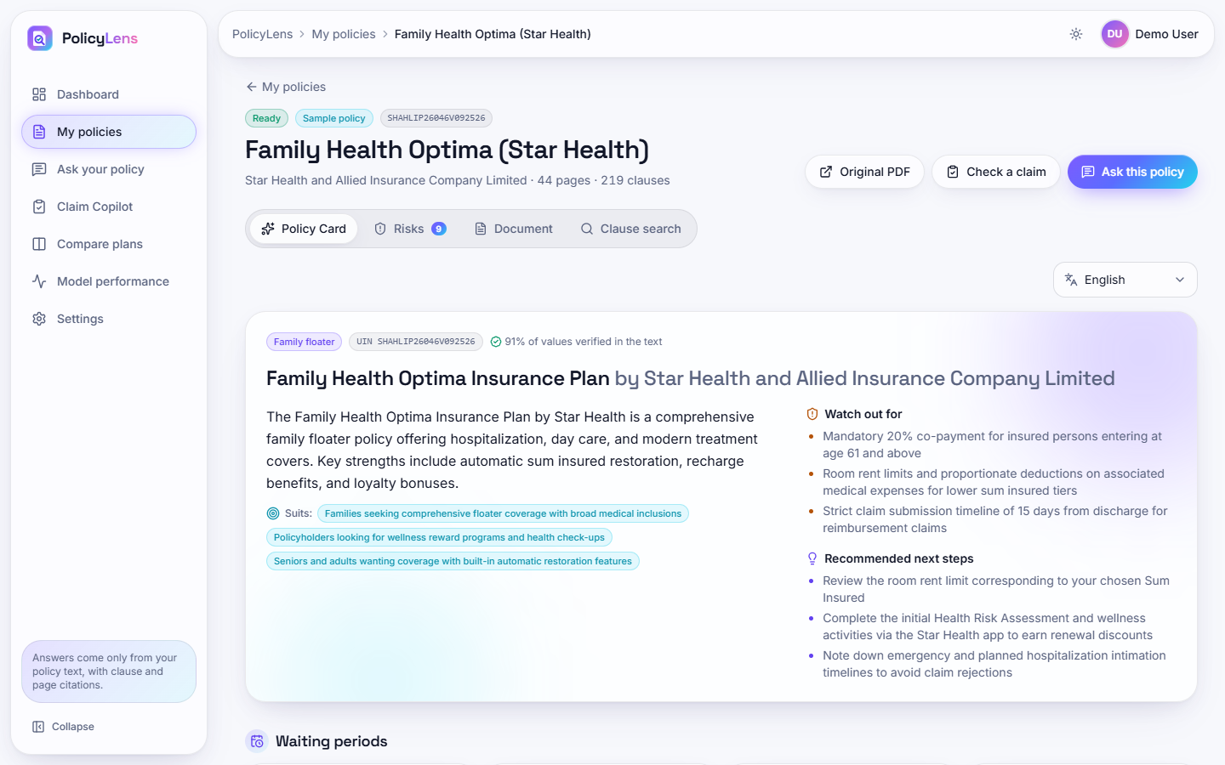
Fig. 12: Policy Card
The Star Health Family Health Optima card: type, UIN, the share of values verified in the text (91%), a plain-language overview, the people it suits, what to watch out for and recommended next steps; the waiting periods and other values follow below, each with a clause and page chip.
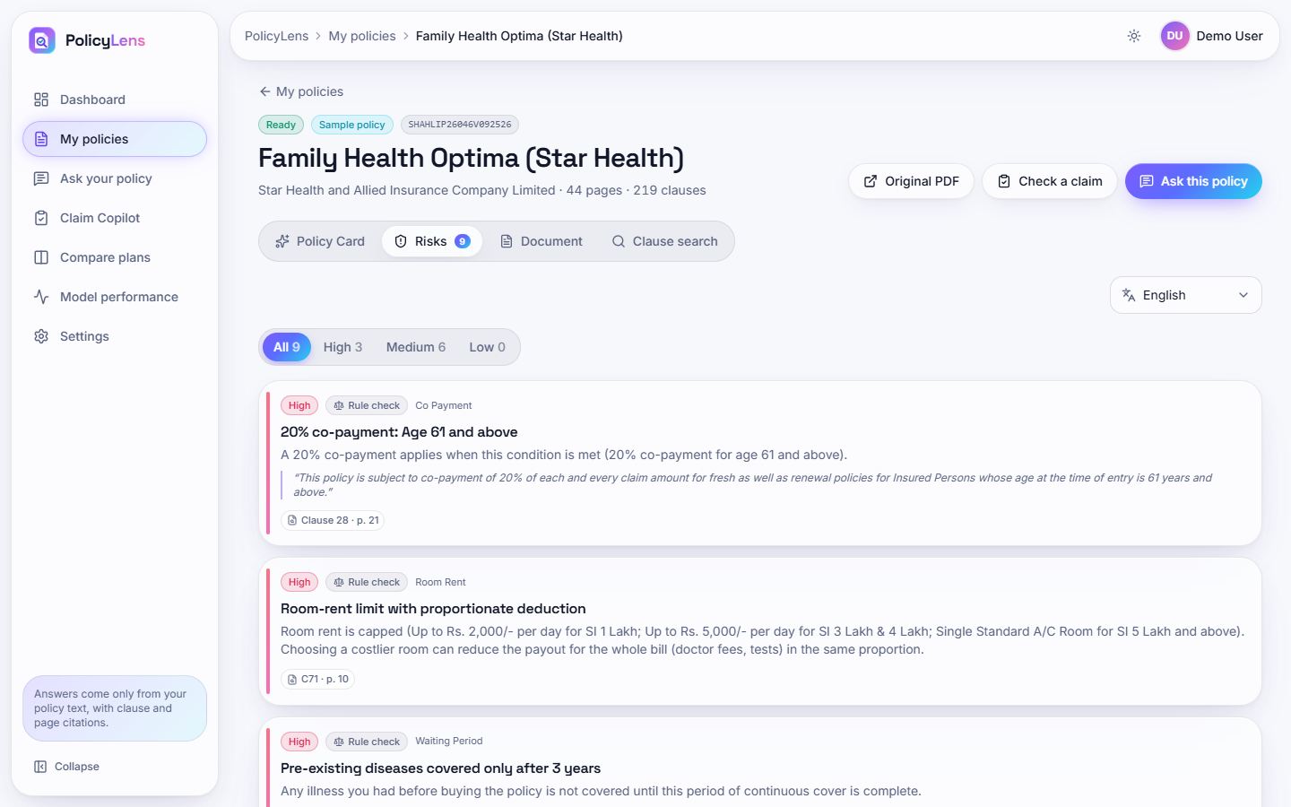
Fig. 13: Risk highlights
Nine risks for the Star Health wording (3 high, 6 medium), each with its category, the source (rule check or AI), an explanation, the quoted wording and the clause and page chip: the 20% co-payment from age 61, the room-rent limit with proportionate deduction and the three-year pre-existing-disease wait.
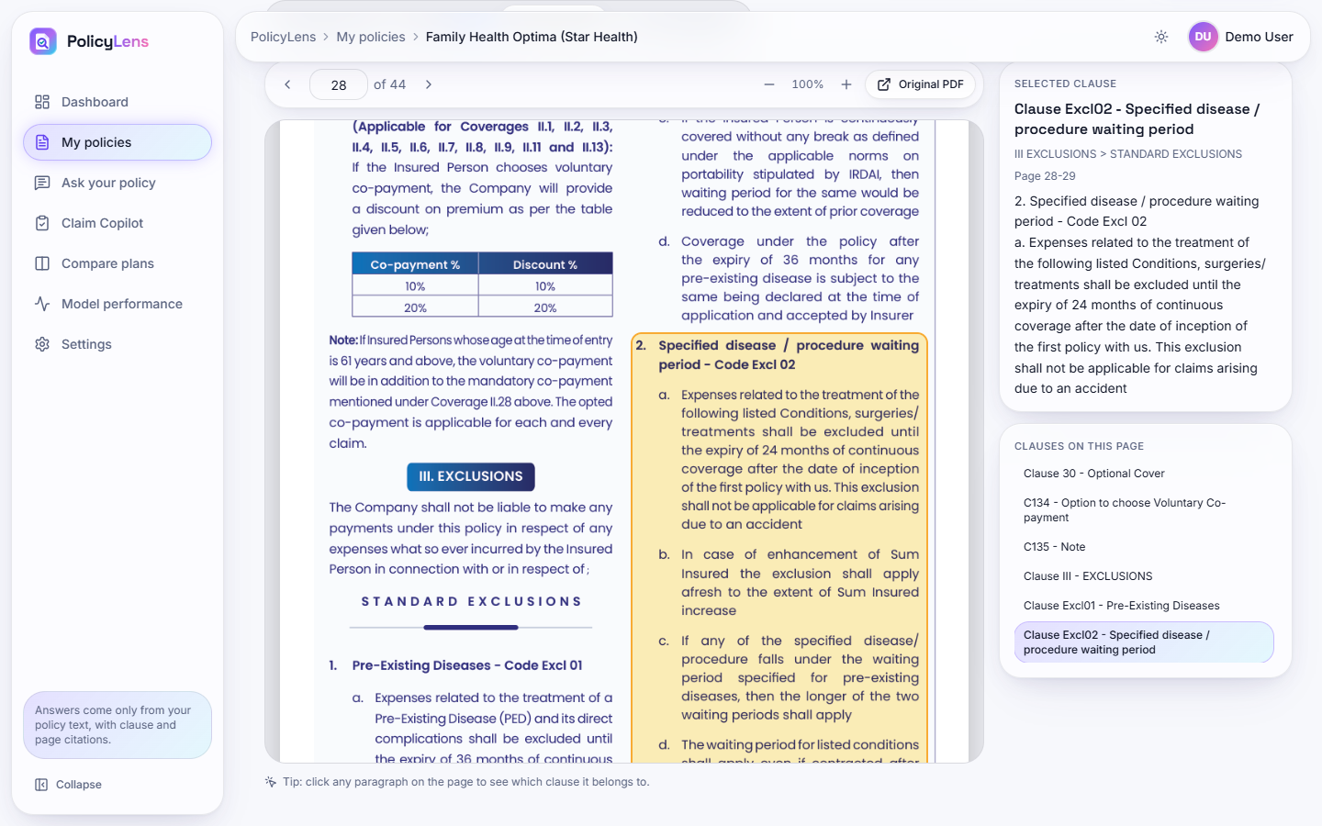
Fig. 14: Original document with the cited clause highlighted
Page 28 of the original wording with the clause Excl02 (specified disease and procedure waiting period) outlined in yellow; the side panel shows the selected clause, its section path and text, and the other clauses on the page.
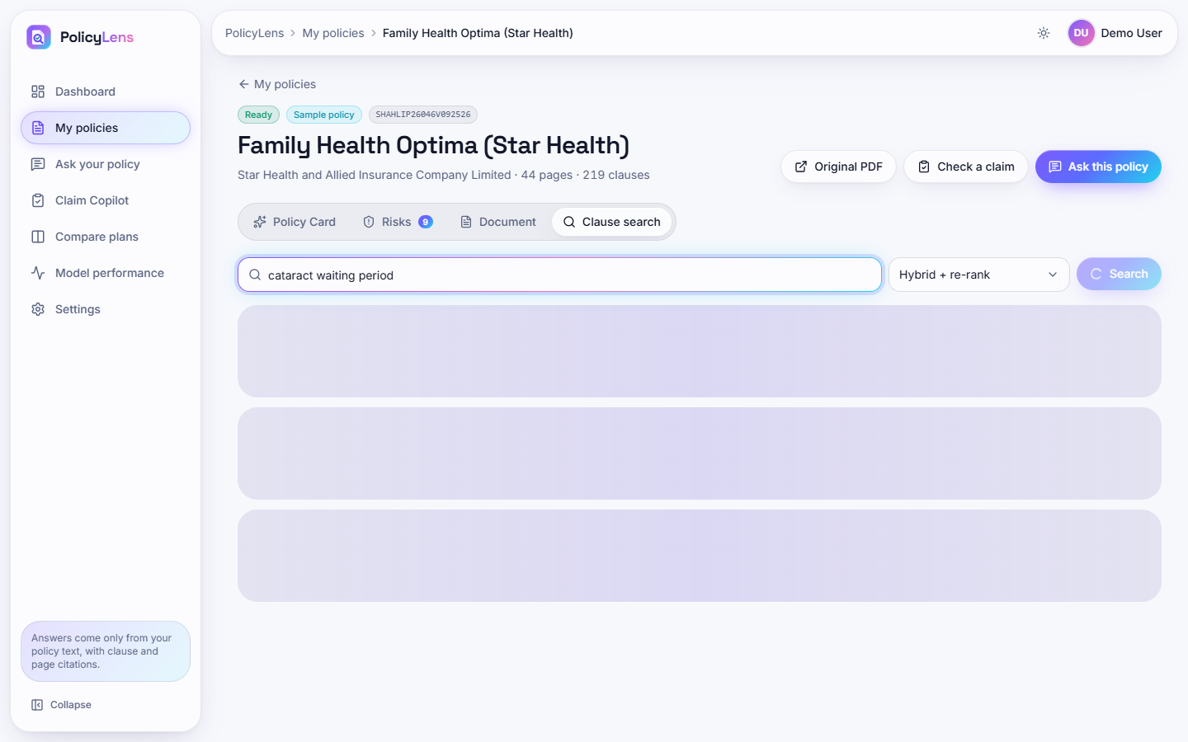
Fig. 15: Clause search
Hybrid search with re-ranking for "cataract waiting period": eight clauses, the timings of each stage (BM25 2 ms, dense 20 ms, fusion 0 ms, re-rank 1.0 s), and for each result its keyword rank, semantic rank and relevance with the matching words highlighted.
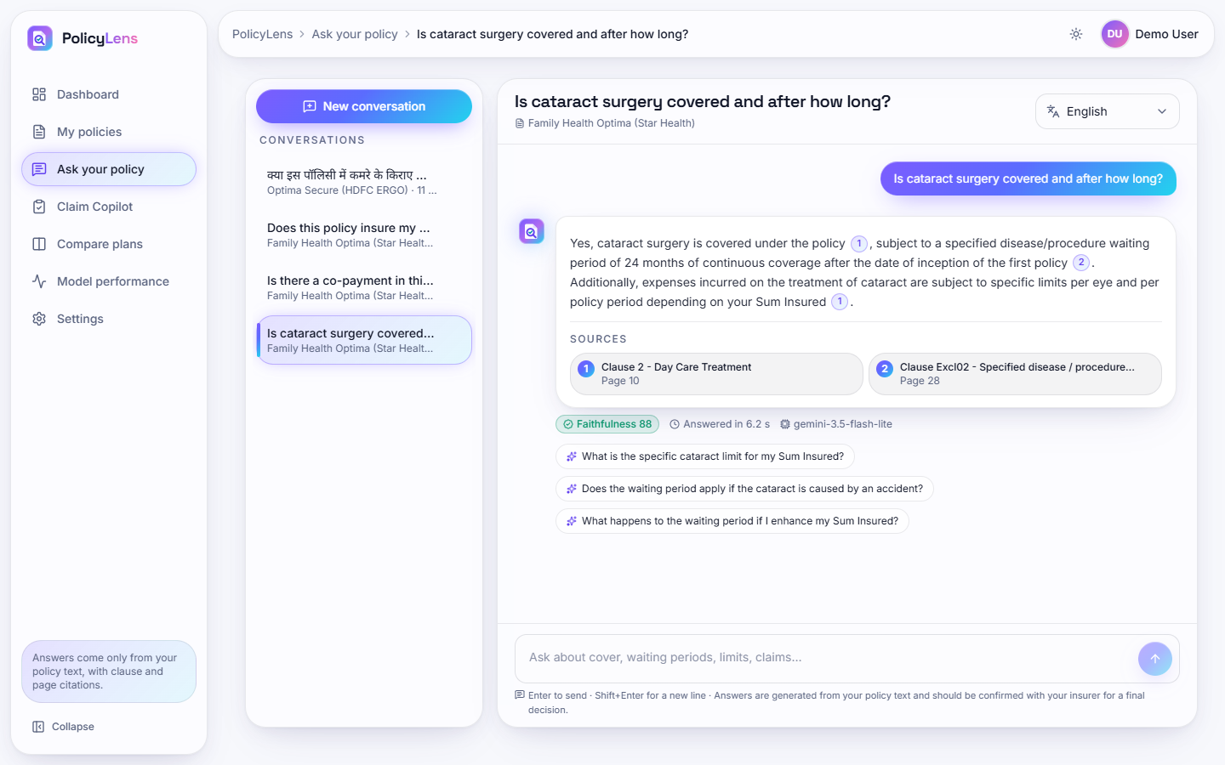
Fig. 16: Cited answer
The answer to "Is cataract surgery covered and after how long?": covered after a 24-month specified-disease waiting period, with per-eye limits; two source chips (Clause 2, page 10; Clause Excl02, page 28), the badge Faithfulness 88, the response time 6.2 s, the model used and three follow-up questions.
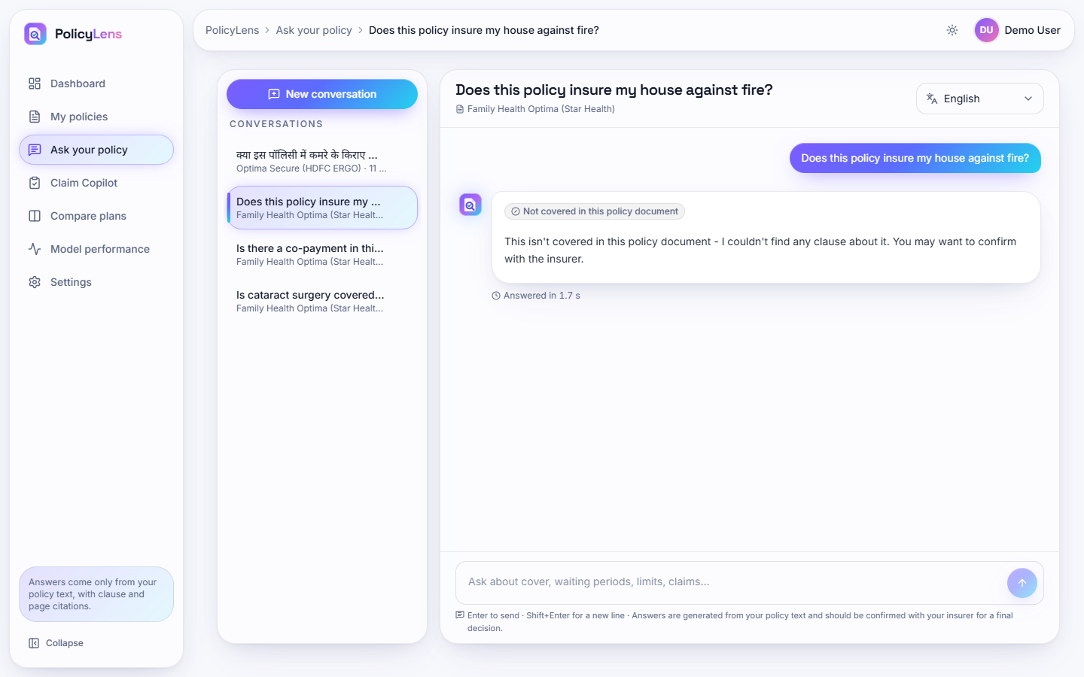
Fig. 17: Out-of-scope question declined
"Does this policy insure my house against fire?" is answered "Not covered in this policy document - I couldn't find any clause about it" in 1.7 s, with no sources and no model call.
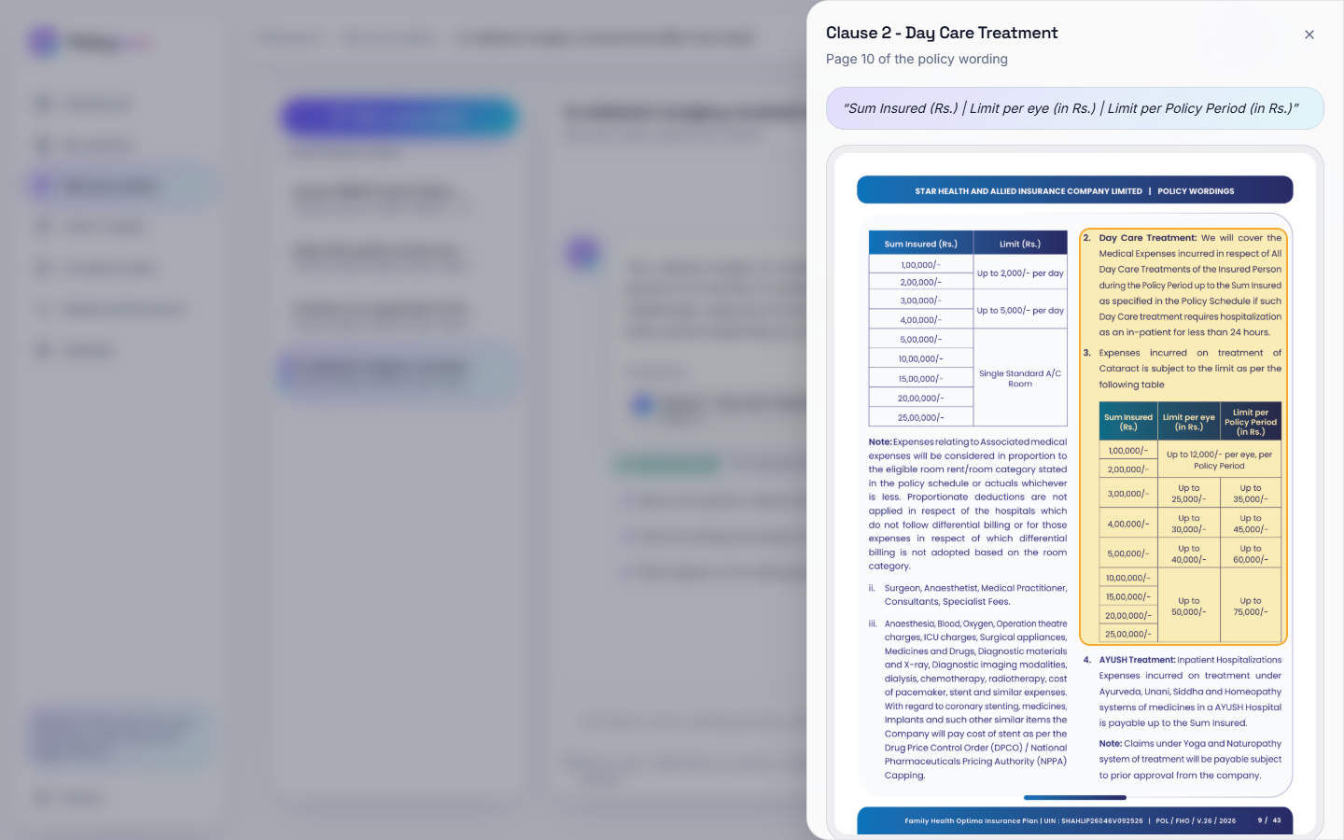
Fig. 18: Citation sheet
Clicking a source chip opens the cited page of the original policy with the clause outlined, and the quoted text at the top.
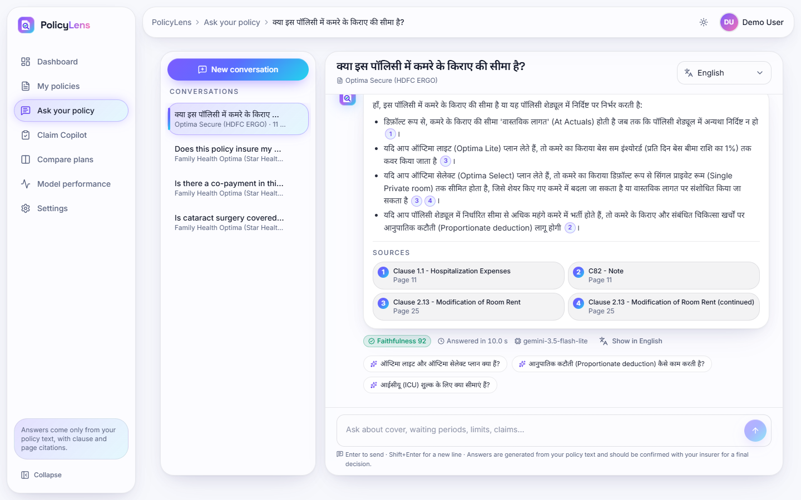
Fig. 19: Hindi answer
A question about the room-rent limit asked in Hindi is answered in Hindi with four source chips, faithfulness 92 and the link Show in English.
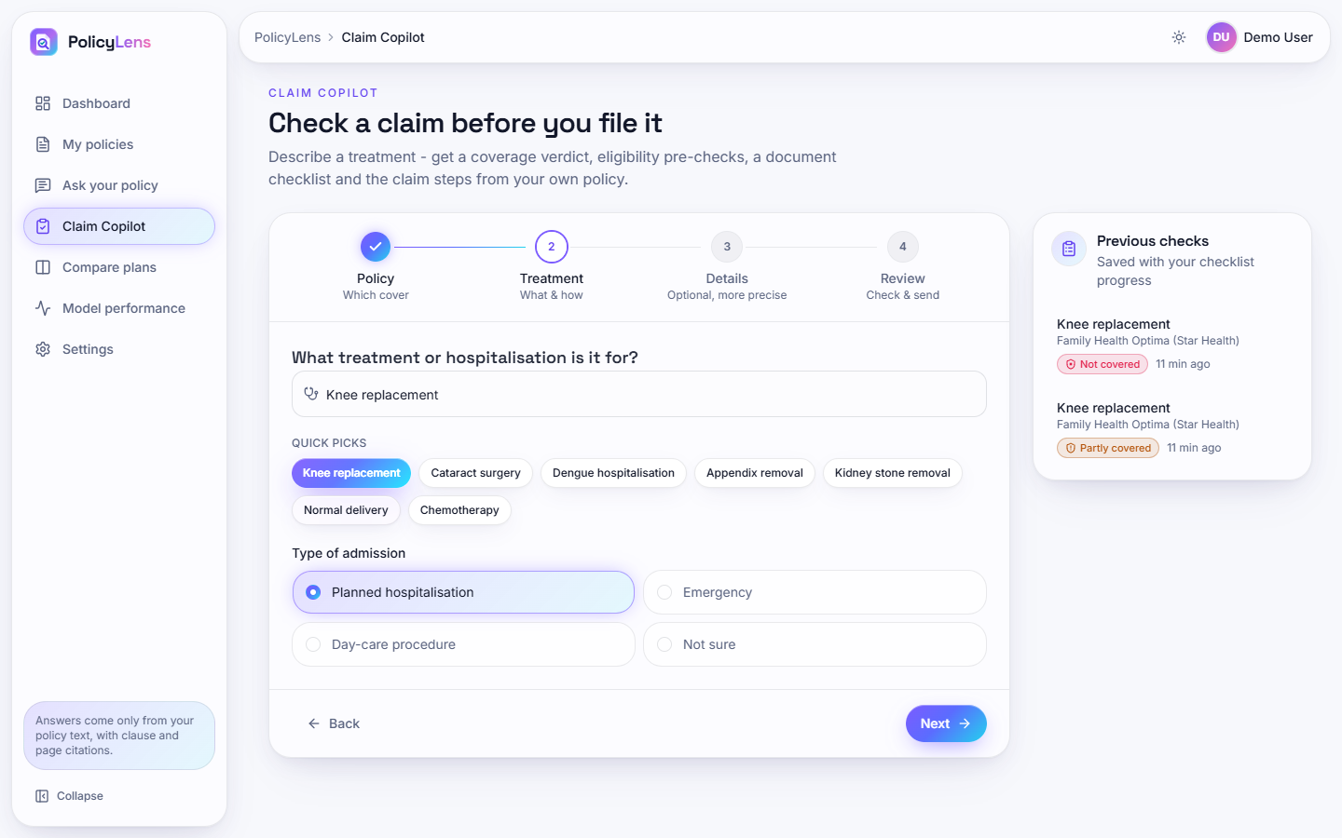
Fig. 20: Claim Copilot: treatment step
Step 2 of the four-step wizard (Policy, Treatment, Details, Review) with quick picks (Knee replacement, Cataract surgery, Dengue hospitalisation and others), the type of admission, and the list of previous checks.
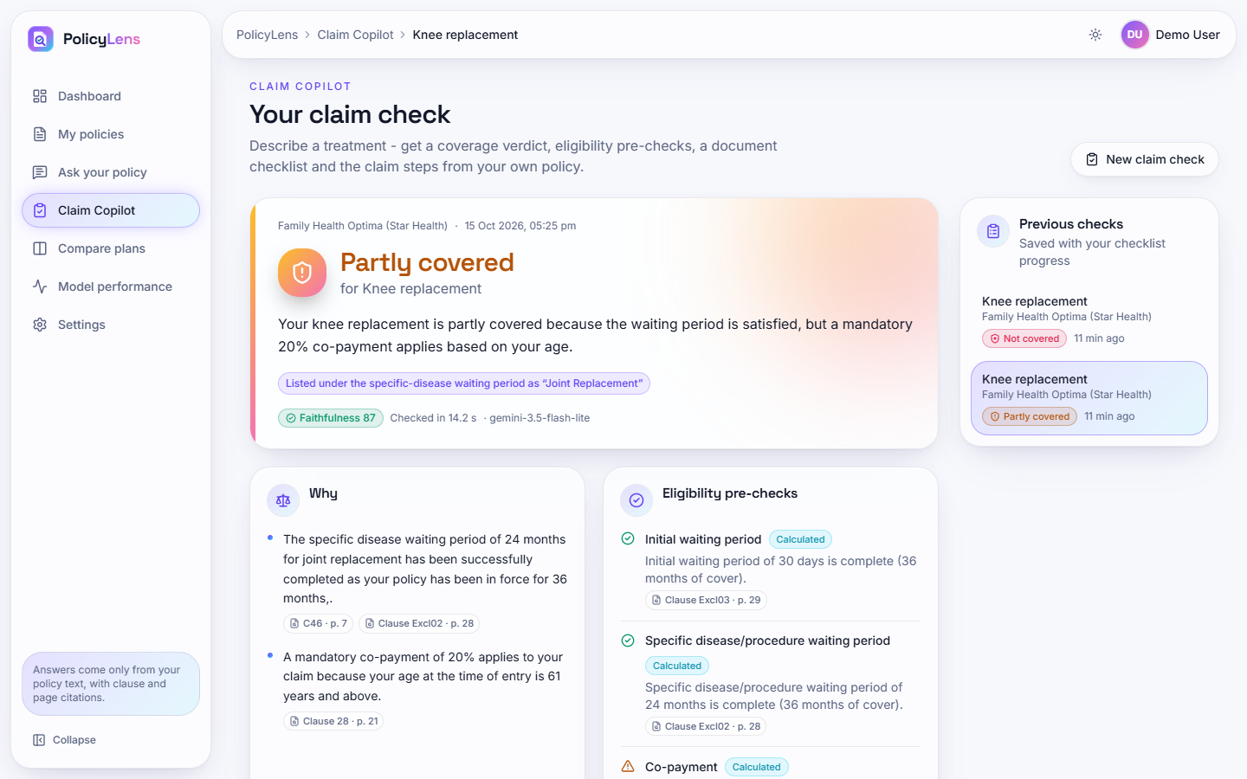
Fig. 21: Claim check: partly covered
Knee replacement under the Star Health policy, cover from 1 October 2023, age 64: partly covered because the waiting periods have passed but a mandatory 20% co-payment applies from age 61; the eligibility pre-checks are marked Calculated and each carries its clause and page.
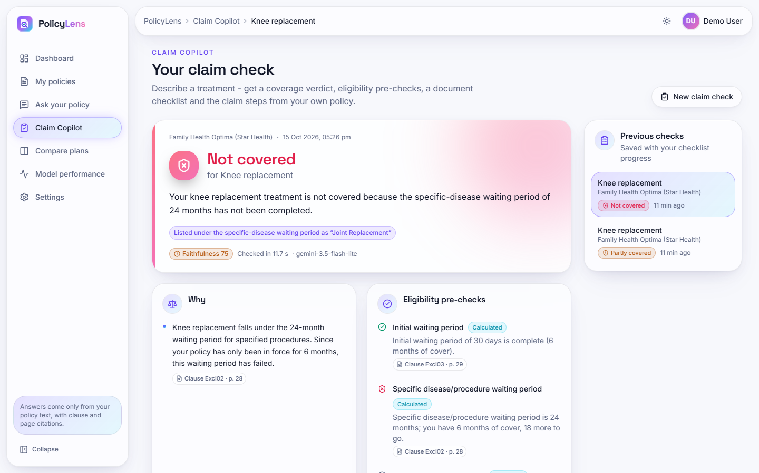
Fig. 22: Claim check: not covered
The same treatment with cover from 1 April 2026: not covered because the 24-month specific-disease waiting period has not been completed (6 months of cover, 18 more to go).
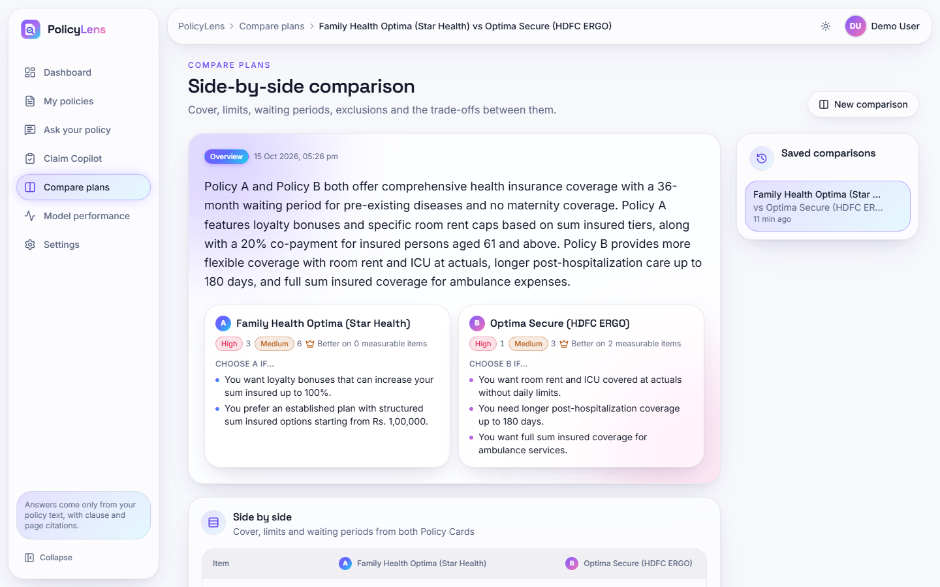
Fig. 23: Plan comparison
Star Health Family Health Optima against HDFC ERGO Optima Secure: an overview, the risk counts of each policy, "choose A if / choose B if" lists and the start of the side-by-side table.
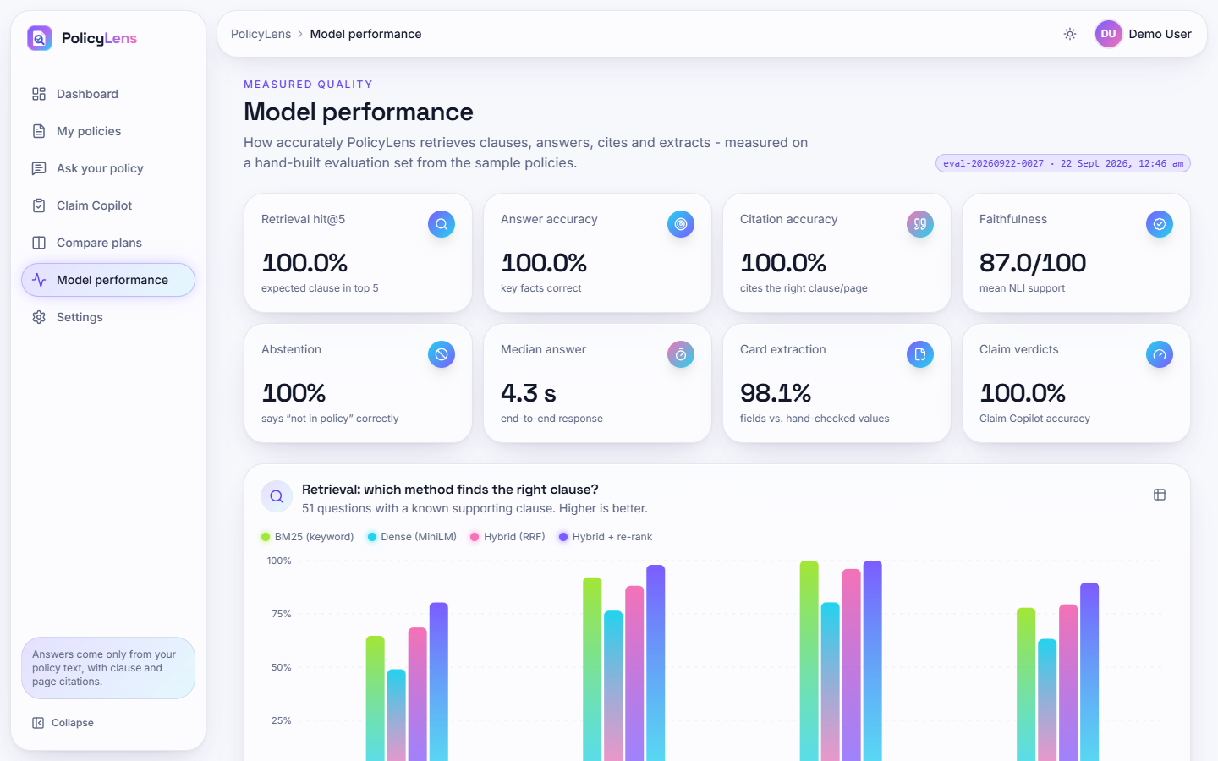
Fig. 24: Model performance
The public page of measured results from run eval-20260922-0027: retrieval hit@5 100%, answer accuracy 100%, citation accuracy 100%, faithfulness 87.0/100, abstention 100%, median answer 4.3 s, card extraction 98.1%, claim verdicts 100%, and the retrieval ablation chart.

5.1 Additional screens
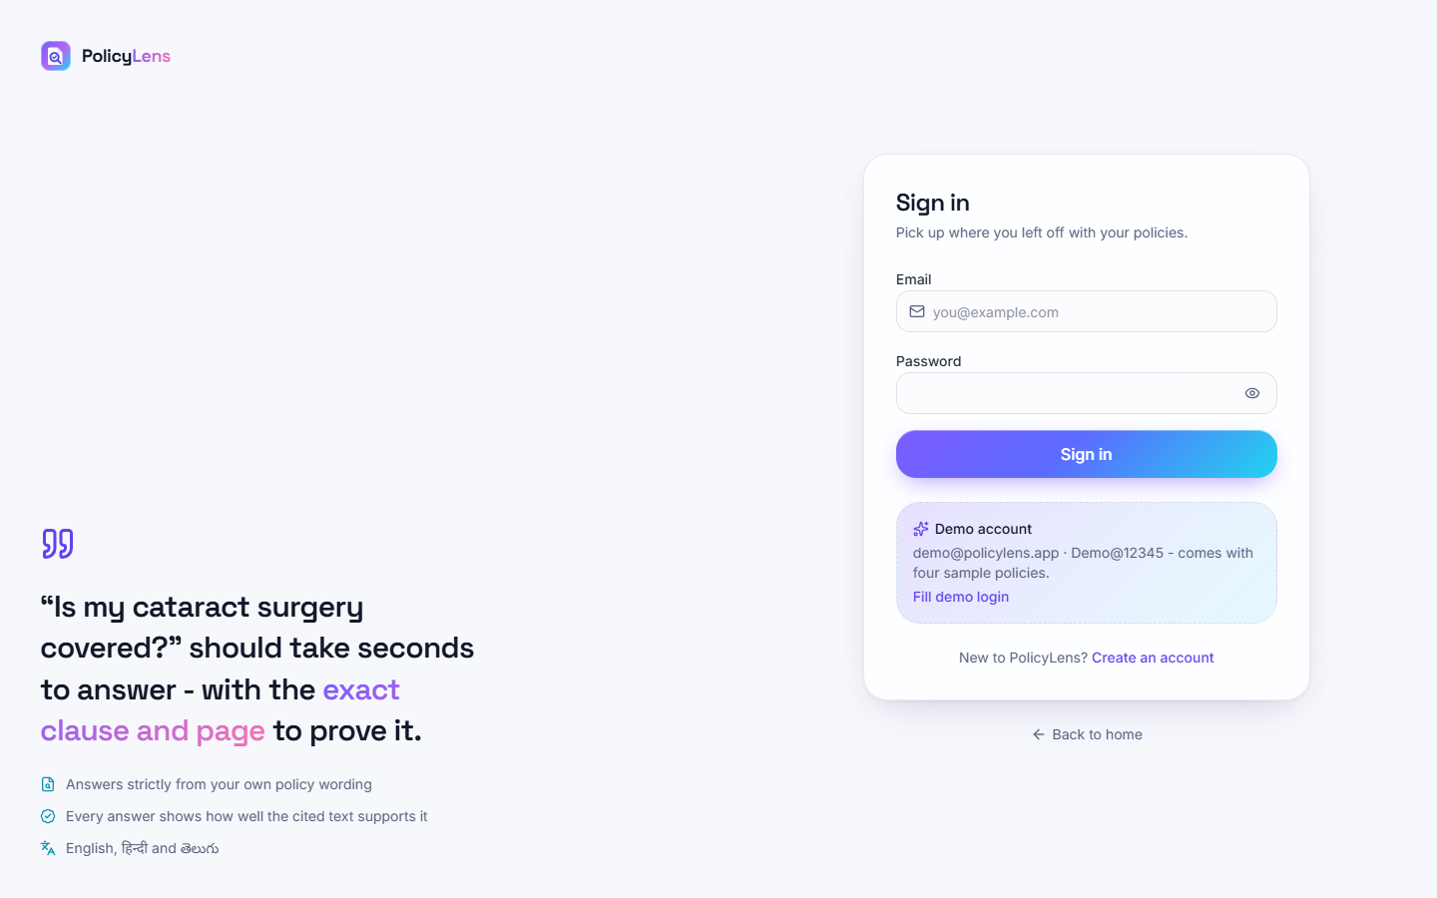  Fig. 25: Sign in | 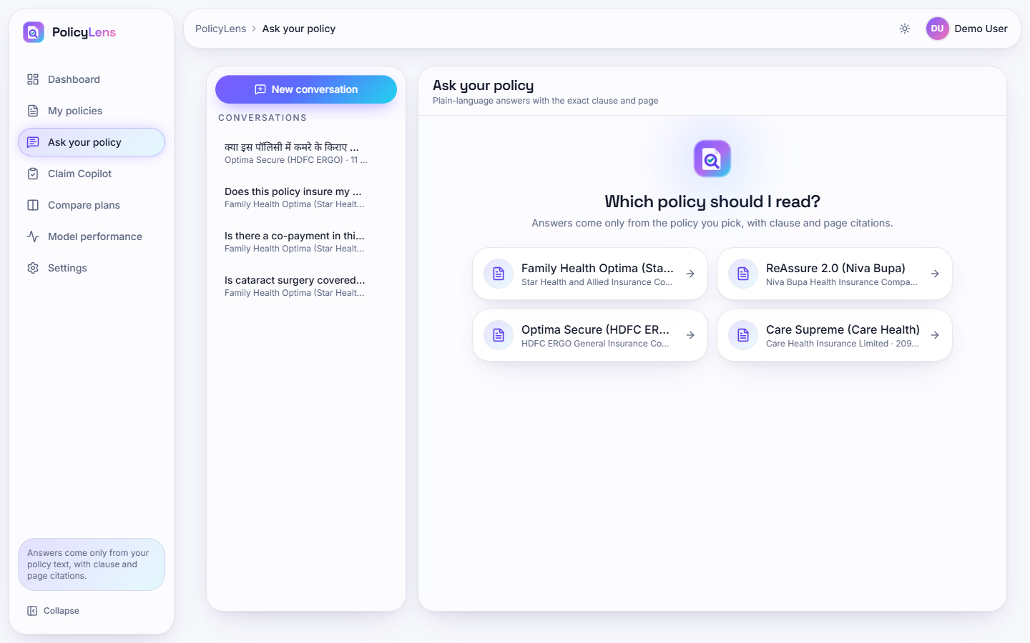  Fig. 26: Ask your policy: choose a policy

Sign in. The sign-in form with the e-mail and password fields.
Ask your policy: choose a policy. The start of a conversation: the user picks which of the four policies the answers must come from.
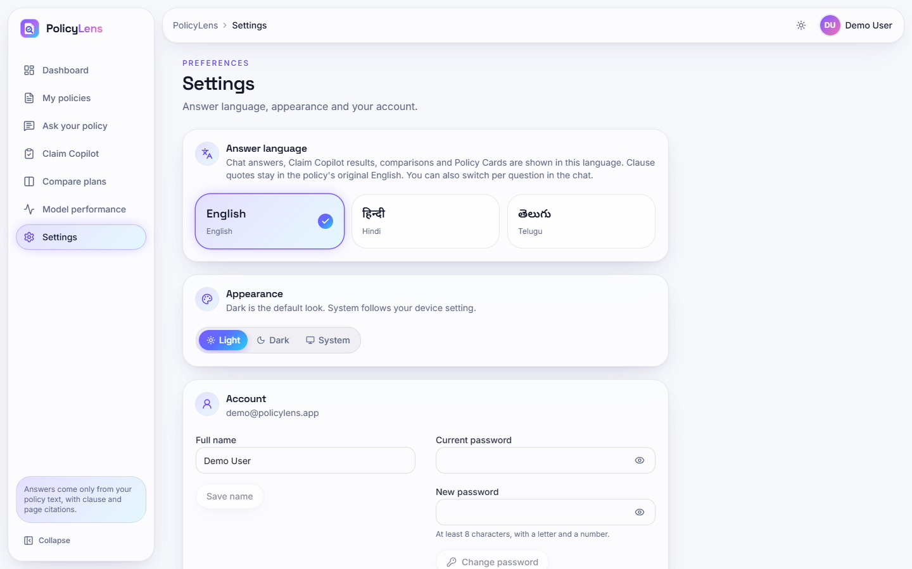  Fig. 27: Settings | 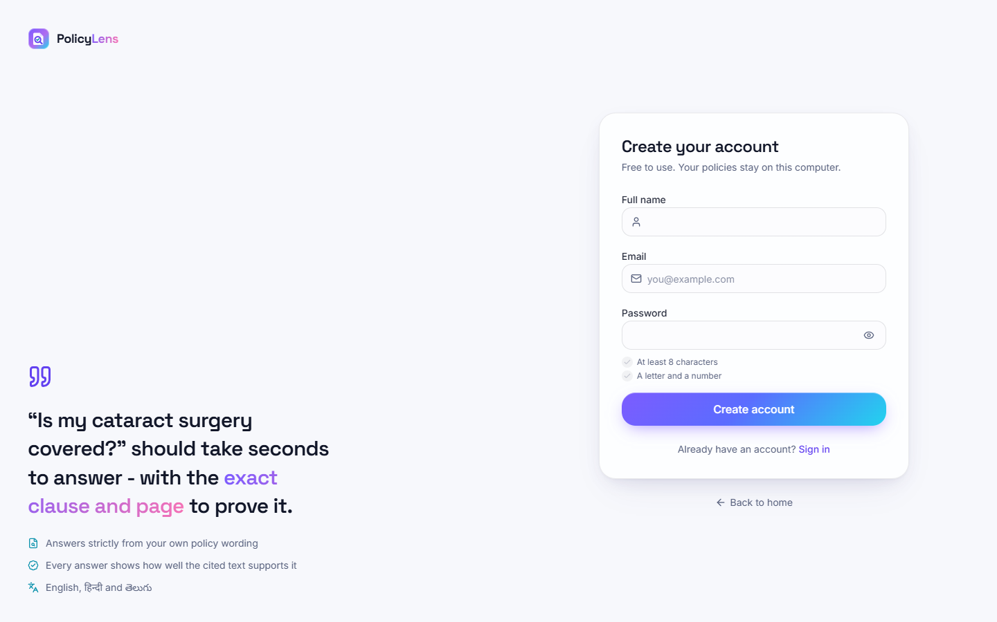  Fig. 28: Create account

Settings. The answer language (English, Hindi, Telugu), the appearance (light, dark, system) and the account: name and password change.
Create account. The registration form (name, e-mail, password with the stated rule).
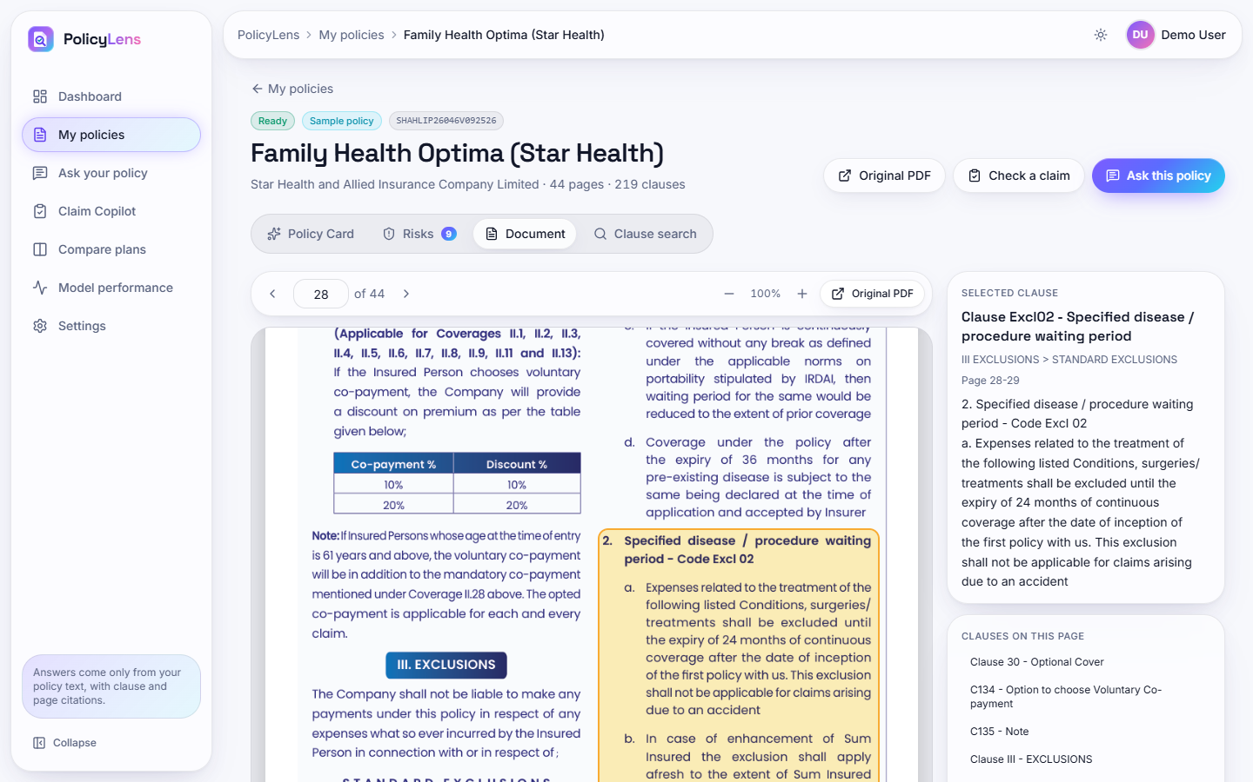  Fig. 29: Original document viewer | 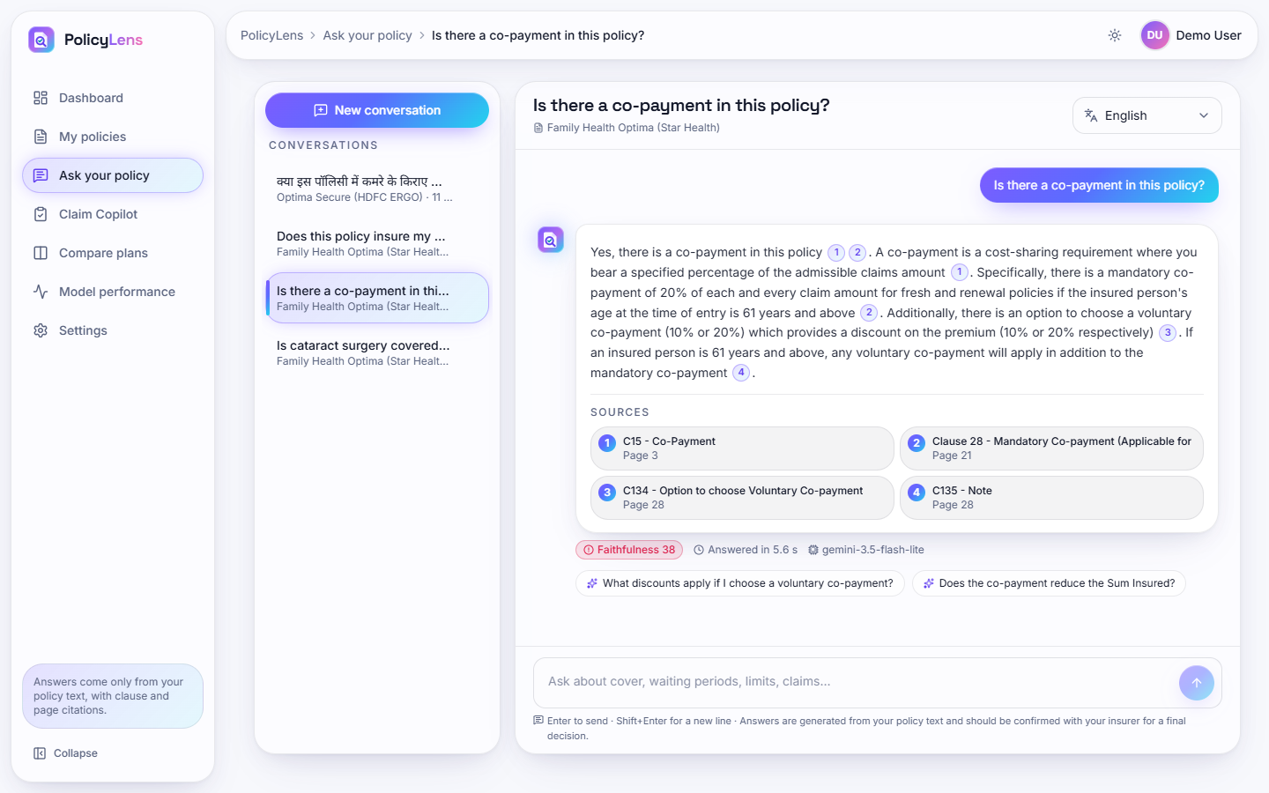  Fig. 30: Co-payment answer (weak support score)

Original document viewer. The viewer on the page of a cited clause before scrolling: page navigation, zoom, the selected clause and the clauses on the page.
Co-payment answer (weak support score). The answer to "Is there a co-payment in this policy?" received a faithfulness score of 38 in this run (99 in an earlier run of the same question), an example of the variability of the score discussed in Section 8.7.
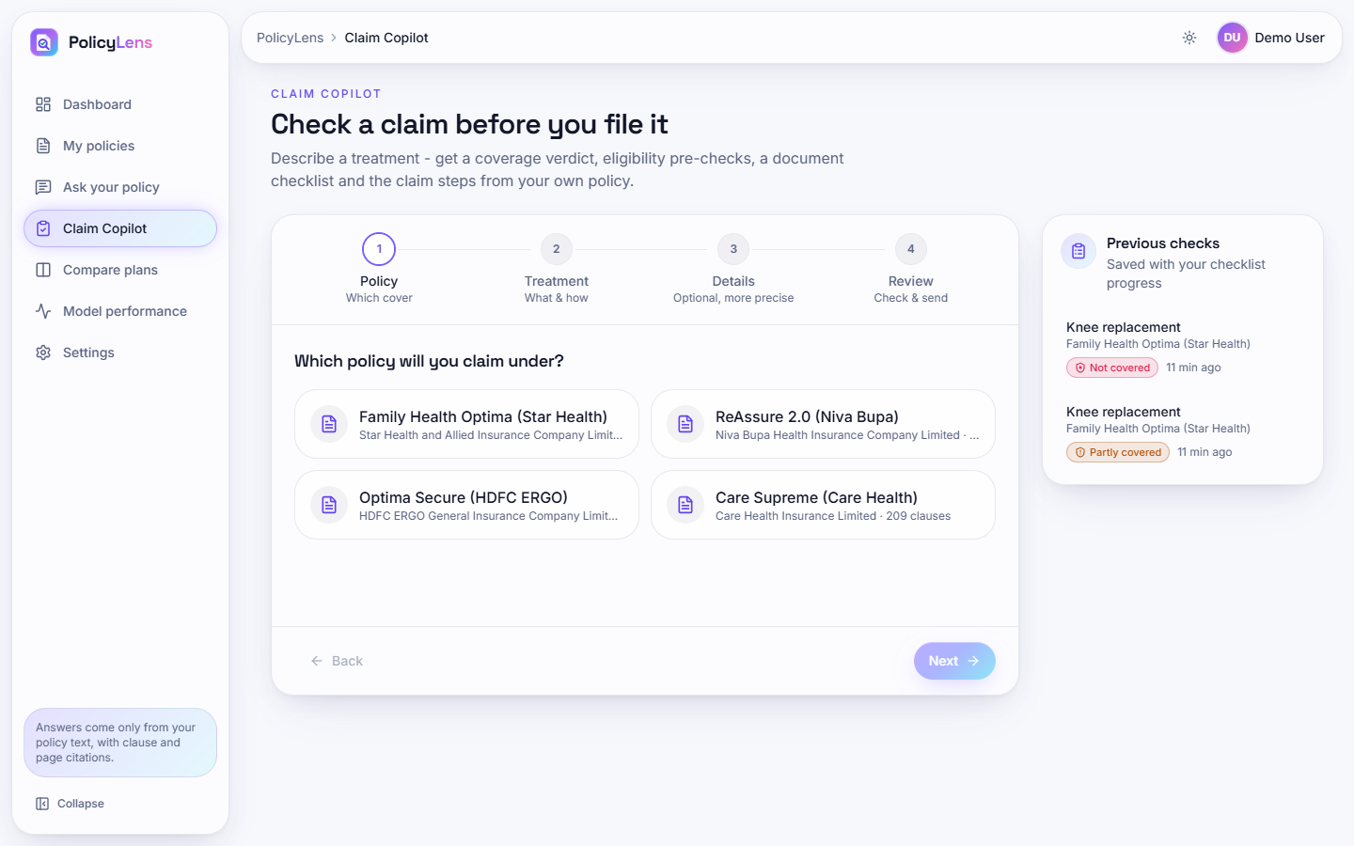  Fig. 31: Claim Copilot: policy step | 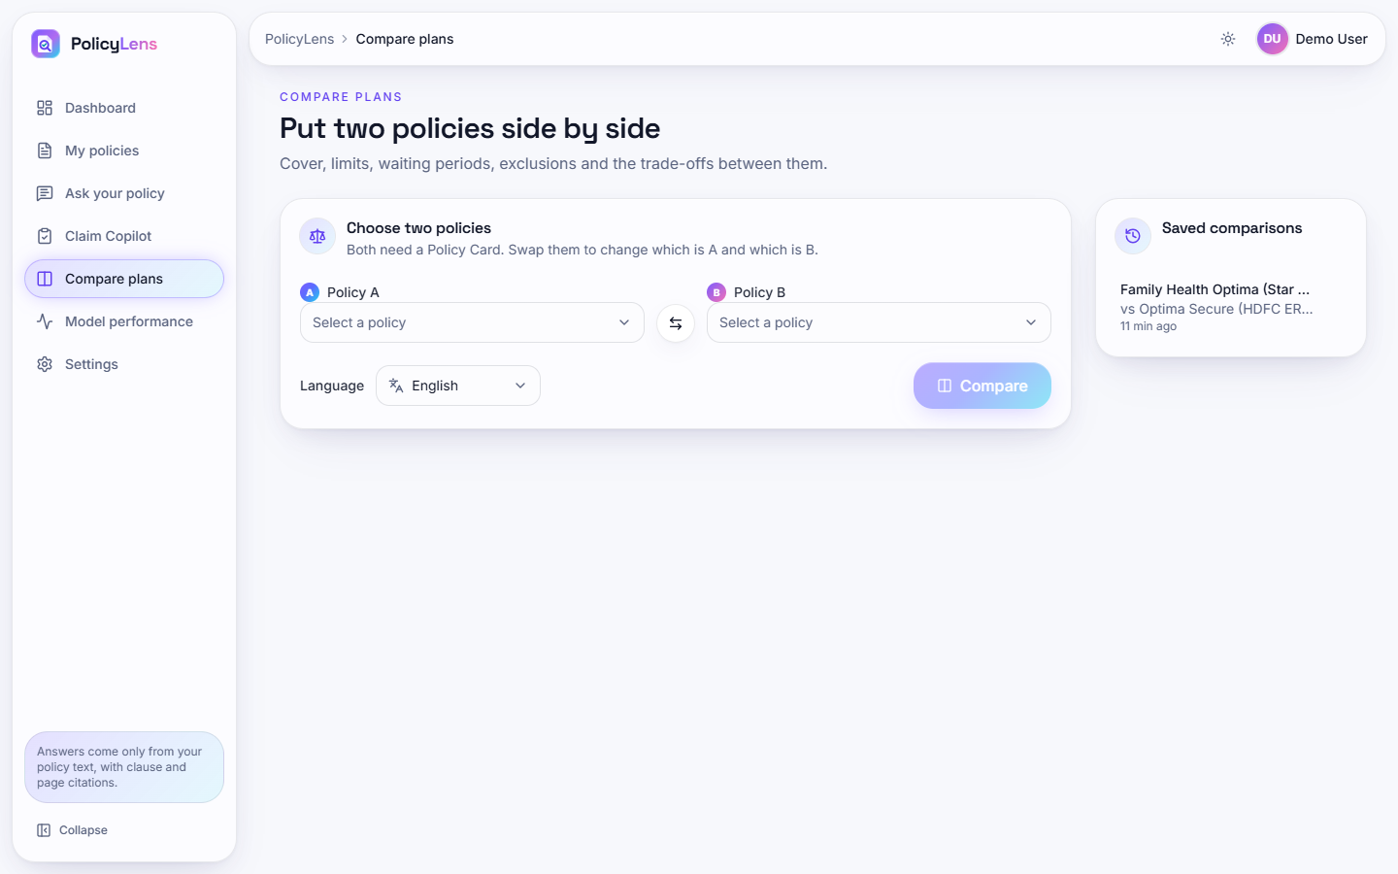  Fig. 32: Compare plans: form

Claim Copilot: policy step. Step 1: choose the policy to claim under.
Compare plans: form. Choose two policies, swap them and choose the answer language.
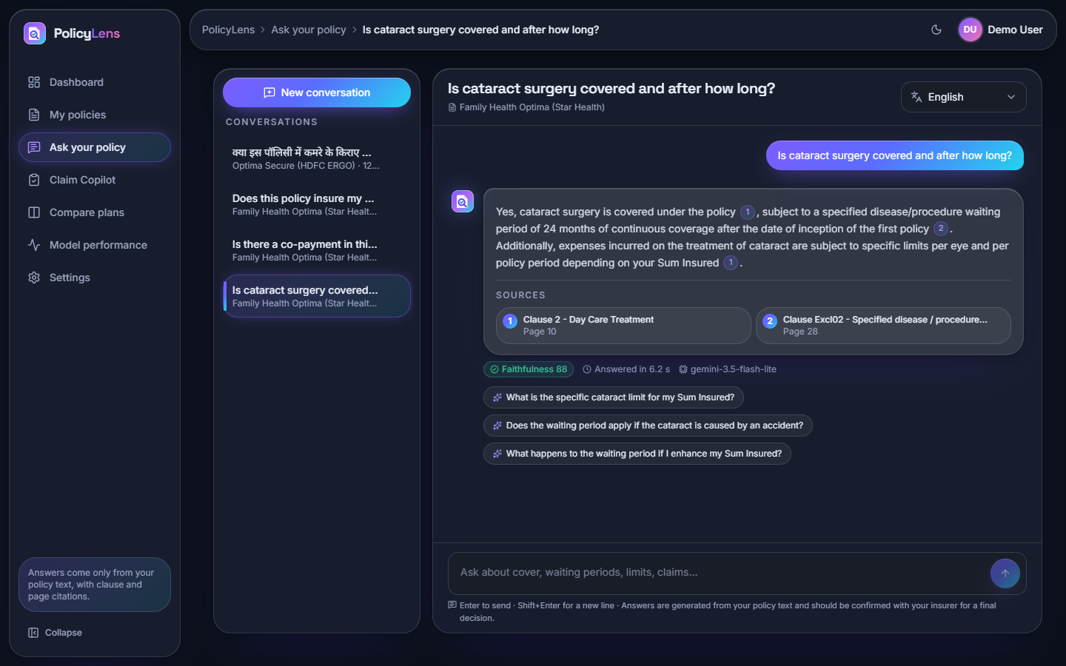  Fig. 33: Dark theme | 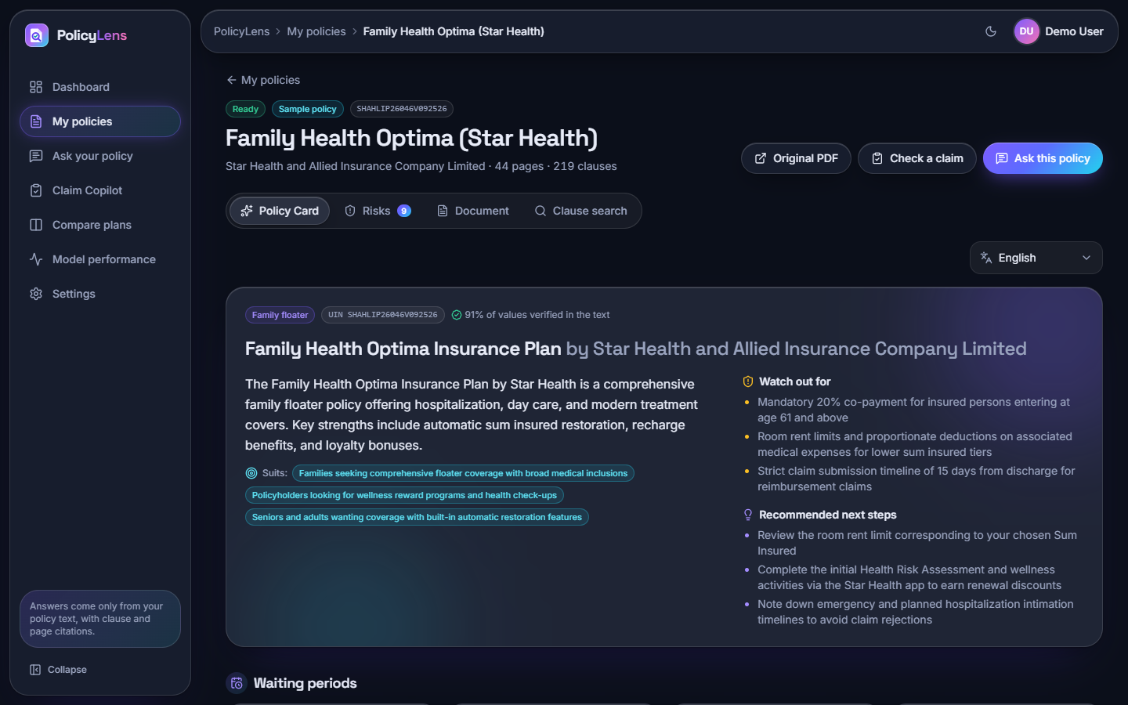  Fig. 34: Policy Card, dark theme

Dark theme. The cited answer in the dark theme.
Policy Card, dark theme. The Policy Card in the dark theme.
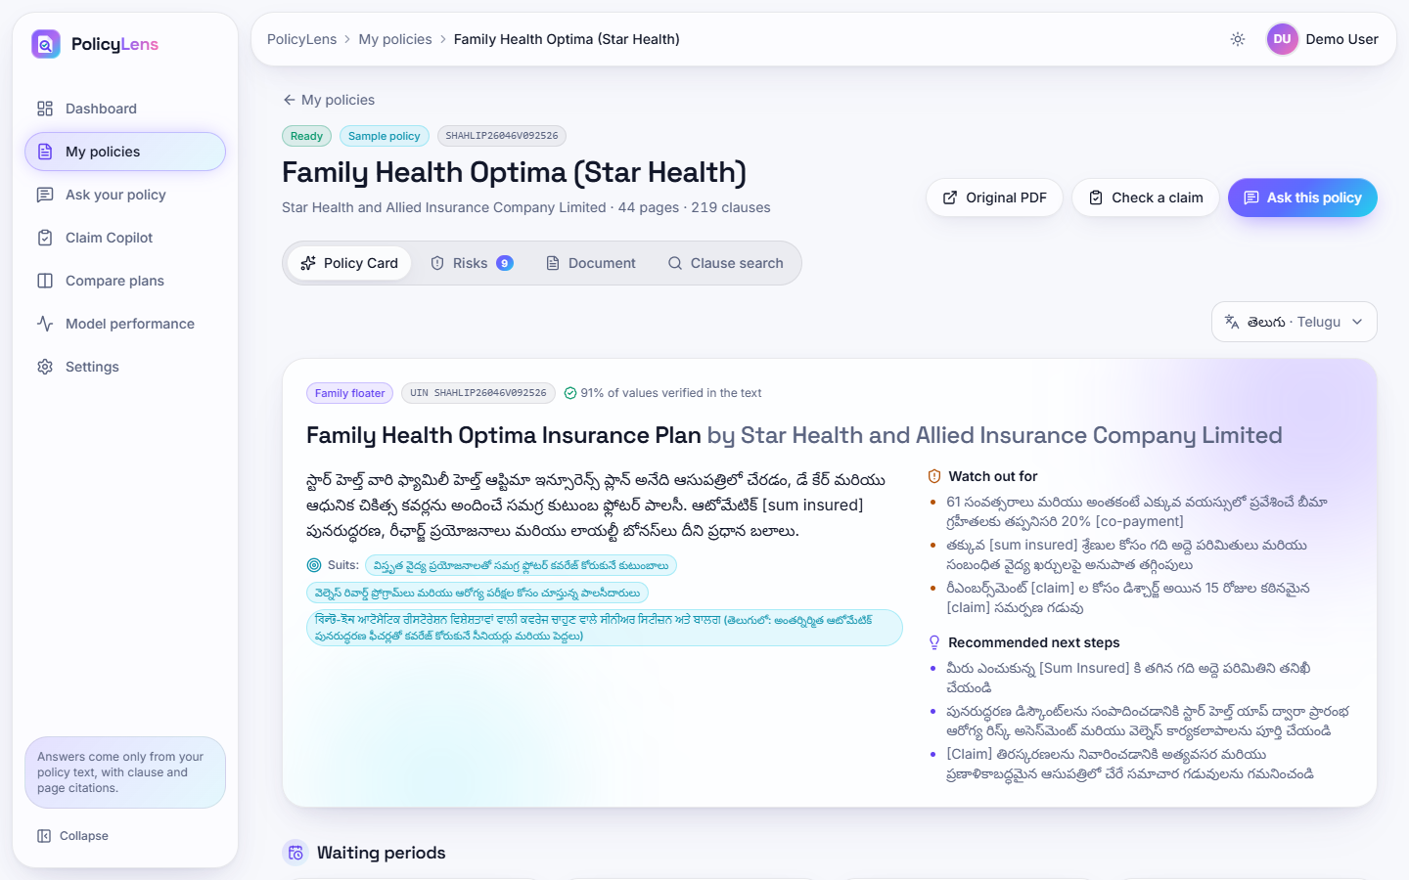
Fig. 35: Policy Card translated to Telugu

Policy Card translated to Telugu. The card in Telugu. The third "Suits" line contains Bengali and Gurmukhi script mixed into the Telugu text and several terms stay in English in brackets; this is a known limitation of the translation step.
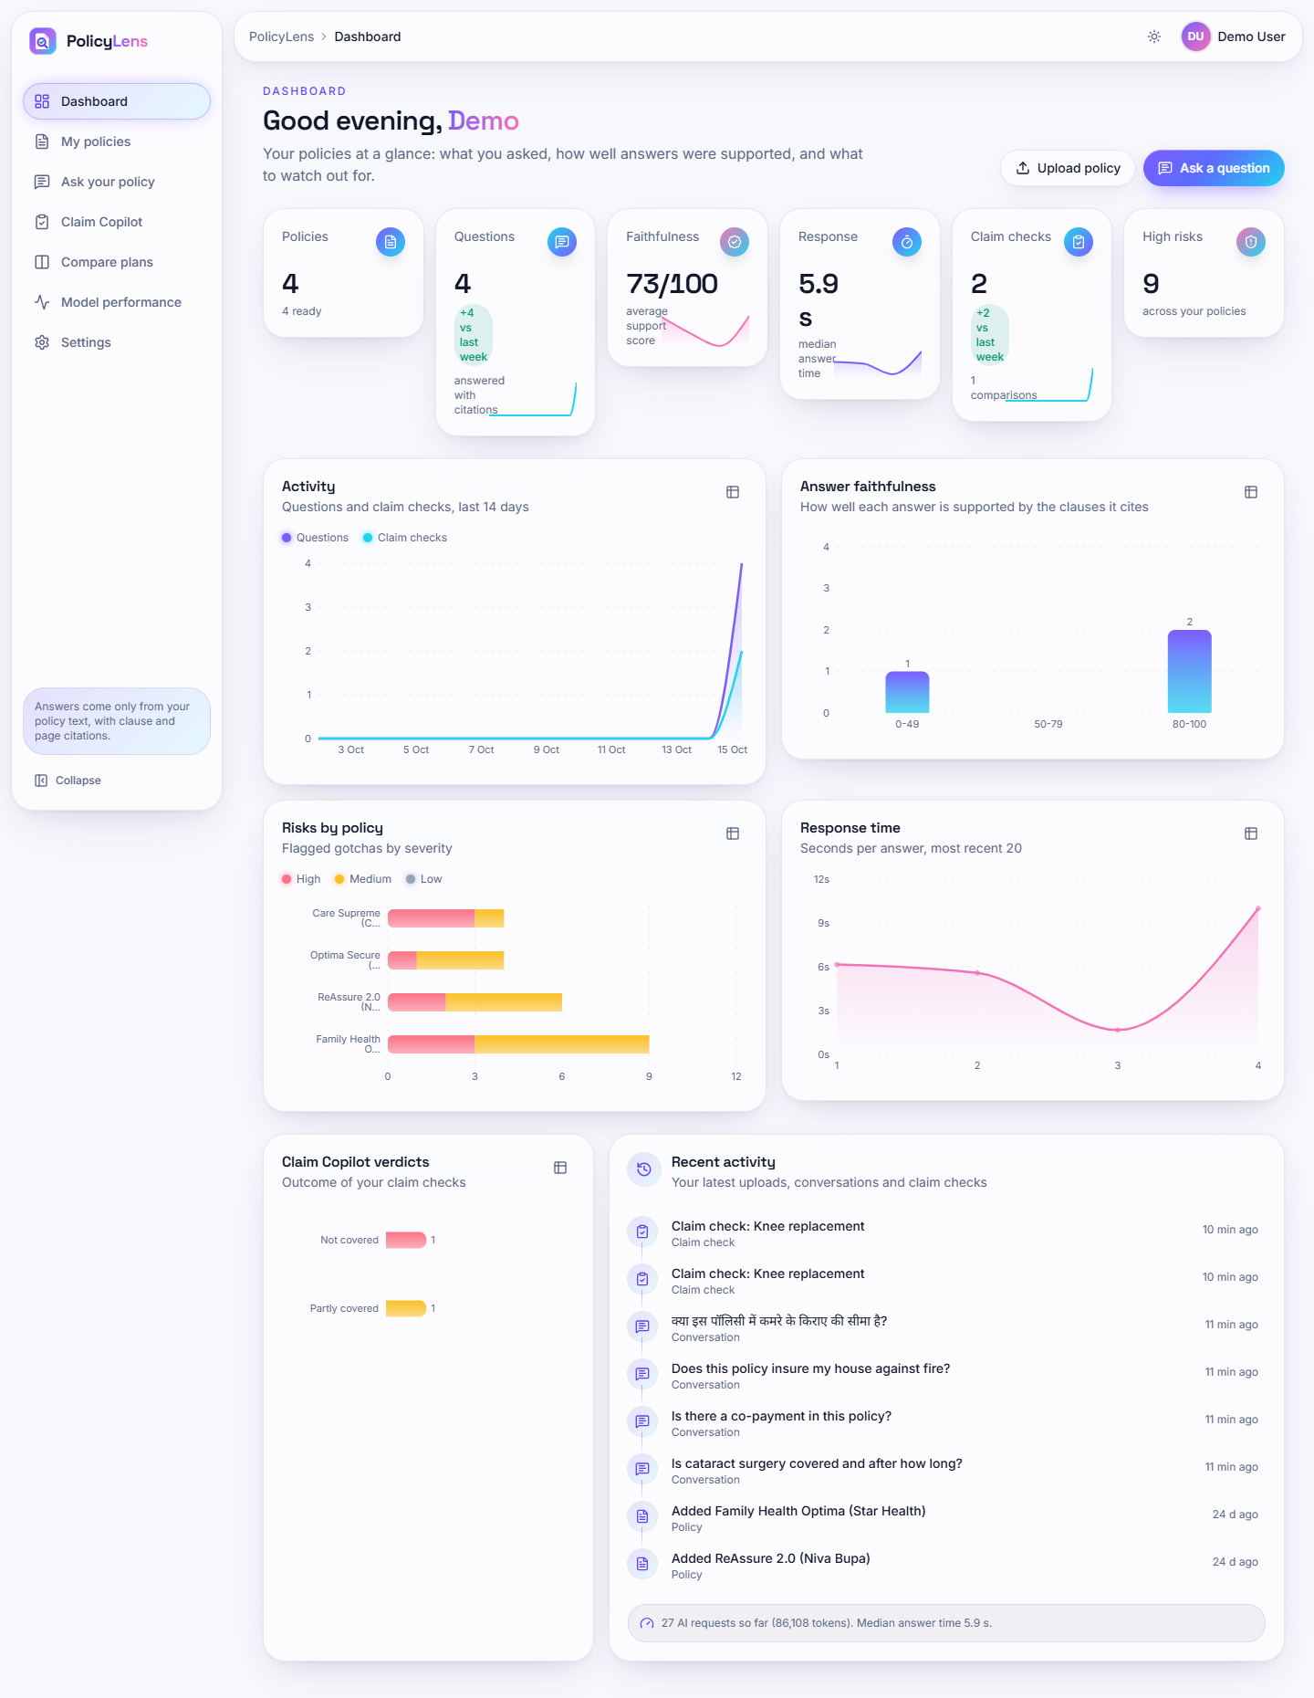  Fig. 36: Dashboard (full page) | 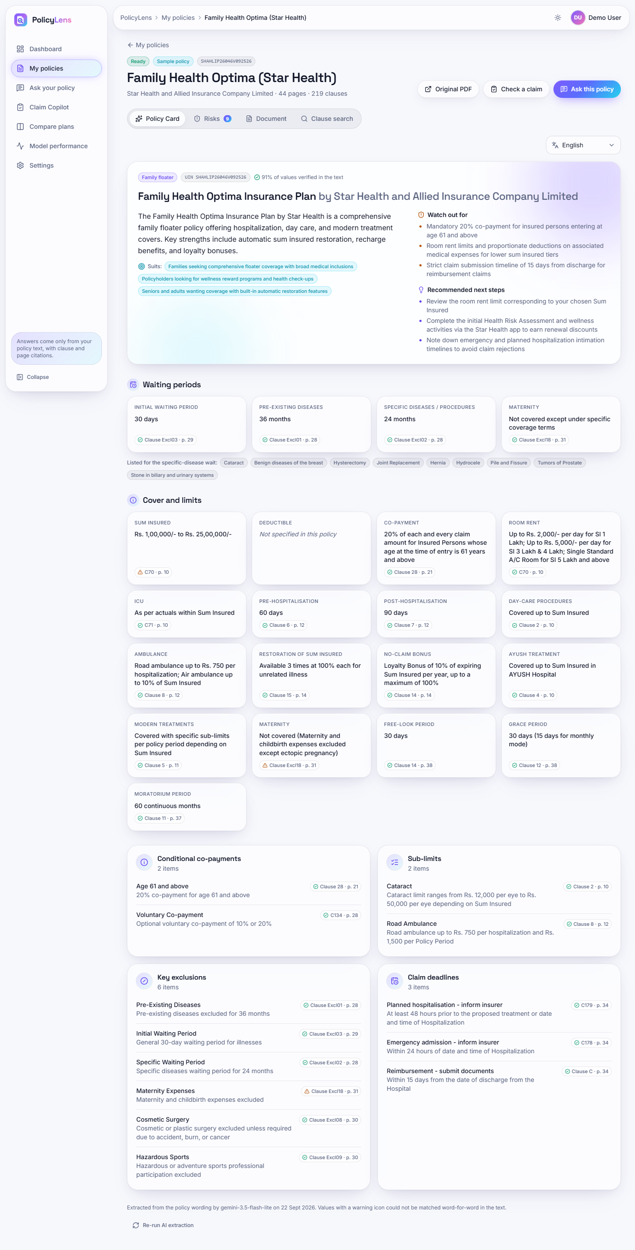  Fig. 37: Policy Card (full page)

Dashboard (full page). The whole dashboard including the answer faithfulness chart and the latest activity.
Policy Card (full page). The complete card: waiting periods, benefits, sub-limits, exclusions and claim deadlines, each with a clause and page chip.
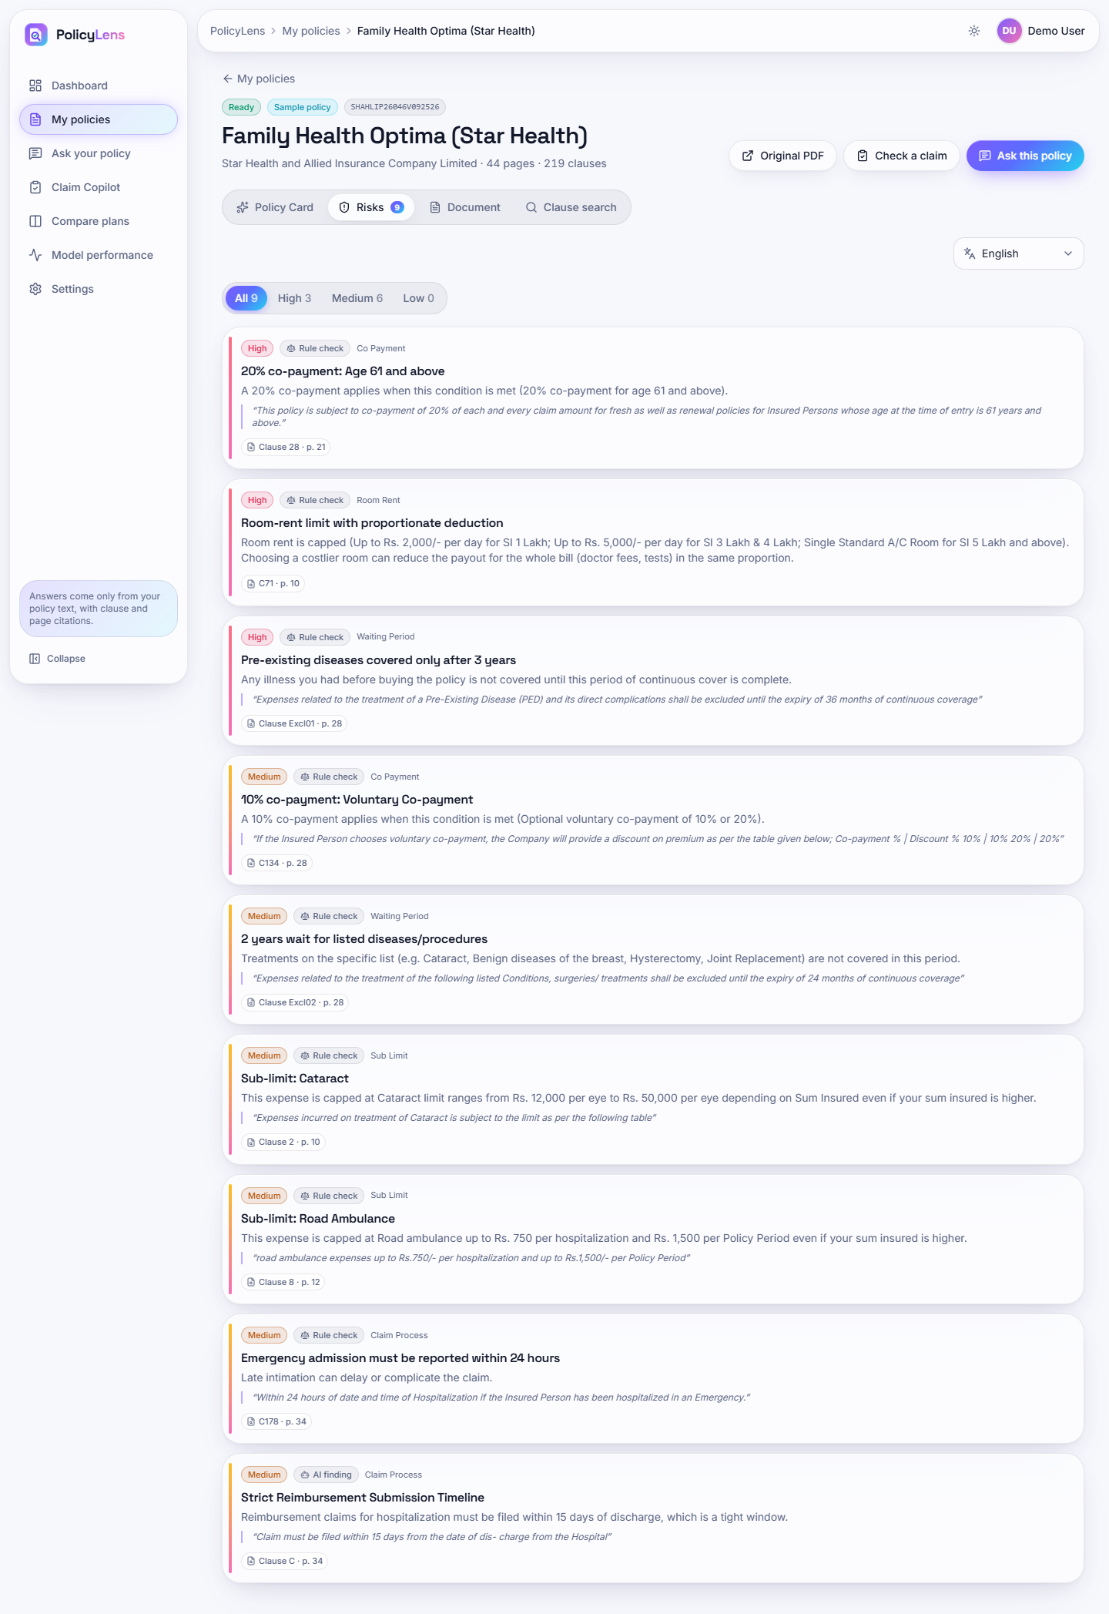  Fig. 38: Risk highlights (full page) | 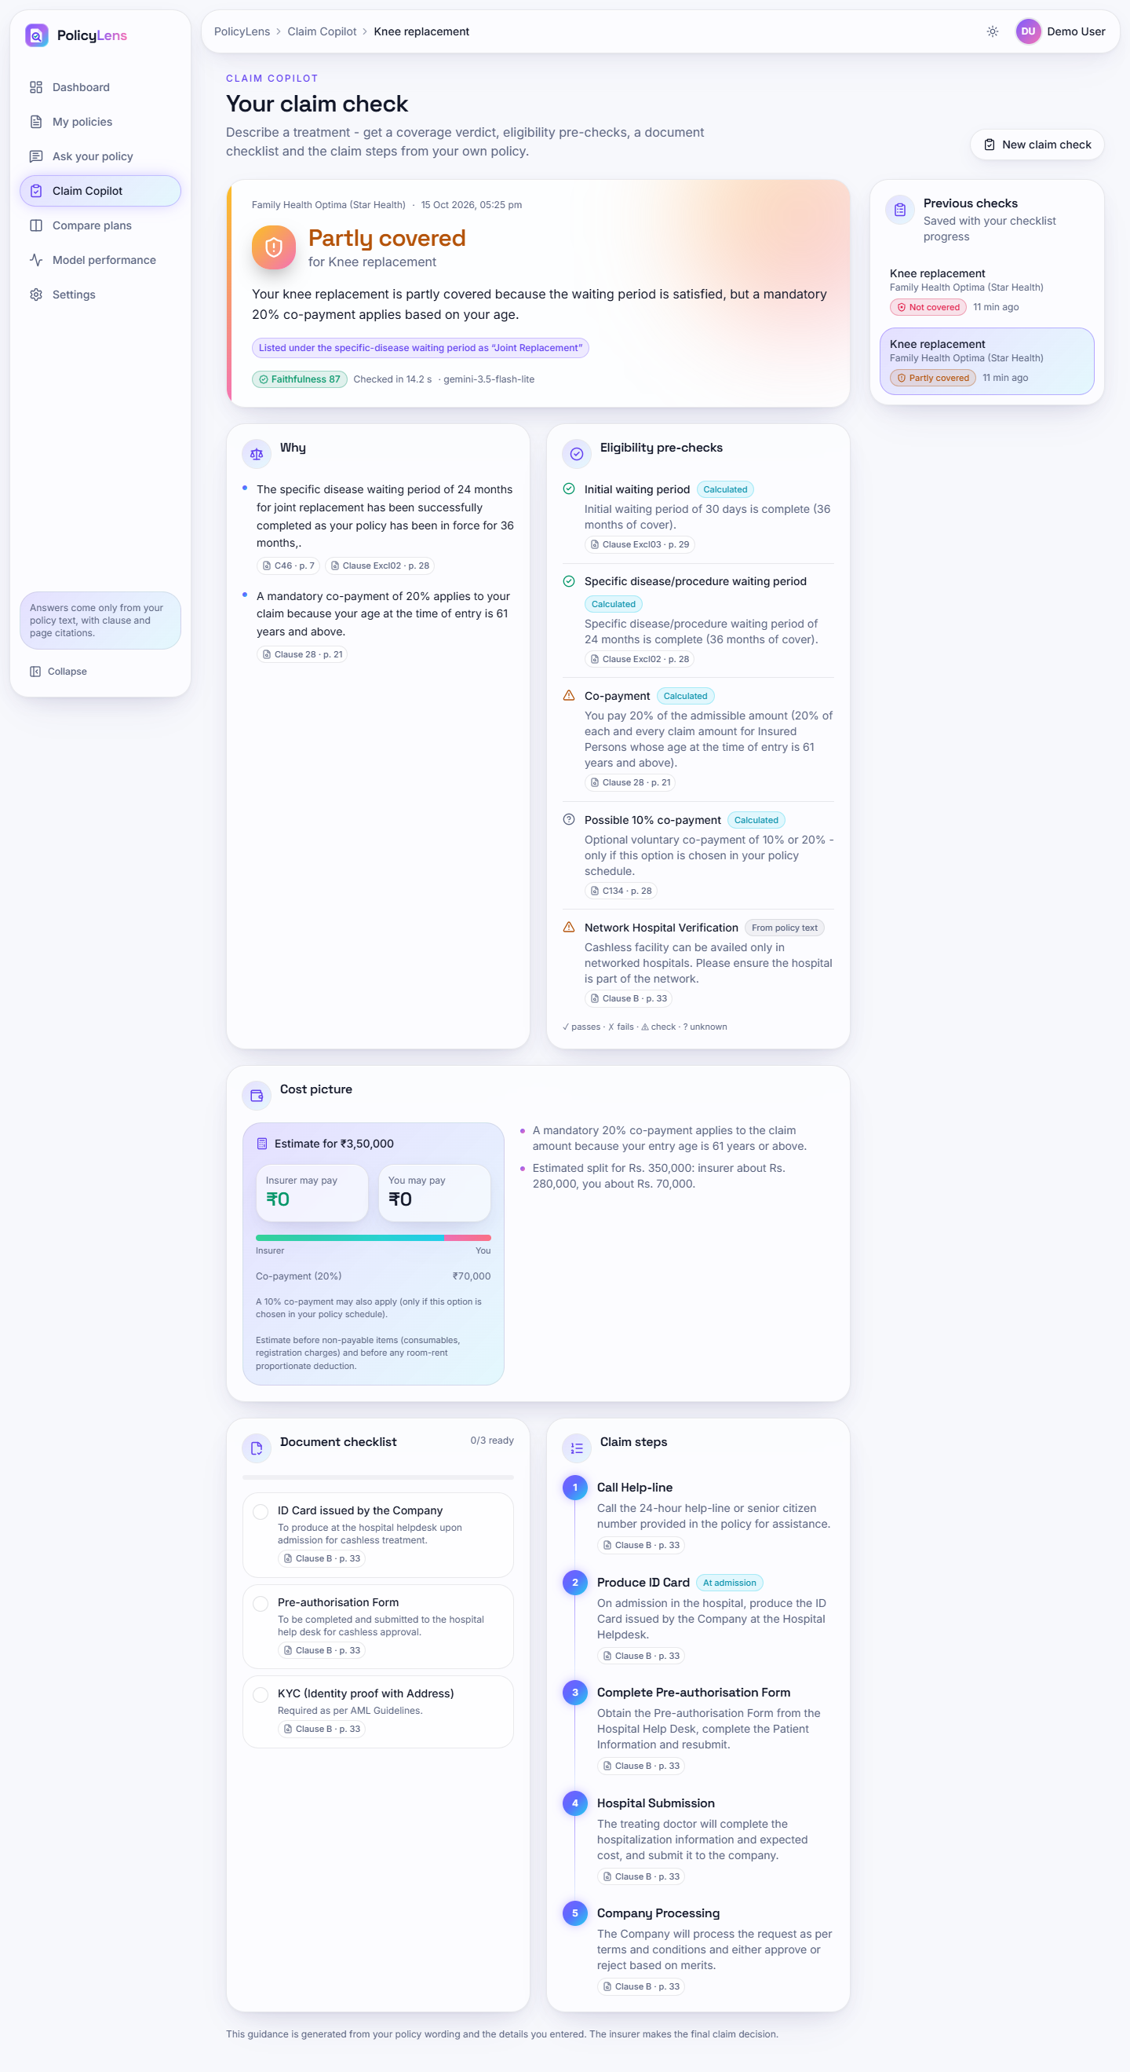  Fig. 39: Claim check, partly covered (full page)

Risk highlights (full page). All nine risks of the Star Health wording.
Claim check, partly covered (full page). The complete plan: reasons, pre-checks, estimated split of the bill, document checklist and claim steps.
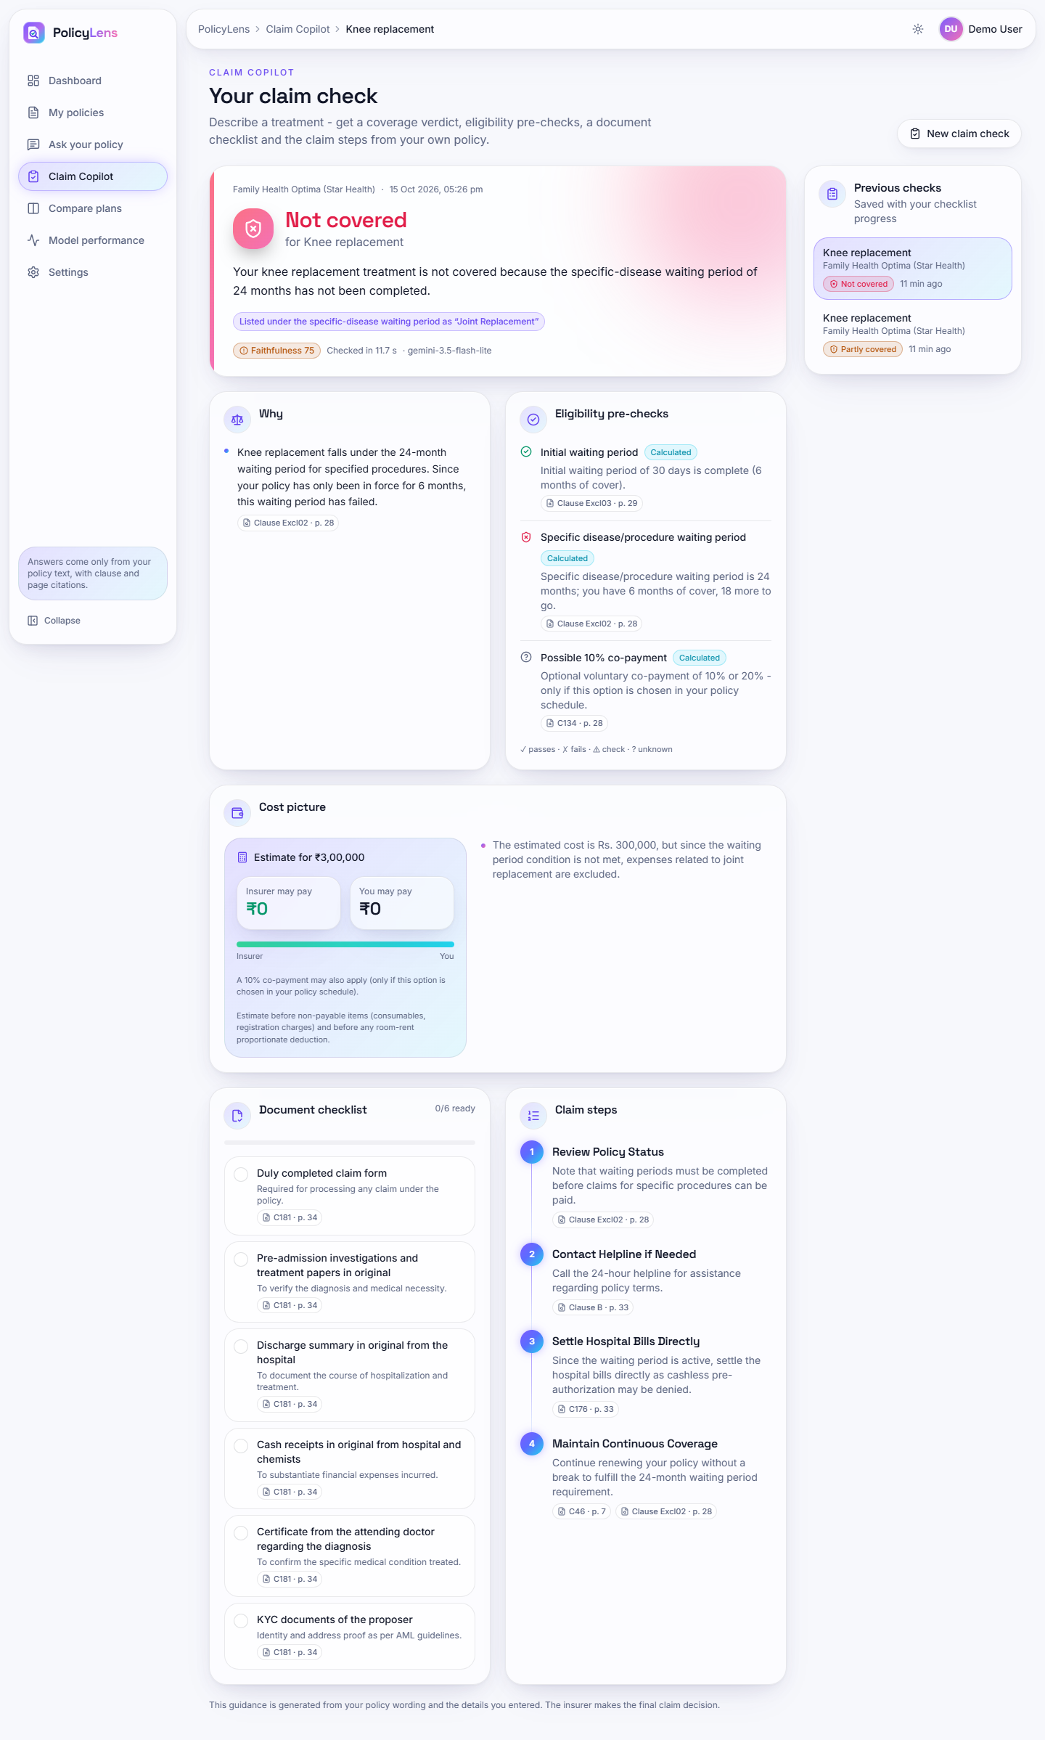  Fig. 40: Claim check, not covered (full page) | 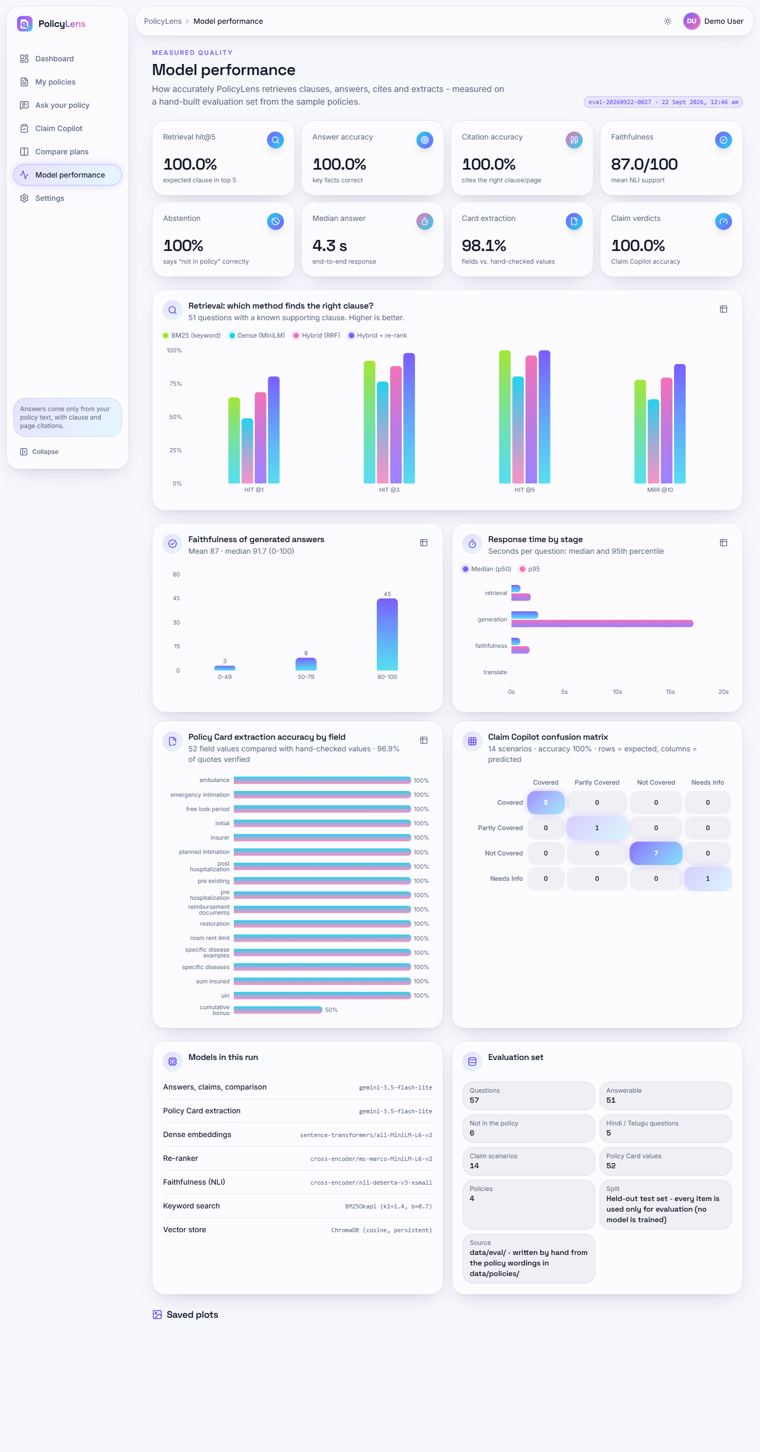  Fig. 41: Model performance (full page)

Claim check, not covered (full page). The complete plan for the failed waiting period.
Model performance (full page). All charts of the measured-quality page.
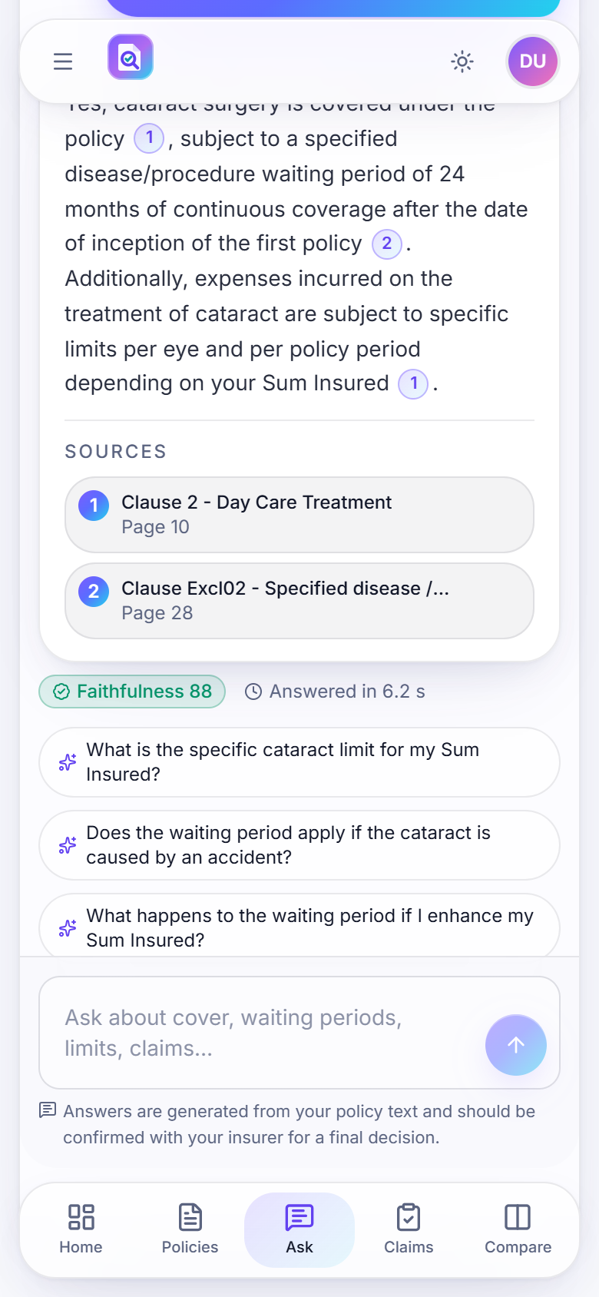  Fig. 42: Phone layout: cited answer (390 px) | 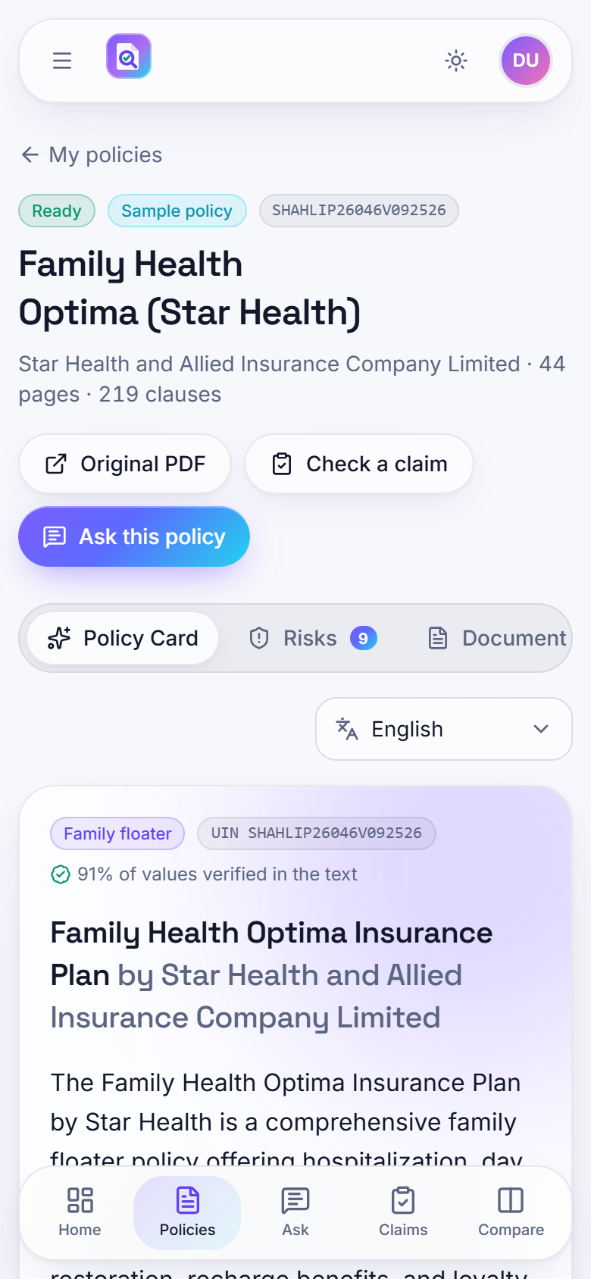  Fig. 43: Phone layout: Policy Card (390 px)

6 Sample Inputs and Outputs
Table 11: Sample inputs and outputs (live run, 15 October 2026)
Input | Output
Question: "Is cataract surgery covered and after how long?" (Star Health) | Covered under the policy, subject to a specified disease/procedure waiting period of 24 months of continuous coverage; expenses for cataract are subject to limits per eye and per policy period depending on the sum insured. Sources: Clause 2 (p. 10), Clause Excl02 (p. 28). Faithfulness 88.
Question: "Does this policy insure my house against fire?" | "Not covered in this policy document - I couldn't find any clause about it. You may want to confirm with the insurer." No sources; 1.7 s.
Claim: knee replacement, planned, cashless, cover from 2023-10-01, age 64, Rs. 3,50,000 | Partly covered: waiting periods complete (36 months of cover); mandatory 20% co-payment from age 61; document checklist and claim steps; estimated split of the bill.
Claim: knee replacement, cover from 2026-04-01, age 45 | Not covered: the 24-month specific-disease waiting period has not been completed (6 months of cover).
Compare: Star Health Family Health Optima and HDFC ERGO Optima Secure | Overview; 21-row side-by-side table; Policy A better on 0 measurable items, Policy B on 2; choose-A and choose-B lists.

7 Comparison with the Base Paper
The base paper [1] summarises Turkish court rulings and reports ROUGE scores; PolicyLens answers questions about English health-insurance wordings and reports retrieval, citation, faithfulness and verdict measures. The datasets, the tasks, the languages and the metrics all differ, so the numbers cannot be compared and no head-to-head claim is made. What can be compared is the approach.
Table 12: PolicyLens and the base paper
Aspect | Base paper [1] | PolicyLens
Task | Multi-document summarisation | Cited question answering, claim guidance, comparison
Documents | 2,000 Turkish court rulings (consumer-rights cases) | 4 English health-insurance wordings (166 pages, 801 clauses)
Selection step | TF-IDF and TextRank sentence extraction | BM25 + dense retrieval, fusion and cross-encoder re-ranking, measured
Generation | LED, Long-T5, BART-large, GPT-3.5 Turbo | Gemini with a JSON schema and tagged clauses
Training | Models fine-tuned for summarisation | None; pre-trained models only
Metric | ROUGE-1 55%, ROUGE-2 35%, ROUGE-L 42% (best model); content F1 0.47 (TF-IDF) | hit@5 100%, answer accuracy 100%, citation accuracy 100%, faithfulness 87.0, verdicts 14/14
Support for statements | Not measured; no citations | Citations to clause and page; NLI faithfulness score
Language | Turkish | English documents; English, Hindi, Telugu interaction

The closest quantitative point of comparison is the policy-document RAG study [6], which reports faithfulness of 0.347 (plain LLM), 0.621 (basic RAG) and 0.797 (RAG with a cross-encoder) with a different model, a different corpus (public-health guidance) and a different faithfulness measure. PolicyLens's mean faithfulness of 87.0 out of 100 is on its own NLI-based scale and is not comparable with those values either; the shared observation is that two-stage retrieval with re-ranking is what makes grounded answers reliable.

8 Success and Failure Analysis

8.1 Where it works
- Every answerable question in the evaluation set was answered correctly and cited correctly; every out-of-scope question was declined.
- Every claim scenario received the expected verdict, including the single "needs information" case.
- The Policy Card is right for 51 of 52 checked values and marks values whose quote it cannot find as unverified.
- Hindi and Telugu questions return answers in the requested script with the key facts (5 of 5).

8.2 Where it fails or is weak
Table 13: Failure and weakness analysis
Observation | Cause | Effect / handling
Cumulative bonus of the HDFC ERGO card differs from the reference | The wording covers seven plan variants with different bonuses | Card reports the Optima Secure figure (50%) while the reference takes the general clause (10%); plan-variant selection is planned
Three correct answers scored below 50 for faithfulness | NLI limits: exclusion item vs heading; inverted rule; abbreviation vs defined term | Score is shown as a prompt to open the cited clause; the heading-evidence fix was rejected because it confirmed a wrong statement
Same co-payment question scored 99.0 and then 37.9 | The score depends on how the model phrases its claims and which windows the NLI model sees | The score is a heuristic; sources are always shown
Telugu card line mixes Bengali and Gurmukhi script; bracketed English terms | Translation by the smaller model | Known limitation; English card and citations remain correct
Answer time up to 24.8 s | Fallback chain waits when the larger models are out of quota or overloaded | Median 4.3 s; the model used is shown
Dashboard tiles at 1440 px wrap values and have uneven heights | Layout of the tiles at that width | Cosmetic; noted for the next UI pass

9 Limits of the Results
- Small set. 51 answerable questions over four policies. 100% here means no errors were found on this set, not that PolicyLens never errs. Every answer shows its sources and a faithfulness score for that reason.
- Tuned on the same set. The abstention thresholds and the parsing fixes were made after studying failures on this set, so the final figures are optimistic. The next check is a fresh question set on policy wordings PolicyLens has not seen.
- Model and quota. The Gemini model used depends on the free-tier quota at the time. The run records which model produced each result; all results here are for the smallest model in the chain.
- One machine, no user study. All timings are from one desktop; no load testing; no policyholder has rated the answers.
- No numeric comparison with the base paper is possible, as explained above.

10 Objectives Against Outcomes
Table 14: Objectives against outcomes
Objective | Outcome | Evidence
1. Extract key policy attributes automatically | Achieved | Policy Card with sourced values; 51 of 52 values correct; 96.9% verified in the text
2. Build a RAG pipeline that retrieves the relevant clauses | Achieved | Hybrid + re-rank: relevant clause in the top 5 for 51 of 51 questions; first for 80.4%
3. Generate plain-language answers grounded in and citing the clauses | Achieved | Answer accuracy 51/51, citation accuracy 100%; out-of-scope questions declined 6/6
4. Provide guided claim support with pre-checks, checklists and steps | Achieved | 14 of 14 verdicts correct; calculated pre-checks; checklist and steps; cost estimate
5. Summarise risks, exclusions and trade-offs to support plan comparison | Achieved | Risk highlights with severity (23 across the four samples); 21-row comparison with trade-offs. The comparison quality was not scored against a reference
6. Evaluate answer accuracy, faithfulness and response time | Achieved, with limits | Measured on a small set partly tuned on itself; faithfulness mean 87.0; median 4.3 s; no user study

