PolicyLens: Clause-Grounded Health-Insurance Question Answering and Claim Guidance with Hybrid Retrieval and an LLM
G.PRANATHI  Roll No. 23K91A6764  Department of Computer Science and Engineering (Data Science)  [COLLEGE NAME]  [CITY]  [EMAIL] | CH.AISHWARYA  Roll No. 23K91A6747  Department of Computer Science and Engineering (Data Science)  [COLLEGE NAME]  [CITY]  [EMAIL] | BHAVANSH MANE  Roll No. 23K91A6728  Department of Computer Science and Engineering (Data Science)  [COLLEGE NAME]  [CITY]  [EMAIL] | B.DEEKSHITH  Roll No. 24K95A6701  Department of Computer Science and Engineering (Data Science)  [COLLEGE NAME]  [CITY]  [EMAIL] | [GUIDE NAME]  [DESIGNATION], Project Guide  Department of Computer Science and Engineering (Data Science)  [COLLEGE NAME]  [CITY]  [EMAIL]

Abstract—Health-insurance policy wordings are long and technical, so policyholders often learn what is excluded only when a claim is reduced. General chatbots answer from training data rather than from the user's own policy and can state coverage that the wording does not contain. This paper presents PolicyLens, an assistant that answers strictly from an uploaded wording. The wording is parsed into numbered clauses with page positions; a hybrid retriever that combines BM25, MiniLM embeddings, Reciprocal Rank Fusion and a cross-encoder selects the relevant clauses; a large language model writes a cited answer in English, Hindi or Telugu; and an independent natural-language-inference model scores how well each answer is supported. A two-score rule makes the assistant decline when the wording is silent, and calculated rules guide claims. On a hand-built set from four real wordings the relevant clause was in the top five for 51 of 51 questions, all 51 answers were correct and cited, six of six out-of-scope questions were declined, and the mean faithfulness score was 87.0. The set is small and partly tuned, and no user study was carried out.
Index Terms—claim guidance, faithfulness, health insurance, hybrid retrieval, large language model, question answering, retrieval-augmented generation.
I. INTRODUCTION
Health insurance is the main protection most families have against hospital costs, and each product is defined by a policy wording: a document of twenty to sixty pages that states what is covered, what is excluded, how long a policyholder must wait before certain treatments are covered, what share of a bill the policyholder pays and how a claim is made. The wording is legally binding but written in dense technical language, so the conditions that matter most, such as waiting periods, sub-limits and co-payments, are easily missed until a claim is reduced or rejected.
Today a policyholder reads the wording alone, asks an agent or a helpline, or uses a comparison site that compares premiums and headline benefits. Agents are slow and inconsistent, and comparison sites do not explain exclusions or claim conditions. A general-purpose chatbot is fluent but answers from broad training data, not from the user's policy, and large language models are known to produce plausible statements that the source does not support [16]. The cost is real: in a study of retrieval-augmented GPT-4o answering Quebec car-insurance questions, between 5% and 13% of the answers contained a false statement that could mislead a customer [2]. The base paper [1] shows how long legal text can be handled by selecting the important passages first and generating from them, but it summarises Turkish court rulings; it does not answer questions, cite passages or guide claims.
This paper presents PolicyLens, an assistant that answers questions strictly from the user's own policy wording, shows the clause and page behind every statement, measures how well each answer is supported, and guides claims. Its contributions are:
1) clause-aware parsing and segmentation of insurance wordings, so that every citation can be highlighted on the original page, and a Policy Card whose values are verified against their quotes;
2) a measured hybrid retriever (BM25, dense embeddings, Reciprocal Rank Fusion, cross-encoder) and grounded generation in which citations to unretrieved clauses are removed;
3) an independent natural-language-inference faithfulness score and a two-score abstention rule that declines questions the wording does not cover;
4) Claim Copilot, whose waiting-period, co-payment and estimate rules are calculated and cannot be overruled by the model, and an offline evaluation on four real wordings.
Section II reviews related work, Section III describes the method, Section IV reports the results and Section V concludes.
A. System Hardware
All measurements were taken on one desktop with a 12th-generation Intel Core i5-12500 (6 cores, 12 threads), 15.7 GB of memory and no discrete graphics card, running Windows 11 and Python 3.11.9. The three local models run on the CPU. Language generation uses the Google Gemini API on its free tier.
B. Software Requirements
The back end is FastAPI with Pydantic 2, SQLAlchemy 2 over SQLite, PyJWT and bcrypt; PDFs are read with PyMuPDF; keyword search uses rank-bm25 and vectors are stored in ChromaDB. The local models are all-MiniLM-L6-v2, ms-marco-MiniLM-L6-v2 and nli-deberta-v3-xsmall, run through sentence-transformers and PyTorch. The front end is React 18 with TypeScript, Vite, Tailwind CSS, TanStack Query and Recharts. Tests use pytest.
II. LITERATURE SURVEY
Base paper. Albayati and Findik [1] address the lack of tools for summarising Turkish legal documents. They collected 2,000 Turkish consumer-rights court rulings from a public site and cleaned them to keep the decisions and arguments. Their hybrid pipeline first selects important sentences with TF-IDF and TextRank, then generates abstractive summaries with LED, Long-T5, BART-large and GPT-3.5 Turbo from the extractive output. The extractive stage is scored with cosine similarity and content precision, recall and F1 (0.47 for TF-IDF with keywords) and the generators with ROUGE [19]; GPT-3.5 Turbo was best with ROUGE-1 55%, ROUGE-2 35%, ROUGE-L 42% and ROUGE-Sum 44%. The idea that carries over is select-then-generate. What does not carry over is the task and the evaluation: overlap with a reference summary does not show whether a statement is supported by the source, and there are no citations back to passages.
Question answering over insurance and policy text. Beauchemin et al. [2] built a Quebec car-insurance corpus and 82 expert answers, and found that retrieval improved GPT-4o on average but left 5-13% of answers with a false statement. Maharjan and Yadav [6] compared a plain LLM, basic RAG and RAG with cross-encoder re-ranking on public-health policy documents with Mistral-7B and the same MiniLM embeddings as ours: faithfulness rose from 0.347 to 0.621 and 0.797, and document segmentation remained a bottleneck. A multi-strategy RAG system for medical-insurance questions [3] and a chatbot for the Iran Health Insurance Organization [4] are listed in our batch survey; we could not retrieve their text and so state no result for them. Knollmeyer et al. [5] study knowledge-graph-enhanced RAG for manufacturing documents.
Retrieval, ranking and checking. Retrieval-augmented generation [7] conditions a generator on retrieved passages. BM25 [8] is the standard keyword ranking; dense retrieval [18] with Sentence-BERT [10] and the distilled MiniLM [11] captures paraphrase; Reciprocal Rank Fusion [9] combines rankings without calibrating scores; cross-encoders [12] trained on MS MARCO [15] rank more accurately at higher cost. Natural-language-inference models trained on MultiNLI [14], such as the DeBERTa family [13], predict whether a text entails a statement and so can score support. We use Gemini [17] for generation.
TABLE I
RELATED WORK
Work | Approach | Data | Reported result | Limitation
[1] base paper | TF-IDF/TextRank, then LED, Long-T5, BART, GPT-3.5 | 2,000 Turkish rulings | ROUGE-1 55%, -2 35%, -L 42% | Summaries; no citations or QA
[2] 2024 | RAG with GPT-4o | Quebec auto insurance; 82 answers | Better on average; 5-13% false | Auto insurance; one model
[6] 2026 | LLM vs RAG vs RAG + re-rank | Public-health policies | Faithfulness .347/.621/.797 | Not insurance wordings
[5] 2025 | Knowledge-graph RAG | Manufacturing documents | Not read | Other domain
[3] 2026, [4] 2023 | Multi-strategy RAG; service chatbot | Not retrieved | Not retrieved | Titles only

Gap. The reviewed work summarises rulings, answers questions in another insurance line or domain, or is available only by title. We found no system that joins clause-level structure with page citations, a per-answer support score, a rule for declining unanswerable questions, claim guidance and a repeatable evaluation on several real health-insurance wordings. PolicyLens addresses this combination.
III. METHODOLOGY
A. Pipeline and Architecture
PolicyLens has two phases. Preparation runs once per wording in a background worker: validate the PDF (signature, size, encryption, SHA-256), parse, segment, index, extract the Policy Card and compute risks. Use runs on demand: retrieve, generate, check. Fig. 1 shows the architecture: a React web app, a FastAPI back end with eight services, SQLite and ChromaDB storage, three CPU models, and the Gemini API as the only external service.
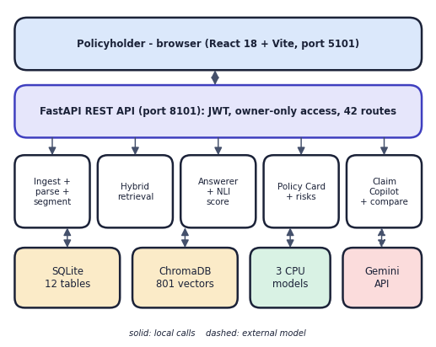
Fig. 1. System architecture of PolicyLens.
B. Parsing and Segmentation
Wordings are laid out for print. The parser reads each line with its page, box and font, removes running headers and footers by their repetition, restores the reading order of two-column pages, joins letter-spaced headings and reads tables by row; a page without a text layer is rejected. The segmenter starts a clause at a printed number (4.2.1), a definition (Def. 5), an IRDAI exclusion code (Excl03) or a heading, makes each coded list item its own clause, keeps the heading path and the highlight rectangles, and splits chunks longer than 380 words. The four sample wordings (166 pages, 73,001 words) gave 801 clauses. Fixed-size windows were not used because a citation must point at one rule and be highlighted on its page.
C. Hybrid Retrieval
For each question BM25 Okapi (k1 = 1.4, b = 0.7, with an insurance synonym list) and cosine search over 384-dimensional MiniLM vectors each return 30 clauses. Reciprocal Rank Fusion scores a clause d over the rankings r as
RRF(d) = Σ_{r} 1 / (60 + rank_{r}(d)) (1)
The fused top 20 plus each retriever's own top 8 form the pool, so that a clause found by only one method still reaches the re-ranker. The cross-encoder score CE(q, d) decides the order and the fused rank breaks ties:
s(d) = CE(q, d) + 0.06 · RRF(d) (2)
The best seven clauses are passed on, together with the rule that a retrieved table belongs to and the tables that a rule governs (up to four more), because lists and sub-limit tables are separate clauses from the rule that gives them meaning.
D. Grounded Generation and the Abstention Rule
Gemini receives the tagged clauses, the question and a JSON schema, and returns a status, the answer in the requested language, an English version, claims tagged with clauses, and follow-up questions. Any tag that does not belong to a retrieved clause is removed. Before the call, let S be the best final score and B the best BM25 score of the retrieved clauses; the assistant answers "not covered in this policy" without calling the model if
S < 0.004 and B < 9.0 (3)
Neither score separates answerable from unanswerable questions alone, but the pair does (Section IV). Hindi and Telugu questions are translated into an English search query and searched together with the original.
Languages. A question whose script is Devanagari or Telugu is detected without a model call and translated into an English search query by the lighter Gemini model; the original and the translation are both searched and the cross-encoder keeps the better view of each clause. The answer is written in the requested language and also in English, which is the text that the faithfulness scorer reads, so the score does not depend on the translation. Cards and risk lists are translated on request and cached; clause quotes always stay in the policy's original English.
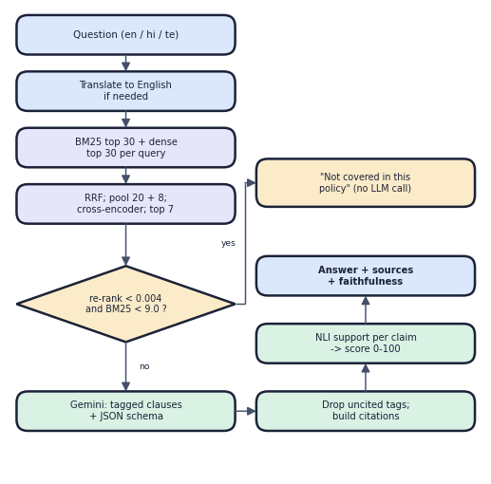
Fig. 2. Main flow of answer_question().
E. Faithfulness Score
An independent NLI model scores each claim. The cited clause text is cut into sentence and two-sentence windows w; the eight windows most similar to the claim c are kept and the entailment probability e(w, c) is taken from the softmax of the model's logits. With o(c) the token overlap of the claim and its evidence, the support of a claim is
sup(c) = max( max_{w} e(w, c), 0.75 · o(c) [o(c) ≥ 0.8] ) · κ (4)
where κ = 0.5 if a number in the claim (dates and years excluded) does not occur in the cited text, and 1 otherwise. The score of an answer with n claims is F = (100 / n) Σ sup(c), labelled well supported (F ≥ 80), partly supported (50 ≤ F < 80) or weakly supported (F < 50). The scorer is independent of the writing model, runs offline and costs no quota.
F. Policy Card, Claim Copilot and Comparison
One Gemini call with a JSON schema extracts the Policy Card: sum insured, deductible, co-payment, room-rent rule, initial, pre-existing, specific-disease and maternity waiting periods, sub-limits, key exclusions and claim timelines, each as a value with a verbatim quote and a clause tag. The quote is then located in the clauses with fuzzy matching to confirm its clause and page, and values whose quote is not found are shown as unverified; the share of verified values was 0.91 to 1.00 across the four wordings. A risk engine applies rules to the extracted numbers (for example a co-payment above a threshold, a long waiting period, a room-rent cap, a short claim deadline) and merges them with model-found risks, removing duplicates and assigning a severity. Claim Copilot gathers 16 clauses with seven to nine targeted searches. Rules calculate from the card the months of cover against each waiting period, the co-payment that applies at the insured's age and claim mode, sub-limits that name the treatment, and the split of the bill: with a bill C, deductible dd, sub-limit L and co-payment p percent, P = min(max(0, C − dd), L) and the insurer pays P − P·p/100. A failed waiting-period check can never be shown as "covered". A comparator builds a field-by-field table with trade-offs that cite both policies.
G. Implementation
The API has 42 route handlers under /api with JWT authentication (HS256, 24 h), bcrypt password hashes and owner-only access to every record. Uploads are validated and processed by a background thread that resumes after a restart. The Gemini client requests JSON-schema output, falls back through three models, pauses an overloaded model for ten minutes, paces requests and caches identical requests on disk. No model is trained; the three local models are pre-trained. Twenty-five automated tests cover authentication, parsing, rules, faithfulness and the full policy flow with a stand-in for the language model.
IV. RESULTS
A. Test Conditions
The evaluation set was written by hand from the four wordings (Star Health, HDFC ERGO, Niva Bupa, Care Health): 57 questions (51 answerable, 6 out of scope), 5 Hindi or Telugu questions, 14 claim scenarios and 52 Policy Card values. Evidence snippets are copied verbatim from the PDFs. No model is trained, so the whole set is held-out test data. A clause is relevant if it contains an evidence snippet; a question is answered correctly if the answer contains every key fact. The figures are from run eval-20260922-0027 on the machine of Section I-A. During the run the free-tier quota of the two larger Gemini models was used up, so every answer came from the smallest model, gemini-3.5-flash-lite. Retrieval is scored by hit@k (a relevant clause in the top k), mean reciprocal rank MRR@10 and evidence recall@5; answers by accuracy, citation accuracy (the cited clause contains the evidence or lies on an expected page), faithfulness and abstention accuracy; claims by verdict accuracy and per-verdict precision, recall and F1; and the card by the share of 52 hand-checked values that are correct after unit conversion.
B. Retrieval, Answers and Faithfulness
TABLE II
MEASURED RESULTS, RUN EVAL-20260922-0027
Measure | Result
Hybrid + re-rank: hit@1 / hit@5 / MRR@10 | 0.804 / 1.000 / 0.897
BM25 only: hit@1 / hit@5 | 0.647 / 1.000
Dense only: hit@1 / hit@5 | 0.490 / 0.804
Hybrid (RRF): hit@1 / hit@5 | 0.686 / 0.961
Answer accuracy / citation accuracy | 51/51 / 51/51
Faithfulness, mean / median | 87.0 / 91.7
Well / partly / weakly supported | 45 / 8 / 3 (of 56)
Out-of-scope declined / false abstentions | 6/6 / 0
Hindi or Telugu answers correct | 5/5
Claim verdicts correct | 14/14
Policy Card values correct | 51/52 (98.1%)
Answer time, median / 95th percentile | 4.3 s / 18.2 s
Automated tests | 25 passed

Keywords matter in policy text: BM25 alone put a relevant clause in the top five for every question, while dense search alone missed one question in five (Fig. 3a). The cross-encoder decides the top of the list: it lifted hit@1 from 0.686 (fusion) to 0.804 and MRR@10 from 0.795 to 0.897, at a median cost of 0.88 s on the CPU. All 51 answers contained every key fact and cited a clause that contains the evidence. Of 56 scored answers, 45 were well supported, 8 partly and 3 weakly; all three weak ones were still correct. They show the limits of a small NLI model: an exclusion-list item that does not itself say "excluded" (its heading does), a rule stated as the inverse of an exclusion, and a defined term replaced by its abbreviation. Adding the heading to the evidence fixed the first kind but also confirmed a wrong statement about an exception, so it was not adopted. The same co-payment question scored 99.0 in one run and 37.9 in another, so the score is shown as a prompt to open the cited clause, not as a verdict. Accuracy was complete in every category: waiting periods 14 of 14, benefits 15 of 15, claim process 8 of 8, exclusions 5 of 5, policy terms 4 of 4, room rent 3 of 3 and sub-limits 2 of 2. Parsing and indexing a wording took 3.2 to 4.2 s (24 to 53 pages), and the median retrieval stage took 0.86 s, Gemini 2.5 s and the faithfulness scorer 0.83 s, which together give the 4.3 s median answer time.
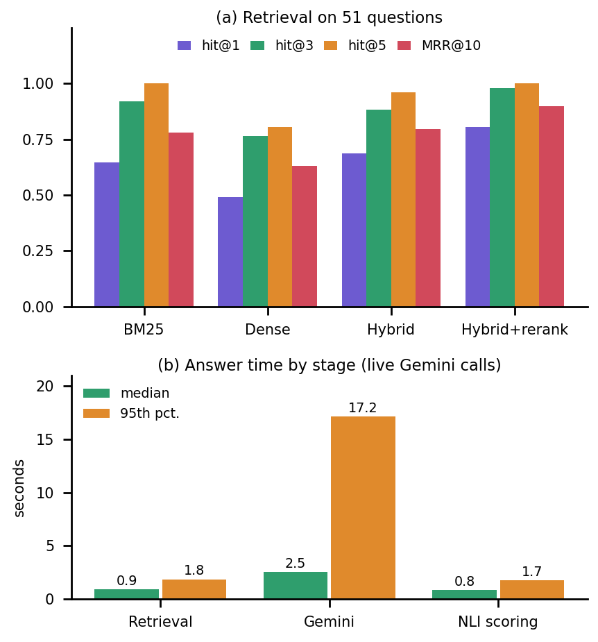
Fig. 3. Retrieval methods (a) and answer time by stage (b).
C. Abstention, Claims and Policy Card
Measured through the running API for all 57 questions, the best re-rank score was at most 0.0029 and the best BM25 score at most 7.3 for the six out-of-scope questions, while answerable questions reached scores as low as 0.0020 and 7.1. Neither alone separates them, but the pair of Eq. (3) declined 6 of 6 out-of-scope questions and none of the 51 answerable ones. All 14 claim verdicts were correct (five covered, one partly covered, seven not covered, one needs information); precision, recall and F1 were 1.0 for every verdict, and the reasons had a mean faithfulness of 82.7. The one wrong Policy Card value is an ambiguity of the document: the HDFC ERGO wording covers seven plan variants with different cumulative bonuses, and the card reports the Optima Secure figure (50%) while the reference takes the general clause (10%).
D. Improvement Across Three Runs
Three runs are kept, each fixing what the previous one exposed. The baseline run reached hit@5 of 98.0%, answer accuracy of 88.2% and citation accuracy of 92.2%, with five false abstentions: answerable questions that the assistant declined. Requiring both a low re-rank score and a low keyword score before declining, and sending a rule together with the tables it governs, raised answer accuracy to 98.0% and citation accuracy to 96.1% and left one false abstention. The last remaining errors came from list items that carry an exclusion code, which the segmenter had merged into a single clause. Making each such item its own clause, telling the model that an exclusion is an answer, and no longer applying a non-network co-payment to cashless claims gave 100% on retrieval, answers and citations with no false abstention. The gains came from structure and context, not from a better model. They were also made by studying failures on the evaluation set itself, which is why the final figures should be read as optimistic.
E. Output Screens
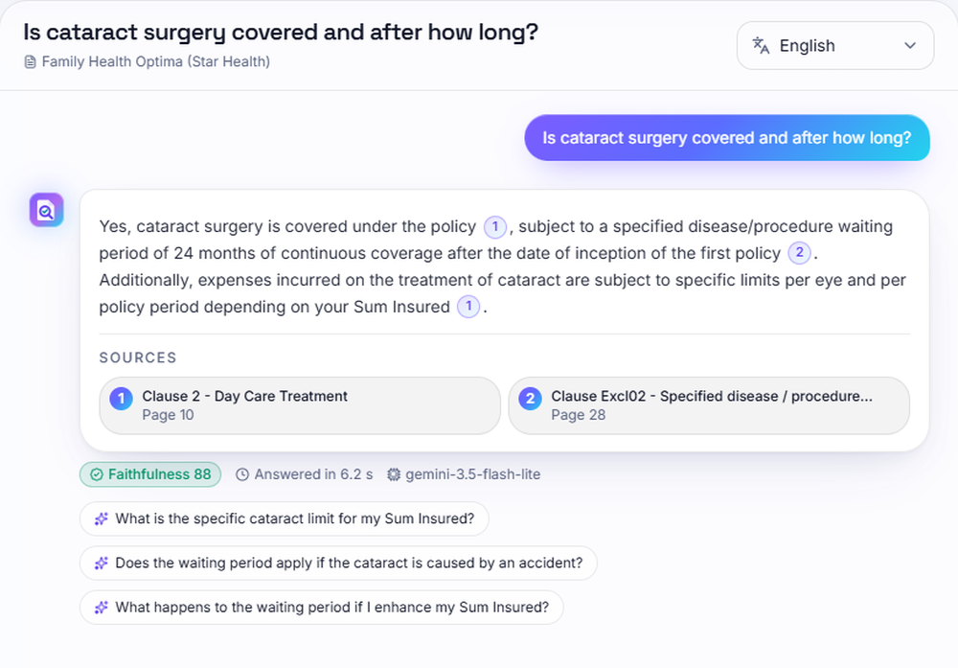
Fig. 4. Cited answer: 24-month wait, two sources, faithfulness 88.
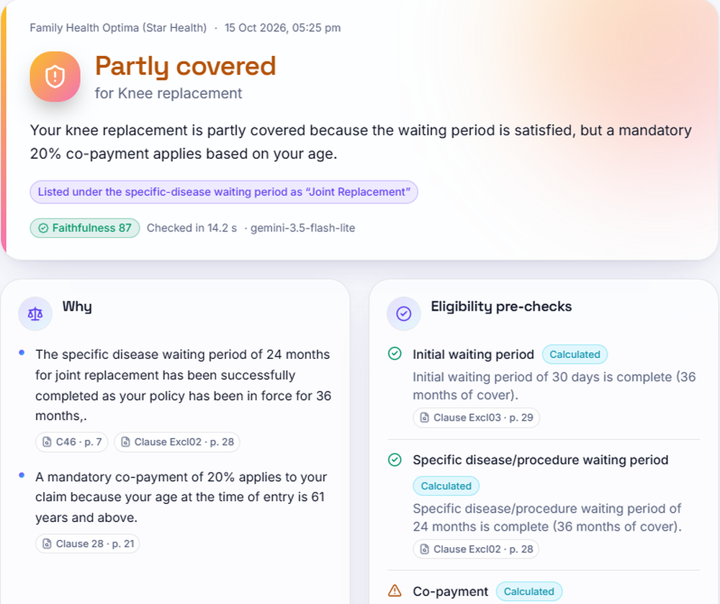
Fig. 5. Claim Copilot: knee replacement partly covered (20% co-payment).
Fig. 4 shows a real answer to "Is cataract surgery covered and after how long?": covered after a 24-month waiting period, with two source chips that open the original page. An out-of-scope question (a house fire) was declined in 1.7 s without a model call; the Hindi room-rent answer scored 92. Fig. 5 shows the claim check for a knee replacement with 36 months of cover at age 64: partly covered because the waiting periods are complete but a 20% co-payment applies from age 61.
F. Comparison with the Base Paper and Observed Limits
The datasets, tasks, languages and metrics differ from the base paper [1] (summarisation of Turkish rulings, ROUGE), so no numeric comparison is possible and none is claimed; the comparison is of approach. The closest figure is the policy-document study [6], whose faithfulness values (0.347, 0.621, 0.797) use another model, corpus and measure and are not comparable with our 87.0, but agree that two-stage retrieval with re-ranking is what makes grounded answers reliable. The limits are these: 51 answerable questions over four policies, with the abstention thresholds and parser fixes tuned on the same set, so the figures are optimistic; only the smallest Gemini model was measured; the Telugu translation of one card line mixes Bengali and Gurmukhi script; a slow tail of answers (95th percentile 18.2 s, maximum 24.8 s) comes from the model fallback chain; and no load, security or user-acceptance test was carried out.
V. CONCLUSION
PolicyLens answers health-insurance questions from the user's own wording, with a clause and page behind every statement, an independent support score, and a rule for declining what the wording does not cover. Against the objectives, key attributes are extracted into a verified Policy Card (51 of 52 values), relevant clauses are retrieved (top five for 51 of 51 questions), answers are plain-language, grounded and cited (51 of 51), claims are guided (14 of 14 verdicts), and accuracy, faithfulness (mean 87.0) and speed (median 4.3 s) were measured. The main finding is that structure and re-ranking, not a larger model, drove the gains across three runs, from 88.2% to 100% answer accuracy. The honest limits are a small set partly tuned on itself, the smallest model, a heuristic faithfulness score and no user study.
Future work: a fresh evaluation on unseen wordings with the larger Gemini models; plan-variant selection and OCR for scanned policies; better faithfulness scoring and automatic checks of translation quality; and a hosted deployment with HTTPS, load testing and a study with real policyholders.
REFERENCES
[1] M. A. A. Albayati and O. Findik, "A hybrid transformer-based framework for multi-document summarization of Turkish legal documents," IEEE Access, vol. 13, pp. 37165-37181, 2025, doi: 10.1109/ACCESS.2025.3545750.
[2] D. Beauchemin, R. Khoury and Z. Gagnon, "Quebec automobile insurance question-answering with retrieval-augmented generation," in Proc. Natural Legal Language Processing Workshop (NLLP), Miami, FL, USA, 2024, pp. 48-60, doi: 10.18653/v1/2024.nllp-1.5.
[3] "A medical insurance question answering system based on multi-strategy retrieval-augmented generation," in Proc. 2026 5th Int. Symp. Computer Applications and Information Technology (ISCAIT), 2026 (listed in the batch literature survey; not independently retrieved).
[4] "Artificial intelligence chatbot in Iran Health Insurance Organization: A new era in service providing," Iranian Journal of Health Insurance, 2023 (listed in the batch literature survey; not independently retrieved).
[5] S. Knollmeyer, O. Caymazer and D. Grossmann, "Document GraphRAG: Knowledge graph enhanced retrieval augmented generation for document question answering within the manufacturing domain," Electronics, vol. 14, no. 11, Art. 2102, 2025, doi: 10.3390/electronics14112102.
[6] A. Maharjan and U. Yadav, "Chunking, retrieval, and re-ranking: An empirical evaluation of RAG architectures for policy document question answering," arXiv:2601.15457, Jan. 2026.
[7] P. Lewis et al., "Retrieval-augmented generation for knowledge-intensive NLP tasks," in Advances in Neural Information Processing Systems (NeurIPS), vol. 33, 2020, pp. 9459-9474.
[8] S. Robertson and H. Zaragoza, "The probabilistic relevance framework: BM25 and beyond," Foundations and Trends in Information Retrieval, vol. 3, no. 4, pp. 333-389, 2009.
[9] G. V. Cormack, C. L. A. Clarke and S. Buettcher, "Reciprocal rank fusion outperforms Condorcet and individual rank learning methods," in Proc. 32nd Int. ACM SIGIR Conf. Research and Development in Information Retrieval, 2009, pp. 758-759.
[10] N. Reimers and I. Gurevych, "Sentence-BERT: Sentence embeddings using Siamese BERT-networks," in Proc. EMNLP-IJCNLP, 2019, pp. 3982-3992.
[11] W. Wang, F. Wei, L. Dong, H. Bao, N. Yang and M. Zhou, "MiniLM: Deep self-attention distillation for task-agnostic compression of pre-trained transformers," in Advances in Neural Information Processing Systems (NeurIPS), vol. 33, 2020, pp. 5776-5788.
[12] R. Nogueira and K. Cho, "Passage re-ranking with BERT," arXiv:1901.04085, 2019.
[13] P. He, J. Gao and W. Chen, "DeBERTaV3: Improving DeBERTa using ELECTRA-style pre-training with gradient-disentangled embedding sharing," arXiv:2111.09543, 2021.
[14] A. Williams, N. Nangia and S. Bowman, "A broad-coverage challenge corpus for sentence understanding through inference," in Proc. NAACL-HLT, 2018, pp. 1112-1122.
[15] T. Bajaj et al., "MS MARCO: A human generated machine reading comprehension dataset," arXiv:1611.09268, 2016.
[16] Z. Ji et al., "Survey of hallucination in natural language generation," ACM Computing Surveys, vol. 55, no. 12, Art. 248, 2023.
[17] Gemini Team, Google, "Gemini: A family of highly capable multimodal models," arXiv:2312.11805, 2023.
[18] V. Karpukhin et al., "Dense passage retrieval for open-domain question answering," in Proc. EMNLP, 2020, pp. 6769-6781.
[19] C.-Y. Lin, "ROUGE: A package for automatic evaluation of summaries," in Text Summarization Branches Out, ACL Workshop, Barcelona, Spain, 2004, pp. 74-81.

