Department of Computer Science and Engineering (Data Science)
CSDS-A | Batch A17 (CSE - Data Science, Section A)
CropSight: Smart Crop Delivery with AI-Based Price and Quality Intelligence
(CropSight)
S.No. | Student name | Roll / hall ticket no.
1 | G.PRANAVI | 23K91A6765
2 | G.SIRI CHANDANA | 23K91A6763
3 | A.NIKHIL | 23K91A6715
4 | G.VISHNU VARDHAN | 23K91A6754
Under the guidance of: K. Mounika, [DESIGNATION]
RESULTS
This document reports the real results of the project: the evaluation of the grading, price, delivery and monitoring components, every output screen with a caption, the success and failure cases, and the objectives measured against the outcomes. Both machine-learning models are trained on synthetic data, so the scores measure how well each model recovers its generator; a real-photograph check is reported separately.

1 Model Performance
CropSight contains two trained models, a Random Forest that grades a crop photograph and a Gradient Boosting model that prices it, and two rule-based parts, the delivery score and the sensor simulator. No real labelled crop-image set and no real market-price series were available to the project, so both models were trained on synthetic data generated by the project's own code. The admin screen says so. This has a consequence for how every figure in this section must be read: a score on a synthetic test set measures how well a model recovers the generator that produced its training data, not how it performs on a farm or in a market. To go beyond that, the grader was also run on 3,200 real photographs (see the subsection on real photographs below). All figures come from experiments/*/metrics.json and were produced on an Intel Core i5-12500 with 15.7 GB RAM and no GPU.
Table 1: Headline results
Measure | Result | Data
Quality grader accuracy (shipped split, 1,200 rows) | 92.3%, macro F1 0.924 | synthetic
Quality grader accuracy, five seeds | 92.9% +- 0.3 | synthetic
Quality grader on real fruit photographs (fresh vs rotten) | 50.4% (chance 50%), AUC 0.571 | 3,200 real photos
Same 11 features retrained on real labels, 5-fold CV | 90.6%, AUC 0.970 | 3,200 real photos
Price model MAE / RMSE (INR per quintal) | 164.6 / 252.2 | synthetic
Price model R2 / MAPE | 0.9916 / 5.1% (noise floor 2.8%) | synthetic
15-85% price band coverage (nominal 70%) | 69.3% | synthetic
Delivery ranking: top buyer unchanged under weight changes | 97.7% | 256 cases, 4 buyers
Automated tests | 36 passed, 3 expected failures | pytest
Upload-and-grade response time (median / 95th percentile) | 174 ms / 207 ms | live API

1.1 Quality grader on its synthetic test set
Table 2: Per-grade results of the Random Forest (1,200 synthetic test rows)
Grade | Precision | Recall | F1 | Support
A | 0.928 | 0.964 | 0.946 | 280
B | 0.924 | 0.862 | 0.892 | 325
C | 0.909 | 0.894 | 0.901 | 312
Reject | 0.933 | 0.986 | 0.959 | 283

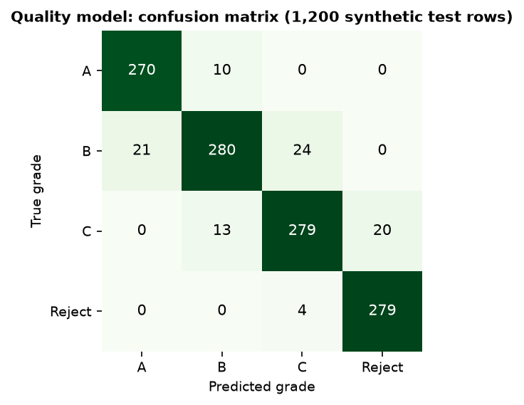
Fig. 1: Confusion matrix of the quality grader on the synthetic test set
Accuracy is 92.3% and macro F1 0.924 (train accuracy 93.9%). Of the 92 errors, all are between neighbouring grades: none confuses A with C or Reject, or B with Reject. The model is a little less confident when it is wrong (mean top probability 0.79 against 0.87 when right). Over five different splits and forest seeds the accuracy is 92.9% with a standard deviation of 0.3 points (range 92.5% to 93.2%).
What the number means. The training data contain 6% label noise (360 of 6,000 labels moved to a neighbouring grade), so the best a model can do on the noisy test labels is about 94.1%. Scored against the clean labels of the same test rows the forest reaches 98.1%, and trained and tested on clean labels 98.0%. The grader has therefore learned the generator's grade profiles almost completely; that is the ceiling of this experiment.
Table 3: Baselines on the same synthetic split
Model (same split) | Accuracy | Macro F1
Majority class | 0.271 | 0.107
Decision tree (depth 9) | 0.885 | 0.887
Histogram gradient boosting | 0.922 | 0.923
Random Forest (shipped) | 0.923 | 0.924
k-nearest neighbours (k = 15) | 0.930 | 0.931
Logistic regression | 0.931 | 0.932

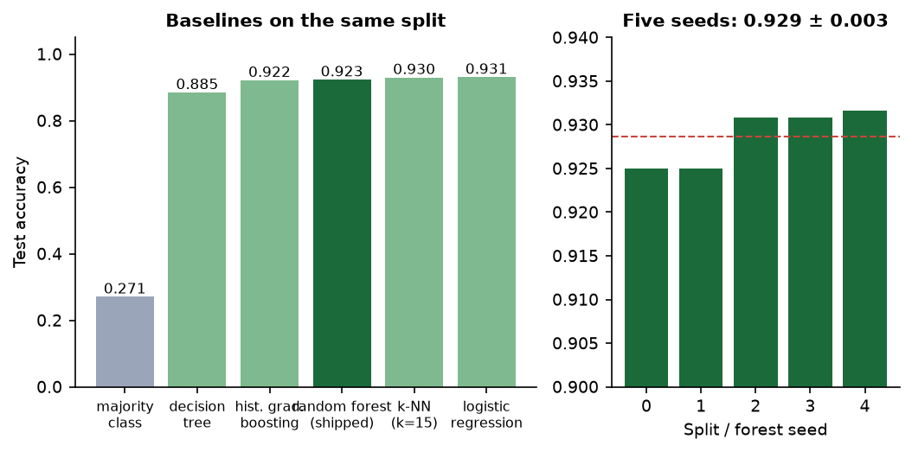
Fig. 2: Baselines and the five-seed study
A linear model (0.931) and k-nearest neighbours (0.930) match the forest (0.923): the synthetic grade classes are close to linearly separable, so the choice of forest over a simpler model is not justified by accuracy on this data. It is justified by the tree-based SHAP explanations and by the expectation that real data will not be separable linearly.
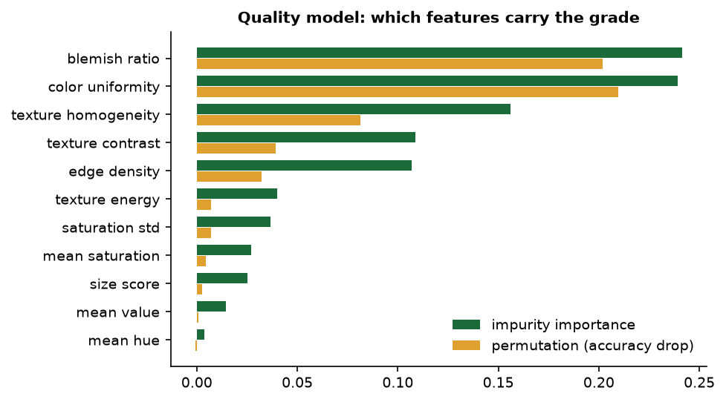  Fig. 3: Impurity and permutation importance of the 11 features | 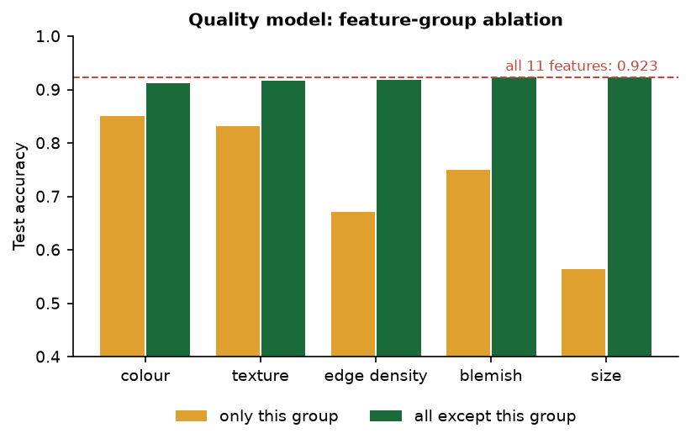  Fig. 4: Feature-group ablation: one group alone against all but one group

Blemish ratio (impurity importance 0.241) and colour uniformity (0.239) matter most; mean hue matters least (0.004). Removing any single group costs at most 1.2 points because the groups carry overlapping information; each group alone gives 56% (size score) to 85% (colour).

1.2 Quality grader on real photographs
To test the grader outside its own generator, the real feature extractor and the shipped model were run on all 3,200 images of the Fresh and Rotten Fruits dataset [8] (CC BY 4.0): 1,600 fresh and 1,600 rotten photographs of eight fruits, 200 of each state per fruit. The dataset labels are fresh or rotten, not A, B, C or Reject, so the check maps fresh to {A, B} and rotten to {C, Reject}; this mapping is an assumption of the check, and the fruits are not CropSight's crops, but a grader that sees quality in a photograph should still rank a rotten fruit below a fresh one.
Table 4: Grades predicted by the shipped model for 3,200 real fruit photographs
True state | Grade A | Grade B | Grade C | Reject
Fresh | 0.12% | 99.81% | 0.06% | 0.00%
Rotten | 0.06% | 99.12% | 0.81% | 0.00%

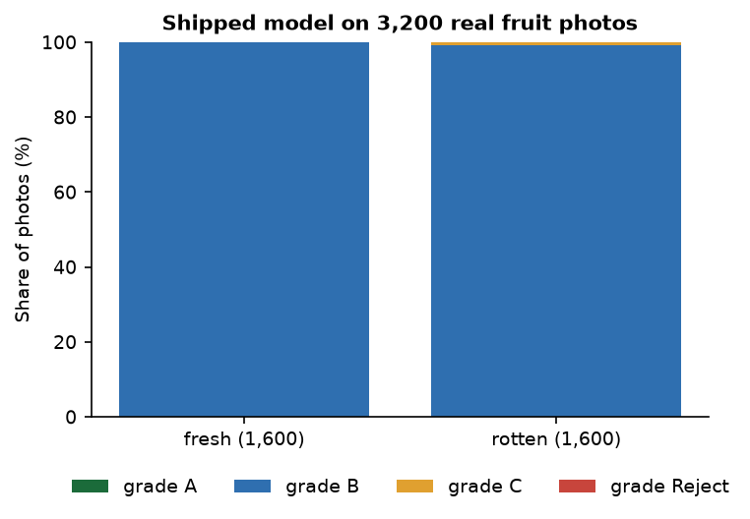
Fig. 5: Predicted grade share for fresh and rotten photographs
The shipped grader does not transfer. It calls 99.8% of the fresh and 99.1% of the rotten photographs grade B; the mapped fresh-or-rotten accuracy is 50.4% (chance is 50%) and the area under the ROC curve of P(A)+P(B) is 0.571. Per fruit the AUC ranges from 0.19 (jujube, i.e. inverted) to 0.81 (strawberry). 99.8% of the real images lie outside the three-standard-deviation envelope of every synthetic grade profile.
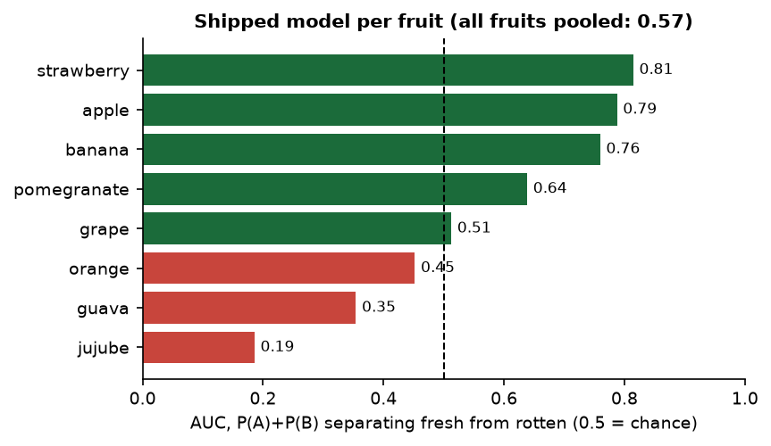
Fig. 6: Fresh-versus-rotten AUC of the shipped model for each fruit
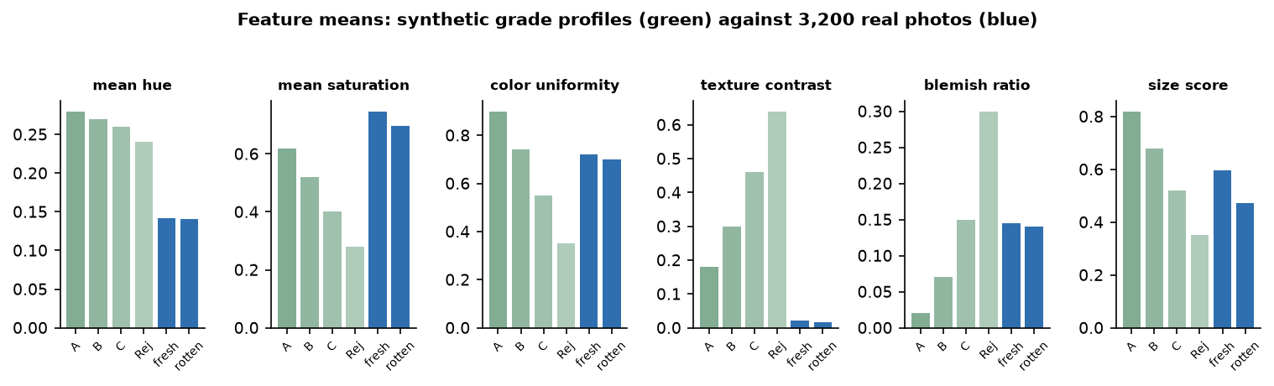
Fig. 7: Mean feature values of the synthetic grade profiles and of the real photographs
The reason is visible in the feature means: real photographs have mean hue 0.14 (synthetic grades 0.24-0.28), texture contrast 0.02 (synthetic 0.18-0.64), blemish ratio 0.14 for both fresh and rotten fruit and colour uniformity 0.70-0.72. The synthetic profiles were written by hand around plausible values, and real images fall in none of them; the classifier maps all of them to the middle grade.
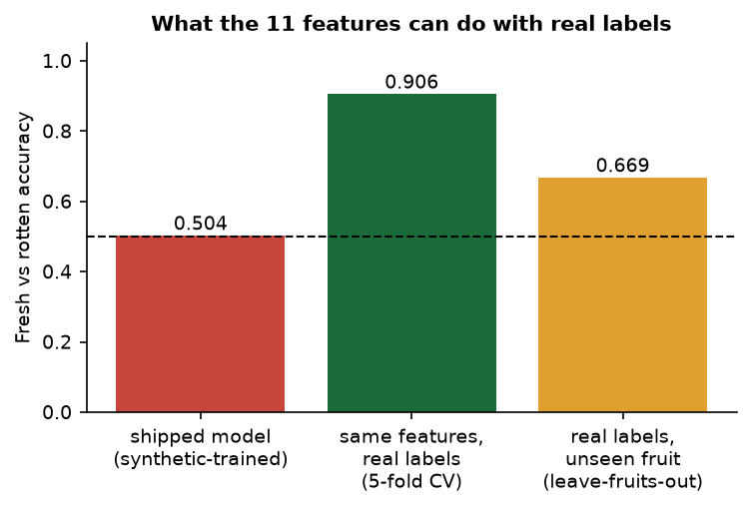
Fig. 8: Fresh-versus-rotten accuracy: shipped model, retrained on real labels, and retrained on unseen fruits
The extractor itself is not the problem. The same 11 features, with a Random Forest of the same size trained on the real labels, reach 90.6% accuracy (AUC 0.970) in five-fold cross-validation. When whole fruit types are held out the accuracy falls to 66.9% (AUC 0.748), so the features are fruit-specific. The most important real-label features are mean hue (0.29) and mean saturation (0.12), the opposite order to the synthetic model. The practical conclusion is that the grader must be retrained on real labelled images of the crops it is meant to grade before its grades can be trusted.

1.3 Price model
Table 5: Price model results on the synthetic series
Measure | Value
Test MAE / RMSE (3,504 rows, INR per quintal) | 164.6 / 252.2
R2 / MAPE | 0.9916 / 5.08%
Noise floor (noise-free generating formula against the observed price) | MAE 105.5, MAPE 2.80%
Model against the noise-free formula | MAE 120.5, MAPE 3.99%
Five seeds, MAE / R2 | 162.8 +- 5.5 / 0.9919 +- 0.0006
Time hold-out (train 2022-23, test 2024), MAE / R2 / MAPE | 191.8 / 0.988 / 5.1%
15-85% band: empirical coverage, mean width | 69.3% (nominal 70%), 23.1% of the price
Test rows where the lower quantile model exceeds the upper one | 119 of 3,504

Table 6: Price baselines on the same split
Model | MAE | R2 | MAPE
Crop mean | 990 | 0.719 | 32.8%
Crop x grade mean | 714 | 0.858 | 20.2%
Linear regression | 528 | 0.908 | 20.6%
Random Forest (200 trees) | 245 | 0.983 | 7.2%
Gradient boosting (shipped) | 165 | 0.992 | 5.1%

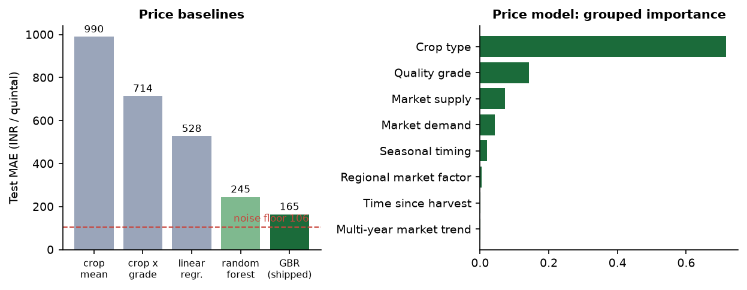  Fig. 9: Price baselines and grouped feature importance | 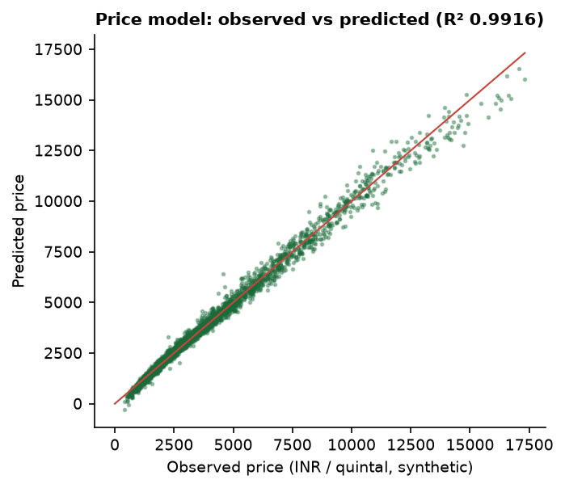  Fig. 10: Observed against predicted price on the synthetic test set

The boosted model clearly beats every baseline and sits close to the noise floor of its data (MAPE 5.1% against 2.8%). The 2024 hold-out is only slightly worse (R2 0.988) even though the trend feature leaves its training range. The error is largest for the Reject grade (MAPE 11.4%, against 4.2% for grades A and B) and for the dearest crop, cotton (MAE 383). The 70% band covers 69.3% of the observed prices, so it is well calibrated on this data.
What the model learned. Crop type carries 72% of the importance, quality grade 14%, market supply 7% and demand 4%; rainfall and average temperature are almost zero (0.00009 and 0.00005). The generator uses temperature not at all and rainfall only above 150 mm, which almost never occurs, so a model that ignores weather is correct for this data - and a reminder that weather, one of the inputs the project set out to use, plays no real role here.
Behaviour of the served forecast. The forecast shown to the farmer evaluates the point model on 31 successive daily market contexts that are generated from a hash of crop, region and date (not from a weather or demand feed). Over all 256 crop, region and grade combinations the recommended best day is today in 24.2% of cases, on average day 6.2, and waiting for it would raise the price by 14.6% on average (median 8.4%, largest 136%); the mean spread between the highest and lowest price over 30 days is 33.5% of the mean. These swings come from the hashed daily noise in demand and supply, so the sell-day advice is an illustration of the interface, not market information. The price order A > B > C > Reject holds for all 64 crop-region pairs.
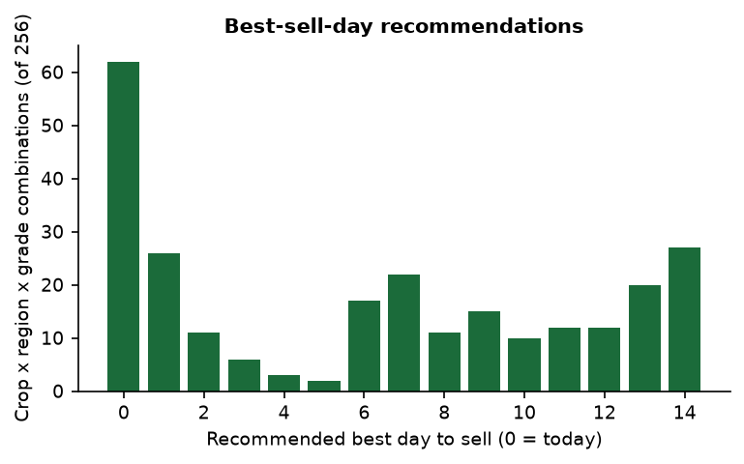
Fig. 11: Distribution of the recommended best sell day over 256 combinations

1.4 Delivery recommendation
The delivery engine is a weighted score, not a trained model: 0.38 price, 0.22 distance, 0.18 quality fit, 0.14 reliability and 0.08 low spoilage risk (the weights sum to 1.00). For all 256 crop, region and grade combinations an independent re-computation reproduced the served top buyer in 256/256 cases. When every weight was multiplied by a random factor between 0.5 and 1.5 (100 trials per case) the top buyer stayed the same 97.7% of the time (worst case 74%) and the full ranking correlated at 0.95 with the original, so the ranking is stable. Across the four buyers distance separates them most, then price; quality fit does not differ between buyers at all, because it is a property of the lot. The offered prices are the model price times a hash-derived factor between 0.90 and 1.18, so they are simulated, not quotes.
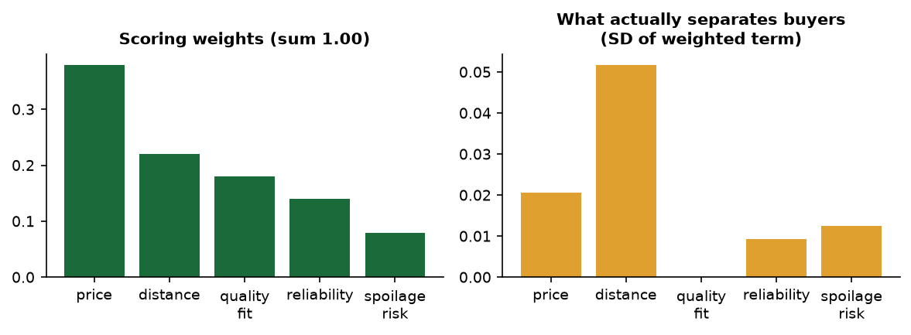
Fig. 12: Scoring weights and the spread each term creates between buyers

1.5 Sensor stream and alerts
The sensor stream is simulated (no hardware exists). Over 50 simulated shipments of 1,200 steps the first alert came after a median of 26 steps (0.6 minutes at 1.4 s per step). The temperature and humidity are random walks without a pull back to normal, so shipments drift out of the alarm band: 28% were in alarm by step 50, 58% by step 100 and all 50 by step 400, and 97.3% of all flagged steps were persistent drift rather than injected events. The median longest uninterrupted alarm lasted 1102 of the 1,200 steps. The live run reproduced this: the first alert after 44 s and a persistent banner at 215 s.
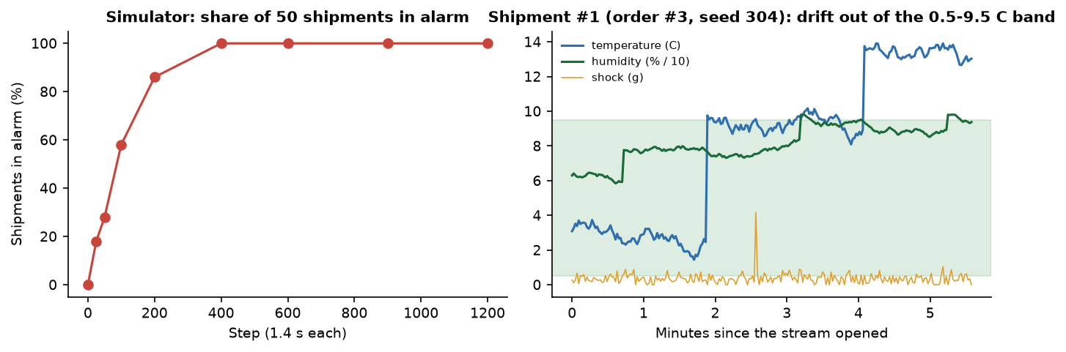
Fig. 13: Share of simulated shipments in alarm (left) and one simulated trajectory, the demo shipment of order 3, seed 304 (right)

1.6 Response time
Table 7: API response times (live server on 127.0.0.1, same machine, other jobs running)
Endpoint | n | Median (ms) | 95th percentile (ms)
Log in (bcrypt) | 30 | 325.3 | 349.0
Health check | 30 | 1.6 | 4.7
Upload and grade a 900 x 675 photograph | 20 | 173.9 | 207.3
Price forecast with SHAP | 30 | 54.9 | 119.4
Delivery recommendation | 30 | 99.8 | 147.9
Marketplace listings | 30 | 17.7 | 36.5
Admin overview | 30 | 22.8 | 46.0
Admin model insights | 30 | 112.9 | 149.5

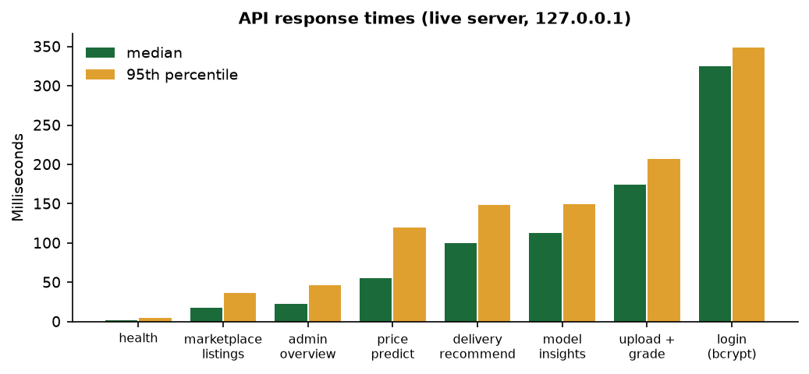
Fig. 14: Median and 95th-percentile response time per endpoint
Grading a photograph, including feature extraction, the forest, SHAP and the database write, takes about 0.17 s; the slowest call is the bcrypt log-in at about 0.33 s, which is intended. No load test with many concurrent users was run.

2 Software Verification Results
The backend has a pytest suite (backend/tests) that uses a throw-away SQLite database. 36 tests pass and 3 are expected failures (about 30 s). The three expected failures are tests that assert the behaviour a hardened system should have and fail on the shipped code; they are kept visible rather than deleted.
Table 8: Automated test results
Group | Tests | What is checked
Health and authentication | 8 | sign-up and log-in round trip, duplicate e-mail, no admin self-sign-up, validation errors, wrong password, token required, tampered token rejected
Role guards | 1 | a buyer cannot upload, a farmer cannot order, non-admins cannot read admin routes, a distributor cannot ask for a delivery plan
Listings, grading and CV features | 12 | grade, probabilities and 11 features returned; blemished photo not graded above a clean one; non-image and oversize uploads rejected; feature vector contract; deterministic grading; foreign listings are 404
Price intelligence | 5 | response shape (31 days, band contains the price, best day 0-14), A > B > C > Reject, listing grade is used
Delivery | 3 | top five sorted by score within 0-100, weights sum to 1, foreign listing is 404
Marketplace and orders | 5 | browse and filter, full lifecycle placed to delivered with every guard, unlisted listing cannot be ordered, role-scoped order lists
IoT and simulator | 4 | WebSocket delivers three readings, history stored, unknown shipment 404, simulator deterministic per seed and bounded
Admin | 1 | overview counts, both models' transparency cards
Expected failures | 3 | corrupt image returns HTTP 500 and leaves a gradeless draft listing; unknown crop is accepted; non-positive order quantity is accepted

The end-to-end flow was also executed in the browser: a farmer graded, forecast, planned and published a tomato lot; a buyer ordered it; the farmer confirmed; a distributor started transit, watched the live stream and could mark the order delivered. Every state change was refused when attempted by the wrong role or out of order (tested in the suite).

3 Functional Testing
The functional tests follow the golden path of the product and were run against the live application on 26 October 2026 in Chrome at 1440 x 900, using real tomato, onion and potato photographs and the demo accounts. The farmer, buyer, distributor and admin steps were driven through the browser interface (Playwright); the extra listings and orders that populate the lists were created through the same API the interface calls. The screenshots in Chapter 8 are the captures made during this run.
Table 9: Functional test cases (live walk-through)
No. | Requirement | Test performed | Observed
F1 | Sign-in with a role-based home | Log in as farmer, buyer, distributor, admin | Pass: each role lands on its own dashboard
F2 | Reject bad credentials | Log in with a wrong password | Pass: the API returns 401 and the page reports it
F3 | Grade a crop from a photograph | Upload tomato_1.jpg, tomato, 620 kg | Pass: grade B, confidence 70.1 %, radar and SHAP bars shown
F4 | Forecast the price | Press Forecast price | Pass: INR 2,272 per quintal, range 2,068 to 2,272, curve, best day 9 Nov, SHAP drivers
F5 | Plan delivery | Press Plan delivery | Pass: four buyers ranked, best 67.7 % match (Harvest & Co.), route and transit time
F6 | Publish to the marketplace | Enter 2,250 and publish | Pass: listing visible to buyers with grade and price
F7 | Buyer places an order | Open listing, place order 620 kg at 2,250 | Pass: order placed, listing becomes sold
F8 | Farmer confirms | Confirm on the orders page | Pass: status confirmed
F9 | Distributor starts transit | Start transit, open Live monitor | Pass: shipment created, live traces appear
F10 | Cold-chain alert | Keep the monitor open | Pass: alert toast at 44.2 s (an injected humidity spike); red banner on at 215 s with temperature 9.5 C and humidity 93.7 %
F11 | Admin views | Open overview and model insights | Pass with a defect: gross volume is overstated 100 times (price per quintal multiplied by kilograms)
F12 | Model transparency | Open model insights | Pass: grader shown as 92.3 % accuracy and the synthetic-training disclosure is displayed

Every functional step passed except where a defect is noted, and one observation deserves emphasis: the photographs used in the walk-through were all graded B or A by the shipped grader (every scanned tomato and onion was B, 39 of 40 potatoes B), which is consistent with the real-photo check of Chapter 6 and means the C and Reject paths were exercised by the automated tests, not by real photographs.

4 Performance Testing
Response times were measured against a live server on the same machine over 127.0.0.1 (an Intel Core i5-12500 with 6 cores and 12 threads, 15.7 GB of memory, no discrete GPU, Windows 11) while other jobs were running, so the figures are indicative rather than a benchmark. Each request type was repeated 20 to 30 times with real tomato photographs.
Table 10: API response times (live server)
Request | Runs | Median (ms) | 95th percentile (ms) | Max (ms)
Health check | 30 | 1.6 | 4.7 | 4.9
Marketplace listings | 30 | 17.7 | 36.5 | 49.1
Admin overview | 30 | 22.8 | 46.0 | 46.8
Price forecast (31 days, band, SHAP) | 30 | 54.9 | 119.4 | 123.4
Delivery recommendation | 30 | 99.8 | 147.9 | 148.8
Admin model insights | 30 | 112.9 | 149.5 | 447.7
Upload and grade (photo, features, forest, SHAP, database) | 20 | 173.9 | 207.3 | 208.1
Log in (bcrypt verification) | 30 | 325.3 | 349.0 | 356.8

Measured inside the process, the price model takes a median of 13.1 ms (95th percentile 29.9 ms, maximum 96.7 ms) over 256 crop, region and grade combinations, and the delivery recommendation a median of 64.7 ms (95th percentile 107.1 ms). Grading a photograph, the heaviest request, takes about 0.17 s at the median; log-in is the slowest request at about 0.33 s because bcrypt is deliberately slow. Extracting features from 3,200 full-size fruit photographs and classifying them took about ten minutes (about 0.19 s each, including decoding), measured while other jobs ran. Both models train in seconds, and the whole backend suite runs in about 30 seconds.
Not measured: concurrent users, memory use under load, behaviour with a large database, the front end's load time, and other hardware.

5 Output Screens
Every screen below is a real capture of CropSight running with real data on 26 October 2026: real photographs of a tomato, onions and potatoes from a public vegetable dataset, the models trained from the project's code, and orders that moved through the full farmer, buyer and distributor flow. The farmer, buyer and distributor steps of the featured tomato lot were performed in the browser; the extra onion and potato listings and their orders were created through the same API the browser uses. The captures are 1440 by 900 pixels.
  Fig. 15: Landing page |   Fig. 16: Failure case: wrong password

Landing page. The public home page: the headline "Move every harvest with certainty, not guesswork", the line that CropSight grades quality from a photo, forecasts the price and says who to sell to and when, and the buttons Get started and Log in. The four counters under the headline (38,400+ crops graded, +17% average price uplift, 92% grading accuracy, 2,400+ farmers onboarded) are fixed marketing text in the page source; they are not measurements of this project, and the only measured accuracy figures are those in this chapter.
Failure case: wrong password. The log-in page after the farmer's e-mail was entered with a wrong password. The API answered HTTP 401 and the page shows the red message "Couldn't sign in - Invalid email or password". The panel on the right also lists the four demo accounts.
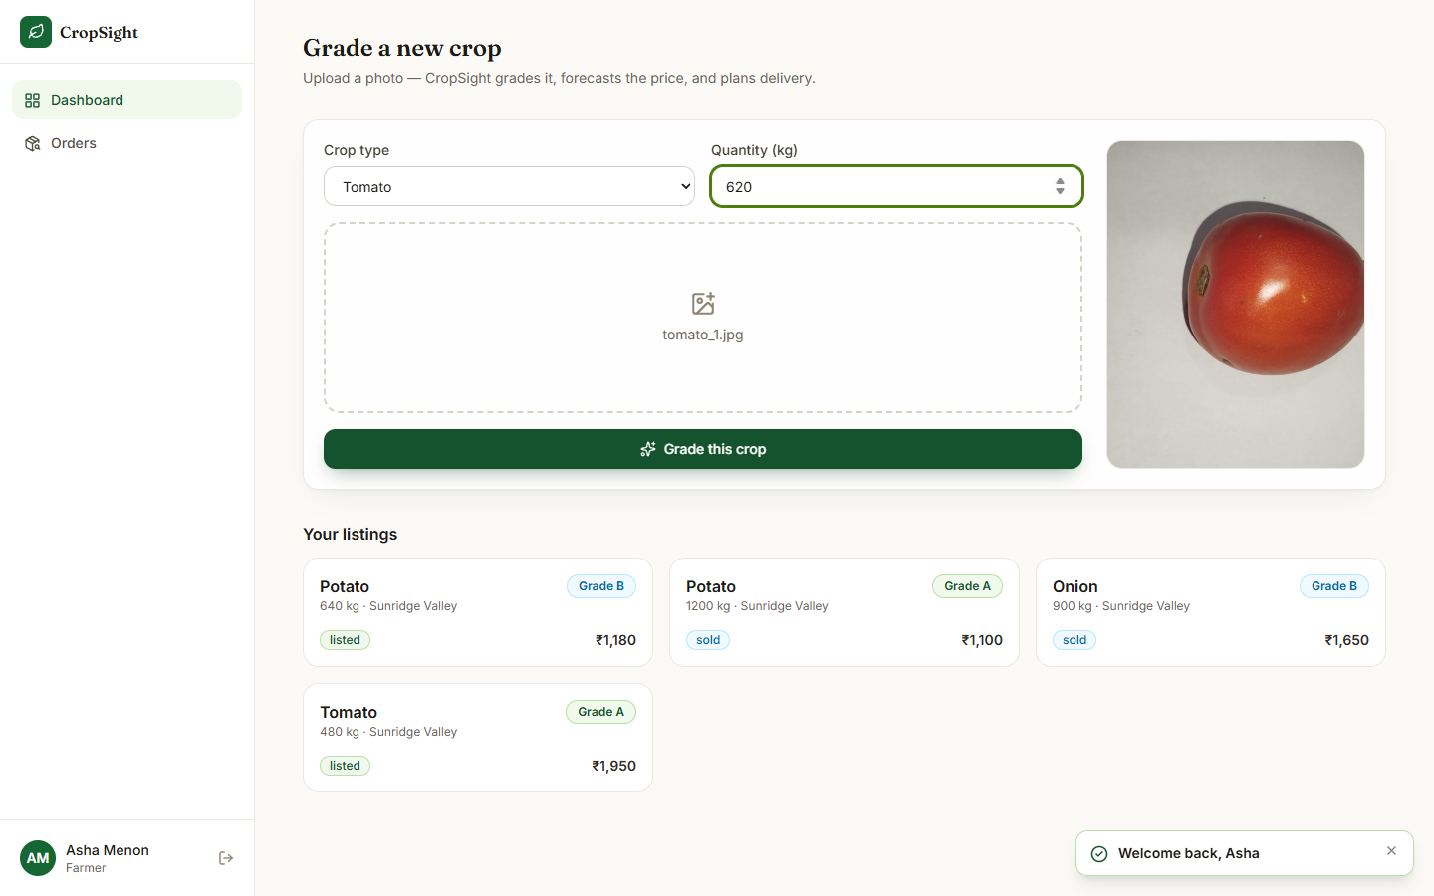
Fig. 17: Farmer dashboard with a real photograph selected

Farmer dashboard with a real photograph selected. The farmer chose the crop Tomato, a quantity of 620 kg and the real photograph tomato_1.jpg (from the public vegetable dataset); the photograph appears in the preview panel on the right. The four earlier listings of the farmer (two potato lots, an onion lot and the seeded tomato lot) are listed below with their grade, status and asking price.
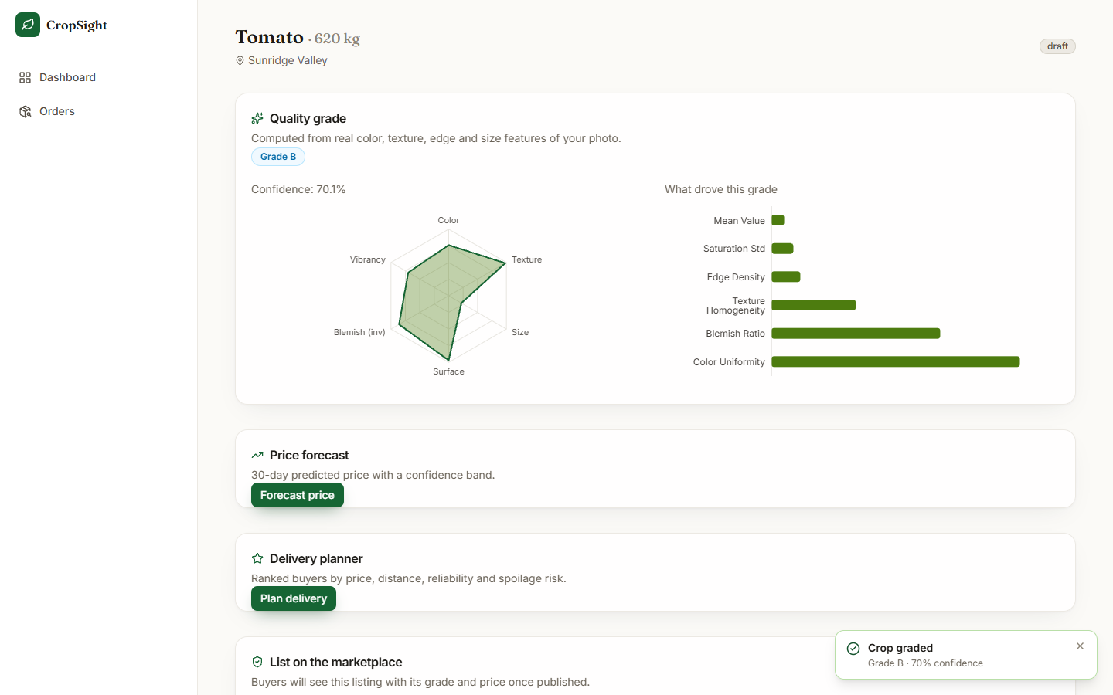
Fig. 18: Grading result
Right after the upload the app opened the listing workspace: Tomato, 620 kg, Sunridge Valley, Grade B with 70.1% confidence. The radar chart summarises colour, texture, size, surface, blemish (inverted) and vibrancy; the bar chart "What drove this grade" shows the six largest SHAP contributions (colour uniformity, blemish ratio, texture homogeneity, edge density, saturation spread, mean value). The toast says "Crop graded - Grade B, 70% confidence".
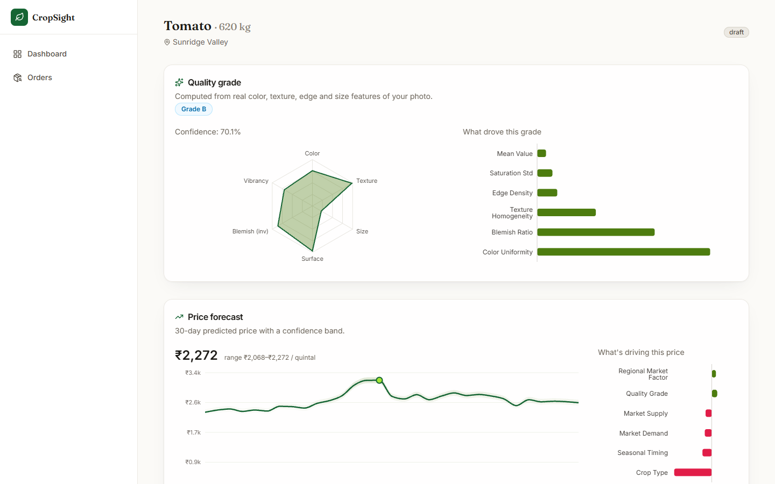
Fig. 19: Price forecast
After pressing Forecast price: the current price INR 2,272 per quintal with the range INR 2,068 to 2,272, the 30-day curve with its confidence band (peak near 9 November) and the SHAP bars "What's driving this price" - crop type is the largest (negative) contributor, quality grade and regional factor push up. The range ends exactly at the current price, because the displayed band is clamped to include the point estimate.
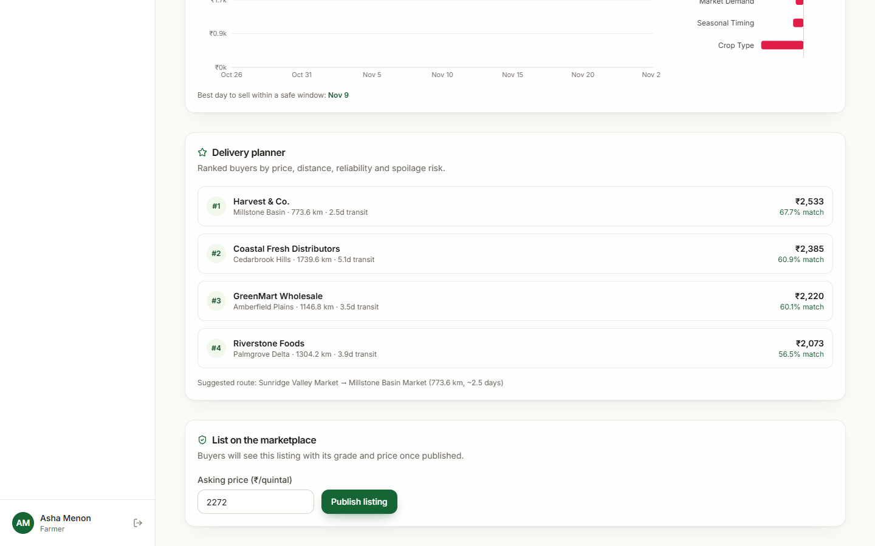
Fig. 20: Delivery planner
After Plan delivery: four buyers ranked by match score - Harvest & Co. (Millstone Basin, 773.6 km, 2.5 days, INR 2,533, 67.7% match), Coastal Fresh Distributors (60.9%), GreenMart Wholesale (60.1%) and Riverstone Foods (56.5%) - and the suggested route Sunridge Valley Market to Millstone Basin Market. The best sell day for the listing is 9 November. The buyer offers are simulated from a hash of the buyer and crop.
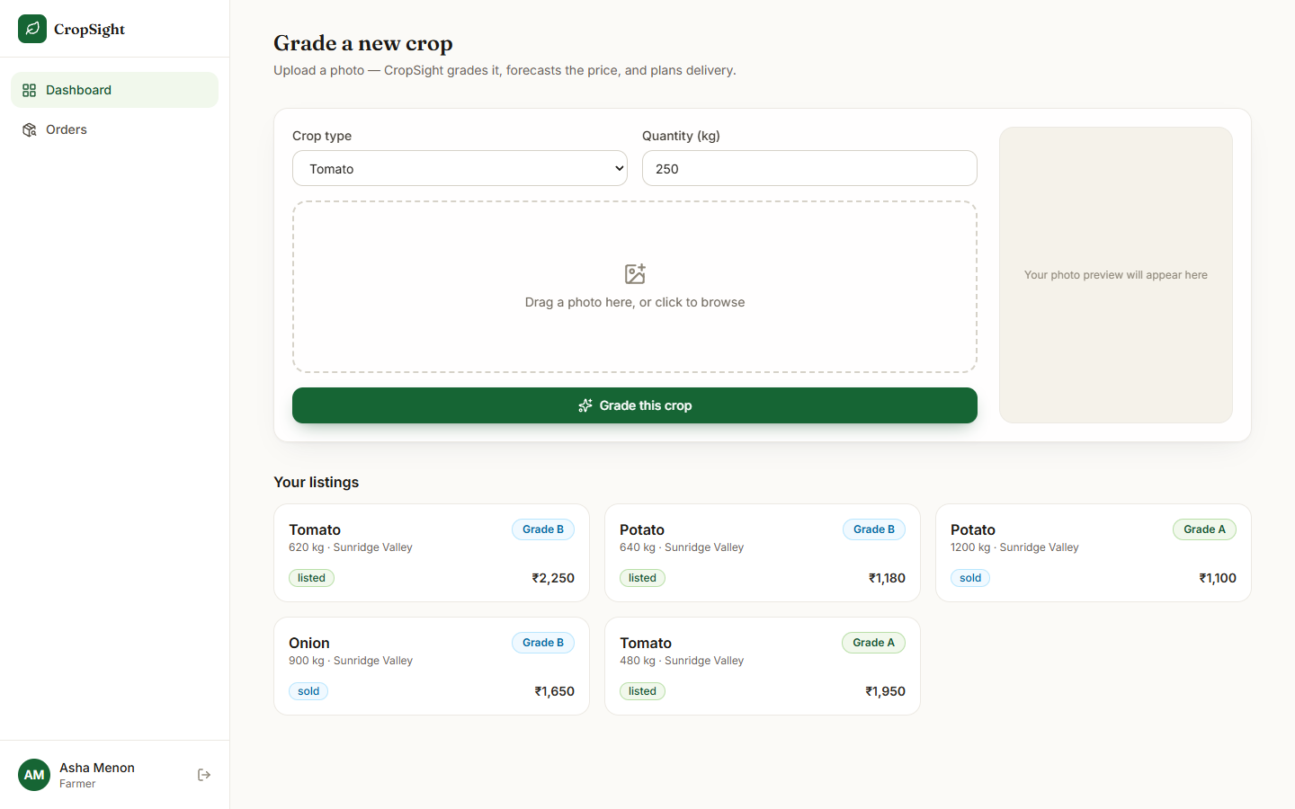  Fig. 21: Listings after publishing | 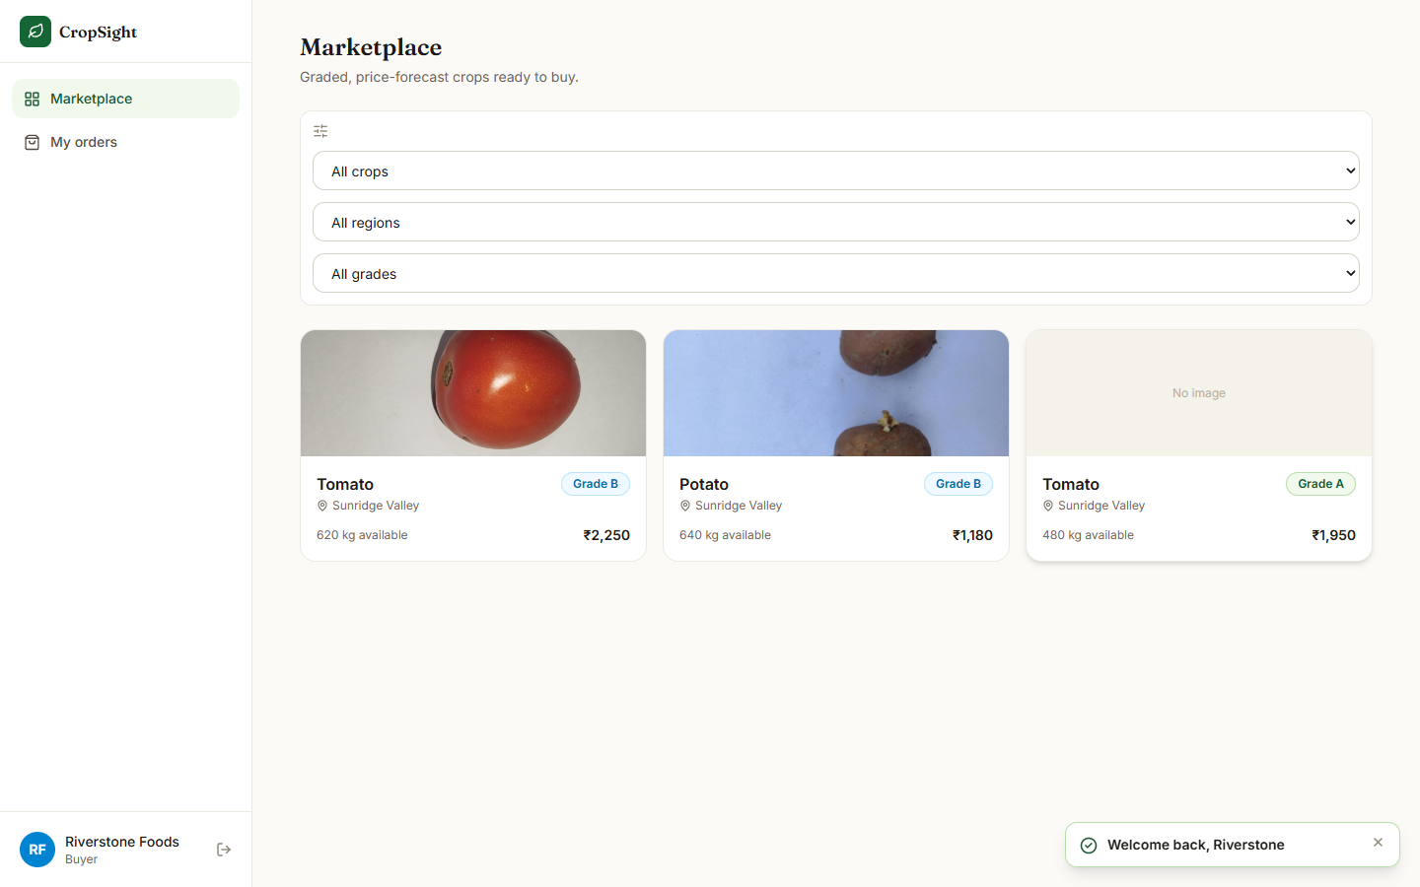  Fig. 22: Buyer marketplace

Listings after publishing. The farmer's dashboard after the tomato lot was published at INR 2,250: Tomato 620 kg (Grade B, listed), Potato 640 kg (Grade B, listed), Potato 1,200 kg (Grade A, sold), Onion 900 kg (Grade B, sold) and the seeded Tomato 480 kg (Grade A, listed).
Buyer marketplace. The buyer (Riverstone Foods) sees the three listings that are still for sale with their photographs, grade badges, quantity and asking price: Tomato 620 kg at INR 2,250 (Grade B), Potato 640 kg at INR 1,180 (Grade B) and the seeded Tomato 480 kg at INR 1,950 (Grade A, no image). Filters for crop, region and grade sit above the cards.
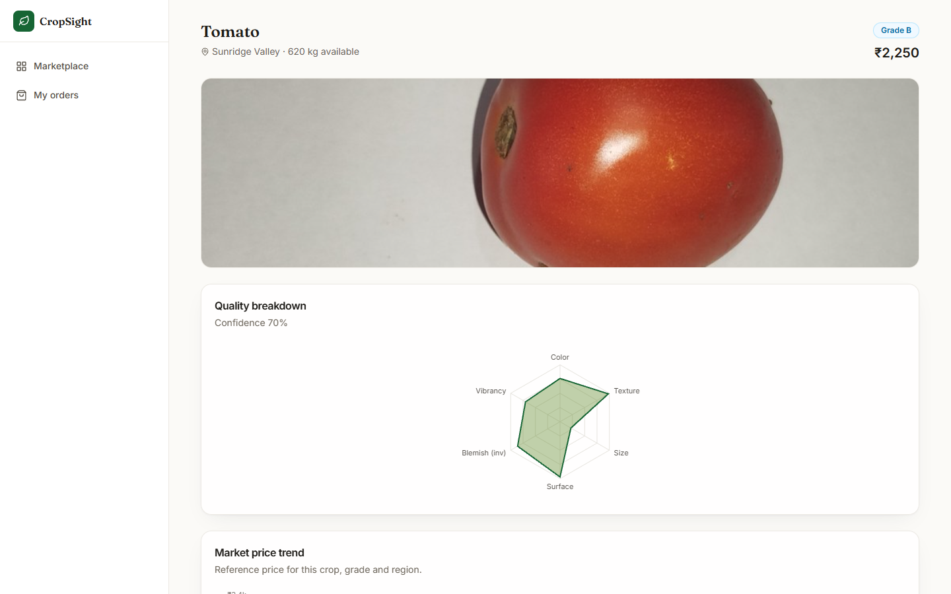  Fig. 23: Listing detail | 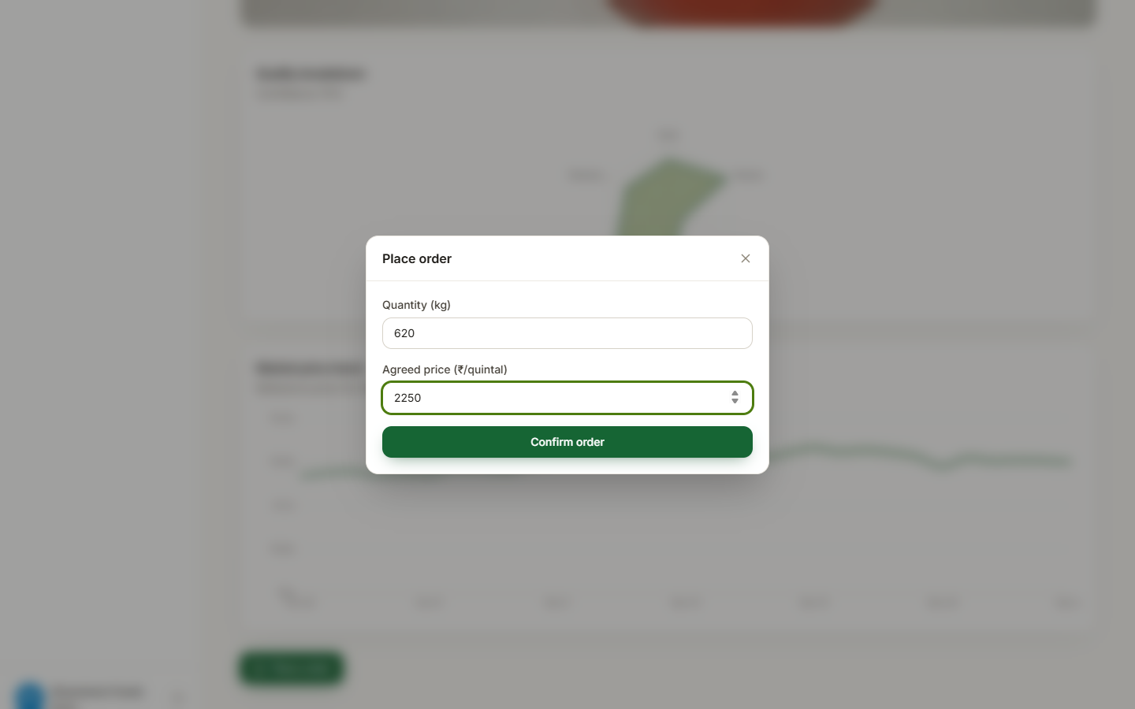  Fig. 24: Place-order dialog

Listing detail. The buyer's view of the tomato lot: photograph, Grade B, INR 2,250, 620 kg available, the quality breakdown radar with "Confidence 70%" and, below it, the market price trend (reference price for this crop, grade and region).
Place-order dialog. The Place order dialog over the blurred listing: quantity 620 kg and agreed price INR 2,250 per quintal entered by the buyer, and the Confirm order button.
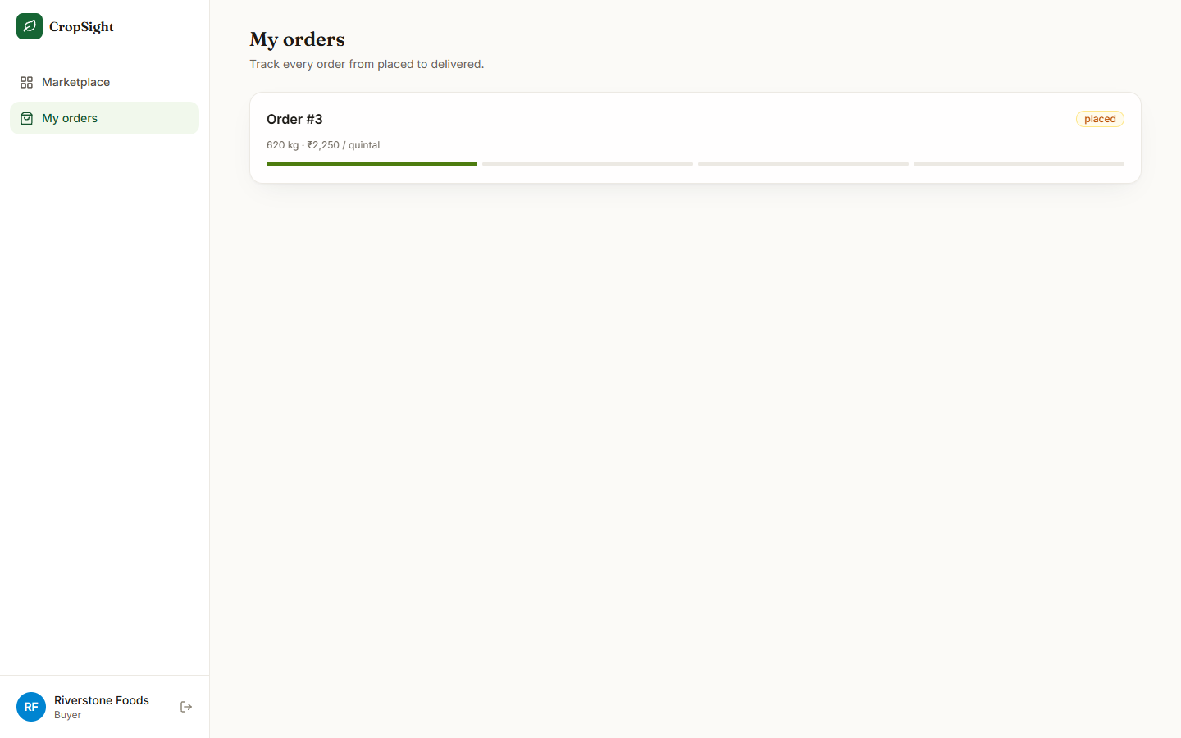  Fig. 25: Buyer orders | 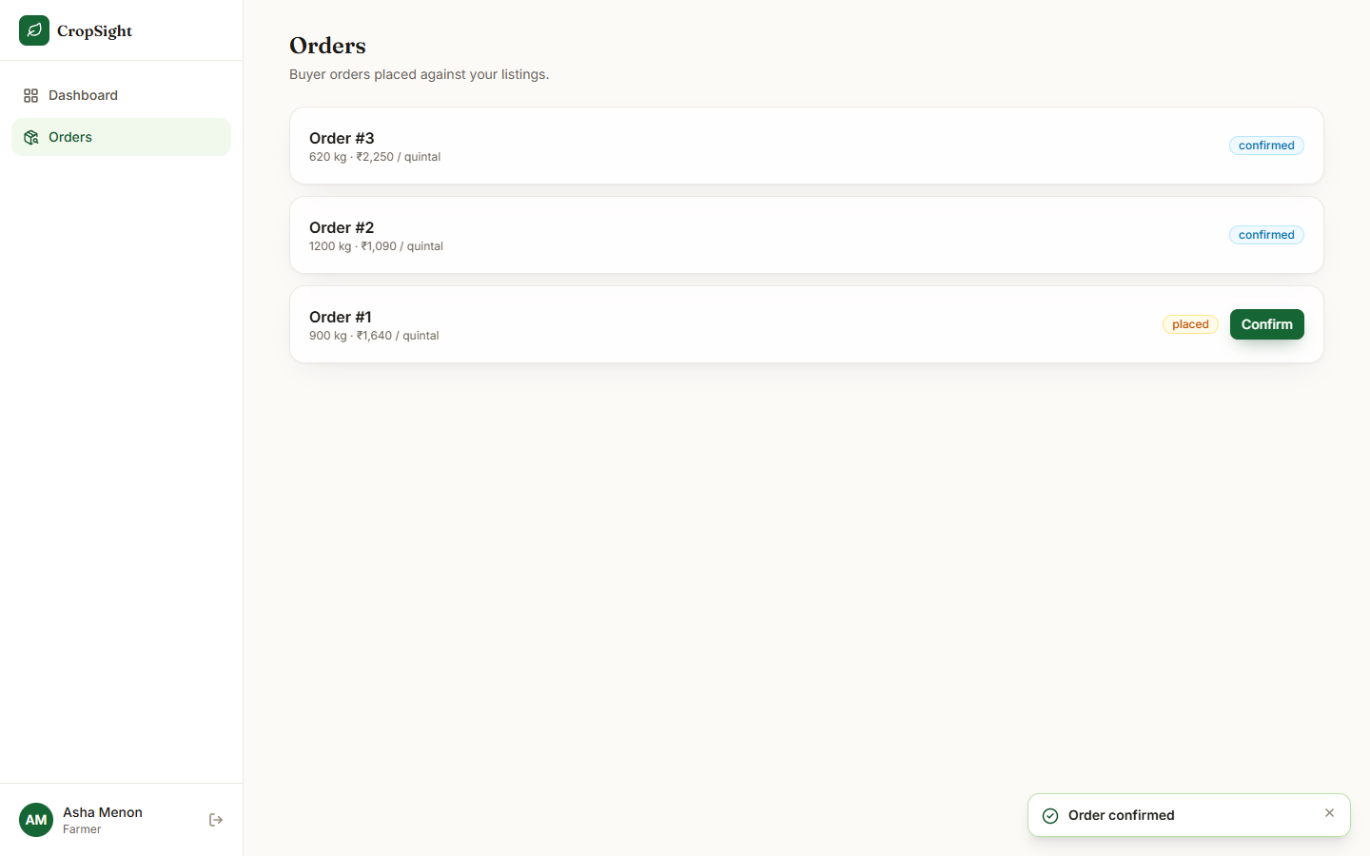  Fig. 26: Farmer confirms an order

Buyer orders. My orders for the buyer: Order #3, 620 kg at INR 2,250 per quintal, state placed, with a four-segment progress bar of which the first segment (placed) is filled.
Farmer confirms an order. The farmer's Orders page after pressing Confirm: Order #3 (620 kg, INR 2,250) and Order #2 (1,200 kg, INR 1,090) are confirmed, Order #1 (900 kg, INR 1,640) is still placed with its Confirm button; the toast reads "Order confirmed".
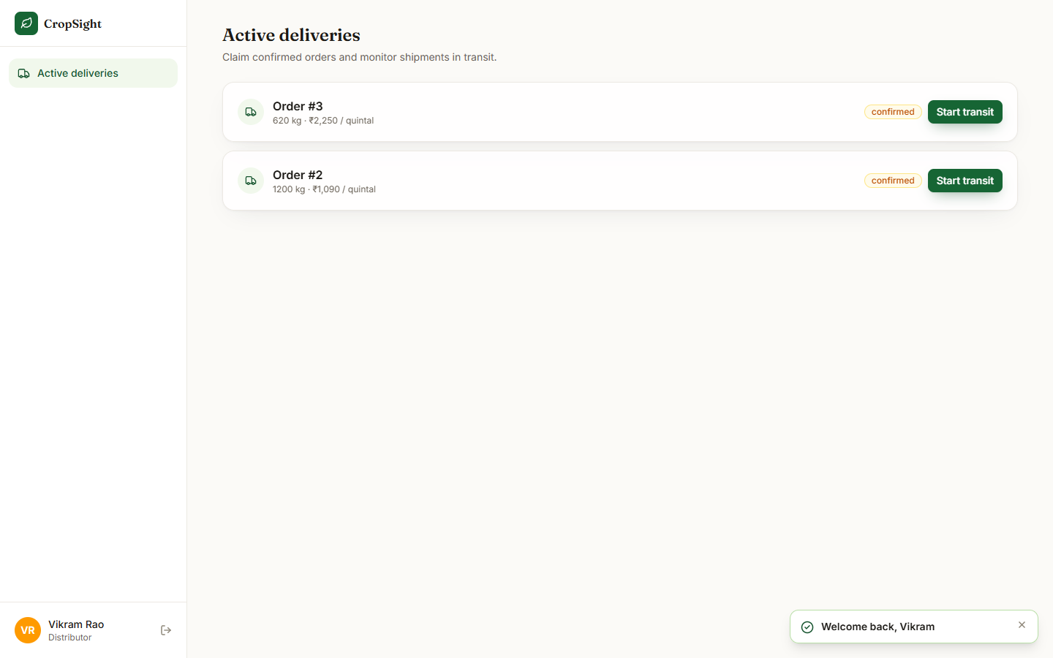  Fig. 27: Distributor: orders ready to ship | 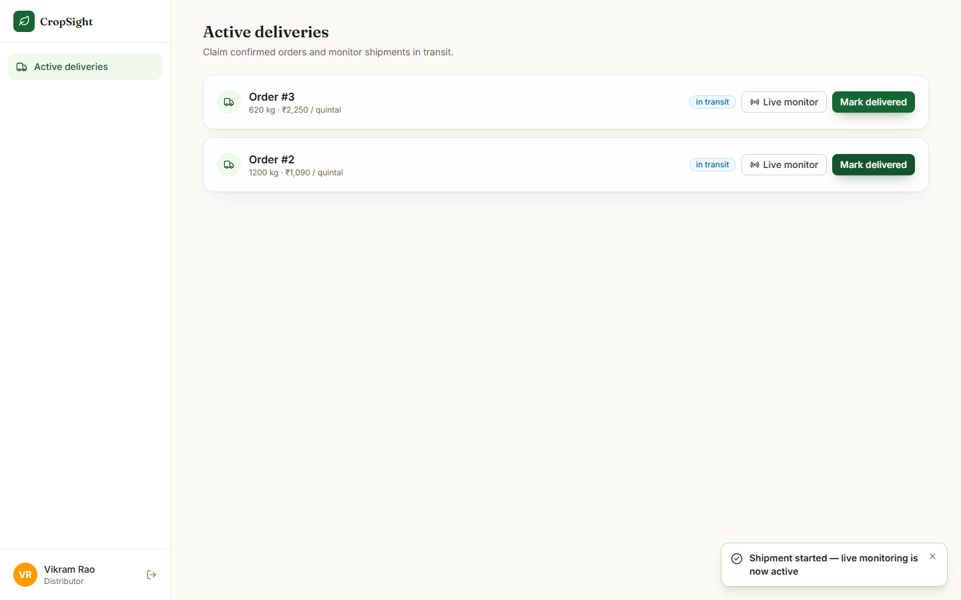  Fig. 28: Distributor: shipments in transit

Distributor: orders ready to ship. Active deliveries for the distributor (Vikram Rao): the two confirmed orders, #3 and #2, each with a Start transit button.
Distributor: shipments in transit. After Start transit on both orders: each row shows the badge "in transit", Live monitor and Mark delivered; the toast says "Shipment started - live monitoring is now active". Starting transit created a shipment record for each order.
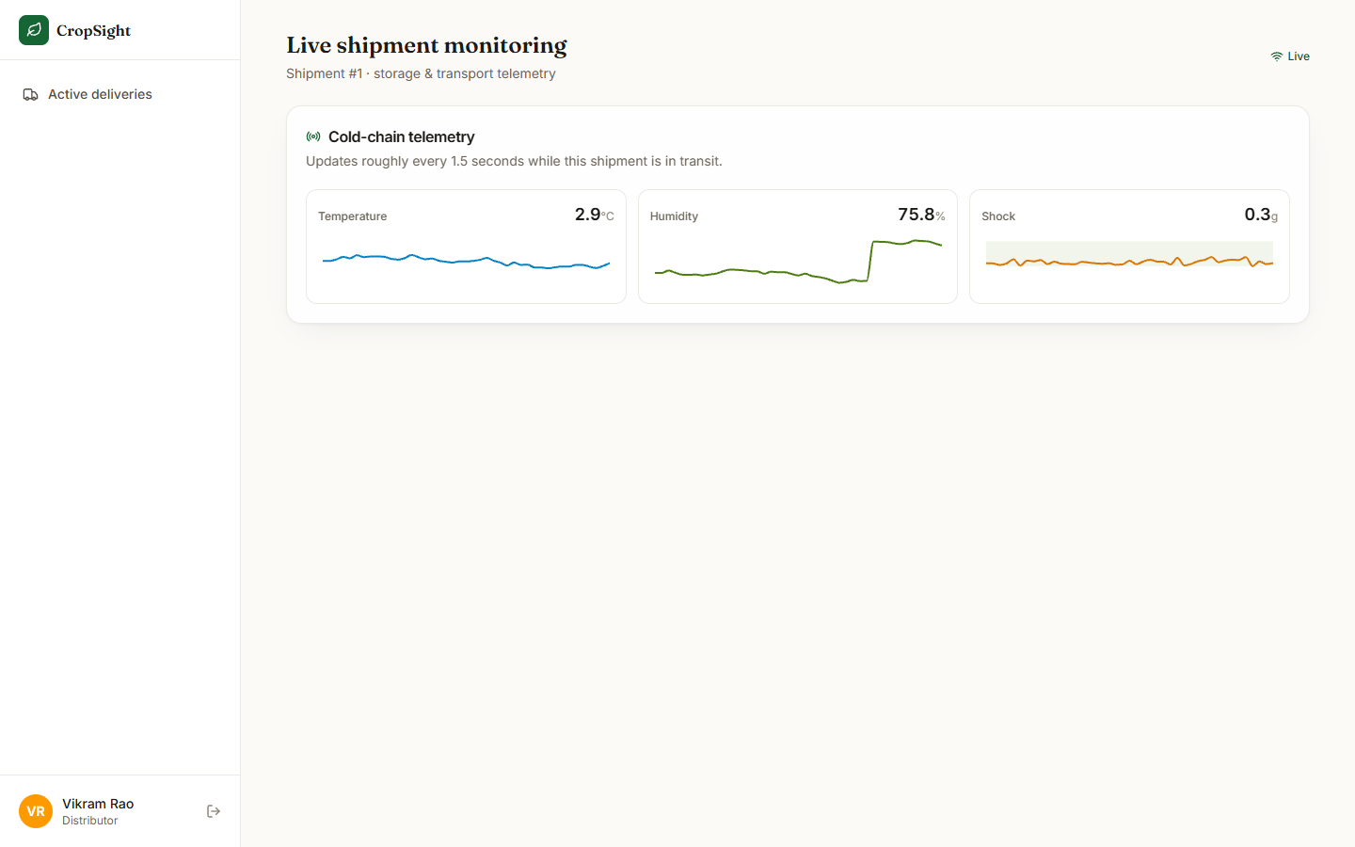  Fig. 29: Live shipment monitoring | 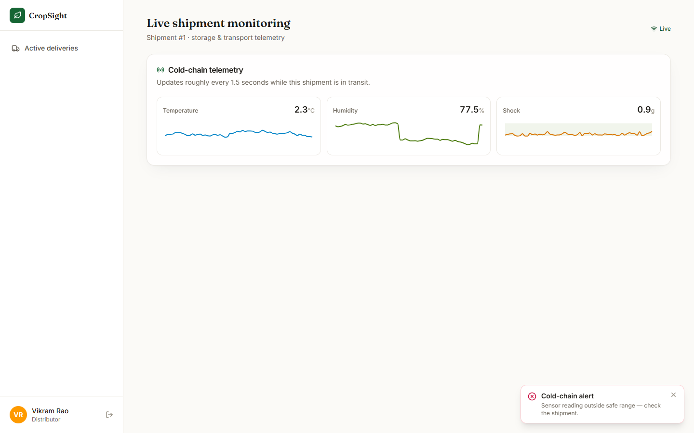  Fig. 30: Cold-chain alert toast

Live shipment monitoring. Shipment #1 about one minute after the page was opened: the Live indicator, and three trace panels for temperature (2.9 C), humidity (75.8%, after a step upwards) and shock (0.3 g). All values are inside the alarm band, so no banner is shown. The readings come from the simulated sensor stream over a WebSocket.
Cold-chain alert toast. 44 seconds after the page was opened the simulator's first injected event arrived and the red toast "Cold-chain alert - Sensor reading outside safe range" appeared while the traces were still near normal (temperature 2.3 C, humidity 77.5%, shock 0.9 g).
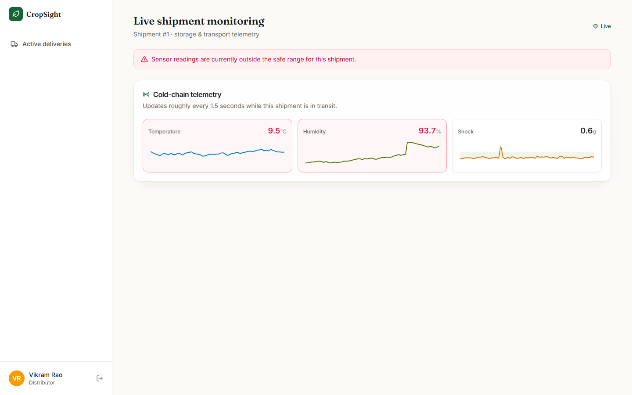
Fig. 31: Alert banner after drift
215 seconds after opening the page the red banner "Sensor readings are currently outside the safe range for this shipment" is on: temperature 9.5 C and humidity 93.7% are highlighted in red. The temperature and humidity random walks had drifted out of the alarm band without any new event.
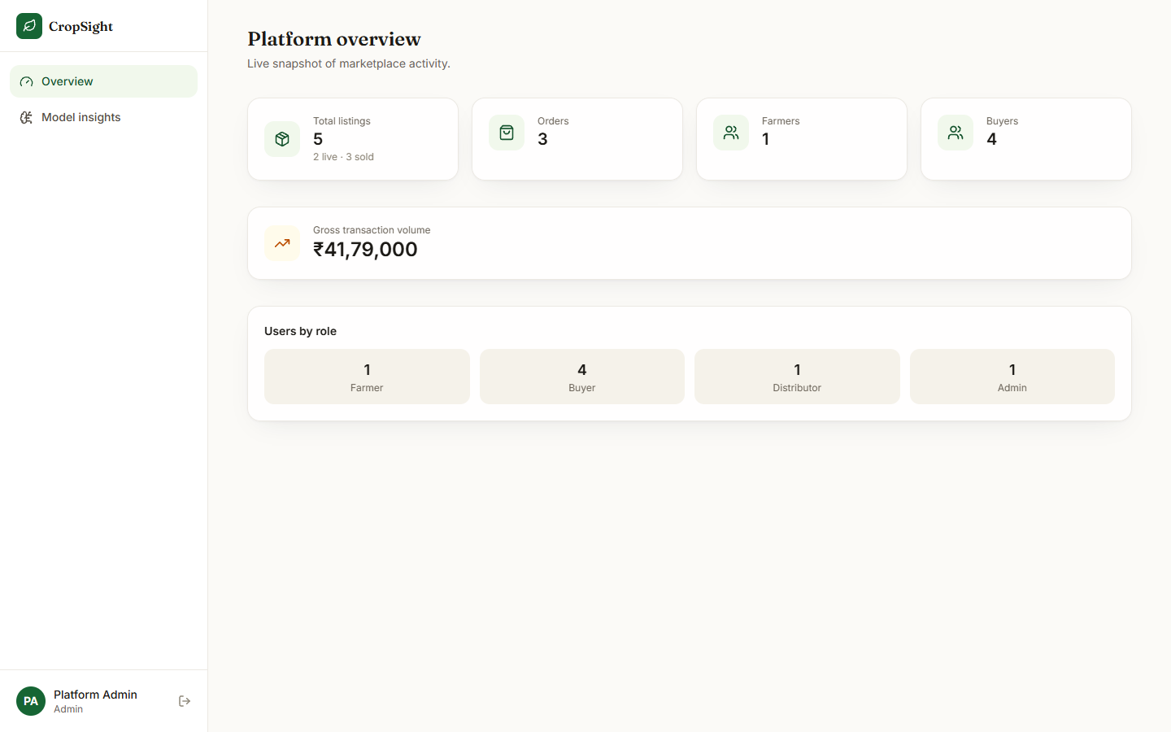  Fig. 32: Admin overview | 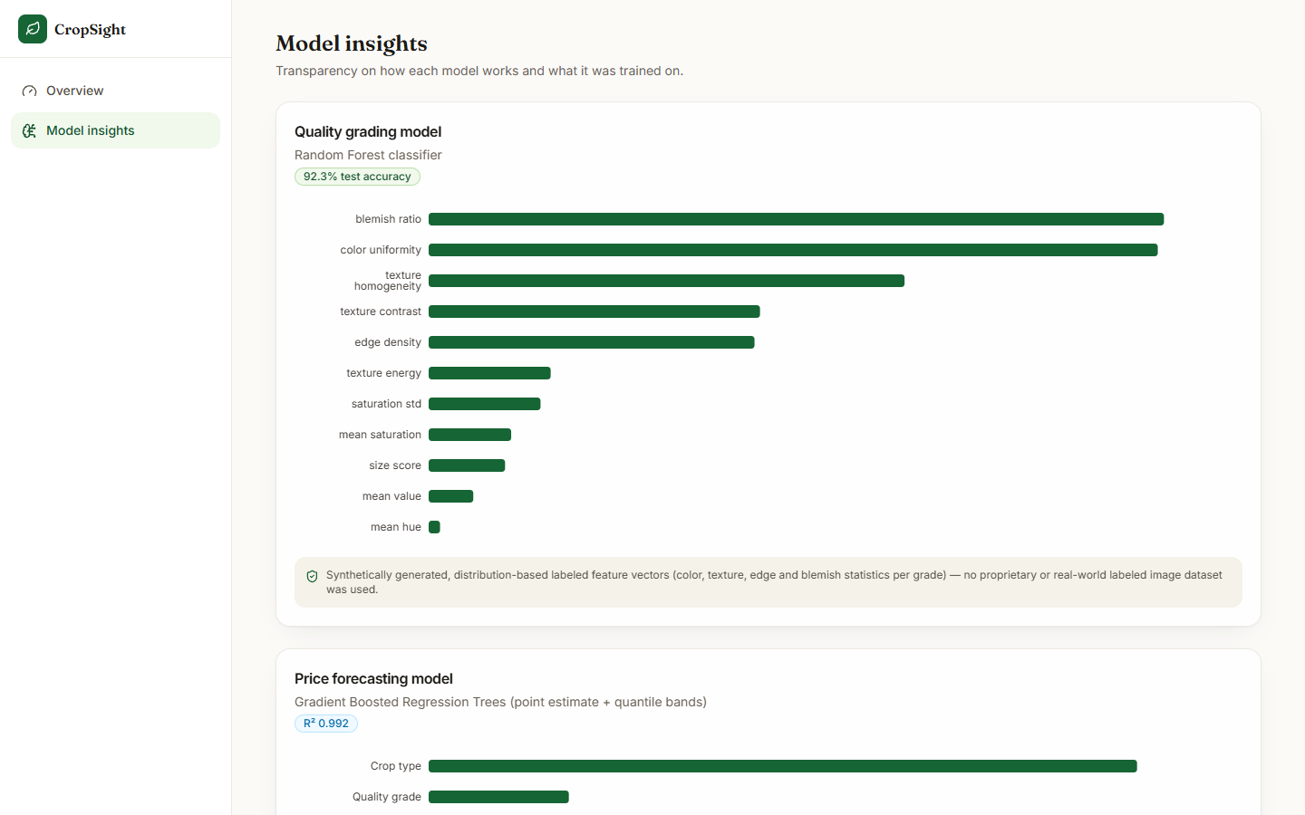  Fig. 33: Model insights: quality model

Admin overview. Platform overview: 5 listings (2 live, 3 sold), 3 orders, 1 farmer, 4 buyers, 1 distributor, 1 admin, and a gross transaction volume of INR 41,79,000. This volume is overstated by a factor of 100: the sum multiplies the price per quintal by the quantity in kilograms (see the section Success and Failure Analysis).
Model insights: quality model. The admin's transparency page: Random Forest classifier, the badge "92.3% test accuracy", the impurity importance of the 11 features (blemish ratio and colour uniformity largest, mean hue smallest) and the disclosure that the training data were synthetically generated and no real labelled image set was used.

5.1 Additional screens
  Fig. 34: Log-in page | 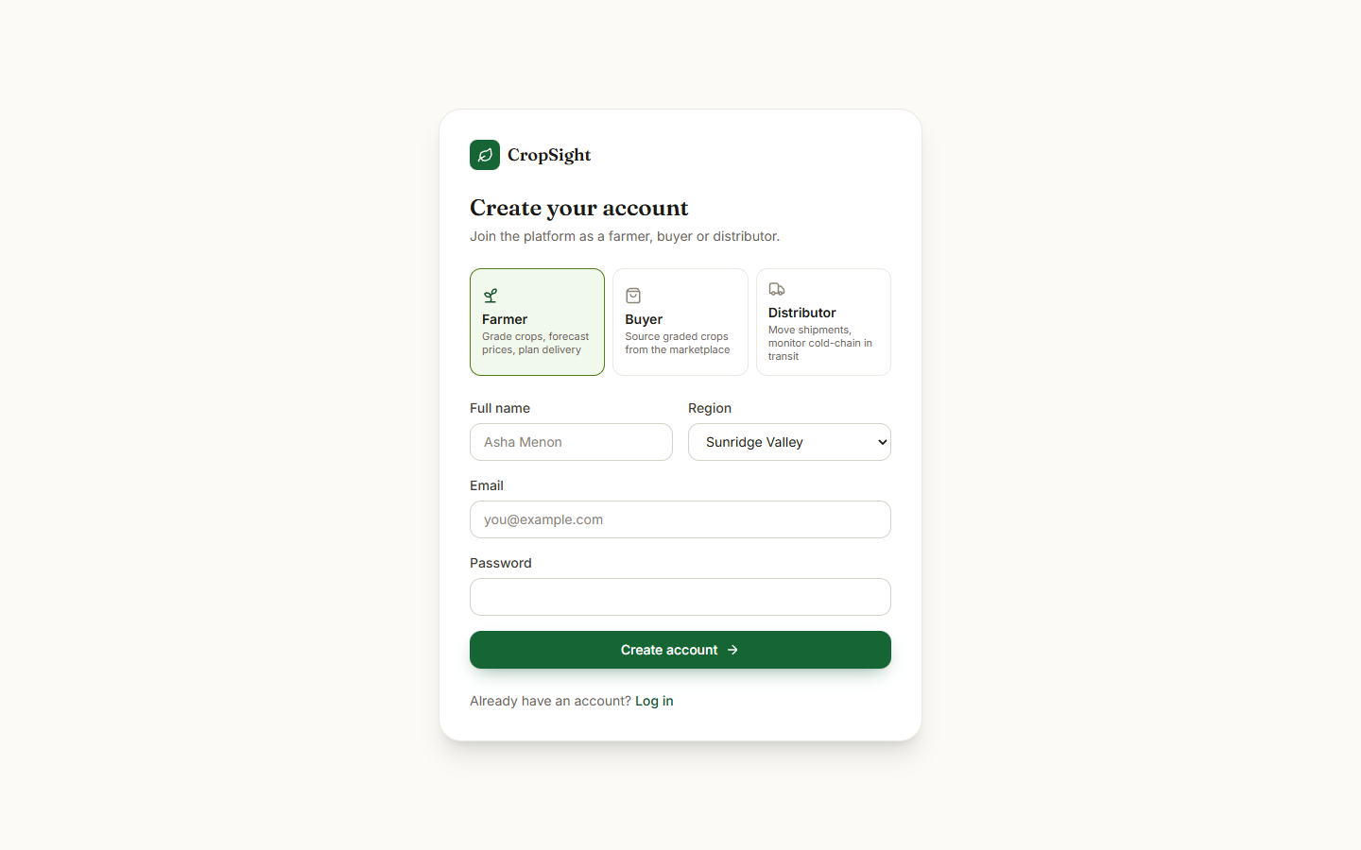  Fig. 35: Sign-up page

Log-in page. The log-in form with the e-mail and password fields and the four demo-account shortcuts (farmer, buyer, distributor, admin).
Sign-up page. The registration form with name, e-mail, password (minimum six characters), role (farmer, buyer or distributor), region and phone.
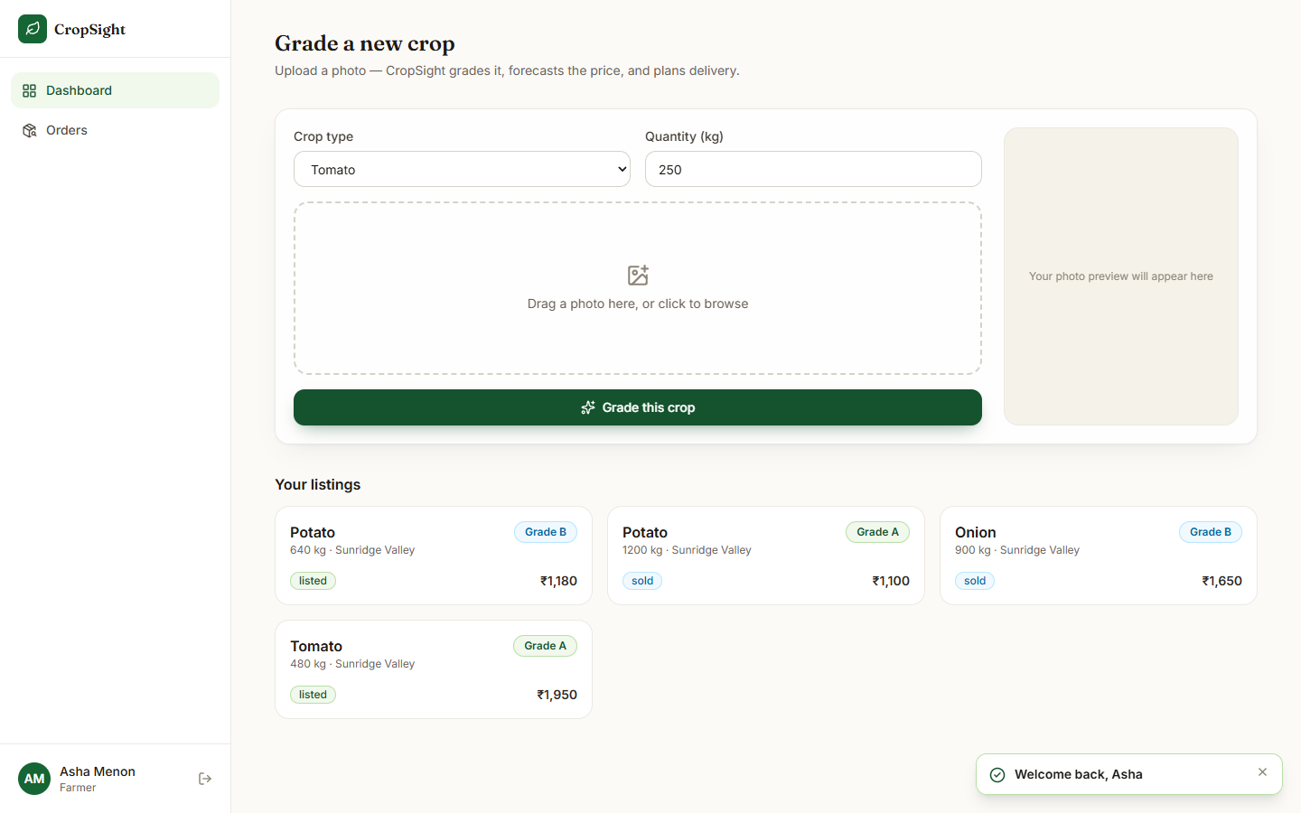  Fig. 36: Farmer dashboard before an upload | 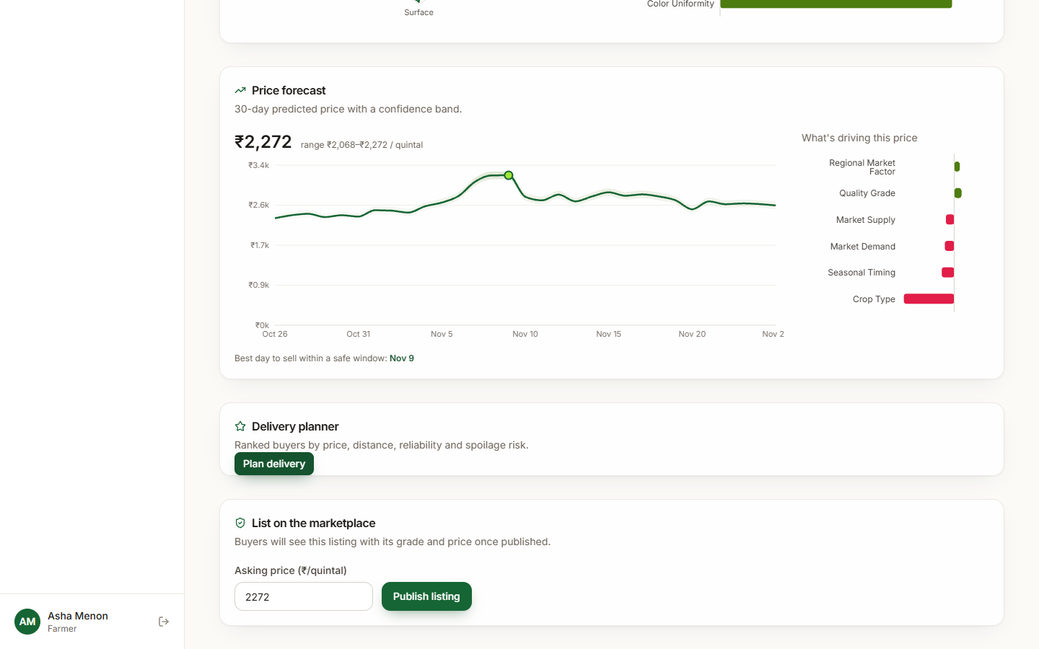  Fig. 37: Price forecast panel

Farmer dashboard before an upload. The Grade a new crop form with the default crop and quantity, the empty drop zone and photo preview, and the farmer's existing listings.
Price forecast panel. The forecast panel with the best-day line ("Best day to sell within a safe window: Nov 9"), followed by the Delivery planner and the List on the marketplace card with the asking-price field pre-filled with the forecast (2,272).
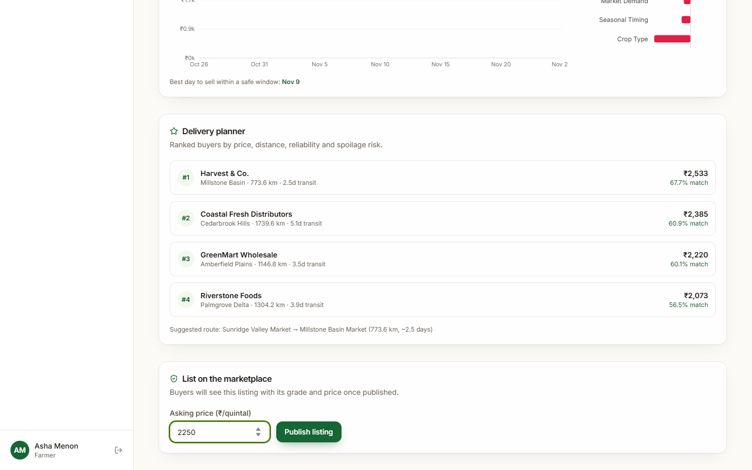  Fig. 38: Publishing a listing | 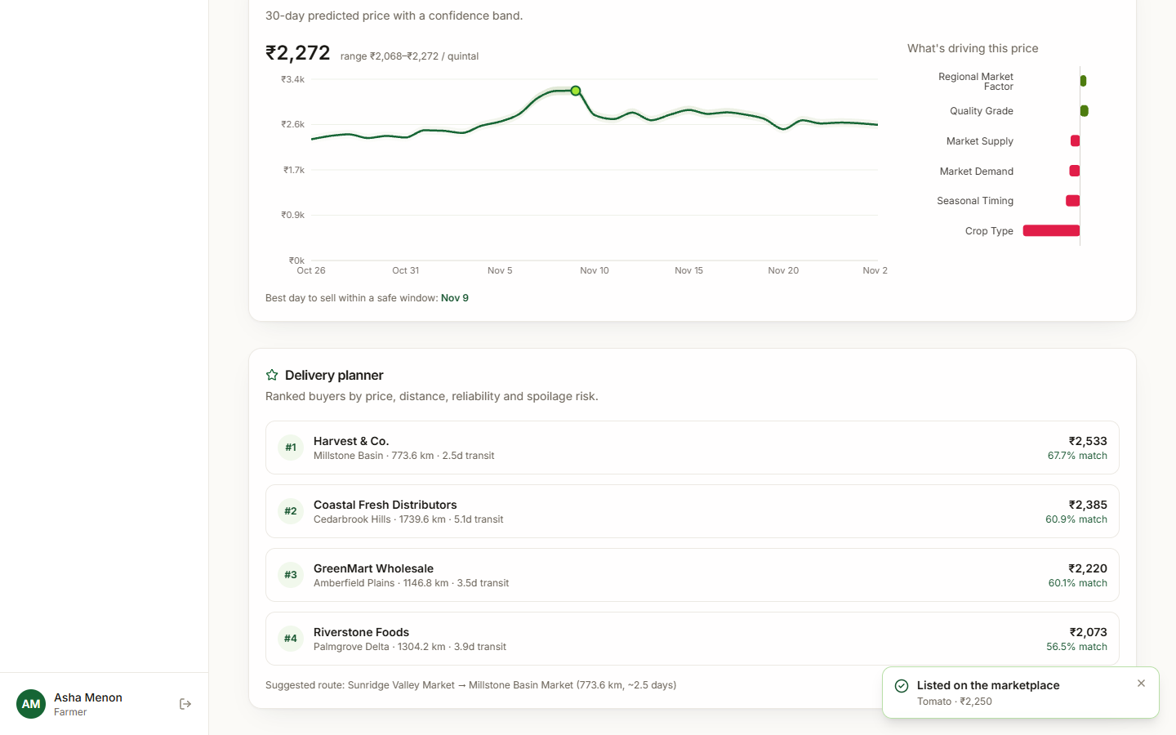  Fig. 39: Listing published

Publishing a listing. The asking price changed to INR 2,250 and the Publish listing button.
Listing published. The forecast and the four ranked buyers after publishing; the toast says "Listed on the marketplace - Tomato INR 2,250".
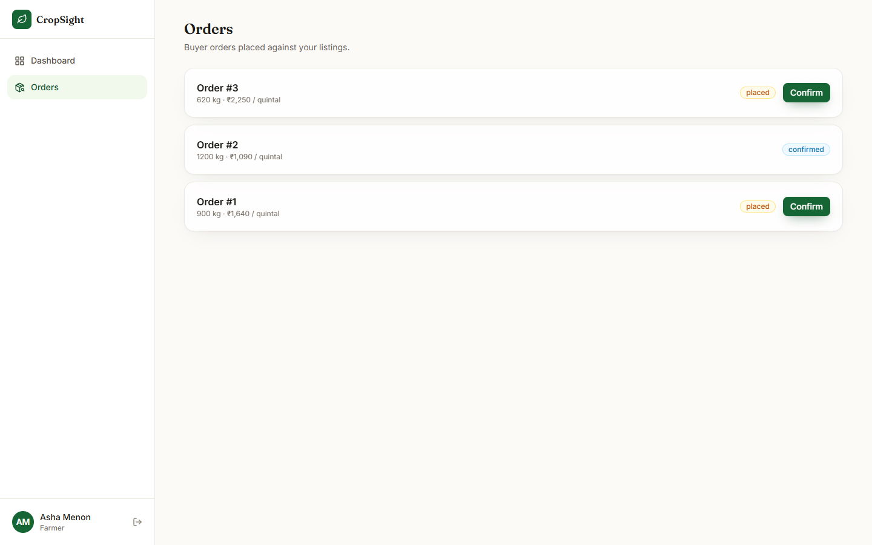  Fig. 40: Farmer orders before confirming | 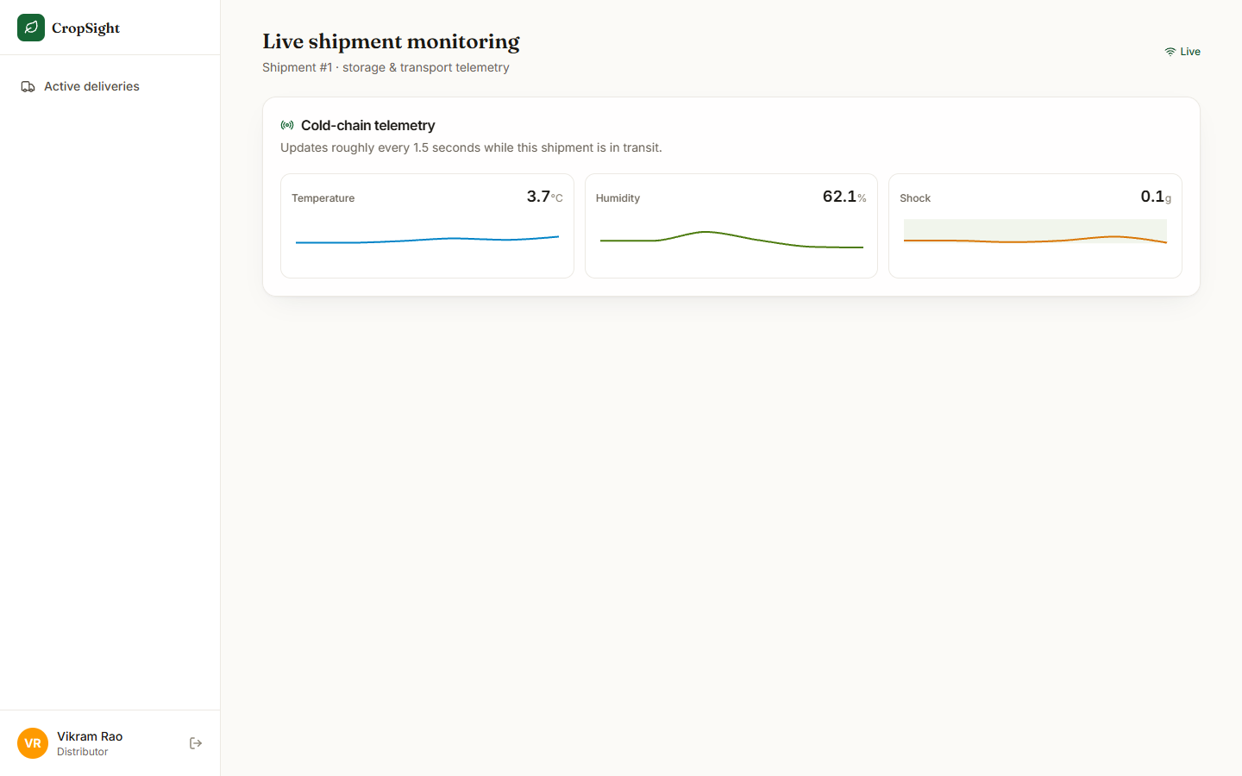  Fig. 41: Live monitoring right after opening

Farmer orders before confirming. Orders #3 and #1 are placed and show Confirm buttons; Order #2 is already confirmed.
Live monitoring right after opening. The page a few seconds after the WebSocket connected: the Live indicator and the three telemetry panels begin to fill.
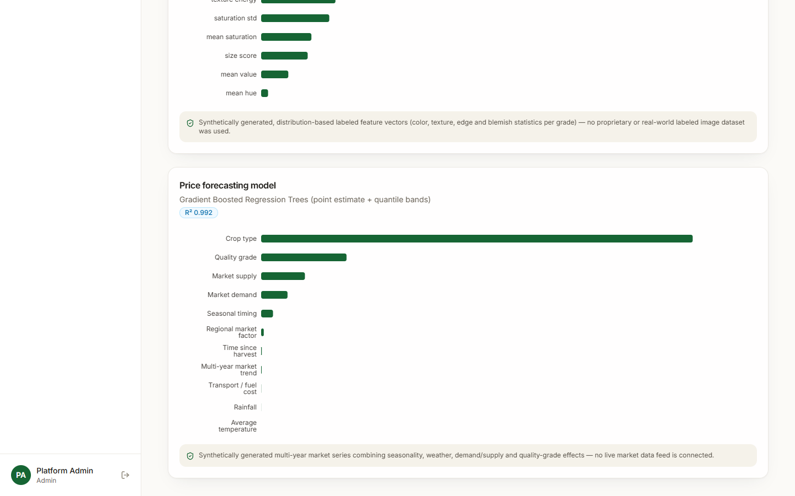
Fig. 42: Model insights: price model

Model insights: price model. The price model card: Gradient Boosted Regression Trees with point estimate and quantile bands, the badge "R2 0.992", grouped importances (crop type largest; rainfall and average temperature almost zero) and the disclosure of synthetic training data.
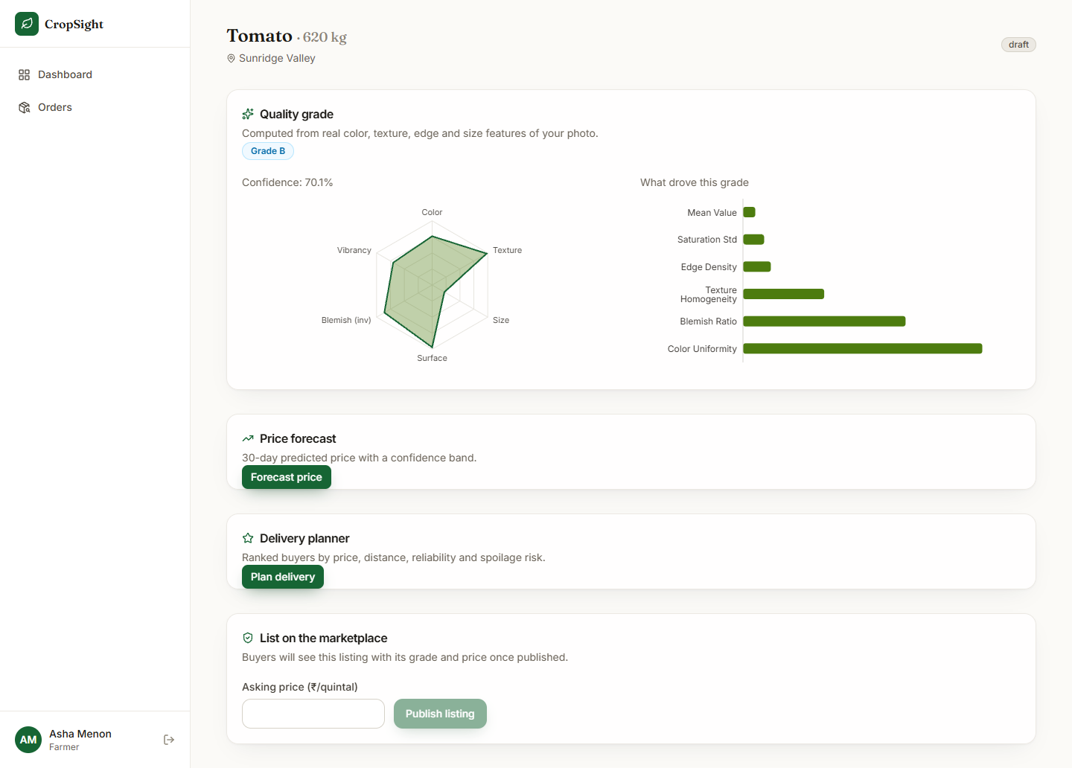  Fig. 43: Listing workspace, full length | 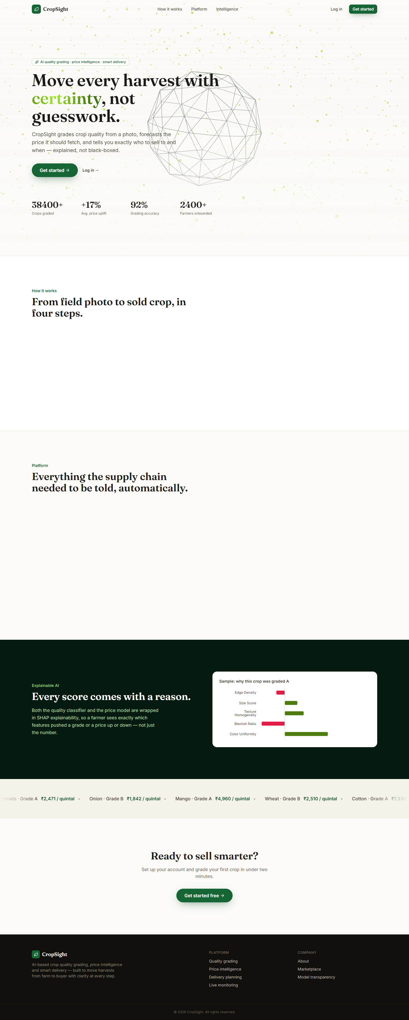  Fig. 44: Landing page, full length

Listing workspace, full length. The complete workspace after grading: quality card, the Forecast price and Plan delivery buttons and the List on the marketplace card.
Landing page, full length. The whole landing page including the how-it-works, platform and intelligence sections.

6 Sample Inputs and Outputs
Table 11: Real sample photographs and the grades the shipped model gave them
Photograph | Crop | Photos scanned | Grade | Confidence
tomato_1.jpg | Tomato | 40 (A 0, B 40, C 0, Reject 0) | B | 0.701
onion_1.jpg | Onion | 40 (A 0, B 40, C 0, Reject 0) | B | 0.742
potato_1.jpg | Potato | 40 (A 1, B 39, C 0, Reject 0) | B | 0.662
potato_2.jpg | Potato | 40 (A 1, B 39, C 0, Reject 0) | A | 0.834

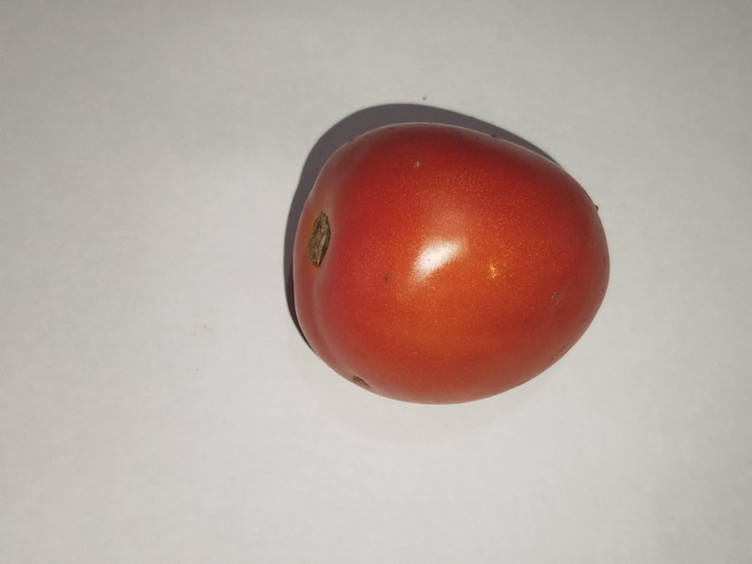  Fig. 45: tomato_1.jpg, graded B (0.701) | 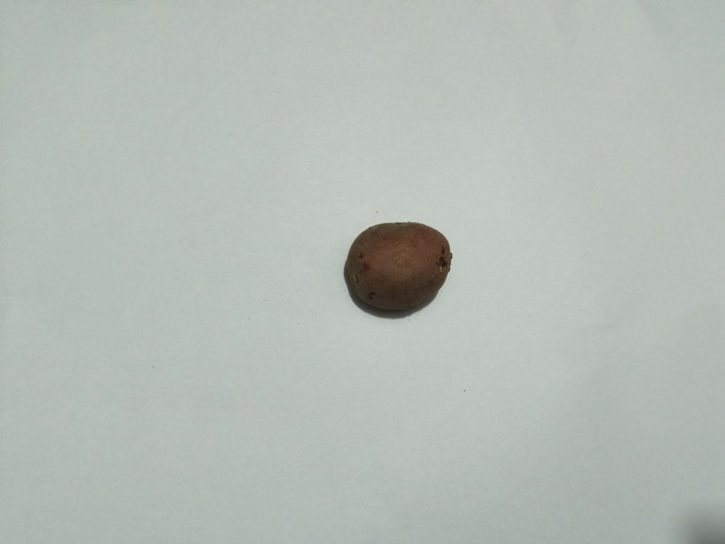  Fig. 46: potato_2.jpg, graded A (0.834)

The photographs come from the public vegetable dataset [9]. Forty photographs of each crop were graded and the examples were chosen so that the screens show more than one grade; this selection is not a test. All 40 tomatoes and all 40 onions were graded B and 39 of 40 potatoes were graded B, which is consistent with the real-photograph finding that the grader gives B to almost everything.
Table 12: Sample inputs and outputs (live run, 26 October 2026)
Input | Output
Photograph tomato_1.jpg, Tomato, 620 kg, Sunridge Valley (farmer) | Grade B, confidence 70.1%; top SHAP features colour uniformity, blemish ratio, texture homogeneity; stored as a draft listing
Forecast for the graded lot | Current price INR 2,272 per quintal, range 2,068 to 2,272, 30-day curve, best day to sell 9 November
Delivery plan for the lot | 1 Harvest & Co. 67.7% (INR 2,533, 773.6 km, 2.5 days); 2 Coastal Fresh Distributors 60.9%; 3 GreenMart Wholesale 60.1%; 4 Riverstone Foods 56.5%
Publish at INR 2,250; buyer orders 620 kg at INR 2,250 | Listing becomes sold; Order #3 placed; farmer confirms; distributor starts transit; shipment #1 opens the live stream
Wrong password for the farmer account | HTTP 401, message "Invalid email or password"
Admin overview after the demo | 5 listings (2 live, 3 sold), 3 orders, 7 users (1 farmer, 4 buyers, 1 distributor, 1 admin); displayed volume INR 41,79,000

7 Comparison with the Base Paper
The base paper [1] builds an AI-driven smart-agriculture system for the pre-harvest stage: IoT soil sensors and a weather API feed deep tabular models for irrigation advice (Transformer-based tabular learning, accuracy 99.13%), soil analysis (TabNet regressor, RMSE 1.51, R2 98.7%), crop recommendation (SwiFT, 98.75%) and fertiliser recommendation (TabNet classifier, 99.3%), with explainable-AI techniques (LIME [21] and TabNet [22] among them) and a chatbot. CropSight takes the same idea of IoT, learning and explanation into the post-harvest stage. The two works differ in task, data, model family and metric, and CropSight's data are synthetic, so the figures cannot be compared and no head-to-head claim is made. What can be compared is capability.
Table 13: CropSight and the base paper
Aspect | Base paper [1] | CropSight
Stage of the farm cycle | Before harvest: soil, irrigation, crop and fertiliser choice | After harvest: quality grading, price, delivery, marketplace
Input data | Tabular soil, weather and crop records; IoT sensor readings | Crop photographs; synthetic market series; simulated sensor stream
Models | Transformer-based tabular learning, TabNet, SwiFT (deep) | Random Forest, Gradient Boosting with quantile bands (classical), weighted scoring
Explainability | XAI techniques applied to TabNet predictions | SHAP for both models, shown to the farmer; feature importance for the admin
IoT | Soil sensors for real-time analysis | Simulated cold-chain stream over WebSocket with alerts; no hardware
Reported results | 99.13% (irrigation), RMSE 1.51 / R2 98.7% (soil), 98.75% (crop), 99.3% (fertiliser) | 92.3% grading and R2 0.992 pricing on synthetic data; chance level on real photographs
Marketplace and delivery | Not part of the system | Farmer, buyer and distributor marketplace with order states; delivery ranking
User interface | Chatbot interface for farmers | React web app with four role dashboards

The batch literature survey also lists [3] (image-based quality inspection and e-commerce grading), [4] and [5] (crop price prediction with machine learning). These three could not be retrieved, so no result from them is used here.
Two other works that were read support the direction. The foundation-model study [6] shows on real USDA price data that modern time-series models beat classical, machine-learning and deep-learning forecasters; CropSight's price model uses none of that and is trained on synthetic data, so it is the first thing to replace. The crop-image recognition study [7] reports an accuracy of 0.982 for a ConvLSTM-based model on real crop images; again a different task and data.

8 Success and Failure Analysis

8.1 Where it works
- The complete marketplace flow works end to end with four roles, JWT authentication and an order state machine that refuses wrong-role and out-of-order changes (36 passing tests).
- Grading, SHAP explanation, price forecast with a band, delivery ranking and the live sensor stream all respond quickly: 0.17 s to upload and grade, 55 ms median for a price forecast, 100 ms for a delivery plan.
- On its own generated data the grader reaches 92.3% and the price model R2 0.992, with errors only between neighbouring grades and a band that covers 69.3% against 70% nominal.
- The weighted delivery ranking is stable: the top buyer survives 97.7% of random weight changes.
- The admin transparency page discloses honestly that both models are trained on synthetic data.

8.2 Where it fails or is weak
Table 14: Failure and weakness analysis
Observation | Cause | Effect / handling
Grader gives grade B to 99% of 3,200 real photographs and is at chance for fresh versus rotten (50.4%, AUC 0.57) | Trained only on synthetic feature profiles that real images do not resemble | Grades on real photographs are not trustworthy; retrain on real labelled images (future scope)
A corrupt file sent as an image gives HTTP 500 and leaves a gradeless draft listing | The listing row is saved before grading and grading is not guarded | Expected-failure test; wrap grading and roll back the listing
Admin gross volume INR 41,79,000 for three small orders | Price per quintal multiplied by quantity in kilograms (100 times too large) | Divide by 100; the correct figure for the demo orders is INR 41,790
Sensor alarm drifts into permanent alarm; each connection restarts the stream from its seed | Random walks without mean reversion; simulator state lives in the connection | Add return-to-normal behaviour and hysteresis; keep state per shipment
Order accepts zero, negative or larger-than-listing quantities | No validation of quantity or price | Expected-failure test; add schema constraints and a stock check
Unknown crop or region is priced instead of rejected | No catalogue check; unknown crop uses an all-zero one-hot | Expected-failure test; validate against the catalogue
Displayed price range ends exactly at the current price | The band is clamped to include the point estimate | Report the unclamped quantile band or recalibrate
Landing page shows 38,400+ crops graded, +17% price uplift, 92% accuracy, 2,400+ farmers | Fixed marketing numbers in the page source | Remove or replace with real statistics
"Best day to sell" suggests large gains (mean +14.6%) | Hash-generated daily demand and supply noise, not a real forecast | Treat as an illustration; replace with a real time-series model

9 Limits of the Results
- Synthetic data. The accuracy of 92.3%, the R2 of 0.992 and the 70% band all describe recovery of the project's own generators. They say nothing about real farms or markets; the only real-image evidence is the negative result above.
- Mapped labels. The real-photograph check maps fresh and rotten to grades and uses fruits instead of the app's crops; it shows non-transfer clearly but cannot measure the accuracy of A, B, C and Reject grading.
- Simulated sensors and offers. The sensor stream, the buyer offers and the daily market context are generated, so the alert behaviour, the ranking and the sell-day advice illustrate the interface only.
- Small, single-machine measurements. Timings come from one desktop with other jobs running, 20 to 30 calls per endpoint, no concurrent load and no memory profile; no user study was carried out.
- Chosen photographs. The sample photographs on the output screens were picked from 40 scanned per crop to show more than one grade.
- No numeric comparison with the base paper is possible, as explained in the section Comparison with the Base Paper.

10 Objectives Against Outcomes
Table 15: Objectives against outcomes
Objective | Outcome | Evidence
1. Grade crop quality automatically from images | Partly achieved | Implemented as classical machine learning on 11 hand-crafted features, not a deep network; 92.3% on synthetic data; at chance on 3,200 real photographs; retraining on real labels reaches 90.6%
2. Forecast crop prices from market, weather and demand data | Partly achieved | Boosted model with a 70% band, R2 0.992 on synthetic data; weather has almost no effect; the 30-day forecast uses generated context; no real price feed
3. Monitor storage and transport with IoT sensors | Demonstrated with simulation only | WebSocket stream, stored readings and alert banner work end to end; no hardware, and the alarm drifts into permanent alarm
4. Explain grading and pricing decisions with XAI | Achieved | SHAP top-six contributions for every grade and price, shown in the app; importance charts for the admin
5. Recommend buyers, routes and the best time to sell | Achieved as a heuristic | Weighted ranking stable under weight changes (97.7%); route is the top buyer's town; offers and sell-day advice are simulated
6. Connect farmers, distributors and buyers through a marketplace | Achieved | Four roles, listings, orders, state machine, shipments; 36 tests pass; 3 validation gaps documented

