AI-BASED FINANCIAL IDENTIFICATION BASED ON DEMOGRAPHY AND FINANCIAL FORECASTING
Results
Product: FinSight AI
Department of Computer Science and Engineering, TKR College of Engineering and Technology (Autonomous)
Batch C9 (CSE-C) · Academic year [ACADEMIC YEAR]
Table 1: Project team
S.No. | Student name | Roll number
1 | MOHD AHMED | 23K91A05F7
2 | MANNE UPENDER | 23K91A05E6
3 | PADALA RAJESH | 23K91A05H7
4 | MADAGOUNI HARSHAVARDHAN GOUD | 23K91A05D5

Project guide: B SRIKANTH
Chapter and section numbers quoted in the text (for example Section 6.6 or Chapter 8) refer to the full project report, 17.Final Document. Figures and tables in this document are numbered from 1.

CHAPTER 8: RESULTS AND OUTPUT SCREENS

8.1 Output screens
The screens below are captures of the running application at 1440 x 900 pixels, taken in Chrome by scripts/capture_screens.py and scripts/capture_extra_screens.py against the live servers (API on port 8409, React front end on port 5409). Every screen shows real model output computed from the profile typed into the form; none is a mock-up. Some captures include the green 'Analysis complete' notification, which is part of the interface.

Figure 1: Dashboard: serving model, test accuracy, ROC-AUC and F1 read from the artifacts, the five strongest SHAP drivers and the economic outlook
The dashboard is the first screen after sign-in. Its four tiles are filled from /api/dashboard: the serving model (XGBoost), accuracy 87.8% on the held-out test set, ROC-AUC 0.932 (cross-validated 0.929 +/- 0.001) and F1 0.724 with precision 79% and recall 67%. Beneath them are a bar chart of the five largest mean absolute SHAP values and a short statement of the economic outlook, with buttons to start an assessment or open the forecast.

Figure 2: Financial assessment form filled with the sample profile (age 39, State-gov, Bachelors, Never-married, Adm-clerical)
The form collects the twelve inputs, each with its allowed range or option list shown under the field. The values in the capture are the first record of the Adult data set. 'Use sample profile' fills them in one click and 'Clear' empties them. Validation runs in the browser and again on the server; the next figure shows a rejected entry.

Figure 3: Validation error: age 7 is outside the permitted range of 16 to 100, so the field is outlined and the analysis is refused
When the server returns HTTP 400 the page shows a pink banner and marks the offending field with its allowed range ('Must be between 16 and 100.'). No model is run and no result is shown. This is the behaviour the edge-case tests of Chapter 7 checked at the API level.

Figure 4: Result for the sample profile: Emerging profile, High risk band, financial-strength score 1.1%, with the SHAP factors that shaped it
The result screen shows the predicted profile, the risk band, the financial-strength score (the model's probability of income above 50K, here 0.0109) and the live SHAP contributions for this one person, split into strengthening and weakening factors with a plain-language sentence for each. For this record years of education (+0.545) and age (+0.184) strengthen the prediction, while its investment-gains value of 2,174 is the largest weakening factor (-1.626) presumably because larger gains accompany high incomes in the training data. The text below the score states the risk-band rule: strength of at least 60% is Low risk, 35% to 60% Moderate and below 35% High.

Figure 5: Result for a dual-income profile (age 34, Local-gov, Some-college, married, Sales, 42 hours): Developing profile, Moderate risk, score 46.8%
A profile between the two thresholds. Being married to a civilian spouse (+0.836) and the household role 'Wife' (+0.553) are the strongest strengthening factors; the screen makes clear that the score of 46.8% sits inside the Developing band, which in the test split corresponds to a population in which 44.0% actually earn more than 50K (Section 8.2).

Figure 6: Result for a mid-career manager (age 52, Private, Masters, married, Exec-managerial, gains 7,688, 50 hours): Established profile, Low risk, score 99.9%
The third band. Investment gains (+4.678) dominate, followed by marital status (+1.004), age (+0.550) and years of education (+0.527). The full page continues with the actionable insights, an echo of the inputs and a miniature of the forecast; the full-page capture is stored as docs/screenshots/15_result-established-full.png.
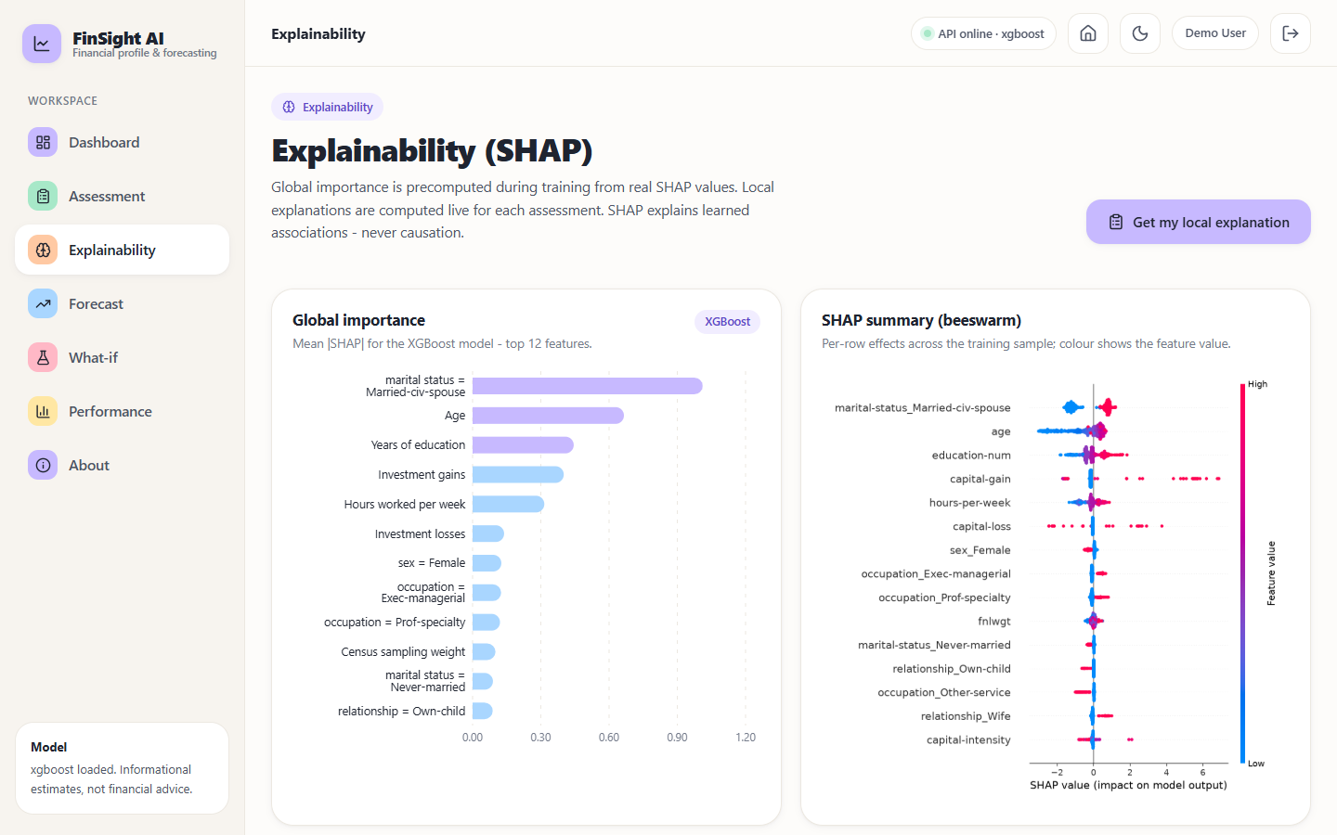
Figure 7: Explainability screen: global SHAP importance (left) and the SHAP summary of per-row effects (right)
The explainability screen shows the global picture computed at training time. 'marital status = Married-civ-spouse' has the largest mean absolute SHAP value (1.012), followed by age (0.665), years of education (0.444), investment gains (0.401) and hours per week (0.315). In the beeswarm on the right each dot is one row; the colour is the feature value, so red capital-gain dots far to the right show that large gains push the prediction up. A banner states that SHAP explains learned associations, never causation.
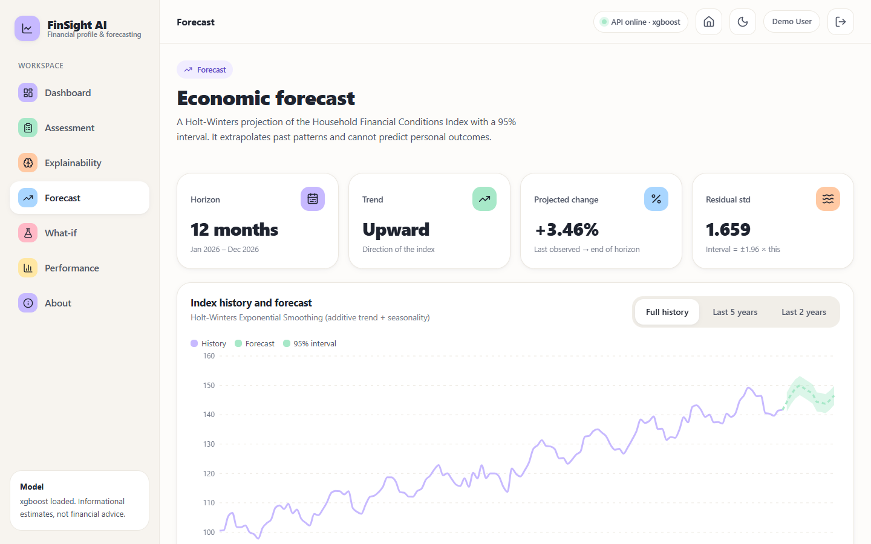
Figure 8: Forecast screen: 12-month Holt-Winters projection of the Household Financial Conditions Index with its 95% interval
Four tiles give the horizon (12 months, January to December 2026), the trend direction (upward), the projected change (+3.46%, from 141.7 to 146.6) and the residual standard deviation (1.659), from which the interval of plus or minus 1.96 standard deviations is drawn. The chart can be switched between the full history, the last five years and the last two years. The subtitle says the projection 'extrapolates past patterns and cannot predict personal outcomes'; the series it extrapolates is synthetic, as Section 8.2 explains.
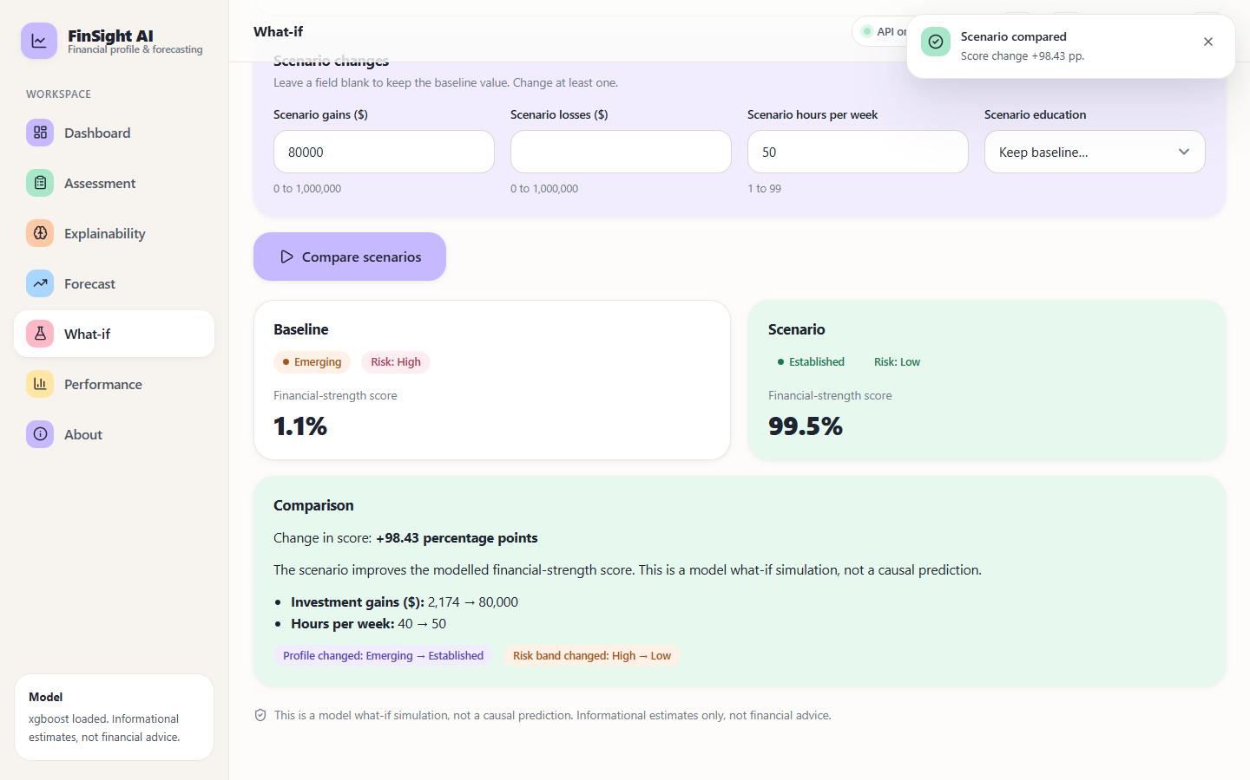
Figure 9: What-if screen: scenario gains of 80,000 and 50 weekly hours compared with the baseline profile
The what-if screen keeps the baseline from the last assessment and lets the user change gains, losses, hours or education. In the capture, raising gains to 80,000 and hours to 50 moves the same person from Emerging (1.1%) to Established (99.5%), a change of +98.43 percentage points, and the comparison lists the two changed fields. Every result is captioned as a model simulation, not a causal prediction, because a jump of this size is the model extrapolating into a region where the training data are sparse (Section 8.5).
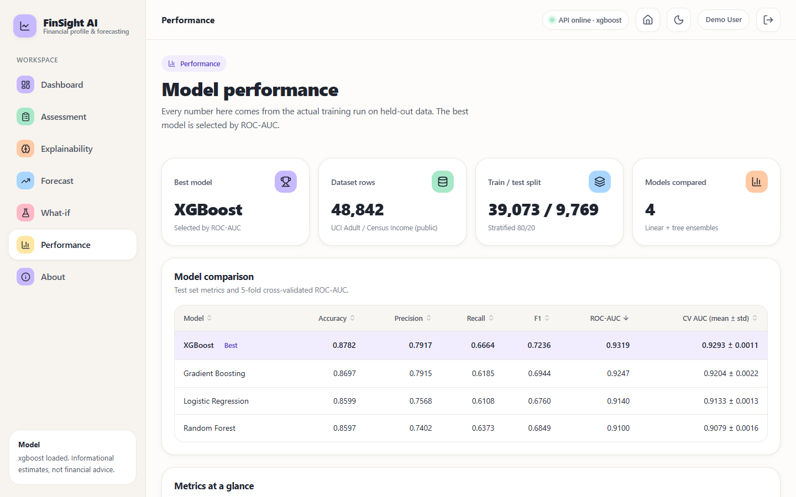
Figure 10: Performance screen: model comparison table with the selected model highlighted, followed by the metrics, ROC and confusion-matrix views
The performance screen lists the four models with accuracy, precision, recall, F1, ROC-AUC and the mean and standard deviation of cross-validated AUC, with the best model marked. Below the fold it shows the ROC curves, the confusion matrix, the validation protocol with the per-fold AUCs, and the correlation and logistic-regression statistics. The numbers on this screen are the numbers in Section 8.2.

8.2 Model performance
All numbers in this section are measured on the 9,769 records of the stratified test split (2,338 with income above 50K and 7,431 at or below), produced by training on the other 39,073 records. Classification uses the default threshold of 0.5 unless stated. A classifier that always answered 'at most 50K' would score 76.1% accuracy on this split, which is the bar the accuracy figures should be read against; ROC-AUC, which does not depend on the class ratio, is the primary metric.
Table 2: Test-set metrics of the four classifiers
Model | Accuracy | Precision | Recall | F1 | ROC-AUC | 5-fold CV AUC
Logistic Regression | 0.8599 | 0.7568 | 0.6108 | 0.6760 | 0.9140 | 0.9133 +/- 0.0013
Random Forest | 0.8597 | 0.7402 | 0.6373 | 0.6849 | 0.9100 | 0.9079 +/- 0.0016
Gradient Boosting | 0.8697 | 0.7915 | 0.6185 | 0.6944 | 0.9247 | 0.9204 +/- 0.0022
XGBoost (selected) | 0.8782 | 0.7917 | 0.6664 | 0.7236 | 0.9319 | 0.9293 +/- 0.0011

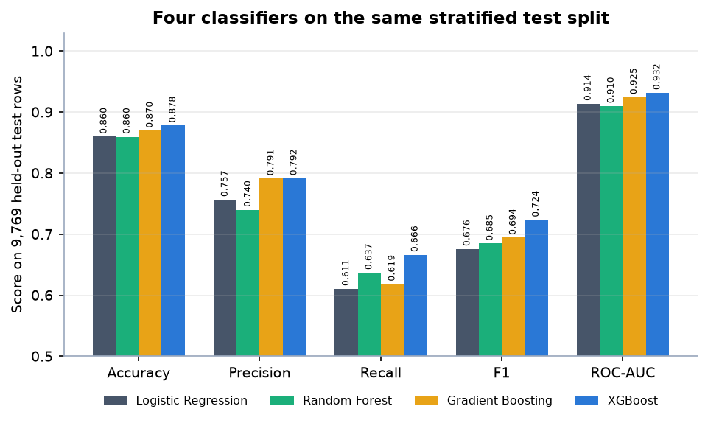
Figure 11: The four classifiers compared on the held-out test split
XGBoost is best on every metric, with Gradient Boosting essentially tied on precision (0.791 against 0.792). Its ROC-AUC of 0.9319 is 0.0179 above Logistic Regression and 0.0072 above Gradient Boosting. The size of the gain over the linear baseline is modest: Logistic Regression already reaches 0.914, and it is slightly ahead of Random Forest (0.910) on AUC. With 48,842 rows and mostly categorical inputs, much of the signal is linear in the engineered features, which is why interpretable regression remains a strong comparator.
The ranking is stable. The cross-validated AUC, computed on the training split only, gives the same order (XGBoost 0.9293, Gradient Boosting 0.9204, Logistic Regression 0.9133, Random Forest 0.9079), the fold-to-fold standard deviation is at most 0.0022, and XGBoost beats Gradient Boosting in every one of the five folds. No formal significance test (such as the DeLong test used by the base paper) was run, and the model was chosen using the test split, so the headline figure is slightly optimistic; the cross-validated figure is the cleaner estimate.
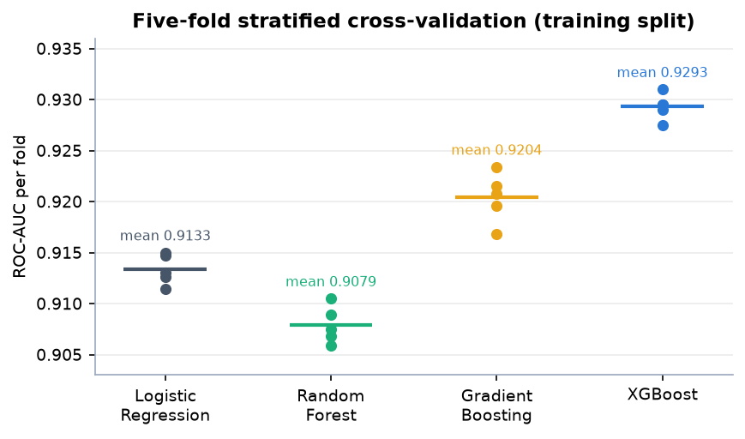
Figure 12: Per-fold ROC-AUC of the five-fold stratified cross-validation for each model
Table 3: Confusion-matrix counts, specificity, PR-AUC and Brier score on the test split
Model | TN | FP | FN | TP | Specificity | PR-AUC | Brier
Logistic Regression | 6,972 | 459 | 910 | 1,428 | 0.9382 | 0.7867 | 0.0976
Random Forest | 6,908 | 523 | 848 | 1,490 | 0.9296 | 0.7955 | 0.0981
Gradient Boosting | 7,050 | 381 | 892 | 1,446 | 0.9487 | 0.8228 | 0.0903
XGBoost | 7,021 | 410 | 780 | 1,558 | 0.9448 | 0.8381 | 0.0857

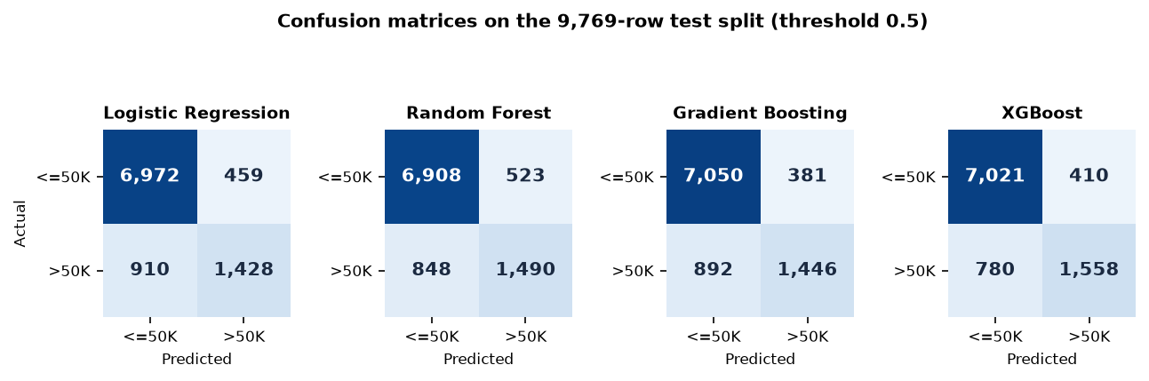
Figure 13: Confusion matrices of the four models on the test split (rows: actual, columns: predicted)
For the selected model, 7,021 of the 7,431 people at or below 50K are classified correctly (specificity 94.5%) and 1,558 of the 2,338 above 50K are found (recall 66.6%). The 1,190 errors split into 410 false positives and 780 false negatives: the model errs more often by missing a high-income person than by promoting a low-income one. It also has the best Brier score (0.0857) and PR-AUC (0.8381), so its probabilities as well as its labels are better than the alternatives'.
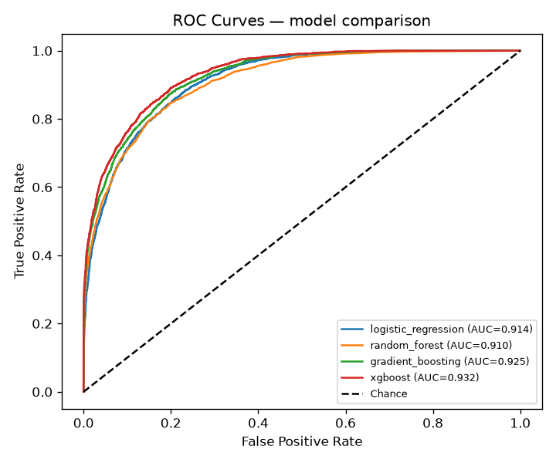
Figure 14: ROC curves of the four models on the test split (generated by the training script)
The ROC curves of the four models lie close together and well above the diagonal; the ordering by area matches the table. A threshold of 0.5 is a convention, not an optimum for this application, so the threshold analysis below is more informative than any single operating point.
Table 4: Threshold analysis of the selected model (test split)
Threshold | Accuracy | Precision | Recall | F1
0.20 | 0.8212 | 0.5825 | 0.8922 | 0.7048
0.30 | 0.8529 | 0.6531 | 0.8221 | 0.7279
0.35 | 0.8637 | 0.6901 | 0.7810 | 0.7327
0.40 | 0.8698 | 0.7219 | 0.7417 | 0.7316
0.50 | 0.8782 | 0.7917 | 0.6664 | 0.7236
0.60 | 0.8764 | 0.8523 | 0.5851 | 0.6939
0.70 | 0.8650 | 0.8996 | 0.4906 | 0.6349
0.80 | 0.8483 | 0.9573 | 0.3832 | 0.5473

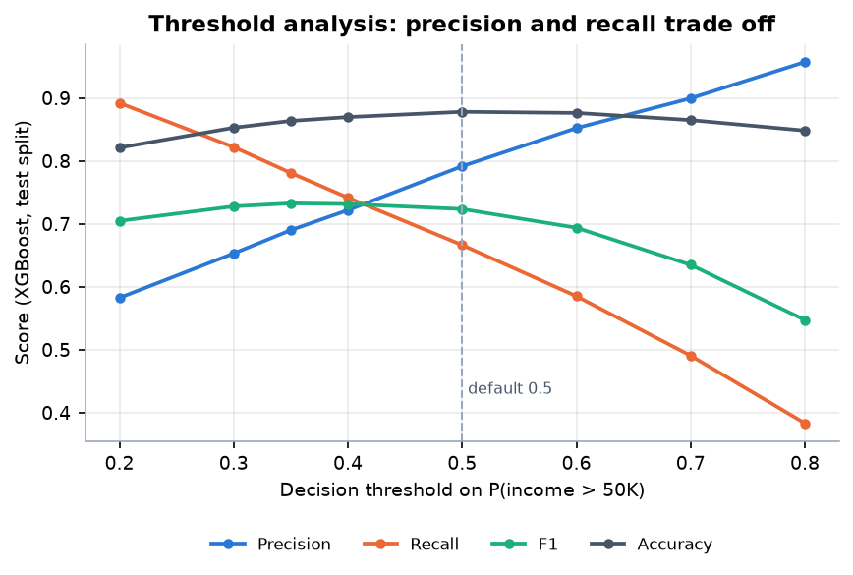
Figure 15: Precision, recall, F1 and accuracy of the selected model as the decision threshold moves
Lowering the threshold from 0.5 to 0.3 raises recall from 66.6% to 82.2% while precision falls from 79.2% to 65.3%. F1 peaks at a threshold of 0.35 (0.7327), slightly above its value at 0.5 (0.7236), and accuracy is highest near 0.5 (0.8782). At 0.8 precision reaches 95.7% but only 38.3% of high-income people are found. An institution that wants to avoid missing strong profiles would choose a lower threshold; one that wants few false alarms, a higher one. The application does not use a single threshold for its output: it uses the probability itself, mapped to three bands, as described next.
Table 5: Calibration of the selected model: predicted probability against observed share above 50K (test split)
Probability bin | Rows | Mean predicted | Observed share
0.0-0.1 | 5,336 | 0.0212 | 0.0221
0.1-0.2 | 852 | 0.1462 | 0.1573
0.2-0.3 | 638 | 0.2469 | 0.2571
0.3-0.4 | 541 | 0.3474 | 0.3475
0.4-0.5 | 434 | 0.4470 | 0.4055
0.5-0.6 | 363 | 0.5493 | 0.5234
0.6-0.7 | 330 | 0.6475 | 0.6697
0.7-0.8 | 339 | 0.7472 | 0.7404
0.8-0.9 | 238 | 0.8475 | 0.8697
0.9-1.0 | 698 | 0.9843 | 0.9871

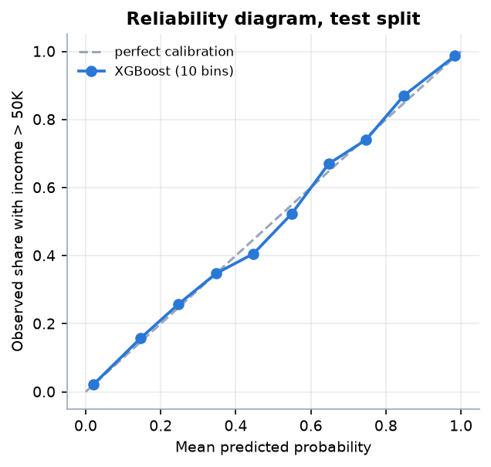
Figure 16: Reliability diagram of the selected model on the test split
The model is well calibrated: in every bin the mean predicted probability is close to the observed share, with the largest gap in the 0.4 to 0.5 bin (0.447 predicted, 0.406 observed). This matters for the application because the financial-strength score shown to the user is this probability; a score of 47% really does correspond to roughly four to five in ten comparable people earning above 50K in this data. Calibration was measured but not corrected; the raw XGBoost probabilities were used.
Table 6: Profile bands on the test split
Profile band | Rule on probability p | Test rows | Actually earn above 50K
Emerging (High risk) | p < 0.35 | 7,123 | 7.2%
Developing (Moderate risk) | 0.35 <= p < 0.60 | 1,041 | 44.0%
Established (Low risk) | p >= 0.60 | 1,605 | 85.2%

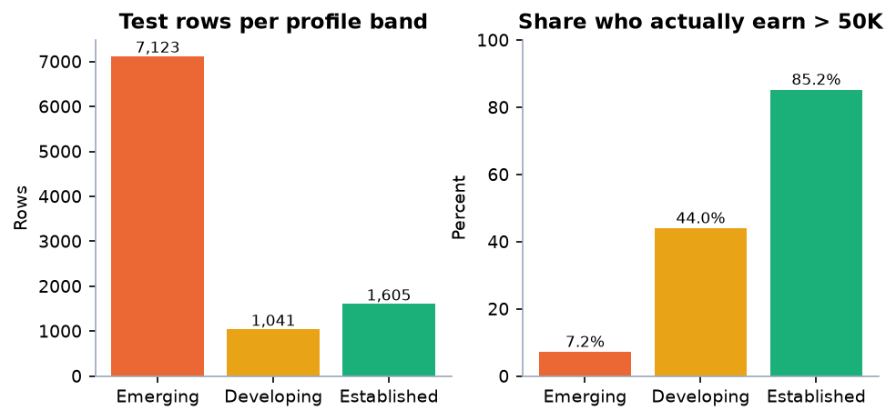
Figure 17: Number of test rows per profile band and the share of each band that actually earns above 50K
The bands separate the population usefully: only 7.2% of the 7,123 rows in the Emerging band actually earn above 50K, against 44% in Developing and 85.2% in Established. The band thresholds (0.35 and 0.60) are fixed in the application code (profile_from_proba). The labels are descriptive names for ranges of a probability; they are not credit grades.
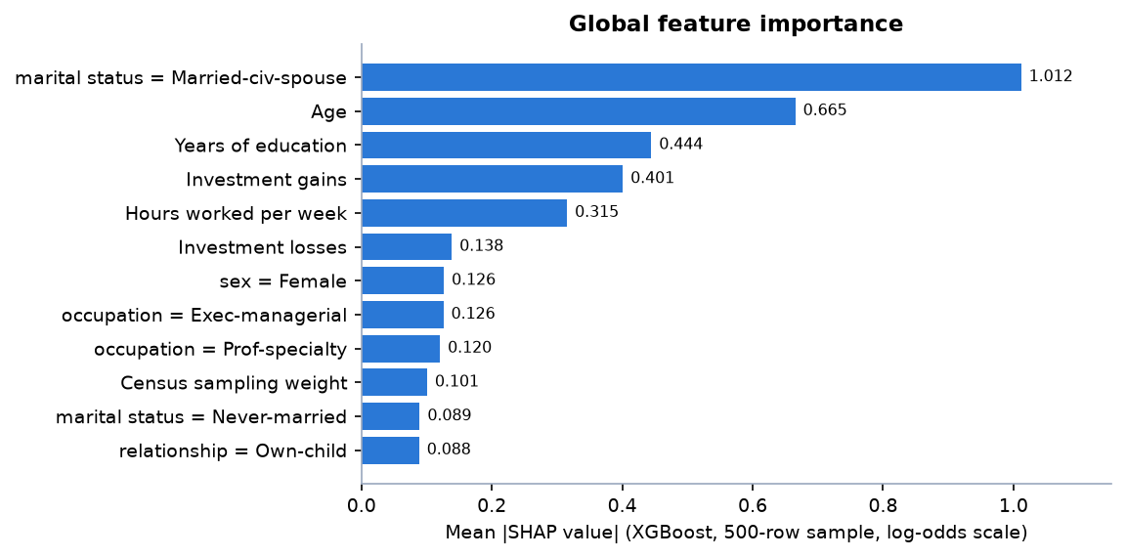
Figure 18: Twelve largest global SHAP importances of the selected model
Table 7: Top ten global SHAP importances (XGBoost, 500-row sample, log-odds scale)
Rank | Feature | Mean |SHAP|
1 | marital status = Married-civ-spouse | 1.0116
2 | Age | 0.6653
3 | Years of education | 0.4445
4 | Investment gains | 0.4007
5 | Hours worked per week | 0.3153
6 | Investment losses | 0.1385
7 | sex = Female | 0.1263
8 | occupation = Exec-managerial | 0.1256
9 | occupation = Prof-specialty | 0.1204
10 | Census sampling weight | 0.1007

Marital status (being a civilian-spouse household), age, education, investment gains and weekly hours account for most of the model's behaviour. Sex appears in the top ten (rank 7). The logistic-regression statistics computed on the training split point the same way: correlations with income above 50K are 0.335 for years of education, 0.231 for weekly hours, 0.229 for age and 0.212 for net capital, and the four logit coefficients are all positive with p-values reported as 0.0. As the base paper also stresses [1], these are associations learned from historical data, not causal effects.
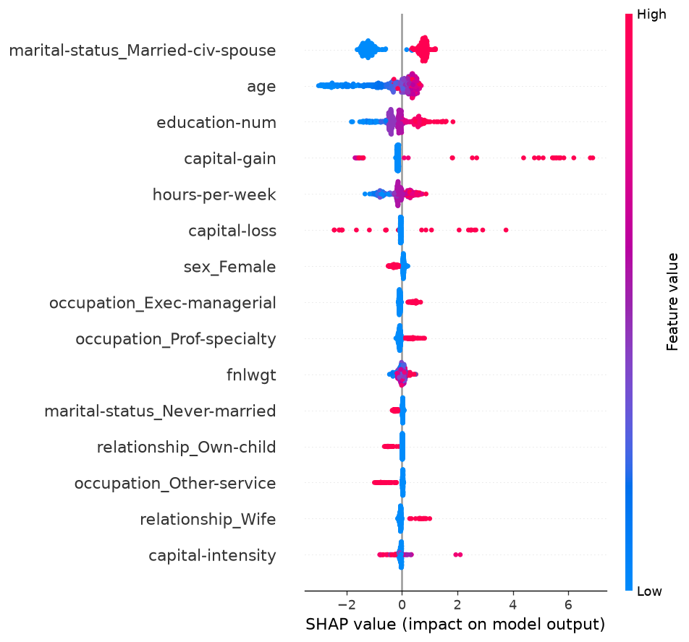
Figure 19: SHAP beeswarm plot: effect of each feature value on the prediction (generated by the training script)

Forecast
The forecast series is synthetic. The Adult data have no time dimension, so the 12-month forecast uses a Household Financial Conditions Index generated by scripts/forecast.py (132 monthly values from January 2015 to December 2025: a linear trend, a yearly sinusoid, Gaussian noise and a mild downturn in March to August 2020). It is documented as illustrative in data/README.md. The numbers below therefore measure how well the Holt-Winters method recovers its own generating pattern; they are not evidence of accuracy on real economic data.
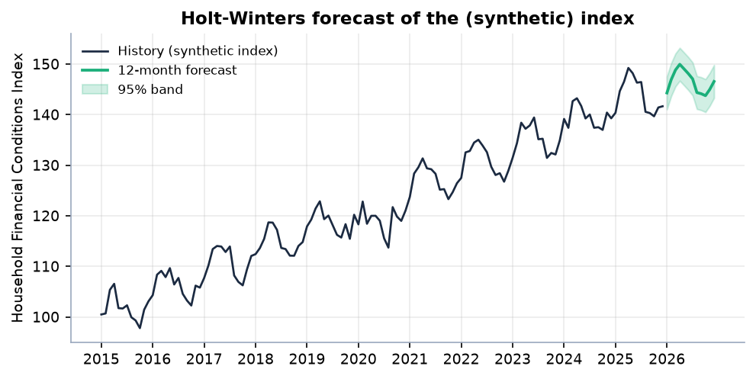
Figure 20: Holt-Winters forecast of the synthetic index with its 95% band
Table 8: Back-test of the forecasting method on the synthetic series
Quantity | Value
Fitting window | 120 months (2015-01 to 2024-12)
Held-out window | 12 months (2025)
Mean absolute error | 1.429 index points
Root mean squared error | 1.600
Mean absolute percentage error | 0.997%
Naive last-value forecast, MAE | 4.504
Share of held-out months inside the 95% band | 100% (12 of 12)

Fitted to 2015-2024, the model predicts the 12 months of 2025 with a mean absolute error of 1.43 index points (1.00%), about a third of the 4.50 of a naive forecast that repeats the last value, and all 12 held-out values fall inside the 95% band. Because the series is generated from a trend plus seasonality plus noise, a trend-and-seasonality smoother is almost guaranteed to do well; the result confirms that the code is correct, nothing more. The live forecast (fitted to all 132 months) moves from 141.7 in December 2025 to 146.6 in December 2026 (+3.46%), with a final-month band of 143.3 to 149.8.

8.3 Comparison with the base paper
The base paper [1] is the only quantitative reference for this project, and the comparison has to be read with care because almost everything differs. The table below sets the numbers side by side and the figure that follows plots them. This is context, not a ranking.
Table 9: Base paper and this project compared (ROC-AUC)
Model | Base paper (hospital-level Group K-Fold) | This project, test split | This project, 5-fold CV
Logistic Regression | 0.776 | 0.914 | 0.913
Random Forest | 0.831 | 0.910 | 0.908
Gradient Boosting | 0.840 | 0.925 | 0.920
XGBoost | 0.842 | 0.932 | 0.929

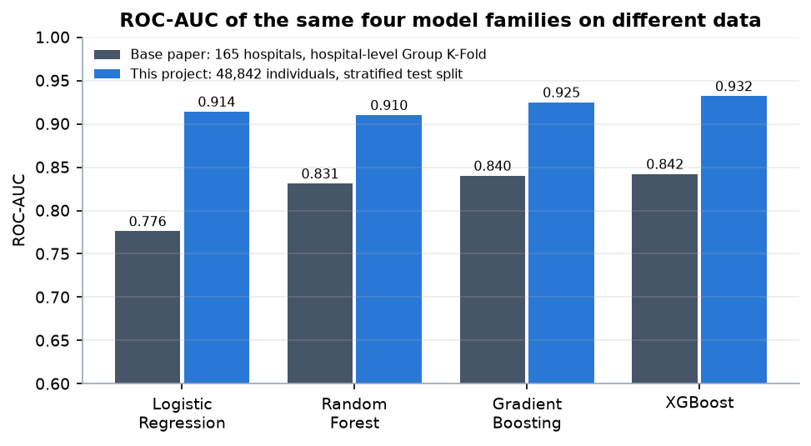
Figure 21: ROC-AUC of the same four model families in the base paper and in this project (different data and protocols)
Table 10: What differs between the two studies
Aspect | Base paper | This project
Unit of analysis | Hospitals (organisations) | Individual people
Data | 165 Korean hospitals, 825 hospital-year rows, 2019-2023, 236 line items reduced to 11 features | UCI Adult / Census Income, 48,842 rows from 1994, 14 raw fields expanded to 26 columns
Target | Annual deficit (net income below zero), 41.2% positive | Income above 50K, 23.9% positive; mapped to a profile band, not a distress label
Validation | Hospital-level Group K-Fold (primary), temporal hold-out 2019-22 to 2023, stratified K-Fold for reference | Stratified 80/20 split and stratified 5-fold CV; one row per person, so no entity grouping and no temporal split
Further analyses | Counterfactual subsidy analysis, panel fixed-effects regression, DeLong tests, Altman Z'' baseline | Not reproduced; SHAP, a logistic-regression table, a what-if screen, calibration and threshold analysis instead
Deliverable | A framework and findings | A working web application around the same framework

Three observations can be drawn. First, the ordering of the families is similar: gradient-boosted trees lead and the linear model trails, although in this project Random Forest falls below Logistic Regression while in the base paper it sits between boosting and the linear baseline. Second, the gap between boosting and the linear baseline is much smaller here (0.018 AUC) than in the base paper (0.066), consistent with a large, mostly categorical person-level data set in which main effects explain most of the signal. Third, the absolute AUCs (0.932 against 0.842) must not be compared as a measure of skill: they are computed on different populations and different targets, with a much larger sample and a less demanding protocol here. The base paper's own contrast between random and entity-grouped validation (0.860 to 0.831 for Random Forest) shows how much the protocol alone can move AUC. What this project adds to the base paper is not a better number but the extension of the approach to individuals and its delivery as an explainable application.

8.4 Sample inputs and outputs
Five profiles were sent to the running API (POST /api/predict) by scripts/error_analysis.py; the table lists the inputs and the output of the system, copied from artifacts/sample_predictions.json. Profile A is the first record of the Adult data set; the others were written to span the range of outputs.
Table 11: Sample profiles and the system's output
ID | Inputs | Strength | Profile / risk
A | 39, State-gov, Bachelors, Never-married, Adm-clerical, Male, gains 2,174, losses 0, 40 h | 1.1% | Emerging / High
B | 52, Private, Masters, Married-civ-spouse, Exec-managerial, Male, gains 7,688, losses 0, 50 h | 99.9% | Established / Low
C | 34, Local-gov, Some-college, Married-civ-spouse, Sales, Female, gains 0, losses 0, 42 h | 46.8% | Developing / Moderate
D | 22, Private, HS-grad, Never-married, Other-service, Female, gains 0, losses 0, 20 h | 0.0% | Emerging / High
E | 45, Self-emp-inc, Doctorate, Divorced, Prof-specialty, Male, gains 0, losses 1,902, 55 h | 81.0% | Established / Low

Table 12: Strongest drivers reported for each sample (two strengthening, one weakening)
ID | SHAP contributions (log-odds)
A | Years of education (+0.545); Age (+0.184); Investment gains (-1.626)
B | Investment gains (+4.678); marital status = Married-civ-spouse (+1.004); Overall investment activity (-0.243)
C | marital status = Married-civ-spouse (+0.836); relationship = Wife (+0.553); Investment gains (-0.156)
D | occupation = Machine-op-inspct (+0.020); occupation = Farming-fishing (+0.012); Age (-1.558)
E | Years of education (+1.812); Investment losses (+1.125); marital status = Married-civ-spouse (-1.466)

The five outputs behave sensibly. Profile B (52, Masters, married, executive, gains 7,688) is near certain to be Established because the capital gain contributes +4.678 on the log-odds scale; Profile D (22, part-time, high-school graduate) is far below the Emerging threshold, with age the main weakening factor; Profile E combines a doctorate and long hours with a divorced status and investment losses and lands in Established with a mixed explanation (education +1.813, losses +1.125, a pattern learned from the training data and not advice to incur losses, against marital status -1.466). Profile C falls in the Developing band. The what-if comparison shown in Section 8.1, applied to Profile A, with gains of 80,000 and 50 weekly hours, moved the score from 1.1% to 99.5% (+98.43 percentage points).

8.5 Success and failure analysis

Where the model succeeds
The model is right on 8,579 of 9,769 test records and is confident when it is right: its mean confidence (the probability it assigns to the class it predicts) is 0.903 on correct predictions against 0.701 on errors. 5,907 correct predictions have confidence of at least 0.9 while only 127 errors do, so a very confident prediction is wrong about once in 47 cases. The Emerging band is the strongest: 7,123 rows, of which 7.2% are actually above 50K. The Adult data also contain an awkward spike at an investment gain of 99,999 (a value that appears to be a censoring code): all 63 test rows with that value are above 50K, which is consistent with the model treating a very large gain as a strong positive signal.

Where the model fails
Of the 1,190 errors, 349 are low-confidence (below 0.6) and 1,232 test rows lie in the borderline probability range of 0.35 to 0.65, which is where most mistakes concentrate. The most confident mistakes are listed below. They are mostly cases where a single dominant attribute, usually capital gain, contradicts the label: the model sees a large capital gain (or, in the third case, a reported investment loss, which it also associates with higher incomes) and says 'above 50K', while the person's recorded income is below; the false negatives are young, unmarried or part-time workers whose recorded income is nonetheless high. Both kinds are individually plausible and show a limit of an eleven-attribute census profile: it cannot see the factors that actually separate such people.
Table 13: Most confident errors on the test split (FP: predicted above 50K, actually at most 50K; FN: the reverse)
Case | Record | P(above 50K)
FP1 | 55, Self-emp-not-inc, HS-grad, Divorced, Exec-managerial, Male, gains 34,095, losses 0, 60 h | 0.9944
FP2 | 63, Self-emp-not-inc, Masters, Married-civ-spouse, Farming-fishing, Male, gains 41,310, losses 0, 50 h | 0.9786
FP3 | 57, Private, Assoc-voc, Married-civ-spouse, Prof-specialty, Male, gains 0, losses 1,902, 45 h | 0.9726
FN1 | 26, Private, Bachelors, Never-married, Adm-clerical, Female, gains 0, losses 0, 40 h | 0.0064
FN2 | 23, Local-gov, Some-college, Never-married, Protective-serv, Male, gains 0, losses 0, 40 h | 0.0082
FN3 | 67, Private, 11th, Married-civ-spouse, Other-service, Male, gains 0, losses 0, 9 h | 0.0123

Error rates by group
Because the model uses sex, marital status and age, the error rates were broken down by these groups on the test split. The table gives, for each group, the share who actually earn above 50K, the share the model predicts to, and the recall, false-positive rate and precision of the model. This is a descriptive check, not a fairness audit: no fairness criterion was set in advance and no mitigation was tried.
Table 14: Test-split outcomes by group (threshold 0.5)
Attribute | Group | Rows | Actually >50K | Predicted >50K | Recall | False-positive rate | Precision
Sex | Female | 3,289 | 11.2% | 8.3% | 59.1% | 1.9% | 79.5%
Sex | Male | 6,480 | 30.4% | 26.2% | 68.0% | 7.8% | 79.1%
Marital status | Married-civ-spouse | 4,428 | 45.2% | 40.7% | 70.5% | 16.1% | 78.3%
Marital status | All other statuses | 5,341 | 6.3% | 3.1% | 43.6% | 0.4% | 88.5%
Education tier | Secondary-or-below | 4,450 | 13.4% | 5.9% | 35.8% | 1.2% | 81.6%
Education tier | Higher-secondary | 2,841 | 20.2% | 16.8% | 61.6% | 5.5% | 74.0%
Education tier | Tertiary | 2,478 | 47.2% | 49.6% | 84.8% | 18.2% | 80.7%
Age band | 18-25 | 1,969 | 1.8% | 0.7% | 34.3% | 0.1% | 92.3%
Age band | 26-35 | 2,501 | 18.8% | 13.8% | 57.2% | 3.7% | 78.0%
Age band | 36-50 | 3,296 | 36.1% | 32.2% | 71.1% | 10.3% | 79.6%
Age band | 51-65 | 1,642 | 34.2% | 29.8% | 68.5% | 9.7% | 78.6%
Age band | 65+ | 361 | 22.7% | 16.1% | 57.3% | 3.9% | 81.0%

The disparities are large and they follow the data. In the test split 11.2% of women and 30.4% of men earn above 50K; the model predicts 8.3% and 26.2%. Its precision is almost identical for the two groups (79.5% and 79.1%), but recall is lower for women (59.1% against 68.0%), so high-earning women are missed more often than high-earning men. Married civilian-spouse households have a recall of 70.5% but also a false-positive rate of 16.1%, while every other marital status has a recall of only 43.6% and a false-positive rate of 0.4%: the model leans heavily on being married. Recall also rises steeply with education tier (35.8% for secondary or below, 84.8% for tertiary) and with age band (from 34.3% at 18-25 to 71.1% at 36-50). In plain terms, the model reproduces a historical income pattern in which men, married people, graduates and the middle-aged more often earn above 50K, and it is least able to recognise a high earner who is young, unmarried, a woman or has little formal education. That is a property of the 1994 data and of the model's reliance on it, and it is the main reason the application is described throughout as informational and not as a basis for decisions about individuals.

Extrapolation and the what-if screen
The what-if results (+98.43 and +98.26 points in the examples above and in Chapter 7) are a different kind of failure. Raising investment gains from a few thousand to tens of thousands or a million moves the score to the top of the scale because in the training data almost everyone with large gains earns above 50K. The model has not learned that a person can raise their own gains; it has learned a correlation, and the what-if screen applies it as if it were an intervention. The interface labels the result as a simulation; the numbers should be read as 'people with such gains in this data are almost all high earners', never as 'what you would earn if you changed this'.

8.6 Limitations of the results
• Different target from the objective. The model predicts income above 50K. It is a financial-profile signal built from census attributes, not a credit-default or distress model, and the report makes no claim about repayment.
• Dated, single-source data. The training data are 1994 US census records. Accuracy figures say how well the model reproduces that data, not how it would perform on a current or non-US population.
• Synthetic forecast. The forecast component was validated only against its own generator. Real economic indicators were not used.
• Selection on the test split and no tuning. The best model was chosen by test ROC-AUC, hyperparameters were fixed, and no significance test was run; the cross-validated AUC (0.929) is the safer estimate.
• Single random split. One stratified split and one cross-validation were run with one random seed (42). The variability across splits was not measured beyond the fold standard deviations.
• No fairness audit. Section 8.5 shows large group differences in recall and in predicted positive rate. They were measured but not corrected.
• Modest recall. About one in three high-income people is missed at the default threshold; the threshold can be lowered at the cost of precision.
• Uncertain generalisation of scenarios. What-if scores far from the bulk of the training data are extrapolations.

8.7 Objectives versus outcomes
The six objectives are those recorded in the project's objectives document. The table states plainly what was achieved against each.
Table 15: Objectives versus outcomes
No. | Objective | Status | Outcome
1 | Collect a dataset combining demographic attributes with financial and transactional parameters. | Met in part | UCI Adult / Census Income, 48,842 individual records with age, education, occupation, location (native country), and capital gains and losses. It has no transaction-level data, so the 'transactional parameters' part is not met.
2 | Preprocess the data, handle missing values and encode categorical demographic fields. | Met | '?' markers turned into missing values, median / 'Unknown' imputation and one-hot encoding inside each scikit-learn Pipeline, and 12 interpretable derived features.
3 | Train models to classify financial profile and estimate credit or distress risk. | Met in part | Four classifiers trained; XGBoost selected. The target is income above 50K, mapped to Emerging / Developing / Established profiles with Low / Moderate / High risk bands. It is not a credit-default or distress label.
4 | Build a forecasting component that projects future financial position. | Met in part | Holt-Winters 12-month forecast with a 95% band is built and served, but on a documented synthetic Household Financial Conditions Index; it does not forecast an individual's own finances.
5 | Add an explainability layer showing which factors drove each assessment. | Met | SHAP global importance, live per-assessment SHAP contributions in plain language, and a labelled non-causal what-if comparison.
6 | Evaluate using accuracy, precision, recall and ROC-AUC, and deploy through a web interface. | Met | Accuracy, precision, recall, F1 and ROC-AUC reported for all four models; the system is deployed as a Flask API with a React interface on ports 8409 and 5409.

Three of the six objectives are met in full and three in part. The parts that were not met share one cause: the project used a public census data set instead of a data set that combines demographic and transactional or credit-history variables, and no such data set was available openly. The consequences are that the classifier answers 'how does this profile compare with higher-earning profiles' instead of 'how likely is distress or default', and that forecasting is demonstrated on an aggregate index, not on a person's finances. Within those limits, the system delivers what was promised: a working, explainable, evaluated and deployed pipeline from demographic input to profile, explanation and forecast.

