AI POWERED CROP DISEASE DETECTION AND RECOMMENDATION SYSTEM FOR SUSTAINABLE DEVELOPMENT
Results
Department of Computer Science and Engineering, [COLLEGE NAME]
Batch C16 (CSE-C) · Academic year [ACADEMIC YEAR]
Table 1: Project team
S.No. | Student name | Roll number
1 | Pishke Vishal | 23K91A05J2
2 | Kyatham Nithisha | 23K91A05D1
3 | Mekala Tharun Kuruma | 23K91A05F1
4 | Nakka Sreenith | 23K91A05H0

Project guide: V Krishna Teja
Chapter and section numbers quoted in the text (for example Chapter 8 or Section 6.2) refer to the full project report, 17.Final Document. Figures and tables in this document are numbered from 1.

1. RESULTS AND OUTPUT SCREENS
This chapter reports what AgriVision does when it is run: the screens a farmer sees, followed by the measured accuracy of the diagnosis. The two must be read together. The screens show a complete, working application. The measurements show that the diagnosis engine installed in it is not accurate, and what accuracy a trained network can reach on the same photographs. All accuracy figures are measured on the 236 photographs of the PlantDoc test folder; none of these photographs was used to fit or to select any model.

1.1 What was measured and how
Four things were measured, all by scripts/run_experiments.py on Intel Core i5-12500 (6 cores, 12 threads), 15.7 GB RAM, Windows 11 Pro, CPU only (no GPU); software versions are listed in Chapter 6.
Table 2: Engines evaluated
Engine | What it is | In the application? | Runs
Heuristic | Colour and texture score in agrivision/inference.py | yes (the only engine that ships) | 5 PYTHONHASHSEED values; 0 is what run.bat uses
Compact CNN | Network of agrivision/train.py, 189,655 parameters, trained here | no (agrivision/models/ is empty) | 3 seeds (42, 43, 44); 10 % of the training folder held out for early stopping
MobileNetV2 | ImageNet weights, new 27-way head, top 30 layers fine-tuned | no (reference experiment) | 3 seeds
Colour/texture classifiers | Random forest and logistic regression on hand-made features | no (baseline) | 1 run each (seed 42)

Metrics: top-1 accuracy, top-3 accuracy, macro-F1 (mean of the per-class F1 over the 27 classes that have test photographs), crop-level accuracy (was the right crop named?) and healthy-versus-diseased accuracy. Chance and trivial baselines for the same split: always answering the most frequent class (Corn leaf blight, 12 photographs) gives 5.1 %; guessing uniformly among the 38 classes gives 2.6 %; guessing uniformly among the candidate classes of the right crop gives 36.0 %; always answering 'diseased' gives 61.9 % healthy-versus-diseased accuracy.

1.2 Output screens
The screens were captured at 1440 x 900 pixels (one at phone width) from the running application, signed in as the demonstration farmer, with real PlantDoc test photographs uploaded through the interface or the API so that the dashboard, history and analytics are not empty. Every result shown was produced by the heuristic engine; the sidebar says so on every screen ('Engine: colour/texture heuristic. No trained CNN is installed, so treat results as a first screen and confirm with your agri officer').

1.2.1 Landing, registration and sign-in
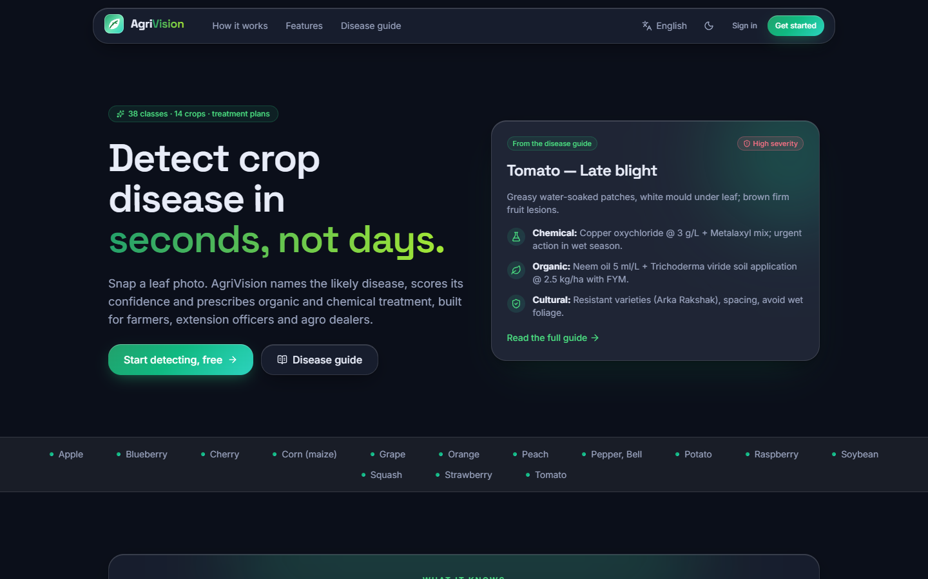  Figure 1: Landing page, dark theme: headline, call to action and the live counters (38 classes recognised). | 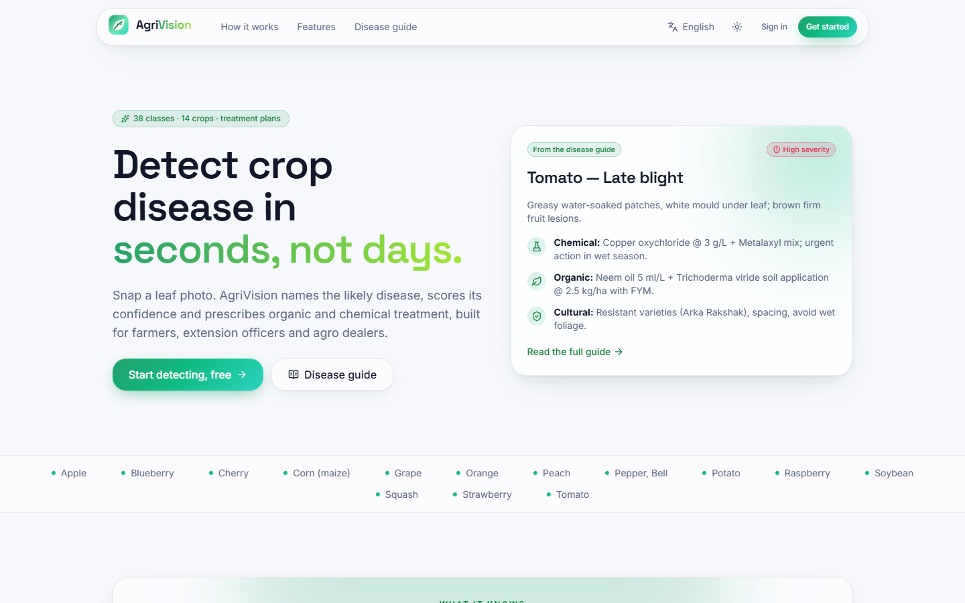  Figure 2: Landing page, light theme; the theme choice is remembered between visits.

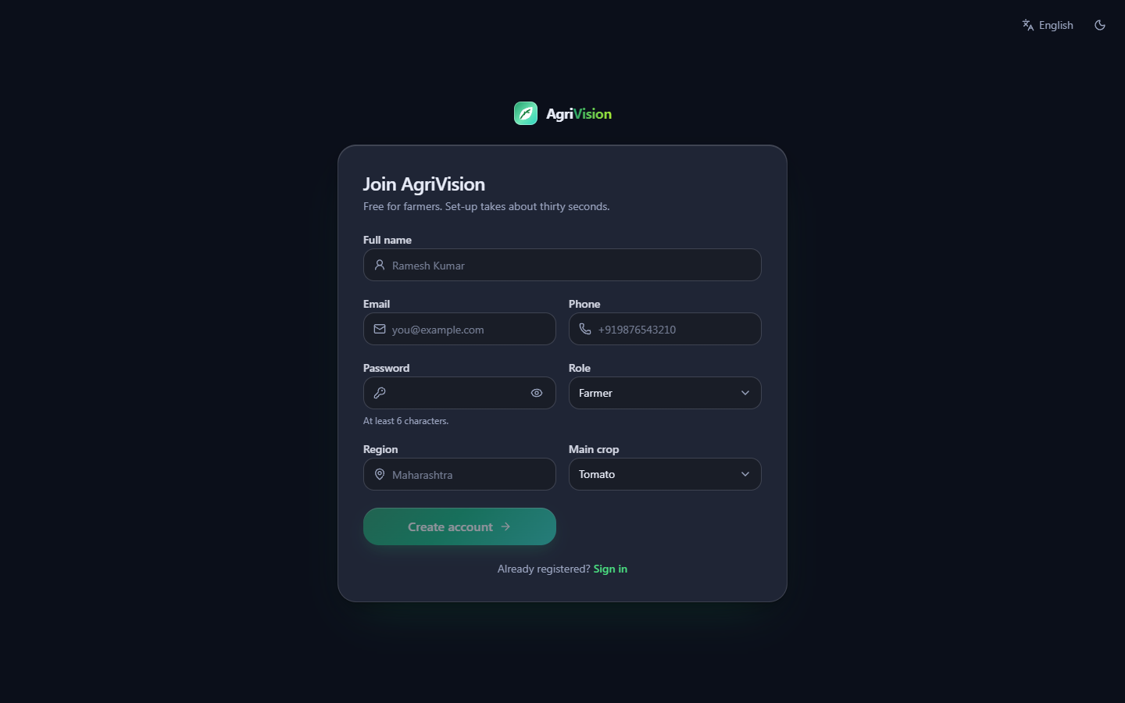  Figure 3: Register: name, email, password, region, language and main crop; the account is created with the role 'farmer'. |   Figure 4: Sign in, with the demonstration account shown as a hint; a wrong password shows the API's message.

1.2.2 Diagnosis
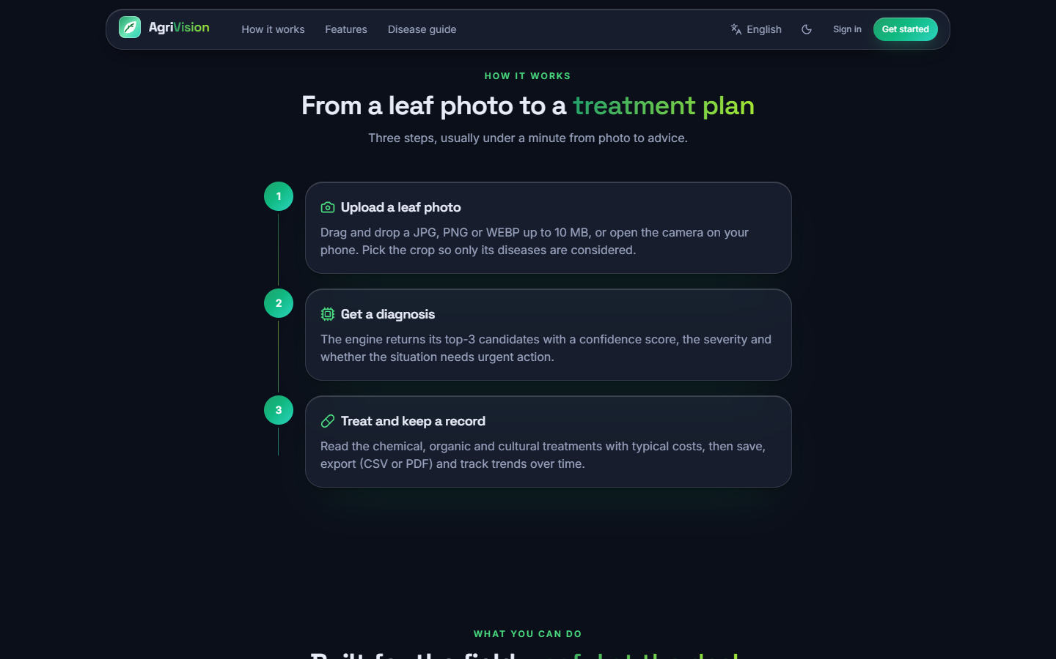  Figure 5: Landing page, 'how it works': upload, analyse, act - the three steps the application really performs. | 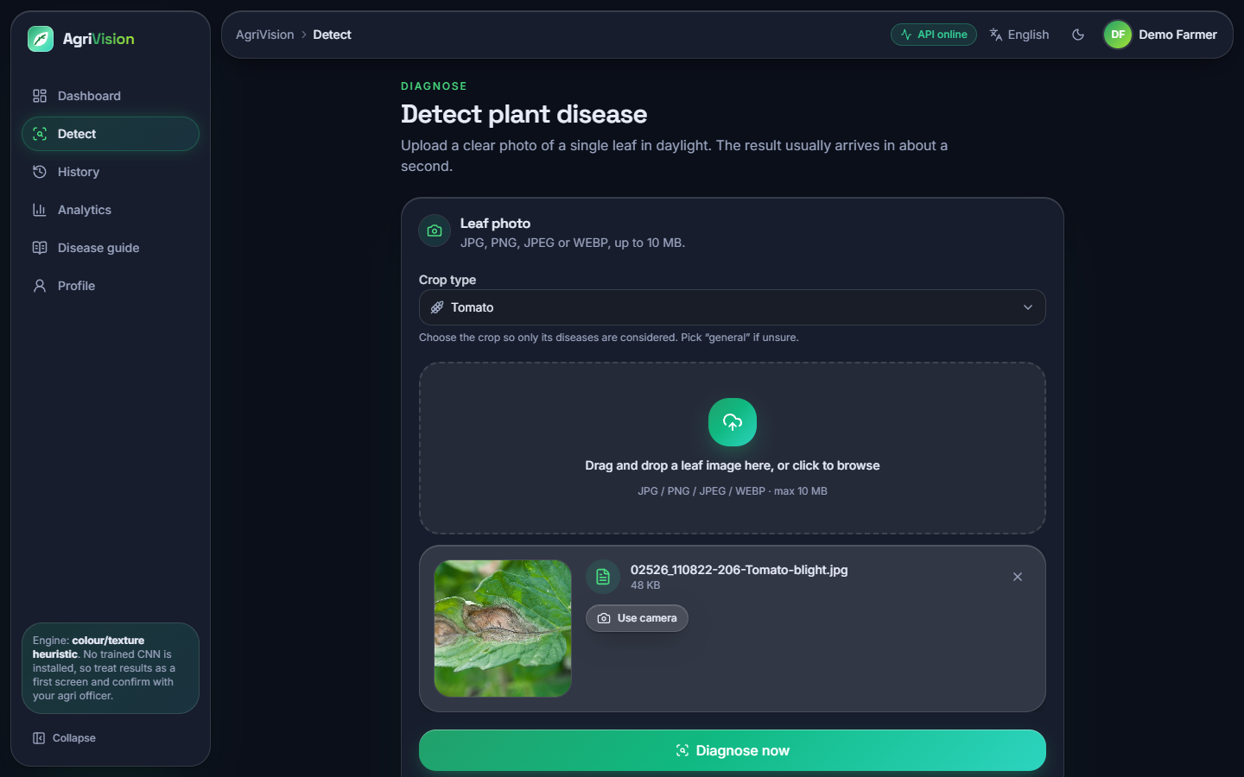  Figure 6: Detect screen with a PlantDoc leaf chosen and the crop selected: JPG, PNG, JPEG or WEBP up to 10 MB are accepted.

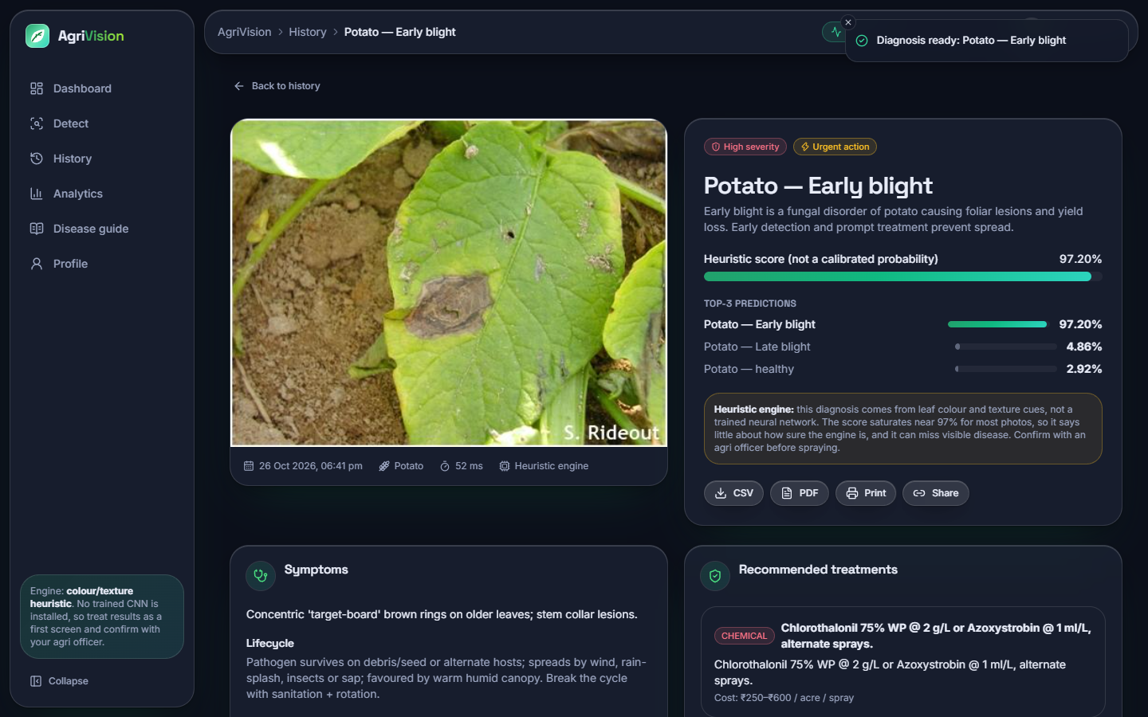  Figure 7: Result for a Potato early blight photograph (correct): the top-1 class, severity high, 'urgent action' badge, the top-3 list and the engine note. | 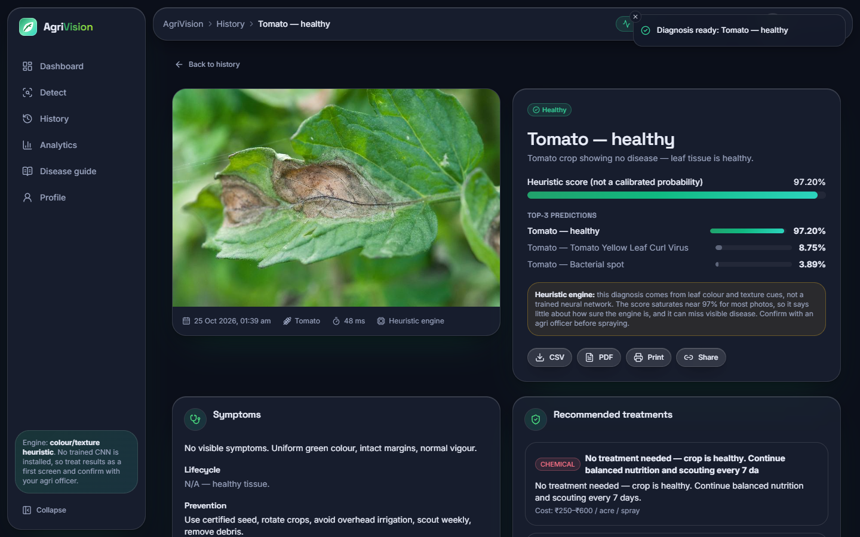  Figure 8: Result for a Tomato late blight photograph: the engine answers 'Tomato - healthy' with 97.20 %, a wrong answer shown with the same confidence as a right one.

Both results show the same layout: the class, a confidence bar labelled 'Heuristic score (not a calibrated probability)', the top-3 predictions, the amber engine note, buttons for CSV, PDF, print and share, then the symptoms, lifecycle, prevention and the recommended treatments (chemical, organic and cultural, each with a cost per acre in rupees). For the correct case the advice is the knowledge-base card for early blight; for the wrong case it is the card for a healthy tomato, 'No treatment needed', which is the harm a wrong answer does.
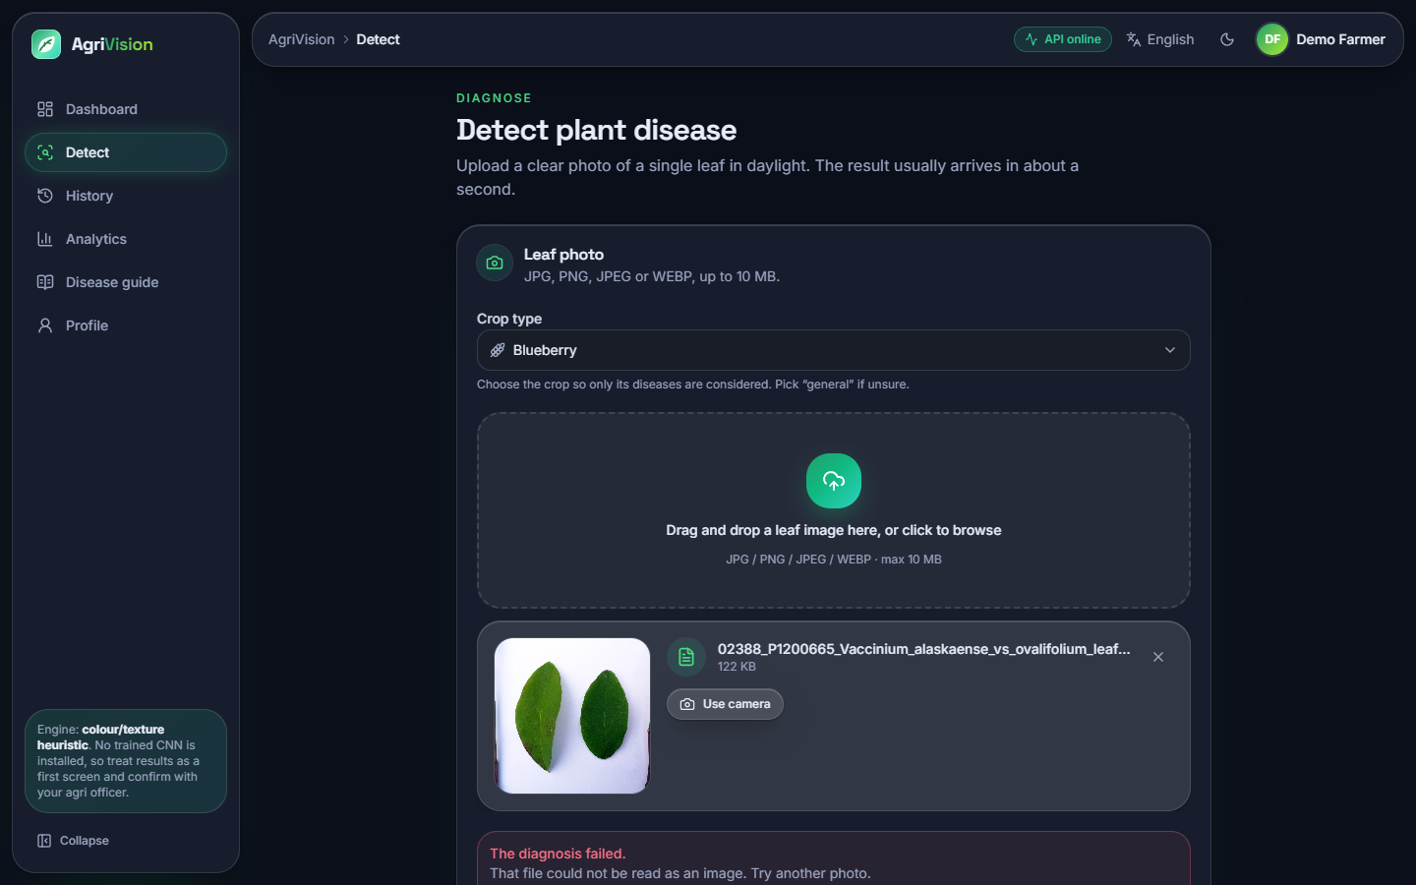  Figure 9: Detect with the crop set to Blueberry: 'The diagnosis failed. That file could not be read as an image' for a valid photograph (defect D1). | 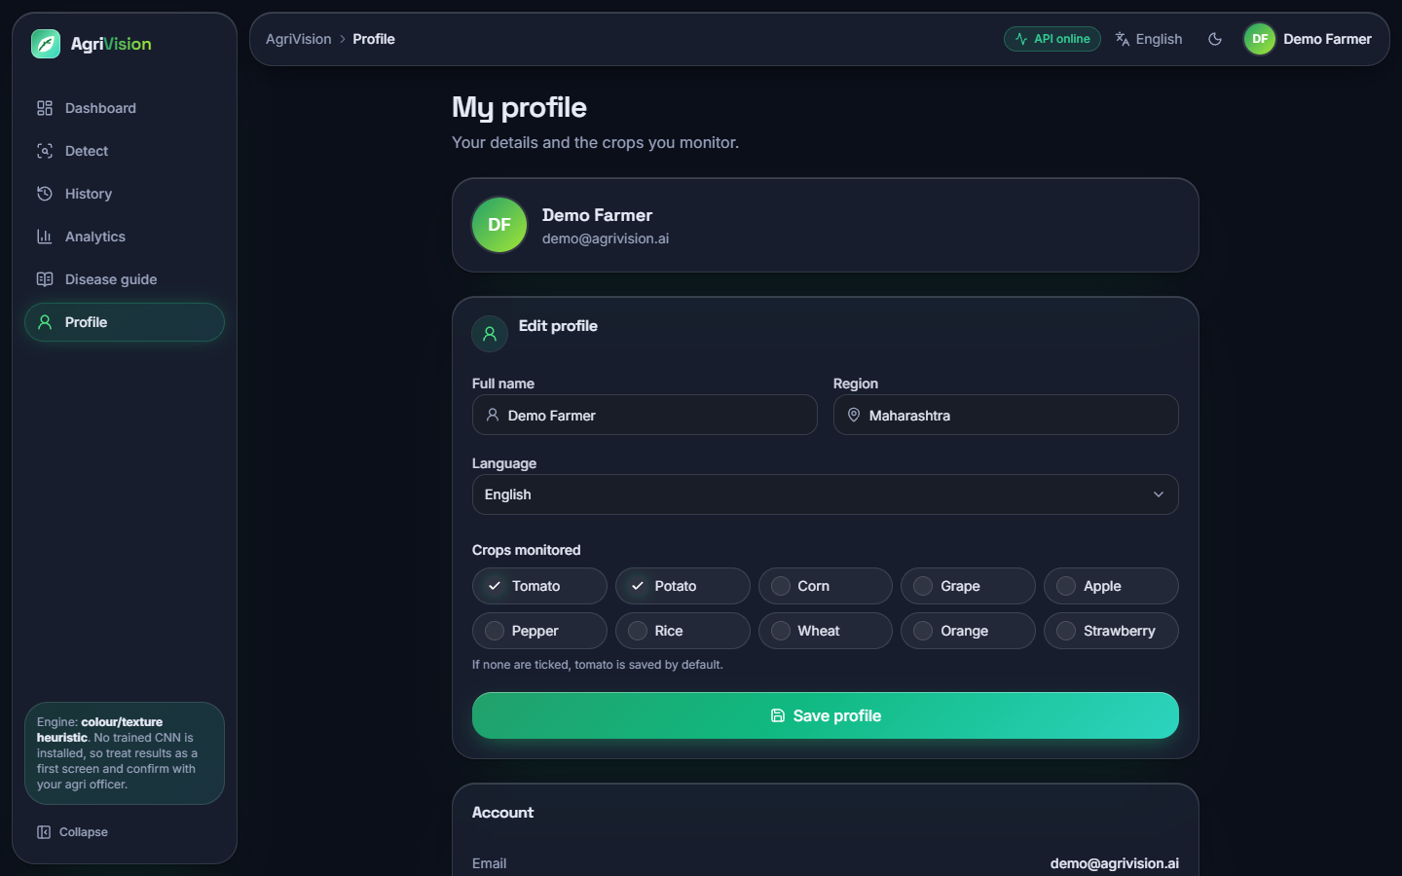  Figure 10: Profile: name, region, interface language (English, Hindi, Marathi) and crops of interest; the language is saved to the account.

1.2.3 Dashboard, history, analytics and profile
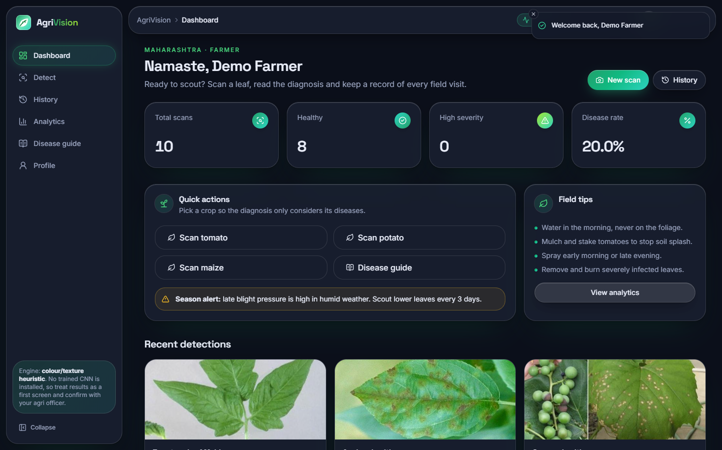  Figure 11: Dashboard, dark: total scans, healthy count, high-severity count, disease rate, quick actions and recent detections. | 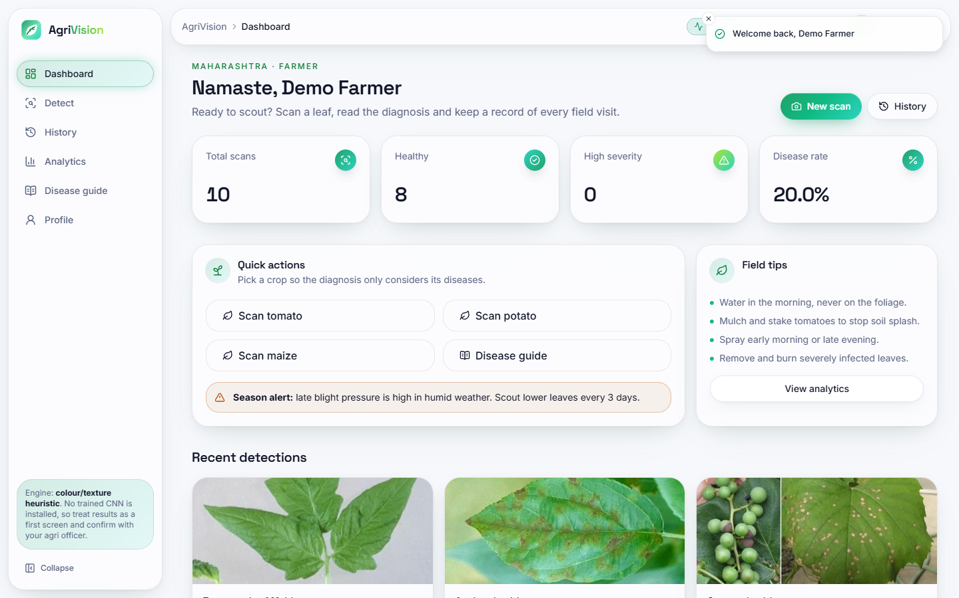  Figure 12: Dashboard, light theme.

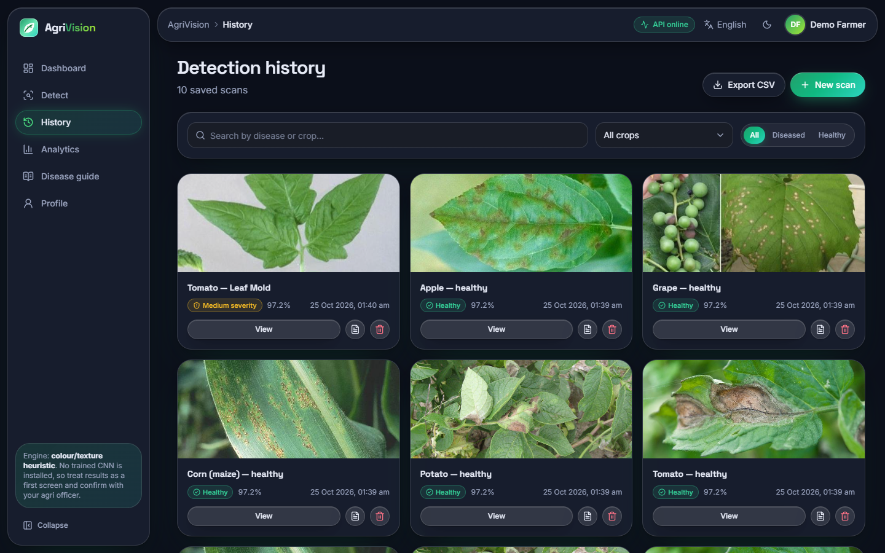  Figure 13: History: one card per scan with image, class, severity, score and date; search, crop filter, All / Diseased / Healthy switch, per-scan PDF and delete, CSV export. | 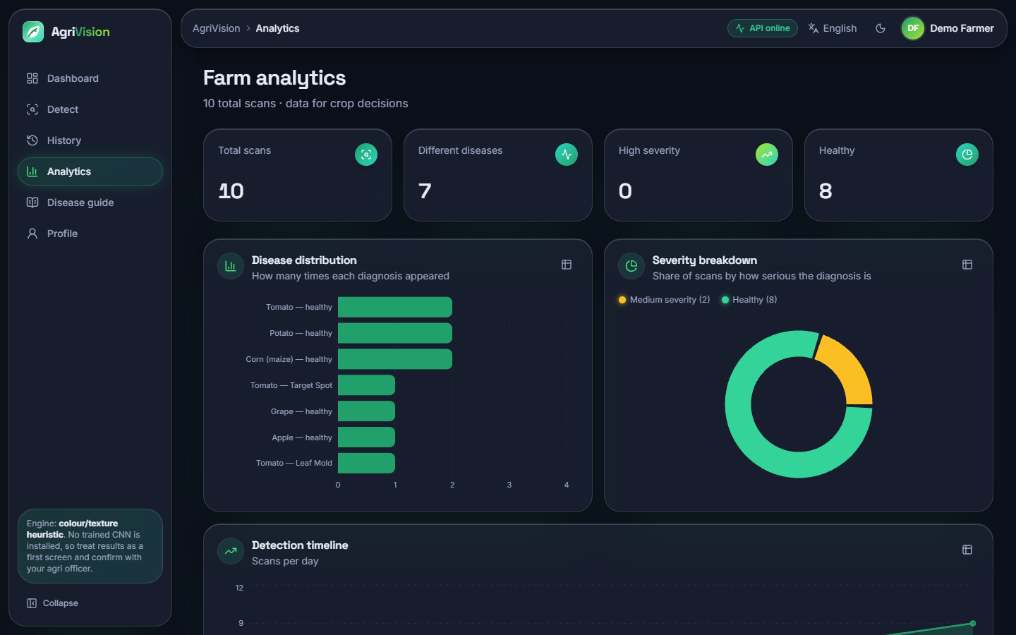  Figure 14: Analytics: disease distribution, severity split and a timeline of scans from the user's own history (Recharts).

1.2.4 Disease guide
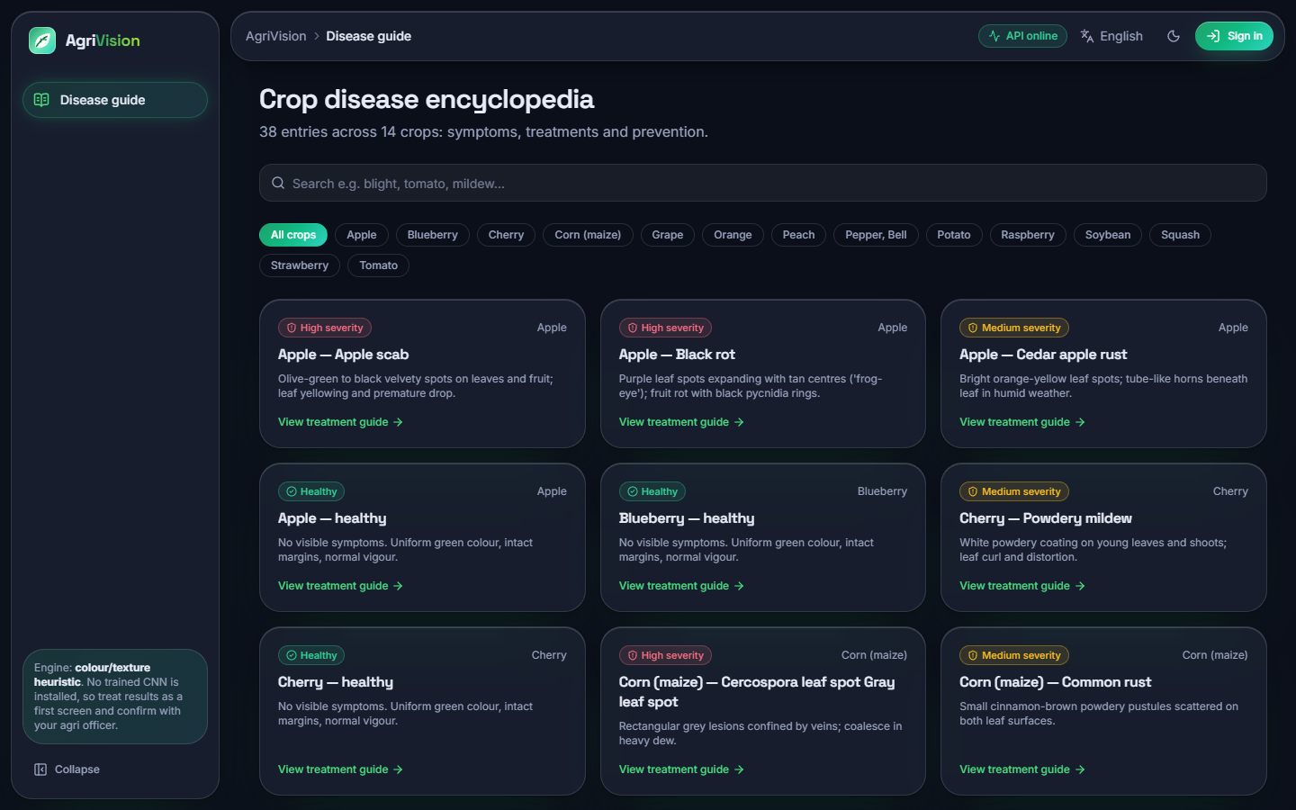  Figure 15: Disease guide: the 38 classes with search and crop filter; it needs no sign-in. | 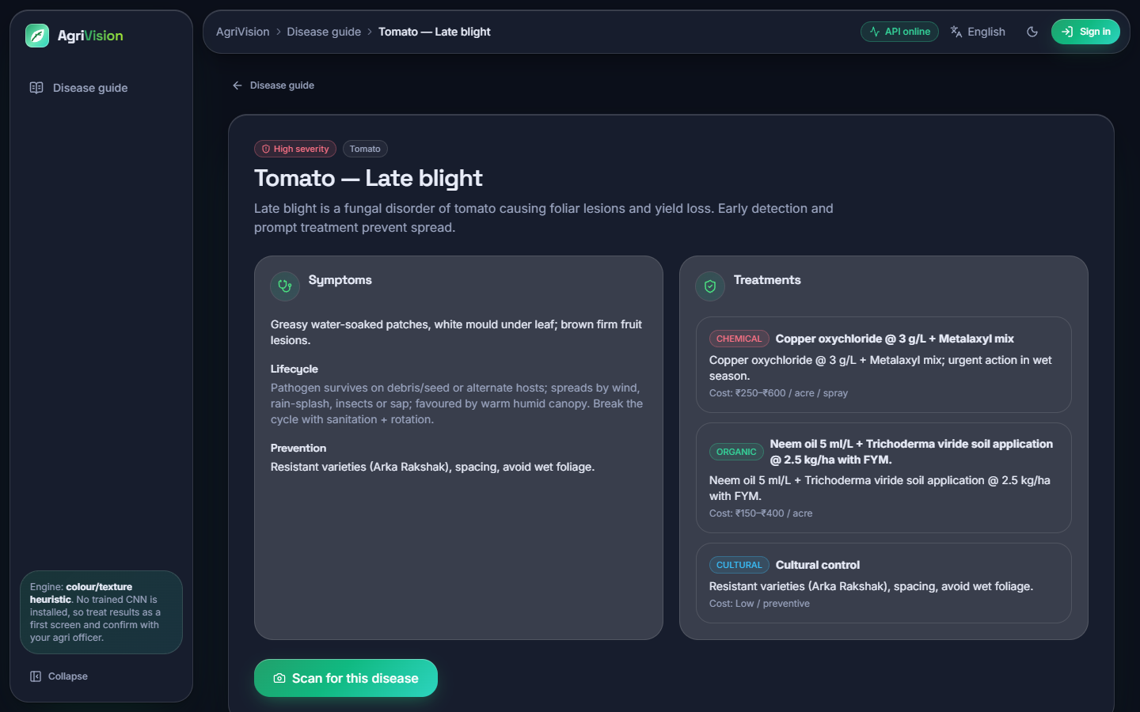  Figure 16: Disease detail (Tomato late blight): symptoms, lifecycle, three treatment options with costs and prevention.

1.2.5 Other languages and phone width
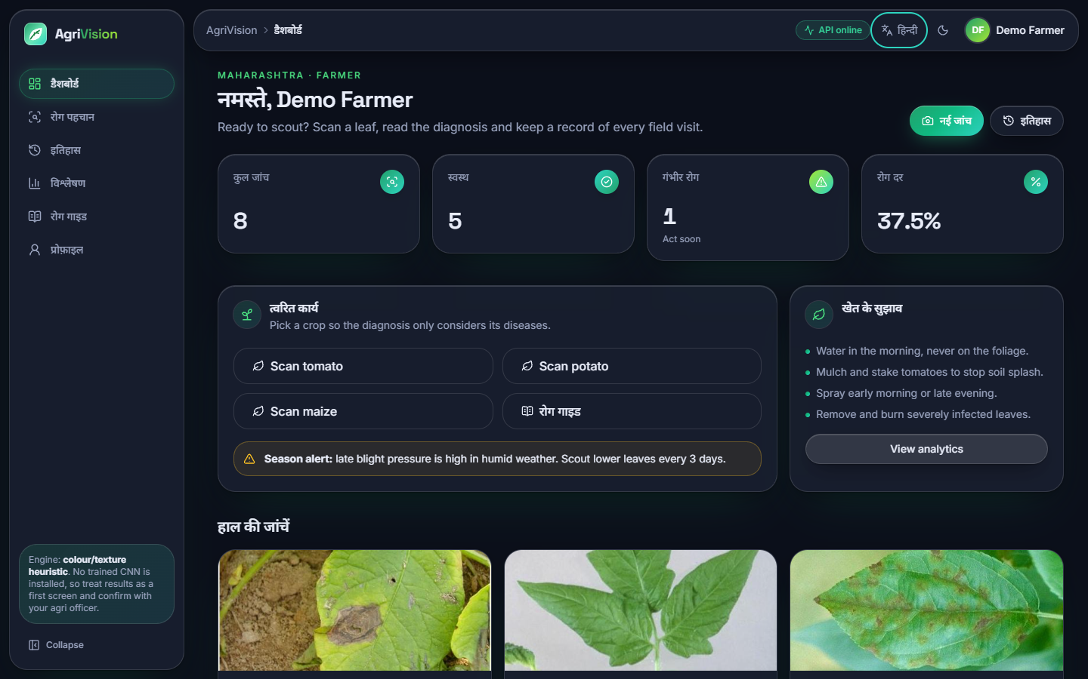  Figure 17: Dashboard with the Hindi interface: menus, headings and counters are translated; the sentences below them stay in English because only 44 interface strings are translated. | 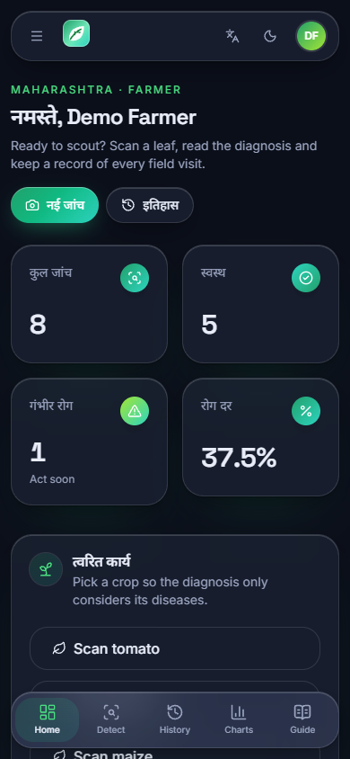  Figure 18: Dashboard at phone width (390 x 844 px, Hindi interface): the sidebar becomes a bottom navigation bar and the cards stack in one column.

1.3 Dataset used for the measurements
PlantDoc [4] is a set of photographs of leaves collected from the web, with real backgrounds, hands, soil, several leaves per photograph and uneven lighting. The local copy has 2,342 training and 236 test photographs in 28 training folders; the test folder has 27 because it contains no photograph of Tomato two-spotted spider mites (the training folder has only two). Class sizes range from 2 to 180 training photographs (Figure below); the test folder has 4 to 12 photographs per class, so one photograph moves a class's recall by 8 to 25 percentage points. Ten of the folders are healthy leaves and 18 are diseased; the test set holds 90 healthy and 146 diseased photographs.
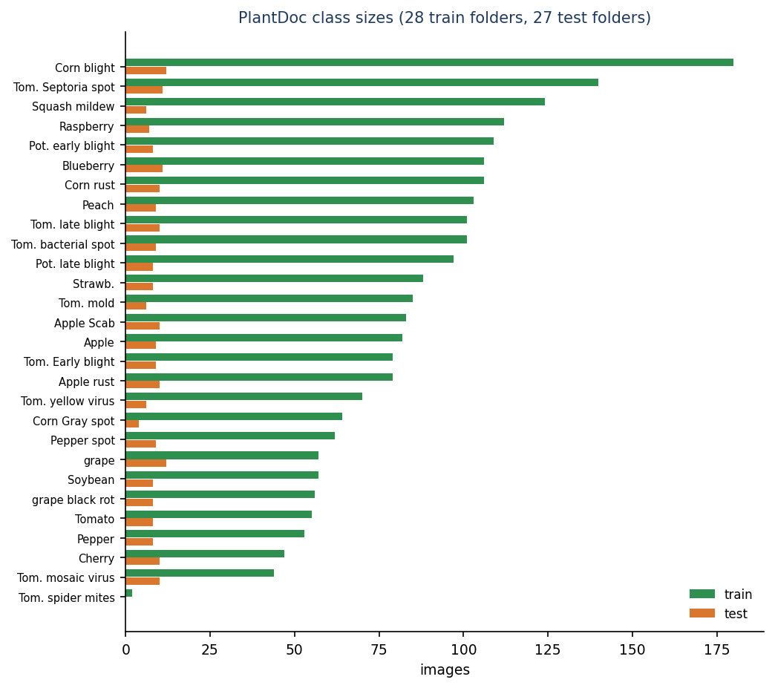
Figure 19: PlantDoc class sizes in the local copy: 28 training folders and 27 test folders.
The 28 folders map one to one onto the 38 classes of the knowledge base; ten knowledge-base classes (for example Apple black rot, Grape esca, Potato healthy, Tomato target spot) have no PlantDoc photograph and could not be measured.

1.4 The diagnosis engine that ships: the heuristic
With the right crop chosen, as a farmer would, the heuristic names the correct class for 9.1 ± 1.0 % of the test photographs (mean and standard deviation over five hash seeds; 10.6 % with seed 0, the value run.bat fixes). The right class is among its top three for 34.9 ± 1.6 %, the right crop is named for 67.8 ± 0.0 % and the macro-F1 is 0.090 ± 0.015. With the crop left on 'general' it names the correct class for 1.3 ± 0.7 %, below the 2.6 % expected from guessing among 38 classes.
Table 3: Heuristic engine on the PlantDoc test split (236 photographs; five hash seeds)
Measure | Crop chosen | Crop 'general'
Top-1 accuracy | 9.1 ± 1.0 % | 1.3 ± 0.7 %
Top-3 accuracy | 34.9 ± 1.6 % | 4.2 ± 0.8 %
Macro-F1 | 0.090 ± 0.015 | 0.014 ± 0.007
Right crop named | 67.8 ± 0.0 % | 12.2 ± 0.6 %
Healthy-versus-diseased accuracy | 35.1 ± 0.9 % | 33.1 ± 0.3 %
Healthy leaves called healthy | 10.2 ± 0.8 % | 20.0 ± 0.0 %
Diseased leaves called diseased | 50.4 ± 1.1 % | 41.2 ± 0.5 %
Photographs given no answer | 32.2 % | 0.0 %
Top-1 accuracy among answered photographs | 13.4 ± 1.5 % | 1.3 ± 0.7 %

Three findings follow. First, the accuracy is below what guessing within the right crop would give (36.0 %); part of the reason is the 32.2 % of photographs on which the engine fails (defect D1), but even among the photographs it answers only 13.4 ± 1.5 % are right. Second, the engine does not separate healthy from diseased leaves: only 10.2 ± 0.8 % of healthy leaves are called healthy, and the healthy-versus-diseased accuracy of 35.1 ± 0.9 % is lower than the 61.9 % obtained by always saying 'diseased'. Third, the answers are stable with respect to the only random element, the hash jitter: the standard deviation over five hash seeds is about one percentage point, so the low accuracy is not a seed effect.

1.5 The compact CNN of the training script
agrivision/train.py defines a small network of five depthwise-separable convolution blocks with batch normalisation, max pooling and dropout, a global-average-pooling head and a 256-unit dense layer, with flip, rotation, zoom and contrast augmentation inside the model. Counted by TensorFlow it has 189,655 parameters (the script's docstring says about 1.1 million, defect D6). It was trained on the 224 x 224 photographs with Adam at 1e-3, batch 32, up to 60 epochs with early stopping on the validation accuracy (patience 8) and learning-rate halving on a validation-loss plateau, for three seeds. Validation data were 10 % of the training folder, chosen per seed, never the test folder.
Table 4: Compact CNN on the PlantDoc test split
Run | Accuracy | Macro-F1 | Top-3 | Right crop | Healthy vs diseased | Epochs | Train time
Held-out validation, 3 seeds | 12.0 ± 0.5 % | 0.086 ± 0.010 | 30.9 ± 1.9 % | 26.0 ± 4.6 % | 76.8 ± 1.9 % | 28 | 478 s
Shipped protocol (test folder as validation), seed 42 | 13.6 % | 0.090 | 26.7 % | 25.4 % | 78.0 % | 31 | 520 s
No learning-rate decay, patience 20, seed 42 | 12.7 % | 0.092 | 29.7 % | 23.7 % | 74.6 % | 39 | 656 s

The network learns very little: training accuracy is only 22.2 ± 2.8 % and the best validation accuracy 18.7 ± 2.0 %, so it under-fits rather than memorises. Neither the shipped protocol (which selects checkpoints on the test photographs and so cannot be taken at face value, defect D5) nor a variant without learning-rate decay changes the picture: all runs lie between 11 and 14 % accuracy. On the test set 18 of the 27 classes have F1 = 0 for seed 42; the best are Tomato leaf yellow virus (0.67), Strawberry leaf (0.38), Corn rust leaf (0.27). The network does separate healthy from diseased better than the heuristic (76.8 ± 1.9 %) but mostly by calling leaves diseased (diseased recall 90.6 ± 2.3 %, healthy recall 54.4 ± 6.4 %). A single photograph takes a median of 70 ms on the CPU.
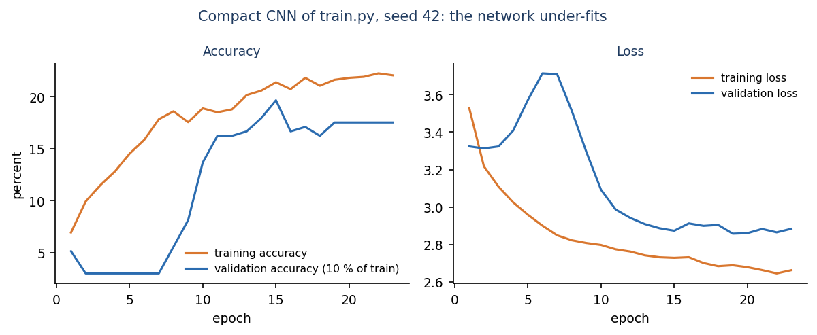
Figure 20: Training and validation accuracy and loss of the compact CNN, seed 42: both stay low.

1.6 MobileNetV2 with ImageNet weights
As a reference for what the same data can support, MobileNetV2 [9] pre-trained on ImageNet [13] was given a new 28-way output layer. First only the head was trained (up to 20 epochs, learning rate 1e-3), then the last 30 layers were unfrozen and trained at 1e-4 (up to 12 epochs), with the same augmentation and the same 10 % validation split. This is not part of the application; it measures what is within reach. The model has 2,293,852 parameters, trained in 723 s on average and needs a median of 89 ms per photograph on the CPU.
Table 5: MobileNetV2 on the PlantDoc test split (3 seeds)
Stage | Accuracy | Macro-F1 | Top-3 | Right crop | Healthy vs diseased
Head only | 48.7 ± 1.4 % | 0.467 ± 0.019 | - | - | -
Head + top 30 layers fine-tuned | 50.3 ± 0.9 % | 0.490 ± 0.010 | 79.8 ± 1.4 % | 71.8 ± 2.6 % | 88.8 ± 0.5 %

Accuracy is 50.3 ± 0.9 % with macro-F1 0.490 ± 0.010; the right class is among the top three for 79.8 ± 1.4 % of the photographs, the right crop is named for 71.8 ± 2.6 % and healthy and diseased leaves are told apart 88.8 ± 0.5 % of the time (healthy recall 85.6 ± 2.4 %, diseased recall 90.9 ± 1.2 %). Fine-tuning adds only about 1.6 points over the head alone. The three seeds give 51.3 %, 49.2 %, 50.4 % (Figure below), against 11.9 %, 12.7 %, 11.4 % for the compact CNN.
Table 6: Best and worst classes of MobileNetV2 (seed 42, F1 on the test photographs)
Best | F1 | n | Worst | F1 | n
Strawberry leaf | 1.00 | 8 | Bell pepper leaf spot | 0.00 | 9
grape leaf black rot | 0.93 | 8 | Tomato leaf bacterial spot | 0.00 | 9
grape leaf | 0.92 | 12 | Tomato leaf mosaic virus | 0.00 | 10
Corn rust leaf | 0.89 | 10 | Bell pepper leaf | 0.17 | 8
Raspberry leaf | 0.86 | 7 | Tomato mold leaf | 0.21 | 6
Squash Powdery mildew leaf | 0.80 | 6 | Blueberry leaf | 0.25 | 11

The easy classes are those with a distinctive crop and a large visible symptom (Strawberry, grape leaves and grape black rot, corn rust, raspberry, squash powdery mildew). The classes with F1 = 0 (tomato bacterial spot, tomato mosaic virus and bell pepper leaf spot) are diseases that look alike on a small leaf photograph: in the confusion matrix (Figure below) six of the nine bacterial-spot photographs are called Septoria leaf spot, three of the ten mosaic-virus photographs are called leaf mould, and the nine bell-pepper leaf-spot photographs are scattered over several tomato and apple classes. This agrees with the PlantDoc authors' remark that Tomato bacterial spot and Septoria are hard to separate by visual features alone.
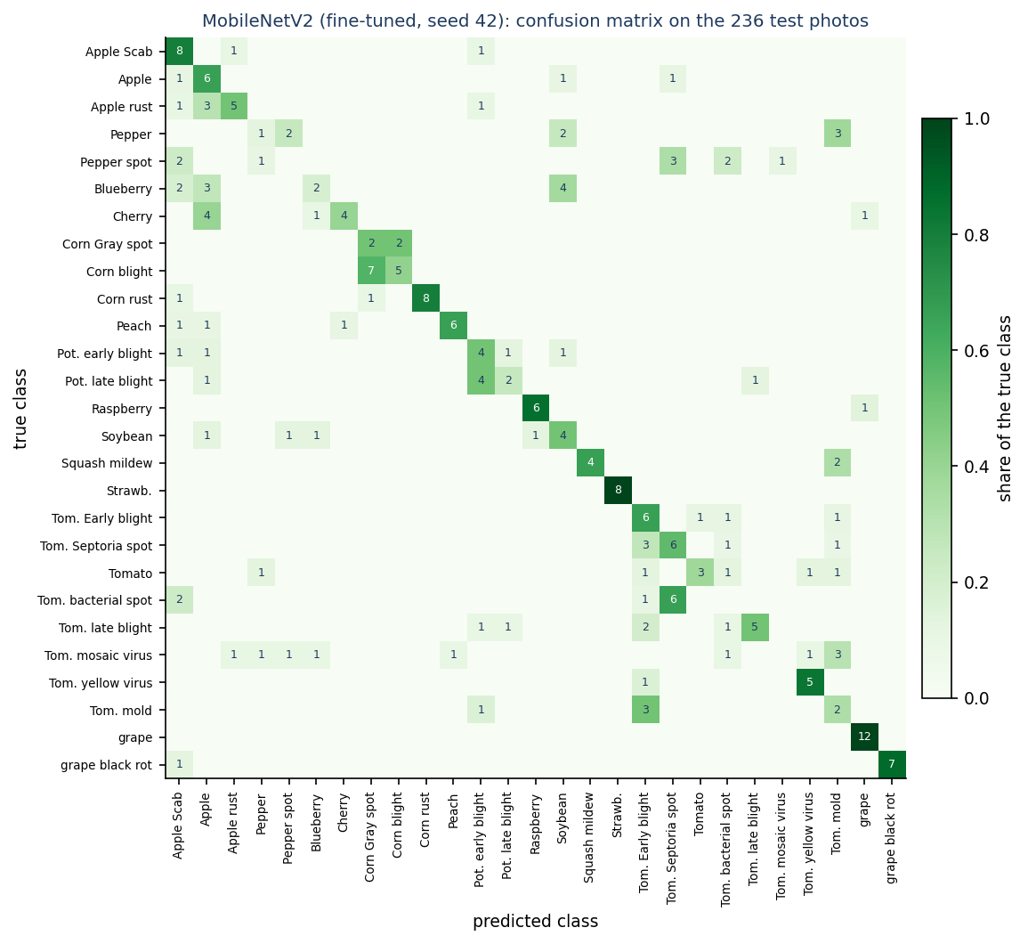
Figure 21: Confusion matrix of MobileNetV2 (seed 42) on the 236 test photographs; the diagonal holds the correct answers.
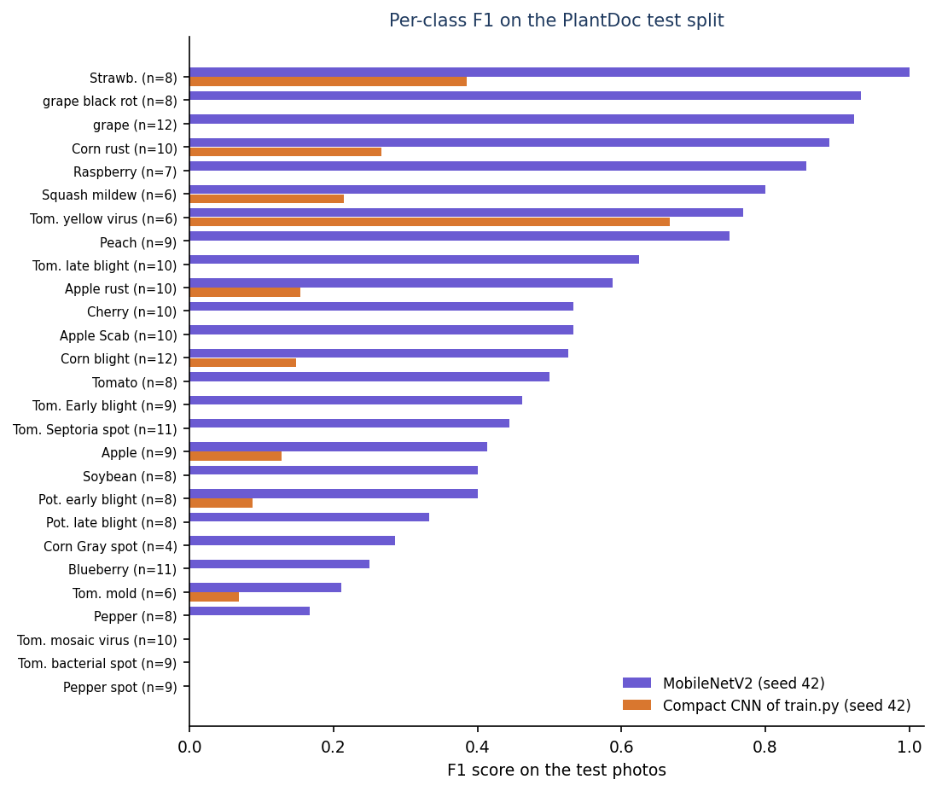
Figure 22: Per-class F1 of MobileNetV2 and of the compact CNN (seed 42); the number of test photographs is in brackets.
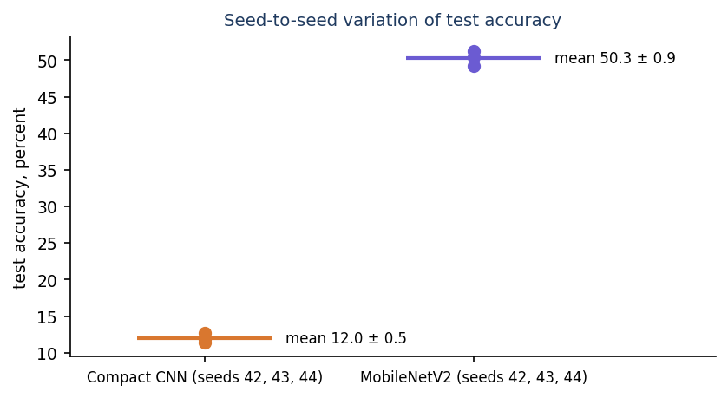
Figure 23: Test accuracy of the three training seeds of each network: the gap between the networks is far larger than the variation between seeds.

1.7 Colour-and-texture classifiers
To see how much a classifier can get from the same kind of cues as the heuristic, a random forest ([18], 300 trees) and a logistic regression were trained on 43 hand-made features per photograph (HSV histograms, grey-level mean and spread, edge-magnitude statistics and per-channel means and spreads). The random forest reaches 21.6 % accuracy with macro-F1 0.199, top-3 36.0 %, right crop 34.3 % and healthy-versus-diseased accuracy 79.7 %; the logistic regression reaches 13.1 % (macro-F1 0.120). Learning the weights from data roughly doubles what hand-set weights achieve, which supports the conclusion that the heuristic's rules, not just the dataset, are the weak point. Both stay far below a pre-trained network.

1.8 Comparison of all engines
Table 7: All engines on the PlantDoc test split
Engine | Accuracy | Macro-F1 | Top-3 | Right crop | Healthy vs diseased
Always the most frequent class | 5.1 % | - | - | - | 61.9 %
Shipped heuristic, crop chosen | 9.1 ± 1.0 % | 0.090 ± 0.015 | 34.9 ± 1.6 % | 67.8 ± 0.0 % | 35.1 ± 0.9 %
Shipped heuristic, crop 'general' | 1.3 ± 0.7 % | 0.014 ± 0.007 | 4.2 ± 0.8 % | 12.2 ± 0.6 % | 33.1 ± 0.3 %
Logistic regression on colour/texture | 13.1 % | 0.120 | 28.4 % | 23.7 % | 80.1 %
Compact CNN of train.py (3 seeds) | 12.0 ± 0.5 % | 0.086 ± 0.010 | 30.9 ± 1.9 % | 26.0 ± 4.6 % | 76.8 ± 1.9 %
Random forest on colour/texture | 21.6 % | 0.199 | 36.0 % | 34.3 % | 79.7 %
MobileNetV2 head only (3 seeds) | 48.7 ± 1.4 % | 0.467 ± 0.019 | - | - | -
MobileNetV2 fine-tuned (3 seeds) | 50.3 ± 0.9 % | 0.490 ± 0.010 | 79.8 ± 1.4 % | 71.8 ± 2.6 % | 88.8 ± 0.5 %

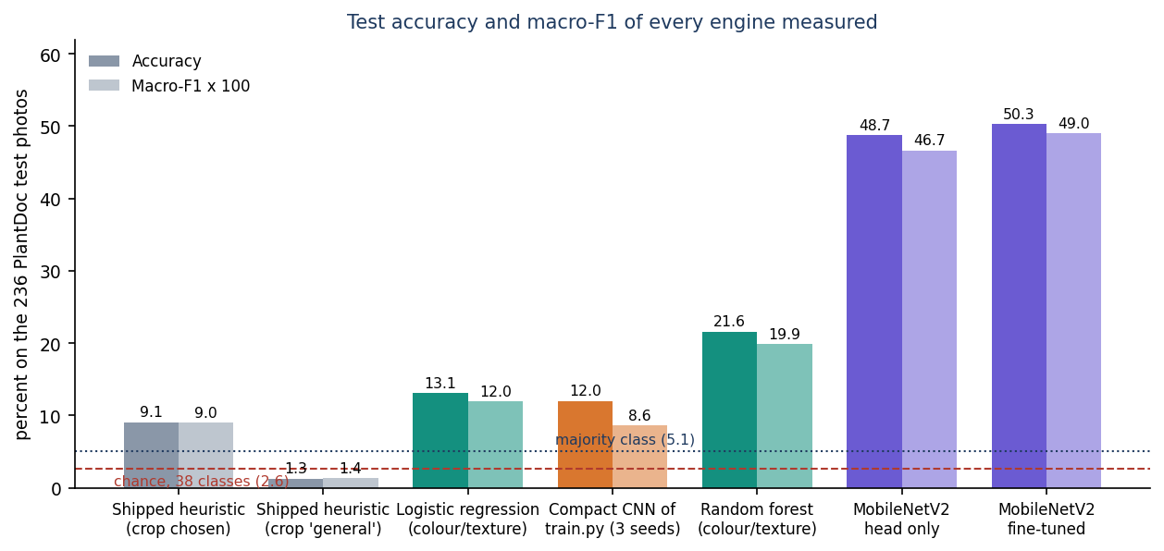
Figure 24: Accuracy and macro-F1 of every engine measured, with chance and majority-class lines.
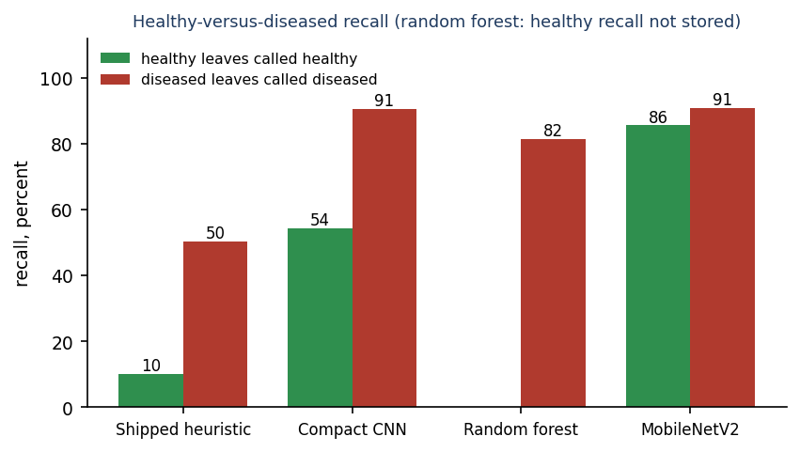
Figure 25: Healthy leaves called healthy and diseased leaves called diseased, per engine (the random forest's healthy recall was not stored).
Only the transfer-learning network is clearly useful, at about 50 % top-1 and 80 % top-3. The shipped heuristic is the worst engine measured; the compact CNN as scripted is barely better; the data themselves are the second limit, as the next section places it in context.

1.9 Does the displayed confidence mean anything?
Every result screen shows a confidence bar. For the 160 test photographs the heuristic can answer with the right crop chosen, the mean displayed confidence is 95 %, because the engine maps its score into the range 0.62 to 0.99 and most photographs saturate near 0.972. Accuracy within the confidence bins is 21 % for 0.80 to 0.90 (n = 19), 22 % for 0.90 to 0.95 (n = 23) and 14 % for 0.95 to 1.00 (n = 118); there is no photograph below 0.80. The most confident bin is not the most accurate. In addition the three scores shown for a photograph add up to more than 102 % on 82 % of these photographs and reach 112 % (defect D2). The interface compensates in part: the bar is labelled 'Heuristic score (not a calibrated probability)' and an amber note says that the score 'saturates near 97 % for most photos'. A farmer reading only the large number would still be misled.
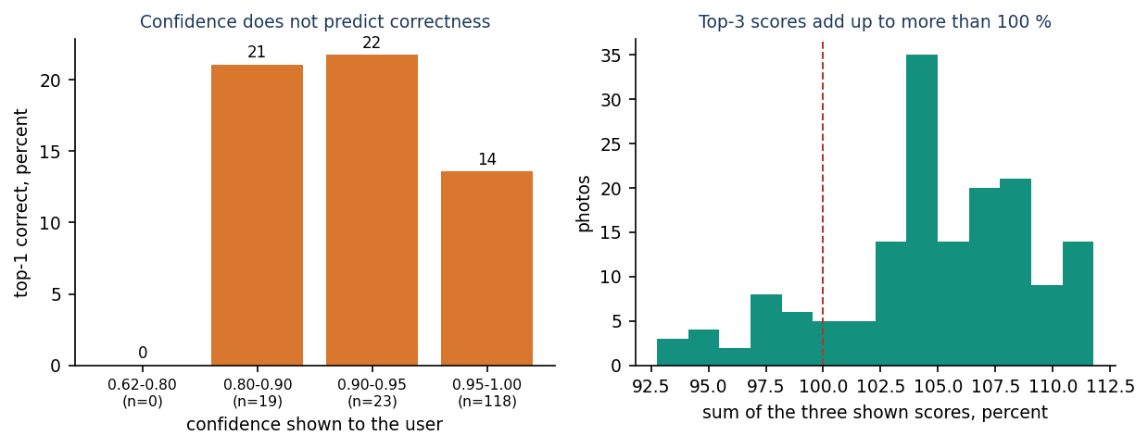
Figure 26: Left: accuracy of the heuristic within confidence bins. Right: sum of the three scores shown for each photograph.

1.10 Comparison with the base paper and the companion papers
The base paper chosen by the batch, Foliagen [1], is a framework that generates annotated foliage images from single-leaf photographs and uses them to train and fine-tune VGG19, ResNet50, DenseNet121, Swin Transformer and CBAM-ConvNeXt on soybean and tomato; it reports up to 98 % accuracy on natural soybean foliage when 5 % of that dataset is added to the generated data, on two RTX 6000 Ada GPUs. AgriVision does not implement it: there is no image generation, no foliage-level image and no soybean foliage dataset here, and the numbers of the two works are not comparable. What the project takes from the base paper is its motivation (disease classifiers trained on single-leaf photographs do not transfer to field images, and annotated field data are scarce) and its finding that pre-training and fine-tuning help; the 50 % of the fine-tuned MobileNetV2 against 12 % of the network trained from scratch is consistent with that.
Table 8: Reported results and this project, with the differences stated
Work | Task and data | Reported result | Comparable?
Foliagen [1] | Generated foliage images; soybean and tomato; natural foliage test set | Up to 98 % with 5 % real images added | No: different task, crops, data and GPUs
PD36-C [2] | Compact CNN, 1,250,694 parameters; New Plant Diseases Dataset, 87 k lab-style images, 38 classes | 99.53 % average test accuracy | No: laboratory backgrounds, 38 classes, 37 times more images
Kanakala and Ningappa [3] | CNN and LSTM; 70,295 training and 17,572 validation images, 38 classes | CNN 96.4 % validation, LSTM 93.43 % | No: random split of a lab-style collection
PlantDoc paper [4] | Same photographs; VGG16, InceptionV3, InceptionResNetV2; 100 x 100 px | Cropped leaves 44.5 to 70.5 %; raw photographs, VGG16, 13.7 to 29.7 % | Closest: same data, different split and cropping
AgriVision, shipped heuristic | PlantDoc test split, crop chosen | 9.1 ± 1.0 % | -
AgriVision, compact CNN of train.py | PlantDoc test split | 12.0 ± 0.5 % | -
AgriVision, MobileNetV2 reference | PlantDoc test split, raw uncropped photographs | 50.3 ± 0.9 % | Inside the PlantDoc paper's range

The honest reading is that field photographs are much harder than the clean images behind the 96 to 99.5 % figures of the companion papers, that this project's best model sits where the PlantDoc authors' own models sit, and that the novelty of this project is the application around the diagnosis, not the accuracy.

1.11 Sample inputs and outputs
The table lists twelve PlantDoc test photographs, run through the application's predict() with the crop set to the photograph's own crop and PYTHONHASHSEED=0. 'Shown' is the top-1 answer and the confidence printed on the result screen.
Table 9: Input photographs and what AgriVision printed
PlantDoc folder / file | Crop chosen | Top-1 shown | Confidence | Verdict
Apple_Scab_Leaf / 02343 | apple | Apple - Apple scab | 97.2 % | correct
Corn_rust_leaf / 02432 | corn | Corn (maize) - Common rust | 97.2 % | correct
Corn_leaf_blight / 02413 | corn | Corn (maize) - Northern leaf blight | 97.2 % | correct
grape_leaf_black_rot / 02572 | grape | Grape - Black rot | 91.4 % | correct
Potato_leaf_early_blight / 02448 | potato | Potato - Early blight | 97.2 % | correct
Tomato_mold_leaf / 02554 | tomato | Tomato - Leaf Mold | 97.2 % | correct
Tomato_leaf_late_blight / 02526 | tomato | Tomato - healthy | 97.2 % | wrong: a blighted leaf called healthy
Apple_rust_leaf / 02361 | apple | Apple - healthy | 97.2 % | wrong: rust called healthy
Tomato_leaf_bacterial_spot / 02517 | tomato | Tomato - Leaf Mold | 97.2 % | wrong: bacterial spot called mould
Tomato_leaf_mosaic_virus / 02536 | tomato | Tomato - healthy | 97.2 % | wrong: mosaic virus called healthy
Squash_Powdery_mildew_leaf / 02475 | squash | no answer (HTTP 400 'could not be read as an image') | - | defect D1
Blueberry_leaf / 02388 | blueberry | no answer (HTTP 400 'could not be read as an image') | - | defect D1

The correct answers come with the same 97.2 % as the wrong ones: the engine's score saturates, so the number cannot be used to tell them apart.

1.12 Success and failure analysis

1.12.1 Where it works
• Application behaviour. All 39 integration checks pass; accounts, upload, history, search, exports, analytics and deletion behave as specified, a diagnosis returns in a median of 23 ms on the test PC and the interface works from 360 to 1440 px.
• Distinctive lesions on a known crop. The heuristic is right on photographs with strong brown or yellow lesion colour on a large leaf, for example apple scab, corn rust, corn leaf blight, grape black rot, potato early blight and tomato leaf mould in the table above; 25 of the 160 answerable test photographs are named correctly.
• Transfer learning. MobileNetV2 names the right class for about half of the photographs and the right crop for 72 %, and separates healthy from diseased leaves 89 % of the time.

1.12.2 Where it fails
• Diseased leaves called healthy. The heuristic's healthy score rewards green area; a blighted leaf that is still mostly green is called healthy (late blight, rust and mosaic virus in the table). Only 50.4 ± 1.1 % of diseased leaves are called diseased.
• Crop choices with fewer than three classes give no answer at all (32.2 % of the test photographs; screenshot 16).
• Diseases that look alike. Even the best model gives F1 = 0 for tomato bacterial spot, tomato mosaic virus and bell pepper leaf spot.
• Rare classes. Several classes with fewer than 60 training photographs are weak (bell pepper F1 0.17, tomato mosaic virus 0.00 for MobileNetV2), although some small classes (grape) are easy; Tomato two-spotted spider mites (2 training photographs, no test photograph) cannot be learned or measured.
• Field conditions. PlantDoc photographs have soil, hands, several leaves and watermarks (the potato example carries one); none of the models is told where the leaf is.

1.13 Limitations of these results
• 236 test photographs and 4 to 12 per class: one photograph changes a class's recall by 8 to 25 points, and the accuracy figures have a sampling error of several points that was not computed.
• Three training seeds for the compact CNN and MobileNetV2, one run for the shipped-protocol, no-decay and classical baselines; no significance test.
• The heuristic was evaluated with the crop supplied by the folder name; a farmer may choose wrongly, which would lower its figures further.
• PlantDoc is the only dataset; the local test folder is the official one (as shipped in the HF mirror) and shares no photograph with the training folder by construction, but PlantDoc is web-scraped and near-duplicates may exist; this was not checked.
• No photographs of the project team's own, no field trial, no user study, no measurement of the advice's correctness.
• Time and latency numbers come from one PC that also ran other jobs during training; accuracy numbers are not affected.

1.14 Objectives against outcomes
Table 10: The six objectives of the batch (6.OBJECTIVES&PROBLEM STATEMENT) and what was achieved
# | Objective | Outcome
1 | Assemble a labelled dataset of healthy and diseased crop leaf images across target crops | Achieved with a public dataset: PlantDoc, 2,578 photographs, 28 classes, 13 crops. Not self-collected.
2 | Preprocess and augment the images | Partly. Resize to 224 px and flip, rotation, zoom and contrast augmentation inside the training script; the application's heuristic only resizes to 256 px.
3 | Train a CNN to classify leaf images into disease categories | Trained but not accurate. 12.0 ± 0.5 % for the script's network; 50.3 ± 0.9 % for the transfer-learning reference. Neither is installed in the application.
4 | Map each disease to a treatment and fertiliser recommendation | Treatment mapping achieved for all 38 classes (chemical, organic, cultural, prevention, cost). Fertiliser, yield and weather advice not implemented. Advice not checked by an agronomist.
5 | Deliver diagnosis and advice through a web interface with multilingual support | Web interface achieved (12 pages, 16 API routes). Multilingual for interface strings only (English, Hindi, Marathi); disease and treatment text is English.
6 | Evaluate accuracy per disease class and validate recommendations against agronomic guidance | Per-class accuracy measured (Sections 8.4 to 8.6). Recommendations not validated.

In one sentence: the application is complete, the knowledge base is useful as a reference, and the diagnosis is the part that still has to be built; Chapter 10 lists how.

