SECURE FILE STORAGE SYSTEM WITH ENCRYPTION AND ROLE-BASED ACCESS CONTROL (RBAC)
Results
Department of Computer Science and Engineering, TKR College of Engineering & Technology
Batch C13 (CSE-C) · Academic year [ACADEMIC YEAR]
Table 1: Project team
S.No. | Student name | Roll number
1 | Pramod Reddy Yalala | 23K91A05J9
2 | Pendela Vyshnavi | 23K91A05J1
3 | Luke Abraham Sam | 23K91A05D4
4 | Mudavath Suresh | 23K91A05G2

Project guide: D V V Deepthi
Chapter and section numbers quoted in the text (for example Chapter 8 or Section 6.2) refer to the full project report, 17.Final Document. Figures and tables in this document are numbered from 1.

1. RESULTS AND OUTPUT SCREENS

1.1 Experimental set-up
All measurements in this chapter were made on one desktop computer: 12th Gen Intel Core i5-12500 (6 cores / 12 threads), 15.7 GB of memory, Windows 11, Python 3.11.9 for the server and the measurement scripts, and Google Chrome 155.0.8059.85 (headless) for everything that runs in the browser. Client and server communicated over the loopback address 127.0.0.1, so the figures contain no network latency. Other programs, including other automated sessions, were using the processor during the runs; absolute timings are therefore indicative, and repeated runs of the 10 MiB cases differed by up to about a factor of three. CipherVault trains nothing and uses no dataset: there is no accuracy, precision or F1-score to report. What can be measured, and what this chapter reports, is the cost of the cryptography, the latency of the server, whether the access rules give the expected answer for every combination of user and operation, and whether tampering is detected.
Table 2: Experiments and what each measured.
Experiment | Set-up | Quantity measured
Browser cryptography (8.3) | Web Crypto in headless Chrome; AES-256-GCM and SHA-256 on random data of 1 KiB, 64 KiB, 1 MiB, 10 MiB and 25 MiB (50, 50, 20, 8 and 4 repetitions); RSA-2048 key generation 12 times; wrap and unwrap 40 times; PBKDF2 12 times | Median, 95th percentile (p95), ciphertext overhead
End-to-end pipeline (8.4) | In the browser: generate file key, encrypt, hash, wrap, upload, download, unwrap, decrypt, verify; same endpoint with an unencrypted payload as baseline; 30, 20 and 15 repetitions for 1 KiB, 1 MiB, 10 MiB | Time per complete upload and download
Server API (8.5) | Python HTTP client against a throw-away server and database, 1 to 60 repetitions per call | Latency per endpoint, upload and download of 1 KiB to 25 MiB
Access control (8.6) | Four principals (owner, editor, viewer, stranger) times nine operations on one shared file, plus unauthenticated and forged tokens | Observed HTTP status against the expected allow or deny
Integrity and audit (8.7) | 2,000 random bit flips in an AES-GCM ciphertext; nine kinds of manipulation applied to a copy of the real audit log, about 200 trials each; chain verification at five log sizes; 100 concurrent logins | Detection rate, verification time, chain validity
Automated tests (8.8) | pytest suite, API end-to-end script, browser walk-through, evaluation script | Checks passed

Timings are the median with the 95th percentile (p95), because a few slow runs dominate the mean on a shared machine. Chrome rounds its clock to 0.1 ms, so operations on 1 KiB and 64 KiB were timed in batches of 200 and divided. The scripts are scripts/measure_metrics.py, scripts/evaluate.py, scripts/e2e_check.py and scripts/smoke_test.py; the raw figures are in docs/metrics/metrics.json.

1.2 Output screens
The screens below were captured from the running application at 1440 by 900 pixels (one is cropped) with the demonstration data that the demo login creates: five fictional text files owned by Olivia Owner, shared with an editor (Eddie Editor) and a viewer (Vera Viewer). The vault was unlocked, the audit log held more than two hundred real events, and no screen is empty or a mock-up. The landing, sign-in and registration pages and the mobile layouts are in Appendix C.

1.2.1 Dashboard and file list
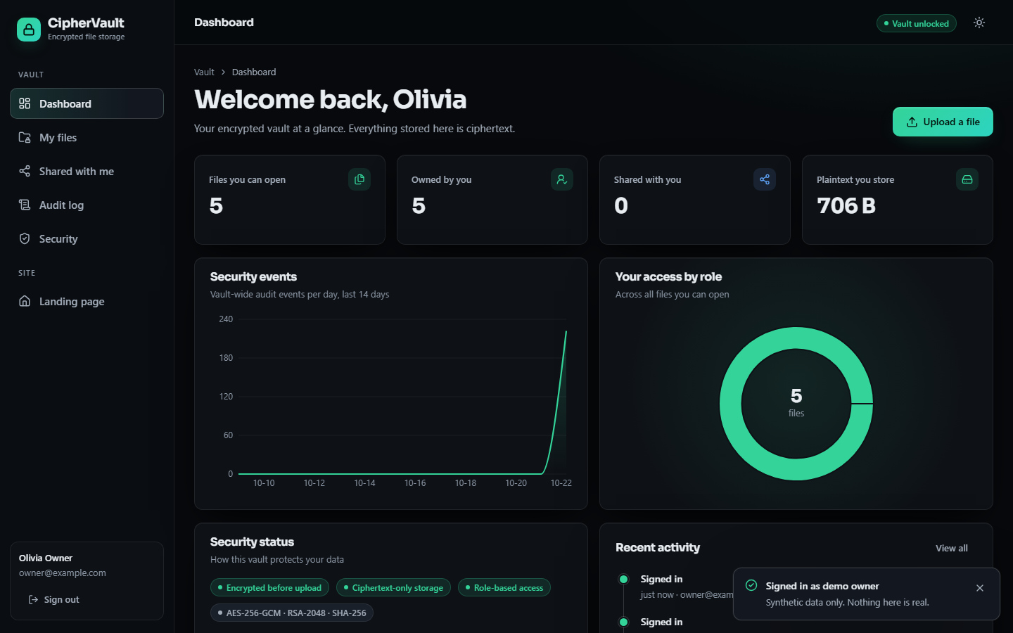
Figure 1: Dashboard of the owner: four counters (5 files can be opened, 5 are owned, 0 shared with the user, 706 B of plaintext stored), a chart of vault-wide audit events per day, the donut of access by role (all five files owned), the security-status chips Encrypted before upload, Ciphertext-only storage, Role-based access and AES-256-GCM, RSA-2048, SHA-256, and the recent-activity list. The event chart is flat before 22 October because all events were generated on that day.
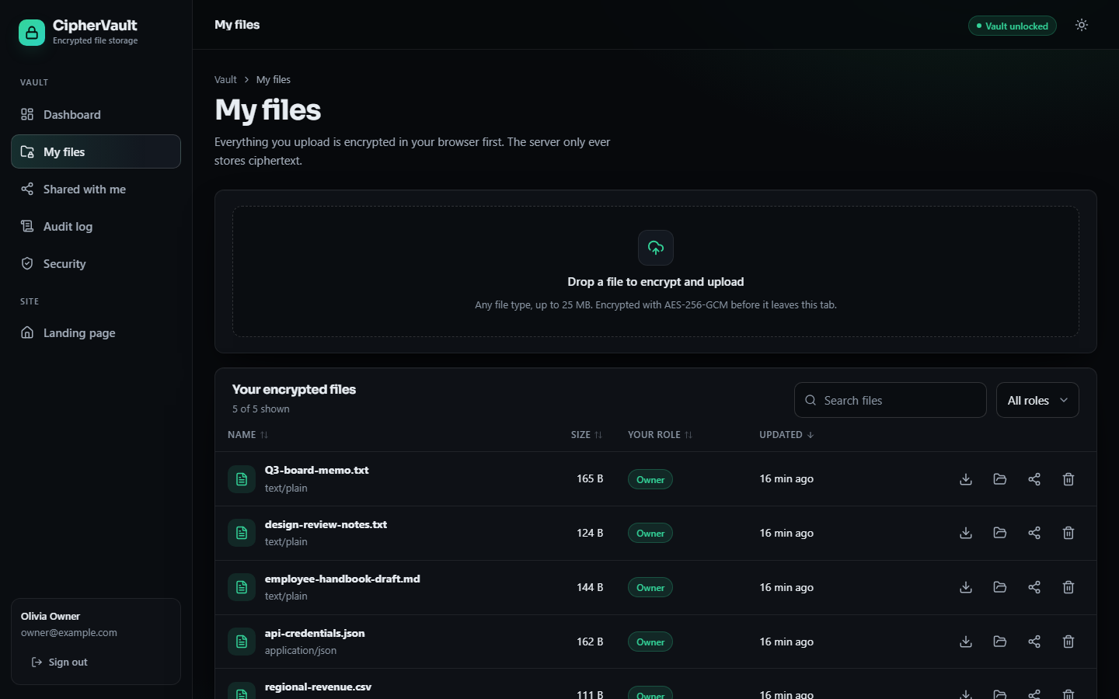
Figure 2: My files: the drop zone (any file type up to 25 MB, encrypted with AES-256-GCM before it leaves the tab) and the list of the five encrypted files with name, MIME type, plaintext size, role, last update and the download, open, share and delete buttons; the table can be searched, sorted and filtered by role.

1.2.2 File details and sharing

Figure 3: File details for Q3-board-memo.txt: 165 B of plaintext stored as 181 B of ciphertext, the SHA-256 of the plaintext and the AES-GCM initialisation vector, the access list (owner, editor, viewer) and the owner-only file history. The history, newest first, shows five downloads by the viewer and the red Access denied entry for the viewer's delete attempt (delete denied (owner only)); the older entries (editor's content replacement, two shares, upload) lie below the crop.
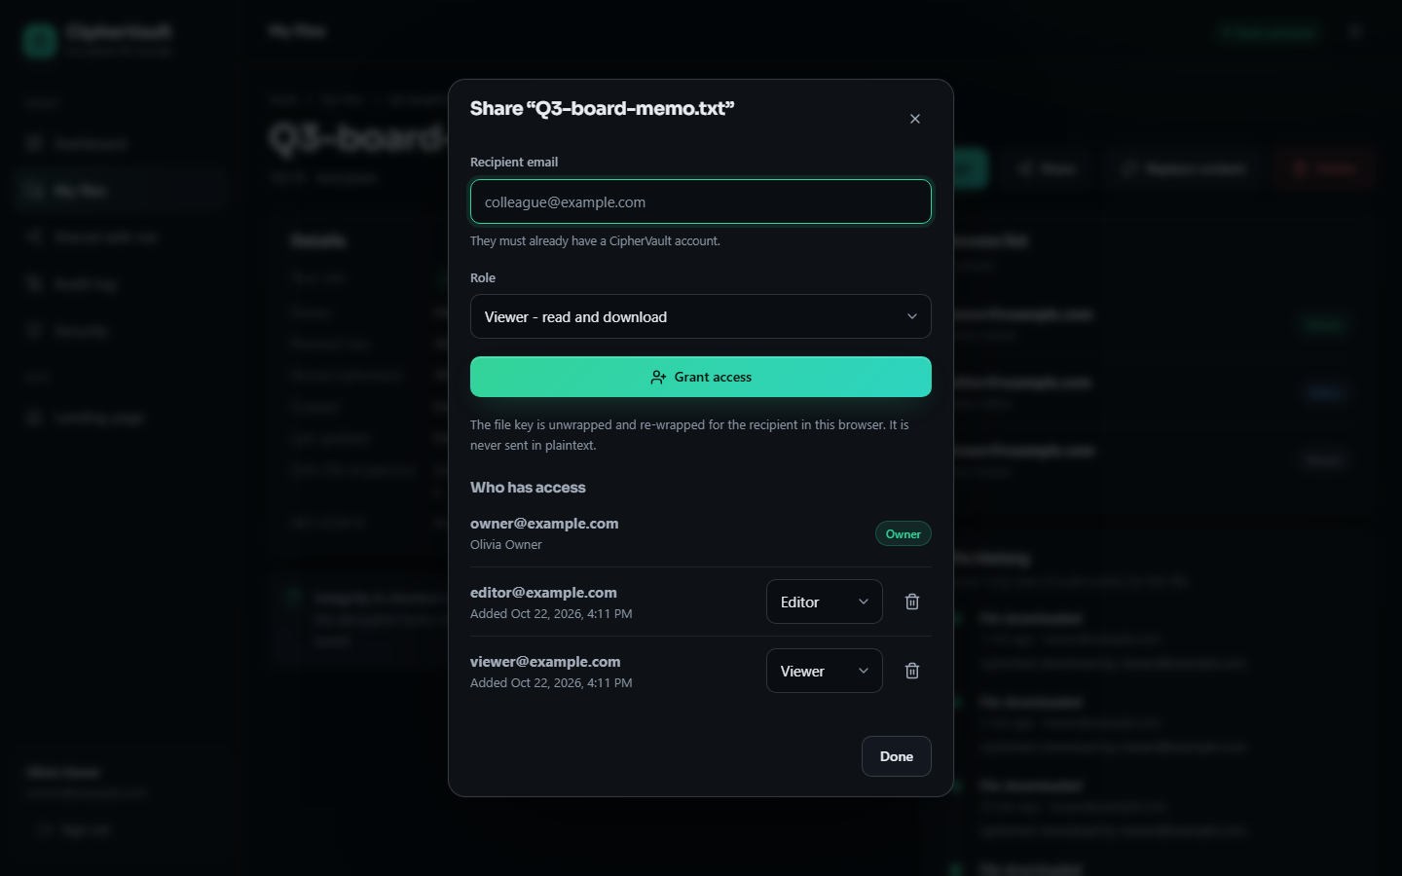
Figure 4: Share dialog: recipient e-mail, role (Viewer, read and download; Editor), the Grant access button and the statement that the file key is unwrapped and re-wrapped for the recipient in this browser and never sent in plaintext; below, the current access list with a role selector and a remove button for each collaborator.

1.2.3 Audit log
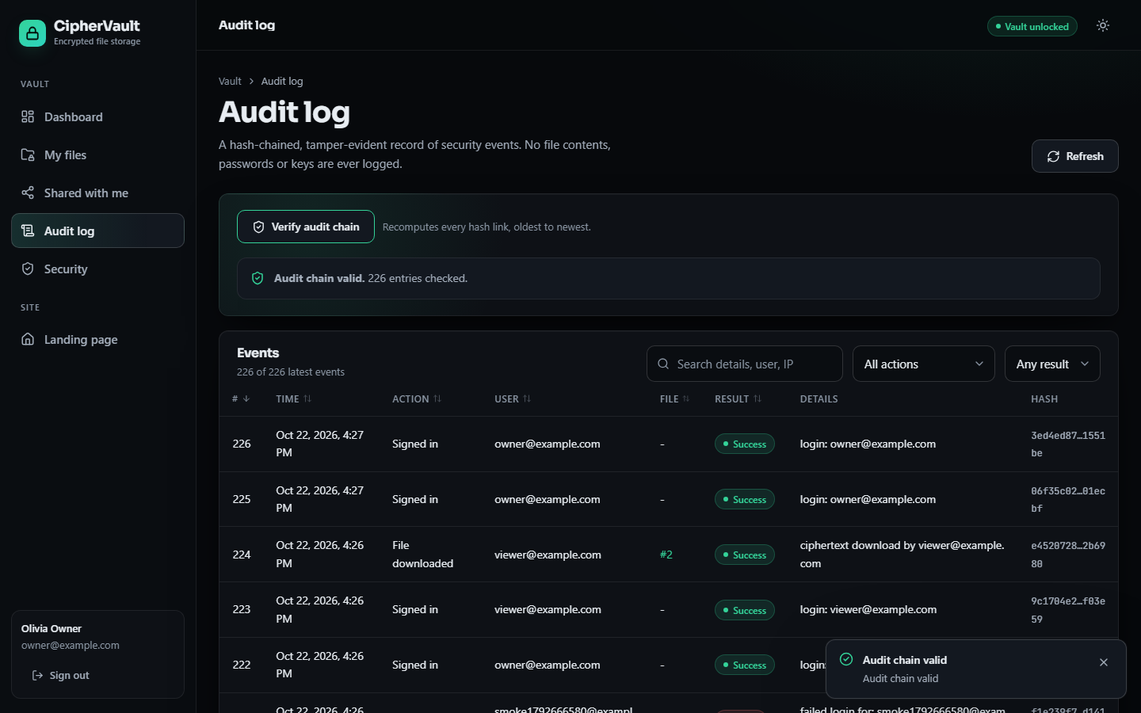
Figure 5: Audit log after Verify audit chain: the message Audit chain valid. 226 entries checked. above the event table (number, time, action, user, file, result, details and a shortened SHA-256) with search and action and result filters; the newest entries are sign-ins and a ciphertext download by the viewer.

1.2.4 Security profile and vault lock
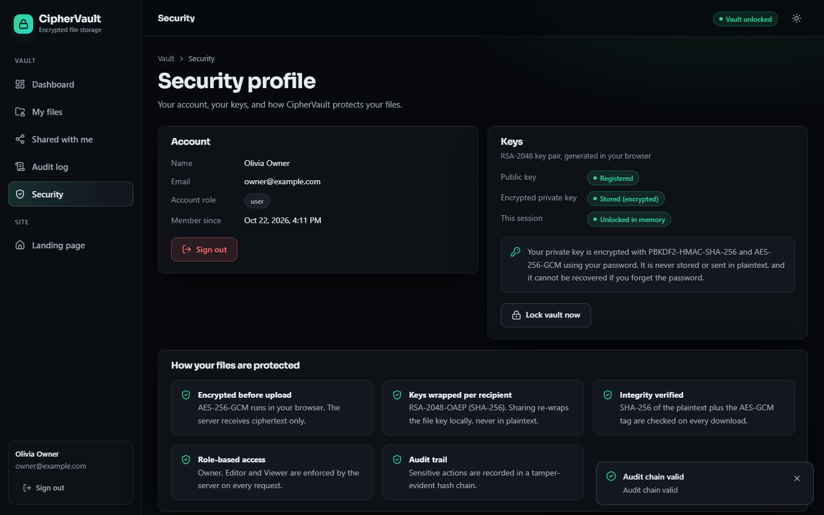
Figure 6: Security profile: account data, the key status (public key registered, encrypted private key stored, this session unlocked in memory), the Lock vault now button and the five protection statements.
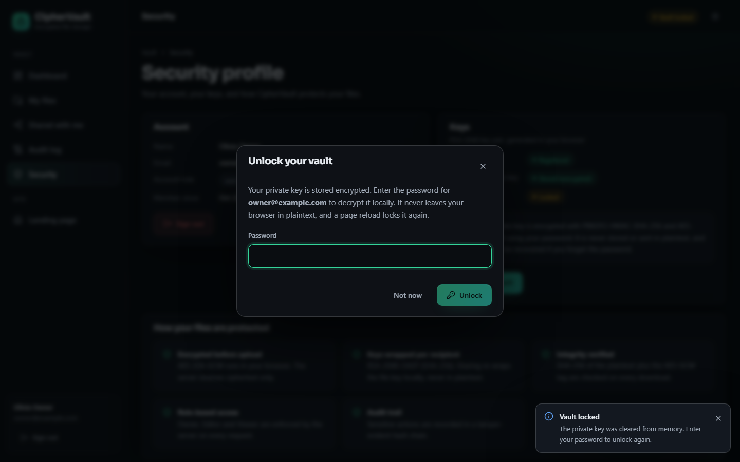
Figure 7: Unlock dialog shown after the vault was locked: the private key was cleared from browser memory (toast Vault locked) and is decrypted again only after the password is entered; a page reload locks the vault in the same way.

1.3 Cryptographic cost in the browser
Every file is encrypted and hashed in the browser before the first byte is sent, so the first question is what that costs. The first table below gives the median and p95 of one AES-256-GCM encryption, one decryption and one SHA-256 digest at five file sizes, with the added length and the encryption throughput where the call overhead no longer dominates. The use of AES-GCM follows [21] and the digest [23].
Table 3: Web Crypto timings in headless Chrome (median / p95, ms).
Plaintext size | AES-GCM encrypt | AES-GCM decrypt | SHA-256 | Added bytes | Encrypt MiB/s
1 KiB | 0.008 / 0.020 | 0.009 / 0.020 | 0.006 / 0.011 | 16 | -
64 KiB | 0.059 / 0.14 | 0.066 / 0.14 | 0.043 / 0.059 | 16 | -
1 MiB | 2.40 / 6.30 | 2.00 / 3.50 | 1.30 / 1.60 | 16 | 417
10 MiB | 23.8 / 33.3 | 26.2 / 33.9 | 12.9 / 18.0 | 16 | 420
25 MiB | 53.8 / 69.7 | 50.9 / 52.3 | 26.4 / 26.7 | 16 | 465

Encryption of a 25 MiB file takes 53.8 ms and decryption 50.9 ms, a throughput of roughly 420 to 465 MiB/s; the cost grows linearly with size, as the first chart below shows on logarithmic axes. The ciphertext is always exactly 16 bytes longer than the plaintext, the length of the GCM authentication tag, so storage overhead is negligible. Hashing costs about half as much as encryption. For a 1 MiB file the file-level cryptography (encryption, digest and key wrapping, summed from separately measured medians) is about 3.7 ms.
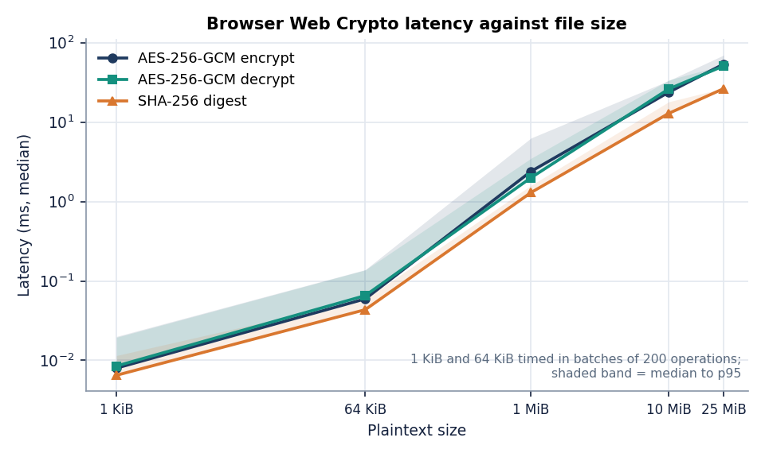
Figure 8: AES-256-GCM encryption, decryption and SHA-256 time against file size (median, log-log): 53.8 ms to encrypt 25 MiB.
Table 4: Key-management primitives in the browser (n = repetitions; median / p95, ms).
Operation | n | Median / p95
RSA-2048 key pair generation (once per account) | 12 | 102 / 158
PBKDF2-HMAC-SHA-256, 120,000 iterations (each unlock) | 12 | 32.8 / 47.7
RSA-OAEP wrap of the file key (per share and per upload) | 40 | 0.030 / 0.035
RSA-OAEP unwrap of the file key (per download) | 40 | 0.71 / 0.84

Key management is the other cost. Generating the RSA-2048 key pair takes about 102 ms once, at registration. Deriving the key-encryption key from the password with PBKDF2 takes 32.8 ms on this machine; this is deliberately the slowest step of an unlock. Wrapping the file key for a recipient takes 0.030 ms and unwrapping it 0.71 ms, and a wrapped key is always 256 bytes. The iteration count of 120,000 is below the 310,000 reported by [2]; the time an attacker needs per guess scales with this count (Section 8.12).
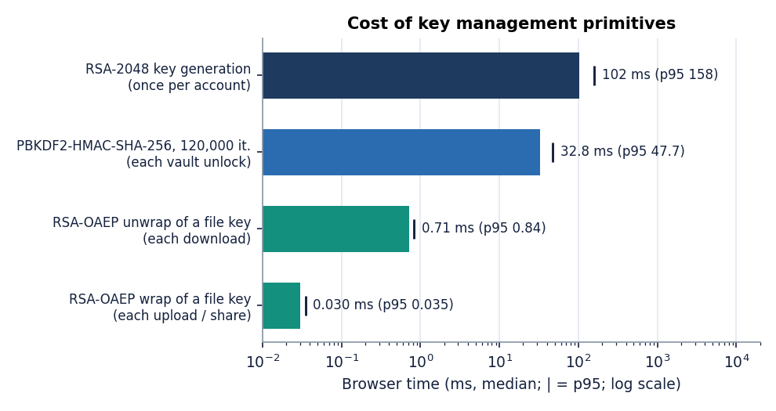
Figure 9: Key-management primitives in the browser (median, log scale): key generation, PBKDF2, wrap and unwrap.

1.4 End-to-end upload and download
The next experiment times the whole user-visible operation in the browser. An encrypted upload generates the file key, encrypts, hashes, wraps the key with the owner's public key and posts the multipart request; an encrypted download fetches the ciphertext, unwraps the key, decrypts and compares the SHA-256. The baseline sends the same bytes unencrypted to the same endpoint (with the digest and a wrapped key left over from the encrypted run, so that the server's validation passes) and fetches them back without decryption. The table below gives the medians and the difference of the medians.
Table 5: Browser upload and download with and without encryption (median / p95, ms; difference = encrypted minus plain, medians).
Size | Encrypted upload | Plain upload | Diff. | Encrypted download + verify | Plain download | Diff.
1 KiB | 30.4 / 82.5 | 28.9 / 73.7 | +1.5 | 30.4 / 48.4 | 28.6 / 94.6 | +1.8
1 MiB | 63.0 / 107 | 52.9 / 97.8 | +10.2 | 61.0 / 161 | 51.0 / 94.5 | +10.1
10 MiB | 209 / 352 | 194 / 258 | +14.4 | 184 / 236 | 157 / 197 | +27.1

For 10 MiB the encrypted upload took 209 ms against 194 ms for the unencrypted one, and the encrypted download with decryption and digest check 184 ms against 157 ms. The difference of the medians is therefore 14 ms for the upload and 27 ms for the download. The 95th-percentile ranges of the two variants overlap at every size and the spread between repetitions is larger than some of the differences (at 1 KiB the difference is smaller than the noise), so these differences should be read as estimates of the order of magnitude, not as resolved values. The time spent only in the encryption call is 2.10 ms for 1 MiB and 20.8 ms for 10 MiB, which is consistent with the browser timings of Section 8.3.
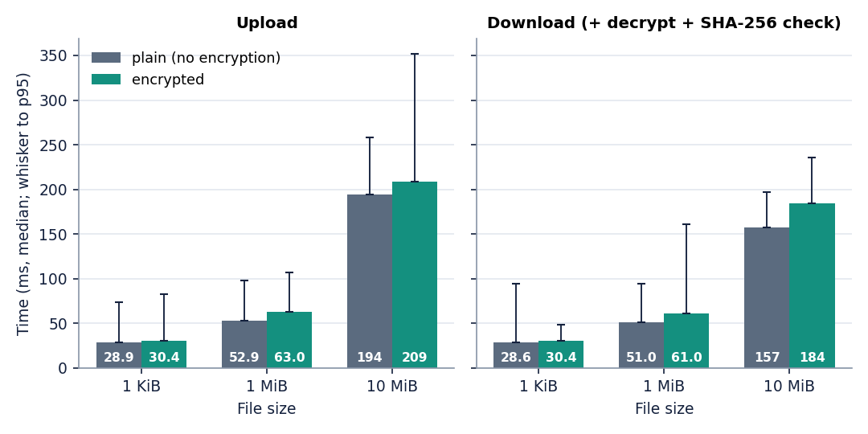
Figure 10: Encrypted against plain transfer in the browser (median, whisker to p95): at 10 MiB the encrypted upload takes 209 ms and the plain one 194 ms.

1.5 Server API latency
The server was measured separately with a Python client over loopback, so that the cost of the FastAPI application, the database and the file store is visible without the browser. The ciphertexts used here were produced with AES-GCM in Python, since the server cannot tell the difference. The first table lists the control-plane calls; the second gives upload and download of ciphertext objects of increasing size.
Table 6: Latency of the API calls (median / p95, ms).
Call | n | Median / p95
Health check (GET /api/health) | 60 | 1.68 / 2.69
Current user (GET /api/auth/me, JWT check and one query) | 60 | 6.32 / 17.7
Login, correct password (bcrypt cost 12, JWT, audit entry) | 15 | 308 / 349
Login, wrong password of an existing account | 10 | 326 / 372
Failed login of an unknown e-mail (one audit entry written) | 40 | 19.0 / 90.0
List the user's own files | 20 | 40.3 / 58.9
Share a file (one run) | 1 | 37.8
Change a role (one run) | 1 | 22.7
Revoke access (one run) | 1 | 24.7
Download after revoke (one run, HTTP 403) | 1 | 18.6

Calls that do little work return in a few milliseconds (1.68 ms for the health check). Login is dominated by bcrypt at cost 12, about 308 ms, which is the intended price of slowing down password guessing [28]. A wrong password costs the same, as it should. A failed login for an e-mail that does not exist, however, takes only 19.0 ms: the code skips the bcrypt comparison when no account is found, so response time tells an attacker whether an account exists (Section 8.11). This call also measures one audit write, because every failed login adds an audit entry.
Table 7: Upload and download of ciphertext through the API (median / p95, ms).
Object size | n | Upload | Download
1 KiB | 20 | 27.2 / 38.3 | 21.7 / 32.4
64 KiB | 20 | 32.4 / 44.4 | 12.1 / 28.1
1 MiB | 15 | 44.5 / 70.3 | 22.4 / 34.0
10 MiB | 6 | 139 / 163 | 102 / 228
about 25 MiB | 3 | 288 / 339 | 177 / 194

A 25 MiB object, the largest the server accepts, uploads in 288 ms and downloads in 177 ms, based on only three runs. An upload larger than the 25 MB limit was rejected with HTTP 413. Both directions grow roughly linearly with size.
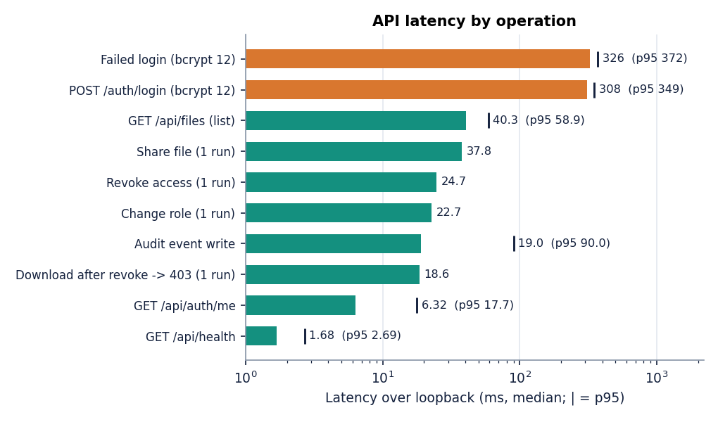
Figure 11: API latency over loopback (median, marker at p95): login 308 ms (bcrypt), health check 1.68 ms.
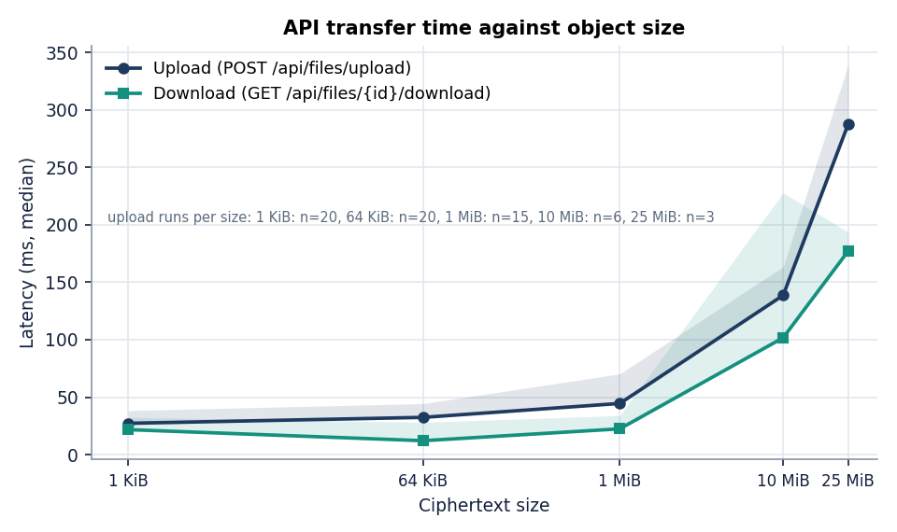
Figure 12: Upload and download of ciphertext against object size (median, shaded to p95).

1.6 Access-control correctness
Role-based access control is checked on the server for every request. To test it exhaustively, one file was shared with an editor and a viewer, and each of four principals (the owner, the editor, the viewer and a registered user with no access) attempted each of the nine operations on it. The table below shows the HTTP status observed; 200 means allowed and 403 means denied. All 36 cells matched the rule table of the design (owner: everything; editor: read and replace content; viewer: read; stranger: nothing), an agreement of 100 per cent.
Table 8: Observed HTTP status for every principal and operation (36 cells, all as expected).
Operation | Owner | Editor | Viewer | Stranger
View metadata (GET /api/files/{id}) | 200 | 200 | 200 | 403
Download ciphertext | 200 | 200 | 200 | 403
Replace content (PUT) | 200 | 200 | 403 | 403
List permissions | 200 | 200 | 200 | 403
Share a file | 200 | 403 | 403 | 403
Change a role | 200 | 403 | 403 | 403
Revoke access | 200 | 403 | 403 | 403
View the file's audit history | 200 | 403 | 403 | 403
Delete the file | 200 | 403 | 403 | 403

Requests without a token were answered with HTTP 401 in all 5 cases, and four invalid tokens (forged signature, expired, signed with the wrong secret, and one with the algorithm set to none) were all rejected with HTTP 401. After the owner revoked the editor's access, the editor's next download returned HTTP 403 in 18.6 ms. The experiment is exhaustive over the implemented operations on one file; it is a correctness check of the rule table, not a user study, and it does not measure access-control accuracy in the sense of a classifier.
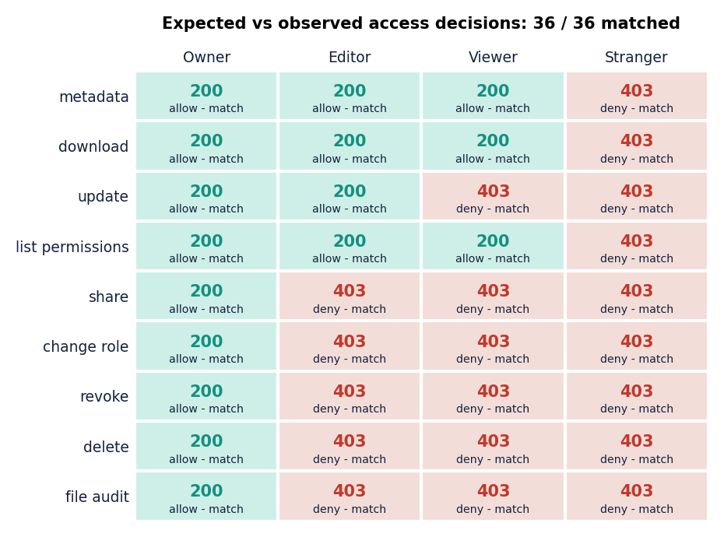
Figure 13: Access-control matrix on the live API: observed status for four principals and nine operations; 36 of 36 matched the expected decision.

1.7 Integrity and tamper evidence
Two mechanisms detect tampering. For file contents, AES-GCM authenticates the ciphertext and the browser compares the SHA-256 of the decrypted bytes with the stored digest. In 2,000 trials with one random bit changed in an AES-GCM ciphertext, decryption failed in 2,000; a wrong key was rejected as well. This test used the Python implementation of the same primitive on a 4 KiB message, not the browser. For the audit log, each entry stores the SHA-256 of the previous hash and its own fields, and verify_chain recomputes the chain [31], [32]. Nine manipulations were applied to an in-memory copy of the 461 real entries of the measurement run, with a verifier equal to the server's. The table below gives the result.
Table 9: Detection of manipulations of the audit log (copy of a real log).
Manipulation | Trials | Detected | Rate
Edit the details text of an entry | 200 | 200 | 100%
Change the action of an entry | 200 | 200 | 100%
Flip the success flag | 200 | 200 | 100%
Change the user of an entry | 200 | 200 | 100%
Overwrite the stored hash | 200 | 200 | 100%
Delete an entry in the middle | 199 | 199 | 100%
Swap two adjacent entries | 200 | 200 | 100%
Insert a forged entry | 200 | 200 | 100%
Cut off the newest entries | 199 | 0 | 0%
Rewrite one entry and recompute every later hash | 1 | 0 | not detected

Eight of the nine classes were detected in every trial. Two weaknesses are real and are stated here as findings. Truncating the newest entries was never detected (0 of 199): the remaining prefix is still a valid chain, and nothing outside the database records how long the chain should be. An attacker who rewrites an entry and recomputes all later hashes is not detected either, because the chain uses no secret key and has no external anchor. Detection therefore holds against careless or partial edits, not against an adversary with write access to the whole table.
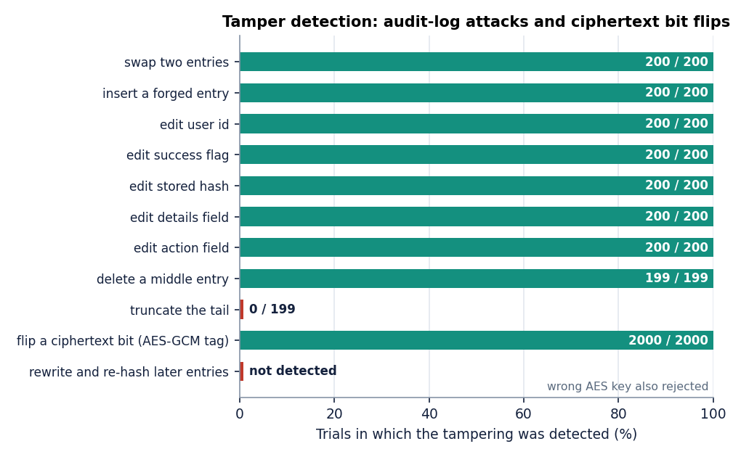
Figure 14: Detection rate per manipulation class: eight classes at 100 per cent, tail truncation at 0 per cent; 2,000 of 2,000 ciphertext bit flips were rejected.
Verification time grows with the log: 27.2 ms for 463 entries and 404 ms for 5002 entries, with scatter caused by other processes (median of three runs); the verifier reads the whole table, so the cost is linear in the log length. The most serious defect appeared in the concurrency check. 100 failed logins were sent through 4 parallel workers in 3.55 s; the chain had been valid before and was invalid afterwards, with the first broken link at entry 5047 of 5145. record_event reads the last hash, computes the next one and commits without a lock, so two simultaneous requests chain to the same predecessor and the log forks. A single-writer assumption is built in; the defect is documented here and was not fixed.
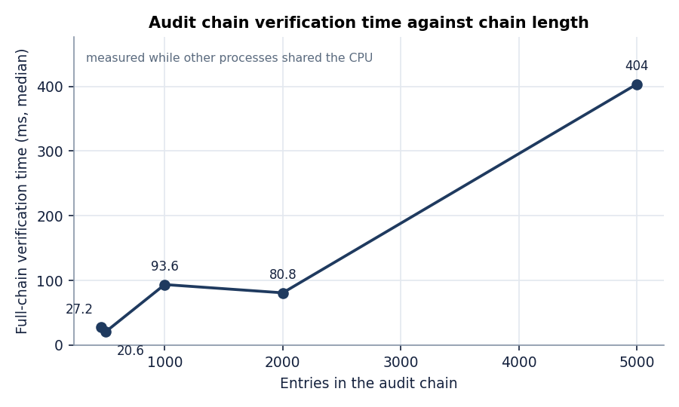
Figure 15: Time to verify the audit chain against its length (median of three runs).
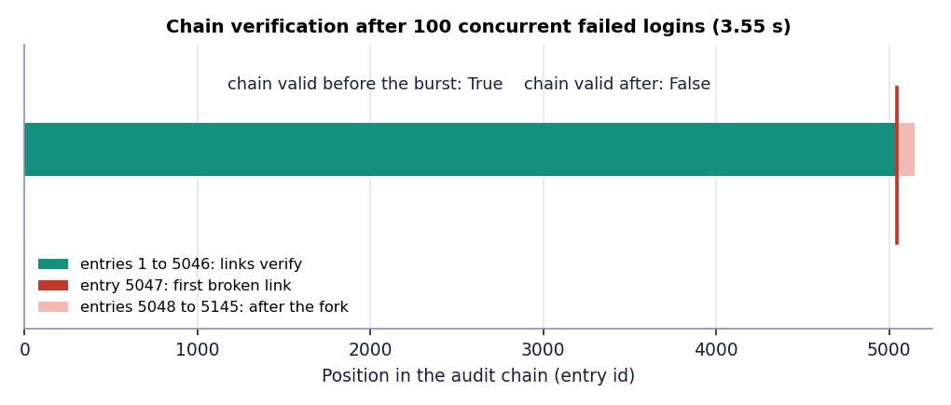
Figure 16: Audit chain before and after 100 concurrent failed logins: valid before, first broken link at entry 5047 afterwards.

1.8 Automated tests
Table 10: Automated checks and their outcome.
Check | Passed | Remark
pytest suite (tests/: authentication 6, crypto 5, files 3, RBAC 5, audit 2) | 21 / 21 | 13 s
API end-to-end script (scripts/e2e_check.py) | 17 / 17 | register to delete, 285 audit entries verified
Browser walk-through (scripts/smoke_test.py, Chrome) | 18 / 18 | register, upload, download, share, revoke, audit, lock, 360 / 768 px
Evaluation script (scripts/evaluate.py) | 17 / 17 | primitives, authorisation, tamper checks

All four sets passed on the code as measured. The evaluation script times a Python implementation under the name browser_encrypt; those timings are not browser timings and are superseded by Section 8.3. What was not tested: many simultaneous users, files above 25 MB, browsers other than Chrome, the PostgreSQL configuration, the Docker build, and an accessibility audit with a screen reader.
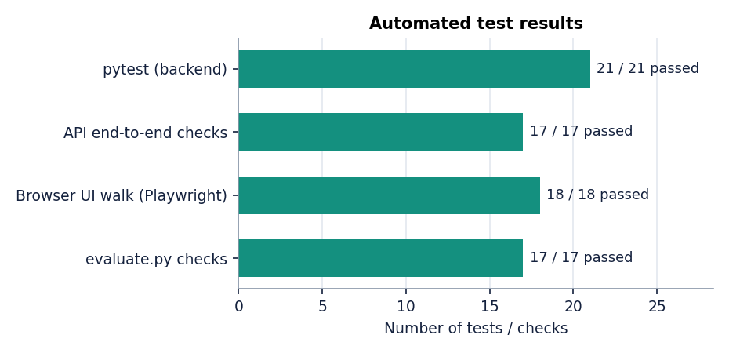
Figure 17: Automated checks passed: 21 of 21 pytest tests, 17 of 17 API checks, 18 of 18 browser steps, 17 of 17 evaluation checks.

1.9 Sample inputs and outputs
The following values are taken from the application's own screens and measurement runs, not constructed. The first table describes one stored file as the file-details screen shows it.
Table 11: One stored file as shown on the details screen (file-details screen).
Item | Value
Plaintext file | Q3-board-memo.txt, text/plain, 165 B (after the editor replaced the original 217 B upload)
Stored object | 181 B of ciphertext (165 B + 16 B tag) under a random 32-character hexadecimal name; the real file name appears only in the database
SHA-256 of plaintext | 652b4723fe9e13590fa166c7a87e90d74151048ee774c8b77a7aa719559fed96
AES-GCM IV | 9FuZxp4z9WWxWTo8 (12 bytes in base64, a fresh random value for each encryption)
Wrapped file key | 256 bytes (344 base64 characters) for each of the three principals; the owner's copy is stored with the file, the others in file_permissions
API check run | e2e-report.txt: 16,000 B of plaintext, 16,016 B stored; server holds ciphertext, not plaintext

The second table reproduces four consecutive entries of the audit log from the audit screen; the hash column is shortened by the interface to the first eight and last six characters.
Table 12: Entries 223 to 226 of the audit log (audit-log screen).
# | Time | Action | User | File | Result | Details | Hash
226 | 4:27 PM | Signed in | owner@example.com | - | Success | login: owner@example.com | 3ed4ed87...1551be
225 | 4:27 PM | Signed in | owner@example.com | - | Success | login: owner@example.com | 06f35c02...01ecbf
224 | 4:26 PM | File downloaded | viewer@example.com | #2 | Success | ciphertext download by viewer@example.com | e4520728...2b6988
223 | 4:26 PM | Signed in | viewer@example.com | - | Success | login: viewer@example.com | 9c1704e2...f03e59

The chain verification endpoint returned {"valid": true, "checked": 5043, "failure_at": null, "message": "Audit chain valid"} at the end of the measurement run, and the same endpoint after the concurrent logins returned a failure at entry 5047 (Section 8.7). A request for a file without permission returns {"detail": "Access denied"} with status 403 and adds an unauthorized_access entry; an upload above the limit returns status 413.

1.10 Success cases
• The server never holds plaintext. In the end-to-end check the stored object of a 16,000-byte file was 16,016 bytes of ciphertext, and the details screen shows the same 16-byte difference for a real file.
• Access rules behave exactly as specified: 36 of 36 operation and role combinations matched, and every missing or invalid token was refused.
• The cost of encryption is small next to the transfer. Encrypting 25 MiB takes 53.8 ms and a 10 MiB upload with all cryptography took 209 ms against 194 ms without.
• Tampering with a file is always noticed: 2,000 of 2,000 bit flips were rejected, and a wrong key fails to decrypt.
• Accidental or crude edits of the log are noticed: eight of nine manipulation classes were detected in every trial, and the screen shows the verification result in one click.
• Sharing needs no secret to travel. The share dialog re-wraps the file key for the recipient in the browser; the server sees only a 256-byte value, and revocation takes effect on the next request (HTTP 403 in the measurement).

1.11 Failure cases and defects
The experiments exposed the weaknesses in the table below. They are stated as measured; none has been fixed, and Chapter 10 ranks them.
Table 13: Weaknesses found, with the evidence.
Finding | Evidence
Audit tail truncation is not detected | 0 of 199 trials; the remaining prefix is a valid chain and the log length is not recorded elsewhere
A full rewrite with recomputed hashes is not detected | The chain has no secret key and no external anchor; anyone able to write the table can re-chain it
Concurrent writers fork the chain | 100 concurrent failed logins: chain invalid, first broken entry 5047 of 5145 (no lock around read-last-hash and insert)
The server cannot tell ciphertext from plaintext | The unencrypted baseline of Section 8.4 was accepted by the same upload endpoint; encryption is a property of the trusted client, not enforced by the server
Login timing reveals whether an account exists | Unknown e-mail 19.0 ms against 326 ms for a wrong password; the register endpoint also names an existing e-mail
Any signed-in user sees the global audit list | GET /api/audit returns the latest events of all users (e-mail addresses, file numbers, IP addresses); only the per-file history is owner-only
Revocation cannot recall what was already downloaded | The server deletes the recipient's wrapped key and refuses further downloads (403), but a file key or ciphertext saved earlier stays usable; there is no re-keying
Editor updates reuse the file key | The new ciphertext uses a fresh random 96-bit IV under the same key; the server cannot verify the pairing, so the client's digest check is the only guard
Deployment-level exposures | The server delivers the JavaScript that performs the cryptography; the file name, size, type, owner and time are stored in clear; the token is kept in sessionStorage; the login throttle (20 attempts per 300 s) is in memory; there is no second factor; losing the password loses the data

The first three concern the audit trail and weaken the claim of tamper evidence to evidence of non-malicious or partial modification. The fourth and the fifth follow from the design: a web server cannot inspect what it stores and still be blind to it. The remaining items are limits that every comparable browser-encryption service shares, the best-known being that the server supplies the code that does the encryption, which is the starting point of the attacks on MEGA [8].

1.12 Comparison with the base paper and the closest architecture
The declared base paper [1] designs a scheme for electronic health records. Its evaluation is a calculation: the cost of each phase is obtained from operation counts and the measured time of single primitives (OpenSSL) on a server and a Raspberry Pi, in microseconds, and no dataset or end-to-end run is reported. CipherVault measures real requests in milliseconds on a different machine, with a different scheme (AES-256-GCM with per-user key wrapping against attribute-based encryption), so the two sets of numbers must not be ranked against each other and no ranking is claimed. The paper that is closest in architecture, [2], reports measurements, but states neither its hardware nor its test protocol, so its figures cannot be reproduced or compared like for like either. The table below sets side by side what each reports.
Table 14: Base paper, closest architecture and CipherVault (what each reports; not a ranking).
Aspect | Base paper [1] | IJEDR paper [2] | CipherVault
System | Health records for a semi-trusted cloud; attribute-based encryption with a ledger | Cloud file store with client-side encryption and RBAC | General secure file store, local web application
Cryptography | ECC dual-attribute encryption (160-bit key), ClinicalBERT attribute extraction, multiple key-generation centres | AES-256-GCM, RSA-2048 OAEP, PBKDF2 (310,000 iterations), TOTP, ECDSA-signed log entries | AES-256-GCM, RSA-2048 OAEP, PBKDF2 (120,000 iterations), bcrypt, no second factor
Access control | Policy over user and data attributes, checked by decryption | Owner, editor, viewer | Owner, editor, viewer per file, enforced on the server
Audit / integrity | Hyperledger Fabric ledger of public keys and policies; hash of the record | SHA-256 chained log with signatures | SHA-256 chain in the database; digest check on download
Evaluation | Calculated from primitive timings and operation counts; no dataset or end-to-end run reported | 50 users, 3 roles; 900 access attempts; 50 simulated tamper events | Measured on one machine: 36 access cells, about 1,800 audit-manipulation trials, 2,000 bit flips
Hardware | HPE server (E5-2620 v3) and Raspberry Pi 3 B+ | not stated | Core i5-12500, 15.7 GB, shared with other jobs
Reported cost | About 8,506 microseconds in total at five attributes on the Raspberry Pi (other schemes 8,812 to 71,323) | +320 ms for a 10 MB upload | Encrypted 10 MiB upload 209 ms against 194 ms plain (median)
Reported correctness | Security argued by proof sketches | 98.6 per cent access-control accuracy (13 of 900 attempts misclassified); 100 per cent of 50 tamper events detected; no exposure in 30 days | 36 of 36 cells; 8 of 9 audit manipulation classes detected, tail truncation and a full re-chain not detected

What is adopted from the base paper is its trust model (the store is untrusted and sees only ciphertext), the hash comparison after decryption, and the idea of treating revocation and the audit trail as part of the design; attribute-based encryption, ClinicalBERT, the key-generation centres and the blockchain are not adopted, because they would add cost and administration for a three-role file store. Against the closest architecture CipherVault lacks multi-factor authentication, chunked encryption, a stronger key-derivation setting and signed log entries, and says so; it adds a measured failure analysis of its own audit log, which that paper does not give. Its single quantitative claim that can be set beside a CipherVault number is the extra time for a 10 MB upload, +320 ms against a measured difference of medians of about 14 ms; the setups differ (client, network, whether the server is remote), so this is context, not a result.

1.13 Analysis and limits of these results
• Cryptography is not the bottleneck. Browser encryption of a file the server accepts costs tens of milliseconds at most; login (bcrypt) and PBKDF2 are the slowest operations a user sees, by design.
• Correctness of access rules is the strongest result, because it is exhaustive over the implemented operations; its weakness is that it covers one file and the rules as implemented, not rules that are missing (for example, no admin role exists and the global audit list is open to all users).
• The audit trail is weaker than its interface suggests. The screen says Audit chain valid; the measurements show that this statement is true for consistent logs and cannot be trusted against truncation, a re-chaining attacker or a concurrent burst.
• Several guarantees depend on the client. Encryption, the digest check and key wrapping all happen in code delivered by the server; the server cannot enforce them.
The results are limited in the following ways. All timings come from one shared machine over loopback, from headless Chrome only, with small repetition counts at large sizes (four runs at 25 MiB, three for the API). The audit-manipulation tests ran on a copy of one log of about 460 entries, not on the running server. The demonstration files are fictional and tiny (111 to 165 bytes), so large-file behaviour rests on the synthetic measurements only. No load test, independent penetration test or usability study was carried out, and the figures of the closest architecture could not be reproduced.

1.14 Objectives versus outcomes
Table 15: The six project objectives against what was measured.
Objective | Status | Evidence
1. Registration and authentication with hashed credentials and JWT sessions | Achieved, with gaps | bcrypt cost 12, HS256 tokens valid for 120 min; 21 of 21 tests pass; forged, expired and none tokens refused. Gaps: login timing reveals account existence, in-memory throttle, no second factor
2. Encrypt every upload with AES-256-GCM before it reaches storage | Achieved (client side) | Browser encryption; stored objects are ciphertext (16 B longer). The server cannot verify that a client really encrypted: a plain payload was accepted
3. Role-based access with ownership checks | Achieved | 36 of 36 cells as expected; unauthenticated and forged requests refused; revoke takes effect at once
4. Verify integrity on download | Achieved | AES-GCM tag plus SHA-256 comparison; 2,000 of 2,000 bit flips rejected (Python primitive)
5. Structured audit log of uploads, downloads, deletes and denials | Achieved, with defects | All four kinds are logged and chained; tail truncation and re-chaining undetected; concurrent writers fork the chain; global list open to every user
6. Evaluate encryption overhead, access-control correctness and integrity | Achieved, within limits | Sections 8.3 to 8.7; one shared machine, Chrome only, small repetition counts, no load test

1.15 Summary of findings
• AES-256-GCM encryption of 25 MiB takes 53.8 ms in the browser, adds 16 bytes, and an encrypted 10 MiB upload took 209 ms against 194 ms unencrypted (medians, shared machine).
• All 36 role and operation combinations gave the expected answer; invalid tokens were always refused.
• All 2,000 ciphertext bit flips and eight of nine audit manipulation classes were detected.
• Tail truncation, a full re-chain and concurrent writers defeat the audit chain (0 of 199; not detected; first broken link at 5047).
• Login timing, the open global audit list, non-recallable revocation and the trust placed in the delivered JavaScript are documented limits.
• 21 of 21 unit tests, 17 of 17 API checks and 18 of 18 browser steps passed; load, other browsers, PostgreSQL and Docker were not tested.

