GRAPH NEURAL NETWORK ANALYSIS FOR SCALABLE FAKE PROFILE DETECTION AND BOTNETS
Results
Department of Computer Science and Engineering, TKR College of Engineering & Technology
Batch A9 (CSE-A) · Academic year [ACADEMIC YEAR]
Table 1: Project team
S.No. | Student name | Roll number
1 | Bijja Naga Lakshmi | 23K91A0538
2 | Divvela Srivatshav | 23K91A0564
3 | Adumulla Durga | 23K91A0504
4 | Burugula Koushik | 23K91A0550

Project guide: Neelima
Chapter and section numbers quoted in the text (for example Chapter 8 or Section 6.2) refer to the full project report, 17.Final Document. Figures and tables in this document are numbered from 1.

1. RESULTS AND OUTPUT SCREENS
This chapter reports what BotGraph achieved: the comparison of the models, what the result depends on, the botnet clusters, scalability, a comparison with the base paper, every output screen, sample API responses, the effect of moderator decisions on retraining, where the system succeeds and fails, and the objectives measured against the outcomes. Where a number looks better than it should, the chapter says what it rests on.

1.1 Experimental set-up
Every number in this chapter comes from files written by the project's own scripts: experiments/metrics.json (the three-seed comparison, written by ml/train.py), experiments/scalability.json and experiments/eval/metrics.json (ml/eval.py), experiments/extra/metrics.json (scripts/run_extra_experiments.py: threshold sweep, error analysis, feature-group ablation) and, for the API samples and retraining runs, responses captured from a scratch copy of the application on 2026-10-26. No result was typed in by hand. The measurements were made on one machine: 12th Gen Intel Core i5-12500 (6 cores, 12 threads), 16 GB RAM, Windows 11 Pro, CPU only, Python 3.11.9 and PyTorch 2.14.1 (CPU build). The machine was shared with other programs, so timings are indicative; accuracy figures do not depend on load.
Table 2: Data used in the evaluation
Item | Content | Status
Topology | 3,963 accounts and 88,156 ties from ten SNAP Facebook ego networks | Real public data
Profile attributes | 696 labelled Instagram rows, resampled and jittered onto every account | Real rows, resampled
Posting behaviour | 50,000 labelled Twitter rows; retweets, mentions, post length, hashtags | Real rows; the label carries almost no signal
Injected botnets | 8 botnets of sizes 62, 50, 52, 60, 48, 56, 58, 34 (420 accounts) and 150 lone spammers; 6,300 injected ties | Synthetic, seeded (seed 7)
Timing and interaction features, handles | Posting rate, burstiness, peak hour, interactions per week, names | Synthetic, seeded
Camouflage | 198 bots given a genuine-looking profile; 231 genuine accounts given a fake-looking one | Synthetic, by design
Final graph | 4,533 accounts, 94,456 ties, 570 fake (12.6%) | Stratified split 60/20/20: 2,719 / 906 / 908

The test split holds 908 accounts, 114 of them fake. Because only 12.6 % of accounts are fake, a classifier that answers genuine for everybody would score 87.4 % accuracy, so the headline measure in this chapter is F1 (with precision and recall), not accuracy. All four models use the same 23 features, the same split and the same training budget (two layers, 64 hidden units, dropout 0.3, Adam with learning rate 0.01, up to 160 epochs with early stopping on validation F1, class-weighted loss); the decision threshold is tuned on the validation set. Each model was trained with seeds 0, 1 and 2 and the tables give the mean and the standard deviation over the three seeds. Three seeds is a small sample, so deviations are indicative only.

1.2 Model performance
The first table below compares the four models on the held-out test split. GraphSAGE has the best value on every column: F1 0.939 ± 0.006, precision 0.975, recall 0.906 and ROC-AUC 0.990. It was also chosen as the served model by the project's own rule, the best mean validation F1 among the three graph models (0.959, against 0.955 for GAT and 0.891 for GCN).
Table 3: Test-split results, mean ± standard deviation over three seeds (908 accounts, 114 fake)
Model | Accuracy | Precision | Recall | F1 | ROC-AUC | PR-AUC | Train s
Feature-only baseline (MLP) | 0.959 ± 0.003 | 0.868 | 0.789 | 0.827 ± 0.010 | 0.967 | 0.907 | 3.0
GCN | 0.964 ± 0.002 | 0.958 | 0.743 | 0.837 ± 0.009 | 0.988 | 0.939 | 10.4
GAT | 0.977 ± 0.004 | 0.963 | 0.845 | 0.900 ± 0.018 | 0.978 | 0.946 | 40.6
GraphSAGE (served) | 0.985 ± 0.001 | 0.975 | 0.906 | 0.939 ± 0.006 | 0.990 | 0.974 | 11.7

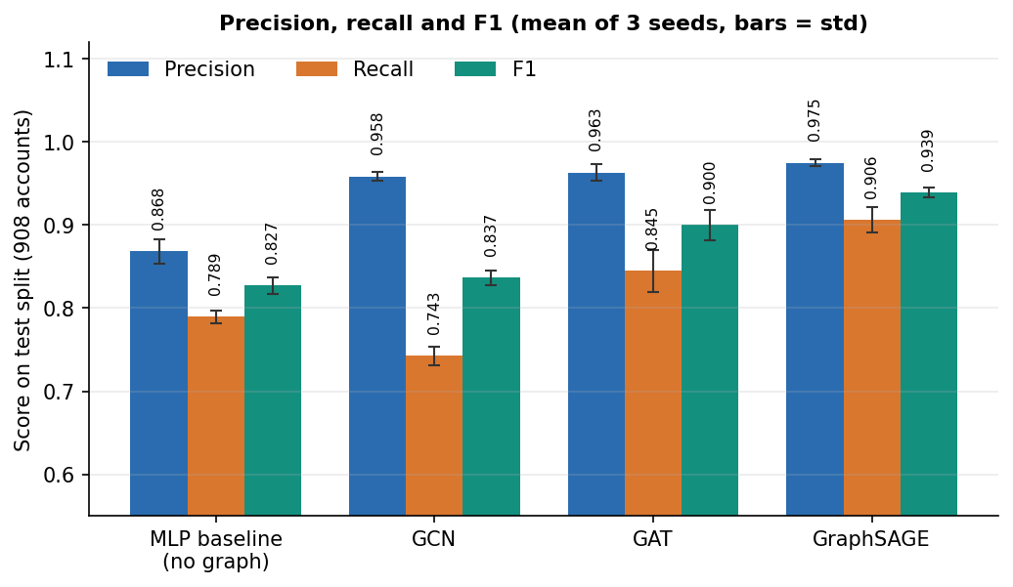
Figure 1: Precision, recall and F1 of the four models on the test split (mean over three seeds).
The graph helps, but by very different amounts. Over the feature-only baseline (F1 0.827), GCN gains 1.0 point, GAT 7.3 points and GraphSAGE 11.2 points. GCN's small gain is a trade: its precision rises to 0.958 but its recall (0.743) is lower than the baseline's (0.789), so it finds fewer fake accounts than a model that ignores the graph. A plausible reason, which these experiments do not prove, is that GCN's symmetric normalisation averages an account with its neighbours, so a fake account with a few genuine neighbours is pulled towards them, whereas GraphSAGE keeps the account's own features in a separate weight from the neighbourhood mean. GAT is in between and is the least stable: its F1 over the three seeds is 0.901, 0.877 and 0.922.
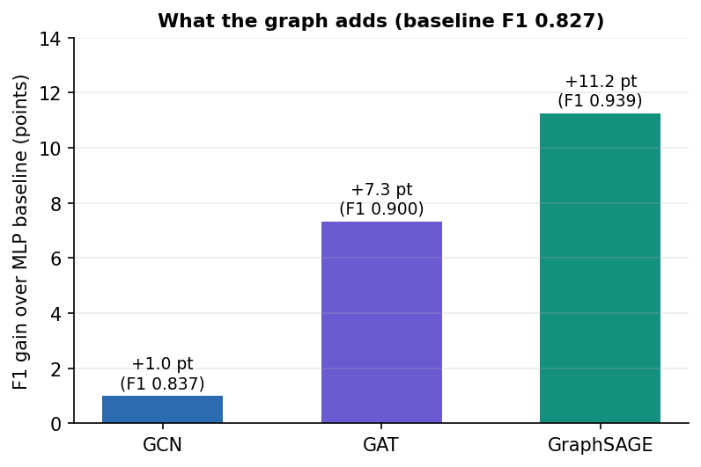
Figure 2: F1 gained over the feature-only baseline by each graph architecture, in F1 points.

1.2.1 Seed variation
Table 4: F1 by training seed (with the validation-tuned threshold)
Model | Seed 0 | Seed 1 | Seed 2
Feature-only baseline (MLP) | 0.833 (thr 0.500) | 0.835 (thr 0.500) | 0.813 (thr 0.500)
GCN | 0.847 (thr 0.675) | 0.837 (thr 0.625) | 0.826 (thr 0.750)
GAT | 0.901 (thr 0.475) | 0.877 (thr 0.500) | 0.922 (thr 0.425)
GraphSAGE | 0.946 (thr 0.500) | 0.941 (thr 0.500) | 0.931 (thr 0.525)

GraphSAGE's three values lie within 0.015 of each other and every one is above every value of GAT, GCN and the baseline, so its ranking does not depend on the seed. GAT's spread is large enough that its best seed (0.922) nearly reaches GraphSAGE's worst (0.931). GAT's edge softmax sums in a non-deterministic order, so re-running it can move its F1 by about 0.01.
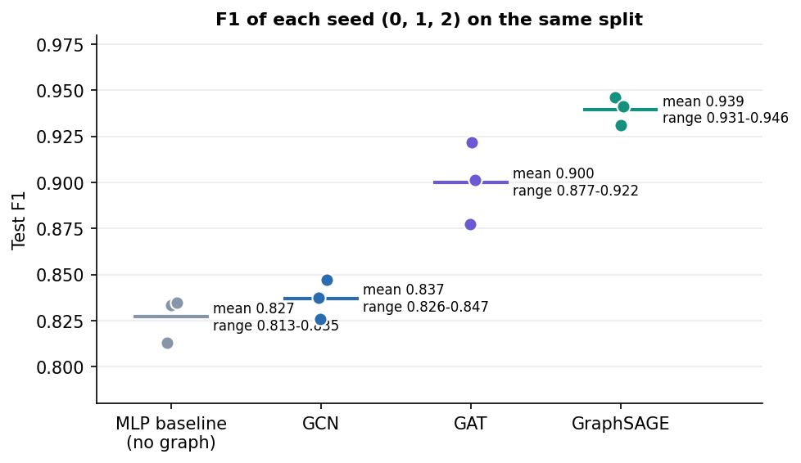
Figure 3: F1 of every model for each of the three training seeds.

1.2.2 Confusion matrices and ROC curves
The stored confusion matrices belong to the first seed. GraphSAGE misses 9 of the 114 fake accounts and wrongly flags 3 of 794 genuine accounts; the baseline misses 24 and wrongly flags 12.
Table 5: Confusion counts on the 908-account test split (seed 0)
Model | TP | FN | FP | TN | Threshold
Feature-only baseline (MLP) | 90 | 24 | 12 | 782 | 0.500
GCN | 86 | 28 | 3 | 791 | 0.675
GAT | 96 | 18 | 3 | 791 | 0.475
GraphSAGE | 105 | 9 | 3 | 791 | 0.500

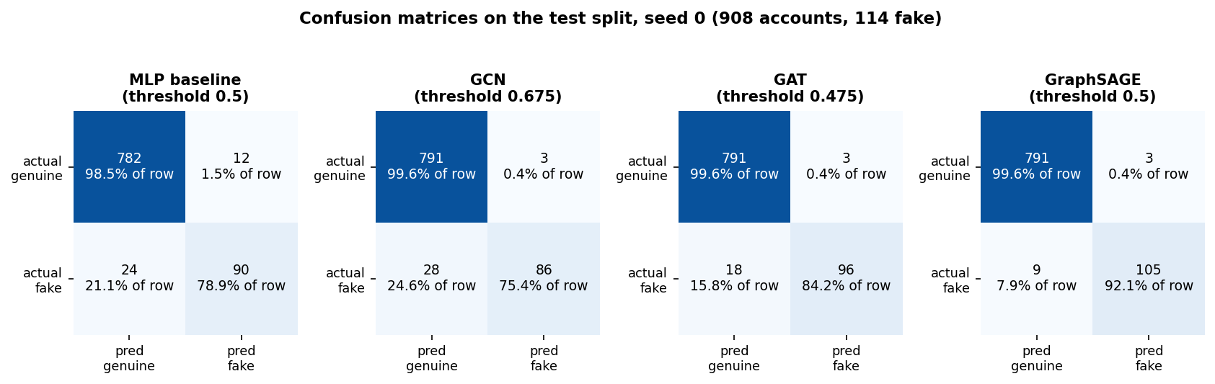
Figure 4: Confusion matrices of the four models on the test split (seed 0).
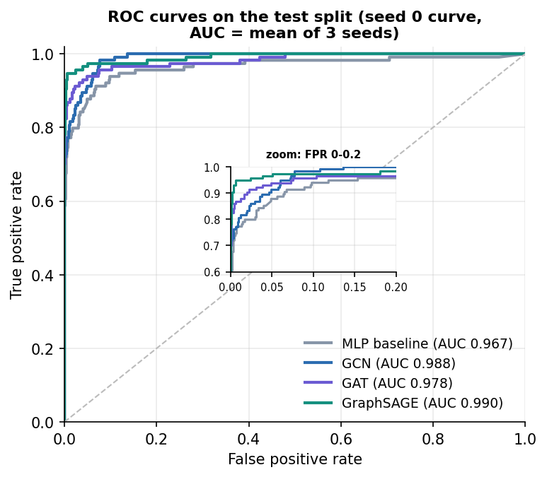
Figure 5: ROC curves of the four models on the test split (seed 0).
The ROC-AUC values are all high (0.967 to 0.990) because the classes are easy to rank; the PR-AUC column of the table above separates the models better (0.907 for the baseline, 0.974 for GraphSAGE) because it reflects the minority class.

1.3 Threshold analysis
An account is flagged when its fake-probability reaches the threshold. The served model uses 0.5, which the validation set chose. To see how much the result depends on that choice, the stored GraphSAGE scores (seed 0) were swept over thresholds on the test split.
Table 6: Served GraphSAGE at different thresholds (test split, seed 0)
Threshold | Precision | Recall | F1 | False positives | False negatives
0.20 | 0.838 | 0.956 | 0.893 | 21 | 5
0.30 | 0.908 | 0.947 | 0.927 | 11 | 6
0.40 | 0.956 | 0.947 | 0.952 | 5 | 6
0.50 | 0.972 | 0.921 | 0.946 | 3 | 9
0.60 | 0.981 | 0.904 | 0.941 | 2 | 11
0.70 | 0.980 | 0.877 | 0.926 | 2 | 14
0.80 | 0.990 | 0.851 | 0.915 | 1 | 17
0.90 | 0.989 | 0.798 | 0.883 | 1 | 23

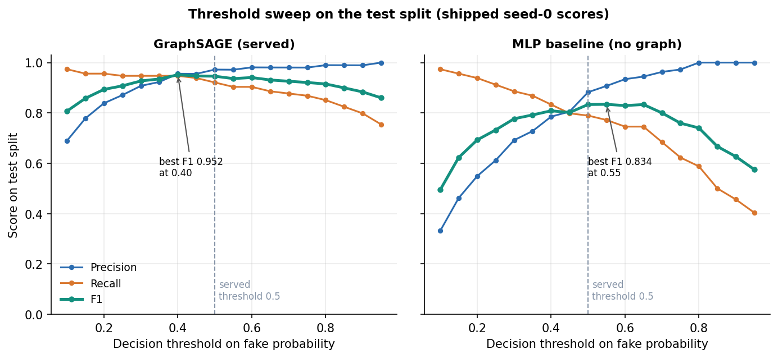
Figure 6: Precision, recall and F1 of the served GraphSAGE model against the decision threshold (test split, seed 0).
F1 stays between 0.927 and 0.952 for every threshold from 0.30 to 0.60, so the result does not hinge on the tuned threshold. Raising the threshold buys precision at the cost of recall: at 0.90 only one genuine account is flagged but 23 of the 114 fake accounts are missed. Lowering it does the opposite: at 0.20, 21 genuine accounts are flagged and 5 fake accounts are missed. The peak of the sweep (F1 0.952 at 0.40) is measured on the test split itself, so it is shown for analysis only; the served threshold was fixed on validation data. The baseline's best F1 over the same sweep is 0.834 (threshold 0.55); to reach a recall above 0.9 it has to accept a precision below 0.62, whereas GraphSAGE keeps a precision of 0.87 at a recall of 0.947. For a moderation team this is the useful reading: the graph model lets a team choose how many false alarms to accept without losing much recall.

1.4 Which features matter: an ablation
To find out where the performance comes from, the baseline and GraphSAGE were retrained with groups of features removed, three seeds each, in memory and without touching the shipped models. The row all 23 features (baseline 0.822, GraphSAGE 0.942) differs slightly from the main table (0.827 and 0.939) because it is a separate run with its own seeds' random draws.
Table 7: Test F1 with feature groups removed (mean ± standard deviation over three seeds)
Variant | Features | Baseline MLP | GraphSAGE | GraphSAGE precision / recall
all 23 features | 23 | 0.822 ± 0.009 | 0.942 ± 0.001 | 0.966 / 0.918
without profile metadata | 11 | 0.803 ± 0.013 | 0.887 ± 0.004 | 0.969 / 0.819
without posting behaviour | 19 | 0.822 ± 0.016 | 0.946 ± 0.005 | 0.973 / 0.921
without temporal pattern | 17 | 0.515 ± 0.003 | 0.840 ± 0.003 | 0.898 / 0.789
without interaction frequency | 22 | 0.825 ± 0.010 | 0.919 ± 0.022 | 0.975 / 0.871
profile metadata only | 12 | 0.512 ± 0.011 | 0.831 ± 0.012 | 0.878 / 0.789
behaviour only (posting, temporal, interaction) | 11 | 0.803 ± 0.013 | 0.887 ± 0.004 | 0.969 / 0.819
degree only (structure, no attributes) | 1 | 0.338 ± 0.003 | 0.965 ± 0.003 | 0.962 / 0.968

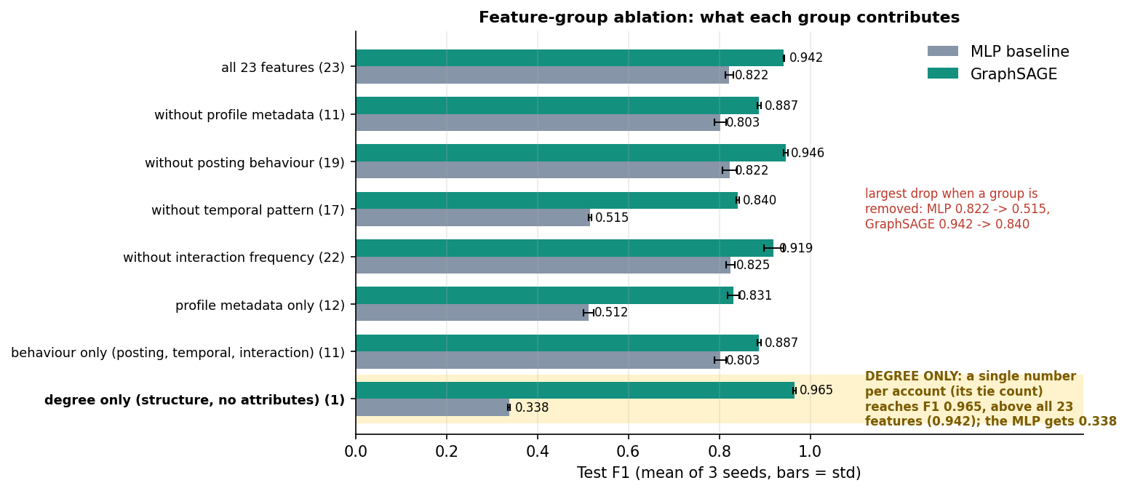
Figure 7: Test F1 of the baseline and GraphSAGE when feature groups are removed (three seeds).
1. The temporal group matters most. Removing the temporal features (account age, posts per day, burstiness, peak-hour share and its sine and cosine) drops the baseline from 0.822 to 0.515 and GraphSAGE from 0.942 to 0.840. These features are synthetic: botnet members share a creation window and a peak hour by construction, so this is the place where the benchmark is most generous.
2. Posting behaviour adds nothing. GraphSAGE scores 0.946 without it, which fits the finding that the Twitter bot label carries almost no signal.
3. The neighbourhood supplies what the profile lacks. On the 12 profile features alone the baseline reaches only 0.512 while GraphSAGE reaches 0.831.
4. One structural feature is enough here. GraphSAGE given nothing but the logarithm of each account's number of ties scores F1 0.965 (precision 0.962, recall 0.968), above the model with all 23 features (0.942). The no-graph model on the same single feature scores 0.338: an account's own degree is not enough, but its neighbours' degrees separate the classes.
The last finding changes how the headline result must be read. In this benchmark the injected botnets and lone spammers have a distinctive local degree pattern (dense ties inside a botnet, two to ten ties to real accounts), so message passing over degrees alone nearly solves the task. The benchmark therefore rewards structure more than a real platform would, and the graph lift of 11.2 F1 points is real for this data but partly produced by how the botnets were injected. The F1 of 0.939 must not be read as accuracy on a real platform. Showing this was the purpose of the ablation: a result that looks excellent should be asked what it depends on.

1.5 Botnet cluster detection
The embeddings of every account scored at 0.30 or more were linked to their five most similar neighbours and to their real ties, and Louvain community detection was run on that graph. Groups under five accounts were dropped. Nine groups remained: eight coordinated clusters and one loose group of 160 accounts. A botnet counts as recovered when one cluster contains at least 80 % of its accounts and at least 80 % of that cluster's accounts belong to it.
Table 8: Recovery of the eight injected botnets
Botnet | Accounts | Matched cluster | Recall | Precision | Recovered
Botnet 1 | 62 | cluster 2 | 1.000 | 1.000 | yes
Botnet 2 | 50 | cluster 6 | 1.000 | 1.000 | yes
Botnet 3 | 52 | cluster 5 | 1.000 | 1.000 | yes
Botnet 4 | 60 | cluster 1 | 1.000 | 0.923 | yes
Botnet 5 | 48 | cluster 7 | 1.000 | 1.000 | yes
Botnet 6 | 56 | cluster 4 | 1.000 | 1.000 | yes
Botnet 7 | 58 | cluster 3 | 1.000 | 0.983 | yes
Botnet 8 | 34 | cluster 8 | 1.000 | 1.000 | yes

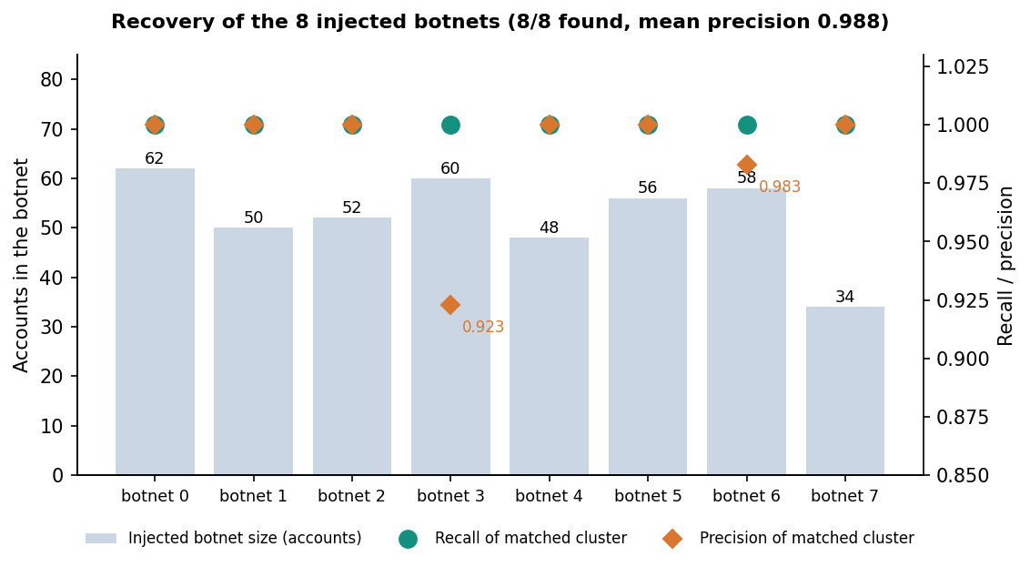
Figure 8: Recall and precision of the cluster that best matches each injected botnet.
All eight botnets are recovered as single communities: the mean recall is 1.000 and the mean precision 0.988; the lowest precision is 0.923 (botnet 4, whose cluster also contains five accounts that are not part of it). The fake purity of all clustered accounts is 0.913, which is lower than the botnet precision because the loose group of 160 accounts holds lone spammers together with look-alike genuine accounts: it has a tie density of 0.14 % and only 18 internal ties, and the application labels it loose group instead of coordinated because its density is below 5 %. That label is what separates a coordinated network from independent accounts that merely look alike.
This is a known-answer test. The botnets were injected with a tie probability of 0.28 between members, a shared creation window and a shared posting hour, so they are easy to find by construction. The result shows that the method recovers this kind of coordination; it says nothing about the recall of real botnets that hide their ties.
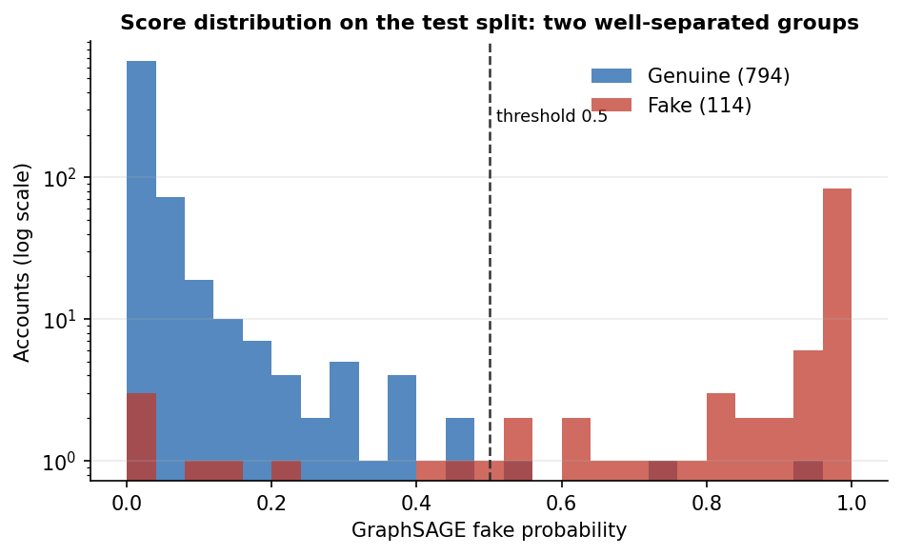
Figure 9: Distribution of GraphSAGE fake-probabilities for genuine and fake accounts.

1.6 Scalability and response time
The sweep of Section 7.7 grows the graph from 4,533 accounts and 94,456 ties to 36,264 accounts and 755,648 ties. A GraphSAGE epoch takes 0.060 s on the smallest graph and 0.392 s on the largest, GCN 0.142 s and 0.577 s, GAT 0.255 s and 2.022 s; one forward pass over the whole graph takes 0.186 s for GraphSAGE and 0.584 s for GAT at the largest size. Cost grows roughly in proportion to the number of ties, and GAT is the most expensive. GraphSAGE is both the most accurate and, among the graph models, the cheapest, so on this benchmark there is no accuracy-for-speed trade-off to make.
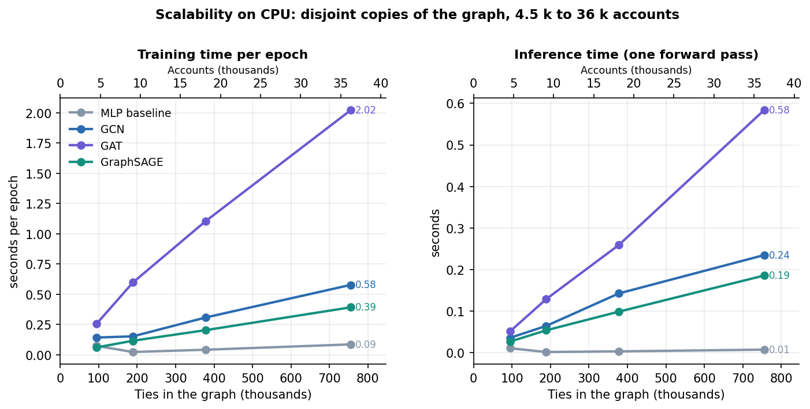
Figure 10: Training time per epoch and inference time against graph size, CPU, for the four models.
The API answers its read endpoints in 3 to 16 ms (median) and no 95th percentile exceeds 29 ms; sign-in takes about 233 ms because of bcrypt, and the API needs 5.1 s to load the artefacts at start-up. The limits of these figures (a 36 thousand-account graph, disjoint copies, one machine) are stated in Section 7.7.

1.7 Comparison with the base paper
The base paper [1] proposes PruferNET: Prufer-sequence features from a minimum spanning tree, added to classical centralities and fed to a GraphSAGE model that classifies each node by its depth in the tree. Its task is to find influential nodes, not fake ones, and its data carry no fake-account labels. The two works share a family of data (SNAP Facebook networks), a model family (GraphSAGE) and the idea that structure adds information a per-node model lacks, but they do not measure the same thing. Their numbers cannot be compared like for like, and no ranking is claimed.
Table 9: What each work reports
Aspect | PruferNET (base paper) | BotGraph (this project)
Task | 3-class node classification by depth in a minimum spanning tree (Very Shallow / Shallow / Deep) | Binary fake-account detection plus botnet cluster detection
Labels | Depth classes computed from the graph itself | Dataset labels: genuine / fake (12.6 % fake); partly synthetic
Data | SNAP Facebook, 4,039 nodes and 88,234 edges; Email-Eu-core, 986 nodes and 16,064 edges | 4,533 nodes, 94,456 ties: SNAP Facebook topology (3,963 nodes) plus injected accounts, real profile rows, synthetic timing features
Model | GraphSAGE, 64 hidden units, dropout 0.5, AdamW lr 0.003, 300 epochs | GCN, GAT and GraphSAGE, 2 layers, 64 hidden units, dropout 0.3, Adam 0.01, up to 160 epochs, plus an MLP baseline
Features | Prufer-sequence statistics, degree, closeness, PageRank, trust score | 23 attributes: profile, posting, temporal, interaction; no Prufer or centrality features
Split | 60/20/20 | Stratified 60/20/20 (2,719 / 906 / 908)
Headline result | Test accuracy 99.63% with Prufer features, 96.54% without | GraphSAGE F1 0.939 ± 0.006 (accuracy 98.5%); baseline F1 0.827
Hardware | T4 GPU, 16 GB RAM | CPU only (i5-12500, 16 GB)
Clusters, scalability, review loop | None reported | Louvain botnet clusters (8 of 8 recovered), scalability to 36 k accounts, moderator queue with retraining

Three points of reading follow. First, accuracy is not the right yardstick for BotGraph, because 87.4 % of accounts are genuine; the accuracy of 98.5 % corresponds to an F1 of 0.939. Second, PruferNET's classes are defined by the same graph from which its features are computed, which makes high scores likely, and its own caveat that the paper is not about a new network architecture applies equally here: BotGraph's contribution is the application, not a new layer. Third, the Prufer features were not used in BotGraph and testing whether they help bot detection is listed as future work. The companion works in the batch survey (RABot and HW-GNN) address imbalance, noisy ties and homophily in bot detection; they were used to frame the problem and were not reproduced, so no number from them is quoted.

1.8 Summary of the numbers
Table 10: Headline numbers
Measure | Value
Served model | GraphSAGE
Test F1 (mean ± std, 3 seeds) | 0.939 ± 0.006
Test precision / recall | 0.975 / 0.906
Test ROC-AUC / PR-AUC | 0.990 / 0.974
Lift over the no-graph baseline | +11.2 F1 points (baseline 0.827)
Confusion (seed 0, 908 accounts) | TP 105, FN 9, FP 3, TN 791
Botnets recovered | 8 of 8 (mean recall 1.000, precision 0.988)
Accounts flagged at 0.5 | 548 of 4,533
GraphSAGE epoch at 36,264 accounts | 0.392 s
API median response | 3-16 ms (p95 up to 28 ms)
Smoke test | 36 of 36 checks pass

1.9 Learning from moderator decisions
Two retraining runs were made from a scratch copy of the application with the shipped data, to see what the feedback loop does. Each run trains all four models with one seed on the original training labels plus the labels given by the decisions, and the F1 is measured before and after on the same 908 test accounts (decisions on test accounts are ignored). The before value is the first seed of the main run, so the two columns use the same seed.
Table 11: F1 on the test split before and after retraining on moderator decisions (one seed)
Scenario | Model | F1 before | F1 after | Change (points)
A. Correct decisions | Feature-only baseline (MLP) | 0.833 | 0.836 | +0.2
 | GCN | 0.847 | 0.826 | -2.1
 | GAT | 0.901 | 0.892 | -0.9
 | GraphSAGE | 0.946 | 0.947 | +0.1
B. Includes two deliberate errors | Feature-only baseline (MLP) | 0.833 | 0.830 | -0.3
 | GCN | 0.847 | 0.765 | -8.2
 | GAT | 0.901 | 0.887 | -1.5
 | GraphSAGE | 0.946 | 0.905 | -4.1

Scenario A. Confirmation of the three largest coordinated clusters (BN-00112, BN-03963, BN-03936) and dismissal of three flagged accounts whose dataset label is genuine; every decision agrees with the dataset labels. 187 accounts received a label; 144 of them were outside the test split and were used. The run took 60 s. Afterwards the application flagged 521 accounts (548 before) and showed 8 botnets (8 before).
Scenario B. One confirmation of a flagged account and of cluster BN-00112 (65 accounts), both correct, and two deliberate errors: a dismissal of a fake account (@juniper2) and a dismissal of the whole cluster BN-03963 (62 accounts, a true botnet). 129 accounts received a label; 99 of them were outside the test split and were used. The run took 93 s. Afterwards the application flagged 534 accounts (548 before) and showed 7 botnets (8 before).
In scenario A every decision agrees with the dataset labels. Confirming botnets the model already scores near 100 % adds little information, so F1 barely moves for the baseline (+0.2 points) and GraphSAGE (+0.1) and falls for GCN (-2.1) and GAT (-0.9). With so few labels these changes are of the size of the seed-to-seed variation in Section 8.2.1, so the run shows that the loop works and does not damage the model, not that it improves it. One side effect is a defect worth recording: after this run the application served GAT instead of GraphSAGE, because the best architecture is picked on the validation F1 of a single seed and the validation set has just lost the reviewed accounts, although GraphSAGE has the higher test F1 after the run (0.947 against 0.892). Retraining can therefore switch the served model to a worse one. In scenario B the two errors cost F1 for every model: GCN falls by 8.2 points, GraphSAGE by 4.1, GAT by 1.5 and the baseline by 0.3, the number of botnets shown drops from 8 to 7 because the 62 accounts of the wrongly dismissed botnet were relabelled genuine, and 534 accounts remain flagged instead of 548. The loop learns whatever it is told: it makes moderator decisions valuable, and moderator errors costly. Two runs with one seed each do not support any statistical statement, but the direction is clear and follows from how the labels are used.

1.10 Output screens
All 18 screenshots in docs/screenshots/ are real captures of the running application (1440 x 900, Chromium) with the shipped GraphSAGE model and the committed graph; nothing is a mock-up. They were captured with scripts/capture_screens.py on 2026-10-24 and the decisions visible in the queue screens (four confirmations and one dismissal) were made during that session. Accounts shown as injected are the seeded synthetic accounts described in Section 8.1; their handles and display names are generated.

1.10.1 Landing page (light theme)
The public landing page. The headline reads Fake accounts hide alone. Botnets can't hide together., followed by one sentence on what the product does and two buttons, Try the live demo and See how it works. Three chips name the content (GCN, GAT and GraphSAGE; runs locally; moderator in the loop). The panel on the right is labelled Schematic illustration: it is a drawing of a small graph with a cluster of rose-coloured fake accounts, not real data, and two floating cards beside it carry real counters from the API (8 botnets found by clustering, 4,533 accounts in the graph). The top bar links to the sections, the theme switch, Sign in and Try the demo.

Figure 11: Landing page (light theme).

1.10.2 Sign-in page with the demo accounts
The sign-in page lists the two demo accounts with their roles and the shared password Demo@1234. A Fill button beside each copies the credentials into the form, and a one-click demo sign-in as the moderator sits under the Sign in button. The cards on the right restate the idea (Accounts are judged by their company) and the moderator's role (You make the call).
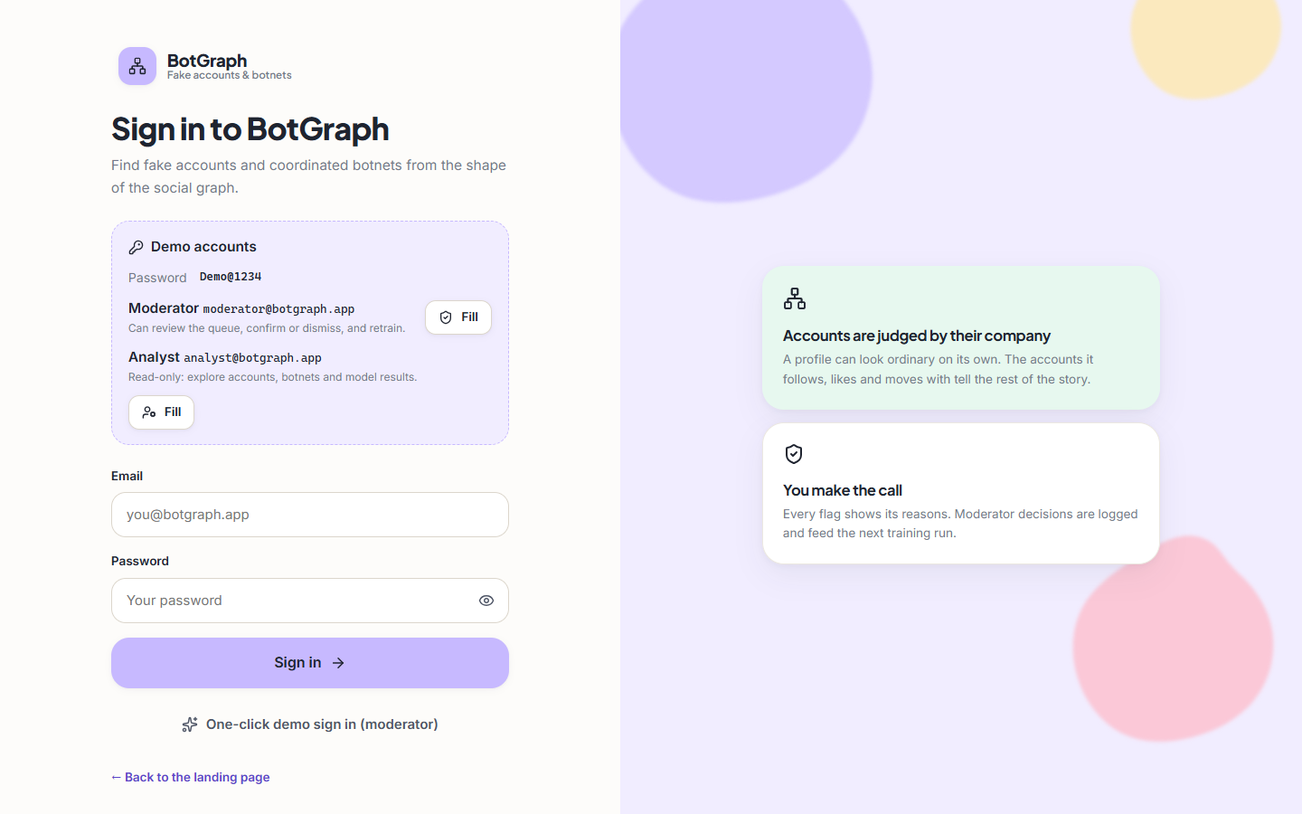
Figure 12: Sign-in page with the demo accounts.

1.10.3 Overview screen, light theme
The first screen after sign-in. Five counters read from the running API: 4,533 accounts and 94 thousand ties, 548 accounts flagged as fake (12.1 % of accounts), 8 botnet clusters plus one loose group, 510 items waiting for review (with 8 clusters and 5 decisions made during the capture session), and the F1 of GraphSAGE, 93.9 %, which is 11.2 points above the no-graph model. Below them, a histogram shows that almost every account scores below 10 % and a small group sits at 90-100 %, and a bar chart compares the test-set F1 of the four models (82.7, 83.7, 90.0 and 93.9 %).
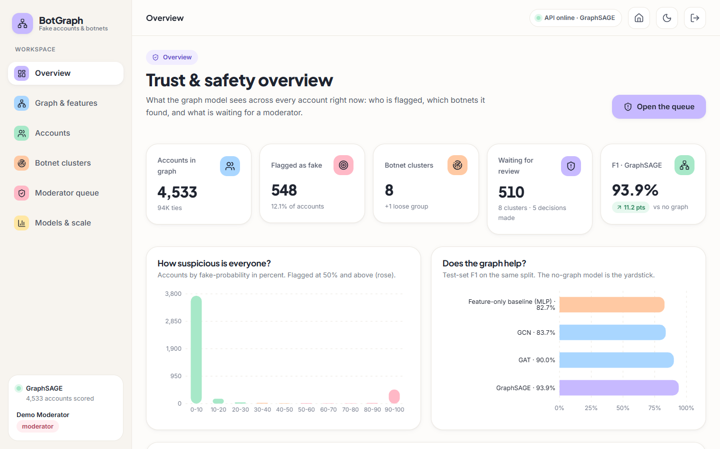
Figure 13: Overview screen, light theme.

1.10.4 Graph and features screen
The screen that explains how the graph is built. Counters give 4,533 nodes (3,963 real topology, 570 injected), 94,456 undirected ties (88,156 real, 6,300 injected), 570 fake accounts (12.6 %, a heavily imbalanced set) and 23 features per account with an average of 41.7 ties. A blue note states the schema: a node is an account with 23 features and a label used only for training and evaluation, an edge is a tie marked real or injected, and the split is 2,719 train, 906 validation and 908 test accounts, the same for every model. The charts below show the real and injected parts and the number of ties per account.
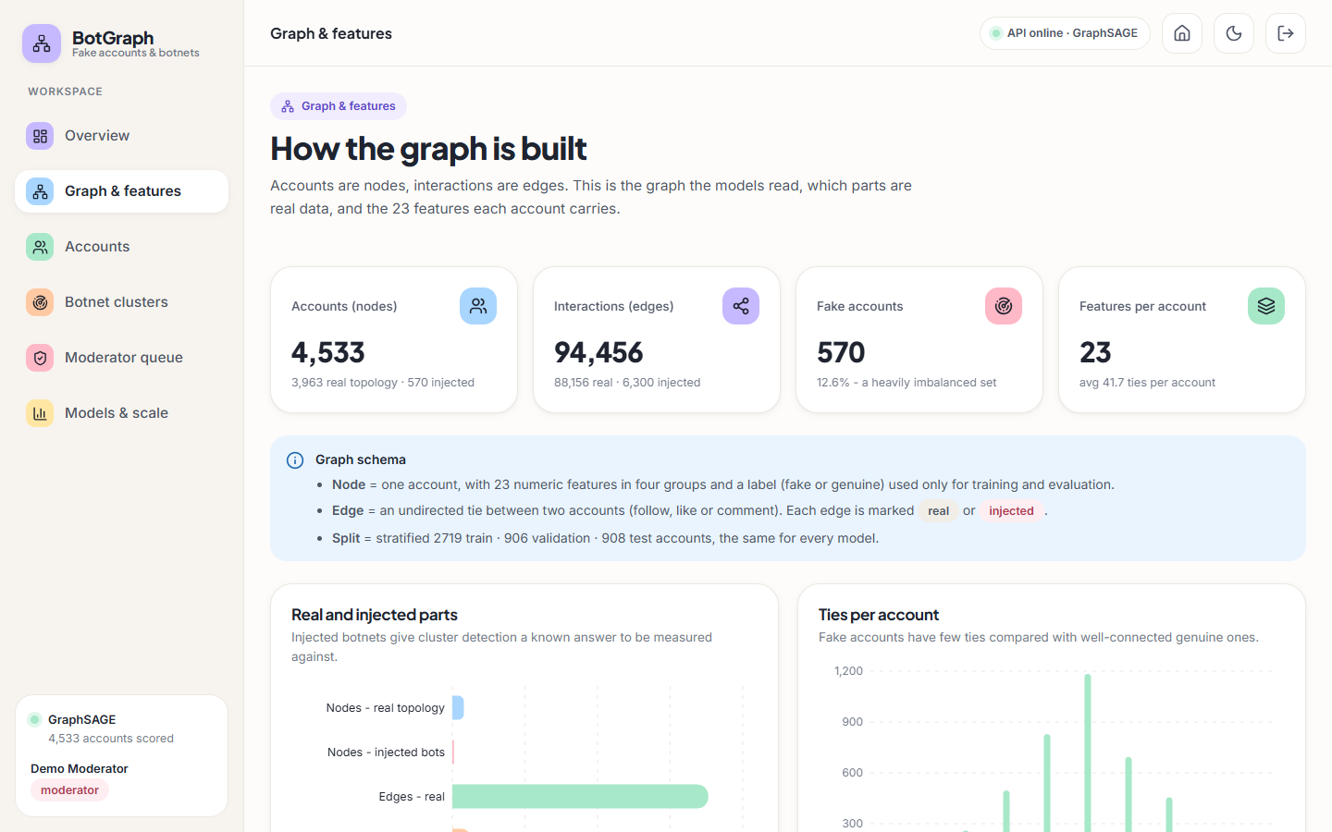
Figure 14: Graph and features screen.

1.10.5 Ranked accounts screen
Every account with its fake-probability. The filter bar offers a search box for the handle or name, a status filter, a botnet filter, a sort key and an order switch. The table shows handle and display name, a probability bar, the status badge, the botnet identifier, flagged neighbours out of all neighbours, followers and account age. The top rows are all members of BN-04235 at 100 %; their badges (Confirmed fake, Dismissed, Needs review) show decisions that had been recorded in the demonstration database before the capture, including a dismissal of an account whose dataset label is fake.
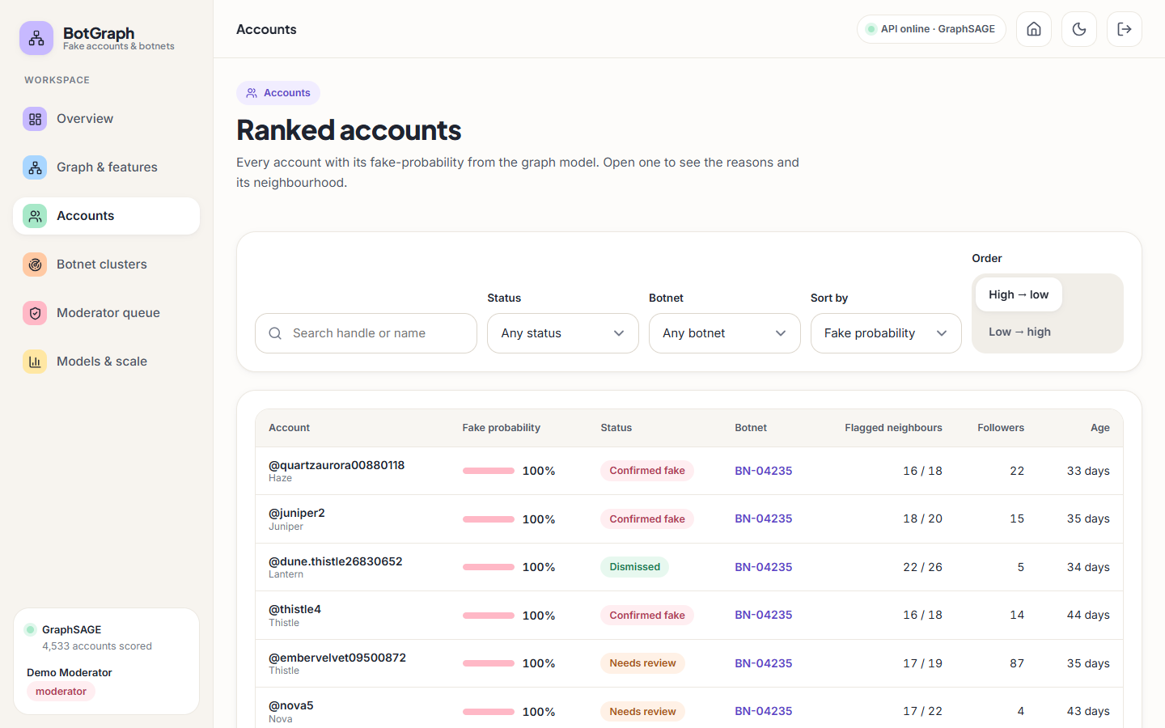
Figure 15: Ranked accounts screen.

1.10.6 Account detail screen, upper half
The page for @quartzaurora00880118, an account added to the graph as an injected account. A gauge shows 100 % fake probability from GraphSAGE, above the 50 % flag threshold, and a button shows that it is a member of BN-04235 (56 accounts). Same account, every model lists the probability from each model: the no-graph baseline, GCN, GAT and GraphSAGE all score it near 100 %, so this is an easy case in which the graph adds nothing. The Moderator decision panel offers Confirm fake and Dismiss and shows the current status, Confirmed fake.
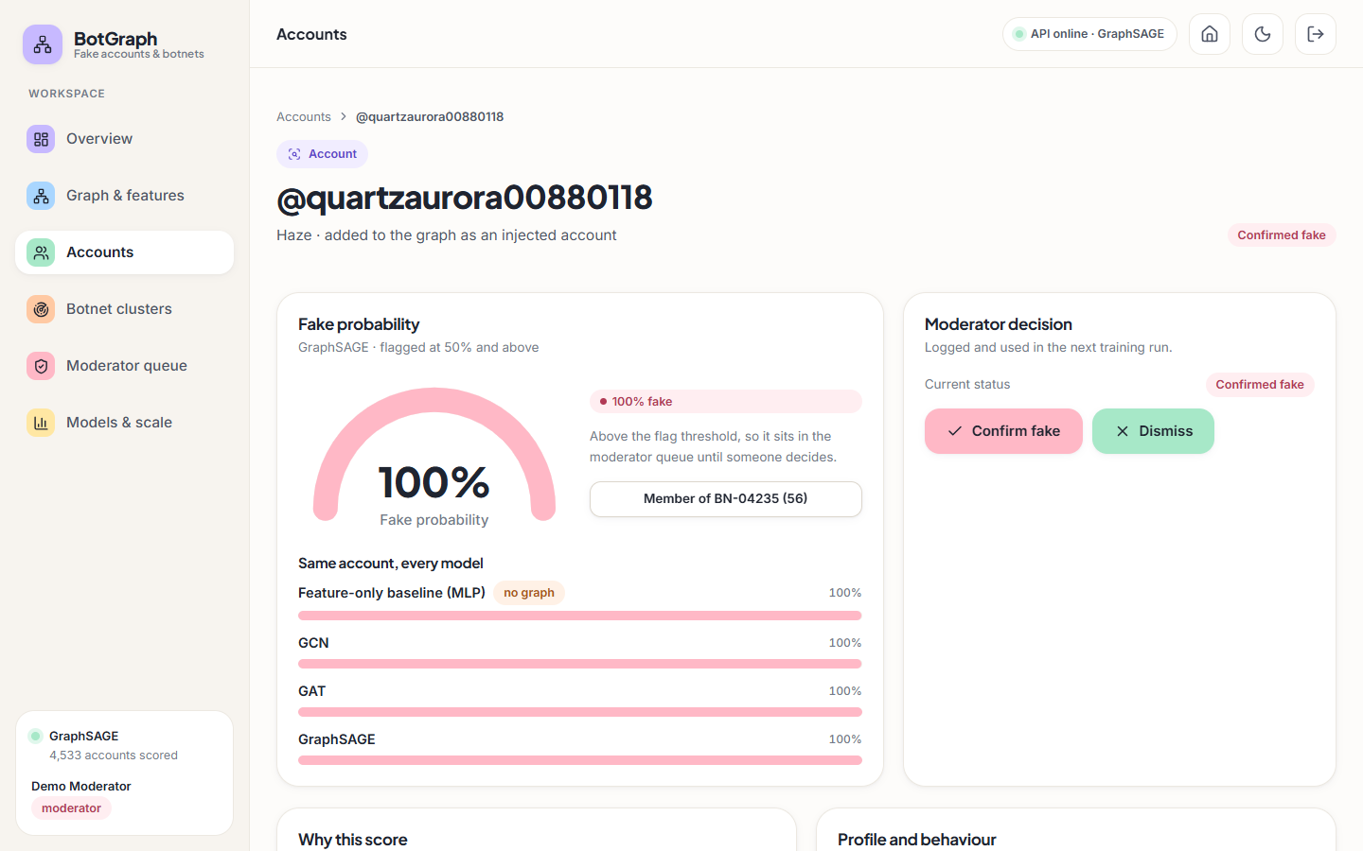
Figure 16: Account detail screen, upper half.

1.10.7 Botnet clusters screen
Louvain communities over the account embeddings. A note explains the two types: a coordinated cluster has dense ties between members, a loose group is suspicious accounts that merely look similar. The table lists BN-00055 first as a loose group (160 accounts, average probability 75 %, tie density 0 %, spread over 2.8 years), followed by coordinated clusters from BN-00112 (65 accounts, 96 %, 26 % density, 94 % active around 22:00, created within 17 days) down to BN-04187 (48 accounts, 100 %, 33 %). Every row is still marked Needs review.
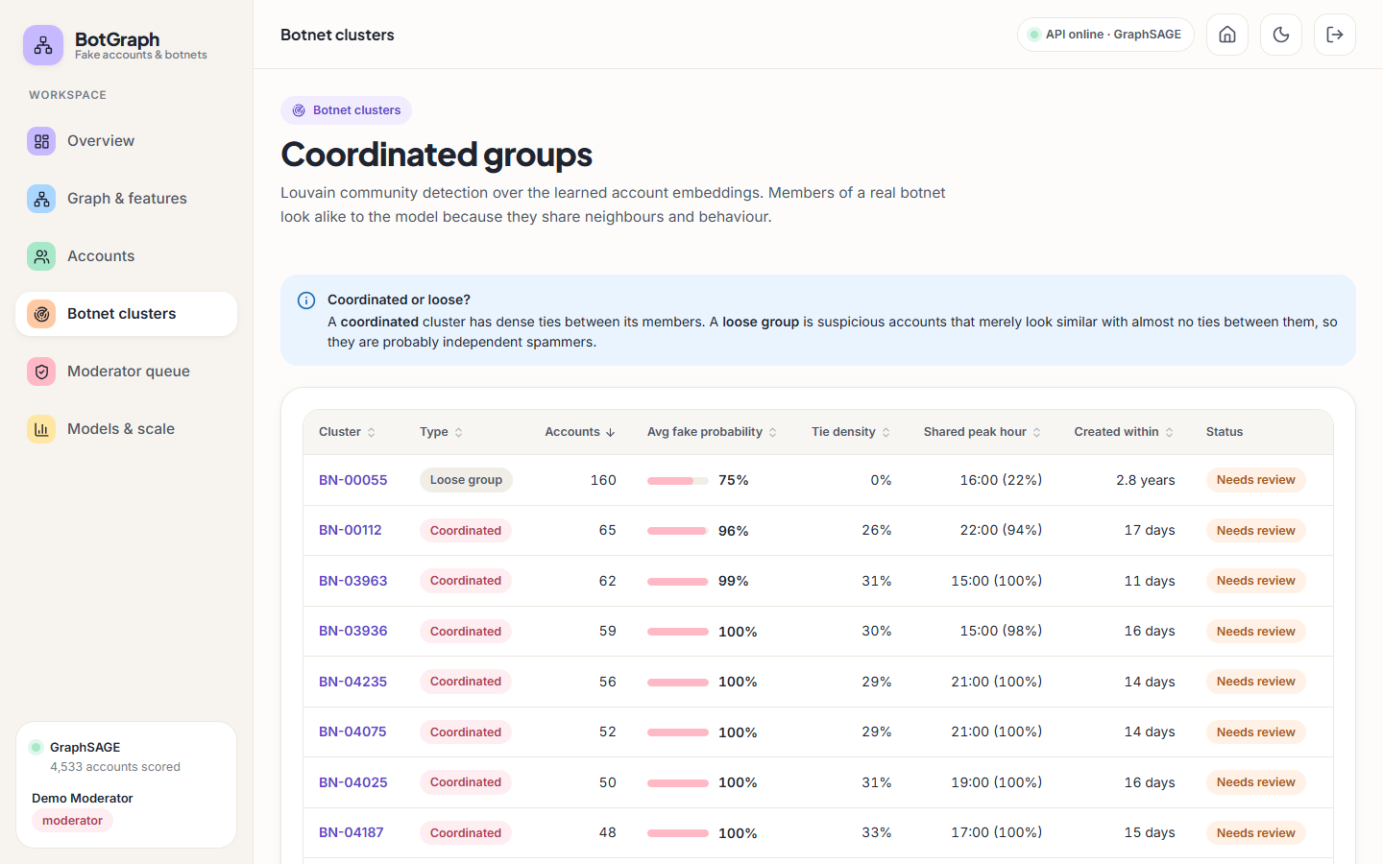
Figure 17: Botnet clusters screen.

1.10.8 Cluster detail screen for BN-00112
A sentence summarises the cluster (65 accounts tied to each other, 26 % of possible ties, 94 % most active around 22:00, created within about 17 days of each other). Four tiles give the size (95 % flagged individually), the 544 ties inside it, the shared peak hour 22:00 (94 % within one hour) and 289 distinct outside accounts the members are tied to. Below are the cluster graph, a Moderator decision panel whose decision applies to all 65 members, and a Shared behaviour list (average fake probability 96 %, created within 17 days, median account age 8 months). In this capture the graph is drawn small, as a compact pink knot with a few detached real accounts, because the force layout had not yet spread out.
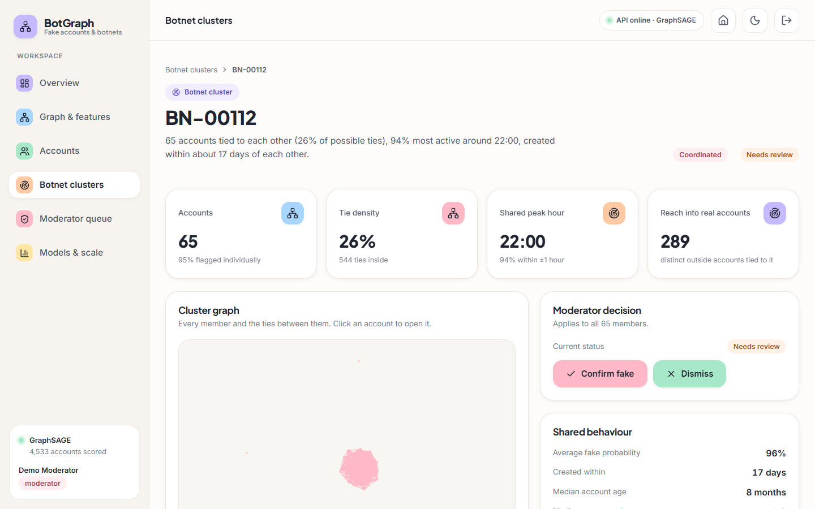
Figure 18: Cluster detail screen for BN-00112.

1.10.9 Moderator queue, accounts tab
The working screen for moderators. Four counters show 510 accounts and 8 clusters to review, 4 confirmed and 1 dismissed. Tabs switch between accounts, botnet clusters and the decision log, and a switch shows items that still need review or are already decided. The table lists flagged accounts from the highest score down. The panel on the right, Next training run, states that decisions become training labels and the test split is never touched, reports 38 labelled accounts ready to learn from and carries the Retrain with decisions button.
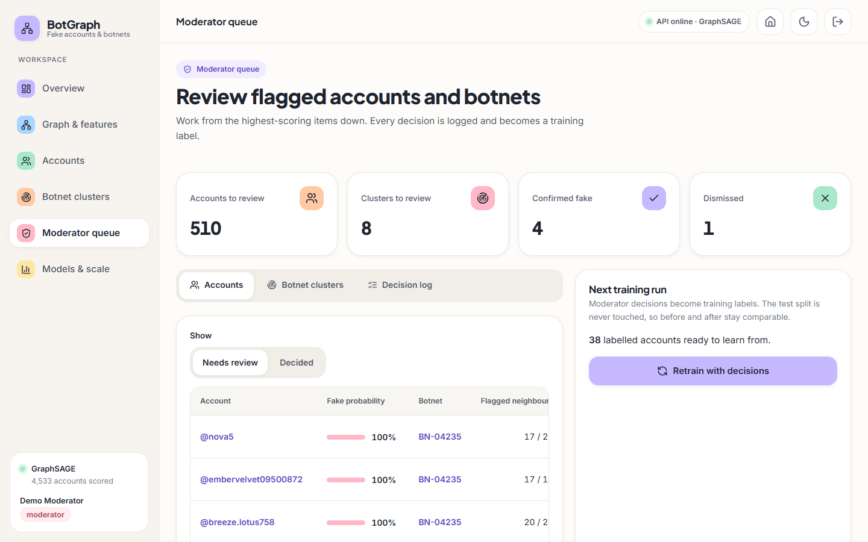
Figure 19: Moderator queue, accounts tab.

1.10.10 Moderator queue, botnet clusters tab
The same screen with the clusters tab selected: each cluster appears with its type, size, average fake probability and tie density, starting with the loose group BN-00055. A decision taken here applies to every member of the cluster and clears them from the account queue.
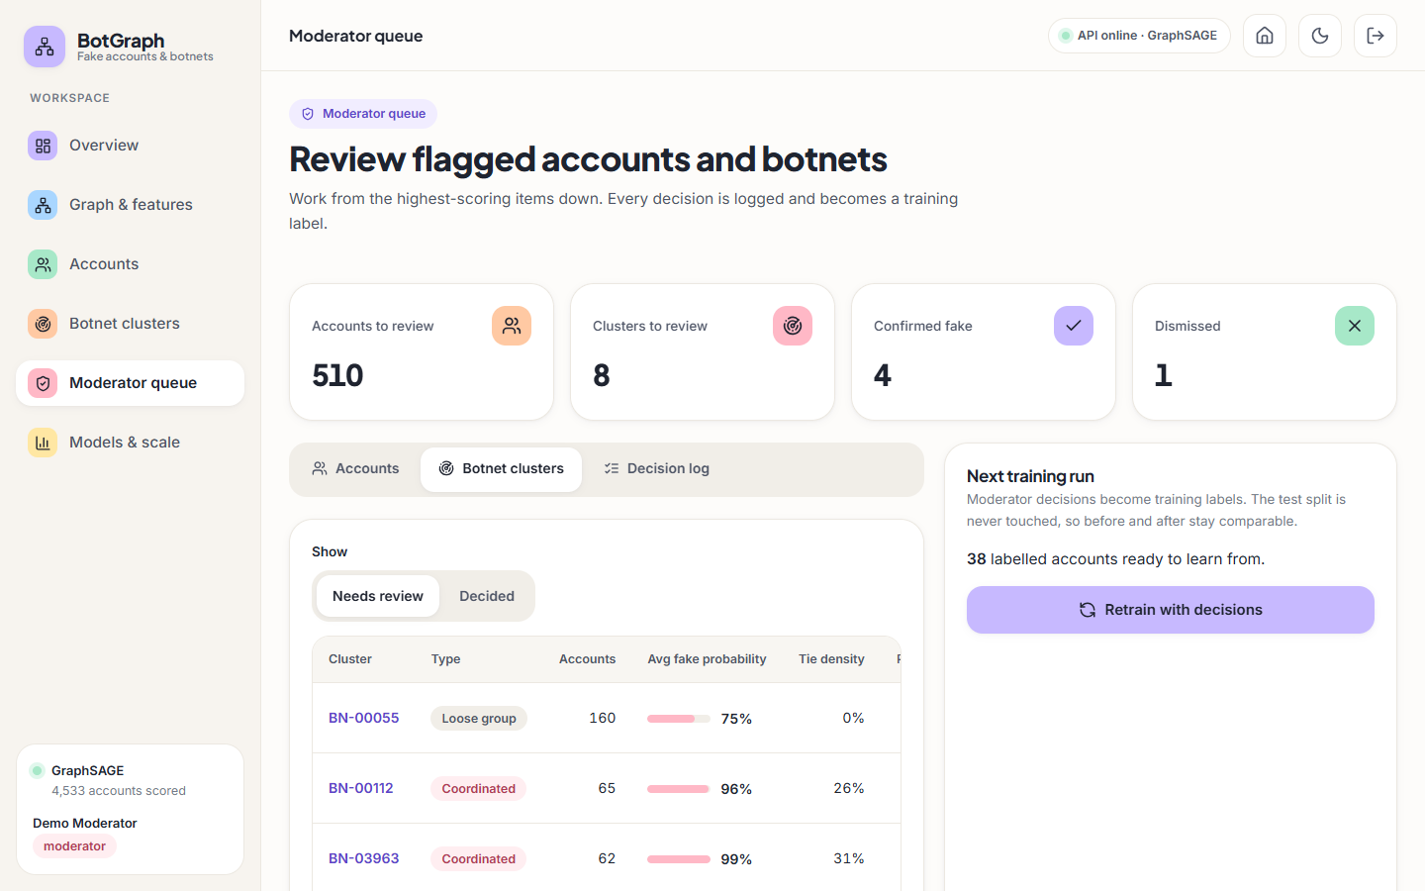
Figure 20: Moderator queue, botnet clusters tab.

1.10.11 Models and scale screen, comparison tab
Four tiles: the best architecture (GraphSAGE, chosen on validation F1 averaged over seeds), its F1 of 93.9 % with a deviation of 0.006 over seeds, the lift of 11.2 points over the no-graph baseline, and 8 of 8 botnets recovered (mean recall 100 %, precision 99 %). The table beneath compares the four models on the same 908-account test split (mean over three seeds, threshold tuned on the validation set) with accuracy, precision, recall, F1 with its deviation, ROC-AUC, PR-AUC, the F1 difference to the baseline and the training time.
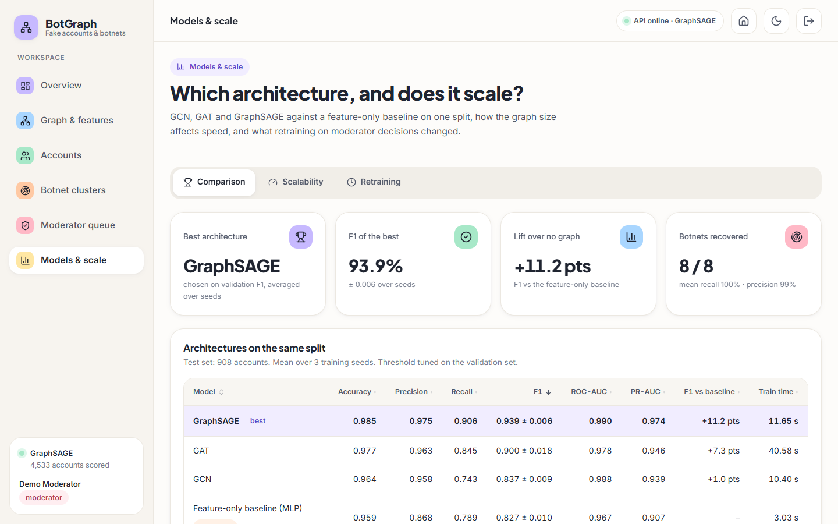
Figure 21: Models and scale screen, comparison tab.

1.10.12 Overview screen, dark theme
The Overview screen in the dark theme, with the same counters and charts. The theme button at the top right switches between the two themes and the choice is remembered in the browser.
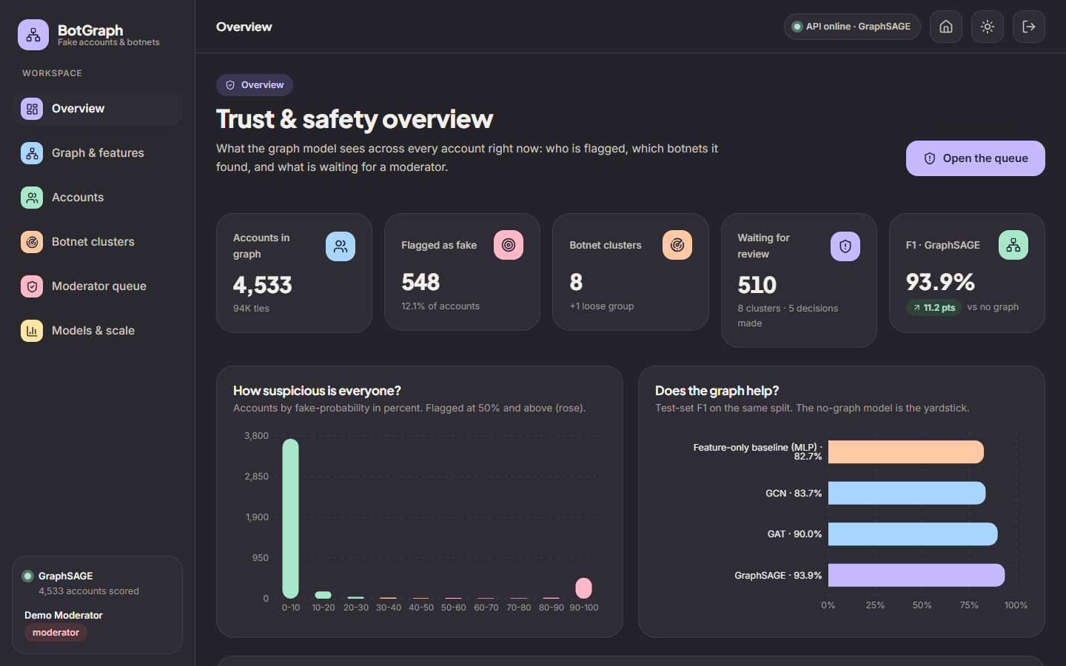
Figure 22: Overview screen, dark theme.

1.10.13 Landing page (dark theme)
The landing page in the dark theme: the same content, with muted pastel shapes on a dark background.

Figure 23: Landing page (dark theme).

1.10.14 Account detail screen, reasons and neighbourhood
The lower half of the account page. Why this score lists the account's own traits that push towards fake (rose bars) in order of contribution: account age (+1.93), share of activity in the peak hour (+1.05), posting burstiness (+0.89), digits in the username (+0.55), interactions per week (+0.26), posts per day (+0.22) and followers (+0.17). A blue note says the accounts around it add +9.73 to the model margin, that 7 of the top 7 traits push towards fake, and that gradient times input is an approximation, not a proof. Profile and behaviour shows the raw values (22 followers and 22 following, 5 posts, 33 days old, no profile picture, no bio, 1.5 posts a day, 100 interactions a week, most active at 22:00) and a green note records that the dataset label (fake) is used only for evaluation and never shown to the model at scoring time.
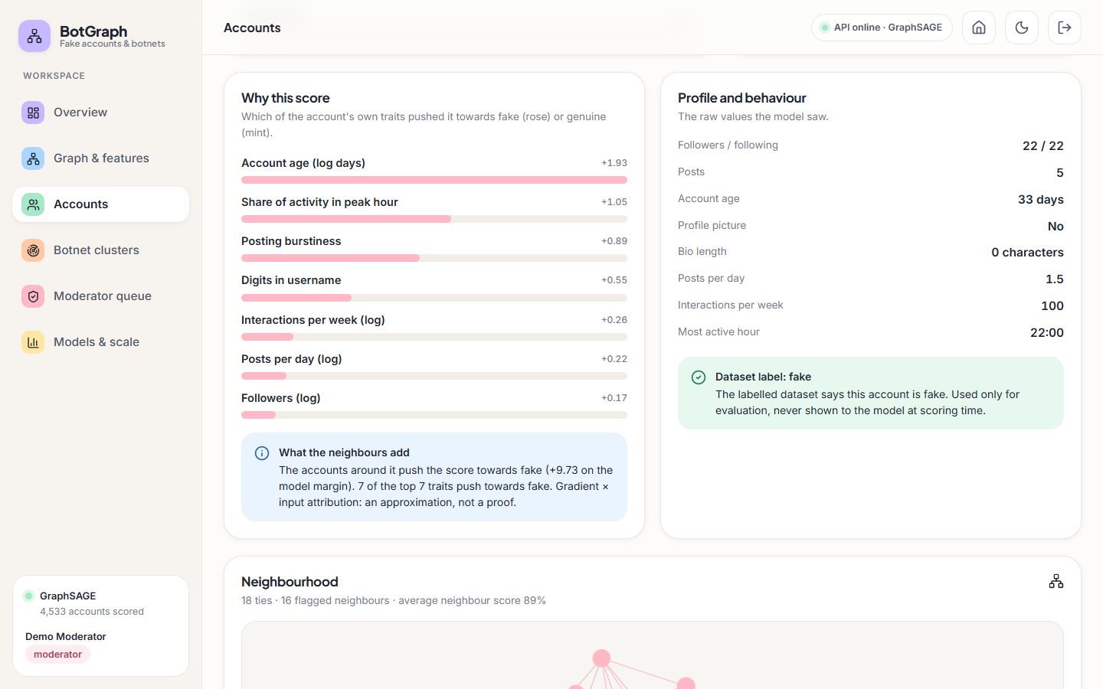
Figure 24: Account detail screen, reasons and neighbourhood.

1.10.15 Cluster detail screen, second layout state
A second capture of the BN-00112 page while the force layout was still moving, showing the cluster as a tight pink group with a few outlying accounts.
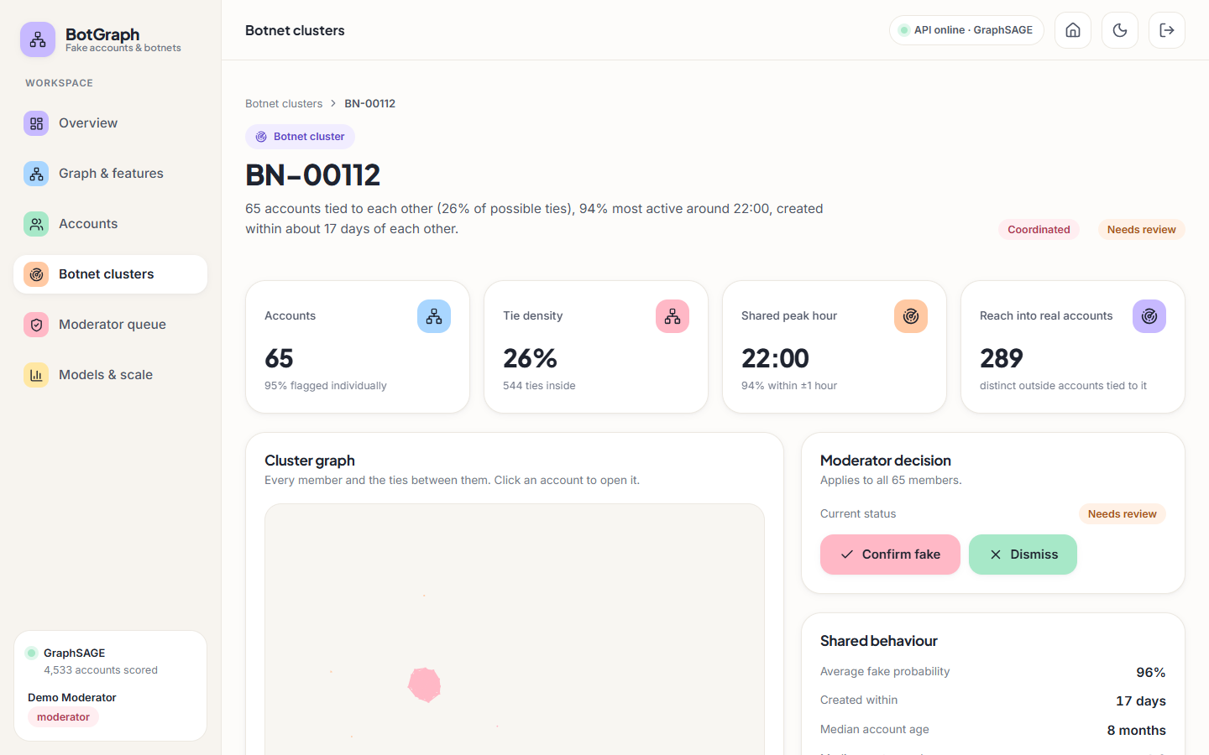
Figure 25: Cluster detail screen, second layout state.

1.10.16 Moderator queue, decision log tab
The decision log with a search box and a table of time, target, decision, accounts affected and moderator. The first rows are a Confirmed fake decision on cluster BN-04349 that affects 34 accounts and single-account decisions on @thistle4 (confirmed) and @dune.thistle26830652 (dismissed).
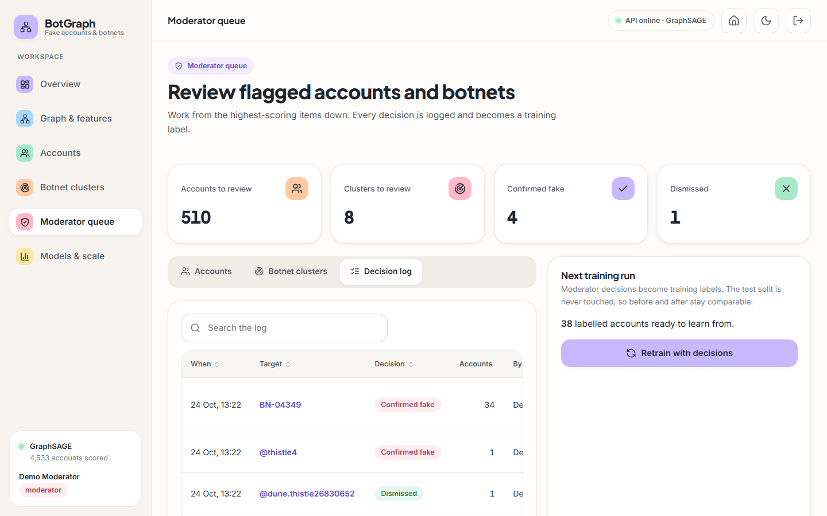
Figure 26: Moderator queue, decision log tab.

1.10.17 Models and scale screen, scalability tab
A note explains the sweep: the account graph is copied one to eight times as disjoint components, growing from 4,533 to 36,264 accounts and 94 thousand to 756 thousand ties; training time is averaged over 10 epochs and inference is the median of three forward passes, on CPU. Two line charts show training time per epoch (up to 2.2 s, GAT highest) and inference time (up to 0.6 s) against graph size.
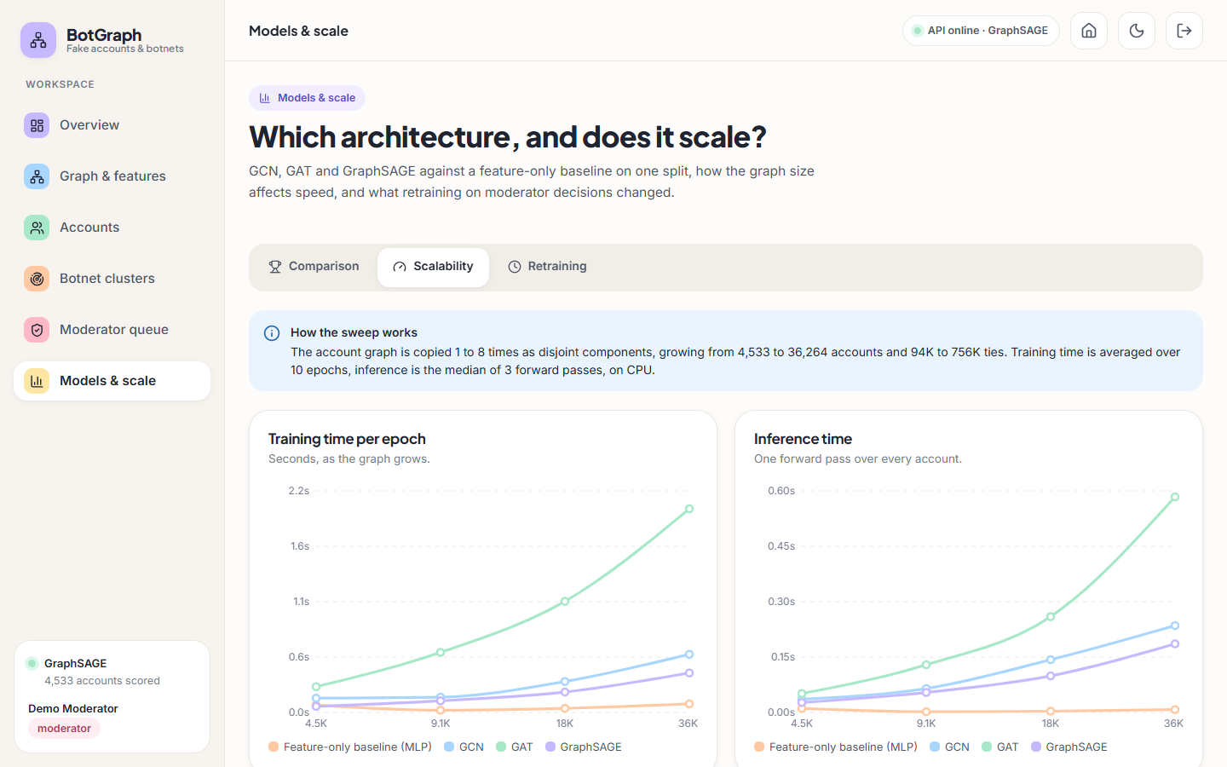
Figure 27: Models and scale screen, scalability tab.

1.10.18 Models and scale screen, retraining tab before any run
Before any retraining run the tab shows an empty state (No retraining runs yet) that tells the moderator to confirm or dismiss a few accounts and then retrain. A note explains that each run adds the decisions to the training labels and that the test split is never touched, so the before and after F1 are measured on the same accounts with one training seed each. The results of two such runs are given in Section 8.9.
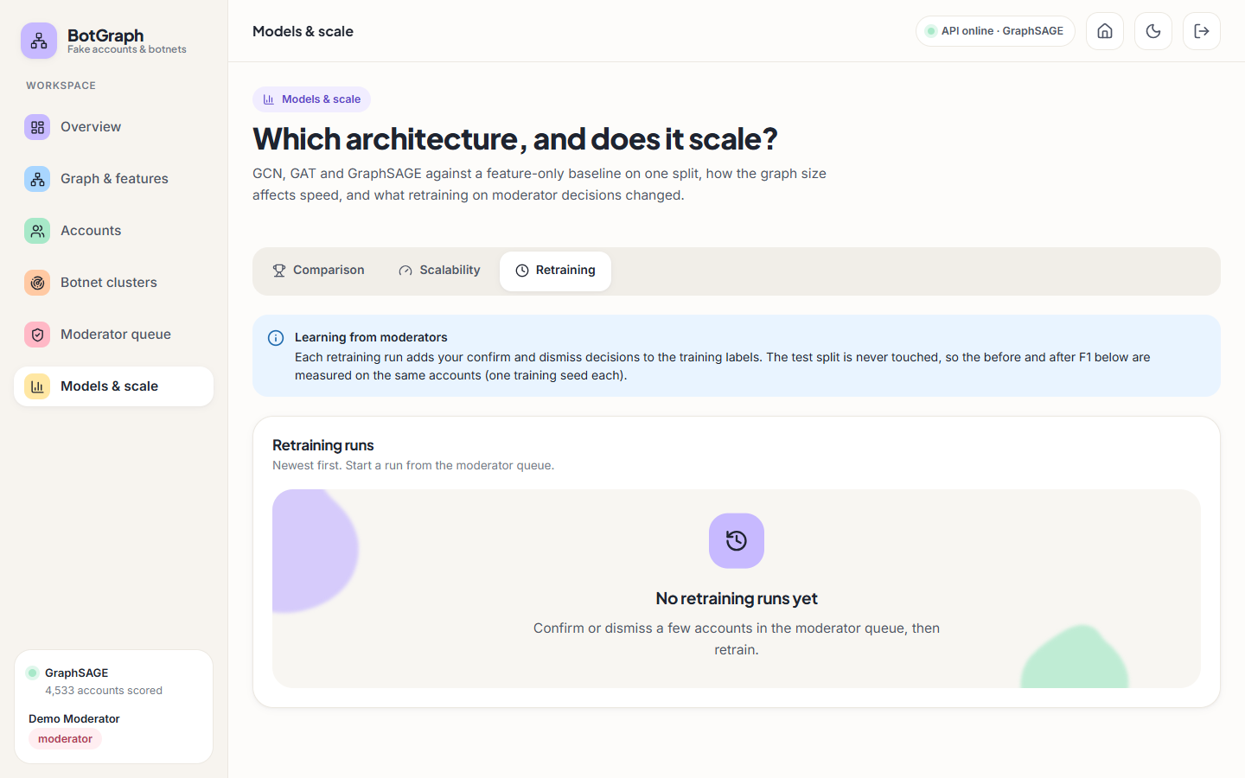
Figure 28: Models and scale screen, retraining tab before any run.

1.11 Sample inputs and outputs
The excerpts below are real responses of the API, captured on 2026-10-26 from a scratch copy of the application (long lists shortened with ...). They show the shape of the data behind the screens.

1.11.1 Sign-in and access control
POST /api/auth/login {"email": "moderator@botgraph.app", "password": "x"}
-> 401 {"detail": "That email and password do not match. Use one of the demo logins shown on the sign-in page."}

GET /api/overview (no token)
-> 401 {"detail": "Please sign in to continue."}

POST /api/queue/decisions (analyst token)
-> 403 {"detail": "Only moderators can record decisions or retrain the model."}

1.11.2 One ranked account and its explanation
GET /api/accounts?page_size=3 -> first item
{"id": 4286, "handle": "quartzaurora00880118", "display_name": "Haze", "score": 1.0, "flagged": true, "status": "pending", "cluster_id": "BN-04235", "followers": 22, "following": 22, "account_age_days": 33, "degree": 18, "flagged_neighbours": 16}

GET /api/accounts/4286 (trimmed)
{
"id": 4286,
"handle": "quartzaurora00880118",
"score": 1.0,
"flagged": true,
"status": "pending",
"model": "GraphSAGE",
"model_scores": {
"baseline": 0.9987,
"gcn": 0.9997,
"gat": 1.0,
"sage": 1.0
},
"cluster_id": "BN-04235",
"cluster_size": 56,
"explanation": {
"margin": 16.99,
"own_total": 5.38,
"network": 9.73,
"top": [
{
"feature": "log_account_age_days",
"value": 3.499,
"contribution": 1.93
},
{
"feature": "peak_hour_share",
"value": 0.364,
"contribution": 1.05
},
{
"feature": "posting_burstiness",
"value": 0.655,
"contribution": 0.89
}
]
},
"neighbourhood": {
"degree": 18,
"flagged": 16,
"mean_score": 0.89,
"injected_ties": 18
}
}

The three model scores in model_scores show that for this account every model, including the one that ignores the graph, is certain. The explanation says that the account's own traits contribute +5.38 to the fake-versus-genuine margin of 16.99 and that the other accounts' features, reached by message passing, contribute +9.73.

1.11.3 A botnet cluster
GET /api/clusters/BN-00112 -> headline
"65 accounts tied to each other (26% of possible ties), 94% most active around 22:00, created within about 17 days of each other."

GET /api/clusters -> second item
{"id": "BN-00112", "rank": 2, "kind": "coordinated", "size": 65, "mean_score": 0.9612287282943726, "flagged_share": 0.9538461538461539, "density": 0.26153846153846155, "internal_edges": 544, "peak_hour": 22, "peak_hour_share": 0.9384615384615385, "created_span_days": 17, "median_posts_per_day": 1.25, "median_account_age_days": 244, "status": "pending"}

1.11.4 A decision and an error
POST /api/queue/decisions {"target_type": "account", "target_id": "4286", "decision": "confirm", "note": "sample"}
-> 201 {"id": 1, "target_type": "account", "target_id": "4286", "decision": "confirm", "affected_accounts": 1, "at": "2026-10-26T05:38:44.856480+00:00"}

GET /api/accounts/99999999
-> 404 {"detail": "No account with id 99999999."}

1.12 Success and failure analysis

1.12.1 Where the system succeeds
• Coordinated accounts. All 82 botnet members in the test split are caught by GraphSAGE; the feature-only baseline catches 64. The graph rescues 18 fake accounts the baseline misses (a net gain of 18 botnet members), typically accounts with a camouflaged profile whose neighbours are not camouflaged.
• Few false alarms. At the served threshold 3 of 794 genuine accounts are flagged (0.4 %); all three are accounts of the real topology, with 4, 10 and 41 ties.
• Stable ranking. GraphSAGE leads on every metric and every seed (Section 8.2.1) and its F1 stays between 0.927 and 0.952 for any threshold from 0.30 to 0.60.
• Cluster recovery. Eight of eight injected botnets come back as single communities, and the density rule separates them from the loose group.
• Cost. A full pass over 36 thousand accounts and 756 thousand ties takes under 0.6 s on a laptop-class CPU, and the application answers requests in tens of milliseconds.

1.12.2 Where it fails
• Lone spammers. Of 32 lone spammers in the test split GraphSAGE catches 23, and the baseline 26: for accounts with no coordinated neighbourhood the graph does not help, and it loses 3 accounts the baseline caught. All 9 missed fake accounts are lone spammers with only 4 to 8 ties (median 7, against 20 for caught fake accounts); their scores range from 0.02 to 0.50. 6 fake accounts are missed by both models.
• GCN loses recall below the no-graph baseline (0.743 against 0.789), so a graph model is not automatically a better detector.
• Moderator mistakes spread. In the retraining experiment (Section 8.9), a wrong dismissal of a cluster relabelled every member as genuine and lowered the F1 of three of four models. The queue offers no second opinion or confidence check on a decision.
• The loose group needs a person. The 160-account group has no internal structure; it is flagged because its members individually look suspicious, and the system cannot say whether they are related.
• Easy cases look the same as hard cases on screen. The account shown on the account detail screen is scored 100 % by every model, including the baseline; the interface does not tell the moderator whether the graph contributed anything to a given score.
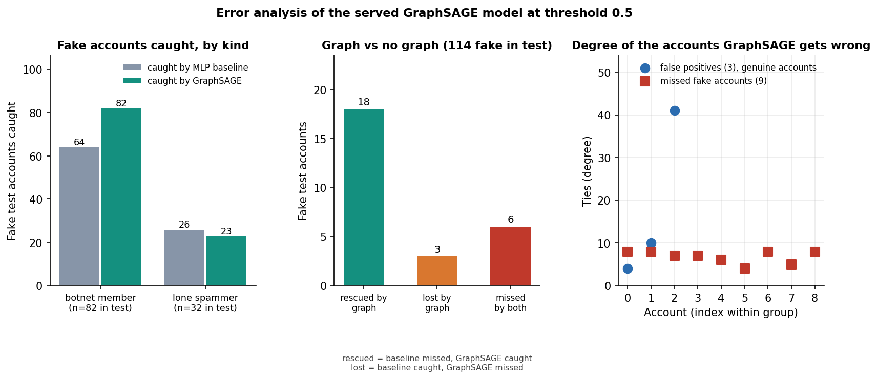
Figure 29: Test fake accounts caught and missed by GraphSAGE and by the baseline, by kind (botnet member, lone spammer).
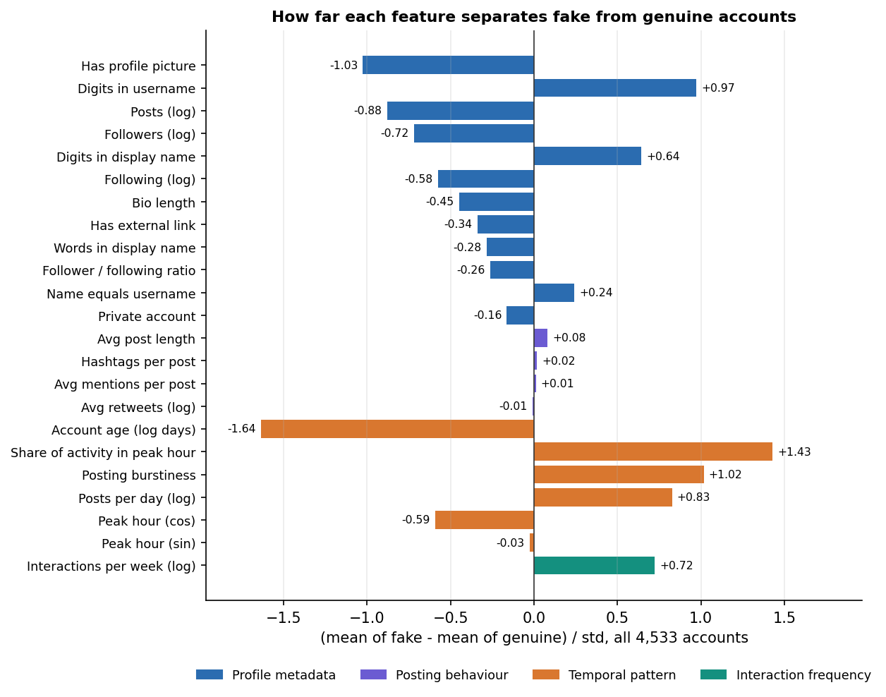
Figure 30: Mean value of each feature for genuine and fake accounts (standardised).
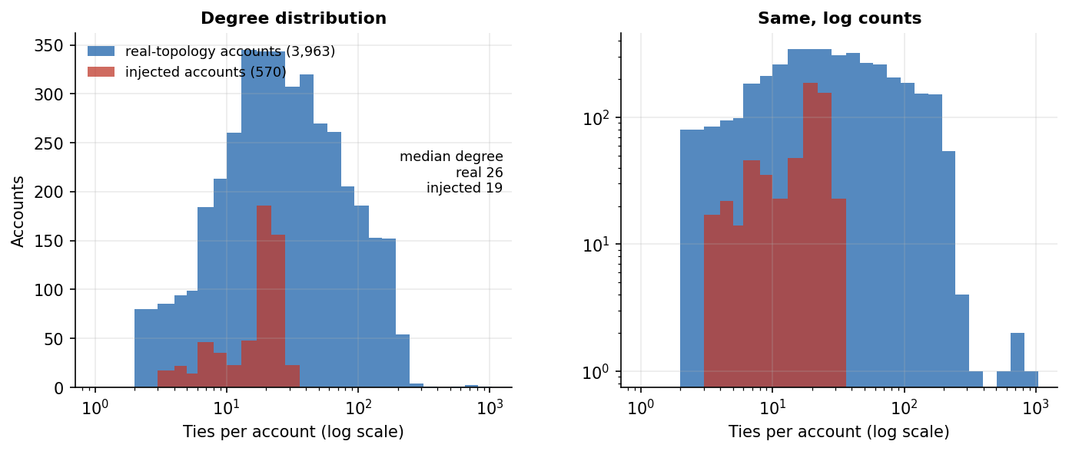
Figure 31: Number of ties per account for genuine and fake accounts.

1.13 Limitations of the results
• The data are partly synthetic. The eight botnets, the 150 lone spammers, the timing and interaction features and the handles are generated, and the profile and posting rows come from different people. The results describe this benchmark, not Indian platforms such as ShareChat or Moj.
• Structure alone nearly solves the benchmark (Section 8.4): GraphSAGE on log degree alone scores F1 0.965. The graph lift is partly an effect of how the botnets were injected.
• One split and three seeds. There is no cross-validation, no second dataset and no significance test; the deviations are over three seeds only. The confusion matrices and the threshold sweep use the first seed.
• No real botnets and no adversary. Recovery is measured against seeded botnets that do not try to hide their ties, and no attack on the model was tried.
• No text features. The abstract mentions linguistic cues; the 23 features contain none.
• The explanation is approximate. Reasons are gradient times input of one forward pass, which is a first-order approximation, as the screen itself says.
• Scale was measured on disjoint copies of a 4.5 thousand-account graph, up to 36 thousand accounts, on one CPU.
• The retraining experiment has two runs, one seed each, so its before-and-after differences are not statistically supported.

1.14 Objectives against outcomes
Table 12: The six objectives of the project and what was measured
# | Objective | Outcome | Evidence
1 | Construct a graph of accounts (nodes) and interactions (edges) | Met. 4,533 nodes, 94,456 undirected ties, documented schema; 88,156 real and 6,300 injected ties | Graph & features screen; Section 8.1
2 | Engineer node features: profile, posting behaviour, interaction frequency | Met. 23 features in four groups; no text features | Graph & features screen; ablation, Section 8.4
3 | Implement and compare GCN, GAT and GraphSAGE | Met. Same split, features and budget, three seeds, plus a no-graph baseline; GraphSAGE best (F1 0.939), GCN +1.0, GAT +7.3, GraphSAGE +11.2 points | Sections 8.2-8.4
4 | Detect coordinated botnet clusters from learned embeddings | Met on injected botnets. 8 of 8 recovered, mean recall 1.000, precision 0.988; real-world botnets not tested | Section 8.5
5 | Evaluate accuracy, precision and recall against labelled data | Met. Six metrics, ROC, confusion matrices, threshold sweep; labels are partly synthetic | Sections 8.2-8.3
6 | Assess scalability as nodes and edges grow | Met to 36 k accounts / 756 k ties on CPU, roughly linear in ties; platform scale untested | Section 8.6; Chapter 7.7

Beyond the six objectives the project added a moderator queue with a retraining loop, explanations for every score and an API with role-based access. Where an objective is marked as met, the margin of the claim is given in the evidence column and in Section 8.13.

