DETECTING AI GENERATED IMAGES WITH CNN AND INTERPRETATION USING EXPLAINABLE AI
Results
Department of Computer Science and Engineering, [COLLEGE NAME]
Batch C14 (CSE-C) · Academic year [ACADEMIC YEAR]
Table 1: Project team
S.No. | Student name | Roll number
1 | Ponugoti Viduranandan | 23K91A05J5
2 | Naina Baherji | 23K91A05G9
3 | Likki Pranathi | 23K91A05D2
4 | Motasani Sathish | 23K91A05G0

Project guide: M Thanmayee
Chapter and section numbers quoted in the text (for example Chapter 8 or Section 6.2) refer to the full project report, 17.Final Document. Figures and tables in this document are numbered from 1.

1. RESULTS AND OUTPUT SCREENS
This chapter reports what the system actually does. It starts with the experimental set-up and the output screens of the running application, then gives the model results on the held-out test set, the fusion and threshold analysis, robustness to degradation, the cross-domain probe, the Grad-CAM explanations, the comparison with the base paper, sample inputs and outputs, success and failure cases, limitations, and the objectives measured against outcomes. Several results are negative, and they are reported as findings.

1.1 Experimental Set-up
Every measurement in this chapter was made on one machine: an Intel Core i5-12500 (6 cores, 12 threads) with 15.7 GB of memory, no GPU, Windows 11, Python 3.11.9, PyTorch 2.14.1 (CPU build), torchvision 0.29.1, Flask 3.1.3 and scikit-learn 1.9.1. The screens of Section 8.2 were captured from the running application at 1440 x 900 pixels after the four routes had been retrained on real data. The models that the repository originally shipped had been trained on synthetic demo images and scored 100% on every metric, which says nothing about real images; they are kept only in models/demo_backup/ and none of their numbers is used below.
Table 2: Evaluation set-up used for every result in this chapter
Item | Setting
Training data | CIFAKE subset [8]: 3,000 real (CIFAR-10 [9]) + 3,000 Stable Diffusion v1.4 [10] images, 32 x 32 px; 6% of the 100,000 official training images
Validation data | 600 + 600 images from the official training split, disjoint from the training subset; used for early stopping
Held-out test | 1,000 real + 1,000 AI-generated images from the official test split (n = 2,000); never used for training
Robustness subset | First 500 real + 500 AI-generated test images (1,000), the same images in every condition
Cross-domain probe | 300 real photographs + 300 AI-generated images from another public source (full resolution, about 640 px and 1024 px); generators not named by the source
Training | AdamW, cosine decay, early stopping on validation F1; epochs A1 5, A2 5, C 5, B 3; seeds 42 to 45; single run per route
Metrics | Accuracy, precision, recall, F1, ROC-AUC, balanced accuracy, confusion matrix, 95% bootstrap interval (2,000 resamples), expected calibration error (15 bins)

The test subset is balanced, so accuracy and balanced accuracy coincide. All images are 32-pixel JPEG thumbnails: a well-known public benchmark, but nothing in this chapter says how the models behave on modern high-resolution generators.

1.2 Output Screens
The screens below were captured from the running application with real data in it: the test images fake_00000.png and real_00000.png from the CIFAKE test subset, and two full-resolution images from the cross-domain probe. The web app is served on port 5414 and talks to the Flask API on port 8414; the demo account is demo@verivision.ai.
  Figure 1: Landing page (light theme): the four routes with their input sizes and fusion weights, read live from the API. |   Figure 2: Sign-in page: the demo account is shown beside the form; images are analysed locally.

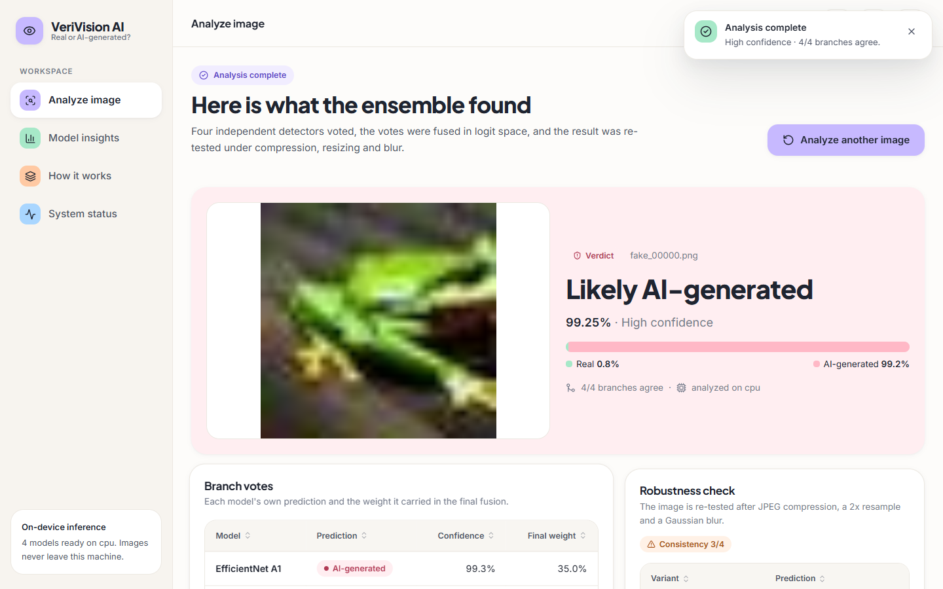  Figure 3: Result for fake_00000.png: "Likely AI-generated", 99.25% (High confidence), 4/4 branches agree; the bar splits the fused probability into Real 0.8% and AI-generated 99.2%. | 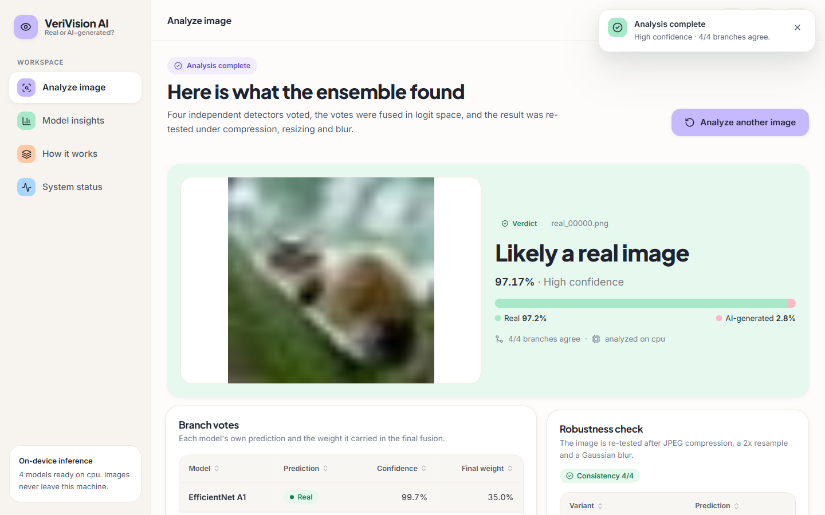  Figure 4: Result for real_00000.png: "Likely a real image", 97.17% (High confidence), Real 97.2% / AI-generated 2.8%, 4/4 branches agree, robustness consistency 4/4 (green).

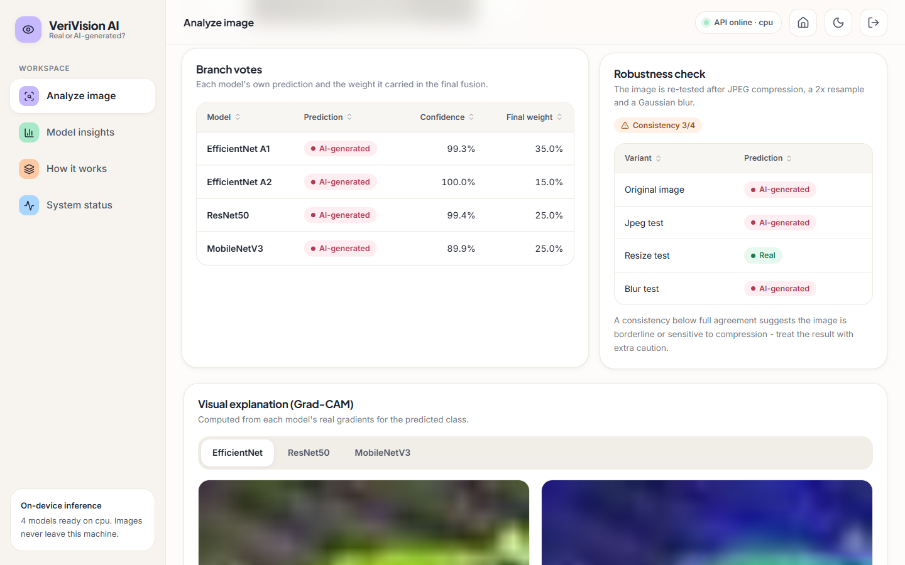
Figure 5: Branch votes and robustness check for the same image. All four routes vote AI-generated (99.3%, 100.0%, 99.4%, 89.9%) with fusion weights 35, 15, 25 and 25%. The re-test agrees on the original, JPEG and blur variants but reads the 2x resized copy as Real, giving consistency 3/4 and an amber warning.
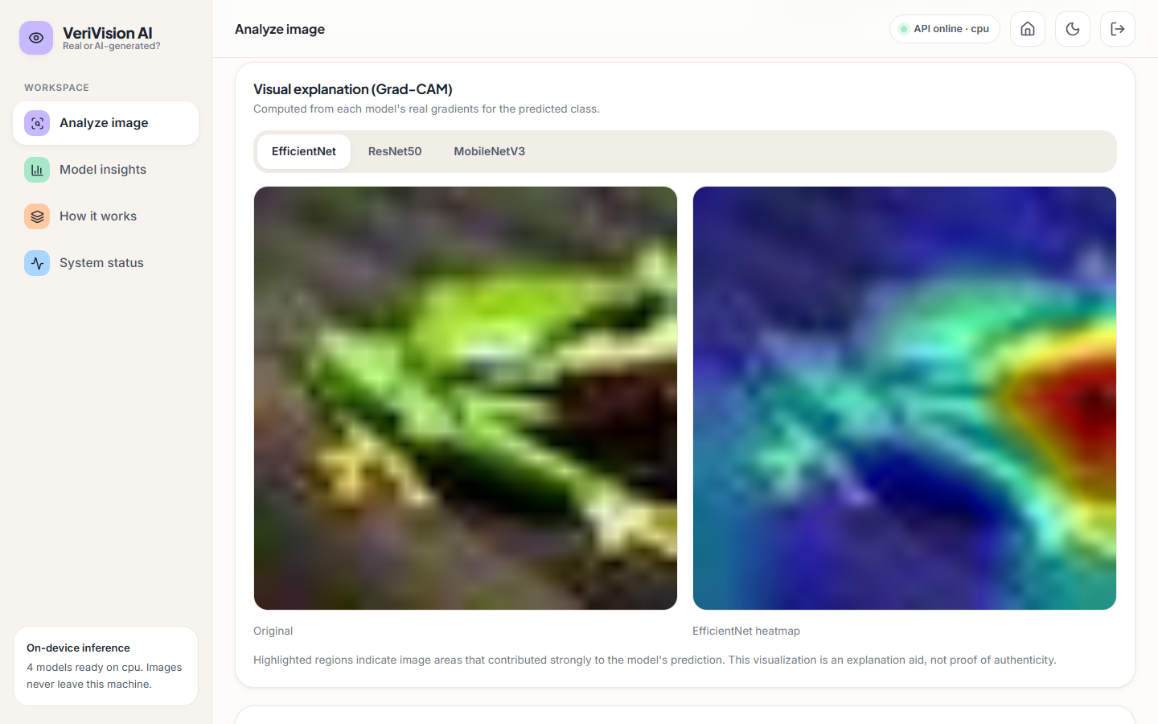  Figure 6: Grad-CAM tab for route A1 (EfficientNet): the activation concentrates on the right edge of the subject. | 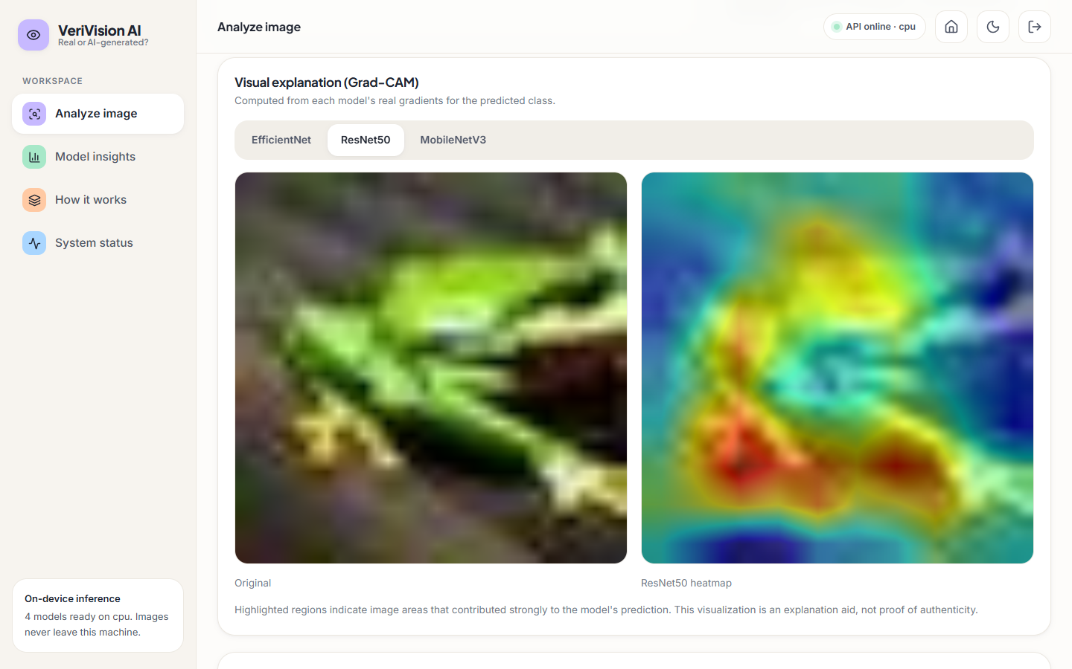  Figure 7: Grad-CAM tab for route B (ResNet50) on the same image: activation spreads over most of the subject.

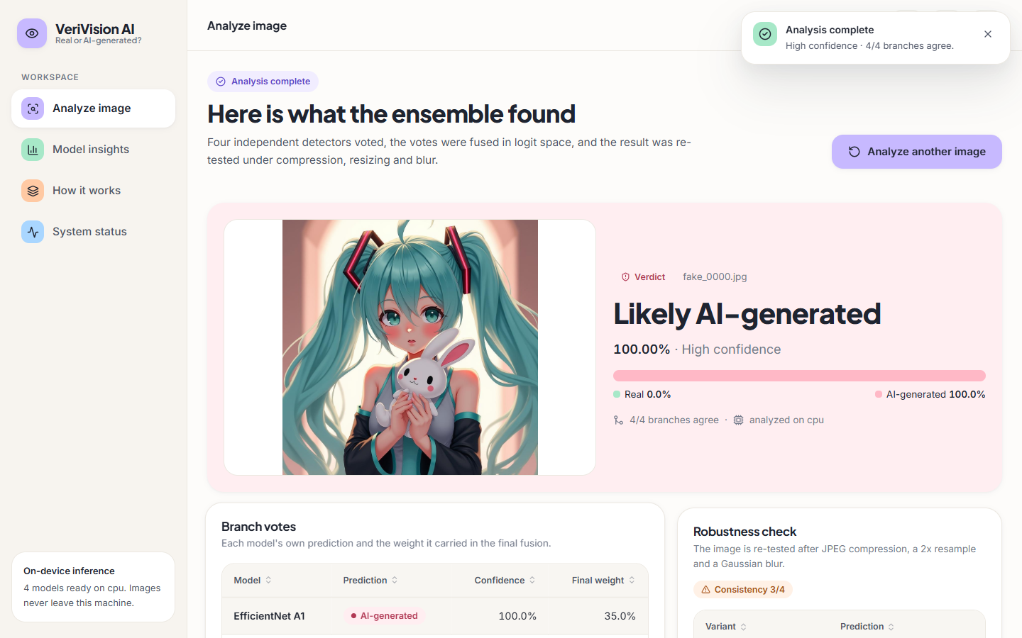  Figure 8: Cross-domain AI-generated image (fake_0000.jpg, 1024 px): correctly called AI-generated with 100.00% confidence, but the robustness check agrees on only 3/4 variants. | 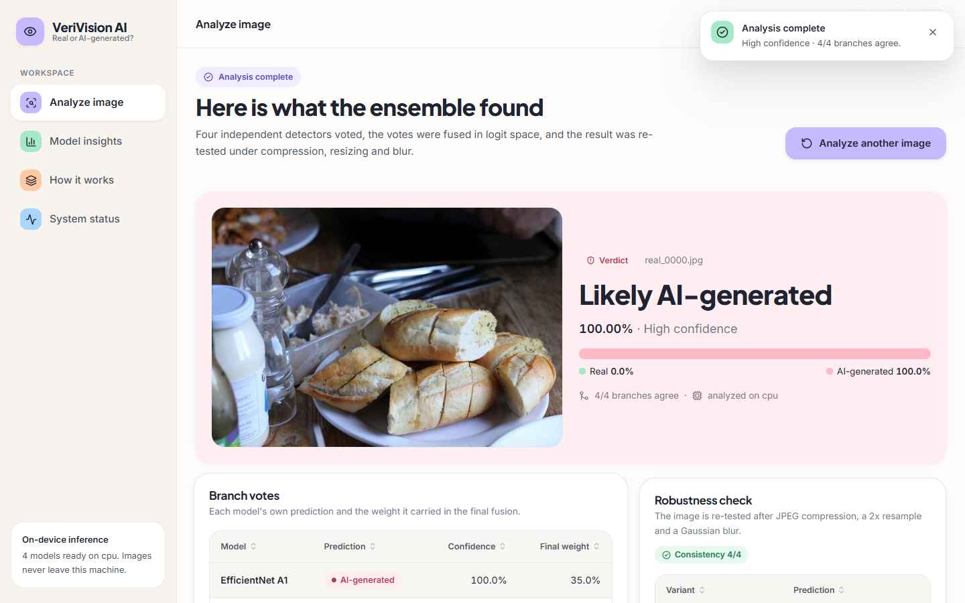  Figure 9: Cross-domain real photograph (real_0000.jpg): called AI-generated with 100.00% confidence and 4/4 consistency. This is a confident wrong answer.

The model is sure of both verdicts, yet the second is wrong, and the consistency check cannot flag it because every variant gives the same wrong answer. Section 8.6 measures how often this happens.
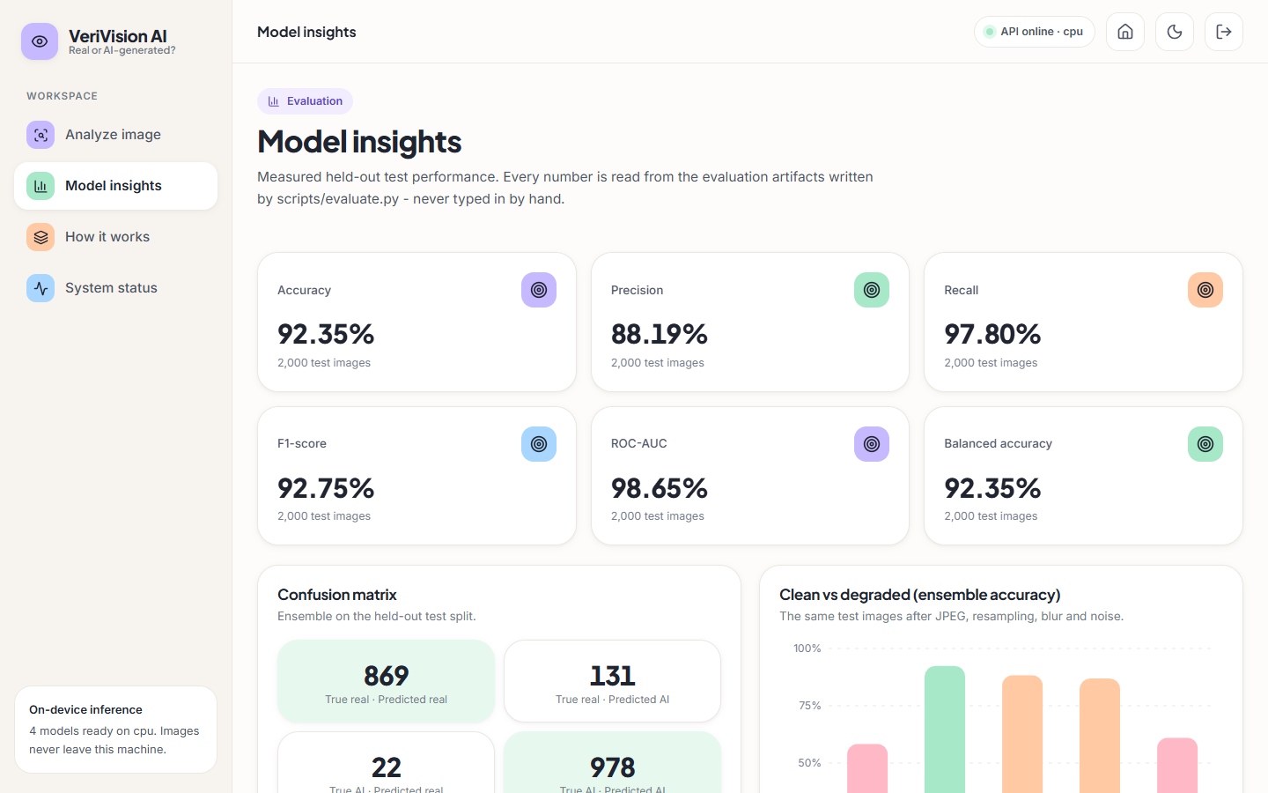
Figure 10: Model insights page: held-out ensemble metrics (accuracy 92.35%, precision 88.19%, recall 97.80%, F1 92.75%, ROC-AUC 98.65%, balanced accuracy 92.35%), the confusion matrix (869 / 131 / 22 / 978) and the clean-versus-degraded chart, all read from the evaluation files.
  Figure 11: How-it-works page with one card per route: backbone, input size, loss, fusion weight and F1. | 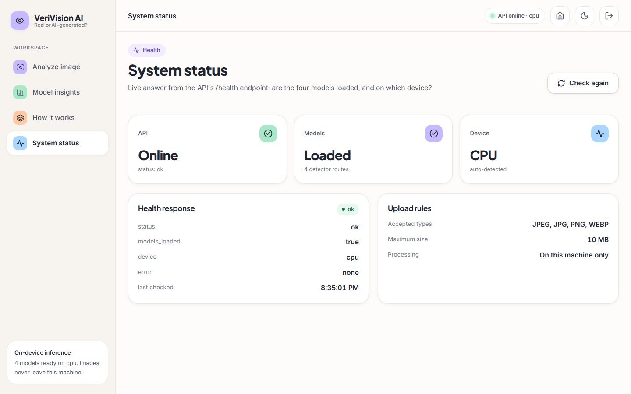  Figure 12: System status page: the /health answer (models loaded, device cpu) and the upload rules.

Section 8.12 notes that the "Validation F1" rows of the how-it-works page show test-set F1 values. Further screens (dark theme, the page mid-animation, the landing page sections) are in Appendix C.

1.3 Model Performance on the Held-out Test Set
The first table below gives the held-out results of the four routes and the deployed ensemble on the 2,000 test images (single run, seed 42). The ensemble reaches an accuracy of 92.35%, an F1 of 92.75% and a ROC-AUC of 98.65%. The best single route, EfficientNet-B0 A1, reaches 91.80% accuracy and 97.49% ROC-AUC, and its bootstrap interval (0.905-0.930) overlaps that of the ensemble (0.911-0.934). The 0.55-point accuracy advantage of the ensemble over A1 is therefore not statistically distinguishable on this sample; its higher ROC-AUC (0.9865 against 0.9749) and a lower false-negative rate (2.2% against 4.7%) are the clearer gains. ResNet50 B has the highest single-route ROC-AUC (0.9828) but the lowest accuracy (0.8660), because its threshold sits too far toward AI-generated: it finds 99.1% of the fakes and wrongly flags 25.9% of the real images.
Table 3: Held-out performance of the four routes and the ensemble (n = 2,000)
Model | Accuracy | Precision | Recall | F1 | ROC-AUC | 95% CI (accuracy)
EfficientNet-B0 A1 | 0.9180 | 0.8907 | 0.9530 | 0.9208 | 0.9749 | 0.905-0.930
EfficientNet-B0 A2 | 0.9020 | 0.8533 | 0.9710 | 0.9083 | 0.9769 | 0.888-0.915
ResNet50 B | 0.8660 | 0.7928 | 0.9910 | 0.8809 | 0.9828 | 0.851-0.881
MobileNetV3-Large C | 0.8995 | 0.8648 | 0.9470 | 0.9041 | 0.9670 | 0.885-0.912
Ensemble (deployed) | 0.9235 | 0.8819 | 0.9780 | 0.9275 | 0.9865 | 0.911-0.934

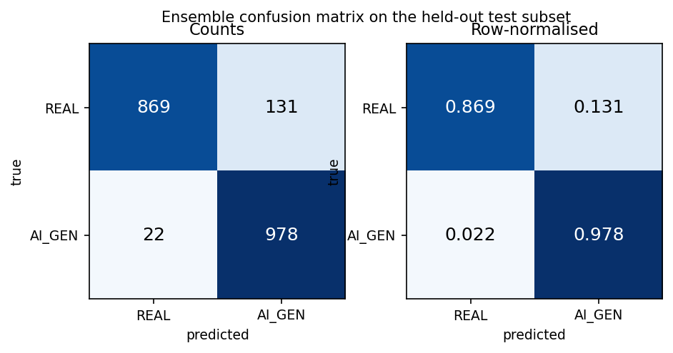  Figure 13: Confusion matrix of the deployed ensemble: counts (left) and row-normalised (right). | 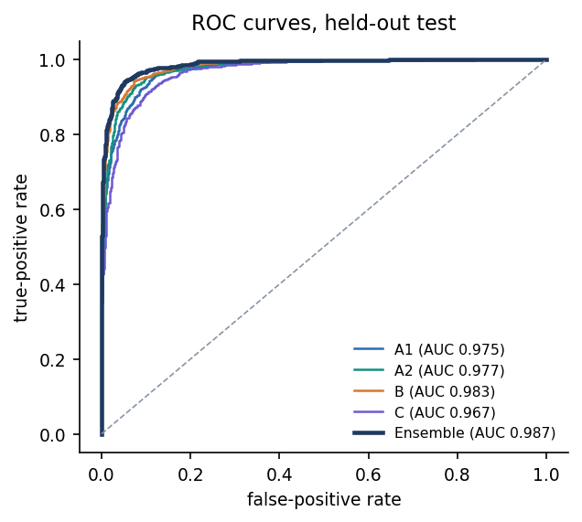  Figure 14: ROC curves of the four routes and the ensemble on the held-out test set.

Table 4: Confusion-matrix counts and error rates (positive class: AI_GENERATED)
Model | TN | FP | FN | TP | FPR | FNR | Predicted fake
EfficientNet-B0 A1 | 883 | 117 | 47 | 953 | 11.7% | 4.7% | 53.5%
EfficientNet-B0 A2 | 833 | 167 | 29 | 971 | 16.7% | 2.9% | 56.9%
ResNet50 B | 741 | 259 | 9 | 991 | 25.9% | 0.9% | 62.5%
MobileNetV3-Large C | 852 | 148 | 53 | 947 | 14.8% | 5.3% | 54.8%
Ensemble | 869 | 131 | 22 | 978 | 13.1% | 2.2% | 55.5%

Every route and the ensemble predict AI-generated more often than the true 50% share (the ensemble 55.5%). The ensemble makes 153 errors in 2,000: 131 real images flagged as AI-generated (false-positive rate 13.1%) and 22 fakes missed (2.2%). In a forensic setting the first kind of error, calling a genuine photograph fake, is the costly one, and it is the more frequent one here.
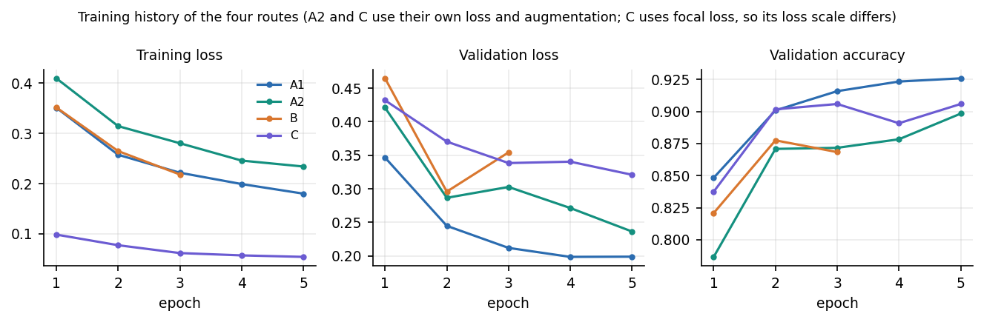
Figure 15: Training and validation curves of the four routes (route B stopped after three epochs; C uses focal loss, so its loss scale differs).
Validation accuracy of A1 was still rising at epoch 5 (92.58%); A2 and C ended at 89.83% and 90.58%, and B reached its best validation F1 (0.8902) at epoch 2 of 3. With only 3 to 5 epochs on 6,000 images (CPU-only hardware) these are not converged models; a longer run on the full 100,000 images would probably score higher.
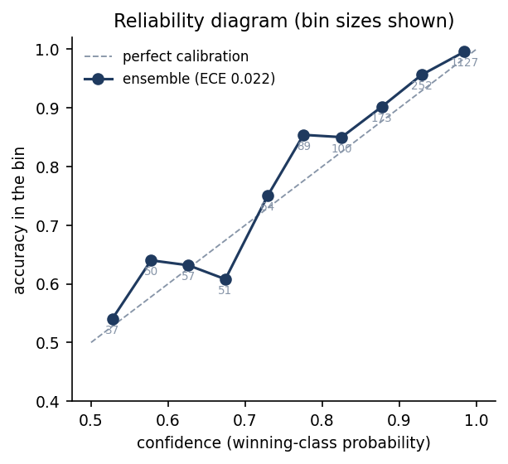  Figure 16: Reliability diagram of the ensemble (expected calibration error 0.022); bin sizes are printed under the points. | 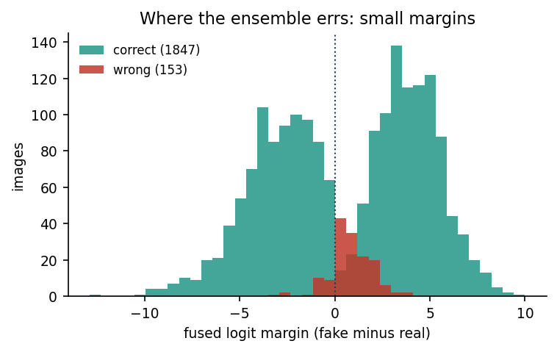  Figure 17: Fused logit margin of correct (green) and wrong (red) predictions on the test set.

The ensemble is well calibrated on this test set: its expected calibration error is 0.022, close to the best single routes (A1 0.018, A2 0.018) and far below route C (0.122) and route B (0.058). The reliability curve lies slightly above the diagonal in the middle bins (a little under-confident), and 1,127 of the 2,000 images fall in the top bin. Calibration holds only on the training distribution; Section 8.6 shows that confidence does not survive a change of domain.

1.4 Fusion Rules and Decision Threshold
The fusion rule of Chapter 6 was tested by replacing it, on the same cached logits, with simpler variants. The ablation table below shows that the two gates did not improve the result: Gate 1 fired on 7 of 2,000 images and Gate 2 on none, and removing both gates scores 0.9245 against 0.9235 for the deployed rule, a difference of two images. Probability averaging scores slightly higher in accuracy (0.9260) but lower in ROC-AUC (0.9846), and majority voting loses ranking quality (ROC-AUC 0.9383) presumably because its score takes only a few distinct values. The gate design follows HEDGE [2], whose own ablation gained 0.37 robust-F1 points from its gates on a different, much harder benchmark; here the thresholds (2.5, 2.5, 0.75) are engineering defaults that were never tuned, and the finding is that the gates are inactive on this data.
Table 5: Fusion-rule ablation on the held-out test set (same logits)
Variant | Accuracy | F1 | ROC-AUC
Deployed: weights + Gate 1 + Gate 2 | 0.9235 | 0.9275 | 0.9865
Weights only (no gates) | 0.9245 | 0.9285 | 0.9868
Gate 1 only | 0.9235 | 0.9275 | 0.9865
Gate 2 only | 0.9245 | 0.9285 | 0.9868
Equal weights + gates | 0.9215 | 0.9257 | 0.9867
Probability averaging (weights) | 0.9260 | 0.9299 | 0.9846
Majority vote (ties to weighted) | 0.9230 | 0.9269 | 0.9383

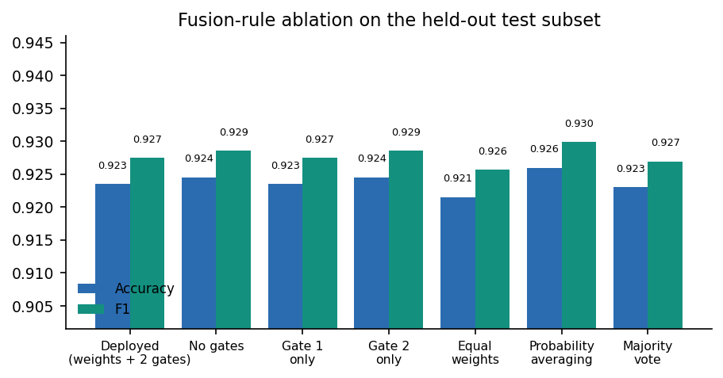  Figure 18: Accuracy and F1 of the fusion variants; the vertical axis starts at 0.905, which magnifies differences of a few images. | 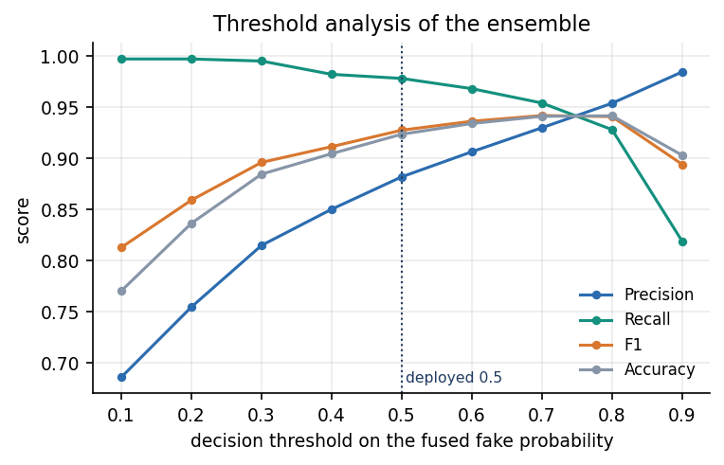  Figure 19: Precision, recall, F1 and accuracy of the ensemble as the decision threshold on the fused fake probability moves from 0.1 to 0.9.

The deployed threshold is 0.5. Raising it to 0.7 or 0.8 lowers the false-positive rate to 7.2% and 4.5% at a cost in recall (95.4% and 92.8%), and accuracy peaks at 94.1% to 94.2%. That gain is optimistic: the threshold was read off the test subset, and a fair choice would need a separate validation set. The sweep does show the trade-off an operator would face, since the model's error is asymmetric and a higher threshold protects real images at the price of missing more fakes.

1.5 Robustness to Compression, Resizing, Blur and Noise
The same 1,000 test images were degraded and re-scored by every route (table and chart below). JPEG compression and noise cost the ensemble about 4 to 5 accuracy points. Resizing and blur are far more damaging: ensemble accuracy falls to 61.0% and 58.3%, close to chance, and the models stop calling images AI-generated (only 12.2% and 8.9% of images are predicted fake against 55% on clean images). The ranking information is only partly lost, since ROC-AUC stays at 0.801 and 0.865: the decision threshold moves rather than the scores becoming random. Route B, trained at 320 pixels with flip augmentation, holds up best against resizing and blur (68.6% and 69.1%), but it is the least robust to JPEG (80.3%) and noise (74.6%).
Table 6: Accuracy under degradation (1,000 images, same images in every condition)
Condition | A1 | A2 | B | C | Ensemble | Ens. AUC | Ens. pred. fake
Clean (1,000-image subset) | 92.2% | 90.0% | 86.5% | 89.9% | 92.4% | 0.986 | 55.0%
JPEG quality 60 | 88.9% | 88.5% | 80.3% | 86.2% | 88.3% | 0.978 | 59.7%
Resize to 1/2 and back | 59.1% | 53.3% | 68.6% | 52.3% | 61.0% | 0.801 | 12.2%
Gaussian blur 5x5, sigma 1 | 59.8% | 54.6% | 69.1% | 52.5% | 58.3% | 0.865 | 8.9%
Gaussian noise, sigma 6 | 84.1% | 87.4% | 74.6% | 86.8% | 86.9% | 0.975 | 61.9%

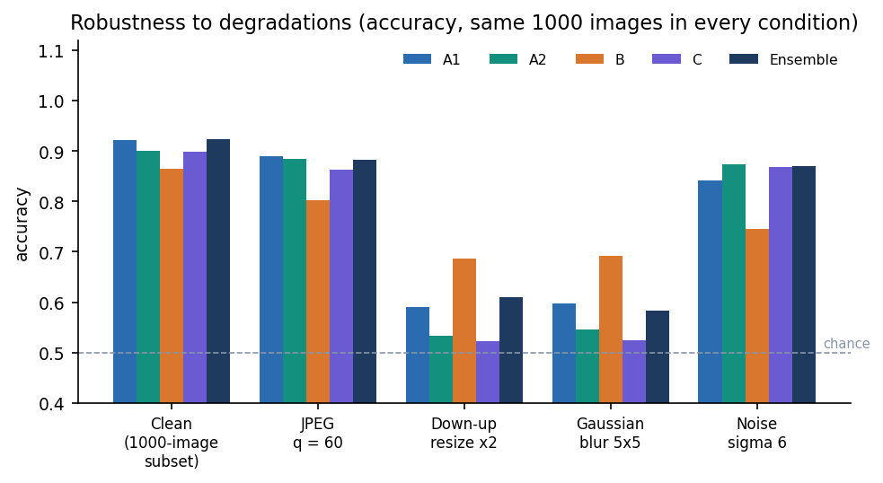
Figure 20: Accuracy of each route and the ensemble on the clean subset and four degradations (dashed line: chance).
Route A2 was trained with blur, noise, JPEG and resampling augmentation precisely to resist these conditions, yet it is not more robust than A1 to resizing (53.3% against 59.1%) or blur (54.6% against 59.8%); its only visible benefit is on noise (87.4% against 84.1%). The same fragility appears in the application: the robustness check of the sample result in Section 8.2 flipped the verdict of the sample image under the resize variant, and a consistency below full agreement is the application's own warning to treat the result with caution.

1.6 Cross-domain Probe
Objective 4 asked for cross-generator evaluation. The probe set contains 300 real photographs and 300 AI-generated images from another public source, at full resolution and with different content (food, animals, illustrations, fantasy scenes) from the CIFAKE objects. The generators are not named by the source, so the probe tests transfer to some unseen generator and domain, not to a specific model. Because resolution, content and generator all change together, the probe cannot say which of them causes the failure.
Table 7: Cross-domain probe, 600 images (models trained on CIFAKE only)
Model | Accuracy | ROC-AUC | Real kept REAL | AI found
EfficientNet-B0 A1 | 50.7% | 0.501 | 170/300 | 134/300
EfficientNet-B0 A2 | 47.8% | 0.385 | 4/300 | 283/300
ResNet50 B | 48.7% | 0.215 | 1/300 | 291/300
MobileNetV3-Large C | 52.2% | 0.564 | 20/300 | 293/300
Ensemble | 51.0% | 0.499 | 163/300 | 143/300

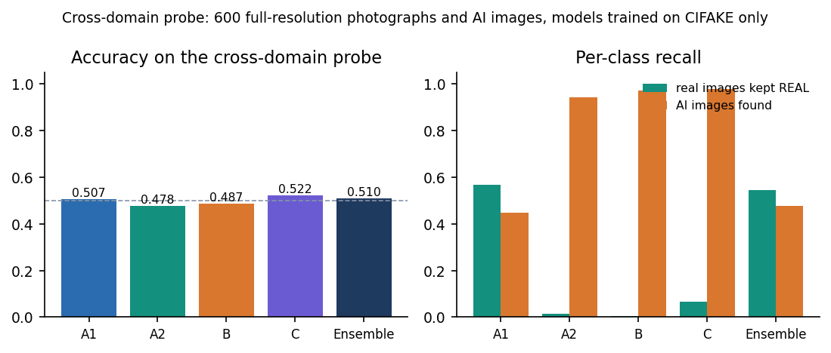
Figure 21: Cross-domain accuracy (left) and per-class recall (right) of each route and the ensemble; the dashed line is chance.
The result is a clear failure to generalise. The ensemble scores 51.0% with a ROC-AUC of 0.499, which is chance; A2, B and C call almost every image AI-generated (B keeps only 1 of 300 real photographs as real), and A1 is close to a coin flip. ROC-AUC below 0.5 for route B (0.215) means its scores are inverted on this data. The deployed confidence is meaningless here: the last pair of screens in Section 8.2 shows a real photograph called AI-generated with 100.00% confidence. Objective 4 was therefore measured and not achieved. This agrees with the literature on cross-generator transfer [3], [12], [13], but this project did not train on several generators or at several resolutions, so it cannot offer a remedy.

1.7 Grad-CAM Explanations
Grad-CAM was run on the predicted class for routes A1, B and C with the same code that the application uses. The figure below shows the first three correctly classified real images and the first three correctly classified AI-generated images of the test set, so the examples are typical and not chosen for neat heat maps.
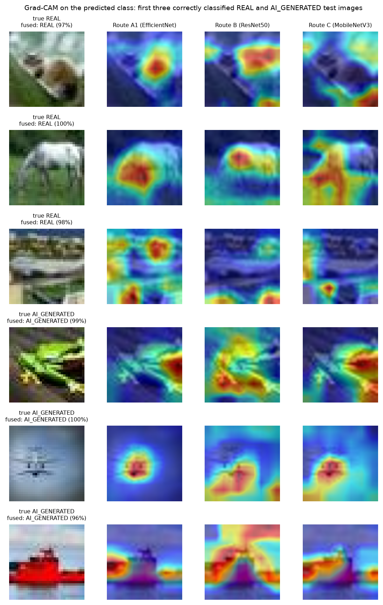
Figure 22: Grad-CAM overlays of routes A1, B and C on the first three real (top) and first three AI-generated (bottom) correctly classified test images.
The maps are coarse blobs, because the target layers have a 7 x 7 to 10 x 10 spatial grid that is upsampled to the image. They usually sit on the main object, but different routes pick different parts of it (for the green frog, A1 and C focus on the head, B on the body), and on the real images the maps are as strong as on the fakes. No map points to a recognisable artefact; the maps show where the evidence is, not what it is. Grad-CAM was judged by eye only (no deletion or insertion test), so the maps are not proof that the model uses a particular region.
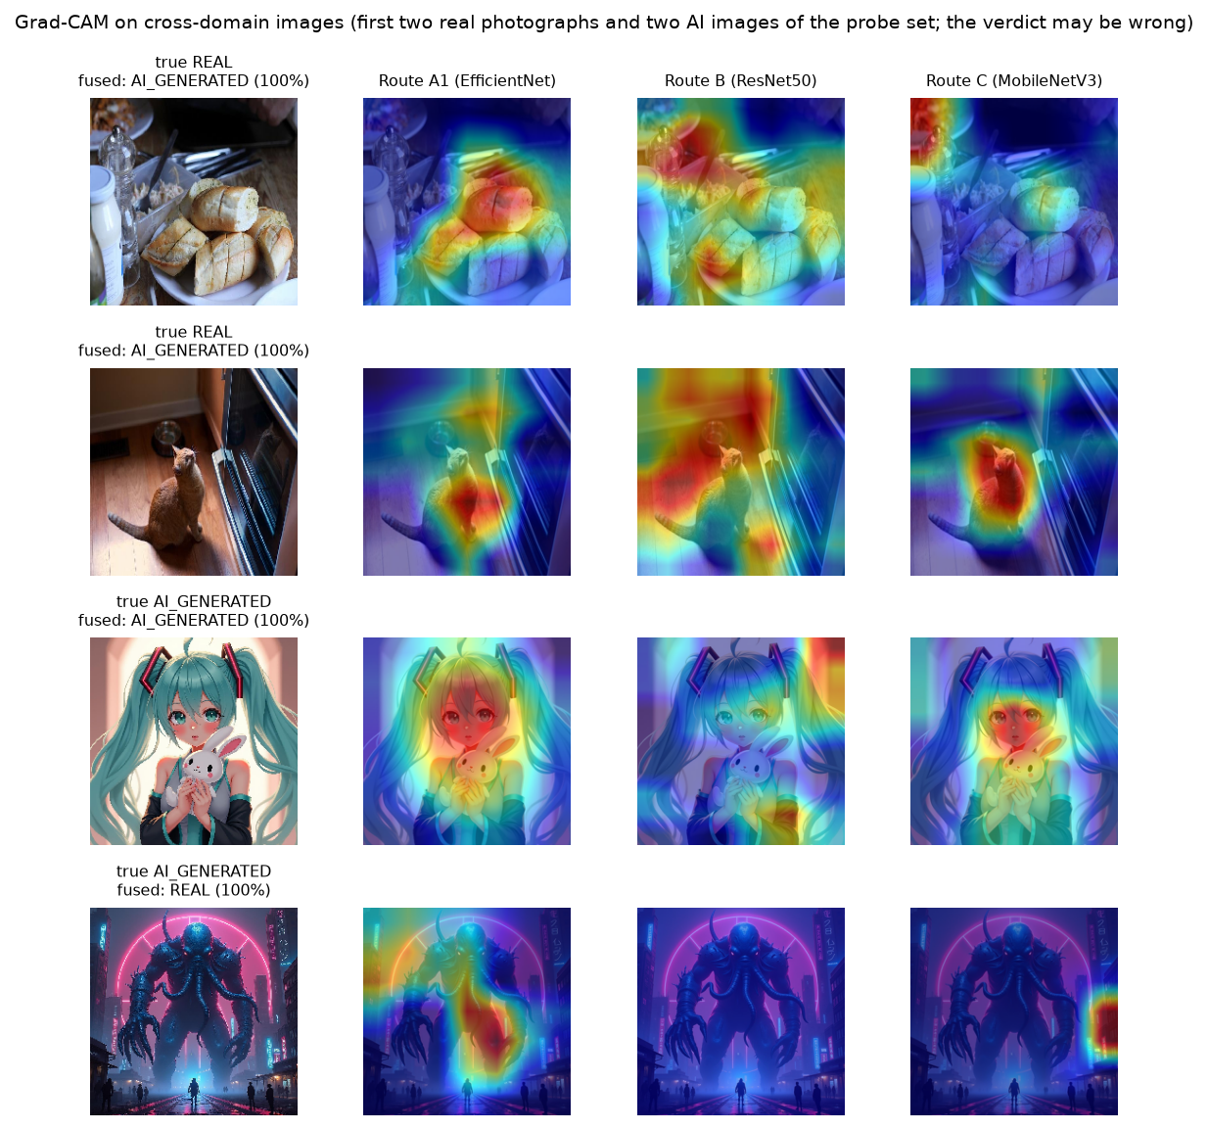
Figure 23: Grad-CAM overlays on the cross-domain probe: two real photographs (both called AI-generated, 100%) and two AI images (the second called REAL, 100%).
On the cross-domain images the maps look as confident as on CIFAKE even where the verdict is wrong (the real bread and cat photographs are called AI-generated, with maps on the food and the cat), so a heat map says nothing about whether the verdict can be trusted.

1.8 Comparison with the Base Paper and the Design Reference
The batch's base paper is the CTrue detector of Larue et al. [1], a one-class face-deepfake detector; this project does not implement it. The design of the heterogeneous routes and gates follows HEDGE [2]. The three works differ in task, data and compute, so the table below lists them side by side and the only like-for-like number is the ROC-AUC on data of the work's own domain.
Table 8: Comparison with the base paper and the design reference
Aspect | CTrue (base paper) | HEDGE (design reference) | This project
Task | Face deepfake detection, one-class | AI-generated image detection in the wild | Real vs AI-generated, general 32-px images
Training data | 720 pristine FaceForensics++ videos plus pseudo-fakes | Not itemised in this report | 6,000 CIFAKE images (6% of the set)
Backbone | EfficientNet-B4 (19.3 M parameters) | DINOv3 and MetaCLIP2 based routes | Four small CNNs, 4.0 M to 23.5 M parameters
Compute | Two V100 GPUs, 200 epochs, about 16 h | 8 H800 GPUs | One CPU, 3 to 5 epochs, 13 to 53 min per route
Headline | AUC 98.9% on FF++ (in-domain) | Balanced accuracy 98.3% on five benchmarks | AUC 98.65%, accuracy 92.35% on CIFAKE (in-domain)
Cross-dataset | AUC 77.0% on DFDC (lambda = 1 ablation) | Robust F1 80.52, 80.89 with gates (competition set) | AUC 49.9%, accuracy 51.0% (cross-domain probe)
Gates / fusion | Not used (single model) | Logit fusion plus dual gating | Logit fusion plus two gates (no gain here)

In-domain, the project's ROC-AUC (98.65%) is close to the base paper's FaceForensics++ figure (98.9%), but the two numbers measure different tasks on different data, with a very different training budget, and they are not evidence that one method is better. Cross-dataset, the base paper's DFDC AUC of 77.0% is well below its in-domain value yet well above this project's 49.9%; the base paper was designed for generalisation and this project was not. The CTrue cross-dataset table is an image in the PDF and is not quoted. The comparison with HEDGE is about design only: the idea of logit fusion with gates is reused, and the ablation of Section 8.4 finds that the gates add nothing on CIFAKE.

1.9 Sample Inputs and Outputs, Speed and Testing
Table 9: Sample analyses captured from the application
Input | True class | Verdict | Confidence | Branches agree | Consistency | Correct
fake_00000.png (32 px) | AI-generated | Likely AI-generated | 99.25% | 4/4 | 3/4 | Yes
real_00000.png (32 px) | Real | Likely a real image | 97.17% | 4/4 | 4/4 | Yes
fake_0000.jpg (1024 px) | AI-generated | Likely AI-generated | 100.00% | 4/4 | 3/4 | Yes
real_0000.jpg (about 640 px) | Real | Likely AI-generated | 100.00% | 4/4 | 4/4 | No

Each POST /api/analyze response carries the verdict and confidence word, the fused probabilities, a record per route, the Grad-CAM overlays as data URLs, the agreement count, the gate decisions and the robustness outcomes with the consistency string. Invalid input returns a JSON error (400 unsupported, empty, corrupt or tiny file; 401 no token; 413 above 10 MB; 503 model files missing).
Table 10: Response time of the running API (median of 8 runs, 127.0.0.1, idle machine)
Endpoint | 32 px image | 1024 px image
GET /health | 16 ms | -
GET /api/insights | 5 ms | -
POST /api/predict (four routes + fusion) | 0.25 s | 0.28 s
POST /api/analyze (adds Grad-CAM x3 and robustness x4) | 1.70 s | 1.98 s

The full analysis takes under two seconds on the CPU, so the 10 to 60 seconds assumed in the first README was too pessimistic for this machine. Model loading happens once at start and is not timed; batched offline inference in the evaluation script costs 283 ms per image for all four routes. The pytest suite (19 tests) passed 19 of 19 in 35 s, the end-to-end smoke test passed 29 of 29 checks, and the capture script walked every screen with a clean browser console. Unit tests for the Grad-CAM and robustness modules, load tests and a GPU run were not done.

1.10 Success and Failure Analysis
Where the ensemble succeeds. All four routes agree on 81.2% of the test images; on those 1,624 images the fused label is right 96.2% of the time, against 76.3% on the other 376 (computed from the cached route logits with the weighted sum, which differs from the deployed rule on two images). Correct predictions have a mean fused margin of 3.56 logit units against 1.09 for wrong ones (figure in Section 8.3): the errors are concentrated near the decision boundary, so the confidence value carries real information on CIFAKE-like images.
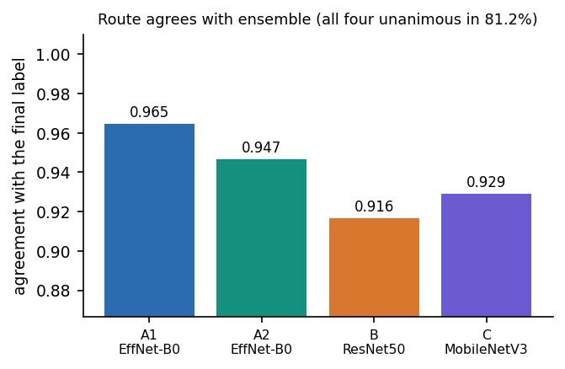
Figure 24: Agreement of each route with the final label (the vertical axis starts at 0.87).
Where it fails. The figure below shows the first six false positives and six false negatives. The false positives are real thumbnails (a truck, a bird, an aeroplane, a car, a sailing boat, a dog) with fake probabilities from 0.51 to 0.89; the false negatives are AI-generated images with natural-looking subjects (a cat, a dog, a sailing boat, a horse) and fake probabilities from 0.07 to 0.40. Nothing in these thumbnails lets a person tell which is which either, so the errors are plausibly cases where the generator's output matches natural statistics at 32 pixels; the project did not test that explanation. Agreement with the final label is highest for A1 (96.5%) and lowest for B (91.6%), consistent with B's bias toward AI-generated.
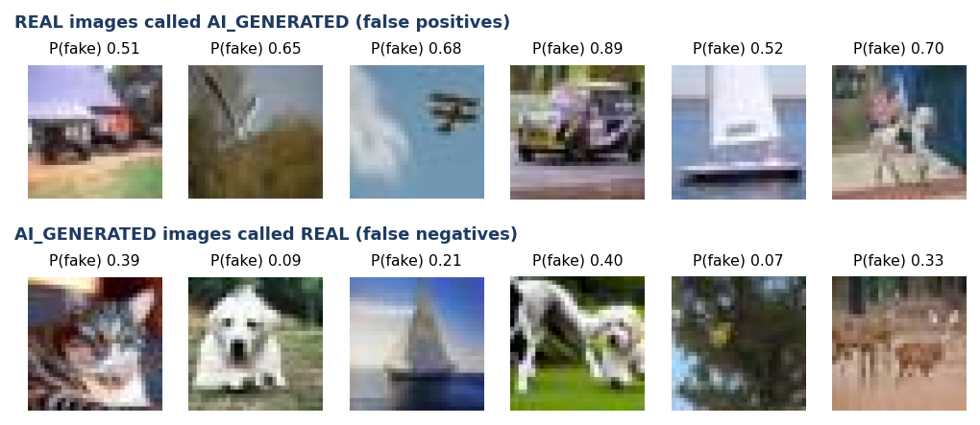
Figure 25: First six false positives (real images called AI-generated, top) and first six false negatives (AI images called real, bottom) with the ensemble's fake probability.
Two failure modes matter for use. A resized or blurred image is read as real, so a fake re-saved at a smaller size is likely to pass; and on images from outside CIFAKE the model is confidently wrong, as the real photograph of Section 8.2 shows. Neither is caught by the visible safeguards (consistency check, Grad-CAM), so the application's own wording, "AI estimate, not proof", is the right framing.

1.11 Limitations of the Results
• Single run per route. Seeds 42 to 45 and one training run each: the ranking of the routes carries run-to-run uncertainty that the bootstrap interval, which resamples only the test set, does not capture.
• Small training subset. 6,000 of 100,000 CIFAKE images and 3 to 5 epochs, chosen for CPU time; a full-data run would probably score higher.
• Tiny images, one generator. CIFAKE images are 32 x 32 JPEG from one generator (Stable Diffusion 1.4). The results do not transfer to modern high-resolution generators, and there is no per-generator breakdown.
• Optimistic operating point. The threshold sweep and the fusion ablation were evaluated on the test subset itself; the deployed gate thresholds and weights are engineering defaults that were not tuned.
• Qualitative explanations. Grad-CAM maps were inspected by eye; there is no faithfulness test.
• Not measured. A user study, GPU timing, load testing, adversarial attacks, and unit tests of the explanation and robustness modules.

1.12 Objectives versus Outcomes
Table 11: Objectives of the project against what was measured
No. | Objective | Outcome | Status
1 | Assemble a dataset of real and AI-generated images | CIFAKE subset (real CIFAR-10 + one generator) with a 6,000 / 1,200 / 2,000 split and a 600-image probe from another source; several generators were not assembled | Partly met
2 | Preprocess and augment for robustness | Per-route augmentation implemented; the distortion-hardened route A2 was not more robust to resize or blur than A1 | Met, with limited effect
3 | Train a CNN classifier | Four routes and a fused ensemble: 92.35% accuracy, F1 92.75%, ROC-AUC 98.65% on the held-out CIFAKE test set | Met
4 | Evaluate cross-generator performance | Measured on 600 full-resolution images: ensemble 51.0% accuracy, ROC-AUC 0.499 (chance) | Measured, not achieved
5 | Apply Grad-CAM to explain classifications | Grad-CAM on three routes in the application and in the figures of Section 8.7; judged qualitatively only | Met (qualitative)
6 | Deploy behind an interface with verdict, confidence and explanation | Flask API (8414) and React app (5414); full analysis in 1.7 to 2.0 s on CPU; 19/19 tests and 29/29 smoke checks passed | Met

Note on the interface. The how-it-works page labels the held-out test F1 of each route as "Validation F1", and the validation block of models/model_metadata.json holds the same test-set values, not the validation F1 recorded during training (A1 0.927, A2 0.905, B 0.890, C 0.911). The numbers on screen are correct as test-set results; only the label is wrong, and the README may still describe the earlier demo-data scores.

