CREDIT CARD FRAUD DETECTION USING MACHINE LEARNING
Results
Department of Computer Science and Engineering, TKR College of Engineering & Technology
Batch A4 (CSE-A) · Academic year [ACADEMIC YEAR]
Table 1: Project team
S.No. | Student name | Roll number
1 | ARELLI PRAVEEN KUMAR | 23K91A0513
2 | BANOTHU AJAY | 23K91A0529
3 | D CHANDRIKA | 23K91A0557
4 | BAIRAGONI VIJAY | 23K91A0525

Project guide: KOTESHWAR RAO
Chapter and section numbers quoted in the text (for example Chapter 8 or Section 6.2) refer to the full project report, 17.Final Document. Figures and tables in this document are numbered from 1.

1. RESULTS AND OUTPUT SCREENS

1.1 Output screens
This section shows the application running with its real data: the 39,000-row synthetic file, the three trained models and the pipeline rebuilt from the 8,000-row sample. Every screenshot was captured from the running application at 1440 x 900 pixels. The screens are described in the order a user meets them; the dark theme, the phone layouts and the offline and error states are in Appendix C.

Figure 1: Landing page: product summary, the four-step flow from payment to decision band, and the six application screens. The headline figures are read from the loaded models and the dataset.
The landing page introduces the product and quotes four live figures: the dataset size (39,000), the number of loaded models (3 of 3), the best F1 and the precision of the best model. The F1 shown is the best epoch of the simulated-annealing model (94.8%, epoch 17), which is chosen on the test split and is therefore slightly more favourable than the final-epoch value of 94.4% used elsewhere in this report. A footer states that the models were trained on a synthetic dataset and are not for production payments.

Figure 2: Dashboard: dataset counts, best F1 and loaded models, fraud rate by merchant category and the best-epoch F1 of each model.
The dashboard gives an overview of the data and the models. The four tiles show 39,000 transactions in 29 columns, 19,500 fraud-labelled rows (50.0 %), the best F1 and the number of models loaded. The bar chart ranks merchant categories by the share of their transactions that carry the fraud label; Electronics and Online head the list, Grocery and Fuel are lowest. Because the file was balanced to 50/50, these rates describe the synthetic generator and say nothing about real merchants.

Figure 3: Verify transaction: the high-risk example scored by the ensemble, with the risk meter, the recommended action and each model's probability.
The Verify screen is the main task. The user enters an amount, merchant category, channel, card-present and country-match flags and a transaction time, with three optional signal fields (V3, V14, V17), and chooses the ensemble or one model. The capture shows the high-risk example (1,200, Online, card not present, country mismatch): the ensemble probability is 68.4%, a MEDIUM risk with the action Challenge with 3-D Secure; the per-model bars show PCD at 50.9%, QS at 59.5% and SAS at 94.7%. The verdict flips to fraud above 50 %, whereas the action bands are 40 % and 70 %, so a transaction at 68 % is called fraud and still only challenged. The signal fields are friendly names for synthetic features; they are not real card-holder attributes.

Figure 4: Bulk verification: the 20-row sample file after upload, showing 20 of 20 rows flagged as fraud and 50.0 % accuracy against the file's own labels.
The Bulk screen screens a CSV in three steps (choose, analyse, review). With the bundled sample_batch.csv, which holds 10 fraud and 10 legitimate rows, the screen reports every row as fraud, 50.0 % accuracy, 100 % recall and an F1 of 66.7 %. The interface itself warns that every row was flagged and suggests checking the scale of the values. This is not a model result: it is the consequence of the scaling defect in the batch route that Section 8.9 explains, and it is shown here because it is what the delivered application does.

Figure 5: Analytics, tab Where: fraud rate by merchant category and by channel.
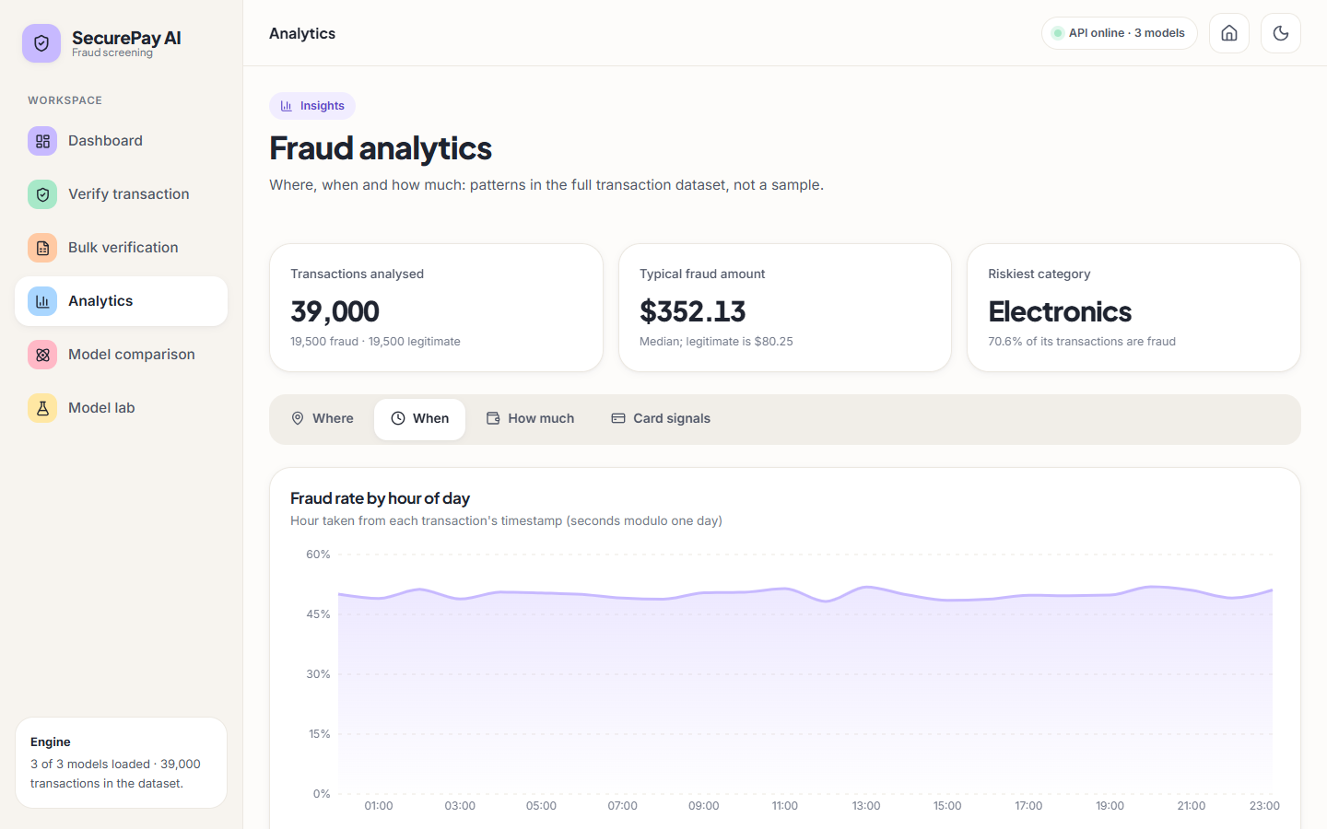
Figure 6: Analytics, tab When: fraud rate by hour of day, taken from the timestamp modulo one day.
The Analytics screen has four tabs that all read the full dataset through /api/dataset_stats. Where ranks merchant categories (Electronics highest at 70.6 % of its transactions labelled fraud) and channels. When plots the fraud rate for each hour of the day; the curve is flat at about 50 %, which is what a generator that draws timestamps uniformly for both classes should produce. A real fraud stream would show hour-of-day structure, so this panel confirms the synthetic nature of the data rather than any finding.

Figure 7: Analytics, tab How much: transactions per amount band split by label, and the amount summary.
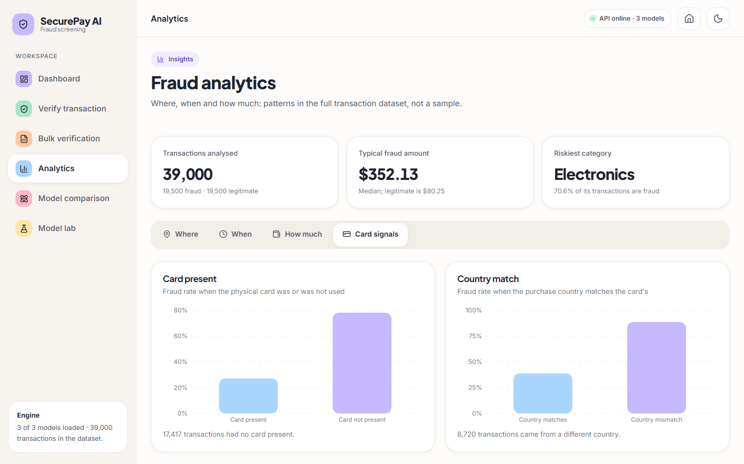
Figure 8: Analytics, tab Card signals: fraud rate with and without the physical card, and with matching or mismatching country.
How much shows that most legitimate amounts lie below 250 while most fraud amounts lie above it: mean 368.20 against 85.21, medians 352.13 and 80.25, and a largest amount of 1,257.23. Card signals confirms that fraud is much more frequent when the card is not present and when the country does not match. These are the same signals that the random forest ranks highest (Section 8.2), so the analytics and the model agree by construction.
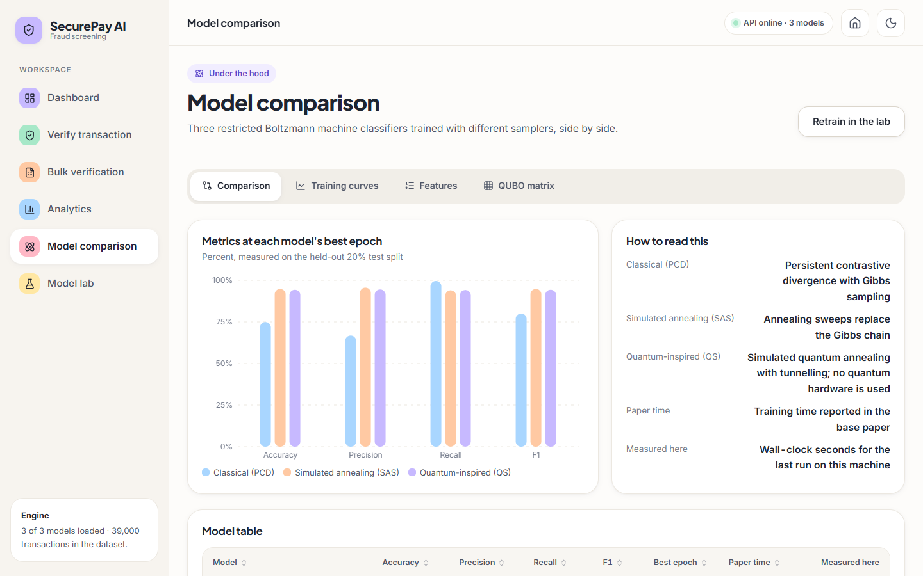
Figure 9: Model comparison, tab Comparison: metrics of the three models at their best epoch, with the paper's training time and the time measured here.
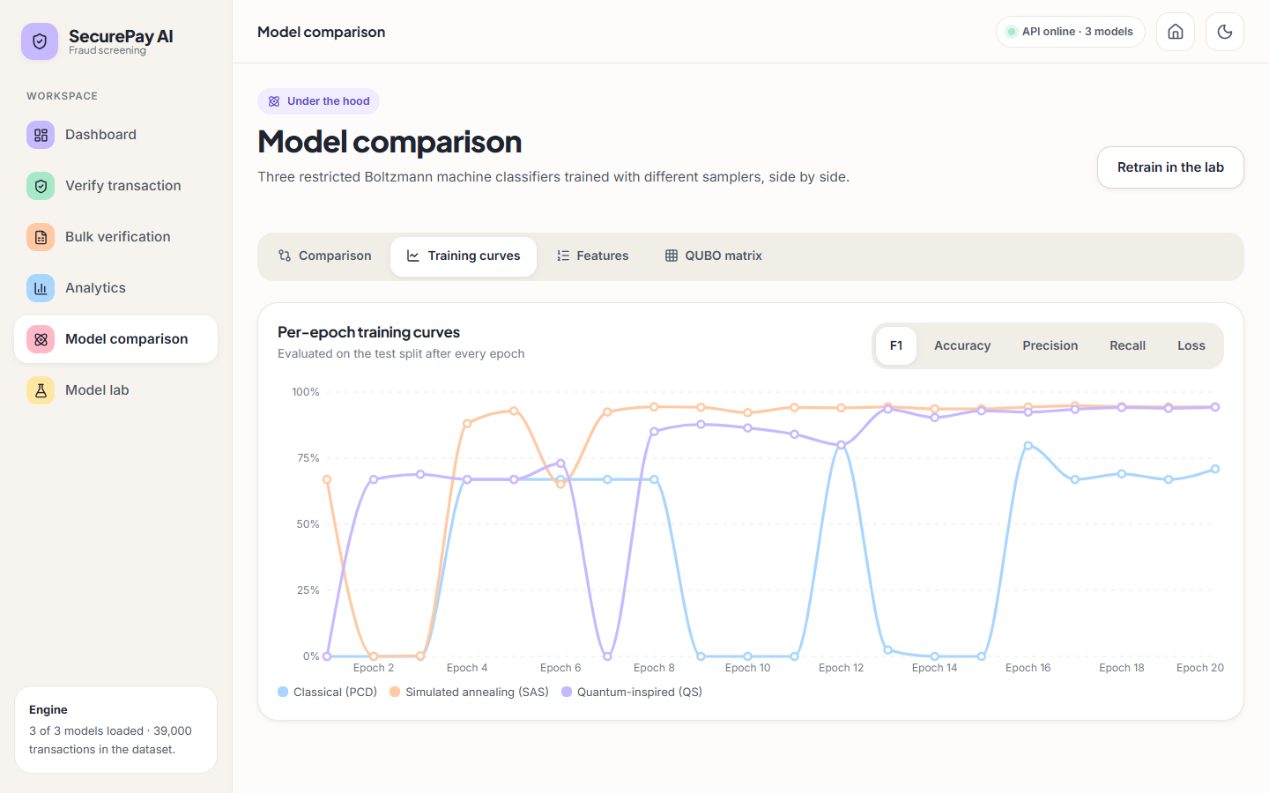
Figure 10: Model comparison, tab Training curves: per-epoch F1 of PCD, SAS and QS over 20 epochs.
The comparison tab plots accuracy, precision, recall and F1 for each model at its best epoch and tabulates them, with a column for the training time the paper reports and one for the wall-clock time measured on this PC; the paper's column is a quotation, not a measurement. The curves tab shows why a best-epoch view is generous. PCD alternates between predicting everything legitimate (F1 0) and everything fraud (F1 66.9 %) and reaches 80.0% only at epoch 12; SAS climbs from epoch 4 and settles near 94 %; QS oscillates until epoch 12 and then settles.
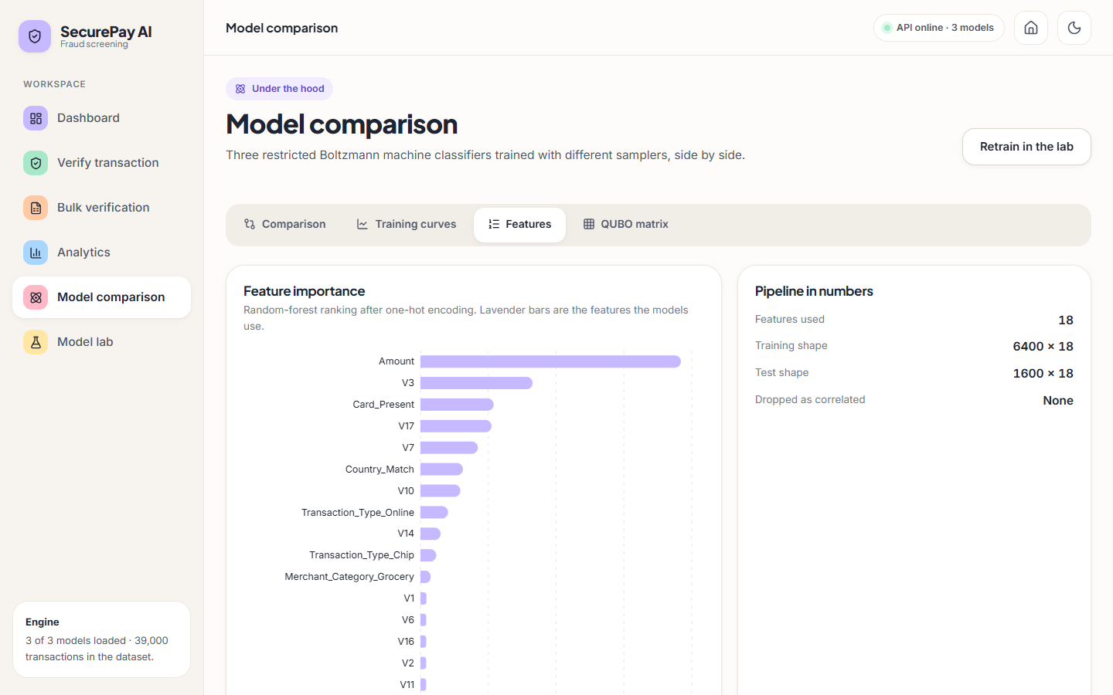
Figure 11: Model comparison, tab Features: random-forest feature importance and the numbers of the pipeline.
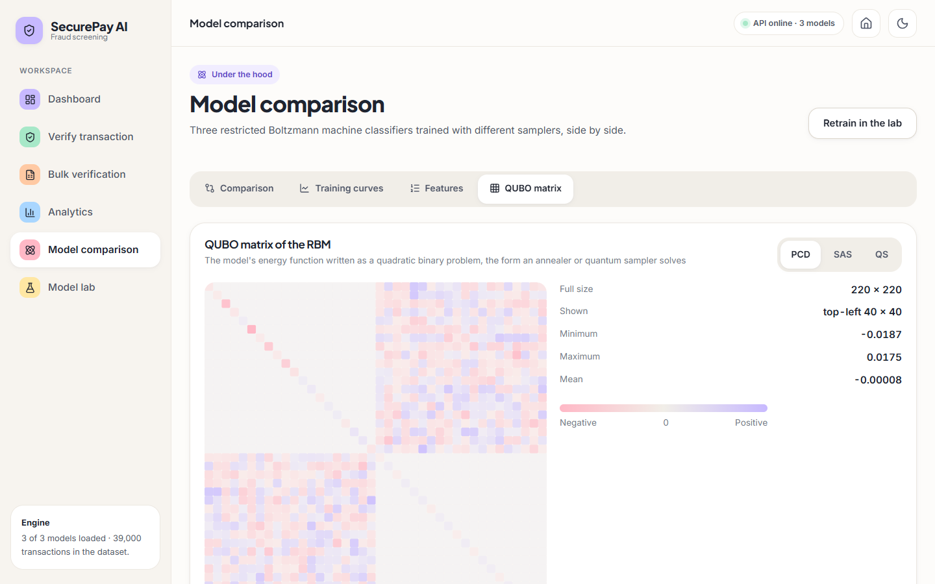
Figure 12: Model comparison, tab QUBO matrix: the 220 x 220 matrix of the PCD model, top-left 40 x 40 block.
The features tab ranks the 18 retained features (Amount first, then V3, Card_Present, V17 and V7) and states the pipeline in numbers: training shape 6,400 x 18, test shape 1,600 x 18, no column dropped as correlated. The QUBO tab draws the energy function of a model as a matrix of 220 x 220 entries (18 visible, 2 label and 200 hidden units for the PCD model), the form a quantum annealer would accept; it is a visualisation of the weights and is not used for prediction.

Figure 13: Model lab: current training state of each model, and the three steps dataset, preprocessing and training.
The Model lab regenerates the synthetic dataset, re-runs the preprocessing with a choice of manual undersampling, SMOTE or Tomek links, and retrains the selected models. The three cards at the top show the state of the loaded models: 20 epochs each, the best F1 and the last accuracy and recall. The PCD card shows a last accuracy of 58.8 % beside a recall of 100 %, the signature of a model that flags nearly everything. The lab overwrites the files in models/, so it was not run for this screenshot; a retraining run captured separately, with the files restored afterwards, is in Appendix C.

1.2 Data and pipeline
All results come from one synthetic dataset of 39,000 rows, half of them fraud-labelled, created by backend/synthetic_data.py to imitate the 39-thousand-row balanced set of the base paper [1]. The backend works on an 8,000-row random sample of it: one-hot encoding, z-scoring of 24 numeric columns, a correlation filter at 0.95 (nothing was removed), random undersampling to equal classes, a random-forest ranking that keeps the 18 most important features, and a stratified 80/20 split into 6,400 training and 1,600 test rows, of which 805 are fraud.
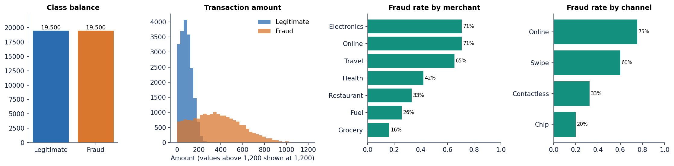
Figure 14: Synthetic dataset: class balance, amount distribution by class and fraud rate by merchant category and channel.
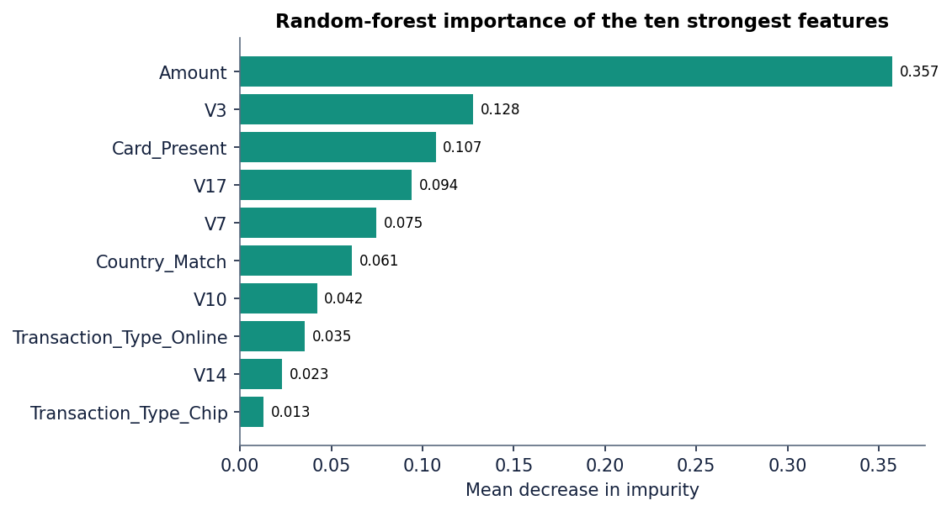
Figure 15: Random-forest importance of the ten strongest features on the training split.
Amount carries by far the largest share of importance, followed by V3, Card_Present, V17 and V7; the generator shifts exactly these signals for fraud, so a classifier that finds them has learned the generator. This is the first reason the numbers below must not be read as a forecast for real transactions.

1.3 Model performance on the held-out split
The table below gives the shipped models on the 1,600-row test split at the decision threshold of 0.5 that the application uses. The models are the files in models/, trained for 20 epochs; the metrics are those of the final epoch.
Table 2: Shipped models on the 1,600-row held-out split (threshold 0.5)
Model | Hidden units | Accuracy | Precision | Recall | F1 | ROC-AUC
PCD (classical) | 200 | 58.8% | 54.9% | 100.0% | 70.9% | 0.986
SAS (annealing) | 65 | 94.5% | 96.7% | 92.2% | 94.4% | 0.986
QS (quantum-inspired) | 65 | 94.3% | 94.5% | 94.2% | 94.3% | 0.986
Ensemble (mean of three) | - | 94.6% | 96.5% | 92.5% | 94.5% | 0.986

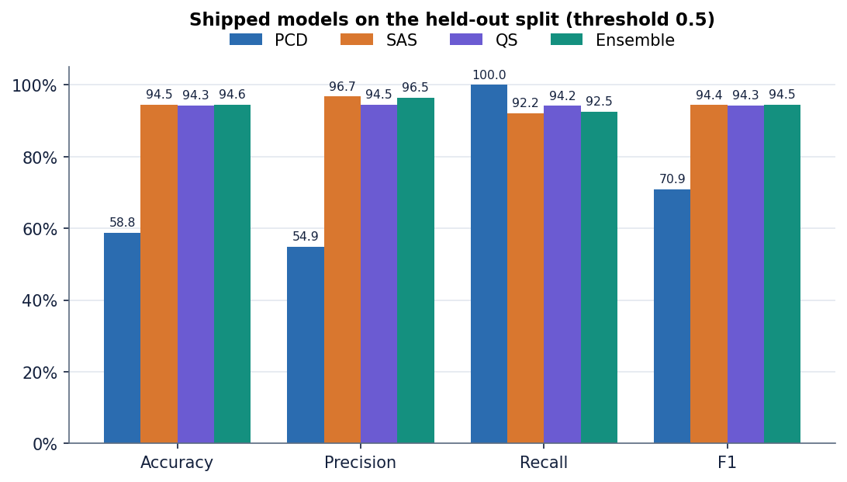
Figure 16: Accuracy, precision, recall and F1 of the three shipped models and their ensemble.
The SAS and QS models are close to each other (F1 94.4% and 94.3%) and the ensemble is marginally above both (94.5%). SAS errs towards missing fraud (63 false negatives against 25 false alarms), QS is more balanced (47 against 44). The PCD model is the exception: its recall is 100.0%, but it raises 660 false alarms among 795 legitimate rows, so its precision is 54.9% and its accuracy 58.8%. All three models have the same ROC-AUC of 0.986, which means they rank transactions equally well; the PCD model is wrong only about where to put the threshold.
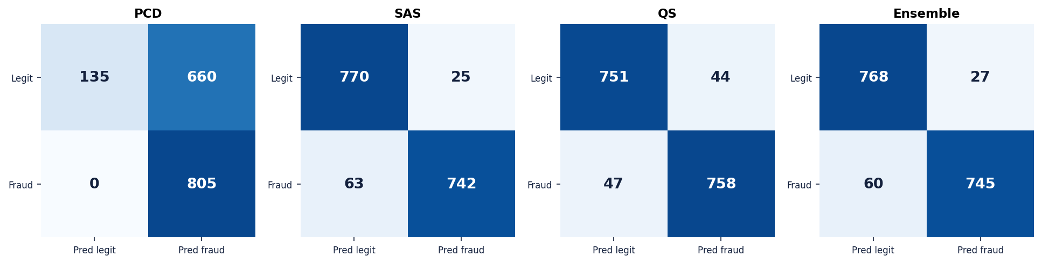
Figure 17: Confusion matrices of the three shipped models and the ensemble on the 1,600-row test split.
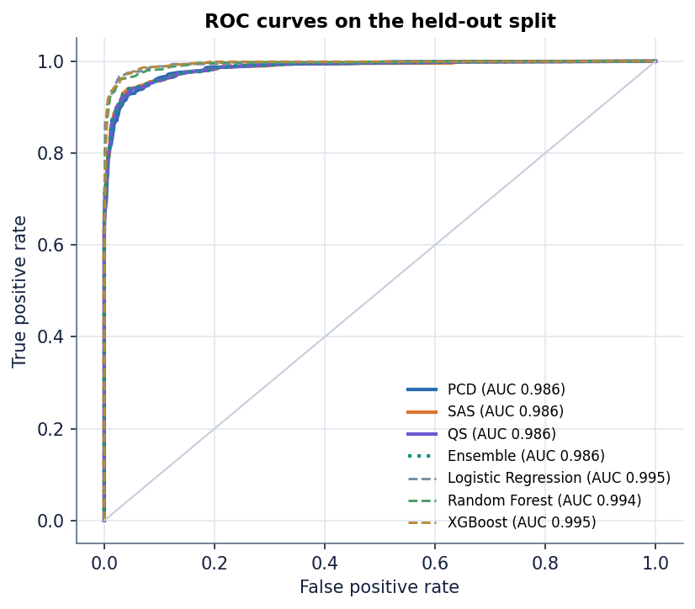
Figure 18: ROC curves of the shipped models and of Logistic Regression, Random Forest and XGBoost on the same split.

1.4 Threshold and calibration
The application labels a transaction as fraud above 0.5 and uses 0.4 and 0.7 as action bands. The figure below shows what each cut-off does to the ensemble and to the PCD model. For the ensemble, a threshold of 0.4 gives precision 72.8% and recall 99.6%; at 0.5 the values are 96.5% and 92.5%; at 0.6 precision rises to 99.8% but recall falls to 67.5%. At 0.7 and above no transaction reaches the threshold, so the HIGH band of the interface is never triggered by the ensemble on this data: the probabilities from these energy models are compressed into a narrow range around 0.5 and are not calibrated.
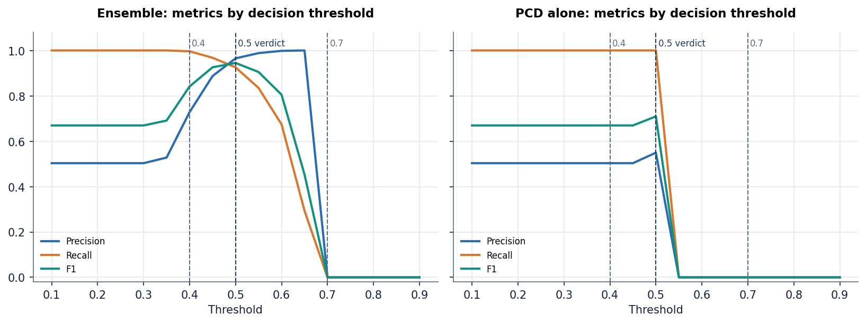
Figure 19: Precision, recall and F1 against the decision threshold for the ensemble and the PCD model.
The PCD model is even more compressed: its probabilities fall in a narrow band between about 0.4 and 0.6, so a threshold of 0.5 puts most of them on the fraud side (accuracy 58.8%) and 0.6 puts all of them on the other side (recall 0 %). This is why the ROC-AUC is high while every fixed threshold performs badly, and it argues for calibrating the output (Platt scaling or isotonic regression on a validation set) before the bands are used for decisions; the undersampling that balanced the data also shifts probabilities, a known effect of the technique [11].

1.5 Training behaviour and stability
The shipped models come from a single run, so the retraining experiment repeats training for five random seeds with 20 epochs on the same split and reports the final epoch (table below). A single seed would hide the instability that the training curves already hint at.
Table 3: GRBMC retrained over five seeds (final epoch, mean +/- standard deviation, percent)
Trainer | Accuracy | Precision | Recall | F1 | Best-epoch F1 | Seconds
PCD | 75.7 +/- 14.5 | 89.9 +/- 15.7 | 67.5 +/- 33.2 | 69.2 +/- 23.1 | 92.6 +/- 1.4 | 4.0
SAS | 94.5 +/- 0.1 | 96.8 +/- 0.2 | 92.2 +/- 0.4 | 94.4 +/- 0.1 | 94.5 +/- 0.1 | 4.9
QS | 92.7 +/- 1.5 | 91.9 +/- 4.7 | 94.2 +/- 2.7 | 92.9 +/- 1.2 | 94.3 +/- 0.2 | 4.2

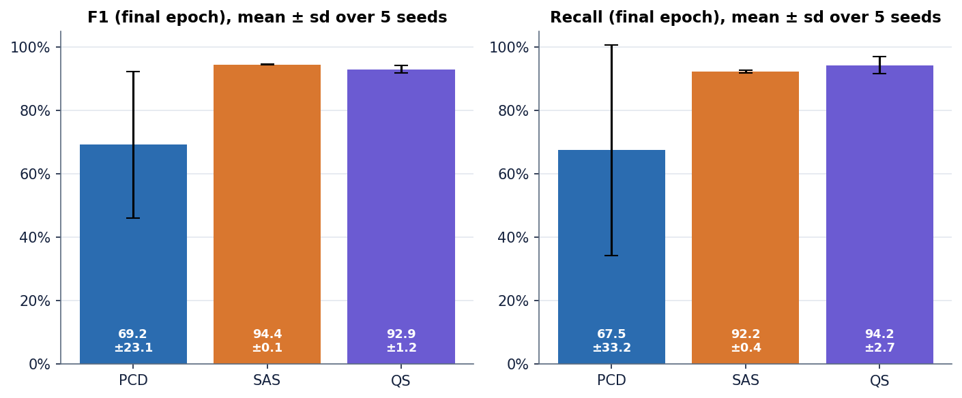
Figure 20: Final-epoch F1 and recall of the three trainers over five seeds.
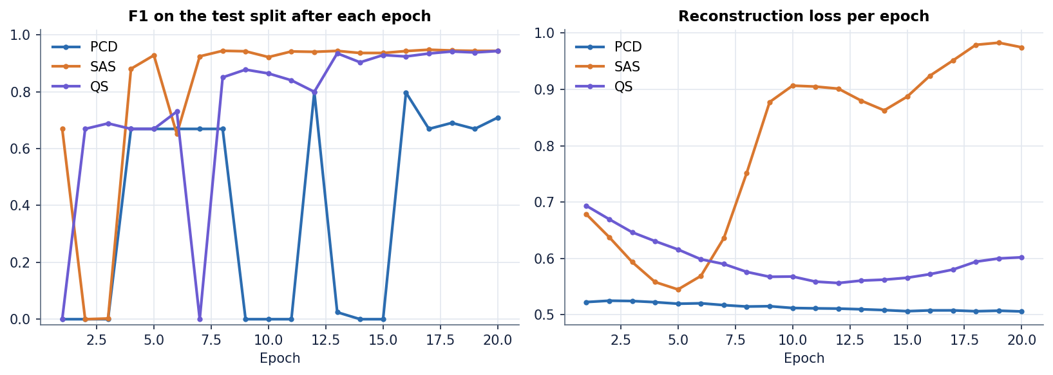
Figure 21: Per-epoch F1 and loss of the three shipped models over 20 epochs.
SAS is stable (F1 94.4 +/- 0.1), QS is acceptable (F1 92.9 +/- 1.2) and PCD is not: its final-epoch F1 varies by 23 points between seeds, from a model that finds most fraud to one that finds almost none, even though the best epoch of every seed is good (92.6 +/- 1.4). A model whose result depends on which epoch is read is not deployable unless a validation set chooses the epoch. The best-epoch columns, like the figures on the landing page, are selected on the test split and are optimistic by construction.
Training took 4 to 5 seconds per run, and the full 39,000-row file took 19 s (PCD), 6 s (SAS) and 4 s (QS). The paper's hours are not reproduced: the SAS and QS trainers here use ten sweeps and 16 reads on a subsample of 3,000 rows per epoch and estimate the negative phase from a single averaged vector, which is far cheaper than annealing the whole model on a simulator or quantum hardware.

1.6 Comparison with standard classifiers
The batch objectives name Logistic Regression, Random Forest and XGBoost. They are not part of the delivered application; they were trained by scripts/run_experiments.py on exactly the same 6,400 training rows and 18 features and scored on the same 1,600 test rows, with scikit-learn and XGBoost defaults except 100 trees with a minimum leaf size of 2 (random forest) and 200 trees of depth 4 (XGBoost).
Table 4: Standard classifiers and the RBM models on the same balanced split
Model | Accuracy | Precision | Recall | F1 | ROC-AUC
Logistic Regression | 96.7% | 96.3% | 97.1% | 96.7% | 0.995
Random Forest | 96.2% | 96.3% | 96.3% | 96.3% | 0.994
XGBoost | 96.5% | 97.0% | 96.0% | 96.5% | 0.995
RBM, SAS | 94.5% | 96.7% | 92.2% | 94.4% | 0.986
RBM, QS | 94.3% | 94.5% | 94.2% | 94.3% | 0.986
RBM ensemble | 94.6% | 96.5% | 92.5% | 94.5% | 0.986

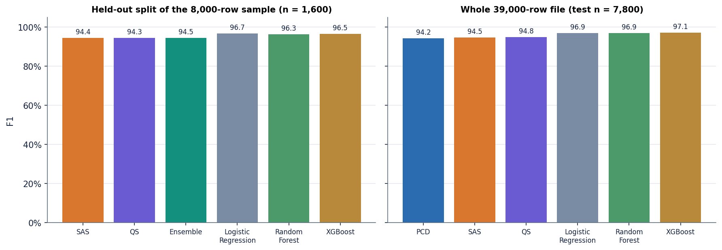
Figure 22: F1 of the RBM models and the standard classifiers on the 1,600-row split and on the 39,000-row file.
The simple classifiers win on this data. Logistic Regression reaches F1 96.7% and ROC-AUC 0.995 against 94.5% and 0.986 for the RBM ensemble, and it fits in 6 ms. That a linear model is the best is itself informative: the synthetic classes differ by mean shifts, which a linear boundary separates well; the energy-based network does not help here. On the full 39,000-row file the order is the same (XGBoost F1 97.1%, Logistic Regression 96.9%, SAS 94.5%, QS 94.8%), and the gap is about two to three points. This agrees with the literature in which tree ensembles are strong baselines on tabular fraud data [2], [3], [4].

1.7 Behaviour when fraud is rare
The balanced file hides the central difficulty of the problem. To see it, the generator was run again with 1 % fraud (39,000 rows), the data were split first (stratified 80/20), and each balancing strategy was fitted on the training rows only. The test set has 7,800 rows with 78 fraud, and the results are means over five splits (table below). The strategies are the ones the base paper discusses: no resampling, class weights, SMOTE [12] and random undersampling [1], [15].
Table 5: 1 % fraud variant: precision, recall, F1, PR-AUC and mean error counts per 7,800 test rows (threshold 0.5)
Model | Strategy | Precision | Recall | F1 | PR-AUC | FP | FN
Logistic Regression | none | 0.946 | 0.805 | 0.869 | 0.922 | 3.6 | 15.2
Random Forest | none | 0.991 | 0.659 | 0.790 | 0.872 | 0.4 | 26.6
XGBoost | none | 0.953 | 0.751 | 0.838 | 0.893 | 3.0 | 19.4
Logistic Regression | class_weight | 0.259 | 0.972 | 0.409 | 0.899 | 217.8 | 2.2
Random Forest | class_weight | 0.989 | 0.479 | 0.644 | 0.886 | 0.4 | 40.6
XGBoost | class_weight | 0.804 | 0.821 | 0.810 | 0.892 | 15.8 | 14.0
Logistic Regression | SMOTE | 0.325 | 0.962 | 0.485 | 0.902 | 156.8 | 3.0
Random Forest | SMOTE | 0.921 | 0.744 | 0.821 | 0.869 | 5.0 | 20.0
XGBoost | SMOTE | 0.900 | 0.826 | 0.861 | 0.909 | 7.2 | 13.6
Logistic Regression | undersample | 0.203 | 0.979 | 0.336 | 0.891 | 301.8 | 1.6
Random Forest | undersample | 0.223 | 0.969 | 0.362 | 0.883 | 266.0 | 2.4
XGBoost | undersample | 0.192 | 0.956 | 0.320 | 0.857 | 313.6 | 3.4
GRBMC (SA) | undersample | 0.950 | 0.595 | 0.721 | 0.734 | 3.0 | 31.6
Rule: 3 of 4 risk signals | - | 0.557 | 0.421 | 0.478 | - | 27.0 | 45.2

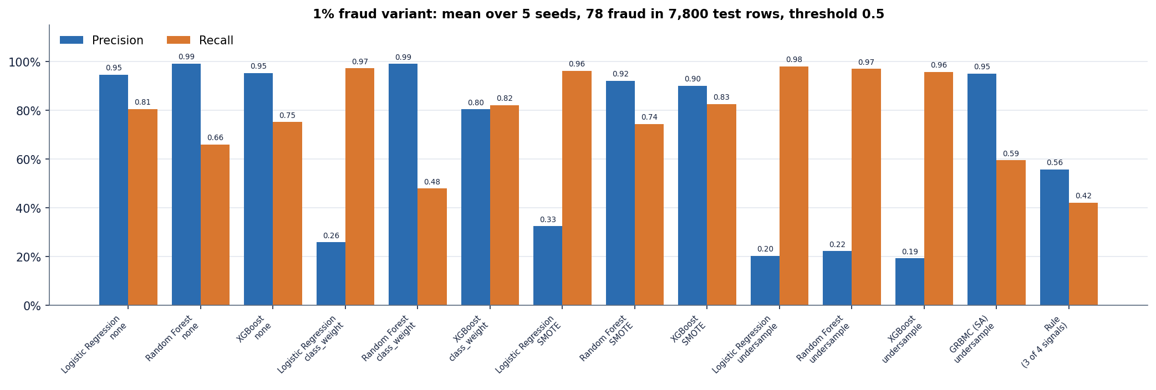
Figure 23: Precision and recall by model and balancing strategy when fraud is 1 % of the stream.
Three findings follow. First, undersampling, the strategy the base paper settled on, gives the highest recall (above 0.96) but destroys precision: precision falls to 0.19 to 0.22 and a model raises 266 to 314 false alarms for every 78 frauds. An analyst would have to review roughly 3.5 to 4.2 false alerts for every fraud found. Second, with no resampling the same models keep precision at 0.95 or better and still find 0.66 to 0.81 of the fraud, giving the best F1 (Logistic Regression 0.869); SMOTE and class weights give XGBoost a balanced F1 (0.86 and 0.81) but push Logistic Regression towards the undersampling pattern (precision 0.33 and 0.26). Third, the RBM trained on undersampled data (SAS) has precision 0.95 but recall of only 0.59, and a PR-AUC of 0.73 against 0.92 for Logistic Regression; the generative model loses most of its advantage once the class proportions it saw in training differ from those at test time. The illustrative rule (flag when three of four risk signals are present) reaches F1 0.48, so the learned models are far better than a fixed rule of this kind, which supports the first problem stated in the batch abstract.
The result is consistent with the observation of the base paper that SMOTE and Tomek links performed poorly when the minority class was very small, and with the known effect that undersampling distorts probabilities [1], [11]. It also shows that the application's models, trained and scored on a balanced set, would give an optimistic picture of a real stream, where the proportion of fraud is of the order of 0.01 % to 4 % [1], [3].

1.8 Comparison with the base paper
The table below sets the results beside Table 1 of the base paper. The two sets of numbers are not comparable: the paper used about 145 million real transactions from a Brazilian payment company, balanced to 39 thousand rows, 50 epochs and real or simulated D-Wave sampling, while this project used a synthetic file of the same size, 20 epochs, subsampled classical samplers and no quantum hardware. The table is given to show where the two stand, not to claim an improvement.
Table 6: Base paper (real data) and this project (synthetic data), best epoch by F1
Method | Source | Accuracy | Precision | Recall | F1 | Training time
PCD | paper | 84 % | 86 % | 81 % | 83 % | 2 minutes
PCD | this project | 74.9% | 66.8% | 99.6% | 80.0% | 4.4 s
SAS | paper | 85 % | 94 % | 82 % | 88 % | 4 hours
SAS | this project | 94.8% | 95.6% | 94.0% | 94.8% | 4.2 s
QS | paper | 85 % | 91 % | 79 % | 84 % | 1.8 hours
QS | this project | 94.3% | 94.5% | 94.2% | 94.3% | 3.4 s

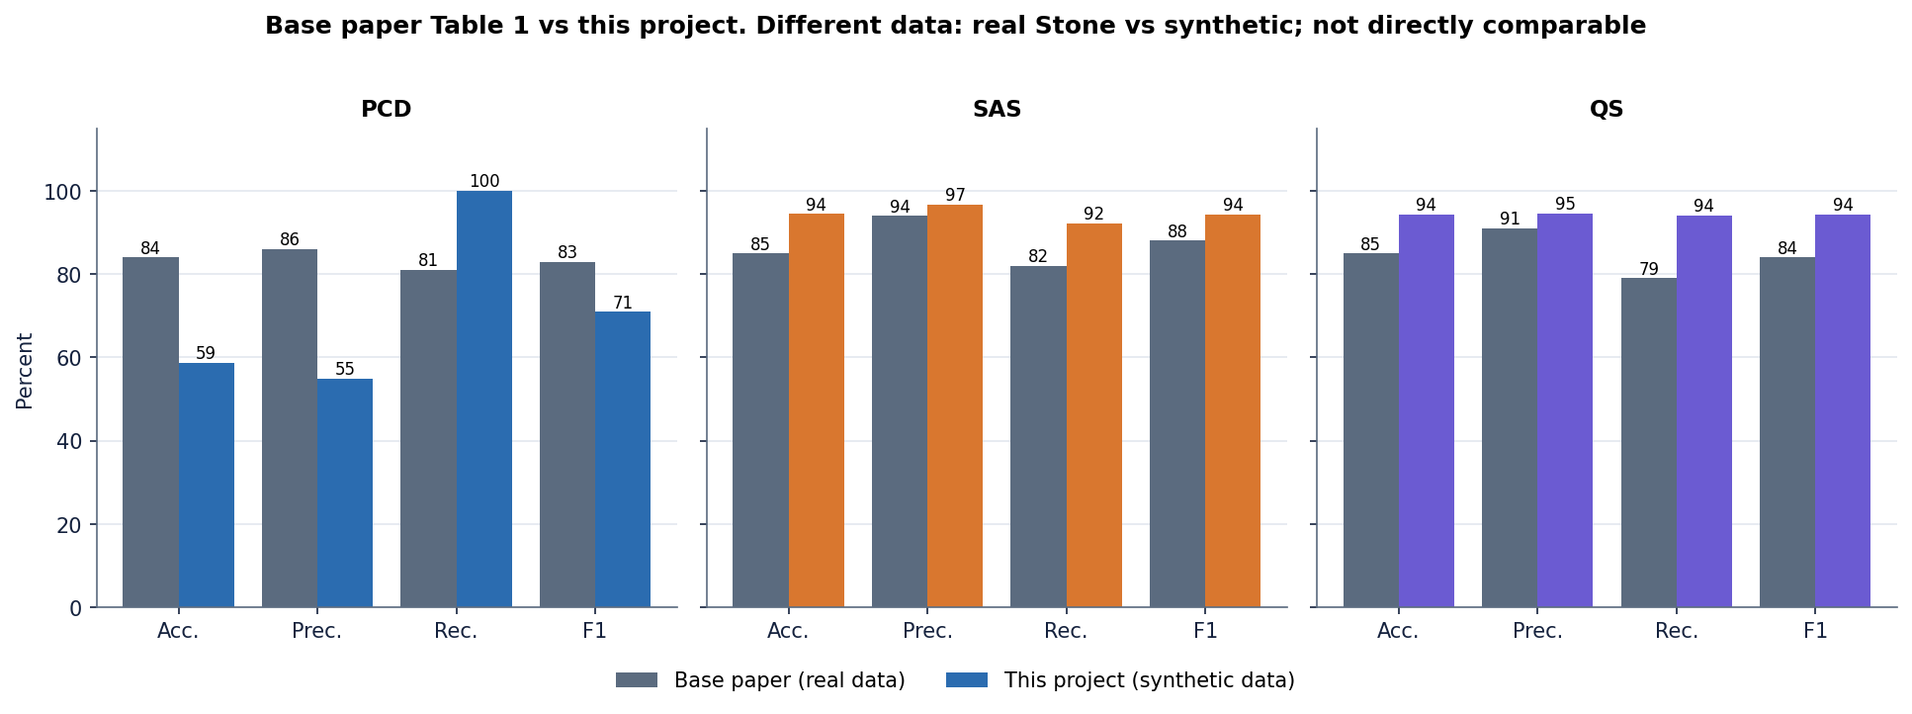
Figure 24: F1 of the base paper (real Stone data) and of this project (synthetic data). The data differ, so the bars are not directly comparable.
Qualitatively the ordering of the paper is partly reproduced: the annealing-based trainers beat classical PCD in both studies, and the simulated-annealing trainer is the best or tied for best. Two things are not reproduced. The paper's quantum sampling is slightly below simulated annealing, whereas here the two are equal within noise; and the paper's classical model is a reasonable classifier at 84 % accuracy, whereas the PCD model here is unstable. The synthetic data are easier than real data (a linear model scores 96.7 %), which is why accuracy exceeds the paper's even for a simplified sampler.

1.9 Sample inputs and outputs, and the serving defect
The table below gives the real responses of /api/predict_single for three transactions, next to the probabilities computed offline with correct scaling. They are identical to full precision, so the single-transaction route is correct; the high-risk example is flagged as fraud (MEDIUM band), the low-risk example is approved, and a middle example is a coin toss at 52.6 %.
Table 7: Live responses of the single-transaction route and offline recomputation
Example | PCD | SAS | QS | Ensemble | Verdict, band | Offline ensemble
High-risk example | 50.9% | 94.7% | 59.5% | 68.4% | FRAUD, MEDIUM | 68.4%
Low-risk example | 50.1% | 21.4% | 47.2% | 39.5% | LEGITIMATE, LOW | 39.5%
Middle example | 50.3% | 56.5% | 51.0% | 52.6% | FRAUD, MEDIUM | 52.6%

Inputs: high-risk = amount 1,200, merchant Online, channel Online, card not present, country mismatch, time 54,000 s, V3 1.8, V14 -1.1, V17 1.4; low-risk = amount 80, Grocery, Chip, card present, country match, V3, V14 and V17 at 0; middle = amount 350, Electronics, Contactless, card present, country match, V3 0.8, V14 -0.4, V17 0.6. Fields not given are filled with the dataset mean or mode.
The batch route behaves differently. In predict_batch the one-hot columns are first reduced to the 18 selected features and only then scaled; the scaler was fitted on 24 numeric columns, so scaler.transform on the 13 numeric columns that remain raises an error, and a bare except: pass hides it. The models then receive raw, unscaled values. The second table below measures the effect on a fresh 2,000-row balanced batch produced by the same generator with a new random seed, once as the route serves it and once with correct scaling.
Table 8: Batch route: fresh 2,000-row balanced batch, as served and with correct scaling (ensemble)
Condition | Accuracy | Precision | Recall | F1 | ROC-AUC | FP | FN
As served (no scaling) | 50.2% | 50.1% | 100.0% | 66.8% | 0.893 | 995 | 0
With scaling | 94.8% | 97.3% | 92.3% | 94.7% | 0.986 | 26 | 77

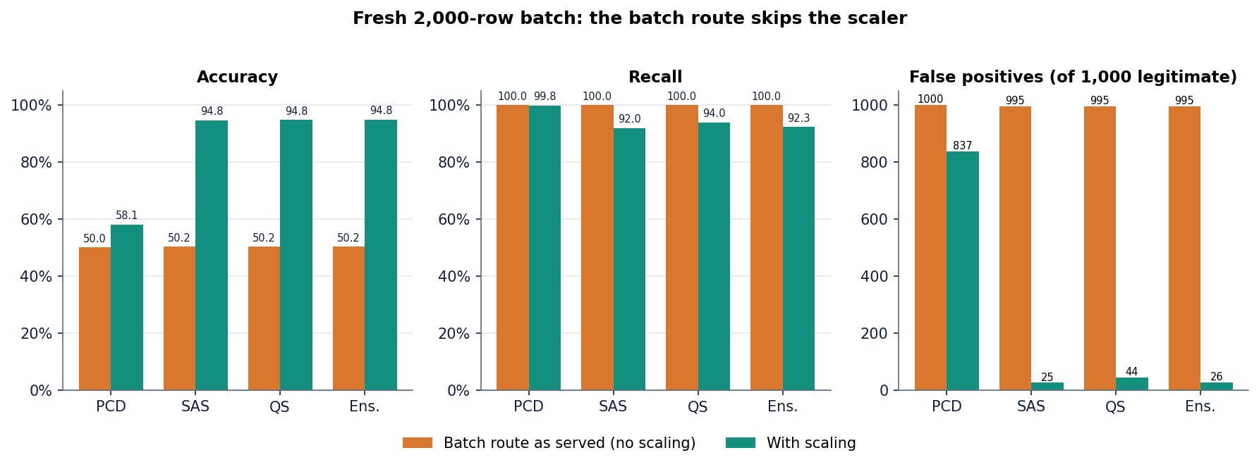
Figure 25: Effect of the skipped scaling in the batch route: accuracy, recall and false alarms as served and with correct scaling.
As served, the batch route flags essentially every row (accuracy 50.2%, recall 100.0%, 995 false alarms among 1000 legitimate rows); with scaling it matches the offline result (94.8%). The bundled sample file shows it too: 20 of 20 rows are flagged as served, 11 when scaled (the file holds 10 fraud rows). The defect is documented and was deliberately not fixed in the delivered product: the repair is one line (apply the scaler to the full numeric block before selecting columns), but the report describes the system as built. It also shows why the smoke test, which only checks that a response exists, did not catch it.

1.10 Success and failure analysis
Where the system works. The simulated-annealing and quantum-inspired models separate the synthetic classes with ROC-AUC 0.986 and F1 about 94 %; the ensemble is at least as good as its members; the single-transaction route is numerically correct; a check takes a median of 17 ms; and the interface exposes the whole workflow (check, screen, analyse, compare, retrain) with real data behind every screen.
Where it fails. The concrete failure cases are these:
• The PCD model flags almost everything. At the application's threshold it has 660 false alarms against 135 correct approvals; its ranking is good (ROC-AUC 0.986) but it is not calibrated, and it is unstable across seeds.
• The batch route is broken by the scaling defect. Accuracy falls to 50.2% and the sample file is flagged 20 of 20 (Section 8.9).
• An extreme amount produces NaN. An amount of 1,000,000 yields a probability that is not a number and an LOW-risk approval (Section 7.6).
• Precision collapses when fraud is rare. With undersampling and 1 % fraud every model, standard or RBM, either raises hundreds of false alarms or misses a large part of the fraud (Section 8.7).
• The HIGH band never fires. The ensemble probabilities stay below 0.7 on this data, so decline and alert is unreachable in practice (Section 8.4).
• Oscillation of the annealed trainers. The per-epoch F1 of SAS and QS moves by several points between neighbouring epochs and SAS drops to 0.0% in the early epochs; choosing the last epoch, as done here, is safe only because the curves have settled by about epoch 13.
• The simple models are better. On this data Logistic Regression, Random Forest and XGBoost beat the RBM ensemble by about two points of F1, so the benefit of the base paper's method is not shown by this project.

1.11 Limitations of the results
• The data are synthetic and generated with simple mean shifts, so accuracy is higher and easier than on real transactions, and no result transfers to a bank.
• The quantum sampler is a classical simulation with ten sweeps and a subsampled epoch; no quantum hardware, D-Wave simulator or Julia package was used, so nothing here tests quantum advantage.
• Best-epoch figures are chosen on the test split. The primary figures in this chapter are final-epoch values; the best-epoch values are shown only where the base paper's convention requires them.
• Scaling, balancing and feature ranking were fitted on the whole 8,000-row sample before the split, a mild leak; the 1 % experiment avoids it.
• There is a single dataset, single split for the shipped models and no confidence intervals beyond the five-seed spread.
• Latency was measured on one PC with a development server and says nothing about concurrent load.

1.12 Objectives versus outcomes
The table below sets the six objectives of the project proposal against what was achieved.
Table 9: Objectives and measured outcomes
No. | Objective | Outcome | Evidence
1 | Acquire a benchmark dataset and quantify the imbalance | Partly met: a synthetic file, not a public benchmark; imbalance quantified by the 50/50 file and a 1 % variant | Sections 8.2, 8.7
2 | Scaling, feature selection, stratified split | Met: z-score, correlation filter, RF top-18, stratified 80/20; mild leak noted | Section 8.2
3 | Compare SMOTE with random undersampling | Met in experiments (not in the product UI, which offers it only through the lab): undersampling lifts recall and wrecks precision at 1 % fraud | Section 8.7
4 | Train Logistic Regression, Random Forest and XGBoost | Met in scripts/run_experiments.py; not shipped inside the application | Section 8.6
5 | Evaluate with precision, recall, F1 and ROC-AUC | Met: all four, plus PR-AUC and confusion matrices | Sections 8.3-8.7
6 | Deploy the best model behind an interface that flags a transaction | Met with defects: the interface flags transactions in a median 17 ms; the deployed model is the RBM ensemble, not the best model, and the batch route is mis-scaled | Sections 8.1, 8.9

