PNEUMONIA DETECTION USING DEEP LEARNING
Results
Department of Computer Science and Engineering, TKR College of Engineering and Technology (Autonomous)
Batch A12 (CSE-A) · Academic year 2026-2027
Table 1: Project team
S.No. | Student name | Roll number
1 | CHOUDAM AKSHITHA | 23K91A0556
2 | BOGGULA SATVIK KUMAR | 23K91A0541
3 | ARUTLA ABHI THEJ REDDY | 23K91A0515
4 | DUGGARAJU LIKHITHA | 23K91A0565

Project guide: V. MEENAKSHI
Chapter and section numbers quoted in the text (for example Section 6.6 or Chapter 8) refer to the full project report, 17.Final Document. Figures and tables in this document are numbered from 1.

CHAPTER 8: RESULTS AND OUTPUT SCREENS

8.1 Output screens
The screens below are captures of the running application at 1440 x 900 pixels, taken by scripts/capture_screens.py after real scans had been uploaded through the interface (four public sample radiographs, so the history, dashboard and result pages hold real data). The script fails on any console error or failed request; none occurred.
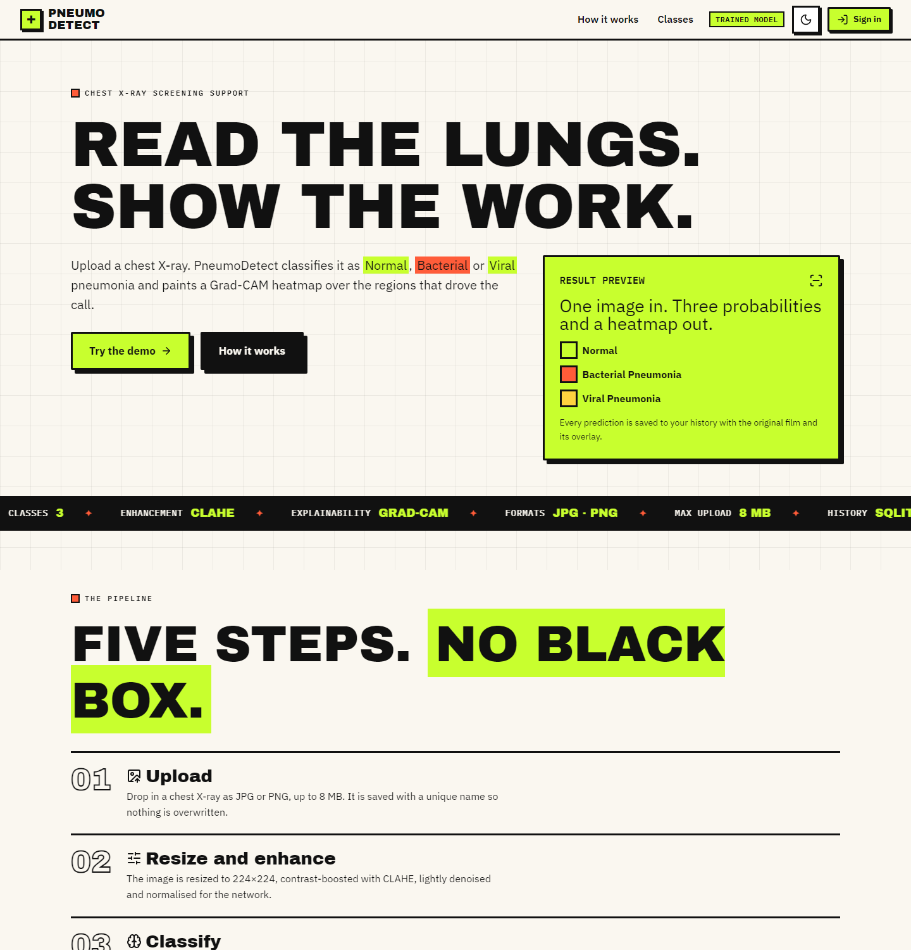
Figure 1: Landing page (light theme): hero, how the pipeline works, the three classes and the clinical disclaimer
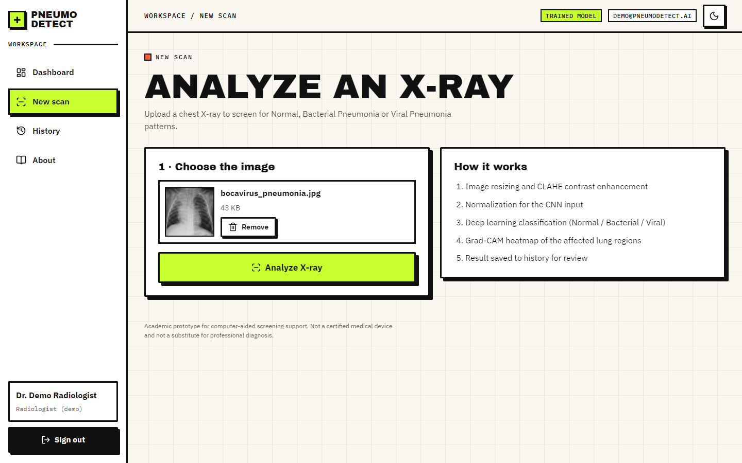
Figure 2: Detect screen with a preview of the selected radiograph and the Analyse button
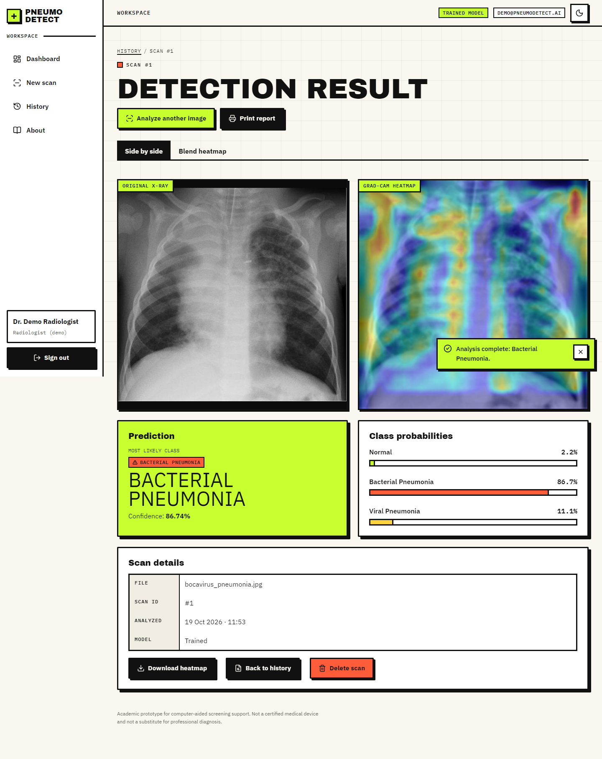
Figure 3: Result screen: original X-ray beside the Grad-CAM overlay, class badge, confidence and the three probability bars
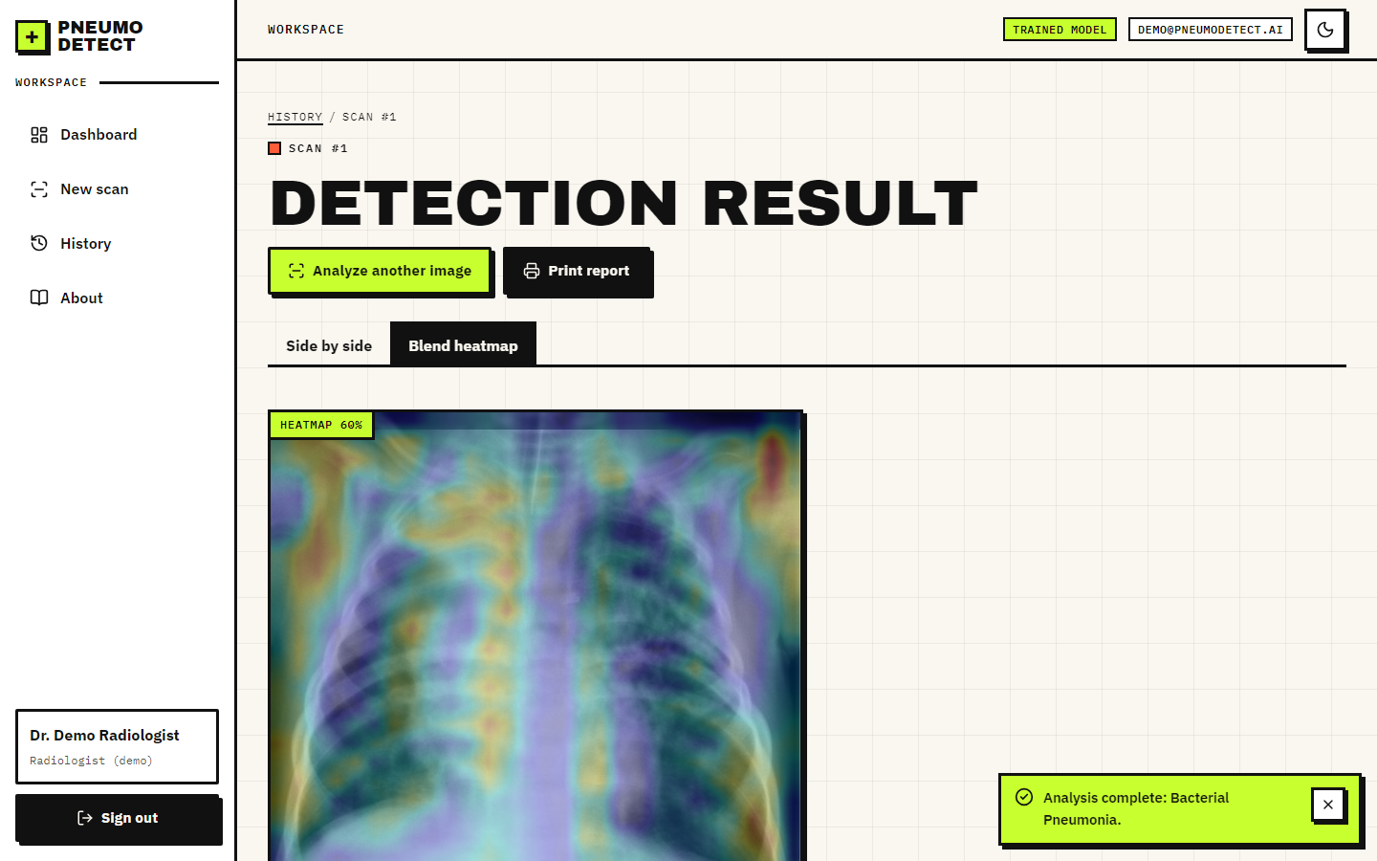
Figure 4: Result screen, blended view: a slider sets how strongly the heat map is laid over the X-ray
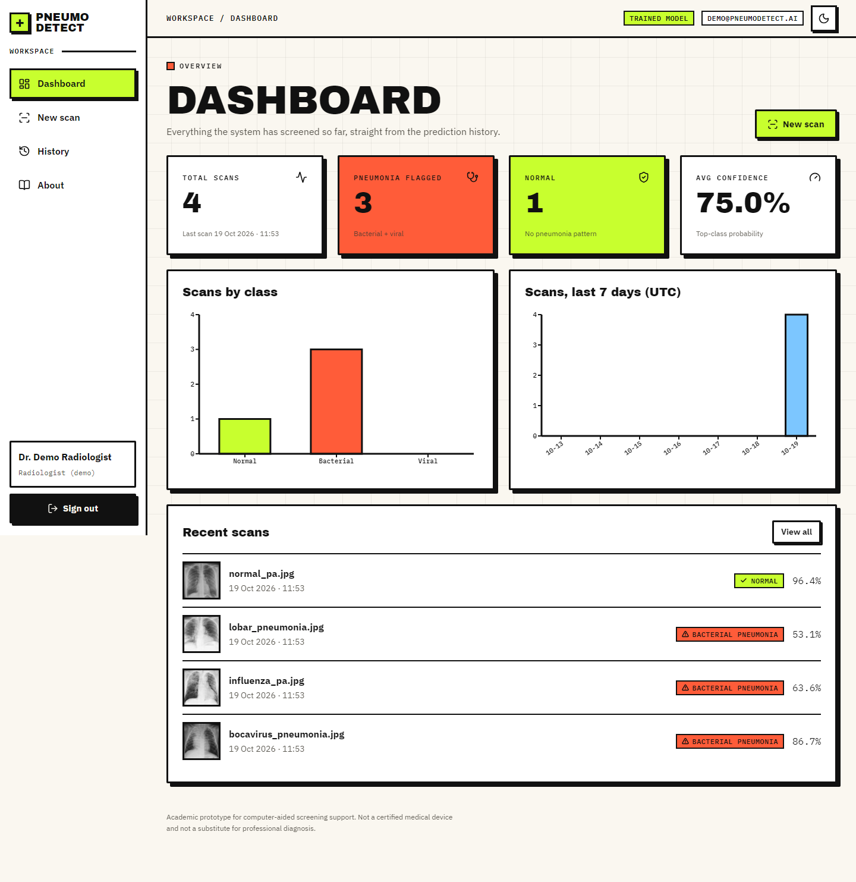
Figure 5: Dashboard: totals, class distribution, scans per day and the most recent scans
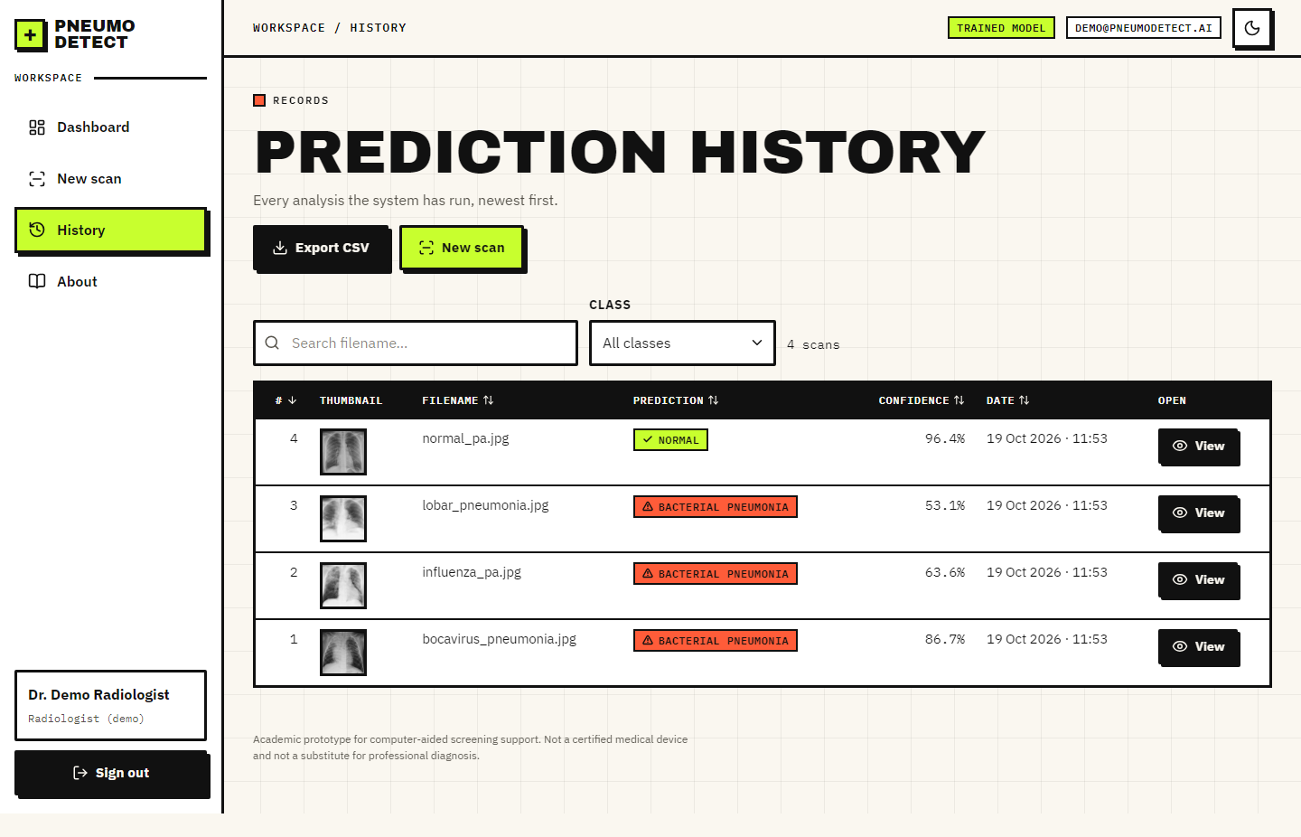
Figure 6: History: searchable, filterable, sortable table with thumbnails and CSV export
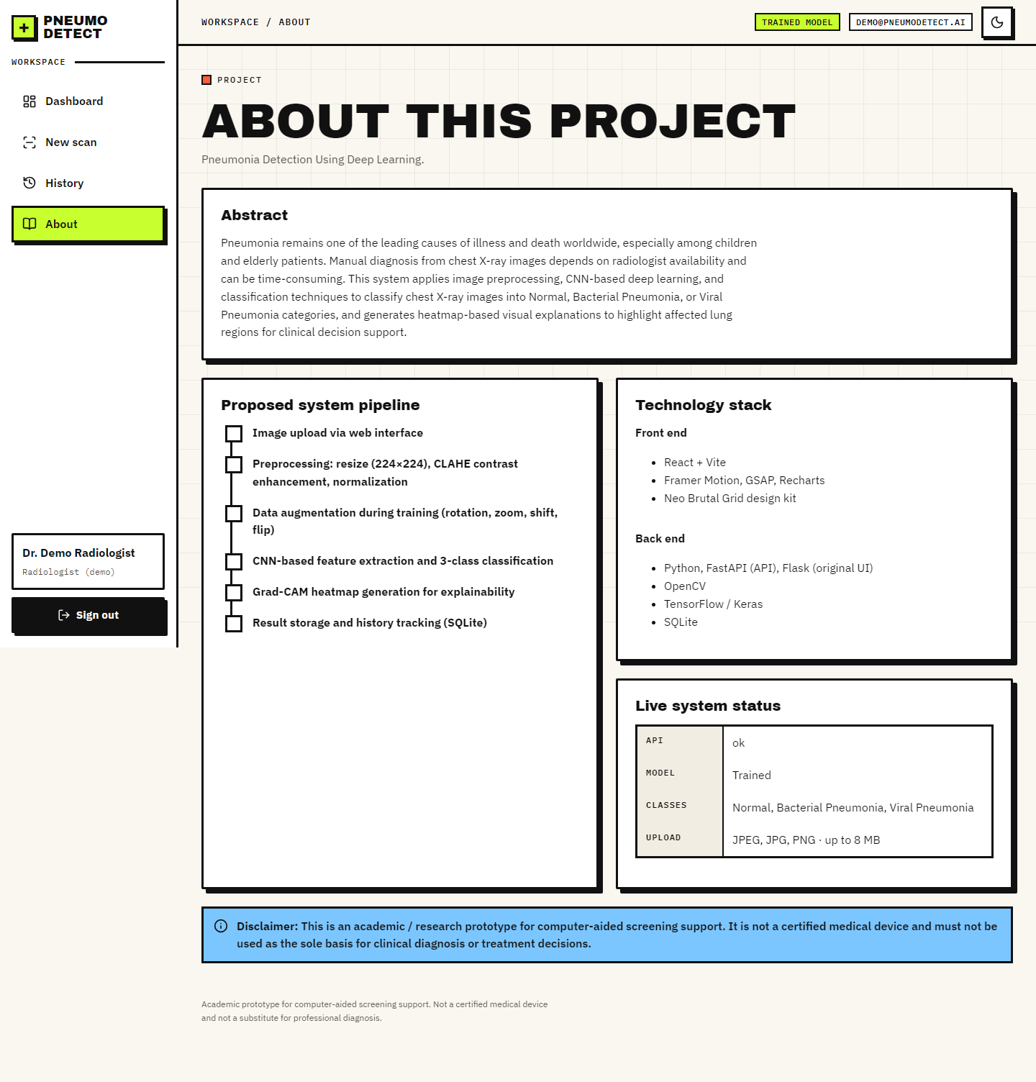
Figure 7: About screen: abstract, the five-step pipeline, technology and disclaimer

8.2 Experimental setup and protocol
All model results come from scripts/train_experiment.py, which writes experiments/<name>/metrics.json. The protocol of the main experiment is fixed before looking at any test result:
Table 2: Protocol of the main experiment
Item | Value
Data | Kermany et al. paediatric chest X-ray dataset, 5,856 images, three classes derived from file names
Training pool | Official train + val folders; patient-level 10 % validation split (stratified group split, seed 42)
Sizes | train 4,688 (2,635 patients) / validation 544 (293 patients) / test 624 (official, used once)
Model | custom CNN, 590,019 parameters, trained from scratch
Training | Adam 0.0003, batch 32, up to 40 epochs; 21 run, best epoch 11; about 214 s per epoch on a CPU
Class weights | Normal 1.29, Bacterial Pneumonia 0.69, Viral Pneumonia 1.28
Environment | TensorFlow 2.21.0, Python 3.11.9, Intel Core i5-12500, no GPU

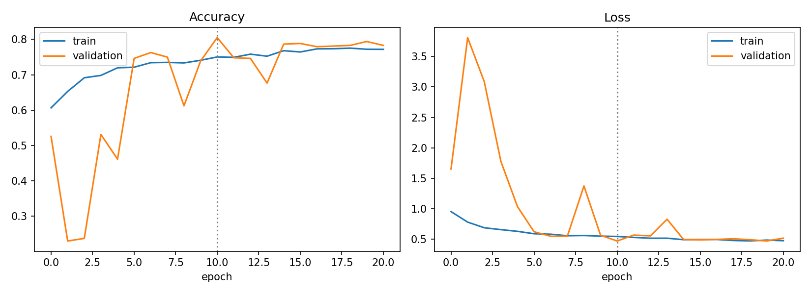
Figure 8: Training and validation accuracy and loss of the main experiment (dotted line: best epoch)
Validation accuracy of the restored best model is 80.5%. The validation curve is noisy, which is typical of batch-normalised networks trained from scratch on a small validation set (544 images).

8.3 Model performance on the official test split
Table 3: Per-class results on the official test split (n = 624)
Class | Precision | Recall | F1 | Support
Normal | 0.967 | 0.620 | 0.755 | 234
Bacterial Pneumonia | 0.835 | 0.959 | 0.892 | 242
Viral Pneumonia | 0.607 | 0.804 | 0.692 | 148
Macro average | 0.803 | 0.794 | 0.780 | 624

Overall three-class accuracy is 79.5% and the macro F1 is 0.780 (macro one-vs-rest AUC 0.933). The class recalled best is Bacterial Pneumonia (95.9%); the class recalled worst is Normal (62.0%).
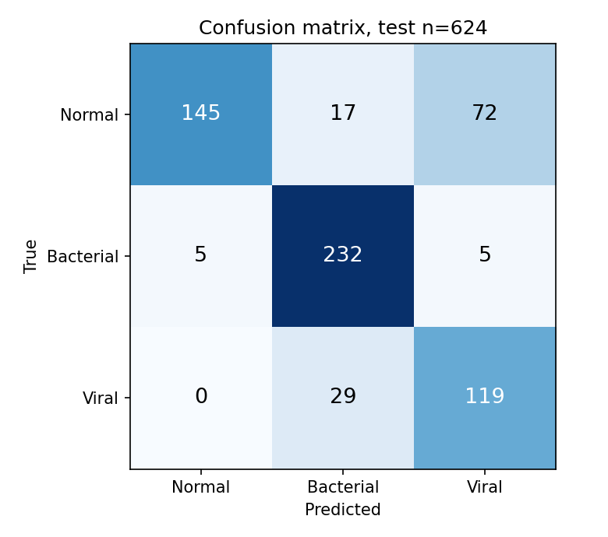
Figure 9: Confusion matrix on the official test split (rows: true class, columns: predicted class)
The largest single confusion is Normal images predicted as Viral (72 images), followed by Viral predicted as Bacterial (29 images).
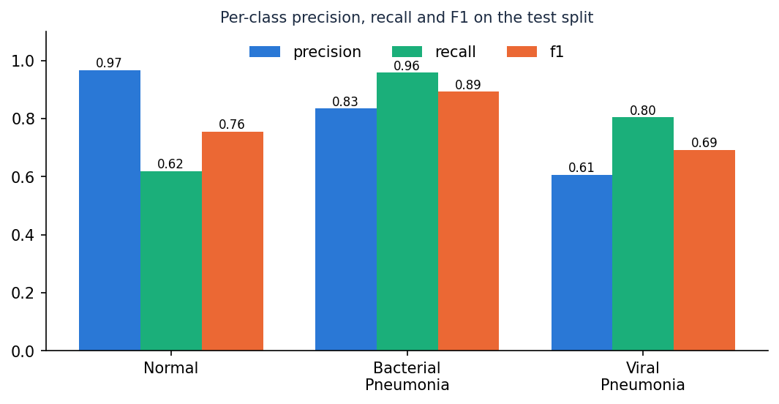
Figure 10: Per-class precision, recall and F1 on the official test split

Normal against pneumonia
Collapsing the two pneumonia classes gives the binary view used by most of the literature, with pneumonia as the positive class:
Table 4: Binary view of the same predictions
Measure | Value
True positives / false negatives | 385 / 5
True negatives / false positives | 145 / 89
Accuracy | 84.9%
Sensitivity (recall of pneumonia) | 98.7%
Specificity | 62.0%
Precision | 81.2%
F1 | 0.891
AUC (1 - P(Normal) as score) | 0.942

Calibration: the expected calibration error is 0.033 (10 bins) and the mean confidence is 0.777 against an accuracy of 0.795; a gap between the two means the softmax probability should not be read as a literal probability of being right.

8.4 Overlap between the training and test folders
Pneumonia file names carry a patient id (person123_virus_45.jpeg). Counting ids, 320 of the 624 official test images (320 of the 390 pneumonia images) have an id that also occurs in the training folders, while none of the 234 normal test images do. Shahi and Bagale [6] made the same observation about this dataset. Some of these coincidences may be different children given the same number, but the file names cannot show this, so the conservative reading is possible patient leakage.
The model's metrics on the 304 test images whose id does not occur in training are given next to the full-test metrics. The subset contains 234 normal, 48 bacterial and 22 viral images, so its class mix differs from the full test split.
Table 5: Full official test split against the id-disjoint subset
Measure | Full test (n = 624) | Id-disjoint subset (n = 304)
3-class accuracy | 79.5% | 69.7%
Pneumonia sensitivity | 98.7% | 98.6%
Normal specificity | 62.0% | 62.0%
Recall: Normal / Bacterial / Viral | 62.0% / 95.9% / 80.4% | 62.0% / 95.8% / 95.5%

A second, stricter protocol re-partitions all 5,856 images by patient (stratified group split, seed 42): 4,102 training, 899 validation and 855 test images with no id shared between the three parts (test images sharing an id with training: 0). The same network and settings reach 79.1% three-class accuracy and macro F1 0.779 on this test part, with pneumonia sensitivity 94.8% and normal specificity 94.0%. Its class mix and test size differ from the official split, so the two are reported side by side, not averaged.
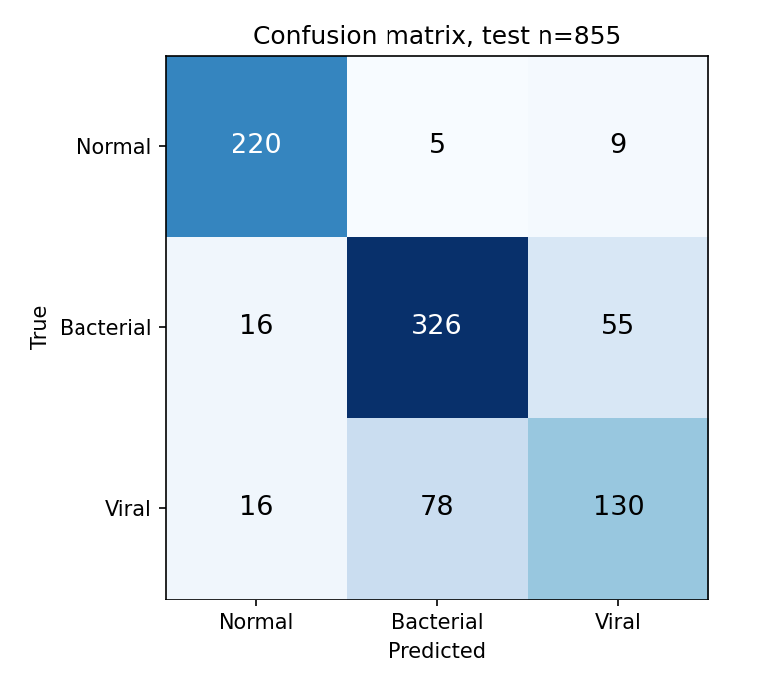
Figure 11: Confusion matrix of the patient-level re-partition

8.5 Ablation and comparison with MobileNetV3Small
Three further runs use the same code and seed. The CLAHE ablation removes the contrast step from training and inference; the MobileNetV3Small run uses the backbone that the base paper selects [1], [13], trained in two stages (head only, then fine-tuning) and evaluated on the same official test images. The patient-level run uses a different test part and is listed for completeness.
Table 6: Experiments compared
Experiment | Parameters | 3-class acc. | Macro F1 | Sensitivity | Specificity
Baseline: project defaults (lr 1e-4), stopped early | 590,019 | 68.1% | 0.655 | 99.0% | 35.5%
Tuned recipe (deployed model) | 590,019 | 79.5% | 0.780 | 98.7% | 62.0%
Tuned, no CLAHE (ablation) | 590,019 | 82.2% | 0.810 | 99.2% | 66.7%
MobileNetV3Small, ImageNet start (base-paper backbone) | 940,851 | 61.9% | 0.593 | 100.0% | 25.2%
Tuned, patient-level re-partition (own test part) | 590,019 | 79.1% | 0.779 | 94.8% | 94.0%

Removing CLAHE changes three-class accuracy by +2.7 percentage points and macro F1 by +0.030. With one seed per configuration this difference should be read as indicative; differences of a few points are within the run-to-run variation of small CNNs, which this project could not measure for lack of repeated runs. The variant without CLAHE scored higher on the test split, so this project does not show that the contrast step helps. Its validation accuracy (80.7%) was almost the same as that of the deployed model (80.5%), the deployed model had been chosen before the ablation was run, and the deployed application keeps CLAHE for consistency with the original project; re-training the deployed model without CLAHE is listed as future work.
The shipped gradcam.py cannot compute a heat map for the MobileNetV3Small model, because the backbone is a nested model and the feature tensor is not connected to the outer input; this is one reason the transfer-learning option was not deployed; its accuracy on these test images was also lower than that of the custom CNN.
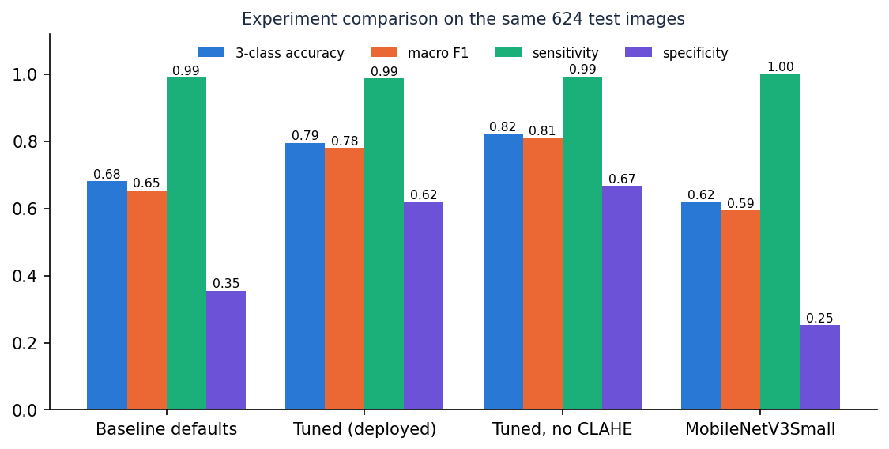
Figure 12: Comparison of the experiments on the official test images

8.6 Threshold analysis
Confidence threshold. A deployment could auto-report only scans whose top probability reaches a threshold and send the rest for review. The table below shows the trade-off on the test split: a higher threshold raises accuracy on the scans kept but reduces coverage.
Table 7: Accuracy against minimum confidence
Threshold | Scans kept | Coverage | Accuracy on kept
0.00 | 624 | 100.0% | 79.5%
0.50 | 585 | 93.8% | 82.1%
0.60 | 520 | 83.3% | 86.0%
0.70 | 446 | 71.5% | 89.5%
0.80 | 332 | 53.2% | 92.8%
0.90 | 148 | 23.7% | 95.3%
0.95 | 67 | 10.7% | 97.0%

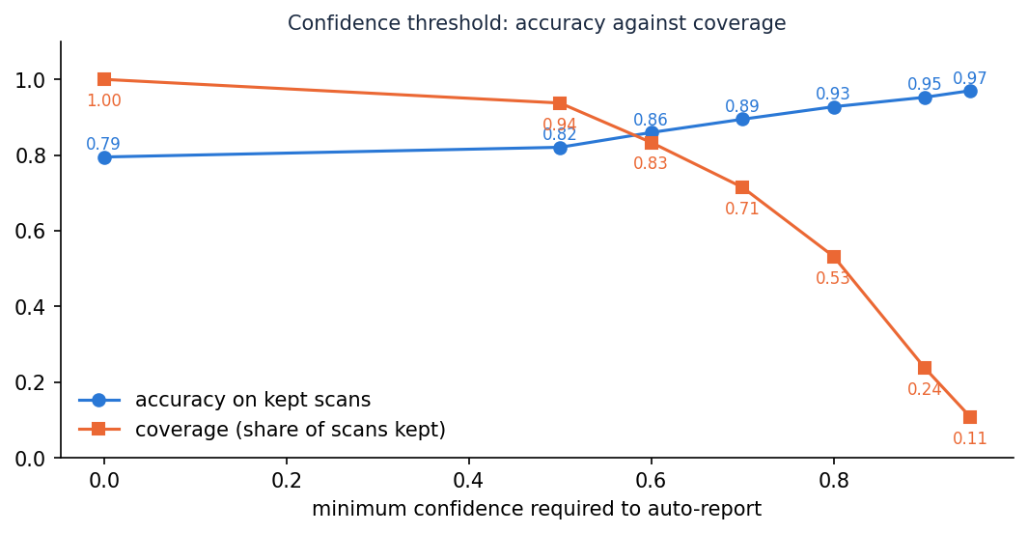
Figure 13: Accuracy on the scans kept and coverage as the minimum confidence rises
Decision threshold for pneumonia. Using the score 1 - P(Normal), sweeping the threshold moves the operating point between sensitivity and specificity. The default arg-max rule corresponds to a threshold near 0.5.
Table 8: Pneumonia decision-threshold sweep
Threshold | Sensitivity | Specificity | Accuracy
0.2 | 99.7% | 40.6% | 77.6%
0.3 | 99.7% | 47.9% | 80.3%
0.4 | 99.5% | 53.8% | 82.4%
0.5 | 99.2% | 58.1% | 83.8%
0.6 | 98.7% | 62.4% | 85.1%
0.7 | 97.4% | 67.1% | 86.1%
0.8 | 96.2% | 71.4% | 86.9%

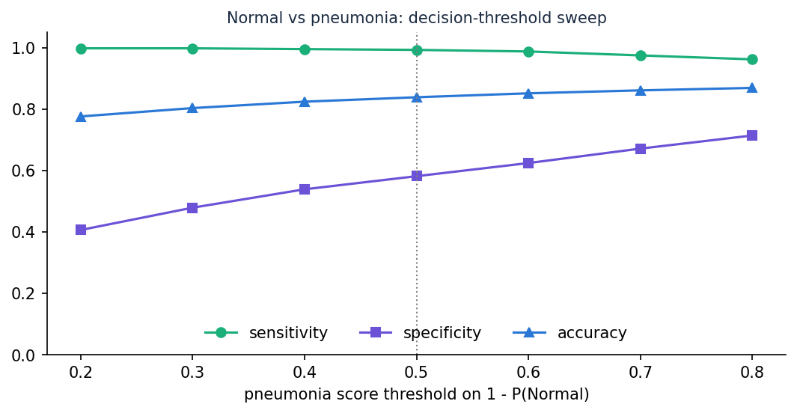
Figure 14: Sensitivity, specificity and accuracy against the pneumonia decision threshold

8.7 Comparison with the base paper
The datasets and protocols differ, so this table is context and not a ranking. The base paper's figures are taken from its text and abstract; those for this project are from Section 8.3.
Table 9: Base paper and this project
Aspect | Base paper [1] | This project
Task | Binary Normal / Pneumonia; 4-class COVID-19, Normal, Pneumonia, TB | 3-class Normal / Bacterial / Viral; binary view derived
Image source | Mendeley paediatric set (5,863 images) and a merged 7,135-image set | Same Kermany paediatric images (5,856 in the public folders)
Split | Balanced subset, 1,300 per class; 2,080 / 260 / 260 (binary) | Official imbalanced split; 4,688 / 544 / 624
Model | MobileNet family, ImageNet-pretrained; SSL with FixMatch, FlexMatch, FreeMatch | Custom CNN from scratch (590,019 parameters)
Reported accuracy | Up to 98 % (binary), 97 % (4-class); 97 % with 20 % / 30 % labels | 79.5% three-class; 84.9% Normal vs pneumonia
Explanation | Grad-CAM | Grad-CAM (on every scan, in the application)
Reliability | MC Dropout (50 passes, entropy 0.30), TTA, ECE | ECE 0.033; confidence-threshold analysis
Latency | 0.11 s per image (MobileNetV3Small) | 0.20 s per image for preprocessing, inference and Grad-CAM (CPU)
Deliverable | Research framework | Complete web application with history, dashboard and tests

Two points are worth stating plainly. First, the base paper's 97 to 98 % comes from a balanced 260-image test subset and from ImageNet-pretrained backbones; this project's 84.9% Normal-versus-pneumonia accuracy is on the official 624-image test split, which is about 62 % pneumonia, from a network trained from scratch, and three-class accuracy is a harder task. Second, studies on the same images report anywhere from 79.7 % to 98 % depending on the protocol [3], [5], [6], so a gap of several points between two papers is not evidence of a better method.

8.8 Sample inputs and outputs
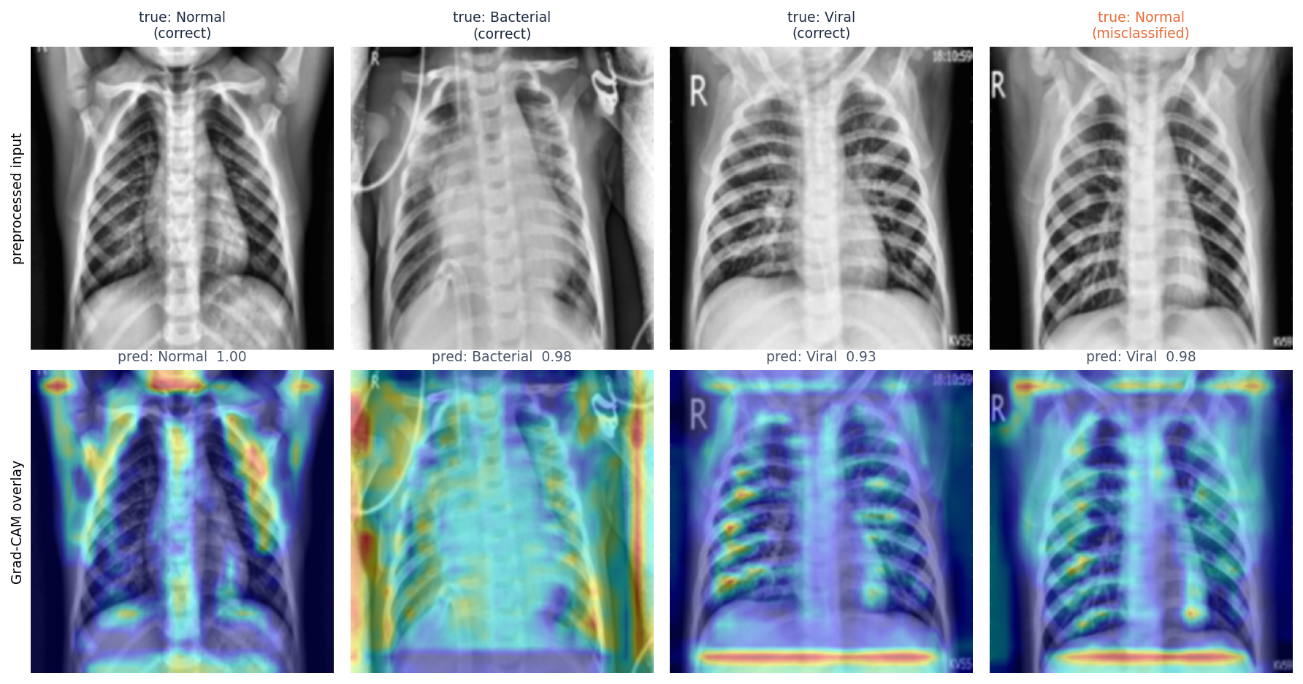
Figure 15: Grad-CAM overlays for the highest-confidence correct test image of each class and the most confident misclassification
The four public-domain sample radiographs in dataset_sample/ were sent through the running API. They come from Wikimedia Commons (not from the training data, and some are adult films), so they illustrate the interface and the output format, not accuracy. The class named in the source caption is shown for reference only; it is not a dataset label.
Table 10: Sample radiographs through the deployed API
File | Source caption | Predicted | Confidence | P(N / B / V) % | ms
normal_pa.jpg | Normal PA chest radiograph | Normal | 96.4% | 96 / 2 / 1 | 509
lobar_pneumonia.jpg | X-ray of lobar pneumonia | Bacterial Pneumonia | 53.1% | 0 / 53 / 47 | 351
influenza_pa.jpg | Chest radiograph in influenza | Bacterial Pneumonia | 63.6% | 0 / 64 / 36 | 657
bocavirus_pneumonia.jpg | Human bocavirus 1 pneumonia | Bacterial Pneumonia | 86.7% | 2 / 87 / 11 | 343

8.9 Success and failure analysis
Where it works. Pneumonia is detected as pneumonia in 98.7% of cases (5 of 390 pneumonia images were called normal) and bacterial pneumonia has a recall of 95.9%. The heat maps in the Grad-CAM figure are diffuse: in the correctly classified examples they cover parts of the lung fields but also the ribs, the shoulders, the corners and the diaphragm line, so they do not isolate a lesion.
Where it fails. The confusion counts above show the pattern:
• Normal predicted as Viral: 72 images
• Viral predicted as Bacterial: 29 images
• Normal predicted as Bacterial: 17 images
• Bacterial predicted as Viral: 5 images
In short, normal radiographs are the weak point: 72 of 234 are called viral and 17 bacterial pneumonia (specificity 62.0%), and viral precision is 0.61; confusion between the two pneumonia types is smaller (29 viral called bacterial, 5 bacterial called viral). A likely contributor, not tested here, is that the official test folder differs in distribution from the training folder; the patient-level re-partition (Section 8.4) removes most of this gap. Separating bacterial from viral pneumonia is hard in general because the two overlap on a radiograph and the pathogen label in this dataset comes from the file name, not from a re-read of the image. The most confident misclassification (last column of the Grad-CAM figure) shows that a wrong prediction can still carry a high confidence.
Why the heat maps need care. Grad-CAM shows where the network looked, not why a region matters clinically. Without segmentation the maps also highlight areas outside the lungs in some images (borders, text markers, the diaphragm line), which is a reason to treat the overlay as a prompt for inspection and not as a lesion detector.

8.10 Limitations of the results
• One data source, one seed per configuration: no confidence intervals and no repeated runs.
• Pathogen labels derive from file names and were not re-verified.
• Possible patient overlap between the official training and test folders; the id-disjoint and patient-level results are the safer reading.
• No external or prospective validation; the four sample images are illustrations.
• Probabilities are uncalibrated softmax values.

8.11 Objectives against outcomes
Table 11: Objectives of Section 1.5 and their outcome
Objective | Outcome | Evidence
1. Acquire and preprocess a dataset (resize, normalise, augment) | Achieved | Kermany data; preprocess.py; augmentation in train_experiment.py (Sections 6.2 and 6.3)
2. U-Net lung segmentation before classification | Not achieved | No segmentation network was implemented, trained or evaluated
3. Train a CNN to separate pneumonia from normal | Achieved | Three-class CNN; pneumonia sensitivity 98.7%, specificity 62.0%
4. Evaluate with accuracy, sensitivity, specificity, F1, confusion matrix | Achieved | Section 8.3, plus AUC, ECE and threshold analysis
5. Heat-map visualisation for each prediction | Achieved | Grad-CAM overlay on every scan (application and Section 8.8)
6. Deploy behind an interface with prediction, confidence and heat map | Achieved | FastAPI + React application, original Flask UI, 73 tests

