SAFEGRID-AI: AN EXPLAINABLE MULTI-AGENT SYSTEM FOR DYNAMIC POWER ROUTING
Results
Department of Computer Science and Engineering, TKR College of Engineering and Technology (Autonomous)
Batch A13 (CSE-A) · Academic year [ACADEMIC YEAR]
Table 1: Project team
S.No. | Student name | Roll number
1 | DISHA KAUSHAL | 23K91A0563
2 | BOLLAM RAKESH | 23K91A0542
3 | CHINNOLLA RAVINDHAR | 23K91A0554
4 | AFFAN MOHAMMED RAMY | 23K91A0505

Project guide: CHANDRASHEKAR
Chapter and section numbers quoted in the text (for example Section 6.6 or Chapter 8) refer to the full project report, 17.Final Document. Figures and tables in this document are numbered from 1.

CHAPTER 8: RESULTS AND OUTPUT SCREENS
This chapter shows the console with real data (Section 8.1), reports the experiment that compares three control strategies on seven scenarios (8.2 to 8.7) and interprets it, including where the shield does not help (8.8 to 8.11). Every number was produced by running this repository; none is quoted from a paper.

8.1 Application Output Screens
All screens were captured from the running application at 1440 x 900 pixels in the dark theme and show one run: scenario unsafe_ai_action, agent brain Mock LLM, seed 42, instant playback, 12 of 12 steps. The scenario injects absurd and malformed proposals so that the shield has something to do.
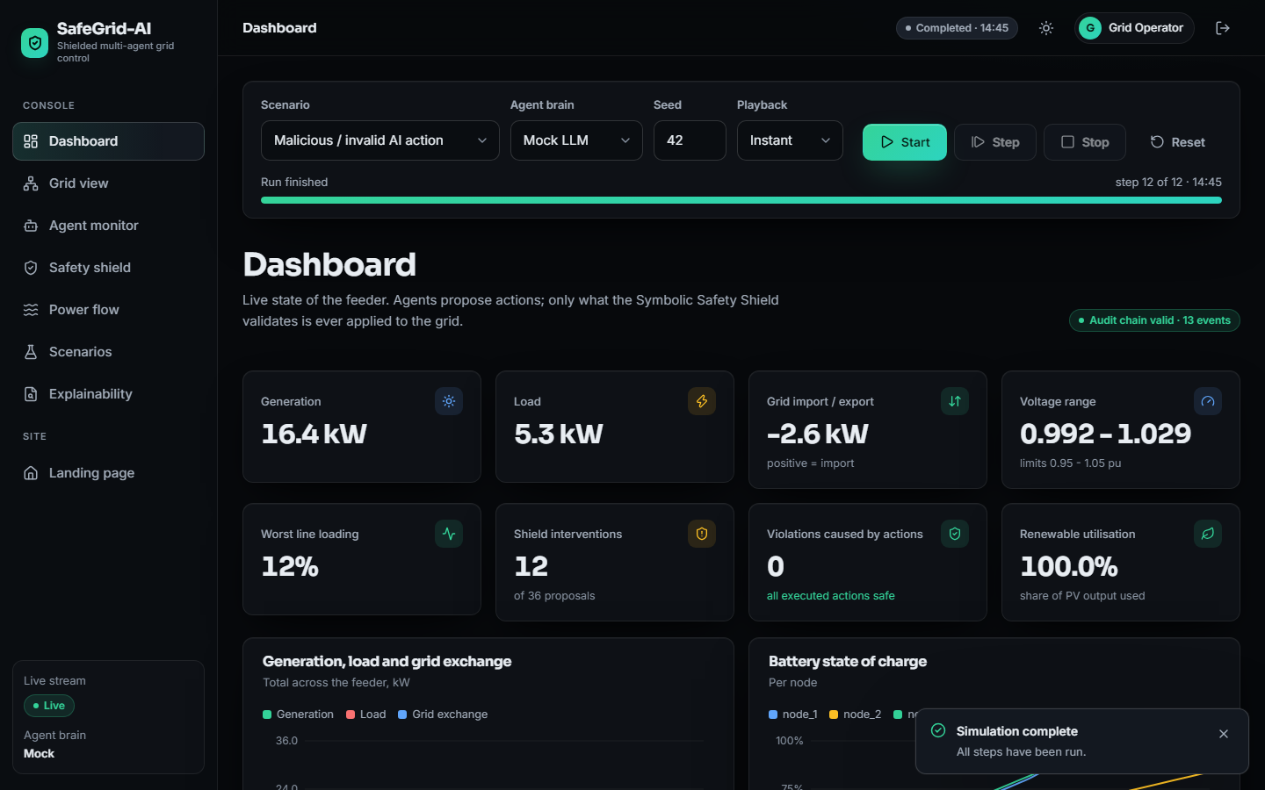
Figure 1: Dashboard after a completed run of the unsafe-action scenario
The status reads Completed 14:45 (step 12 of 12) and a badge reports Audit chain valid, 13 events. At the last step the tiles show generation 16.4 kW, load 5.3 kW, grid exchange -2.6 kW (a net export), voltage range 0.992 to 1.029 pu, worst line loading 12 %, 12 shield interventions out of 36 proposals, 0 violations caused by actions and renewable utilisation 100 %.
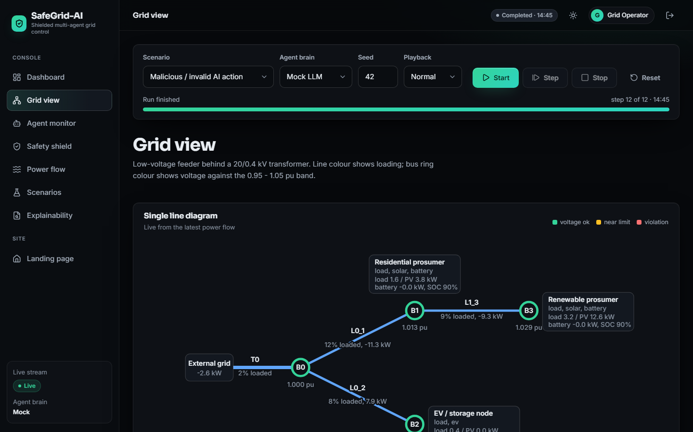
Figure 2: Grid view: single-line diagram of the feeder
The diagram is drawn from the live power-flow result: the external grid exports 2.6 kW, transformer T0 is 2 % loaded, buses B0, B1 and B3 are at 1.000, 1.013 and 1.029 pu, and lines L0_1, L1_3 and L0_2 are at 12 %, 9 % and 8 % loading. Rings and lines turn amber near a limit and red in violation; here all are green.
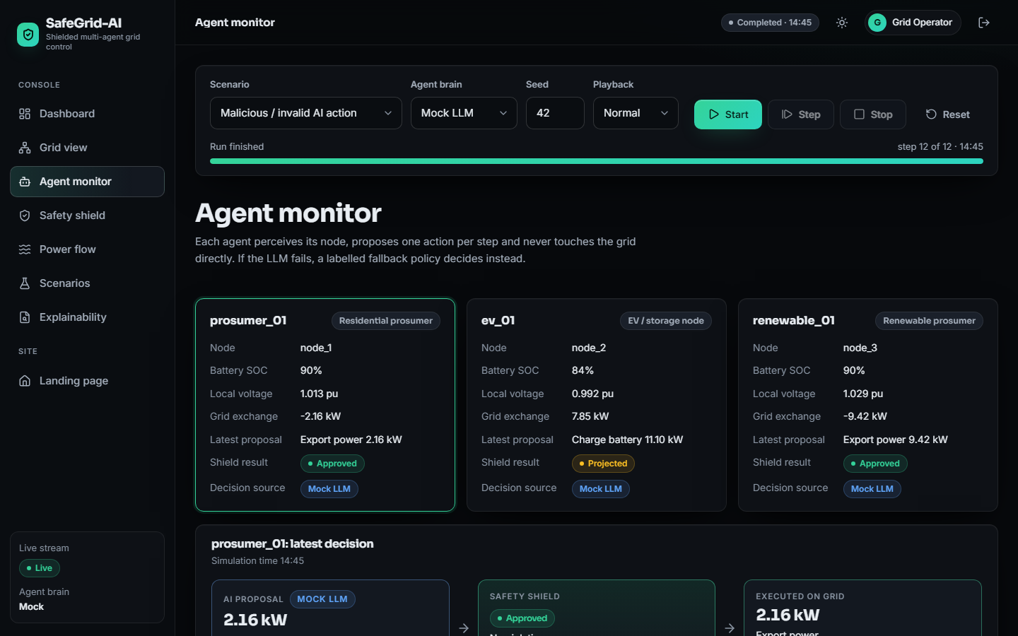
Figure 3: Agent monitor: the three agents and the latest decision
Each card reports node, state of charge, local voltage, exchange, latest proposal, shield result and decision source. prosumer_01 proposed to export 2.16 kW and renewable_01 9.42 kW, both approved; ev_01 (84 %, 0.992 pu) asked to charge at 11.10 kW and the shield marked it Projected, scaled down before execution. All three decisions came from the Mock LLM source.
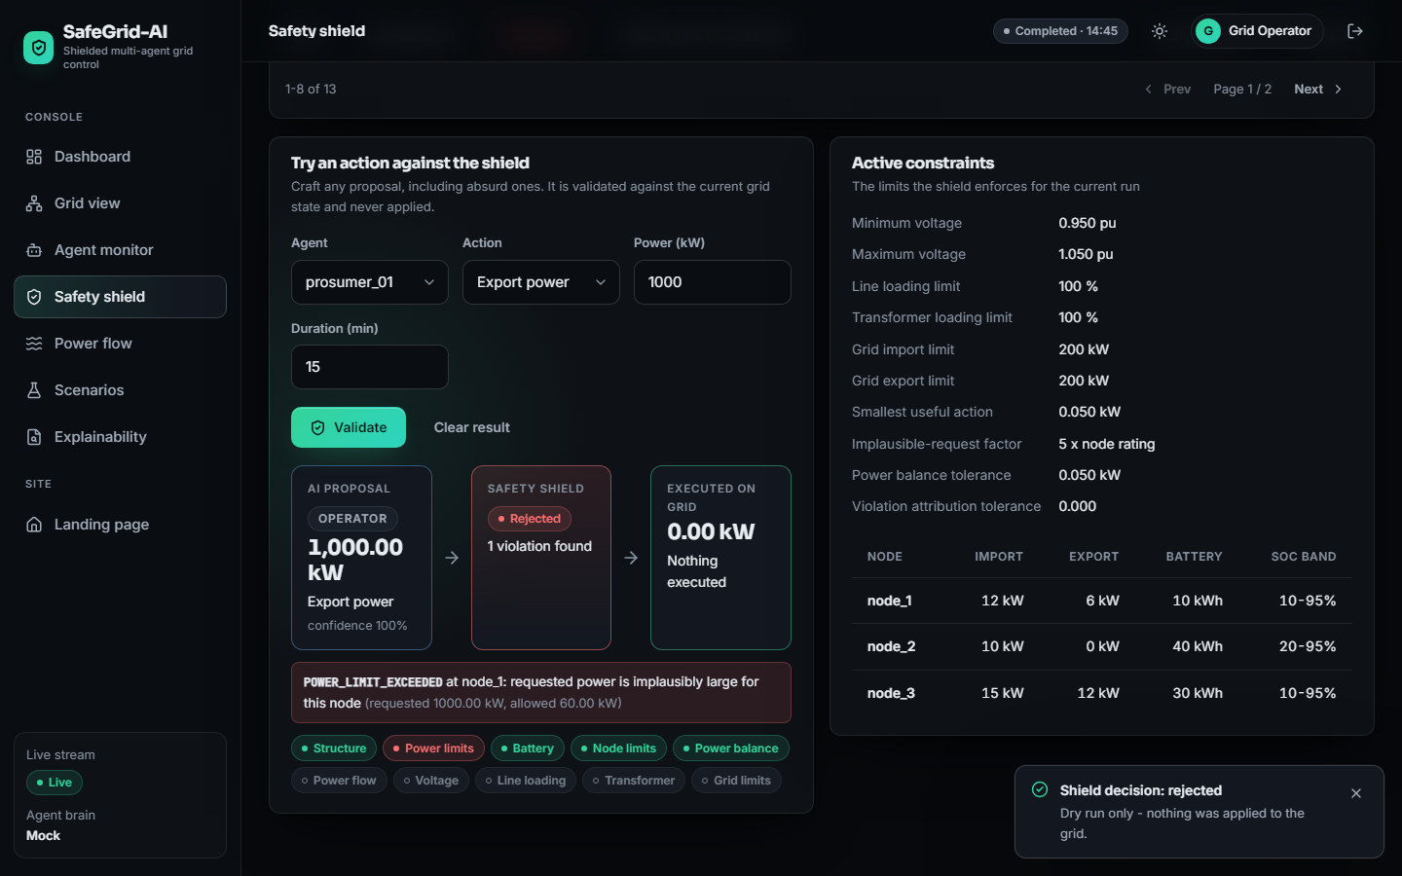
Figure 4: Safety shield: dry run of a 1,000 kW export, and the active constraints
The left panel validates any crafted action against the current grid without applying it. prosumer_01 is asked to export power 1,000 kW for 15 minutes and the shield answers Rejected: POWER_LIMIT_EXCEEDED at node_1: requested power is implausibly large for this node (requested 1000.00 kW, allowed 60.00 kW), with 0.00 kW executed. The check chips show that the power-flow-based checks were not evaluated because rejection happened earlier. The right panel lists the enforced limits: 0.950 to 1.050 pu, 100 % line and transformer loading, 200 kW grid import and export, a 0.050 kW smallest useful action and per-node import, export and state-of-charge limits.
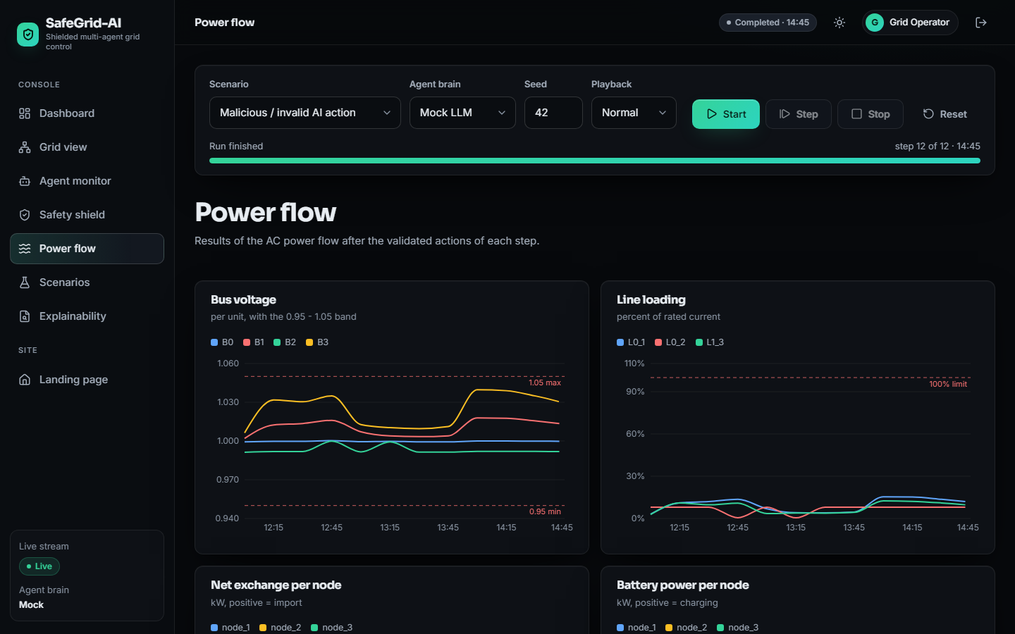
Figure 5: Power flow: bus voltages and line loadings over the run
The screen plots the AC power-flow results of the twelve steps (12:15 to 14:45): bus voltages stay between about 0.99 and 1.04 pu, inside the dashed 0.95 and 1.05 limits, and all line loadings stay below about 15 % against the 100 % limit. Six more charts follow below the capture.
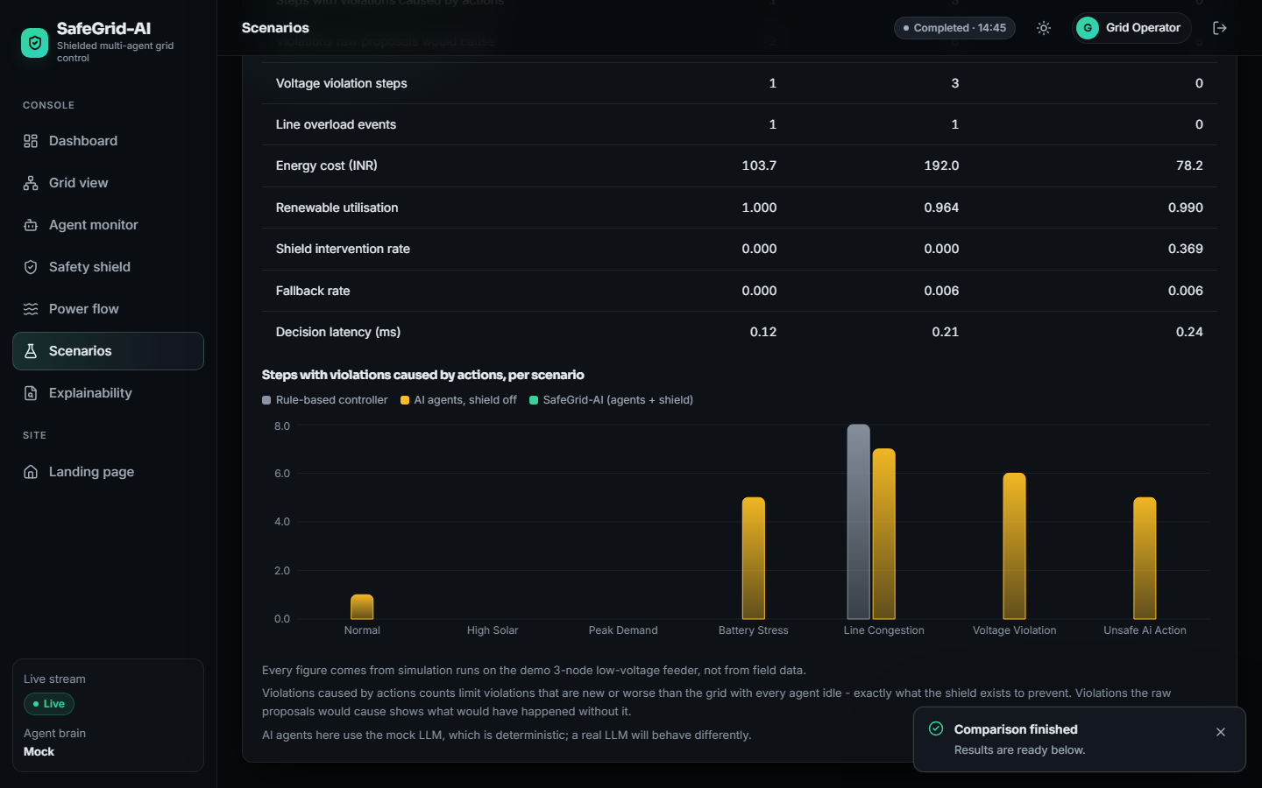
Figure 6: Scenarios: result of the strategy comparison
This capture shows a short comparison with the screen's default settings (one seed, eight steps per run), so its numbers differ from the three-seed, 24-step experiment below. For the rule baseline, the agents without the shield and SafeGrid-AI it reports voltage violation steps 1, 3 and 0, line overload events 1, 1 and 0, and energy cost 103.7, 192.0 and 78.2 INR; SafeGrid-AI's shield intervention rate is 0.369. The chart shows no violations caused by actions for SafeGrid-AI.
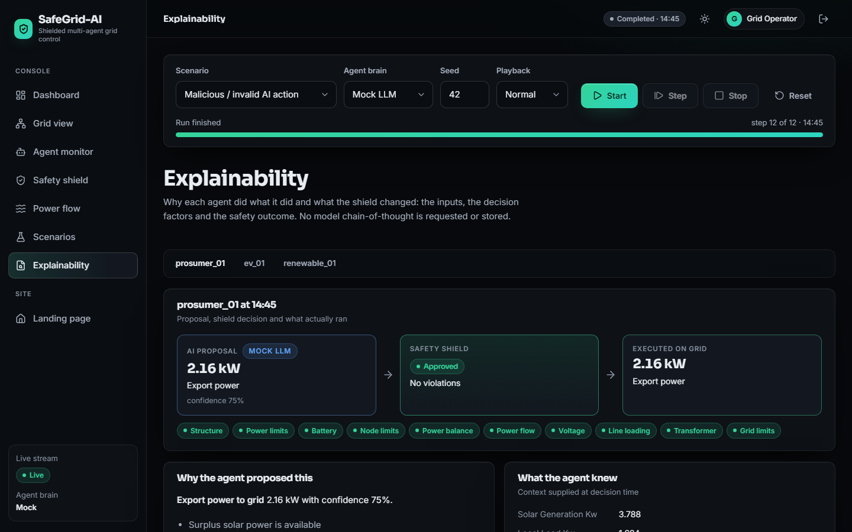
Figure 7: Explainability: proposal, shield decision and executed action for one agent
For prosumer_01 at 14:45 the screen shows the AI proposal (export power 2.16 kW, source Mock LLM, confidence 75 %), the shield decision (Approved, No violations) and the executed action (2.16 kW), ten green check chips, the factor Surplus solar power is available and the context the agent knew (for example solar 3.788 kW). No model chain-of-thought is requested or stored.

8.2 Experimental Setup
Three control strategies (arms) are compared on the three-node feeder of Chapter 5; all arms see identical inputs for a given scenario and seed.
Table 2: Experimental setup
Item | Value
Scenarios | 7: normal, high solar, peak demand, battery stress, line congestion, voltage violation, unsafe AI action
Seeds | 0, 1, 2 (three seeds per scenario and arm)
Steps per run | 24 steps of 15 minutes (6 simulated hours) in every run
Runs | 63 = 7 scenarios x 3 arms x 3 seeds; 21 runs per arm; 504 steps per arm
Arm 1: rule baseline | Non-LLM time-of-use rules, no shield, no fault injection
Arm 2: agents, no shield | Agents with the mock provider and the scenario's injected faults; proposals applied exactly as requested
Arm 3: SafeGrid-AI | Same agents and faults, every proposal validated by the Symbolic Safety Shield
Language model | Deterministic seeded mock provider in every agent run; the real-model provider was not exercised
Machine | Intel Core i5-12500 (6 cores, 12 threads), 15.7 GB RAM, Windows 11 Pro, no GPU used; the 63 runs took about ten minutes
Tariff | Illustrative time-of-use tariff of 3.8 to 9.0 INR per kWh; export credited at 60 % of the import price

Two definitions matter. A violation is caused by an action when it is new, or worse than in the same step with every agent idle; this is what the shield is designed to prevent. A step has pre-existing stress when a limit is violated even with every agent idle; the shield is not designed to remove that. Results are means over seeds. Every run uses 24 steps, longer than the native length of the shorter scenarios (12 to 16 steps), whose injected faults occur early.

8.3 Violations Caused by Executed Actions
Over 21 runs of 24 steps, SafeGrid-AI caused no violation: 0 of 504 shielded steps. The same agents without the shield caused 144 violations in 99 steps; the rule baseline, which has no safety layer either, caused 46 violations in 46 steps, all in line_congestion and peak_demand.
Table 3: Overall comparison of the three strategies (mean per run of 24 steps; 21 runs per strategy)
Metric | Rule baseline | Agents, no shield | SafeGrid-AI
Steps with violations caused by actions (of 24) | 2.19 | 4.71 | 0.00
Violations caused by actions | 2.19 | 6.86 | 0.00
Violations the raw proposals would cause | 6.05 | 8.52 | 9.14
Steps with pre-existing stress (every agent idle) | 6.33 | 6.33 | 6.33
Steps with any violation after execution | 6.05 | 6.38 | 2.48
Voltage violation steps (strict counter) | 4.33 | 4.43 | 3.14
Line overload events (strict counter) | 1.71 | 1.86 | 0.71
Transformer overload events | 0.00 | 0.14 | 0.00
Energy cost per run, INR (illustrative tariff) | 216.4 | 380.8 | 225.0
Renewable utilisation | 1.000 | 0.884 | 0.860
Battery utilisation (throughput / capacity) | 0.520 | 3.392 | 0.508
Shield intervention rate | 0.000 | 0.000 | 0.232
Fallback rate | 0.0000 | 0.0020 | 0.0020
Mean decision latency, ms (mock provider) | 0.103 | 0.160 | 0.168
Mean step time, ms | 107.9 | 106.2 | 347.8

Table 4: Steps with violations caused by actions, per scenario (mean of three seeds, of 24 steps)
Scenario | Rule baseline | Agents, no shield | SafeGrid-AI
normal | 0.00 | 1.67 | 0.00
high solar | 0.00 | 0.67 | 0.00
peak demand | 3.33 | 4.00 | 0.00
battery stress | 0.00 | 4.67 | 0.00
line congestion | 12.00 | 11.33 | 0.00
voltage violation | 0.00 | 6.33 | 0.00
unsafe ai action | 0.00 | 4.33 | 0.00
all scenarios (mean) | 2.19 | 4.71 | 0.00

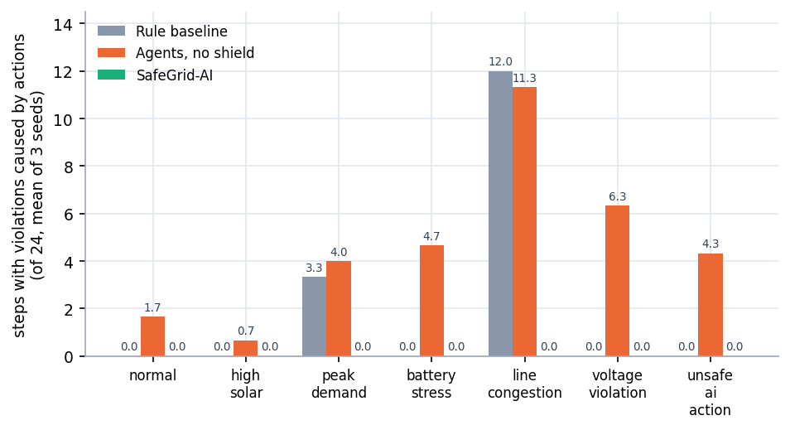
Figure 8: Steps with violations caused by actions, per scenario and strategy (mean of three seeds)
Without the shield the agents cause violations in every scenario, from 0.67 steps in high_solar to 11.33 in line_congestion; the injected faults of unsafe_ai_action give 4.33. The rule baseline is safe in five scenarios but fails in line_congestion (12.00 steps) and peak_demand (3.33): its rules charge the vehicle at the full available rate (BASELINE_UNCONTROLLED_EV_CHARGING) on a feeder with reduced ampacity. The shield brings the count to zero everywhere because it checks the consequences of an action, not its intention.
The strict counters in the overall table (voltage violation steps 3.14, line overload events 0.71) are not zero for SafeGrid-AI. They use a tighter tolerance than the shield (1e-9 pu against 1e-6 pu; 1e-6 % against 1e-4 %), and projection places a quantity exactly on its limit, so a step can be counted although the shield accepts it. The size of those excesses was not measured; the attribution counters are the primary evidence.

8.4 What the Shield Decided
Across 21 shielded runs (1,512 agent proposals) the shield approved 1,162 (76.9 %), projected 237 (15.7 %) and rejected 113 (7.5 %), and no executed action created or worsened a limit violation (0 of 504 steps), whereas the same agents without the shield did so in 99 steps (144 violations). Across the 21 runs the shield also wrote 354 safety-log events, the coordinator reported 241 conflicts, and the hash chain verified in 21 of 21 runs.
Table 5: Shield decisions per scenario, SafeGrid-AI arm (mean per run of three seeds)
Scenario | Proposals | Approved | Projected | Rejected | Raw-proposal violations | Pre-existing stress steps | Cost (INR)
normal | 72 | 59.7 | 8.7 | 3.7 | 1.7 | 0.3 | -16.7
high solar | 72 | 55.7 | 12.0 | 4.3 | 2.3 | 20.0 | -97.6
peak demand | 72 | 61.0 | 9.0 | 2.0 | 14.0 | 12.0 | 1126.4
battery stress | 72 | 52.0 | 12.0 | 8.0 | 5.3 | 3.0 | -57.0
line congestion | 72 | 45.7 | 23.0 | 3.3 | 16.0 | 0.0 | 580.8
voltage violation | 72 | 57.3 | 6.3 | 8.3 | 12.7 | 6.7 | 61.5
unsafe ai action | 72 | 56.0 | 8.0 | 8.0 | 12.0 | 2.3 | -22.7

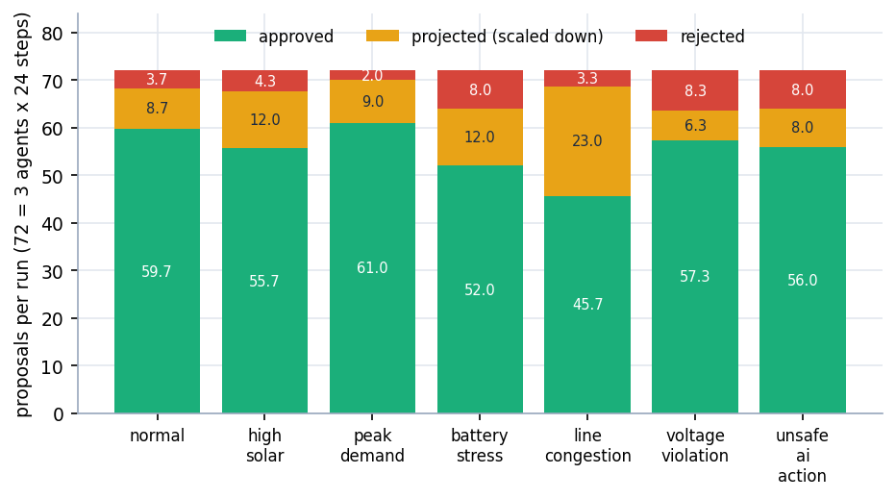
Figure 9: Approved, projected and rejected proposals per run and scenario (SafeGrid-AI arm)
The shield approved 76.9% of proposals, projected 15.7% and rejected 7.5%; the intervention rate rises from 15.3 % in peak_demand to 36.6 % in line_congestion, where almost every EV charging request has to be scaled down. The same proposals would have caused 16.0 violations per run in line_congestion and 14.0 in peak_demand without the shield. Projection is more common than rejection (237 against 113), so the shield usually keeps the agent's intent and reduces its size.

8.5 Pre-existing Grid Stress
Some violations exist even when no agent acts. The shield does not repair them by design, but relief-first ordering and projection can reduce them; the table shows the steps that still carried any violation after execution.
Table 6: Steps with any violation after execution, per scenario (mean of three seeds, of 24 steps)
Scenario | Stress with every agent idle | Rule baseline | Agents, no shield | SafeGrid-AI
normal | 0.3 | 0.3 | 1.7 | 0.0
high solar | 20.0 | 16.7 | 2.7 | 1.7
peak demand | 12.0 | 7.3 | 13.7 | 8.7
battery stress | 3.0 | 0.0 | 4.7 | 1.7
line congestion | 0.0 | 12.0 | 11.3 | 0.0
voltage violation | 6.7 | 6.0 | 6.3 | 4.3
unsafe ai action | 2.3 | 0.0 | 4.3 | 1.0
all scenarios (mean) | 6.33 | 6.05 | 6.38 | 2.48

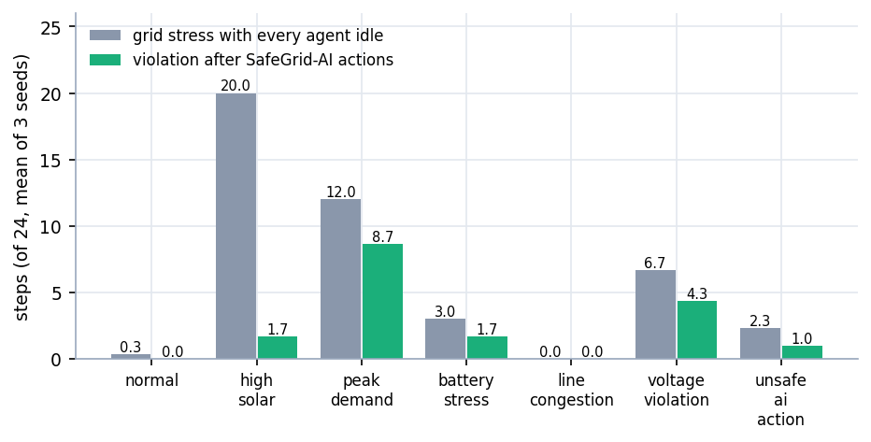
Figure 10: Grid stress with every agent idle compared with violations after SafeGrid-AI actions
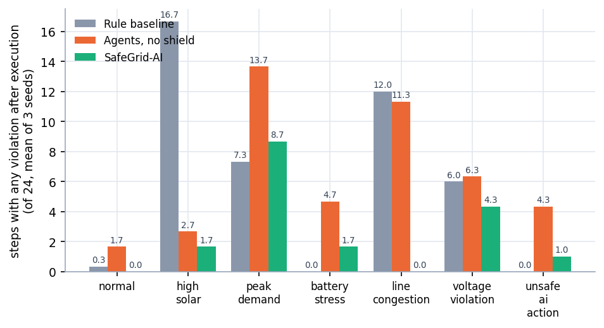
Figure 11: Steps with any violation after execution, per scenario and strategy
Averaged over scenarios, 6.05 steps per run carry a violation under the rule baseline, 6.38 without the shield and 2.48 with SafeGrid-AI, against 6.33 steps of stress with every agent idle. The reduction comes mostly from high_solar (20.0 stress steps with everyone idle, 1.7 after SafeGrid-AI), where the agents absorb surplus solar in their batteries; removing violations was not the shield's guarantee, and Section 8.8 shows where the gain does not appear.

8.6 Cost of Safety
A safety layer is not free; the table and figures show the trade-offs.
Table 7: Energy cost per run (INR, illustrative tariff) and renewable utilisation, per scenario
Scenario | Cost: rule | Cost: no shield | Cost: SafeGrid | RU: rule | RU: no shield | RU: SafeGrid
normal | -108.7 | -6.7 | -16.7 | 1.000 | 0.794 | 0.765
high solar | -267.6 | -56.6 | -97.6 | 1.000 | 0.554 | 0.607
peak demand | 1285.0 | 1197.5 | 1126.4 | 1.000 | 1.000 | 1.000
battery stress | -53.1 | -35.1 | -57.0 | 1.000 | 1.000 | 1.000
line congestion | 664.9 | 633.3 | 580.8 | n/a | n/a | n/a
voltage violation | 29.6 | 47.4 | 61.5 | 1.000 | 0.959 | 0.787
unsafe ai action | -35.4 | 885.8 | -22.7 | 1.000 | 1.000 | 1.000

RU is renewable utilisation (the share of available solar output that was used); it is not defined in line_congestion, which has no available solar generation, and is printed as n/a.
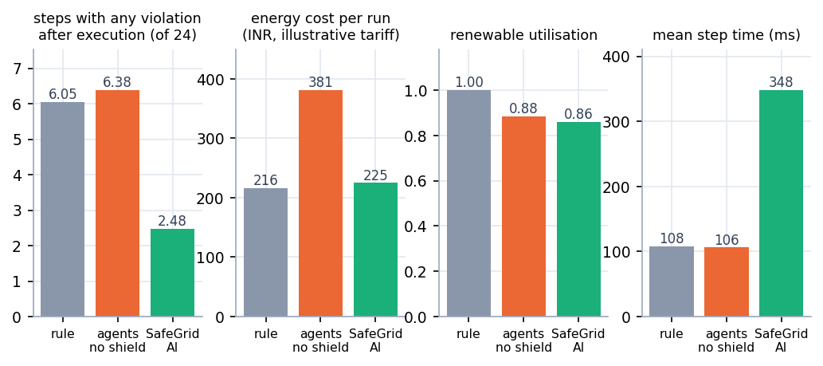
Figure 12: Overall comparison: violations after execution, cost, renewable utilisation and step time
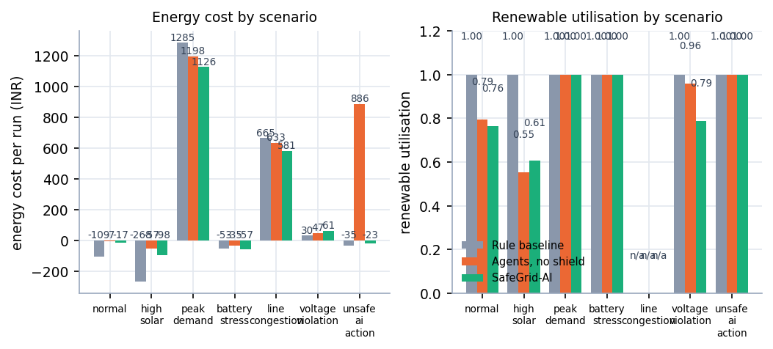
Figure 13: Energy cost and renewable utilisation per scenario
• Cost. Mean cost per run is 225.0 INR with the shield, 380.8 without it and 216.4 for the rule baseline. The unshielded agents are dear mainly because of unsafe_ai_action, where an injected 900 kW import raises the cost to about 886 INR per run against -22.7 with the shield. SafeGrid-AI is slightly dearer than the rule baseline overall but cheaper in peak_demand and line_congestion.
• Renewable utilisation. The rule baseline uses all available solar; the shielded arm uses 0.860. The cost shows in high_solar (0.607) and voltage_violation (0.787), where the shield limits export to protect voltage; unshielded agents do worse in high_solar (0.554).
• Battery use. Throughput divided by capacity is 0.508 with the shield, 0.520 for the rule baseline and 3.392 for the unshielded agents, dominated by unsafe_ai_action (18.8 times capacity per run).
• Compute. Mean step time rises from about 106 ms to 348 ms, with 834 ms in line_congestion, where nearly every proposal needs bisection. The mock provider's 0.17 ms decision latency is meaningless for a real model.

8.7 Single-Run Traces
Three single runs (seed 42, native length, shield on and off) show what the averages hide.
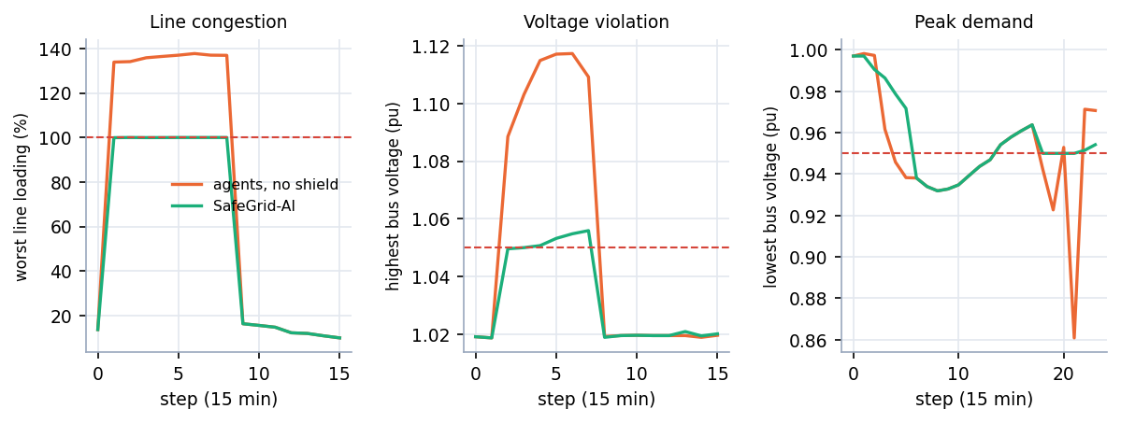
Figure 14: Single-run traces with and without the shield: line loading, highest bus voltage and lowest bus voltage
Table 8: Worst values in the three traced runs
Scenario | Quantity | Agents, no shield | SafeGrid-AI | Limit
line congestion | worst line loading | 137.7 % | 100.0 % | 100 %
voltage violation | highest bus voltage | 1.117 pu | 1.056 pu | 1.05 pu
peak demand | lowest bus voltage | 0.861 pu | 0.932 pu | 0.95 pu

In line_congestion the unshielded agents drive the feeder to 137.7 % of its rating for eight steps; with the shield the loading is projected exactly onto the 100 % limit and never above it. In voltage_violation the voltage climbs to 1.117 pu without the shield and peaks at 1.056 pu with it, still above 1.05 pu because the scenario's weak feeder is already out of band when the agents are idle. In peak_demand the lowest voltage is 0.861 pu without the shield and 0.932 pu with it, still below 0.95 pu because the evening peak itself is the stressor. The shield removes the excess that actions add and leaves the stress that the scenario creates.

8.8 Analysis of Successful and Failure Cases

Where the shield works
• Agent faults. In unsafe_ai_action the unshielded agents cause violations in 4.33 steps per run and the shielded agents in none. The 1,000 kW export and the 900 kW import are rejected; a malformed output becomes a labelled fallback decision that is shielded like any other.
• Congestion by a non-AI controller. The rule baseline causes violations in 12.00 of 24 steps in line_congestion. The shielded agents face the same congested feeder and cause none. No arm combines the rule controller with the shield, so that pairing is not claimed.
• Plausible-but-oversized requests. About one proposal in six is projected, not rejected: the agent wanted the right thing at the wrong size, and the shield returns the largest safe part of it.

Where it does not help, or helps less
• Pre-existing stress remains. high_solar has 20.0 stress steps out of 24 with every agent idle, and peak_demand has 12.0; after SafeGrid-AI actions peak_demand still shows 8.67 steps with a violation.
• A rule controller can leave fewer violations in peak demand. Steps with any violation after execution in peak_demand are 7.33 for the rule baseline, 8.67 for SafeGrid-AI and 13.67 without the shield. The shield prevents harm but does not search for relief; this is a real limitation of a veto-style layer and the reason future work proposes a planner rewarded for resolving violations.
• Renewable energy is sometimes given up. Utilisation falls to 0.607 in high_solar and 0.787 in voltage_violation.
• Strict counters are not zero (3.14 and 0.71), for the tolerance reason in Section 8.3, and everything depends on the model: the shield is only as good as the simulated grid it asks.

8.9 Discussion of Limitations
The results support one limited claim: in this simulator, under these scenarios, with a deterministic stand-in for a language model, validating every action with an AC power flow prevents all new or worsened limit violations, at the cost of some renewable energy and about three times the compute per step. The limits of the evidence are:
• Every agent result comes from the deterministic mock provider; no live language model was evaluated, so language-model reasoning quality and real inference latency are unmeasured.
• The batch objective 'violation resolution rate' was not measured; the project measures violations prevented (caused by actions = 0) and steps with any violation, not repair of a grid that is already outside its limits.
• Mean decision latency is 0.1-0.2 ms for the mock provider and says nothing about a real model.
• Three seeds, a three-node synthetic feeder, an illustrative tariff, no protection, no dynamics and no three-phase unbalance.
• The guarantee is model-relative (no new or worse violations in the simulated model), not a formal proof; the abstract's 'mathematically guaranteeing zero physical constraint violations' is stronger than what was built and tested.
• The comparison with the base paper is qualitative: different system, no shared benchmark, no like-for-like numbers.
• Two unit tests fail on numeric tolerances with pandapower 3.5.6 and one WebSocket test hangs under the installed Starlette test client.
• No user study was carried out, so usability and operator trust are not measured.
Three seeds do not support confidence intervals, and means over scenarios mix very different situations, so the per-scenario tables are more informative than the overall one.

8.10 Objectives versus Outcomes
Table 9: Objectives of the project and what was delivered
Objective | Status | Evidence
1. Multi-agent grid model | Achieved | Three agents (prosumer, EV storage, renewable prosumer) on a 3-node pandapower feeder; a coordinator detects peer mismatch, target contention and shared-feeder conflicts.
2. LLM planning agent | Achieved with a mock model | Agents build a structured context and obtain a schema-validated EnergyAction from a provider. A real-LLM provider (Anthropic / OpenAI wire format) is implemented but was not run against a live model; all measured results use the deterministic mock provider.
3. Safety shielding | Achieved | Symbolic Safety Shield with ten ordered checks and bisection projection: 0 violations caused by executed actions in all 504 shielded steps (1,512 proposals).
4. Explanations | Achieved | Every decision carries inputs, decision factors, the action, the safety result and a reason code list; no chain-of-thought is requested or stored (tested).
5. Fault and overload scenarios | Achieved | Seven seeded scenarios, including injected unsafe and malformed proposals; the shield rejected or scaled down 350 of 1,512 proposals.
6. Evaluation metrics | Partly achieved | Unsafe actions blocked (113 rejected, 237 projected) and decision latency were measured. A violation-resolution rate for pre-existing violations was not measured: the project measures violations prevented, not violations repaired.

8.11 Comparison with the Base Paper
The base paper [1] designs a rule-based multi-agent energy management system for a DC microgrid and validates it in MATLAB/Simulink in eight scenarios. SafeGrid-AI differs in the system modelled, in how decisions are made and in what is measured, so no numeric comparison is possible or attempted. Grid-Agent [2] is closer in spirit, but its safety rests on sandboxed execution with rollback and its results are success rates on IEEE and CIGRE networks, on which this project did not run. The table compares design and evidence qualitatively.
Table 10: SafeGrid-AI compared with the base paper (qualitative)
Aspect | Base paper [1] | SafeGrid-AI
System modelled | DC microgrid, 800 V bus, MATLAB/Simulink | Three-node AC low-voltage feeder, pandapower AC power flow
Decision makers | Four rule-based agents | Three agents driven by a pluggable LLM provider (mock in all measurements), with a deterministic fallback
Safety mechanism | Control logic keeps the bus voltage regulated; no separate validation layer | Independent Symbolic Safety Shield: approve, project or reject every action before it is executed
Explanation | None reported | Structured explanation per decision, hash-chained audit log, dashboard views
Evidence | Eight Simulink scenarios, bus voltage regulated at 800 V | Seven scenarios x 3 strategies x 3 seeds (63 runs): 0 violations caused by executed actions in 504 shielded steps
Validation reached | Simulation only; authors note the lack of experimental validation | Simulation only; synthetic profiles; mock LLM; no field data

It supports the gap stated in the batch survey: an independent, deterministic safety layer with explanations and an audit trail is what this project adds and measures, within the limits above.

