Department of Computer Science and Engineering (Data Science)
CSDS-A | Batch A2 (CSE - Data Science, Section A)
Attendance Magic: A Smart Geo-Fenced Attendance System with Live Challenge Verification
(Attendance Magic)
S.No. | Student name | Roll / hall ticket no.
1 | A.GREESHMA | 23K91A6706
2 | B.VINAY | 23K91A6740
3 | G.SRIRAM | 23K91A6757
4 | B.SAI KUMAR | 24K95A6704
Under the guidance of: [GUIDE NAME], [DESIGNATION]
RESULTS
This document reports the real results of the project: the evaluation of the verification chain (identity, duplicate, liveness, geo-fence and latency), the attack tests, every output screen with a caption, the success and failure cases, and the objectives measured against the outcomes. No model is trained in this project, so there are no training curves; the pre-trained components are evaluated as they are used, on the public LFW benchmark, and no human-subject or field trial was carried out.

1 Performance of the Verification Chain
Because nothing is trained, the usual learning curves do not exist. The chain is evaluated by measuring each decision on public images and, for liveness, by attacking it. All figures come from the scripts in scripts/eval_*.py; their raw output is in docs/evaluation/.

1.1 Identity and duplicate thresholds (LFW verification protocol)
The standard LFW protocol has 6,000 pairs (3,000 same-person and 3,000 different-person). The product's own embed() rejected 1,208 of the 7,701 images used (15.7%; 1,197 as 'more than one face', 11 as 'no face'), which removed 1,693 pairs and left 4,307 scored pairs: 2,141 same-person and 2,166 different-person. Same-person similarity has a mean of 0.673 (SD 0.107, 5th percentile 0.494); different-person similarity has a mean of 0.004 (SD 0.058) and a maximum of 0.246.
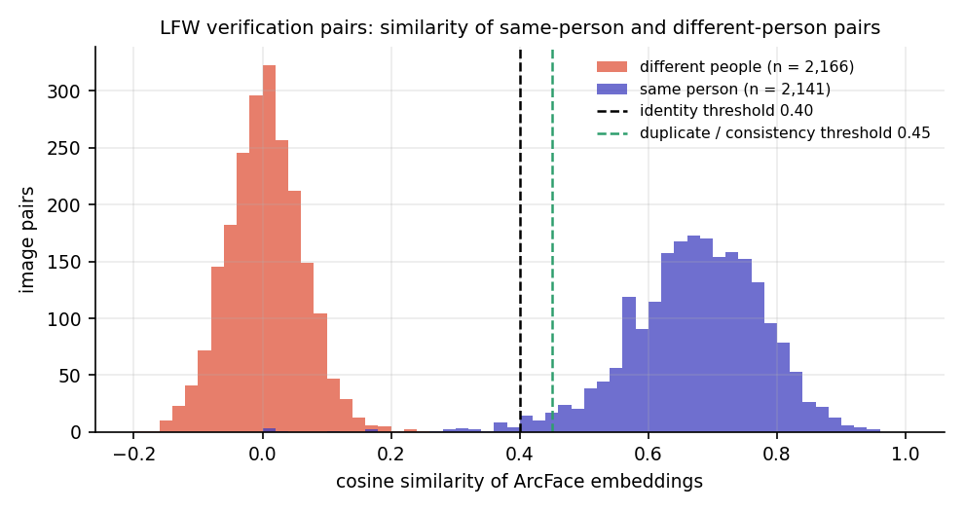
Fig. 1: Cosine similarity of same-person and different-person LFW pairs with the two deployed thresholds
Table 1: Behaviour of the similarity threshold on LFW (4,307 scored pairs)
Threshold | Same person accepted | Same person rejected | Different person accepted | Pair accuracy
0.20 | 99.67% | 0.33% | 0.18% | 99.74%
0.30 | 99.53% | 0.47% | 0.00% | 99.77%
0.35 | 99.30% | 0.70% | 0.00% | 99.65%
0.40 (identity) | 98.69% | 1.31% | 0.00% | 99.35%
0.45 (duplicate) | 97.15% | 2.85% | 0.00% | 98.58%
0.50 | 94.72% | 5.28% | 0.00% | 97.38%
0.60 | 78.47% | 21.53% | 0.00% | 89.30%

The area under the ROC curve is 0.9992. The equal error rate is 0.30% at a threshold of 0.19; the best single threshold on this data is 0.25 with 99.84% accuracy; the 10-fold protocol gives 99.82% (SD 0.22%). The deployed identity threshold of 0.40 accepts 98.7% of same-person pairs and none of the 2,166 different-person pairs, because the highest different-person similarity (0.246) is far below 0.40. The duplicate threshold of 0.45 flags 97.2% of same-person pairs as the same face; the remaining 2.8% would pass undetected when a person is photographed under very different conditions, which is the false-negative cost of a conservative threshold. The deployed thresholds therefore lie above the equal-error point and trade a small number of retakes for margin against look-alikes.
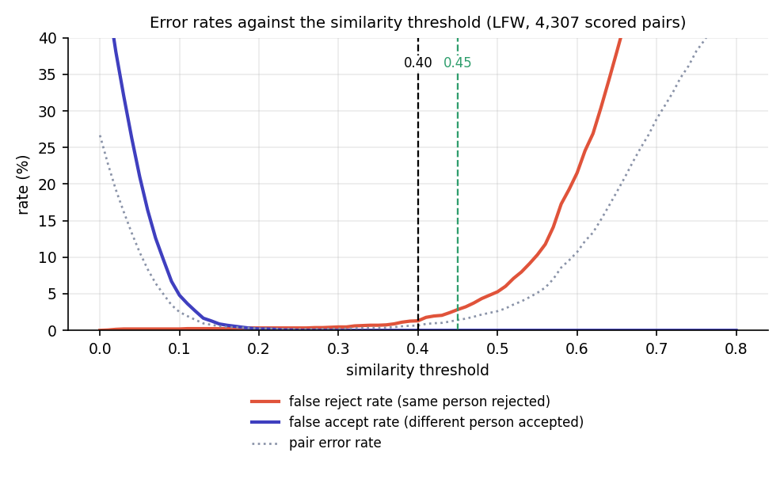
Fig. 2: False reject and false accept rates against the similarity threshold

1.2 Liveness challenge
Neutral frame. Of 1,000 random LFW photographs, 329 (32.9%) satisfied the neutral-frame rule; the others were not frontal (499), had several faces (92), an open mouth (79) or no face (1). These are press photographs taken for other purposes, so the figure says how strict the rule is, not how often students will pass it.
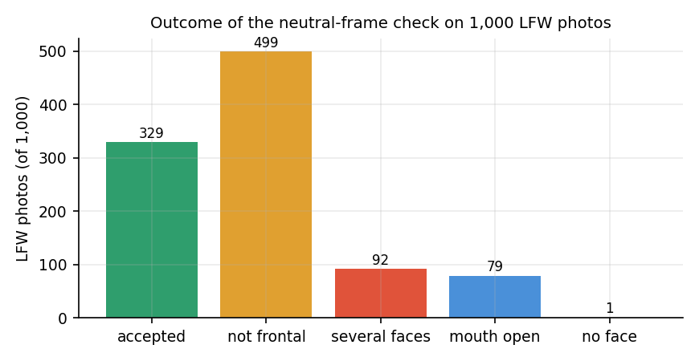
Fig. 3: Outcome of the neutral-frame check on 1,000 LFW photographs
Static replay. When the same photograph is submitted as both the neutral and the challenge frame (329 accepted neutral frames), none passes any head, tilt or mouth challenge. Close-eyes is the exception: 27 of 329 (8.2%) pass because the photograph already shows closed eyes (EAR at or below 0.18).

1.3 Attacks on the liveness check
Rotated photograph. Rotating a single photograph on screen by a signed angle changes the measured roll by exactly that angle. Rotations within 10 degrees pass neither tilt challenge; at 12 degrees (the threshold) about half pass; from 15 degrees the matching tilt challenge is passed by 98-99% of the 300 photographs. A student who holds a phone showing a photograph at a tilt can therefore pass a tilt challenge. The two tilt challenges are two of the eight random challenges.
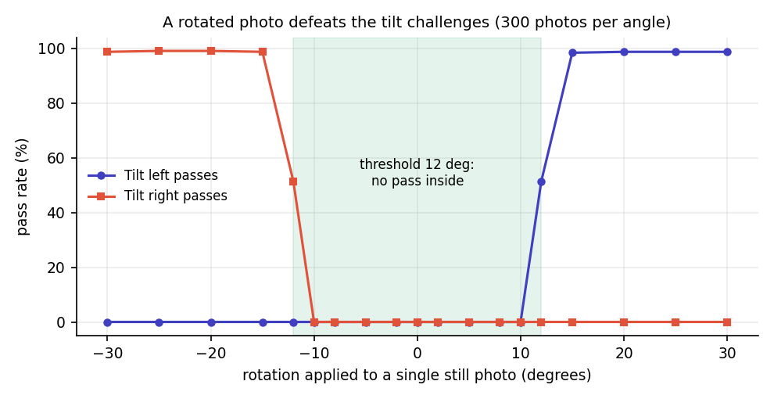
Fig. 4: Pass rate of the tilt challenges when one photograph is rotated
Photo bank. An attacker who owns several real photographs of the victim in different poses can pick the pair that fits the issued challenge. On the 154 LFW identities with at least 10 photographs (one photograph held out as the enrolled reference; up to five neutral candidates tried), the full chain (challenge, frame consistency at least 0.45 and identity at least 0.40) is passed as follows:
Table 2: Share of spoofing attempts that pass each challenge
Challenge | Static replay | Photo bank: liveness only | Photo bank: full chain
Turn left | 0.0% | 98.7% | 95.5%
Turn right | 0.0% | 97.4% | 94.2%
Look up | 0.0% | 83.1% | 79.9%
Look down | 0.0% | 77.9% | 72.7%
Tilt left | 0.0% | 73.4% | 70.1%
Tilt right | 0.0% | 73.4% | 69.5%
Open mouth | 0.0% | 50.6% | 48.7%
Close eyes | 8.2% | 56.5% | 52.6%

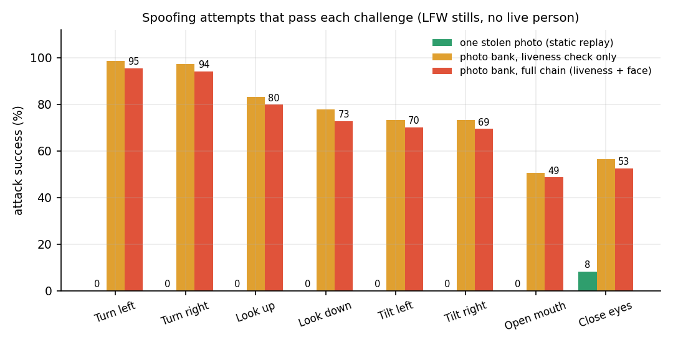
Fig. 5: Spoofing attempts that pass each challenge: a stolen photograph, and a bank of photographs
The result is mixed and is stated as such. The random challenge stops a single stolen photograph for seven of the eight actions. It does not stop an attacker who has collected several photographs of the victim: head-turn challenges are passed by about 94-96% of such attackers, mouth and eye challenges by about half. LFW identities with ten or more photographs are public figures with large photo collections, so these rates are an upper bound for ordinary students, but social media photographs make the scenario realistic. The attacker still has to be inside the geo-fence, use the victim's registered device and appear before the session closes; the system gives three tries and a fresh random challenge each time, so an attacker with a limited bank succeeds with a probability that depends on the draw.

1.4 Geo-fence
The spherical haversine distance differs from the ellipsoidal Vincenty distance by a constant 0.469% at latitude 17.385 degrees: 0.35 m at 75 m, 2.3 m at 500 m and 4.7 m at 1 km. A boundary sweep with a 60 m radius and 15 m tolerance accepts every point up to and including 75 m and rejects from 80 m (steps of 5 m); a fix with a reported accuracy of 150 m is accepted and one of 151 m is rejected.
GPS noise matters far more than the formula. A simulation (isotropic Gaussian error with standard deviation sigma per axis, 20,000 trials per point; an assumed model, not a field measurement) gives the probability that a student at a true distance is accepted:
Table 3: Simulated acceptance probability against GPS error
GPS error sigma | At 40 m | At 60 m | At 100 m | At 150 m
3 m | 100.0% | 100.0% | 0.0% | 0.0%
5 m | 100.0% | 99.9% | 0.0% | 0.0%
10 m | 100.0% | 92.3% | 0.5% | 0.0%
20 m | 94.2% | 72.3% | 8.5% | 0.0%
30 m | 80.8% | 60.0% | 15.7% | 0.3%

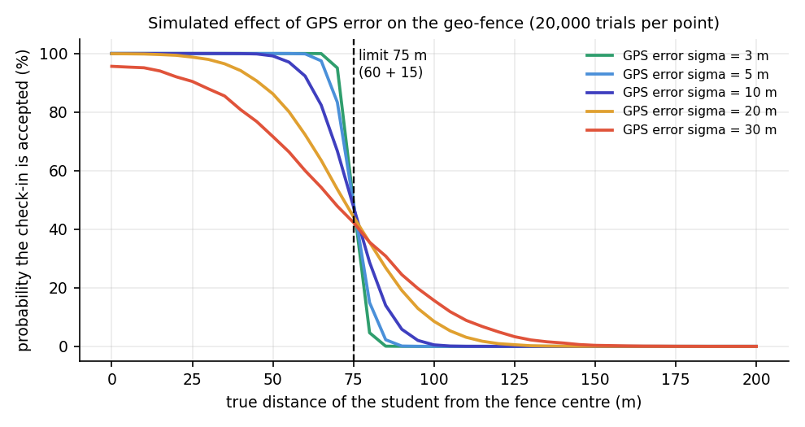
Fig. 6: Simulated probability of acceptance against true distance for several GPS error magnitudes
With errors of 10 m or less a student standing 60 m from the centre is accepted about 92% of the time or more, and one 100 m away is almost never accepted; with 30 m errors, typical of indoor reception, 40% of students at 60 m would be rejected and 16% at 100 m accepted. Faculty should set the radius with the building and the expected GPS quality in mind. Real phone GPS error was not measured.

2 Application Results
Table 4: Application results
Item | Result
Automated tests | 23 pytest tests passed; 41 of 41 API smoke checks passed
Endpoints / tables / pages | 27 REST endpoints, 5 database tables, 12 React routes
Code size | core/ 1,229 lines, backend 626, Streamlit UI 581, tests 353, React source about 4,470 lines
Check-in time (server, median) | 564 ms (806 ms at the 95th percentile)
Production build | Vite build in 23 s; largest chunk 581 kB (194 kB gzipped)
Demo run (UI) | Session CS601: 4 present, 4 blocked attempts; session CS604: 3 present of 5 expected, 7 blocked attempts, 30 checks logged
Identity similarities in the demo | 0.856, 0.628 and 0.593 for three students (different photographs of each person)

3 Functional Testing
Each functional requirement of Section 4.3 was exercised by at least one automated check or one of the scripted scenarios below. The scenarios were run with demo_pipeline.py (service layer), the smoke test (HTTP) and the UI walkthrough (browser).
Table 5: Functional scenarios
Scenario | Expected | Observed
Genuine student, inside the fence, right challenge | Attendance recorded | Recorded (distance 7.7 m, liveness 1.00)
Same student again | Blocked at eligibility | 'Attendance already marked for this session.'
Student 556 m away | Blocked at location | 'Outside geo-fence: you are 556 m away, limit is 75 m.'
Static photo for OPEN_MOUTH | Blocked at liveness | 'Mouth open ratio: measured 0.073, required 0.350'
Another person's face under this roll number | Blocked at identity | 'Face does not match ... similarity 0.02, required >= 0.40'
Same face under a second roll number | Blocked as duplicate | 'This face has already marked attendance in this session as 23K91A6706 (similarity 1.00)'
Roll number not on the list | Blocked at eligibility | 'Roll number 99X99X9999 is not allowed in this session.'
Second device for the same student | Blocked at eligibility | 'This device is not registered to your account.'
Three failed challenges | Wizard locked | 'Check-in locked after repeated failed liveness challenges'
Closed session | Refused | 'This session was closed by the faculty.'

In the demo pipeline the same photograph is used for enrolment and check-in, so the identity similarity is 1.00 there; with different photographs of one person (the UI walkthrough, using LFW images) the identity similarities were 0.59, 0.63 and 0.86.

4 Performance Testing
Measurements were made on an Intel Core i5-12500 (6 cores, 12 threads, 15.7 GB RAM) running Windows 11 with Python 3.11.9, CPU only. Other desktop applications were running; a run made while the CPU was at about 100% from other processes gave an embedding median of 277 ms instead of 176 ms, so the figures below should be read as typical rather than best case. Network time is excluded because the HTTP test uses an in-process client.
Table 6: Performance measurements
Stage (median / 95th percentile, ms) | Value
Model load at start: MediaPipe / InsightFace | 812 / 1547 (single load)
JPEG decode and resize (1280 x 886) | 4.8 / 8.5
MediaPipe landmarks, one photo | 6.8 / 8.8
Challenge decision | 0.004 / 0.006
InsightFace embedding, one photo | 176 / 244
Face decision with 30 session faces | 0.38 / 0.56
AI work for one check-in (2 landmark + 2 embedding passes) | 368 / 525
HTTP: login (PBKDF2) | 106 / 123
HTTP: eligibility / location | 13 / 15 and 8 / 10
HTTP: liveness (two uploads) | 23 / 27
HTTP: face match and record | 521 / 759
HTTP: complete check-in after login | 564 / 806 (40 runs)

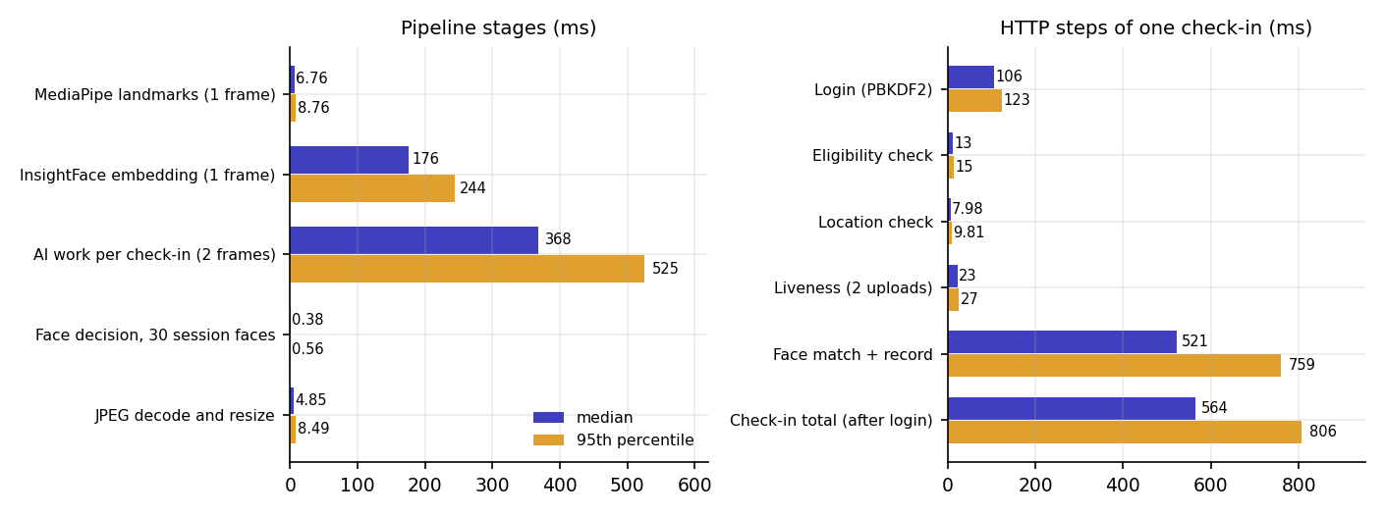
Fig. 7: Latency of the pipeline stages and of the HTTP steps of one check-in (median and 95th percentile)
The duplicate scan is a linear loop over the embeddings already recorded in the session. It took 0.14 ms for 10 faces, 1.15 ms for 100, 11.9 ms for 1,000 and 41 ms for 5,000, so a lecture-sized session adds no noticeable time.
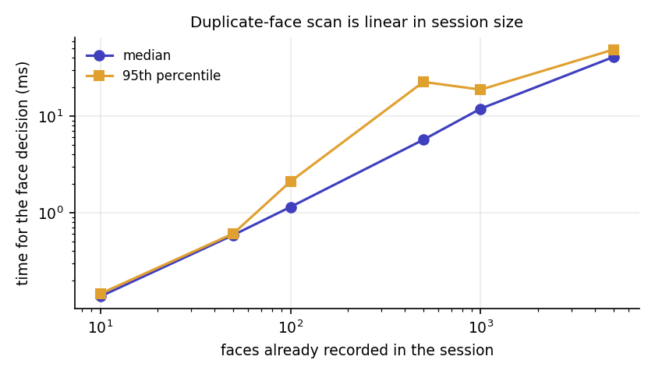
Fig. 8: Time of the duplicate-face scan against the number of faces recorded in the session
Not measured: concurrent users (a single uvicorn process serialises model inference behind a lock), memory use, other hardware, mobile network latency.

5 Output Screens
All screens below are real captures of the running application at a width of 1440 px with demo data in it: two sessions, a closed one with four students present and a live one with three present and seven blocked attempts. Face photographs are public LFW images used as stand-ins for student photographs (their file names were anonymised) because the project holds no student photographs and no camera was attached; camera capture was replaced by the application's own Upload photo tab. Nothing is mocked up.
The public front page with the Student check-in and Faculty actions and live statistics read from /api/stats (sessions, check-ins, blocked attempts, students enrolled).
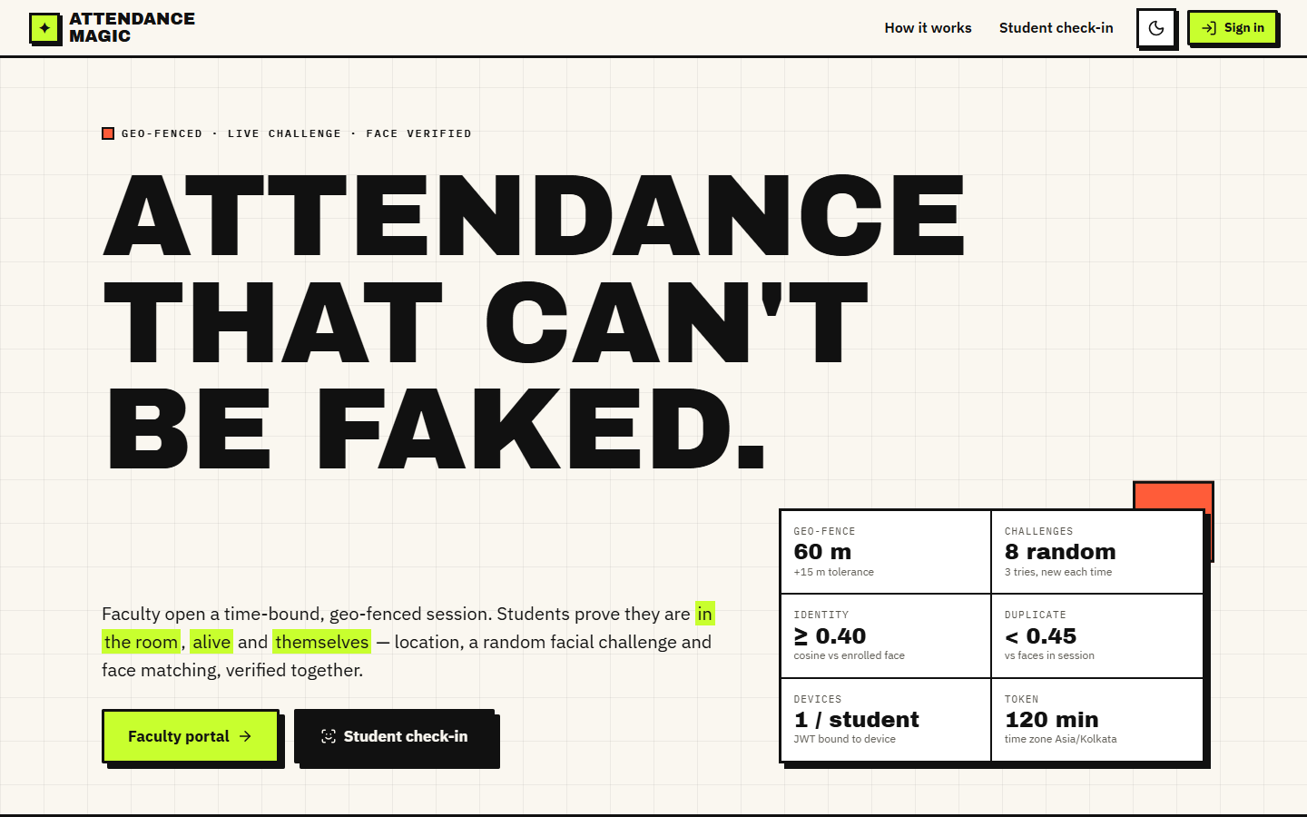
Fig. 9: Landing page
A public page that explains the six checks (eligibility, device, location, live challenge, identity, duplicate) in the order a student meets them.
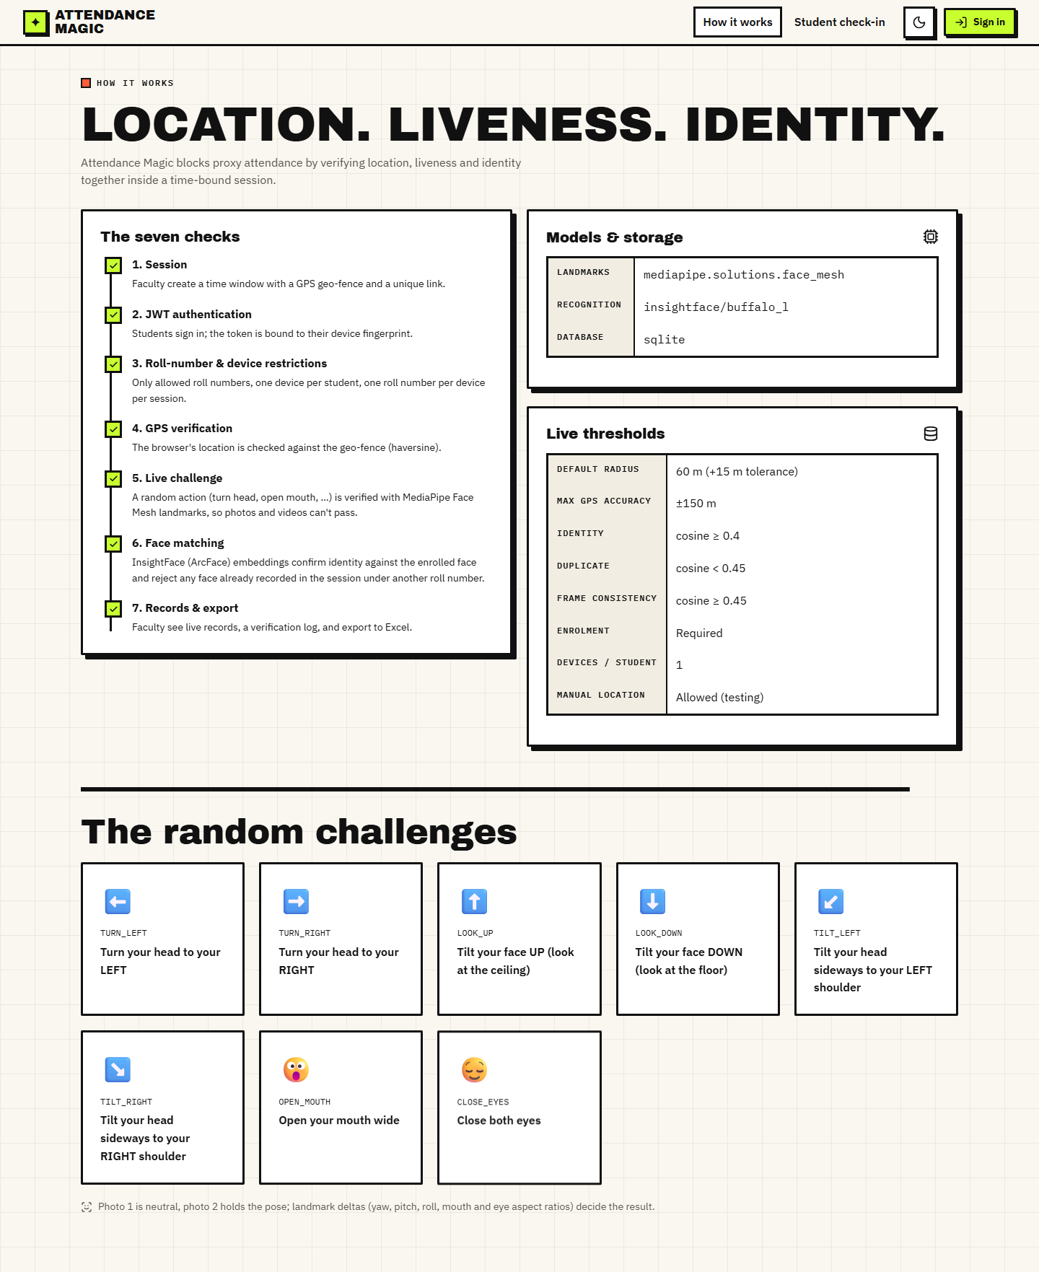
Fig. 10: How it works page
Sign-in for faculty with a username or e-mail and a password; a student account used here is refused with a message that names the right portal.
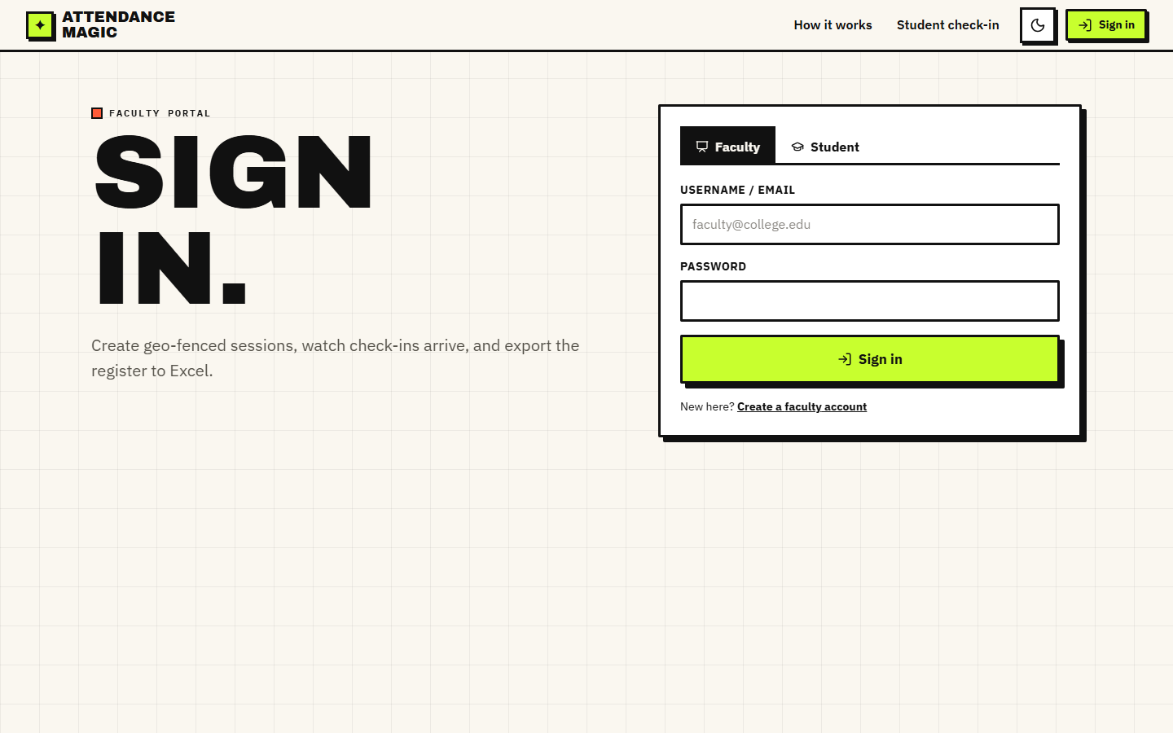
Fig. 11: Faculty sign-in
Sign-in for students with a roll number or username; the JWT issued on success is bound to the browser's device hash.
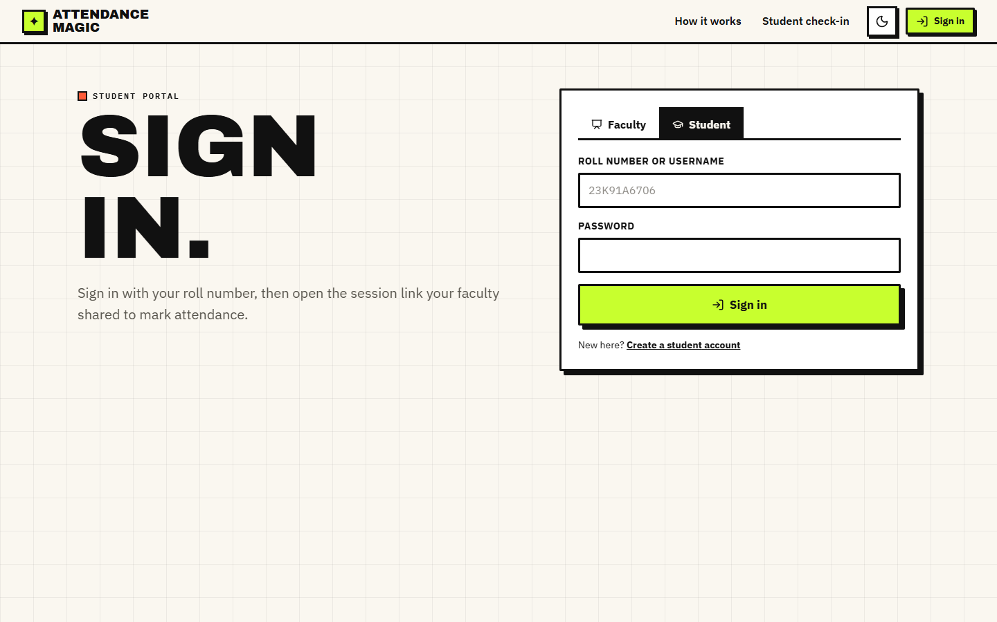
Fig. 12: Student sign-in
Registration asks for the name, roll number, password and a reference face photograph (camera or upload). The photo must contain exactly one frontal face with the mouth closed, otherwise the account is not created.
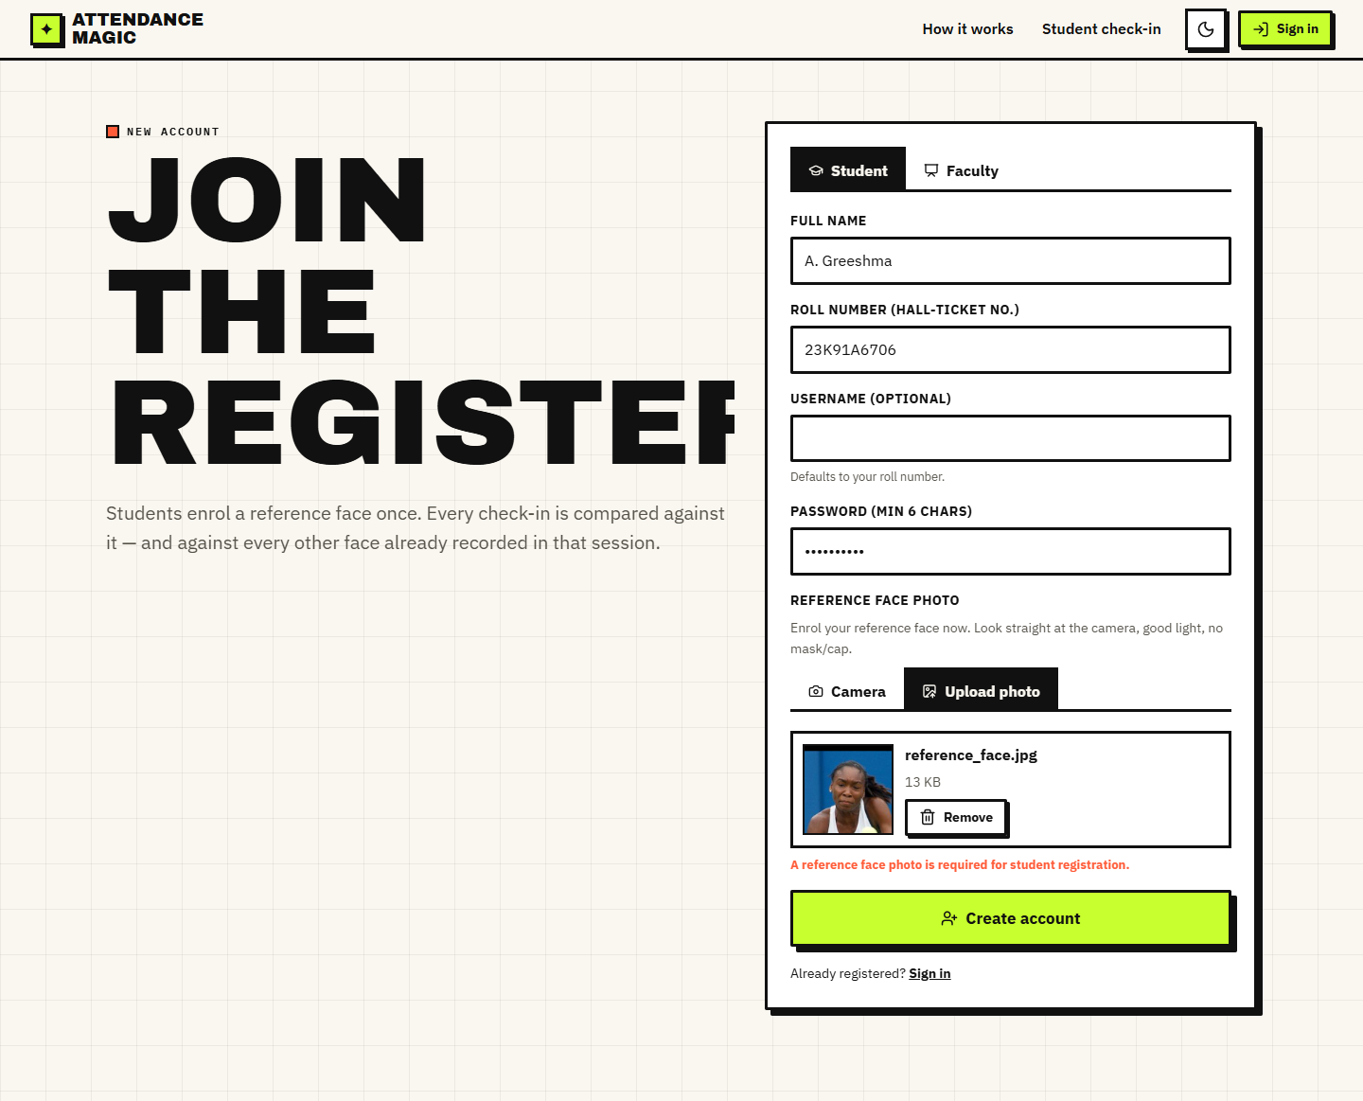
Fig. 13: Student registration with a reference face
A student who has a session link or token pastes it here to open the check-in wizard.
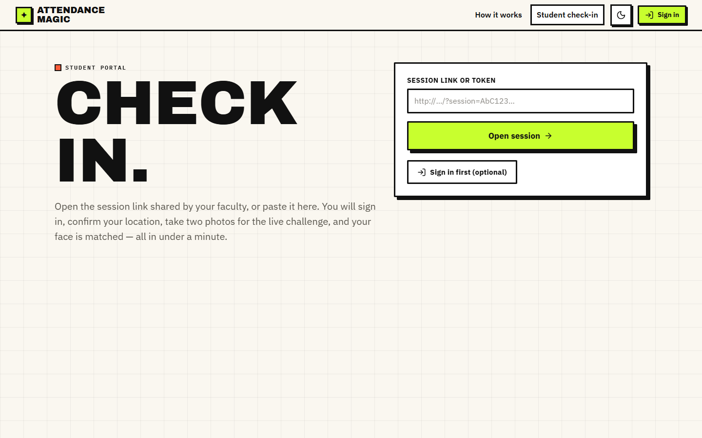
Fig. 14: Check-in portal
Faculty enter the course, section, date, start time, duration, the classroom location (browser GPS or manual coordinates), the radius (10-500 m slider) and the allowed roll numbers; the map previews the fence and its 15 m tolerance ring.
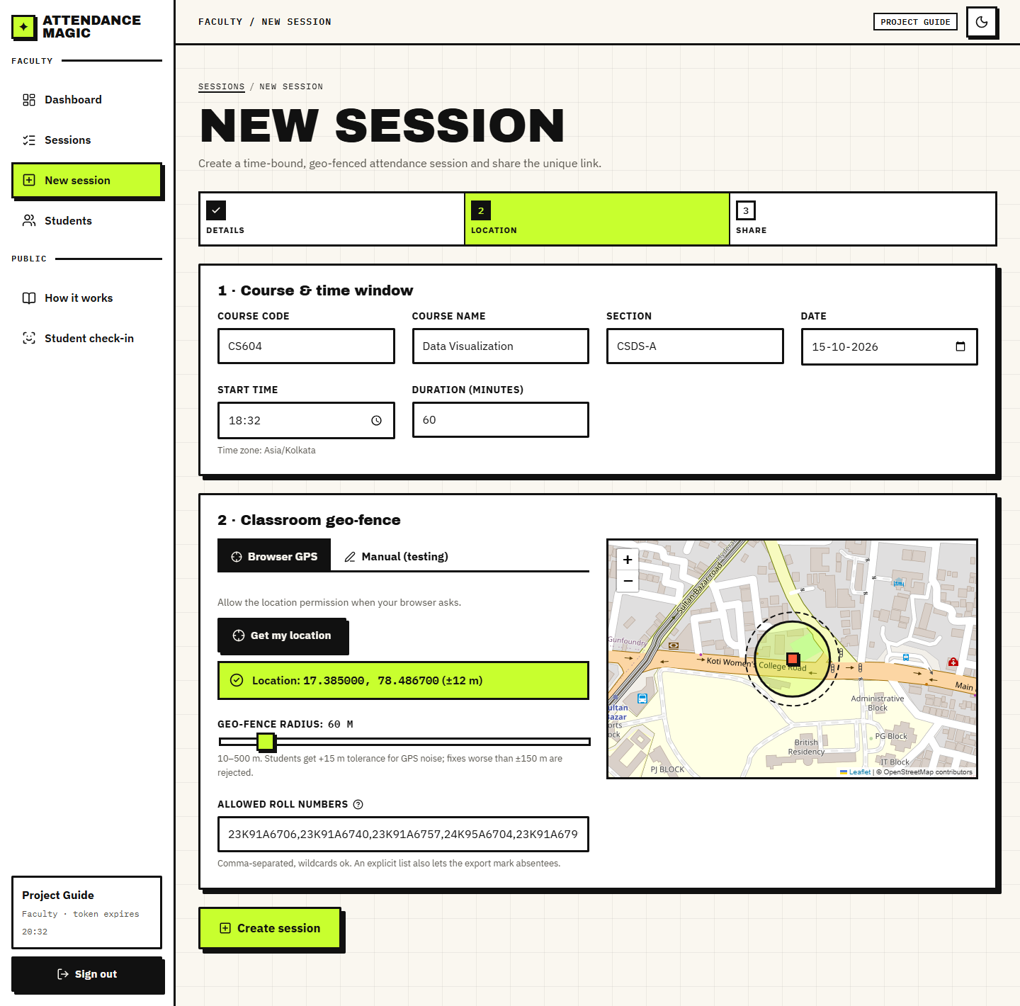
Fig. 15: New session form with geo-fence preview
After creation the page shows the unique link and a QR code to display in class, with a summary of the window, radius and allowed rolls.
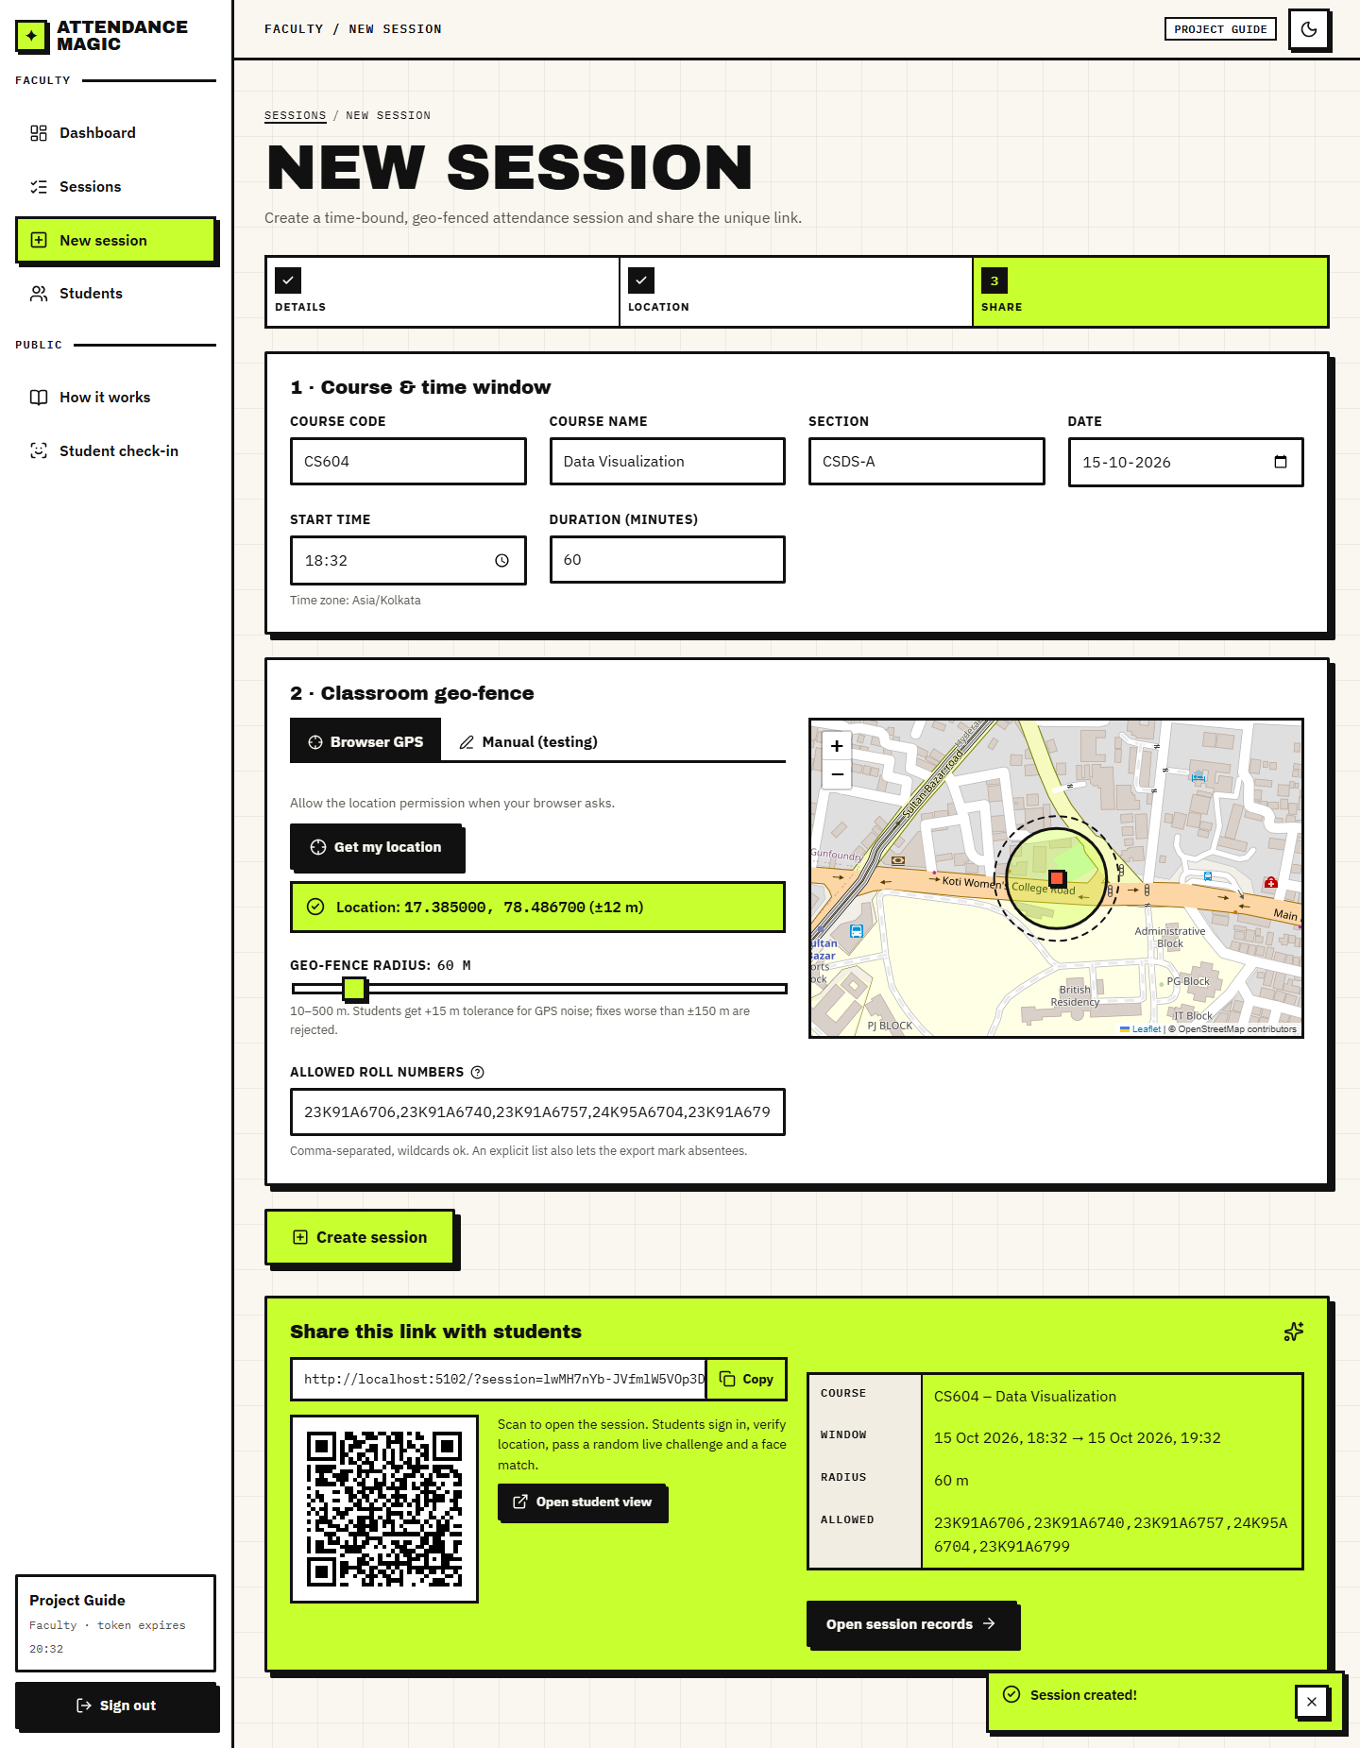
Fig. 16: Session created: link and QR code
KPI tiles (2 sessions, 1 live, 7 check-ins, 11 blocked attempts, 18% blocked), check-ins per session, checks by stage (passed and blocked) and the latest verification attempts with reasons.
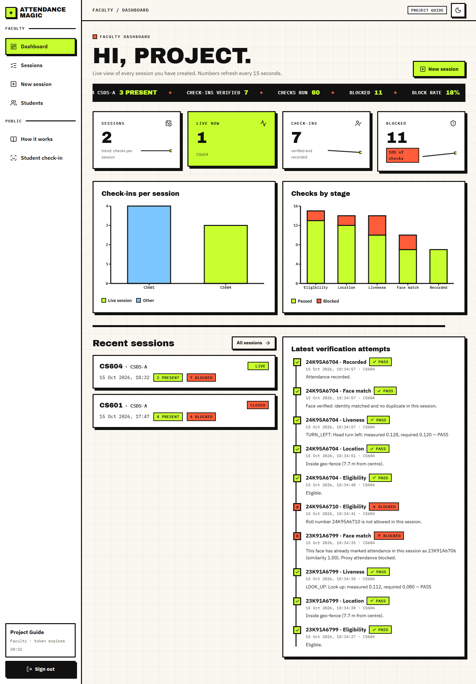
Fig. 17: Faculty dashboard
All sessions of the signed-in faculty with status, window, present count, expected count and blocked attempts.
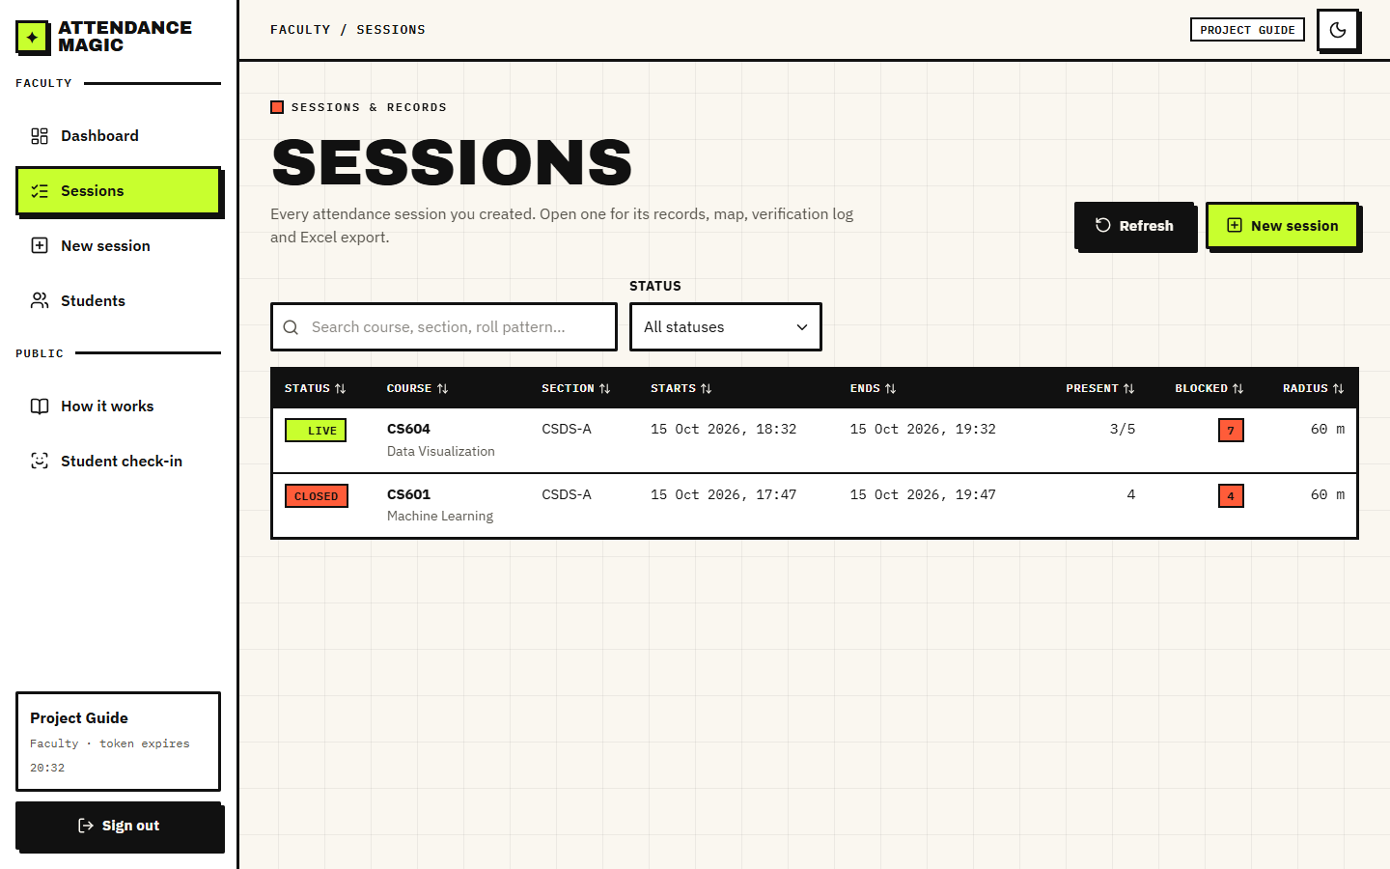
Fig. 18: Sessions list
The live session CS604 with 3 present of 5 expected (explicit roll list) and 7 blocked attempts out of 30 checks; the share link and QR code; the records table shows distance, GPS accuracy, challenge, liveness score, identity similarity and the maximum duplicate similarity, and lists absentees.
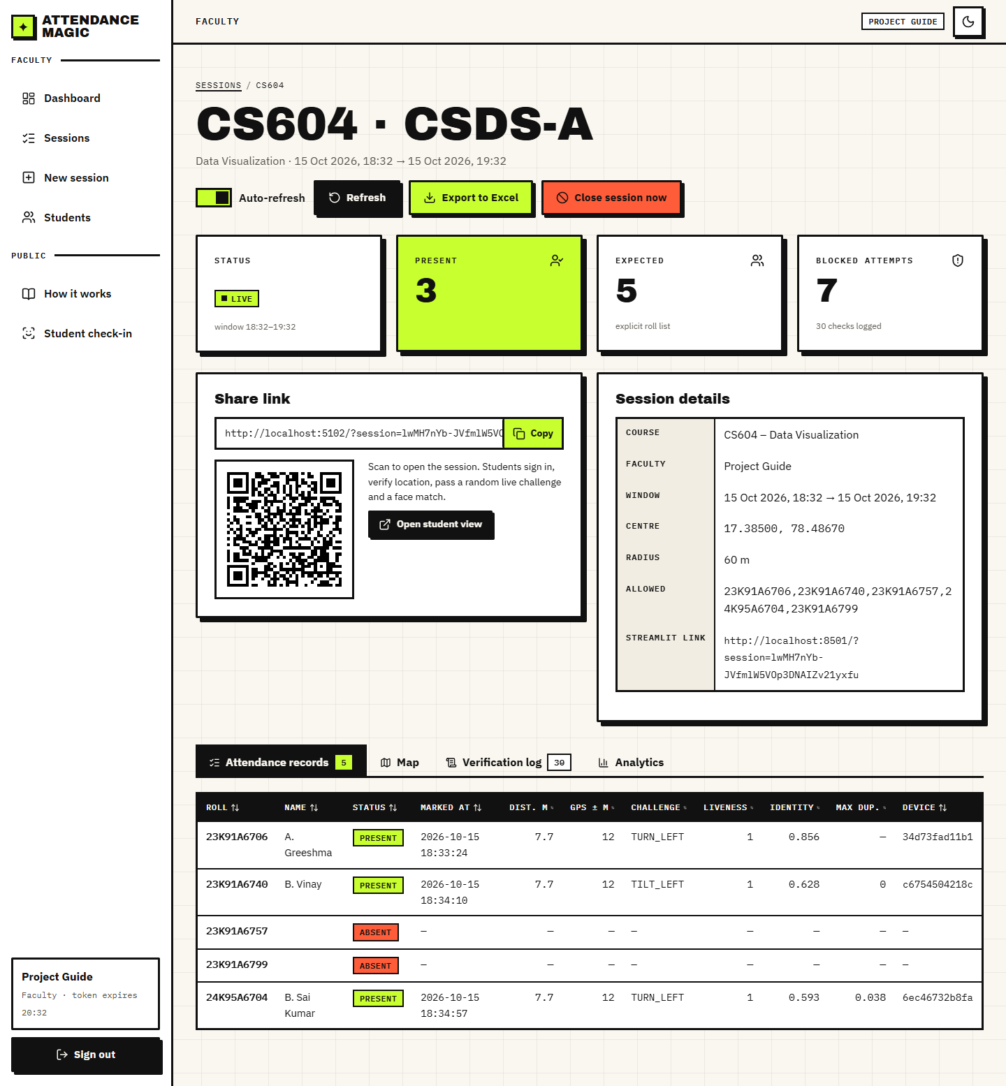
Fig. 19: Live session: records
The geo-fence centre (red), the 60 m radius and the 15 m tolerance ring on an OpenStreetMap map, with the check-in positions of the present students (blue).
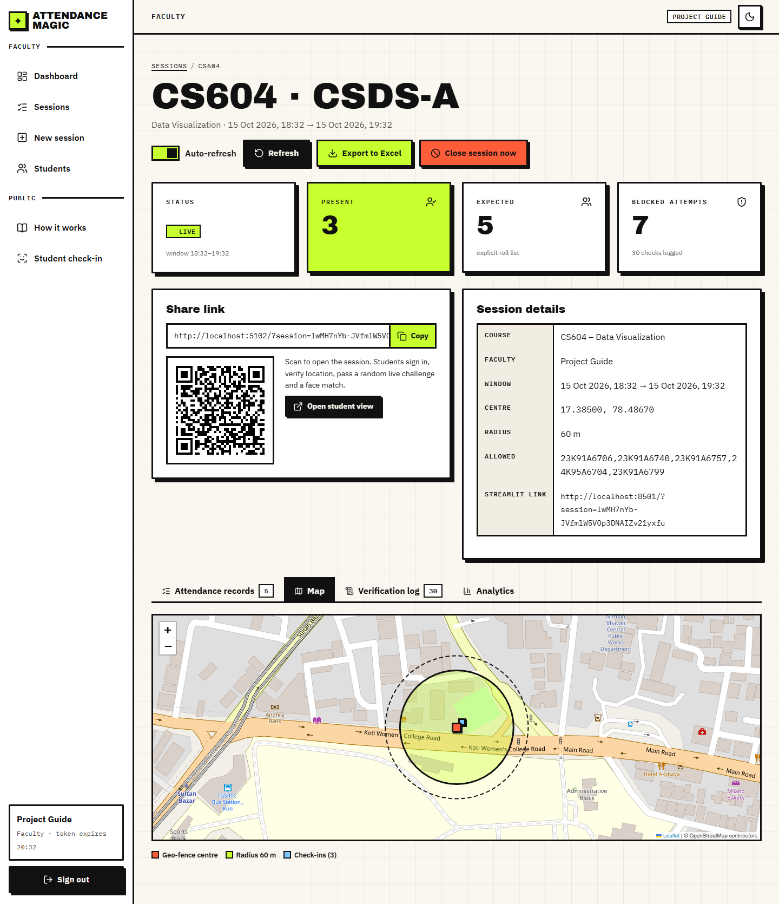
Fig. 20: Session map
Every attempt, newest first, with the roll number, stage, PASS or BLOCKED and the reason text; the blocked rows include the out-of-fence, challenge, identity and duplicate-face reasons.
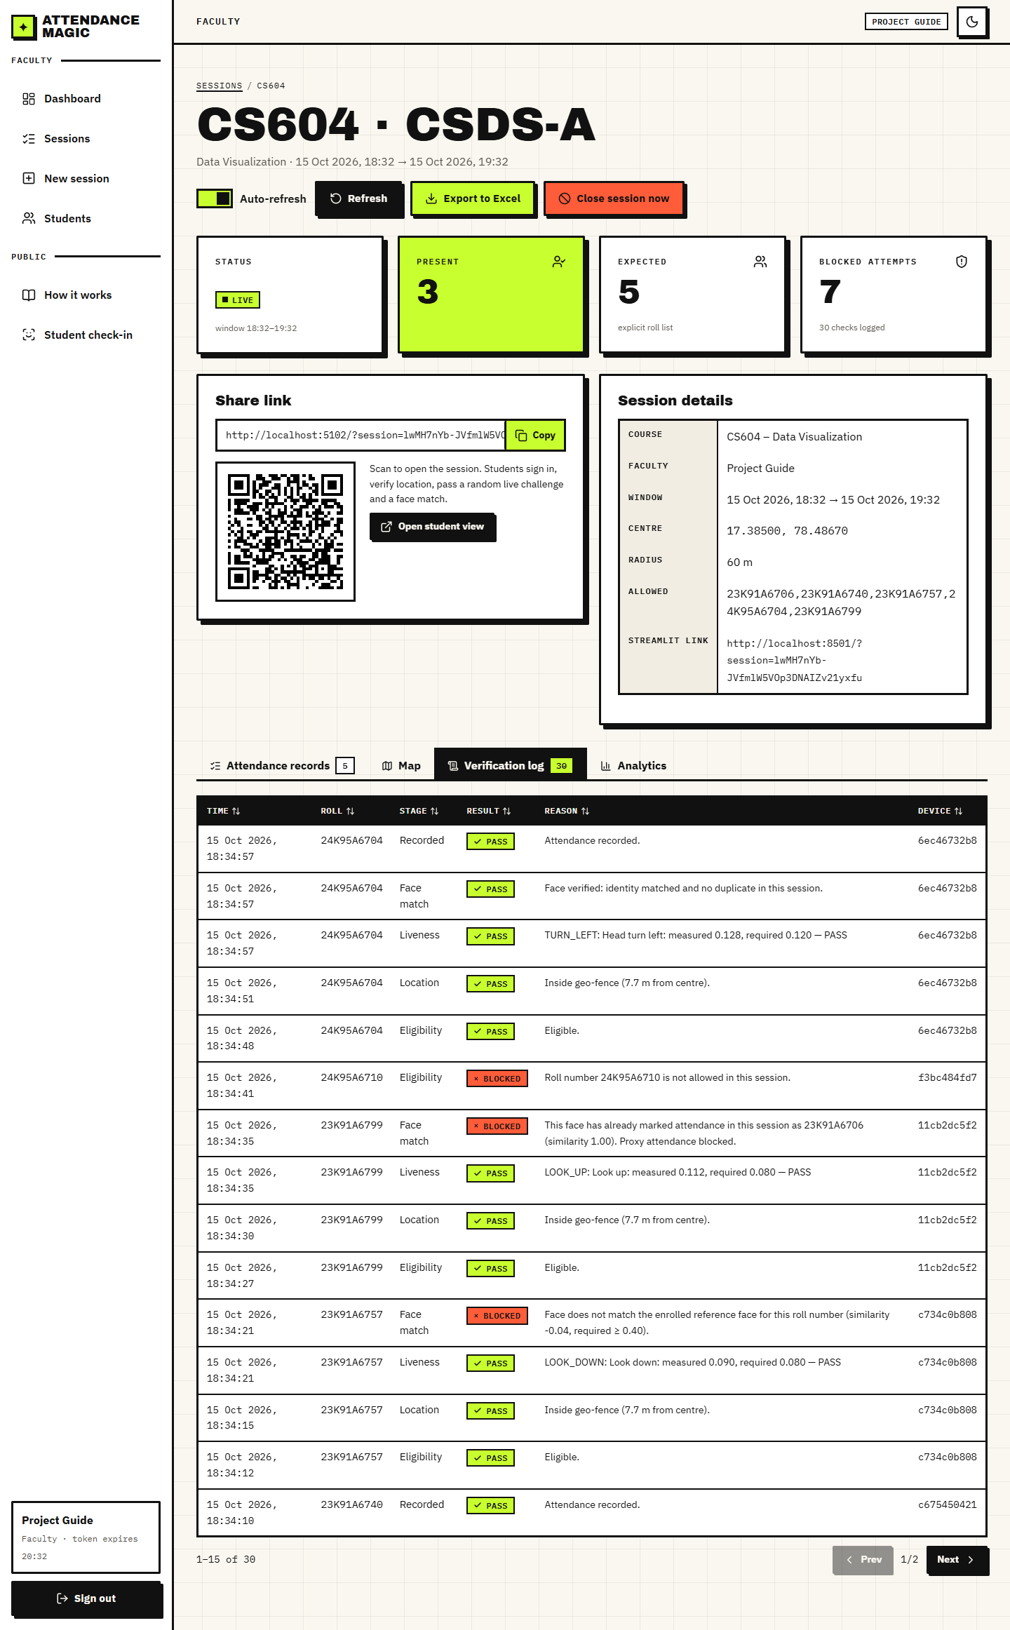
Fig. 21: Verification log
Checks by stage (passed and blocked) and the distance of each present student from the centre, with the mean liveness score and the limit.
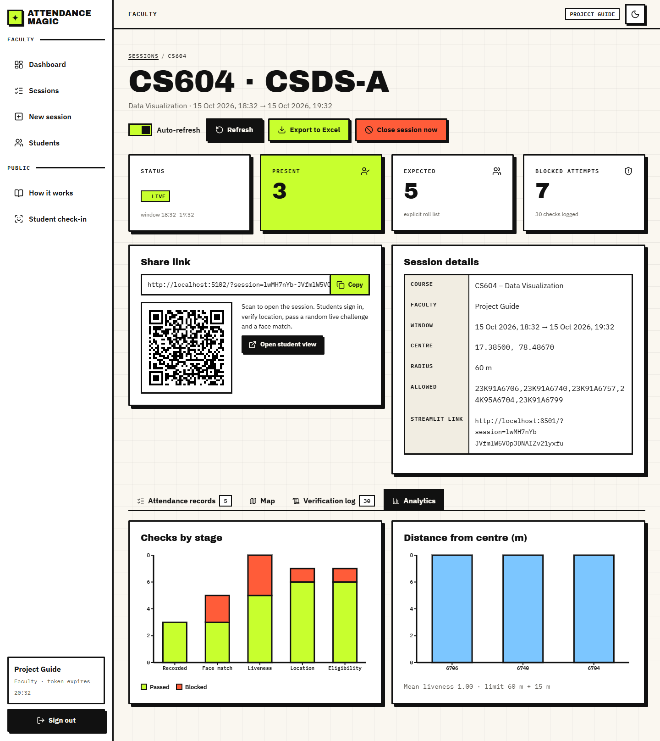
Fig. 22: Session analytics
The closed session CS601: all four students present, with distance 7.7 m for each.
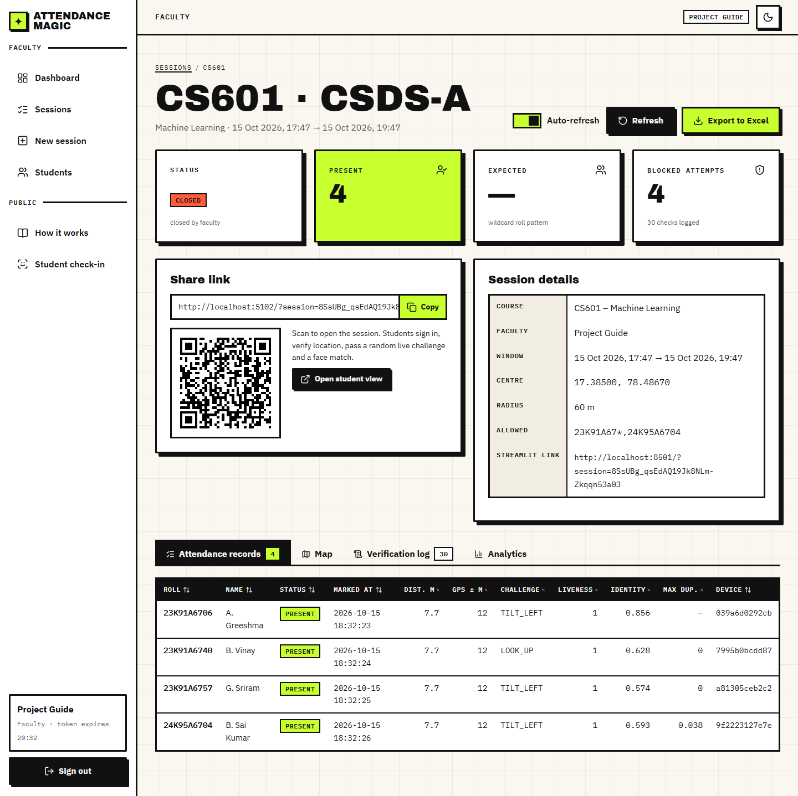
Fig. 23: Closed session: records
The log of the closed session, including the proxy attempt blocked as a duplicate face and the visitor whose roll number was not allowed.
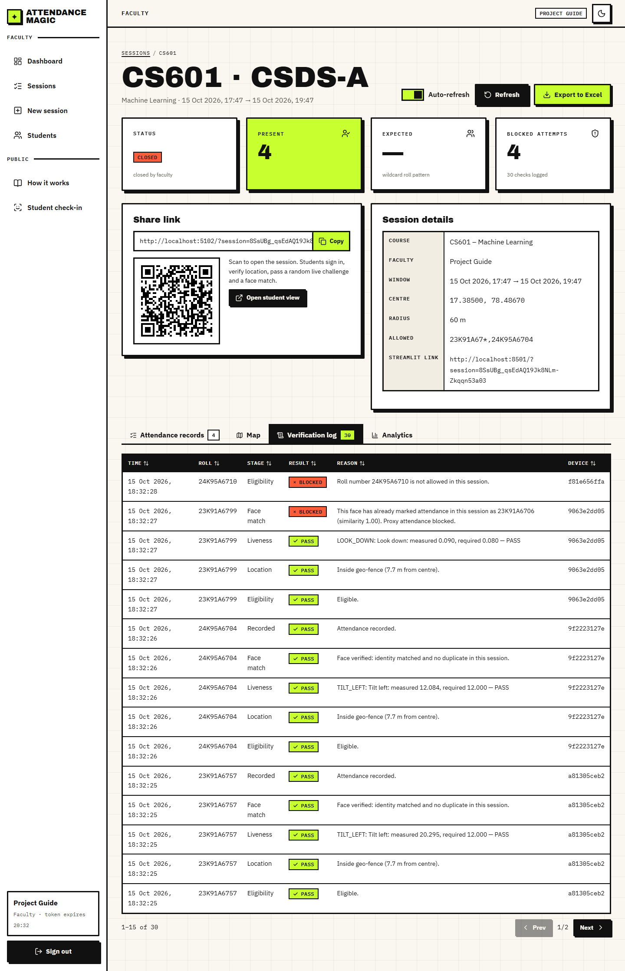
Fig. 24: Closed session: verification log
All students with roll number, enrolment status and number of bound devices, with search and a Manage action.
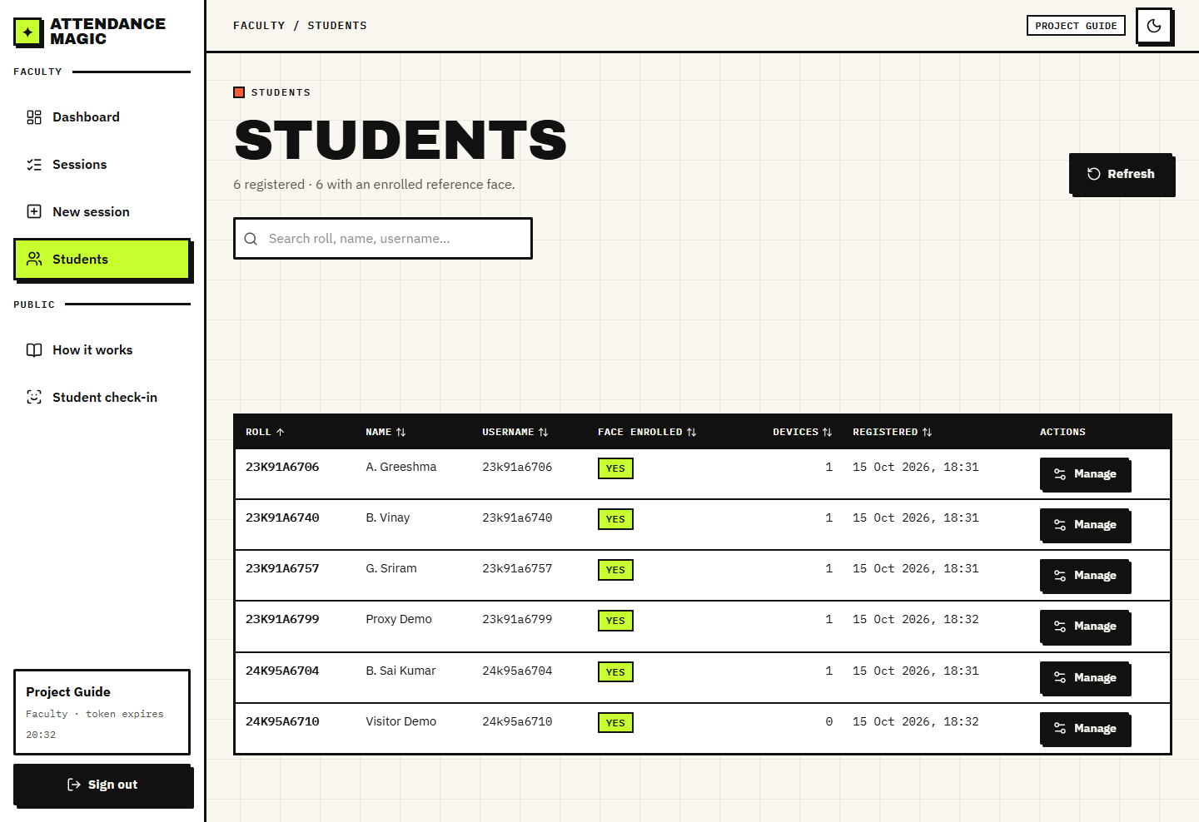
Fig. 25: Students
A drawer with the student's details, a button to remove device bindings and an upload to replace the reference face.
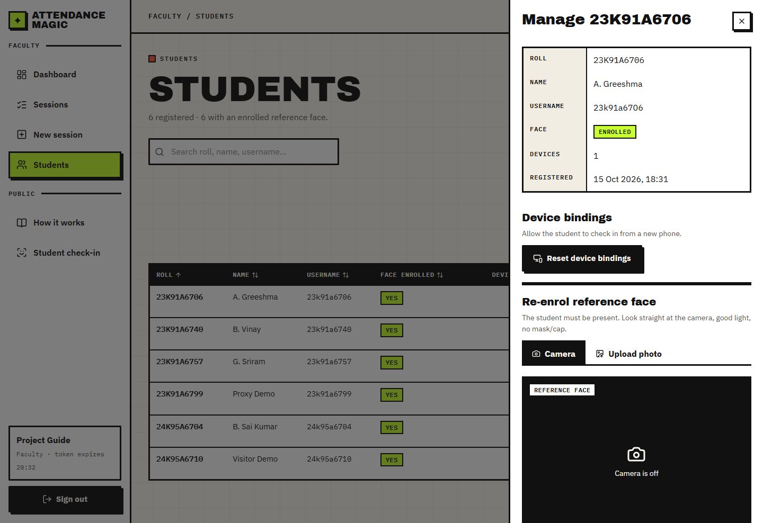
Fig. 26: Manage a student
Step 1 of the student wizard: the session header (course, window, faculty) and the sign-in form.
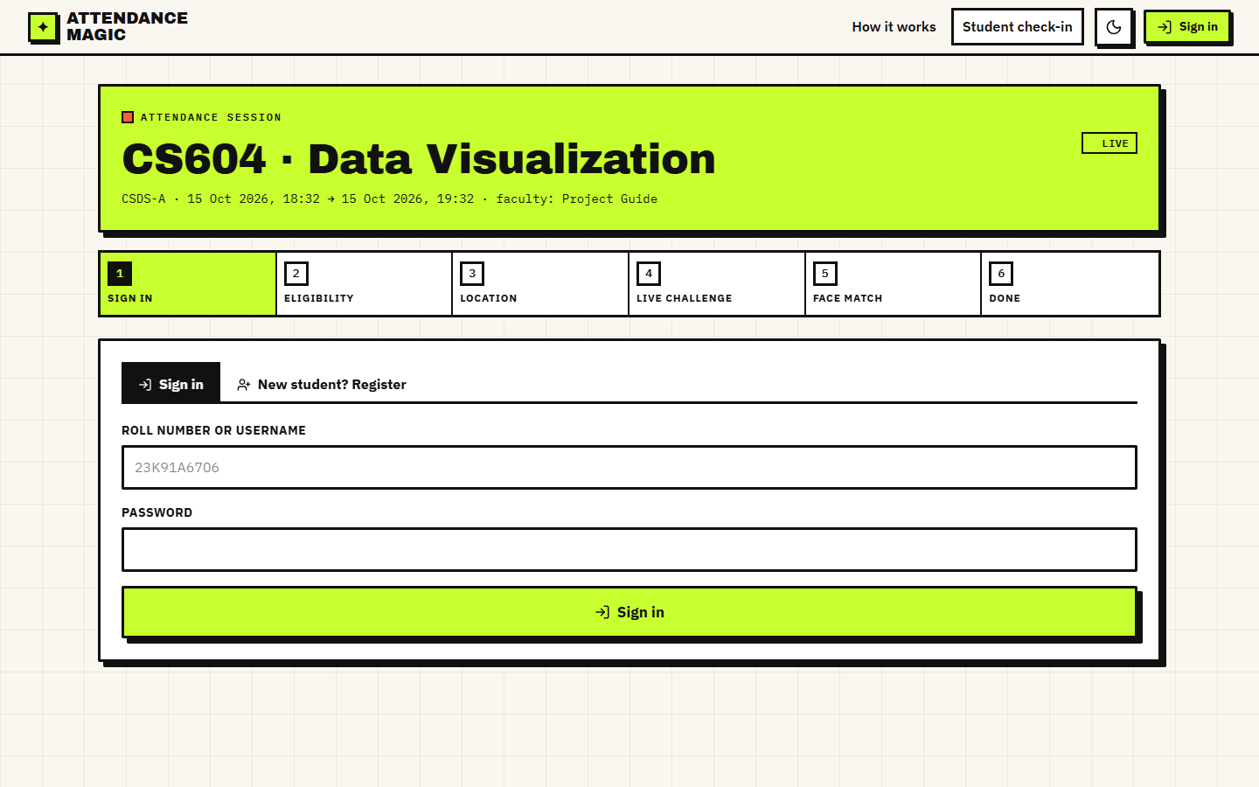
Fig. 27: Check-in: sign in
Step 2: the student taps Get my location; the browser fix is shown with its accuracy and the map shows the fence and the student's position.
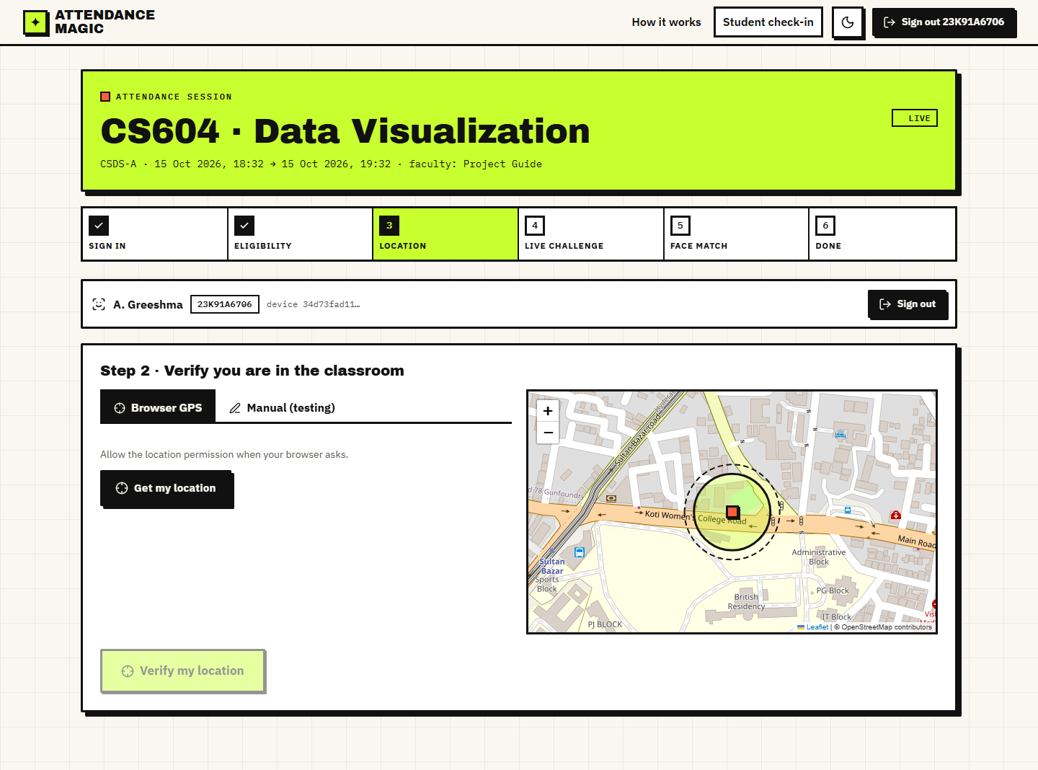
Fig. 28: Check-in: location
Step 3: the random challenge ('Turn your head to your LEFT'), three tries left, and the two photo slots, each with a camera tab and an upload tab.
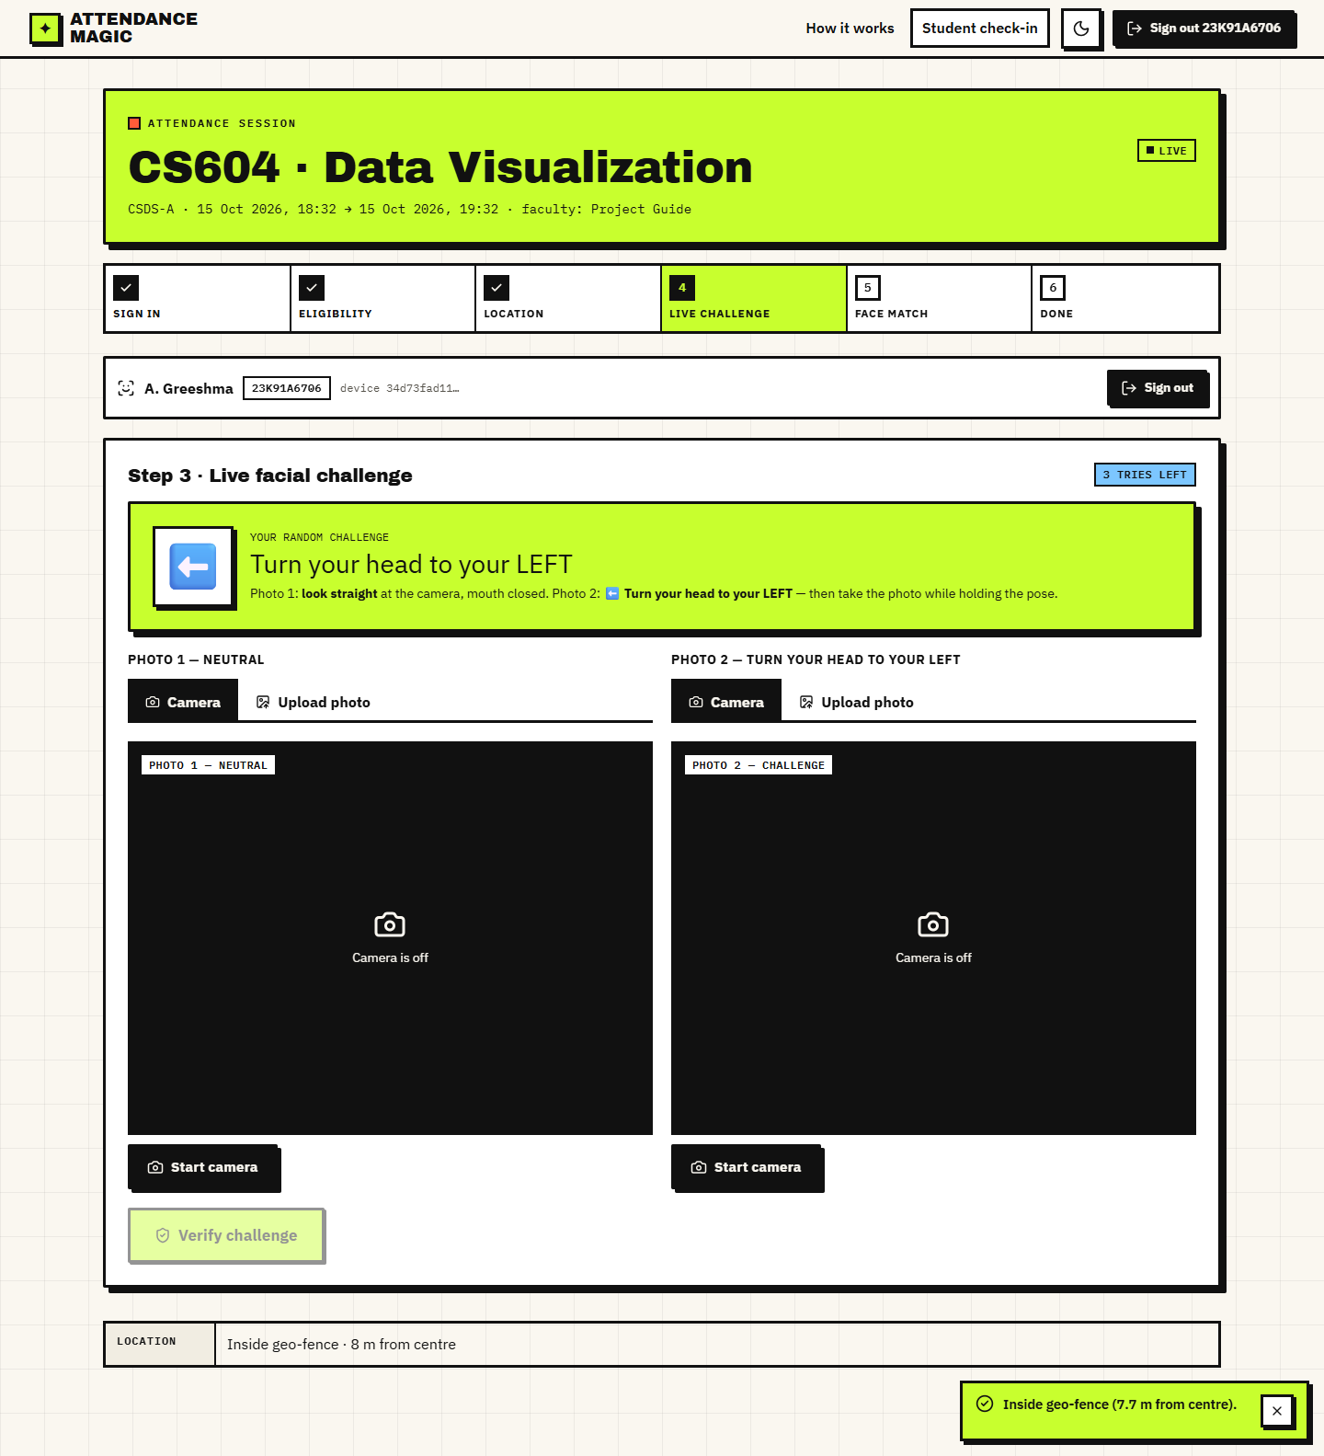
Fig. 29: Check-in: random challenge
Both photos loaded for a turn left challenge. The first photo was accepted as a good neutral frame.
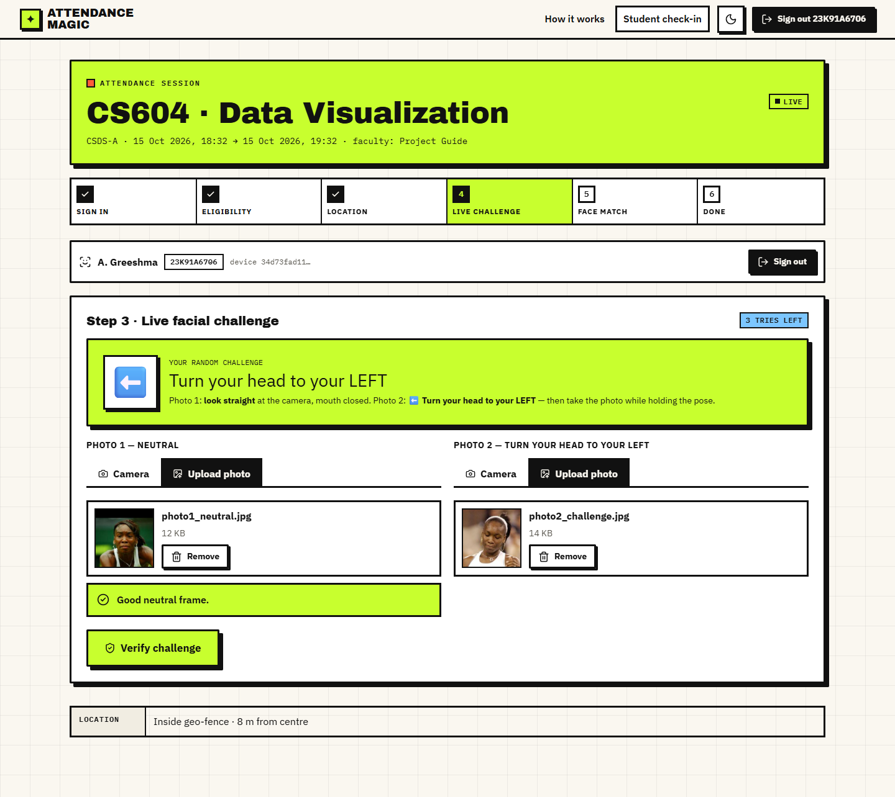
Fig. 30: Check-in: photos loaded
Step 5: 'Marked. Present.' with the distance (shown as 8 m, 7.7 m in the record), the liveness score (1.00), the identity similarity (0.86, required at least 0.4) and the thresholds that applied.
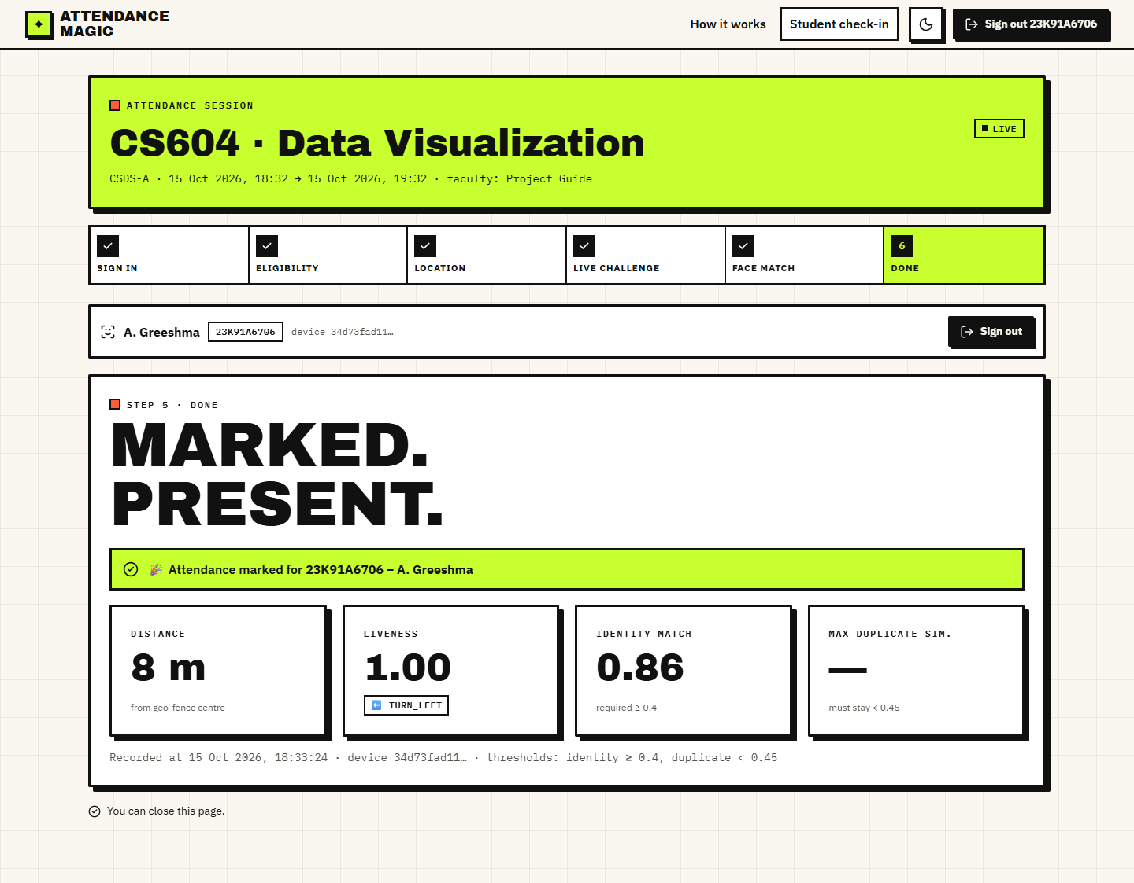
Fig. 31: Check-in: marked present
A student 556 m from the centre is told 'Outside geo-fence: you are 556 m away, limit is 75 m.' The map shows the position far outside the circle.
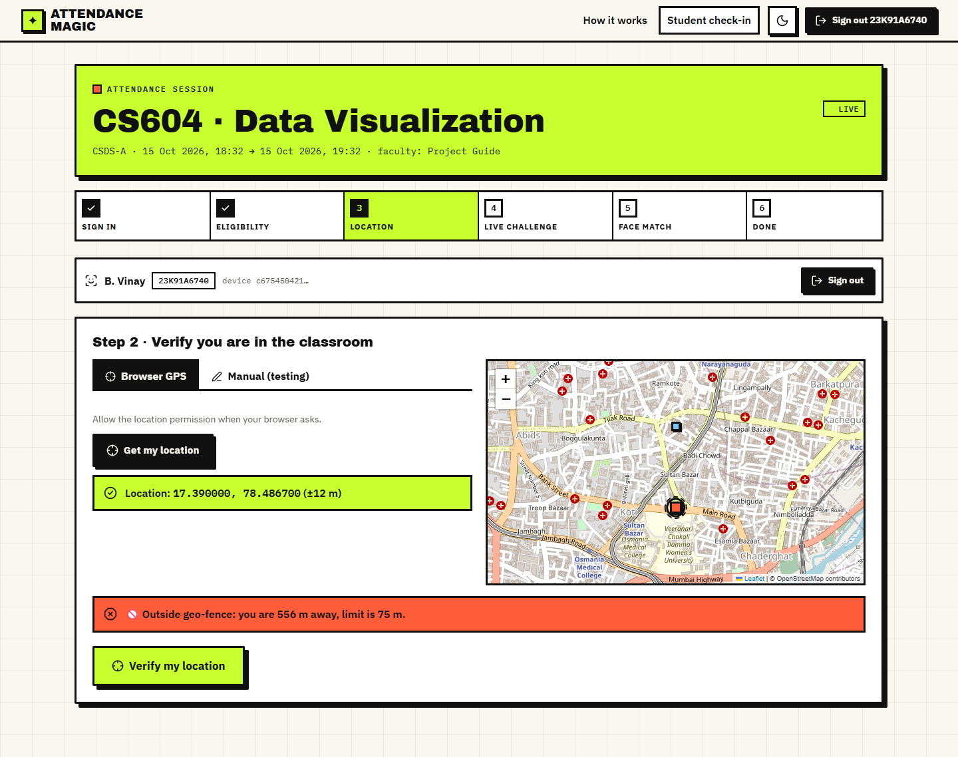
Fig. 32: Blocked: outside the geo-fence
The same photograph submitted twice fails the challenge; the reason reports the measured and required values and a new random challenge is issued with two tries left.
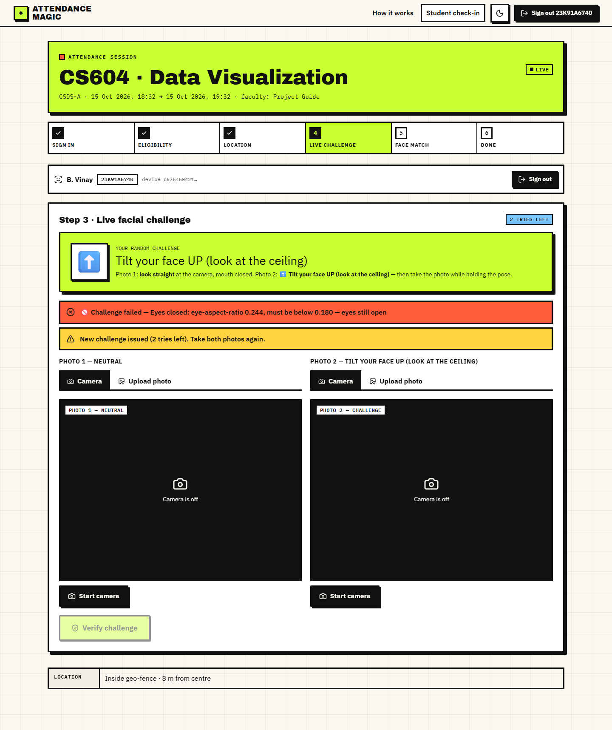
Fig. 33: Blocked: static photo
After the third failed challenge the wizard stops and offers Start over.
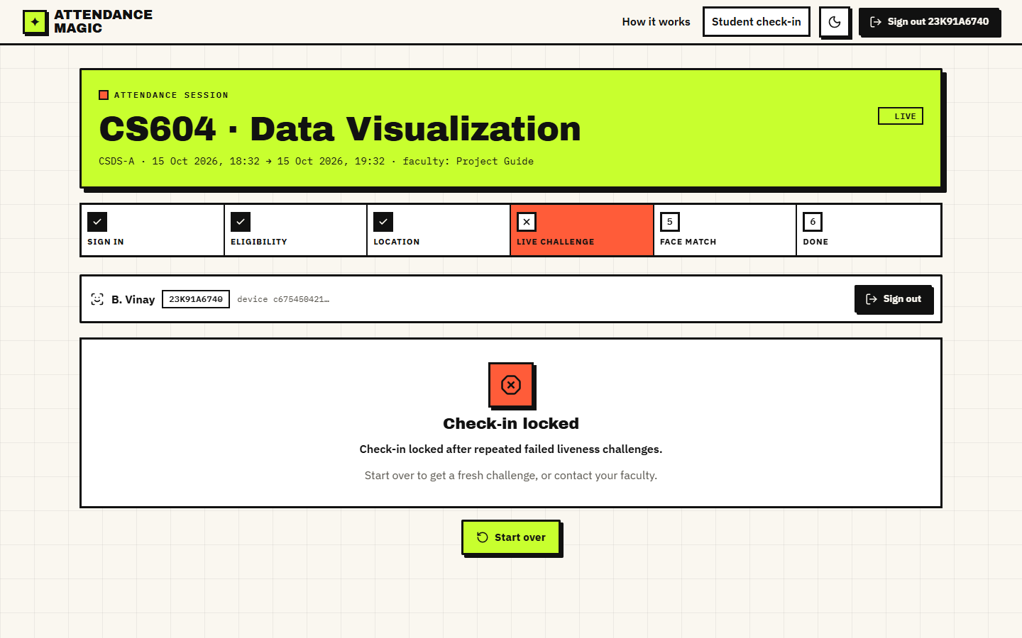
Fig. 34: Locked after three failed challenges
A student presents another person's photographs; the face step reports that the face does not match the enrolled reference face for this roll number.
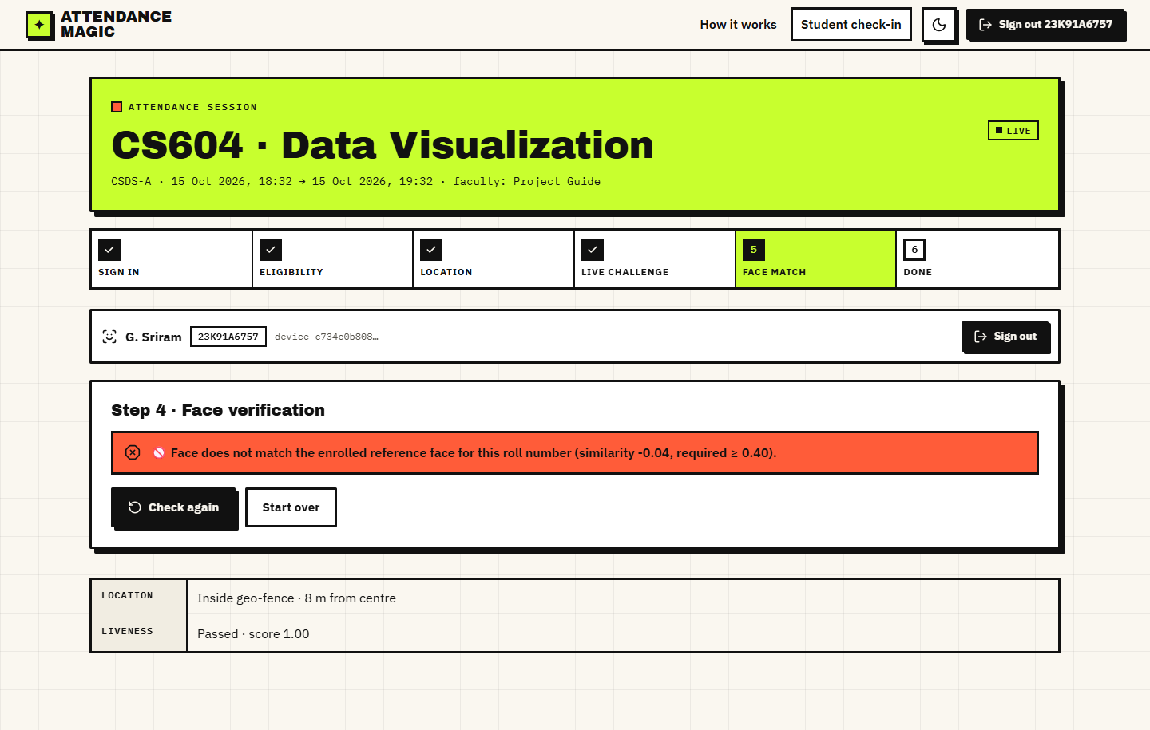
Fig. 35: Blocked: face does not match
A second account enrolled with the same face passes the identity check but is stopped by the duplicate scan: 'This face has already marked attendance in this session as 23K91A6706 (similarity 1.00). Proxy attendance blocked.'
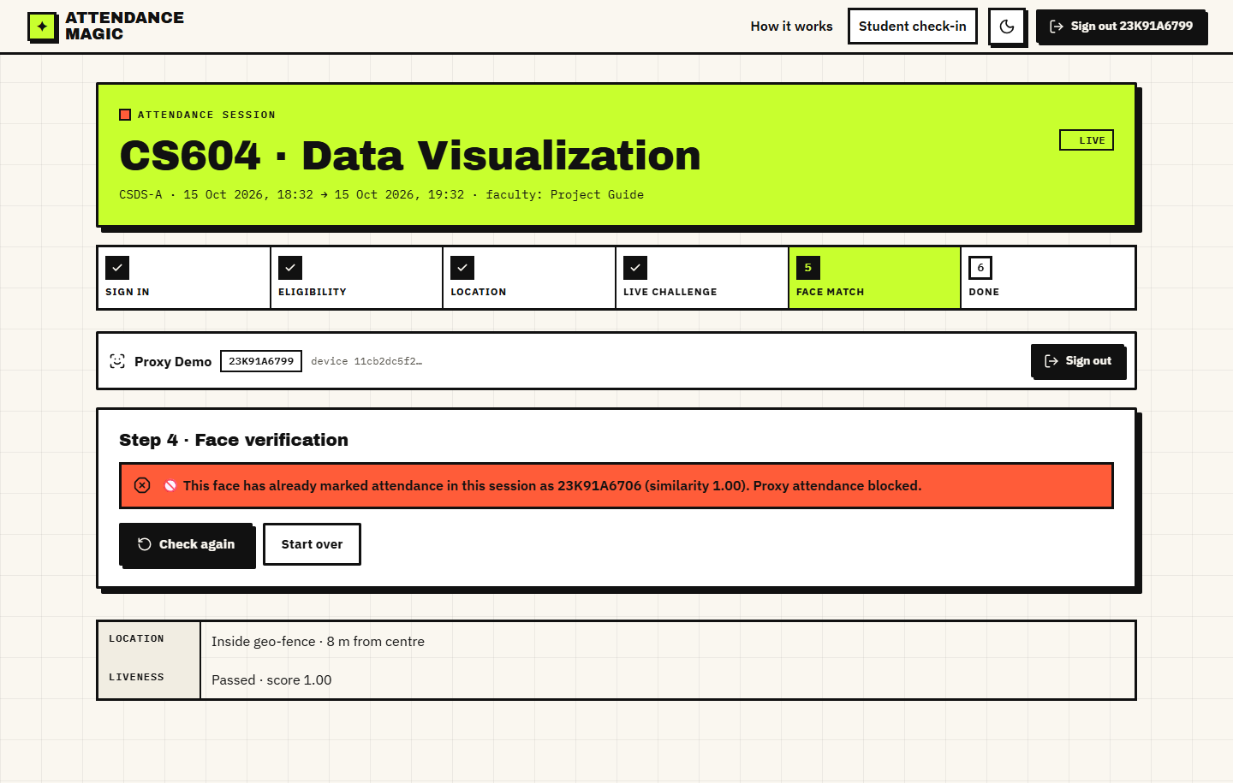
Fig. 36: Blocked: duplicate face
A student whose roll number is not on the session's list is stopped at the eligibility step.
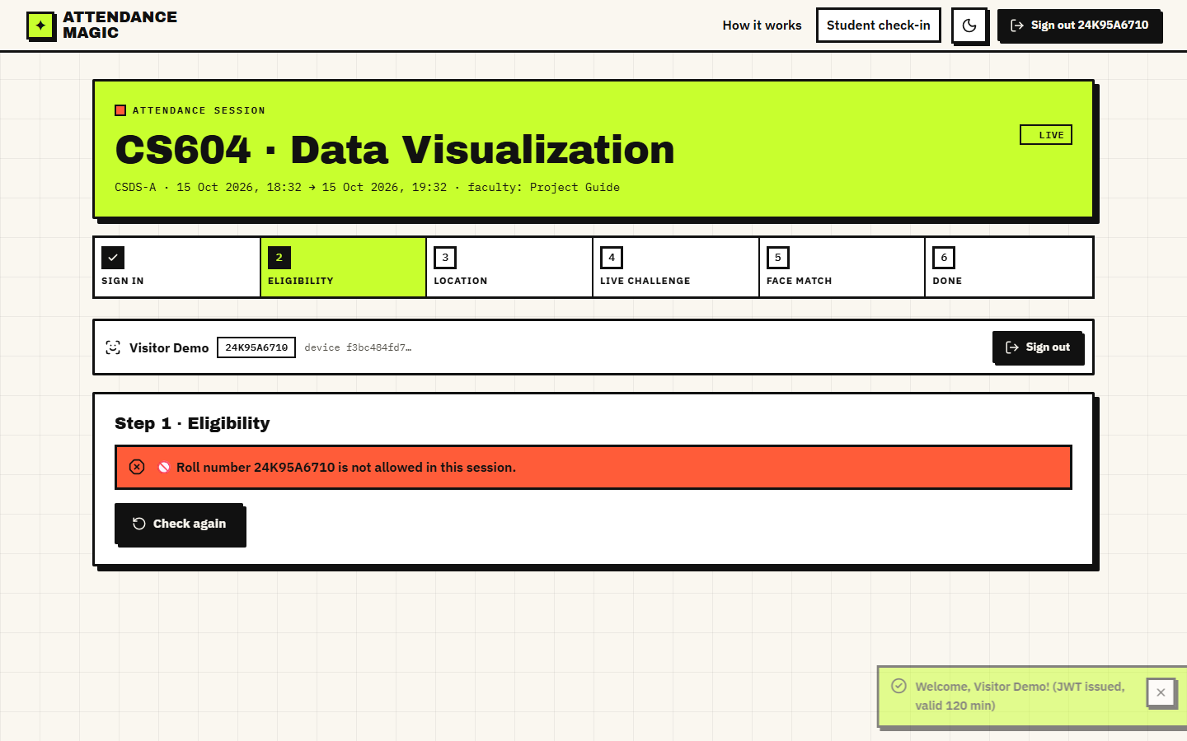
Fig. 37: Blocked: roll number not allowed
The OpenAPI page generated by FastAPI at /docs, listing the 27 endpoints by tag.
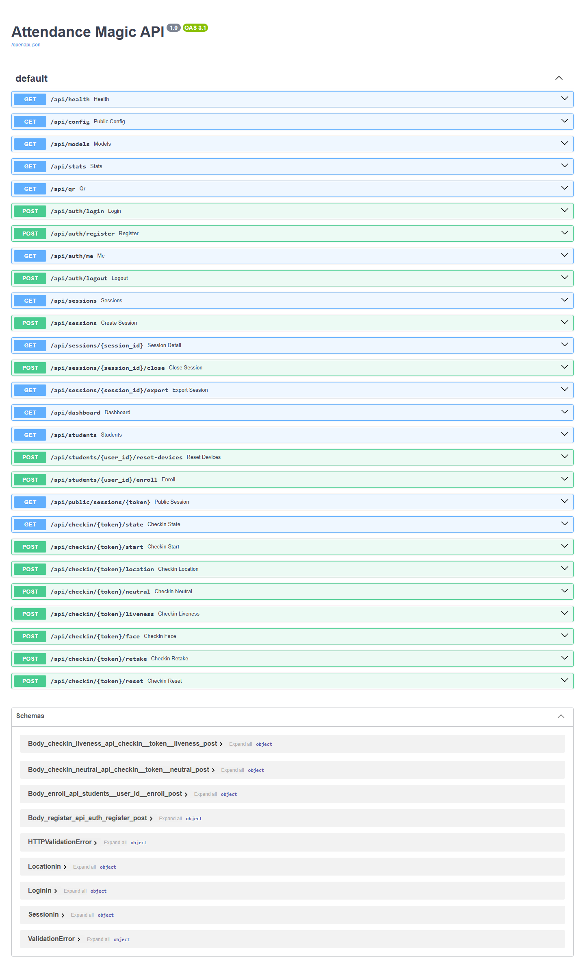
Fig. 38: Interactive API documentation
Course, section, faculty, window, geo-fence centre, radius, present, absent and blocked-attempt counts.
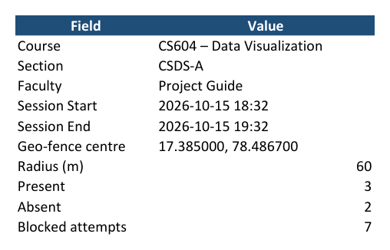
Fig. 39: Excel export: Summary sheet
One row per student with status, time, distance, accuracy, challenge, scores and device; absent students from the explicit list are included.
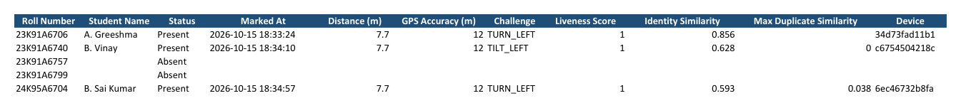
Fig. 40: Excel export: Attendance sheet
Every attempt with time, roll number, stage, PASS or BLOCKED, reason and device.
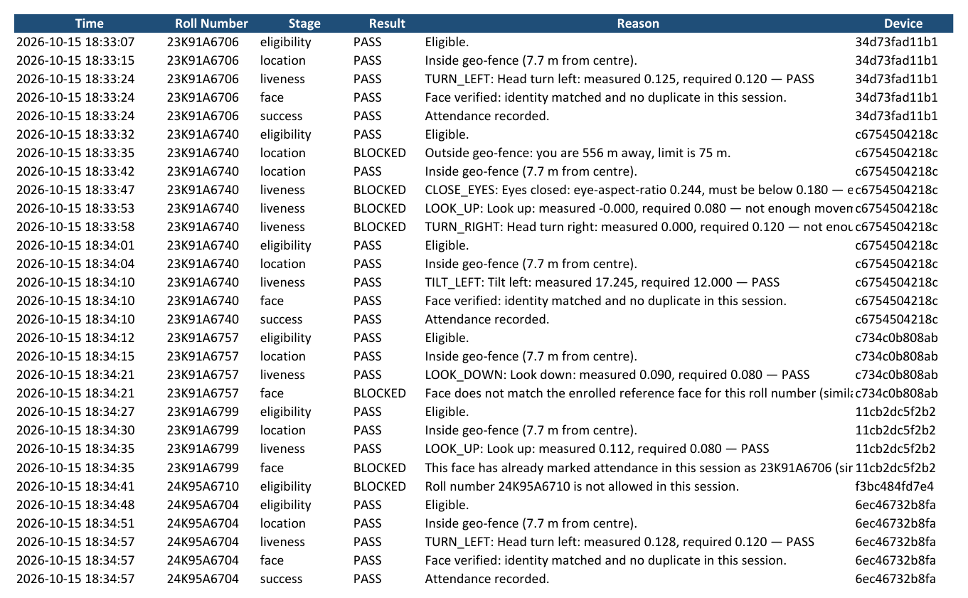
Fig. 41: Excel export: Verification Log sheet

6 Sample Inputs and Outputs
A successful check-in returns the following result (from the demo run; values rounded). The input is a GPS fix inside the fence and two photographs; the output is the record that appears in the faculty's table and in the Excel export.
Table 7: Sample output of a successful check-in
Field | Value | Meaning
Roll number / name | 23K91A6706 / A. Greeshma | the signed-in student
Distance | 7.7 m | haversine distance from the fence centre (limit 75 m)
GPS accuracy | 12 m | browser-reported accuracy (limit 150 m)
Challenge | TURN_LEFT, score 1.00 | random challenge and its score
Identity similarity | 0.856 | cosine between the live and the enrolled embedding (required at least 0.40)
Maximum duplicate similarity | none | the first record of the session
Device | 34d73fad11b1... | first 12 characters of the device hash

Examples of blocked outputs from the verification logs of the two demo sessions:
Table 8: Sample blocked outputs
Stage | Reason stored
location | Outside geo-fence: you are 556 m away, limit is 75 m.
liveness | Tilt left: measured -0.000, required 12.000 - not enough movement, try a bigger motion
face (identity) | Face does not match the enrolled reference face for this roll number (similarity ..., required >= 0.40).
face (duplicate) | This face has already marked attendance in this session as 23K91A6706 (similarity 1.00). Proxy attendance blocked.
eligibility | Roll number 24K95A6710 is not allowed in this session.

7 Comparison with the Base Paper
The comparison is qualitative and the datasets differ. The base paper [1] reports its own classroom tests with a small, unstated number of students and the LBPH recogniser; this project reports threshold behaviour on the public LFW protocol with a pre-trained ArcFace recogniser. The figures are not comparable as accuracies and no numerical advantage is claimed.
Table 9: Comparison with the base paper (different datasets)
Aspect | Base paper [1] | Attendance Magic
Recogniser | Haar cascade + LBPH trained on 25-50 images per student | SCRFD + ArcFace R50, one reference photo per student, no training
Reported identity result | About 92-95% recognition, 5-8% false negatives, 0% false positives (own classroom data) | 98.7% of same-person LFW pairs accepted, 0 of 2,166 different-person pairs accepted
Speed | Under 2 s per face | 176 ms per embedding; 564 ms for a whole check-in (server)
Spoof resistance | Not described | Random challenge; single photograph passes 0% of 7 of 8 challenges; rotated and multiple photographs can pass (measured)
Presence proof | None | GPS geo-fence with tolerance and accuracy gate
Duplicate identity | None | Duplicate scan; 97.2% of same-person pairs flagged at 0.45
Interface | Tkinter desktop application on the classroom computer | React web application on any browser; also the original Streamlit UI
Storage | CSV files | Database, attempt log and Excel export with absentees

8 Success and Failure Analysis

8.1 Where the system succeeds
- A genuine student inside the fence with a correct challenge and a clear photograph is recorded in about 0.56 s of server time.
- Forwarded links, remote marking, repeat marking, second devices, disallowed rolls, another person's face and a duplicate face were each blocked at the intended stage in every scripted scenario.
- A single stolen photograph fails seven of the eight challenges, and different-person pairs never reached the identity threshold on 2,166 LFW pairs.

8.2 Where it fails or is weak
Table 10: Weak points found by the experiments
Case | Observation | Consequence
Rotated photograph | Passes tilt challenges at 15 degrees or more (98-99%) | 2 of 8 challenges are defeated by one photograph on a tilted screen
Photo bank | Passes the full chain 49-96% depending on the challenge | A determined attacker with several photos can succeed; mitigated only by the geo-fence, device binding, time window and tries
Close eyes with a blinking photograph | 8.2% of still photographs pass | A photograph that already shows closed eyes passes this challenge
Single-face rule | 15.7% of LFW photos rejected | Retakes needed; a bystander in the frame blocks the check-in
Strict neutral frame | 32.9% of LFW press photos accepted | Students must look straight, mouth closed
Very different photographs of one person | 1.3% of same-person pairs fall below 0.40 | Rare false rejections; re-enrolment with a better reference photo fixes it
Poor GPS | A 30 m error rejects 40% of students at 60 m (simulation) | Faculty should use a larger radius indoors

9 Limitations of the Results
- LFW photographs are news images, not selfies; the single-face and frontal-pose rates on student phone photographs are unknown.
- No live person performed any challenge. The genuine pass rate of each challenge, the time to complete a check-in and the number of retakes were not measured.
- The photo-bank attack uses public figures with many photographs; it is an upper bound for ordinary students.
- The GPS results are a simulation under an assumed noise model.
- Timings come from one machine that was running other applications; they are indicative.
- The comparison with the base paper is qualitative because its data, size and protocol are not given.

10 Objectives versus Outcomes
Table 11: Objectives against outcomes
No. | Objective | Outcome | Evidence
1 | Time-bound sessions with configurable geo-fences | Achieved | Session form, link and QR, close; screens 09, 10, 13; unit and smoke tests
2 | JWT, device identification, roll restrictions | Achieved | Token bound to device (401 from another device); device bindings; roll patterns; tests
3 | GPS location against the session boundary | Achieved; field accuracy not measured | Haversine, tolerance, accuracy gate; boundary sweep; simulation only for GPS noise
4 | Liveness by random facial challenge (MediaPipe) | Achieved with a measured weakness | 8 challenges; single photo fails 7 of 8; rotated and multiple photos can pass; no live-person trial
5 | Duplicate identities prevented with InsightFace embeddings | Achieved | Duplicate scan; proxy blocked in the UI run; 97.2% same-person pairs flagged at 0.45 (LFW)
6 | Attendance summaries and Excel export | Achieved | Records, map, log, analytics, 3-sheet Excel with absentees
7 | Verification by tests and measurement | Achieved | 23 pytest tests, 41 smoke checks, LFW threshold evaluation, attack, latency and geo-fence experiments

