Attendance Magic: Geo-Fenced Attendance with Live Challenge Verification and Measured Spoofing Limits
A.GREESHMA  Roll No. 23K91A6706  Department of Computer Science and Engineering (Data Science)  [COLLEGE NAME]  [CITY]  [EMAIL] | B.VINAY  Roll No. 23K91A6740  Department of Computer Science and Engineering (Data Science)  [COLLEGE NAME]  [CITY]  [EMAIL] | G.SRIRAM  Roll No. 23K91A6757  Department of Computer Science and Engineering (Data Science)  [COLLEGE NAME]  [CITY]  [EMAIL] | B.SAI KUMAR  Roll No. 24K95A6704  Department of Computer Science and Engineering (Data Science)  [COLLEGE NAME]  [CITY]  [EMAIL] | [GUIDE NAME]  [DESIGNATION], Project Guide  Department of Computer Science and Engineering (Data Science)  [COLLEGE NAME]  [CITY]  [EMAIL]

Abstract—Classroom attendance is still taken by roll call or by links and QR codes that can be forwarded to absent students, and face-recognition systems answer only who a face is, not whether a live person is present at the right place. This paper presents Attendance Magic, a browser-based system in which a faculty member opens a time-bound, geo-fenced session and a student checks in from a phone through a fixed chain: eligibility and device binding, a GPS geo-fence, a random live facial challenge judged on face-mesh landmarks, and ArcFace identity and duplicate-face checks. Nothing is trained; pre-trained models run on a CPU. On the Labeled Faces in the Wild protocol the identity check reached an AUC of 0.9992 and accepted no impostor pair at its deployed thresholds. A static photo failed seven of eight challenges, but a rotated photo passed the tilt challenges and an attacker holding several photos of the victim passed the full chain in 49% to 96% of trials depending on the challenge. A complete check-in took a median of 564 ms of server time after sign-in.
Index Terms—attendance system, face verification, geo-fencing, liveness detection, photo-bank attack, random challenge.
I. INTRODUCTION
Attendance decides whether a student may sit an examination and is the first sign that a student is falling behind, yet the way it is captured is a trade-off between time and trust. Calling the roll costs teaching minutes and invites a friend to answer for an absentee. A shared link or QR code is fast but proves neither who is using it nor where they are, because it can be forwarded or photographed. Camera-based recognition removes the roll call, but a recognised face on a webcam is not proof of a live person, and nothing in it ties the person to the classroom. The base paper [1] describes such a desktop system, built on a Haar cascade and an LBPH recogniser, that logs attendance to subject-wise files; the questions of liveness, location and duplicate identities are left open.
This paper presents Attendance Magic, in which a faculty member creates a time-bound session with a geo-fence and a list of allowed roll numbers, and each student completes a short check-in on their own phone. Its contributions are:
1) a single check-in chain of eligibility and device binding, geo-fence, random live challenge, identity match and a per-session duplicate-face check, with every stage logged and a plain reason given for every refusal;
2) an application with a React front end, a thin FastAPI back end of 27 endpoints and a faculty view of records, map, log, analytics and Excel export;
3) a calibration of the face thresholds on the 6,000-pair LFW protocol [9] with the real pipeline;
4) a measured account of what the liveness challenge does not stop: a rotated photo and a bank of photos of the victim.
Section II reviews the literature, Section III describes the method, Section IV reports measurements and Section V concludes.
A. System Hardware
All measurements were taken on one desktop with an Intel Core i5-12500 (6 cores, 12 threads), 15.7 GB of memory, no discrete GPU (the integrated graphics were not used) and Windows 11 Pro. Other desktop applications were running, so timings carry some variance.
B. Software Requirements
The back end runs on Python 3.11.9 with FastAPI [18], SQLAlchemy [19] over SQLite, PyJWT, MediaPipe 0.10.21 [8], InsightFace 2.0 with ONNX Runtime 1.31 on the CPU, OpenCV and openpyxl. The front end is React 19 [20] with Vite, Leaflet and Recharts. Tests use pytest 9.1.1.
II. LITERATURE SURVEY
Base paper. Dharmaraj et al. [1] automate attendance with a webcam. Each student registers 25 to 30 face images (50 or more in the results section); a Haar cascade detects faces and an LBPH recogniser trained on the registrations identifies them; a Tkinter interface, spoken feedback and subject-wise CSV files complete the system. They report about 92-95% accuracy in well-lit frontal conditions, 5-8% false negatives, 0% false positives and under 2 s per face, but state neither the number of students tested nor how accuracy was computed. Their method has no liveness, location or duplicate-identity step, and a new student means retraining.
Attendance with anti-spoofing. Shandilya and Shah [3] combine ArcFace recognition, LBP texture analysis and blink detection with a dress-code check and report, in the abstract, 96.2% recognition and 97.1% liveness reliability for genuine users. Salam et al. [5] use a CNN with the Fourier transform for silent anti-spoofing on a Raspberry Pi. A ResNet101 and ArcFace classroom system [4] and a review of smart-attendance techniques [2] are in our batch survey, but we could read only their titles and so state no result for them. None of the works we could read mentions a geo-fence or a comparison against faces already recorded in the session.
Recognition, landmarks and liveness. FaceNet [13] and ArcFace [6] map faces to embeddings compared by distance or cosine; ArcFace's angular margin tightens identity clusters, and its detector companion SCRFD [7] finds small faces. MediaPipe Face Mesh [8] gives 468 landmarks in real time on mobile devices. The eye aspect ratio [10] falls sharply when an eye closes, and blink detection from an ordinary webcam [11] was an early defence against photographs; Yu et al. [12] survey learned presentation-attack detection and note poor generalisation to unseen attacks. For location, the haversine formula [14] is the usual spherical distance and Vincenty's method [15] the ellipsoidal reference. Labeled Faces in the Wild [9] is the standard unconstrained verification benchmark.
Passive and active liveness. Liveness checks fall into two families. Passive methods judge a single image or frame by texture, frequency content or a learned model [3], [5], [12]; they need no action from the user but need a trained model and data, and they generalise poorly to attacks unseen in training [12]. Active methods ask the user to do something, such as blink [11] or close the eyes [10]; they work on any camera with a landmark model, but a replayed video can contain the action. Attendance Magic follows the active family and makes the action random, so that it cannot be prepared in advance, and it then measures how far that choice protects it.
Earlier attendance systems. The base paper [1] also summarises five 2024 systems: a Haar and LBPH system that reached over 99% in controlled light but fell with poor lighting or occlusion, a CNN with SVM or KNN classifiers that was flexible but heavy, VGG16 and ResNet transfer learning that needed substantial hardware, a FaceNet [13] and MTCNN system that could confuse similar faces and so called for extra verification, and an end-to-end CNN with a GUI that reported no accuracy. In every case identity is the only question asked.
TABLE I
RELATED WORK
Work | Approach | Data | Reported result | Limitation
[1] base paper | Haar + LBPH, Tkinter, CSV | Own classroom set | 92-95% accuracy | Identity only; no liveness
[3] 2026 | ArcFace, LBP, blink, dress code | Not read | 96.2% recog.; 97.1% liveness | No geo-fence in abstract
[5] 2025 | CNN + Fourier anti-spoof | Not read | Not read | Hardware-bound; no session logic
[4], [2] 2026 | ResNet101 + ArcFace; review | Not retrieved | Not retrieved | Titles only
[11] 2007, [10] 2016 | Blink; eye aspect ratio | Webcam video | Not reproduced | Replayed blinks; no location
This work | Session chain + random challenge | LFW pairs | AUC 0.9992 | Photo-bank attack

Location, tokens and passwords. The haversine formula [14] gives great-circle distance on a sphere and is accurate to a fraction of a percent at campus scale, so Vincenty's ellipsoidal solution [15] is needed here only as a yardstick. Stateless JSON Web Tokens [16] suit a REST back end, and PBKDF2 [17] with a high iteration count is the standard defence for stored passwords. The attendance systems above do not describe binding a token to a device, which is what stops a signed-in session from being handed to a classmate's phone.
Gap. The reviewed systems verify identity, and some add a liveness module, but we found none that joins a time-bound faculty session, a geo-fence, a random challenge, a per-session duplicate-face check and a device restriction in one logged chain, and none that measures how its own liveness check fails.
III. METHODOLOGY
A. Architecture and Flow
Fig. 1 shows the architecture. The React app captures the camera image and the GPS fix and sends the device identifier and a bearer token; the FastAPI layer is thin and calls the core services, which hold all rules; five SQLite tables store users, sessions, records, device bindings and a log of every verification attempt. MediaPipe Face Mesh and InsightFace buffalo_l (SCRFD detector, ArcFace-R50 recogniser, 512-d embeddings) are used as released: no model is trained or fine-tuned here. Fig. 2 gives the check-in flow, in which every stage must pass and writes a log row.
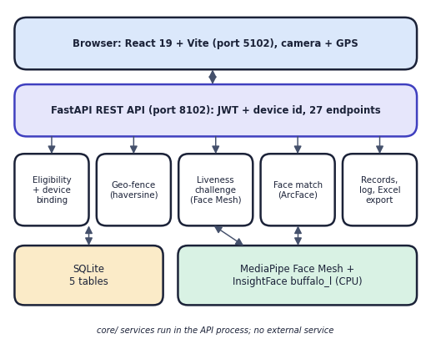
Fig. 1. System architecture of Attendance Magic.
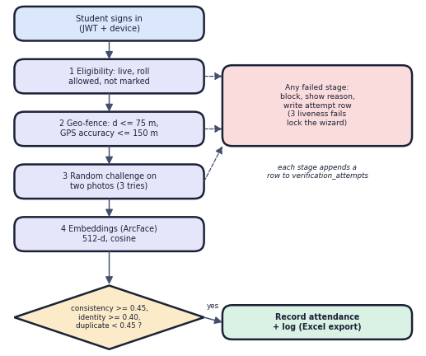
Fig. 2. Main check-in flow with deployed thresholds.
B. Eligibility, Device Binding and Security
A check-in starts only if the session is live, the signed-in user is a student whose roll number matches a faculty pattern, no record exists yet and the device has not marked another roll in the session. The device hash is a SHA-256 of the user-agent, language and client-hint headers plus a browser identifier; a student may bind one device. Passwords use PBKDF2-HMAC-SHA256 with 200,000 iterations [17]; the session token is a JWT [16] carrying the device hash and is rejected from any other device.
C. Geo-Fence
The distance between the reported fix (φ₂, λ₂) and the session centre (φ₁, λ₁) is the haversine distance [14] with R = 6,371 km:
d = 2R · asin √( sin²(Δφ/2) + cos φ₁ cos φ₂ sin²(Δλ/2) ) (1)
A fix is accepted if d ≤ r + 15 m, where r is the faculty radius (default 60 m), and the reported GPS accuracy is at most 150 m.
D. Random Live Challenge
The server draws one of eight challenges: turn left or right, look up or down, tilt left or right, open the mouth or close the eyes. The student takes a neutral photo and a challenge photo. Face Mesh landmarks give the yaw, the pitch, the roll and the mouth and eye aspect ratios; for example
yaw = (x_{nose} − x_{L}) / (x_{R} − x_{L}) − 0.5 (2)
The neutral photo must contain one face with |yaw| ≤ 0.10 and a mouth aspect ratio MAR ≤ 0.25. The challenge passes if the change from the neutral photo reaches the threshold: |Δyaw| ≥ 0.12, Δpitch ≥ 0.08, Δroll ≥ 12°, MAR ≥ 0.35 or eye aspect ratio EAR ≤ 0.18. The liveness score is min(1, measured/threshold). A failure issues a new random challenge, and three failures lock the wizard.
E. Identity and Duplicate Check
Both photos are embedded and L2-normalised; similarity is the cosine, s = e₁ · e₂. Exactly one face is required in each photo (a second face is tolerated only if narrower than half the largest). Three tests must pass: the two photos show the same person (s ≥ 0.45), the live face matches the enrolled reference (s ≥ 0.40), and the maximum similarity to any other embedding recorded in the session stays below 0.45, so one person cannot mark two rolls. The decision is a deterministic threshold rule, chosen so that every refusal can be explained to the student; the thresholds are calibrated in Section IV.
F. Decision Rule and Operating Point
Taking a check-in as accepted only when all stages pass, the decision can be written as
A = E ∧ (d ≤ r + 15) ∧ L ∧ (s_{c} ≥ 0.45) ∧ (s_{id} ≥ 0.40) ∧ (max_{j} s_{j} < 0.45) (3)
where E is eligibility, L the challenge outcome, s_c the frame-consistency similarity, s_id the identity similarity and s_j the similarity to the j-th embedding already recorded in the session. A conjunction can only lower acceptance, so each added stage trades a possible retake for a closed route to a proxy. The two similarity thresholds are checked against the LFW protocol in Section IV-B. The duplicate threshold is the higher one: two photographs of the same person score far above it (a repeated photograph scored 1.00 in the demonstration), whereas two different people scored near zero (impostor mean 0.004).
G. Application and Implementation
The 27 endpoints fall into four groups: health, configuration, statistics and QR generation; authentication (login, registration with a reference face, token check); faculty routes for sessions, dashboard, students, export and device reset; and the student wizard (state, start, location, neutral photo, liveness, face, retake, reset). The wizard state is kept on the server for each student, so a client cannot skip a stage, and eligibility is checked again immediately before the record is written. A unique constraint on (session, student) makes a second record impossible even if two requests race. A session is upcoming, live, expired or closed according to its window and a close flag; times are stored in UTC and shown in Asia/Kolkata. Every stage writes a row with its reason to the log, and the Excel export has three sheets: summary, attendance and verification log. All thresholds live in one configuration file and can be overridden through the environment. A weakness we keep is the placeholder default for the token-signing secret, which must be replaced before a real deployment.
The design follows three choices. Deterministic thresholds on landmarks and cosine similarity were preferred to a learned spoof classifier because every refusal can then be explained to the student and no spoof data set is needed. Pre-trained embeddings were preferred to per-student training because one reference photo suffices and adding a student needs no retraining. A thin API over a service layer was preferred because the same services also serve the original Streamlit interface, which is kept and covered by two interface tests.
IV. RESULTS
A. Test Conditions
No model was trained, so there is no training split; the figures evaluate pre-trained components inside the product's own functions. Identity thresholds were measured on the LFW verification protocol [9]: 6,000 pairs over 7,701 images. The product rejects an image unless it has exactly one face, which dropped 1,208 images (15.7%) and left 4,307 scored pairs (2,141 genuine, 2,166 impostor). LFW images are cropped press photographs, not selfies, so the retake rate on real phone selfies was not measured. No live person or camera took part: liveness was studied with still photographs only.
Every measurement can be repeated: one script per experiment (verification, liveness, photo-bank attack, geo-fence and latency) writes a JSON file next to the documentation, the thresholds are read from the same configuration the product uses, and the random seed of the neutral-frame sample is fixed (7). The LFW archive is downloaded separately and is not redistributed. Latency figures come from 40 repetitions per stage on the machine described in Section I-A.
B. Identity and Duplicate Thresholds
TABLE II
MEASURED RESULTS (CPU ONLY, LFW STILLS)
Measure | Result
Identity AUC / EER (threshold 0.19) | 0.9992 / 0.30%
10-fold accuracy (LFW protocol) | 99.82% ± 0.22
At 0.40 (identity): TAR / FAR | 98.69% / 0.00%
At 0.45 (duplicate): TAR / FAR | 97.15% / 0.00%
Largest impostor similarity | 0.246
Neutral frames accepted (1,000 LFW images) | 32.9%
Static photo, tilt/turn/look/mouth | 0% pass
Static photo, close eyes | 8.2% pass
Rotated photo, tilt, ≥ 15° | 98-99% pass
Photo-bank attack, full chain | 48.7-95.5%
Haversine error vs Vincenty | 0.47% (0.35 m at 75 m)
AI time per check-in, p50 / p95 | 368 / 525 ms
Server time after sign-in, p50 / p95 | 564 / 806 ms
Tests: pytest / API smoke | 23 / 23; 41 / 41

The genuine similarities averaged 0.673 (SD 0.107) and the impostor similarities 0.004 (SD 0.058). At the deployed identity threshold of 0.40 no impostor pair of 2,166 was accepted, since the largest impostor score was 0.246, while 1.3% of genuine pairs would need a retake. At 0.45 a second roll marked with the same person's face is caught in 97.2% of cases; the remaining 2.8% pass undetected. The thresholds are therefore conservative against the EER point of 0.19, trading some retakes for safety (Fig. 3a).
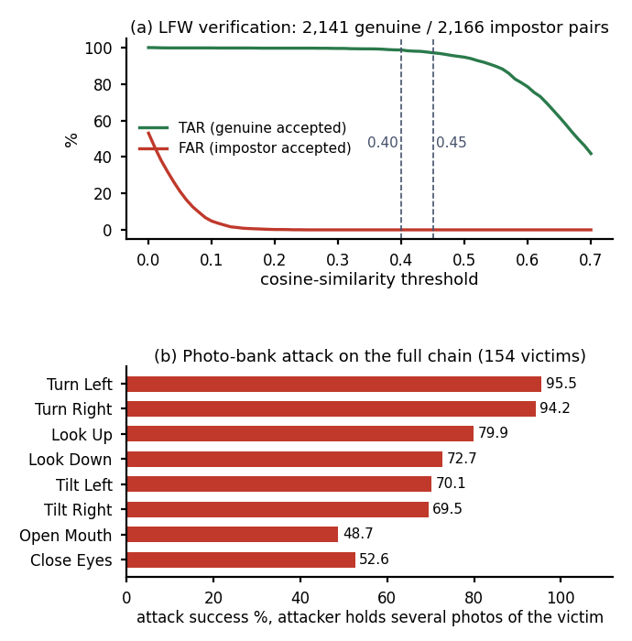
Fig. 3. (a) Genuine and impostor acceptance against threshold; (b) photo-bank attack success.
The one-face rule explains the dropped pairs: 1,197 images contained more than one face and 11 none. This matters for deployment because a retake is the only cost, but the retake rate on real selfies is unknown. When the same person was photographed differently in the interface run, identity similarities were 0.59 to 0.86, comfortably above 0.40. Embedding an image took a mean 281 ms (p95 547 ms) while other jobs loaded the machine and a median of 176 ms on a lightly loaded one.
C. Liveness and Attacks
Of 1,000 random LFW images, 32.9% satisfied the neutral-frame rule (499 were not frontal, 92 had several faces, 79 an open mouth), which is a property of press photographs rather than of cooperating students. Replaying one photo as both frames failed every challenge except close-eyes, which 8.2% of photos passed because the eyes were already closed. Two attacks defeat the check. Rotating a photo on screen changes the measured roll by exactly the rotation: rotations within ±10° passed 0% of the time, 12° passed 51% and 15° or more passed 98-99% of tilt challenges. Second, an attacker who holds several photos of the victim in different poses can choose the pair that fits the challenge; against the full chain, including frame consistency and a held-out enrolled photo, 154 victims with at least ten photos were passed in 95.5% (turn left), 94.2%, 79.9%, 72.7%, 70.1%, 69.5%, 48.7% and 52.6% of trials (Fig. 3b) with up to five neutral candidates. These are public figures with many photographs, so an ordinary student is probably safer, but the result shows that a random challenge stops a single stolen photo, not a prepared bank. Because the challenge is random and three tries are allowed, an attacker still needs the easy challenge to be drawn. The genuine-user pass rate was not measured.
On the neutral frames that passed, the measured yaw had mean 0.001 and SD 0.053, the pitch 0.354 (SD 0.055), the roll −0.9° (SD 6.9°), the mouth aspect ratio 0.095 (SD 0.086) and the eye aspect ratio 0.283 (SD 0.069). The tilt threshold of 12° is therefore about 1.7 standard deviations of the roll spread across neutral photographs, so a deliberate tilt is detectable while a modest rotation of a photo is also enough to reach it. The close-eyes threshold of 0.18 lies well below the natural eye aspect ratio of 0.283, which is the margin that keeps open eyes from passing.
D. Geo-Fence and Performance
The boundary sweep accepted every distance up to 75 m and refused from 80 m; a GPS accuracy of 150 m was accepted and 151 m refused. Real phone GPS error was not measured. A simulation with Gaussian error of 10 m per axis accepted a student at 60 m in 92.3% of trials and one at 100 m in 0.5%; at 20 m error these became 72.3% and 8.5%, so indoor drift can turn honest students away and the faculty radius should allow for it. The haversine distance differs from Vincenty by a constant 0.47%. Of the check-in, InsightFace embedding dominates at 176 ms (p50) per photo; a 5,000-face duplicate scan takes 41 ms. Model loading is 0.81 s for Face Mesh and 1.55 s for InsightFace. Latency was measured in-process, so network time is excluded; no concurrency test was done.
Through the API on the same machine (in-process client, 40 complete check-ins, p50 / p95), login took 105 / 123 ms, the eligibility step 12.6 / 14.8 ms, the location step 8.0 / 9.8 ms, the liveness step with two uploads 23.1 / 26.6 ms and the face step including the record 521 / 759 ms, so the face stage, which contains two embeddings and the duplicate scan, accounts for about nine tenths of a check-in. The challenge mathematics itself costs 4 microseconds. The duplicate scan grows linearly with the session: 0.14 ms for 10 faces, 5.7 ms for 500 and 11.9 ms for 1,000. A loaded machine raised the InsightFace median to 277 ms, so the timings should be read as indicative.
E. Testing and Output Screens
The pytest suite (23 tests) and the end-to-end API smoke test with the real models (41 checks) all passed. In a scenario matrix of ten cases one genuine check-in passed and nine proxy attempts were stopped at the intended stage: a repeat mark, a student 556 m away, a static photo, another person's face, one face under a second roll, a roll not on the list, a second device, a token used from another device and three failed challenges. Fig. 4 shows the success screen of a real session run (distance 8 m, liveness 1.00, identity 0.86) and Fig. 5 a refused attempt with the reason given and two tries left. The faces in the screens are LFW stand-ins, since no student photographs were stored.
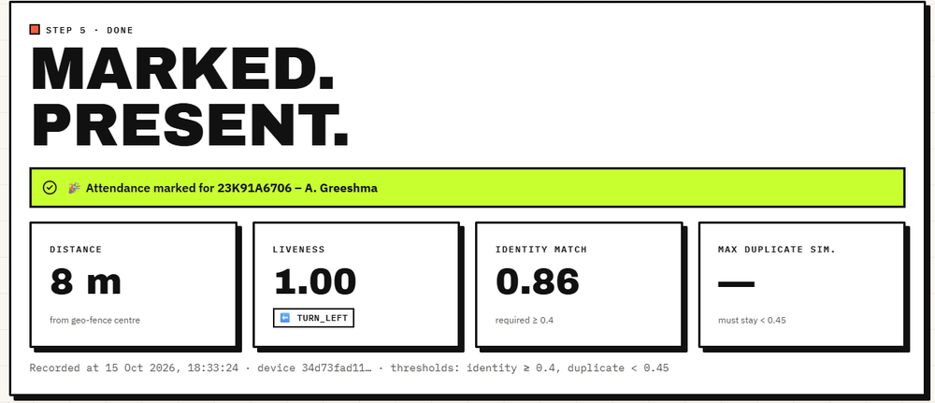
Fig. 4. Check-in success: distance, liveness and identity scores.
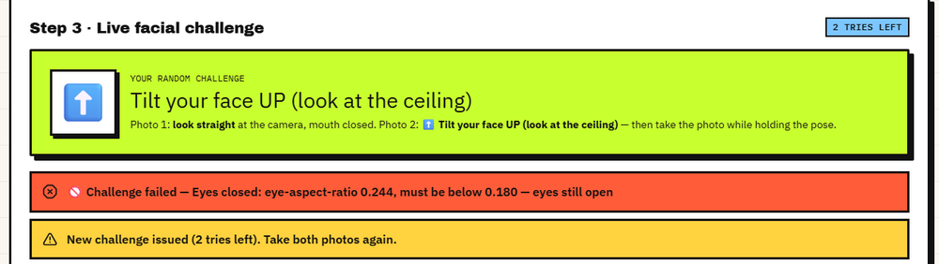
Fig. 5. Refused challenge with reason and tries left.
In the interface run with two sessions, the closed session CS601 recorded 4 of 4 students present and 4 blocked attempts (outside the fence, a static photo, a duplicate face and a roll not allowed); the live session CS604, with an explicit list of five rolls, had 3 present, 7 blocked attempts and 30 checks logged. A failed liveness stage fails closed: the student sees the measured value and the required value, for example an eye aspect ratio of 0.244 against 0.180, and receives a new challenge.
Failure cases follow from these numbers. A genuine student can be turned away by a one-face rule (a second face wider than half the largest, or none), by an eye aspect ratio that stays above 0.18 when the eyes are not shut firmly, by GPS drift near the fence edge, or by a similarity below 0.40, which affected 1.3% of genuine LFW pairs. In every case the screen states the measured value and the limit and issues a retry; after three failed challenges the wizard locks and the student starts again. An attacker is stopped by a single stolen photograph (in seven of the eight challenges), by a second device, by a forwarded link without a matching roll and device, and by a second roll marked with the same face, but not by the two attacks of Section IV-C.
F. Comparison with the Base Paper
The base paper [1] reports 92-95% accuracy on its own classroom images with a Haar and LBPH pipeline; this work reports verification on LFW pairs with ArcFace embeddings. The datasets, protocols and tasks differ, so no number here is claimed to beat theirs. The comparison is of scope: [1] answers who the face is, whereas this system also checks presence, location, liveness and duplicates and measures its own weaknesses. Observed limits are the 15.7% of LFW images that the one-face rule rejects, the tilt and photo-bank attacks, simulated rather than field GPS, a single-process SQLite server and no user study.
V. CONCLUSION
Attendance Magic turns attendance into a time-bound, geo-fenced session in which a student must be eligible, inside the fence, respond to a random facial challenge and match an enrolled face that no one else has already used. Against the six objectives, all stages are implemented, tested (23 of 23 tests, 41 of 41 smoke checks) and logged, and a check-in needs about 0.56 s of server time after sign-in on a CPU. The main finding is double: the identity thresholds separate people cleanly on LFW (AUC 0.9992, no impostor accepted at 0.40), yet the liveness challenge is only as strong as the attacker's photo collection, and a rotated photo defeats the tilt challenges. Other limits are the absence of a live-person trial, field GPS data, HTTPS phone tests and load tests.
Objectives against outcomes: time-bound geo-fenced sessions, JWT with device and roll restrictions, the GPS check, the random liveness challenge, the duplicate-identity check and the summaries with Excel export are all implemented and were exercised end to end. What is not shown is equally clear: that genuine students pass the challenges at an acceptable rate, that phone GPS behaves as the simulation assumes, and that the system survives many simultaneous check-ins.
Practical use follows from the findings. The face thresholds can stay as deployed; the tilt challenges should be dropped or paired with a screen-reflection check; the radius should be set above the expected GPS error of the room; and the system should be treated as one layer, with spot roll calls for sessions that matter.
Future work: texture or depth anti-spoofing and a live video challenge; removing tilt challenges or checking for screens; a user study measuring genuine pass rates and retakes; GPS-spoof detection and field calibration of the radius; and HTTPS deployment with a server database and load testing.
REFERENCES
[1] K. B. Dharmaraj, C. N. Dhanushree, H. V. Revanth, N. Shashank and P. M. Tejaswini, "Real-Time Student Face Recognition Attendance System Using AI," International Advanced Research Journal in Science, Engineering and Technology (IARJSET), vol. 12, no. 5, pp. 1067-1072, May 2025, doi: 10.17148/IARJSET.2025.125183.
[2] "A comprehensive review on face recognition, anti-spoofing liveness verification and automated dress code enforcement techniques for smart attendance framework," International Journal of Research Publication and Reviews, 2026.
[3] A. Shandilya and H. R. Shah, "Smart attendance framework using face recognition, anti-spoofing liveness verification and automated dress code enforcement," International Journal of Innovative Science and Research Technology (IJISRT), vol. 11, no. 6, Jun. 2026, doi: 10.38124/ijisrt/26jun403.
[4] "A classroom attendance system with anti-spoofing based on ResNet101 and ArcFace for face recognition," Journal of Intelligence and Knowledge Engineering, 2026.
[5] A. E. U. Salam et al., "Automatic attendance system using silent face anti-spoofing to detect spoof on face recognition," in Proc. 2025 Int. Conf. Smart Computing, IoT and Machine Learning (SIML), 2025, doi: 10.1109/SIML65326.2025.11081084.
[6] J. Deng, J. Guo, N. Xue and S. Zafeiriou, "ArcFace: Additive angular margin loss for deep face recognition," in Proc. IEEE/CVF Conf. Computer Vision and Pattern Recognition (CVPR), 2019, pp. 4690-4699.
[7] J. Guo, J. Deng, A. Lattas and S. Zafeiriou, "Sample and computation redistribution for efficient face detection," in Proc. Int. Conf. Learning Representations (ICLR), 2022.
[8] Y. Kartynnik, A. Ablavatski, I. Grishchenko and M. Grundmann, "Real-time facial surface geometry from monocular video on mobile GPUs," in Proc. CVPR Workshops, 2019, arXiv:1907.06724.
[9] G. B. Huang, M. Ramesh, T. Berg and E. Learned-Miller, "Labeled Faces in the Wild: A database for studying face recognition in unconstrained environments," Univ. Massachusetts Amherst, Tech. Rep. 07-49, Oct. 2007.
[10] T. Soukupova and J. Cech, "Real-time eye blink detection using facial landmarks," in Proc. 21st Computer Vision Winter Workshop, 2016.
[11] G. Pan, L. Sun, Z. Wu and S. Lao, "Eyeblink-based anti-spoofing in face recognition from a generic webcamera," in Proc. IEEE Int. Conf. Computer Vision (ICCV), 2007.
[12] Z. Yu, Y. Qin, X. Li, C. Zhao, Z. Lei and G. Zhao, "Deep learning for face anti-spoofing: A survey," IEEE Trans. Pattern Analysis and Machine Intelligence, vol. 45, no. 5, pp. 5609-5631, 2023.
[13] F. Schroff, D. Kalenichenko and J. Philbin, "FaceNet: A unified embedding for face recognition and clustering," in Proc. IEEE CVPR, 2015, pp. 815-823.
[14] R. W. Sinnott, "Virtues of the haversine," Sky and Telescope, vol. 68, no. 2, p. 159, 1984.
[15] T. Vincenty, "Direct and inverse solutions of geodesics on the ellipsoid with application of nested equations," Survey Review, vol. 23, no. 176, pp. 88-93, 1975.
[16] M. Jones, J. Bradley and N. Sakimura, "JSON Web Token (JWT)," RFC 7519, Internet Engineering Task Force, May 2015.
[17] K. Moriarty, B. Kaliski and A. Rusch, "PKCS #5: Password-based cryptography specification version 2.1," RFC 8018, Internet Engineering Task Force, Jan. 2017.
[18] S. Ramirez, "FastAPI documentation." [Online]. Available: https://fastapi.tiangolo.com
[19] M. Bayer, "SQLAlchemy," in The Architecture of Open Source Applications, vol. 2, A. Brown and G. Wilson, Eds., 2012.
[20] Meta Platforms, "React documentation." [Online]. Available: https://react.dev

