SYMPTOTRACKAI: HYBRID RAG BASED SYMPTOM TRACKING AND HEALTH MONITORING SYSTEM
Results
Department of Computer Science and Engineering, TKR College of Engineering & Technology
Batch C12 (CSE-C) · Academic year [ACADEMIC YEAR]
Table 1: Project team
S.No. | Student name | Roll number
1 | Mariyada Karthika Reddy | 23K91A05E9
2 | Nacharam Akshaya | 23K91A05G6
3 | Madoori Prabath Teja | 23K91A05D6
4 | Pulimadhi Keerthan | 23K91A05K1

Project guide: Dr. Ch. B. Naga Lakshmi
Chapter and section numbers quoted in the text (for example Chapter 8 or Section 6.2) refer to the full project report, 17.Final Document. Figures and tables in this document are numbered from 1.

1. RESULTS AND OUTPUT SCREENS
This chapter reports what was measured and what the running application shows. Section 8.1 describes the set-up, Section 8.2 presents every output screen, Sections 8.3 to 8.9 give the quantitative results (retrieval accuracy, ablation, the relevance display, generated text, the safety layer, speed and tests), Section 8.10 compares the work with the base paper, and Sections 8.11 to 8.13 give sample output, success and failure analysis, the limits of the evaluation and the outcome against each objective. Where a result is weak it is reported as weak.

1.1 Experimental set-up
All measurements were made on one machine: 12th Gen Intel Core i5-12500 (6 cores / 12 threads), no GPU, 15.7 GB of memory, Windows, Python 3.11.9, PyTorch 2.14.1+cpu, transformers 5.20.2, sentence-transformers 6.2.0, FAISS 1.15.1, scikit-learn 1.9.1, FastAPI 0.159.1. No GPU was used. The three models are sentence-transformers/all-MiniLM-L6-v2, cross-encoder/ms-marco-MiniLM-L-6-v2 and google/flan-t5-small; retrieval takes a candidate pool of 15 records, fuses semantic and lexical scores with weights 0.65 and 0.35, and keeps the top 5 after reranking.
Data. The knowledge base holds 176 records for 30 conditions (3.98 symptoms per record, a vocabulary of 97 symptom phrases). It is synthetic: scripts/prepare_data.py writes 30 hand-typed condition entries with up to six random symptom subsets each, and all records of a condition share one description and one guidance text (only 30 distinct description-guidance pairs exist). No public dataset and no clinical review were involved, so every accuracy below measures how well the pipeline finds the right entry in this small table, not how well it recognises disease.
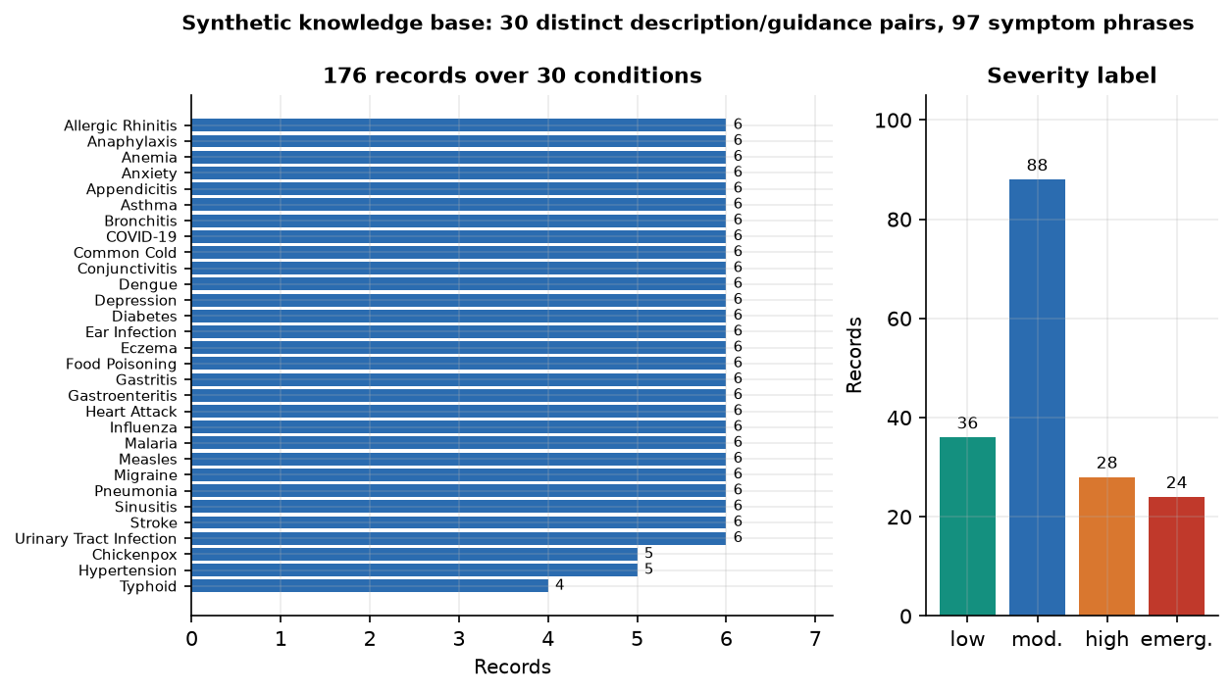
Figure 1: Composition of the knowledge base: records per condition and severity labels (synthetic data).
Query sets. Five query sets were used, because the choice of set changes the picture a great deal.
Table 2: Query sets used in the evaluation
Set | Queries | How they were made | Held-out handling
S1 shipped protocol | 30 | I have + the symptom list of one random record per condition (the protocol of scripts/evaluate.py, seed 7) | Held-out record remains in the index
S1 leave-one-out | 30 | The same 30 queries | Held-out record removed from both retrievers
S2 | 176 | Every record's own symptom list | Leave-one-out
S3 | 176 | Two random symptoms of each record (I have a and b) | Leave-one-out
S4 | 60 | Two everyday-language descriptions per condition written by the authors (not copied from the knowledge base) | Not needed

The S4 queries, 15 out-of-knowledge-base complaints, 40 emergency descriptions and 30 non-emergency texts were written by the project team, not by clinicians; they are small probe sets that exercise the pipeline and should be read as such. Accuracy is the share of queries whose first retrieved record belongs to the right condition (top-1); intervals are 95% Wilson intervals [34]. Top-3 and Top-5 count the first three or five retrieved records; MRR@5 is the mean reciprocal rank of the first correct record.

1.2 Output screens
The screens below were captured from the running application (Chrome, 1440 by 900 pixels, backend on port 8412 and React frontend on port 5412) using the demo account, with real queries sent through the real pipeline. The application is called CareLens AI on screen. Screens 07, 08, 09 to 12, 18, 19 and 20 were captured with the evidence-based fallback generator active, because the default local generator returns its own prompt in this software environment (Section 8.6); screen 21 was captured with the default generator and shows that defect. History rows are from the capture run only.
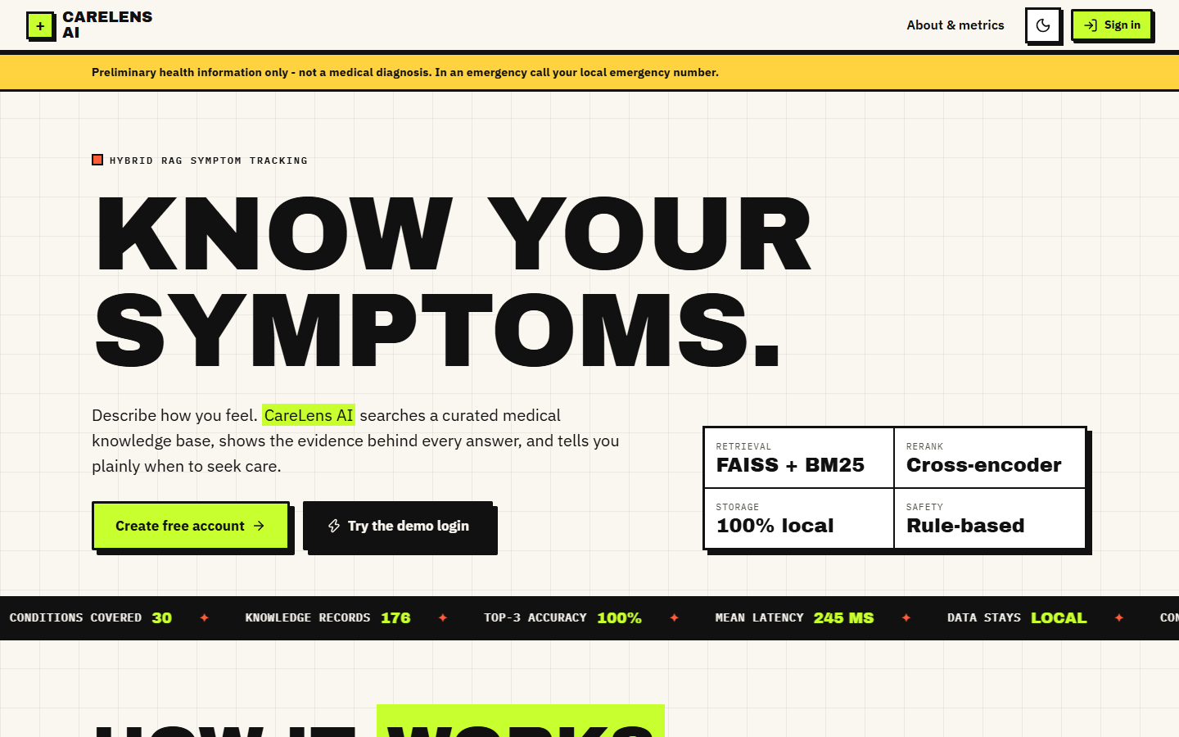  Figure 2: Landing page, light theme: product pitch and entry buttons. | 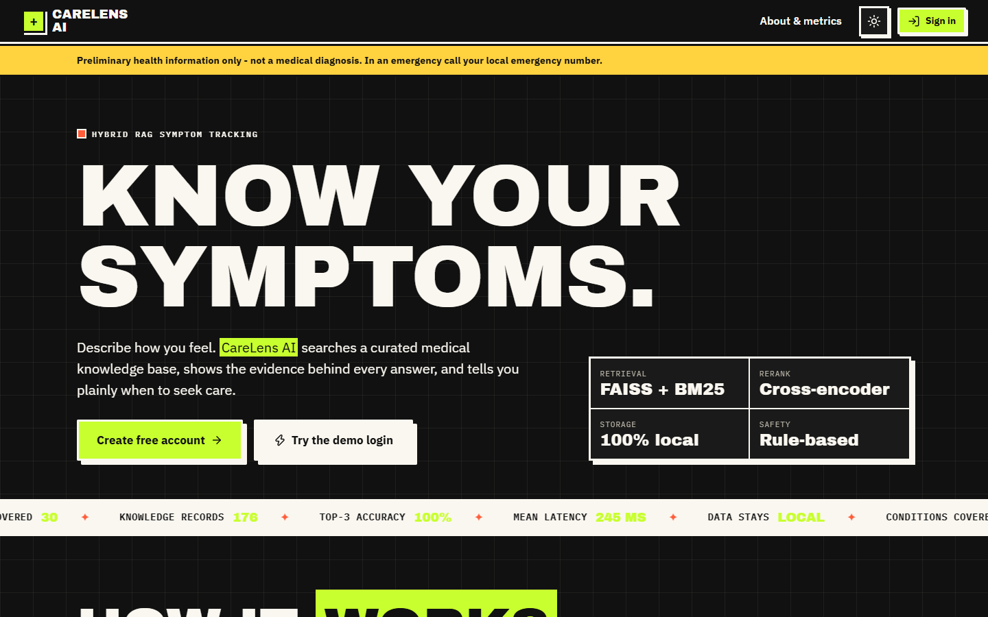  Figure 3: Landing page, dark theme.

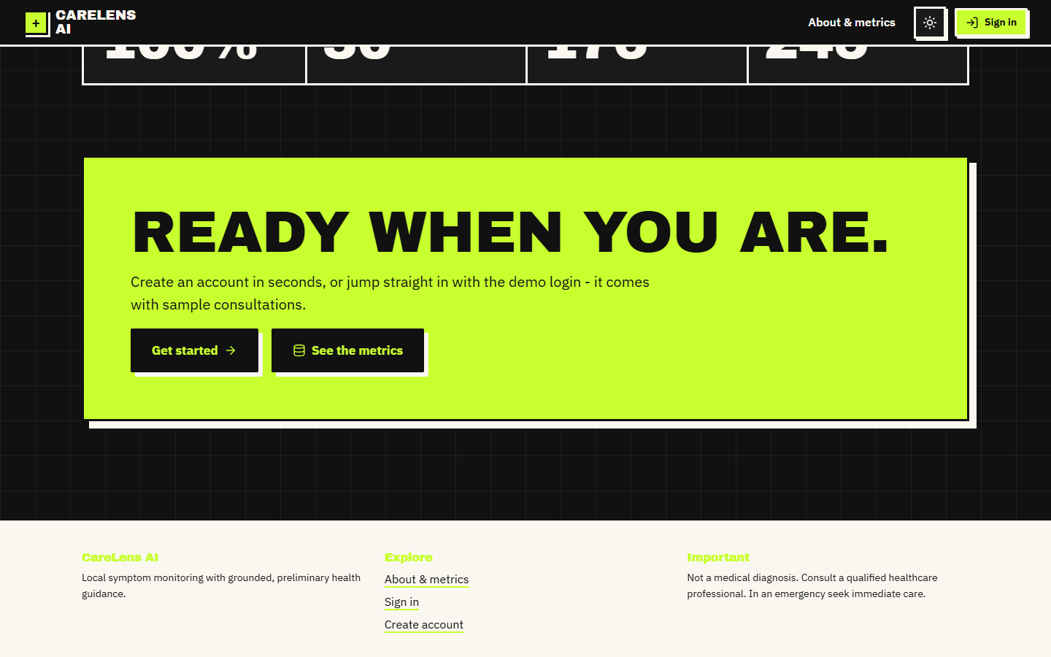  Figure 4: Bottom of the landing page (dark theme). | 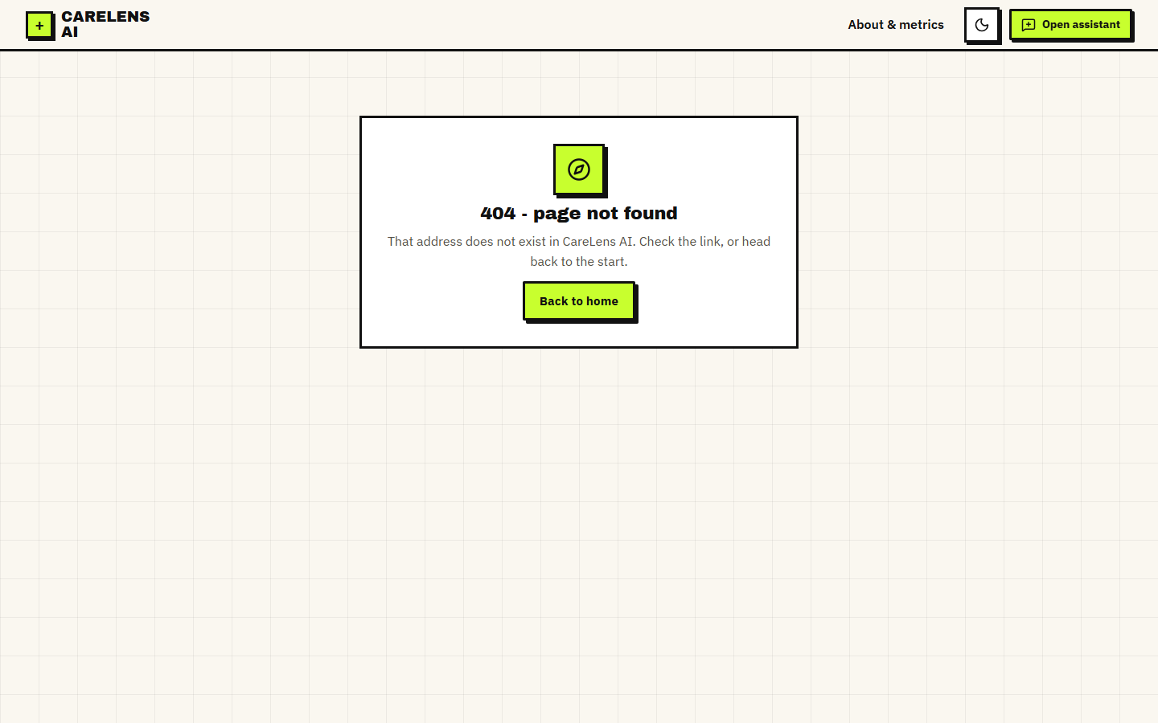  Figure 5: Unknown route: the 404 screen.

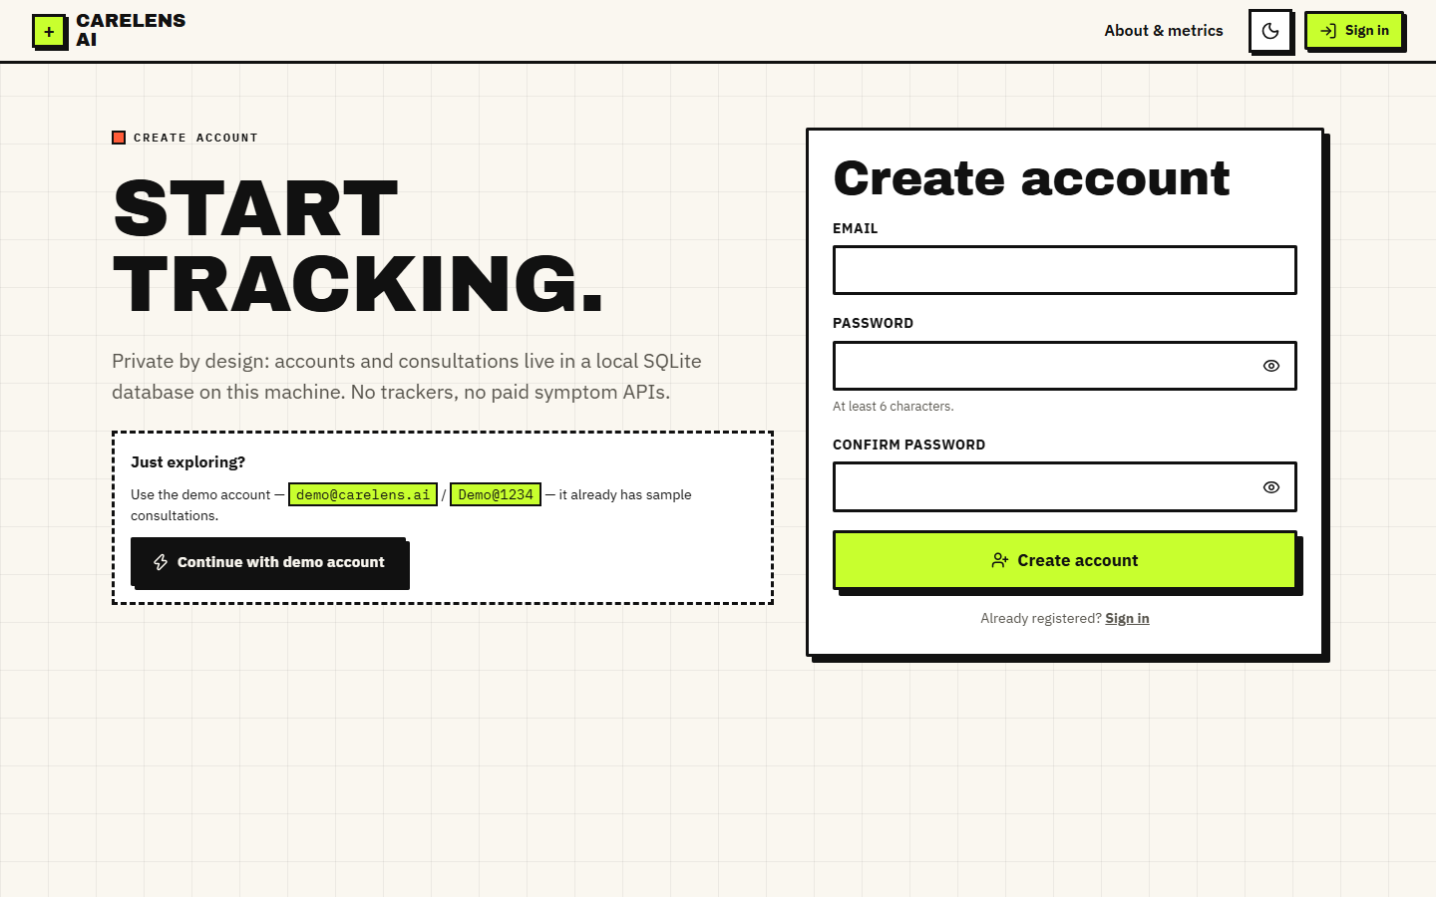  Figure 6: Create-account form (email and a password of 6 to 128 characters). | 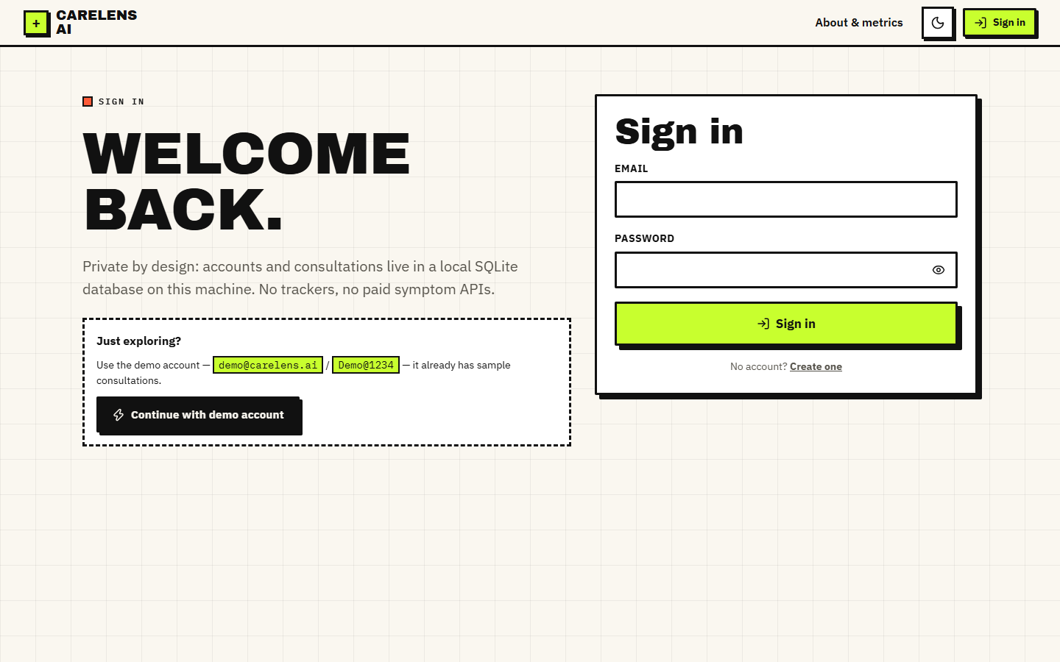  Figure 7: Sign-in form; the demo account is created automatically at start-up.

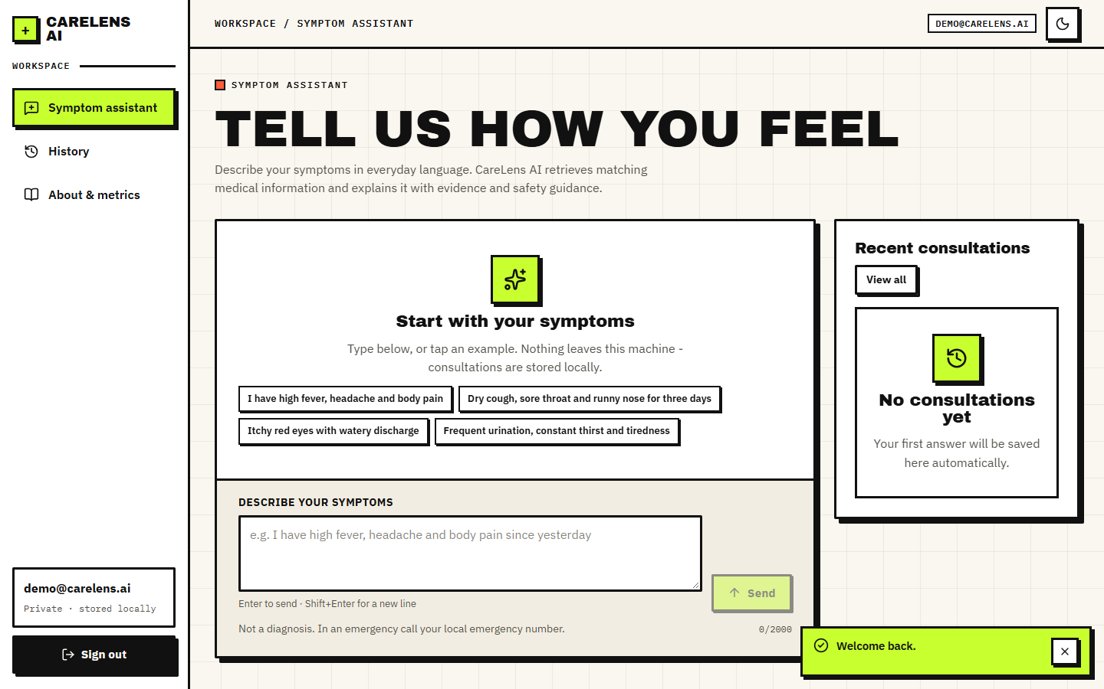
Figure 8: Symptom assistant before the first question: example chips, the consultation box and the permanent not-a-diagnosis line.
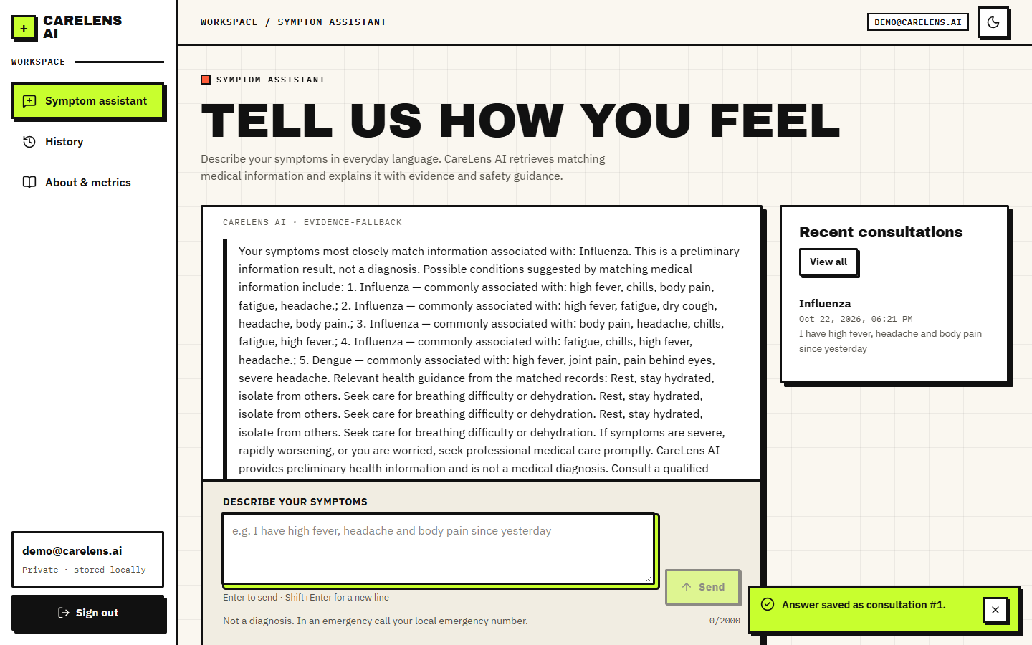
Figure 9: Answer to "I have high fever, headache and body pain since yesterday" (fallback generator): top condition Influenza, text assembled from the matched records. Note that the guidance sentence is repeated because several near-identical records matched.
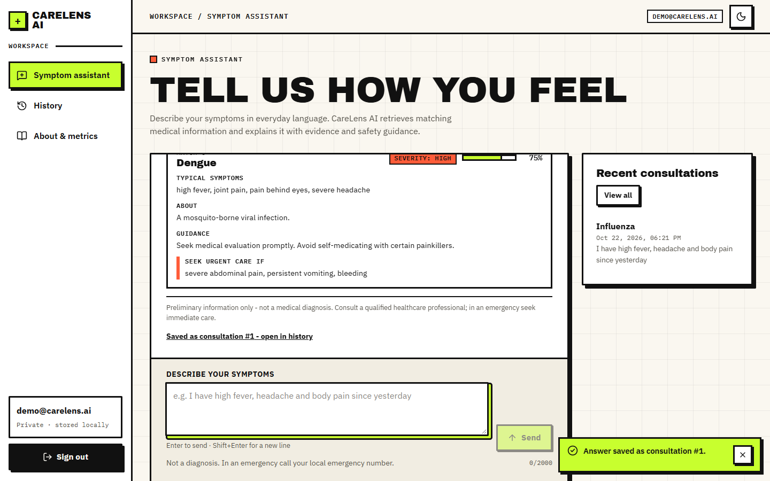
Figure 10: The same answer scrolled to the evidence cards: typical symptoms, description, guidance, severity badge, match bar and red flags per record. The fifth card is Dengue with a displayed match of 75%.
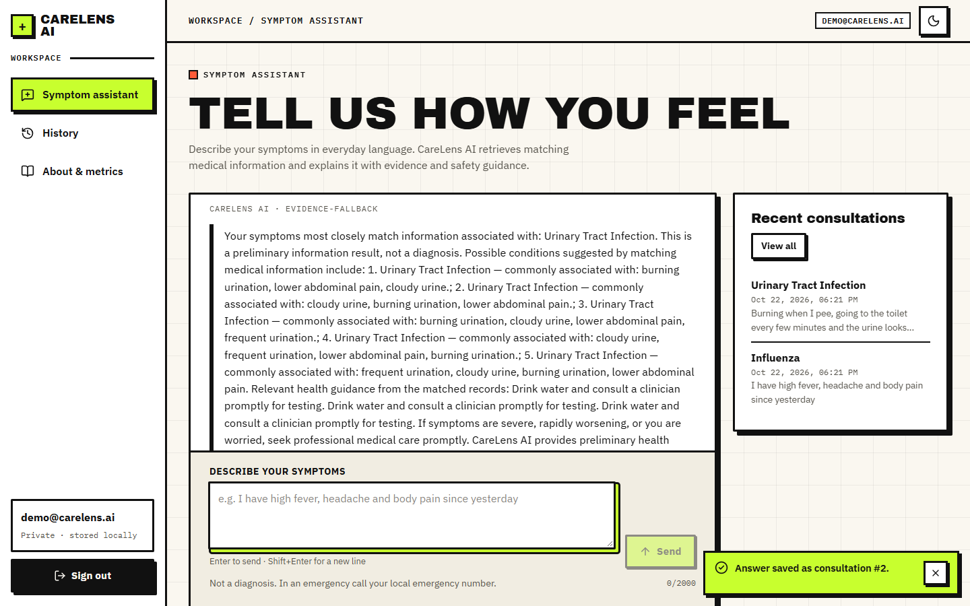
Figure 11: An everyday-language query ("Burning when I pee, going to the toilet every few minutes and the urine looks cloudy") retrieving Urinary Tract Infection.
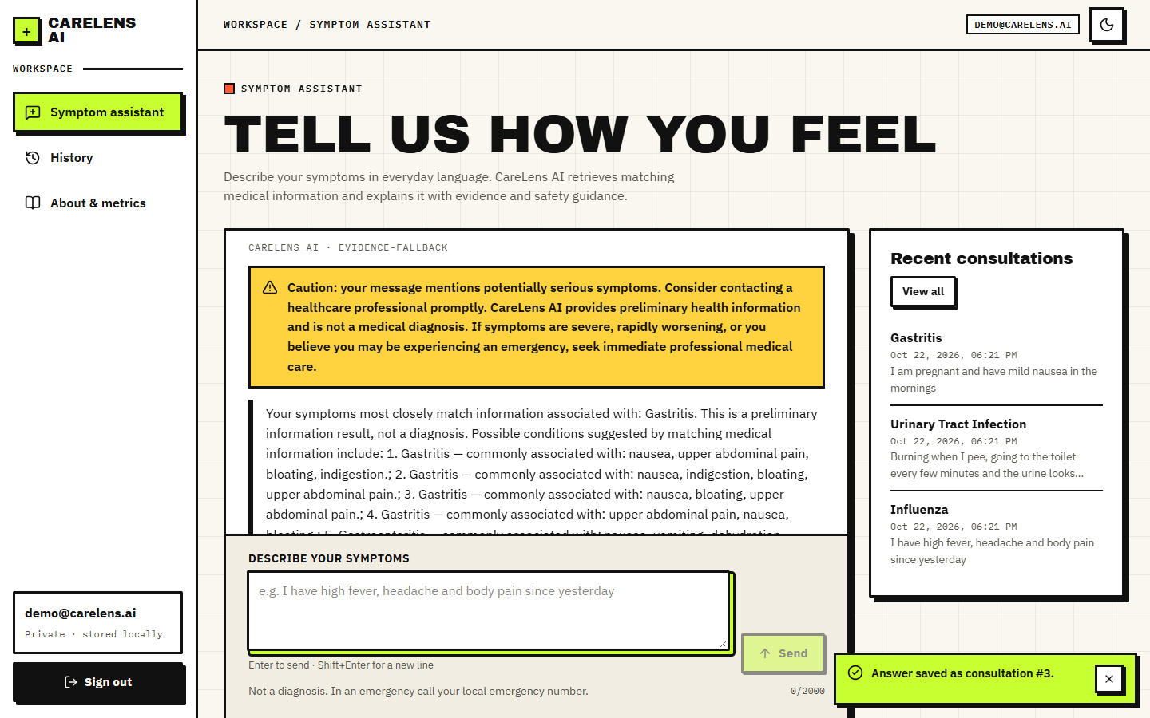
Figure 12: Caution banner (amber) for "I am pregnant and have mild nausea in the mornings": the word pregnant is a caution keyword; the top record is Gastritis.
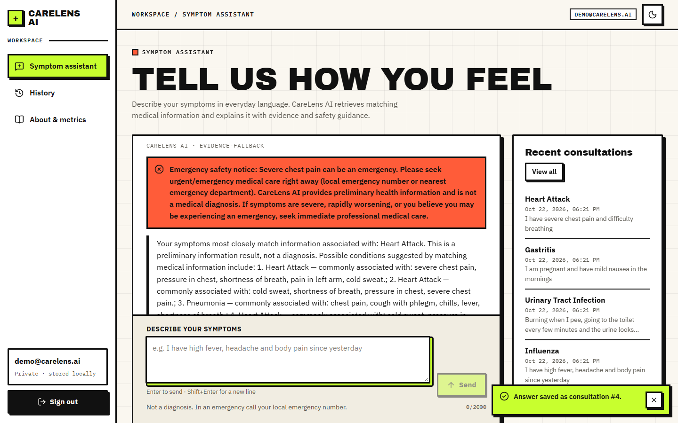
Figure 13: Emergency banner (red) for "I have severe chest pain and difficulty breathing": the rule layer prepends an urgent-care notice and the top record is Heart Attack.
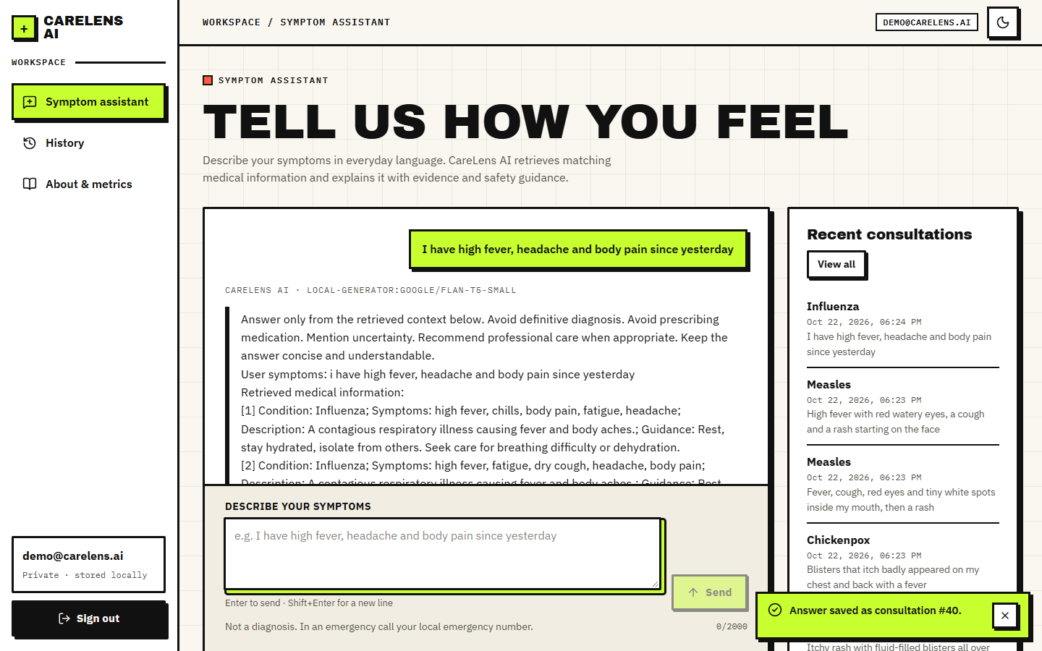
Figure 14: Failure case: with the default Flan-T5 generator the answer text is the prompt itself (instruction lines, User symptoms: and the retrieved records), labelled local-generator:google/flan-t5-small.
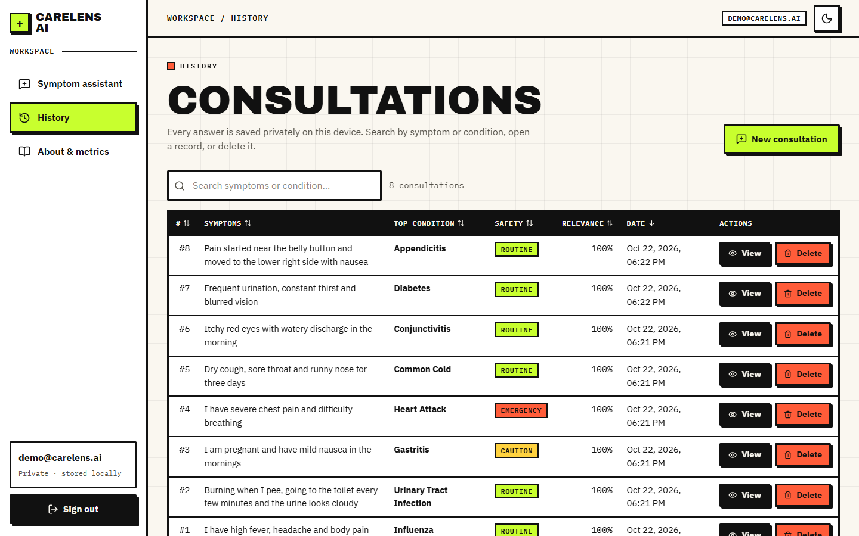
Figure 15: Consultation history: query, top condition, safety badge, displayed relevance (always 100% for the top record), date and view/delete actions.
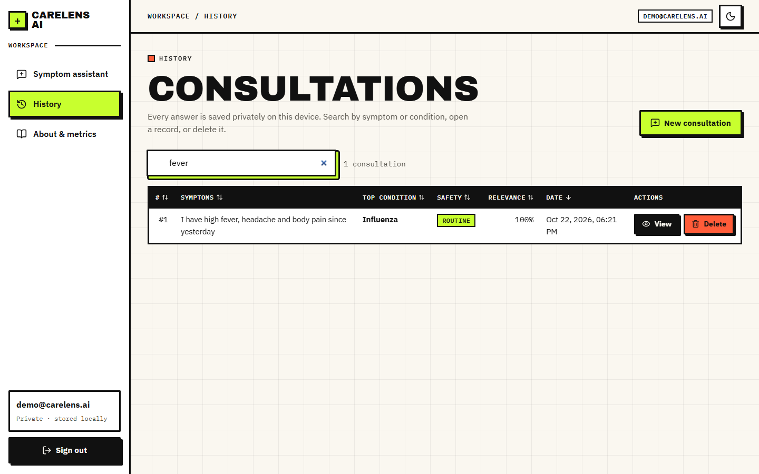
Figure 16: History filtered by the search term "fever".
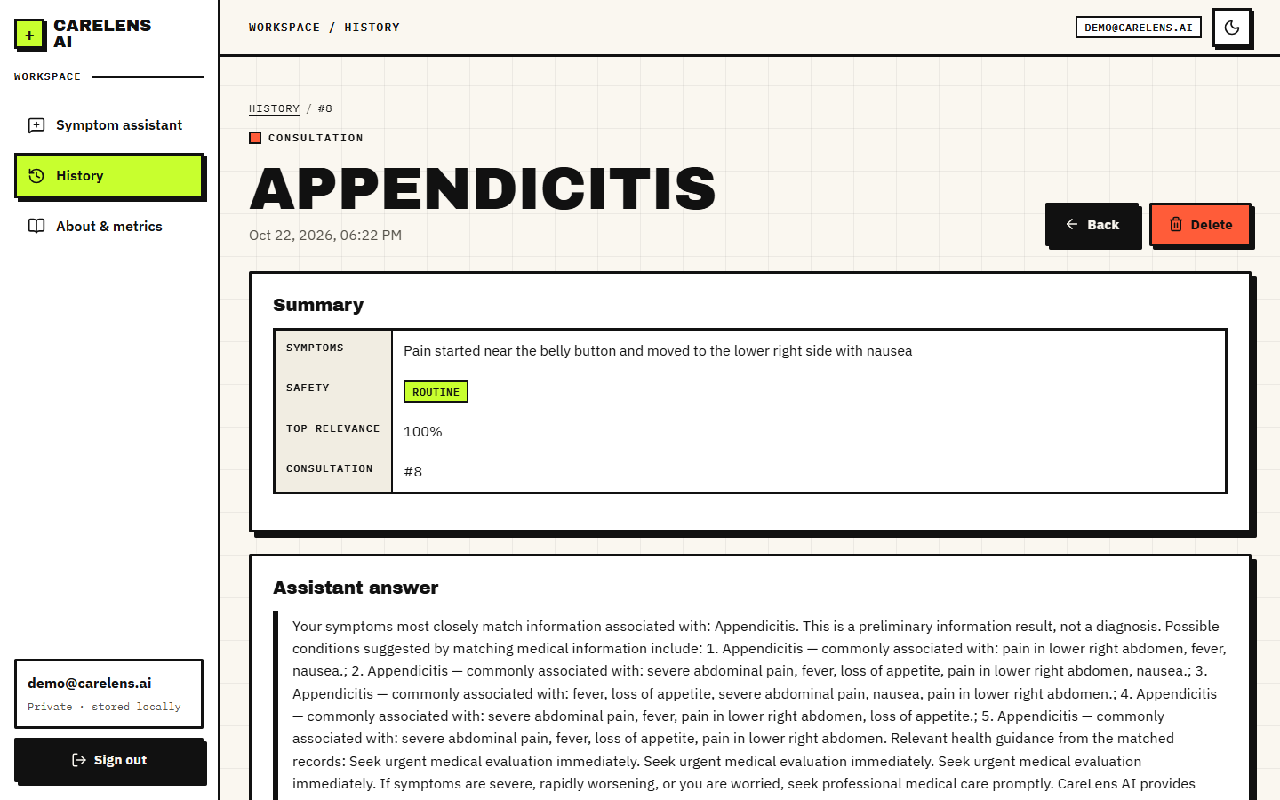
Figure 17: Saved consultation: summary table (symptoms, safety flag, top relevance, id) and the stored assistant answer, with back and delete buttons.
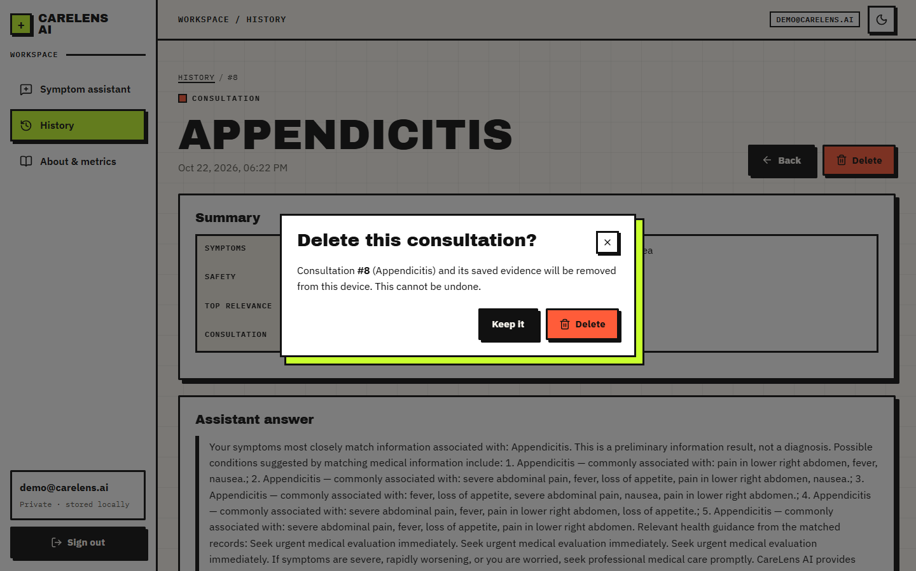
Figure 18: Confirmation dialog before a consultation is deleted.
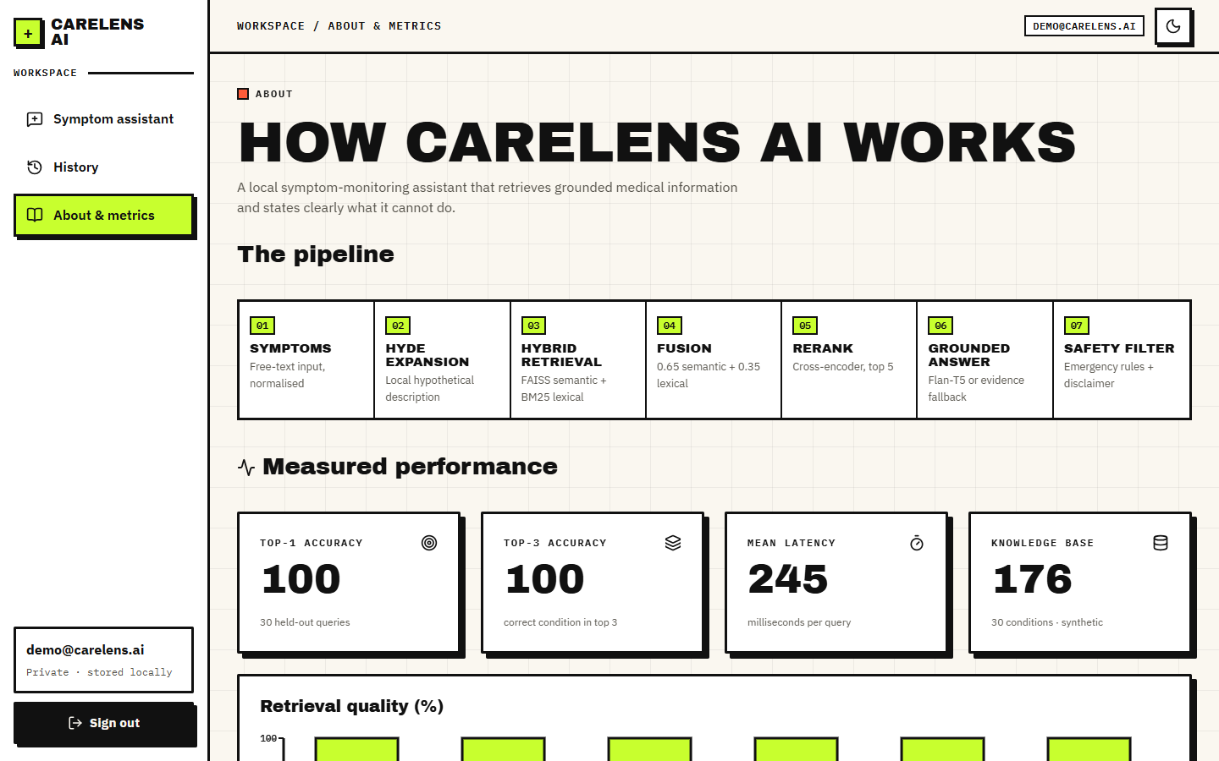
Figure 19: About page: the seven pipeline stages and the figures served from results/metrics.json (Top-1 100, Top-3 100, 245 ms, 176 records). These are the shipped evaluation's values; Section 8.3 explains why they are an upper bound, and the page itself adds that caveat further down.
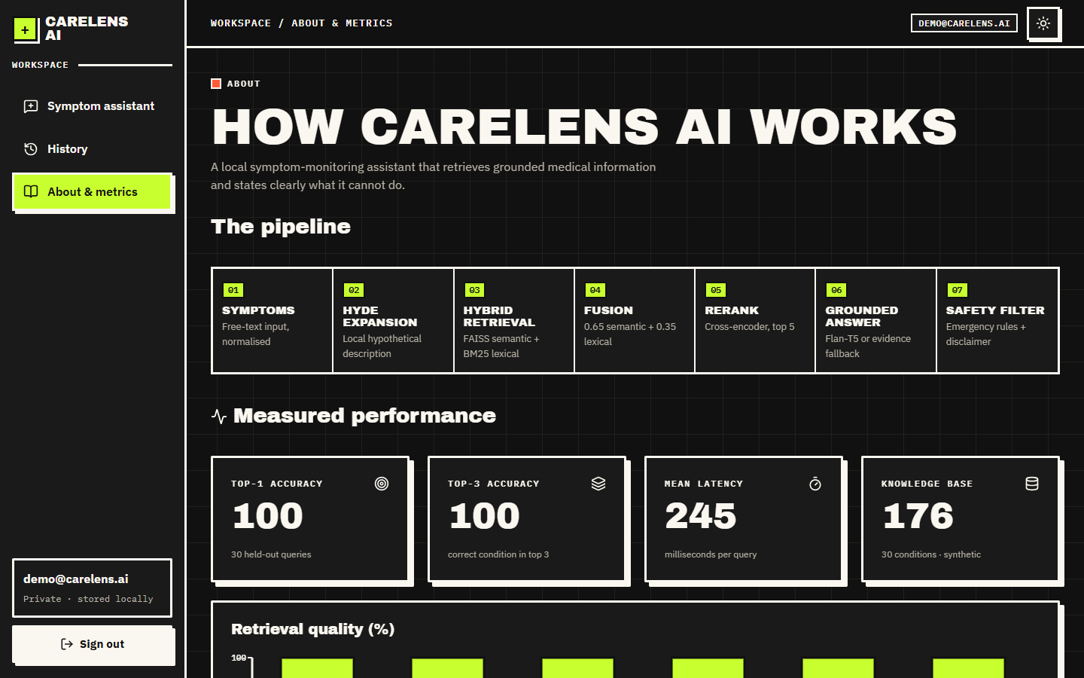
Figure 20: About page, dark theme.
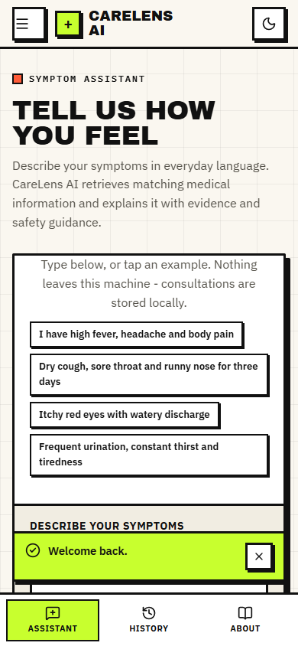  Figure 21: Assistant at phone width (390 pixels). | 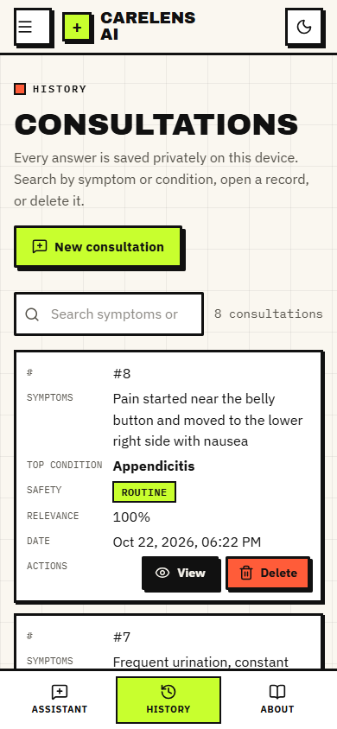  Figure 22: History as cards at phone width.

1.3 Retrieval accuracy of the shipped pipeline
The shipped configuration is hybrid fusion followed by the cross-encoder, with the HyDE-style expansion on. Table 8.2 gives its accuracy on the five query sets.
Table 3: Accuracy of the shipped pipeline (hybrid + cross-encoder) on the five query sets
Query set | n | Top-1 | 95% CI | Top-3 | Top-5 | MRR@5 | Misses
S1, shipped protocol (held-out record still indexed) | 30 | 100.0% | 88.6-100.0% | 100.0% | 100.0% | 1.000 | 0
S1, leave-one-out | 30 | 96.7% | 83.3-99.4% | 96.7% | 96.7% | 0.967 | 1
S2, every record verbatim, leave-one-out | 176 | 97.2% | 93.5-98.8% | 97.2% | 97.2% | 0.972 | 5
S3, two random symptoms, leave-one-out | 176 | 88.1% | 82.5-92.1% | 88.1% | 92.0% | 0.890 | 21
S4, lay-language probes | 60 | 96.7% | 88.6-99.1% | 98.3% | 98.3% | 0.972 | 2

1.3.1 The shipped 100% is an upper bound
scripts/evaluate.py holds one record per condition out of the test set but leaves it in the index, and its query is that record's own symptom list. Retrieval then finds the record itself, and the About page reports 100% for Top-1, Top-3, precision, recall, F1 and MRR on 30 queries. Reproducing that protocol gives 100.0%; removing the held-out record gives 96.7% on the same queries and 97.2% on all 176 records. The sibling records of the same condition remain in the index, so even leave-one-out is generous; the figure shows how the same pipeline falls as queries become less like the stored text.
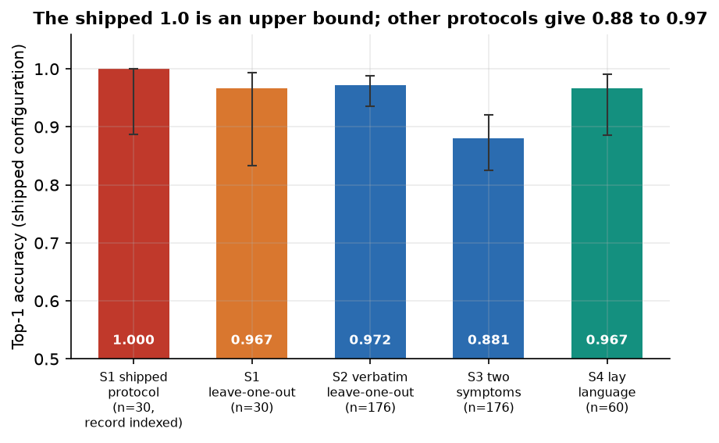
Figure 23: The shipped pipeline under four conditions: shipped protocol, leave-one-out, two-symptom queries and lay-language probes.

1.3.2 Failure patterns
On the lay-language probes the pipeline fails 2 times in 60: "My nose will not stop running and I have a slight cough, nothing serious" (true Common Cold, first record Allergic Rhinitis); "A slow-rising fever for days, feeling weak, no appetite, abdominal pain" (true Typhoid, first record Appendicitis). Both are confusions between conditions that share most symptoms. On two-symptom queries it fails 21 times in 176; the logged examples are "I have congestion and runny nose" (Common Cold read as Allergic Rhinitis); "I have headache and fatigue" (Influenza read as Migraine); "I have chills and headache" (Influenza read as Malaria); "I have fever and chills" (Pneumonia read as Malaria). Two symptoms such as headache and fatigue are shared by many conditions, so these misses reflect real ambiguity, and a single ranked answer hides it.
Per condition, the shipped pipeline answered both lay-language probes correctly for 28 of the 30 conditions, and missed at least one for Common Cold (1 of 2), Typhoid (1 of 2). Conditions with a distinctive symptom (a rash with blisters, loss of smell and taste, face droop with slurred speech) are found reliably; conditions that overlap with a close neighbour, such as a common cold and allergic rhinitis, or a prolonged fever and appendicitis, are where the first record can be wrong.
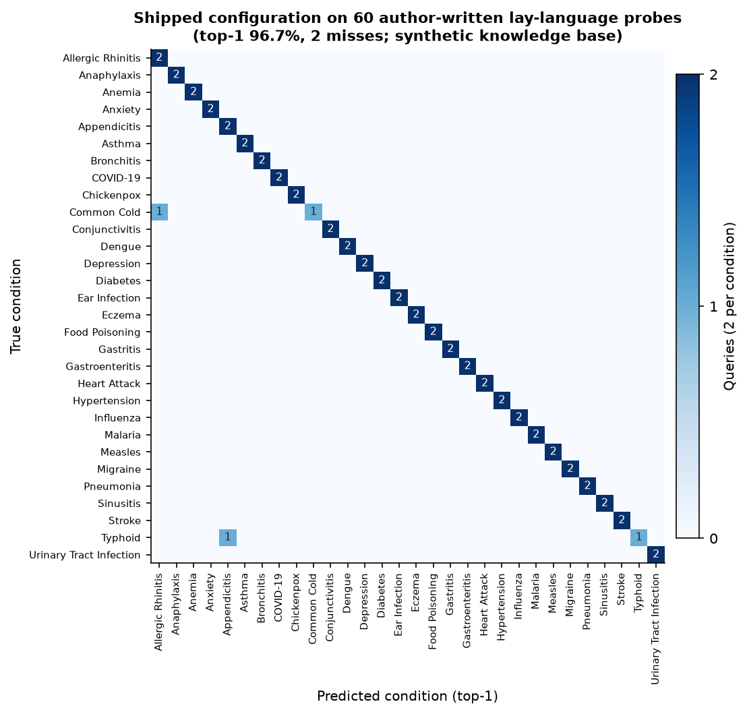
Figure 24: Confusion matrix of the shipped pipeline on the 60 lay-language probes (rows: true condition, columns: first retrieved condition).
The five evidence cards are not five different conditions: the mean number of distinct conditions among the five retrieved records is 1.2 on the lay probes and 1.483 on the two-symptom queries, because each condition owns four to six near-identical records. The "possible conditions" list is therefore not a differential diagnosis.

1.4 Ablation: what each stage contributes
The same query sets were run through seven configurations. The BM25 and dense paths use the same expanded query as the pipeline, so the table isolates retrieval and ranking rather than the interface.
Table 4: Top-1 accuracy by configuration (leave-one-out for S2 and S3)
Configuration | S2 (176) | S3 (176) | S4 (60) | S4 MRR@5
BM25 only (lexical) | 100.0% | 89.8% | 88.3% | 0.883
Dense only (MiniLM + FAISS) | 86.4% | 70.5% | 90.0% | 0.917
Hybrid fusion (0.65/0.35) | 96.6% | 85.8% | 90.0% | 0.908
Hybrid + cross-encoder (shipped) | 97.2% | 88.1% | 96.7% | 0.972
Shipped, without HyDE expansion | 99.4% | 89.8% | 100.0% | 1.000
Dense TF-IDF fallback | 100.0% | 89.2% | 76.7% | 0.779
Hybrid with TF-IDF fallback (offline mode) | 100.0% | 90.3% | 81.7% | 0.823

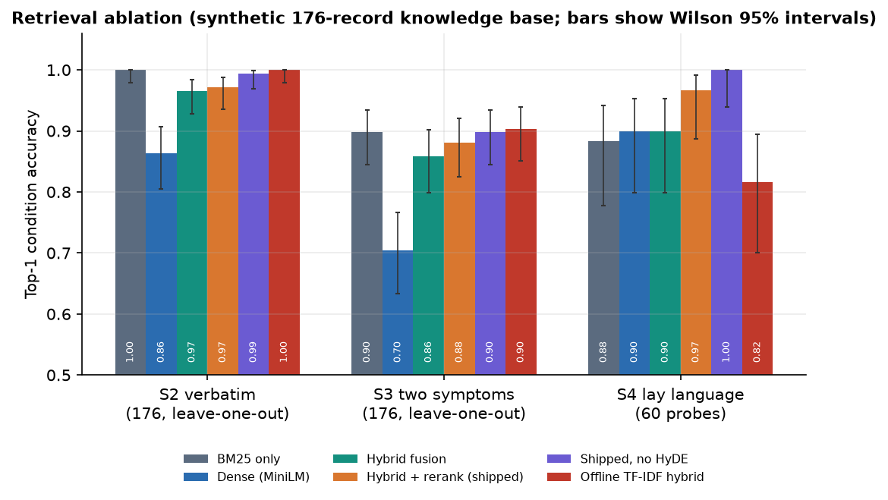
Figure 25: Top-1 accuracy of the seven retrieval configurations on the verbatim, two-symptom and lay-language query sets.
• Lexical matching is already strong on this data. BM25 alone reaches 100.0% on S2 and 88.3% on S4. The knowledge base was generated from short symptom phrases, so word overlap is a very good signal.
• Dense embeddings alone are weaker on verbatim text (86.4% on S2) but slightly better on lay language (90.0% on S4); fusion gives 96.6% and 90.0%.
• The cross-encoder helps on lay language (90.0% to 96.7%, a change of about 4 queries out of 60) and on two-symptom queries (85.8% to 88.1%), at a cost of several hundred milliseconds (Section 8.8).
• The HyDE-style expansion did not help. Without it the shipped pipeline scores 99.4% on S2, 89.8% on S3 and 100.0% on S4, against 97.2%, 88.1% and 96.7% with it. The expansion is a fixed template that wraps the user's words in generic medical phrasing; it adds no information, and the extra words dilute the query. The differences are small (a few queries) and the intervals overlap, so the honest reading is no measurable benefit rather than proven harm.
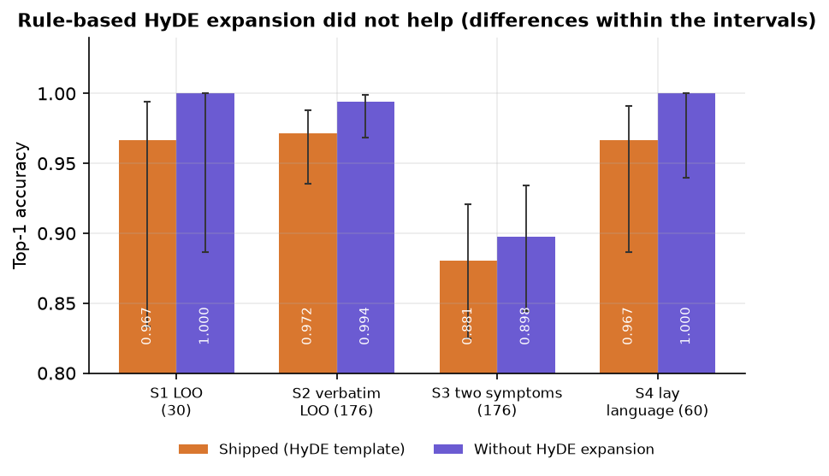
Figure 26: Effect of the HyDE-style expansion: the shipped pipeline with and without it on each query set.
Offline mode. When the sentence-embedding model cannot be downloaded the application falls back to TF-IDF vectors and skips reranking. That mode scores 81.7% on S4 and 90.3% on S3 (and 100.0% on verbatim S2): usable, and weaker than the full pipeline on paraphrased input (96.7%). The interface does not tell the user which mode is running.

1.5 The displayed relevance score
The match bar and the labels Strong, Moderate and Weak are computed by min-max normalising the cross-encoder scores of the 15 candidates, so the best candidate always receives 1.00 and a Strong label. The measurement confirms it: the top record had displayed relevance 1.00 in all 60 in-knowledge-base queries and in all 15 out-of-knowledge-base complaints, and all 15 of the latter were labelled Strong match (also through pipeline.answer: {'Strong match': 15}). The history screen shows 100% in every row for the same reason.
Table 5: Complaints with no matching condition in the knowledge base
Query | First record shown | Displayed | Raw rerank score
My tooth aches badly when I drink cold water | Common Cold | 100% Strong | -4.80
Sprained my ankle playing football, it is swollen and bruised | Anaphylaxis | 100% Strong | -5.99
Lower back pain after lifting heavy boxes | Appendicitis | 100% Strong | -5.69
My hair has been falling out in clumps | Depression | 100% Strong | -8.83
Knee pain when climbing stairs | Heart Attack | 100% Strong | -6.36
A bruise on my arm that is not healing | Heart Attack | 100% Strong | -6.13

The information needed to do better is present. The raw cross-encoder score of the top record averages 2.481 for in-knowledge-base queries (range -4.52 to 6.494) and -6.336 for out-of-knowledge-base ones (range -9.116 to -4.766); the area under the ROC curve for telling them apart is 1.0 with the raw rerank score and 0.9322 with the raw hybrid score. The normalisation throws it away. On this small set a threshold on the raw score would separate the groups perfectly; with only 15 out-of-knowledge-base queries that is encouraging but not a guarantee.
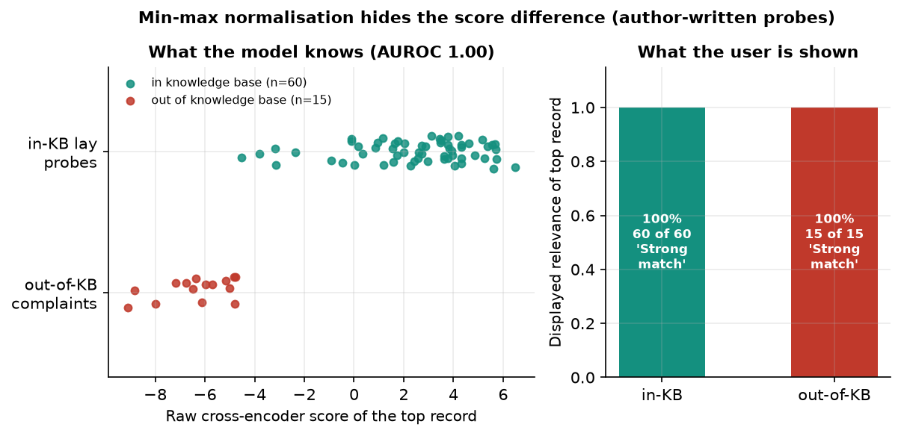
Figure 27: Raw cross-encoder score of the top record for in-knowledge-base and out-of-knowledge-base queries, against the constant displayed value of 100%.

1.6 Generated answer text
With the default configuration the generator returned the prompt, not an answer: 30 of 30 test queries (100%) produced text beginning with the instruction lines followed by the user's symptoms and the retrieved records. The cause is the installed library version: transformers 5.20.2 no longer provides the text2text-generation task (unavailable: KeyError), so the code falls back to the text-generation task, which for a T5 model returns its input. The answer is still labelled local-generator:google/flan-t5-small. Generation took 808 ms on average. The requirement file asks only for transformers>=4.38, so an older version would not show this behaviour; it was not tested here.
The evidence-based fallback, used when no generator can be loaded, builds the answer from the retrieved records in 0.031 ms. Every condition it names is one of the retrieved records (30 of 30 answers; true by construction). This gives structural grounding, since nothing outside the retrieved text can appear. It is not a synthesis: it lists the matched records and repeats their guidance sentence once per matching record (screens 07 and 11), it has no per-statement citation, and no human or model judgement of groundedness was carried out, so objective 4 is only partly met.

1.7 Safety layer
The rule layer has 10 emergency patterns and 6 caution keywords. It was tested with 40 emergency descriptions and 30 other texts written by the team.
Table 6: Emergency detection on the probe sets
Probe group | Texts | Result
Emergencies worded like the rules | 28 | 27 flagged emergency
Emergencies in everyday wording | 12 | 0 flagged emergency; 0 flagged caution; the rest passed as routine
Ordinary non-emergency texts | 20 | 0 false emergencies; 20 routine
Hard negatives (negation, history) | 10 | 6 false emergencies, 4 caution flags

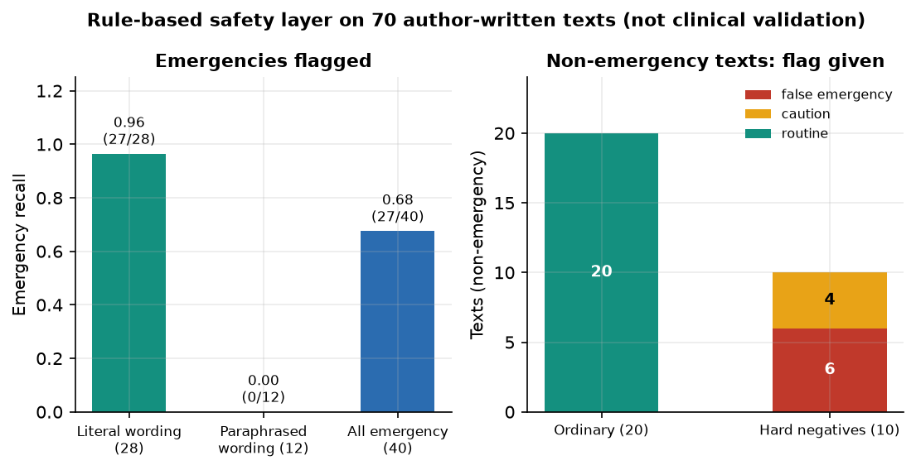
Figure 28: Emergency detection: recall on literal and paraphrased wording, and false alarms on ordinary and hard-negative texts.
Overall recall is 67.5% (95% CI 52.0-79.9%) and precision 81.8%. The rules catch the wording they were written for and nothing else: "pressure in my chest and my left arm hurts", "I cannot catch my breath" and "I do not want to live anymore" all passed as routine. In the other direction a sentence that merely mentions a trigger ("I do not have difficulty breathing, only a blocked nose") raised an emergency alarm because negation and history are not understood. For a health tool, the missed paraphrases are the serious failure.
The answer filter removed a banned phrase in 6 of 14 test sentences, and in 6 of the 10 cases that use one of its five listed phrases: the replacement is case-sensitive, so "Take ibuprofen", "Dosage:" and "Prescribe" at the start of a sentence are detected but not replaced. Drug names outside the list (paracetamol, amoxicillin) pass through. The retrieved guidance texts contain no dosages, so the filter is a second line of defence that was never needed in the captured sessions.

1.8 Speed
Per-stage times for 30 queries with warm models are in Table 8.5. The cross-encoder dominates (555 ms on average for 15 pairs on the CPU); everything else except the query embedding (93 ms mean, with a few slow outliers) takes a few milliseconds. The stages were timed in separate passes, so they do not add up exactly to the totals. A whole pipeline.answer call takes 979 ms on average with the local generator (p95 1376 ms) and 484 ms with the fallback (p95 697 ms).
Table 7: Time per pipeline stage (milliseconds, 30 queries, warm models)
Stage | Mean | Median | 95th percentile
query expansion | 0.03 | 0.03 | 0.05
query embedding | 92.96 | 56.21 | 269.18
FAISS search | 0.19 | 0.13 | 0.46
BM25 search | 2.46 | 2.13 | 4.19
score fusion | 0.07 | 0.06 | 0.11
cross-encoder rerank (15 pairs) | 554.66 | 542.57 | 841.96
safety rules | 0.04 | 0.04 | 0.08

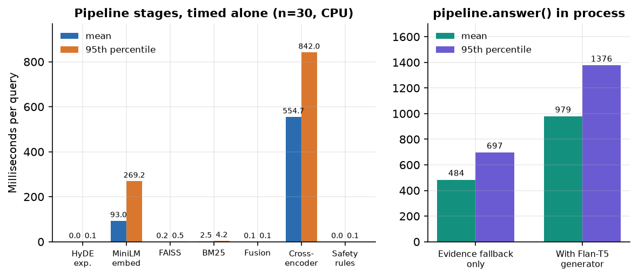
Figure 29: Mean time per pipeline stage and totals for the two generator modes.
Over HTTP on 127.0.0.1, POST /api/chat took 403 ms on average with the fallback generator (median 397, p95 569) and 766 ms with the Flan-T5 generator (median 737, p95 1077); sign-in takes about 249 ms because of bcrypt, listing the history about 32 ms and the health check about 8 ms. The first request after start-up must load the models, which took about a minute in the measurement script, so the application is best started once and kept running. A reply in well under two seconds is comfortable for a chat; no load or concurrency test was made.
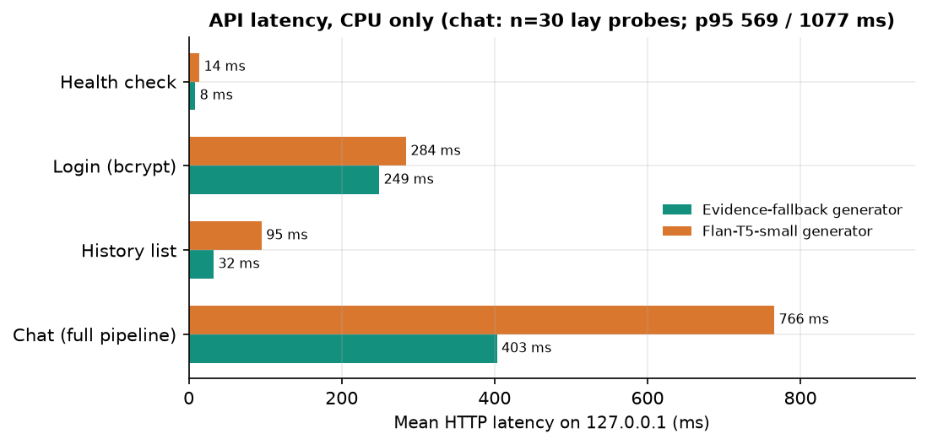
Figure 30: HTTP latency of POST /api/chat with the fallback generator and with the default Flan-T5 generator.

1.9 Functional tests
The nine pytest tests passed (9 of 9, 34.09 s): query normalisation, emergency detection, the dosage filter, password hashing, fusion, the generator fallback, authentication with history isolation between users, request validation and a retrieval round trip. The end-to-end smoke test, which goes through the Vite proxy as a browser would, passed 22 of 22 checks (health, sign-in, session cookie, chat, evidence fields, emergency escalation, validation, history list, search, detail, delete, registration, duplicate-email rejection, private history of a new account, sign-out). The tests show that the wiring works; they do not measure clinical correctness.

1.10 Comparison with the base paper
The base paper Madhury and Ramesh (IJERST, 2026) [1] reports no figures: its results section describes "experimental observations" that the hybrid retrieval "consistently" returns relevant records and shows one chat example (constipation, stomach ache, high fever and swollen lymph nodes giving Typhoid). There is no accuracy, no recall, no latency and no stated dataset size, and its "Sequence-NQ transformer" is not specified further. A numerical comparison is therefore impossible, and the datasets differ in any case: the base paper's symptom-disease knowledge base is not described in measurable terms, and this project's is a synthetic 176-record table. What can be compared is what each system does.
Table 8: Qualitative comparison with the base paper
Aspect | Base paper [1] | This project (CareLens AI)
Retrieval | Sequence-NQ embeddings + FAISS | MiniLM embeddings + FAISS and BM25, fused 0.65/0.35
Reranking | Not described | Cross-encoder (MS MARCO MiniLM) on 15 candidates
Query expansion | Not described | Rule-based HyDE-style template (no measured benefit)
Generation | RAG answer generation | Flan-T5-small or deterministic evidence-based fallback
Safety | Not described | Emergency regex rules, caution keywords, answer filter, disclaimer
Application | Registration, login, chatbot, history | FastAPI + React app, bcrypt/JWT, private history with search, detail and delete
Longitudinal tracking | Stores history "to support future analysis" | Stores and lists consultations; no trend analysis
Evaluation | Qualitative observations, no figures | Five query sets, ablation, probes, latency, tests, with intervals
Data | Symptom-disease knowledge base (not quantified) | Synthetic, 176 records, 30 conditions

The honest summary is that this work adds components and a measurement the base paper does not describe, while neither work has been validated on real clinical data.

1.11 Sample inputs and outputs, success and failure analysis
Table 9: Sample queries and what the pipeline did (captured sessions and logged probes)
Input | Output | Verdict
I have high fever, headache and body pain since yesterday | Top record Influenza; fifth card Dengue (75%); routine | Correct; plausible differential
Burning when I pee, going to the toilet every few minutes and the urine looks cloudy | Urinary Tract Infection | Correct on everyday wording
I have severe chest pain and difficulty breathing | Emergency banner; top record Heart Attack | Correct and safe
I am pregnant and have mild nausea in the mornings | Caution banner; top record Gastritis | Caution correct; condition is a weak guess
I have congestion and runny nose | Allergic Rhinitis (true Common Cold) | Failure: shared symptoms
I have chills and headache | Malaria (true Influenza) | Failure: shared symptoms
Sprained my ankle playing football, it is swollen and bruised (out-of-knowledge-base) | Anaphylaxis, shown as 100% Strong match | Failure: no abstention

1.11.1 What works
• Condition retrieval on symptom text is accurate on this knowledge base: 97.2% on verbatim leave-one-out and 96.7% on lay language.
• Emergency wording that matches the rules is escalated prominently, and the permanent disclaimer is always present.
• The application is responsive on a CPU-only PC, keeps data private per user, runs offline with fallbacks, and passed 9 of 9 unit tests and 22 of 22 end-to-end checks.

1.11.2 What fails
• The local generator echoes its prompt in the tested environment, so the generative half of "RAG" is not working; answers come from a template.
• The relevance display cannot express uncertainty: everything is a Strong match, including complaints outside the knowledge base.
• Emergency rules miss all 12 paraphrased emergencies in the probe set and raise false alarms on negations.
• Evidence cards repeat near-identical records, so the user sees one condition five times instead of alternatives.
• Reported symptoms are not tracked over time: the history is a list, not a trend.

1.12 Limitations of the evaluation
• The knowledge base is synthetic and tiny; high scores reflect how it was built (short phrases, one text per condition), not medical competence.
• The lay-language, out-of-knowledge-base and safety probes were written by the authors, are small, and were not reviewed by clinicians.
• Leave-one-out leaves sibling records in the index; a stricter test would hold out whole record families or use an independent source.
• No human judgement of answer quality or groundedness, no user study, no load test, no accessibility audit.
• One machine and one library set; the generator behaviour depends on the installed transformers version.
• Latency stages were timed in separate passes on warm models; cold-start cost was measured once.

1.13 Objectives against outcomes
Table 10: Objectives of the project against what was measured
No. | Objective | Status | Evidence
1 | Build a curated medical knowledge base and index it for semantic retrieval | Achieved (synthetic data) | 176 records, 30 conditions, FAISS flat index and BM25 index; written by the team, not clinically curated.
2 | Accept natural-language symptoms and expand the query | Achieved | Free text accepted (3 to 2000 characters); expansion is a rule-based template and showed no measurable benefit.
3 | Hybrid retrieval with neural reranking | Achieved, measured | Hybrid + cross-encoder: top-1 96.7% on lay probes and 88.1% on two-symptom queries.
4 | Grounded responses that cite the retrieved source for every statement | Partly | Answers are built from retrieved records and shown with evidence cards (record id, symptoms, guidance), but there is no per-statement citation and the local generator echoes its prompt.
5 | Track reported symptoms over time to reveal progression and trends | Not achieved beyond storage | Consultations are saved, searchable, viewable and deletable; there is no trend, timeline or progression analysis.
6 | Evaluate retrieval relevance, groundedness and response time | Partly | Retrieval and response time measured; groundedness checked structurally only (no judge).

In short, the retrieval half of the system works and has been measured honestly; the generative half, the uncertainty display, the safety rules on paraphrased input and the longitudinal tracking promised by the base paper's gap statement are the parts that still need work before the tool could be used by real patients.

