Multiple Linear Regression Model Example
### Set Current Working directory
setwd("C:/CTU/Big Data")
### Reading the data from csv file
mydata <- read.csv("Ozone_data.csv")
### Create Linear Equation
lmMod <- lm(Ozone ~ Temp+Wind, data = mydata)
### Summary of Multiple Linear Regression
summary(lmMod)
##
## Call:
## lm(formula = Ozone ~ Temp + Wind, data = mydata)
##
## Residuals:
## Min 1Q Median 3Q Max
## -42.156 -13.216 -3.123 10.598 98.492
##
## Coefficients:
## Estimate Std. Error t value Pr(>|t|)
## (Intercept) -67.3220 23.6210 -2.850 0.00524 **
## Temp 1.8276 0.2506 7.294 5.29e-11 ***
## Wind -3.2948 0.6711 -4.909 3.26e-06 ***
## ---
## Signif. codes: 0 '***' 0.001 '**' 0.01 '*' 0.05 '.' 0.1 ' ' 1
##
## Residual standard error: 21.73 on 108 degrees of freedom
## Multiple R-squared: 0.5814, Adjusted R-squared: 0.5736
## F-statistic: 74.99 on 2 and 108 DF, p-value: < 2.2e-16
### Based on the above summary of linear model, here is the linear regression equation
### Ozone = 1.8 Temp - 3.3 Wind - 67
### R-squared value = 0.58
### Ozone is Directly proportional to Temp
### Ozone is Indirectly proportional to Wind
### And Wind impacts more than Temp
### Draws a correlation plot
pairs(mydata)
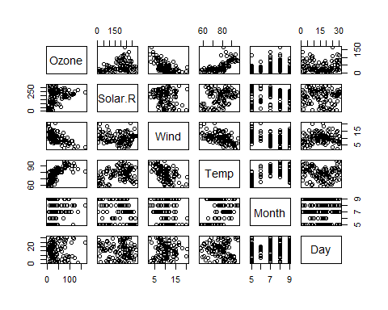
### calculates the Pearson's correlation coefficient
cor(mydata)
## Ozone Solar.R Wind Temp Month
## Ozone 1.000000000 0.34834169 -0.61249658 0.6985414 0.142885168
## Solar.R 0.348341693 1.00000000 -0.12718345 0.2940876 -0.074066683
## Wind -0.612496576 -0.12718345 1.00000000 -0.4971897 -0.194495804
## Temp 0.698541410 0.29408764 -0.49718972 1.0000000 0.403971709
## Month 0.142885168 -0.07406668 -0.19449580 0.4039717 1.000000000
## Day -0.005189769 -0.05775380 0.04987102 -0.0965458 -0.009001079
## Day
## Ozone -0.005189769
## Solar.R -0.057753801
## Wind 0.049871017
## Temp -0.096545800
## Month -0.009001079
## Day 1.000000000
### Confidence Interval
model1=lm(Ozone ~ Temp+Wind+Temp*Wind, data = mydata)
confint(model1,conf.level=0.95)
## 2.5 % 97.5 %
## (Intercept) -336.2751998 -143.5084539
## Temp 2.8240024 5.1770536
## Wind 5.1059971 22.0889184
## Temp:Wind -0.3253122 -0.1092398

