1. Created madhava.txt file in local file system as shown below.

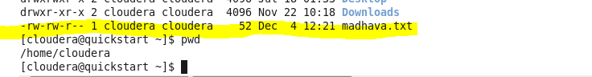

1. Copy the above local file to HDFS using the below command

hdfs dfs –put /home/cloudera/madhava.txt /user/cloudera/

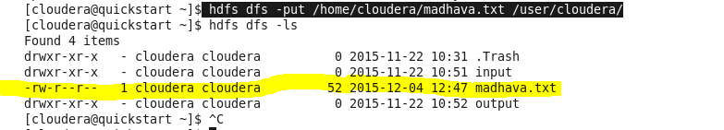

Hue View:

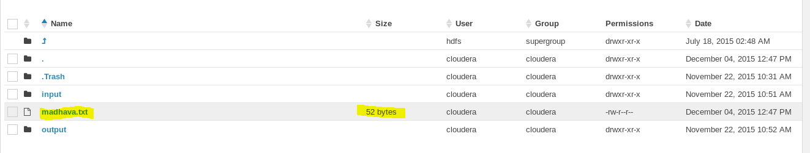

1. Added few more lines in the same file in local file system and see the file size in local file system.

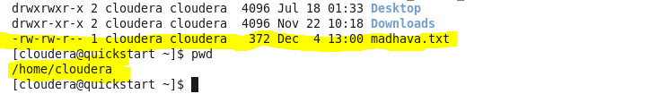

1. Copy the above modified file to HDFS file system.

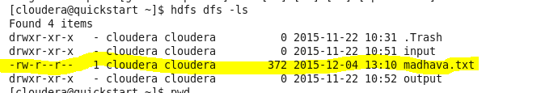

Hue View:

