1. Created testfie1 and testfie2 in the local fie system.

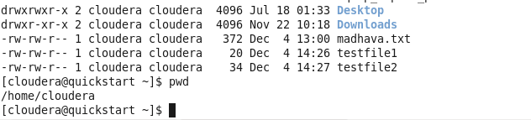

1. Copied the above two files to HDFS file system under /user/cloudera/input/

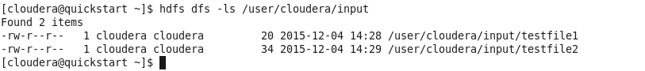

1. Change directory to /usr/lib/hadoop-mapreduce and run the below command

hadoop jar hadoop-mapreduce-examples.jar wordcount /user/cloudera/input /user/cloudera/output

1. It will show the below logger information.

**Logger information :**

[cloudera@quickstart hadoop-mapreduce]$ pwd  
/usr/lib/hadoop-mapreduce  
[cloudera@quickstart hadoop-mapreduce]$ hadoop jar hadoop-mapreduce-examples.jar wordcount /user/cloudera/input /user/cloudera/output  
15/12/04 14:36:51 INFO client.RMProxy: Connecting to ResourceManager at /[0.0.0.0:8032](http://0.0.0.0:8032/)  
15/12/04 14:36:56 INFO input.FileInputFormat: Total input paths to process : 2  
15/12/04 14:36:56 INFO mapreduce.JobSubmitter: number of splits:2  
15/12/04 14:36:57 INFO mapreduce.JobSubmitter: Submitting tokens for job: job_1449253983960_0001  
15/12/04 14:37:00 INFO impl.YarnClientImpl: Submitted application application_1449253983960_0001  
15/12/04 14:37:00 INFO mapreduce.Job: The url to track the job: <http://quickstart.cloudera:8088/proxy/application_1449253983960_0001/>  
15/12/04 14:37:00 INFO mapreduce.Job: Running job: job_1449253983960_0001  
15/12/04 14:37:50 INFO mapreduce.Job: Job job_1449253983960_0001 running in uber mode : false  
15/12/04 14:37:50 INFO mapreduce.Job:  map 0% reduce 0%  
15/12/04 14:38:30 INFO mapreduce.Job:  map 100% reduce 0%  
15/12/04 14:38:51 INFO mapreduce.Job:  map 100% reduce 100%  
15/12/04 14:38:55 INFO mapreduce.Job: Job job_1449253983960_0001 completed successfully  
15/12/04 14:38:55 INFO mapreduce.Job: Counters: 49  
    File System Counters  
        FILE: Number of bytes read=120  
        FILE: Number of bytes written=331919  
        FILE: Number of read operations=0  
        FILE: Number of large read operations=0  
        FILE: Number of write operations=0  
        HDFS: Number of bytes read=306  
        HDFS: Number of bytes written=62  
        HDFS: Number of read operations=9  
        HDFS: Number of large read operations=0  
        HDFS: Number of write operations=2  
    Job Counters   
        Launched map tasks=2  
        Launched reduce tasks=1  
        Data-local map tasks=2  
        Total time spent by all maps in occupied slots (ms)=77097  
        Total time spent by all reduces in occupied slots (ms)=15960  
        Total time spent by all map tasks (ms)=77097  
        Total time spent by all reduce tasks (ms)=15960  
        Total vcore-seconds taken by all map tasks=77097  
        Total vcore-seconds taken by all reduce tasks=15960  
        Total megabyte-seconds taken by all map tasks=78947328  
        Total megabyte-seconds taken by all reduce tasks=16343040  
    Map-Reduce Framework  
        Map input records=2  
        Map output records=10  
        Map output bytes=94  
        Map output materialized bytes=126  
        Input split bytes=252  
        Combine input records=10  
        Combine output records=10  
        Reduce input groups=8  
        Reduce shuffle bytes=126  
        Reduce input records=10  
        Reduce output records=8  
        Spilled Records=20  
        Shuffled Maps =2  
        Failed Shuffles=0  
        Merged Map outputs=2  
        GC time elapsed (ms)=941  
        CPU time spent (ms)=4230  
        Physical memory (bytes) snapshot=516685824  
        Virtual memory (bytes) snapshot=4510953472  
        Total committed heap usage (bytes)=299442176  
    Shuffle Errors  
        BAD_ID=0  
        CONNECTION=0  
        IO_ERROR=0  
        WRONG_LENGTH=0  
        WRONG_MAP=0  
        WRONG_REDUCE=0  
    File Input Format Counters   
        Bytes Read=54  
    File Output Format Counters   
        Bytes Written=62

1. Output will be printed in /user/cloudera/output directory as shown below.

[cloudera@quickstart hadoop-mapreduce]$ hdfs dfs -ls /user/cloudera/output  
Found 2 items  
-rw-r--r--   1 cloudera cloudera          0 2015-12-04 14:38 /user/cloudera/output/_SUCCESS  
-rw-r--r--   1 cloudera cloudera         62 2015-12-04 14:38 /user/cloudera/output/part-r-00000

[cloudera@quickstart hadoop-mapreduce]$ hdfs dfs -cat /user/cloudera/output/part-r-00000  
HDFS    2  
Hadoop    1  
Hello    1  
World    1  
count    1  
example    1  
in    2  
word    1  
[cloudera@quickstart hadoop-mapreduce]$ 

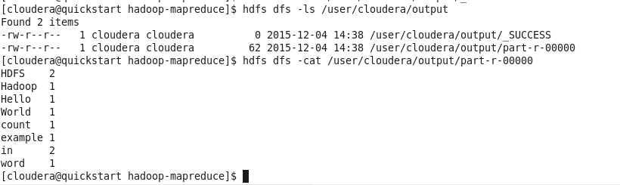

1. Get the output file from HDFS to local file system



