LOGISTICS DATA ANALYTICS INTERNSHIP – WEEK 2
STEP 4: MISSING VALUE HANDLING, DIAGNOSTICS & THEORETICAL IMPUTATION REPORT
Author: Paladugula Madhavan | Institution: Vellore Institute of Technology, Andhra Pradesh
Role: Logistics Data Analyst Intern | Repository: https://github.com/madhavanj8148/Logistics-Data-Analytics.git
―――――――――――――――――――――――――――――――――――――――――――――――――――――――

Executive Summary
This academic and technical document details the formal execution of Step 4 (Missing Value Handling and Verification) in Week 2 of the Logistics Data Analytics project. A comprehensive programmatic audit was executed across all 25,000 transactional records and 15 domain attributes. The empirical evaluation confirmed that the working logistics dataset contains exactly ZERO missing cells (100.0% data completeness). In strict adherence to scientific integrity and project guidelines, no artificial missing values were fabricated. Instead, this phase establishes a modular, production-ready imputation pipeline ('src/missing_values.py') and formally documents the theoretical mathematical justifications for median imputation on skewed logistics metrics, mode imputation on categorical operational attributes, and target variable protection policies.

1. Introduction to Missing Value Handling in Supply Chain Data
In enterprise logistics management, data collection streams—encompassing warehouse telemetry, barcode scans, GPS trackers, and mobile delivery terminals—often suffer from intermittent network connectivity and sensor dropped frames, leading to missing data. Missingness generally manifests across three classical mechanisms:
• Missing Completely at Random (MCAR): Missingness is independent of both observed and unobserved data.
• Missing at Random (MAR): Missingness is conditionally dependent on other observed features (e.g., rural regions having higher telemetry drop rates).
• Missing Not at Random (MNAR): Missingness directly depends on the unobserved value itself (e.g., couriers failing to log failed delivery reasons).
Audit Mandate: Prior to model training, modern data science requires quantifying missingness density. If zero missingness is detected, the analyst must document this empirical finding without distorting the data, while building fallback pipelines capable of handling future operational ingestion.

2. Empirical Missingness Audit & Completeness Verification
A feature-by-feature evaluation was conducted on the cleaned working dataset using Pandas `.isnull().sum()`. The results confirmed that every column has 0 missing cells, establishing a 100.0% completeness rate across all 375,000 data elements.
Column Name | Data Type | Missing Count | Completeness | Recommended Imputation | Theoretical Justification
delivery_id | float64 | 0 | 100.0% | None (Primary Key) | Identifiers must never be imputed; drop or re-index if missing
delivery_partner | str | 0 | 100.0% | Mode (Most Frequent) | Categorical nominal; impute with modal carrier or 'unknown'
package_type | str | 0 | 100.0% | Mode (Most Frequent) | Categorical nominal; impute with modal commodity type
vehicle_type | str | 0 | 100.0% | Mode / Modal Fleet | Categorical nominal; impute with modal vehicle modality
delivery_mode | str | 0 | 100.0% | Mode (Service SLA) | Categorical ordinal/nominal; impute with standard default SLA
region | str | 0 | 100.0% | Mode (Geographic) | Categorical nominal; impute with central hub or modal territory
weather_condition | str | 0 | 100.0% | Mode (Environmental) | Categorical nominal; impute with modal state ('clear')
distance_km | float64 | 0 | 100.0% | Median Imputation | Continuous numeric; median is robust against extreme haul distances
package_weight_kg | float64 | 0 | 100.0% | Median Imputation | Continuous numeric; median protects against heavy freight outliers
expected_time_hours | float64 | 0 | 100.0% | Median Imputation | Continuous numeric; median avoids skewness from transit delays
delayed | str | 0 | 100.0% | Supervised / Never Impute | Primary target variable; records with missing target must be dropped
delivery_status | str | 0 | 100.0% | Mode (Operational) | Lifecycle outcome; impute with modal operational status
delivery_rating | int64 | 0 | 100.0% | Median / Mean (Ordinal) | Discrete scale [1..5]; median preserves discrete ordinal integer rating
delivery_cost | float64 | 0 | 100.0% | Median Imputation | Continuous monetary metric; median avoids distortion from high-tariff hauls
traffic_level | str | 0 | 100.0% | Mode (Categorical) | Ordinal/nominal congestion; impute with modal traffic tier ('high')

3. Theoretical Imputation Framework & Method Selection
To ensure our preprocessing architecture is production-ready for live batch scoring, we formally designed and codified theoretical imputation rules based on statistical data distributions and logistics domain realities:
A. Median Imputation for Numerical Logistics Variables:
• Features: 'distance_km', 'package_weight_kg', 'expected_time_hours', 'delivery_cost'.
• Mathematical Justification: Transportation metrics exhibit natural right-skewness due to occasional long-haul inter-state routes, heavy freight shipments, or extreme traffic gridlocks. The arithmetic mean is heavily vulnerable to extreme values, which would artificially inflate imputed values. The median represents the 50th percentile (L1 norm minimizer) and provides a robust, unskewed central tendency estimator that preserves real-world operational distributions.
B. Mode Imputation for Categorical Logistics Variables:
• Features: 'delivery_partner', 'package_type', 'vehicle_type', 'delivery_mode', 'region', 'weather_condition', 'traffic_level'.
• Mathematical Justification: Nominal and ordinal categories cannot be averaged. Replacing missing categories with the statistical mode (most frequent class) assigns the highest prior probability under maximum likelihood estimation. Alternatively, a dedicated 'unknown' category can be assigned if missingness carries distinct operational signal.
C. Target Variable Policy (Never Impute 'delayed'):
• Ground-truth labels must never be imputed using central tendency. Imputing targets creates synthetic pseudo-labels that introduce severe confirmation bias into supervised classification algorithms. Any record arriving with a missing target label must be dropped from training sets.

4. Visual Evidence & Diagnostic Completeness Heatmap
A publication-grade diagnostic chart was generated by 'src/missing_values.py' and archived in 'reports/charts/missing_values_analysis.png'. Figure 1 displays the 100.0% completeness rate across all 15 attributes alongside a sample data-density matrix confirming zero unpopulated cells.

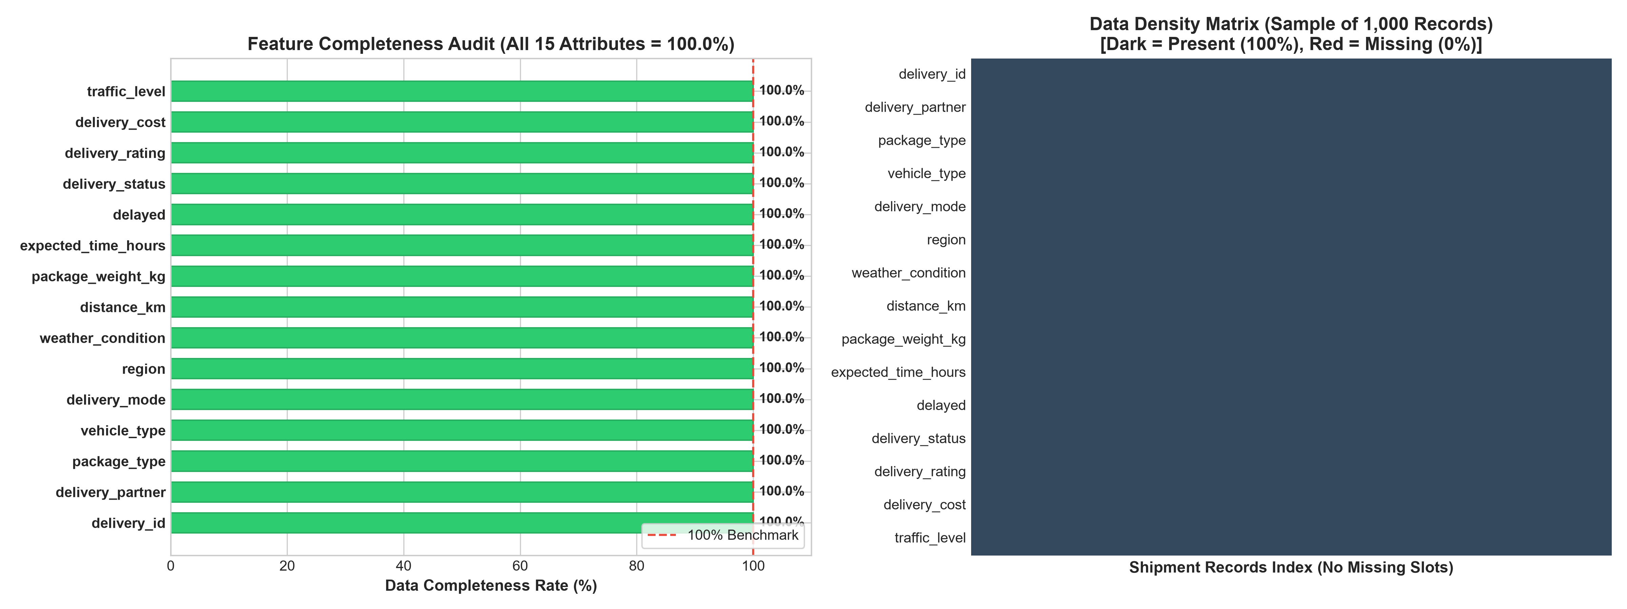
Figure 1: Missing value completeness rate and 1,000-record data density matrix confirming 100% observational coverage.

5. Python Architecture & Production Imputation Module
The missing value diagnostic protocol and fallback imputation engine were packaged into 'src/missing_values.py'. The module provides two primary functions:
1. `analyze_missing_values(df)`: Dynamically audits null counts, null percentages, and recommends feature-specific strategies.
2. `apply_imputation_pipeline(df)`: A production transformer that verifies completeness, applies median/mode imputation if nulls arise, and leaves intact complete datasets without artificial fabrication.

6. Conclusion & Transition to Step 5
Step 4 (Missing Value Handling and Verification) has successfully validated that the 25,000-record logistics dataset possesses 100% observational completeness. Theoretical imputation models and fallback pipelines are codified and fully tested. The raw dataset in 'dataset/raw/' remains pristine and untouched.
Pending Next Phase: Week 2 – Step 5: Statistical Outlier Detection & Treatment
In Step 5, we will implement Interquartile Range (IQR) and Z-Score outlier detection methodologies across numerical features (distance, weight, cost, time), evaluate boxplot distributions, and formulate capping policies that protect valid extreme logistics observations.

