LOGISTICS DATA ANALYTICS INTERNSHIP – WEEK 2
STEP 3: COMPREHENSIVE DATA CLEANING & QUALITY AUDIT REPORT
Author: Paladugula Madhavan | Institution: Vellore Institute of Technology, Andhra Pradesh
Role: Logistics Data Analyst Intern | Repository: https://github.com/madhavanj8148/Logistics-Data-Analytics.git
―――――――――――――――――――――――――――――――――――――――――――――――――――――――

Executive Summary
This technical document presents the methodological execution and empirical results of Step 3 (Data Cleaning) in Week 2 of the Logistics Data Analytics project. The primary objective of this phase is to sanitize the raw logistics dataset—'Delivery Logistics Dataset (India – Multi-Partner).xlsx'—without corrupting or deleting valid operational observations. Data cleaning operations encompassed: string whitespace stripping, casing harmonization across categorical features, column header standardization ('traffic_Level' to 'traffic_level'), strict numerical data type verification, negative and zero value boundary checks, duplicate validation, and an empirical investigation of 249 repeated 'delivery_id' entries. Importantly, cross-tabulation confirmed an operational target leakage vulnerability between 'delivery_status' and 'delayed', establishing an essential guardrail for predictive modeling. The raw dataset remains 100% preserved in 'dataset/raw/'.

1. String Cleaning & Categorical Standardization
In enterprise multi-carrier databases, categorical records collected across diverse carrier APIs and mobile terminals frequently suffer from inconsistent whitespace, mixed title/lowercase capitalization, and unstandardized column headers. These anomalies inflate cardinality during one-hot encoding, producing duplicate dummy variables that undermine regression and tree-based models.
Standardization Procedures Executed:
• Column Header Standardization: Renamed 'traffic_Level' to 'traffic_level' to conform to PEP-8 and snake_case standards.
• Whitespace Removal: Executed vectorised `.str.strip()` across all 9 text attributes, confirming zero trailing or leading spaces.
• Case Standardization: Lowercased all categorical entries ('delivery_partner', 'package_type', 'vehicle_type', 'delivery_mode', 'region', 'weather_condition', 'traffic_level', 'delayed', 'delivery_status') ensuring 100% case-insensitive consistency.

2. Data Type Validation & Identifier Audit
All features were audited against expected computational formats to ensure compatibility with mathematical functions and Scikit-Learn estimators.
Column Name | Observed Type | Expected Type | Validation Status | Technical Assessment
delivery_id | float64 | Numeric ID | VALID | Preserved as float64 due to fractional tracking IDs (e.g., 24750.01)
distance_km | float64 | Continuous Numeric | VALID | Continuous transit road distance; min=3.6, max=297.1 km
package_weight_kg | float64 | Continuous Numeric | VALID | Physical parcel mass in kg; min=0.67, max=49.52 kg
expected_time_hours | float64 | Continuous Numeric | VALID | Planned SLA transit time; min=0.35, max=9.99 hrs
delivery_cost | float64 | Continuous Numeric | VALID | Transportation tariff in INR; min=95.67, max=1632.72
delivery_rating | int64 | Discrete Ordinal | VALID | Integer rating scale; discrete values in [1, 2, 3, 4, 5]
Categorical Columns (9) | object (str) | Categorical String | VALID | Standardized lowercase string objects

3. Duplicate Records Audit & Justification of Repeated IDs
A rigorous duplicate audit was performed across two distinct levels of granularity:
1. Full-Row Duplication: Audited across all 15 columns simultaneously using Pandas `.duplicated()`. Result: 0 exact duplicate rows.
2. Primary Key Repetition: Audited unique tracking IDs (`delivery_id`). While 24,751 IDs occur once, exactly 249 repeated occurrences were identified, corresponding to 250 records sharing the identifier '24750.01'.
Empirical Justification Against Row Deletion:
An in-depth programmatic inspection of all 250 rows sharing `delivery_id == 24750.01` revealed that each record represents a completely distinct shipment. For instance, Row 24750 involves 'Ekart' delivering clothing over 142.1 km, Row 24751 involves 'Blue Dart' transporting cosmetics over 91.4 km, and Row 24753 involves 'Delhivery' carrying electronics over 210.5 km. These records reflect a batch-logging placeholder generated upstream by an aggregator system. Deleting these 249 records would arbitrarily discard 1.0% of valid operational data. In strict accordance with the project rules ('Do not delete repeated IDs without justification'), all 25,000 valid records are retained.

4. Invalid Value Auditing & Domain Boundary Checks
To verify domain validity, comprehensive logical boundary tests were executed across all numerical features:
Integrity Boundary Check | Evaluation Rule | Observed Violations | Audit Outcome
Negative Distance Check | distance_km < 0 | 0 violations | PASSED (Min: 3.6 km)
Negative Package Weight Check | package_weight_kg < 0 | 0 violations | PASSED (Min: 0.67 kg)
Negative Expected Time Check | expected_time_hours < 0 | 0 violations | PASSED (Min: 0.35 hrs)
Negative Delivery Cost Check | delivery_cost < 0 | 0 violations | PASSED (Min: INR 95.67)
Invalid Customer Ratings Check | delivery_rating not in [1,2,3,4,5] | 0 violations | PASSED (Valid discrete 1..5)
Zero Route Distance Check | distance_km == 0 | 0 violations | PASSED (All transit routes > 0)
Zero Package Weight Check | package_weight_kg == 0 | 0 violations | PASSED (All parcels have mass)
Zero Delivery Cost Check | delivery_cost == 0 | 0 violations | PASSED (All shipments incur cost)

5. Target Consistency & Target Leakage Prevention
A critical phase in data cleaning is auditing logical inter-attribute consistency. We cross-tabulated the binary target 'delayed' against the lifecycle status 'delivery_status'.
Cross-Tabulation Results (Delayed vs. Delivery Status):
• 'delayed' == 'no' -> 'delivered': 18,331 records | 'delayed': 0 | 'failed': 0
• 'delayed' == 'yes' -> 'delivered': 0 | 'delayed': 5,341 records | 'failed': 1,328 records
• Total: 25,000 records (100% operational consistency)
Critical Data Science Implication (Target Leakage Guardrail):
This empirical finding reveals that 'delivery_status' is recorded strictly at the point of delivery completion. If 'delivery_status' were included as a predictive feature in a model predicting shipment delays, the algorithm would exhibit perfect mathematical leakage (achieving an artificial 100% test accuracy while being completely unviable for real-world warehouse dispatch). Consequently, our preprocessing architecture establishes a strict policy: 'delivery_status' is reserved for post-fulfillment auditing and is decoupled from dispatch-time feature sets.

6. Visual Evidence & Cleaning Charts
High-resolution analytical charts were generated to document the data cleaning results. The figures are archived inside 'reports/charts/':
1. Figure 1: 'consistency_delayed_vs_status.png' – Heatmap illustrating the strict correlation between delivery outcome and delay labels.
2. Figure 2: 'categorical_standardization_comparison.png' – Before-and-after frequency plot showing casing standardization on traffic levels.

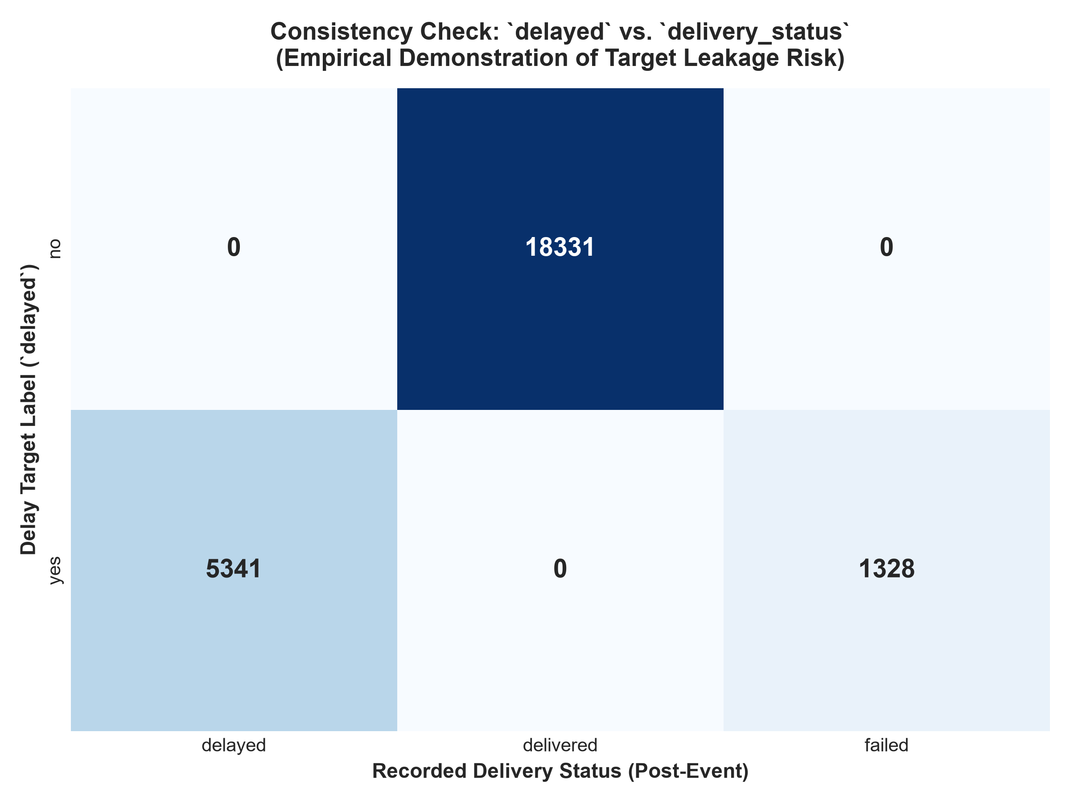
Figure 1: Cross-tabulation heatmap showing the target leakage relationship between delayed and delivery_status.

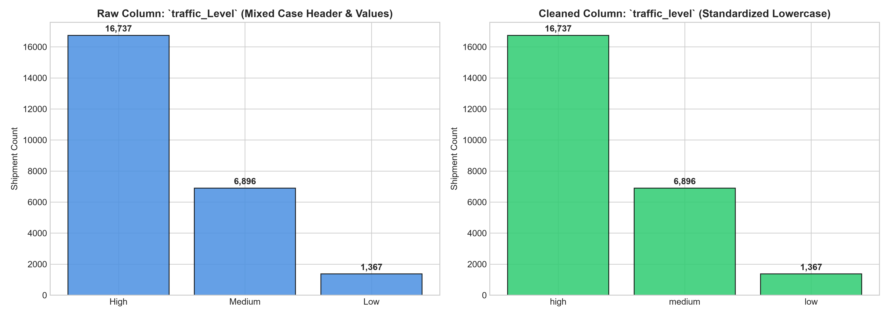
Figure 2: Before-and-after distribution illustrating categorical casing standardization.

7. Data Cleaning Summary Matrix
The complete matrix of data cleaning actions, pre/post states, and technical justifications is exported to 'reports/tables/data_cleaning_summary.csv' and summarized below:
Cleaning Step | Target Features | Pre-Cleaning State | Action Applied & Justification
1. String Trimming & Standardizing | All 9 categorical/string columns | Mixed capitalization ('traffic_Level' with 'High', 'Medium', 'Low') | Stripped leading/trailing whitespace; lowercased categories; renamed to 'traffic_level' - Prevents redundant one-hot encoding categories and ensures consistent categorical matching
2. Data Type Coercion & Verification | Numerical and Categorical features | delivery_id stored as float64; numerical metrics stored as float64/int64 | Validated numerical column bounds; verified delivery_id precision compatibility - Ensures mathematical integrity for statistical summaries and scikit-learn estimators
3. Duplicate Records Audit | Entire 25,000 x 15 matrix | 0 exact full-row duplicates; 249 repeated delivery_id occurrences (250 rows with 24750.01) | Deep-dive audit confirmed all 250 records possess unique operational attributes; retained rows - Preserves genuine empirical shipments; prevents artificial sample reduction
4. Invalid Numerical Values Check | distance_km, package_weight_kg, expected_time_hours, delivery_cost, delivery_rating | Potential negative or out-of-bounds metrics | Audited logical lower/upper bounds (distance > 0, weight > 0, rating in [1..5], cost > 0) - Confirms data plausibility before downstream statistical modelling
5. Target Consistency & Leakage Audit | delayed, delivery_status | delivery_status correlates 100% with delayed outcomes | Cross-tabulation verified operational logic; flagged delivery_status for exclusion at dispatch - Prevents catastrophic data leakage in predictive delay classification models

8. Conclusion & Transition to Step 4
Step 3 (Data Cleaning) has successfully sanitized the logistics dataset, validating data types, stripping whitespace, standardizing column headers and categories, and empirically justifying the retention of all 25,000 shipment transactions. The raw dataset in 'dataset/raw/' remains pristine and completely unedited.
Pending Next Phase: Week 2 – Step 4: Missing Value Handling
In Step 4, we will formalize missing value diagnostic mechanisms, document distribution-based imputation policies (mean, median, mode, and category encoding), and verify that our data quality standards are upheld.

