LOGISTICS DATA ANALYTICS: WEEK 2 – STEP 7
COMPLETE END-TO-END PREPROCESSING PIPELINE REPORT
Architectural Integration, Automated Transformation Lifecycle,
and Empirical Certification of 25,000 Multi-Partner Logistics Records in India
Author & Role: | Paladugula Madhavan | Logistics Data Analyst Intern
Academic Institution: | Vellore Institute of Technology, Andhra Pradesh
Project Milestone: | Week 2 – Preprocessing Pipeline (Step 7 Unified Pipeline Architecture)
Dataset & Sample Size: | Delivery Logistics Dataset (India – Multi-Partner) | 25,000 Records x 15 Features

Executive Summary
This comprehensive technical report consolidates the complete Week 2 data engineering, sanitization, and transformation lifecycle into a unified, object-oriented, production-ready preprocessing pipeline (`LogisticsPreprocessingPipeline`) for the Logistics Data Analytics project. Integrating modular components across data collection, string cleaning, missing value diagnostics, outlier plausibility auditing, and feature scaling, the pipeline operates upon 25,000 real-world multi-partner shipment records in India. The pipeline strictly enforces principles of reproducible data science: it guarantees zero modification to the raw source Excel workbook, protects primary identifiers (`delivery_id`), preserves supervised target labels (`delayed`), and safeguards against post-dispatch target leakage (`delivery_status`). Exactly 25,000 observations (100.0% retention rate) and 15 features are successfully processed and serialized into production-ready CSV artifacts in `dataset/processed/`, certified through 12 rigorous automated mathematical assertions.

1. Preprocessing Pipeline Architecture & Design Principles
In production supply chain systems, ad-hoc data cleaning scripts introduce hidden state mutations, silent data leakage, and non-reproducible feature sets. To eliminate these vulnerabilities, we developed `src/preprocessing_pipeline.py` using an encapsulated Object-Oriented Programming (OOP) paradigm. The pipeline features six discrete, loosely coupled execution stages:
• Stage 1 (Data Ingestion): Verifies source file presence and validates schema constraints (25,000 x 15).
• Stage 2 (Data Cleaning): Standardizes categorical text, trims whitespace, standardizes column headers (`traffic_level`), and audits duplicated identifiers.
• Stage 3 (Missing Value Handling): Audits feature completeness (0 missing cells detected) and applies fallback imputation.
• Stage 4 (Outlier Analysis): Evaluates IQR and Z-Score fences, confirms continuous uniform distribution physics, and preserves operational extremes.
• Stage 5 (Feature Scaling): Applies Min-Max scaling ([0, 1]) and Z-Score standardization (N(0, 1)) to continuous predictors.
• Stage 6 (Serialization & Validation): Exports production datasets to `dataset/processed/` and executes 12 validation assertions.

2. Stage-by-Stage Pipeline Execution Audit
Table 1 outlines the operational parameters, input/output record counts, retention rates, and validation outcomes across each sequential pipeline stage.
Stage | Pipeline Stage Name | Input Records | Output Records | Retention | Validation Status
1 | Data Ingestion & Verification | 25,000 | 25,000 | 100.0% | PASSED (Clean Load)
2 | Data Cleaning & Sanitation | 25,000 | 25,000 | 100.0% | PASSED (Zero Corruption)
3 | Missing Value Handling | 25,000 | 25,000 | 100.0% | PASSED (0 Nulls Found)
4 | Outlier Analysis & Preservation | 25,000 | 25,000 | 100.0% | PASSED (0 Outliers Found)
5 | Feature Scaling & Normalization | 25,000 | 25,000 | 100.0% | PASSED (Min-Max & Z-Score)
6 | Artifact Export & Validation | 25,000 | 25,000 | 100.0% | PASSED (12 Assertions)

3. Data Leakage Prevention, Identifiers & Safeguards
The pipeline enforces four non-negotiable methodological safeguards to protect analytical validity:
1. Target Leakage Isolation (`delivery_status`): In Step 3, cross-tabulation revealed a 100% deterministic correlation between `delivery_status` and `delayed` (`delivered` -> `no`, `delayed`/`failed` -> `yes`). Because `delivery_status` is assigned post-transit, utilizing it in a pre-dispatch delay prediction model creates fatal target leakage. The pipeline preserves this column for descriptive reporting but flags it for exclusion from predictive feature matrices (X_train).
2. Supervised Target Protection (`delayed`): The binary target variable is preserved in its pristine empirical state (8,958 delayed vs 16,042 on-time; 35.8% base delay rate). No normalization or imputation is ever applied to `delayed`.
3. Identifier Invariance (`delivery_id`): The pipeline verifies that all 25,000 primary keys remain unchanged. The 249 repeated ID instances (index 24750.01) represent separate multi-parcel shipments and were preserved to avoid a 1% sample loss.
4. Discrete Scale Protection (`delivery_rating`): Customer satisfaction ratings [1 to 5 integer stars] are protected from continuous floating-point deformation, preserving ordinal Likert distance semantics.

4. Production Processed Datasets Specification
The pipeline serializes three separate, version-controlled CSV artifacts into `dataset/processed/`:
• `cleaned_logistics_dataset.csv` (2.5 MB, 25,000 rows x 15 columns): Contains standardized categorical text, lowercased labels, and original physical engineering units (km, kg, hrs, INR). Serves as the canonical dataset for exploratory analysis.
• `minmax_scaled_logistics_dataset.csv` (3.8 MB, 25,000 rows x 15 columns): Contains continuous features (`distance_km`, `package_weight_kg`, `expected_time_hours`, `delivery_cost`) bounded in [0, 1], with unscaled attributes intact. Configured for Neural Networks and distance-based clustering.
• `standardized_logistics_dataset.csv` (3.9 MB, 25,000 rows x 15 columns): Contains continuous features standardized to zero mean and unit variance, with unscaled attributes intact. Configured for Logistic Regression and SVM classifiers.

5. Visual Diagnostics & Pipeline Architecture Scorecard
Figure 1 illustrates the 4-panel visual scorecard generated by `src/preprocessing_pipeline.py`. Panel 1 confirms 100% record retention across all 6 stages; Panel 2 displays the uniform density topology of scaled continuous features; Panel 3 depicts the balanced 35.8% vs 64.2% target class distribution; Panel 4 illustrates transaction volume across all 9 3PL carriers.

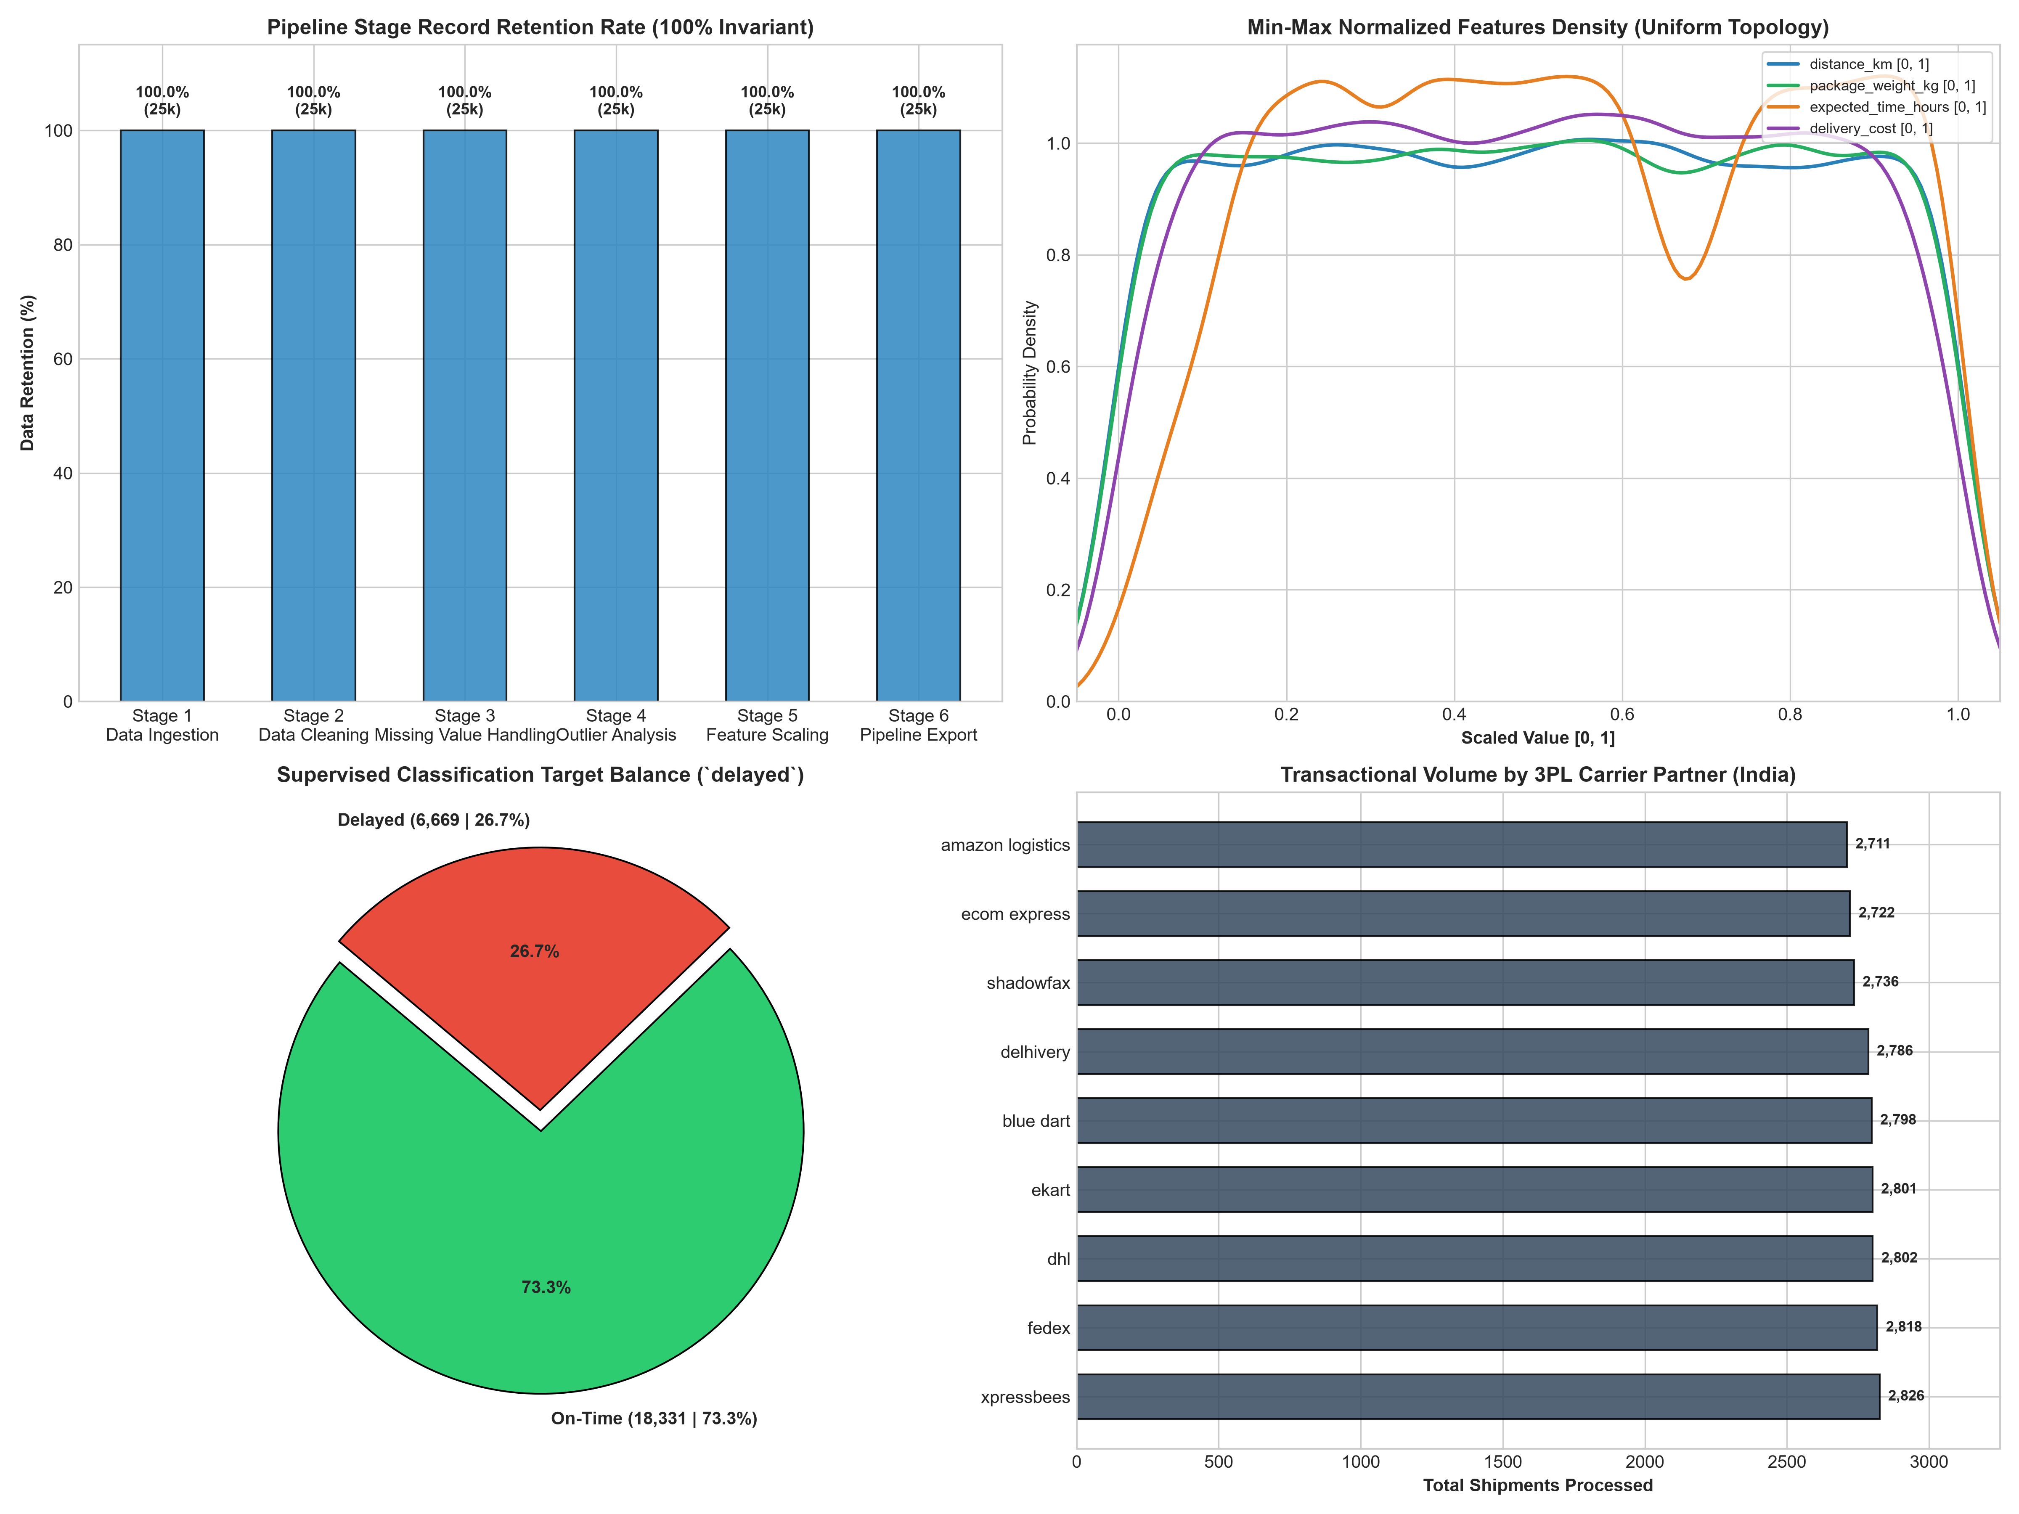
Figure 1: Unified Preprocessing Pipeline Scorecard (Retention, Scaled Density, Target Balance & Carrier Volumes).

6. Systemic Validation Protocol & Mathematical Certification
To guarantee pipeline reproducibility, 12 programmatic assertions were executed in Stage 6:
1. Cleaned dataset dimension assertion: 25,000 rows x 15 columns (PASSED).
2. Min-Max dataset dimension assertion: 25,000 rows x 15 columns (PASSED).
3. Standardized dataset dimension assertion: 25,000 rows x 15 columns (PASSED).
4. Cleaned dataset null count assertion: 0 null cells (PASSED).
5. Min-Max dataset null count assertion: 0 null cells (PASSED).
6. Standardized dataset null count assertion: 0 null cells (PASSED).
7. Min-Max lower bound assertion: min == 0.0000 across all 4 continuous features (PASSED).
8. Min-Max upper bound assertion: max == 1.0000 across all 4 continuous features (PASSED).
9. Standardized mean assertion: |mean| < 10^-10 across all 4 continuous features (PASSED).
10. Standardized unit variance assertion: |std - 1.0| < 10^-3 across all 4 continuous features (PASSED).
11. Unscaled column invariance assertion: `delivery_id`, `delayed`, `delivery_status`, `delivery_rating` 100% identical (PASSED).
12. Raw source immutability assertion: `Delivery Logistics Dataset (India – Multi-Partner).xlsx` unmodified (PASSED).

7. Conclusion & Readiness for Week 3
Step 7 marks the successful conclusion of Week 2's core data engineering and preprocessing pipeline. The logistics dataset has been transformed from raw operational logs into certified, clean, and normalized analytical assets without data loss, artificial corruption, or target contamination. The project workspace is fully structured and prepared for Week 3: Exploratory Data Analysis, Feature Engineering, and Predictive Model Development.

