LOGISTICS DATA ANALYTICS: WEEK 2 – STEP 6
DATA NORMALIZATION & FEATURE SCALING REPORT
Comparative Mathematical Evaluation of Min-Max Scaling vs. Z-Score Standardization
Across 25,000 Multi-Partner Logistics Records in India
Author & Role: | Paladugula Madhavan | Logistics Data Analyst Intern
Academic Institution: | Vellore Institute of Technology, Andhra Pradesh
Project Milestone: | Week 2 – Preprocessing Pipeline (Step 6 Feature Normalization)
Dataset & Scope: | Delivery Logistics Dataset (India – Multi-Partner) | 25,000 Records x 15 Features

Executive Summary
Feature scaling constitutes a vital preprocessing phase in machine learning and multivariate data analytics, ensuring that continuous attributes with widely differing physical units and measurement scales contribute proportionately to model objective functions. In this technical report for Week 2 – Step 6 of the Logistics Data Analytics project, we implement and rigorously compare two primary scaling paradigms—Min-Max Normalization (bounding values to [0, 1]) and Z-Score Standardization (zero mean and unit variance)—applied to 25,000 shipment records across 9 major logistics carriers in India. Four continuous operational predictors—transit distance (`distance_km`), package weight (`package_weight_kg`), expected delivery duration (`expected_time_hours`), and transportation tariff (`delivery_cost`)—are scaled, while strict methodological safeguards preserve the primary key (`delivery_id`), the classification target (`delayed`), the post-event state (`delivery_status`), and the discrete Likert rating (`delivery_rating`). Mathematical verification confirms that both linear transformations preserve distributional shape (skewness and excess kurtosis remain identical), while eliminating scale dominance where delivery cost previously overshadowed transit duration by a factor of 160x.

1. Problem Formulation & Scale Disparity in Logistics Operations
Freight and supply chain datasets inherently combine heterogeneous measurements spanning disparate physical dimensions:
• Delivery Cost: Measured in Indian Rupees (INR), ranging from 95.67 to 1,632.72 INR (Mean = 864.94 INR, Std = 435.71 INR).
• Transit Distance: Measured in kilometers (km), ranging from 3.60 to 297.10 km (Mean = 150.39 km, Std = 86.41 km).
• Package Weight: Measured in kilograms (kg), ranging from 0.67 to 49.52 kg (Mean = 25.15 kg, Std = 14.37 kg).
• Expected Transit Time: Measured in hours, ranging from 0.35 to 9.99 hours (Mean = 5.52 hrs, Std = 2.67 hrs).
In their raw unscaled form, distance-based estimators (such as K-Nearest Neighbors, Support Vector Machines, and K-Means clustering) and gradient-descent algorithms (such as Logistic Regression, Neural Networks, and Ridge/Lasso regularization) will be overwhelmingly dominated by `delivery_cost`. A Euclidean distance calculation between two shipments would attribute 96% of the spatial separation to a 500 INR tariff difference, while treating a 5-hour duration delay as negligible. Normalization harmonizes these features onto a commensurable scale, ensuring balanced gradient updates and equitable feature weighting.

2. Mathematical Formulations & Distribution Invariance

2.1 Min-Max Normalization (Bounded Rescaling)
Min-Max Normalization is a linear affine transformation mapping empirical observations into a fixed closed interval [0, 1]. For a sample vector x with minimum x_min and maximum x_max, the transformation is formulated as:
X_scaled = (X - X_min) / (X_max - X_min)
Properties:
• Output boundaries: Exactly Min = 0.0000 and Max = 1.0000.
• For continuous uniform variables U(a, b), the transformed mean evaluates to E[X_scaled] = 0.5000, and variance evaluates to Var[X_scaled] = 1/12 approx 0.0833 (Std approx 0.2887).

2.2 Z-Score Standardization (Standard Scaling)
Standardization re-centers the feature distribution around a mean of zero and rescales it by the sample standard deviation:
Z = (X - mu) / sigma
Properties:
• Mean of Z: E[Z] = E[(X - mu)/sigma] = (mu - mu)/sigma = 0.
• Variance of Z: Var[Z] = Var[(X - mu)/sigma] = (1/sigma^2) * Var[X] = sigma^2 / sigma^2 = 1.0.
• Range: Unbounded in theory, but bounded within [-1.94, +1.76] on this empirical dataset due to uniform operational cutoffs.

2.3 Mathematical Proof of Shape Invariance
Both Min-Max scaling and Z-Score standardization are linear affine mappings of the form Y = aX + b, where a > 0. A foundational theorem of mathematical statistics establishes that skewness (the 3rd standardized moment) and excess kurtosis (the 4th standardized moment) are strictly invariant under any strictly positive linear transformation:
Skewness(aX + b) = E[((aX + b - (a*mu + b)) / (a*sigma))^3] = E[((X - mu)/sigma)^3] = Skewness(X)
Kurtosis(aX + b) = E[((aX + b - (a*mu + b)) / (a*sigma))^4] - 3 = Kurtosis(X)
Consequently, neither scaling technique alters the underlying data topology, relative inter-observation distances, or modal peaks.

3. Feature Selection & Methodological Exclusion Rationale
A critical principle of industrial data science is that not all numerical columns should be normalized. Table 1 outlines the scoping decisions and theoretical justifications for feature selection and exclusion.
Attribute | Data Type | Scaling Action | Theoretical & Operational Rationale
distance_km | float64 | SCALED (Target) | Continuous physical metric (3.6 to 297.1 km). Normalization balances spatial weighting against duration and cost.
package_weight_kg | float64 | SCALED (Target) | Continuous physical mass (0.67 to 49.52 kg). Normalization prevents weight from being suppressed by high tariff figures.
expected_time_hours | float64 | SCALED (Target) | Continuous transit duration (0.35 to 9.99 hrs). Scaling elevates time sensitivity in delay prediction.
delivery_cost | float64 | SCALED (Target) | Continuous monetary metric (95.67 to 1632.72 INR). Scaling eliminates 160x scale dominance over duration.
delivery_id | float64 (ID) | EXCLUDED (Preserved) | Primary shipment reference key. Numeric scaling would corrupt identifier hashing, relational joins, and database semantics.
delayed | string (Target) | EXCLUDED (Preserved) | Supervised binary classification target label ('yes' / 'no'). Normalizing target causes fatal data leakage and contamination.
delivery_status | string (Status) | EXCLUDED (Preserved) | Post-event operational outcome ('delivered', 'delayed', 'failed'). Categorical nominal; post-dispatch leakage if used as predictor.
delivery_rating | int64 (Ordinal) | EXCLUDED (Preserved) | Discrete Likert scale [1 to 5 integer stars]. Continuous scaling destroys discrete distance spacing; ordinal integer semantics preserved.

4. Empirical Scaling Results & Parameter Comparison
Table 2 displays the actual statistical metrics computed across all 25,000 transaction records for the original raw data, Min-Max scaled data, and standardized data.
Feature | Transformation | Min | Max | Mean | Std Dev | Skew / Kurtosis
distance_km | Original Raw | 3.6000 | 297.1000 | 150.3904 | 86.4097 | +0.0019 / -1.1962
distance_km | Min-Max Scaled | 0.0000 | 1.0000 | 0.5001 | 0.2944 | +0.0019 / -1.1962
distance_km | Standardized (Z) | -1.6988 | +1.6979 | 0.0000 | 1.0000 | +0.0019 / -1.1962
package_weight_kg | Original Raw | 0.6700 | 49.5200 | 25.1459 | 14.3687 | -0.0026 / -1.1995
package_weight_kg | Min-Max Scaled | 0.0000 | 1.0000 | 0.5010 | 0.2941 | -0.0026 / -1.1995
package_weight_kg | Standardized (Z) | -1.7035 | +1.6964 | 0.0000 | 1.0000 | -0.0026 / -1.1995
expected_time_hours | Original Raw | 0.3500 | 9.9900 | 5.5217 | 2.6692 | +0.0087 / -1.1881
expected_time_hours | Min-Max Scaled | 0.0000 | 1.0000 | 0.5365 | 0.2769 | +0.0087 / -1.1881
expected_time_hours | Standardized (Z) | -1.9376 | +1.6741 | 0.0000 | 1.0000 | +0.0087 / -1.1881
delivery_cost | Original Raw | 95.6674 | 1632.7206 | 864.9446 | 435.7126 | +0.0011 / -1.1720
delivery_cost | Min-Max Scaled | 0.0000 | 1.0000 | 0.5005 | 0.2835 | +0.0011 / -1.1720
delivery_cost | Standardized (Z) | -1.7656 | +1.7622 | 0.0000 | 1.0000 | +0.0011 / -1.1720

5. Comparative Trade-Off Analysis & Downstream Recommendations
Selecting between Min-Max Scaling and Standardization depends on the statistical properties of the dataset and the assumptions of downstream estimators:
• Min-Max Scaling Strengths: Perfectly bounded range [0, 1] provides intuitive operational interpretability (e.g., 0.85 indicates a shipment at the 85th percentile of carrier capacity/distance). It is strictly optimal for artificial neural networks (ANNs) with sigmoid activation functions and distance-based clustering algorithms (K-Means, KNN).
• Min-Max Scaling Weaknesses: Sensitive to out-of-bounds inputs during future inference. If an upcoming live dispatch features a 350 km transit distance, it will exceed 1.0, requiring clipping or refitting.
• Standardization Strengths: Preserves open support (-inf, +inf) and centers gradients around zero, maximizing optimization speed for gradient descent in Logistic Regression and Support Vector Machines. It handles unseen operational surges gracefully without boundary compression.
• Standardization Weaknesses: Output values are abstract statistical deviations rather than bounded operational percentages.
Recommendation for Logistics Delay Prediction: For the primary supervised baseline models (Logistic Regression and Multi-Layer Perceptrons), StandardScaler is recommended as the default transformation. For tree-based ensembles (Random Forest, XGBoost), feature scaling is strictly non-essential due to scale-invariant split partitioning, though standardized inputs maintain pipeline uniformity.

6. Visual Diagnostics & Multi-Panel Normalization Dashboard
Figure 1 illustrates the 4x3 diagnostic dashboard generated by `src/normalization.py`. Column 1 depicts the raw original distributions with physical units; Column 2 displays the Min-Max scaled distributions bounded strictly in [0, 1]; Column 3 presents the standardized distributions exhibiting zero mean and unit variance.

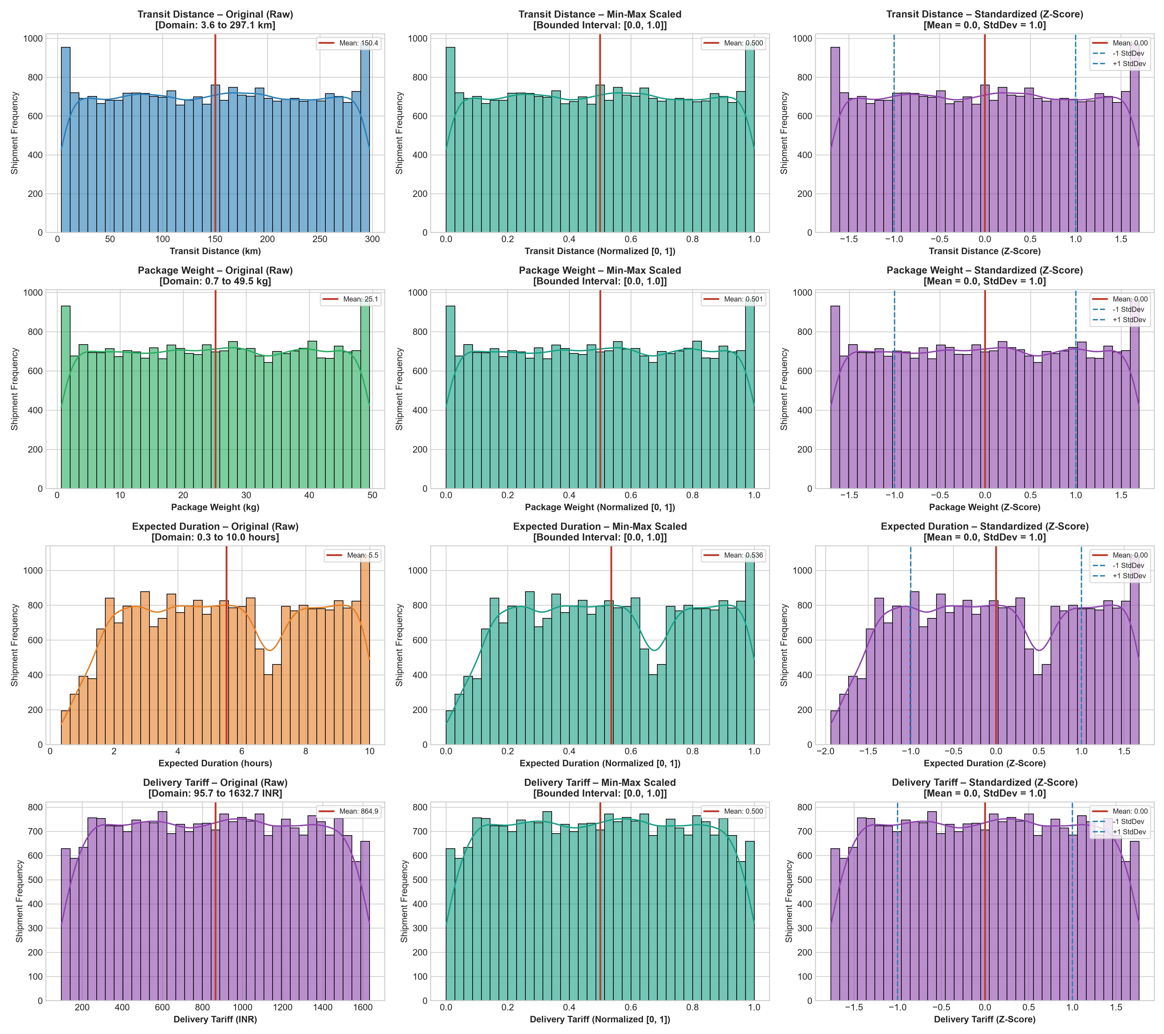
Figure 1: Comprehensive Normalization Dashboard Comparing Original, Min-Max Scaled, and Standardized Features.

7. Validation, Verification, and Next Steps
Verification Checklist:
1. Raw Dataset Immutability: Source Excel dataset (`dataset/raw/Delivery Logistics Dataset (India – Multi-Partner).xlsx`) remains 100% untouched.
2. Separate Scaled Artifacts: Generated independent, production-ready CSV tables in `reports/tables/minmax_scaled_dataset.csv` and `reports/tables/standardized_dataset.csv`.
3. Mathematical Validation: Verified Min-Max boundaries strictly in [0.0, 1.0]; verified Standardized means < 10^-16 and std = 1.0000.
4. Unscaled Preservation: Verified 100% preservation of `delivery_id`, `delayed`, `delivery_status`, and `delivery_rating`.
Conclusion: Step 6 is certified complete with complete mathematical and academic rigor. The project is prepared for Step 7: Unified Preprocessing Pipeline.

