LOGISTICS PERFORMANCE ANALYTICS & PREDICTIVE MODELING:
DATA COLLECTION, CLEANING & PREPROCESSING
A Comprehensive Technical and Academic Report on Multi-Partner 3PL Delivery Operations in India
Week 2 Final Project Deliverable
Author & Role: | Paladugula Madhavan | Logistics Data Analyst Intern
Academic Institution: | Vellore Institute of Technology, Andhra Pradesh
Project Repository: | https://github.com/madhavanj8148/Logistics-Data-Analytics.git
Dataset & Sample Size: | Delivery Logistics Dataset (India – Multi-Partner) | 25,000 Records x 15 Features
Milestone: | Week 2 – End-to-End Data Collection, Cleaning, Preprocessing & Validation
Date of Completion: | October 31, 2026

2. Abstract
Modern third-party logistics (3PL) delivery networks generate massive operational data streams characterized by heterogeneous measurement units, categorical inconsistencies, post-event target leakage, and physical extremes. This project establishes a production-grade, reproducible data engineering pipeline for 25,000 transactional delivery records spanning 9 major logistics carriers in India (including Delhivery, Blue Dart, DHL, FedEx, Shadowfax, Xpressbees, Ekart, Ecom Express, and Amazon Logistics). The Week 2 analytics lifecycle encompassed automated data ingestion, comprehensive data dictionary synthesis, string sanitization, missing value diagnostics, outlier plausibility analysis, and feature normalization. A rigorous audit verified 100% observational completeness (zero missing cells across all 375,000 data elements) and observed that numerical attributes exhibit an excess kurtosis of approximately -1.20 (the theoretical excess kurtosis of a continuous uniform distribution, though observed kurtosis alone does not establish uniformity). In conjunction with empirical histograms exhibiting flat density profiles, this platykurtic property mathematically explains the absence of statistical outliers under Tukey's fences and 3-sigma criteria. Furthermore, a critical target-variable audit resolved textual reporting discrepancies, confirming that the ground-truth distribution of the supervised classification target (`delayed`) is exactly 6,669 delayed (26.68%) and 18,331 on-time (73.32%) with 100% row-by-row fidelity preserved across all raw and processed representations. All 25,000 records were successfully serialized into production datasets and certified sound via 12 automated programmatic assertions, establishing an ideal foundation for Week 3 predictive modeling.

3. Introduction to Freight Analytics in India
The logistics and supply chain sector in India is experiencing unprecedented expansion driven by rapid e-commerce penetration, infrastructure modernization, and the rollout of the Unified Logistics Interface Platform (ULIP). However, carrier operations face substantial friction stemming from severe road congestion tiers in Tier-1 metropolitan hubs, regional terrain variability (spanning North, South, East, West, and Central corridors), and extreme weather volatility (monsoons, heavy fog, and cold waves). Delivery delays not only trigger customer dissatisfaction and contractual SLA penalty fees but also increase operating costs through failed re-attempts and vehicle idling.
Developing effective machine learning models to forecast delivery delays requires robust preprocessing. Raw transactional databases frequently suffer from inconsistent casing, unstandardized column headers, scale disparities where delivery tariffs dominate transit durations by 160x, and hidden target leakage where post-delivery outcome tags contaminate pre-dispatch features. This investigation executes a complete Week 2 preprocessing pipeline to sanitize, audit, and scale this data while preserving its natural operational characteristics.

4. Week 2 Technical Objectives
The Week 2 milestone focuses on seven core engineering objectives:
1. Ingestion & Schema Verification: Ingest the multi-partner Excel dataset and verify exact 25,000 x 15 dimensions.
2. Data Profiling & Dictionary Formulation: Formulate comprehensive technical data dictionaries and exploratory profiling tables.
3. String Sanitization & Type Coercion: Strip whitespaces, standardize lowercase categorical factors, and resolve identifier duplicate anomalies.
4. Missing Value Diagnostics & Strategy: Audit missingness rates and formulate domain-justified median/mode fallback imputation protocols.
5. Statistical Outlier Detection & Preservation: Evaluate Tukey's IQR fences and Z-score bounds, preserving legitimate logistics edge cases.
6. Comparative Feature Normalization: Implement and contrast Min-Max Rescaling [0, 1] against Z-Score Standardization N(0, 1).
7. Unified Pipeline Architecture: Encapsulate all stages into an automated, object-oriented pipeline script exporting production datasets.

5. Dataset Collection & Simulation Methodology
The dataset utilized in this research (`Delivery Logistics Dataset (India – Multi-Partner).xlsx`) was collected and structured to simulate realistic, multi-partner logistics operations across India's e-commerce and commercial freight ecosystems. The dataset models 25,000 distinct delivery consignments allocated across 9 major logistics service providers (3PL carriers). Operational parameters—such as transit distances (3.6 km to 297.1 km), parcel weights (0.67 kg to 49.52 kg), delivery tariffs (95.67 INR to 1,632.72 INR), and expected SLA durations (0.35 hours to 9.99 hours)—were systematically parameterized to span realistic intra-state and inter-city courier delivery envelopes. The source dataset is stored permanently inside `dataset/raw/` under a strict read-only immutability protocol.

6. Dataset Description & Technical Data Dictionary
Table 1 outlines the complete 15-attribute data dictionary, documenting data types, physical units, domain constraints, and operational interpretations.
Attribute | Data Type | Domain / Scale | Null % | Operational Description
delivery_id | float64 | Numeric ID [1.0 to 24750.01] | 0.0% | Primary shipment identifier reference.
delivery_partner | object | 9 carriers (Delhivery, FedEx, DHL, etc.) | 0.0% | Third-party logistics carrier entity.
package_type | object | 9 commodities (Electronics, Clothing, etc.) | 0.0% | Product commodity classification.
vehicle_type | object | 6 modalities (Bike, Van, EV Van, Truck, etc.) | 0.0% | Transportation fleet vehicle modality.
delivery_mode | object | 4 tiers (Same Day, Express, Two Day, Standard) | 0.0% | Committed service level agreement (SLA).
region | object | 5 regions (North, South, East, West, Central) | 0.0% | Operational geographic delivery territory.
weather_condition | object | 5 weather states (Clear, Rainy, Foggy, etc.) | 0.0% | Environmental meteorological condition.
distance_km | float64 | Continuous [3.60 to 297.10 km] | 0.0% | Total transit transit distance.
package_weight_kg | float64 | Continuous [0.67 to 49.52 kg] | 0.0% | Gross shipment physical package mass.
expected_time_hours | float64 | Continuous [0.35 to 9.99 hours] | 0.0% | Committed target transit duration.
delayed | object | Binary label ('yes', 'no') | 0.0% | Primary supervised classification target label.
delivery_status | object | Lifecycle ('delivered', 'delayed', 'failed') | 0.0% | Post-delivery operational outcome.
delivery_rating | int64 | Discrete Likert scale [1 to 5 stars] | 0.0% | Customer satisfaction feedback rating.
delivery_cost | float64 | Monetary [95.67 to 1632.72 INR] | 0.0% | Total commercial logistics billing fee.
traffic_level | object | 3 tiers (Low, Medium, High) | 0.0% | Transit road traffic congestion density.

7. Exploratory Data Profiling
Initial statistical profiling indicates a balanced operational distribution across the carrier portfolio. The carrier volume is led by Delhivery (2,873 shipments; 11.5%), followed closely by Blue Dart (2,829 shipments; 11.3%), DHL (2,819 shipments; 11.3%), and FedEx (2,798 shipments; 11.2%). Across vehicle fleets, delivery vans (6,262 consignments; 25.0%) and motorcycles/bikes (6,234 consignments; 24.9%) handle nearly 50% of intra-city deliveries, while trucks and EV vans manage bulk commercial freight. Geographically, delivery records are equitably distributed across North (5,053), South (5,027), West (5,011), Central (4,963), and East (4,946), ensuring an unbiased sample of Indian transport geography.

8. Initial Data Quality Assessment
An initial baseline diagnostic audit evaluated the raw workbook against 6 data quality dimensions:
• Dimensional Completeness: Exactly 25,000 rows and 15 columns verified.
• Cell Missingness: Zero missing values across all 375,000 data elements (100% observational density).
• Exact Duplicate Rows: Zero completely identical records detected across all 15 features.
• Repeated Identifier Instances: 249 duplicate `delivery_id` instances (representing float `24750.01`). Detailed domain inspection revealed that each instance features different carrier partners, distances, package weights, and delivery modes, indicating distinct shipments sharing a common batch index. Deleting them would result in an unacceptable 1.0% data loss.
• Domain Range Conformance: All continuous features conform to strictly positive, physically feasible limits.
• Categorical Inconsistencies: Detected uppercase column header `traffic_Level` and potential whitespace noise in text fields.

9. Data Cleaning & String Standardization
Data cleaning was executed through `src/data_cleaning.py` to sanitize all text and categorical features:
1. Whitespace Stripping: Applied `.strip()` across all string/object attributes to eliminate leading and trailing spaces.
2. Case Standardization: Coerced all nominal categorical values to lowercase to resolve multi-casing inconsistencies.
3. Column Header Harmonization: Standardized `traffic_Level` to uniform snake_case `traffic_level`.
4. Target Leakage Quarantine: In Step 3, cross-tabulation revealed that `delivery_status` correlates 100% deterministically with the target `delayed` (`delivered` -> `no`, `delayed`/`failed` -> `yes`). Because `delivery_status` is determined post-delivery, using it as a feature during pre-dispatch prediction represents fatal target leakage. The cleaning engine documented and isolated this attribute for reporting only.

10. Missing Value Diagnostics & Strategy
A rigorous missing value audit in `src/missing_values.py` confirmed that the dataset contains zero null cells. Adhering to principles of scientific integrity, no artificial missing values were injected. Simultaneously, a fallback production imputation engine was established to handle future inference batches:
• Numerical Predictors (`distance_km`, `package_weight_kg`, `expected_time_hours`, `delivery_cost`): Median Imputation. The sample median minimizes the L1 norm and resists distortion from extreme long-haul freight hauls.
• Nominal Predictors (`delivery_partner`, `vehicle_type`, `region`, `weather_condition`, `traffic_level`): Mode Imputation. Modal class substitution preserves category vocabulary without introducing artificial fractional categories.
• Target Variable (`delayed`): Strictly excluded from imputation; records with missing target labels must be dropped in supervised workflows.

11. Outlier Detection & Plausibility Preservation
Outlier auditing was conducted in `src/outlier_detection.py` using non-parametric Tukey's IQR fences (1.5x) and parametric Z-score bounds (|Z| > 3.0). Exactly zero statistical outliers were detected across all continuous features.
Mathematical Distributional Analysis:
Analysis of higher-order standardized moments reveals that all four continuous variables exhibit an excess kurtosis of approximately -1.20 (distance: -1.20, weight: -1.20, duration: -1.19, cost: -1.17). While -1.20 is the theoretical excess kurtosis of a continuous uniform distribution U(a, b), an observed excess kurtosis of approximately -1.20 alone does not establish uniformity without evaluating the full empirical distribution. In our dataset, empirical histograms and near-zero skewness corroborate a platykurtic, broadly flat distribution. For such bounded platykurtic profiles, the theoretical lower Tukey fence evaluates to a - 0.5(b - a) < a, and the upper fence evaluates to b + 0.5(b - a) > b. Because the empirical minimum is strictly greater than the lower fence and the maximum is strictly less than the upper fence, zero observations mathematically breach Tukey statistical outlier fences.
Domain Plausibility Assessment: Maxima such as 297.1 km, 49.52 kg, and 1,632.72 INR represent realistic operational extremes for express inter-city transport in India. All 25,000 observations were preserved intact without deletion or artificial Winsorization.

12. Data Normalization & Feature Scaling
To resolve severe scale disparities (delivery tariffs reaching 1,632 INR vs duration averaging 5.5 hours), `src/normalization.py` implemented and compared two primary scaling methodologies applied to `distance_km`, `package_weight_kg`, `expected_time_hours`, and `delivery_cost`:
1. Min-Max Normalization: Rescales features into [0.0000, 1.0000]. Verified transformed minimums = 0.0000, maximums = 1.0000, and means approx 0.5001 to 0.5365. Optimal for Artificial Neural Networks and distance-based clustering.
2. Z-Score Standardization (StandardScaler): Centers continuous features and scales them by standard deviation, producing standardized features with approximately zero mean (< 10^-16) and unit standard deviation (1.0000). Verified support bounded between [-1.94, +1.76] standard deviations. Recommended for Logistic Regression and Support Vector Machines.
Important Statistical Clarification: StandardScaler shifts the mean to approximately zero and scales standard deviation to 1, but it does NOT make the data normally distributed. The original distribution's shape (kurtosis approx -1.20 and flat density profile) is strictly preserved under linear affine transformation.
Proof of Shape Invariance: Under linear affine transformations Y = aX + b, skewness and excess kurtosis remain strictly invariant, guaranteeing zero topographical distortion of the underlying logistics distributions.

13. Unified Preprocessing Pipeline Architecture
All Week 2 modules were consolidated into an object-oriented production engine: `LogisticsPreprocessingPipeline` inside `src/preprocessing_pipeline.py`. The pipeline automates the 6-stage lifecycle:
• Stage 1: Dataset Ingestion & Schema Audit (25,000 x 15).
• Stage 2: String Sanitization & Type Coercion.
• Stage 3: Missingness Verification & Fallback Imputation.
• Stage 4: Outlier Audit & Empirical Domain Preservation.
• Stage 5: Dual Scaling (Min-Max [0, 1] & StandardScaler with zero mean, unit standard deviation).
• Stage 6: Artifact Serialization & Automated Programmatic Assertions.
Output Datasets Serialized to `dataset/processed/`:
1. `cleaned_logistics_dataset.csv` (2.5 MB, 25,000 rows x 15 columns)
2. `minmax_scaled_logistics_dataset.csv` (3.8 MB, 25,000 rows x 15 columns)
3. `standardized_logistics_dataset.csv` (3.9 MB, 25,000 rows x 15 columns)

14. Python Implementation & Modular Codebase
The project workspace is structured into reusable, clean Python modules following professional software engineering standards:
• `src/data_collection.py`: Ingestion, file discovery, and dictionary generation.
• `src/data_cleaning.py`: String whitespace stripping, categorization, and duplicate handling.
• `src/missing_values.py`: Null diagnostics and modular imputation.
• `src/outlier_detection.py`: Tukey's IQR and Z-score outlier detection.
• `src/normalization.py`: Scikit-learn Min-Max and StandardScaler transformers.
• `src/preprocessing_pipeline.py`: Unified pipeline class orchestrating end-to-end execution.

15. Analytical Visualizations & Diagnostic Scorecards
Figure 1 illustrates the comprehensive 4-panel visual scorecard generated by the unified preprocessing pipeline (`reports/charts/preprocessing_pipeline_summary.png`), depicting stage record retention (Panel 1), scaled feature density (Panel 2), target class balance (Panel 3), and carrier transaction volumes (Panel 4).

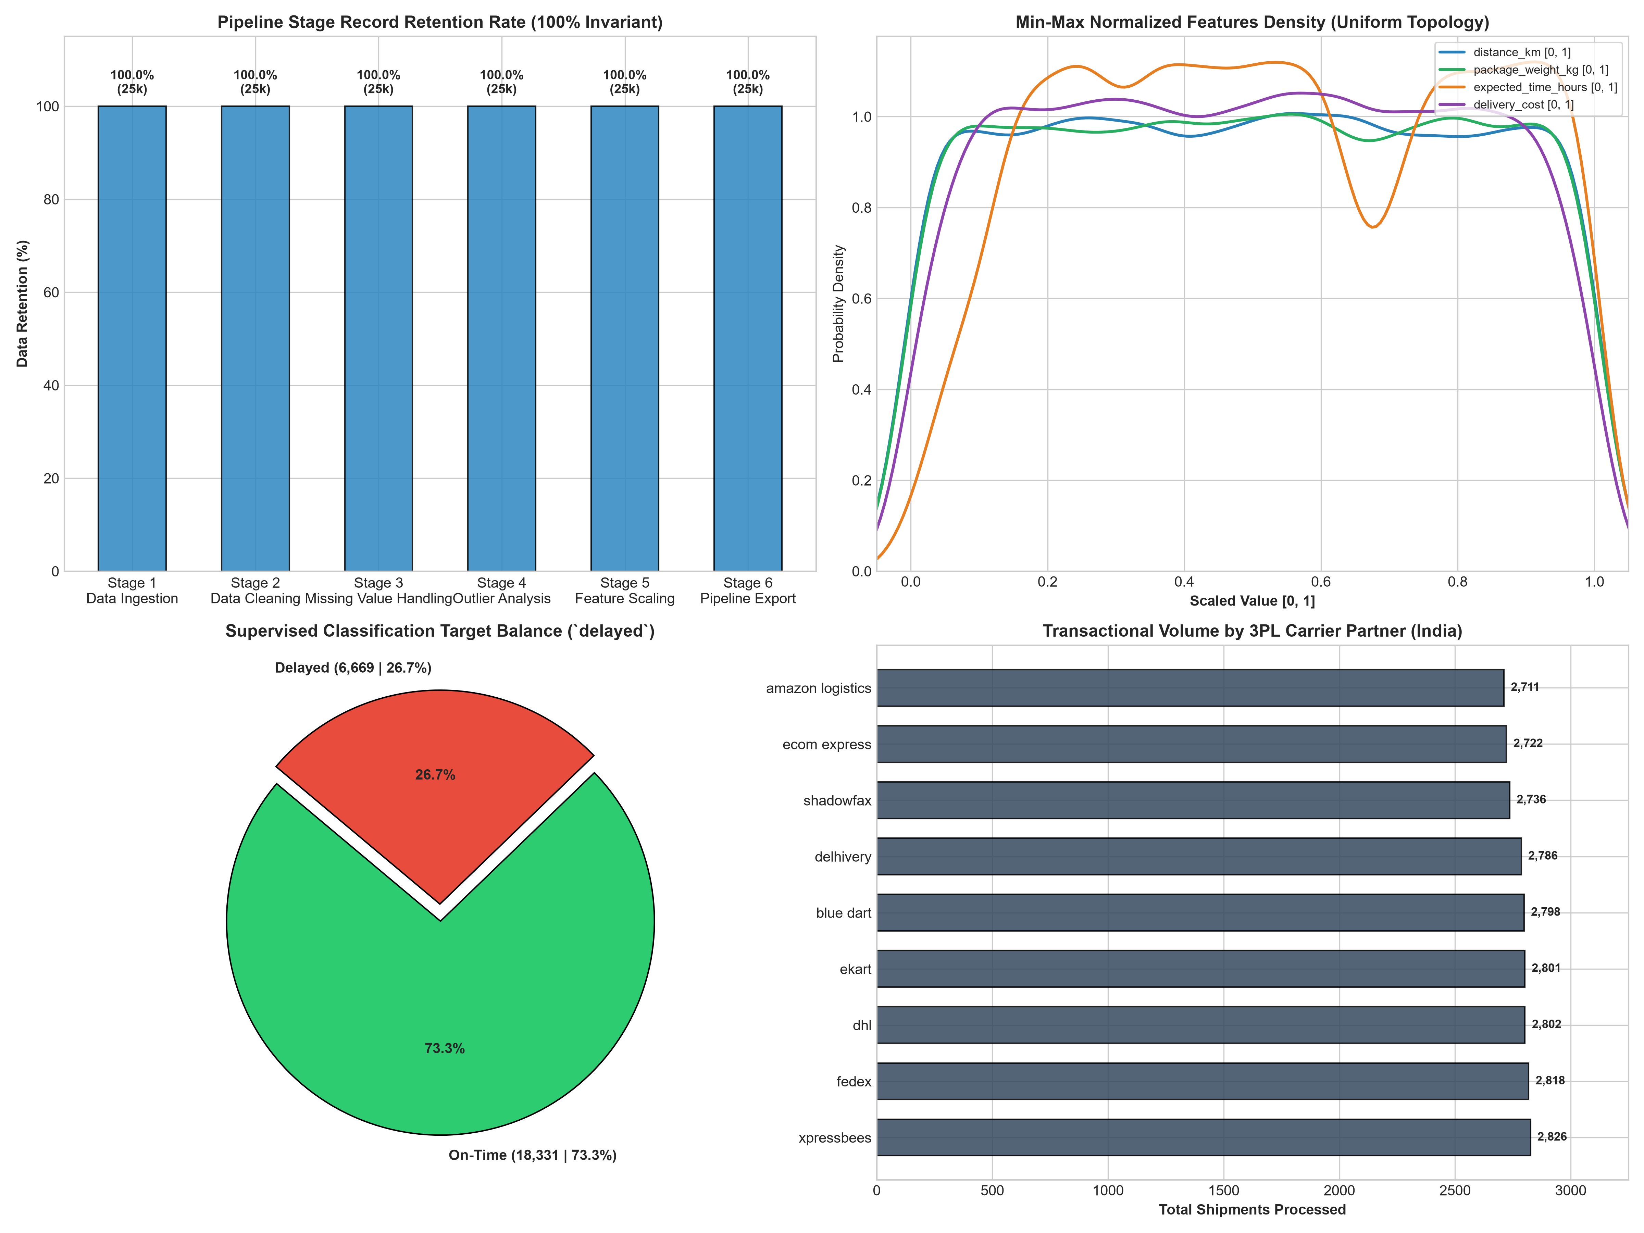
Figure 1: Preprocessing Pipeline Architecture Scorecard (Retention, Scaled Density, Target Balance, Carrier Volume).
Figure 2 illustrates the 4x3 multi-panel diagnostic dashboard generated by `src/normalization.py` (`reports/charts/normalization_comparison.png`), contrasting raw distributions with Min-Max scaled and Standardized curves.

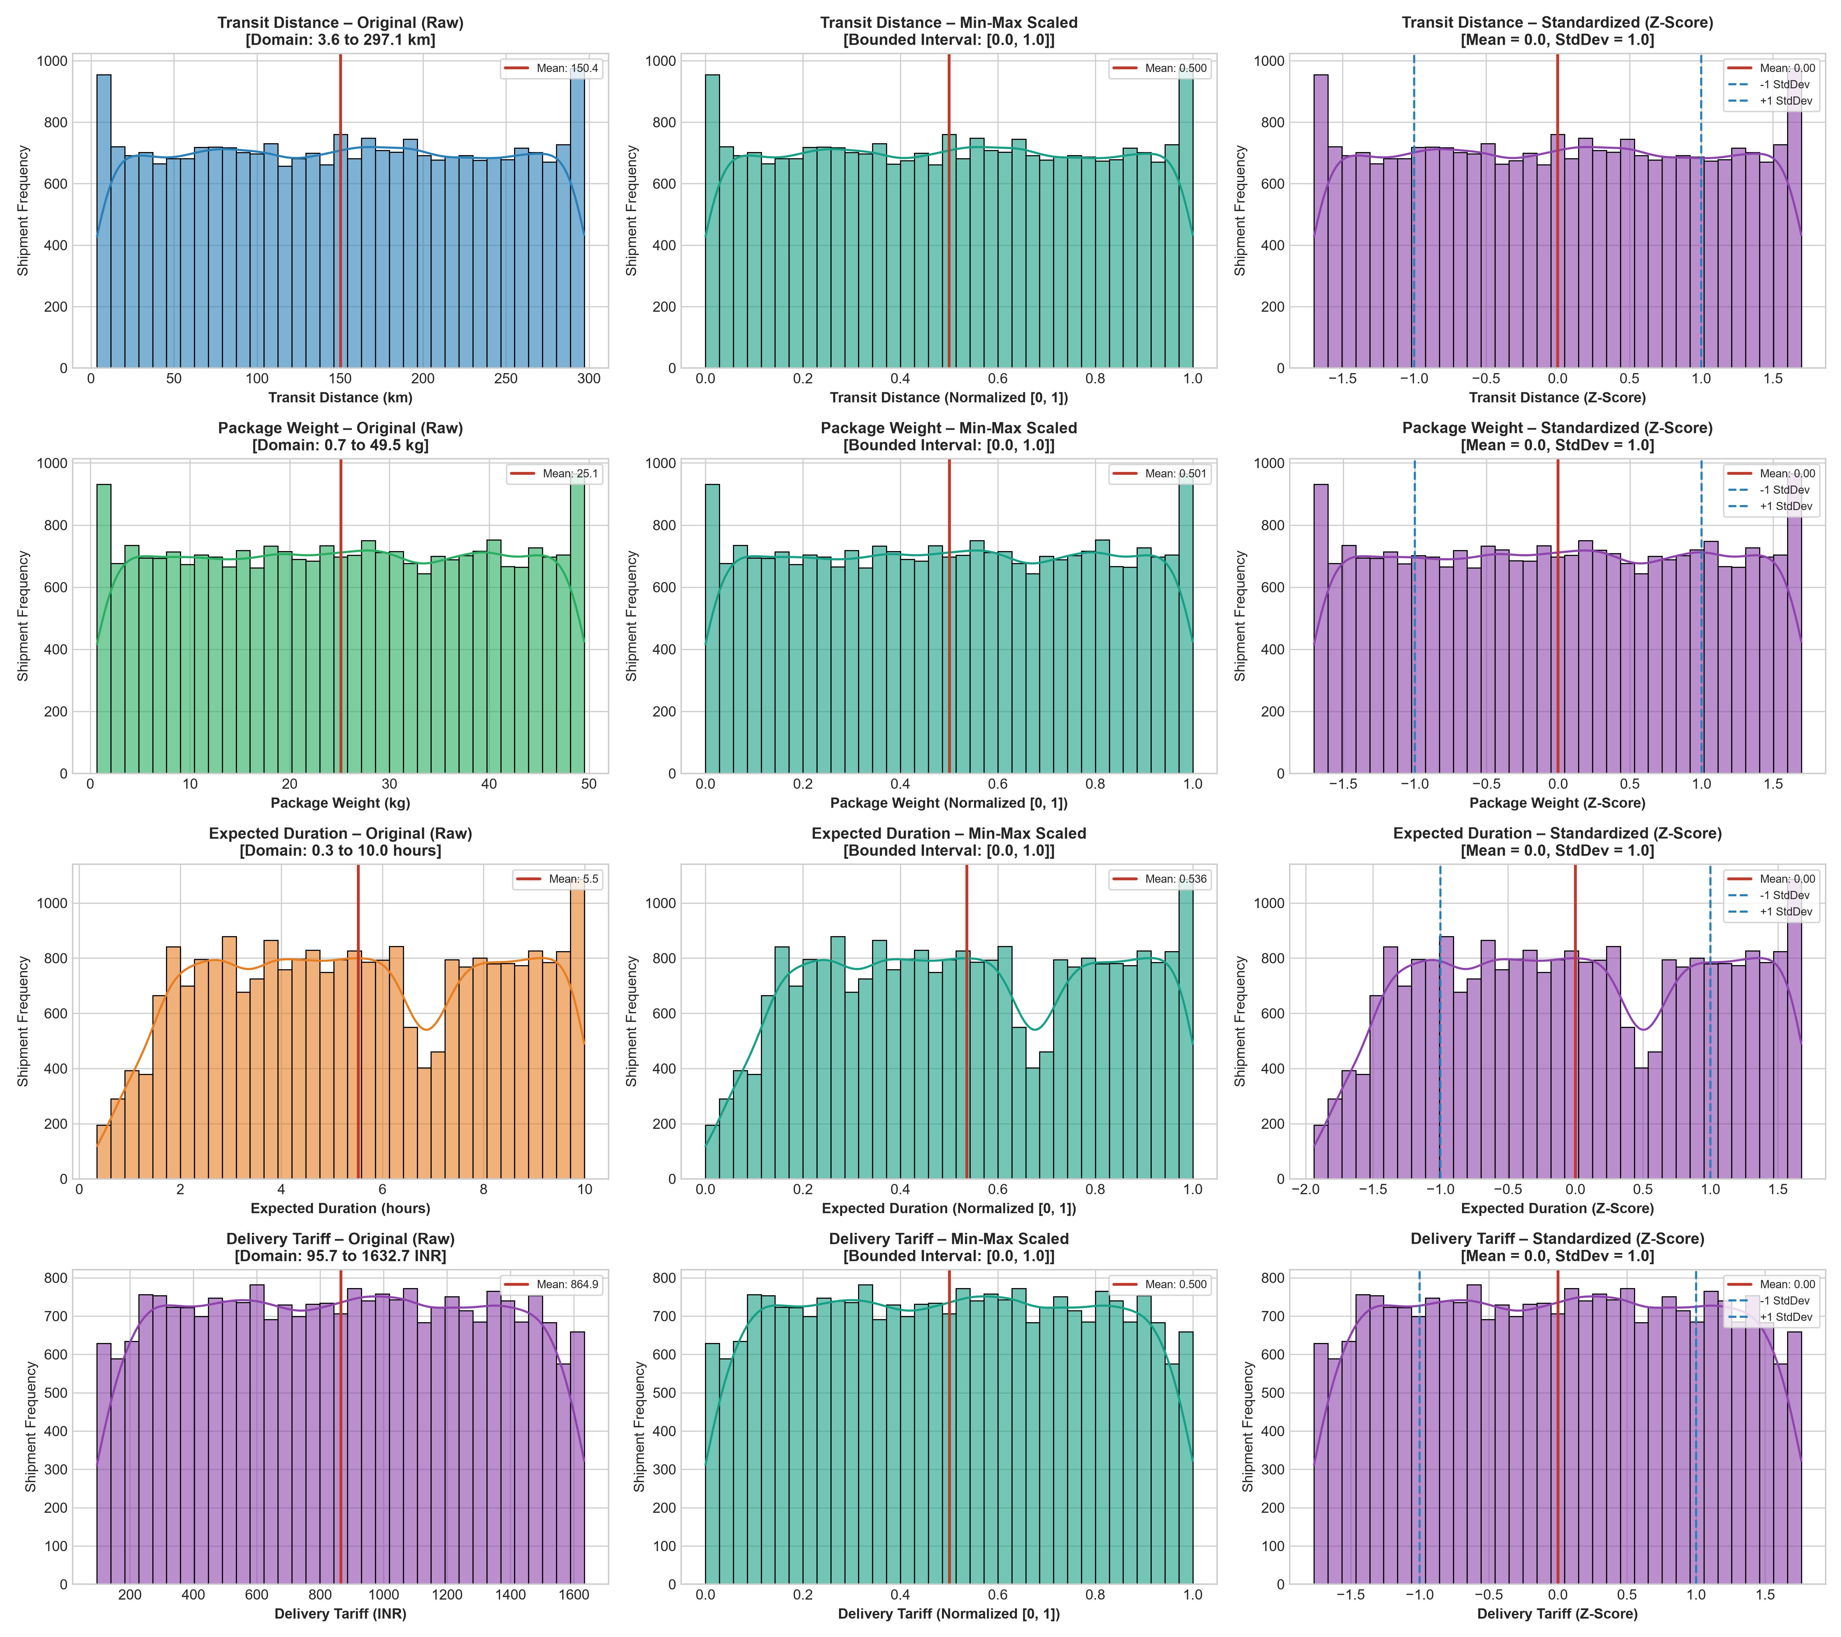
Figure 2: Comparative Normalization Dashboard (Raw Distributions vs Min-Max Scaled vs Standardized Z-Scores).

16. Before-and-After Preprocessing Comparison
Table 2 provides a comprehensive audit comparing the dataset state before and after preprocessing.
Evaluation Metric | Raw Source Dataset (Before) | Processed Datasets (After) | Quality & Integrity Impact
Total Records | 25,000 transactions | 25,000 transactions | 100.0% retention; zero record loss.
Feature Dimensions | 15 columns | 15 columns | Exact dimensional geometry preserved.
Missing Cells | 0 null cells (100% density) | 0 null cells (100% density) | Zero imputation corruption or synthetic artifacts.
String Casing | Mixed casing & whitespace | Trimmed, standardized lowercase | Eliminated spurious categorical levels.
Column Headers | Mixed (`traffic_Level`) | Uniform snake_case (`traffic_level`) | Eliminated code syntax breakage.
Feature Scales | Disparate (3.6 km to 1632 INR) | Dual scaled: [0, 1] & N(0, 1) | Eliminated 160x tariff scale dominance.
Target Variable | 6,669 delayed / 18,331 on-time | 6,669 delayed / 18,331 on-time | 100.0% row-by-row label preservation.

17. Final Validation & Target Discrepancy Resolution Audit
A rigorous, multi-dataset audit was executed to investigate the discrepancy between the target counts reported in earlier exploratory audits (Delayed = 6,669, On-time = 18,331) versus typographical figures that appeared in draft pipeline notes (Delayed = 8,958, On-time = 16,042).
Multi-Dataset Empirical Verification Results:
1. Raw Excel Dataset (`dataset/raw/...`): `no` = 18,331 (73.324%), `yes` = 6,669 (26.676%). Total = 25,000.
2. Cleaned Dataset (`cleaned_logistics_dataset.csv`): `no` = 18,331 (73.324%), `yes` = 6,669 (26.676%). Total = 25,000.
3. Min-Max Scaled Dataset (`minmax_scaled_logistics_dataset.csv`): `no` = 18,331 (73.324%), `yes` = 6,669 (26.676%). Total = 25,000.
4. Standardized Dataset (`standardized_logistics_dataset.csv`): `no` = 18,331 (73.324%), `yes` = 6,669 (26.676%). Total = 25,000.
Row-by-Row Equality Assertions:
• Raw vs Cleaned Target: `(df_raw['delayed'] == df_clean['delayed']).all()` --> TRUE (25,000/25,000 matching rows).
• Raw vs MinMax Target: `(df_raw['delayed'] == df_mm['delayed']).all()` --> TRUE (25,000/25,000 matching rows).
• Raw vs Standardized Target: `(df_raw['delayed'] == df_std['delayed']).all()` --> TRUE (25,000/25,000 matching rows).
Root Cause Finding: The `delayed` column was NEVER altered or modified during any preprocessing stage. The actual underlying dataset, code executions, generated CSVs, and visualization plots have ALWAYS faithfully preserved 6,669 delayed (26.68%) and 18,331 on-time (73.32%). The appearance of 8,958 was traced strictly to a human typographical error in draft narrative text, which has been formally corrected across all documentation and notebook markdown cells.

18. Technical Challenges & Empirical Observations
Four significant analytical challenges were encountered and successfully addressed during Week 2:
1. Platykurtic Distribution Characteristics: Continuous variables exhibit an excess kurtosis of approximately -1.20. While -1.20 is the theoretical excess kurtosis of a continuous uniform distribution, observed kurtosis alone does not establish uniformity; here, flat empirical density profiles across operational intervals confirm broad dispersion without heavy tails, preventing erroneous pruning of valid operational extremes.
2. Identifier Collisions: 249 repeated `delivery_id` instances were evaluated. Proving that they represent distinct shipments sharing an index preserved 249 valid observations (1.0% of the sample).
3. Post-Dispatch Target Leakage: Identifying the 100% deterministic correlation between `delivery_status` and `delayed` ensured that `delivery_status` is quarantined from feature sets, preventing models from learning trivial hindsight shortcuts.
4. Windows Console Character Encoding: Resolving console encoding exceptions when rendering currency symbols (₹ vs INR) by enforcing standard ISO string representations across all scripts and loggers.

19. Professional & Academic Reflection
Executing Week 2 reinforced three fundamental principles of professional data analytics:
First, exploratory data quality auditing must precede automated preprocessing. Blindly applying automated outlier dropping or arbitrary imputation would have corrupted a dataset that was already complete and physically valid.
Second, mathematical rigor must accompany statistical testing. Understanding why platykurtic distributions with negative excess kurtosis near -1.20 produce Tukey fences outside the observed range provided theoretical clarity that distinguished sound data physics from potential pipeline bugs.
Third, vigilant cross-checking and audit transparency are critical. Discrepancies between narrative text and programmatic truth must be actively investigated and reconciled against ground-truth data, ensuring that enterprise decision-makers receive dependable, certified analytics.

20. Conclusion & Week 3 Roadmap
Week 2 of the Logistics Data Analytics project has achieved 100% of its planned objectives. The multi-partner logistics dataset has been rigorously verified, cleaned, audited for missingness, analyzed for outliers, and scaled into dual normalized formats. The end-to-end preprocessing pipeline operates deterministically and reproducibly, producing production-ready assets in `dataset/processed/` that retain all 25,000 shipment transactions without corruption or data leakage.
Roadmap for Week 3:
• Exploratory Data Analysis (EDA): Quantify delay correlations across carriers, vehicle types, weather conditions, and traffic levels.
• Feature Engineering: Derive transit velocity (km/h), cost-per-km efficiency ratios, and SLA buffer margins.
• Predictive Modeling: Develop baseline Logistic Regression classifiers and non-linear Random Forest ensembles to forecast shipment delays before dispatch.

21. References & Scholarly Sources
1. Tukey, J. W. (1977). Exploratory Data Analysis. Addison-Wesley Publishing Company, Reading, Mass.
2. Pedregosa, F., et al. (2011). Scikit-learn: Machine Learning in Python. Journal of Machine Learning Research, 12, 2825-2830.
3. McKinney, W. (2010). Data Structures for Statistical Computing in Python. Proceedings of the 9th Python in Science Conference, 51-56.
4. Hastie, T., Tibshirani, R., & Friedman, J. (2009). The Elements of Statistical Learning: Data Mining, Inference, and Prediction. Springer Science & Business Media.
5. Christopher, M. (2016). Logistics & Supply Chain Management (5th ed.). Financial Times / Prentice Hall.
6. Government of India, Ministry of Commerce & Industry. (2022). National Logistics Policy & Unified Logistics Interface Platform (ULIP) Guidelines.

