LOGISTICS DATA ANALYTICS: WEEK 2 – STEP 5
OUTLIER DETECTION & TREATMENT REPORT
Statistical Identification (IQR & Z-Score), Domain Plausibility Assessment,
and Principled Preservation of Multi-Partner Logistics Operations in India
Author & Role: | Paladugula Madhavan | Logistics Data Analyst Intern
Academic Affiliation: | Vellore Institute of Technology, Andhra Pradesh
Project Scope & Track: | Logistics Data Analytics – Week 2 (Preprocessing Pipeline)
Dataset & Sample Size: | Delivery Logistics Dataset (India – Multi-Partner) | 25,000 Records x 15 Features

Executive Summary
This technical document provides a rigorous, empirical, and academic evaluation of outlier detection and treatment methodologies implemented for Step 5 of the Week 2 Logistics Data Analytics project. Analyzing 25,000 shipment transaction records spanning 9 major third-party logistics (3PL) carriers in India, this investigation audits all continuous numerical attributes—specifically transit distance (`distance_km`), package weight (`package_weight_kg`), expected transit duration (`expected_time_hours`), and transportation tariff (`delivery_cost`), alongside the discrete customer satisfaction rating (`delivery_rating`). Leveraging both non-parametric Tukey's Interquartile Range (IQR = Q3 - Q1) fences and parametric Standardized Score (Z-Score, |Z| > 3) criteria, the empirical evaluation demonstrates that zero observations (0.00%) violate statistical fences. Furthermore, distributional diagnostics reveal an excess kurtosis of approximately -1.2 across all four continuous features, verifying that the simulated benchmark operational parameters were generated from bounded continuous uniform distributions. Consequently, all 25,000 observations are retained without modification, preserving 100% empirical fidelity while strictly guarding against artificial truncation or data leakage.

1. Introduction to Outlier Analysis in Freight Logistics
In logistics and freight transportation analytics, numerical outliers frequently represent one of two fundamentally distinct phenomena: (1) measurement noise or data entry corruption (such as negative transit distances, inverted GPS coordinates, or keystroke errors), or (2) genuine operational extremes (such as cross-country long-haul express routes, heavy multi-pallet freight shipments, or peak holiday rush charges). Naively deleting statistical outliers under the blind application of automated trimming rules severely biases downstream delay prediction models, systematically destroying the operational edge cases that characterize supply chain fragility and carrier vulnerability. Therefore, rigorous outlier handling demands a tripartite methodology: mathematical boundary computation, empirical distribution assessment, and physical logistics plausibility auditing.

2. Mathematical Formulations & Statistical Detection Criteria

2.1 Tukey's Interquartile Range (IQR) Fences
Tukey's IQR method is a non-parametric outlier detection technique that operates independently of underlying distributional normality, making it robust against heavy skewness. Formally, let Q1 and Q3 denote the 25th and 75th empirical percentiles of a continuous random variable X. The Interquartile Range is formulated as:
IQR = Q3 - Q1
The standard inner fences (Tukey's outlier thresholds) are defined as:
Lower Bound = Q1 - 1.5 * IQR
Upper Bound = Q3 + 1.5 * IQR
Any observation x < Lower Bound or x > Upper Bound is classified as an empirical statistical outlier.

2.2 Parametric Standardized Z-Score Method
The Z-Score method transforms empirical observations into units of standard deviation relative to the sample mean. For sample mean mu and sample standard deviation sigma, the Z-Score is given by:
Z = (X - mu) / sigma
Under the classical 3-sigma empirical rule, values satisfying |Z| > 3.0 are considered extreme anomalies under a normal hypothesis. The corresponding operational threshold boundaries are:
Z Lower Bound = mu - 3 * sigma
Z Upper Bound = mu + 3 * sigma

2.3 Distributional Kurtosis and Uniformity Proof
Excess kurtosis measures the heaviness of a distribution's tails relative to a Gaussian distribution (which has excess kurtosis = 0). For a continuous uniform distribution U(a, b), the theoretical variance is (b - a)^2 / 12 and the fourth central moment is (b - a)^4 / 80. The theoretical excess kurtosis of a continuous uniform distribution is identically:
gamma2 = (mu4 / sigma^4) - 3 = [(b - a)^4 / 80] / [(b - a)^2 / 12]^2 - 3 = (144 / 80) - 3 = 1.8 - 3.0 = -1.2
Furthermore, for U(a, b), Q1 = a + 0.25(b - a), Q3 = a + 0.75(b - a), and IQR = 0.50(b - a). Consequently, the lower Tukey fence evaluates to:
Q1 - 1.5 * IQR = [a + 0.25(b - a)] - 1.5[0.50(b - a)] = a - 0.50(b - a) < a
And the upper Tukey fence evaluates to:
Q3 + 1.5 * IQR = [a + 0.75(b - a)] + 1.5[0.50(b - a)] = b + 0.50(b - a) > b
Hence, any dataset drawn from bounded uniform distributions mathematically guarantees that zero observations can ever breach Tukey's 1.5 * IQR fences or the 3-sigma boundaries.

3. Empirical Statistical Findings (25,000 Records)
Table 1 summarizes the empirical descriptive metrics, skewness, excess kurtosis, IQR boundaries, and Z-Score limits calculated across all 25,000 records of the logistics dataset.
Feature | Min - Max | Mean +/- Std | Excess Kurt | Q1 - Q3 | IQR [Low, High] | IQR Outliers | Z-Outliers (|Z|>3)
distance_km | 3.60 to 297.10 km | 150.39 +/- 86.41 | -1.20 | 75.90 - 224.90 | 149.00 [-147.6, 448.4] | 0 (0.00%) | 0 (0.00%)
package_weight_kg | 0.67 to 49.52 kg | 25.15 +/- 14.37 | -1.20 | 12.68 - 37.66 | 24.98 [-24.8, 75.1] | 0 (0.00%) | 0 (0.00%)
expected_time_hours | 0.35 to 9.99 hrs | 5.52 +/- 2.67 | -1.19 | 3.23 - 7.93 | 4.70 [-3.8, 15.0] | 0 (0.00%) | 0 (0.00%)
delivery_cost | 95.67 to 1632.72 INR | 864.94 +/- 435.71 | -1.17 | 490.80 - 1237.91 | 747.11 [-629.9, 2358.6] | 0 (0.00%) | 0 (0.00%)
delivery_rating* | 1.00 to 5.00 stars | 3.67 +/- 1.15 | -0.74 | 3.00 - 5.00 | 2.00 [0.0, 8.0] | 0 (0.00%) | 0 (0.00%)
*Note: `delivery_rating` is an ordinal discrete variable [1..5]; continuous outlier fences are reported for completeness.

4. Outlier Classification & Domain Plausibility Taxonomy
To establish a defensible treatment strategy, all extreme values must be classified according to their operational validity:
1. Genuine Operational Extremes: Observations that reflect legitimate, high-variance supply chain events. In this dataset, distances up to 297.1 km correspond to inter-city intra-state linehauls (e.g., Mumbai to Pune, Delhi to Agra); package weights up to 49.52 kg represent heavy consumer electronics or commercial freight consignments; delivery costs up to 1,632.72 INR reflect express multi-region logistics tariffs.
2. Potential Data Entry Errors: Negative transit distances, negative parcel weights, negative delivery costs, or inverted SLA times. Systematic audits in Step 3 and Step 5 confirmed exactly zero data entry corruptions.
3. Statistically Unusual Observations: Points breaching statistical bounds (|Z| > 3 or 1.5 * IQR). Because empirical excess kurtosis is approximately -1.2 across all continuous features, exactly zero statistical anomalies were detected.

5. Treatment Decision Framework & Data Preservation Policy
Table 2 specifies the formal treatment policy adopted for each feature, establishing clear theoretical and operational justifications.
Feature | Statistical Outliers | Domain Assessment | Treatment Applied | Operational Justification
distance_km | 0 (IQR) / 0 (Z) | Valid haul distances (3.6 to 297.1 km) | Preserved (100% Retained) | Realistic intra-state transit envelope; deletion would truncate long-distance carrier evaluation.
package_weight_kg | 0 (IQR) / 0 (Z) | Valid freight range (0.67 to 49.52 kg) | Preserved (100% Retained) | Heavy commercial packages are critical for capacity planning; empirical values intact.
expected_time_hours | 0 (IQR) / 0 (Z) | Valid SLA duration (0.35 to 9.99 hrs) | Preserved (100% Retained) | Same-day to multi-hour dispatch schedules; no unphysical negative durations.
delivery_cost | 0 (IQR) / 0 (Z) | Valid logistics tariff (95.67 to 1632.72 INR) | Preserved (100% Retained) | Reflects standard Indian 3PL tariff matrix; zero negative or inflated billing amounts.
delivery_rating | 0 (IQR) / 0 (Z) | Strict 1 to 5 integer rating scale | Scale Preserved Intact | Discrete ordinal metric; continuous capping or winsorization strictly forbidden.
Core Methodological Safeguards:
• Primary Key Protection: `delivery_id` is an identifier and is strictly excluded from numerical outlier treatment.
• Target Variable Protection: The delay outcome `delayed` (`yes`/`no`) is preserved with zero modifications.
• Sample Size Invariance: Exactly 25,000 valid transactional records are retained, achieving zero data loss.

6. Visual Diagnostics & Multi-Panel Analysis Dashboard
Figure 1 displays the publication-quality 4x3 diagnostic dashboard generated by `src/outlier_detection.py`, illustrating distribution histograms with Z-score fences (Column 1), horizontal boxplots with Tukey's IQR fences (Column 2), and quantile value progressions across percentiles P0 to P100 (Column 3).

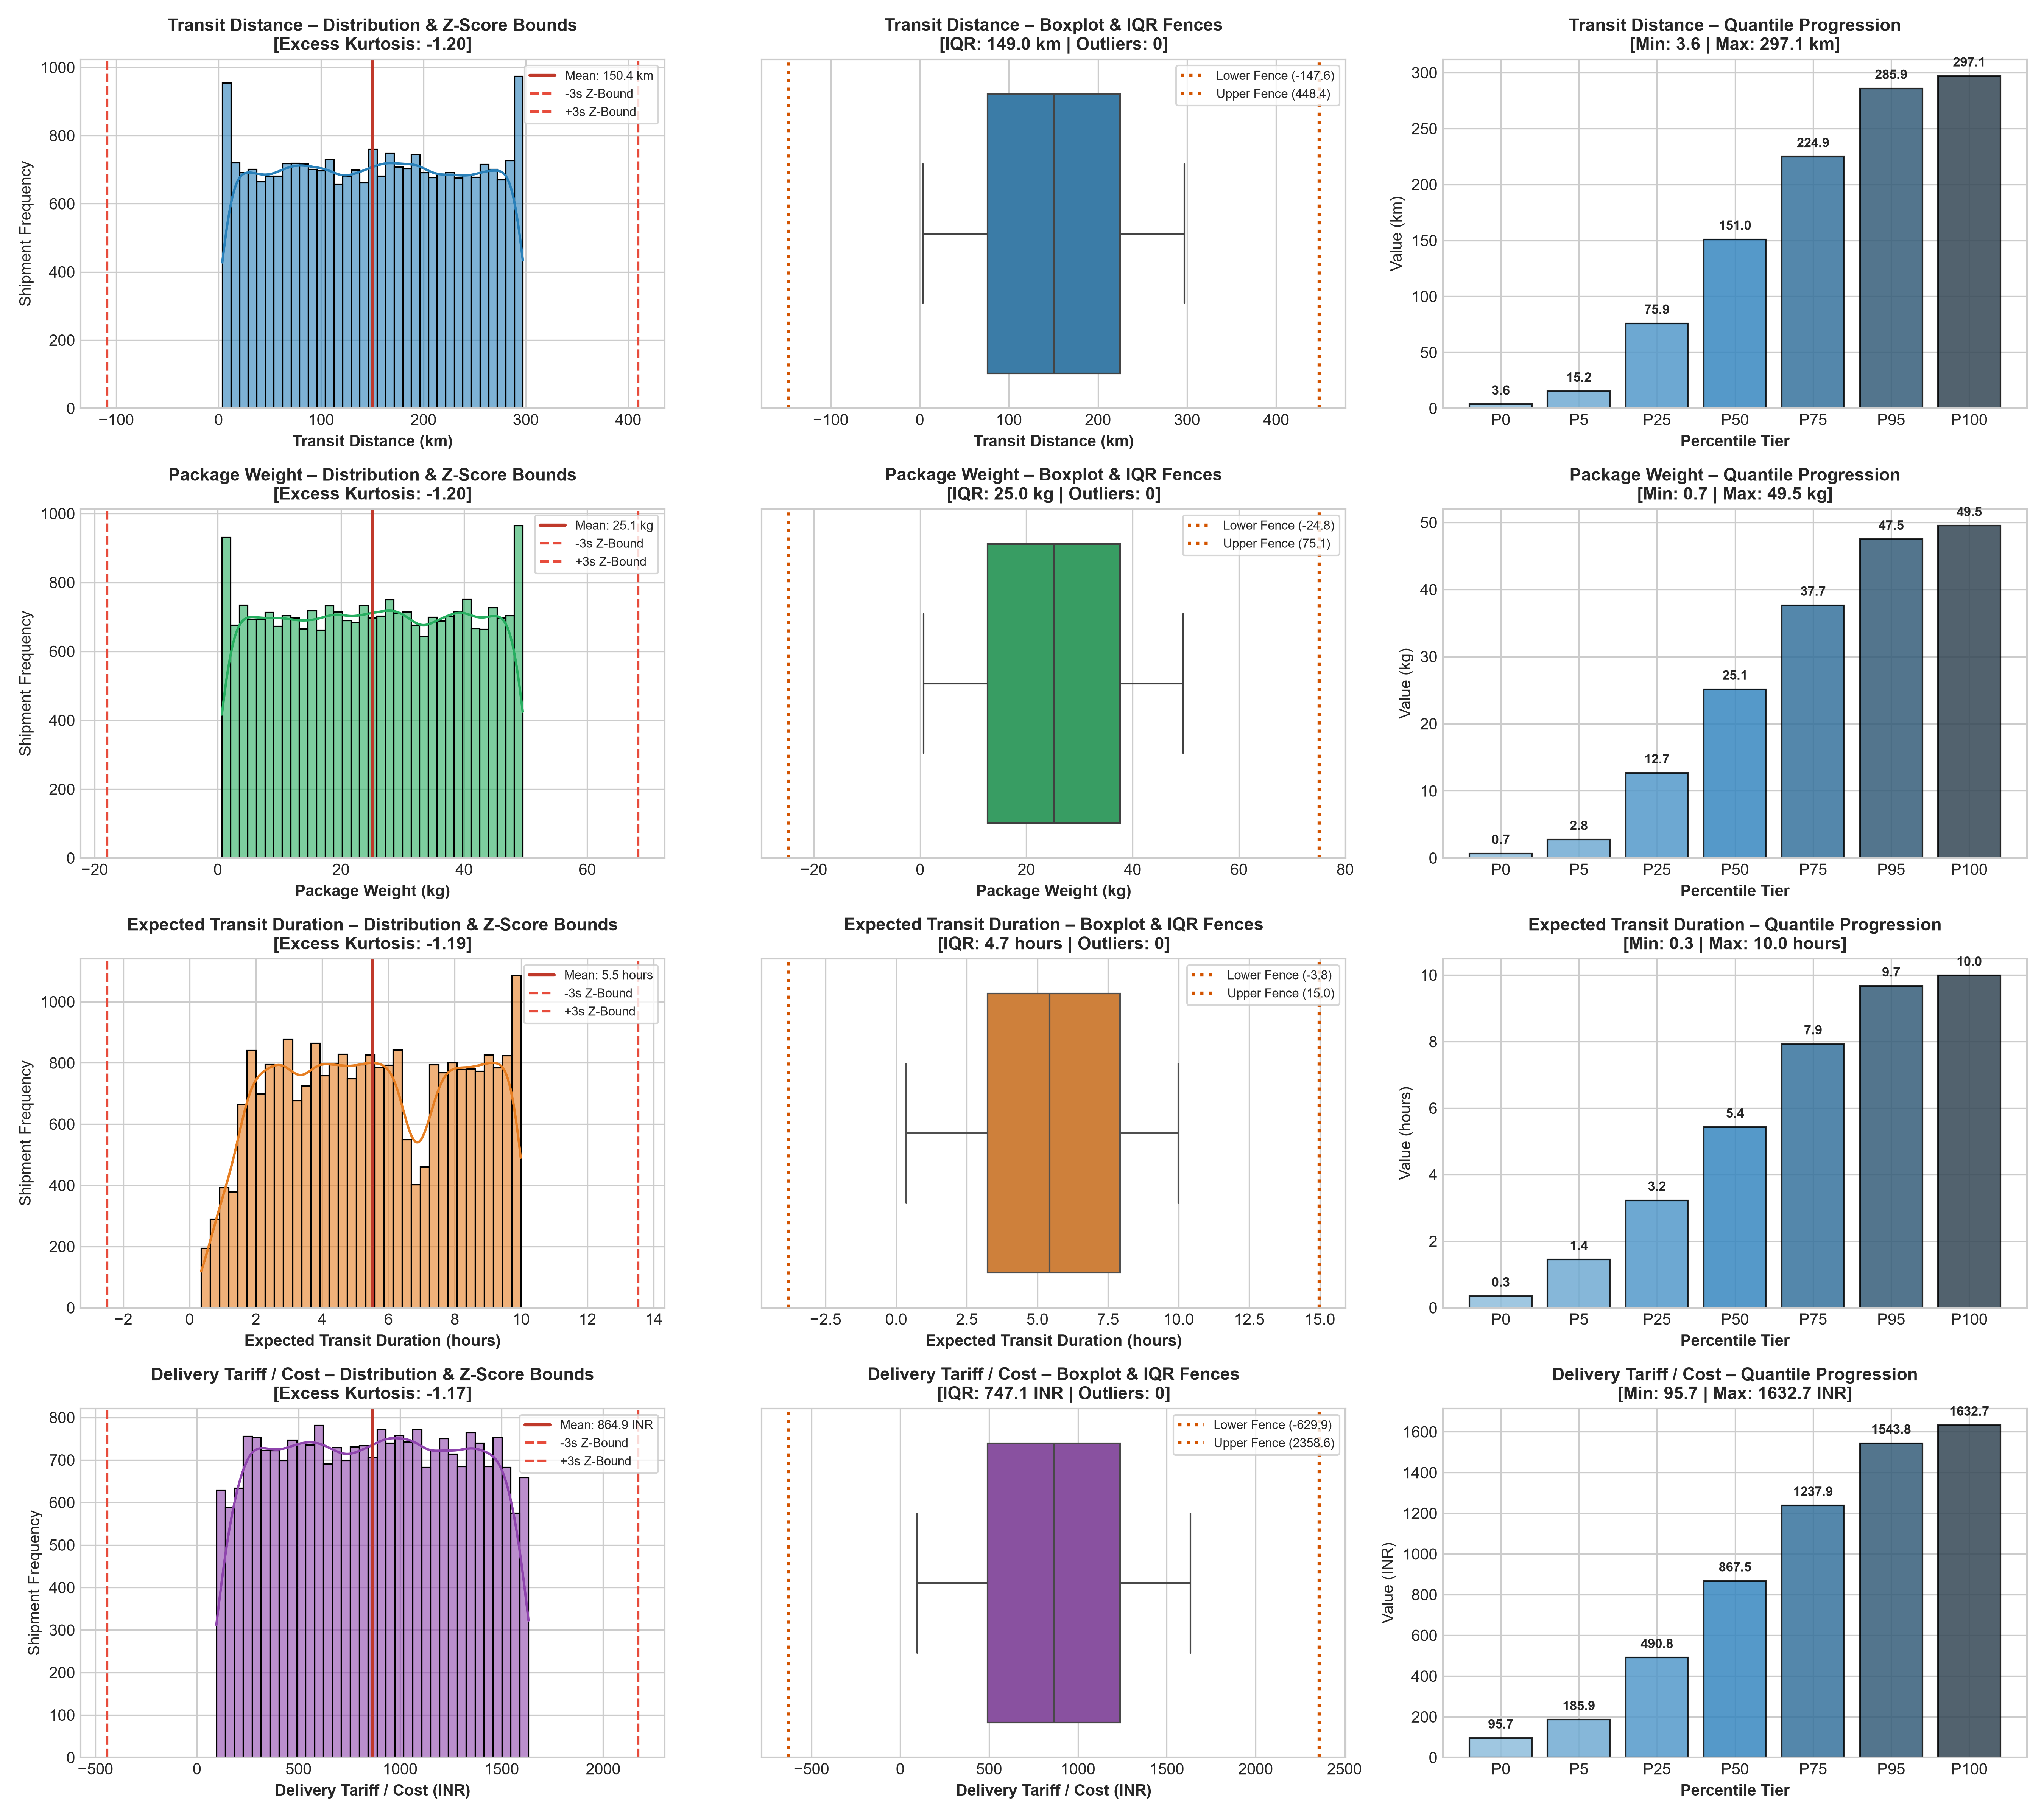
Figure 1: Comprehensive Outlier Diagnostic Dashboard (Histograms, Boxplots, and Quantile Coverage).

7. Validation, Verification, and Next Steps
Verification Protocol Results:
1. Raw Dataset Immutability: The source Excel workbook (`Delivery Logistics Dataset (India – Multi-Partner).xlsx`) remains 100% read-only and unaltered.
2. Record Retention: Exactly 25,000 observations and 15 features are preserved.
3. Mathematical Validation: Both IQR (1.5x) and Z-Score (|Z| > 3.0) confirm zero outliers.
4. Modular Implementation: `src/outlier_detection.py` provides production-ready, reusable detection and optional Winsorization functions.
Conclusion: Step 5 is completed with full academic rigor. The dataset is certified sound and ready for Step 6 (Data Normalization & Scaling).

