***STOCK MARKET ANALYSIS***

DATASET :

The dataset provided has been extracted from the NSE website. The Stock price data provided is from 1-Jan-2015 to 31-July-2018 for six stocks Eicher Motors, Hero, Bajaj Auto, TVS Motors, Infosys and TCS.

Brief Problem Description :

1. When the shorter-term moving average crosses above the longer-term moving average, it is a **signal** to BUY, as it indicates that the trend is shifting up. This is known as a Golden Cross.
2. On the opposite when the shorter term moving average crosses below the longer term moving average, it is a **signal** to SELL, as it indicates the trend is shifting down. It is sometimes referred to as the Death Cross.
3. When the signal is neither buy nor sell, it is classified as hold.

**THE IMPORTANT ANALYSIS WITH RESPECT TO DETERMINING THE SIGNAL FOR ALL STOCKS WAS DONE USING ‘MYSQL’**

**STEPS PERFORMED:**

1. Created a new schema
2. Imported data in ‘csv’ format using table data import wizard (used date as primary key)
3. Created new tables such as balaji1, eicher1 , etc which consists of 20day Moving Average ,50day Moving average and close prices
4. Created a master table containing the date and close price of all the six stocks.
5. Created new tables such as balaji2, eicher2 , etc which consists of close prices and Signal mentioning whether to buy , sell or hold the stock
6. Created a User defined function, that takes the date as input and returns the signal for that particular day (Buy/Sell/Hold) for the Bajaj stock.
7. Created a stored procedure where Stock name given as input the output will be the date and close prices of all stocks which had a signal of ‘buy’ or ‘sell’

SUMMARY OF THE ANALYSIS:

***THE COUNT OF SELL, BUY , HOLD , INFO NOT AVAILABLE ( The initial 49 rows where Signal cannot be evaluated because we choose 20day ma and 50day ma) for all stocks is as follows***

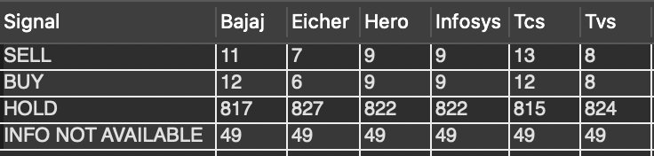

***THE AVERAGE OF STOCK PRICES ACCROSS SELL, BUY , HOLD , INFO NOT AVAILABLE ( The initial 49 rows where Signal cannot be evaluated because we choose 20day ma and 50day ma) for all stocks is as follows***

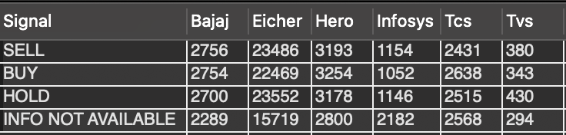

**KEY OBSERVATIONS AS PART OF THE ANALYSIS:**

1. The Eicher , TVS and TCS stocks experienced very low periods of **Golden cross** and **Death cross** which indicates that these stocks are stable
2. Bajaj stock has experienced high periods of Golden Cross and Death Cross compared to other stocks which indicates that it is more apt for short term investments
3. The average stock prices for the first 49 rows ( 1 Jan 2015 to 19 Feb 2015) comes under the category ‘INFO NOT AVAILABLE’ . The hold period contributes approximately about 90% of the data from 2015 to 2018. As the average close price for ***bajaj, eicher , hero , tvs***- **holding period** is greater than the average close price for **bajaj, eicher , hero , tvs**-  **(1 Jan 2015 to 19 Feb 2015)** we can see that the value of these stocks have grown through time whereas the value of Infosys and Tvs stocks have decreased over time.
4. ***Based on the following information it is recommended for a person who is aiming for short term returns to invest on Bajaj Shares and a person looking for long term stable investment to invest on Eicher or Tvs***