SECURE CODING

NAME : HARISH MADHAVAN J U

ROLL NO : CH.EN.U4CYS.22018

Types Of Behaviour:

1) Implementation defined :

Implementation-defined behaviour refers to the behaviour of a program that is specified by the implementation (compiler or platform) rather than by the language standard. It occurs when the language standard allows multiple valid behaviours for a certain construct, and the implementation chooses one of them. The specific behaviour chosen may vary between different platforms or compilers, but it remains consistent and reliable within a given implementation. It is important to note that relying on implementation-defined behaviour can lead to non-portable code, as it may only work under specific platforms or compilers

Code :
#include <stdio.h>

int main() {
int x = -1;
unsigned int y = 1;

if (x < y) {
printf("x is less than y\n");
} else {
printf("x is not less than y\n");
}

return 0;
}

Output Screenshot :
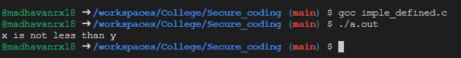

2)Locale Specific :

Behaviour of a program that is influenced by the specific locale or cultural settings of the system on which it is running. A locale represents a specific language and geographic region, and it defines various aspects of the program's behaviour, such as language, date and time formatting, currency formatting, and collation (sort) order.

Code :
#include <stdio.h>
#include <time.h>

int main() {

time_t currentTime;
struct tm *localTime;
char timeString[100];

// Get the current time
currentTime = time(NULL);

localTime = localtime(&currentTime);

strftime(timeString, sizeof(timeString), "%c", localTime);

printf("Current time: %s\n", timeString);

return 0;
}

Output Screenshot :
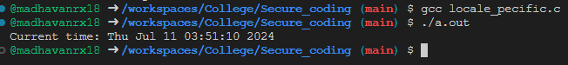

3) Undefined Behaviour :
Undefined behaviour can lead to bugs, security vulnerabilities, and difficult-to-debug issues.

Code:
#include <stdio.h>

int main() {
int arr[5] = {1, 2, 3, 4, 5};
int index = 6; // Index of element not present in the array

printf("Element at index %d is %d\n", index, arr[index]);

return 0;
}

Output Screenshot :
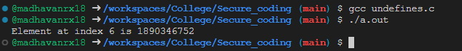

4)Unspecific Behaviour:

Unspecific behavior refers to behavior that lacks specificity or is not detailed or specific in nature. It is characterized by a lack of clear definition or precise attributes. Here are a few key points to understand about unspecific behavior:

Code :
#include <stdio.h>

int main() {
int a = 10;
int b;
int result;

printf("Enter the value of b: ");
scanf("%d", &b);

result = a / b; // Division by zero

printf("The result is: %d\n", result);

return 0;
}

Output Screenshot :
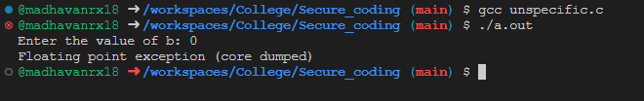

VULNERABILITIES:

1 ) STR 30 – C Vulnerability :

It is associated with unsafe string functions that can lead to buffer overflows or undefined behaviour if not used correctly

Code :
#include<stdio.h>

int main(){
char *str = "Hello";
str[0] = 'Y';
printf("%s",*str);
}

Output :
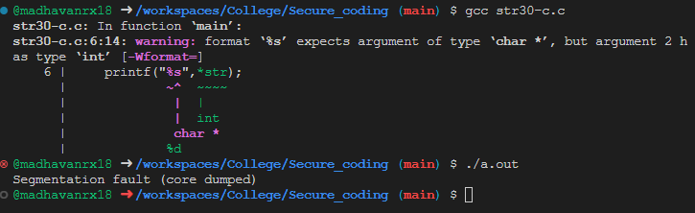

2) ARR01 – C VULNERABLITY :

When the elements are accessed using [ ] operator , bounds are not checked unless the programmer explicitly mentions it , which may lead to buffer overflow or other security vulnerablities.

Code :
#include<stdio.h>

void size(int arr[]){
int n = sizeof(arr)/sizeof(arr[0]);
printf("size calculated by size function %d",n);
}

int main (){
int arr[] = {1,2,3,4,5};
int n = sizeof(arr)/sizeof(arr[0]);
printf("array size calculated by main function %d",n);
size(arr);
}

Output Screenshot :
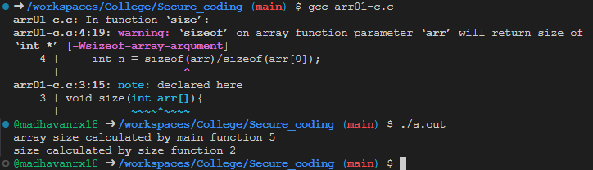

3) STR 36 -C Vulnerablity :

the STR36-C vulnerability arises when the size of the array is not properly specified to accommodate the string literal assigned to it. This can result in the trailing null byte being omitted, leading to potential vulnerabilities when the array is subsequently used as a null-terminated byte string.

Code :
#include <stdio.h>

void main() {
char str[5] = "hello"; // Incorrect: bound specified is too small
printf("%s\n", str);

char strc[]="hi how are you ";
printf("%s\n",strc);
}

Output :
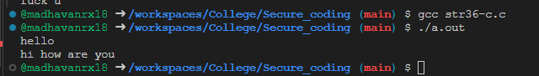

4) Gets Vulenerablity :

Code :
#include <stdio.h>
#include <stdlib.h>

void get_y_or_n(void) {
char response[8];
puts("Continue? [y] n: ");
gets(response);
if (response[0] == 'n')
exit(0);
return;
}

char *gets(char *dest) {
int c = getchar();
char *p = dest;
while (c != EOF && c != '\n') {
*p++ = c;
c = getchar();
}
*p = '\0';
return dest;
}

int main() {
get_y_or_n();
return 0;
}

Output Screenshot :
