|  |
| --- |
| Serial Number: 85 |
| Instrument Name: DELTACORP & AMJLAND |

**ECON F212**

**FUNDAMENTALS OF FINANCE AND ACCOUNTING**

|  |
| --- |
| Financial Analysis of |
| DELTACORP & AMJLAND |

|  |
| --- |
| Author: Supervisor: |
| SHUBH MADHAVAN DR. THOTA NAGARAJU |

**Abstract:**

*The primary motive of this project is to make recommendations in relation to the financial health of the stocks of AMJLAND & DELTACORP. In order to do this, the spot prices between 1st April ’19 to 30th March ’20 are to be analysed on the Daily, Weekly and Monthly Frequencies, so as to find out which investing methodology will work best in ensuring greater returns for the same amount of risk. Apart from calculating Returns on the aforementioned frequencies, these Returns will also be adjusted with the Treasury-Bill Returns in order to calculate the Excess Returns. This is important as it paints a more realistic picture of the situation and helps an investor in making more informed decisions.*

*All analysis has been done through extensive usage of* ***Python*** *(using the Numpy, Pandas and Matplotlib Libraries). The important observations from the analysis are the Annualised Returns of Risk Adjusted Data & Calculations related to the Expected rate of return and the Required rate of return..*

**Table of Contents**

**Section 1**

1 Introduction 4

2 Ownership Pattern 5

3 Board of Directors 7

4 Sample Returns 8 **Section 2**

5 Risk Adjusted Returns & Visualization 9

6 Observations & Inferences 11

**Section 3**

7 Expected Rate of Return 12

8 Required Rate of Return 12

9 Conclusion 14

10 References 15

**Section 1**

**1 Introduction & Overall Greatness:**

DELTACORP:

Delta Corp, founded in the year 1985, is the country’s only listed company working in the casino gaming industry. Apart from their endeavours in the casino business, they also have multiple suites and online gaming sites. (Delta Corp Ltd., 2009)

Some of their business ventures have been enlisted in the following table:

|  |  |  |
| --- | --- | --- |
| Deltin Royale | Deltin JAQK | Deltin Caravela |
| Deltin Suites | Deltin Denzong | Adda52.com |
| Villa Marina | LeagueAdda.com | The Deltin |

(Delta Corp Ltd., 2009)

Its roots can be traced to Creole Holdings Company Pvt Ltd, which was established on 5 November 1985. Delta Corp has definitely come a long way since then. The following chart displays the company’s progression and various name changes:

(Wikipedia, n.d.)

The company is undoubtedly doing good business, especially in the states of Goa and Sikkim. Moreover, apart from their ventures in the gaming industry, their work in Hospitality is also commendable.

 

The Delta Corp Logo The AMJ Land Logo

AMJLAND:

The roots of AMJ Land Holdings can be traced back to the year 1964, when it was promoted by (and later on, merged with) Pudumjee Paper Mills Pvt. Ltd. (AMJ Land Holdings, n.d.)

AMJ Land Holdings have made a name for themselves in the Real Estate Industry and have been managing their business from their headquarters in Pune. Their vision of providing sustainable solutions through the means of renewable energy is truly commendable. Their CSR initiatives in the field of education showcase their intentions of giving back to society.

(AMJ Land , n.d.) AMJ Land’s sustainable treatment of waste water was also recognised by “United Nations Environmental Programme” and their work was used as an example for other companies and units.

(Business Standard, n.d.)

**2 Ownership Pattern & its Implications:**

DELTACORP:

The following pie chart represents the ownership pattern of Delta Corp Ltd.; it is clear that Promoters hold the most no. of shares (32.77%). This means that they have faith in the company’s growth in the future. Their act of holding the company’s shares is a measure of their confidence in it.

AMJLAND:

The following pie chart shows AMJ Land’s ownership pattern. It is clear that Promoters hold a most of the shares (61.75%). Promoter’s investment in the company shows that they believe in AMJ Land’s potential for expansion and their confidence in the same.

As it can be seen from the pie chart below, the second largest percentage of shares is owned by the General Public (31.25%).

**3 Board of Directors:**

DELTACORP: The following table reveals information about the company’s Board of Directors. The most well-known name amongst the members is definitely that of Mr. Rakesh Jhunjhunwala, who is amongst the top 50 richest people in India. Most of the members are over 50 in age and belong to a variety of backgrounds; however, the most common is Finance & Management. The sole female member is Mrs. A. P. Chinai, who is known for her commendable Philanthropic work. (Delta Corp Ltd., n.d.)

|  |  |  |
| --- | --- | --- |
| **Name** | **Designation** | **Specialization** |
| Mr. Jaydev M. Mody | Chairman | Biz. Management & Development |
| Mr. Ashish Kapadia | Managing Director | Chartered Accountant |
| Mr. Rakesh Jhunjhunwala | Non-Executive Director | Chartered Accountant & Investment |
| Mr. Chetan Desai | Non-Executive Director | Chartered Accountant |
| Mr. Rajesh Jaggi | Independent Director | Strategic Planning & Finance |
| Dr. Vrajesh Udani | Independent Director | Paediatric Neurologist |
| Mr. Ravinder Kr. Jain | Independent Director | Business Administration |
| Mrs. Alpana Piramal Chinai | Independent Director | Industrialist & Philanthropist |

AMJLAND: The following table showcases the membership details of AMJLAND’s Board of Directors. Mr. Surendra Kumar Bansal was appointed as the whole time Director of the company in 2018. Mr. A. K. Jatia owns more than 2 per cent of the Company's paid-up equity capital along with his family. Preeti Mehta is the only female member in the list. She is one of AMJ’s Independent Directors.

(Business Standard, 2019)

|  |  |  |
| --- | --- | --- |
| **Name** | **Designation** | **Specialization** |
| Mr. S. K. Bansal | Director | Biz. Management |
| Mr. V. K. Beswal | Non Executive Independent Director | Entrepreneurship |
| Nandan Damani | Non-Executive Independent Director | Chartered Accountant & Investment |
| Ashok Kumar | Non-Executive Director | Chartered Accountant |
| Preeti Mehta | Non-Executive Independent Director | Strategic Planning & Finance |
| Mr. A. K. Jatia | Non-Executive Chairman and Promoter Director | Strategic Planning & Finance |

**4 Sample Returns (Unadjusted):**

On calculating the percentage returns on Daily, Weekly and Monthly data of both Delta Corp and AMJ Land stocks, the following results were obtained. The mean values will be annualised in a later section.

DELTACORP:

|  |  |  |  |
| --- | --- | --- | --- |
|  | Daily | Weekly | Monthly |
| Max | 12.879 | 20.248 | 23.979 |
| Min | -15.822 | -31.53 | -51.395 |
| Mean | -0.513 | -2.224 | -9.053 |
| Std. Dev | 3.6461 | 9.253 | 20.104 |

Table 1: Comparison of Daily, Weekly and Monthly **Risk- Unadjusted** Returns (in %, rounded off)

The annualised data is -84.699% for Daily frequency, -68.9% for Weekly frequency and -67.977% for Monthly frequency. It is clear that the company is in decline, the reasons for which will be analysed later.

AMJLAND:

|  |  |  |  |
| --- | --- | --- | --- |
|  | Daily | Weekly | Monthly |
| Max | 15.882 | 18.153 | 14.433 |
| Min | - 11.037 | -11.471 | -25.45 |
| Mean | -0.0713 | -0.455 | -2.162 |
| Std. Dev | 3.2524 | 5.369 | 11.068 |

Table 2: Comparison of Daily, Weekly and Monthly **Risk- Unadjusted** Returns (in %, rounded off)

Annualising these frequencies gives us the values- -22.921% for Daily, -21.111% for Weekly and -23.071% for Monthly frequencies.

(Note: The graphs for the above two tables are given in Section 2)

**Section 2**

**5 Risk Adjusted Returns:**

DELTACORP:

|  |  |  |  |
| --- | --- | --- | --- |
|  | Daily | Weekly | Monthly |
| Max | 12.862 | 20.13 | 23.558 |
| Min | -15.835 | -31.612 | -51.749 |
| Mean | -0.528 | -2.571 | -9.493 |
| Std. Dev | 3.646 | 9.174 | 20.094 |

Table 3: Comparison of Daily, Weekly and Monthly **Risk- Adjusted** Returns (in %, rounded off)

The annualised data is -85.519% for Daily frequency, -74.190% for Weekly frequency and -69.788% for Monthly frequency. It is clear that the company is in decline, the reasons for which will be analysed later. It is clear that, after taking the risk factor into consideration (by adjusting the returns on all frequencies with the T-Bill Rates), the investor is likely to lose the least money if he/she invests on a Monthly basis. The graphs for both the risk unadjusted and adjusted returns are given below:

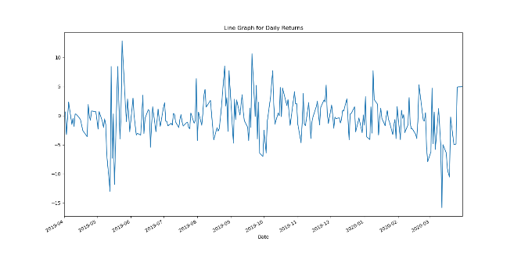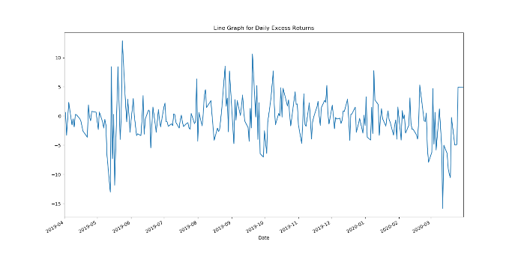

Comparison of **Daily** Risk-Unadjusted and Risk- AdjustedReturns

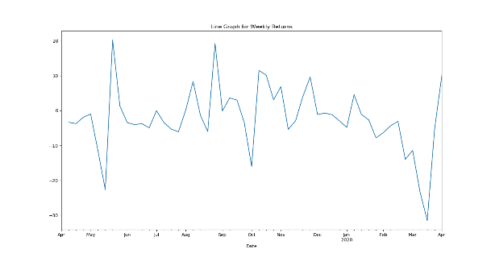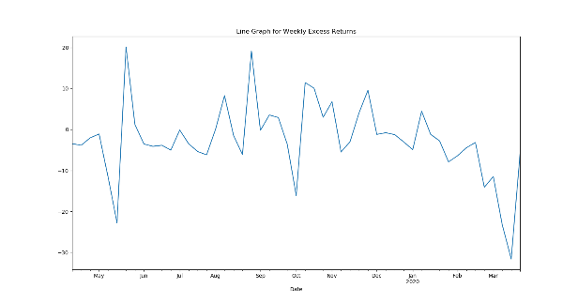

Comparison of **Weekly** Risk-Unadjusted and Risk- AdjustedReturns

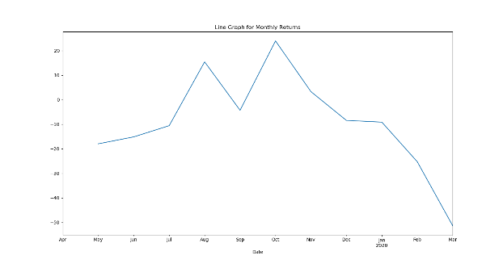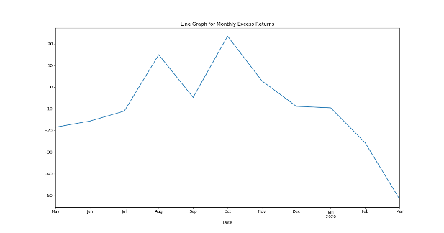

Comparison of **Monthly** Risk-Unadjusted and Risk- AdjustedReturns

AMJLAND:

|  |  |  |  |
| --- | --- | --- | --- |
|  | Daily | Weekly | Monthly |
| Max | 15.867 | 18.055 | 14.005 |
| Min | -11.051 | -11.553 | -25.804 |
| Mean | -0.086 | -0.496 | -2.602 |
| Std. Dev | 3.252 | 5.403 | 11.058 |

Table 4: Comparison of Daily, Weekly and Monthly **Risk- Adjusted** Returns (in %, rounded off)

Annualising these frequencies gives us the values- -26.950% for Daily, -22.7838% for Weekly and -27.121% for Monthly frequencies. An investor will make the least losses if he invests on a weekly basis. The least amount of loss is made on making investments on a Weekly frequency. Thus, it is important to consider the risk adjusted data in order to get a clearer, and a more realistic picture of the scenario.

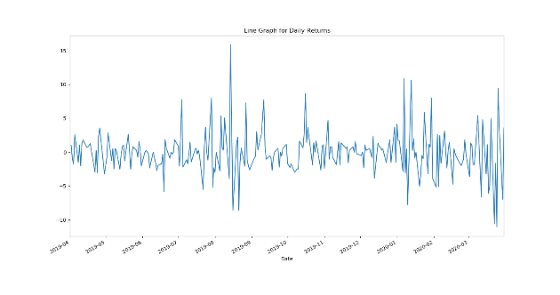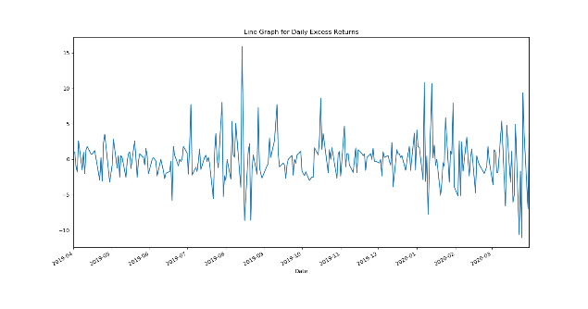

Comparison of **Daily** Risk-Unadjusted and Risk- AdjustedReturns

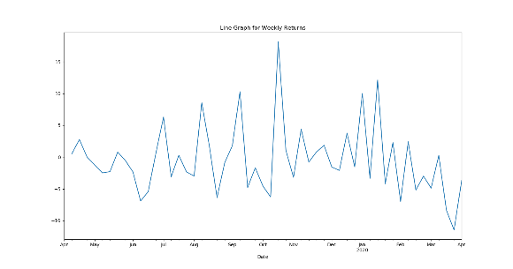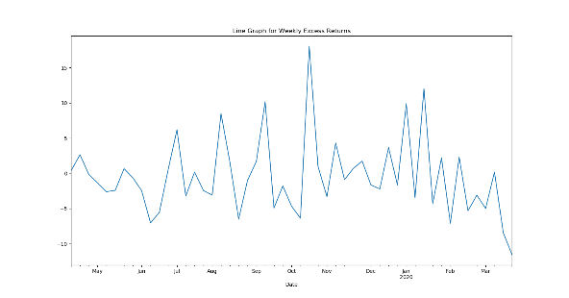

Comparison of **Weekly** Risk-Unadjusted and Risk- AdjustedReturns

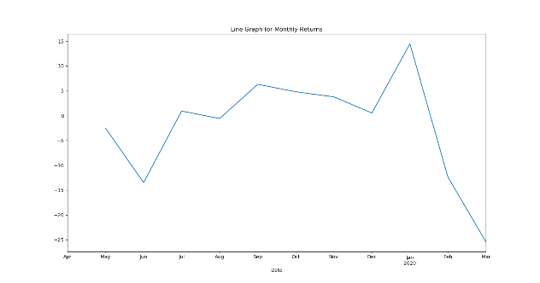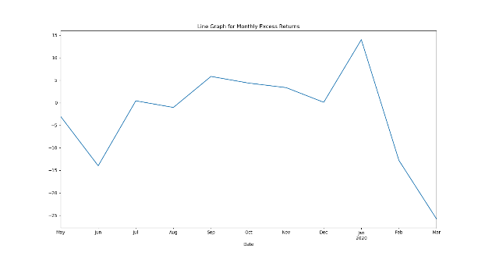

Comparison of **Monthly** Risk-Unadjusted and Risk- AdjustedReturns

**6 Observations & Inferences:**

* As it can be seen from the graphs, the trends for both unadjusted and adjusted returns are quite similar. However, if we compare the exact values, then the adjusted returns will always be less than the unadjusted returns due to the T-Bill rates being subtracted from the latter.
* The negative mean and annualised returns for both the companies is attributed to their poor performances during the 2019-20 financial year. However, it is also important to consider that stock prices came crashing down around the world due to the COVID-19 Pandemic, especially after January, 2020.
* An investor who had invested in AMJLAND would have lost the least money, if he/she had invested on a Weekly frequency.
* An investor who had invested in DELTACORP would have lost the least money, if he/she had invested on a Monthly frequency.

**Section 3**

**7 Expected Rate of Returns:**

We know that, in the financial year 2019-20, the First Trading Day Price for AMJLAND was Rs.19.6, while that for DELTACORP was Rs.270.25. Similarly, the last trading day prices were Rs.14.5 (AMJLAND) and Rs.63.35 (DELTACORP). Thus, the Expected Rate of Returns can be calculated using the following formula, for a single year sample size:

Thus, the expected rate of return for AMJLAND is -0.51% and for Delta Corp is -74%. While both the companies witnessed a decline in stock prices, it was a much worse scenario for Delta Corp. Moreover, the Dividend amount wasn’t sufficiently large enough to boost the expected rate of return value in the case of Delta Corp.

**8 Required Rate of Returns:**

1. **Zero Growth in Dividends**

We will be assuming that rs (expected return) is 7.5 % (or 0.075). Also, D (Dividend)= Rs. 3. Thus, the value of P0 comes out to be Rs. 40 (by applying the formula Po= D/ rs).

1. **Constant Growth Rate Dividends**

DELTACORP: It is given that Do (Dividend of last year) = Rs.6 and g (constant growth rate) = 1.25% or 0.0125. Also, we know that rs = Do((1+g)/Po)+g From the stock data of DELTACORP, the last trading price Po was Rs.63.35. Calculating, we get rs = 10.8394%.

AMJLAND: For the same values of Do and g, with Po = Rs. 14.5, the rs value comes out to be 43.14%. This is because of the small magnitude of Po in the denominator of the formula.

1. **Supernormal Growth in Dividends.**

First, we need to calculate the present value of the dividends:



Thus, Rs. 9 is the present value during this period. Now, we need to find the present value of the dividends after this period. The stock value at the beginning of constant growth period.

P3= D4/(rs-g) = (Dp(1+gs)^3(1+g))/(0.20-0.06) =Rs. 39.25.

Also, the present value of the constant growth dividends is Po= P3/(1+rs)^3=Rs. 22.7140.

Thus, the Fair Present Value is Rs.31.7140 (sum of both values during normal and supernormal periods)

**Conclusion:**

The analysis of both the companies’ financial state shows the dire state of the global economy currently. The mean unadjusted and adjusted returns for all three of Daily, Weekly and Monthly Frequencies come out to be negative, showing the poor financial health currently. Delta Corp has definitely suffered more, due to the nature of its business (Casinos & Hotel Chains- both not sustainable during Lockdown). However, the ray of Hope lies in the fact that after the COVID-19 pandemic has subsided, business will soon recover back to the usual.

It can also be seen from the analysis above that an investor would have lost the least money if he had traded on a Weekly basis for AMJLAND and on a Monthly basis for DELTACORP. Finally, calculations related to the Expected & Required Rate of Returns were also made and corresponding solutions were obtained.

# **References**

AMJ Land . (n.d.). *About*. Retrieved from AMJLAND: amjland.com

*AMJ Land Holdings*. (n.d.). Retrieved from Economic Times: https://economictimes.indiatimes.com/amj-land-holdings-ltd/infocompanyhistory/companyid-13241.cms

Business Standard. (2019, 07 01). *Annual Report of AMJ Land*. Retrieved from Business Standard: https://bsmedia.business-standard.com/_media/bs/data/announcements/bse/01072019/411fa070-fb70-4867-9b95-6f8425dd6c1f.pdf

Business Standard. (n.d.). *Company History of AMJ Land*. Retrieved from Business Standard: https://www.business-standard.com/company/amj-land-453/information/company-history

Delta Corp Ltd. (2009). *About Us*. Retrieved from Delta Corp: http://www.deltacorp.in/group.html

Delta Corp Ltd. (n.d.). *BOD*. Retrieved from Delta Corp: http://www.deltacorp.in/bod.html

Wikipedia. (n.d.). *Delta Corp Limited*. Retrieved from Wikipedia: https://en.wikipedia.org/wiki/Delta_Corp_Limited